Supplementary Material
Table S1
Pearson correlations between phenological onset dates (BBCH 61: beginning of flowering: 10 % of flowers open/emitting pollen), BBCH 65: full flowering: > 50 % of flowers open/emitting pollen, first petals falling, BBCH 10: mouse-ear stage: green leaf tips 10 mm above the bud scales, BBCH 11: > 50 % leaves unfolded) of silver birch (Betula pendula Roth), common hazel (Corylus avellana L.) and horse chestnut (Aesculus hippocastanum L.) and corresponding air temperature (T; 1_2: mean of January and February, 3_4: mean of March and April), significance level: *** p ≤ 0.001.
 | T | BBCH 61 | BBCH 65 | BBCH 10 | BBCH 11
Silver birch | 3_4 | -0.594 *** | -0.625 *** | -0.563 *** | -0.550 ***
Common hazel | 1_2 | -0.771 *** | -0.720 ***
Horse chestnut | 3_4 | -0.541 *** | -0.714 ***

Table S2
Bivariate correlations between leaf morphological characteristics (M: mass, F: area, THK: thickness, SLA: specific leaf area) of silver birch (Betula pendula Roth) and corresponding temperature (T3_4: mean air temperature of March and April). All values represent Pearson’s correlation coefficients, except for the non-normally distributed variable thickness where we used Spearman correlations, significance level: *** p ≤ 0.001.
 | F | THK | SLA | T3_4
M | 0.730 *** | 0.673 *** | -0.620 *** | 0.058
F |  | 0.384 *** | 0.042 | -0.013
THK |  |  | -0.620 *** | 0.221
SLA |  |  |  | 0.274

Table S3
Spearman correlations between long-term pollutants and temperature (T1_2: mean air temperature of January and February, T3_4: mean air temperature of March and April) for urban and rural sites and for urban sites solely, significance levels: *** p ≤ 0.001, ** p ≤ 0.01, * p ≤ 0.05.
Urban and rural sites
 | NO₂ | NO_{x} |  | PM_{2.5} |  | PM₁₀ |  | PM_{2.5} abs |  | T1_2 |  | T3_4
O₃ | -0.632 *** | -0.535 *** |  | -0.271 *** |  | -0.326 *** |  | -0.339 *** |  | -0.733 *** |  | -0.711 ***
NO₂ |  | 0.962 *** |  | 0.605 *** |  | 0.736 *** |  | 0.800 *** |  | 0.656 *** |  | 0.762 ***
NO_{x} |  |  |  | 0.694 *** |  | 0.787 *** |  | 0.866 *** |  | 0.571 *** |  | 0.686 ***
PM_{2.5} |  |  |  |  |  | 0.548 *** |  | 0.687 *** |  | 0.215 |  | 0.340 ***
PM₁₀ |  |  |  |  |  |  |  | 0.783 *** |  | 0.449 ** |  | 0.444 ***
PM_{2.5} abs |  |  |  |  |  |  |  |  |  | 0.366 * |  | 0.452 ***
Urban sites
 | NO₂ |  | NO_{x} |  | PM_{2.5} |  | PM₁₀ |  | PM_{2.5} abs |  | T1_2 |  | T3_4
O₃ | -0.445 *** |  | -0.334 *** |  | -0.250 * |  | -0.245 * |  | -0.224 * |  | -0.586 ** |  | -0.586 ***
NO₂ |  |  | 0.940 *** |  | 0.727 *** |  | 0.787 *** |  | 0.811 *** |  | 0.599 ** |  | 0.501 ***
NO_{x} |  |  |  |  | 0.801 *** |  | 0.855 *** |  | 0.876 *** |  | 0.313 |  | 0.433 ***
PM_{2.5} |  |  |  |  |  |  | 0.735 *** |  | 0.816 *** |  | -0.041 |  | 0.319 **
PM₁₀ |  |  |  |  |  |  |  |  | 0.839 *** |  | 0.069 |  | 0.385 ***
PM_{2.5} abs |  |  |  |  |  |  |  |  |  |  | 0.135 |  | 0.350 **

Fig. S1. Spatial variability of long-term O₃ concentration [µg/m³] (blue shades) with onset dates of birch [DOY, day of the year](small circles) and corresponding April-March temperatures [°C] (big circles) in the greater area of Munich in 2010.
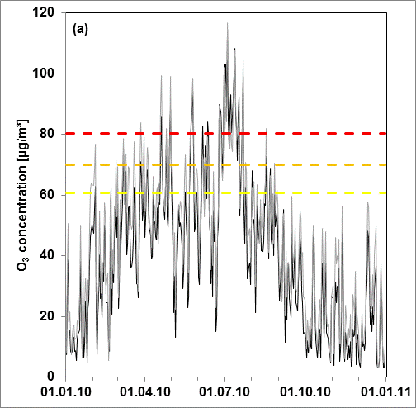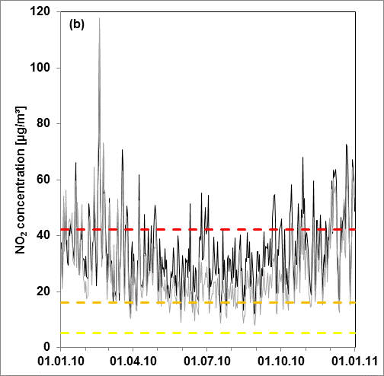
Fig. S2. Temporal course of pollutant concentrations for (a) O₃ and (b) NO₂ in 2010 at two measuring stations (LfU, Bayerisches Landesamt für Umwelt) in Munich (black line: Lothstraße, grey line: Johanneskirchen). Dashed lines indicate values of the passive sampling campaign in 2010 (red: maximum, orange: mean, yellow: minimum).

