Supporting materials

Supporting Figures

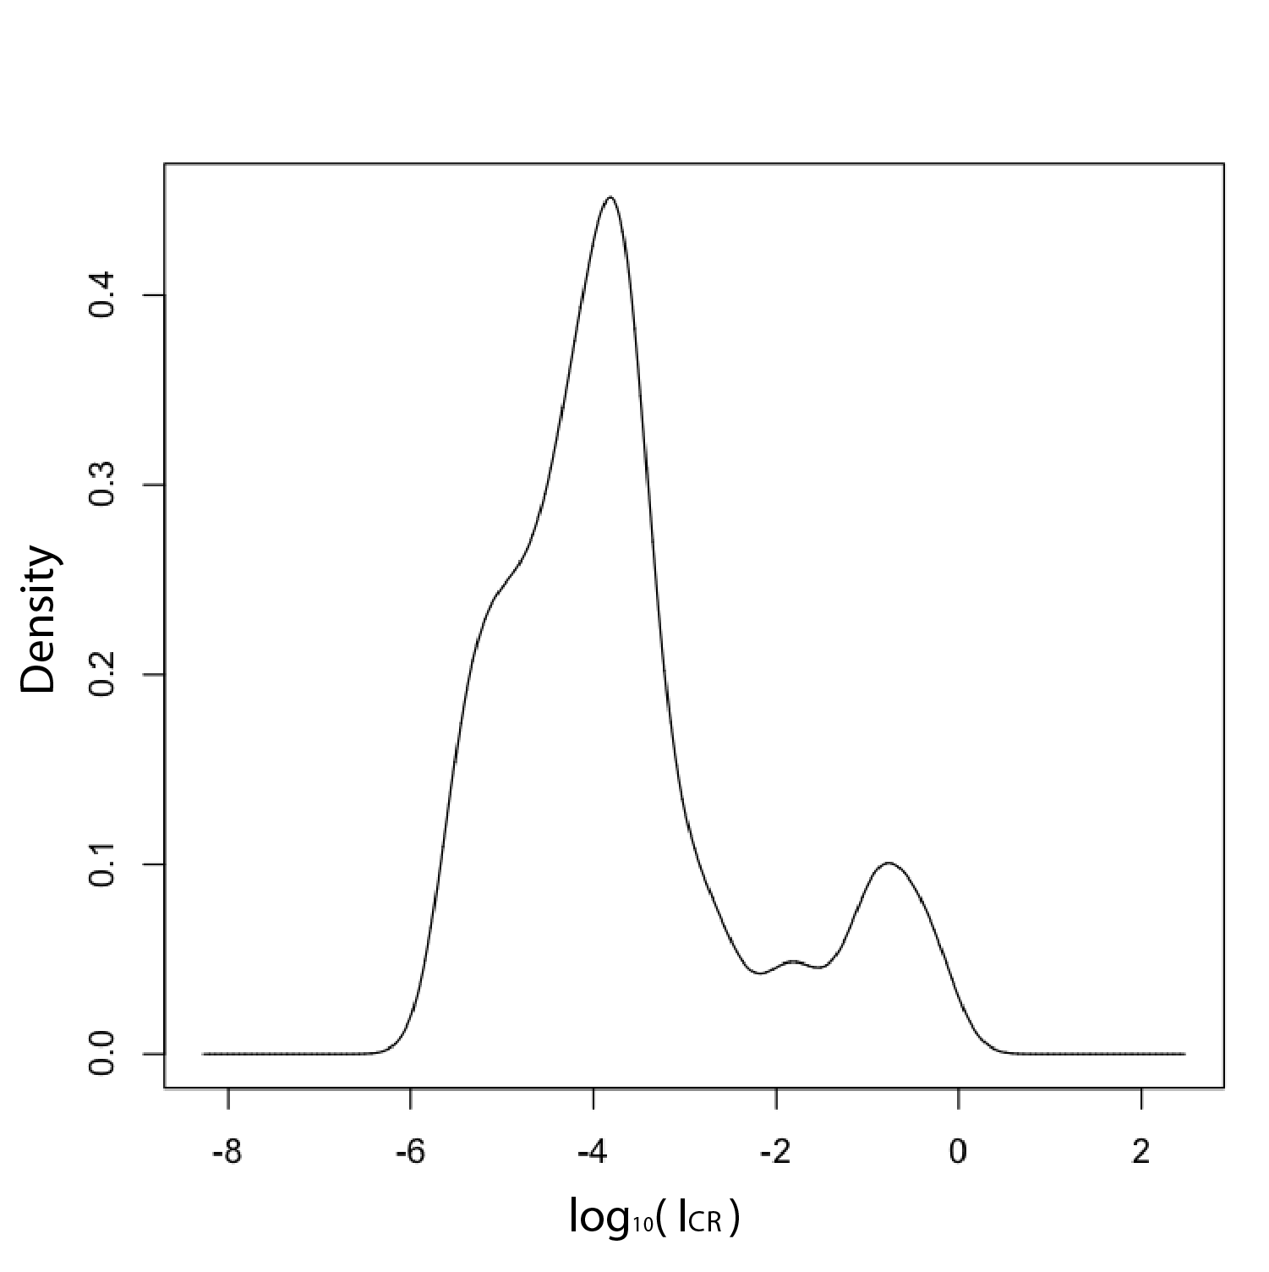
Fig. S1. The density profile of the I_{CR} values, obtained using Gaussian Kernel Density Estimation (KDE) analysis.

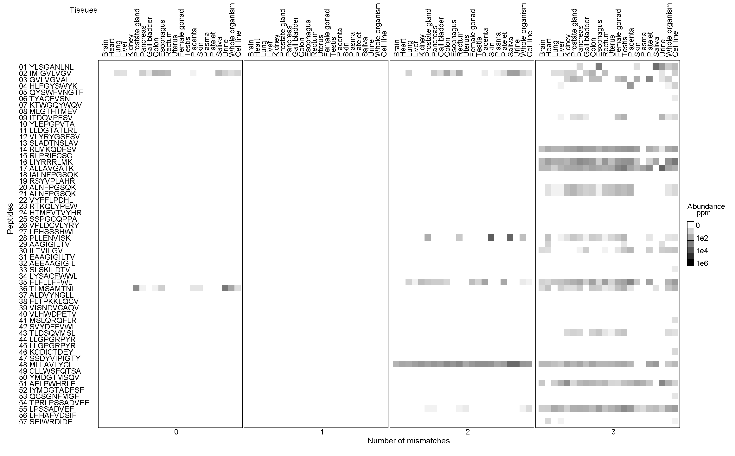
Fig. S2C. The CR-map for the “Differentiation” antigens (Group C).

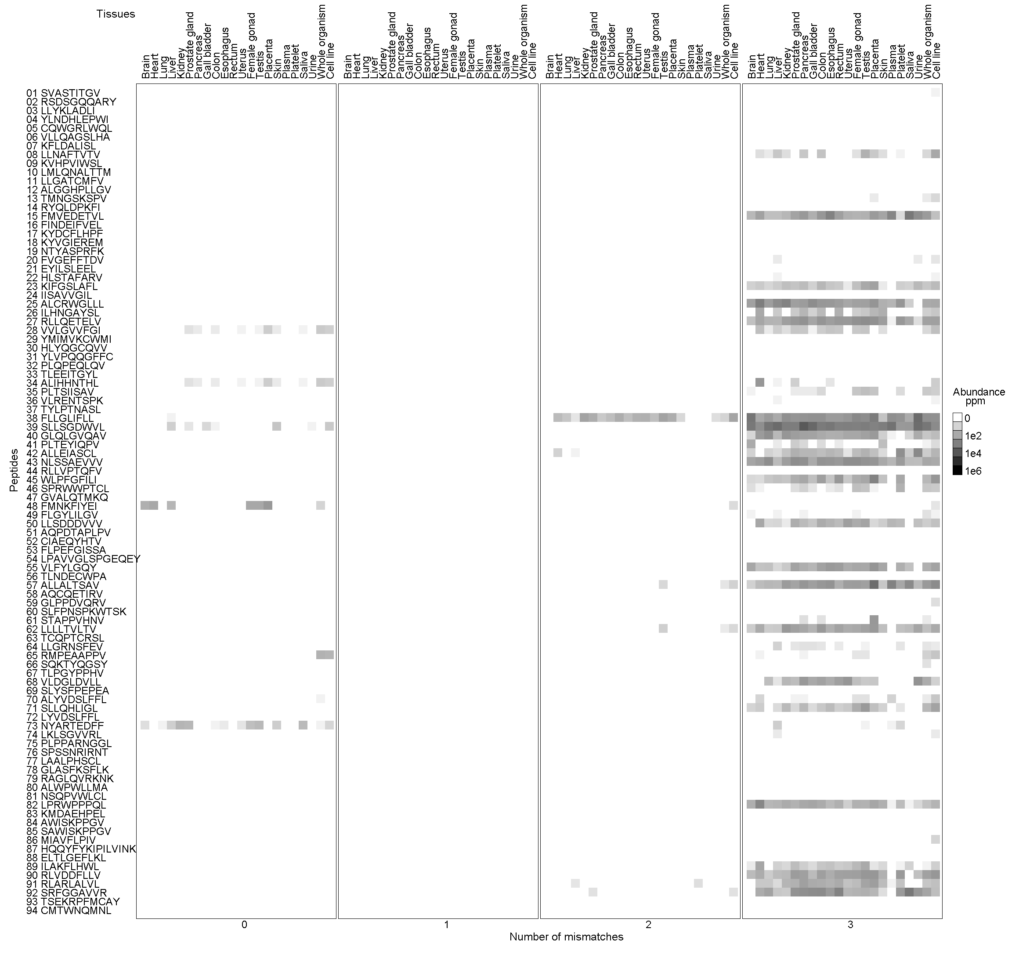

Fig. S2D. The cross-reactivity map for the “Overexpressed” antigens (Group D).
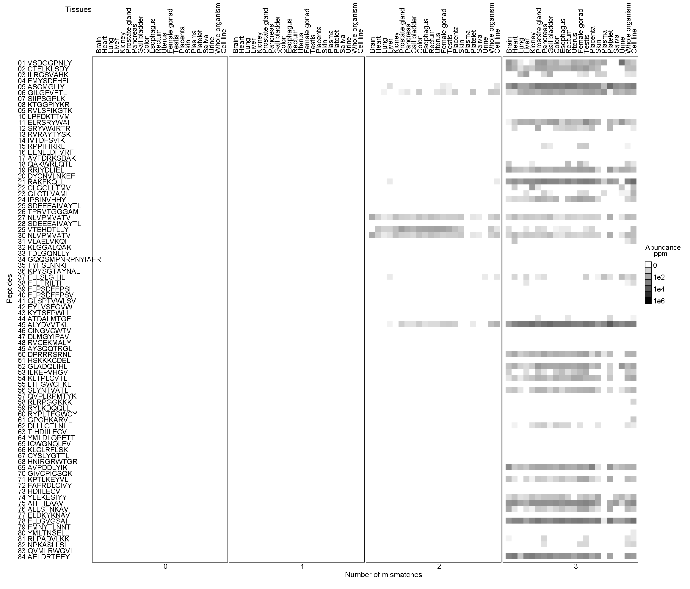
Fig. S2E. The cross-reactivity map for the “Viruses” antigens (Group E).

Tables 1 A-E

Table 1A. List of “mutation” antigens (Group A) obtained from the database of T cell-defined human tumor antigens (Vigneron, et al., 2013). The columns are: sequential number of peptide in the group; HLA name of allele; Gene or protein name; position of peptide in gene or protein; I_{CR} index.
# | Peptide | HLA | Gene-protein | Position | I_{CR} | I_{CR} error
01 | FIASNGVKLV | HLA-A02:01 | alpha-actinin-4 | 118-127 | 0 | 0
02 | SSKALQRPV | HLA-A02:01 | BCR-ABL-fusion-protein-(b3a2) | 926-934 | 0 | 0
03 | GFKQSSKAL | HLA-B08:01 | BCR-ABL-fusion-protein-(b3a2) | 922-930 | 2.593e-05 | 4.522e-06
04 | FLIIWQNTM | HLA-A02:01 | CASP-5 | 67-75 | 0 | 0
05 | FPSDSWCYF | HLA-B35:01 | CASP-8 | 476-484 | 1.559e-05 | 6.627e-07
06 | SYLDSGIHF | HLA-A24:02 | beta-catenin | 29-37 | 1.682e-05 | 3.871e-07
07 | ACDPHSGHFV | HLA-A02:01 | CDK4 | 23-32 | 0 | 0
08 | CILGKLFTK | HLA-A11:01 | CDK12 | 924-932 | 0.01383 | 0.0006714
09 | AVCPWTWLR | HLA-A11:01 | CDKN2A | "125-133,or111-119" | 0 | 0
10 | ILDKVLVHL | HLA-A02:01 | CLPP | 240-248 | 6.285e-05 | 2.964e-06
11 | GLFGDIYLA | HLA-A02:01 | CSNK1A1 | 26-34 | 0 | 0
12 | KILDAVVAQK | HLA-A03:01 | EFTUD2 | 668-677 | 0 | 0
13 | ETVSEQSNV | HLA-A68:01 | Elongation-factor-2 | 581-589 | 0 | 0
14 | RIAECILGM | HLA-A02:01 | ETV6-AML1-fusion-protein | 334-342 | 0 | 0
15 | YVDFREYEYY | HLA-A01:01 | FLT3-ITD | 591-600 | 0 | 0
16 | VVMSWAPPV | HLA-A02:01 | FNDC3B | 292-300 | 6.768e-05 | 6.323e-06
17 | SLADEAEVYL | HLA-A02:01 | GAS7 | 141-150 | 1.781e-05 | 2.874e-06
18 | TLDWLLQTPK | HLA-A03:01 | GPNMB | 179-188 | 0 | 0
19 | ILNAMIAKI | HLA-A02:01 | HAUS3 | 154-162 | 4.244e-06 | 1.273e-06
20 | SLFEGIDIYT | HLA-A02:01 | hsp70-2 | 286-295 | 0.1373 | 0.002356
21 | AEPINIQTW | HLA-B44:02 | - | 262-270 | 6.865e-05 | 5.446e-06
22 | FLEGNEVGKTY | HLA-A01:01 | MART2 | 446-455 | 0 | 0
23 | KTLTSVFQK | HLA-A11:01 | MATN | 226-234 | 0.0002105 | 1.395e-05
24 | FLDEFMEGV | HLA-A02:01 | ME1 | 224-232 | 5.286e-05 | 4.488e-06
25 | EEKLIVVLF | HLA-B44:02 | MUM-1 | 30-38 | 0.0008986 | 7.883e-05
26 | SELFRSGLDSY | HLA-B44:02 | MUM-2 | 123-133 | 0 | 0
27 | EAFIQPITR | HLA-A68:01 | MUM-3 | 322-330 | 0.01269 | 0.001402
28 | KINKNPKYK | HLA-A03:01 | Myosin-class-I | 911-919 | 0 | 0
29 | SLYKFSPFPL | HLA-A02:01 | OGT | 28-37 | 0 | 0
30 | KELEGILLL | HLA-B44:02 | OS-9 | 438-446 | 7.718e-06 | 6.584e-07
31 | VVPCEPPEV | HLA-A02:01 | p53 | 217-225 | 0 | 0
32 | YTDFHCQYV | HLA-A01:01 | PPP1R3B | 172-180 | 0 | 0
33 | LLLDDLLVSI | HLA-A02:01 | PRDX5 | 163-172 | 0 | 0
34 | VVVGAVGVG | HLA-B35:01 | K-ras | 07--15 | 0.0001572 | 5.612e-06
35 | ILDTAGREEY | HLA-A01:01 | N-ras | 55-64 | 0 | 0
36 | RPHVPESAF | HLA-B07:02 | RBAF600 | 329-337 | 0.04202 | 0.001942
37 | KIFSEVTLK | HLA-A03:01 | SIRT2 | 192-200 | 3.264e-05 | 2.185e-06
38 | SHETVIIEL | HLA-B38:01 | SNRPD1 | 11--19 | 8.489e-06 | 1.411e-06
39 | QRPYGYDQIM | HLA-B07:02 | SYT-SSX1-or-SSX2-protein | "402-410-(SYT),111-112-(SSX2)" | 0 | 0
40 | RLSSCVPVA | HLA-A02:01 | TGF-betaRII | 131-139 | 3.284e-06 | 9.852e-07

Table 1B. List of “tumor-specific” (CT) antigens (Group B)
# | Peptide | HLA | Gene-protein | Position | I_{CR} | I_{CR} error
01 | FLDRFLSCM | HLA-A02:01 | Cyclin-A1 | 227-235 | 0 | 0
02 | SLIAAAAFCLA | HLA-A02:01 | Cyclin-A1 | 341-351 | 0 | 0
03 | YYWPRPRRY | HLA-A29:02 | "GAGE-3,4,5,6,7" | 10--18 | 0 | 0
04 | VLPDVFIRC | HLA-A02:01 | GnTV | intron | 1.134e-05 | 1.273e-06
05 | MLAVISCAV | HLA-A02:01 | HERV-K-MEL | 1--9 | 3.112e-05 | 2.657e-06
06 | RQKRILVNL | HLA-B15:01 | KK-LC-1 | 76-84 | 0.03021 | 0.009056
07 | NYNNFYRFL | HLA-A24:02 | KM-HN-1 | 196-204 | 6.516e-05 | 4.376e-06
08 | EYSKECLKEF | HLA-A24:02 | KM-HN-1 | 499-508 | 0 | 0
09 | EYLSLSDKI | HLA-A24:02 | KM-HN-1 | 770-778 | 0 | 0
10 | MLMAQEALAFL | HLA-A02:01 | LAGE-1 | "ORF2,1-11" | 0 | 0
11 | SLLMWITQC | HLA-A02:01 | LAGE-1 | 157-165 | 0 | 0
12 | LAAQERRVPR | HLA-A31:01 | LAGE-1 | "ORF2,18-27" | 0 | 0
13 | ELVRRILSR | HLA-A68:01 | LAGE-1 | 103-111 | 0.0001839 | 8.258e-06
14 | APRGVRMAV | HLA-B07:02 | LAGE-1 | "ORF2,46-54" | 0.00104 | 4.801e-05
15 | RYCNLEGPPI | HLA-A24:02 | LY6K | 119-128 | 0 | 0
16 | EADPTGHSY | HLA-A01:01 | MAGE-A1 | 161-169 | 0.1067 | 0.02051
17 | KVLEYVIKV | HLA-A02:01 | MAGE-A1 | 278-286 | 0.0003038 | 8.84e-06
18 | SLFRAVITK | HLA-A03:01 | MAGE-A1 | 96-104 | 0.1057 | 0.01937
19 | EVYDGREHSA | HLA-A68:01 | MAGE-A1 | 222-231 | 0 | 0
20 | RVRFFFPSL | HLA-B07:02 | MAGE-A1 | 289-298 | 0.0002432 | 1.509e-05
21 | EADPTGHSY | HLA-B35:01 | MAGE-A1 | 161-169 | 0.1067 | 0.02051
22 | KEADPTGHSY | HLA-B44:02 | MAGE-A1 | 160-169 | 0 | 0
23 | DPARYEFLW | HLA-B53:01 | MAGE-A1 | 258-266 | 0 | 0
24 | ITKKVADLVGF | HLA-B57:01 | MAGE-A1 | 102-112 | 0 | 0
25 | YLQLVFGIEV | HLA-A02:01 | MAGE-A2 | 157-166 | 0 | 0
26 | EYLQLVFGI | HLA-A24:02 | MAGE-A2 | 156-164 | 5.663e-05 | 4.142e-06
27 | EVDPIGHLY | HLA-A01:01 | MAGE-A3 | 168-176 | 0.0007743 | 5.308e-05
28 | FLWGPRALV | HLA-A02:01 | MAGE-A3 | 271-279 | 2.51e-05 | 3.436e-06
29 | KVAELVHFL | HLA-A02:01 | MAGE-A3 | 112-120 | 0.1356 | 0.02064
30 | TFPDLESEF | HLA-A24:02 | MAGE-A3 | 97-105 | 3.011e-05 | 2.898e-06
31 | VAELVHFLL | HLA-A24:02 | MAGE-A3 | 113-121 | 0 | 0
32 | MEVDPIGHLY | HLA-B18:01 | MAGE-A3 | 167-176 | 0 | 0
33 | EVDPIGHLY | HLA-B35:01 | MAGE-A3 | 168-176 | 0.0007743 | 5.308e-05
34 | AELVHFLLL | HLA-B40:01 | MAGE-A3 | 114-122 | 0.0001089 | 4.864e-06
35 | MEVDPIGHLY | HLA-B44:02 | MAGE-A3 | 167-176 | 0 | 0
36 | EVDPASNTY | HLA-A01:01 | MAGE-A4 | 169-177 | 0.3032 | 0.06037
37 | GVYDGREHTV | HLA-A02:01 | MAGE-A4 | 230-239 | 0 | 0
38 | NYKRCFPVI | HLA-A24:02 | MAGE-A4 | 143-151 | 8.057e-06 | 1.323e-06
39 | EVDPIGHVY | HLA-B35:01 | MAGE-A6 | 168-176 | 0.0006249 | 2.643e-05
40 | ALSVMGVYV | HLA-A02:01 | MAGE-A9 | 223-231 | 1.069e-05 | 2.826e-06
41 | GLYDGMEHL | HLA-A02:01 | MAGE-A10 | 254-262 | 0.2043 | 0.0354
42 | DPARYEFLW | HLA-B53:01 | MAGE-A10 | 290-298 | 0 | 0
43 | FLWGPRALV | HLA-A02:01 | MAGE-A12 | 271-279 | 2.51e-05 | 3.436e-06
44 | ILFGISLREV | HLA-A02:01 | MAGE-C1 | 959-968 | 0 | 0
45 | KVVEFLAML | HLA-A02:01 | MAGE-C1 | 1083-1091 | 0.1105 | 0.02207
46 | LLFGLALIEV | HLA-A02:01 | MAGE-C2 | 191-200 | 0 | 0
47 | ALKDVEERV | HLA-A02:01 | MAGE-C2 | 336-344 | 0 | 0
48 | SESIKKKVL | HLA-B44:02 | MAGE-C2 | 307-315 | 1.013e-05 | 1.504e-06
49 | ASSTLYLVF | HLA-B57:01 | MAGE-C2 | 42-50 | 9.018e-05 | 1.167e-05
50 | SLLMWITQC | HLA-A02:01 | NY-ESO-1_LAGE-2 | 157-165 | 0 | 0
51 | MLMAQEALAFL | HLA-A02:01 | NY-ESO-1_LAGE-2 | "ORF2,1-11" | 0 | 0
52 | YLAMPFATPME | HLA-A24:02 | NY-ESO-1_LAGE-2 | 91-101 | 0 | 0
53 | ASGPGGGAPR | HLA-A31:01 | NY-ESO-1_LAGE-2 | 53-62 | 0 | 0
54 | LAAQERRVPR | HLA-A31:01 | NY-ESO-1_LAGE-2 | "ORF2,18-27" | 0 | 0
55 | TVSGNILTIR | HLA-A68:01 | NY-ESO-1_LAGE-2 | 127-136 | 0 | 0
56 | APRGPHGGAASGL | HLA-B07:02 | NY-ESO-1_LAGE-2 | 60-72 | 0 | 0
57 | MPFATPMEAEL | HLA-B35:01 | NY-ESO-1_LAGE-2 | 94-104 | 0 | 0
58 | MPFATPMEA | HLA-B51:01 | NY-ESO-1_LAGE-2 | 94-102 | 8.424e-05 | 5.463e-06
59 | FATPMEAELAR | HLA-C12:03 | NY-ESO-1_LAGE-2 | 96-106 | 0 | 0
60 | LYATVIHDI | HLA-A24:02 | SAGE | 715-723 | 0 | 0
61 | ILDSSEEDK | HLA-A01:01 | Sp17 | 103-111 | 4.812e-05 | 2.72e-06
62 | KASEKIFYV | HLA-A02:01 | SSX-2 | 41-49 | 0.06739 | 0.007796
63 | SLGWLFLLL | HLA-A02:01 | TAG-1 | 78-86 | 8.213e-05 | 6.395e-06
64 | LSRLSNRLL | HLA-B08:01 | TAG-1 | 42-50 | 0 | 0
65 | LSRLSNRLL | HLA-B08:01 | TAG-2 | 42-50 | 0 | 0
66 | EVISCKLIKR | HLA-A68:01 | TRP2-INT2 | intron2 | 0 | 0
67 | RQKKIRIQL | HLA-A02:01 | XAGE-1b/GAGED2 | 21-29 | 6.252e-06 | 1.429e-06

Table 1C. List of “differentiation” antigens (Group C).
# | Peptide | HLA | Gene-protein | Position | I_{CR} | I_{CR} error
01 | YLSGANLNL | HLA-A02:01 | CEA | 605-613 | 7.369e-05 | 9.035e-06
02 | IMIGVLVGV | HLA-A02:01 | CEA | 691-699 | 0.5705 | 0.02878
03 | GVLVGVALI | HLA-A02:01 | CEA | 694-702 | 9.45e-05 | 9.995e-06
04 | HLFGYSWYK | HLA-A03:01 | CEA | 61-69 | 2.241e-05 | 2.146e-06
05 | QYSWFVNGTF | HLA-A24:02 | CEA | 268-277 | 0 | 0
06 | TYACFVSNL | HLA-A24:02 | CEA | 652-660 | 2.602e-06 | 7.807e-07
07 | KTWGQYWQV | HLA-A02:01 | gp100_Pmel17 | 154-162 | 0 | 0
08 | MLGTHTMEV | HLA-A02:01 | gp100_Pmel17 | 177(8)-186 | 0 | 0
09 | ITDQVPFSV | HLA-A02:01 | gp100_Pmel17 | 209-217 | 4.851e-05 | 3.603e-06
10 | YLEPGPVTA | HLA-A02:01 | gp100_Pmel17 | 280-288 | 0 | 0
11 | LLDGTATLRL | HLA-A02:01 | gp100_Pmel17 | 457-466 | 0 | 0
12 | VLYRYGSFSV | HLA-A02:01 | gp100_Pmel17 | 476-485 | 0 | 0
13 | SLADTNSLAV | HLA-A02:01 | gp100_Pmel17 | 570-579 | 0 | 0
14 | RLMKQDFSV | HLA-A02:01 | gp100_Pmel17 | 619-627 | 0.0002279 | 1.396e-05
15 | RLPRIFCSC | HLA-A02:01 | gp100_Pmel17 | 639-647 | 0 | 0
16 | LIYRRRLMK | HLA-A03:01 | gp100_Pmel17 | 614-622 | 0.0002308 | 1.5e-05
17 | ALLAVGATK | HLA-A03:01 | gp100_Pmel17 | 17-25 | 0.0002437 | 1.283e-05
18 | IALNFPGSQK | HLA-A03:01 | gp100_Pmel17 | 86-95 | 0 | 0
19 | RSYVPLAHR | HLA-A03:01 | gp100_Pmel17 | 195-202and191or192e | 0 | 0
20 | ALNFPGSQK | HLA-A03:01 | gp100_Pmel17 | 87-95 | 9.59e-05 | 4.7e-06
21 | ALNFPGSQK | HLA-A11:01 | gp100_Pmel17 | 87-95 | 9.59e-05 | 4.7e-06
22 | VYFFLPDHL | HLA-A24:02 | gp100_Pmel17 | intron4 | 0 | 0
23 | RTKQLYPEW | HLA-A32:01 | gp100_Pmel17 | "40-42,47-52" | 0 | 0
24 | HTMEVTVYHR | HLA-A68:01 | gp100_Pmel17 | 182-191 | 0 | 0
25 | SSPGCQPPA | HLA-B07:02 | gp100_Pmel17 | 529-537 | 0 | 0
26 | VPLDCVLYRY | HLA-B35:01 | gp100_Pmel17 | 471-480 | 0 | 0
27 | LPHSSSHWL | HLA-B35:01 | gp100_Pmel17 | 630-638 | 0 | 0
28 | PLLENVISK | HLA-A03:01 | mammaglobin-A | 23-31 | 0.001393 | 0.0002753
29 | AAGIGILTV | HLA-A02:01 | Melan-A_MART-1 | 26(27)-35 | 1.321e-05 | 2.466e-06
30 | ILTVILGVL | HLA-A02:01 | Melan-A_MART-1 | 32-40 | 6.507e-05 | 3.067e-06
31 | EAAGIGILTV | HLA-B35:01 | Melan-A_MART-1 | 26-35 | 0 | 0
32 | AEEAAGIGIL | HLA-B45:01 | Melan-A_MART-1 | 24-33(34) | 0 | 0
33 | SLSKILDTV | HLA-A02:01 | NY-BR-1 | 904-912 | 2.602e-06 | 8.083e-07
34 | LYSACFWWL | HLA-A24:02 | OA1 | 126-134 | 0 | 0
35 | FLFLLFFWL | HLA-A02:01 | PAP | 18-26 | 0.001818 | 0.0001554
36 | TLMSAMTNL | HLA-A02:01 | PAP | 112-120 | 0.5041 | 0.05894
37 | ALDVYNGLL | HLA-A02:01 | PAP | 299-307 | 0 | 0
38 | FLTPKKLQCV | HLA-A02:01 | PSA | 165-174 | 0 | 0
39 | VISNDVCAQV | HLA-A02:01 | PSA | 178-187 | 0 | 0
40 | VLHWDPETV | HLA-A02:01 | RAB38_NY-MEL-1 | 50-58 | 0 | 0
41 | MSLQRQFLR | HLA-A31:01 | TRP-1_gp75 | altORF | 4.244e-06 | 1.273e-06
42 | SVYDFFVWL | HLA-A02:01 | TRP-2 | 180-188 | 0 | 0
43 | TLDSQVMSL | HLA-A02:01 | TRP-2 | 360-368 | 5.584e-05 | 5.335e-06
44 | LLGPGRPYR | HLA-A31:01 | TRP-2 | 197-205 | 0 | 0
45 | LLGPGRPYR | HLA-A33:01 | TRP-2 | 197-205 | 0 | 0
46 | KCDICTDEY | HLA-A01:01 | tyrosinase | 243-251 | 4.926e-06 | 1.478e-06
47 | SSDYVIPIGTY | HLA-A01:01 | tyrosinase | 146-156 | 0 | 0
48 | MLLAVLYCL | HLA-A02:01 | tyrosinase | 1--9 | 0.006077 | 0.0001972
49 | CLLWSFQTSA | HLA-A02:01 | tyrosinase | 8--17 | 0 | 0
50 | YMDGTMSQV | HLA-A02:01 | tyrosinase | 369-377 | 0 | 0
51 | AFLPWHRLF | HLA-A24:02 | tyrosinase | 206-214 | 0.0001747 | 9.794e-06
52 | IYMDGTADFSF | HLA-A24:02 | tyrosinase | 368-373_336-340e | 0 | 0
53 | QCSGNFMGF | HLA-A26:01 | tyrosinase | 90-98 | 3.284e-06 | 9.852e-07
54 | TPRLPSSADVEF | HLA-B35:01 | tyrosinase | 309-320 | 0 | 0
55 | LPSSADVEF | HLA-B35:01 | tyrosinase | 312-320 | 0.0004798 | 2.932e-05
56 | LHHAFVDSIF | HLA-B38:01 | tyrosinase | 388-397 | 0 | 0
57 | SEIWRDIDF | HLA-B44:02 | tyrosinase | 192-200 | 8.21e-06 | 7.525e-07

Table 1D. List of “overexpressed” antigens (Group D).
# | Peptide | HLA | Gene-protein | Position | I_{CR} | I_{CR} error
01 | SVASTITGV | HLA-A02:01 | adipophilin | 129-137 | 1.642e-06 | 4.926e-07
02 | RSDSGQQARY | HLA-A01:01 | AIM-2 | intron | 0 | 0
03 | LLYKLADLI | HLA-A02:01 | ALDH1A1 | 88-96 | 0 | 0
04 | YLNDHLEPWI | HLA-A02:01 | BCLX_(L) | 173-182 | 0 | 0
05 | CQWGRLWQL | HLA-A02:01 | BING-4 | ORF2 | 0 | 0
06 | VLLQAGSLHA | HLA-A02:01 | CALCA | 16-25 | 0 | 0
07 | KFLDALISL | HLA-A24:02 | CD45 | 556-564 | 0 | 0
08 | LLNAFTVTV | HLA-A02:01 | CD274 | 15-23 | 7.557e-05 | 4.133e-06
09 | KVHPVIWSL | HLA-A02:01 | CPSF | 250-258 | 0 | 0
10 | LMLQNALTTM | HLA-A02:01 | CPSF | 1360-1369 | 0 | 0
11 | LLGATCMFV | HLA-A02:01 | cyclin_D1 | 101-109 | 0 | 0
12 | ALGGHPLLGV | HLA-A02:01 | DKK1 | 20-29 | 0 | 0
13 | TMNGSKSPV | HLA-A02:01 | ENAH_(hMena) | 502-510 | 1.013e-05 | 1.684e-06
14 | RYQLDPKFI | HLA-A24:02 | EpCAM | 173-181 | 0 | 0
15 | FMVEDETVL | HLA-A02:01 | EZH2 | 120-128 | 0.0002503 | 9.832e-06
16 | FINDEIFVEL | HLA-A02:01 | EZH2 | 165-174 | 0 | 0
17 | KYDCFLHPF | HLA-A24:02 | EZH2 | 291-299 | 0 | 0
18 | KYVGIEREM | HLA-A24:02 | EZH2 | 735-743 | 0 | 0
19 | NTYASPRFK | HLA-A03:01 | FGF5 | "172-176,217-220" | 0 | 0
20 | FVGEFFTDV | HLA-A02:01 | glypican-3 | 144-152 | 8.489e-06 | 1.383e-06
21 | EYILSLEEL | HLA-A24:02 | glypican-3 | 298-306 | 0 | 0
22 | HLSTAFARV | HLA-A02:01 | G250_MN_CAIX | 254-262 | 3.284e-06 | 7.525e-07
23 | KIFGSLAFL | HLA-A02:01 | HER-2_neu | 369-377 | 0.0001509 | 4.674e-06
24 | IISAVVGIL | HLA-A02:01 | HER-2_neu | 654-662 | 0 | 0
25 | ALCRWGLLL | HLA-A02:01 | HER-2_neu | 40675 | 0.0002609 | 1.121e-05
26 | ILHNGAYSL | HLA-A02:01 | HER-2_neu | 435-443 | 0.0001044 | 8.212e-06
27 | RLLQETELV | HLA-A02:01 | HER-2_neu | 689-697 | 0.0002524 | 3.779e-06
28 | VVLGVVFGI | HLA-A02:01 | HER-2_neu | 665-673 | 0.2831 | 0.03958
29 | YMIMVKCWMI | HLA-A02:01 | HER-2_neu | 952-961 | 0 | 0
30 | HLYQGCQVV | HLA-A02:01 | HER-2_neu | 48-56 | 0 | 0
31 | YLVPQQGFFC | HLA-A02:01 | HER-2_neu | 1023-1032 | 0 | 0
32 | PLQPEQLQV | HLA-A02:01 | HER-2_neu | 391-399 | 0 | 0
33 | TLEEITGYL | HLA-A02:01 | HER-2_neu | 402-410 | 0 | 0
34 | ALIHHNTHL | HLA-A02:01 | HER-2_neu | 466-474 | 0.283 | 0.03849
35 | PLTSIISAV | HLA-A02:01 | HER-2_neu | 650-658 | 5.483e-05 | 3.142e-06
36 | VLRENTSPK | HLA-A03:01 | HER-2_neu | 754-762 | 3.284e-06 | 7.525e-07
37 | TYLPTNASL | HLA-A24:02 | HER-2_neu | 63-71 | 0 | 0
38 | FLLGLIFLL | HLA-A02:01 | HLA-DOB | 232-240 | 0.01634 | 0.005191
39 | SLLSGDWVL | HLA-A02:01 | Hepsin | 191-199 | 0.2525 | 0.04056
40 | GLQLGVQAV | HLA-A02:01 | Hepsin | 229-237 | 0.0002098 | 1.004e-05
41 | PLTEYIQPV | HLA-A02:01 | Hepsin | 268-276 | 4.663e-05 | 3.715e-06
42 | ALLEIASCL | HLA-A02:01 | IDO1 | 199-207 | 0.0003109 | 3.65e-06
43 | NLSSAEVVV | HLA-A02:01 | IGF2B3 | 515-523 | 0.0002687 | 1.272e-05
44 | RLLVPTQFV | HLA-A03:01 | IGF2B3 | 199-207 | 0 | 0
45 | WLPFGFILI | HLA-A02:01 | IL13Ralpha2 | 345-353 | 0.000181 | 3.59e-06
46 | SPRWWPTCL | HLA-B07:02 | Intestinal_carboxyl_esterase | altORF | 6.698e-05 | 6.158e-06
47 | GVALQTMKQ | HLA-A02:01 | alpha-foetoprotein | 542-550 | 0 | 0
48 | FMNKFIYEI | HLA-A02:01 | alpha-foetoprotein | 158-166 | 0.5654 | 0.06554
49 | FLGYLILGV | HLA-A02:01 | Kallikrein | 11-19 | 1.202e-05 | 1.404e-06
50 | LLSDDDVVV | HLA-A02:01 | KIF20A | 12-20 | 0.0001663 | 3.508e-06
51 | AQPDTAPLPV | HLA-A02:01 | KIF20A | 284-293 | 0 | 0
52 | CIAEQYHTV | HLA-A02:01 | KIF20A | 809-817 | 0 | 0
53 | FLPEFGISSA | HLA-A02:01 | Lengsin | 270-279 | 0 | 0
54 | LPAVVGLSPGEQEY | HLA-B35:01 | M-CSF | altORF | 0 | 0
55 | VLFYLGQY | HLA-A02:01 | mdm-2 | 53-60 | 0.0002056 | 8.346e-06
56 | TLNDECWPA | HLA-A02:01 | Meloe | 36-44 | 0 | 0
57 | ALLALTSAV | HLA-A02:01 | Midkine | 13-21 | 0.0005443 | 6.251e-05
58 | AQCQETIRV | HLA-A02:01 | Midkine | 114-122 | 0 | 0
59 | GLPPDVQRV | HLA-A02:01 | MMP-2 | 560-568 | 4.244e-06 | 2.116e-07
60 | SLFPNSPKWTSK | HLA-A03:01 | MMP-7 | 96-107 | 0 | 0
61 | STAPPVHNV | HLA-A02:01 | MUC1 | 950-958 | 2.389e-05 | 6.38e-06
62 | LLLLTVLTV | HLA-A02:01 | MUC1 | 12-20 | 0.0004853 | 2.166e-05
63 | TCQPTCRSL | HLA-A24:02 | MUC5AC | 716-724 | 0 | 0
64 | LLGRNSFEV | HLA-A02:01 | p53 | 264-272 | 3.329e-05 | 3.162e-06
65 | RMPEAAPPV | HLA-A02:01 | p53 | 65-73 | 0.1538 | 0.03076
66 | SQKTYQGSY | HLA-B46:01 | p53 | 99-107 | 3.813e-06 | 4.235e-22
67 | TLPGYPPHV | HLA-A02:01 | PAX5 | 311-319 | 0 | 0
68 | VLDGLDVLL | HLA-A02:01 | PRAME | 100-108 | 0.0001541 | 1.356e-05
69 | SLYSFPEPEA | HLA-A02:01 | PRAME | 142-151 | 0 | 0
70 | ALYVDSLFFL | HLA-A02:01 | PRAME | 300-309 | 0.01303 | 0.0039
71 | SLLQHLIGL | HLA-A02:01 | PRAME | 425-433 | 0.000134 | 6.205e-06
72 | LYVDSLFFL | HLA-A24:02 | PRAME | 301-309 | 0 | 0
73 | NYARTEDFF | HLA-A24:02 | PSMA | 178-186 | 0.6127 | 0.05038
74 | LKLSGVVRL | HLA-A02:01 | RAGE-1 | 352-360 | 5.205e-06 | 7.807e-07
75 | PLPPARNGGL | HLA-A02:01 | RAGE-1 | 32-40 | 0 | 0
76 | SPSSNRIRNT | HLA-B07:02 | RAGE-1 | 11-20 | 0 | 0
77 | LAALPHSCL | HLA-A02:01 | RGS5 | 5-13 | 0 | 0
78 | GLASFKSFLK | HLA-A03:01 | RGS5 | 74-83 | 0 | 0
79 | RAGLQVRKNK | HLA-A03:01 | RhoC | 176-185 | 0 | 0
80 | ALWPWLLMA | HLA-A02:01 | RNF43 | 11-19(20) | 0 | 0
81 | NSQPVWLCL | HLA-A24:02 | RNF43 | 721-729 | 0 | 0
82 | LPRWPPPQL | HLA-B07:02 | RU2AS | antisense | 0.0001991 | 8.617e-06
83 | KMDAEHPEL | HLA-A02:01 | secernin_1 | 196-204 | 0 | 0
84 | AWISKPPGV | HLA-A02:01 | SOX10 | 332-340 | 0 | 0
85 | SAWISKPPGV | HLA-A02:01 | SOX10 | 331-340 | 0 | 0
86 | MIAVFLPIV | HLA-A02:01 | STEAP1 | 292-300 | 5.455e-06 | 1.636e-06
87 | HQQYFYKIPILVINK | HLA-A02:01 | STEAP1 | 102-116 | 0 | 0
88 | ELTLGEFLKL | HLA-A02:01 | survivin | 95-104 | 0 | 0
89 | ILAKFLHWL | HLA-A02:01 | Telomerase | 540-548 | 0.0001158 | 5.901e-06
90 | RLVDDFLLV | HLA-A02:01 | Telomerase | 865-873 | 0.0002193 | 5.983e-06
91 | RLARLALVL | HLA-A02:01 | TPBG | 17-25 | 0.0003167 | 3.571e-05
92 | SRFGGAVVR | HLA-B27:05 | VEGF | _ | 0.000382 | 4.823e-05
93 | TSEKRPFMCAY | HLA-A01:01 | WT1 | 317-327 | 0 | 0
94 | CMTWNQMNL | HLA-A24:02 | WT1 | 235-243 | 0 | 0

Table 1E. “Viruses” antigens (Group E). In the column ‘Virus’ is given virus name; position of the peptide in gene is not defined.
# | Peptide | HLA | Gene-protein | Position | I_{CR} | I_{CR} error
01 | VSDGGPNLY | HLA-A01:01 | InfluenzaA | _ | 0.0001799 | 6.119e-06
02 | CTELKLSDY | HLA-A01:01 | InfluenzaA | _ | 0.000175 | 3.121e-06
03 | ILRGSVAHK | HLA-A03:01 | InfluenzaA | _ | 6.314e-05 | 4.882e-06
04 | FMYSDFHFI | HLA-A02:02 | InfluenzaA | _ | 0 | 0
05 | ASCMGLIY | HLA-B27:05 | InfluenzaA | _ | 0.0005795 | 3.851e-05
06 | GILGFVFTL | HLA-A02:02 | InfluenzaM | _ | 0.001238 | 6.781e-05
07 | SIIPSGPLK | HLA-A03:01 | InfluenzaM | _ | 0 | 0
08 | KTGGPIYKR | HLA-A68:01 | InfluenzaNP | _ | 0 | 0
09 | RVLSFIKGTK | HLA-A03:01 | InfluenzaNP | _ | 0 | 0
10 | LPFDKTTVM | HLA-B07:02 | InfluenzaNP | _ | 0 | 0
11 | ELRSRYWAI | HLA-B08:01 | InfluenzaNP | _ | 0.00019 | 1.475e-05
12 | SRYWAIRTR | HLA-B27:05 | InfluenzaNP | _ | 6.887e-05 | 8.652e-06
13 | RVRAYTYSK | HLA-A03:01 | EBV | _ | 0 | 0
14 | IVTDFSVIK | HLA-A11:01 | EBV | _ | 0 | 0
15 | RPPIFIRRL | HLA-B07:02 | EBV | _ | 2.177e-05 | 3.623e-06
16 | EENLLDFVRF | HLA-B44:02 | EBV | _ | 0 | 0
17 | AVFDRKSDAK | HLA-A11:01 | EBV_EBNA_4NP | _ | 0 | 0
18 | QAKWRLQTL | HLA-B08:01 | EBV_EBNA3 | _ | 4.135e-05 | 5.417e-06
19 | RRIYDLIEL | HLA-B27:05 | EBV_EBNA3C | _ | 0.0002109 | 1.382e-05
20 | DYCNVLNKEF | HLA-A24:02 | EBV_RTA | _ | 0 | 0
21 | RAKFKQLL | HLA-B08:01 | EBV_BZLF-1 | _ | 0.000407 | 4.155e-05
22 | CLGGLLTMV | HLA-A02:02 | EBV_LMP2A | _ | 3.786e-05 | 5.82e-06
23 | GLCTLVAML | HLA-A02:02 | EBV_BMLF1 | _ | 3.831e-05 | 2.385e-06
24 | IPSINVHHY | HLA-B35:01 | CMV_pp65 | _ | 0.0001328 | 3.018e-06
25 | SDEEEAIVAYTL | HLA-B18:01 | HCMV | _ | 0 | 0
26 | TPRVTGGGAM | HLA-B07:02 | HCMV | _ | 0 | 0
27 | NLVPMVATV | HLA-A02:02 | HCMV_pp65 | _ | 0.002579 | 0.0001738
28 | SDEEEAIVAYTL | HLA-B18:01 | HCMV | _ | 0 | 0
29 | VTEHDTLLY | HLA-A01:01 | HCMVpp50 | _ | 0.003122 | 0.0001608
30 | NLVPMVATV | HLA-A02:02 | HCMVpp65 | _ | 0.002579 | 0.0001738
31 | VLAELVKQI | HLA-A02:02 | HCMVIE1 | _ | 1.813e-05 | 3.681e-06
32 | KLGGALQAK | HLA-A03:01 | HCMVIE1 | _ | 0 | 0
33 | TDLGQNLLY | HLA-A01:01 | Adenovirus5 | _ | 0 | 0
34 | GQQSMPNRPNYIAFR | HLA-A03:01 | Adenovirus5 | _ | 0 | 0
35 | TYFSLNNKF | HLA-A24:02 | Adenovirus5 | _ | 0 | 0
36 | KPYSGTAYNAL | HLA-B07:02 | Adenovirus5 | _ | 0 | 0
37 | FLLSLGIHL | HLA-A02:02 | HBVp | _ | 0.0002262 | 2.758e-05
38 | FLLTRILTI | HLA-A02:02 | HBVe | _ | 9.536e-06 | 1.557e-06
39 | FLPSDFFPSI | HLA-A02:02 | HBVc | _ | 0 | 0
40 | FLPSDFFPSV | HLA-A02:02 | HBVca | _ | 0 | 0
41 | GLSPTVWLSV | HLA-A02:02 | HBVsa | _ | 0 | 0
42 | EYLVSFGVW | HLA-A24:02 | HBVc | _ | 0 | 0
43 | KYTSFPWLL | HLA-A24:02 | HBVp | _ | 0 | 0
44 | ATDALMTGF | HLA-A01:01 | HCVNS3 | _ | 1.366e-05 | 2.555e-06
45 | ALYDVVTKL | HLA-A02:02 | HCVNS5b | _ | 0.001873 | 0.0001365
46 | CINGVCWTV | HLA-A02:02 | HCVNS3 | _ | 0 | 0
47 | DLMGYIPAV | HLA-A02:02 | HCVcore | _ | 0 | 0
48 | RVCEKMALY | HLA-A03:01 | HCVNS5B | _ | 0 | 0
49 | AYSQQTRGL | HLA-A24:02 | HCVNS3 | _ | 0 | 0
50 | DPRRRSRNL | HLA-B07:02 | HCVcore | _ | 0.0001824 | 1.147e-05
51 | HSKKKCDEL | HLA-B08:01 | HCVNS3 | _ | 0 | 0
52 | GLADQLIHL | HLA-A02:02 | HIV-1Vif | _ | 0.000197 | 1.077e-05
53 | ILKEPVHGV | HLA-A02:02 | HIV-1RT | _ | 8.397e-05 | 7.268e-06
54 | KLTPLCVTL | HLA-A02:02 | HIV-1envgp120 | _ | 0.0001564 | 5.704e-06
55 | LTFGWCFKL | HLA-A02:02 | HIV-1Nef | _ | 0 | 0
56 | SLYNTVATL | HLA-A02:02 | HIV-1gagp17 | _ | 0.0001414 | 6.108e-06
57 | QVPLRPMTYK | HLA-A03:01 | HIV-1nef | _ | 0 | 0
58 | RLRPGGKKK | HLA-A03:01 | HIV-1gagp | _ | 5.455e-06 | 1.636e-06
59 | RYLKDQQLL | HLA-A24:02 | HIV-1gaggp41 | _ | 0 | 0
60 | RYPLTFGWCY | HLA-A24:02 | HIV-1Nef | _ | 0 | 0
61 | GPGHKARVL | HLA-B07:02 | HIVgagp24 | _ | 6.975e-06 | 7.935e-07
62 | DLLLGTLNI | HLA-A02:02 | HPVE7 | _ | 5.018e-05 | 4.385e-06
63 | TIHDIILECV | HLA-A02:02 | HPVE6 | _ | 0 | 0
64 | YMLDLQPETT | HLA-A02:02 | HPVE7 | _ | 0 | 0
65 | ICWGNQLFV | HLA-A02:02 | HPVL1 | _ | 0 | 0
66 | KLCLRFLSK | HLA-A03:01 | HPV33E6 | _ | 0 | 0
67 | CYSLYGTTL | HLA-A24:02 | HPVE6 | _ | 0 | 0
68 | HNIRGRWTGR | HLA-A68:01 | HPVE6 | _ | 0 | 0
69 | AVPDDLYIK | HLA-A11:01 | HPVL1 | _ | 0.0002195 | 1.971e-06
70 | GIVCPICSQK | HLA-A11:01 | HPVE7 | _ | 0 | 0
71 | KPTLKEYVL | HLA-B07:02 | HPV33E7 | _ | 0.0001203 | 8.236e-06
72 | FAFRDLCIVY | HLA-B35:01 | HPVE6 | _ | 0 | 0
73 | HDIILECV | HLA-B40:02 | HPVE6 | _ | 0 | 0
74 | YLEKESIYY | HLA-A01:01 | RSVMP | _ | 0.0001364 | 7.183e-06
75 | AITTILAAV | HLA-A02:02 | RSVfp | _ | 0.0002754 | 3.372e-06
76 | ALLSTNKAV | HLA-A02:02 | RSVfp | _ | 0.0001205 | 8.074e-06
77 | ELDKYKNAV | HLA-A02:02 | RSVfp | _ | 0 | 0
78 | FLLGVGSAI | HLA-A02:02 | RSVfp | _ | 0.0003315 | 4.943e-06
79 | FMNYTLNNT | HLA-A02:02 | RSVfp | _ | 0 | 0
80 | YMLTNSELL | HLA-A02:02 | RSVfp | _ | 2.602e-06 | 8.016e-07
81 | RLPADVLKK | HLA-A03:01 | RSVMP2 | _ | 1.787e-05 | 1.992e-06
82 | NPKASLLSL | HLA-B07:02 | RSVNP | _ | 2.373e-05 | 1.496e-06
83 | QVMLRWGVL | HLA-B08:01 | RSVNP | _ | 0 | 0
84 | AELDRTEEY | HLA-B44:02 | RSVMP2 | _ | 0.0002624 | 1.154e-05

Supplementary text and image output files

The following files are available for download as an archive at: http://webclu.bio.wzw.tum.de/icrossr/Bioinformatics/SuppMaterials.tgz

Tables S2. The values (CR-profile tables) for all individual epitopes of the Groups A-E.

Files: 400_(EpitopeSeq)_.txt

The CR-profile table: in the 4 rows, corresponding to k=0,1,2,3, the 22 tissue columns - each cell contains log10 of the cross-reactivity value S(k,t) (calculated according to Eq. 2 as the sum of abundances of the proteins harboring the epitope e in a particular tissue t with k mismatches). The values are scaled similarly to I_{CR}., i.e. to give range from 0 to 6. The CR-index calculated from the R-profile values (Eq. 3) follows after the table.

Figures S2. The visualizations of the CR-profiles for all individual epitopes of the Groups A-E.

Files: 400_(EpitopeSeq)_.png

The images are similar to the visualization at the bottom of Fig. 1.

