A Novel Genetic Variant in Long Non-coding RNA Gene NEXN-AS1 is Associated with Risk of Lung Cancer

Hua Yuan1,2,3† , Hongliang Liu1,2† , Zhensheng Liu1,2, Dakai Zhu4 , Christopher I. Amos4 , Shenying Fang5 , Jeffrey E. Lee5 and Qingyi Wei1,2 1 Duke Cancer Institute, Duke University Medical Center, Durham, NC 2 Department of Medicine, Duke University School of Medicine, Durham, NC 3 Department of Oral and Maxillofacial Surgery, Affiliated Hospital of Stomatology, Nanjing Medical University, Nanjing, China 4 Community and Family Medicine, Geisel School of Medicine, Dartmouth College, Hanover, NH 5 Department of Surgical Oncology, The University of Texas M. D. Anderson Cancer Center, Houston, TXTheSaban Research Institute of Children’s Hospital Los Angeles, Los Angeles, CA
2
Division of Hematology, Oncology, and Blood & Marrow Transplantation, University of Southern California Keck School of Medicine, Los Angeles, CA
3
Department of Pediatrics, University of Southern California Keck School of Medicine, Los Angeles, CA
4
Department of Orthopedic Surgery, University of Southern California, Los Angeles, CA
5
Department of Biochemistry & Molecular Biology, University of Southern California, Los Angeles, CA
6
Norris Comprehensive Cancer Center Bioinformatics Core and Division of Hematology, University of Southern California Keck School of Medicine, Los
Angeles, CA
Hua Yuan^{1,2,3}, Hongliang Liu^{2,3} , Zhensheng Liu^{2,3}, Kouros Owzar^{3,4}, Younghun Han⁵, Li Su^{6,7}, Yongyue Wei^{6,7}, Rayjean J. Hung⁸, John McLaughlin⁹, Yonathan Brhane⁸, Paul Brennan¹⁰, Heike Bickeboeller¹¹, Albert Rosenberger¹¹, Richard S. Houlston¹², Neil Caporaso¹³, Maria Teresa Landi¹³, Joachim Heinrich^{14,15}, Angela Risch^{16,17,18}, David C. Christiani^{6,7}, Zeynep H. Gümüş¹⁹, Robert J. Klein¹⁹, Christopher I. Amos⁵, and Qingyi Wei^{2,3}

¹ Collaborative Innovation Center For Cancer Personalized Medicine, Nanjing Medical University; Department of Oral and Maxillofacial Surgery, Affiliated Hospital of Stomatology, Nanjing Medical University, Nanjing, China
² Department of Medicine, Duke University School of Medicine, Durham, NC
³ Duke Cancer Institute, Duke University Medical Center, Durham, NC
⁴ Department of Biostatistics and Bioinformatics, Duke University Medical Center, Durham, NC
⁵ Community and Family Medicine, Geisel School of Medicine, Dartmouth College, Hanover, NH
⁶ Massachusetts General Hospital, Boston, Massachusetts.
⁷ Department of Environmental Health, Harvard School of Public Health, Boston, Massachusetts.
⁸ Lunenfeld-Tanenbaum Research Institute of Mount Sinai Hospital, Toronto, Ontario, Canada.
⁹ Public Health Ontario, Toronto, Ontario, Canada
¹⁰ Genetic Epidemiology Group, International Agency for Research on Cancer (IARC), Lyon, France
¹¹ Department of Genetic Epidemiology, University Medical Center, Georg-August-University Göttingen, Göttingen, Germany.
¹² Division of Genetics and Epidemiology, The Institute of Cancer Research, London, United Kingdom
¹³ Genetic Epidemiology Branch, Division of Cancer Epidemiology and Genetics, National Cancer Institute, National Institutes of Health, Bethesda, MD, USA
¹⁴ Helmholtz Centre Munich, German Research Centre for Environmental Health, Institute of Epidemiology I, Neuherberg, Germany
¹⁵ Institute and Outpatient Clinic for Occupational, Social and Environmental Medicine, University Hospital Munich, Ludwig Maximilian University Munich, Munich, Germany
¹⁶ Department of Molecular Biology, University of Salzburg, Salzburg, Austria
¹⁷ Department of Epigenomics and Cancer Risk Factors, DKFZ - German Cancer Research Center, Heidelberg, Germany
¹⁸ Translational Lung Research Center Heidelberg (TLRC-H), Member of the German Center for Lung Research (DZL), Heidelberg, Germany.
¹⁹ Department of Genetics and Genomic Sciences, Icahn Institute for Genomics and Multiscale Biology, Icahn School of Medicine at Mount Sinai, New York, USA

Correspondence to: Qingyi Wei, M.D., Ph.D., Duke Cancer Institute, Duke University Medical Center, 905 S. Lasalle Street, Durham, NC 27710, USA, Tel.: 1-(919) 660-0562, E-mail: qingyi.wei@duke.edu
Supplementary Table 1. Associations between SNPs in the lncRNAs and lung cancer risk with a P value<1 × 10⁻⁷ in the six GWAS datasets
SNP | Chr | Positionª | lncRNA | Allele^{b} | EAF^{c} | P_{hete}^{d} | I² | Effects^{e} | OR (95%CI)^{f} | P^{f}
rs16969968 | 15 | 78882925 | RP11-650L12.2 | G/A | 0.369 | 0.896 | 0.000 | ++++++ | 1.35(1.30-1.40) | 4.94E-61
rs17484524 | 15 | 78772676 | RP11-650L12.1 | A/G | 0.359 | 0.182 | 33.959 | ++++++ | 1.30(1.24-1.37) | 1.35E-43
rs17408276 | 15 | 78881618 | RP11-650L12.2 | T/C | 0.360 | 0.551 | 0.000 | ------ | 0.88(0.85-0.92) | 1.77E-11
rs3094604 | 6 | 31434111 | HCP5 | A/G | 0.183 | 0.695 | 0.000 | ++++++ | 1.17(1.11-1.22) | 5.89E-11
rs3130907 | 6 | 31431813 | HCP5 | A/G | 0.121 | 0.738 | 0.000 | ++++++ | 1.19(1.13-1.26) | 3.96E-10
rs3132089 | 6 | 31430010 | HCP5 | G/A | 0.121 | 0.736 | 0.000 | ++++++ | 1.19(1.13-1.26) | 4.00E-10
rs3099839 | 6 | 31430065 | HCP5 | C/T | 0.121 | 0.737 | 0.000 | ++++++ | 1.19(1.13-1.26) | 4.00E-10
rs3094605 | 6 | 31430694 | HCP5 | G/C | 0.121 | 0.738 | 0.000 | ++++++ | 1.19(1.13-1.26) | 4.01E-10
rs3130477 | 6 | 31428920 | HCP5 | T/C | 0.121 | 0.734 | 0.000 | ++++++ | 1.19(1.13-1.26) | 4.10E-10
rs3132090 | 6 | 31430752 | HCP5 | G/A | 0.120 | 0.735 | 0.000 | ++++++ | 1.19(1.13-1.26) | 4.15E-10
rs3128986 | 6 | 31433693 | HCP5 | T/C | 0.121 | 0.751 | 0.000 | ++++++ | 1.19(1.13-1.26) | 4.29E-10
rs2517572 | 6 | 30842629 | DDR1-AS1 | C/T | 0.114 | 0.462 | 0.000 | ++++++ | 1.19(1.12-1.25) | 4.46E-10
rs3131619 | 6 | 31434331 | HCP5 | A/T | 0.121 | 0.768 | 0.000 | ++++++ | 1.19(1.13-1.26) | 4.98E-10
rs3094013 | 6 | 31434366 | HCP5 | G/A | 0.121 | 0.769 | 0.000 | ++++++ | 1.19(1.13-1.26) | 5.01E-10
rs2535340 | 6 | 30838497 | DDR1-AS1 | T/C | 0.114 | 0.476 | 0.000 | ++++++ | 1.19(1.12-1.25) | 6.01E-10
rs2535334 | 6 | 30812996 | XXbac-BPG27H4.8 | G/A | 0.114 | 0.471 | 0.000 | ++++++ | 1.19(1.12-1.25) | 6.04E-10
rs2535332 | 6 | 30813249 | XXbac-BPG27H4.8 | C/T | 0.114 | 0.471 | 0.000 | ++++++ | 1.19(1.12-1.25) | 6.04E-10
rs2517578 | 6 | 30811265 | XXbac-BPG27H4.8 | G/C | 0.114 | 0.471 | 0.000 | ++++++ | 1.19(1.12-1.25) | 6.11E-10
rs62010332 | 15 | 78918762 | RP11-335K5.2 | G/C | 0.340 | 0.349 | 10.430 | -----+ | 0.89(0.86-0.92) | 8.22E-10
rs3130380 | 6 | 30279130 | HCG17 | G/A | 0.101 | 0.471 | 0.000 | ++++++ | 1.19(1.13-1.26) | 1.07E-09
rs3129830 | 6 | 30248711 | HCG17 | G/A | 0.102 | 0.495 | 0.000 | ++++++ | 1.19(1.13-1.26) | 1.08E-09
rs3094069 | 6 | 30251391 | HCG17 | C/T | 0.102 | 0.495 | 0.000 | ++++++ | 1.19(1.13-1.26) | 1.09E-09
rs3115631 | 6 | 29986324 | ZNRD1-AS1 | T/A | 0.098 | 0.456 | 0.000 | ++++++ | 1.20(1.13-1.27) | 1.14E-09
rs3131618 | 6 | 31434621 | HCP5 | A/G | 0.117 | 0.729 | 0.000 | ++++++ | 1.19(1.13-1.26) | 1.18E-09
rs3094078 | 6 | 30224970 | HCG17 | T/A | 0.102 | 0.454 | 0.000 | ++++++ | 1.19(1.13-1.26) | 1.50E-09
rs3094146 | 6 | 29970960 | ZNRD1-AS1 | G/C | 0.099 | 0.411 | 0.869 | ++++++ | 1.19(1.12-1.26) | 2.55E-09
rs35031105 | 15 | 78772806 | RP11-650L12.1 | C/T | 0.212 | 0.077 | 49.741 | ------ | 0.81(0.76-0.87) | 2.75E-09
rs3094066 | 6 | 30278745 | HCG17 | C/T | 0.103 | 0.495 | 0.000 | ++++++ | 1.18(1.12-1.25) | 4.14E-09
rs3094075 | 6 | 30229267 | HCG17 | G/C | 0.103 | 0.507 | 0.000 | ++++++ | 1.18(1.12-1.25) | 4.26E-09
rs3130399 | 6 | 30230768 | HCG17 | A/T | 0.103 | 0.507 | 0.000 | ++++++ | 1.18(1.12-1.25) | 4.33E-09
rs9267123 | 6 | 31427395 | HCP5 | G/C | 0.135 | 0.830 | 0.000 | ++++++ | 1.17(1.11-1.23) | 4.91E-09
rs3132685 | 6 | 29945949 | HCG9 | G/A | 0.109 | 0.388 | 4.509 | ++++++ | 1.18(1.12-1.25) | 4.91E-09
rs3128987 | 6 | 31434198 | HCP5 | T/C | 0.191 | 0.830 | 0.000 | ++++++ | 1.15(1.09-1.20) | 5.12E-09
rs3131620 | 6 | 31433831 | HCP5 | A/G | 0.191 | 0.827 | 0.000 | ++++++ | 1.15(1.09-1.20) | 5.53E-09
rs3094014 | 6 | 31433558 | HCP5 | G/A | 0.191 | 0.824 | 0.000 | ++++++ | 1.15(1.09-1.20) | 5.90E-09
rs3094628 | 6 | 30285312 | HCG17 | G/C | 0.104 | 0.442 | 0.000 | ++++++ | 1.19(1.12-1.26) | 6.01E-09
rs2844777 | 6 | 30206014 | HCG17 | G/A | 0.103 | 0.499 | 0.000 | ++++++ | 1.18(1.12-1.25) | 6.20E-09
rs2844781 | 6 | 30204247 | HCG17 | A/T | 0.103 | 0.523 | 0.000 | ++++++ | 1.18(1.12-1.25) | 6.56E-09
rs3131617 | 6 | 31436738 | HCP5 | A/T | 0.121 | 0.821 | 0.000 | ++++++ | 1.17(1.11-1.24) | 7.43E-09
rs1264373 | 6 | 30769273 | LINC00243 | G/A | 0.112 | 0.605 | 0.000 | ++++++ | 1.17(1.11-1.24) | 8.33E-09
rs2524266 | 6 | 30780568 | LINC00243 | C/T | 0.112 | 0.564 | 0.000 | ++++++ | 1.17(1.11-1.24) | 1.01E-08
rs1264357 | 6 | 30783579 | LINC00243 | G/A | 0.112 | 0.568 | 0.000 | ++++++ | 1.17(1.11-1.24) | 1.10E-08
rs2023473 | 6 | 30075613 | TRIM31-AS1 | T/C | 0.102 | 0.439 | 0.000 | ++++++ | 1.18(1.11-1.25) | 1.13E-08
rs3131788 | 6 | 31024796 | HCG22 | G/A | 0.115 | 0.630 | 0.000 | ++++++ | 1.17(1.11-1.23) | 1.32E-08
rs3132600 | 6 | 30746367 | HCG20 | C/T | 0.111 | 0.673 | 0.000 | ++++++ | 1.17(1.11-1.24) | 1.49E-08
rs1264349 | 6 | 30796659 | LINC00243 | A/G | 0.112 | 0.572 | 0.000 | ++++++ | 1.17(1.11-1.24) | 1.55E-08
rs1264351 | 6 | 30792117 | LINC00243 | G/C | 0.112 | 0.578 | 0.000 | ++++++ | 1.17(1.11-1.23) | 1.62E-08
rs3130668 | 6 | 30743729 | HCG20 | G/A | 0.101 | 0.672 | 0.000 | ++++++ | 1.19(1.12-1.26) | 1.68E-08
rs3132580 | 6 | 30920124 | HCG21 | G/A | 0.133 | 0.418 | 0.000 | ++++++ | 1.16(1.10-1.22) | 1.90E-08
rs3094086 | 6 | 30919391 | HCG21 | G/A | 0.135 | 0.318 | 14.938 | ++++++ | 1.15(1.10-1.21) | 2.48E-08
rs3129693 | 6 | 30207929 | HCG17 | A/T | 0.157 | 0.821 | 0.000 | ++++++ | 1.15(1.09-1.20) | 3.17E-08
rs3094228 | 6 | 31429927 | HCP5 | T/C | 0.216 | 0.513 | 0.000 | ++++++ | 1.13(1.08-1.18) | 3.27E-08
rs3099840 | 6 | 31430721 | HCP5 | A/G | 0.216 | 0.521 | 0.000 | ++++++ | 1.13(1.08-1.18) | 3.42E-08
rs146423591 | 6 | 30218379 | HCG17 | C/T | 0.115 | 0.446 | 0.000 | ++++++ | 1.17(1.10-1.23) | 4.07E-08
rs2517601 | 6 | 30074072 | TRIM31-AS1 | G/C | 0.106 | 0.365 | 8.078 | ++++++ | 1.17(1.11-1.24) | 4.61E-08
rs1264356 | 6 | 30784068 | LINC00243 | C/T | 0.123 | 0.568 | 0.000 | ++++++ | 1.16(1.10-1.22) | 6.17E-08
rs3094012 | 6 | 31434520 | HCP5 | G/C | 0.129 | 0.850 | 0.000 | ++++++ | 1.16(1.10-1.22) | 8.68E-08
rs114020893 | 1 | 78353605 | NEXN-AS1 | T/C | 0.085 | 0.672 | 0.000 | ++++++ | 1.23 (1.14-1.33) | 9.08E-08
rs886424 | 6 | 30782002 | LINC00243 | C/T | 0.119 | 0.565 | 0.000 | +++++- | 1.15(1.10-1.22) | 9.60E-08
ªBased on NCBI build 37 of the human genome.
^{b}Reference allele/effect allele.
^{c}Effect allele frequency.
^{d}P value for Cochran's heterogeneity test.
^{e}Effects by study: ICR, MDACC, IARC, NCI, SLRI, and HGF Germany, respectively. + represents OR > 1.00, and - represents OR < 1.00.
^{f}Meta-analysis additive model P-value based on six lung cancer GWASs.

Supplementary Table 2. Characteristics of the study populations by tumor type included in the participating GWASs
Variable | ICR¹ |  |  | MDACC² |  |  | IARC³ |  |  | NCI⁴ |  |  | Toronto 5 |  |  | GLC Germany⁶ |  |  | Harvard⁷ |  |  | deCODE⁸
Variable | Case | Control |  | Case | Control |  | Case | Control |  | Case | Control |  | Case | Control |  | Case | Control |  | Case | Control |  | Case | Control
Overall | 1952 | 5200 |  | 1150 | 1134 |  | 2533 | 3791 |  | 5713 | 5736 |  | 331 | 499 |  | 481 | 478 |  | 984 | 970 |  | 4009 | 221529
AD | 465 | 5200 |  | 619 | 1134 |  | 517 | 2824 |  | 1841 | 5736 |  | 90 | 499 |  | 186 | 478 |  | 597 | 970 |  | 1501 | 198334
SQ | 611 | 5200 |  | 306 | 1134 |  | 911 | 2968 |  | 1447 | 5736 |  | 50 | 499 |  | 97 | 478 |  | 216 | 970 |  | 811 | 144851

AD: adenocarcinoma, SQ: squamous cell carcinoma.
¹ ICR: the Institute of Cancer Research Genome-wide Association Study, UK;
² MDACC: the MD Anderson Cancer Center Genome-wide Association Study, US;
³ IARC: the International Agency for Research on Cancer Genome-wide Association Study,France;
⁴ NCI: the National Cancer Institute Genome-wide Association Study, US;
⁵Toronto: the Samuel Lunenfeld Research Institute Genome-wide Association Study, Toronto, Canada;
⁶ GLC: German Lung Cancer Study, Germany;
⁷Harvard: Harvard Lung Cancer Study, US;
⁸deCODE: Icelandic Lung Cancer Study, Iceland.
Supplementary Figure 1. Forest plot of the C allele effect of rs114020893 in the six discovery datasets from TRICL consortium. The TRICL GWAS meta-analysis includes six GWASs: the Institute of Cancer Research (ICR) GWAS, the MD Anderson Cancer Center (MDACC) GWAS, the International Agency for Research on Cancer (IARC) GWAS, the National Cancer Institute (NCI) GWAS, the Samuel Lunenfeld Research Institute study (Toronto) GWAS and German Lung Cancer Study (GLC).
Overall (I-squared = 0.0%, P = 0.672)
IARC
Study
ICR
SLRI
MDACC
NCI
GLC
2533
Case
1952
331
1150
5713
481
3791
Control
5200
499
1134
5736
478
1.23 (1.14, 1.33)
1.41 (1.14, 1.73)
1.20 (1.04, 1.38)
1.28 (0.78, 2.08)
1.42 (1.03, 1.94)
1.18 (1.06, 1.32)
1.11 (0.67, 1.86)
OR (95% CI)
0
1
1.8
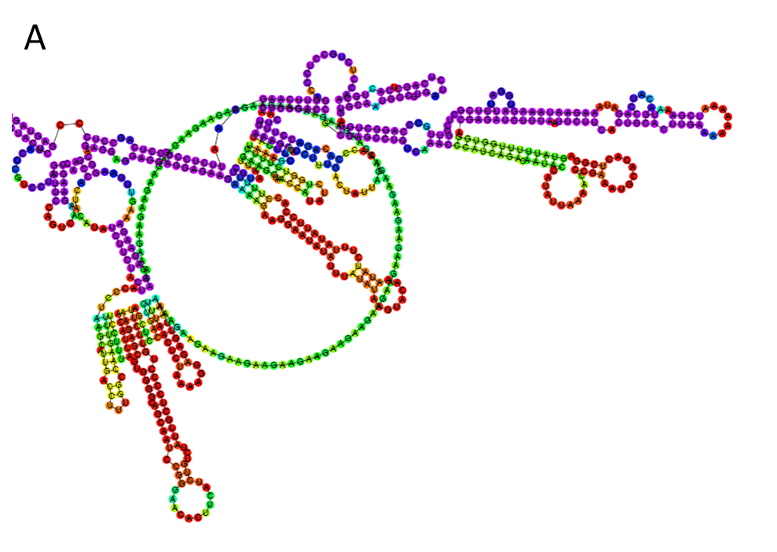
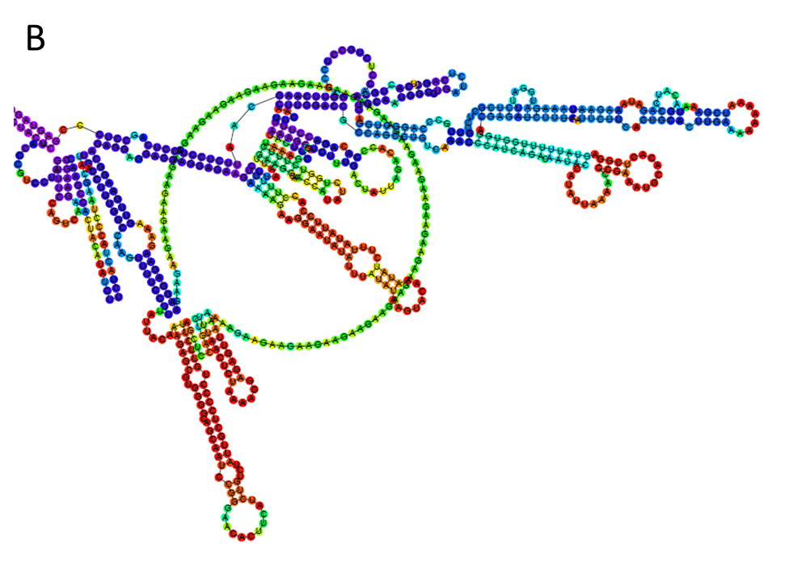
Supplementary Figure 2. In silico analyses predicting of folding structures induced by the rs114020893 T>C change in NEXN-AS1. (A) Corresponding to rs114020893T allele and (B) Corresponding to rs114020893C allele.

15,900 lncRNAs from GENCODE (release 22)
690,564 SNPs
(MAF > 0.05)
Meta-analysis
using six TRICL GWASs
SNPs located at 15,531 autosomal lncRNAs with minor allele frequency (MAF)> 0.05
59 SNPs
(P< 1.00⁻⁷)
12,160 cases and 16,838 controls Additive genetic model
5 SNPs in chromosome 15 (reported)
53 SNPs in chromosome 6 (reported)
1 SNP in chromosome 1
Additional GWAS datasets of Harvard (984 cases and 970 controls) and deCODE (4009 cases and 221529 controls)
Focus on rs114020893 in lncRNANEXN-AS1 (Chr 1)
rs114020893 at 1p31.1as a new lung cancer risk-related locus

Supplementary Figure 3. Flow-chart of SNP selection among the lncRNA genes

