Electronic Supplementary Material

Comprehensive Structure-selective Characterization of Dissolved Organic Matter by Reducing Molecular Complexity and Increasing Analytical Dimensions

Yan Li§, Mourad Harir§,‡, Marianna Lucio§, Michael Gonsior┴, Boris Koch†,∆, Philippe Schmitt-Kopplin§,‡, Norbert Hertkorn§,*

§ Helmholtz Zentrum München, German Research Center for Environmental Health, Research Unit Analytical Biogeochemistry (BGC), Ingolstaedter Landstrasse 1, 85764 Neuherberg, Germany
‡ Chair of Analytical Food Chemistry, Technische Universität München, 85354 Freising, Germany
┴ University of Maryland Center for Environmental Science, Chesapeake Biological Laboratory, Salomons, MD 20688, USA
† Alfred Wegener Institute for Polar und Marine Research, Ecological Chemistry, Am Handelshafen 12, 27570 Bremerhaven, Germany
∆ Hochschule Bremerhaven, University of Applied Sciences, An der Karlstadt 8, 27568 Bremerhaven; Germany
* Corresponding author contact: Phone: +49-89-3187-2834. Fax: +49-89-3187-2705.
E-mail: hertkorn@helmholtz-muenchen.de

Number of figures: 3
Number of pages: 4
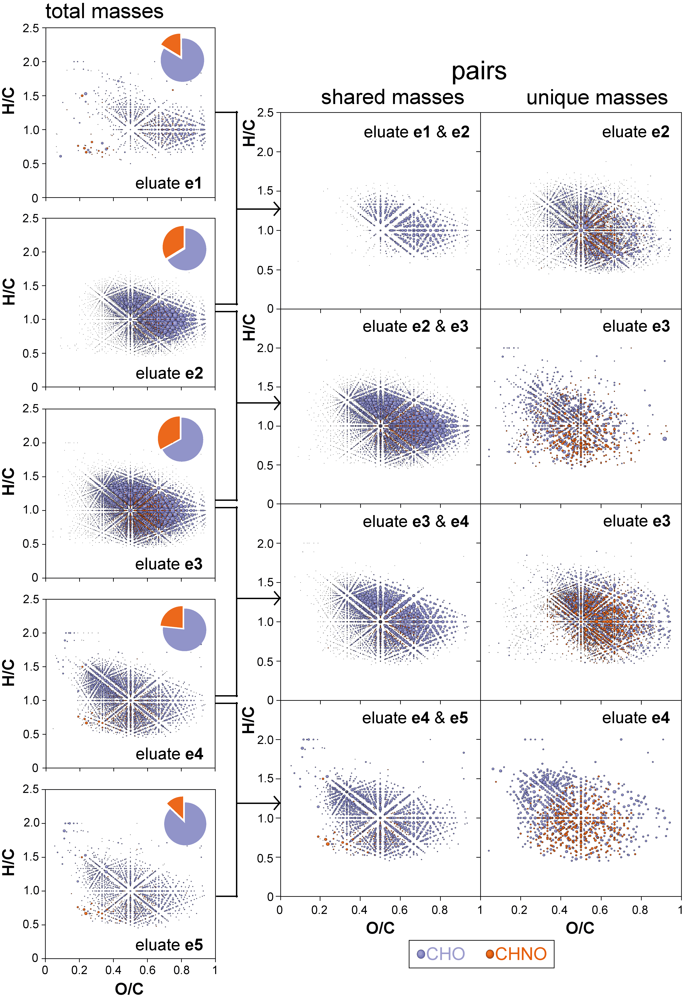
Fig. S1. Comparative analysis of negative electrospray (ESI) FTICR mass spectra; van Krevelen diagrams of the eluates. Left panels: compounds present in each eluates e1-e5; center panels: shared masses (molecular compositions) between adjacent eluates; right panels: unique masses present in disctinctive eluates with respect to adjacent eluates (upstream and downstream) as provided. The bubble area corresponded to the mass peak intensities observed in FTICR mass spectra; color code, blue: CHO molecular series; orange: CHNO molecular series.
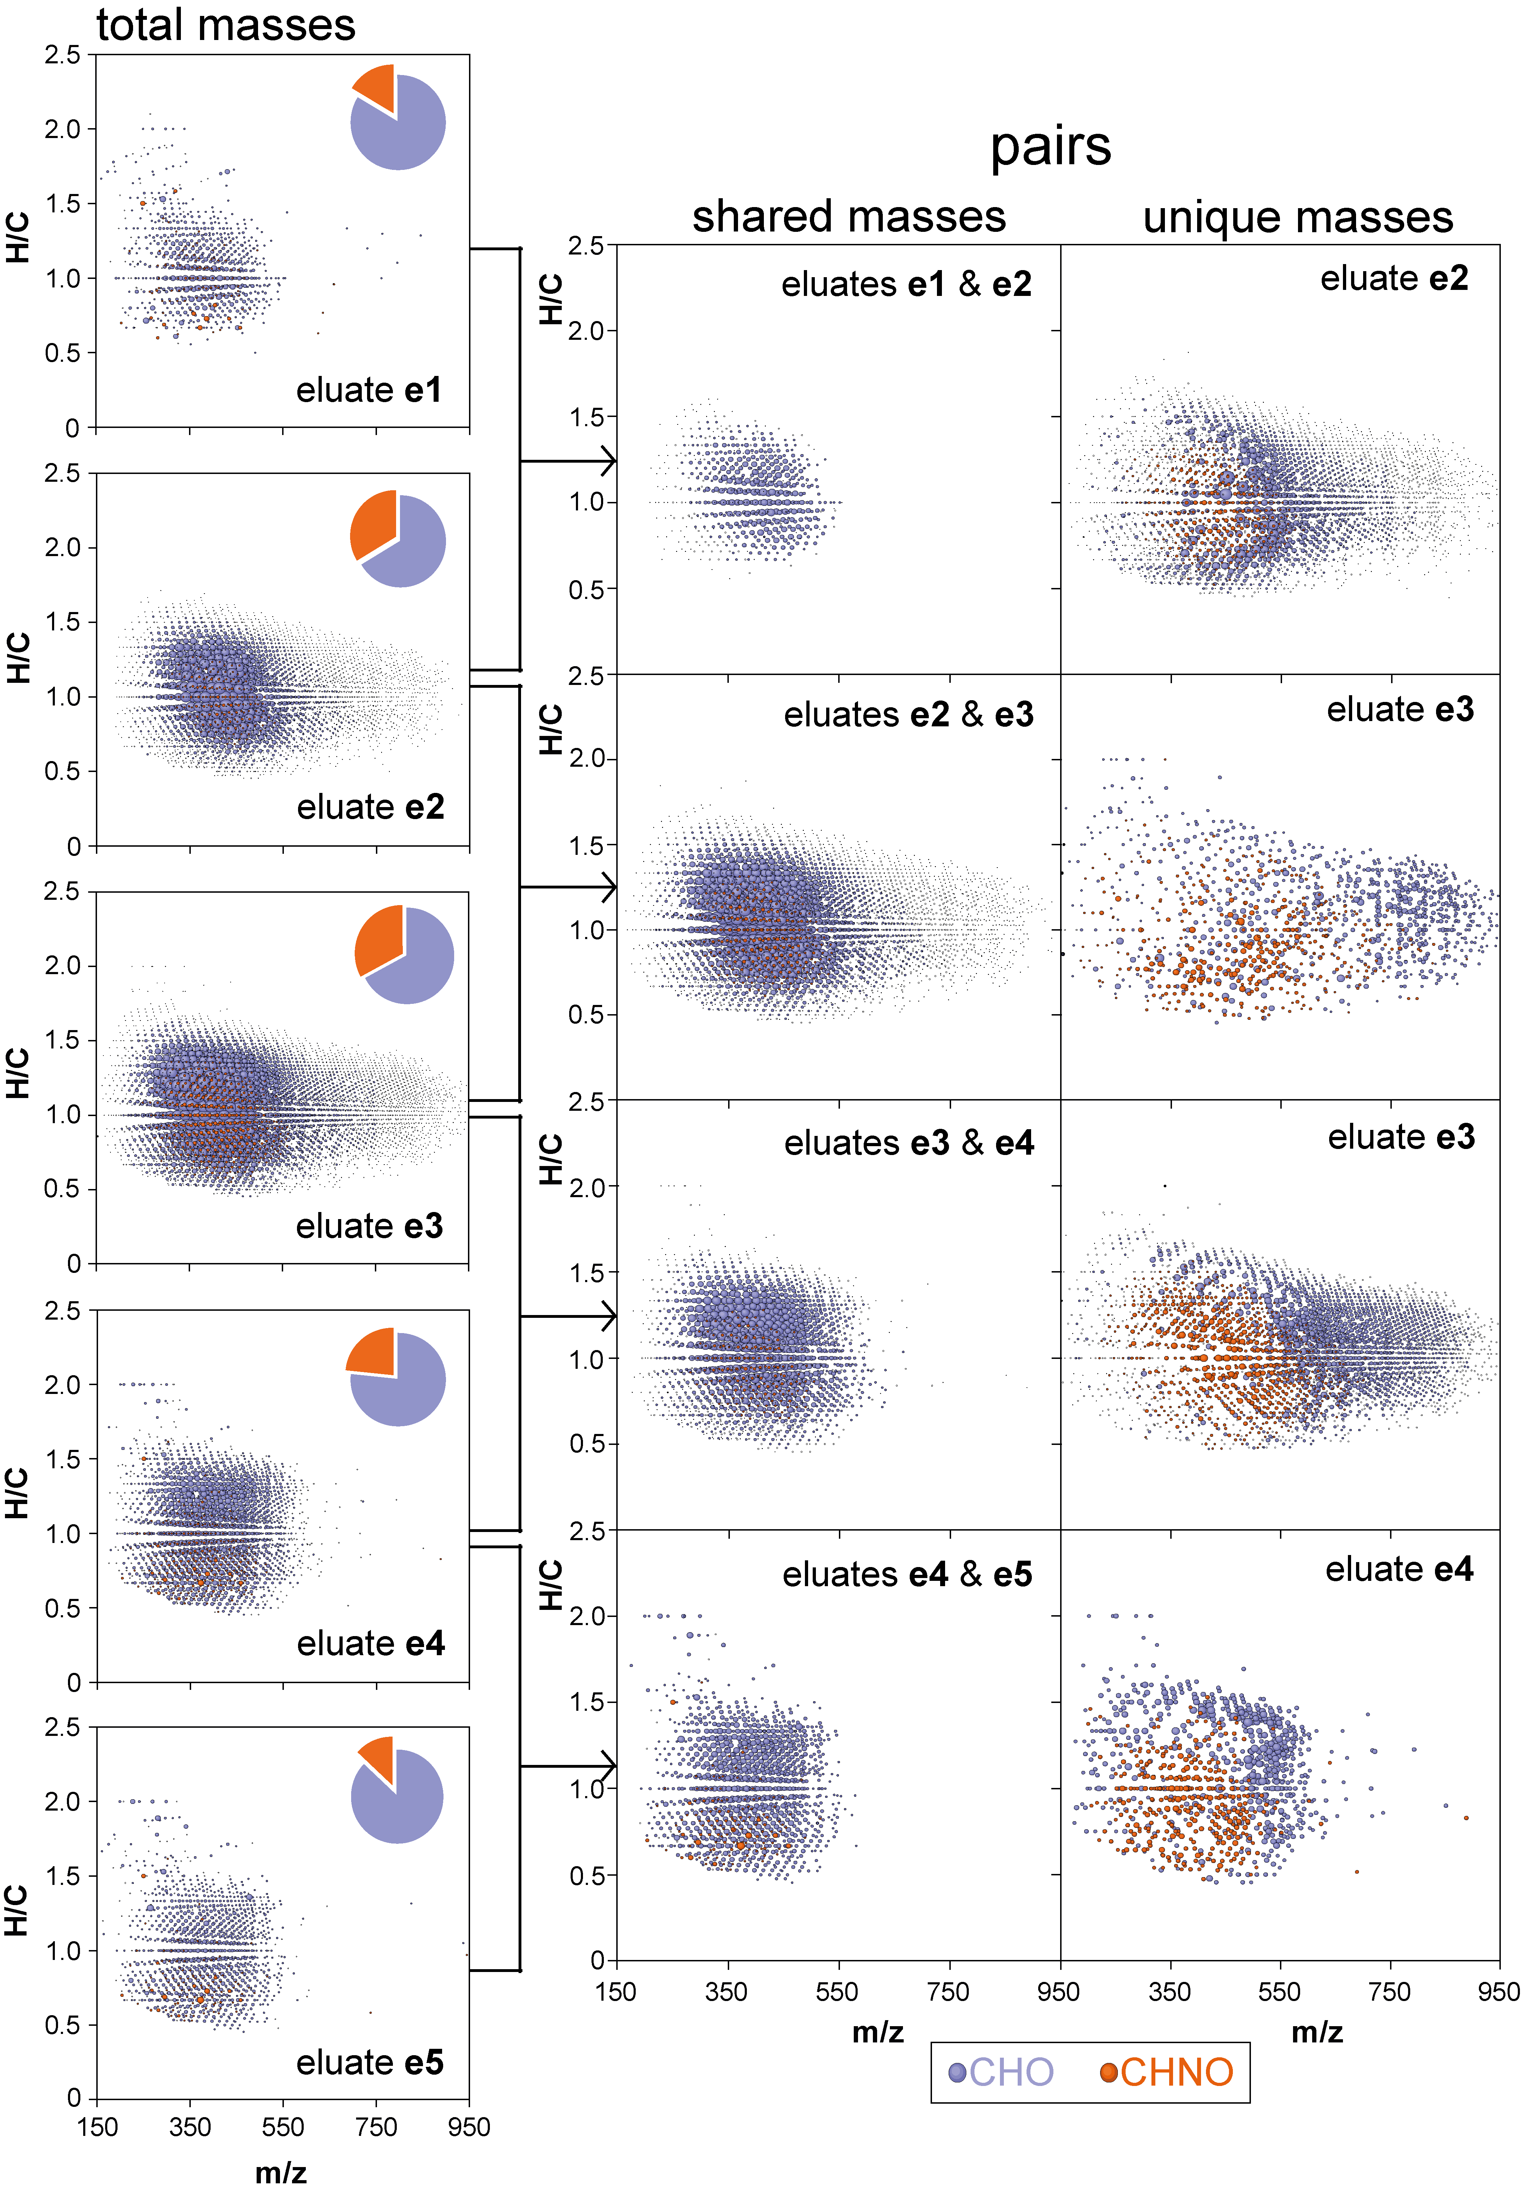
Fig. S2. Comparative analysis of negative electrospray (ESI) FTICR mass spectra; mass-edited H/C ratios of the eluates. Left panels: compounds present in each eluates e1 – e5; center panels: shared masses (molecular compositions) between adjacent eluates; right panels: unique masses present in disctinctive eluates with respect to adjacent eluates (upstream and downstream) as provided. The bubble area corresponded to the mass peak intensities observed in FTICR mass spectra; color code, blue: CHO molecular series; orange: CHNO molecular series.
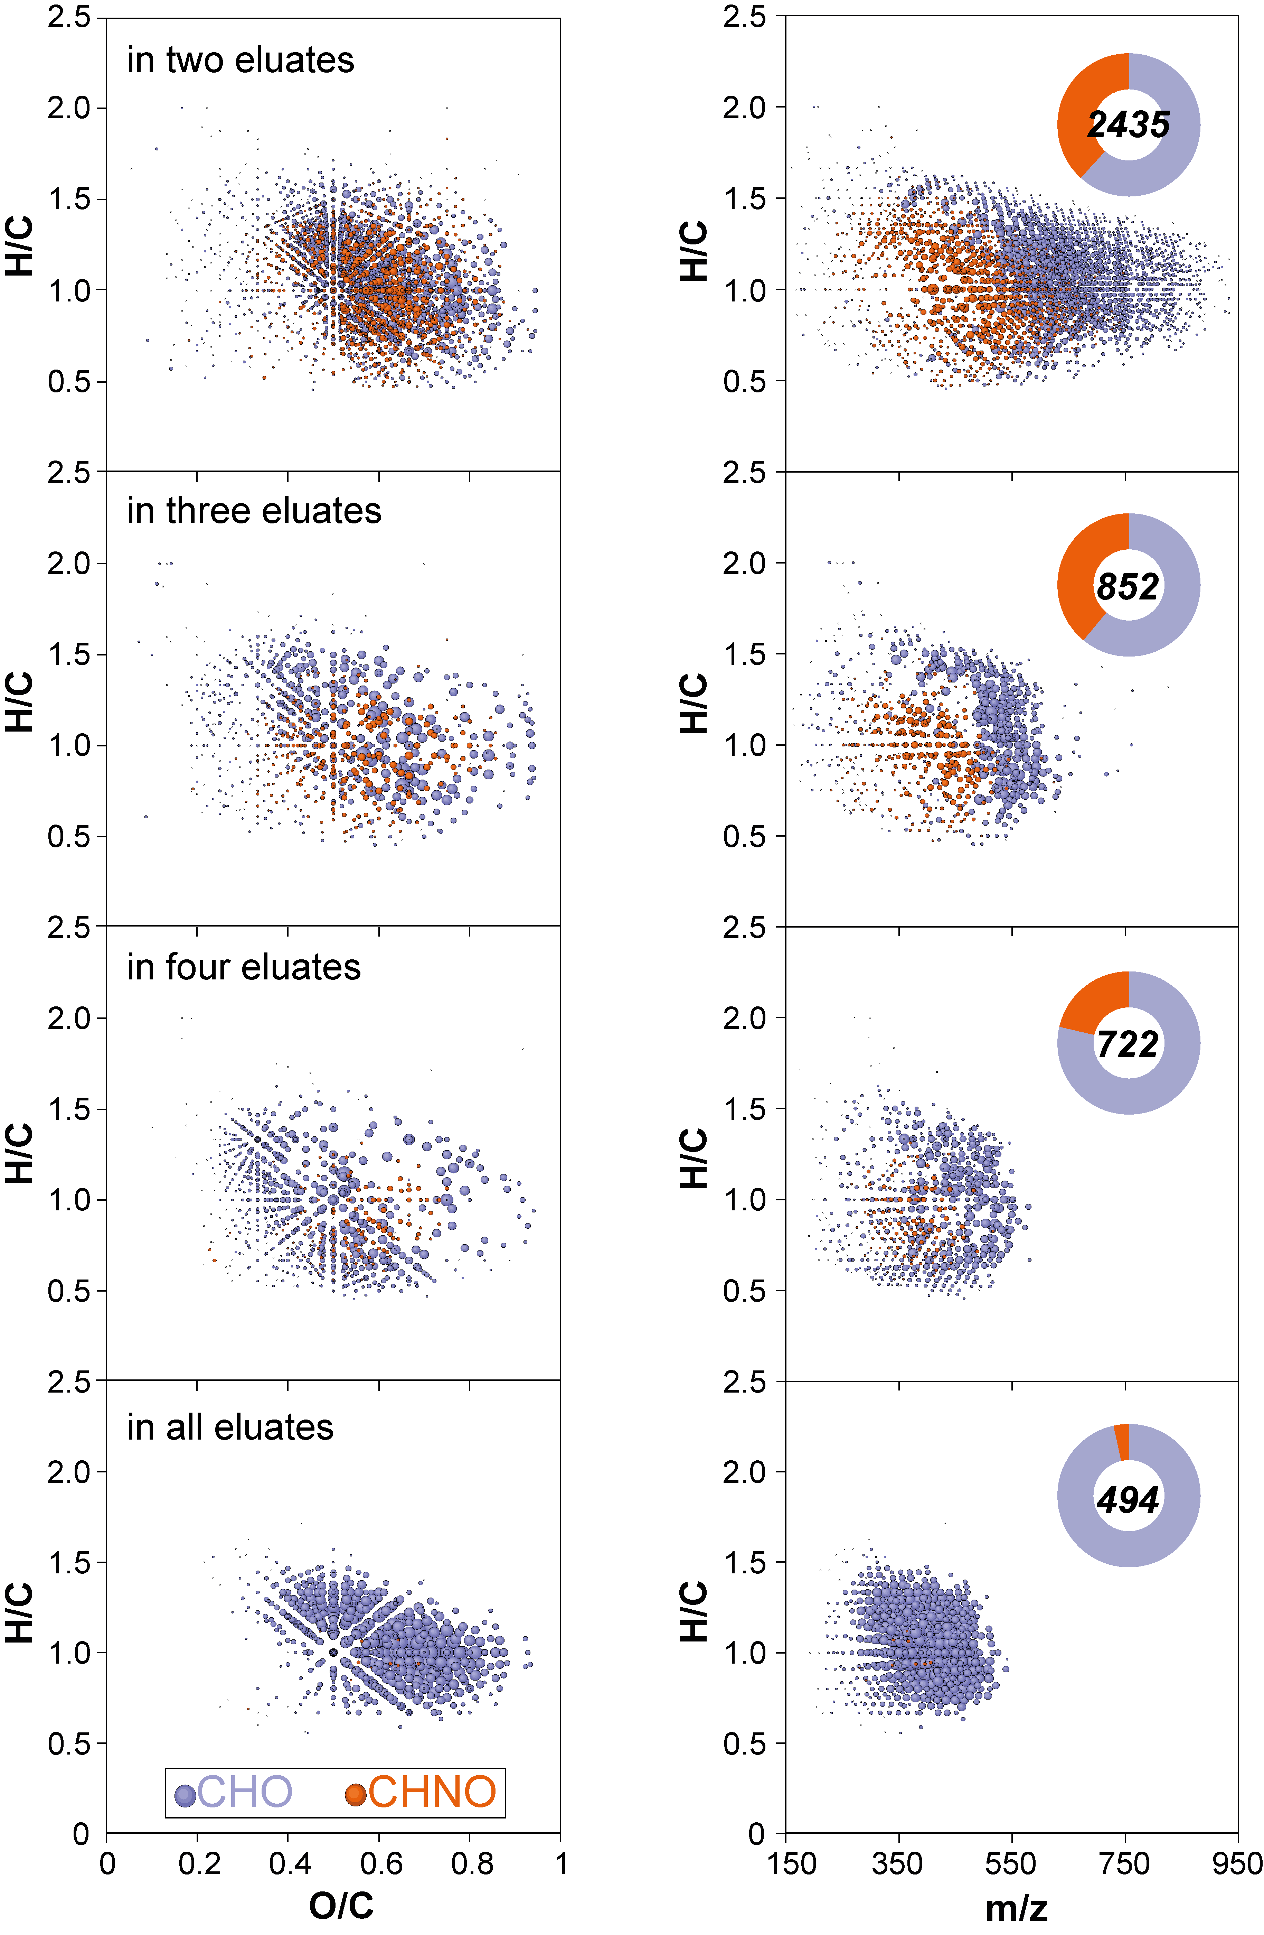
Fig. S3. Comparative analysis of negative electrospray (ESI) FTICR mass spectra; mass peaks (molecular compositions) common to respective number of eluates as provided; 1375 unique molecular compositions were found solely in one eluate. Left panels: H/C versus O/C van Krevelen diagrams; right panels: mass-edited H/C ratios. The bubble area corresponded to the mass peak intensities observed in FTICR mass spectra; color code, blue: CHO molecular series; orange: CHNO molecular series.

