Online supplement for manuscript:
Spatial variations and development of land use regression models of oxidative potential in ten European study areas

Aleksandra Jedynska , Gerard Hoek , Meng Wang , Aileen Yang , Marloes Eeftens, Josef Cyrys , Menno Keuken , Christophe Ampe , Rob Beelen , Giulia Cesaroni , Francesco Forastiere^{f}, Marta Cirach, , Kees de Hoogh, Audrey De Nazelle, Wenche Nystad, Helgah Makarem Akhlaghi, Christophe Declercq, Morgane Stempfelet, Kirsten T. Eriksen, Konstantina Dimakopoulou, Timo Lanki, Kees Meliefste, Mark Nieuwenhuijsen, Tarja Yli-Tuomi, Ole Raaschou-Nielsen, Nicole A.H. Janssen, Bert Brunekreef, Ingeborg M. Kooter

Measurement of EC/OC, PAH, hopanes, steranes, levoglucosan, PM2.5, NO_{x} and elemental composition

The analytical methods of EC/OC, PAH and hopanes/steranes were published previously (Jedynska, Hoek et al. 2014c). In summary, 1cm² of each quartz filter was used for EC/OC analyses, using a thermal-optical analyzer (Sunset Laboratory, Inc., Oregon, USA).
T60A20 filters were used for measurements of16 EPA PAH and 13 hopanes/steranes via gas chromatography in combination with mass spectrometric detection (GS/MS) in electron impact mode (GC/MS EI, Agilent 6890/5973N).
The analytical method for levoglucosan is described elsewhere (Jedynska, Hoek et al. 2014a). Levoglucosan was measured with gas chromatography in combination with mass spectrometric detection (Agilent 6890/5973N GC/MS).
PM2.5 mass and absorbance were determined on Andersen 37 mm 2 µm pore size Teflon filters (Eeftens, Tsai et al. 2012). Reflectance of all filters was measured in IRAS laboratory and transformed into absorbance. NO₂ was measured with Ogawa passive samplers (Cyrys, Eeftens et al. 2012).
PM2.5 Teflon filters were analyzed for elemental composition using energy dispersive X-ray fluorescence (XRF) at Cooper Environmental Services, Portland, OR, USA (de Hoogh, Wang et al. 2013).

Table S1. Predictor variables with predefined variable names, units, defined buffer sizes, transformations of the predictor variables and directions of effect.
GIS dataset | Predictor variable | Name variable¹ | Unit | Buffer size (radius in m)² | Direction of  effect | Central /  local data
Background variables
CORINE | Surface area of high density residential land | HDRES_X | m² | 100, 300, 500, 1000, 5000 | + | Central
CORINE | Surface area of low density residential land | LDRES_X | m² | 100, 300, 500, 1000, 5000 | + | Central
CORINE | Sum of high density and low density residential land | HLDRES_X | m² | 100, 300, 500, 1000, 5000 | + | Central
CORINE | Surface area of industry | INDUSTRY_X | m² | 100, 300, 500, 1000, 5000 | + | Central
CORINE | Surface area of port | PORT_X | m² | 100, 300, 500, 1000, 5000 | + | Central
CORINE | Surface area of urban green² | URBGREEN_X | m² | 100, 300, 500, 1000, 5000 | - | Central
CORINE | Surface area of semi-natural and forested areas³ | NATURAL_X | m² | 100, 300, 500, 1000, 5000 | - | Central
CORINE | Sum of Urban green and Semi-natural and forested areas | GREEN_X | m² | 100, 300, 500, 1000, 5000 | - | Central
Local land use | Similar to CORINE variables | Similar to CORINE variables | m² | 100, 300, 500, 1000, 5000 | As CORINE | Local
Local land use | Surface area / number of buildings | BUILDINGS_X | m² / N(umber) | 100, 300, 500, 1000, 5000 | + | Local
Local land use | Surface area of water | WATER_X | m² | 100, 300, 500, 1000, 5000 | - | Local
Population density | Number of inhabitants | POP_X | N(umber) | 100, 300, 500, 1000, 5000 | + | Central / Local
Household density | Number of households | HHOLD_X | N(umber) | 100, 300, 500, 1000, 5000 | + | Local
Altitude | Altitude | SQRALT | m | NA | - | Local
- | Regional estimate⁴ | REGIONALESTIMATE | NA | NA | NA | Local
- | Coordinate variables⁴ | XCOORD, YCOORD or other combinations | m | NA | NA | Local
Traffic variables
Central road network | Road length of all roads in a buffer | ROADLENGTH_X | m | 25, 50, 100, 300, 500, 1000 | + | Central
Central road network | Road length of major roads in a buffer⁵ | MAJORROADLENGTH_X | m | 25, 50, 100, 300, 500, 1000 | + | Central
Central road network | Inverse distance and inverse squared distance to the nearest road | DISTINVNEARC1  DISTINVNEARC2 | m⁻¹, m⁻² | NA | + | Central
Central road network | Inverse distance and inverse squared distance to the nearest major road⁵ | DISTINVMAJORC1  DISTINVMAJORC2 | m⁻¹, m⁻² | NA | + | Central
Local road network | Traffic intensity on nearest road | TRAFNEAR | Veh.day⁻¹ | NA | + | Local
Local road network | Inverse distance and inverse squared distance to the nearest road | DISTINVNEAR1  DISTINVNEAR2 | m⁻¹, m⁻² | NA | + | Local
Local road network | Product of traffic intensity on nearest road ( TRAFNEAR) and inverse distance to nearest road ( DISTINVNEAR1) and distance squared ( DISTINVNEAR2) | INTINVDIST  INTINVDIST2 | Veh.day⁻¹m⁻¹  Veh.day⁻¹m⁻² | NA | + | Local
Local road network | Traffic intensity on nearest major road⁶ | TRAFMAJOR | Veh.day⁻¹ | NA | + | Local
Local road network | Inverse distance and inverse squared distance to the nearest major road⁶ | DISTINVMAJOR1  DISTINVMAJOR2 | m⁻¹, m⁻² | NA | + | Local
Local road network | Product of traffic intensity on nearest major road (TRAFMAJOR) and inverse of distance to the nearest major road (DISTINVMAJOR1) and distance squared (DISTINVMAJOR2)⁶ | INTMAJORINVDIST  INTMAJORINVDIST2 | Veh.day⁻¹m⁻¹  Veh.day⁻¹m⁻² | NA | + | Local
Local road network | Total traffic load of major roads in a buffer (sum of (traffic intensity * length of all segments))⁶ | TRAFMAJORLOAD_X | Veh.day⁻¹m | 25, 50, 100, 300, 500, 1000 | + | Local
Local road network | Total traffic load of all roads in a buffer (sum of (traffic intensity * length of all segments)) | TRAFLOAD_X | Veh.day⁻¹m | 25, 50, 100, 300, 500, 1000 | + | Local
Local road network | Heavy-duty traffic intensity on nearest road | HEAVYTRAFNEAR* | Veh.day⁻¹ | NA | + | Local
Local road network | Product of heavy-duty traffic intensity on nearest road (HEAVYINT) and inverse of distance to the nearest road (INVDIST) and distance squared (INVDIST2) | HEAVYINTINVDIST  HEAVYINTINVDIST2 | Veh.day⁻¹m⁻¹  Veh.day⁻¹m⁻² | NA | + | Local
Local road network | Heavy-duty traffic intensity on nearest major road⁶ | HEAVYTRAFMAJOR | Veh.day⁻¹ | NA | + | Local
Local road network | Total heavy-duty traffic load of major roads in a buffer (sum of (heavy-duty traffic intensity * length of all segments))⁶ | HEAVYTRAFMAJORLOAD_X | Veh.day⁻¹m | 25, 50, 100, 300, 500, 1000 | + | Local
Local road network | Total heavy-duty traffic load of all roads in a buffer (sum of (heavy-duty traffic intensity * length of all segments)) | HEAVYTRAFLOAD_X | Veh.day⁻¹m | 25, 50, 100, 300, 500, 1000 | + | Local

¹ X denotes the size of the buffer
² Buffer size is the radius of circle around the sampling site

Table S2: Pearson correlation (r) between unadjusted and ratio-adjusted concentrations of oxidative potential
Study area | DTT
Oslo | 0.83
Helsinki/Turku | 0.95
Copenhagen | 0.86
London/Oxford | 0.65
Netherlands | 0.88
Munich/Augsburg | 0.92
Paris | 0.90
Rome | 0.93
Catalonia | 0.82
Athens | 0.98

a)

b)

Figure S 1 Comparison between OP DTT measurement on quartz filters (this study) and Teflon filters (Yang, 2015). a) Unadjusted average OP, b) Adjusted average OP

Figure S2. Comparison of DTT results between two laboratories: TNO and RIVM (TNO REPORTI TNO-060-UTP-2013-00038).

Table S3. Spearman correlations between DTT and other pollutants

A)
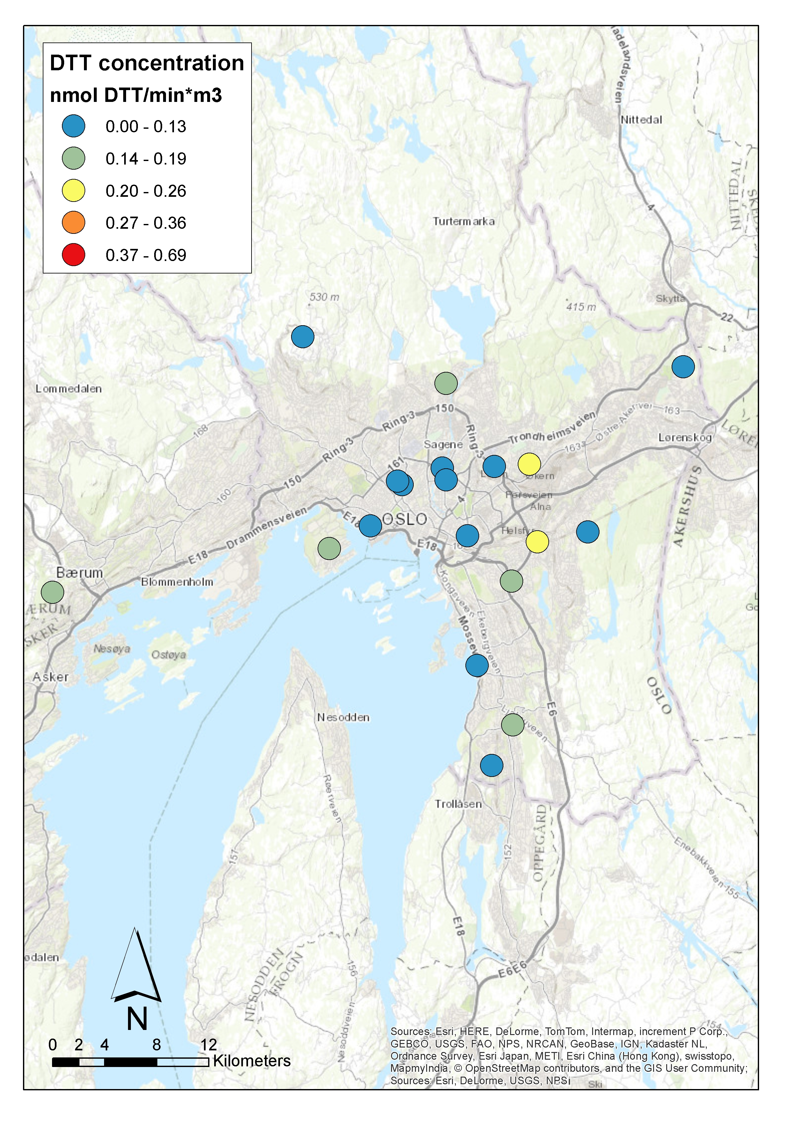
B)
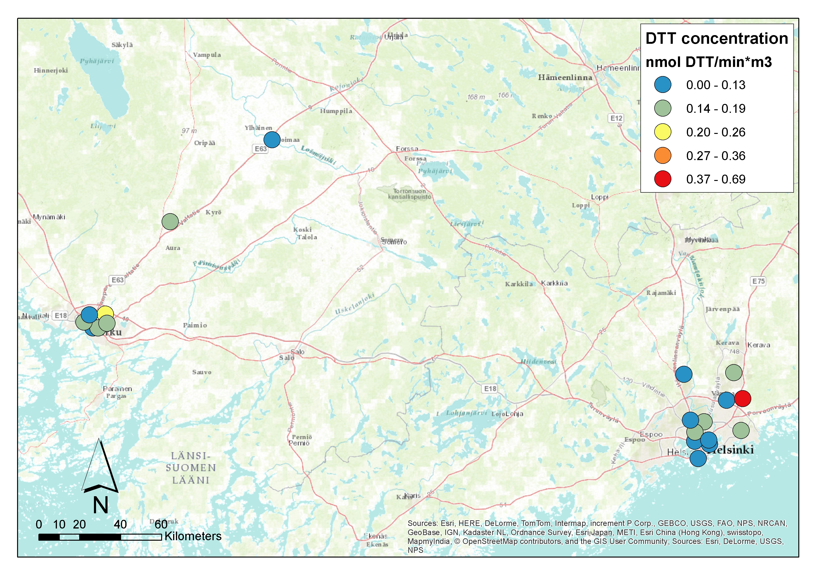
C)
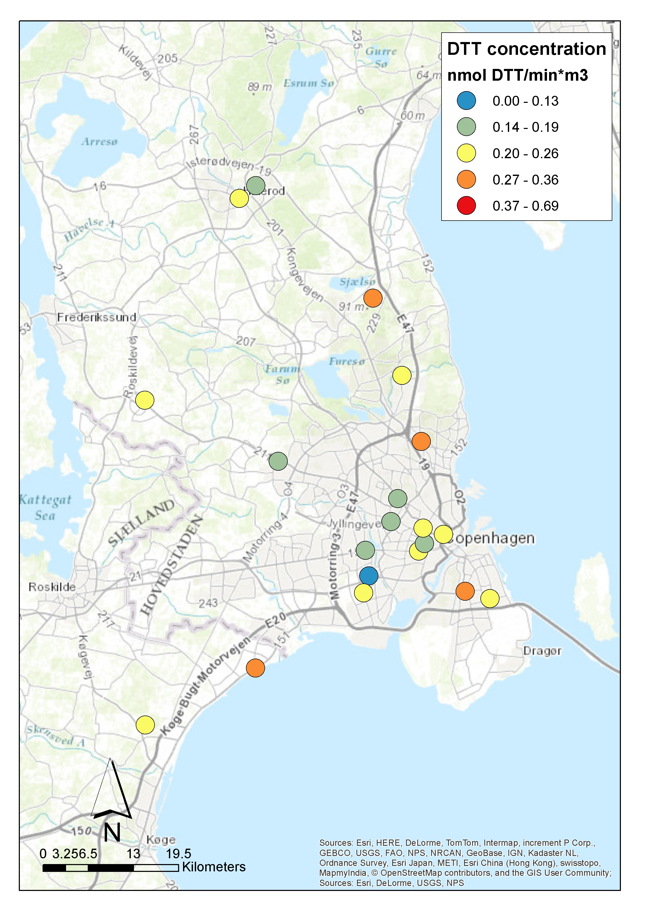
D)
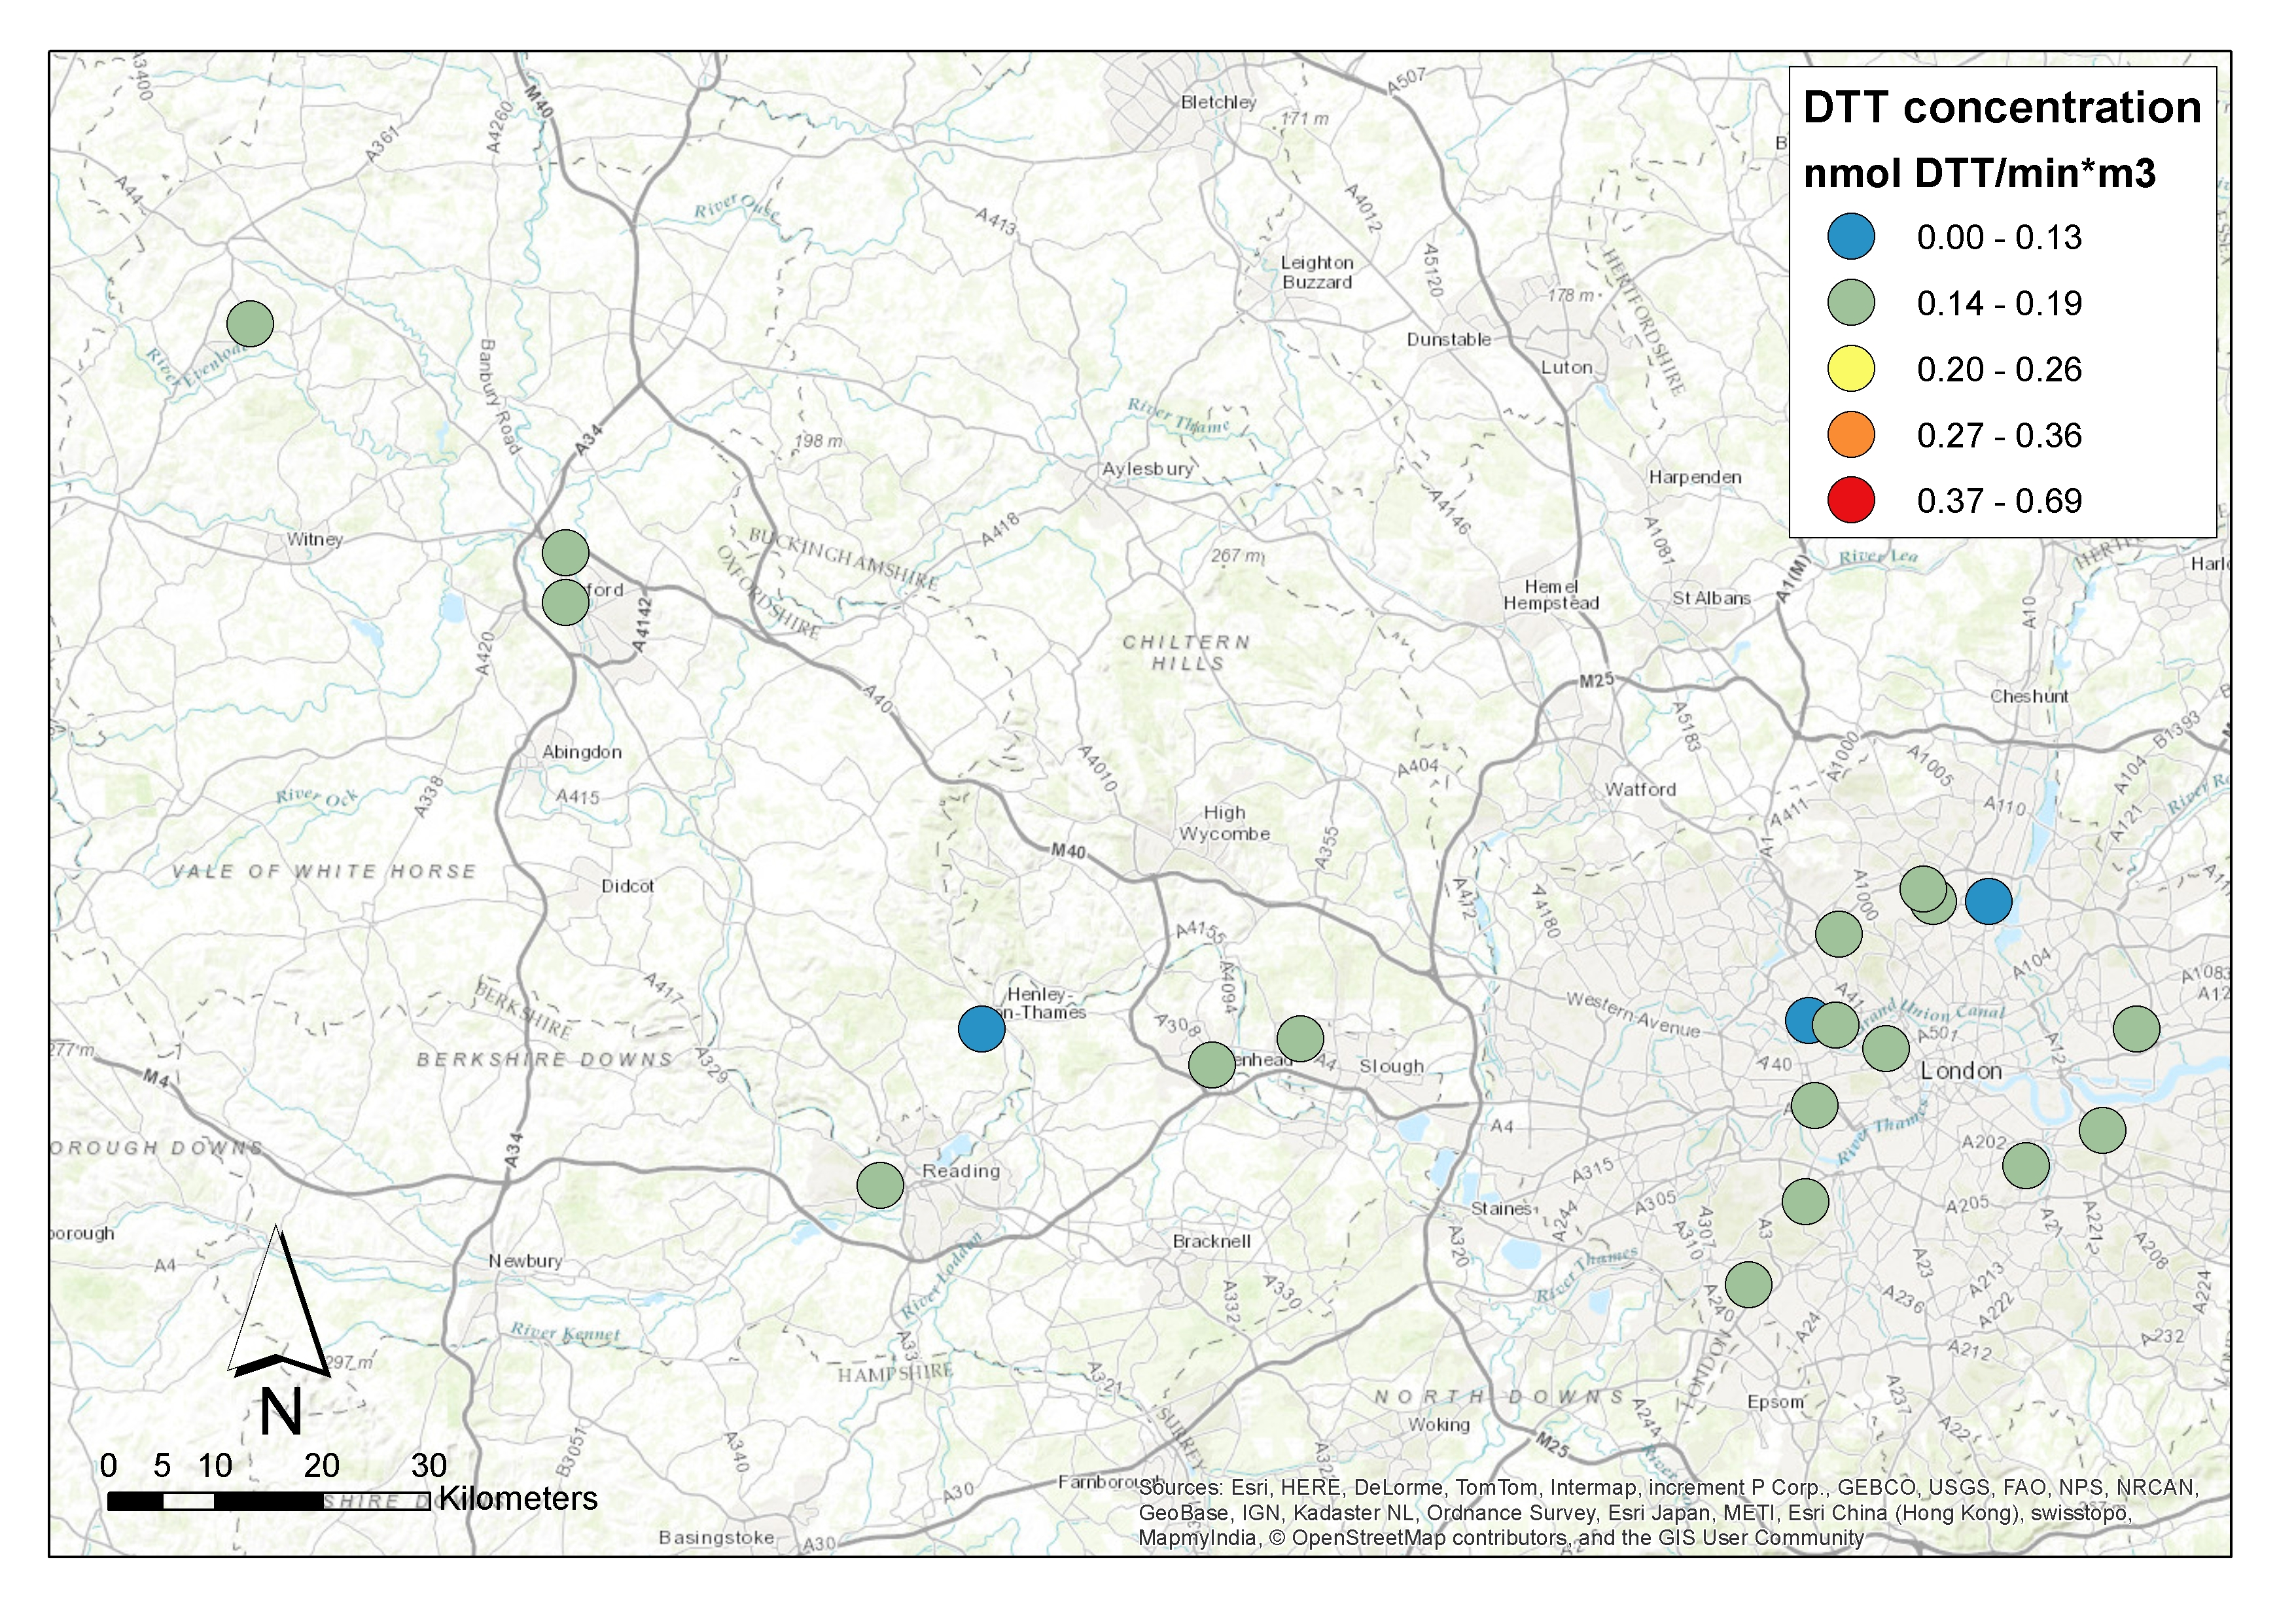
E)
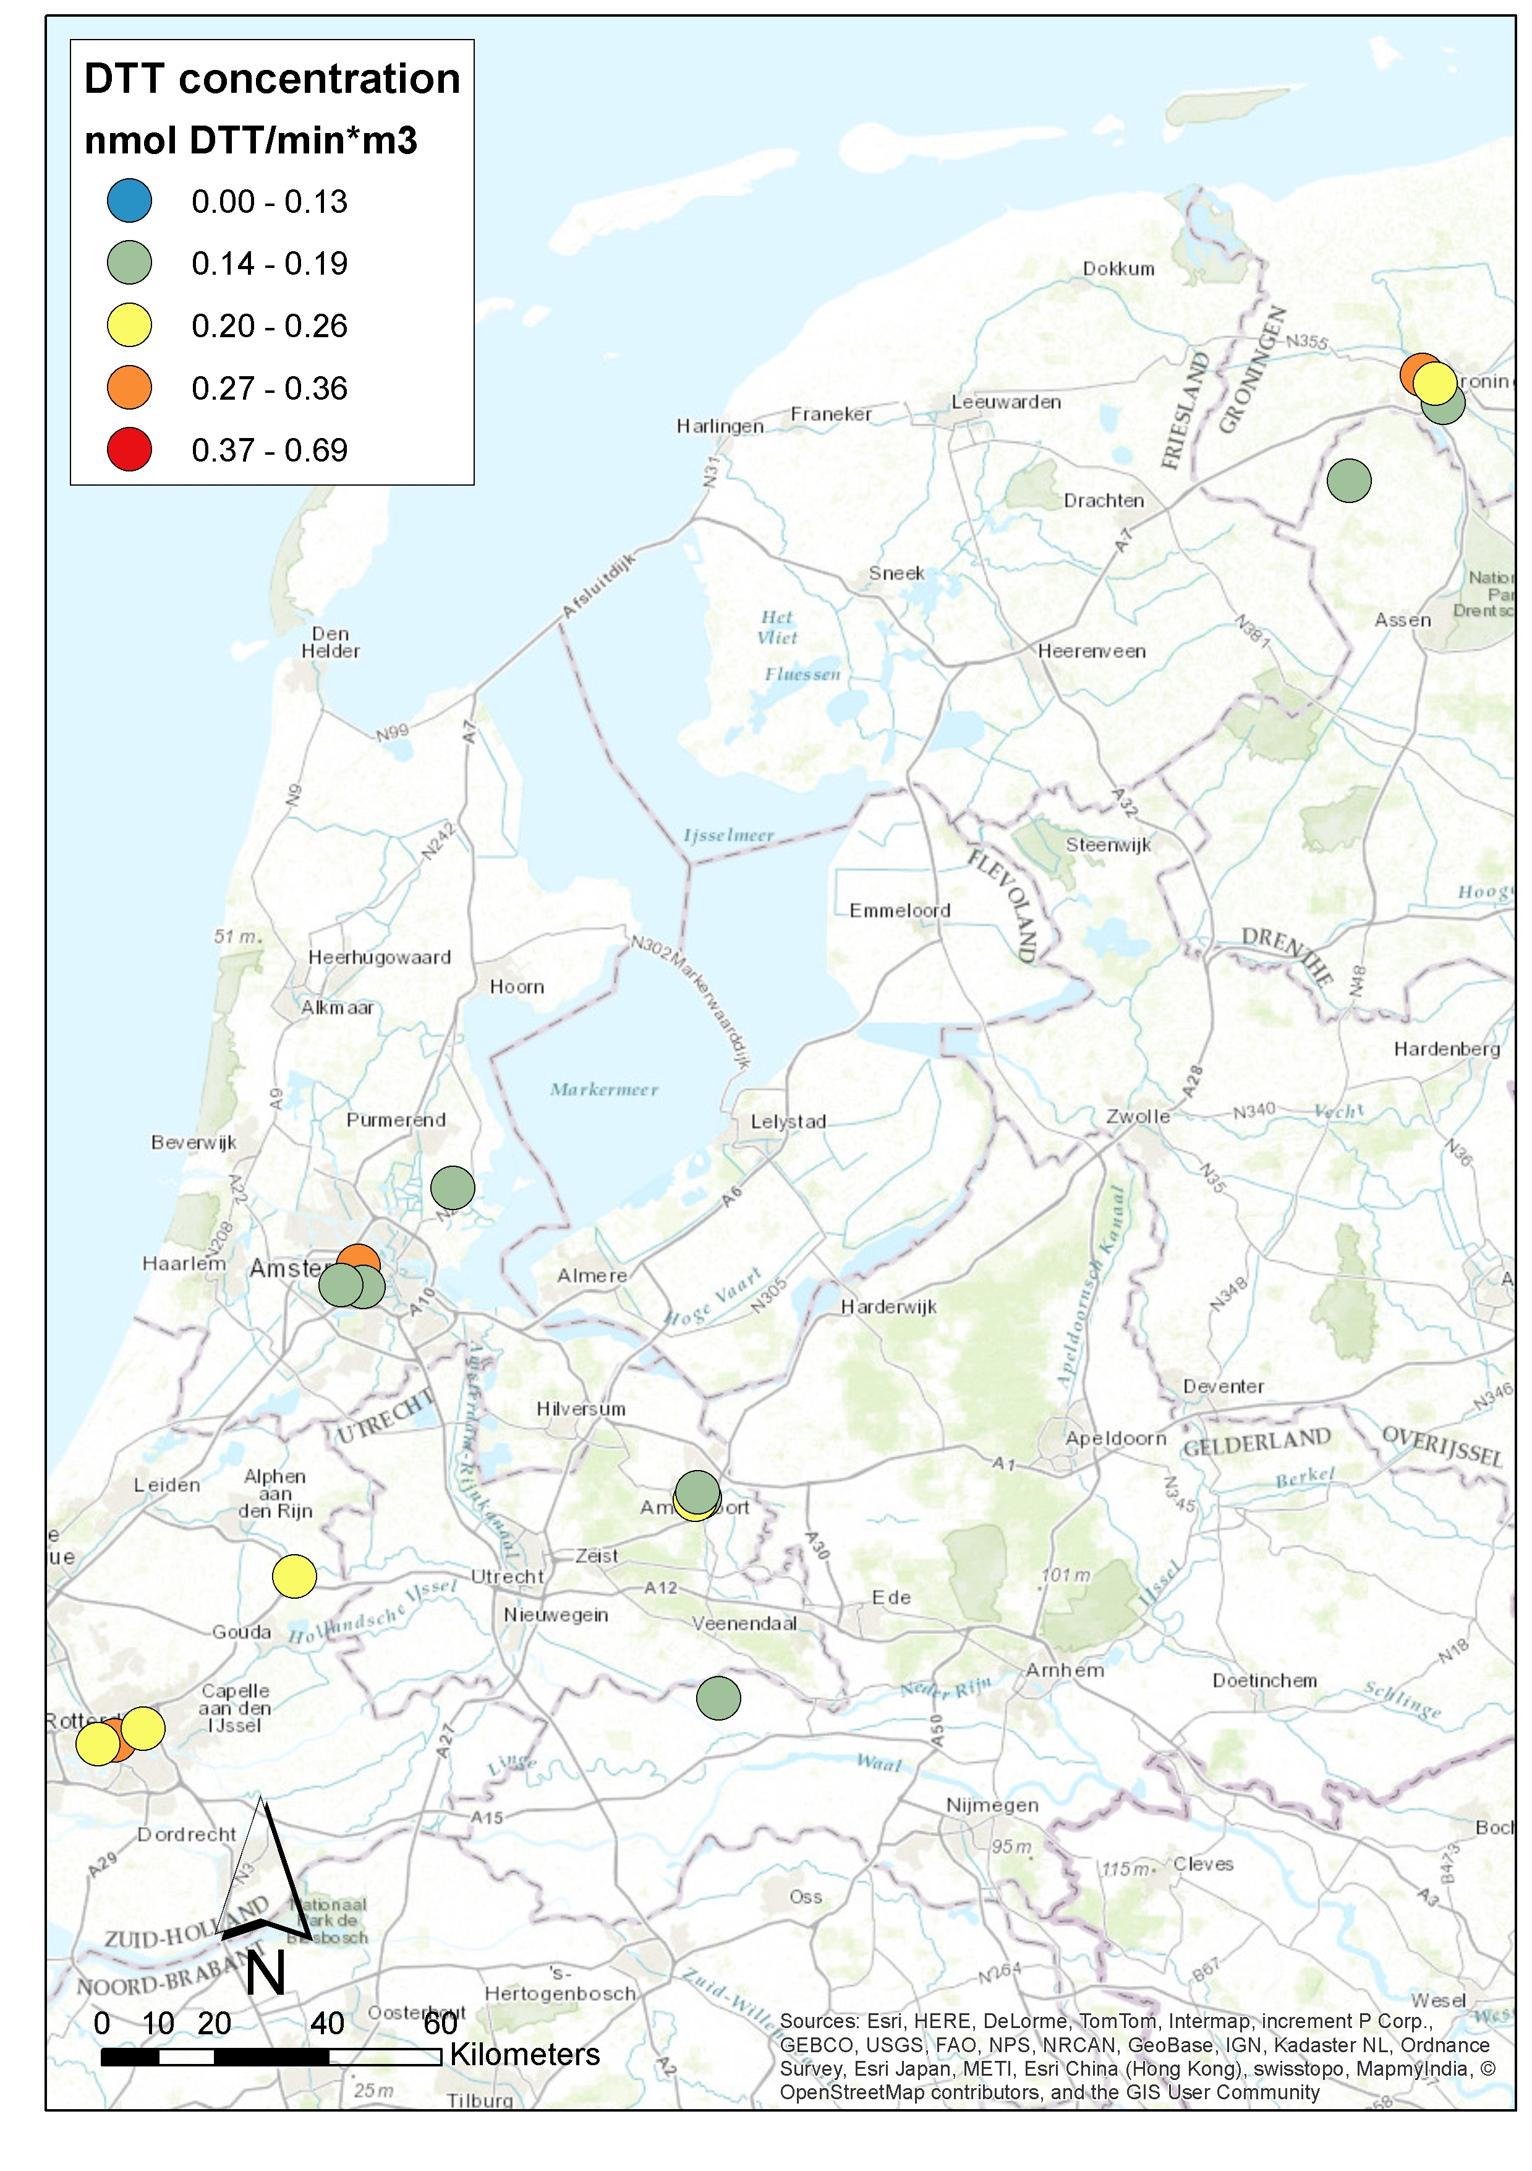
F)
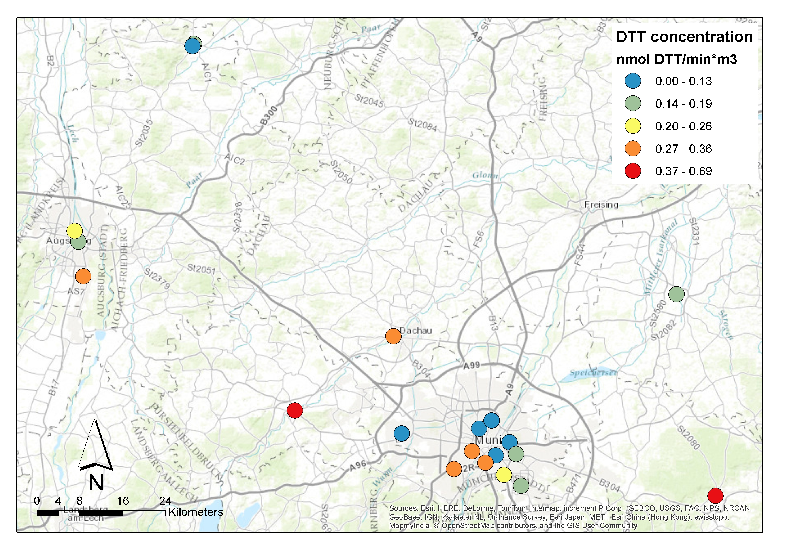
G)
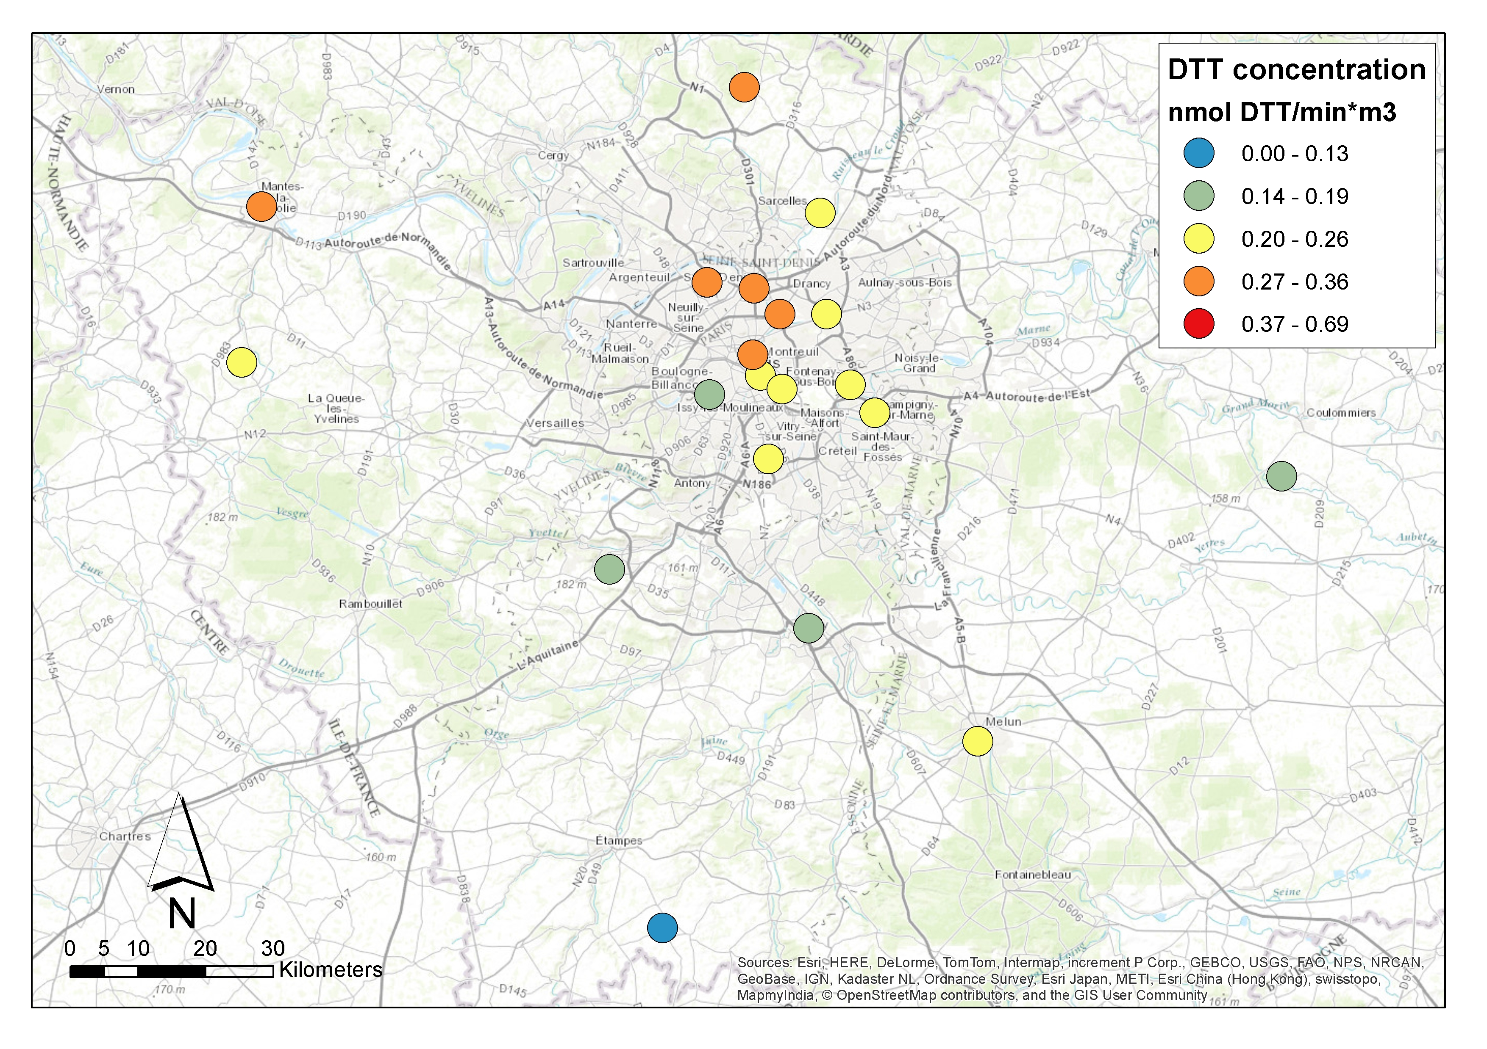
H)
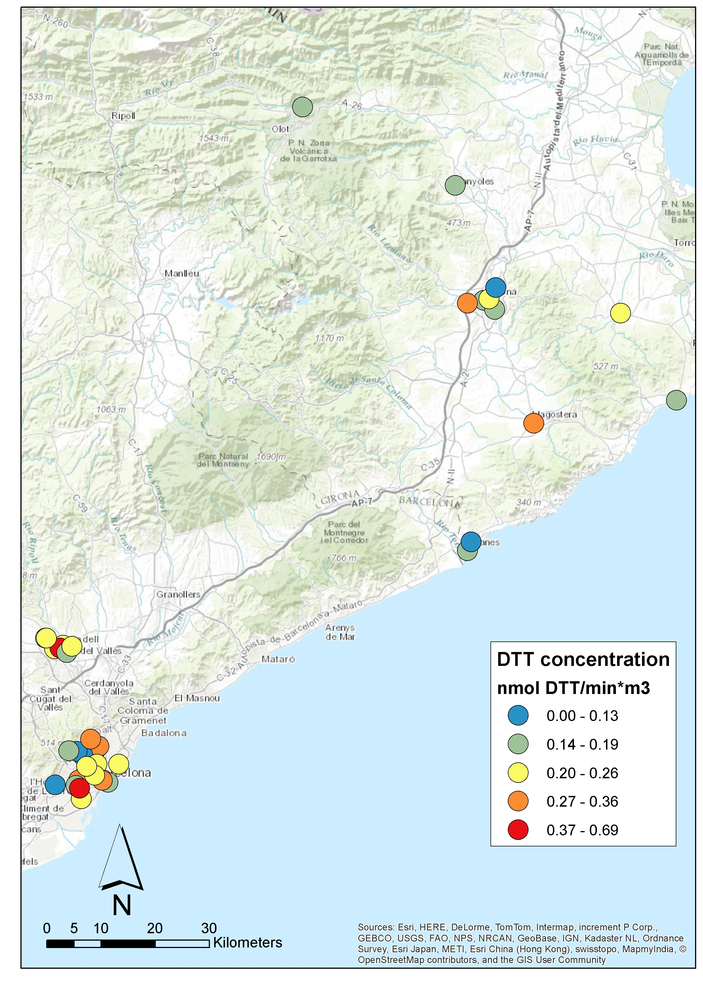
I)
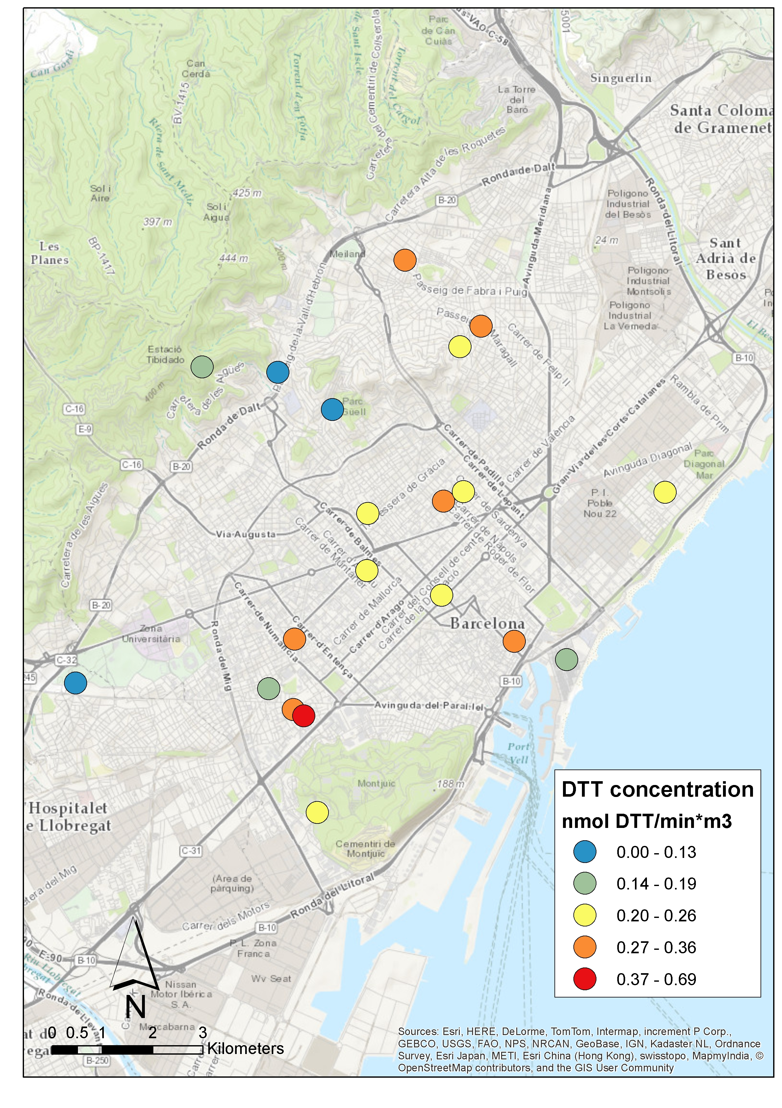
J)

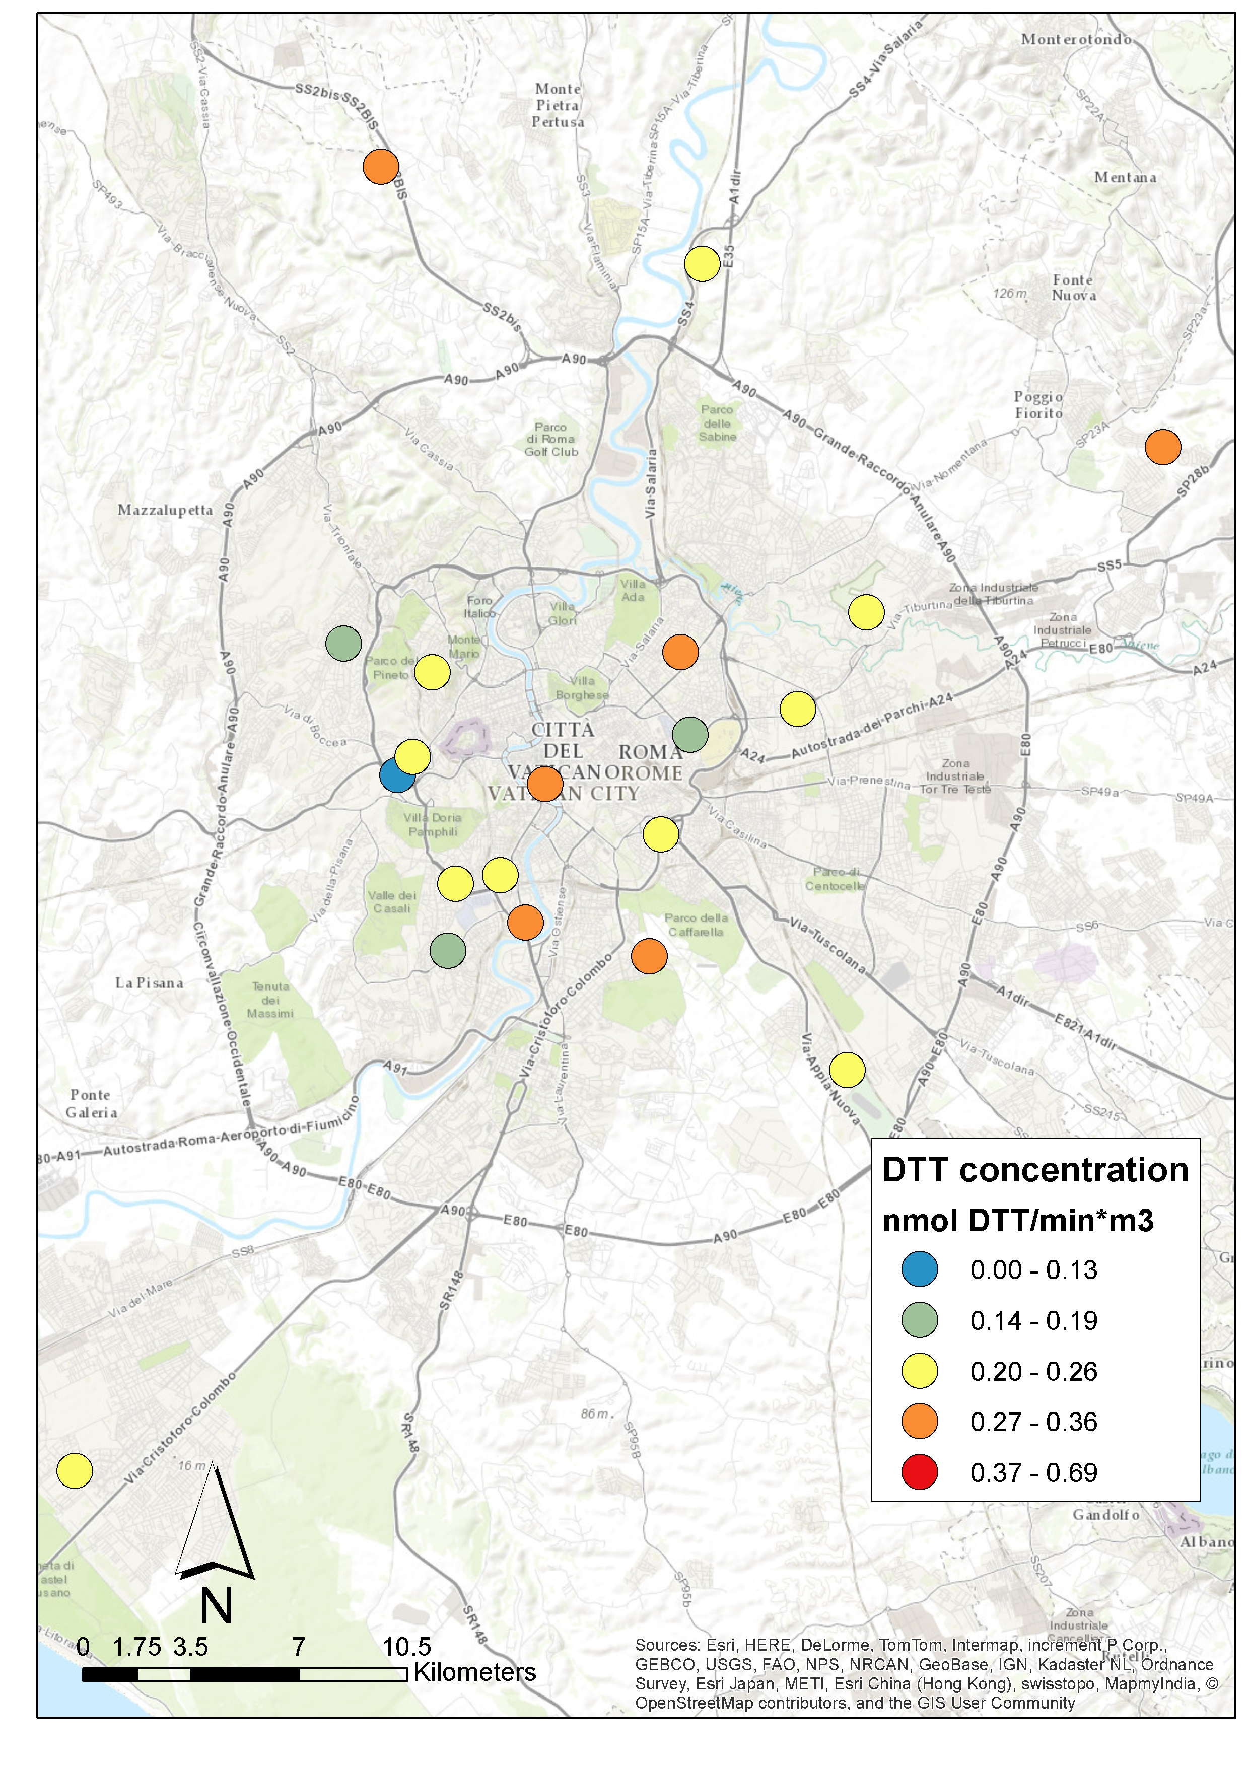
K)
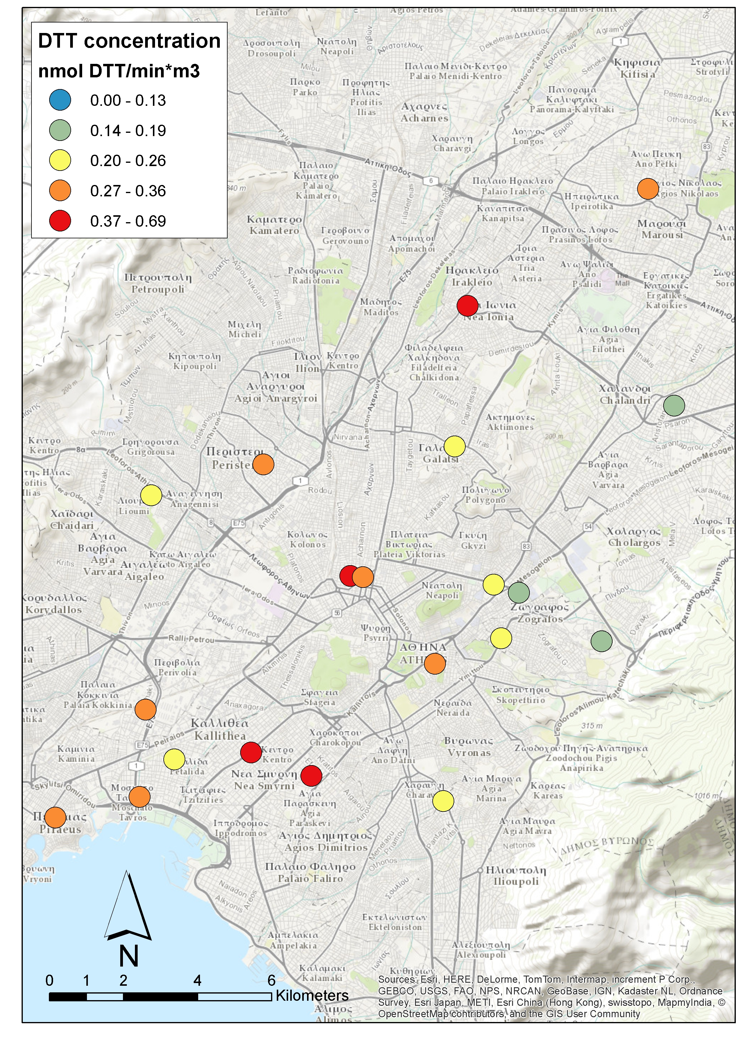

Figures S4. Maps of OP in the study areas. A) Oslo, B) Helsinki/Turku, C) Copenhagen, D) London/Oxford, E) Netherlands, F) Munich/Augsburg, G) Paris, H) Catalonia, I) Barcelona, J) Rome, K) Athens

Table S4 Spatial autocorrelation in the 10 study areas

Study area | Moran’s I | p- value of Moran’s I
Oslo | -0.04 | 0.90
Helsinki/Turku | -0.02 | 0.77
Copenhagen | -0.04 | 0.87
London/Oxford | -0.16 | 0.30
Netherlands | 0.00 | 0.79
Munich/Augsburg | 0.10 | 0.34
Paris | 0.01 | 0.26
Catalonia | 0.17 | 0.06
Rome | -0.07 | 0.87
Athens | 0.02 | 0.40

Table S5. Difference of OP DTT annual levels annual between cold and warm periods

Study area | DTT
Study area | Cold/Warm
Oslo | 2.60**
Helsinki/Turku | 0.88
Copenhagen | 1.88**
London/Oxford | 1.43**
Netherlands | 1.50*
Munich/Augsburg | 1.85**
Paris | 1.52**
Rome | 2.01**
Catalonia | 1.35*
Athens | 1.45**
Median | 1.51

