Vaccinations in early life are not associated with development of islet autoimmunity in type 1 diabetes high-risk children: Results from prospective cohort data

Andreas Beyerlein, PhD*, Andreas N. Strobl, PhD*, Christiane Winkler, PhD, Michaela Carpus, Annette Knopff, Ewan Donnachie, MSc, Donna P. Ankerst, PhD, Anette-G. Ziegler, MD

* shared first authorship

From the Institute for Diabetes Research, Helmholtz Zentrum München, Munich, Germany [AB, CW, MC, AK, A-GZ], Forschergruppe Diabetes der Technischen Universität München, Munich, Germany [AB, CW, MC, AK, A-GZ], Department of Mathematics of the Technische Universität München, Munich, Germany [ANS, DPA], Kassenärztliche Vereinigung Bayerns (Bavarian Association of Statutory Health Insurance Physicians), Munich, Germany [ED], and Department of Epidemiology and Biostatistics, University of Texas Health Science Center at San Antonio, San Antonio, TX, USA [DPA]

Corresponding author:
Prof. Dr. Anette-G. Ziegler, MD
Institute of Diabetes Research
Helmholtz Zentrum München
Heidemannstraße 1
80939 Munich, Germany
Phone +49(0)89 3187-2836
Fax +49(0)89 3081-733
E-mail: anette-g.ziegler@helmholtz-muenchen.de

Running title: Vaccinations and autoimmunity
Key words: islet autoimmunity, type 1 diabetes, vaccinations
Number of tables: 2
Number of figures: 4
Abstract
Aims/hypothesis: Vaccinations in early childhood potentially stimulate the immune system and may thus be relevant for the pathogenesis of autoimmune diseases such as type 1 diabetes (T1D). We determined the association of vaccination burden with T1D-associated islet autoimmunity in children with high familial risk followed prospectively from birth.
Methods: A total of 20,570 certified vaccination records from 1,918 children were correlated with time to onset of T1D-associated islet autoimmunity using Cox regression, considering multiple time periods up until age two years and vaccination types, and adjusting for HLA genotype, sex, delivery mode, season of birth, preterm delivery and maternal T1D status. Additionally, prospective claims data of 295,420 subjects were used to validate associations for the tick-borne encephalitis (TBE) vaccination.
Results: Most vaccinations were not associated with a significantly increased hazard ratio (HR) for islet autoimmunity (e.g. HR [95% confidence interval]: 1.08 [0.96-1.21] per additional vaccination against measles, mumps and rubella at age 0-24 months). Only TBE vaccinations within the first two years of life were nominally associated with a significantly increased autoimmunity risk (HR: 1.44 [1.06-1.96] per additional vaccination at age 0-24 months), which could not be confirmed with respect to outcome T1D in the validation cohort, however (HR: 1.02 [0.90-1.16]).
Conclusions: We found no evidence that early vaccinations increase the risk of T1D-associated islet autoimmunity development. The potential association with early TBE vaccinations appears likely to be due to a meanwhile withdrawn vaccine or a false positive finding and could not be confirmed in an independent cohort.
Introduction
Type 1 diabetes (T1D) is one of the most common chronic diseases in childhood, with worldwide increasing incidence . The disease is preceded by a preclinical period of islet autoimmunity, which most commonly develops in early infancy . Thus, factors that induce a strong immune response in early life might be relevant for the development of T1D-associated islet autoimmunity. We recently reported an association between the number of respiratory infections developed during the first year of life with increased risk of islet autoimmunity .
Vaccinations in early life are also of interest in this regard since they may reduce an individual’s islet autoimmunity risk by protecting against specific infections or on the contrary, increase it by inducing a deleterious stimulation of the still immature immune system. Previous studies on this topic have been inconclusive, and evidence from prospective studies is scarce. Vaccinations against haemophilus influenzae type B (HiB) have been found to be associated with increased T1D risk , and vaccinations against Bacille Calmette-Guerin (BCG) with accelerated disease progression , while measles vaccinations have been linked to reduced T1D risk . Other studies have failed to detect associations between specific vaccinations and T1D , including two prospective studies that have been limited by a small number of events . Studies with outcome islet autoimmunity are lacking, however.
In this study, we combined data from two large German prospective cohort studies of children at high risk for T1D with considerable follow-up to investigate the association of vaccinations with risk of islet autoimmunity development. As vaccinations were recorded together with their exact dates and certified, we were able to comprehensively examine associations between all facets of early childhood vaccination, including timing, type and cumulative vaccine load, with time to islet autoimmunity development, with a focus on vaccinations during the first two years of life.
Research Design and Methods
Study populations
Data from two ongoing German birth cohorts of healthy neonates with a familial increased risk of T1D, the BABYDIAB study and the BABYDIET natural follow-up study , were combined for association analyses of vaccination patterns and development of islet autoimmunity. Between 1989 and 2000, a total of 1650 offspring of patients with T1D were recruited for the BABYDIAB study and were followed for 23,856 patient years (median: 15.7 years). Between 2000 and 2006, 791 additional offspring or siblings of patients with T1D were screened in the context of the BABYDIET study and were followed by using the BABYDIAB protocol for 6,358 patient years (median: 8.7 years). Of those 150 participated in the BABYDIET dietary intervention study and were randomized to gluten exposure at 6 or 12 months of age; the intervention had no effect on either islet autoimmunity or T1D . The studies were approved by the ethical committee of Bavaria, Germany, and executed in accordance with the principles of the Declaration of Helsinki, including written informed consent by all participants.
Additionally, we analyzed data provided by the Kassenärztliche Vereinigung Bayerns (KVB, Bavarian Association of Statutory Health Insurance Physicians), which processes claims data for all statutorily insured patients in Bavaria, Germany (approximately 85% of the total Bavarian population). Just as in a previous analysis , 295,420 infants born between 2005 and 2007 were included and observed until March 2015 or last contact with a physician. Here, we used T1D as outcome variable, because the KVB data did not contain information about islet autoimmunity. Diagnosis of T1D, which was obtained using ICD-10 codes, and numbers of vaccinations against tick-borne encephalitis (TBE) were recorded in quarterly intervals.

Assessment of vaccinations and baseline risk factors
In Germany, every family is issued a vaccination passport or certificate shortly after their child’s birth, where dates and types of all subsequent vaccinations are recorded at their time of occurrence, and certified by the physician’s signature and stamp. As part of the BABYDIAB/BABYDIET studies, parents regularly provided a copy of their child’s vaccination certificate, typically at scheduled visits corresponding to blood draw. Missing information was requested by phone. Date and type of each vaccination record were entered into a database together with the date when the vaccination certificate was seen. The focus of the current analysis lies on common vaccines recommended by the German Standing Committee on Vaccination (STIKO), which includes diphtheria, hepatitis B, HiB, pertussis, poliomyelitis, tetanus, measles, mumps, rubella, meningococcal, pneumococcal, varicella, TBE and influenza. Several vaccinations were typically given as a 3-fold compound (MMR: measles, mumps, rubella) or a 5/6-fold compound (diphtheria, HiB, pertussis, poliomyelitis, tetanus, and since 2001 additionally hepatitis B).

Outcome variables
Islet autoantibodies were measured in venous blood samples from scheduled visits. Children in the BABYDIAB study had scheduled visits at birth, and at age 9 months, and at 2, 5, 8, 11, 14, 17 and 20 years of age, whereas children in the BABYDIET study had 3-monthly visits from birth until the age of 3 years, and yearly until the age of 12 years. Measurement of islet autoantibodies in these studies has been described elsewhere . Islet autoimmunity was defined as the development of persistent autoantibodies to one or more of the antigens insulin, GAD65, IA-2 or Zn-T8, with sample values above the 99th percentile of published population control children classified as positive. In case of single positive antibodies against insulin or GAD65, affinity and epitope reactivity was determined and children with low affinity antibodies (<10⁹ l/mol) were not classified as islet autoantibody positive as these isolated antibody signals are not T1D specific and not associated with increased T1D risk . Persistence was defined as positive in at least two consecutive samples. Islet autoantibody assays were evaluated according to the Diabetes Autoantibody Standardization Program .

Statistical analyses
Vaccination records were available for 1,954 of the 2,441 children recruited in both studies (80.0%; 1,256 from BABYDIAB). A further 36 observations were excluded because of missing information about the HLA-DR3/4 genotype or preterm delivery, yielding a final sample size of n=1,918. The 1,918 children accumulated a total of 20,570 vaccinations covering 61,784 vaccines with a median of 33 vaccines per child (range: 2-59). The last vaccination certificate was seen at a median age of 9.2 years, with 1,837 children (95.8%) having complete documentation of vaccinations during their first two years of life. The documentation of vaccinations in the first two years of life did not differ significantly between children who did or did not develop islet autoimmunity at some time during follow-up, i. e. children who developed autoimmunity did not have more complete vaccination records.
Cox’s proportional hazard model was used to compute hazard ratios (HRs) of time to islet autoimmunity and corresponding 95% confidence intervals (CIs) per additional vaccination in pre-defined time intervals. Additionally, we assessed associations with specific vaccinations in the last six months prior to islet autoimmunity, treating numbers of vaccinations as a time-varying predictor . Compound vaccinations were considered as separate vaccination events. All Cox models were adjusted for HLA-DR3/4 genotype, sex, delivery mode (Caesarean section/vaginal), season of birth (December-February, March-May, June-August, September-November), preterm delivery (< 37 weeks of gestation) and maternal T1D status. In sensitivity analyses, we used a broader definition of HLA risk based on nine genotypes (including DR3/4, but additionally DR4/4, DR4/8, DR3/3, DR4/4b, DR4/1, DR4/13, DR4/9, and DR3/9) as defined by the TEDDY study to check for potential confounding and effect modification. In another sensitivity analysis, we adjusted the TBE vaccination analyses additionally for TBE vaccinations administered in 2000 to take account for a potentially different vaccine which was temporarily available at that time.
For each type of vaccine, we computed the cumulative vaccine load during successively larger time windows, starting at birth with monthly increasing intervals up until age 2 years and performing a Cox regression of the association of the vaccine variables with time to islet autoimmunity. For each time frame for defining the vaccine load, children with either an event or who were censored earlier than the end of the interval were excluded. Reasons for censoring were loss to follow-up or that the end of the respective time interval was later than the date when the vaccination certificate was seen for the last time. In supplementary analyses, we used 6-monthly increasing time intervals of vaccine load up until age 10 years. To validate the findings with respect to the TBE vaccinations, we assessed associations of TBE vaccination load in quarterly increasing intervals during the first 24 months of life and subsequent T1D development in the KVB data, adjusted for sex and season of birth.
All statistical tests were performed at the two-sided 0.05 significance level and all analyses were performed in R version 3.1.2 (http://cran.r-project.org/), using the survival package version 2.37-7.

Results
Descriptive analyses
Characteristics of the subjects studied are reported in Table 1. The proportions of children developing the respective outcome were 7% for islet autoimmunity in BABYDIAB and BABYDIET (139 children across the two studies, figure 1), and 0.2% for T1D in the KVB data, respectively. The largest portion of vaccinations in BABYDIAB and BABYDIET stem from the 5-/6-fold compound of diphtheria, HiB, pertussis, polio, tetanus and hepatitis B. Those vaccines made up for three quarters of all vaccination events and achieved a coverage of 87%-99.7% of all children. Another group of high coverage vaccines (94%-95%) was measles, mumps and rubella, commonly given as a single compound vaccine. About one out of every six vaccination events belonged to that group. The remaining 6293 vaccination events were vaccinations against TBE (2432), influenza (804), pneumococcal (755), meningococcal (751), varicella (534) and others (1017). Most vaccines, especially the compound ones, were given during the first two years of life (Figure 2), with a median number of 16 and 24 documented vaccines per child during age 0-12 and 0-24 months, respectively. Having ≤24 documented vaccines during age 0-24 months was significantly associated with maternal T1D status (chi-square test: p<0.01), but not with sex (p=0.80), sectio (p=0.11), HLA-DR3/4 genotype (p=0.37), season of birth (p=0.18) or preterm delivery (p=0.15).

Risk of islet autoimmunity development
Figure 3 shows the HRs for islet autoimmunity by lifetime vaccinations in monthly steps up to the first 2 years of life. Most vaccinations during this time were not associated with a significantly increased HR for islet autoimmunity (e.g. HR [95% confidence interval (CI)]: 1.08 [0.96-1.21] for MMR; table 2). We observed an increased islet autoimmunity risk for pneumococcal vaccinations at age 0-2 months (HR [95% CI]: 5.23 [1.27-21.63]), which was, however, based on very small numbers (nine children of which two developed islet autoimmunity). Additionally, TBE vaccinations within the first 2 years were associated with increased islet autoimmunity risk (HR [95% CI]: 1.44 [1.06-1.96]). This association, however could not be confirmed with respect to outcome T1D in the KVB validation data (HR [95% CI]: 1.02 [0.90-1.16], figure 4). Other than that, no consistently significant associations with the overall number of vaccinations or with specific vaccinations were found, neither during the first two years of life nor afterwards (Supplementary Figure 1), nor during the 6 months preceding islet autoimmunity (table 2).

Sensitivity analyses
The results were similar if the Cox models were adjusted for HLA risk as defined by the TEDDY study, and we observed no significant interaction terms for HLA risk and vaccination load at age 0-12 or 0-24 months with respect to outcome islet autoimmunity (data not shown). Additionally, adjustment for TBE vaccinations administered in 2000 did not change the observed associations considerably (e. g. HR [95% CI] for TBE vaccinations within the first 2 years: 1.43 [1.05, 1.94]).

Conclusions
This combined analysis of two large prospective birth cohorts suggested that the major vaccinations given during infancy do not affect the risk of developing T1D-associated islet autoimmunity in later life, neither in a protective nor in a harmful way. Vaccinations against TBE until age 2 years were found to be associated with increased risk, which could not be confirmed in a large population-based dataset used for validation, however.
With respect to the latter finding, it should be noted that vaccination against TBE is not generally recommended before age 3 years in Germany because relatively high rates of fever above 38°C – indicating a strong systemic immune response – have been reported for first immunization against TBE at age 1-2 years . In 2000, a modified TBE vaccine had been introduced which led to further increased fever rates after vaccination and was thus withdrawn in the same year . Interestingly, the modified TBE vaccine missed the stabilizer human albumin and was associated with changes in inflammatory markers in vaccinated children, i. e. increased levels of TNF-α and decreased levels of IL-1β . Unfortunately, we were not able to distinguish between different vaccine formulations in our data. However, adjustment for TBE vaccinations administered in 2000 did not explain the observed associations. We therefore assume that the association observed in the BABYDIAB / BABYDIET data was not due to the withdrawn vaccine (which was not available any more when the KVB subjects were vaccinated), but rather a chance finding. This appears even more likely, as the association between TBE vaccinations in the first 2 years and subsequent islet autoimmunity (p=0.017) would not have been significant when we had accounted for multiple testing by all seven vaccination types (resulting in a significance level of 0.05/7=0.007 using Bonferroni correction).
Vaccinations recommendations in Germany underwent several changes since the beginning of the BABYDIAB study. In 1995, the vaccine against hepatitis B was recommended for all children. In 2001, the 6-fold compound was approved, the second MMR dose was shifted from age 5-6 to age 2 and early pneumococcal vaccination was recommended for children with increased health risk. The vaccination against varicella has been recommended since 2004, and a general recommendation to vaccinate against pneumococcus and meningococcus before age 2 has been established in 2006. These changes were usually followed very closely by the doctors (see Supplementary Figure 2). However, we do not think that changes in recommendations may have biased our results, as we counted all specific vaccines separately, thus implicitly distinguishing between different recommendations.
Our results appear to contradict those from previous studies which indicated a reduced risk for T1D after MMR vaccinations. However, the comparability of these studies to ours seems limited, as they were based on a case-control design or on retrospective cohort data of military personnel . We were not able to confirm other studies indicating an increased T1D risk after HiB vaccinations , as we found no such association with respect to islet autoimmunity for the 5-/6-fold compound vaccination, which usually contained the HiB vaccine. In general, our results are in line with those from other studies from US and Europe which indicated that early infections are not associated with T1D risk at all .
Our main analyses were performed on two prospective birth cohorts with considerable sample size, long-term follow-up and frequent measurement of all known T1D-related islet autoantibodies. To our knowledge, this is the first study on this topic covering vaccinations against meningococcus, pneumococcus and TBE, and the 5-/6-fold compound. The validity of the vaccination records is likely to be high, as they were extracted from standard vaccination certificates. In Germany, caretakers are advised to keep these certificates safely and to bring them to the pediatrician for each vaccination to ensure complete documentation of their child’s vaccination history. The focus of our study was on vaccinations during the first 2 years of life, because the vast majority of the recorded vaccines was given during this time frame, and because the peak incidence of islet autoimmunity is known to occur during this time period . For this age period, the validity of our data is likely to be particularly high, as less than 5% of the children had missing vaccination certificates before age 2 years. It should be noted, however, that we were not able to distinguish between children who had never been vaccinated or whose caretakers did not provide their vaccination certificates at any time. To avoid bias, we excluded all data from children without any vaccination records and were thus not able to assess associations in children who had never been vaccinated. We investigated a large number of vaccination types and age intervals without correction for multiple testing and can therefore not exclude false positive findings. For that reason, we aimed to validate the significant associations observed for TBE vaccinations using a population-based dataset, which could not be made available for the other vaccination types and did not contain other potential confounding factors than sex and season of birth, however.
Unfortunately, we were not able to take potential interactions with early infection exposure into account, as this information was available only on a small subset (n=148) of our data.
In summary, our findings indicate that early vaccinations are not associated with either increased or reduced risk of T1D-associated islet autoimmunity development.

Acknowledgments
We thank Lorenz Lachmann, Claudia Matzke, Joanna Stock, Stephanie Krause, Annette Knopff, Florian Haupt, Maren Pflüger, Marlon Scholz and Anita Gavrisan (all: Institute for Diabetes Research, Helmholtz Zentrum München) for data collection and expert technical assistance, Ramona Puff (Institute for Diabetes Research, Helmholtz Zentrum München) for laboratory management, Peter Achenbach (Institute for Diabetes Research, Helmholtz Zentrum München) and Ezio Bonifacio (Center for Regenerative Therapies Dresden and Paul Langerhans Institute Dresden, Technische Universität Dresden) for overseeing antibody measurement, and Sibille Jergens (Institute for Diabetes Research, Helmholtz Zentrum München) for data management. We also thank all pediatricians and family doctors in Germany for participating in the BABYDIAB Study.

Funding
The work was supported by grants from the Kompetenznetz Diabetes mellitus (Competence Network for Diabetes mellitus), funded by the Federal Ministry of Education and Research (FKZ 01GI0805-07, FKZ 01GI0805), the Deutsche Forschungsgemeinschaft (DFG ZI-310/14-1 to -4), the JDRF (JDRF-No 17-2012-16), funding from the German Federal Ministry of Education and Research (BMBF) to the German Center for Diabetes Research (DZD e.V.), and by iMed–the Helmholtz Initiative on Personalized Medicine.

Author contributions
AB (guarantor) and ANS reviewed data, undertook statistical analysis, interpreted results, and drafted the manuscript. CW, MC, AK and ED assisted in obtaining data and critically reviewed the manuscript for intellectual content. DPA contributed to statistical analyses, interpreted the results, and critically reviewed the manuscript for intellectual content. A-GZ is the principal investigator of the BABYDIAB and BABYDIET studies, designed the studies and concept, interpreted the results, and critically reviewed the manuscript for intellectual content.

Conflicts of interest
The authors had no conflicts of interest.

References
[1] Patterson CC, Dahlquist GG, Gyurus E, Green A, Soltesz G, Eurodiab Study Group. Incidence trends for childhood type 1 diabetes in Europe during 1989-2003 and predicted new cases 2005-20: a multicentre prospective registration study. Lancet. 2009;373:2027-33.
[2] Parikka V, Nanto-Salonen K, Saarinen M, Simell T, Ilonen J, Hyoty H, et al. Early seroconversion and rapidly increasing autoantibody concentrations predict prepubertal manifestation of type 1 diabetes in children at genetic risk. Diabetologia. 2012;55:1926-36.
[3] Ziegler AG, Bonifacio E, Babydiab-Babydiet Study Group. Age-related islet autoantibody incidence in offspring of patients with type 1 diabetes. Diabetologia. 2012;55:1937-43.
[4] Beyerlein A, Wehweck F, Ziegler AG, Pflueger M. Respiratory infections in early life and the development of islet autoimmunity in children at increased type 1 diabetes risk: evidence from the BABYDIET study. JAMA pediatrics. 2013;167:800-7.
[5] Classen JB, Classen DC. Clustering of cases of insulin dependent diabetes (IDDM) occurring three years after hemophilus influenza B (HiB) immunization support causal relationship between immunization and IDDM. Autoimmunity. 2002;35:247-53.
[6] Wahlberg J, Fredriksson J, Vaarala O, Ludvigsson J, Abis Study Group. Vaccinations may induce diabetes-related autoantibodies in one-year-old children. Annals of the New York Academy of Sciences. 2003;1005:404-8.
[7] Huppmann M, Baumgarten A, Ziegler AG, Bonifacio E. Neonatal Bacille Calmette-Guerin vaccination and type 1 diabetes. Diabetes care. 2005;28:1204-6.
[8] Duderstadt SK, Rose CE, Jr., Real TM, Sabatier JF, Stewart B, Ma G, et al. Vaccination and risk of type 1 diabetes mellitus in active component U.S. Military, 2002-2008. Vaccine. 2012;30:813-9.
[9] Blom L, Nystrom L, Dahlquist G. The Swedish childhood diabetes study. Vaccinations and infections as risk determinants for diabetes in childhood. Diabetologia. 1991;34:176-81.
[10] Altobelli E, Petrocelli R, Verrotti A, Valenti M. Infections and risk of type I diabetes in childhood: a population-based case-control study. Eur J Epidemiol. 2003;18:425-30.
[11] DeStefano F, Mullooly JP, Okoro CA, Chen RT, Marcy SM, Ward JI, et al. Childhood vaccinations, vaccination timing, and risk of type 1 diabetes mellitus. Pediatrics. 2001;108:E112.
[12] Hviid A, Stellfeld M, Wohlfahrt J, Melbye M. Childhood vaccination and type 1 diabetes. The New England journal of medicine. 2004;350:1398-404.
[13] The EURODIAB Substudy 2 Study Group. Infections and vaccinations as risk factors for childhood type I (insulin-dependent) diabetes mellitus: a multicentre case-control investigation. Diabetologia. 2000;43:47-53.
[14] Balazard F, Le Fur S, Valtat S, Valleron AJ, Bougneres P, Isis-Diab collaborative g, et al. Association of environmental markers with childhood type 1 diabetes mellitus revealed by a long questionnaire on early life exposures and lifestyle in a case-control study. BMC public health. 2016;16:1021.
[15] Hummel M, Füchtenbusch M, Schenker M, Ziegler AG. No major association of breast-feeding, vaccinations, and childhood viral diseases with early islet autoimmunity in the German BABYDIAB Study. Diabetes care. 2000;23:969-74.
[16] Graves PM, Barriga KJ, Norris JM, Hoffman MR, Yu L, Eisenbarth GS, et al. Lack of association between early childhood immunizations and beta-cell autoimmunity. Diabetes care. 1999;22:1694-7.
[17] Hummel M, Bonifacio E, Schmid S, Walter M, Knopff A, Ziegler AG. Brief communication: early appearance of islet autoantibodies predicts childhood type 1 diabetes in offspring of diabetic parents. Annals of internal medicine. 2004;140:882-6.
[18] Hummel S, Pflüger M, Hummel M, Bonifacio E, Ziegler AG. Primary dietary intervention study to reduce the risk of islet autoimmunity in children at increased risk for type 1 diabetes: the BABYDIET study. Diabetes care. 2011;34:1301-5.
[19] Ziegler AG, Hummel M, Schenker M, Bonifacio E. Autoantibody appearance and risk for development of childhood diabetes in offspring of parents with type 1 diabetes: the 2-year analysis of the German BABYDIAB Study. Diabetes. 1999;48:460-8.
[20] Beyerlein A, Chmiel R, Hummel S, Winkler C, Bonifacio E, Ziegler AG. Timing of gluten introduction and islet autoimmunity in young children: updated results from the BABYDIET study. Diabetes care. 2014;37:e194-5.
[21] Beyerlein A, Donnachie E, Jergens S, Ziegler AG. Infections in early life and development of type 1 diabetes. JAMA : the journal of the American Medical Association. 2016;315:1899-901.
[22] Achenbach P, Lampasona V, Landherr U, Koczwara K, Krause S, Grallert H, et al. Autoantibodies to zinc transporter 8 and SLC30A8 genotype stratify type 1 diabetes risk. Diabetologia. 2009;52:1881-8.
[23] Mayr A, Schlosser M, Grober N, Kenk H, Ziegler AG, Bonifacio E, et al. GAD autoantibody affinity and epitope specificity identify distinct immunization profiles in children at risk for type 1 diabetes. Diabetes. 2007;56:1527-33.
[24] Achenbach P, Koczwara K, Knopff A, Naserke H, Ziegler AG, Bonifacio E. Mature high-affinity immune responses to (pro)insulin anticipate the autoimmune cascade that leads to type 1 diabetes. The Journal of clinical investigation. 2004;114:589-97.
[25] Schlosser M, Mueller PW, Torn C, Bonifacio E, Bingley PJ, Participating L. Diabetes Antibody Standardization Program: evaluation of assays for insulin autoantibodies. Diabetologia. 2010;53:2611-20.
[26] Singer JD, Willet JB. Applied Longitudinal Data Analysis: Modeling Change and Event Occurrence: Oxford University Press; 2003.
[27] Hagopian WA, Erlich H, Lernmark A, Rewers M, Ziegler AG, Simell O, et al. The Environmental Determinants of Diabetes in the Young (TEDDY): genetic criteria and international diabetes risk screening of 421 000 infants. Pediatric diabetes. 2011;12:733-43.
[28] Rendi-Wagner P. Advances in vaccination against tick-borne encephalitis. Expert review of vaccines. 2008;7:589-96.
[29] Demicheli V, Debalini MG, Rivetti A. Vaccines for preventing tick-borne encephalitis. Cochrane database of systematic reviews. 2009:CD000977.
[30] Marth E, Kleinhappl B. Albumin is a necessary stabilizer of TBE-vaccine to avoid fever in children after vaccination. Vaccine. 2001;20:532-7.

Figure legends

Figure 1. Flowchart of the data analysed.
Figure 2. Overview of the total vaccination load grouped by intervals of three months.
Figure 3. Hazard ratios and 95% confidence intervals (shaded areas) for the onset of islet autoimmunity by cumulative vaccination load in monthly increments for the first two years of life. The Cox models were adjusted for genetic HLA risk, sex, delivery mode, season of birth, preterm delivery and maternal type 1 diabetes.
Figure 4. Hazard ratios and 95% confidence intervals (shaded areas) for the onset of type 1 diabetes by cumulative vaccination load against tick-borne encephalitis in quarterly increments for the first two years of life as recorded in claims data from the Kassenärztliche Vereinigung Bayerns. The Cox models were adjusted for sex and season of birth.
Supplementary Figure 1. Hazard ratios and 95% confidence intervals (shaded areas) for the onset of islet autoimmunity by cumulative vaccination load in increments of six months for the first ten years of life. The Cox models were adjusted for genetic HLA risk, sex, delivery mode, season of birth, preterm delivery and maternal type 1 diabetes.
Supplementary Figure 2. Vaccination times for the participants of the BABYDIAB and BABYDIET studies within the first ten years of life. Each line corresponds to a single child. Children are sorted by their date of birth.

Table 1. Participant characteristics.
 | BABYDIAB / BABYDIET | KVB
Main outcome variable | Islet autoimmunity | Type 1 diabetes (T1D)
Yes | 139 (7%) | 720 (0.2%)
No | 1779 (93%) | 294700 (99.8%)
Gender
Female | 932 (49%) | 132972 (45%)
Male | 986 (51%) | 162448 (55%)
Caesarean section
Yes | 687 (36%) | ---
No | 1231 (64%) | ---
Preterm delivery
Yes | 219 (11%) | ---
No | 1699 (89%) | ---
Season of birth
March-May | 465 (24%) | 73639 (25%)
June-Aug | 512 (27%) | 77996 (26%)
Sep-Nov | 478 (25%) | 73218 (25%)
Dec-Feb | 463 (24%) | 70567 (24%)
Maternal T1D status
Yes | 1090 (57%) | ---
No | 828 (43%) | ---
HLA-DR3/4 genotype
Yes | 156 (8%) | ---
No | 1762 (92%) | ---

Table 2. Hazard ratios (95% confidence intervals) for islet autoimmunity at any time during follow-up by number of vaccinations during the age of 0-12 and 0-24 months, and in the 6 months preceding islet autoimmunity onset using time-varying covariates. Cox models were adjusted for genetic HLA risk, sex, delivery mode, season of birth, preterm delivery and maternal type 1 diabetes.
Vaccine | 0-12 months | 0-24 months | Preceding 6 months
5-/6-fold | 1.00 (0.96, 1.05) | 1.01 (0.96, 1.05) | 0.93 (0.86, 1.01)
MMR | 0.95 (0.73, 1.22) | 1.08 (0.96, 1.21) | 0.92 (0.75, 1.12)
Pneumococcal | 1.07 (0.82, 1.39) | 1.16 (0.95, 1.42) | 1.54 (0.92, 2.59)
Meningococcal | 1.46 (0.72, 2.96) | 1.33 (0.77, 2.32) | 0.60 (0.15, 2.43)
Varicella | 0.41 (0.06, 2.86) | 0.87 (0.45, 1.67) | 0.73 (0.18, 2.93)
TBE | 2.34 (1.11, 4.91) | 1.44 (1.06, 1.96) | 1.07 (0.63, 1.83)
Influenza | 1.29 (0.48, 3.48) | 1.16 (0.64, 2.11) | 0.40 (0.06, 2.69)

Figure 1.
2441 children
BABYDIAB/BABYDIET
139 children with confirmed islet autoimmunity
27 single autoantibody positive children
1918 children available for analysis
112 multiple autoantibody positive children
523 children without vaccination records or with missing information on HLA risk or preterm delivery
1779 children without confirmed islet autoimmunity
Figure 2.
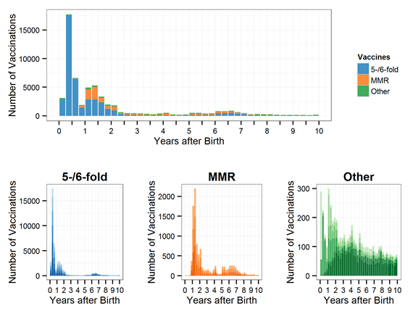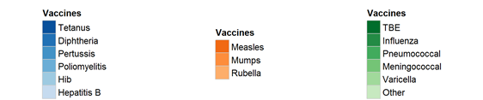
Figure 3.
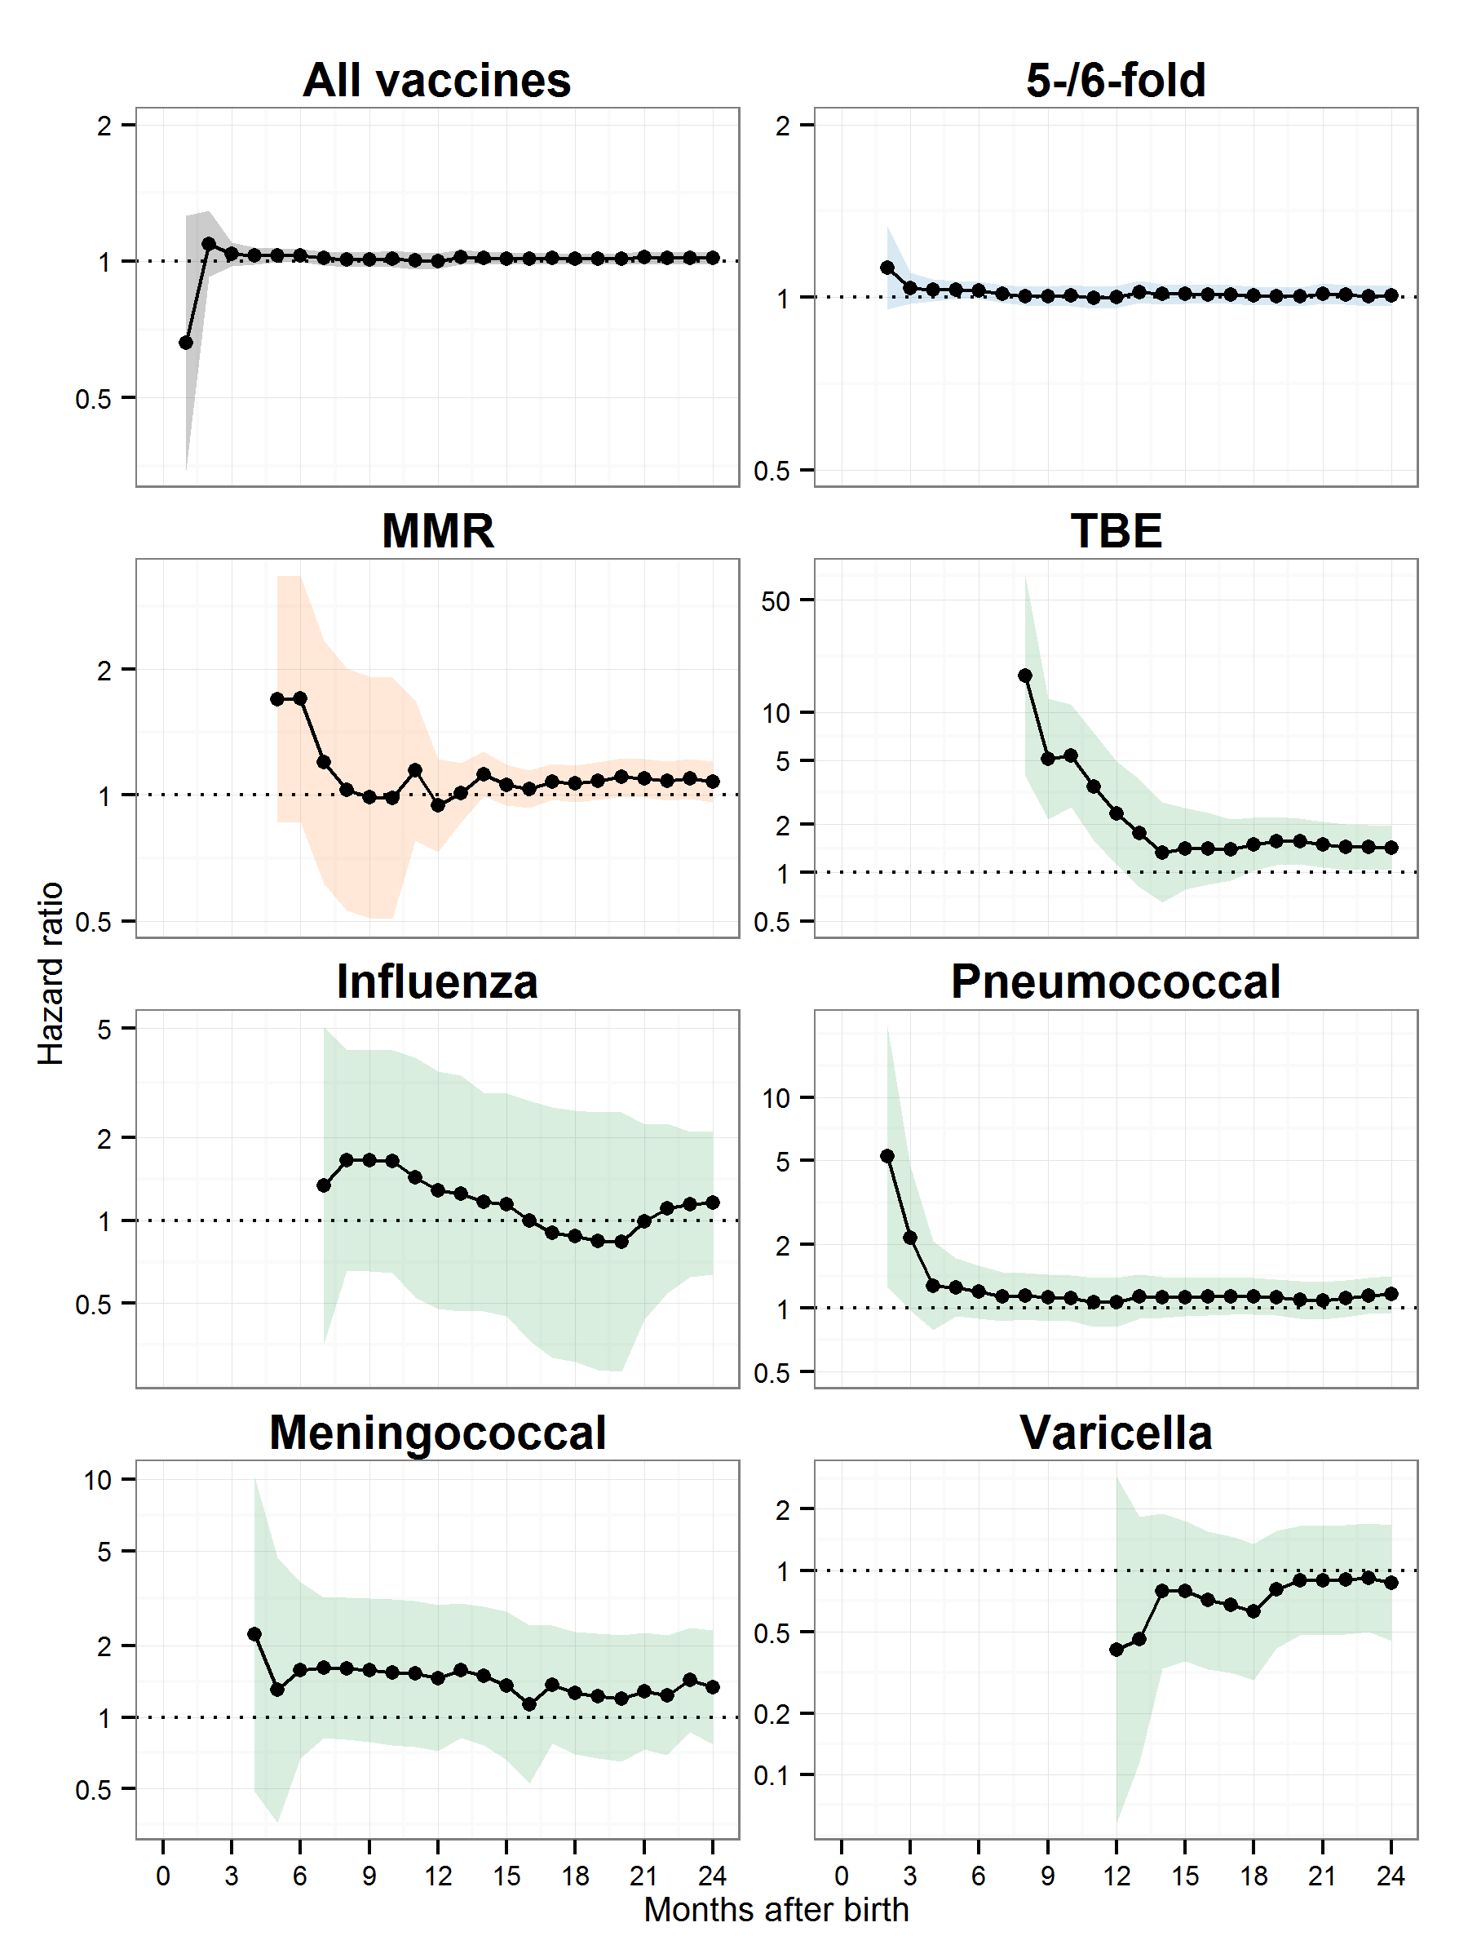
Figure 4.
Supplementary Figure 1.
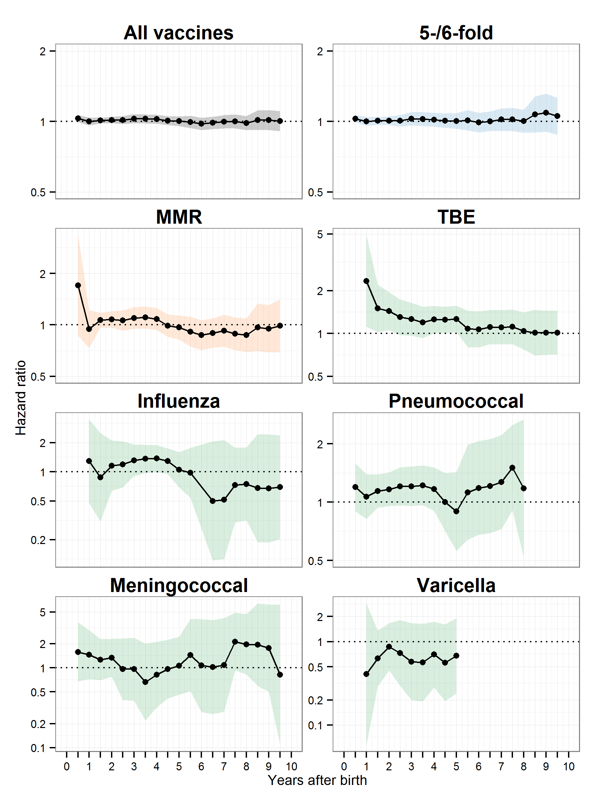
Supplementary Figure 2.
