Associations between genetic variants in mRNA splicing-related genes and risk of lung cancer: a pathway based analysis from published GWASs
Yongchu Pan^{1,2,3*}, Hongliang Liu^{1,3*}, Yanru Wang^{1,3}, Xiaozheng Kang^{1,3}, Zhensheng Liu^{1,3}, Kouros Owzar^{1,4}, Younghun Han⁵, Li Su^{6,7}, Yongyue Wei^{6,7}, Rayjean J. Hung⁸, Yonathan Brhane⁸, John McLaughlin⁹, Paul Brennan¹⁰, Heike Bickeböller¹¹, Albert Rosenberger¹¹, Richard S. Houlston¹², Neil Caporaso¹³, Maria Teresa Landi¹³, Joachim Heinrich¹⁴, Angela Risch¹⁵, Xifeng Wu¹⁶, Yuanqing Ye¹⁶, David C. Christiani^{6,7}, Christopher I. Amos⁵, and Qingyi Wei^{1,3**}.

Supplementary Table 1. Selection of mRNA splicing-related genes in MSigDB and Genecards databases
Database |  |  | Name of Pathway | Genes
MSigDB
Reactome |  |  | mRNA Splicing | 112
 |  |  | mRNA Splicing-minor pathway | 45
Genecards |  |  | mRNA Splicing | 201
Combined |  |  | mRNA Splicing genes | 206

Supplementary Table 2. Function annotation and prediction of six SNPs of PRPF6 in silico
SNPs | Allele | dbSNP func annotation | SNPinfo | RegulomeDB Score | Association with PRPF6 expression (P_{add} / P_{dom})
rs116165844 | G/T | 5’ near gene | - | 2b: TF binding+any motif+DNase Footprint +DNase peak | 0.042/0.039
rs8126213 | G/A | 5’ near gene | TFBS* | 4: TF binding+DNase peak | 0.042/0.039
rs147176547 | C/G | Intron | - | 2b: TF binding+any motif+DNase Footprint+DNase peak | 0.028/0.025
rs112219537 | G/A | Intron | - | - | 0.029/0.026
rs113450630 | C/T | Intron | - | - | 0.028/0.025
rs75100087 | C/T | Intron | - | 5: TF binding or DNase peak | 0.028/0.025
*TFBS: Transcription factor binding site
＃expression quantitative loci analyses from 373 individuals of European descendent (http://www.1000genomes.org/)
206 mRNA splicing-related genes
MisgDB: 112 genes
Genecards: 201 genes
Combined: 206 genes
2 kb upstream and downstream
Genotyping call rate≥90%
Minor allele frequency ≥ 5%
HWE P ≥10⁻⁵
11,966 SNPs
Six SNPs among PRPF6

Meta-analysis
among TRICL Consortium
12,160 cases and 16,838 controls
Additive genetic model

12 SNPs with FDR P≤0.05
Exclude: SNPs in DHX16 and LSM2-In high LD with previously reported lung cancer GWAS SNPs
Include: 6 SNPs in PRPF6 (novel)

LD analysis
SNP function prediction
eQTL analysis

Replication on one tagSNP rs8126213
Replication and overall analysis with Harvard and deCODE lung cancer GWASs

Supplementary Figure 1. Flow-chart of the present study. HWE: Hardy Weinberg Equilibrium; FDR: false discovery rate; LD: Linkage disequilibrium; eQTL: expression quantitative loci
Supplementary Figure 2. rs115420460 (new SNP ID: rs9262135) in DHX16 identified in the TRICL Consortium was in moderate to high linkage disequilibrium (LD) with those previously reported lung cancer GWAS SNPs (P < 10⁻⁸)

Supplementary Figure 3. Five SNPs in LSM2 identified in the TRICL Consortium were in moderate to high linkage disequilibrium (LD) with previously reported lung cancer GWAS SNPs (P < 10⁻⁸).
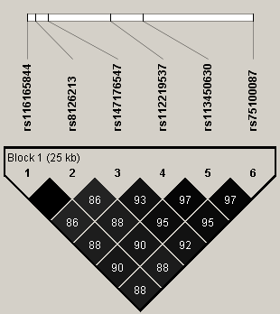
Exon
rs116165844
rs8126213
rs147176547
rs112219537
rs113450630
rs75100087
UTR
PRPF6
20p13
P12.3
20p12.1
20q12
13.12
q13.2
q13.33
Chr20
A
B
C
rs8126213
tagSNP

Supplementary Figure 4. (A) Chromosome position of PRPF6; (B) Diagram of six PRPF6 SNPs; (C) linkage disequilibrium (LD) values (r²) among these six PRPF6. High LD was observed between each of the two SNPs. Among them, rs8126213 was selected as tagSNP due to its potential functionality predicted by dbSNP func annotation, SNPfunc.
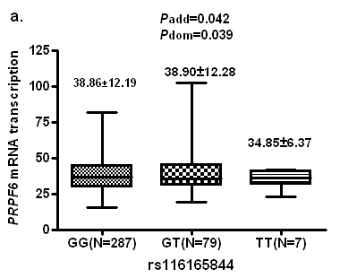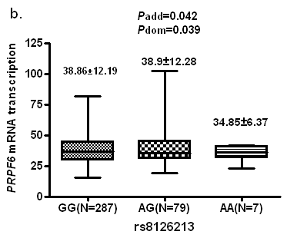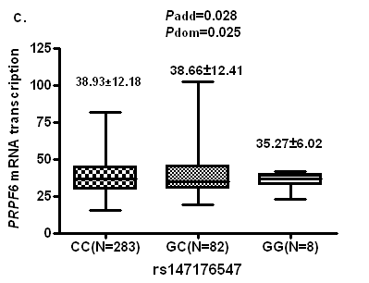
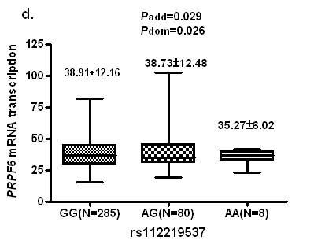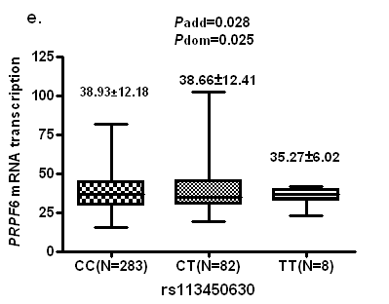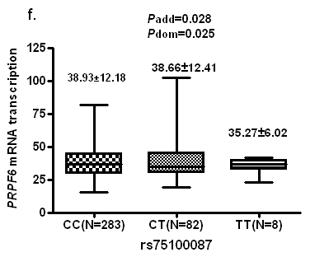

Supplementary Figure 5. Association between the six PRPF6 SNPs and PRPF6 mRNA expression. All the data were from 373 Europeans of 1000 Genomes Project. The association between genotypes and mRNA expression levels was evaluated using a linear regression model. Associations were calculated with additive and dominant genetic model.

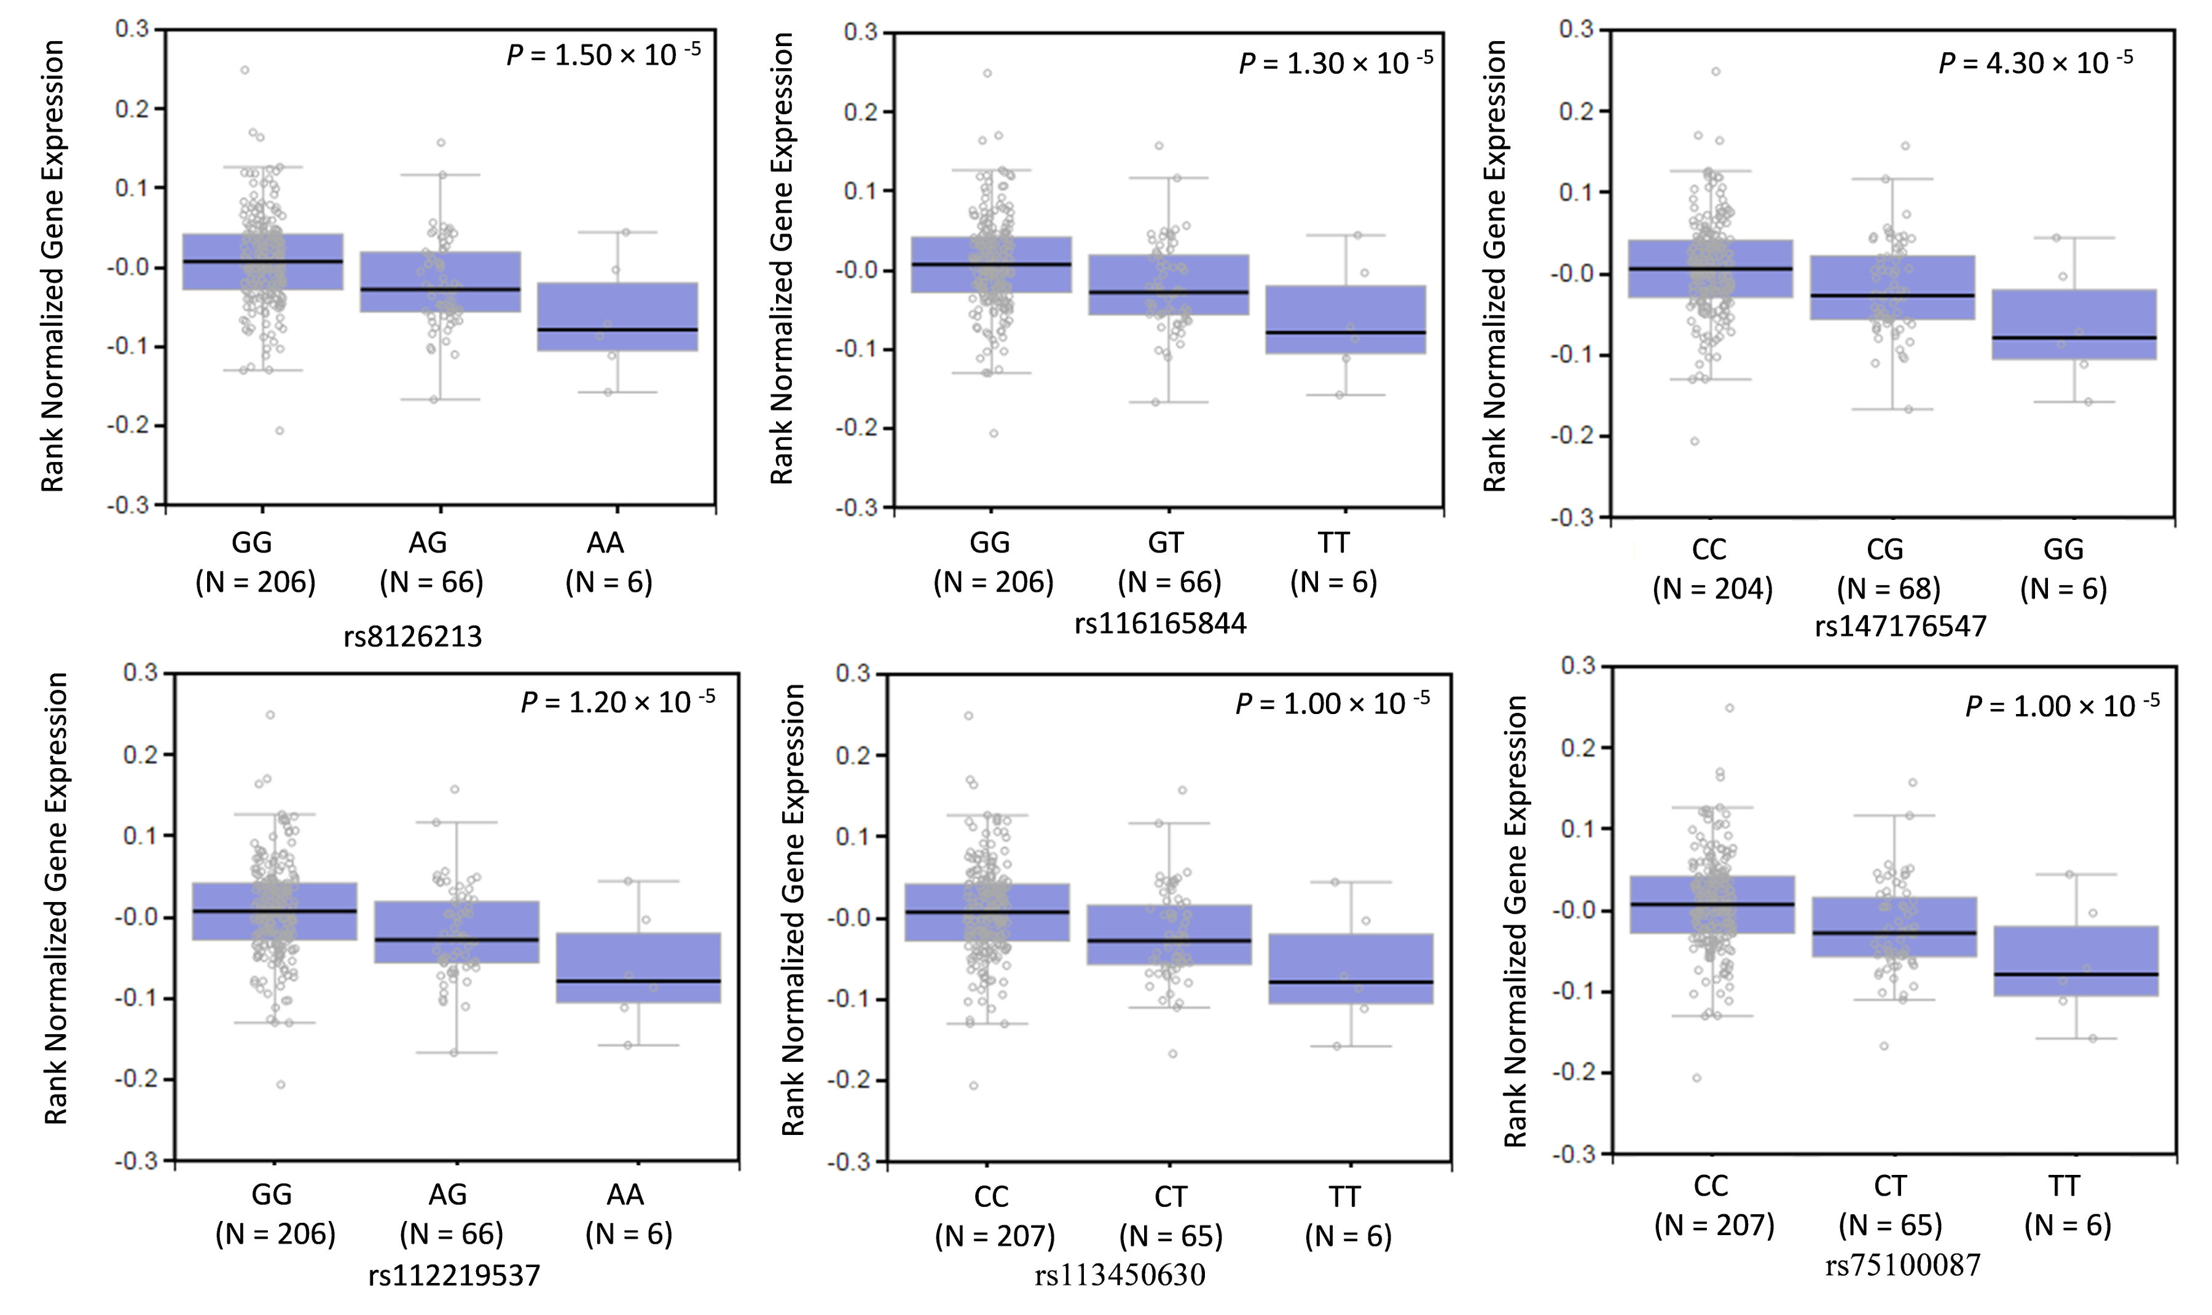
Supplementary Figure 6. Association between the six PRPF6 SNPs and PRPF6 mRNA expression in normal lung tissues. All plots were generated from the Genotype-Tissue Expression (GTEx) project (http://www.gtexportal.org/home/).

