Supplement of
Time-resolved Analysis of Primary Volatile Emissions and Secondary Aerosol Formation Potential from a Small-Scale Pellet Boiler
Hendryk Czechª, Simone M. Pieber^{b}, Petri Tiitta^{c}, Olli Sippula^{c,d}, Miika Kortelainen^{c}, Heikki Lamberg^{c}, Julija Grigonyte^{c}, Thorsten Streibel^{a,d,e}*, André S. H. Prévôt^{b}, Jorma Jokiniemi^{c,d}, Ralf Zimmermann^{a,d,e}
ªJoint Mass Spectrometry Centre, Chair of Analytical Chemistry, Institute of Chemistry, University of Rostock, 18059 Rostock, Germany
^{b}Laboratory of Atmospheric Chemistry, Paul Scherrer Institut, CH-5232, Villigen, Switzerland
^{c}Fine Particle and Aerosol Technology Laboratory, Department of Environmental and Biological Science, University of Eastern Finland, FIN-70211 Kuopio, Finland
^{d}Helmholtz Virtual Institute of Complex Molecular Systems in Environmental Health (HICE) - www.hice-vi.eu
^{e}Joint Mass Spectrometry Centre, Cooperation Group “Comprehensive Molecular Analytics” (CMA), Helmholtz Zentrum München – German Research Centre for Environmental Health, 85764 Neuherberg, Germany

*corresponding author;
phone: +49 381 498 6536, fax: +49 381 498 118 6527, email: thorsten.streibel@uni-rostock.de

Abbreviations:
PICS – photoionisation cross section; med – median; 5thP – 5th percentile; 95thP – 95th percentile; OGC – organic gaseous carbon; VOC – volatile organic compound; PRP – propene; AA – acetaldehyde; VA – vinylacetylene; BTD – butadiene; BENZ – benzene; TOL – toluene; STYR – styrene; IND – indene; NAP – naphthalene; MNAP – methylnaphthalene; BSP – boiler starting phase; OPT – optimised combustion of softwood pellets; RSA – combustion of softwood pellets at reduced secondary air; BBP – optimised combustion of birch bark pellets

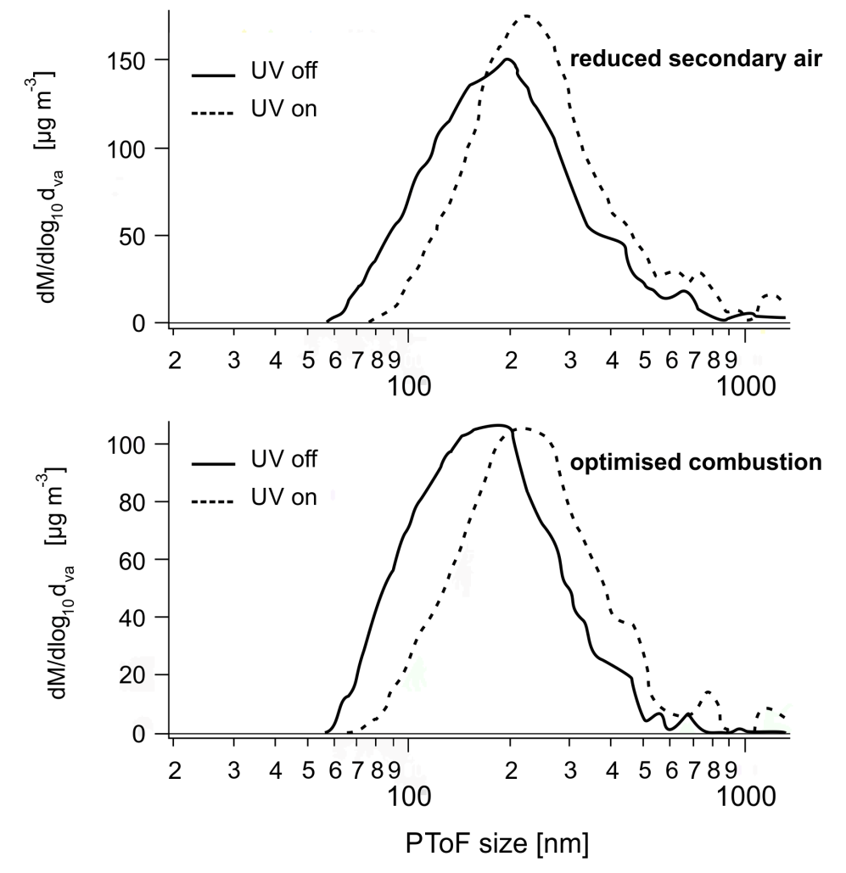
Fig. S1. Size distribution derived from SP-AMS for RSA (top) and OPT (bottom) with UV switched on and off

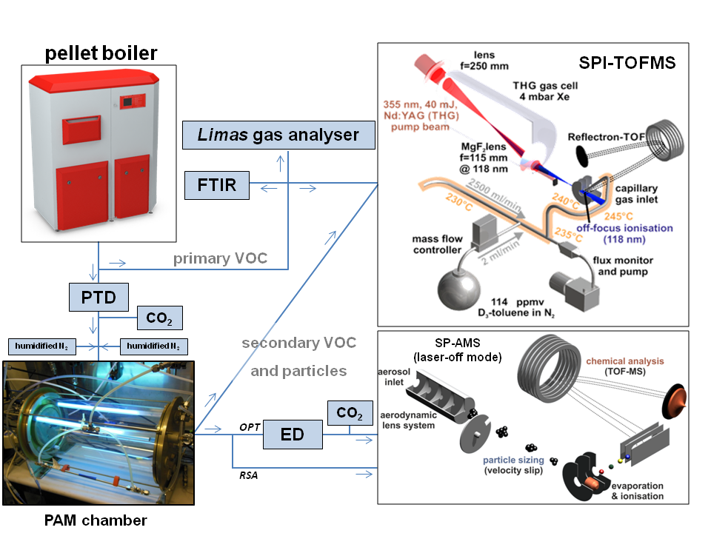
Fig. S2. Experimental setup and instrumentation for primary and secondary emission measurements (PTD: porous tube dilutor; ED: ejector dilutor)

Table S1
Photoionisation cross sections (PICS) relative to toluene and references
VOC | m/z nominal | PICS | Reference
propene (PRP) | 42 | 0.46* | Adam & Zimmermann, 2007
acetaldehyde (AA) | 44 | 0.24* | Adam & Zimmermann, 2007
vinylacetylene (VA) | 52 | 1.29** | Cool et al., 2008
butadiene (BTD) | 54 | 0.71* | Adam & Zimmermann, 2007
benzene (BENZ) | 78 | 1.18* | Adam & Zimmermann, 2007
toluene (TOL) | 92 | 1 | base
styrene (STYR) | 104 | 1.33* | Adam & Zimmermann, 2007
indene (IND) | 116 | 1.96** | Zhou et al., 2009
naphthalene (NAP) | 128 | 1.12* | Adam & Zimmermann, 2007
methylnaphthalene (MNAP) | 142 | 1.92** | Zhou et al., 2009
*calculated with ratio benzene/toluene of 1.18 from Adam & Zimmermann, 2007
**calculated with absolute PICS for benzene of 31.8·10⁻²² m² from Cool et al., 2005

Table S2
Mean concentrations (in %, O₂ and CO₂) and EFs (mg/MJ) with their respective median (Med), 5th percentile (5thP) and 95th percentile (95thP) of all measured data points from all experiments under one condition
 | BSP |  |  |  | OPT |  |  |  | RSA |  |  |  | BBP
 | Mean | Med | 5thP | 95thP | Mean | Med | 5thP | 95thP | Mean | Med | 5thP | 95thP | Mean | Med | 5thP | 95thP
O₂ | 14.64 | 14.63 | 10.67 | 20.52 | 11.96 | 11.95 | 10.90 | 13.07 | 11.76 | 11.76 | 10.49 | 12.96 | 11.84 | 11.82 | 10.23 | 13.48
CO | 557.34 | 208.91 | 58.20 | 1449.32 | 43.09 | 37.02 | 21.56 | 84.15 | 347.30 | 113.12 | 34.57 | 1213.14 | 320.97 | 143.14 | 36.24 | 908.55
CO₂ | 5.99 | 6.01 | 0.01 | 9.74 | 8.53 | 8.54 | 7.43 | 9.58 | 8.58 | 8.58 | 7.45 | 9.77 | 8.27 | 8.27 | 6.70 | 9.87
NO_{x} | 64.22 | 64.23 | 45.44 | 76.20 | 64.21 | 63.59 | 60.37 | 69.93 | 58.18 | 58.42 | 53.81 | 61.55 | 96.96 | 69.01 | 52.84 | 155.79
OGC | 51.96 | 7.74 | 2.48 | 143.37 | 1.30 | 1.26 | 1.03 | 1.69 | 2.91 | 1.61 | 1.15 | 7.77 | 3.66 | 2.45 | 1.36 | 8.42
PRP | 6.284 | 0.326 | 0.046 | 24.950 | 0.037 | 0.033 | 0.010 | 0.077 | 0.055 | 0.046 | 0.018 | 0.116 | 0.102 | 0.049 | 0.016 | 0.363
AA | 18.933 | 1.877 | 0.433 | 87.131 | 0.238 | 0.221 | 0.109 | 0.430 | 0.297 | 0.259 | 0.133 | 0.569 | 0.291 | 0.221 | 0.112 | 0.732
VA | 1.396 | 0.050 | >0.001 | 5.724 | 0.011 | >0.001 | >0.001 | 0.025 | 0.035 | 0.019 | >0.001 | 0.100 | 0.029 | 0.019 | >0.001 | 0.087
BTD | 2.255 | 0.102 | 0.012 | 9.992 | 0.016 | 0.014 | >0.001 | 0.037 | 0.031 | 0.023 | >0.001 | 0.078 | 0.071 | 0.042 | >0.001 | 0.237
BENZ | 3.434 | 0.232 | 0.040 | 11.716 | 0.023 | 0.019 | >0.002 | 0.049 | 0.215 | 0.059 | 0.018 | 0.775 | 0.151 | 0.077 | >0.001 | 0.416
TOL | 0.836 | 0.070 | >0.002 | 2.915 | 0.007 | >0.002 | <0.002 | 0.017 | 0.018 | >0.002 | >0.002 | 0.044 | 0.020 | >0.002 | >0.002 | 0.062
STYR | 0.283 | 0.038 | >0.002 | 0.941 | 0.004 | >0.002 | <0.002 | 0.011 | 0.011 | >0.002 | <0.002 | 0.027 | 0.002 | >0.002 | <0.002 | 0.029
IND | 0.137 | >0.003 | >0.003 | 0.482 | 0.002 | <0.003 | <0.003 | >0.003 | 0.005 | >0.003 | <0.003 | >0.003 | 0.003 | <0.003 | <0.003 | >0.003
NAP | 0.297 | 0.101 | 0.034 | 0.889 | 0.010 | >0.003 | <0.003 | 0.020 | 0.070 | 0.040 | >0.003 | 0.194 | 0.035 | 0.021 | >0.003 | 0.095
MNAP | 0.047 | >0.003 | >0.003 | 0.152 | 0.005 | >0.003 | <0.003 | >0.003 | 0.009 | >0.003 | <0.003 | >0.0039 | 0.005 | >0.003 | <0.003 | >0.003

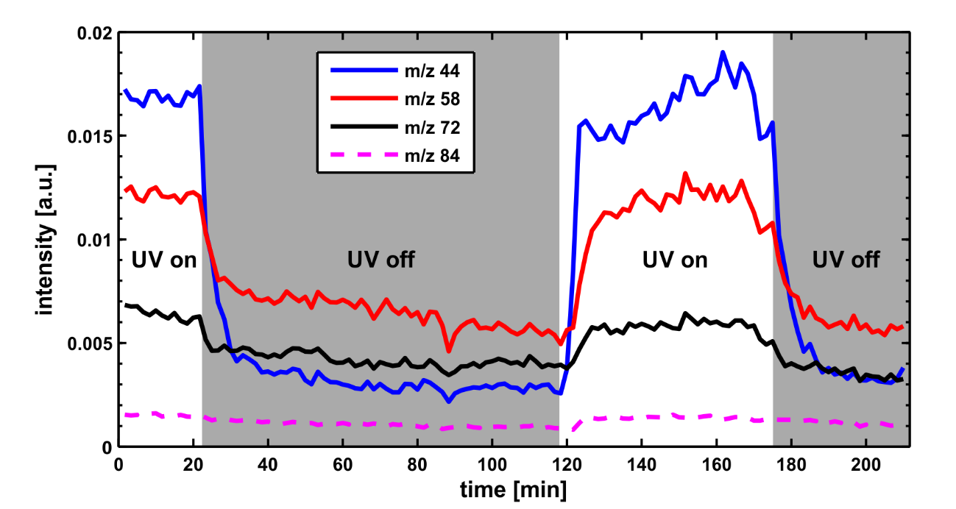
Fig. S3. Time series of selected m/z corresponding to acetaldehyde (m/z 44, blue), C3-carbonyl (m/z 58, red), C4-carbonyl (m/z 72, black) and butenedial / 2(H5-)furanone (m/z 84, magenta). Solid lines indicate a significant (p < 0.05) increase from UV off to UV on.

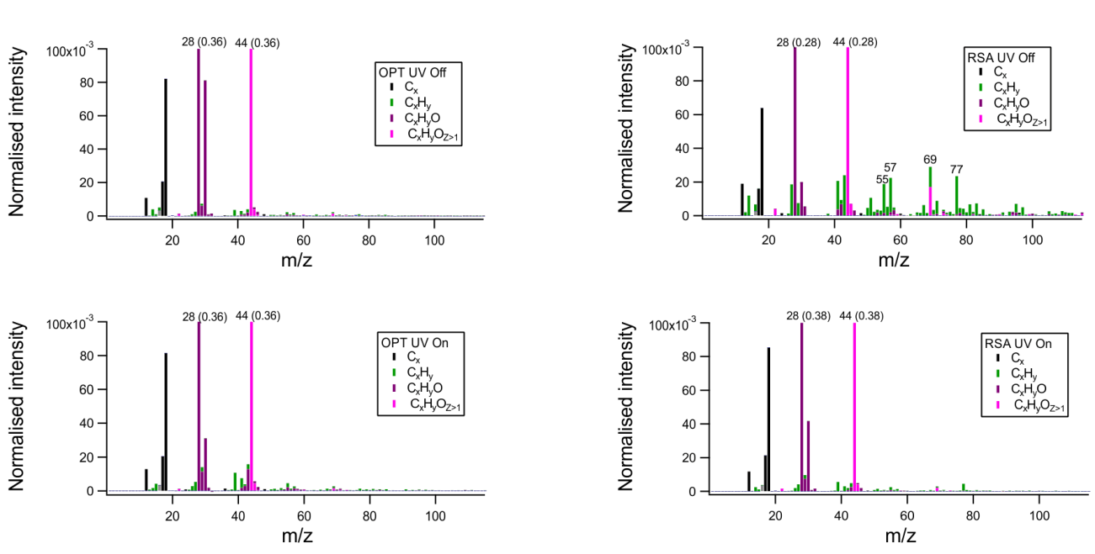
Fig. S4. Average AMS spectra for OPT (left) and RSA (right) with UV off and on

Table S3
Comparison of mean EF in mg/MJ for soft wood pellets with literature data of pellet stoves and boilers with nominal power between 5 and 40 kW
 | Sippula 2007 | Lamberg 2011ª | Boman 2011 | Keller 2012 | Orasche 2012 | Win 2012 | Ozgen 2014 | Krugly 2014 | This study (OPT)
CO | 142 | 63 | 130 | 59.8^{b} | 17 | 13 | 350 | 77 | 43
NO_{x} | 56 | 81 | 57 |  | 81 | 95 | 71 | 83 | 63
OGC | 12^{c} |  | 2.6 | 4.0^{b} | 2 | 1.7^{d} | 1.3e |  | 1.3
PRP |  |  |  |  |  |  |  |  | 0.037
BTD |  |  | 0.006 |  |  |  |  |  | 0.016
BENZ | 1.5 |  | 0.16 |  |  |  |  | 0.08 | 0.023
TOL | 0.6 |  | 0.02 |  |  |  |  | 0.06 | 0.007
STYR | 0.1 |  |  |  |  |  |  |  | 0.004
ªequal pellet boiler to this study
^{b}converted from mg/kg-CO₂ assuming carbon content of 0.5 and lower heating value of 20 MJ/kg
^{c}total volatile organic compounds (TVOC) as toluene equivalent
^{d}total organic carbon (TOC) equivalent methane
^{e}non-methane volatile organic compounds (NMVOC)

Table S4
Properties and changes from primary to aged particles
 | ER_{OA} | O:C_{prim} | O:C_{aged} | H:C_{prim} | H:C_{aged} | OM/OC_{prim} | OM/OC_{aged} | Slope  H:C vs O:C | OSC_{prim} | OSC_{aged}
OPT | 1.55 | 1.07 | 1.78 | 1.21 | 0.88 | 2.39 | 3.44 | -0.44 | 0.88 | 2.68
RSA | 2.02 | 1.12 | 1.37 | 1.31 | 1.20 | 2.60 | 2.93 | -0.47 | 0.93 | 1.55

Table S5
Enhancement ratios (ER) of single ions with significance (p < 0.05) indicated by asterisk
 | C₃H₇⁺  (m/z 43) | C₂H₃O⁺  (m/z 43) | CO₂⁺  (m/z 44) | C₄H₉⁺  (m/z 57) | C₂H₄O₂⁺  (m/z 60) | C₆H₅⁺  (m/z 77)
OPT | 1.85 | 8.1* | 1.48 | 1.32 | 1.78 | 1.77
RSA | 0.66 | 8.3* | 1.91* | 0.56* | 2.78* | 0.57*

References
Adam, T., Zimmermann, R., 2007. Determination of single photon ionization cross sections for quantitative analysis of complex organic mixtures. Analytical and Bioanalytical Chemistry 389, 1941-1951.
Boman, C., Pettersson, E., Westerholm, R., Boström, D., Nordin, A., 2011. Stove performance and emission characteristics in residential wood log and pellet combustion, part 1: Pellet stoves. Energy and Fuels 25, 307-314.
Cool, T.A., Wang, J., Nakajima, K., Taatjes, C.A., McLlroy, A., 2005. Photoionization cross sections for reaction intermediates in hydrocarbon combustion. International Journal of Mass Spectrometry 247, 18-27.
Keller, A., Burtscher, H., 2012. A continuous photo-oxidation flow reactor for a defined measurement of the SOA formation potential of wood burning emissions. Journal of Aerosol Science 49, 9-20.
Krugly, E., Martuzevicius, D., Puida, E., Buinevicius, K., Stasiulaitiene, I., Radziuniene, I., Minikauskas, A., Kliucininkas, L., 2014. Characterization of gaseous-and particle-phase emissions from the combustion of biomass-residue-derived fuels in a small residential boiler. Energy and Fuels 28, 5057-5066.
Lamberg, H., Sippula, O., Tissari, J., Jokiniemi, J., 2011. Effects of air staging and load on fine-particle and gaseous emissions from a small-scale pellet boiler. Energy and Fuels 25, 4952-4960.
Orasche, J., Seidel, T., Hartmann, H., Schnelle-Kreis, J., Chow, J.C., Ruppert, H., Zimmermann, R., 2012. Comparison of emissions from wood combustion. part 1: Emission factors and characteristics from different small-scale residential heating appliances considering particulate matter and polycyclic aromatic hydrocarbon (PAH)-related toxicological potential of particle-bound organic species. Energy and Fuels 26, 6695-6704.
Ozgen, S., Caserini, S., Galante, S., Giugliano, M., Angelino, E., Marongiu, A., Hugony, F., Migliavacca, G., Morreale, C., 2014. Emission factors from small scale appliances burning wood and pellets. Atmospheric Environment 94, 144-153.
Sippula, O., Hytönen, K., Tissari, J., Raunemaa, T., Jokiniemi, J., 2007. Effect of wood fuel on the emissions from a top-feed pellet stove. Energy and Fuels 21, 1151-1160.
Win, K.M., Persson, T., Bales, C., 2012. Particles and gaseous emissions from realistic operation of residential wood pellet heating systems. Atmospheric Environment 59, 320-327.
Zhou, Z., Xie, M., Wang, Z., Qi, F., 2009. Determination of absolute photoionization cross-sections of aromatics and aromatic derivatives. Rapid Communications in Mass Spectrometry 23, 3994-4002.

