Supplemental Information

Long non-coding RNA PARTICLE bridges histone and DNA methylation.
Valerie Bríd O'Leary, Sarah Hain, Doris Maugg, Jan Smida, Omid Azimzadeh, Soile Tapio, Saak V. Ovsepian, Michael John Atkinson.

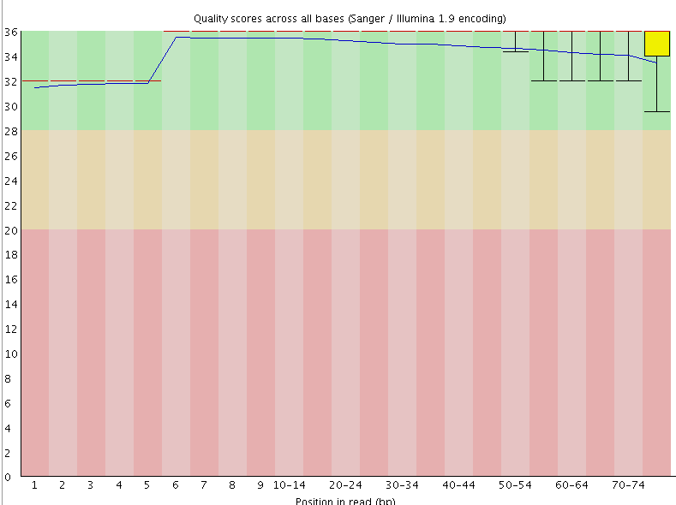
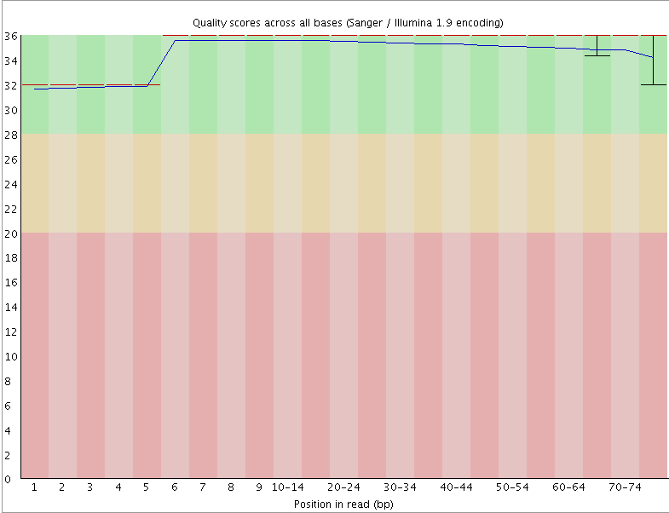
PARTICLE - OE + 0.025 Gy
PARTICLE - WT + 0.025 Gy
Quality scores across all bases
(Sanger / Illumina v 1.9)
Quality scores across all bases
(Sanger / Illumina v 1.9)
36
34
32
30
28
26
24
22
20
18
16
14
12
10
8
6
4
2
0
36
34
32
30
28
26
24
22
20
18
16
14
12
10
8
6
4
2
0
1 2 3 4 5 6 7 8 9 10-14 20-24 30-34 40-44 50-54 60-64 70-74
1 2 3 4 5 6 7 8 9 10-14 20-24 30-34 40-44 50-54 60-64 70-74
position in read (base pair)
position in read (base pair)

Fig. S1 is relevant to Fig. 1 and 2. ChIP-seq analysis of histone 3 lysine 27 trimethylation (H3K27me3) in irradiated MDA-MB-361 in the presence/absence of PARTICLE over-expression. Assessment of ChIP-seq sample quality, represented here as the sequence quality score versus base pair position using fastqc. This is regarded as a critical initial step in ChIP-seq data analysis and a requirement for appropriate interpretations of subsequent downstream analyses ¹. These representative images indicate good quality data, given the low error rate and variability of the reads.

Fig. S2 related to Fig. 1. Ingenuity software (Qiagen) analyis integrating PARTICLE triplex binding sites and H3K27me3 Chip-seq data. (A - B) Diseases (A) and molecular functions (B) significantly associated with PARTICLE triplex binding sites plus enriched H3K27me3 regions in the human genome. Histogram height reflects the associated -log of the calculated p-value, whereby a significant p value of p < 0.05 is equivalent to -log = 1.3.

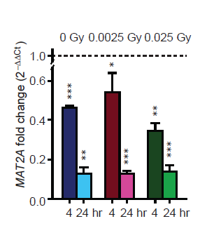

Fig. S3 related to Fig.2. Histograms of MAT2A expression 4 or 24hr following 0, 0.0025 or 0.025 Gy irradiation in MDA-MB-361 (over-expressing PARTICLE following in vitro transfection). Values were normalized with the TATA-binding protein (TBP) encoding endogenous gene with relative expression comparison to sham-irradiated (0 Gy) equivalent cells (dashed lines). Data are represented as mean ± SEM with significance represented by asterisks (p < 0.05) where appropriate.

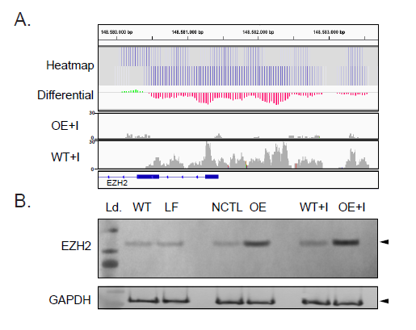
Fig. S4 related to Fig.2. (A) Heatmap of H3K27me3 tract intensity (upper: MDA-MB-361 24 hr post very low dose irradiation exposure (WT + I; bottom) ± PARTICLE overexpression (OE + I; top); Differential data represents the subtraction of H3K27me3 tract data of I minus OE + I; Integrative Genomics Viewer screenshot of H3K27me3 ChIP-seq track peaks across chromosome 7: 148,580,000 – 148,583,750 encoding the 5’ upstream region of Enhanzer of Zeste Homolog 2 (EZH2). (B). Representative Western blots of EZH2 and GAPDH in MDA-MB-361 (WT) cell lysates in LF, NC1 control (NCTL) transfected, WT or OE exposed to 0.025 Gy (WT + I or OE + I, respectively). Gels are cropped images. Precision plus protein standard (Bio-Rad, cat. # 161 – 0374; Ld.) loaded on the left side of both representative gels. Arrow indicate the position of bands of interest.

References
1 Maze, I. et al. Analytical tools and current challenges in the modern era of neuroepigenomics. Nat Neurosci 17, 1476-1490, doi:10.1038/nn.3816 (2014).

