Supplementary Material
The Influence of Land Use Intensity on the Plant Associated Microbiome of Dactylis glomerata L.
Jennifer Estendorfer, Barbara Stempfhuber, Paula Haury, Gisle Vestergaard, Matthias C. Rillig, Jasmin Joshi, Peter Schröder*, Michael Schloter
* Correspondence: Peter Schröder: peter.schroeder@helmholtz-muenchen.de

Supplementary Figures and Tables

Supplementary Figures

Figure S1: Rarefaction curve of phylogenetic diversity in all compartments under low and high LUI at 97% sequence similarity. Bulk soil is depicted in blue, rhizosphere in red and root endosphere in orange. Lighter colors indicate low LUI.
Figure S2: Principal coordinate analysis (PCoA) based on dissimilarity matrices (95% confidence intervals). (A) unweighted Unifrac (R²= 0.33, p<0.001), (B) weighted Unifrac (R²= 0.33, p<0.001), (C) Bray-Curtis (R²= 0.26, p<0.001).
Figure S3: VennDiagram of shared OTUs between all compartments in high versus low LUI. Red circle depicts high LUI, green circle depicts low LUI. Percentages refer to the total data.

Supplementary Tables
Table S1: Summary of edaphic parameters. Water extractable carbon/nitrogen (WEOC/WEON), nitrate, ammonium, C/N ratio in plants, gravimetric water content in the soil (water), Index: land use intensity index, calculated for 2006-2014, as described in Blüthgen et al. (2012) for grassland samples, the management and treatment of sampled sites.
Table S2: Relative abundance of assigned taxa. Groups that were less abundant than 1% in all compartments were grouped together in “Others”. (A) most abundant phyla (B) most abundant families
Table S3: The impact of LUI on the β-diversity (between sample diversity) of bacterial community compositions. Significance (ADONIS, p-value < 0.05) indicated in bold letters, marginal significance (ADONIS, p-value < 0.1) indicated in italics.
Table S4: Classification of shared core OTUs that were found in 95% of all samples.
Table S5: Classification of core OTUs that were found in 95% of all samples only under low land use intensities.
Table S6: Classification of core OTUs that were found in 95% of all samples only under high land use intensities.
Table S7: Families that are significantly affected by land use intensity. Significance was tested using t-test. Marginal significance (p <0.1) is indicated in italics (A) in roots, (B) in rhizosphere and (C) in bulk soil

Figure S1
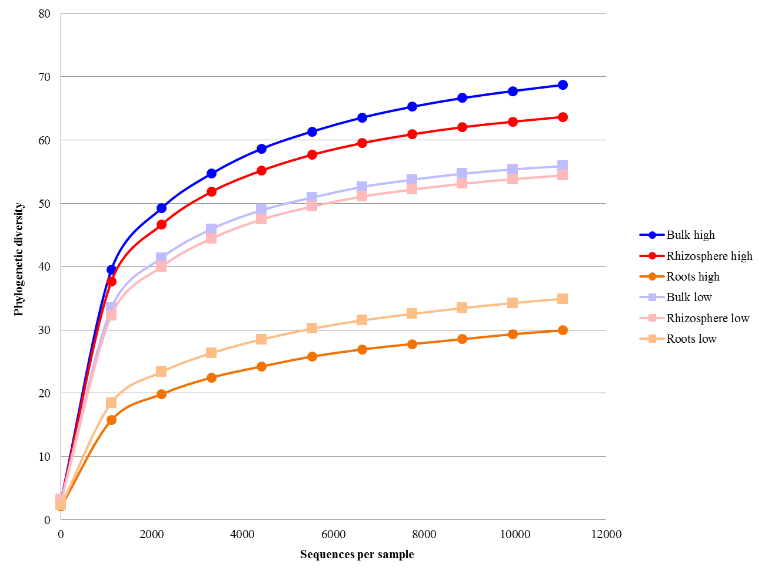

Figure S2A
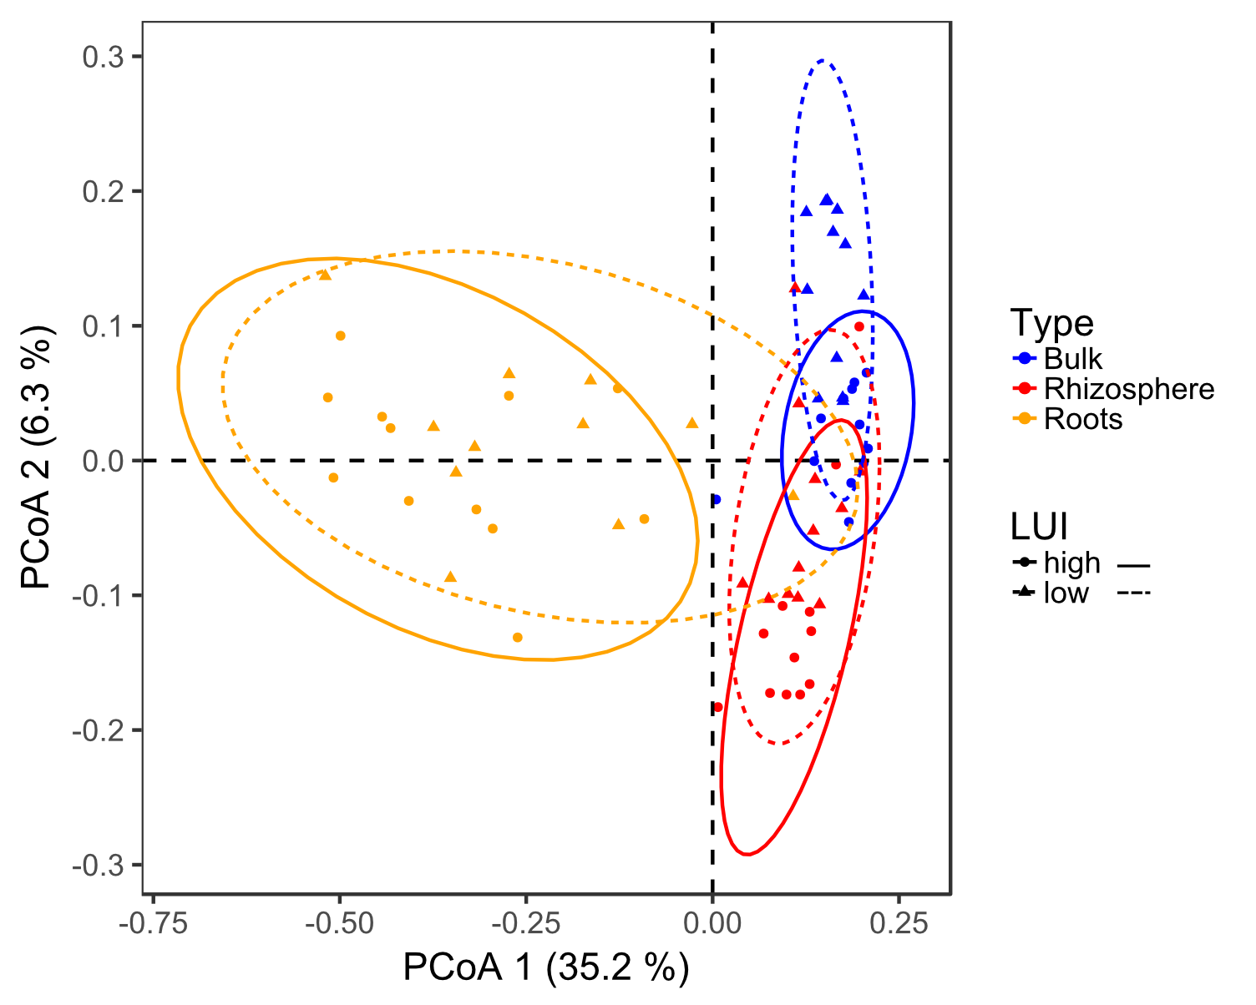

Figure 2B
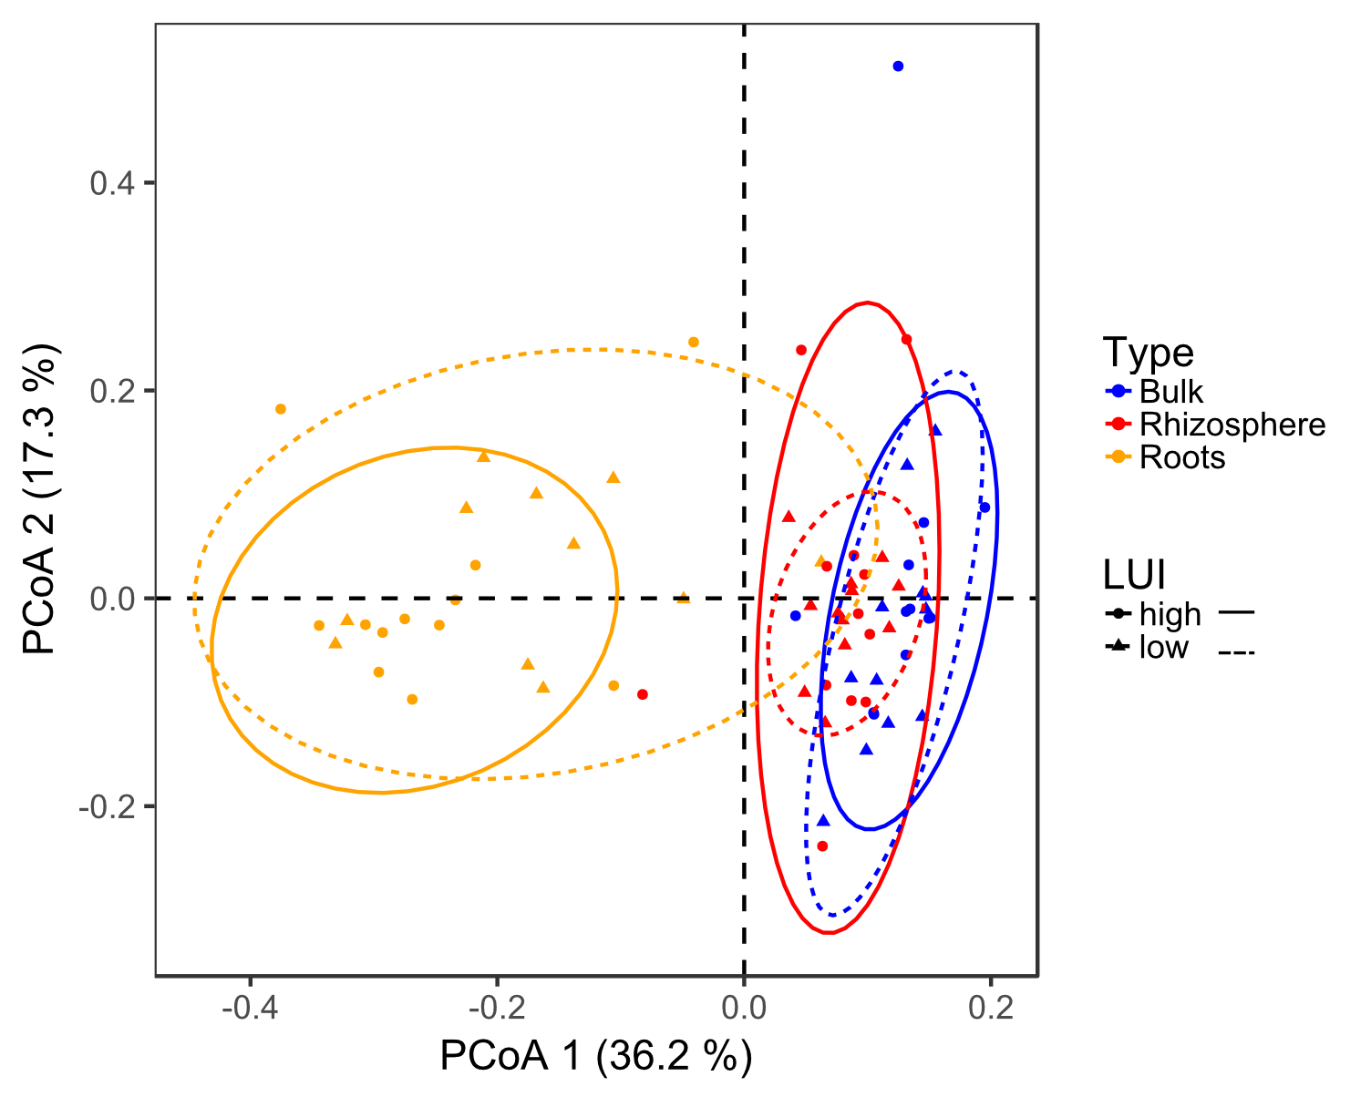

Figure 2C
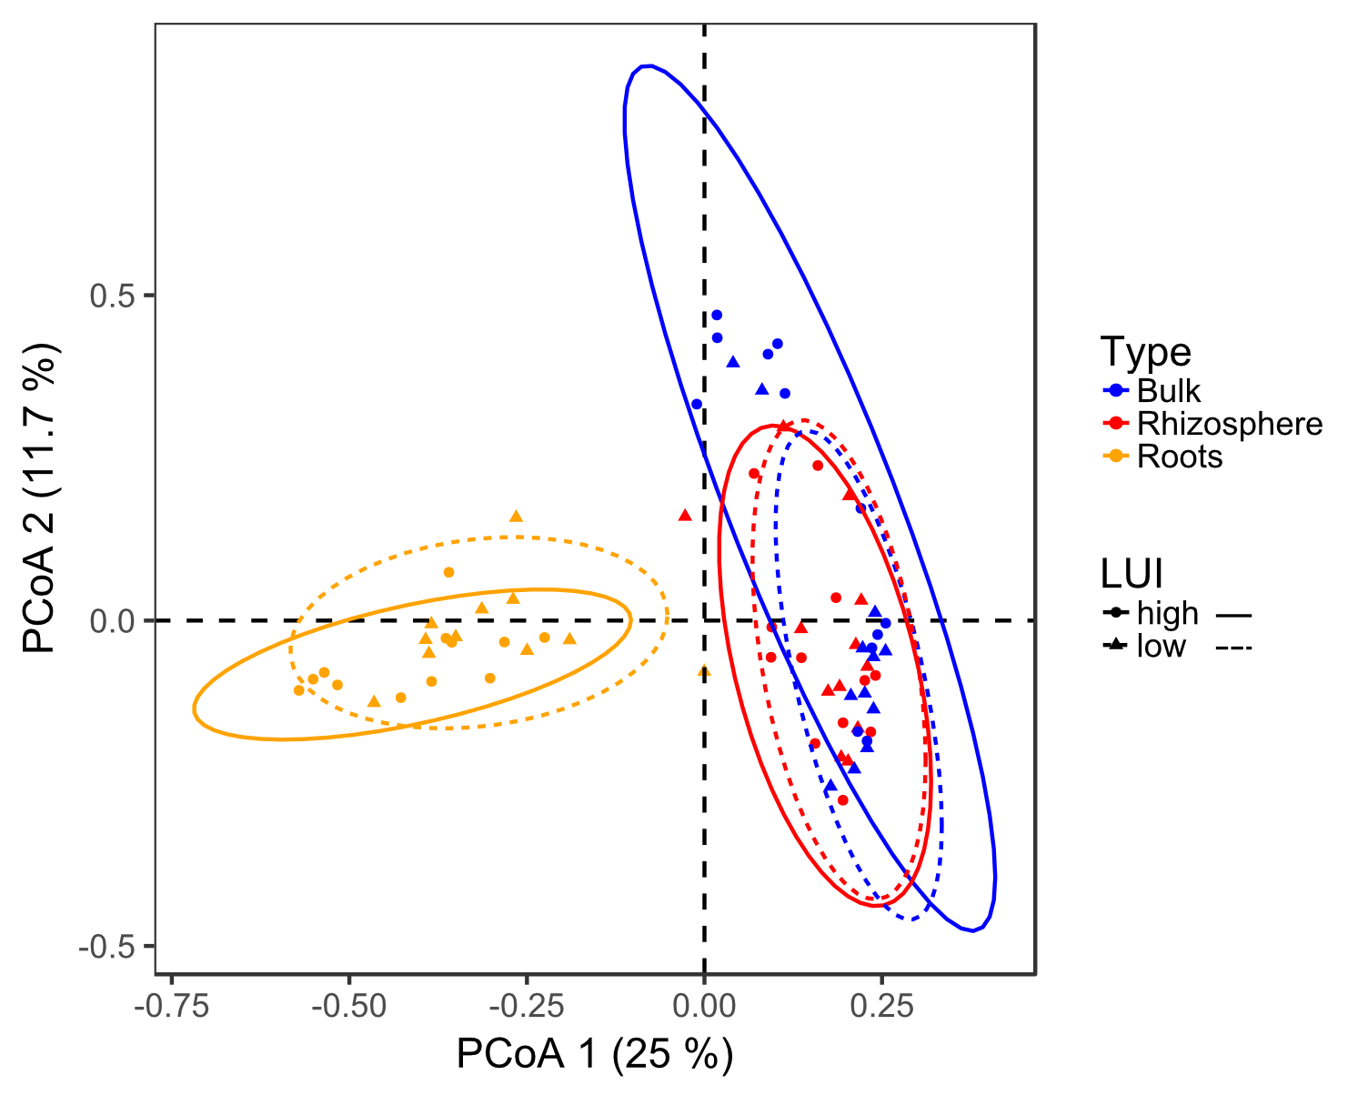

Figure S3
12
26
16.2%
5
8.4%
high
low

Table S1
Plot ID | WEOC [µg g-1 dw] | WEON [µg g-1 dw] | Nitrate [µg N g-1 dw] | Ammonium [µg N g-1 dw] | C/N ratio plants | Water (%) | Index (2006-2014) | Management | Treatment
AEG6 | 25.84±5.55 | 40.65±8.23 | 42.29±4.53 | 0.1±0.04 | 19.73±2.78 | 37 | 2.25 | mown pasture | fertilized
AEG19 | 30.25±7.8 | 41.87±9.41 | 45.57±9.13 | 0.11±0.03 | 12.25±0.19 | 34 | 2.28 | mown pasture | fertilized
AEG20 | 24.75±4.76 | 48.42±11.92 | 51.04±7.26 | 0.11±0.02 | 13.04±1.41 | 44 | 1.55 | pasture | fertilized
AEG21 | 25.56±4.5 | 41.57±12.2 | 45.43±11.04 | 0.13±0.06 | 14.51±1.39 | 36 | 3.62 | pasture | fertilized
AEG7 | 27.54±21.35 | 25.61±5.79 | 17.03±4.87 | 5.76±1.57 | 16.65±0.21 | 40 | 0.56 | pasture | non-fertilized
AEG28 | 25.08±6.02 | 14.46±3.8 | 12.11±2.93 | 2.28±0.49 | 25.78±1.85 | 34 | 1.06 | pasture | non-fertilized
AEG33 | 25.48±8.08 | 8.67±1.56 | 4.55±2.48 | 2.81±0.91 | 26.46±1.27 | 31 | 1.32 | pasture | non-fertilized
AEG34 | 24.05±4.71 | 21.25±4.59 | 24.77±5.19 | 0.79±0.38 | 28.33±0.28 | 30 | 1.31 | pasture | non-fertilized

Table S2A
Phylum | Bulk RA (%) | Rhizosphere RA (%) | Roots RA (%)
Proteobacteria | 0.60 | 0.69 | 0.91
Bacteroidetes | 0.20 | 0.13 | 0.05
Actinobacteria | 0.09 | 0.10 | 0.02
Acidobacteria | 0.04 | 0.04 | 0.01
Firmicutes | 0.02 | 0.01 | 0.01
Nitrospirae | 0.01 | 0.01 | <0.01
TM7 | 0.01 | <0.01 | <0.01
Chlorobi | 0.01 | <0.01 | <0.01
Gemmatimonadetes | 0.01 | 0.01 | <0.01
Others | 0.01 | <0.01 | <0.01

Table S2B
Family | Bulk RA (%) | Rhizosphere RA (%) | Roots RA (%)
Pseudomonadaceae | 0.01 | 0.01 | 0.15
Enterobacteriaceae | <0.01 | 0.01 | 0.12
Comamonadaceae | 0.04 | 0.07 | 0.10
Oxalobacteraceae | <0.01 | 0.01 | 0.09
Rhizobiaceae | <0.01 | 0.01 | 0.09
Sphingomonadaceae | 0.02 | 0.03 | 0.07
Xanthomonadaceae | 0.03 | 0.06 | 0.06
Bradyrhizobiaceae | 0.04 | 0.05 | 0.05
Sinobacteraceae | 0.09 | 0.09 | 0.04
Burkholderiaceae | <0.01 | <0.01 | 0.03
Phyllobacteriaceae | 0.01 | 0.01 | 0.02
Chitinophagaceae | 0.12 | 0.07 | 0.02
Hyphomicrobiaceae | 0.10 | 0.08 | 0.02
Sphingobacteriaceae | <0.01 | 0.01 | 0.02
Caulobacteraceae | <0.01 | 0.01 | 0.02
Rhodospirillaceae | 0.02 | 0.02 | 0.01
Xanthobacteraceae | <0.01 | <0.01 | 0.01
Haliangiaceae | 0.02 | 0.01 | 0.01
Mycobacteriaceae | <0.01 | 0.01 | <0.01
Flavobacteriaceae | 0.01 | 0.01 | <0.01
Solibacteraceae | 0.02 | 0.02 | <0.01
Propionibacteriaceae | 0.01 | 0.01 | <0.01
Cytophagaceae | 0.02 | 0.01 | <0.01
Bacillaceae | 0.01 | 0.01 | <0.01
Micromonosporaceae | <0.01 | 0.01 | <0.01
C111 | 0.01 | 0.01 | <0.01
Alcaligenaceae | 0.01 | 0.01 | <0.01
EB1017 | 0.01 | 0.01 | <0.01
Nitrospiraceae | 0.01 | 0.01 | <0.01
Gaiellaceae | 0.01 | 0.01 | <0.01
Syntrophobacteraceae | 0.01 | 0.01 | <0.01
Saprospiraceae | 0.01 | 0.01 | <0.01
Piscirickettsiaceae | 0.01 | <0.01 | <0.01
Others | 0.32 | 0.31 | 0.06

Table S3
Compartment | Distance metrics | R² | p-value
Roots | Unweighted | 0.08093 | 0.015
Roots | Weighted | 0.05146 | 0.278
Roots | Bray-Curtis | 0.05291 | 0.16
Rhizosphere | Unweighted | 0.08949 | 0.003
Rhizosphere | Weighted | 0.05793 | 0.202
Rhizosphere | Bray-Curtis | 0.07037 | 0.068
Bulk soil | Unweighted | 0.1441 | 0.001
Bulk soil | Weighted | 0.0747 | 0.124
Bulk soil | Bray-Curtis | 0.13575 | 0.008

Table S4
OTU ID | Kingdom | Phylum | Class | Order | Family | Genus
573764 | Bacteria | Proteobacteria | Alphaproteobacteria | Rhizobiales | Bradyrhizobiaceae | Bradyrhizobium
4377104 | Bacteria | Proteobacteria | Alphaproteobacteria | Rhizobiales | Bradyrhizobiaceae | Bradyrhizobium
1105814 | Bacteria | Proteobacteria | Alphaproteobacteria | Rhizobiales | Bradyrhizobiaceae | Bradyrhizobium
580625 | Bacteria | Proteobacteria | Alphaproteobacteria | Rhizobiales | Bradyrhizobiaceae | Bradyrhizobium
866365 | Bacteria | Proteobacteria | Alphaproteobacteria | Caulobacterales | Caulobacteraceae | Caulobacter
731707 | Bacteria | Proteobacteria | Betaproteobacteria | Burkholderiales | Comamonadaceae | Variovorax
317632 | Bacteria | Proteobacteria | Alphaproteobacteria | Rhizobiales | Hyphomicrobiaceae | Rhodoplanes
573013 | Bacteria | Proteobacteria | Alphaproteobacteria | Rhizobiales | Hyphomicrobiaceae | Devosia
646549 | Bacteria | Proteobacteria | Gammaproteobacteria | Pseudomonadales | Pseudomonadaceae | Pseudomonas
969805 | Bacteria | Proteobacteria | Alphaproteobacteria | Rhizobiales | Rhizobiaceae | Agrobacterium
1003206 | Bacteria | Proteobacteria | Alphaproteobacteria | Sphingomonadales | Sphingomonadaceae | Sphingomonas
573258 | Bacteria | Proteobacteria | Alphaproteobacteria | Sphingomonadales | Sphingomonadaceae | Kaistobacter

Table S5
OTU ID | Kingdom | Phylum | Class | Order | Family | Genus
399818 | Bacteria | Proteobacteria | Betaproteobacteria | Ellin6067 | Not assigned | Not assigned
113261 | Bacteria | Proteobacteria | Deltaproteobacteria | Myxococcales | Not assigned | Not assigned
254098 | Bacteria | Proteobacteria | Betaproteobacteria | Not assigned | Not assigned | Not assigned
838594 | Bacteria | Firmicutes | Bacilli | Bacillales | Bacillaceae | Bacillus
961922 | Bacteria | Firmicutes | Bacilli | Bacillales | Bacillaceae | Bacillus
580703 | Bacteria | Firmicutes | Bacilli | Bacillales | Bacillaceae | Bacillus
573135 | Bacteria | Proteobacteria | Alphaproteobacteria | Rhizobiales | Bradyrhizobiaceae | Bradyrhizobium
358785 | Bacteria | Proteobacteria | Alphaproteobacteria | Rhizobiales | Hyphomicrobiaceae | Rhodoplanes
545247 | Bacteria | Proteobacteria | Alphaproteobacteria | Rhizobiales | Hyphomicrobiaceae | Rhodoplanes
616682 | Bacteria | Proteobacteria | Alphaproteobacteria | Rhizobiales | Hyphomicrobiaceae | Rhodoplanes
2025156 | Bacteria | Proteobacteria | Alphaproteobacteria | Rhizobiales | Hyphomicrobiaceae | Rhodoplanes
210914 | Bacteria | Proteobacteria | Alphaproteobacteria | Rhizobiales | Hyphomicrobiaceae | Rhodoplanes
New.0.CleanUp.ReferenceOTU4459 | Bacteria | Proteobacteria | Alphaproteobacteria | Rhizobiales | Hyphomicrobiaceae | Not assigned
New.1.CleanUp.ReferenceOTU99 | Bacteria | Proteobacteria | Alphaproteobacteria | Rhizobiales | Hyphomicrobiaceae | Rhodoplanes
620684 | Bacteria | Proteobacteria | Alphaproteobacteria | Rhizobiales | Phyllobacteriaceae | Mesorhizobium
547097 | Bacteria | Proteobacteria | Alphaproteobacteria | Rhizobiales | Phyllobacteriaceae | Mesorhizobium
571263 | Bacteria | Proteobacteria | Alphaproteobacteria | Rhizobiales | Phyllobacteriaceae | Mesorhizobium
398604 | Bacteria | Proteobacteria | Gammaproteobacteria | Pseudomonadales | Pseudomonadaceae | Pseudomonas
350105 | Bacteria | Proteobacteria | Gammaproteobacteria | Pseudomonadales | Pseudomonadaceae | Pseudomonas
3314521 | Bacteria | Proteobacteria | Gammaproteobacteria | Pseudomonadales | Pseudomonadaceae | Pseudomonas
1104627 | Bacteria | Proteobacteria | Alphaproteobacteria | Rhizobiales | Rhizobiaceae | Rhizobium
709657 | Bacteria | Proteobacteria | Alphaproteobacteria | Rhodospirillales | Rhodospirillaceae | Not assigned
281360 | Bacteria | Proteobacteria | Alphaproteobacteria | Rhodospirillales | Rhodospirillaceae | Not assigned
4373617 | Bacteria | Proteobacteria | Gammaproteobacteria | Xanthomonadales | Sinobacteraceae | Not assigned
New.0.CleanUp.ReferenceOTU3078 | Bacteria | Proteobacteria | Gammaproteobacteria | Xanthomonadales | Sinobacteraceae | Not assigned
New.0.CleanUp.ReferenceOTU8268 | Bacteria | Proteobacteria | Alphaproteobacteria | Sphingomonadales | Sphingomonadaceae | Kaistobacter

Table S6
OTU ID | Kingdom | Phylum | Class | Order | Family | Genus
811449 | Bacteria | Proteobacteria | Alphaproteobacteria | Caulobacterales | Caulobacteraceae | Not assigned
689696 | Bacteria | Proteobacteria | Betaproteobacteria | Burkholderiales | Comamonadaceae | Methylibium
211171 | Bacteria | Proteobacteria | Betaproteobacteria | Burkholderiales | Comamonadaceae | Not assigned
849118 | Bacteria | Proteobacteria | Alphaproteobacteria | Rhizobiales | Hyphomicrobiaceae | Devosia
850572 | Bacteria | Proteobacteria | Alphaproteobacteria | Rhizobiales | Rhizobiaceae | Agrobacterium

Table S7A
Kingdom | Phylum | Class | Order | Family | p-value | RA high LUI (%) | RA low LUI (%)
Bacteria | Firmicutes | Bacilli | Turicibacterales | Turicibacteraceae | 0.022 | 0.018 | 0.002
Bacteria | Proteobacteria | Alphaproteobacteria | Rhizobiales | Other | 0.030 | 0.049 | 0.182
Bacteria | Acidobacteria | Solibacteres | Solibacterales | [Bryobacteraceae] | 0.033 | 0.016 | 0.093
Bacteria | Bacteroidetes | Cytophagia | Cytophagales | Cytophagaceae | 0.035 | 0.194 | 0.395
Bacteria | Proteobacteria | Deltaproteobacteria | [Entotheonellales] | [Entotheonellaceae] | 0.054 | 0.003 | 0.035
Bacteria | Proteobacteria | Alphaproteobacteria | Rhizobiales | Not assigned | 0.060 | 0.098 | 0.367
Bacteria | Firmicutes | Bacilli | Bacillales | Not assigned | 0.064 | 0.019 | 0.052
Bacteria | Proteobacteria | Gammaproteobacteria | Xanthomonadales | Sinobacteraceae | 0.065 | 1.978 | 7.375
Bacteria | Actinobacteria | Actinobacteria | Actinomycetales | Actinosynnemataceae | 0.070 | 0.030 | 0.001
Bacteria | Proteobacteria | Gammaproteobacteria | HTCC2188 | HTCC2089 | 0.076 | 0.002 | 0.012
Bacteria | Actinobacteria | Thermoleophilia | Solirubrobacterales | Conexibacteraceae | 0.077 | 0.002 | 0.015
Bacteria | Acidobacteria | Solibacteres | Solibacterales | Solibacteraceae | 0.080 | 0.149 | 0.427
Bacteria | Bacteroidetes | VC2_1_Bac22 | Not assigned | Not assigned | 0.083 | 0.006 | 0.038
Bacteria | Proteobacteria | Gammaproteobacteria | Legionellales | Legionellaceae | 0.088 | 0.034 | 0.000
Bacteria | Proteobacteria | Betaproteobacteria | Methylophilales | Methylophilaceae | 0.092 | 0.185 | 0.028
Bacteria | Proteobacteria | Deltaproteobacteria | Bdellovibrionales | Bacteriovoracaceae | 0.098 | 0.002 | 0.016
Bacteria | Proteobacteria | Deltaproteobacteria | Myxococcales | Not assigned | 0.099 | 0.337 | 0.808
Bacteria | Proteobacteria | Betaproteobacteria | SC-I-84 | Not assigned | 0.099 | 0.134 | 0.390

Table S7B
Kingdom | Phylum | Class | Order | Family | p-value | RA high LUI (%) | RA low LUI (%)
Bacteria | Proteobacteria | Deltaproteobacteria | Myxococcales | Cystobacteraceae | 0.0003 | 0.095 | 0.205
Bacteria | Nitrospirae | Nitrospira | Nitrospirales | Nitrospiraceae | 0.0003 | 1.356 | 0.200
Bacteria | Proteobacteria | Alphaproteobacteria | Not assigned | Not assigned | 0.0010 | 0.082 | 0.257
Bacteria | Proteobacteria | Alphaproteobacteria | Rhizobiales | Not assigned | 0.0022 | 0.648 | 0.953
Bacteria | Proteobacteria | Alphaproteobacteria | Rhodospirillales | Rhodospirillaceae | 0.0022 | 1.712 | 2.384
Bacteria | Proteobacteria | Betaproteobacteria | Ellin6067 | Not assigned | 0.0028 | 2.966 | 4.321
Bacteria | Proteobacteria | Betaproteobacteria | Nitrosomonadales | Nitrosomonadaceae | 0.0042 | 0.082 | 0.007
Bacteria | Proteobacteria | TA18 | PHOS-HD29 | Not assigned | 0.0042 | 0.012 | 0.003
Bacteria | Proteobacteria | Alphaproteobacteria | Ellin329 | Not assigned | 0.0050 | 0.307 | 0.617
Bacteria | Proteobacteria | Alphaproteobacteria | Rhodobacterales | Hyphomonadaceae | 0.0062 | 0.237 | 0.417
Bacteria | Proteobacteria | Alphaproteobacteria | Rhodobacterales | Rhodobacteraceae | 0.0066 | 0.351 | 0.159
Bacteria | Proteobacteria | Betaproteobacteria | IS-44 | Not assigned | 0.0227 | 0.074 | 0.246
Bacteria | Actinobacteria | Actinobacteria | Actinomycetales | Propionibacteriaceae | 0.0230 | 1.206 | 0.470
Bacteria | Proteobacteria | Betaproteobacteria | Rhodocyclales | Rhodocyclaceae | 0.0244 | 0.314 | 0.133
Bacteria | Tenericutes | Mollicutes | Anaeroplasmatales | Anaeroplasmataceae | 0.0334 | 0.001 | 0.010
Bacteria | Proteobacteria | Alphaproteobacteria | Rhizobiales | Beijerinckiaceae | 0.0356 | 0.038 | 0.022
Bacteria | Acidobacteria | Acidobacteriia | Acidobacteriales | Acidobacteriaceae | 0.0358 | 0.002 | 0.012
Bacteria | Actinobacteria | Actinobacteria | Actinomycetales | Intrasporangiaceae | 0.0440 | 0.047 | 0.020
Bacteria | Proteobacteria | Alphaproteobacteria | Rickettsiales | Not assigned | 0.0461 | 0.015 | 0.026
Bacteria | Firmicutes | Clostridia | Clostridiales | Clostridiaceae | 0.0532 | 0.124 | 0.049
Bacteria | Proteobacteria | Gammaproteobacteria | Chromatiales | Not assigned | 0.0550 | 0.002 | 0.010
Bacteria | Actinobacteria | Actinobacteria | Actinomycetales | Pseudonocardiaceae | 0.0567 | 0.434 | 0.200
Bacteria | Proteobacteria | Alphaproteobacteria | Rhodospirillales | Not assigned | 0.0575 | 0.182 | 0.083
Bacteria | Proteobacteria | Gammaproteobacteria | Other | Other | 0.0580 | 0.119 | 0.231
Bacteria | Acidobacteria | Solibacteres | Solibacterales | Not assigned | 0.0630 | 1.054 | 1.427
Bacteria | Actinobacteria | Actinobacteria | Actinomycetales | Streptosporangiaceae | 0.0747 | 0.012 | 0.043
Bacteria | Proteobacteria | Gammaproteobacteria | Thiotrichales | Piscirickettsiaceae | 0.0753 | 0.251 | 0.528
Bacteria | Bacteroidetes | Sphingobacteriia | Sphingobacteriales | Sphingobacteriaceae | 0.0801 | 1.223 | 0.509
Bacteria | Proteobacteria | Betaproteobacteria | Burkholderiales | Alcaligenaceae | 0.0812 | 0.554 | 1.363
Bacteria | Actinobacteria | Actinobacteria | Actinomycetales | Frankiaceae | 0.0815 | 0.184 | 0.054
Bacteria | Bacteroidetes | Flavobacteriia | Flavobacteriales | Cryomorphaceae | 0.0833 | 0.117 | 0.049
Bacteria | Acidobacteria | DA052 | Ellin6513 | Not assigned | 0.0873 | 0.000 | 0.020
Bacteria | Chloroflexi | Anaerolineae | SHA-20 | Not assigned | 0.0875 | 0.002 | 0.012
Bacteria | Proteobacteria | Betaproteobacteria | Not assigned | Not assigned | 0.0918 | 1.575 | 2.388
Bacteria | Proteobacteria | Deltaproteobacteria | Not assigned | Not assigned | 0.0941 | 0.019 | 0.049
Bacteria | Proteobacteria | Gammaproteobacteria | [Marinicellales] | [Marinicellaceae] | 0.0960 | 0.073 | 0.301
Bacteria | TM6 | SJA-4 | Not assigned | Not assigned | 0.0985 | 0.025 | 0.107
Bacteria | Proteobacteria | Deltaproteobacteria | [Entotheonellales] | [Entotheonellaceae] | 0.0992 | 0.175 | 0.421

Table S7C
Kingdom | Phylum | Class | Order | Family | p-value | RA high LUI (%) | RA low LUI(%)
Bacteria | Proteobacteria | Betaproteobacteria | A21b | UD5 | 0.0002 | 0.422 | 0.167
Bacteria | Proteobacteria | Deltaproteobacteria | Desulfuromonadales | Geobacteraceae | 0.0002 | 0.366 | 0.015
Bacteria | Proteobacteria | Alphaproteobacteria | Ellin329 | Not assigned | 0.0002 | 0.200 | 0.401
Bacteria | Elusimicrobia | Elusimicrobia | FAC88 | Not assigned | 0.0003 | 0.024 | 0.004
Bacteria | Proteobacteria | Alphaproteobacteria | Rhodobacterales | Rhodobacteraceae | 0.0003 | 0.141 | 0.034
Bacteria | Actinobacteria | Actinobacteria | Actinomycetales | Intrasporangiaceae | 0.0013 | 0.031 | 0.003
Bacteria | Proteobacteria | Gammaproteobacteria | Alteromonadales | 125ds10 | 0.0015 | 0.027 | 0.077
Bacteria | Nitrospirae | Nitrospira | Nitrospirales | Nitrospiraceae | 0.0016 | 1.395 | 0.212
Bacteria | OD1 | ABY1 | Not assigned | Not assigned | 0.0016 | 0.011 | 0.000
Bacteria | Proteobacteria | Alphaproteobacteria | Rhodospirillales | Rhodospirillaceae | 0.0020 | 1.528 | 2.585
Bacteria | Proteobacteria | Betaproteobacteria | Nitrosomonadales | Nitrosomonadaceae | 0.0022 | 0.121 | 0.005
Bacteria | Proteobacteria | Alphaproteobacteria | Rhizobiales | Not assigned | 0.0025 | 0.710 | 0.975
Bacteria | Proteobacteria | Gammaproteobacteria | Alteromonadales | 211ds20 | 0.0033 | 0.032 | 0.005
Bacteria | Firmicutes | Clostridia | Clostridiales | Peptostreptococcaceae | 0.0050 | 0.034 | 0.006
Bacteria | Firmicutes | Clostridia | Clostridiales | Clostridiaceae | 0.0053 | 0.285 | 0.082
Bacteria | Chloroflexi | Ellin6529 | Not assigned | Not assigned | 0.0056 | 0.046 | 0.019
Bacteria | Actinobacteria | MB-A2-108 | 0319-7L14 | Not assigned | 0.0063 | 0.065 | 0.018
Bacteria | Actinobacteria | Actinobacteria | Actinomycetales | Micromonosporaceae | 0.0072 | 0.228 | 0.507
Bacteria | Proteobacteria | Deltaproteobacteria | NB1-j | NB1-i | 0.0073 | 0.168 | 0.417
Bacteria | Planctomycetes | C6 | d113 | Not assigned | 0.0074 | 0.011 | 0.000
Bacteria | Proteobacteria | Deltaproteobacteria | Myxococcales | Not assigned | 0.0106 | 2.976 | 4.215
Bacteria | Bacteroidetes | Bacteroidia | Bacteroidales | Not assigned | 0.0109 | 0.009 | 0.000
Bacteria | Actinobacteria | Actinobacteria | Actinomycetales | Streptosporangiaceae | 0.0123 | 0.011 | 0.111
Bacteria | Actinobacteria | Actinobacteria | Actinomycetales | Propionibacteriaceae | 0.0160 | 0.832 | 0.417
Bacteria | Proteobacteria | Deltaproteobacteria | Myxococcales | Cystobacteraceae | 0.0175 | 0.100 | 0.280
Bacteria | Nitrospirae | Nitrospira | Nitrospirales | FW | 0.0187 | 0.044 | 0.000
Bacteria | Proteobacteria | Deltaproteobacteria | Spirobacillales | Not assigned | 0.0210 | 0.008 | 0.001
Bacteria | Proteobacteria | Alphaproteobacteria | Rhizobiales | Xanthobacteraceae | 0.0215 | 0.064 | 0.103
Bacteria | TM6 | SJA-4 | Not assigned | Not assigned | 0.0225 | 0.090 | 0.308
Bacteria | Planctomycetes | Other | Other | Other | 0.0229 | 0.014 | 0.047
Bacteria | Actinobacteria | Thermoleophilia | Gaiellales | Gaiellaceae | 0.0243 | 1.687 | 1.000
Bacteria | Acidobacteria | Solibacteres | Solibacterales | AKIW659 | 0.0263 | 0.048 | 0.012
Bacteria | Gemmatimonadetes | Gemmatimonadetes | Ellin5290 | Not assigned | 0.0279 | 0.041 | 0.195
Bacteria | Proteobacteria | Deltaproteobacteria | Myxococcales | Polyangiaceae | 0.0291 | 0.252 | 0.353
Bacteria | Spirochaetes | [Leptospirae] | [Leptospirales] | Leptospiraceae | 0.0295 | 0.056 | 0.030
Bacteria | Bacteroidetes | Sphingobacteriia | Sphingobacteriales | Sphingobacteriaceae | 0.0301 | 0.204 | 0.064
Bacteria | Actinobacteria | Actinobacteria | Actinomycetales | Pseudonocardiaceae | 0.0324 | 0.281 | 2.107
Bacteria | Chloroflexi | TK17 | mle1-48 | Not assigned | 0.0354 | 0.019 | 0.006
Bacteria | Acidobacteria | EC1113 | Not assigned | Not assigned | 0.0357 | 0.014 | 0.005
Bacteria | Gemmatimonadetes | Gemmatimonadetes | Gemmatimonadales | Ellin5301 | 0.0378 | 0.006 | 0.098
Bacteria | Proteobacteria | Alphaproteobacteria | Rhizobiales | Beijerinckiaceae | 0.0389 | 0.051 | 0.032
Bacteria | Proteobacteria | Betaproteobacteria | Rhodocyclales | Rhodocyclaceae | 0.0403 | 0.336 | 0.092
Bacteria | WS3 | PRR-12 | Sediment-1 | Not assigned | 0.0408 | 0.036 | 0.010
Bacteria | Actinobacteria | Acidimicrobiia | Acidimicrobiales | AKIW874 | 0.0429 | 0.366 | 0.774
Bacteria | Actinobacteria | Actinobacteria | Actinomycetales | Other | 0.0432 | 0.133 | 0.227
Bacteria | Firmicutes | Bacilli | Turicibacterales | Turicibacteraceae | 0.0448 | 0.021 | 0.005
Bacteria | Proteobacteria | Betaproteobacteria | Burkholderiales | Oxalobacteraceae | 0.0455 | 0.648 | 0.267
Bacteria | Proteobacteria | Betaproteobacteria | Methylophilales | Methylophilaceae | 0.0487 | 0.167 | 0.036
Bacteria | Chlorobi | OPB56 | Not assigned | Not assigned | 0.0502 | 0.024 | 0.009
Bacteria | Planctomycetes | Not assigned | Not assigned | Not assigned | 0.0503 | 0.032 | 0.064
Bacteria | Spirochaetes | Spirochaetes | Spirochaetales | Spirochaetaceae | 0.0526 | 0.008 | 0.021
Bacteria | Bacteroidetes | Sphingobacteriia | Sphingobacteriales | Not assigned | 0.0536 | 2.927 | 1.546
Bacteria | Acidobacteria | Solibacteres | Solibacterales | Not assigned | 0.0580 | 1.353 | 2.139
Bacteria | Chloroflexi | Anaerolineae | SBR1031 | A4b | 0.0611 | 0.034 | 0.082
Bacteria | Chlamydiae | Chlamydiia | Chlamydiales | Simkaniaceae | 0.0645 | 0.006 | 0.031
Bacteria | Proteobacteria | Deltaproteobacteria | Bdellovibrionales | Bdellovibrionaceae | 0.0680 | 0.027 | 0.015
Bacteria | Acidobacteria | DA052 | Ellin6513 | Not assigned | 0.0693 | 0.002 | 0.023
Bacteria | WS3 | PRR-12 | LD1-PA13 | Not assigned | 0.0696 | 0.046 | 0.143
Bacteria | Proteobacteria | Alphaproteobacteria | Rhizobiales | Rhizobiaceae | 0.0785 | 0.194 | 0.104
Bacteria | WS3 | PRR-12 | Sediment-1 | PRR-10 | 0.0799 | 0.003 | 0.011
Bacteria | Proteobacteria | Betaproteobacteria | SC-I-84 | Not assigned | 0.0818 | 2.586 | 3.524
Bacteria | Proteobacteria | Deltaproteobacteria | Myxococcales | Myxococcaceae | 0.0831 | 0.020 | 0.000
Bacteria | Acidobacteria | Solibacteres | Solibacterales | Solibacteraceae | 0.0844 | 1.598 | 2.384
Bacteria | Proteobacteria | Deltaproteobacteria | Myxococcales | Nannocystaceae | 0.0851 | 0.077 | 0.036
Bacteria | GN02 | 3BR-5F | Not assigned | Not assigned | 0.0857 | 0.009 | 0.000
Bacteria | Proteobacteria | Deltaproteobacteria | [Entotheonellales] | [Entotheonellaceae] | 0.0878 | 0.366 | 0.597
Bacteria | Actinobacteria | Actinobacteria | Actinomycetales | Nakamurellaceae | 0.0896 | 0.070 | 0.038
Bacteria | Gemmatimonadetes | Gemm-5 | Not assigned | Not assigned | 0.0916 | 0.008 | 0.031
Bacteria | Chlorobi | SJA-28 | Not assigned | Not assigned | 0.0932 | 0.871 | 0.284
Bacteria | Proteobacteria | Betaproteobacteria | Other | Other | 0.0998 | 0.046 | 0.024

