Supplementary Material for
FT-Artifacts and Power-function Resolution Filter in Fourier Transform Mass Spectrometry
Basem Kanawati, Theresa Bader, Karl-Peter Wanczek, Yan Li, Philippe Schmitt-Kopplin

This supplementary material shows four different applications of the mass filter, which works based on resolution values of detected signals in mass spectra. The applications are related to the following measurements:

- Measurement of Arginine cluster anions.
- An SRFA measurement in ESI-.
- An egg yolk lipid measurement in ESI-.
- An Ubiquitin intact small protein measurement in ESI+.
The results of the filter in regard to total number of detected signals and number of filtered true signals are mentioned for each application in the main manuscript.
- Measurement of Arginine cluster anions.
Figure S1 shows an enlarged view along the Y-axis of the main arginine cluster anions:
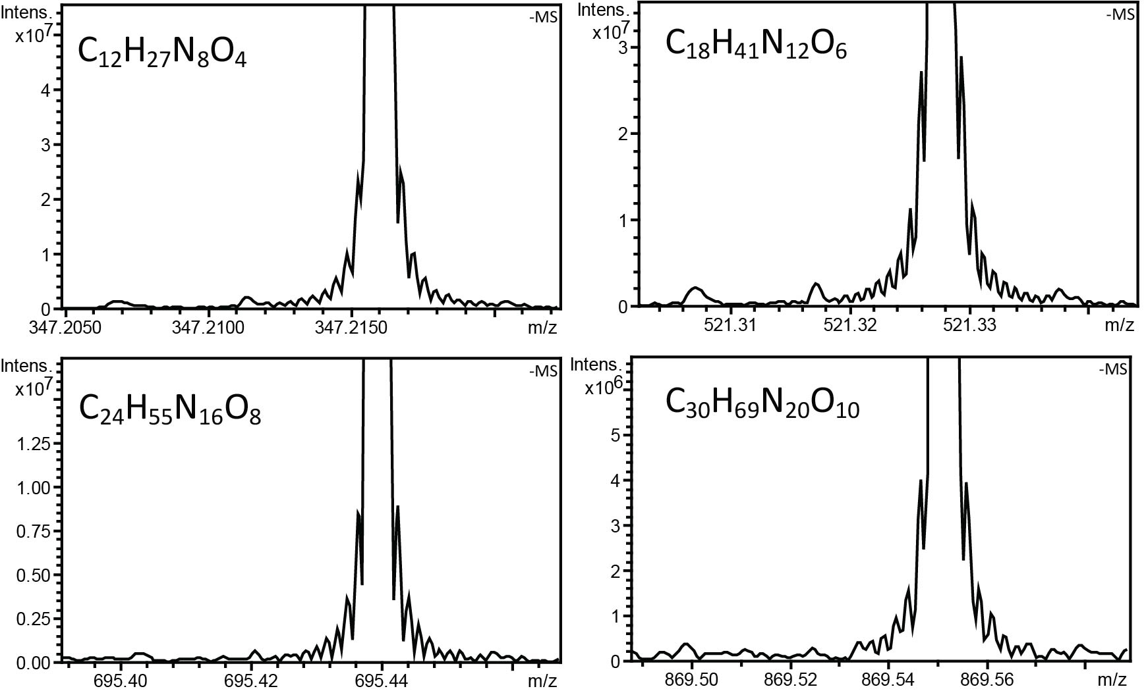
Figure S1: Enlarged view along the Y-axis of the main arginine cluster anions (mono isotopic peaks).

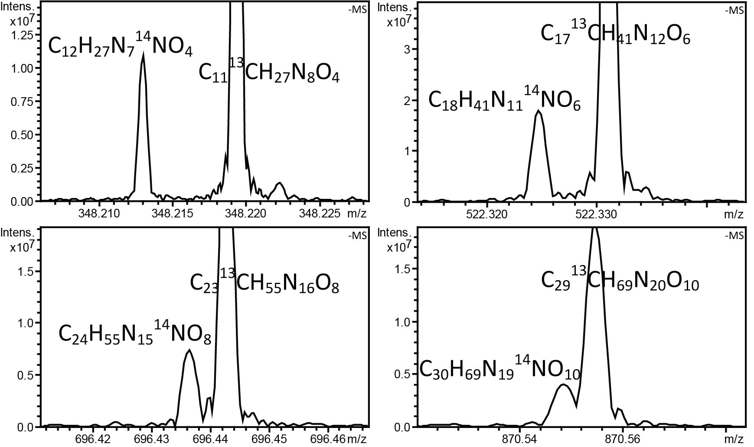
Figure S2: Wiggles around the M+1 heavy isotope of the main arginine cluster anions. The signal on the left is for ¹⁴N heavy isotope, while the signal on the right represents the ¹³C heavy isotope.

Table S1: Sum formulae of the arginine cluster anions M.[M-H]⁻ as mono isotopic as well as in their ¹⁴N and ¹³C heavy isotopic forms. The m/z ratios correspond to the mono isotopic peaks.
n | m/z | Mono isotope | ¹⁴N heavy isotope | ¹³C heavy isotope
2 | 347.216075 | C₁₂H₂₇N₈O₄ | C₁₂H₂₇N₇¹⁴NO₄ | C₁₁¹³CH₂₇N₈O₄
3 | 521.327751 | C₁₈H₄₁N₁₂O₆ | C₁₈H₄₁N₁₁¹⁴NO₆ | C₁₇¹³CH₄₁N₁₂O₆
4 | 695.439426 | C₂₄H₅₅N₁₆O₈ | C₂₄H₅₅N₁₅¹⁴NO₈ | C₂₃¹³CH₅₅N₁₆O₈
5 | 869.551102 | C₃₀H₆₉N₂₀O₁₀ | C₃₀H₆₉N₁₉¹⁴NO₁₀ | C₂₉¹³CH₆₉N₂₀O₁₀

Table S2: List of filtered m/z list out of the 238 signals, which contain also side lobes (wiggles) and was exported into the ascii mass list file.

Table 2 clearly shows the results of the power-resolution filter. Only the correct 85 masses, which represent the arginine cluster ion monoisotopic peaks together with their M+1 corresponding ¹³C and ¹⁴N heavy isotopes together with some solvent fatty acid and sulfonate impurities are shown.

- SRFA measurement:
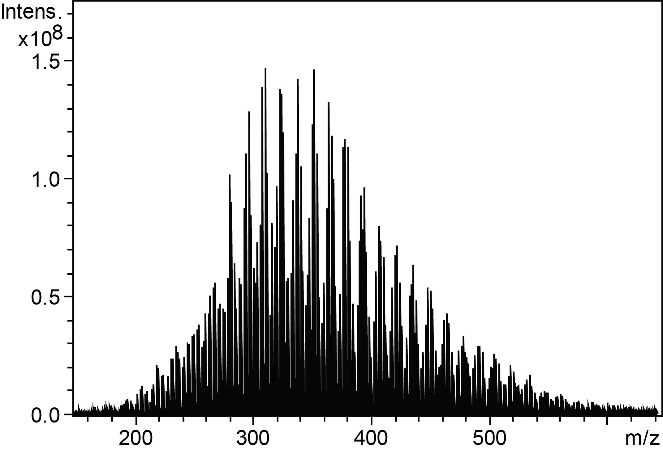
Figure S3: NOM SRFA mass spectrum in the negative ionization mode of electrospray.

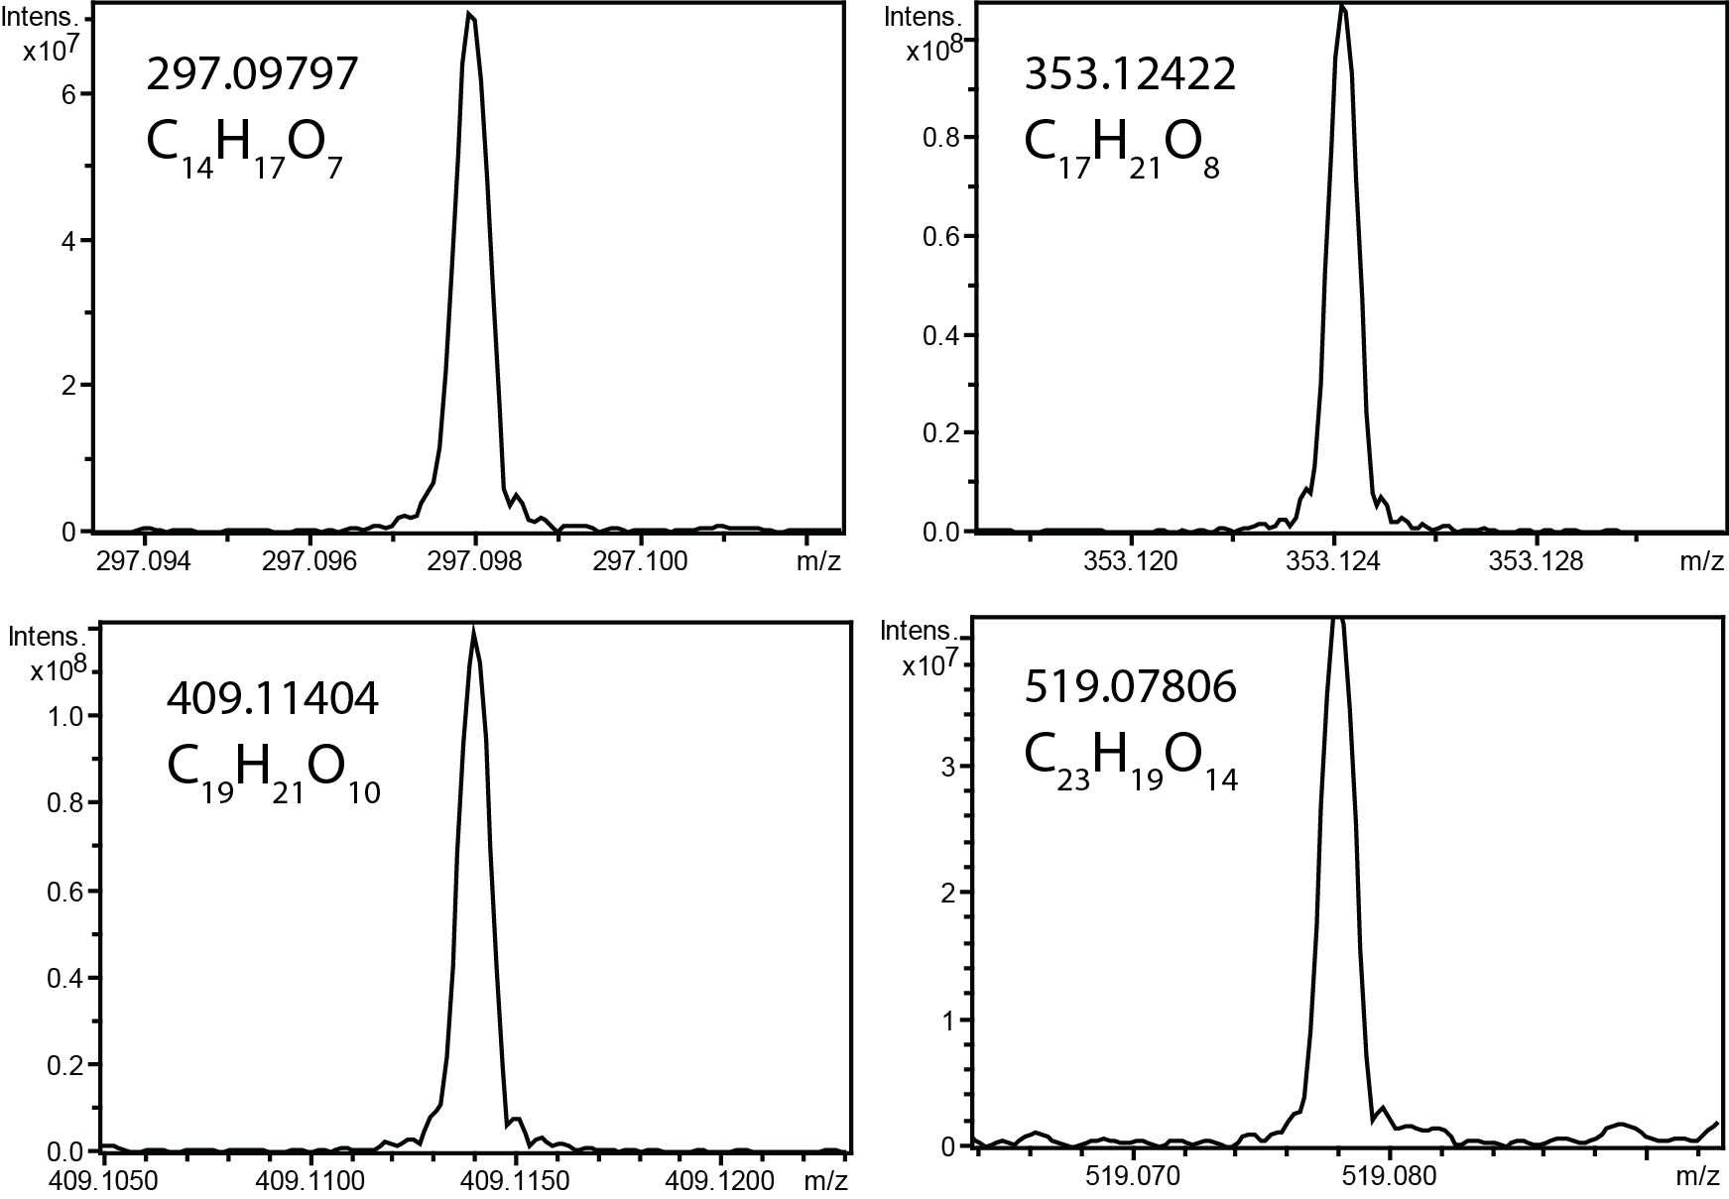
Figure S4: Some representative signals in the mass spectrum of SRFA (CHO space) with their minor but detectable wiggles.

3. Egg yolk lipid measurement:
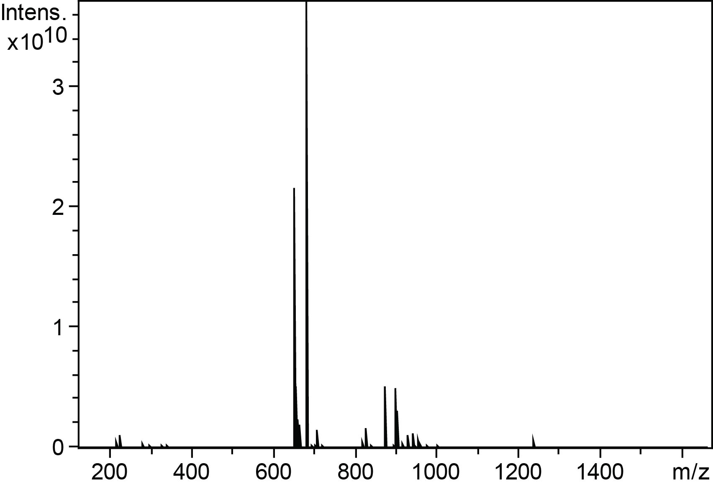
Figure S5: Mass spectrum of egg yolk (1:800 diluted in acetonitrile) in ESI- ionization mode.
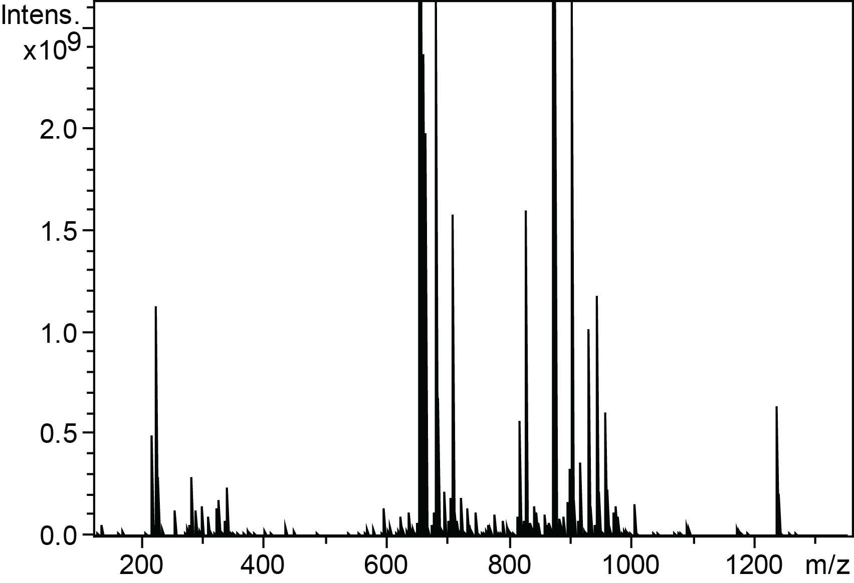
Figure S6: An enlarged view of the mass spectrum of Figure S5, showing more complexity in lipid high m/z range.
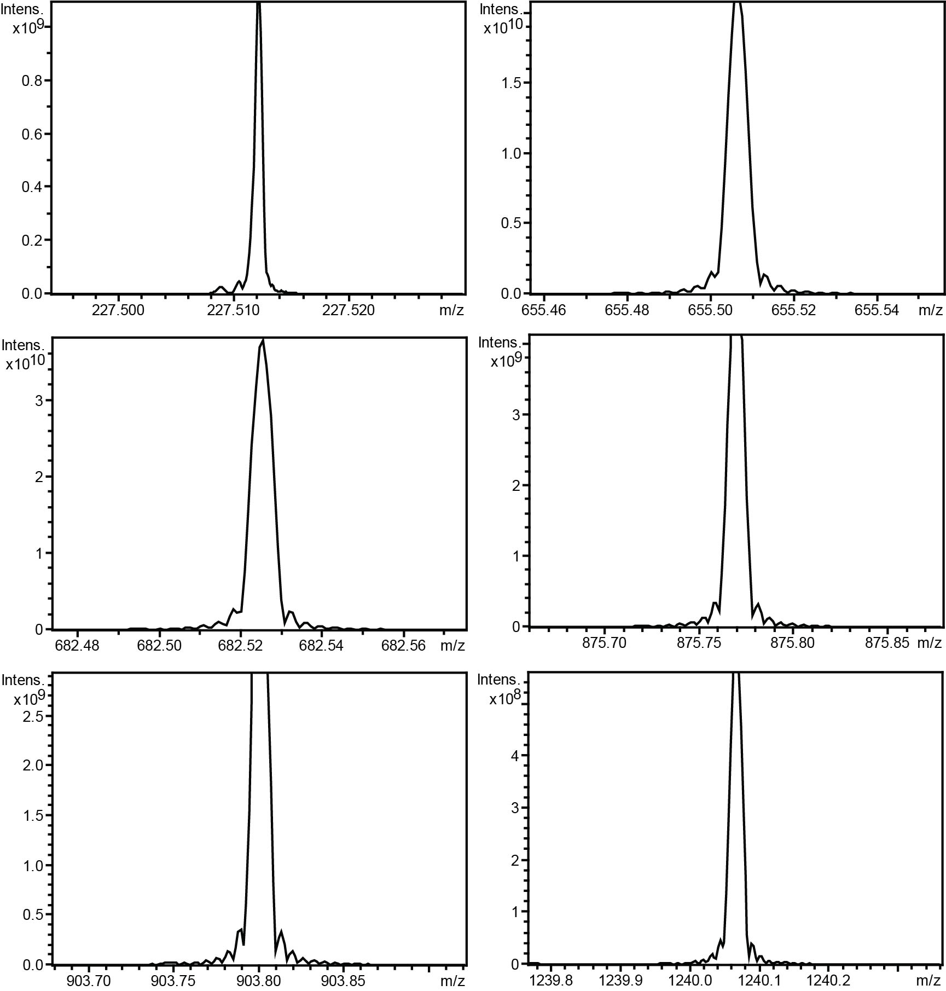
Figure S7: Several enlarged sections of the mass spectrum (Figure S5), which show the wiggles, that accompany main signals in different m/z ratios ranging from small m/z 227 to large m/z 1240.

4. Ubiquitin intact small protein measurement:
FT artifacts are easily seen in all detected multiply charged positive ion signals of ubiquitin, even those signals with m/z > 1000.
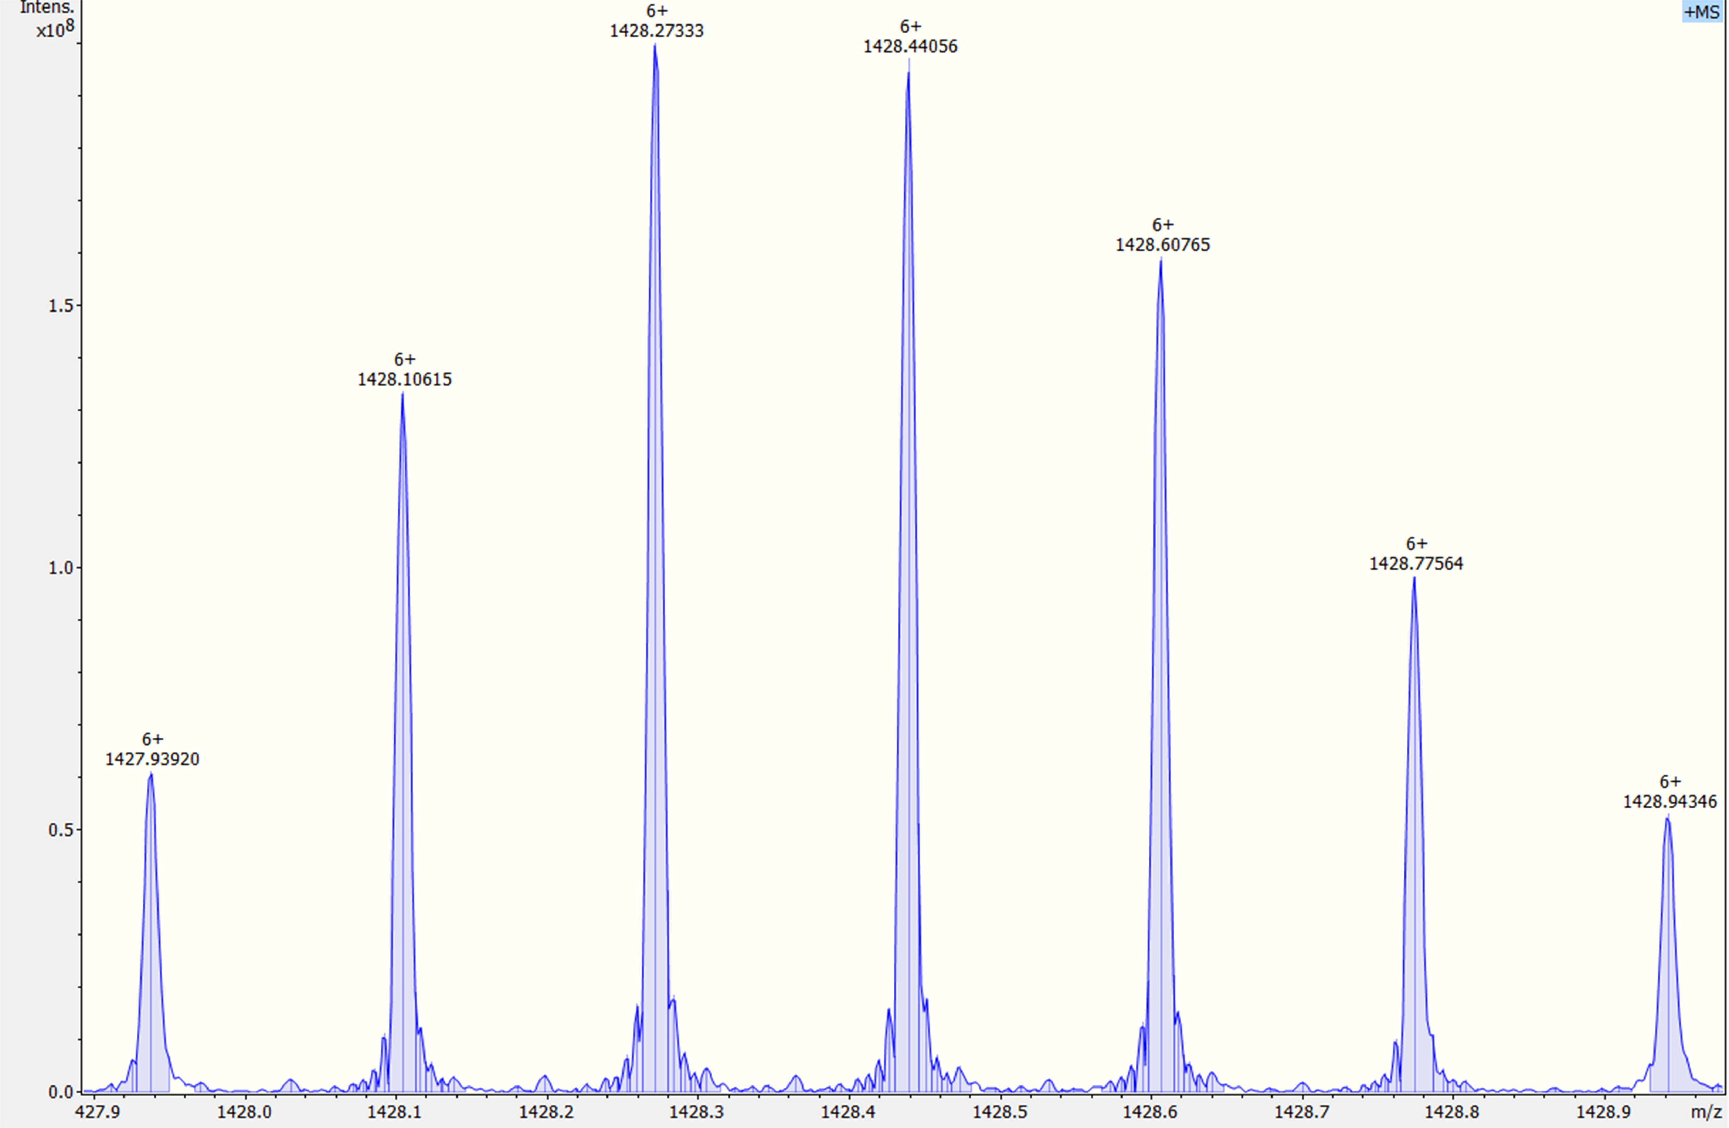
Figure S8: +6 charged Ubiquitin signals at m/z 1428.
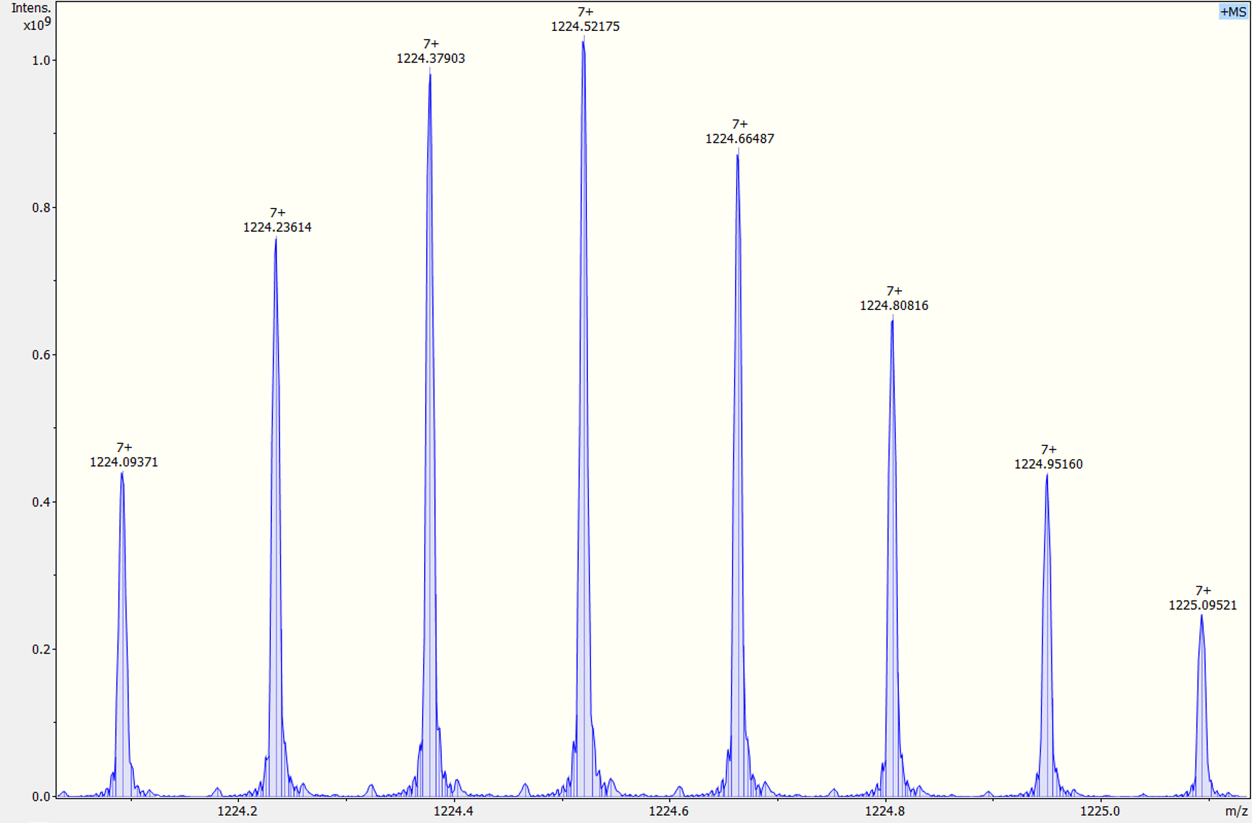
Figure S9: +7 charged Ubiquitin signals at m/z 1224.
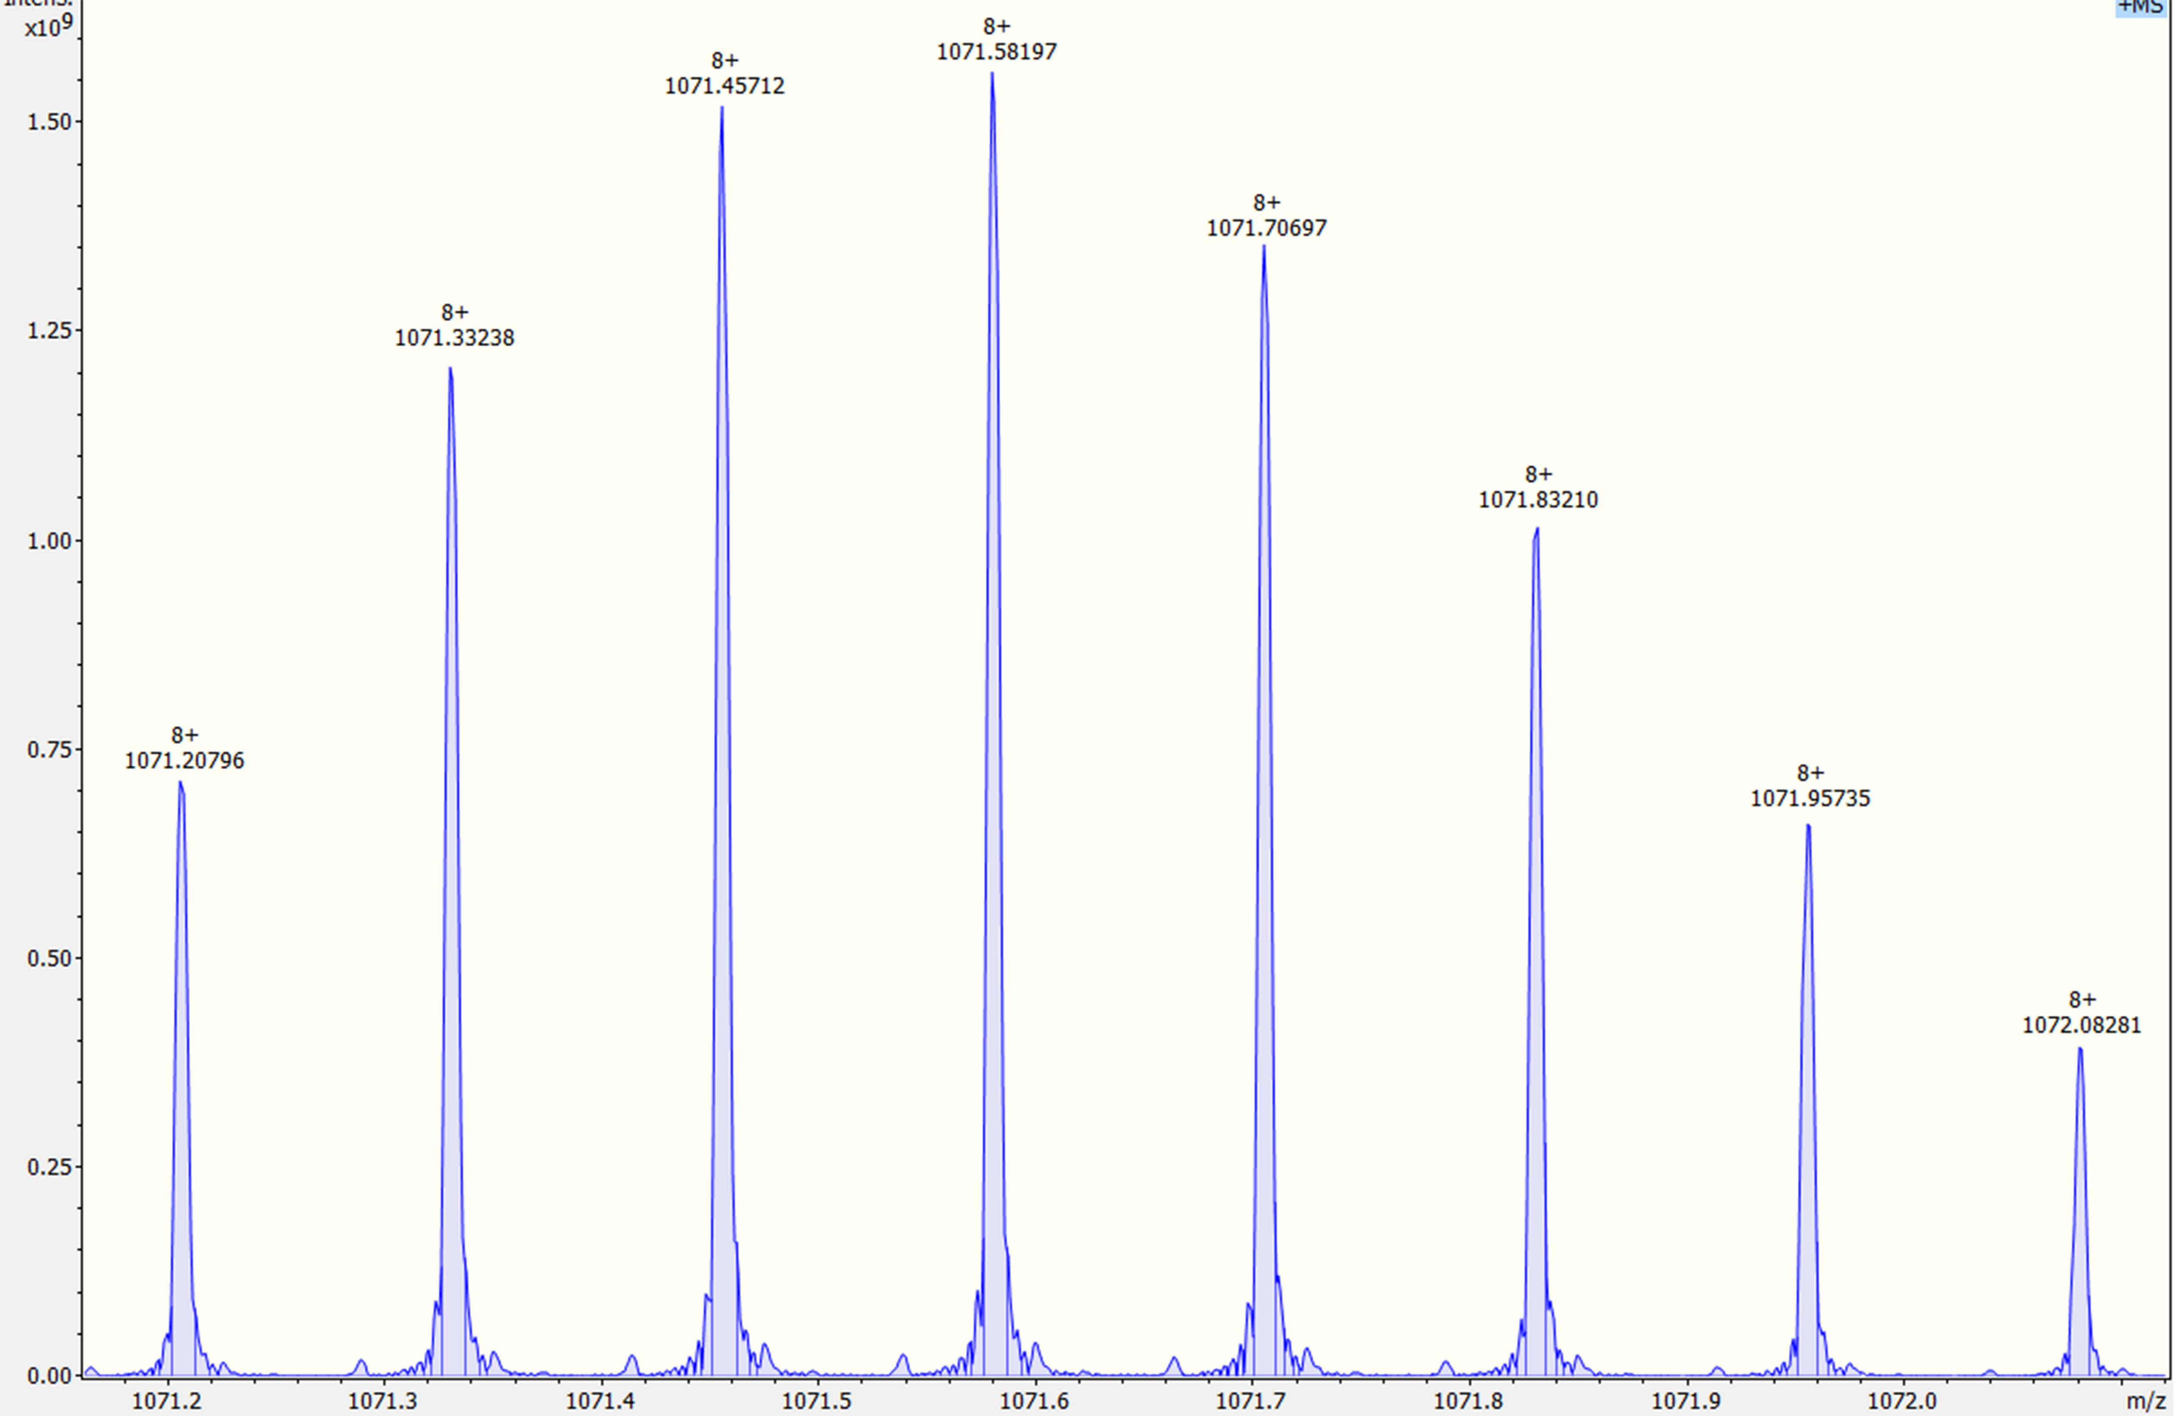
Figure S10: +8 charged Ubiquitin signals at m/z 1071.
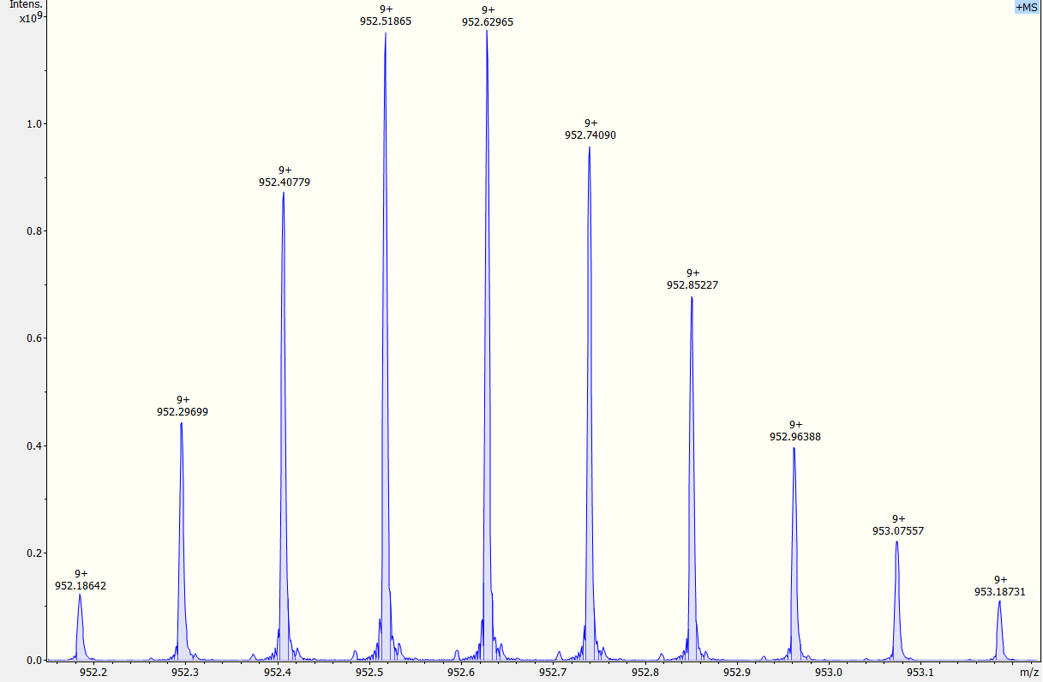
Figure S11: +9 charged Ubiquitin signals at m/z 952.
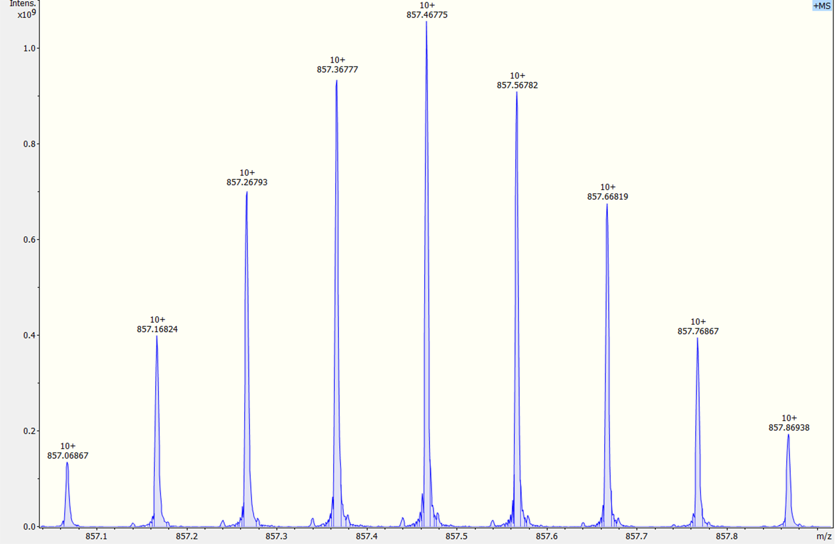
Figure S12: +10 charged Ubiquitin signals at m/z 857.

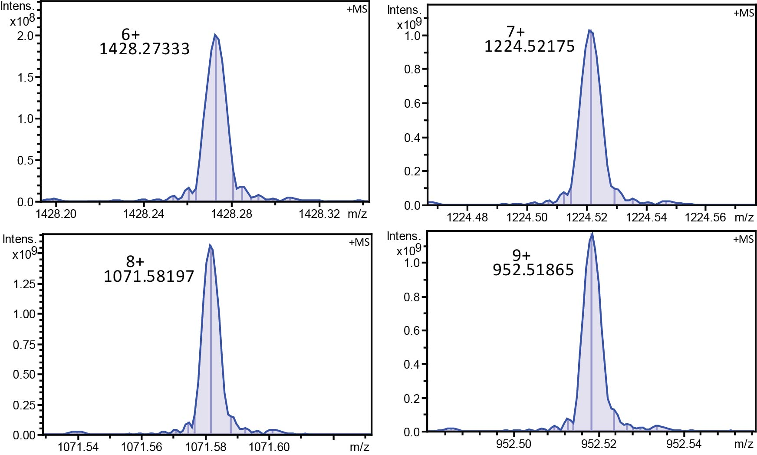
Figure S13: Selected ubiquitin signals at different charge states from +6 to +9, showing significant wiggles that are noticeable even at high mass range.

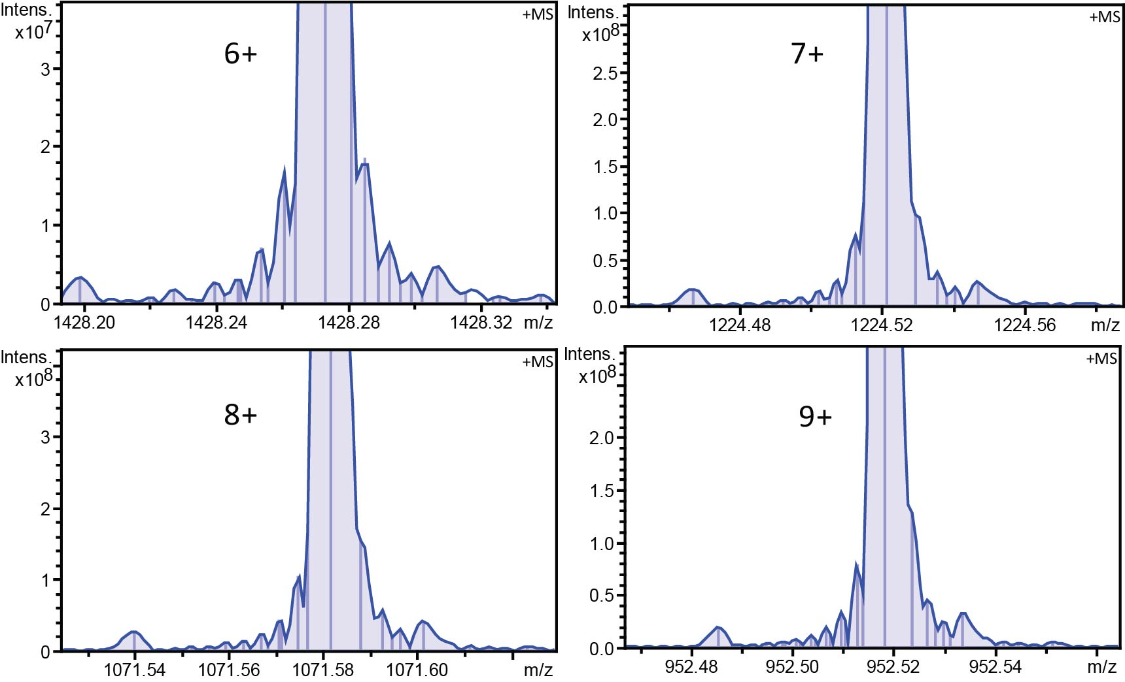
Figure S14: Enlarged view of Figure S13 for selected ubiquitin signals at different charge states from +6 to +9, showing significant wiggles that are noticeable even at high mass range.

