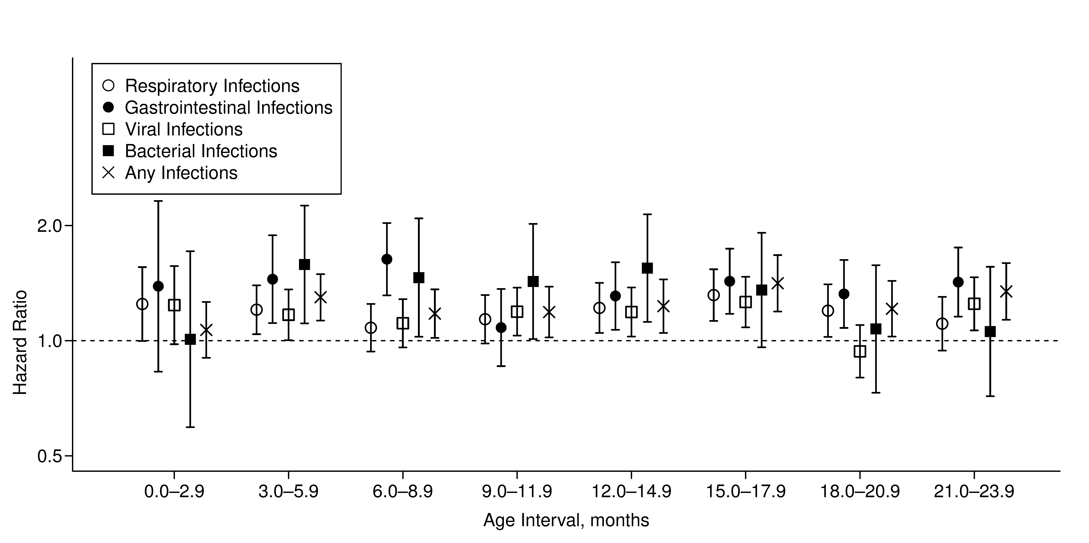
Web Figure 1. Hazard ratios (dots) and 95% confidence intervals for celiac disease development by types of medically attended infectious diseases, adjusted for sex, month of birth, number of previous healthcare visits, and number of previous quarterly intervals with infections of the same type, based on data of n=295,420 infants from Bavaria, Germany, born between 2005 and 2007. Time at risk for CD was measured after the respective infection exposure period for each model.

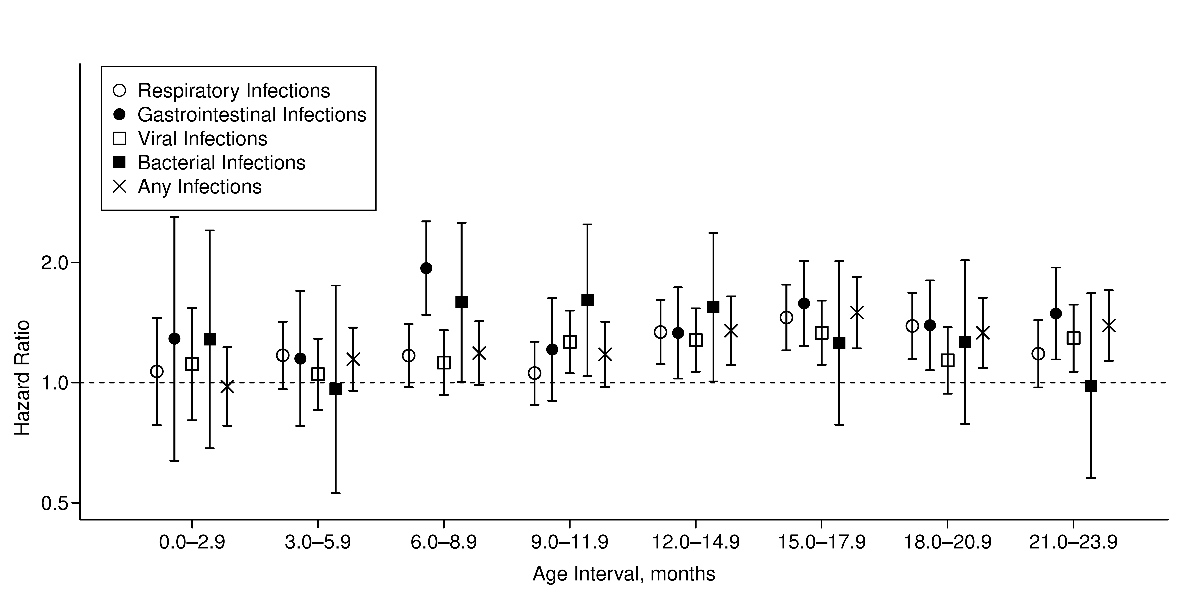
Web Figure 2. Hazard ratios (dots) and 95% confidence intervals for celiac disease development as recorded in at least two quarterly intervals by types of medically attended infectious diseases, adjusted for sex, month of birth and number of previous healthcare visits, based on data of n=295,420 infants from Bavaria, Germany, born between 2005 and 2007. Time at risk for CD was measured after the respective infection exposure period for each model.
Web Table 1. Infections were categorized by symptoms (respiratory, gastrointestinal, dermal, eye, and other) and causes (viral, bacterial, mycoses, parasites, or unknown) based on their ICD-10 code as tabulated below. For each child, the presence of infections (binary variable) from a specific category – but not their frequency – was reported in quarterly intervals. For example, if a child was diagnosed with a gastrointestinal infection in January, March and November of the same year, respectively, it would have a gastrointestinal infection record in the first and fourth quarter, but not in the second and third quarter of this particular year.
ICD-10 code | Categorization by symptoms | Categorization by causes
A00 | gastrointestinal | bacterial
A01 | gastrointestinal | bacterial
A02 | gastrointestinal | bacterial
A03 | gastrointestinal | bacterial
A04 | gastrointestinal | bacterial
A05 | gastrointestinal | bacterial
A06 | gastrointestinal | parasites
A07 | gastrointestinal | parasites
A08.0 | gastrointestinal | viral
A08.1 | gastrointestinal | viral
A08.2 | gastrointestinal | viral
A08.3 | gastrointestinal | viral
A08.4 | gastrointestinal | viral
A08.5 | gastrointestinal | unknown
A09 | gastrointestinal | unknown
A16 | other | bacterial
A21 | other | bacterial
A28 | other | bacterial
A37 | other | bacterial
A38 | respiratory | bacterial
A40 | other | bacterial
A41 | other | bacterial
A42 | other | bacterial
A49 | other | bacterial
A52 | other | bacterial
A54 | other | bacterial
A66 | other | bacterial
A68 | other | bacterial
A69 | other | bacterial
A87 | other | viral
A90 | other | viral
A93 | other | viral
A94 | other | viral
A98 | other | viral
B00 | other | viral
B01 | other | viral
B02 | other | viral
B05 | other | viral
B06 | other | viral
B07 | other | viral
B08 | other | viral
B09 | other | viral
B19 | other | viral
B26 | other | viral
B27 | other | viral
B30 | other | viral
B33 | other | viral
B34 | other | viral
B35 | other | mycoses
B36 | other | mycoses
B37 | other | mycoses
B43 | other | mycoses
B48 | other | mycoses
B49 | other | mycoses
B50 | other | parasites
B65 | other | parasites
B68 | other | parasites
B80 | other | parasites
B82 | other | parasites
B85 | other | parasites
B86 | other | parasites
B89 | other | parasites
B95 | other | bacterial
B97 | other | viral
B99 | other | unknown
G00 | other | bacterial
H00 | eye | unknown
H01 | eye | unknown
H04 | eye | unknown
H10.0 | eye | unknown
H10.2 | eye | unknown
H10.3 | eye | unknown
H10.4 | eye | unknown
H10.5 | eye | unknown
H10.8 | eye | unknown
H10.9 | eye | unknown
H60.0 | other | unknown
H60.3 | other | unknown
H60.9 | other | unknown
H65 | respiratory | unknown
H66 | respiratory | unknown
H70.0 | respiratory | unknown
H70.9 | respiratory | unknown
H73.0 | respiratory | unknown
H92 | respiratory | unknown
I30.1 | other | unknown
I88.0 | other | unknown
I88.9 | other | unknown
I89.1 | other | unknown
J00 | respiratory | viral
J01 | respiratory | unknown
J02.0 | respiratory | bacterial
J02.8 | respiratory | viral
J02.9 | respiratory | viral
J03.0 | respiratory | bacterial
J03.8 | respiratory | viral
J03.9 | respiratory | viral
J04 | respiratory | viral
J05 | respiratory | viral
J06 | respiratory | viral
J09 | respiratory | viral
J10 | respiratory | viral
J11 | respiratory | viral
J12 | respiratory | viral
J13 | respiratory | bacterial
J14 | respiratory | bacterial
J15 | respiratory | bacterial
J18 | respiratory | unknown
J20.0 | respiratory | bacterial
J20.1 | respiratory | bacterial
J20.2 | respiratory | bacterial
J20.3 | respiratory | viral
J20.4 | respiratory | viral
J20.5 | respiratory | viral
J20.6 | respiratory | viral
J20.7 | respiratory | viral
J20.8 | respiratory | unknown
J20.9 | respiratory | unknown
J21 | respiratory | unknown
J22 | respiratory | unknown
J32.0 | respiratory | unknown
J32.2 | respiratory | unknown
J32.8 | respiratory | unknown
J32.9 | respiratory | unknown
J35.9 | respiratory | unknown
J38.5 | respiratory | unknown
J40 | respiratory | unknown
J41 | respiratory | unknown
J42 | respiratory | unknown
J44.8 | respiratory | unknown
J45.1 | respiratory | unknown
J45.8 | respiratory | unknown
J45.9 | respiratory | unknown
J46 | respiratory | unknown
J85.1 | other | bacterial
J98 | respiratory | unknown
K04.6 | other | unknown
K05 | other | unknown
K12 | other | unknown
K13.7 | other | unknown
K14.1 | other | unknown
L00 | dermal | bacterial
L01 | dermal | bacterial
L02.1 | dermal | bacterial
L02.2 | dermal | bacterial
L02.3 | dermal | bacterial
L02.4 | dermal | bacterial
L02.9 | dermal | bacterial
L03 | dermal | bacterial
L04 | dermal | unknown
L08 | dermal | bacterial
M30.3 | other | unknown
M72.6 | other | bacterial
N10 | other | unknown
N11.9 | other | unknown
N30 | other | unknown
N34.1 | other | unknown
N39 | other | unknown
N45.9 | other | unknown
N48.1 | other | unknown
N48.2 | other | unknown
N51.2 | other | unknown
N61 | other | bacterial
N76.2 | other | unknown
N77.1 | other | unknown
P36 | other | unknown
P39.0 | other | unknown
P39.1 | eye | unknown
P39.2 | other | unknown
P39.3 | other | unknown
P39.4 | dermal | unknown
P39.8 | other | unknown
P39.9 | other | unknown
P58.2 | other | unknown
R05 | respiratory | unknown
R06.2 | respiratory | unknown
R06.7 | respiratory | viral
R07.0 | respiratory | unknown
R11 | gastrointestinal | unknown
R21 | dermal | unknown
R50 | fever | unknown
R56.0 | other | unknown
R59 | other | unknown
T88.0 | other | unknown

Web Table 2. Characteristics of study subjects according to records of medically attended infections during the first year of life.
 | All children  (n=295,420) | Children with ≥ 1 respiratory infections (n=203,160) | Children with ≥ 1 gastrointestinal infections (n=54,581)
Total follow-up, years (median) | 2,349,386 (8.5) | 1,640,579 (8.5) | 440,595 (8.5)
Celiac disease, n (%) | 853 (0.29 %) | 626 (0.31 %) | 203 (0.37 %)
Sex, n (%)
Males | 162,448 (55.0 %) | 115,103 (56.7 %) | 31,470 (57.6 %)
Females | 132,972 (45.0 %) | 88,057 (43.3 %) | 23,111 (42.3 %)
Season of birth, n (%)
March to May | 73,639 (24.9 %) | 51,422 (25.3 %) | 13,353 (24.5 %)
June to August | 77,996 (26.4 %) | 55,336 (27.2 %) | 15,361 (28.1 %)
September to November | 73,218 (24.8 %) | 49,470 (24.4 %) | 13,716 (25.1 %)
December to February | 70,567 (23.9 %) | 46,932 (23.1 %) | 12,151 (22.3 %)
Number of previous healthcare visits, n (%)
0-3 visits | 85,333 (28.9 %) | 38,829 (19.1 %) | 7,850 (14.4 %)
4-6 visits | 146,733 (49.7 %) | 109,846 (54.1 %) | 27,560 (50.5 %)
7-9 visits | 51,980 (17.6 %) | 44,086 (21.7 %) | 14,634 (26.8 %)
≥ 10 visits | 11,374 (3.8 %) | 10,399 (5.1 %) | 4,537 (8.3 %)

