Supplementary data of
Chemical composition and speciation of particulate organic matter from modern residential small-scale wood combustion appliances
Hendryk Czechª, Toni Mierschª, Jürgen Orasche^{a,b,c}, Gülcin Abbaszade^{b,c}, Olli Sippula^{c,d}, Jarkko Tissari^{d}, Bernhard Michalke^{e}, Jürgen Schnelle-Kreis^{b,c}, Thorsten Streibel^{a,b,c,}*, Jorma Jokiniemi^{c,d}, Ralf Zimmermann^{a,b,c}
ªJoint Mass Spectrometry Centre, Chair of Analytical Chemistry, Institute of Chemistry, University of Rostock, 18059 Rostock, Germany
^{b}Joint Mass Spectrometry Centre, Cooperation Group “Comprehensive Molecular Analytics” (CMA), Helmholtz Zentrum München – German Research Centre for Environmental Health, 85764 Neuherberg, Germany
^{c}Helmholtz Virtual Institute of Complex Molecular Systems in Environmental Health (HICE), Germany
^{d}Fine Particle and Aerosol Technology Laboratory, Department of Environmental and Biological Sciences, University of Eastern Finland, FIN-70211 Kuopio, Finland
^{e}Research Unit Analytical BioGeochemistry, Helmholtz Zentrum München – German Research Centre for Environmental Health, 85764 Neuherberg, Germany

*corresponding author
email: thorsten.streibel@uni-rostock.de
Keywords: photoionization, PAH, levoglucosan, EC/OC, air staging

Content:
1. ICP-OES method
2. Volcano plots from ANOVA with Bonferroni correction
3. Minimum and maximum EFs
4. REMPI mass spectra of OC3
5. REMPI mass spectra of OC1 and OC2 with logarithmic y-scale

1. Inductively-coupled plasma optical emission spectroscopy (ICP-OES)
1.1. Pressure digestion
Samples were exactly weighed into quartz vessels and 6 mL HNO₃, suprapure, subboiling distilled (Merck, Darmstadt), was added. The vessels were closed and introduced into a microwave digestion system (Paar).
Table S1 Digestion programme
Power | Ramp [min] | Hold [min]
800 | 5 | 5
1300 | 10 | 20
0 |  | 15
The resulting clear solutions were filled up exactly to the mark at 30 mL with Milli-Q H₂O and were then ready for element determination.

1.2 Sample analysis: ICP-OES measurement
Elements were analyzed using ICP atomic emission spectrometry (ICP-AES, system „Spectro Ciros Vision“ system from SPECTRO Analytical Instruments GmbH & Co. KG, Kleve, Germany). Sample introduction was carried out using the peristaltic pump of the instrument, connected to a Seaspray nebulizer with a cyclon spray chamber. The measured spectral element lines were Al 167.078 nm, As 189.042 nm, Ba 455.404 nm, Ca 183.801nm, Cd 214.438 nm, Co 228.616 nm, Cr 267.716 nm, Cu 324.754 nm, Fe 259.941 nm, K 766.491 nm, Mg 279.079 nm, Mn 257.611 nm, Mo 202.030 nm, Na 589.592 nm, Ni 231.604 nm, P 177.496 nm, Pb 220.353 nm, S 180.731 nm, Sb 206.833 nm, Se 196.090 nm, Sn 189.991 nm, Sr 407.771 nm, Ti 334.941 nm, V 292.464 nm, Zn 213.856 nm.
The RF power was set to 1200 W, the plasma gas was 14 L /min Ar, whereas the nebuliser gas was approximately 0.6 L /min Ar after daily optimization.

1.3. Quality control for element determinations
The determination method had been validated previously by regular laboratory inter-comparison studies and by regular analysis of adequate certified reference materials.
Regularly after ten measurements, three blank determinations and a control determination of a certified standard (CPI) for all mentioned elements were performed. Calculation of results was carried out on a computerized lab-data management system, relating the sample measurements to calibration curves, blank determinations, control standards and the weight of the digested sample.

2. Volcano plots from ANOVA with Bonferroni correction
Grey-shaded areas represent compounds which are at least 50 % enhanced in one wood type with a p-values smaller than 0.05.
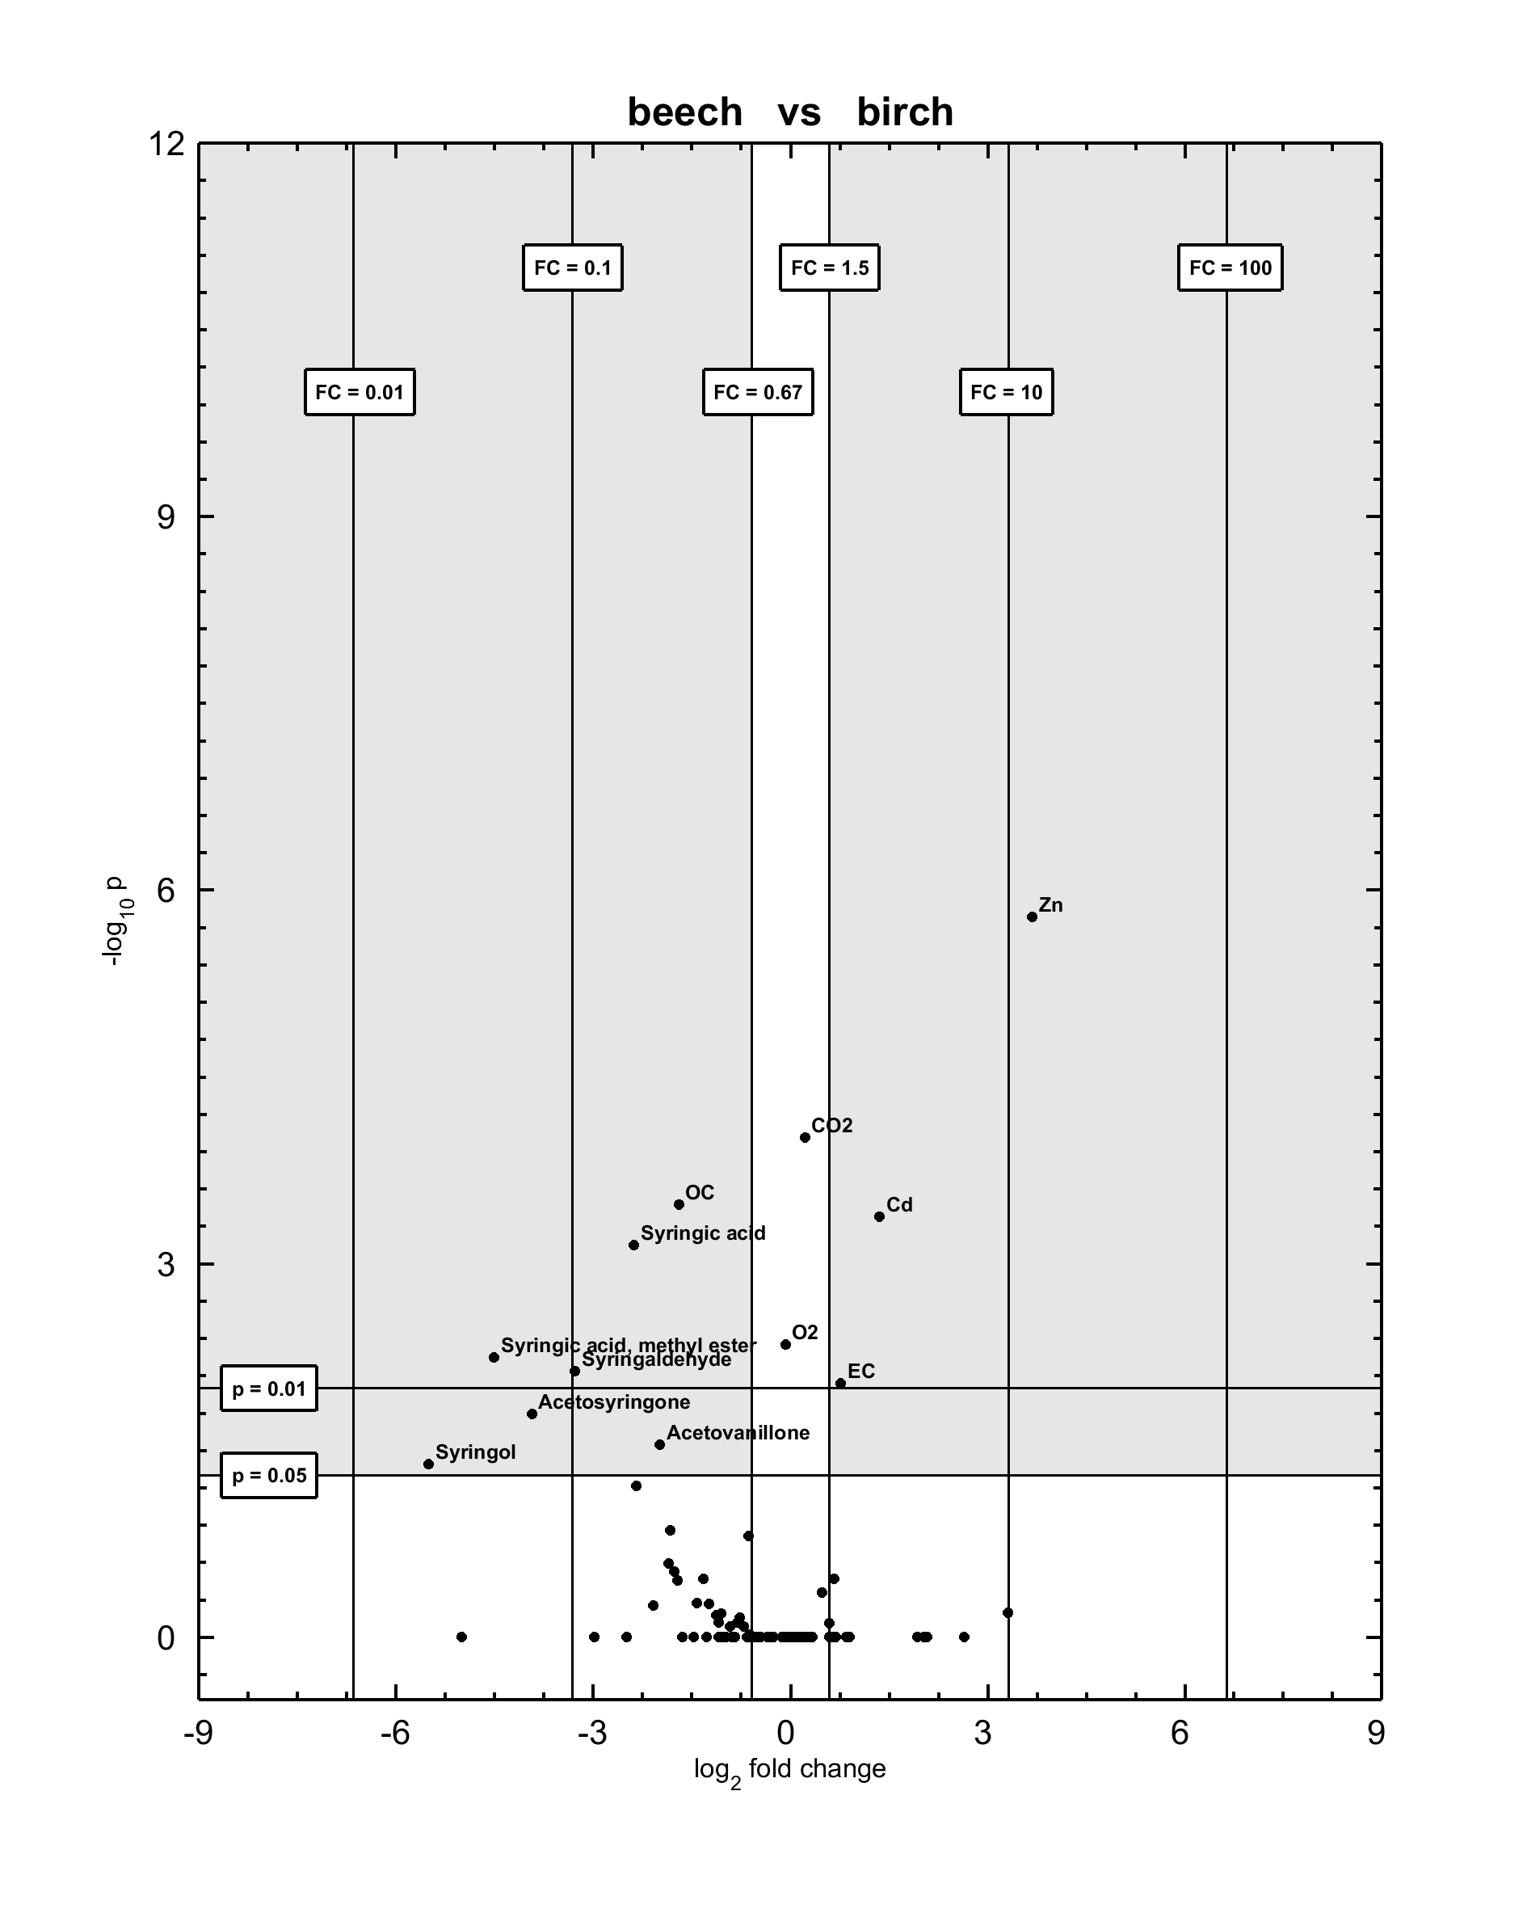
Fig. S1. Volcano plot of beech and birch

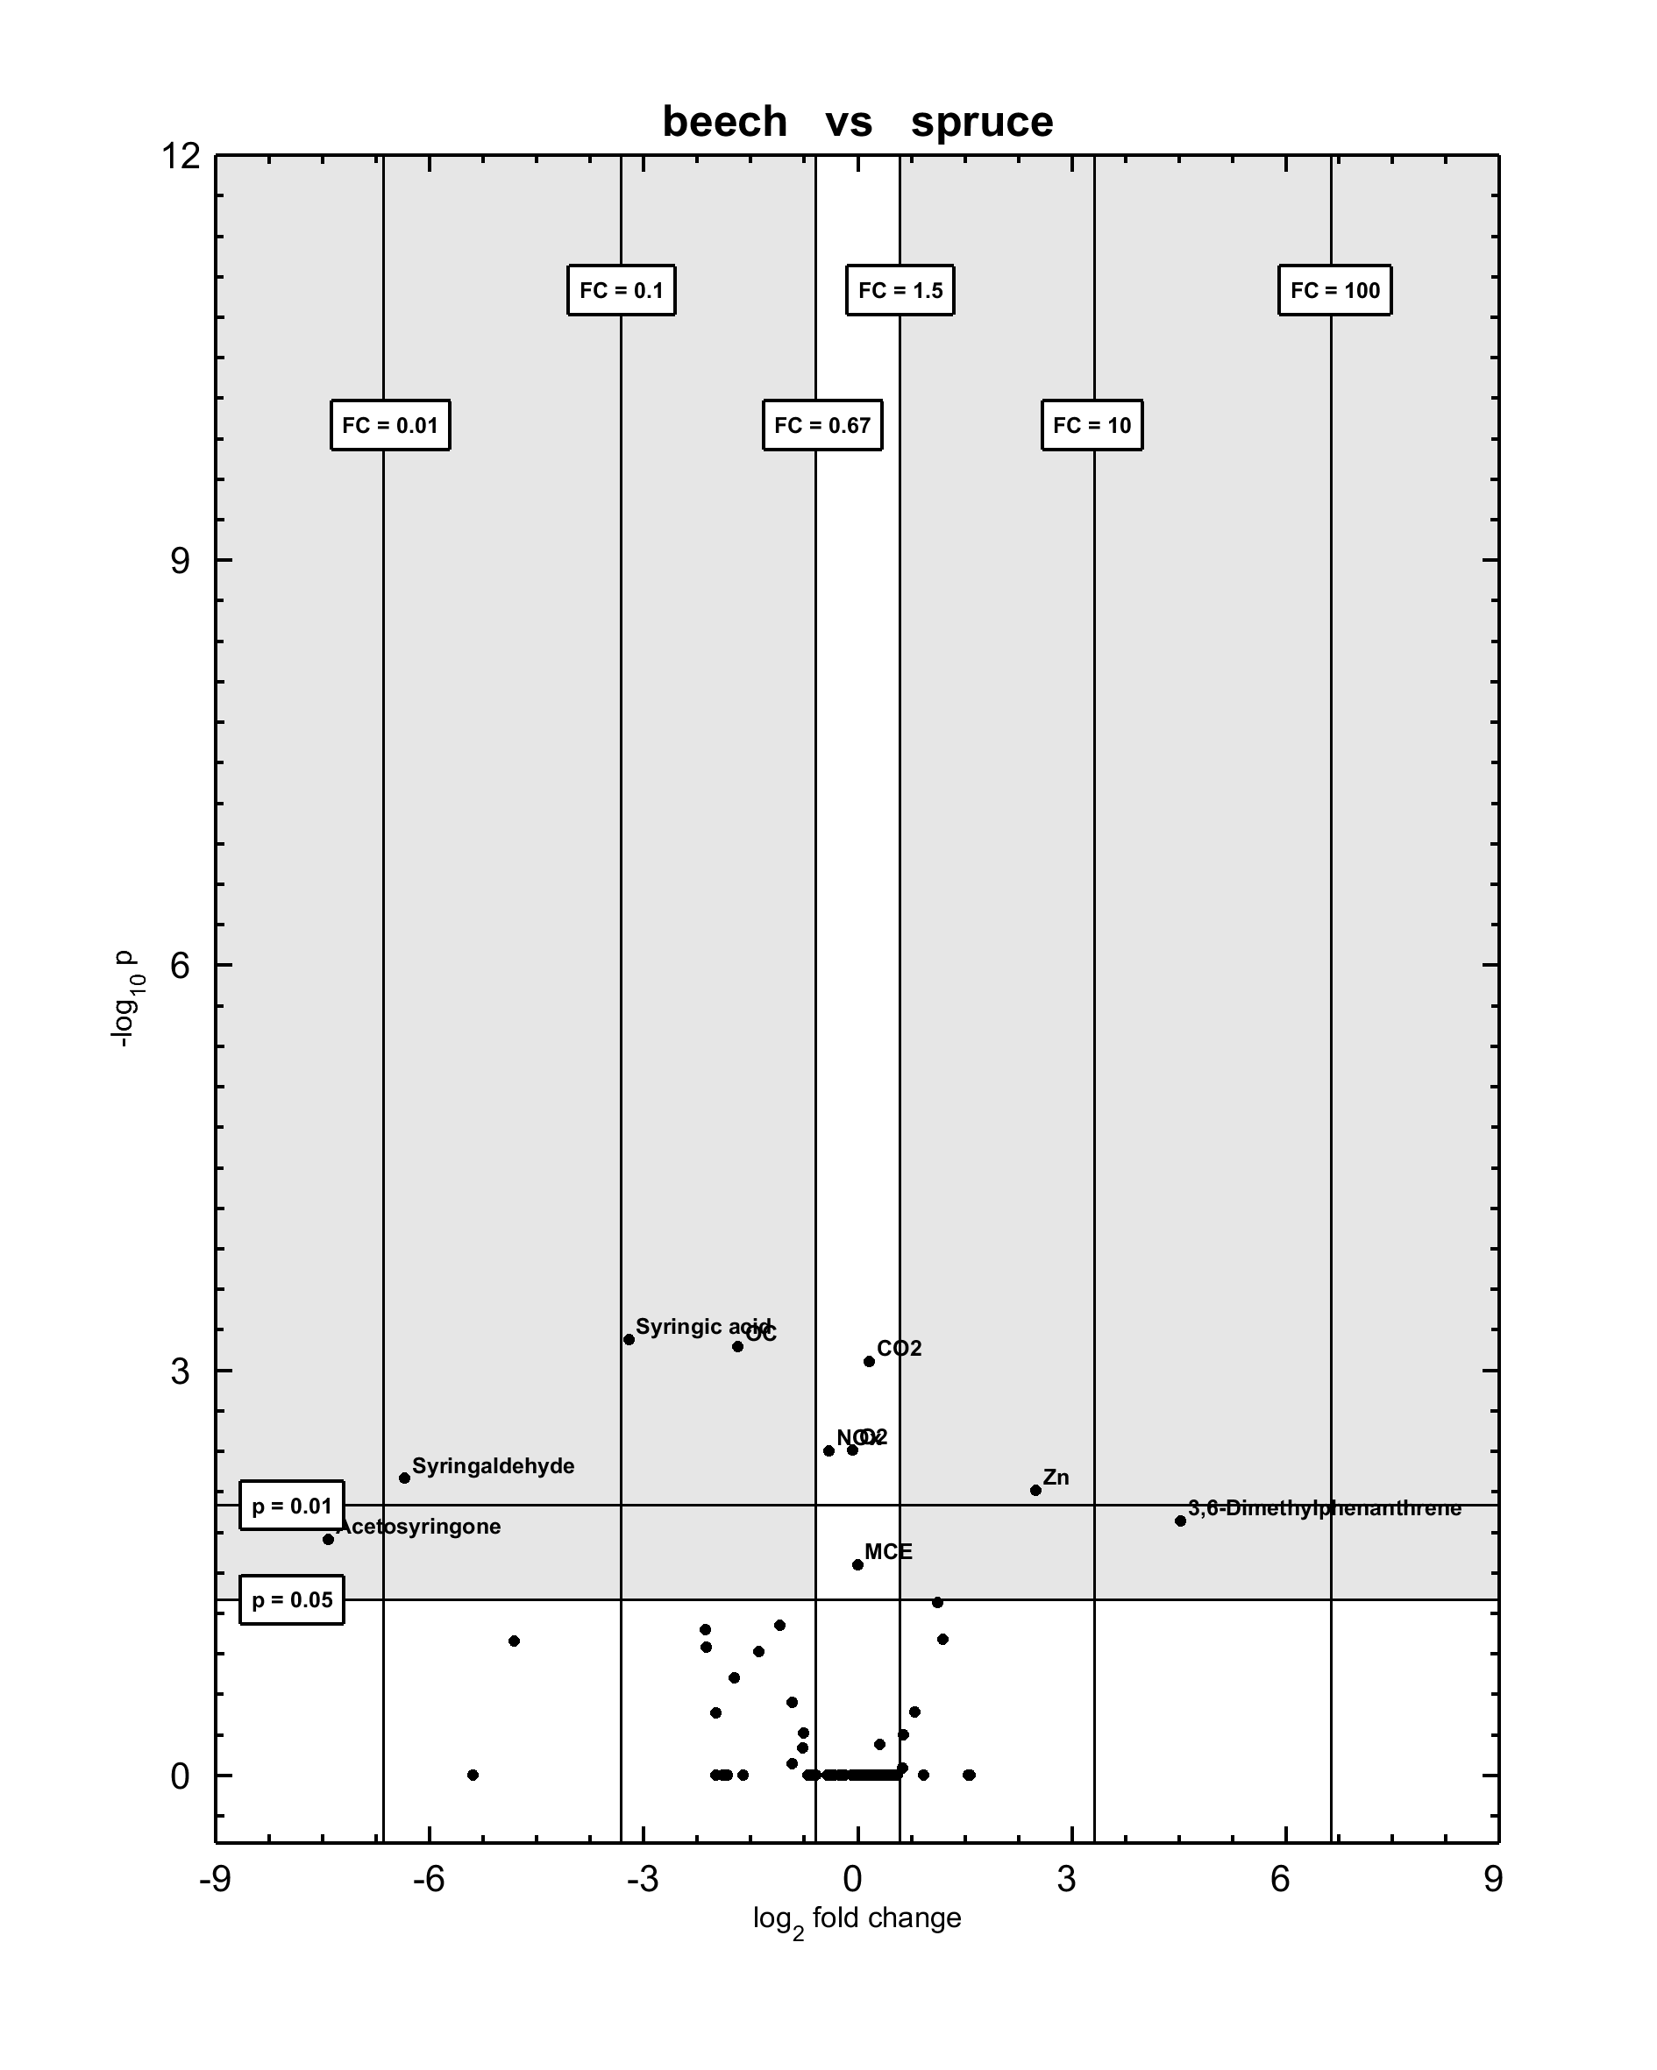
Fig. S2. Volcano plot of beech and spruce

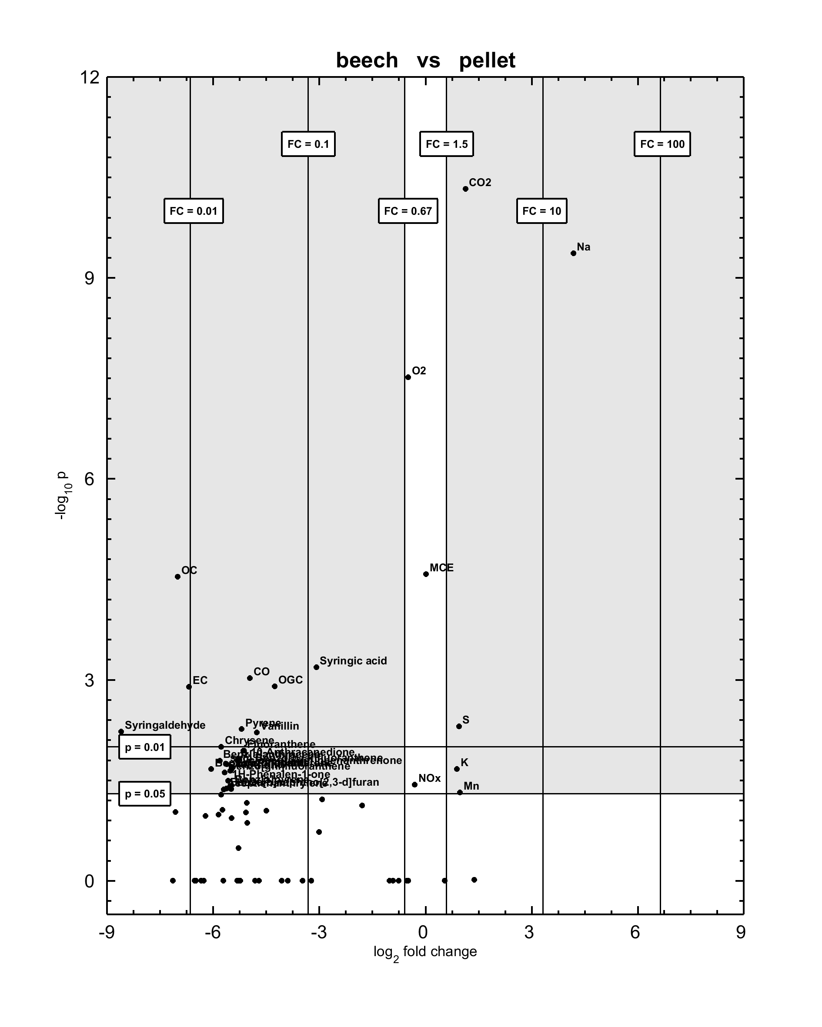
Fig. S3. Volcano plot of beech and pellet

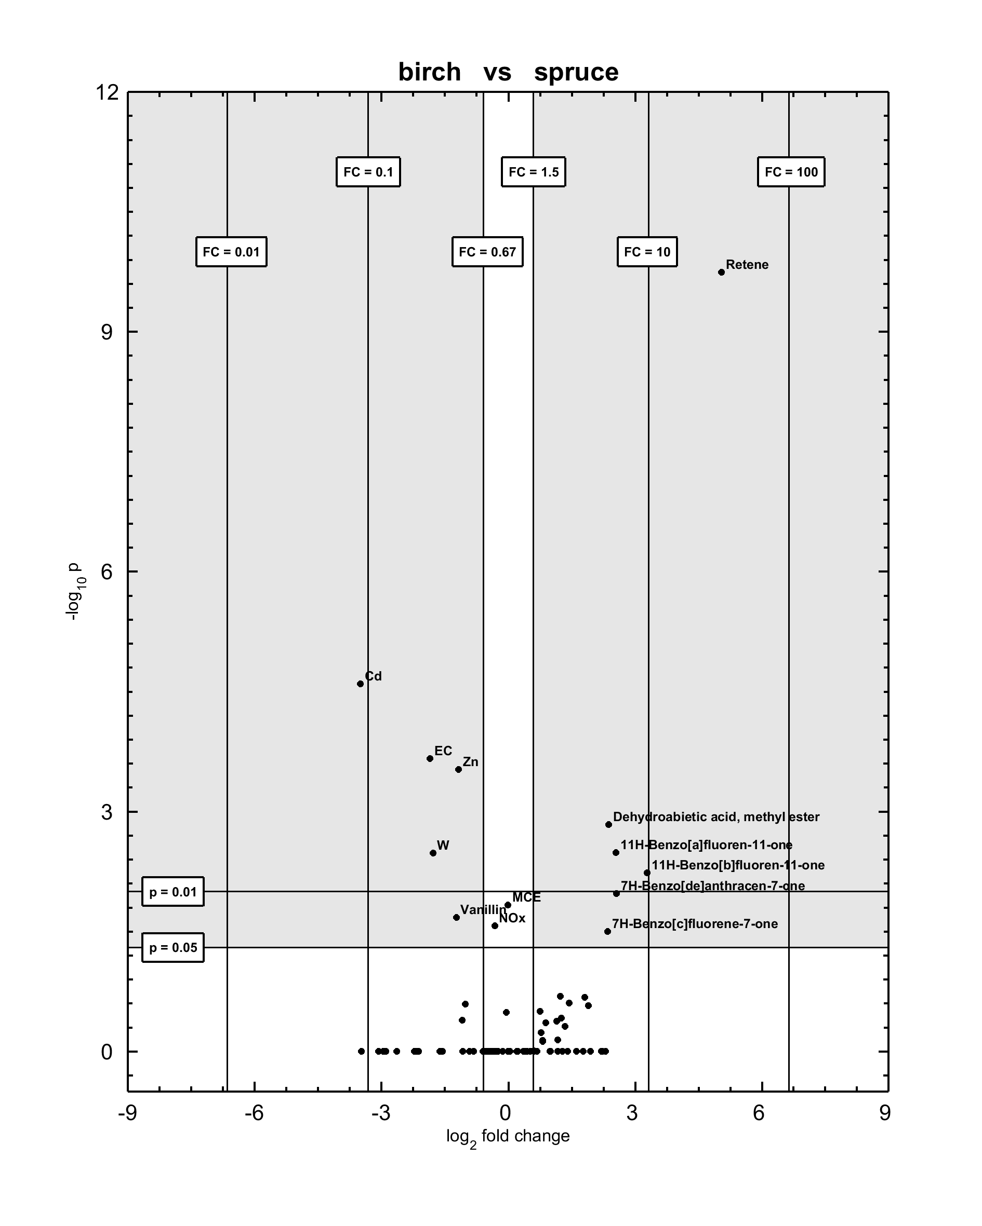
Fig. S4. Volcano plot of birch and spruce

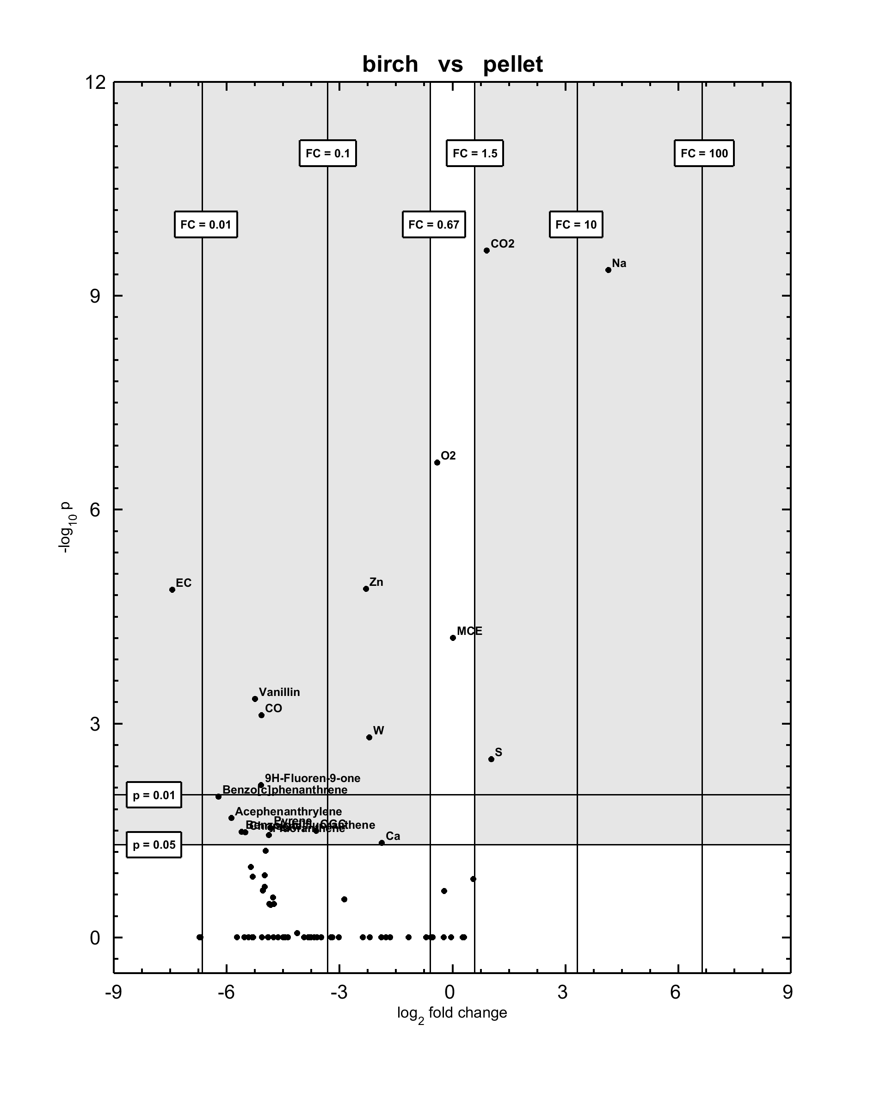
Fig. S5. Volcano plot of birch and pellet

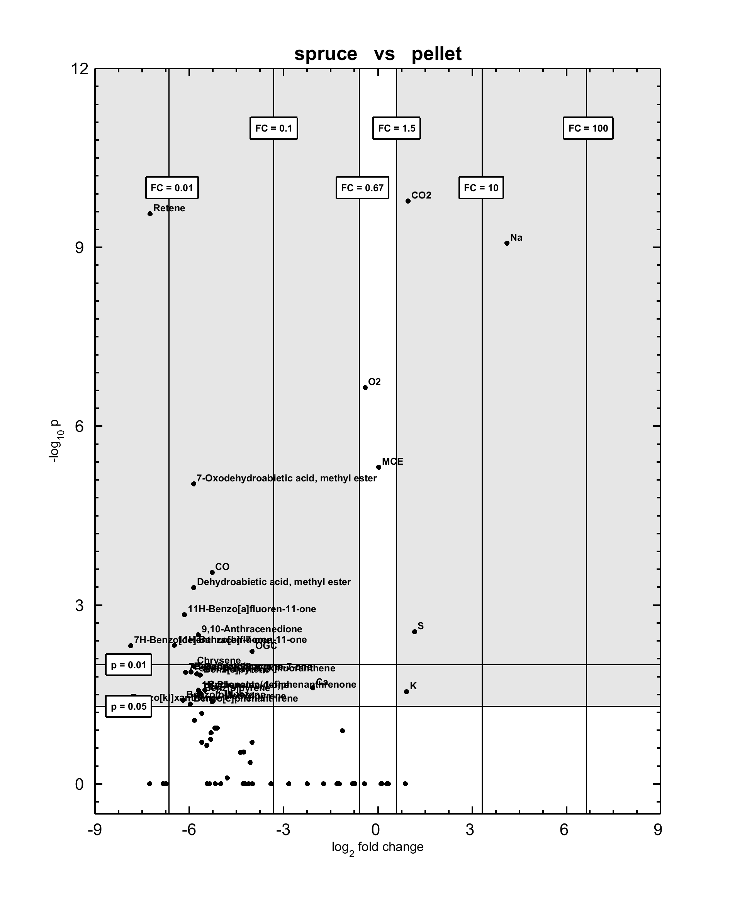
Fig. S6. Volcano plot of spruce and pellet

3. Minimum and maximum EFs
Table S2 Minimum and maximum EFs for experimental repetitions of the same conditions. EFs can be related to the amount of burned fuel by using respective net heating values from Table 1. Entries of b.q.l. refer to EFs below the limit of quantification.
 | beech |  | birch |  | spruce |  | pellets
Number of experiments | 4 |  | 4 |  | 3 |  | 3
 | min | max | min | max | min | max | min | max
Gaseous analytes
O₂ | 16.5 | 17.1 | 15.7 | 16.1 | 15.9 | 16.0 | 11.9 | 12.1
CO₂ | 3.83 | 4.07 | 4.49 | 4.62 | 4.27 | 4.44 | 8.50 | 8.59
CO | 887 | 1540 | 1150 | 1600 | 1600 | 1660 | 39.5 | 45.3
OGC | 15.7 | 29.4 | 12.6 | 18.7 | 19.6 | 21.3 | 1.23 | 1.28
NO_{x} | 99.0 | 119 | 103 | 105 | 75.3 | 86.9 | 89.0 | 89.1
MCE | 0.985 | 0.989 | 0.987 | 0.988 | 0.983 | 0.983 | 0.999 | 0.999
Particulate carbon
OC | 13 | 23 | 5.0 | 7.9 | 4.1 | 7.6 | 0.10 | 0.20
EC | 24 | 34 | 36 | 59 | 11 | 15 | 0.11 | 0.35
TC | 36.8 | 56.8 | 41.5 | 66.5 | 15.4 | 22.9 | 0.21 | 0.55
Inorganic particle constituents
Al | 30.4 | 72.1 | 26.1 | 199.1 | 35.0 | 46.5 | 10.1 | 33.6
B | b.q.l. | 9.19 | 4.30 | 6.71 | b.q.l. | 9.42 | 4.40 | 6.19
Ba | 1.32 | 1.99 | 1.02 | 2.63 | 1.30 | 2.50 | 1.02 | 1.43
Bi | b.q.l. | b.q.l. | b.q.l. | b.q.l. | b.q.l. | b.q.l. | 14.29 | 18.39
Ca | 51.4 | 96.8 | 58.2 | 103 | 56.2 | 143 | 20.0 | 32.0
Cd | 0.81 | 1.21 | 2.24 | 3.22 | b.q.l. | 0.66 | b.q.l. | b.q.l.
Cr | b.q.l. | 4.37 | b.q.l. | 7.14 | b.q.l. | b.q.l. | 0.94 | 2.23
Cu | b.q.l. | 52.2 | b.q.l. | 11.0 | b.q.l. | 8.00 | 6.25 | 9.72
Fe | 11.2 | 34.9 | 12.1 | 94.4 | 9.42 | 62.7 | 6.70 | 15.9
K | 1110 | 2630 | 1770 | 2390 | 1066 | 1990 | 2810 | 3290
Li | b.q.l. | b.q.l. | b.q.l. | b.q.l. | b.q.l. | b.q.l. | 4.84 | 5.14
Mn | 3.80 | 6.52 | 5.45 | 10.39 | 5.40 | 10.3 | 8.29 | 10.4
Mo | b.q.l. | b.q.l. | b.q.l. | b.q.l. | b.q.l. | b.q.l. | 0.70 | 1.10
Na | 17.6 | 89.6 | b.q.l. | 110 | 42.9 | 70.5 | 873 | 985
Pb | 4.91 | 12.8 | b.q.l. | 17.8 | b.q.l. | b.q.l. | b.q.l. | 1.82
S | 275.08 | 602.51 | 336 | 437 | 244 | 444 | 702 | 822
Ti | b.q.l. | 1.88 | 1.18 | 2.56 | 0.68 | 1.64 | b.q.l. | 0.94
W | b.q.l. | b.q.l. | 9.62 | 17.2 | b.q.l. | 6.87 | 2.44 | 3.13
Zn | 43.4 | 74.3 | 590 | 849 | 212 | 352 | 125 | 154
Particle-bound PAH
Phenanthrene | 4.98 | 14.14 | b.q.l. | 22.5 | 1.23 | 3.44 | 0.07 | 0.49
Anthracene | 0.46 | 1.96 | b.q.l. | 2.51 | 0.30 | 0.54 | b.q.l. | 0.07
Fluoranthene | 3.50 | 11.3 | 3.93 | 8.17 | 1.53 | 6.15 | 0.19 | 0.25
Acephenanthrylene | 0.22 | 0.94 | 0.32 | 0.91 | 0.17 | 0.50 | 0.01 | 0.02
Pyrene | 2.81 | 8.45 | 3.24 | 6.19 | 1.33 | 4.93 | 0.16 | 0.22
Benzo[a]fluorene | 0.11 | 0.83 | b.q.l. | 0.41 | 0.36 | 0.64 | 0.01 | 0.01
Benzo[b]fluorene | 0.18 | 0.72 | b.q.l. | 0.44 | 0.35 | 0.69 | 0.01 | 0.01
Benzo[c]phenanthrene | 0.20 | 0.51 | 0.23 | 0.61 | 0.24 | 0.47 | b.q.l. | 0.01
Benzo[ghi]fluoranthene | 1.02 | 2.32 | 0.96 | 2.85 | 0.82 | 1.90 | 0.03 | 0.05
Benz[a]anthracene | 0.27 | 1.07 | 0.34 | 0.71 | 0.62 | 1.09 | 0.01 | 0.02
Cyclopenta[cd]pyrene | b.q.l. | b.q.l. | b.q.l. | 0.25 | b.q.l. | b.q.l. | b.q.l. | 0.01
Chrysene | 0.59 | 1.87 | 0.64 | 1.56 | 1.07 | 1.93 | 0.02 | 0.03
2,2'-Binaphthalene | b.q.l. | b.q.l. | b.q.l. | b.q.l. | 0.07 | 0.11 | b.q.l. | b.q.l.
sum Benzo[b,j,k]fluoranthene | 0.88 | 2.86 | 0.86 | 1.85 | 1.45 | 3.27 | 0.03 | 0.07
Benz[e]pyrene | 0.35 | 1.13 | 0.33 | 0.65 | 0.54 | 1.28 | 0.01 | 0.03
Benz[a]pyrene | 0.36 | 1.31 | 0.30 | 0.94 | 0.64 | 1.38 | b.q.l. | 0.05
Perylene | b.q.l. | 0.14 | b.q.l. | 0.09 | 0.07 | 0.17 | b.q.l. | b.q.l.
Indeno[1,2,3-cd]fluoranthene | b.q.l. | b.q.l. | b.q.l. | 0.96 | b.q.l. | b.q.l. | b.q.l. | b.q.l.
Benzo[b]triphenylene | b.q.l. | b.q.l. | b.q.l. | b.q.l. | b.q.l. | 0.02 | b.q.l. | b.q.l.
Indeno[7,1,2,3-cdef]chrysene | b.q.l. | b.q.l. | b.q.l. | b.q.l. | b.q.l. | 0.08 | b.q.l. | b.q.l.
1-Phenylpyrene | b.q.l. | b.q.l. | b.q.l. | b.q.l. | b.q.l. | 0.02 | b.q.l. | b.q.l.
Dibenz[ah]anthracene | b.q.l. | b.q.l. | b.q.l. | b.q.l. | b.q.l. | 0.11 | b.q.l. | b.q.l.
Indeno[1,2,3-cd]pyrene | b.q.l. | 0.78 | b.q.l. | 0.73 | 0.25 | 0.73 | b.q.l. | 0.01
Benzo[b]chrysene | b.q.l. | b.q.l. | b.q.l. | b.q.l. | b.q.l. | 0.02 | b.q.l. | b.q.l.
Pentaphene | b.q.l. | b.q.l. | b.q.l. | 0.17 | b.q.l. | 0.02 | b.q.l. | b.q.l.
Picene | b.q.l. | b.q.l. | b.q.l. | b.q.l. | b.q.l. | b.q.l. | b.q.l. | b.q.l.
Benzo[ghi]perylene | b.q.l. | 1.1 | b.q.l. | 0.71 | 0.35 | 1.1 | b.q.l. | 0.06
Anthanthrene | b.q.l. | b.q.l. | b.q.l. | b.q.l. | b.q.l. | 0.04 | b.q.l. | b.q.l.
Coronene | b.q.l. | b.q.l. | b.q.l. | b.q.l. | b.q.l. | 0.31 | b.q.l. | 0.03
sum PAH | 15.9 | 51.4 | 11.2 | 53.2 | 11.4 | 31.0 | 0.55 | 1.42
PAH-TEQ | 0.512 | 1.85 | 0.451 | 1.36 | 0.929 | 2.10 | 0.011 | 0.060
particle-bound OH-PAH, OPAH & PASH
1-Hydroxynaphthalene | 2.7 | 12.4 | b.q.l. | 4.0 | 1.3 | 2.1 | 0.12 | 2.5
2-Hydroxynaphthalene | b.q.l. | 0.93 | b.q.l. | 1.6 | 0.22 | 0.60 | b.q.l. | b.q.l.
1,8-Dihydroxynaphthalene | b.q.l. | b.q.l. | b.q.l. | b.q.l. | b.q.l. | b.q.l. | b.q.l. | b.q.l.
1-Naphthalenecarboxaldehyde | b.q.l. | b.q.l. | b.q.l. | 0.31 | b.q.l. | b.q.l. | b.q.l. | b.q.l.
2-Naphthalenecarboxaldehyde | b.q.l. | 0.24 | b.q.l. | 0.94 | b.q.l. | b.q.l. | b.q.l. | b.q.l.
1(2H)-Acenaphthylenone | b.q.l. | 0.13 | b.q.l. | 0.17 | 0.03 | 0.07 | b.q.l. | b.q.l.
9H-Fluoren-9-one | 3.8 | 12 | 6.3 | 14 | 2.2 | 7.00 | 0.10 | 0.55
1H-Phenalen-1-one | 1.3 | 5.2 | 1.1 | 2.8 | 2.8 | 4.89 | 0.03 | 0.11
Xanthone | 1.6 | 5.3 | b.q.l. | 2.9 | 2.1 | 3.3 | 0.03 | 0.14
9,10-Anthracenedione | 1.9 | 5.7 | 1.4 | 4.2 | 4.0 | 6.6 | 0.03 | 0.19
Benzo[b]naphtho[1,2-d]furan | 0.31 | 3.6 | b.q.l. | 0.47 | 0.39 | 0.50 | 0.04 | 0.38
Cyclopenta(def)phenanthrenone | 1.6 | 5.1 | 1.0 | 3.4 | 2.3 | 4.9 | 0.02 | 0.15
1,8-Naphthalic anhydride | 14 | 48.9 | 5.8 | 22 | 2.60 | 11 | b.q.l. | b.q.l.
Benzo[b]naphtho[2,1-d]furan | 0.52 | 1.7 | b.q.l. | 1.0 | 0.36 | 1.3 | 0.01 | 0.04
2,3-5,6-Dibenzoxalene | 0.19 | 0.44 | b.q.l. | 0.40 | 0.15 | 0.51 | 0.01 | 0.01
Benzo[b]naphtho[2,3-d]furan | 0.12 | 0.47 | b.q.l. | 0.27 | 0.18 | 0.52 | b.q.l. | 0.01
Benzo[kl]xanthene | 0.13 | 0.42 | b.q.l. | 0.37 | 0.27 | 0.49 | b.q.l. | b.q.l.
11H-Benzo[a]fluoren-11-one | 0.08 | 0.30 | b.q.l. | 0.21 | 0.32 | 0.58 | b.q.l. | 0.01
7H-Benzo[c]fluorene-7-one | 0.03 | 0.14 | b.q.l. | 0.08 | 0.10 | 0.19 | b.q.l. | b.q.l.
11H-Benzo[b]fluoren-11-one | 0.13 | 0.80 | b.q.l. | 0.32 | 0.69 | 1.5 | 0.01 | 0.01
7H-Benzo[de]anthracen-7-one | 0.26 | 1.2 | b.q.l. | 0.72 | 1.1 | 2.0 | b.q.l. | 0.02
Naphtho[2,1,8,7-klmn]xanthene | 0.11 | 0.70 | b.q.l. | 1.5 | 0.09 | 1.1 | b.q.l. | 0.01
Benz[a]anthracene-7,12-dione | b.q.l. | b.q.l. | b.q.l. | 0.61 | 0.20 | 0.94 | b.q.l. | b.q.l.
5,12-Naphthacenedione | b.q.l. | b.q.l. | b.q.l. | b.q.l. | b.q.l. | b.q.l. | b.q.l. | b.q.l.
Phenanthro[3,4-c]furan-1,3-dione | b.q.l. | 0.38 | b.q.l. | b.q.l. | b.q.l. | b.q.l. | b.q.l. | b.q.l.
6H-Benzo[cd]pyren-6-on | 0.29 | 3.0 | b.q.l. | 2.9 | 0.95 | 5.7 | b.q.l. | 0.07
Dibenzothiophene | b.q.l. | 0.04 | b.q.l. | 0.13 | b.q.l. | 0.04 | b.q.l. | b.q.l.
Particle-bound alkylated PAH
9-Methylphenanthrene | b.q.l. | b.q.l. | b.q.l. | b.q.l. | b.q.l. | b.q.l. | b.q.l. | b.q.l.
3,6-Dimethylphenanthrene | b.q.l. | 0.09 | b.q.l. | 0.37 | 0.25 | 0.79 | b.q.l. | b.q.l.
Retene | b.q.l. | b.q.l. | b.q.l. | 0.29 | 6.0 | 7.1 | 0.01 | 0.11
sum 2-/8-Methylfluoranthene | 0.16 | 0.73 | b.q.l. | 0.45 | 0.31 | 0.66 | b.q.l. | 0.02
sum 1-/3-/7-Methylfluoranthene | 0.24 | 1.0 | b.q.l. | 0.62 | 0.42 | 0.87 | 0.01 | 0.02
4-Methylpyrene | 0.04 | 0.54 | b.q.l. | 0.15 | 0.21 | 0.36 | b.q.l. | 0.01
2-Methylpyrene | 0.23 | 1.0 | b.q.l. | 0.56 | 0.49 | 0.82 | 0.01 | 0.02
1-Methylpyrene | 0.17 | 0.96 | b.q.l. | 0.48 | 0.42 | 0.68 | 0.01 | 0.02
4,5-Dimethylpyrene | b.q.l. | 0.25 | b.q.l. | b.q.l. | b.q.l. | b.q.l. | b.q.l. | 0.01
2,3,6,7-Tetramethylanthracene | b.q.l. | b.q.l. | b.q.l. | b.q.l. | 0.26 | 0.51 | b.q.l. | b.q.l.
1-Methyl-benz[a]anthracene | b.q.l. | b.q.l. | b.q.l. | b.q.l. | b.q.l. | b.q.l. | b.q.l. | b.q.l.
Particle-bound anhydrous sugars
Galactosan | 0.80 | 4.0 | 0.60 | 4.2 | 1.5 | 5.4 | b.q.l. | b.q.l.
Mannosan | 3.5 | 18 | 1.9 | 7.3 | 5.1 | 16.4 | 0.13 | 0.80
Levoglucosan | 31 | 240 | 42 | 73 | 40 | 108 | 3.9 | 14
Particle-bound phenolic species
4-Hydroxyphenylethanol | b.q.l. | 3.1 | b.q.l. | b.q.l. | b.q.l. | b.q.l. | b.q.l. | b.q.l.
4-Hydroxybenzoic acid | b.q.l. | 16.0 | b.q.l. | b.q.l. | b.q.l. | b.q.l. | b.q.l. | b.q.l.
Vanillin | 7.10 | 16.4 | 11.8 | 15.6 | 3.81 | 8.71 | 0.12 | 0.66
Isoeugenol | b.q.l. | 9.82 | b.q.l. | b.q.l. | b.q.l. | b.q.l. | b.q.l. | b.q.l.
Acetovanillone | 0.93 | 2.9 | b.q.l. | 1.5 | 0.62 | 0.98 | b.q.l. | b.q.l.
Methylvanillate | b.q.l. | 2.1 | b.q.l. | b.q.l. | 0.24 | 0.29 | b.q.l. | 0.02
Vanillic acid | b.q.l. | 1.5 | b.q.l. | 3.5 | b.q.l. | b.q.l. | b.q.l. | b.q.l.
3-Guaiacylpropanol | b.q.l. | 2.4 | b.q.l. | b.q.l. | b.q.l. | b.q.l. | b.q.l. | b.q.l.
Coniferaldehyde | b.q.l. | 5.2 | b.q.l. | b.q.l. | b.q.l. | 2.4 | b.q.l. | b.q.l.
Guaiacylaceton | b.q.l. | b.q.l. | b.q.l. | b.q.l. | b.q.l. | b.q.l. | b.q.l. | b.q.l.
4-Guaiacylbutanoic acid | b.q.l. | 2.3 | b.q.l. | b.q.l. | b.q.l. | b.q.l. | b.q.l. | b.q.l.
Syringol | b.q.l. | 3.1 | b.q.l. | 0.15 | b.q.l. | b.q.l. | b.q.l. | b.q.l.
4-Methylsyringol | b.q.l. | 4.4 | b.q.l. | b.q.l. | b.q.l. | b.q.l. | b.q.l. | b.q.l.
4-Ethylsyringol | b.q.l. | 4.8 | b.q.l. | b.q.l. | b.q.l. | b.q.l. | b.q.l. | b.q.l.
Allylsyringol | b.q.l. | 0.32 | b.q.l. | b.q.l. | b.q.l. | b.q.l. | b.q.l. | b.q.l.
Syringaldehyde | 9.9 | 52 | b.q.l. | 9.5 | 0.16 | 0.76 | b.q.l. | 0.25
Syringylpropene | 0.38 | 1.6 | b.q.l. | 0.36 | b.q.l. | 0.03 | b.q.l. | 0.02
Acetosyringone | 0.82 | 6.5 | b.q.l. | 0.87 | b.q.l. | 0.08 | b.q.l. | b.q.l.
Syringic acid, methyl ester | 0.20 | 1.3 | b.q.l. | 0.11 | b.q.l. | b.q.l. | b.q.l. | b.q.l.
Syringic acid | 0.53 | 1.1 | b.q.l. | 0.29 | 0.08 | 0.11 | 0.02 | 0.26
Homosyringic acid | b.q.l. | 0.48 | b.q.l. | b.q.l. | b.q.l. | b.q.l. | b.q.l. | b.q.l.
Sinapylaldehyde | b.q.l. | 2.5 | b.q.l. | b.q.l. | b.q.l. | b.q.l. | b.q.l. | b.q.l.
3,5-Dimethoxy-4,4'-dihydroxystilbene | b.q.l. | 3.8 | b.q.l. | b.q.l. | b.q.l. | b.q.l. | b.q.l. | b.q.l.
sum phenolic species | 19.9 | 143 | 11.8 | 31.9 | 4.91 | 13.4 | 0.14 | 1.21
Particle-bound resin constituents
Pimaric acid | b.q.l. | b.q.l. | b.q.l. | b.q.l. | b.q.l. | 0.12 | b.q.l. | b.q.l.
Isopimaric acid | b.q.l. | b.q.l. | b.q.l. | b.q.l. | b.q.l. | b.q.l. | b.q.l. | b.q.l.
Abietic acid | b.q.l. | b.q.l. | b.q.l. | b.q.l. | b.q.l. | b.q.l. | b.q.l. | b.q.l.
6-Dehydrodehydroabietic acid | b.q.l. | b.q.l. | b.q.l. | b.q.l. | b.q.l. | 3.24 | b.q.l. | b.q.l.
Dehydroabietic acid | b.q.l. | b.q.l. | b.q.l. | 22 | 11 | 98 | b.q.l. | b.q.l.
7-Oxodehydroabietic acid | b.q.l. | b.q.l. | b.q.l. | b.q.l. | 0.08 | 0.08 | b.q.l. | b.q.l.
6-Dehydrodehydroabietic acid, methyl ester | b.q.l. | b.q.l. | b.q.l. | b.q.l. | 0.06 | 0.12 | b.q.l. | b.q.l.
Dehydroabietic acid, methyl ester | b.q.l. | b.q.l. | b.q.l. | 0.38 | 0.58 | 1.10 | 0.01 | 0.03
7-Oxodehydroabietic acid, methyl ester | b.q.l. | b.q.l. | b.q.l. | b.q.l. | 0.07 | 0.11 | b.q.l. | b.q.l.
Particle-bound phytosterols
β-Sitosterol | b.q.l. | b.q.l. | b.q.l. | b.q.l. | b.q.l. | b.q.l. | b.q.l. | 26
Stigmasta-3,5-dien-7-one | b.q.l. | 480 | b.q.l. | 22 | b.q.l. | b.q.l. | b.q.l. | b.q.l.
Lupa-2,22(29)-dien-28-ol | b.q.l. | b.q.l. | b.q.l. | 85 | b.q.l. | 14 | b.q.l. | b.q.l.

4. REMPI mass spectra of OC3
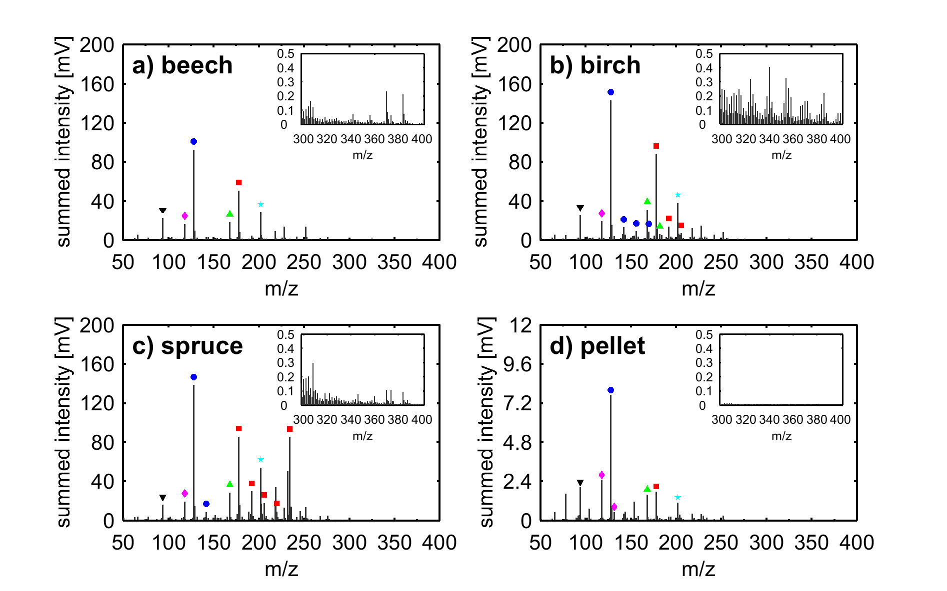
Fig. S7 Mean REMPI mass spectra of summed intensities of OC3 for the four investigated wood types. Symbols denote the homologue series of alkylated dibenzofuran (green triangle), phenanthrene (red squares), pyrene (cyan pentagram), naphthalene (blue circles), benzofuran (magenta diamond) and phenol (black down-pointing triangle).

5. REMPI spectra of OC1+2 in logarithmic y-scale
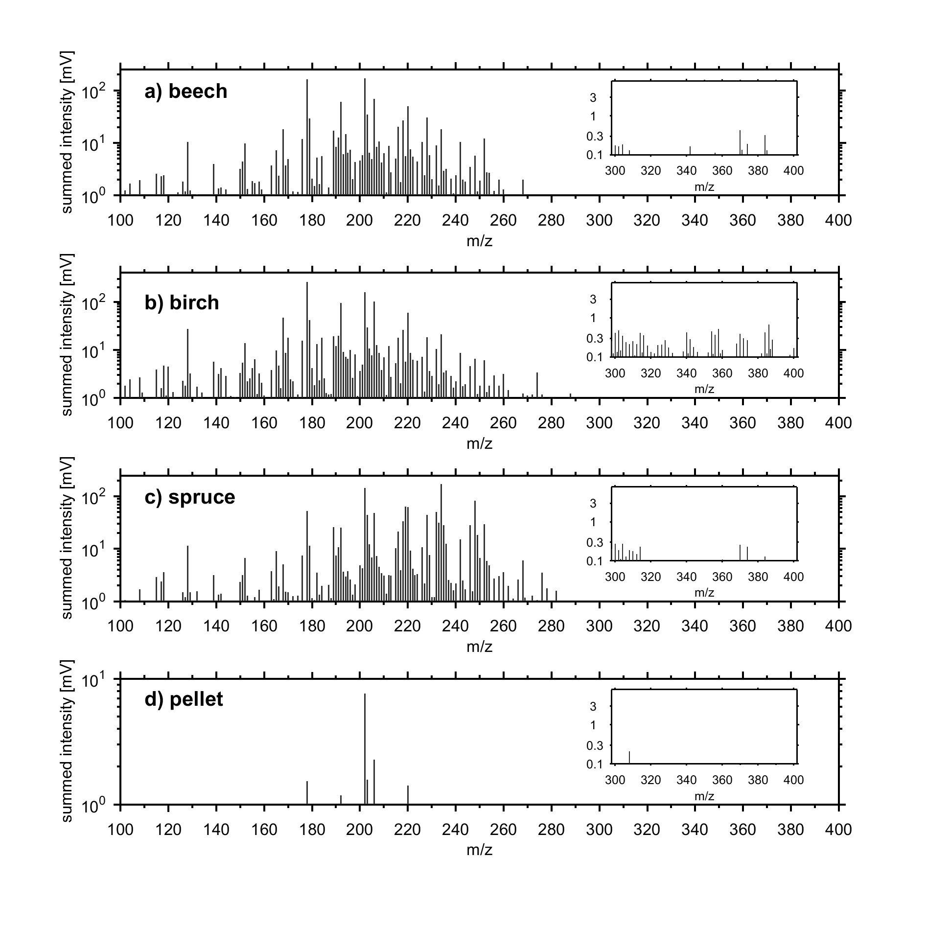
Fig. S8 Mean REMPI mass spectra of summed intensities of OC1+OC2 for the four investigated wood types, equal to Fig. 3 in the manuscript, but with logarithmic y-scale. Panels in the upper right corner belong to fingerprint regions of the wood types, which contain alteration products of phytosterols and lignans and enable wood type identification despite similar alkylation patterns.
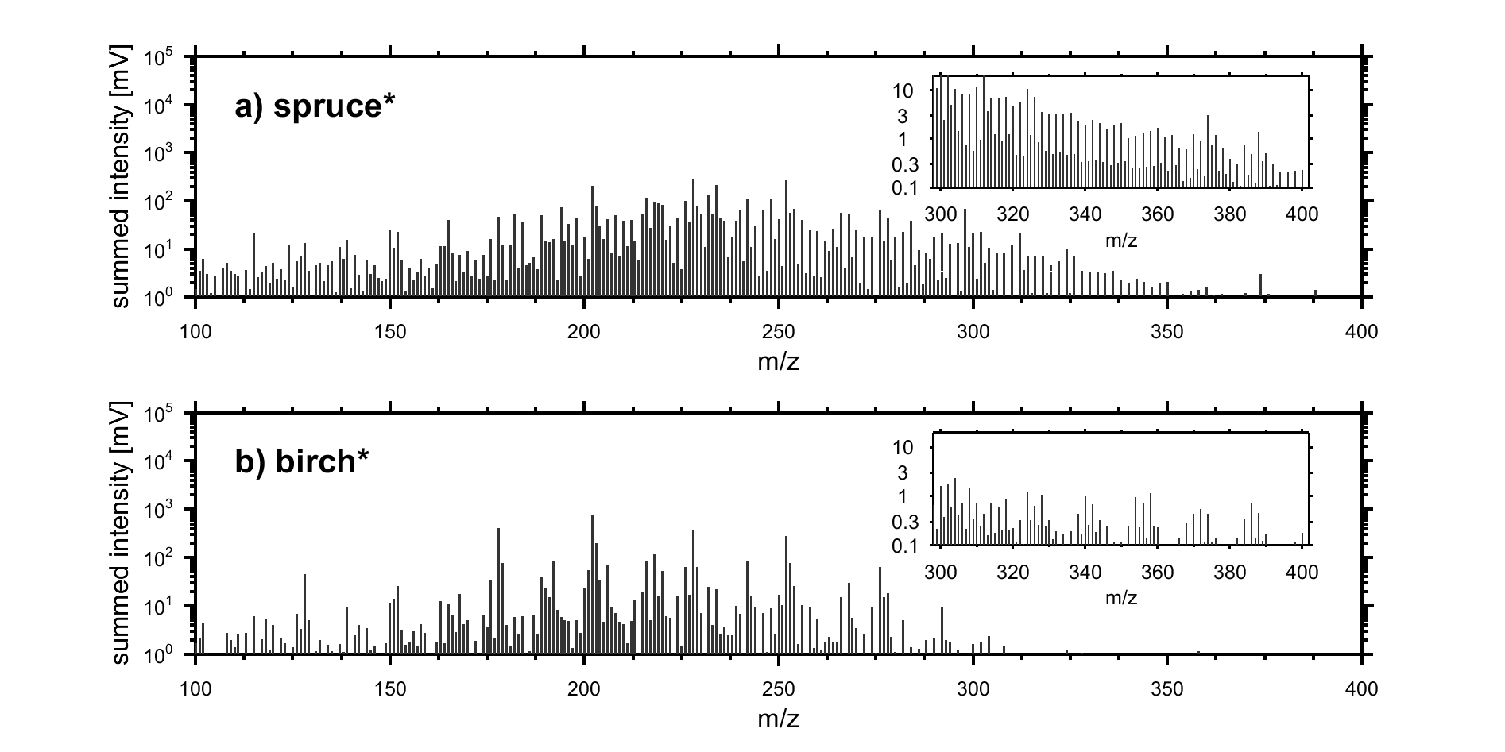
Fig. S9 Mean REMPI mass spectra of summed intensities of OC1+OC2 for combustion experiment with slow ignition, equal to Fig. 5 in the manuscript, but with logarithmic y-scale. Panels in the upper right corner belong to fingerprint regions of the wood fuels, which contain alteration products of phytosterols and lignans. Although both combustion experiments reveal a shift towards larger PAH emissions, the spectrum of spruce* contains numerous peaks, possibly from thermal resin alteration, while for birch* emissions parent PAHs are more pronounced in the alkylation series.

