Supplementary Material

Adoptive T cell transfer
Between 2008 and 2014, 17 patients were enrolled in the clinical trial. Enrolled patients had undergone allo-HSCT for treatment of acute myeloid leukemia, acute lymphoblastic leukemia, chronic myelomonocytic leukemia, Waldenstrom`s disease, myelodysplastic syndromes, multiple myeloma or non-Hodgkin lymphoma. Eight D⁺ patients were treated with MHC-Streptamer-selected CMV-specific T cells from the stem cell donor (patient #1, #2, #3, #9, #10, #13, #14 and #17) and eight D⁻ patients received CMV-specific T cells from partially HLA-matched CMV-seropositive TPD (patients #4, #5, #6, #7, #8, #12, #15 and #16). In case of the 17th patient, D⁺ patient #11, the purification procedure failed and the patient died before a renewed purification of CMV-specific T cells from the HSC donor could be initiated. Starting from a median donor epitope-specific T cell frequency of 0.52% (0.01 - 14.5%) among total T cells, MHC-Streptamer-purified products reached a median purity of 90.2% (13.4 - 99.5%). Given the variation in total target cell number, recipient weight and limitations to the number of not Streptamer-positive, potentially allo-reactive T cells, patients received a broad range of CMV-specific CD8⁺ T cell doses (780 cells / kg bw – 872.000 cells / kg bw) restricted to pp65, pp50 or IE-1 epitopes (Table 1 and Table S3).
In line with our previous observations in compassionate use treatment patients ⁷ we did not observe a dose dependence for the kinetics or the peak size of proliferating T cells and even very low numbers (e.g. patient #1 with 3000 CMV-specific cells / kg bw) led to timely, substantial expansion of adoptively transferred cells (Table S3).
Interestingly, the proliferative capacity of the transferred T cells was found to be an important prerequisite for their function. In this context, although disappointing from a clinical perspective, the exceptional course of patient #13 was potentially instructive (Figure 4): Even though viremia was briefly controlled after transfer, appearing CMV epitope-specific CD8⁺ T cells never adequately expanded. Subsequent viremic episodes were also not sustainably controlled and eventually led to unrestrained viral replication. We compared patients #13 and #14 in more detail to find an explanation for the difference between uncontrollable und controlled virus replication (Figure S3). In both patients CMV pp65-specific T cells became detectable two weeks after transfer, but those obtained from patient #13 showed delayed positivity in ICS and failed to proliferate in response to increasing virus replication (Figure S3B). We considered various reasons for the inadequate expansion of virus-specific cells and could exclude relevant differences in original donor T cell population size, transferred cell numbers, and TCR avidity ²³ of ex vivo isolated CMV epitope-specific T cells (Table S3 and data not shown). Steroid-containing regimens known to interfere with T cell expansion ²⁴ were not applied. However, relapse of the patient’s malignant lymphoma and its treatment could have contributed to a general state of immune suppression.
Endogenous T cell immunity
A clear focus in this prospective phase I/II trial lied on the detection and thorough characterization (quantity, functionality and phenotype) of the transferred, MHC-Streptamer-purified T cells. Yet we have generated additional data (limited by restricted patient material), which gave some insight into endogenous T cell immunity. At screening, endogenous CMV-specific T cells were undetectable in D⁺ and D⁻ patients. At the time of transfer, CMV-specific T cells remained completely undetectable in D⁺ patient #2, #3, #9, #13 and #17. However, we observed in D⁺ patient #1 a clearly detectable endogenous CMV-specific T cell population at transfer (1.87 % A1 pp65-Multimer⁺ T cells of living lymphocytes, see Supplementary Figure S5). As this endogenous T cell population vanished during the observation period while transferred A1 pp50-Multimer⁺ T cells forcefully expanded (0.02 % --> 3.94 %), we would interpret those cells most likely as transiently persisting recipient-derived T cells that were more and more replaced by the transferred donor T cells.
Additionally, we found very tiny endogenous CMV-specific T cell populations at transfer in patient #10 (0.02 % A1 pp50-Multimer⁺; 0.04 % A1 pp65-Multimer⁺; 0.01 % A24 pp65-Multimer⁺) and potentially in patient #14 (0.015 % B7 pp65-Multimer⁺).
During the monitoring phase after transfer, we could detect co-expanding endogenous CMV-specific MHC multimer⁺ T cells in 3 of 8 D⁺ patients (see Supplementary Figure S5). As described before ¹⁰ the expansion of adoptively transferred T cells obviously did not inhibit the consecutive reconstitution of endogenous T cells. We did not discriminate between donor and recipient-derived T cells, but it seems that the detected endogenous T cells were probably thymus-passaged T cells of donor origin, as they stayed detectable until the end of the observation period (month 6 after T cell transfer). However, the transiently detectable A1 pp65-restricted T cells in patient #1 could be of recipient’s origin. We also analyzed additionally available CMV MHC multimer results from D⁻ patients (see Supplementary Figure S6), but endogenous MHC multimer⁺ T cells for other specificities were not detectable in D⁻ patients.

Isolation of CMV-specific T cells
For the immunomagnetic separation of CMV-specific T cells, a non-mobilized apheresis of HSC donor or TPD PBMC was performed either at the Blutspendedienst DRK Hessen-Baden-Württemberg, Frankfurt or the respective study center, using local standard apheresis equipment, as reported²¹. Magnetic enrichment was performed under GMP-compliant conditions (clean room class A in B conditions, Blutspendedienst DRK Hessen-Baden-Württemberg, Frankfurt). The isolation of CMV-specific T cells was performed using the Clinical Streptamer® Isolation Kit as previously described^{7,10,11}. Briefly, the purified positive fraction was incubated with 1 mM D-biotin and washed at 4°C to allow for dissociation and removal of the reversible CMV epitope-specific Streptamer reagents, yielding “minimally manipulated” target cells. The target cell population was washed and resuspended in clinical-grade HSA (20 %) for immediate use. The manufacturing process was covered by a manufacturing license granted by the local state authority.

MHC-Streptamers
The following MHC-Streptamers were used for multimerization with Strep-Tactin® PE (cell staining) or Strep-Tactin® magnetic beads (cell isolation): HLA-A*0101/pp50₂₄₅₋₂₅₃ (VTEHDTLLY), HLA-A*0201/pp65₄₉₅₋₅₀₃ (NLVPMVATV), HLA-A*0201/IE₃₁₆₋₃₂₄ (VLEETSVML), HLA-A*2402/pp65₃₄₁₋₃₄₉ (QYDPVAALF), and HLA-B*0702/pp65₄₁₇₋₄₂₇ (TPRVTGGGAM). All reagents were obtained from Stage Cell Therapeutics (Göttingen, Germany; now part of Juno, Inc., Seattle, WA).

Isolation and cryopreservation of PBMC for T cell monitoring
PBMC were isolated from heparin blood using Ficoll gradient separation (Biocoll, Biochrom AG, Berlin, Germany). For storage of retained samples residual cells were cryopreserved in FCS (Biochrom AG) supplemented with 10% DMSO (Sigma-Aldrich, Taufkirchen, Germany).

Characterization of CMV-specific T cells by MHC-Streptamer staining
The frequency of CMV-specific CD8⁺ T cells was determined via flow cytometry by staining with CMV epitope-specific Streptamers (0.4 µg / 1 x 10⁶ cells) which were multimerized with Strep-Tactin® PE (0.15 µg / 1 x 10⁶ cells). 10⁶ PBMCs were generally used per staining. Before staining, PBMC were incubated with EMA (Life Technologies, Darmstadt, Germany) to exclude dead cells and washed twice using phosphate buffered saline (PBS) supplemented with 0.5% bovine serum albumin (BSA). Cells were stained with MHC-Streptamers followed by incubation with anti-CCR7 FITC (clone 150503; R&D Systems), anti-CD19 ECD (clone J3-119; Beckman Coulter, Krefeld, Germany), anti-CD8 PerCP (clone SK1; BD Biosciences), anti-CD45RA PE-Cy7 (clone L48; BD Biosciences) and anti-CD3 eFluor450 (clone UCHT1; eBioscience). After two washing steps with PBS, cells were fixed with 2% paraformaldehyde and analyzed by BD™ LSR II flow cytometer and FlowJo software (Tristar, Ashland, OR). All steps were carried out (unless otherwise described) at 4 C in the dark.

Detection of functional CMV-specific T cells by ICS
PBMC were stimulated ex vivo with 2 µg/ml relevant peptides (IBA, Göttingen, Germany and Biosynthan, Berlin, Germany) in the presence of costimulatory anti-CD28 (clone L293; BD Biosciences) and anti-CD49d monoclonal antibodies (clone L25; BD Biosciences) for 4.5 h. After 1 h brefeldin A (Sigma) was added. For ICS cells were stained with EMA, anti-CD8 PE (clone RPA-T8; BD Pharmingen), anti-CD4 PerCP (clone SK3; BD Biosciences), and anti-CD3 eFluor450 (clone UCHT1; eBioscience); fixed with Cytofix/Cytoperm™ (BD Biosciences); and stained intracellularly with anti-IFNg FITC (clone 25723.11; BD Biosciences), anti-IL-2 APC (clone 5344.111; BD Biosciences) and anti-TNF PE-Cy7 (MAb11; eBioscience). PBMC were analyzed for cytokine secretion by flow cytometry with the BD™ LSR II and FlowJo software (TreeStar).

T cell counting
TruCOUNT™ Tubes and Tritest™ CD3/CD8/CD45 (both from BD Biosciences) were used to enumerate the absolute counts of T lymphocytes. The frequency of multimer⁺ or CMV peptide-stimulated IFNg⁺ CD8⁺ T cells was indicated among all living lymphocytes. In this manner the absolute number of CMV-specific T cells was calculated as follows: number of CD3⁺ T cells (cells/µl blood) * frequency of multimer⁺ or IFNg⁺ CD8⁺ T cells (%) ÷ 100%.

Supplementary Figures

Figure S1. Gating strategy of MHC multimer staining (A) and ICS (B) for detection of functional CMV-specific T cells.
Dot plots are gated on all lymphocytes (Forward scatter vs. Side scatter), exclusion of doublets (FSC-A vs. FSC-W), exclusion of dump⁺ cells (CD19⁺ cells), living cells (exclusion of EMA positive cells and CD3⁺ T cells (CD3 vs. CD8 (A) and IFNg (B), respectively).
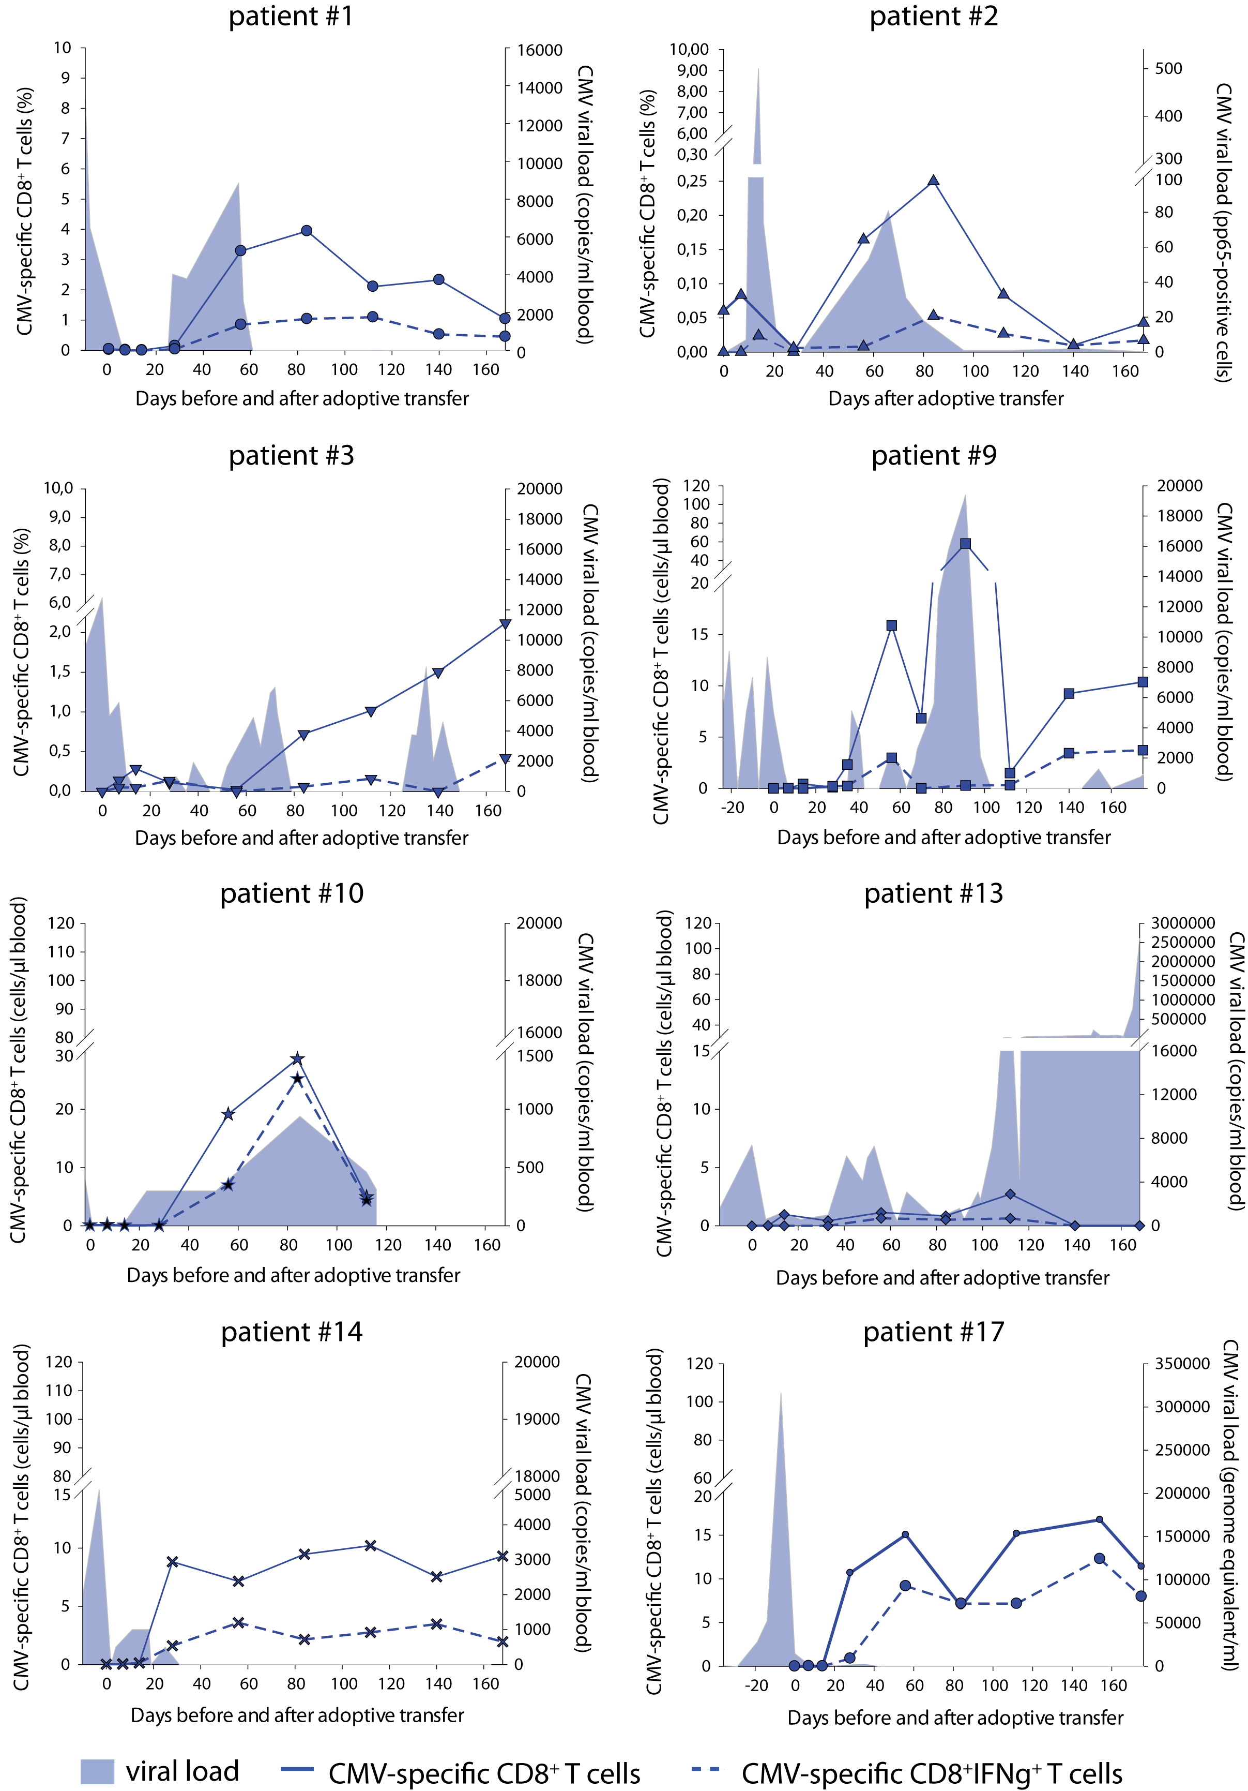
Figure S2. Expansion of functional D⁺ CMV-specific CD8⁺ T cells in correlation with CMV viral load.
Monitoring of adoptively transferred CMV-specific T cells by MHC multimer staining (blue line) and ICS (dotted blue line) in D⁺ patients who received CMV-specific T cells from the HSC donor. PBMC were stimulated for 4.5 h in the presence of CMV-specific peptides before ICS. Where available, concentrations, otherwise frequencies of IFNg producing CD8⁺ T cells in % of living lymphocytes are shown. Viral loads (filled area) were determined by PCR (patient #1, #3, #9, #10, #13, #14: copies/ml blood; patient #17: genome equivalent/ml) or CMV pp65 antigen detection (patient #2: pp65 antigen positive cells).

Figure S3. Proliferation of functional CMV-specific T cells correlates with sustained virus control.
D⁺ patient #14 received HLA-B7-restricted (A) and D⁺ patient #13 HLA-A2-restricted (B) CMV pp65-specific CD8⁺ T cells. (a) CMV-specific T cells were measured by CMV-specific MHC multimers (solid blue line) and ICS (dash blue line), respectively. Viral load in peripheral blood (filled area) was measured by quantitative PCR. (b) Selected dot plots of MHC multimer staining (upper row) and ICS (lower row) during six month immune monitoring.
Figure S4. Functional T cell expansion in D⁻ patients with CMV-specific T cell immunity.
In addition to MHC multimer staining (solid green line), D⁻ patients #8, #15 and #16 were analyzed for functional CMV-specific T cells by ICS (dotted green line). PBMC were stimulated for 4.5 hours in the presence of CMV-specific peptides before intracellular staining of IFNg-producing CD8⁺ T cells are shown as percentage of CD3⁺ T cells. CMV load (filled area) was measured by PCR (copies/ml blood).
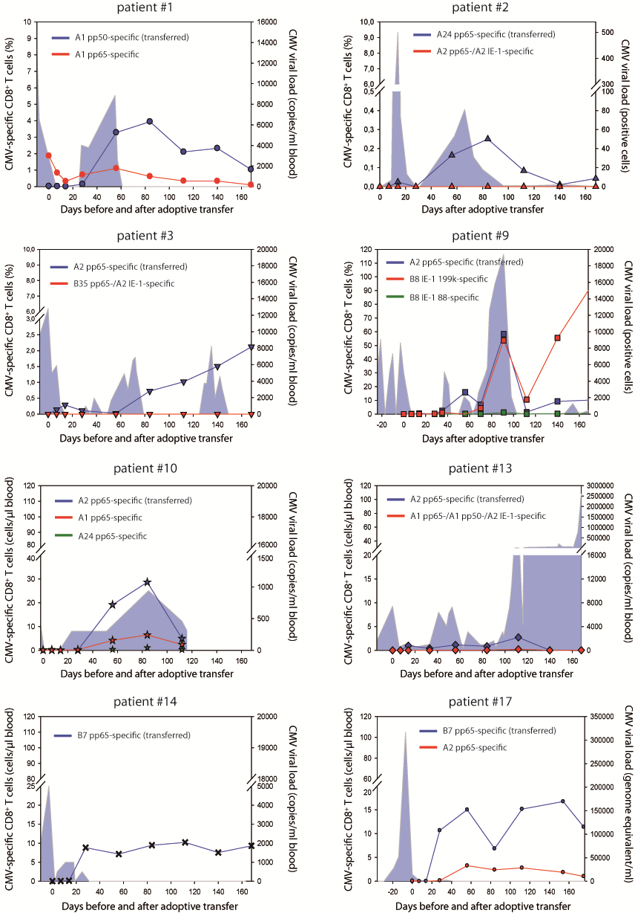
Figure S5. Extended monitoring of developing CMV-specific T cell immunity in D⁺ patients.
MHC multimer staining of T cells with the transferred epitope specificity (blue line) and with additional specificities (red and green line) are shown together with the viral load (filled area) in D⁺ patients. Where available, concentrations, otherwise frequencies of antigen-specific T cells among living lymphocytes are shown.
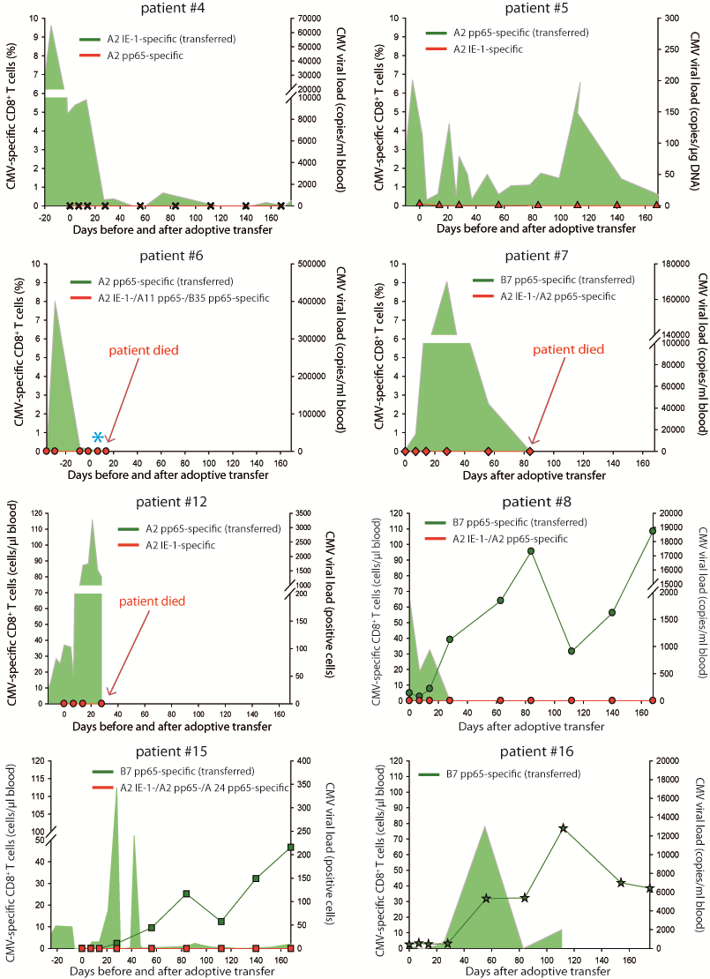
Figure S6. Extended monitoring of developing CMV-specific T cell immunity in D⁻ patients.
MHC multimer staining of T cells with the transferred epitope specificity (green line) and with additional specificities (red line) are shown together with the viral load (filled area) in D⁻ patients. Where available, concentrations, otherwise frequencies of antigen-specific T cells among living lymphocytes are shown.
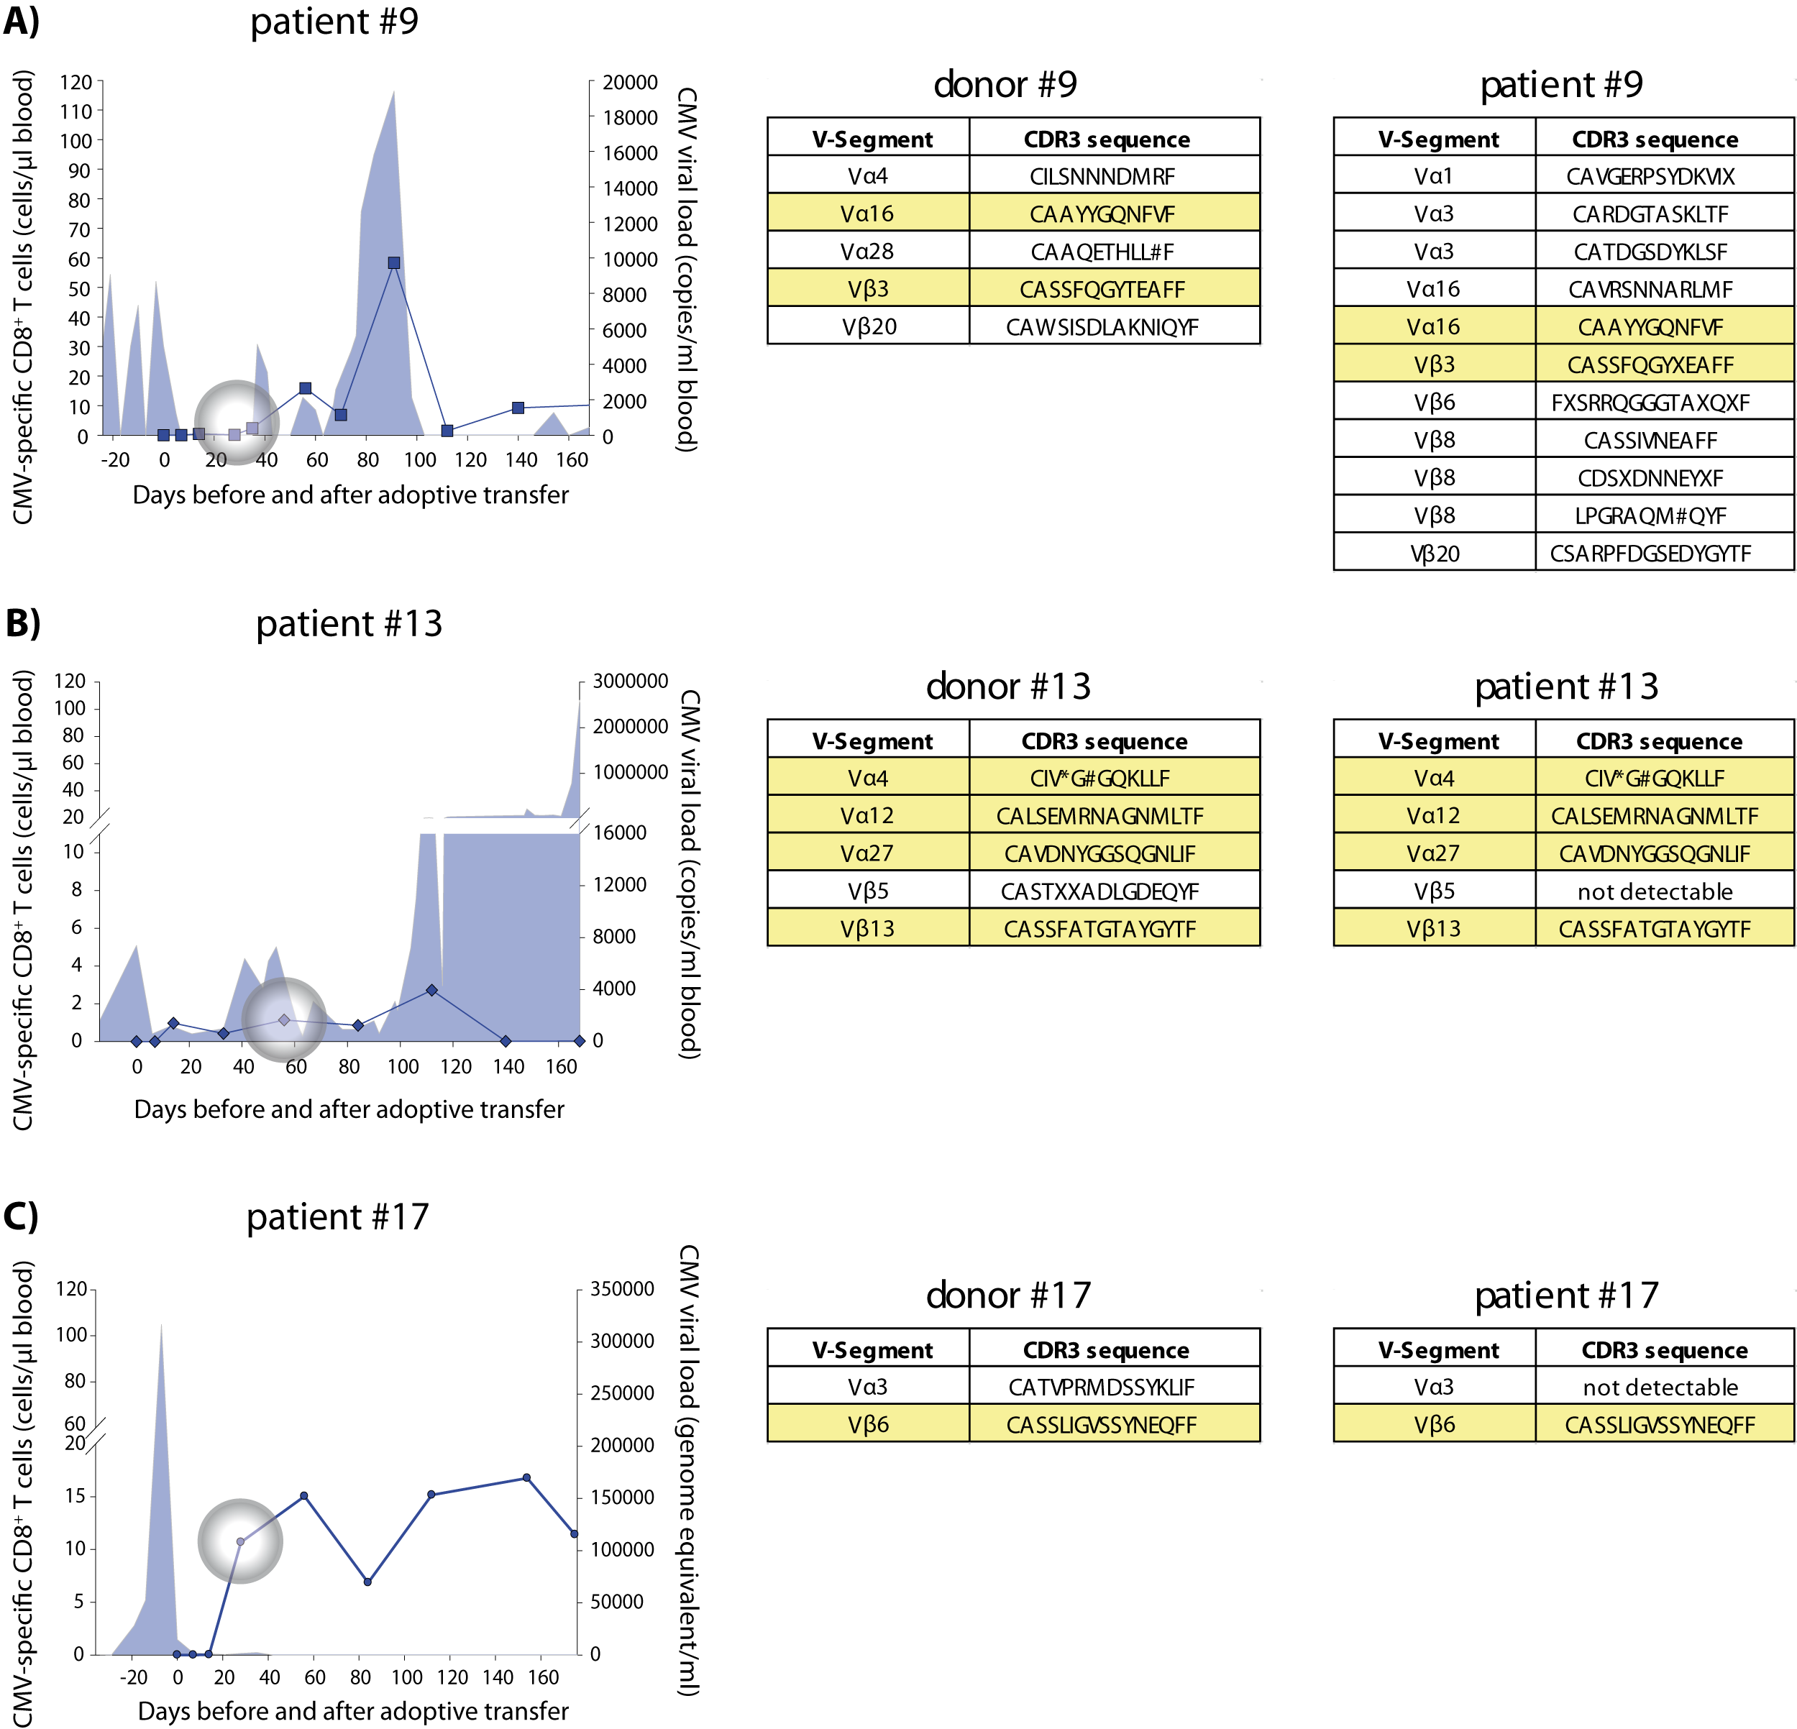
Figure S7. CDR3-tracking of CMV-specific T cells in D⁺ patients.
CDR3 sequences from D⁺ patients were identified by performing single cell RACE PCR of FACS-sorted CMV epitope-specific T cells. (A) Patient #9: T cells from the patient were also examined by RACE PCR, four weeks after T cell transfer (gray circle), to identify identical T cell clones in the respective HLA-B*0702/pp65-Streptamer-sorted T cell population. For T cell tracking in patients #13 (B) and #17 (C) CDR3-specific primers are designed from identified CDR3 sequences and were used to analyze D⁺ patient PBMC at the indicated time points (gray circle). Donor-derived CDR3 sequences could be identified in all patients (highlighted in yellow).

Figure S8. Co-expression of recipient-specific HLA-A2 identifies CMV B7pp65-specific T cells as not being adoptively transferred TPD (A2 pp65-specific) T cells.
PBMC from patient #15 and the respective TPD were stained with CMV B7-restricted pp65 MHC multimer in combination with anti-HLA-A2 antibodies. Dot plots are gated on all lymphocytes (Forward scatter vs. Side scatter), exclusion of doublets (FSC-A vs. FSC-W), exclusion of dump⁺ cells (CD19⁺ cells), living cells (exclusion of EMA positive cells) and CD3⁺ T cells (CD3 vs. CD8) (gating strategy, upper row).

Pat | Weeks of CMV viremia or antiviral therapy before transfer | Antiviral drugs before transfer | Number of antiviral drugs before transfer
01 | 4 | Ganciclovir | 1
02 | 6 | Ganciclovir, Foscarnet, Cidofovir | 3
03 | 4 | Ganciclovir | 1
04 | 10 | Ganciclovir | 1
05 | 9 | Ganciclovir, Foscarnet, Cidofovir | 3
06 | 8 | Ganiclovir, Foscarnet | 2
07 | 19 | Ganciclovir | 1
08 | 5 | Ganciclovir, Foscarnet | 2
09 | 6 (relapse, 44 days of antiviral drugs) | Ganciclovir, Foscarnet | 2
10 | 6 | Ganciclovir | 1
12 | 9 (since 2nd relapse) | Ganciclovir | 1
13 | 7 | Ganciclovir | 1
14 | 16 | Ganciclovir | 1
15 | 8 | Ganciclovir, Foscarnet, Cidofovir | 3
16 | 4 | Ganciclovir | 1
17 | (2nd relapse) | Ganciclovir, Foscarnet, Cytotect | 3

Table S1. Overview about antiviral treatment before adoptive T cell transfer

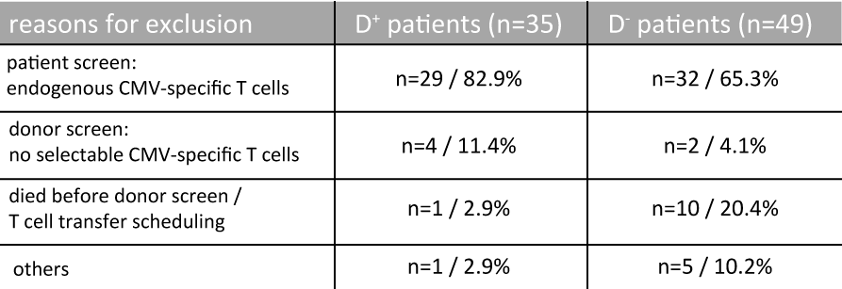
Table S2. Exclusion of patients screened for adoptive T cell transfer.

Table S3. Donor frequency, purity and cell dose of primary isolated CMV-specific donor T cells.

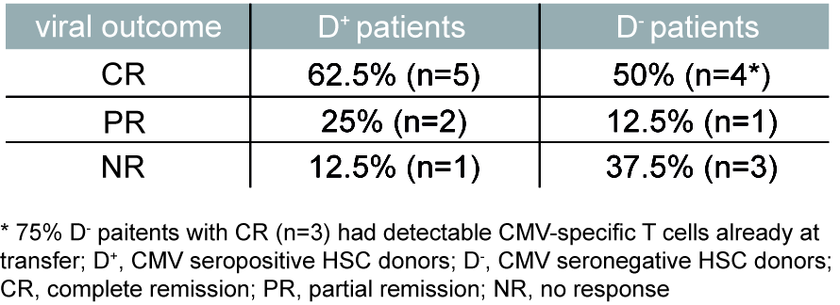
Table S4. Viral outcome of patients after CMV-specific T cell transfer.

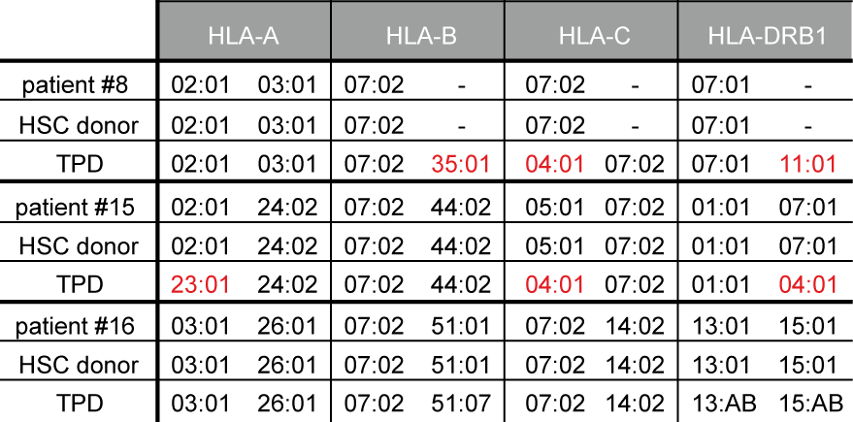
Table S5. Allelic distribution in D- patients with CMV-specific T cell expansion.

Table S6. Allelic distribution of HLA-A, -B, -C and DRB1 of all D⁺ (white) and D⁻ (grey) patients with the respective hematopoietic stem cell (SC) and, if applicable, TPD T cell donor.

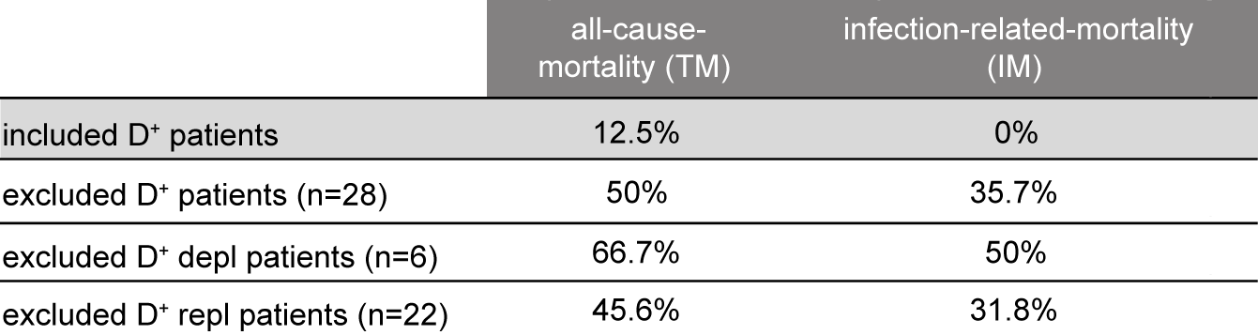
Table S7. Retrospective analysis of the mortality rate in D+ patients.

