Salmonella as an endophytic colonizer of plants - a risk for health safety vegetable production

¹Igor Kljujev, ¹Vera Raicevic, ²Bojana Vujovic, ³Michael Rothballer, ³Michael Schmid

¹Faculty of Agruiculture, University in Belgrade, Serbia;
²Institute for the Development of Water Resources, Belgrade, Serbia
³Research Unit Microbe-Plant Interactions, Helmholtz Zentrum Munchen, Germany

Abstract

Contamination of vegetables and fruits is the result of presence of human pathogen bacteria which can contaminate products in any part of production chain. There is an evidence of presence of: Salmonella spp. on the fresh vegetables and Salmonellosis is connected with tomato, sprouts, cantaloupe etc.
The goal of this research is transmission of pathogen bacteria from irrigation water to plants and studying/monitoring the ability of the Salmonella spp. to colonize the surface and interior (endophytic colonization) of root at different vegetable species.
Transmission of three Salmonella spp. strains from irrigation water to plants, as well as colonization of plants by these bacteria was investigated by using Fluorescence In Situ Hybridization (FISH) in combination with confocal laser scanning microscopy (CLSM).
All tested Salmonella spp. strains showed ability to more or less colonize the surface and interior niches of the root, stem and leaf of the investigated plant species. These bacteria also were found in plant cells cytoplasm, although the mechanism of their entrance has not been clarified yet.

Key words: contamination vegetables, Salmonella spp., irrigation water, FISH, CLSM.

Introduction

The consumption of vegetables is essential for healthy nutrition and it is an integral part of many diets which are recommended by various health organizations (World Health Organization, 2003; United States Department of Agriculture, 2011). Since fresh produce is one of the major components, such as essential vitamins, minerals, and fiber, the consumption of fresh produce has increased worldwide in recent years (EU, 2007; Betts 2014).
The number of outbreaks associated with the consumption of contaminated fresh produce, especially those caused by Salmonella, has also increased. In EU countries excluding Spain, a total of 37 Salmonellosis outbreaks have been linked to the consumption of food of non-animal origin including fresh produce have been reported between 2007 and 2011 (EFSA,2013).
The vegetables could become contaminated (Beuchat and Ryu, 1997) in contact with soil, manure, compost, irrigation water, contaminated water for washing and etc. Irrigation water contaminated with manure or animal waste is a common environmental source for the transmission of microorganisms into fresh produce (Olaimat and Holley, 2012).
The Salmonella is an important human and animal pathogen worldwide, mainly transmitted to humans through contaminated food (Jay et al.,2005). Each year, nontyphoidal Salmonella spp. have been estimated to be responsible for 1.0 million (Scallan et al., 2011) and 80.3 million human salmonellosis cases (Majowicz et al., 2010) in the United States and globally, respectively. The preharvest contamination vegetables by human pathogen is the most often cause of presence microbiologically unsafe products on the market (Pezzoli et al. 2007; CDC 2006b; Gillespie, 2004; Soderstrom et al., 2005). There is evidence that outbreak of tomato-associated salmonellosis was caused by Salmonella Newport. This strain was isolated from water which was used for irrigation tomato plants (Greene et al., 2008). Also, it was happened salmonellosis outbreak which was linked to consumption of alfalfa sprouts contaminated by Salmonella Newport in 2010 (CalFERT, 2011). This Salmonella strain was isolated from seed which was considered as a source of outbreak. The similar outbreak was happened in 2010. with Salmonella enterica – contaminated alfalfa sprout, but the source of this Salmonella strain was run-off water (environmental sample) (CDC, 2011).
The Salmonella Saintpaul – outbreak, which was happened in more states, resulted in more than 1400 infected people in the USDA. This is an example how complicated it could be to detect source of contamination (CDC, 2008). It was initially suspected that contaminated tomatoes are source of the outbreak, but investigation by CDC and FDA revealed that main source of Salmonella Saintpaul were jalapeno and serrano peppers (Klontz et al., 2010). This failure resulted in huge economic loss to tomato growers. Also, some authors found out that about 86% of cases linked with eating raw jalapeno pepper and other similar food at Mexican restaurants (Behravesh et al., 2011).
The products might be contaminated during preharvest as well as postharvest process of production. Some authors examined routs of colonization tomato fruits in preharvest process by S. enterica (Gu et al., 2011; Hintz et al., 2010; Barak et al., 2011.). Their point of view is that irrigation water could be a potential source of colonization fruit by pathogen bacteria. The entrance of S. enterica into the tomato plants through irrigation water is still inconsistent. There is evidence that Salmonella enterica serovar Newport could contaminate different tomato plant tissue via irrigation water (Hintz et al., 2010). The Salmonella-contaminated water was applied only in root zone and Salmonella was detected at tomato plants in different plant growth stages.
Gu et al. (2011) showed that Salmonella typhimurium could colonize interior spaces of tomato plants via leaves and it can lead to high concentration of Salmonella in plant fruits but there are not any visible symptoms on the tomato plants.
Islam et al. (2004) showed that using S. typhimurium-contaminated irrigatin water can lead to contamination carrot and radish during the harvesting crops and S. typhimurium could survive 203 days in the soil after its due date. The S. enterica serovar Thompson can colonize whole leaves of coriander after 6 days of inoculation but the pathogen concentration on leaves largely depends on temperature and relative humidity (Brandl and Mandrell, 2002). Natvig et al., (2002) detected S. enterica Typhimurium in the leaves of rocket after 17 weeks of growing in the manure-contaminated soil. In the field growing conditions, S. enterica serovar Typhimurium can survive 63 days on lettuce and 231 days on parsley if the plants are irrigated with contaminated water and the similar results are obtained with carrot and radish (Islam et al., 2004). Jablasone et al., (2005) showed that S. typhimurium could entry in plant tissue. After surface sterilization plants, they used indirect method for quantification number of S. typhimurium inside plant tissue. The positive plant samples were appeared 9 days after inoculation plants, but number of S. typhimurium was not so high. The experiments of Barak et al., (2003) showed that S. enterica strains easier adhere alfalfa sprouts than E. coli O157:H7. The tomato plants which were grown in hydroponic conditions could be colonized by Salmonella spp. if the water is contaminated with these bacteria. The one day after exposing tomato root to Salmonella spp.-contaminated water, the number of bacteria on hypocotyls, cotyledons and stem reaches 3,01 CFU/log10 - 3,40 CFU/log10 per gram (Guo et al., 2002).
Some experiments showed colonization plant damaged seed coat edge during the seed germination by S. enterica. The S. enterica is able to make huge microcolony (aggregations) on the alfalfa root hairs (Charkowski et al., 2002). It is known that bacterial cells aggregation is associated with synthesis of cellulose fibrils (Smit et al., 1987). The S. enterica also has ability to synthesize cellulose fibrils, but their function is not related with bacterial adherence or aggregation in the rhizosphere (Zogaj et al., 2001).
There is an experiment about localization human pathogen on the root of inoculated plants which are grown in the soil in lab conditions. During the colonization Arabidopsis thaliana root by E. coli Ol57:H7 and S. enterica, these bacteria were concentrated on the root top and in the places of branching lateral roots at an early stage of plant development. The Arabidopsis thaliana root was colonized by these bacteria uniformly at a later stage of plant development (Cooley et al., 2003). Same authors did seed inoculation by S. enterica mutants with reduced flagella number and observed much less colonization which means that bacterial motility has a significant role in plant colonization.
Confocal laser scanning micrographs showed ability of S. enterica serovar Stanley to enter inside undamaged alfalfa sprouts (Gandhi et al., 2001). Warriner et al. (2003b) detected endophytic colonization vascular system of bean sprouts by S. enterica after surface sterilization of plant samples and in situ staining plants. According to their opinion, bacteria enter in plant through the cracks in epidermis and place the growth of lateral roots. Some other researchers also showed interaction between alfalfa seedling and different S. enterica serotypes. The alfalfa seedlings were the most colonized by bacteria on the places the growth of lateral roots. Also, it was noticed differences in endophytic colonization at different S. enterica serotypes, which indicates a specificity of strain for adherence to plants (Dong et al., 2003).
Guo et al. (2001, 2002) inoculated tomato plants at the stage before and after the start of flowering by S. enterica. They tested tomato fruit and out of 30 samples, 11 were positive for the presence of pathogen. The inner content of the tomato fruit in 6 out of 11 samples was contaminated by S. enterica which indicates the movement of the pathogen through the tomato plant. The same authors showed colonization tomato plants by S. enterica in hydroponic growing conditions. After 9 days of growing plants, the number of S. enterica was so high in leaves, stems, hypocotyls and cotyledons of seedlings. This indicates that Salmonella sp. could be transmitted into the plants if the plants are grown in contaminated environment.
The goal of this study is transmission of pathogen bacteria from irrigation water to plants and monitoring the ability of the Salmonella spp. to colonize the root surface and interior of different vegetable species.

Material and method

The ability of the surface and endophytic colonization of different plants by Salmonella strains was investigated in laboratory conditions with ’’monoxenic’’ model growing conditions. (one plant species inoculated by one bacterial strain).
BACTERIAL STRAINS AND PLANT SPECIES:
The three strains of Salmonella enterica serotype typhimurium (LT2, S1 and ATCC14028) were used in this experiment. These strains are part of bacterial culture collection of Helmholtz Zentrum Munchen, German Research Center for Environmental Health (GmbH), Research Unit Microbe-Plant Interactions. The strain Salmonella typhimurium LT2 is commonly used in laboratory experiments and S. typhimurium S1 strain is isolated from organic waste of plants.
The experimental plants were: lettuce (Lactuca sativa) sort 2476; spinach (Spinacia oleracea), parsley (Petroselinum crispum); carrot (Daucus carota subsp. sativus); celery (Apium graveolens); tomato (Lycopersicon esculentum); sweet corn (Zea mays var. saccharata).
INOCULATION EXPERIMENTS IN AN AXENIC MODEL SYSTEM:
The Salmonella strains were cultivated on Xyline-Lysine-Desoxycholate Agar and SS Agar (Merck, Germany) and incubated on 37°C overnight. After incubation, Salmonella typhimurium strains appeared as typical black colonies (Photo 1). The one single colony for each strain is transferred in separate falconen tube with 20 ml Luria Bertani Broth and incubated with shaking on 37°C overnight. The tubes with incubated strains are centrifuged on 5000 rpm for 3 minute, the supernatant is removed and added 20 ml PBS 1x and each tube is vortexed. This step is repeated three times in total. The bacterial concentration (OD) is measured on spectrophotometer on 436 nm wavelength. The bacterial suspension is adjusted by PBS 1x to reach ≈ 10⁸ CFU/ml. The final concentrations for S. typhimurium LT2 and S. typhimurium S1 were ≈ 10⁸ CFU/ml PBS (OD436 = 0.846/ml and OD436 = 0.846/ml) and for S. typhimurium ATCC14028 ≈ 10⁷ CFU/ml PBS (OD436 = 0.710/ml).
It was used certified seeds (Germany) for this experiment. The surface sterilization of seeds was done according to the Burun (2002).
The sterile seeds (without washing) incubated in Petri-dishes with Nutrient Agar and LB Agar (Sigma-Aldrich) on 30ºC during the 24 - 48^{h} to start germination of seeds (appear cotyledons) and check its sterility before bacterial inoculation and planting (Photo 2).
The plants were grown in sterile quartz sand (particle size 1.0–2.5 mm) with Basal Salt Mixture (SIGMA). Basal Salt Mixture: 4.3 g MS powder dissolved in 1000 ml H₂O_{dem} and autoclaved on 121 ºC, 1.5 at, 20 minutes. The 200 g sterile quartz sand was placed in each sterile plastic dish with cap (SIGMA) and it is added 20 ml Basal Salt Mixture dilution. It was planted five same seedlings in one dish and after one day, the seedlings were inoculated by 1 ml of Salmonella sp. suspensions. The bacterial suspension was placed on the quartz sand surface close to seedlings. The control dishes with seedlings were inoculated by 1 ml sterile PBS dilution. The sweet corn seedlings were grown in large sterile glass tubes (3 cm width x 20 cm length) with sterile quartz sand (the tube was filled 7 cm in length) and 10 ml Basal Salt Mixture dilution was added. The one seedling was planted in each tube and inoculated by 1 ml bacterial suspension and tube is covered by sterile cap (Photo 3).
The inoculated plants were grown 21 days in absolute sterile conditions at room temperature and normal light mode.
After 21 days, the plants carefully removed from sand in sterile conditions without damaging the root system and root was cut. The attached quartz sand particles and weak attached bacterial cells were removed by washing root in sterile Phosphate-buffered saline dilution. The inoculated plant root samples were ready for Fluorescence In Situ Hybridization (FISH).
FLUORESCENCE IN SITU HYBRIDIZATION (FISH) AND CONFOCAL LASER SCANNING MICROSCOPY (CLSM):
The FISH was done for all plant root samples inoculated by Salmonella sp. strains (Salmonella typhimurium LT2; Salmonella typhimurium ATCC14028; Salmonella typhimurium S1).
The root samples were fixed in 4% (w/v) paraformaldehyde solution for 1.5^{h} at 4 °C (Amann et al., 1990). The probe Salm-63-Cy3 used in this experiment and the strength of the deionized formamide used in the hybridization buffer and probe specificity is given in Table 1. The probe was synthesized and purchased from Thermo Electron, Division Interactiva (Ulm, Germany). Hybridization with fluorochrome-labelled oligonucleotide probe (Cy3) was performed according to the standard FISH protocol (Amann et al., 1992; Manz et al., 1992).
The confocal laser scanning microscopy LSM-510-META (Zeiss, Germany) was used for three-dimensional microscopic analyses of plant root system. The He–Ne laser provided excitation wavelength of 543 nm for Cy3 excitation with LP 560 long-pass filter. The Cy3 fluorescent dye is shown with its red fluorescence color. The Ar ion laser with 488 nm excitation wavelength and with BP 500–550 band-pass filter was used to show autofluorescence and thus the structure of plant roots.
The number of Salmonella sp. which colonizes plant roots (surface and endophytic colonization) was determined by direct counting in 3D-micrographs by using Zeiss LSM Image Browser software. It was determined volume of plant roots and bacterial cells were counted on the surface and inside plant roots. It was taken root depth 0-5 µm as the surface area while the interior of the root was taken depth greater than 5 µm. The number of Salmonella sp. was calculated per unit volume and was shown as the number of cells / mm³ absolutely dry plant root.
STATISTICAL ANALYSES:
The statistical analyses were done by non-parametric Kruskal-Wallis Test. This test is alternative to the One-Way ANOVA test and it is able to assess if samples come from populations with the same median. The significance level α was 0.05 and the number of degrees of freedom was 2. This test is very useful when not all ANOVA assumptions are met. The reason for using Kruskal-Wallis Test is that our data (variables) were measured at the ordinal level and the assumption of normality was not met. In this test, it was used a null and the alternative hypothesis. The null hypothesis was that all measured samples have same medians. It means that there are not differences in colonization plant roots by different strains of Salmonella. The alternative hypothesis was that there are differences in colonization plant roots by different strains of Salmonella. It means that medians are unequal in all population.

Results

The detection of Salmonella cells was done using Zeiss LSM Image Browser software and all results are presented in the figures 1, 2 and 3. The obtained results showed ability of Salmonella strains for surface and endophytic colonization plant roots in the monoxenic model growing plants. Also, the micrographs of roots showed location of Salmonella cells on the surface and inside plant roots.
INOCULATION EXPERIMENTS IN THE AXENIC SYSTEM:
The Salmonella typhimurium LT2 colonized root surface of lettuce in the highest degree (5.08 x 10⁵ cells/mm³ absolutely dry root). The high degree of surface root colonization was also detected at tomato and sweet corn roots (3.76x10⁵cells/mm³ and 3.42x10⁵cells/mm³ absolutely dry root). The roots of sweet corn (1.99x10⁵cells/mm³), lettuce (1.59x10⁵cells/mm³) and tomato (1.12x10⁵cells/mm³ absolutely dry root) were the most endophiticly colonized by S. typhimurium LT2 (Figure 1).
The surface and endophytic colonization plant roots by Salmonella typhimurium S1 was the largest at celery and tomato. The number of bacteria at celery root surface and interior was 7.45x10⁵cells/mm³ and 2.07x10⁵cells/mm³ absolutely dry root. Also, it was detected 7.44x10⁵cells/mm³ (root surface) and 1.64x10⁵cells/mm³ absolutely dry root (root interior) at tomato. The huge number of S. typhimurium S1 cells was detected on the lettuce root surface (5.17x10⁵cells/mm³ absolutely dry root). The lowest level of colonization by this strain was noticed at spinach and sweet corn roots (Figure 2).
The high level of colonization roots by Salmonella typhimurium ATCC 14028 was found out at leafy and fruitful vegetables but this strain colonized root-tuber plants less than others. Thus, the largest number of S. typhimurium ATCC 14028 was detected on the surface parts of lettuce and sweet corn roots (1.01x10⁶cells/mm³ and 1.02x10⁶cells/mm³ absolutely dry root). Also, these plants were endophitic colonized by this strain. In terms of root-tuber vegetables, the S. typhimurium ATCC 14028 colonized in the highest degree carrot root surface (4.98x10⁵cells/mm³ absolutely dry root) and carrot root interior (1.48x10⁵cells/mm³ absolutely dry root) (Figure 3).
FISH/CLSM ANALYSIS OF INOCULATED ROOTS:
In the interior spaces of the lettuce root, the Salmonella typhimurium LT2 cells were seen as single or in the form of microcolonies. The bacterial cells were also located in intercellular spaces (niches) and they were found very close to vascular system of lettuce root (Micrography 1). Also, it was detected that Salmonella typhimurium LT2 cells can reach very deep layers of interior at tomato and sweet corn roots. The bacterial cells were able to come close to root xylem (Micrography 1). The Salmonella typhimurium LT2 cells could colonize root hairs and root surface in the very high degree (Figure 1 and Micrography 2).
The CLSM micrographs showed that Salmonella typhimurium S1 cells appeared in the form of microcolonies, aggregations in the intercellular niches at lettuce and parsley roots (Micrography 3).
The Salmonella typhimurium ATCC 14028 cells formed aggregations on the sweet corn root hairs and appeared like biofilm. In the deeper layers of sweet corn root, bacterial cells were single and they were located in intracellular niches (Micrography 4). It has been determined that bacterial cells formed microcolonies in the intercellular spaces that were located very close to xylem system of lettuce root. At the spinach root, Salmonella cells were predominantly attached to root hairs and they appeared in biofilm form (Micrography 4). Regarding root-tuber plants, Salmonella typhimurium ATCC 14028 cells were dominantly located on the parsley root surface, but they were rarely found on root hairs. The bacterial cells also were found out in deep layers of carrot and celery root (intercellular niches) and they were located close to root xylem (Micrography 5).

STATISTIC TEST AND DECISION ABOUT THE NULL HYPOTHESIS:
Based on experimental data, it was calculated the sum of ranks for each of the samples of surface colonization plant roots by Salmonella strains: R₁=864 (Salmonella enterica serotype typhimurium LT2); R₂=924 (Salmonella enterica serotype typhimurium S1); R₃=1062 (Salmonella enterica serotype typhimurium ATCC14028). The rejection region for this Chi-Square test was R = χ² : χ² > 5.991 (α = 0.05; df = 3–1=2). The result of Kruskal-Wallis Test was obtainet according to formula:
H_{s} = 12 / N (N+1) (R₁ ²/n₁ + R₂²/n₂ + ⋯ + R_{k}² / n_{k}) – 3(N+1) =
= 12 / 75 (75+1) (864²/31 + 924²/20 + 1062²/24) – 3 (75+1) = 11.501

It is observed that χ² = 11.501 > χ²_{R} = 5.991, and it means that the null hypothesis is rejected. Also, the p-value is p = 0.0032, and since p = 0.0032 < 0.05, it could be concluded that the null hypothesis is rejected. There is statistical evidence about differences between investigated Salmonella strains in surface colonization plant roots at the α=0.05 significance level.
The sum of ranks for samples of colonization interior spaces of plant roots by Salmonella strains are: R₄=741 (Salmonella enterica serotype typhimurium LT2); R₅=859 (Salmonella enterica serotype typhimurium S1); R₆=956 (Salmonella enterica serotype typhimurium ATCC14028). The rejection region for χ²-Test was R = χ² : χ² > 5.991 for α = 0.05 and df = 3–1=2. The result of Kruskal-Wallis Test was:
H_{i} = 12 / N(N+1) (R₄ ²/n₁ + R₅²/n₂ + ⋯ + R_{k}² / n_{k}) – 3(N+1) =
= 12 / 71 (71+1) (741²/28 + 859²/19 + 956²/24) – 3 (71+1) = 10.588

The Kruskal-Wallis Test showed that χ² = 10.588 > χ²_{R} = 5.991, and the null hypothesis must be rejected. The p-value is p = 0.005, and since p = 0.005 < 0.05, it means that the null hypothesis is rejected. The statistical test showed significant differences between investigated Salmonella strains in interior colonization plant roots at the α=0.05 significance level.

Discussion

Our experiments showed that tested Salmonella spp. strains have different ability for plant colonization. Thus, Salmonella enterica serotype typhimurium LT2 has the maximum capacity for surface and endophytic lettuce root colonization but the same strain has the weakest ability to colonize carrot root (Figure 1). The obtained results showed that human pathogen, Salmonela enterica serovar typhimurium (S. typhimurium) could endophytic colonize different plant species very efficiently and also, these bacteria can actively enter into the root tissue and multiply in the intercellular niches of plant root.
There is evidence that Salmonella may exist epiphytically on the plants but it is also able to enter plant through different wounds, root, stomata, hydrathodes. The Salmonella could be found in fruits and seeds after contaminations plant flowers (Gu et al. 2013.). Also, trichomes, stomata, hydratodes allow presence of Salmonella into plant leaves (Gu et al., 2013; Barak et al., 2011; Gu et al., 2011).

Schikora et al. (2008.) showed that Salmonella typhimurium reaches in interior of plant cells Arabidopsis thaliana and multiply in them. Although the infection of Arabidopsis thaliana activates plant immune response, which is similar as well as with other phitopathogen bacteria, it seems that S. typhimurium is able to overcome the host plant defense mechanisms and reproduces in plant. Our results are in accordance with literature and they unequivocally showed that Salmonella typhimurium could be typical plant endopathogen.

The native microbial population in the environment could have positive influence on ability of Salmonella to colonize plants. So, plant pathogens (viruses, fungi, and bacteria), wild and domestic animals could degrade plants and increase possibilities of colonization plants by Salmonella (Jacobsen and Bech, 2012; Ge et al., 2014.).

The Salmonella characteristics, like genetic features, presence of T3SS (type III secretion system), chemotaxis, motility, forming biofilm are very important in survival bacteria in the environment and colonization plants (Schikora et al., 2012). The experiment (Schikora et al., 2012) showed that T3SS is essential for efficient plant colonization.

The plant root surface colonization by Salmonella enterica serovar typhimurium S1 was the most prominent at tomato, lettuce and celery (more than 10⁵cells/mm³ absolutely dry root) but this colonization was the smallest at spinach root. The root endophitic colonization by this strain was also the largest at tomato and celery and, it was detected more than 10⁴cells/mm³ inside of spinach root (Figure 2).
The results of other authors showed that Salmonella is able for colonization tomato plants through root system and leaves (Hintz et al., 2010; Gu et al., 2011). The entrance Salmonella cells through leaf surfaces (even they are modified with carborundum and surfactants) confirm that it is way for internal plant contamination(Gu et al., 2011)
In contrast, the experiment of Garcia et al., (2010) showed poorly colonization all tomato plant parts by S. typhimurium that suggest that contamination could be result of postharvest handling.

The literature data shows that S. typhimurium LT2 and DT104 strains are able to endophitic colonize seedlings and sprouts of barley which are grown in axenic model conditions. Using the FISH analysis, Salomonella typhimurium cells were detected inside plant tissue (Kutter et al., 2006). The investigations which were related to lettuce (Lactuca sativa) immune response to colonization by Salmonella enterica serovar Dublin showed that 43% surface sterilized and 93% none disinfected lettuce plants were colonized by this strain (Klerks et al., 2007).

The Salmonella enterica serovar typhimurium ATCC14028 has proven to be a very good in colonization root of investigated plant species. The highest number of bacterial cells was found out on the root surface at lettuce and sweet corn (10⁶ cells/mm³ absolutely dry root), but the large number of Salmonella cells was also detected at spinach, tomato and carrot root surface (>10⁵ cells/mm³ absolutely dry root). The weakest root surface colonization was noticed at parsley and celery. It was detected ≈10⁵ Salmonella cells/mm³ absolutely dry root, which colonized lettuce and sweet corn root endophyticaly. Also, inside the celery root, it was noted ≈10⁴cells/mm³ absolutely dry root (Figure 3).

The Salmonella is able to form microcolonies near stomata and enter in mesophyll tissue of lettuce and arugula leaves. The lower degree of colonization was detected at red-lettuce and basil leaves but the marginal colonization was noticed at parsley and tomato leaves (Golberg, 2011). It is known that hydratodes and trichomes are very helpful in colonization leaves by Salmonella (Gu et al., 2013; Barak et al., 2011; Gu et al., 2011).

By studying colonization over time, Klerks et al. (2007) found out that the highest number of bacteria was detected the twelfth day after beginning of inoculation. The same authors noticed the highest degree of bacterial colonization eighteenth day after inoculation at non disinfected plants.

Our research showed that Salmonella typhimurium was able to colonize all investigated plants (Figures 1, 2, 3; Photos 1-5).

Also, our previous experiments with Gfp-transformed bacteria showed that if human pathogen bacteria get into the interior of plant leaf, they are able to multiply themselves and this is in accordance with literature (Dong et al., 2003; Iniguez et al., 2005). Many studies showed that Salmonella spp. could be found in apoplast (intercellular spaces) and these bacteria are able to form biofilm in parsley root (Lapidot et al., 2006).

The human and animal infections by S. typhimurium depends on different factors and today it is known mechanism of penetration this bacteria in the epithelial cells of the mammalian host (Fields et al., 1986). The viability of Salmonella spp. in the environment without host organism is not still completely known, but it is evident that these bacteria are very adaptable to low pH and high temperature (Samelis et al., 2003). According to Nicholson et al. (2005), Salmonella spp. is not able to survive in the soil more than 900 days after inoculation.

There is evidence that plants have response to colonization of human pathogen bacteria. It includes immune response, expression of pathogenesis related genes (PRG). The experiment with mutants in T3SS showed that wild-strain is able to exceed the plant immune response (Schikora et al., 2012.).
Wiedemann et al., (2014) showed that Salmonella attachment to plant surface is the most important step in colonization. There are some bacterial factors which are very helpful in this process such as lipopolysaccharides (LPS), fimbria and nonfimbrial adhesions, flagella.
Also, there is differences in attachment Salmonella typhimurium to plant leaves and it depends on plant growing stage, better attachment is at older than at youger leaves (Kroupitski et al., 2011.).

Some research shows that the contaminated soil, for growing crops which are eaten in raw, could be very serious cause of infections by pathogenic bacteria (Brandl, 2006). The Salmonella spp. is able to reach soil mainly through manure, waste water and other waste materials which have organic origin.

Our results show that plants, which were endophytic colonized by Salmonela enterica serovar typhimurium, could be good model for further research of colonization mechanisms and Salmonella spp. pathogenicity in plants.

Using Gfp-transformed bacteria in previous research as well as application FISH analysis, our research has proved surface and endophytic plant root colonization by Salmonella spp. The FISH method is used to detect nucleic acid sequences by means of a phylogenetic fluorescently labelled oligonucleotide probes that specifically hybridize to a complementary target sequence within the bacterial cell (Moter and Gobel, 2000; Eldor, 2007; Blomme and Handler, 2009).

Some confocal micrographs (Photo 4) indicate the presence of bacterial cells in the interior of the plant root cells (cytoplasm) but the mechanism of penetration bacteria remains still unknown.

It is not much important surface and interior colonization leaves, but for consumers, it is important translocation bacteria through plant and reach the fruits. It was detected translocation bacteria in tomato plants (Gu et al., 2011). These authors showed internalization bacteria in tomato fruits when the plant is systemically colonized.
It is known huge heterogeneity in colonization different plants by human pathogen. According to Gorbatsevich et al. (2013), about 20% of plant population is colonization by bacteria, but this range could reach from 20% to 100% and it depends on plant species and bacterial strains.
Barak et al. (2011) showed that when it is done inoculation one tomato cultivar with one Salmonella strain, the interaction between plant and bacteria could be different and it depends on plant species and bacterial strains.

Based on the experimental results, Schikora et al. (2008) suggest that Salmonella spp. is able to inhabit the plant cells cytoplasm of Arabidopsis thaliana and using confocal microscopy, they noticed movement bacteria in the cytoplasm of plant cells. They found out Salmonella cells in the root hairs only 3 hours after inoculation and 17 hours after inoculation, the bacterial cells were noticed in rhizodermal plant cells. The caution in interpreting these results is necessary because it has still not clarified the exact mechanism of penetration human pathogen bacteria through the cell wall of plants.

Conclusion

All investigated Salmonella strains (Salmonella typhimurium LT2, Salmonella typhimurium ATCC14028, Salmonella typhimurium S1) showed ability in colonization vegetable plants. All strains were very good in surface and endophytic colonization plant roots. The Salmonella strains were frequently detected in intercellular spaces of roots all investigated plants. The strain Salmonella typhimurium ATCC 14028 was detected in the interior root cells at sweet corn but the mechanism of penetration bacterial cells through the plant cell wall is still unknown. The future research should be based on the mechanisms of plant response for bacterial colonization and mechanisms of bacterial entrance in plant cells.

Acknowledgment

This study was supported by the EU Commission (FP7 project AREA) and Serbian Ministry of Education, Science and Technological Development (project TR 31080).
I am very thankful to Prof. Anton Hartmann, Dr Michael Schmid, Angelo Weiß and all people from Helmholtz Zentrum Munchen, Germany, AMP Research Unit Microbe-Plant Interactions who helped me to realize my research.

References

Amann R I, Krumholz L & Stahl D A (1990) Fluorescent-oligonucleotide probing of whole cells for determinative, phylogenetic, and environmental studies in microbiology. J Bacteriol 172: 762–770.

Amann R I, Zarda B, Stahl D A & Schleifer K H (1992) Identification of individual prokaryotic cells by using enzymelabeled, rRNA-targeted oligonucleotide probes. Appl Environ Microbiol 58: 3007–3011.

Barak D. J., Whitehead L. C., Charkowski A. O. Difference in Attachment of Salmonella enterica Serovars and Escerichia coli O157:H7 to Alfalfa Sprouts. Appl. Environ. Microbiol. 2003; Vol 69, No 8:4556–4560.

Barak JD, Kramer LC, Hao LY. 2011. Colonization of tomato plants by Salmonella enteric is cultivar dependent, and type 1 trichomes are pre-ferred colonization sites. Appl. Environ. Microbiol. 77:498–504

Behravesh, B.C., Mody, R.K., Jungk, J., Gaul, L., Redd, J.T., Chen, S., et al. (2011) 2008 Outbreak of Salmonella Saintpaul infections associated with raw produce. N Engl J Med 364: 918–927.

Betts R. 2014. Microbial update: fruit and salad. Intl Food Hyg 25:9–12.

Beuchat, L. R. 2002. Ecological factors influencing survival and growth of human pathogens on raw fruits and vegetables. Microbes and Infect. 4: 413–423.

Beuchat, L. R., and J. H. Ryu. 1997. Produce handling and processing practices. Emerg. Infect. Dis. 3:459–465.

Blomme, B., & Handler, A. (2009). Fluorescence In Situ Hybridization. Retrieved from Enviromental Microbiology: http://filebox.vt.edu/users/chagedor/biol_4684/Methods/FISH.html

Brandl M. T. (2006) Fitness of Human Enteric Pathogens on Plants and Implications for Food Safety1. Annual review of phytopathology.

Brandl, M. T., and R. E. Mandrell. 2002. Fitness of Salmonella enterica serovar Thompson in the cilantro phyllosphere. Appl. Environ. Microbiol. 68:3614-3621.

Burun B., Coban Poyrazoglu E. 2002. Embryo Culture in Barley (Hordeum vulgare L.). Turk. J. Biol. 26. 175-180.

CalFERT (2011) Environmental investigation reports; Salmonella outbreak associated with alfalfa sprouts. URL http://www.cdph.ca.gov/pubsforms/Documents/fdbEIRCFF2010 .pdf. Accessed September 2014.

CDC (2006b) Ongoing multistate outbreak of Escherichia coli serotype O157:H7 infections associated with consumption of fresh spinach – United States, September 2006. Morb Mortal Wkly Rep 55, 1045–1046.

CDC (2008) Outbreak of Salmonella serotype Saintpaul infections associated with multiple raw produce items. MMWR Morb Mortal Wkly Rep 57: 929–934.

CDC (2011) Multistate outbreak of human Salmonella I 4,[5],12:i:- infections linked to alfalfa sprouts (final update). URL http://www.cdc.gov/salmonella/i4512i-/index.html.

Charkowski, A. O.J. D. Barak, C. Z. Sarreal, and R. E. Mandrell. 2002. Differences in growth of Salmonella enterica and Escherichia coli Ol57:H7 on alfalfa sprouts. Appl. Environ. Microbiol. 68:3114-3120.

Cooley, M. B., W. G. Miller, and R. E. Mandrell. 2003. Colonization of Arabidopsis thaliana with Salmonella enterica or enterohemorrhagic Escherichia coli Ol57:H7 and competition by Enterobacter asburiae. Appl. Environ. Microbiol. 69:4915-4926.

Dong, Y, A. L. Iniguez, B. M. Ahmer, and E. W. Triplett. 2003. Kinetics and strain specificity of rhizosphere and endophytic colonization by enteric bacteria on seedlings of Medicago sativa and Medicago truncatula. Appl. Environ. Microbiol. 69:1783-1790.

Doyle, M. P., and J. L. Schoeni. 1986. Isolation of Campylobacter jejuni from retail mushrooms. Appl. Environ. Microbiol. 51:449– 450.

EFSA, 2013. Scientific opinion on the risk posed by pathogens in food of non-animal origin. EFSA J. 11 (1), 3025

Eldor, P. (2007). Soil Microbiology, Ecology and Biochemistry. Oxford: Academic Press is an imprint of Elsevier.

EU, 2007. Agricultural commodity markets—past developments: fruits and vegetables.
Fields P. I., Swanson R. V., Haidaris C. G., Heffron F. (1986). Mutants of Salmonella Typhimurium that cannot survive within the macrophage are avirulent. Proc. Natl. Acad. Sci. U.S.A. 83, 5189–5193. doi: 10.1073/pnas.83.14.5189.

Gandhi, M., S. Golding, S. Yaron, and K. R. Matthews. 2001. Use of green fluorescent protein expressing Salmonella Stanley to investigate survival, spatial location, and control on alfalfa sprouts. / Food Prot. 64:1891-1898.

Garcia R, Bælum J, Fredslund L, Santorum P, Jacobsen CS. 2010. Influence of temperature and predation on survival of Salmonella enteric serovar Typhimurium and expression of invA in soil and manure-amended soil. Appl. Environ. Microbiol. 76:5025–5031.

Ge C, Lee C, Nangle E et al. Impact of phytopathogen infection and extreme weather stress on internalization of Salmonella Typhimurium in lettuce. Int J Food Microbiol 2014;168–169:24–31.

Gillespie, I.A. (2004) Outbreak of Salmonella Newport infection associated with lettuce in the UK. Eurosurveillance Weekly 8, http://www.eurosurveillance.org/ew/2004/041007.asp.

Golberg D, Kroupitski Y, Belausov E et al. Salmonella Typhimurium internalization is variable in leafy vegetables and fresh herbs. Int J Food Microbiol 2011;145:250–257.

Gorbatsevich E, Sela Saldinger S, Pinto R et al. Root internalization, transport and inplanta survival of Salmonella enterica serovar Newport in sweet basil. Environ Microbiol Rep 2013;5:151–159.

Greene, S.K., Daly, E.R., Talbot, E.A., Demma, L.J., Holzbauer, S., Patel, N.J., et al. (2008) Recurrent multistate outbreak of Salmonella Newport associated with tomatoes from contaminated fields, 2005. Epidemiol Infect 136: 157–165.

Gu G, Hu J, Cevallos-Cevallos JM, Richardson SM, Bartz JA, van Bruggen AH. 2011. Internal colonization of Salmonella enteric serovar Typhimurium in tomato plants. PLoS One 6 :e27340. doi: 10.1371/journal.pone.0027340

Gu G, Cevallos‐Cevallos JM & van Bruggen AH. Ingress of Salmonella enteric Typhimurium into tomato leaves through hydathodes. PLoS One 2013;8:e53470.

Guo, X. J. Chen, R. E. Brackett, and L. R. Beuchat. 2001. Survival of salmonellae on and in tomato plants from the time of inoculation at flowering and early stages of fruit development through fruit ripening. Appl. Environ. Microbiol. 67:4760-4764.

Guo, X., van Iersel, M. W., Chen, J., Brackett, R. E., and Beuchat, L. R. 2002. Evidence of association of salmonellae with tomato plants grown hydroponically in inoculated nutrient solution. Appl. Environ. Microbiol. Vol 68, No 7:3639–3643.

Hintz LD, Boyer RR, Ponder MA, Williams RC, Rideout SL. 2010. Recovery of Salmonella enteric Newport introduced through irrigation water from tomato (Lycopersicum esculentum) fruit, roots, stems, and leaves. HortScience 45:675–678.

Iniguez L., Dong Y., Carter H., Ahmer B., Stone J. and Triplett E. (2005). Regulation of Enteric Endophytic Bacterial Colonization by Plant Defenses. Molecular Plant-Microbe Interactions. Volume 18, Number 2, Pages 169-178.

Islam, M., Morgan, J., Doyle, M.P., Phatak, S.C., Millner, P. and Jiang, X. (2004) Fate of Salmonella enterica serovars Typhimurium on carrots and radishes grown in fields treated with contaminated manure composts or irrigation water. Appl Environ Microbiol 70, 2497–2502.

Jablasone, J., Warriner, K., Griffiths, M., 2005. Interactions of Escherichia coli O157:H7, Salmonella Typhimurium and Listeria monocytogenes in plants cultivated in a gnotobiotic system. Int. J. Food Microbiol. 99, 7–18.

Jacobsen CS & Bech TB. Soil survival of Salmonella and transfer to freshwater and fresh produce. Food Res Int 2012;45:557–566.

Jay, M., Loessner, M.J., Golden, D.A., 2005. Foodborne gastroenteritidis caused by Salmonella and Shigella. Modern Food Microbiology. Springer Science, New York.

Jerngklinchan, J., and K. Saitanu. 1993. The occurrence of salmonellae in bean sprouts in Thailand. Southeast Asian J. Trop. Med. Public Health 24:114–118.

Klerks, M. M., M. van Gent-Pelzer, E. Franz, C. Zijlstra and A. H. C. van Bruggen: Physiological and molecular response of Lactuca sativa to colonization by Salmonella enterica serovar Dublin, PhD (2007).

Klontz, K.C., Klontz, J.C., Mody, R.K., and Hoekstra, R.M. (2010) Analysis of tomato and jalapeño and Serrano pepper imports into the United States from Mexico before and during a National Outbreak of Salmonella serotype Saintpaul infections in 2008. J Food Prot 73: 1967– 1974.

Kroupitski Y, Pinto R, Belausov E et al. Distribution of Salmonella Typhimurium in romaine lettuce leaves. Food Microbiol 2011;28:990–997.

Kutter, S., Hartmann, A. and Schmid, M. (2006). Colonization of barley (Hordeum vulgare) with Salmonella enterica and Listeria spp. FEMS Microbiology Ecology 56: 262-271.

Lapidot, A., Romling, U., & Yaron, S. (2006). Biofilm formation and the survival of Salmonella typhimurium on parsley. International Journal of Food Microbiology, 109, 229–233.

Majowicz, S.E., Musto, J., Scallan, E., Angulo, F.J., Kirk, M., O'Brien, S.J., Jones, T.F., Fazil, A., Hoekstra, R.M., Studies international collaboration on enteric disease ‘burden of illness’, 2010. The global burden of nontyphoidal Salmonella gastroenteritis. Clin. Infect. Dis. 50 (6), 882–889.

Manz W., Amann R., Ludwig W., Wagner M. and Schleifer K.-H. (1992). Phylogenetic oligodeoxynucleotide probes for the major subclasses of Proteobacteria: problems and solutions. Syst. Appl. Microbiol.15: 593 - 600.

Moter, A., & Gobel, U. (2000). Fluorescence in situ hibridization (FISH) for direct visualisation of microorganisms. Jurnal of Microbiological Methods , 85-112.

Natvig, E.E., Ingham, S.C., Ingham, B.H., Cooperband, L.R., Roper, T.R., 2002. Salmonella enterica serovar Typhimurium and Escherichia coli contamination of root and leaf vegetables grown in soils with incorporated bovine manure. Appl. Environ. Microbiol. 68: 2737–2744.

Nicholson, F. A., S. J. Groves, and B. J. Chambers. 2005. Pathogen survival during livestock manure storage and following land application. Bioresour. Technol. 96:135 – 143.

Olaimat, A.N., Holley, R.A., 2012. Factors influencing the microbial safety of fresh produce: a review. Food Microbiol. 32, 1–19.

Pezzoli, L., Elson, R., Little, C., Fisher, I., Yip, H., Peters, T., Hampton, M., De Pinna, E. et al. (2007) International outbreak of Salmonella Senftenberg in 2007. Eurosurveillance Weekly 12, (accessed on 15 ⁄ 06 ⁄ 07) http://www.eurosurveillance.org/ew/2007/070614.asp

Samelis, J., J.S. Ikeda and J.N. Sofos, 2003. Evaluation of the pH-dependent, stationary phase acid tolerance in Listeria monocytogenes and Salmonella typhimurium DT104 induced by culturing in media with 1% glucose: A comparative study with Escherichia coli O157: H7. J. Applied Microbiol., 95: 563-575.

Scallan, E., Hoekstra, R.M., Angulo, F.J., Tauxe, R.V., Widdowson, M.A., Roy, S.L., Jones, J.L., Griffin, P.M., 2011. Foodborne illness acquired in the United States—major pathogens. Emerg. Infect. Dis. 17 (1), 7–15

Schikora, A., Carreri A., Charpentier E., Hirt H. (2008) The dark side of the salad: Salmonella Typhimurium overcomes the innate immune response of Arabidopsis thaliana and shows an endopathogenic lifestyle. PLoS ONE 3, e2279.

Schikora M, Neupane B, Madhogaria S et al. An image classification approach to analyze the suppression of plant immunity by the human pathogen Salmonella Typhimurium. BMC Bioinformatics 2012;13.

Smit, G., J. W. Kijne, and B. J. Lugtenberg. 1987. Involvement of both cellulose fibrils and a Ca2+-dependent adhesin in the attachment of Rhizobium leguminosarum to pea root hair tips. J. Bacteriol. 169:4294-4301.

Soderstrom, A., Lindberg, A. and Andersson, Y. (2005) EHEC O157 outbreak in Sweden from locally produced lettuce, August–September 2005. Eurosurveillance Weekly 10, E050922.1. (http://www.eurosurveillance.org/ew/2005/050922.asp#1).

United States Department of Agriculture. (2011). USDA and HHS Announce New Dietary Guidelines To Help Americans Make Healthier Food Choices And Confront Obesity Epidemic. Washington, DC: USDA Office of Communications and HHS Press Office.

Viswanathan, P., and R. Kaur. 2001. Prevalence and growth of pathogens on salad vegetables, fruit and sprouts. Int. J. Environ. Health 203:205–213.

Warriner, K., S. Spahiolas, M. Dickinson, C. Wright, and W. M. Waites. 2003b. Internalization of bioluminescent Escherichia coli and Salmonella Montevideo in growing bean sprouts. J. Appl. Microbiol. 95:719-727.

Wiedemann A, Virlogeux‐Payant I, Chausse AM et al. Interactions of Salmonella with animals and plants. Front Microbiol 2014;5:791.

World Health Organization (2003). Fruit and Vegetable Promotion. Geneva: World Health Organization.

Zogaj, X., M. Nimtz, M. Rohde, W. Bokranz, and U. Romling. 2001. The multicellular morphotypes of Salmonella Typhimurium and Escherichia coli produce cellulose as the second component of the extracellular matrix. Mol. Microbiol. 39:1452-1463.

Table list:

Table 1. The characteristics and specificity of oligonucleotide probes and the strength of the deionized formamide used in the hybridization buffer
Bacteria | Probe | Specificity | Binding position |  | Sequence 50-30 | % FA | Reference
Bacteria | Probe | Specificity | Target  (rRNA) | E. coli | Sequence 50-30 | % FA | Reference
S. typhimurium | Salm-63 | Salmonella sp.  Plesiomonas  shigelloides | 23 S | 1742-1760 | GCTGCCTCCCGTAGGAGT | 35 | W.Ludwig  (not pablished)
All bacteria | EUB-338 | Bacteria | 16 S | 338-355 | GCTGCCTCCCGTAGGAGT | 35 | Amann et al. (1990)

Photo list:

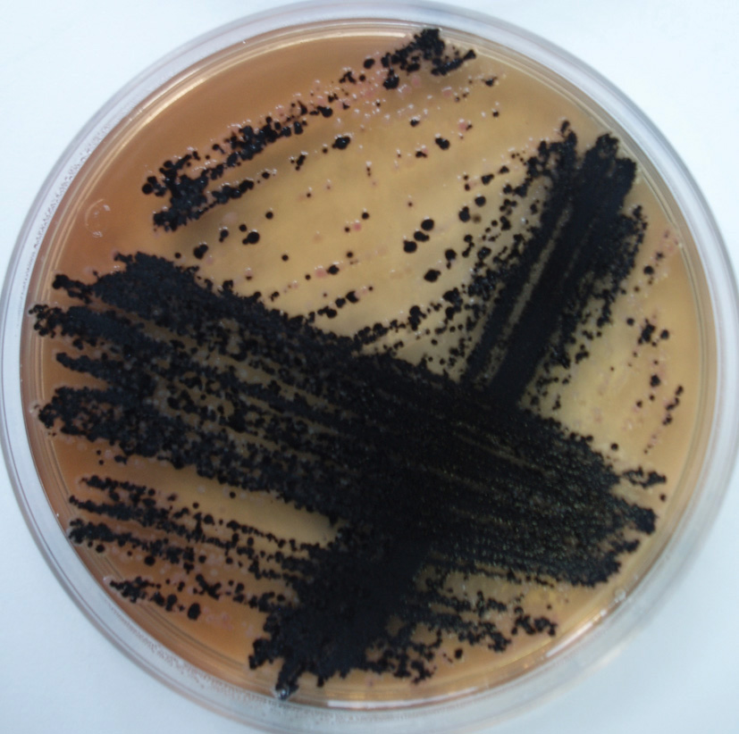
Photo 1. The characteristic black colonies of Salmonella typhimurium S1 strain on XLD Agar (left) and SS Agar (right) which was used for plant inoculation

Photo 2. The seed germination in Petri-dishes with Nutrient Agar and checking of seed sterility
(a – tomato seeds; b – carrot seeds)

Photo 3. The plastic dishes and glass tubes with experimental plants inoculated by Salmonella strains (a – sweet corn in glass tubs; b – growing plants; c – tomato plants; d – spinach plants)

Figure list:

Figure 1. The number of Salmonella typhimurium LT2 cells in the surface
and interior layers of vegetable roots ( root surface root interior)

Figure 2. The number of Salmonella typhimurium S1 cells in the surface
and interior layers of vegetable roots ( root surface root interior)

Figure 3. The number of Salmonella typhimurium ATCC 14028 cells in the surface
and interior layers of vegetable roots ( root surface root interior)

Micrograph list:

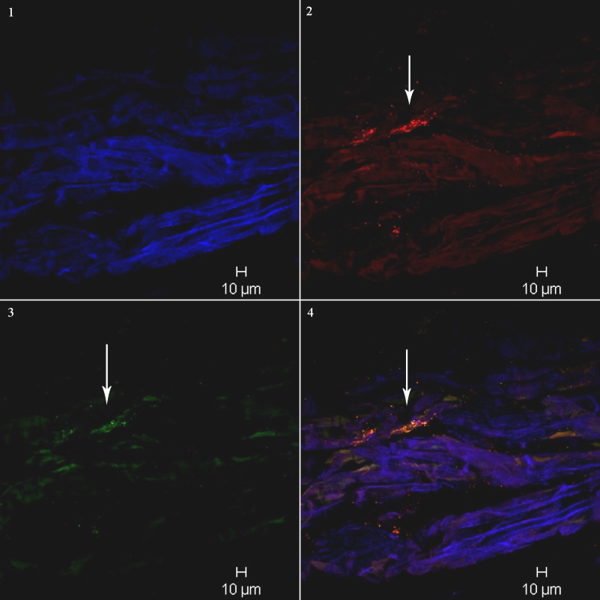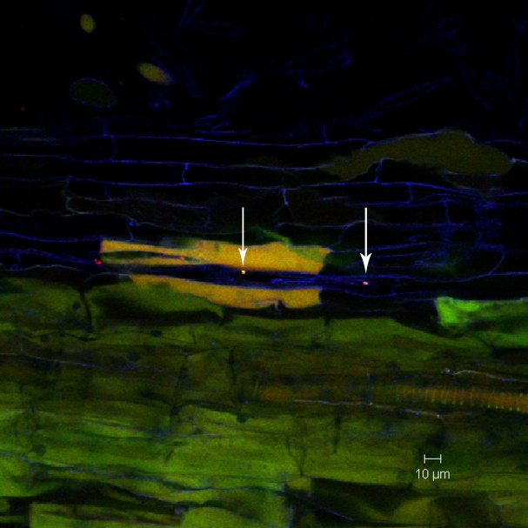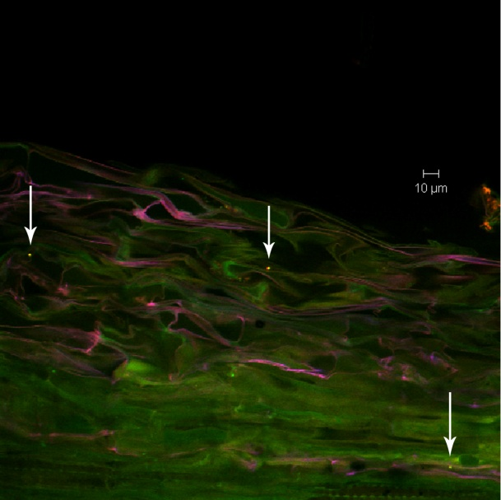

Micrography 1. Colonization lettuce root (left), tomato root (middle), sweet corn root (right) by S. typhimurium LT2. The white arrows show bacterial microcolony (left picture) and single bacterial cells (middle and right picture) inside plant root. The bacterial cells are visible in yellow color.

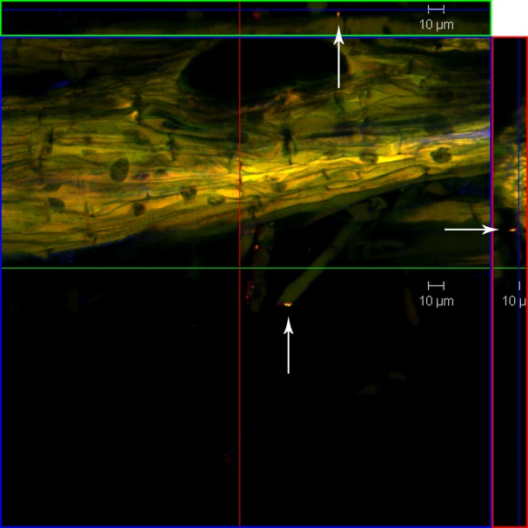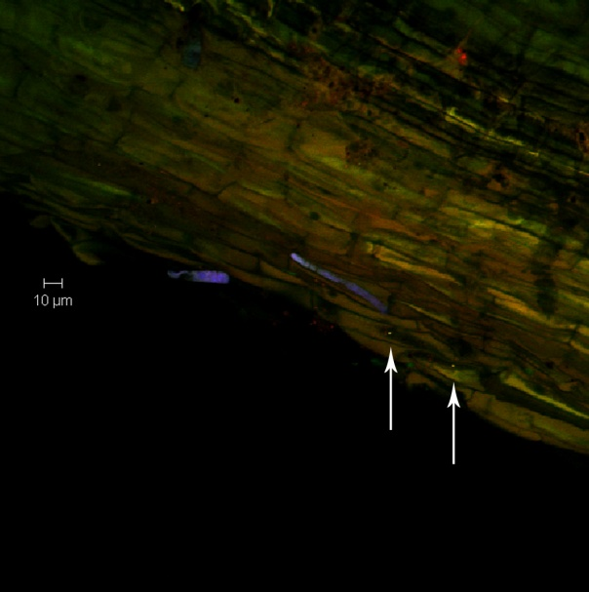

Micrography 2. Colonization celery root (left) and carrot root (right) by Salmonella typhimurium LT2. The left picture is orthogonal view of celery root and white arrows show single bacterial cells which is attached to root hair. The attachment Salmonella cells to the surface of carrot root is visible on right picture. The Salmonella cells are visible in yellow color.

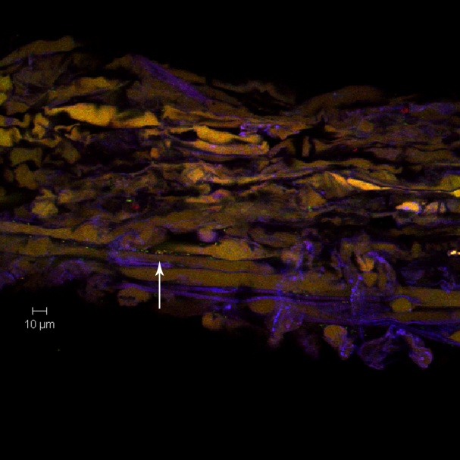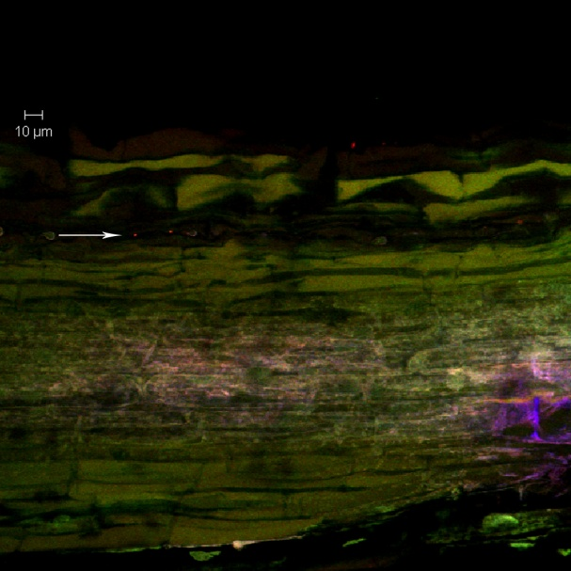

Micrography 3. Colonization lettuce root (left) and parsley root by S. typhimurium S1. The white arrows show presence of Salmonella cells in intercellular spaces inside plant roots and bacteria cells are visible in yellow color.

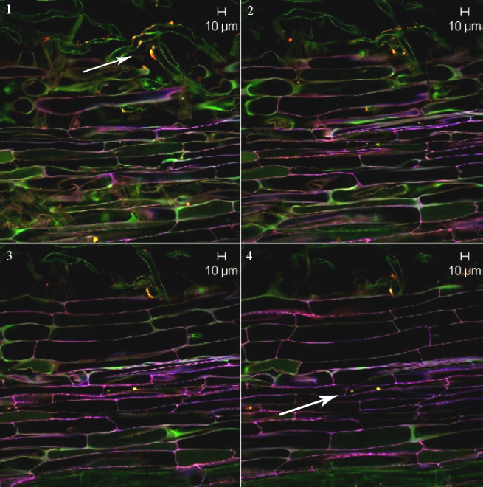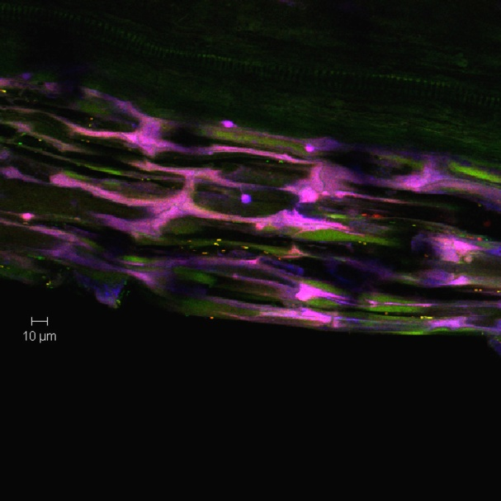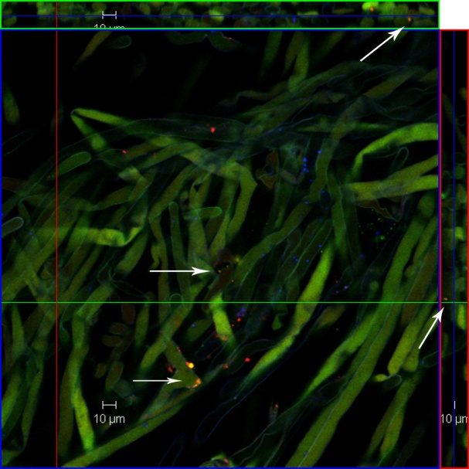

Micrography 4. Colonization sweet corn root (left), lettuce root (middle), spinach root (right) by S. typhimurium ATCC 14028. On the left picture, the Salmonella cells are clear visible as single inside sweet corn root and like microcolomies on the root hairs. On the middle picture, the bacterial cells are visible in deep layers of lettuce root very close to xylem. The right picture shows attachment Salmonella cells to spinach root hairs.

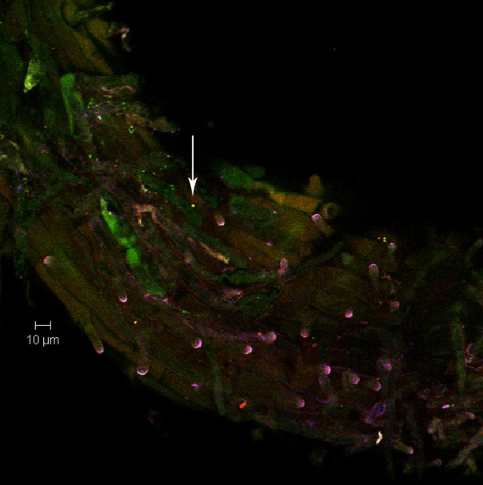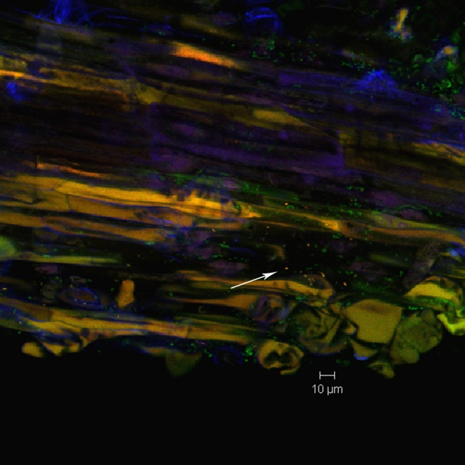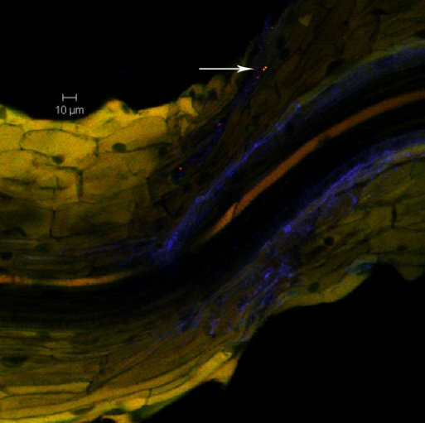

Micrography 5. Colonization parsley (left) carrot (middle), celery (right) by S. typhimurium ATCC 14028. The white arrows show surface attachment bacterial cells to parsley and celery root (left and right picture). On the middle picture, the Salmonella cells are visible deeply inside carrot root.

