Supporting information

Table S1: Concentration of standards used for preparing spiked, hydrolyzed urine and aqueous standards for every sequence.
OH-PAH | Spike standards  (pg/µl) | Concentrations of aqueous standards,  Spiked concentrations in urine  (ng/l)
2-OH-Phe | 0.98, 1.47, 2.45, 3.43, 4.90, 6.37 | 49.0, 73.5, 122.5, 171.5, 245.0, 318.5
3-OH-Phe | 0.45, 0.90, 1.35, 2.03, 2.70, 3.60 | 22.5, 45.0, 67.5, 101.3, 135.0, 180.0
1-OH-Phe | 1.02, 2.04, 3.06, 4.59, 6.12, 8.16 | 51.0, 102.0, 153.0, 229.5, 306.0, 408.0
9-OH-Phe | 1.8, 3.15, 4.50, 5.40, 7.20, 9.90 | 90.0, 157.5, 225.9, 270.0, 360.0, 495.0
4-OH-Phe | 0.67, 1.34, 2.01, 3.02, 4.02, 5.36 | 33.5, 67.0, 100.5, 150.8, 201.0, 268.0
1-OH-Pyr | 1.34, 2.68, 4.02, 6.03, 8.04, 12.06 | 67.0, 134.0, 201.0, 301.5, 402.0, 603.0

Table S2: Spearman’s rank correlation for OH-PAH in urine of 16 individuals (µg/g creatinine).
 | 3-OH-Phen | 1-OH-Phen | 9-OH-Phen | 4-OH-Phen | 1-OH-Pyr
2-OH-Phe | 0.9500 | 0.9265 | 0.7214 | 0.8411 | 0.7000
3-OH-Phe |  | 0.9088 | 0.7179 | 0.8824 | 0.7618
1-OH-Phe |  |  | 0.6214 | 0.8147 | 0.6235
9-OH-Phe |  |  |  | 0.8179 | 0.8536
4-OH-Phe |  |  |  |  | 0.7734

Table S3: Pearson correlation for OH-PAH in urine of 16 individuals (log (µg/g creatinine)).
 | 3-OH-Phen | 1-OH-Phen | 9-OH-Phen | 4-OH-Phen | 1-OH-Pyr
2-OH-Phe | 0.9686 | 0.9286 | 0.5839 | 0.8411 | 0.6949
3-OH-Phe |  | 0.9240 | 0.6235 | 0.8732 | 0.7381
1-OH-Phe |  |  | 0.5138 | 0.8091 | 0.6793
9-OH-Phe |  |  |  | 0.8163 | 0.7552
4-OH-Phe |  |  |  |  | 0.7443

Table S4: Calibration curves, instrument detection limits and matrix effects for the determination of OH-PAH using LC-HR-TOF-MS (method III).
OH-PAH | Calibration function;  range:  5 ng/ml-500 ng/ml, n = 4 | Correlation coefficient | Instrument  detection limit  (pg on column) | ME  (n = 3) | CV  (%)
2-OH-Phe | y = 6718x - 662 | 0.999 | 9.9 | 74 | 25
3-OH-Phe | y = 6696x - 7902 | 0.999 | 8.8 | 111 | 9
1-OH-Phe | y = 8174x - 4581 | 0.999 | 6.6 | 104 | 2
4-OH-Phe | y = 4569x - 1177 | 0.999 | 16.5 | 91 | 10
1-OH-Pyr | y = 5053x - 59603 | 0.998 | 34.3 | 64 | 11
9-Hydroxyphenanthrene was not investigated due to its expected instability (Li et al., 2006)
ME: Matrix effect expressed in recovery (%). Extracts of urine were spiked after SPE.
CV: Coefficient of variation.
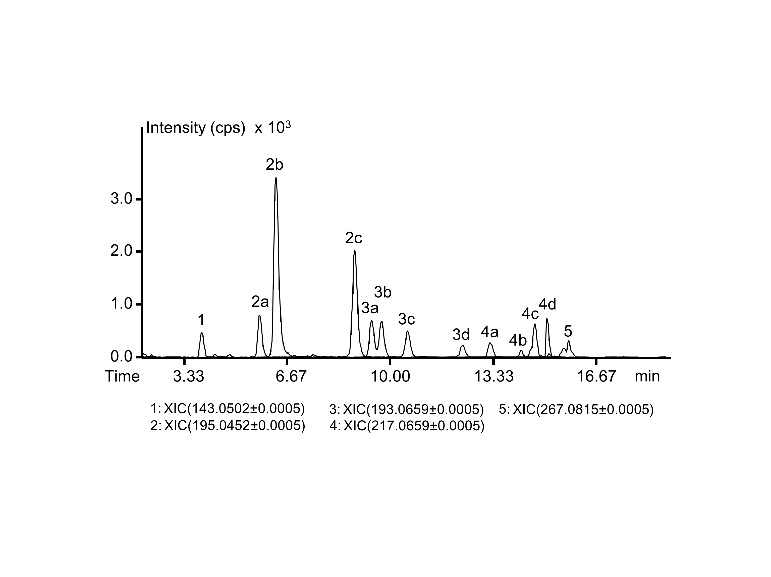
Figure S1: Extracted ion chromatograms of selected exact masses of PM_{2.5} extract. The extract was analyzed using UHPLC-method IV (see Table 2).
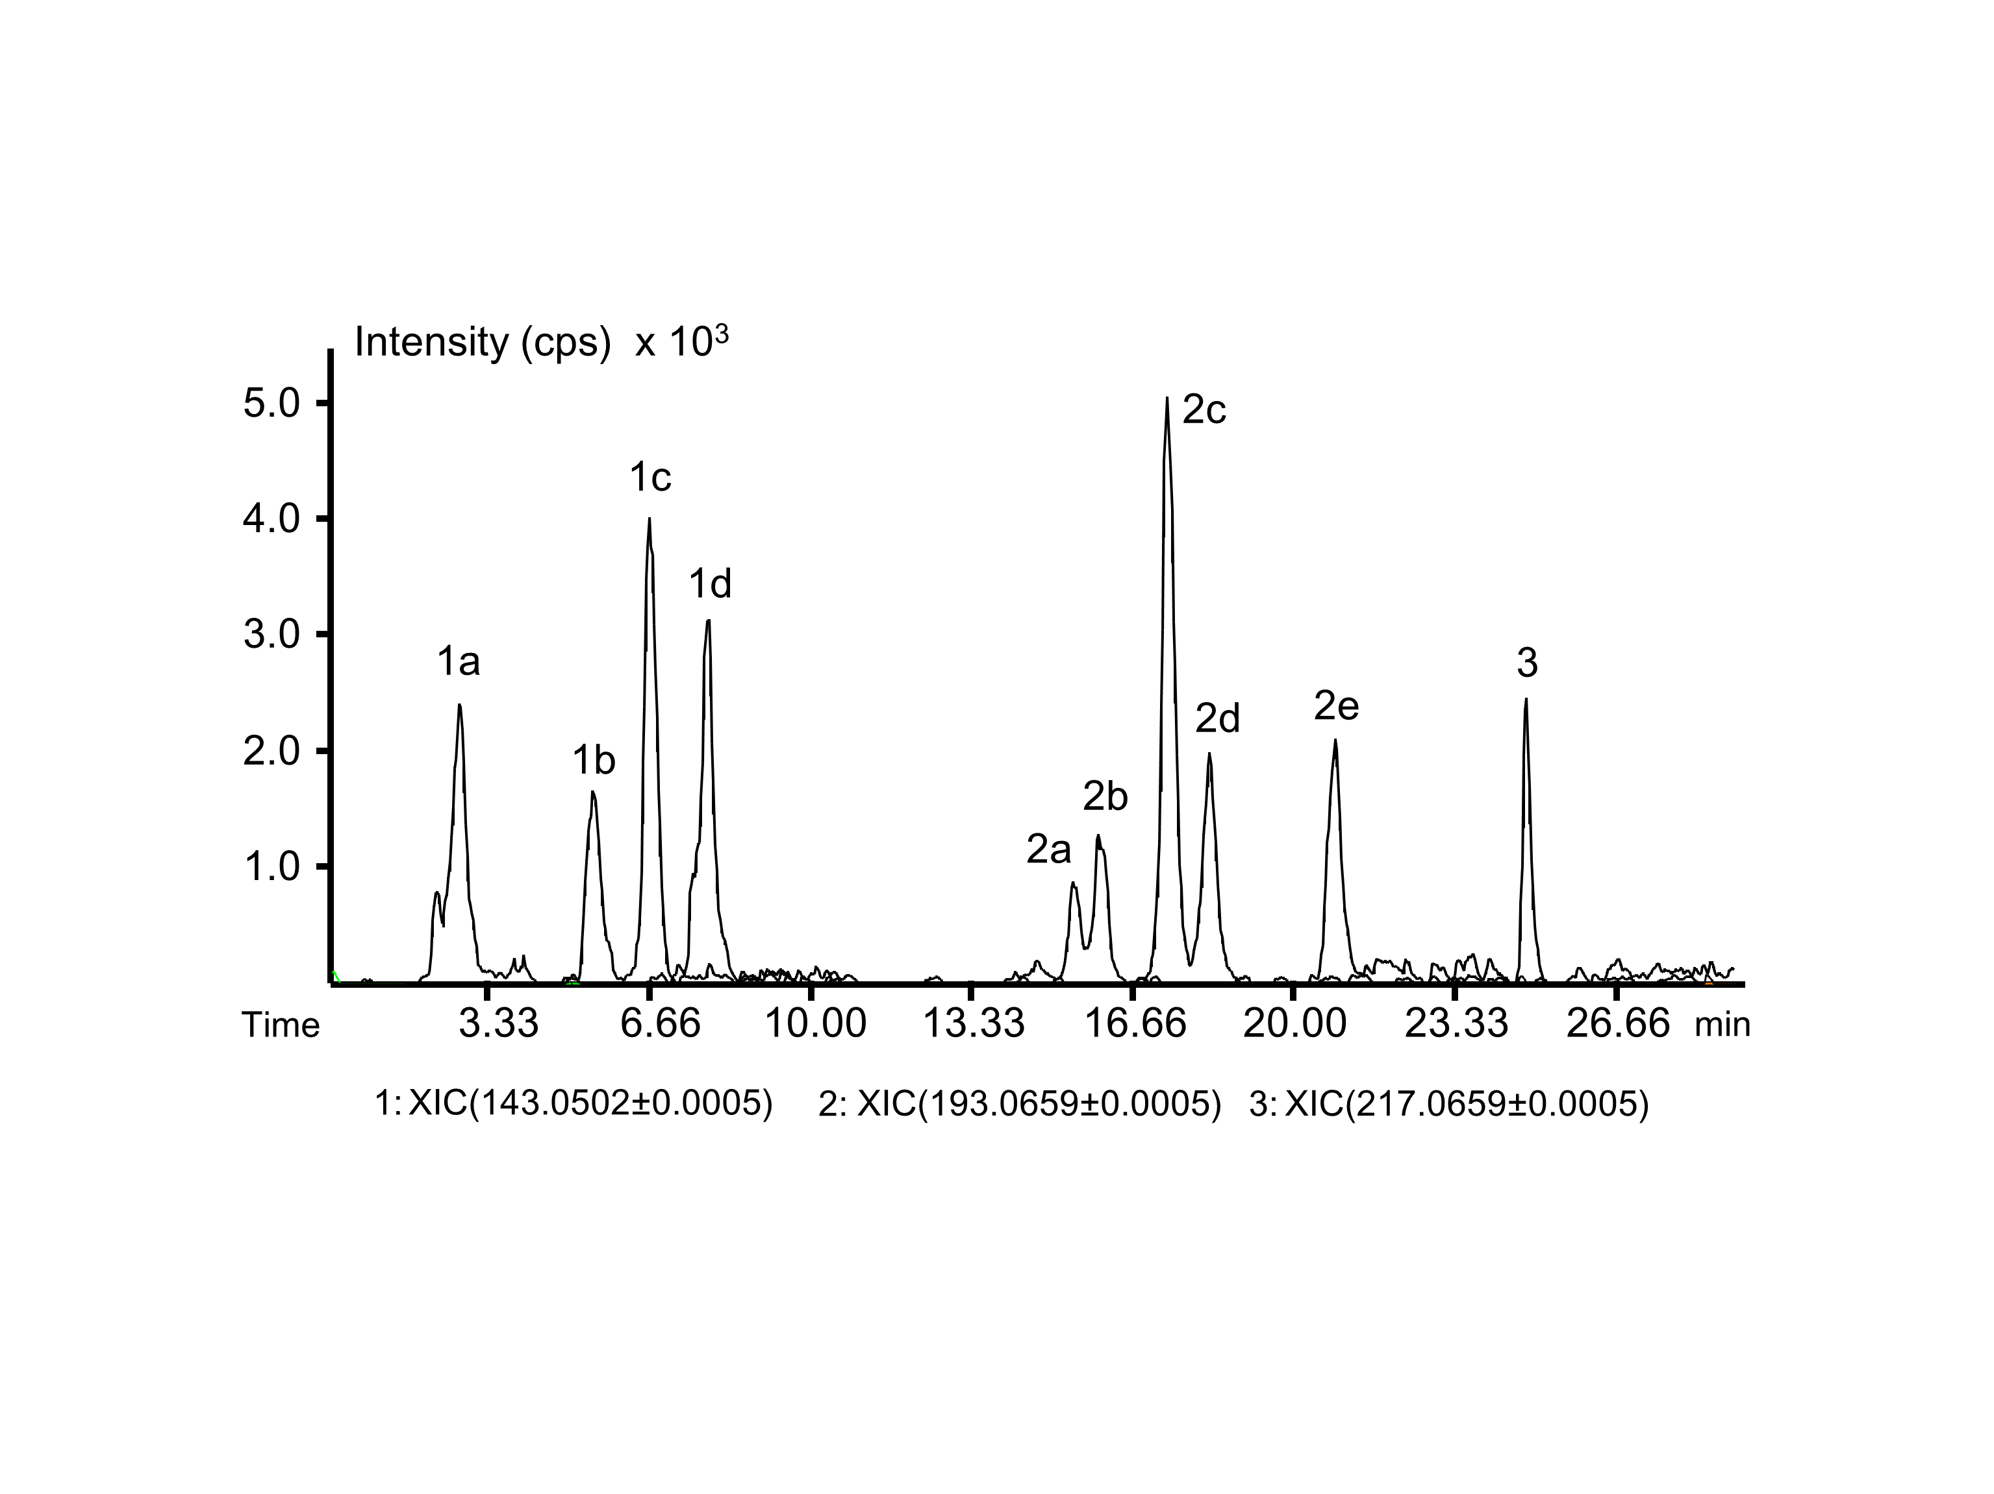
Figure S2: Extracted ion chromatograms of selected exact masses of a urine extract. The extract was analyzed using UHPLC-method III (see Table 2). Only for peak
no. 1d an isotopic pattern expected for the chemical formula of hydroxynaphthalene ([C₁₀H₇O]⁻) was observed.

