Quantitative analysis of modern fuels derived from middle distillates – The impact of diverse compositions on standard methods evaluated by an offline hyphenation of HPLC-refractive index detection with GC×GC - TOFMS
Maximilian K. Jennerwein^{a,b,c*}, Aimée Celeste Sutherland^{b,c}, Markus Eschnerª, Thomas Gröger^{b}, Thomas Wilharmª, Ralf Zimmermann^{b,c}
ªASG Analytik Service Gesellschaft mbH, Neusäß, Germany
^{b}Helmholtz Zentrum München, German Research Center for Environmental Health, Oberschleißheim, Germany
^{c}University of Rostock, Institute of Chemistry, Division of Analytical and Technical Chemistry, Rostock, Germany
Abstract
In this scientific contribution we verified the qualitative and quantitative validity of the DIN EN 12916 or ASTM D6591 based on high performance liquid chromatography with a refractive index detector (HPLC – RID) for the correct determination of aromatic compounds in middle distillates. This was achieved by investigating the influence of the potential insufficient LC separation of aromatic and aliphatic compound classes. The eluent from the HPLC was fractionized in accordingly time fractions and these fractions were subsequently analyzed (offline) by comprehensive two-dimensional gas chromatography time-of-flight mass spectrometry (GC$×$GC-TOFMS). The methodology was evaluated for common commercial available middle distillates (B0 and B7 Diesel, light heating oil and jet fuel), mixtures of pure diesel fuel with up to 7% hydrogenated vegetable oil (HVO) which serves as an example for a modern advanced premium diesel fuel [1] and different amounts of mono and di aromatic in HVO as matrix. Compound classes were identified and quantified by applying a data evaluation method which was previously developed in-house [2] for middle distillates based on GC$×$GC-TOFMS and Visual Basic Scripting (VBS).
Our findings show that the deviations between the results obtained by the GCxGC-MS vs. DIN EN 12916 could be attributed to insufficient separation between compound classes when using the DIN EN 12916 method for current middle distillates.
The composition of modern fuels furthermore affects the qualitative as well as the quantitative outcome of industry established standard methods, and that it is pivotal to revise and develop these analytical techniques in a consequential manner as the composition of fuels and petrochemical products will change and be adapted accordingly to legislative, commercial and environmental changes.

- Introduction
The compositions of common middle distillates have to fulfill different physicochemical and regulatory requirements and must be analyzed using several standardized instrumental techniques. Industry established standard methods are only periodically updated although the composition of fuels and other petrochemical related products are constantly changing as feedstocks are changing rapidly. These standard methods are seldom updated to keep in line with new legislative requirements. The content of the sulfur compounds in diesel fuels is one example: the maximum content of 2000 mg/kg in 1994 has been reduced to 10 mg/kg since 2009 which necessitates more sophisticated analytical methods. Another example is the content of polycyclic aromatic hydrocarbons (PAH), comprising the content of di- and tri+-aromatics, which is regulated by the directive 98/70/EC. The content of PAHs within fuels is known for the formation of particulate matter after incomplete combustion and is causing several serious health problems [3, 4]. The HPLC analysis of mono-aromatic, di-aromatic and tri+-aromatic compounds in middle distillates, as described in DIN EN 12916 or ASTM D6591, respectively, is also another example for a well-established method in industry. As the method is standing currently, it is validated for a content of 6 – 30% mono-aromatics, 1 – 10% di-aromatics, 0 – 2% tri+-aromatics and a biodiesel content (fatty acid methyl esters; FAME) of up to 5% which in fact does not meet the actually regulated FAME content of up to 7%.. It remains an ongoing debate regarding the suitability of this method, especially concerning higher content of FAMEs which can be up to 20%. Furthermore, also the increasing usage of hydrogenated vegetable oil (HVO) as share of biogenic content has to be considered. HVO is produced from the hydrogenation of fatty acids often followed by an isomerization process leading to a mixture of n- and iso-paraffins with carbon numbers up to C20. Diesel fuels blended with high amounts of HVO are often labeled as premium diesel fuels due to better ignition and combustion properties. Based on the so called “Tankstellenstudie” of the “Union zur Förderung von Öl- und Proteinpflanzen E.V.”(UFOP)[1], 20% of common diesel fuels in Germany are already blended with HVO in percentages of approximately 7.7% (v/v) instead of FAME. However, influences of HVO blending on the quantification method following DIN EN 12916 have not been investigated up to now.
The focus of analytical scientists’ has been on applying a broad range of different approaches, mainly gas chromatography-mass spectrometry (GC-MS) [5, 6] and high resolution time-of-flight mass spectrometry (TOFMS) [7], to better resolve middle distillates. Hyphenation between chromatographic techniques, especially the coupling between liquid- and gas chromatography (LC-GC) [8], has also been explored extensively. Approaches such as the online hyphenation between LC and GC (LC×GC) [9], and even LC and two-dimensional GC (LC×GC×GC) has been implemented for special applications [15 – 21].
Two-dimensional techniques are no longer seen as niche techniques but are rather readily used in academia as well as in industry and methods like UOP 990-11 [30] have been approved as standard and reference methods. It has to be emphasized, that although various two-dimensional techniques exists, GC$×$GC-TOFMS [10 – 14] in combination with sophisticated data processing such as Visual Basic Scripting (VBS) [2 – 4, 27 – 29] are by far the most used technique to date. In a previous study a comprehensive quantification method for middle distillates using GC$×$GC-TOFMS was presented for jet A1 fuel, light heating oil and diesel fuel [2]. While the overall compliance of the methods with EN standard methods (DIN EN 12916, DIN EN 14078, DIN EN 14103) could be approved, small deviations to DIN EN 12916 are still not adequately explained.
Within this work, the quantification of aromatics with DIN EN 12916 was evaluated for standard middle distillates (diesel fuel (B0 and B7), heating oil and jet fuel),modern high performance diesel, containing up to 7% HVO as well as artificial blends of HVO with mixtures of diaromatics. The value of the applied HVO is based on the results of UFOPs so called “Tankstellenstudie” [1]. Premium diesel fuels, containing even higher amounts of HVO, were neglected within this study. Different fractions, namely saturated compounds, mono-aromatics, di-aromatics and tri+-aromatics, from the HPLC eluent were collected and further investigated with GC$×$GC-TOFMS to verify their qualitative and quantitative composition. The sampling of the fractions was optimized and different aspects such as insufficient peak separation as well as non-selective detection with refractive index detection were evaluated.

- Experimental
  - GC$×$GC-TOFMS system
The quantification method, presented in our previous work [2], was implemented on a different column combination. Retention time windows were adjusted and fixed to the new elution order of compound groups and carbon number. The GC$×$GC-TOFMS analysis was performed on a DANI Master GC equipped with a Zoex ZX2 loop modulator and a DANI Master TOF. The data acquisition was done with the Master Lab software provided by DANI, exported as network common data format (NETCDF) file and imported into LECO ChromaTOF software (Version 4.50.8.0) for further data processing. The data processing including the use of Visual Basic Scripting is described in our previous published work [2]. The parameters of the hitherto used column combination and the now implemented column combination are listed in Table 1. The fuel samples were diluted in a 1:1 ratio with dichloromethane and spiked with an internal standard solution [2]. 1 µL of each sample was injected with a split ratio of 1:300 at 300°C.

  - Offline HPLC - GC$×$GC-TOFMS coupling
For a detailed evaluation for the quantification of aromatics with the DIN EN 12916 method, an offline coupling between HPLC and GC$×$GC-TOFMS was developed to investigate the achieved separation and possible overlap between compound classes. The LC separation was performed with a Bischoff 2250 HPLC pump equipped with a Hitachi L-7200 autosampler and a Bischoff 8120 refractive index detector. As described by the DIN EN 12916, an amino packed column (UltraSep ES; 250 $×$ 4 mm; AP 5 µm) was used with a flow rate of 0.85 mL n-heptane /min. Samples were diluted 1:10 in n-heptane and 10 µL were injected. Diverging from the standard method the solvent was not recycled. Fresh n-heptane (Rotisolv ≥ 95%; Roth) was used in order to prevent any solvent interference for the quantification emerging from fuel components that remain in the recycled solvent.
  - Standard Solutions and Mixtures
Several solutions of mono- and di-aromatic compounds in HVO as well as blends of HVO and Diesel fuel were prepared The applied standard substances and their concentrations in HVO are given in table 1.
Solution of mono-aromatic compounds in hydrated vegetable oil
Concentration o-xylene | Concentration indane/tetralin | Total mono-aromatic content
Mixture 1: Total mono-aromatic amount approximately 30%

30.04% | 0.00% | 30.04%
20.10% | 9.94% | 30.04%
10.18% | 20.03% | 30.22%
0.00% | 30.15% | 30.15%
Mixture 2: Total mono-aromatic amount approximately 20%

21.15% | 0.00% | 21.15%
16.18% | 5.51% | 21.68%
10.06% | 9.77% | 19.83%
5.97% | 15.88% | 21.84%
0.00% | 19.72% | 19.72%
Solution of di-aromatic compounds in hydrated vegetable oil
Total amount approximately 10%

Concentration Naphthalene | Concentration Biphenyl | Concentration Fluorene | Total di-aromatic content
10.31% | 0.00% | 0.00% | 10.31%
5.07% | 4.98% | 0.00% | 10.05%
4.99% | 0.00% | 5.00% | 9.99%
0.00% | 5.00% | 4.98% | 9.98%
0.00% | 9.97% | 0.00% | 9.97%
0.00% | 0.00% | 10.12% | 10.12%
Table 1: Concentrations of different mono- and di-aromatic compounds in HVO for the evaluation of the quantification method following DIN EN 12916. 1,2-dimethylbenzene (o-xylene) and fluorene are also used as external standard compounds for the calibration following the standard quantification method.

  - Collection and measurement of the HPLC fractions
For the collection of fractions, the time lag between detection and elution from the LC was determined with an external standard. Peak integration was done according to the standard method, which also defines how incomplete separated peaks have to be treated for integration. The refractive index signal was recorded online and the collection started at the corresponding integration points (figure 1) with regard to the time deviation. The initial volume of the detector cell and the capillaries, as well as the known flow rate was used the calculated the time deviation (lag time). The exact elution time was verified by a standard solution of 10 mg/l of n-tetradecylbenzene. The concentration is consistent with the concentration of the standard mixture as described in DIN EN 12916. This compound, n-tetradecylbenzene, was also further chosen to represent alkylbenzenes with high carbon numbers. For the given LC configuration, the chosen standard elutes early in the region of mono-aromatic compounds and thus near the region of saturated compounds. Two measurements of the standard solution were performed with the HPLC system and the eluent was collected in 3 second fractions. The collected fractions were injected in a GC-MS to determine the exact time lag between detector and eluent exit. For this purpose, an Agilent 7890A gas chromatograph coupled to a 5975C MSD single quad mass spectrometer were used for a fast scan method (parameters defined in table 2). Furthermore, regarding the quantification following DIN EN 12916, the influence of considerable differences concerning the differential refractive indices between the calibration standards and the examined compound groups has to be taken under consideration.

 | 1D GC – MS | GC$×$GC-TOFMS
 |  | 1st dimension | 2nd dimension
Phase | ZB 5HT | BPX50 | BPX1
Length | 15 m | 60 m | 2.5 m
Inner Diameter | 0.25 mm | 0.25 mm | 0.1 mm
Film thickness | 0.1 µm | 0.25 µm | 0.1 µm
Temperature Program | 100 – 300°C; 10°C/min | 70 – 300°C; 2°C/min
Injection temperature | 300°C
Carrier Gas | He
Flow | 1 ml/min
Mass range | 30 – 700 m/z | 30 – 500 m/z
Frequency | 10 Spectra/s | 200 Spectra/s
Table 2: GC – MS and GC$×$GC – TOFMS separation parameters
Corresponding to the calculation of a time deviation of +15 seconds, based on the volume of the detector cell and the capillary as well as the solvent flow, the standard compound eluted in the fifth applied GC vial and thus matches the calculated time deviation. No traces of the standard could be detected in the preliminary collected eluent. After the verification of the time deviation, the collection of the fractions was performed for the different middle distillates. Each sample was diluted in n-heptane following DIN EN 12916 and hereafter injected into the HPLC system. For the three samples of main interest: jet fuel A1, diesel fuel B0 and B0/HVO, three solutions were prepared for each sample. The detector signal was monitored online while the eluent was collected manually from the outlet capillary in GC vials corresponding to the integration parameters of the HPLC for the different compound classes (mono-aromatics, di-aromatics and tri+-aromatics) and the time deviation. A representative chromatogram of a diesel fuel is shown in figure 1 together with a magnification of the concerned chromatogram segment with the integration points (A, B, C and D). The first increase of the detector signal marks the first point of the peak integration (A), when the fraction of saturated compounds reaches the detector cell (A – B). The collection of the eluent started 15 seconds hereafter. The next integration point (B) is marked by the lowest signal in the valley, before the mono-aromatic fraction elutes (B – C). The eluent was collected in a new vial another 15 seconds hereafter. The same approach was done for the di-aromatic fraction (C – D) and the eluent was collected until the detection signal reached a stable minimum (D). After no recognizable peak of tri+-aromatics was detected, the eluent was collected in the estimated retention time range.
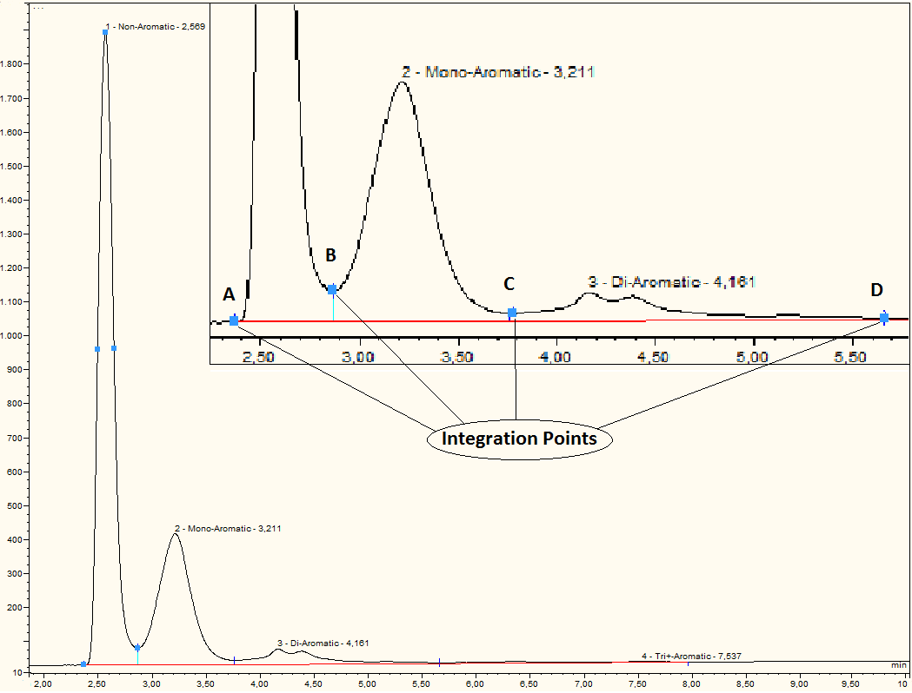
Figure 1: A representative HPLC chromatogram of a common diesel fuel. The sample is separated in non-aromatics, mono-aromatics, di-aromatics and tri+-aromatics. The concerned segment is zoomed in and the different integration points (A, B, C and D) are marked. The fraction of saturated compounds (A – B), mono-aromatics (B – C) and di-aromatics (C – D) were collected.
Before injection in the GC$×$GC-TOFMS system, 250 µL of these collected fractions were weighed in additional vials and after adding 25 µL of the internal standard solution, a precise quantification of the present compound groups was possible. The injection volume, split ratio and concentration of the internal standard were adapted due to the lower concentration of the analytes within the HPLC eluent resulting in a injection volume of 3 µL, split ratio of 1:20 and a dilution 1:200 of the internal standard.

- Results and discussion
  - Adaption of the GC$×$GC-TOFMS method
The methodology for a complete and quantitative group-type analysis of middle distillates using GC$×$GC-TOFMS and Visual Basic Scripting has been published in detail recently [2]. In this previous work a non-polar x polar column combination (normal phase configuration) was used which led to a less than effective separation between the n- and iso-paraffins and naphthenes as well as an excessive tailing of these compounds in the main part of the two-dimensional chromatogram. To cope with these chromatographic disadvantages and to adapt the method for the analysis of blends containing HVO, which consists mainly of n-paraffins in the range of C15 – C19, the method was adapted on a reversed phase column combination. The chromatograms of a common diesel fuel, blended with 7% (v/v) FAME, using normal phase and reversed phase column combinations are shown in figure 2. Within both 2D plots (TIC signal) the FAME content can easily be recognized by its remote location. ,.

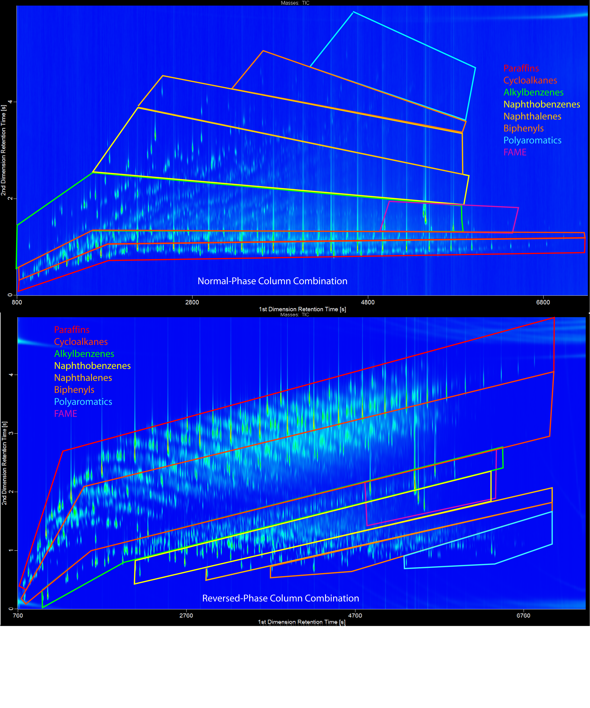
Figure 2: A representative chromatograms of a common diesel fuel (B7) blended with 7% biodiesel (FAME) using normal-phase (above) and reversed-phase (below) column combination. For the given example the elution order of the groups for the second dimension will invert. The separation parameters are given in table 1. The main compound classes are roughly classified within the chromatograms.

Although the separation of aromatic compounds gets worse with increasing carbon numbers, especially in the case of di-aromatic compounds, an outstanding separation of all aromatics is not necessary as long as time-of-flight mass spectrometry and scripting tools based on mass spectra are used for classification. After the quantification method and the compound classification based on Visual Basic Scripting were successfully adapted to the new GC$×$GC-TOFMS system and reversed column combination, the improved method was applied to the fractions collected via the HPLC.

  - Evaluation of the DIN EN 12916 method with GC$×$GC-TOFMS
In the representative HPLC chromatogram given in figure 1, the fundamental shortcoming of the usage of HPLC chromatography for middle distillates becomes obvious in the form of incomplete separation between saturated and mono-aromatic compounds. Insufficient baseline separation could be caused by tailing of saturated compounds or also fronting of the mono-aromatic compounds. Concerning the mono-aromatic and di-aromatic compounds a baseline separation could almost be achieved, but a certain amount of overlap could also be found here. More importantly, is the observation of two peaks within the di-aromatic fraction.
The first distinct peak arising can mainly be ascribe to a large amount of naphthalenes present, whereas the second peak are attributed towards the presence of biphenyls [2]. While GCxGC-TOFMS is able to distinguish between different classes, DIN EN 12916 will summarize naphthalenes and biphenyls, which are the main components as well as minor amounts of diphenylmethanes, acenaphthenes and fluorenes.as one group.
Therefore, DIN EN 12916 will account biphenyls as PAH’s which is formally a wrong allocation, since no condensed ring-systems are present. Tri+-aromatics produce only indistinct peaks using HPLC-RID owing to the fact that the content of PAHs was reduced for legislative reasons. Severe peak broadening of the tri+-aromatics can be prevented by backflushing the HPLC column after the elution of di-aromatics as long as no FAMEs are present. However, the most recent edition of DIN EN 12916 declares that due to further improvements the quantification of tri+-aromatics is not affected anymore by the content of FAMEs. In laboratory this approach is used when the total amount of PAHs (summation of di- and tri+-aromatics) exceeds the maximum value of 8% (98/70/EC). Consequently, the concentration of tri+-aromatics within the collected fractions was very low so that even main components could hardly be identified and thus an evaluation on this basis was not progressed. Comparing the integration process using DIN EN 12916 and the informative content of a whole sample analysis using GC$×$GC-TOFMS, it could be concluded that the HPLC separation will fail for this compound group in modern middle distillate products.
Regarding the quantification using a refractive index detector (RID) the selection of the applied external standards is a considerable issue that has already been discussed in fundamental studies [23, 24]. Differences of the refractive indices within one compound group might be low, but these differences become more important between different groups. At least, not the absolute value of the refractive index is crucial, but the differential refractive index relative to the fluid used as a reference. Normally, the solvent of the HPLC separation is used as reference, in this case n-heptane. The average refractive indices and differential refractive indices relative to n-heptane of the main compound groups are given in the supplemental data. These values were taken from the chemspider online database (http://www.chemspider.com/) and are in good accordance with those given in the above mentioned publication [23]. The differential refractive indices relative to n-heptane are displayed against the carbon number in a diagram in figure 4 in order to make the differences and the progress more visible. Additionally, the values of the calibration standards used for the mono-aromatic and di-aromatic compounds are given in the diagram, too. While the refractive index of the mono-aromatic calibration standard (1,2-dimethylbenzene) is representative for alkylbenzenes, a large amount of the mono-aromatic content consists of naphthenobenzenes, i.e. indanes and tetralins, showing higher differential refractive indices and thus a higher detector response. In the case of di-aromatics, fluorene is used as calibration standard, which shows a higher differential refractive index than most di-aromatics and is therefore in principle an inappropriate standard for the quantification of biphenyls and diphenylmethanes. The detector signal is also furthermore influenced by the variable amount of tailing compounds, showing lower differential refractive indices.

Figure 4: This diagram shows the progress of the differential refractive index along the increasing carbon number for the main compound groups within common middle distillates. Additionally, the values of the calibration standards for mono-aromatic compounds (1,2-dimethylbenzene) and di-aromatic compounds (fluorene) are given.
In order to proof the influence of the calibration on the quantitative results, different mixtures of mono- and di-aromatic compounds dissolved in HVO were measured using HPLC-RID. The concentrations of the different solutions are given in table 1. All results of the HPLC quantification were normalized to the applied concentration. Positive and negative deviations from the known concentrations are given in figure 5 for the mono-aromatic compounds and in figure 6 for di-aromatic compounds. A total amount of 30% mono-aromatic content was used corresponding to the maximum allowed concentration in accordance to the DIN EN 12916. By this approach quantitative results could be obtained exceeding this maximum value when certain amounts of indane and tetralin were applied. Consequently, another solution with a total amount of 20% mono-aromatics was applied. Nevertheless, both approaches show similar progress for the quantitative results of the HPLC-RID measurements with an increasing positive deviation from the actual concentration along with an increasing concentration of indane and tetralin. Figure 5 shows the amounts of o-xylene and the indane/tetralin mixture of the different solutions and the percentage deviation of the HPLC result from the actual concentration.

Figure 5: Quantitative results were converted to percentage deviation from the actual total concentration of mono-aromatic compounds. HPLC measurements of artificial samples with 20% (blue line) and 30% (red line) total mono-aromatic content resulted in increasing overestimations with increasing amounts of indane and tetralin.
For the evaluation of the quantification of di-aromatics, mixtures of three different compounds up to a total aromatic content of 10% were analyzed. The quantitation of the aromatic content according to the DIN EN 12916 resulted in an underestimation. > 3%. Only the quantification of fluorene, which is also the external standard for quantification was correct. The individual deviations for the different mixtures are given in figure 6.

Figure 6: Quantitative results were converted to percentage deviation from the actual total concentration of di-aromatic compounds. HPLC measurements of artificial samples with 10% total di-aromatic content resulted in underestimations for the naphthalene and biphenyl content
The absolute amounts of saturated, mono-aromatic and di-aromatic compounds were identified and quantified using Visual Basic Scripting as per the already developed complete group-type quantification method for middle distillates [2]. The obtained results show the amounts of the compound groups that tail into the integration area of the next eluting group during the HPLC separation. Based on these results, the deviations from the quantitative results using the refractive index detector could be calculated. For each analyzed sample, certain amounts of overlap between the different compound groups could be determined.
The amount of saturated compounds, i.e. n- and iso-alkanes as well as naphthenes, that overlap with the mono-aromatic content was determined. A representative chromatogram of the GC$×$GC-TOFMS measurement of the mono-aromatic fraction is given in figure 7. The different chromatographic regions are marked within the two-dimensional plot. Expectedly, in the first line n- and iso-alkanes, but also a small amounts of naphthenes could be found besides the mono-aromatic content. Also highlighted in the chromatogram are the internal standards, chlorocyclopentane, bromo-octane, 1,2-dichlorobenzene and 1-bromo-naphthalene, which were used for the quantification of the saturated compounds.
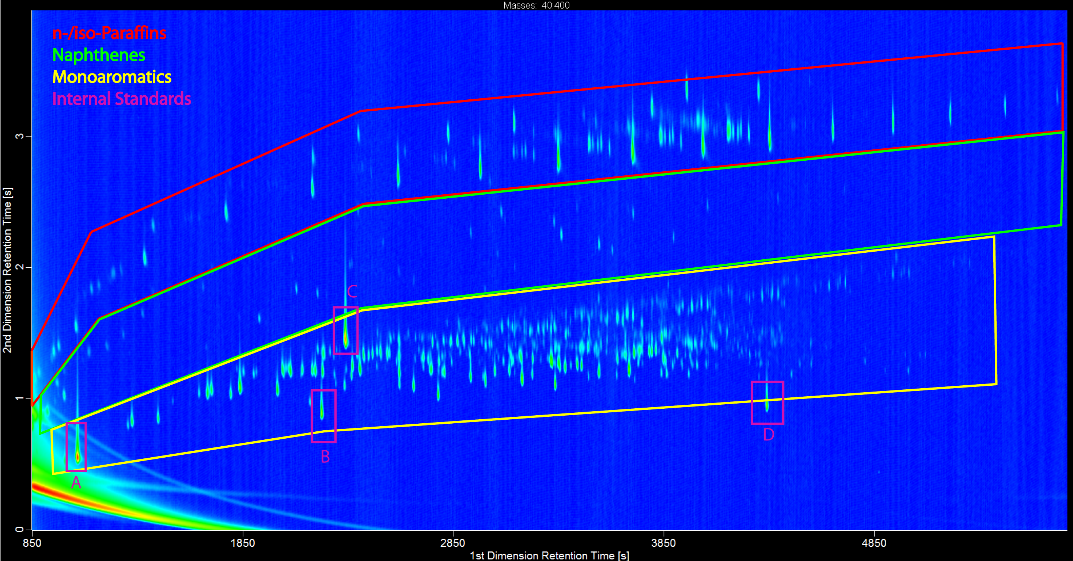
Figure 7: A representative 2D-chromatogram of the GC$×$GC-TOFMS measurement of the mono-aromatic fraction collected from a HPLC separation of B0 diesel fuel blended with 7% HVO. The elution regions for n-/iso-alkanes, naphthenes and mono-aromatic compounds are highlighted. Further, four internal standards are shown: ISTD-A: Chlorocyclopentane; ISTD-B: 1,2-Dichlorobenzene; ISTD-C: 1-Bromo-octane; ISTD-D: 1-Bromo-naphthalene.
The mono-aromatic fractions of the above mentioned middle distillates, exhibited an overlap of the saturated compounds, roughly in the range of 0.4 -0.5%. Similarly, the di-aromatic fractions exhibited a 0.1% overlap of the previously eluting compound groups (mono-aromatics).

All results are given in figure 8a and b. More detailed results can be found in the supplemental data.

Figure 8a and b: Results of the quantification of mono- and di-aromatic compounds using the refractive index detector. The amounts of overlapping compound groups were quantified using GC$×$GC-TOFMS and the values afterwards converted to the HPLC results.
Regarding the lower concentrations within the collected eluent of the di-aromatic fraction, the main mass fragments of the different compound classes were used for the visualization given in figure 9. Within this representative chromatogram of the di-aromatic content of the jet fuel A1, the chromatographic regions of both compound groups are highlighted.
Especially the quantification of Jet fuel A1 results in significant different results between GC$×$GC-TOFMS and DIN EN 12916, which could not be explained by the measurement inaccuracy. An underestimation of monoaromatics by DIN EN 12916 could be explained by the already mentioned overlap of this fraction into the di-aromatic fraction. As a consequence, this amount will be not accounted as monoaromatics. An overlap of saturated compounds into the monoramatic fraction will not compensate for this because of the small relative refractive index of saturated compounds in heptane. On a first glance overlapping of compound classes should also account for the misquantification of di-aromatics. However, the findings in our previous study are contrary. An explanation is the specific composition of di-aromatics in the analyzed jet fuel. It composes mainly by naphthlenes. A resulting misquantification of such biased mixtures was already discussed further up (figure 6). Since also no biphenyls were present in the analyzed jet fuel, the observed overlap of the naphthalene peak with the mono aromatics becomes more delicate. Most of the deviations in quantification observed in our further study [2] now could be explained and an overview of the composition of three middle distillates are shown in figure 10.
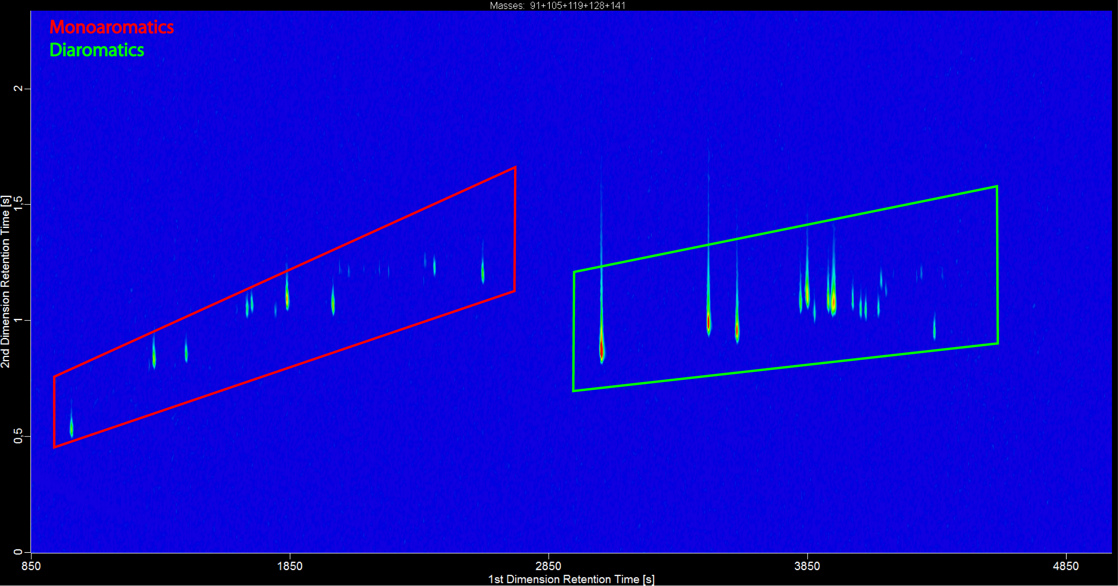
Figure 9: A representative 2D-chromatogram of the di-aromatic fraction collected from the HPLC separation of the Jet fuel A1. The elution regions of mono-aromatic compounds and di-aromatic compounds are highlighted.

Figure 10: Comparison between the compositions of the di-aromatic content of three different middle distillates [2].
The facts of an incomplete separation of the different compound groups, the influence of the differential refractive indices and the appearance of a concentration dependent tailing, lead to the conclusion that the quantification of middle distillates with DIN EN 12916 is biased due to the qualitative as well as quantitative composition of the matrix.
  - Analysis of modern high performance fuel
The investigation of the tailing of saturated compounds into the mono-aromatic peak using GC$×$GC-TOFMS showed n- and iso-alkanes of almost the full range of carbon numbers in the concerning fuel samples. Higher amounts could be found in the cases of the Jet fuel A1 and the B0 diesel fuel / HVO mixture. According to these results an average overlap of 1.36% in the mono-aromatic fraction of the jet fuel and 2.18% for the B0/HVO mixture could be determined. Since the percentages of saturated compounds within these fuels are higher than in the other applied fuel samples, larger peaks in the HPLC chromatogram and stronger overloading of the column were expected which leads to non-ideal peak shapes. This clearly shows the influence of the sample composition on the quantitative results of the method following DIN EN 12916. Special attention was given to the analysis of the B0 diesel fuel which is blended with 7% HVO, in order to investigate if measureable differences appear when the total amount of non-aromatic compounds is increased. Since the amount of diesel fuel on the market, blended with HVO instead of FAME, as well as the share of HVO within the particular fuels are increasing, this is truly an important aspect, not at least because of the relatively conservative share of 7% (v/v) that was used within this work. Since studies have been accomplished on the composition of biogenic fuels within diesel fuels, it is known that 20% of common diesel fuels on the German market contain HVO in an amount of up to 9% (v/v), determined using carbon-14 dating [1]. Premium diesel fuels were neglected from these studies, but it could be assumed that the amounts of HVO are much higher, due to the advantageous technical properties that result from the composition. The determined average overlap of 2.18% in the case of an amount of 7% (v/v) HVO represents the best case.

- Conclusion
In this work we successfully implemented a previous developed group-type quantification method for different kinds of middle distillates using comprehensive two-dimensional gas chromatography coupled with time-of-flight mass spectrometry (GC$×$GC-TOFMS). For this purpose, the method was adapted to a reversed-phase column combination, which provides an advantageous separation of n- and iso-paraffins and different types of naphthenes. Together with the compound classification using Visual Basic Scripting for an automated identification of different mass spectra and the developed quantification method the adapted setup was successfully applied for further studies.
Deviations between the quantitative results, using DIN EN 12916 and the previously presented GC$×$GC-TOFMS quantification method [2] could now be explained by the application of an offline coupling of HPLC and GC$×$GC-TOFMS separation. Our results showed that an insufficient HPLC separation led to overlapping between different compound groups.
In the case of diesel fuel with an amount of 7% (v/v) hydrogenated vegetable oil, and thus higher amounts of n- and iso-paraffins, this leads to increased tailing of saturates into the mono-aromatic fraction and stronger influence on the quantification of the mono-aromatic content. The other interesting case concerns the separation of the mono-aromatic and di-aromatic content within a jet fuel A1. The influence of tailing mono-aromatics into the di-aromatic fraction is stronger caused by the composition of the di-aromatic fraction within jet fuel in general. The di-aromatic content consists in the first line of naphthalenes, which elute earlier and only a traces of later eluting biphenyls could be found.
The influences on the differential refractive indices were also taken into account for an evaluation of the quantitative results. Concerning the complex composition of the aromatic fractions, several different compound groups with different refractive indices have to be taken under consideration. Regarding increasingly strict legal regulations and changing compositions of modern fuels, rough separation techniques and insensitive detection methods are insufficient for complex analytical issues.
All in all, the quantification of the aromatic content within middle distillates following DIN EN 12916 provides a fast and rough oversight, but the influences of the detailed composition is discriminated. Especially in the case of the di- and tri+-aromatics several compromises are made concerning the composition of the samples and the quantification. In contrary GC$×$GC-TOFMS provides a detailed and non biased qualitative and quantitative analysis of all kinds of middle distillates.
Acknowledgments
Financial support from the ASG Analytik-Service GmbH is gratefully acknowledged.

References
[1]http://www.ufop.de/files/9413/9176/4863/UFOP_Analyse_Biodiesel_Rohstoffmix_070214.pdf
[2] Jennerwein, K. Maximilian; Eschner, Markus; Gröger, Thomas; Wilharm, Thomas; Zimmermann, Ralf; Complete Group-Type Quantification of Petroleum Middle Distillates Based on Comprehensive Two-Dimensional Gas Chromatography Time-of-Flight Mass Spectrometry and Visual Basic Script; Energy & Fuels 2014 28 (9) 5670 – 5681
[3] Weggler, Benedikt A.; Gröger, Thomas; Zimmermann, Ralf; Advanced scripting for the automated profiling of two-dimensional gas chromatography-time-of-flight mass spectrometry data from combustion aerosol; Journal of Chromatography A 1364 (2014) 241 – 248
[4] Qadir, R.M.; Abbaszade, G.; Schnelle-Kreis, J.; Chow, J.C.; Zimmermann, R.; Concentrations and source contributions of particulate organic matter before and after implementation of a low emission zone in Munich, Germany; Environmental Pollution 175 (2013) 158 – 167
[5] Briker, Y; Ring, Z.; Iacchelli, A; McLean, N.; Rahimi, P.M.; Fairbridge, C.; Diesel Fuel Analysis by GC-FIMS: Normal Paraffins, Isoparaffins, and Cycloparaffins; Energy & Fuels 2001, 15, 23 – 37
[6] Liu, Guozhu; Wang, Li; Qu, Haijie; Shen, Hui,img; Zhang, Xiangwen; Zhang, Shuting; Mi, Zhentao; Artificial neural network approaches on composition–property relationships of jet fuels based on GC–MS; Fuel 86 (2007) 2551 – 2559
[7] Hughey, Christine A.; Hendrickson, Christopher L.; Rodgers, Ryan P.; Marshall, Alan G.; Elemental Composition Analysis of Processed and Unprocessed Diesel Fuel by Electrospray Ionization Fourier Transform Ion Cyclotron Resonance Mass Spectrometry; Energy & Fuels, 15, 1186 – 1193
[8] Robert, Eric; Beboulene, Jean-Jacques; Codet, Georgie; Enache, Dan; High-performance liquid chromatography coupled off-line with capillary gas chromatography Application to the determination of the aromatics content in middle distillates; Journal of Chromatography A 683 (1994) 215 – 222
[9] De Koning, Sjaak; Janssen, Hans-Gerd; Brinkman, Udo A.Th.; Group-type characterisation of mineral oil samples by two-dimensional comprehensive normal-phase liquid chromatography–gas chromatography with time-of-flight mass spectrometric detection; Journal of Chromatography A 1058 (2004) 217 – 221
[10] Frysinger, Glenn S.; Gaines, Richard B.; Comprehensive Two-Dimensional Gas Chromatography with Mass Spectrometric Detection (GC6 GC/MS) Applied to the Analysis of Petroleum; Journal of High Resolution Chromatography (1999), 22 (5), 251 – 255
[11] Vendeuvre, Colombe; Ruiz-Gerrero, Rosario; Bertoncini, Fabrice; Duval, Laurent; Thiébaut, Didier; Hennion, Marie-Claire; Characterization of middle-distillates by comprehensive two-dimensional gas chromatography (GC$×$GC): A powerfull alternative for performing various standard analysis of middle-distillates; Journal of Chromatography A 1086 (2005) 21 – 28
[12] Striebich, Richard C.; Shafer, Linda M.; Adams, Ryan K.; West, Zachery J.; DeWitt, Matthew J.; Zabarnick, Steven; Hydrocarbon Group-Type Analysis of Petroleum-Derived and
Synthetic Fuels Using Two-Dimensional Gas Chromatography; Energy&Fuels 28 (2014) 5696 – 5706
[13] Kehimkar, Benjamin; Parsons, Brendon A.; Hoggard, Jamin C.; Billingsley, Matthew C.; Bruno, Thomas J.; Synovec, Robert E.; Modeling RP-1 fuel advanced distillation data using comprehensive two-dimensional gas chromatography coupled with time-of-flight mass spectrometry and partial least squares analysis; Anal Bioanal Chem (2015) 407: 321 – 330
[14] Adam, Frédérick; Bertocnini, Fabrice; Thiébaut, Didier; Esnault, Sébastien; Espinat, Didier; Hennion, M.C.; Towards Comprehensive Hydrocarbons Analysis of Middle Distillates by LC–GC×GC; Journal of Chromatographic Science (2007), Vol. 45, 643 – 649
[15] Sciarrone, Danilo; Tranchida, Peter Quinto; Costa, Rosaria; Donato, Paola; Ragonese, Carla; Dugo, Paola; Dugo, Giovanni; Mondello, Luigi; Offline LC- GC$×$GC in combination with rapid scanning quadrupole mass spectrometry; Journal of Separation Science (2008) 31, 3329 – 3336
[16] Mao, Debin; Van De Weghe, Hendrik; Diels, Ludo; De Brucker, Nicole; Lookman, Richard; Vanermen, Guido; High-performance liquid chromatography fractionation using a silver-modified column followed by two-dimensional comprehensive gas chromatography for detailed group-type characterization of oils and oil pollutions; Journal of Chromatography A 1179 (2008) 33 – 40
[17] Mao, Debin; Lookman, Richard; Van De Weghe, Hendrik; Van Look, Dirk; Vanermen, Guido; De Brucker, Nicole; Diels, Ludo; Estimation of ecotoxicity of petroleum hydrocarbon mixtures in soil based on HPLC– GC$×$GC analysis; Chemosphere 77 (2009) 1508 – 1513
[18] Mao, Debin; Lookman, Richard; Van De Weghe, Hendrik; Weltens, Reinhilde; Vanermen, Guido; De Brucker, Nicole; Diels, Ludo; Combining HPLC-GCXGC, GCXGC/ToF-MS, and Selected Ecotoxicity Assays for Detailed Monitoring of Petroleum Hydrocarbon Degradation in Soil and Leaching Water; Environmental Science & Technology (2009) 43, 7651 – 7657
[19] Mao, Debin; Lookman, Richard; Van De Weghe, Hendrik; Weltens, Reinhilde; Vanermen, Guido; De Brucker, Nicole; Diels, Ludo; Detailed analysis of petroleum hydrocarbon attenuation in biopiles by high-performance liquid chromatography followed by comprehensive two-dimensional gas chromatography; Journal of Chromatography A, 1216 (2009) 1524 – 1527
[20] Dutriez, Thomas; Courtiade, Marion; Thiébaut, Didier; Dulot, Hugues; Bertoncini, Fabrice; Hennion, Marie-Claire; Extended characterization of a vacuum oil by offline LC-high-temperature comprehensive two-dimensional gas chromatography; Journal of Seperation Science, 2010, 33, 1787 – 1796
[21] Zoccali, Mariosimne; Tranchida, Peter Quinto; Mondello, Luigi; On-Line Combination of High Performance Liquid Chromatography with Comprehensive Two-Dimensional Gas Chromatography-Triple Quadrupole Mass Spectrometry: A Proof of Principle Study; Analytical Chemistry (2015) 87 (3) 1911 – 1918
[22] Adam, Frédérick; Thiébaut, Didier; Bertoncini, Fabrice; Courtiade, Marion; Hennion, Marie-Claire; Supercritical fluid chromatography hyphenated with twin comprehensive two-dimensional gas chromatography for ultimate analysis of middle distillates; Journal of Chromatography A 1217 (2010) 1386 – 1394
[23] Miller, R.L.; Ettre, L.S.; Quantitative analysis of hydrocarbons by structural group type in gasolines and distillates, II. Liquid Chromatography; Journal of Chromatography, 259 (1983) 393 – 412
[24] Cookson, D.J.; Rix, C.J.; Shaw, I.M; Smith, B.E.; High-Performance Liquid Chromatographic procedure for direct determination of the compound class composition of diesel and kerosene fuels using Refractive Index Detection; Journal of Chromatography, 312 (1984) 237 – 246
[25] Sarowha, S.L.S; Sharma, B.K.; Sharma, C.D.; Bhagat S.D.; Characterization of Petroleum Heavy Distillates Using HPLC and Spectroscopic Methods; Energy&Fuels 11 (1997) 566 – 569
[26] Win Lee, S.; Glavincevski, Boris; NMR method for the determination of aromatics in middle distillate oils; Fuel Processing Technology 60 (1999) 81 – 86
[27] Welthagen, W.; Schnelle-Kreis, J.; Zimmermann, R.; Search criteria and rules for comprehensive two-dimensional gas chromatography–time-of-flight mass spectrometry analysis of airborne particulate matterJournal of Chromatography A 1019 (1-2), 233 – 249
[28] Vogt, Leslie; Gröger, Thomas; Zimmermann, Ralf; Automated compound classification for ambient aerosol sample separations using comprehensive two-dimensional gas chromatography–time-of-flight mass spectrometry;Journal of Chromatography A, 1150 (2007), 2 – 12
[29] Lissitsyna, K.; Huertas, S.; Quintero, L.C.; Polo, L.M.; PIONA analysis of kerosene by comprehensive two-dimensional gas chromatography coupled to time of flight mass spectrometry; Fuel 116 (2014) 716 – 722
[30] ASTM International; UOP standard 990-11; UOP LLC (2011)
[31] Kehimkar, Benjamin; Hoggard, Jasmin C; Marney, Luke C.; Billingsley, Matthew C.; Fraga, Carlo G.; Bruno, Thomas J.; Synovec, Robert E.; Correlation of rocket propulsion fuel properties with chemical composition using comprehensive two-dimensional gas chromatography with time-of-flight mass spectrometry followed by partial least squares regression analysis; Journal of Chromatography A, 1327 (2014) 132 – 140

