Pretreatment of anaerobic digester samples by hydrochloric acid for solution-state ¹H and ¹³C NMR spectroscopic characterization of organic matter (supplementary material)
Sepehr Shakeri Yekta¹, Mattias Hedenström², Jan Eric Stehr³, Mårten Dario¹, Norbert Hertkorn⁴, Annika Björn¹
¹Department of Thematic Studies-Environmental Change and Biogas Research Center, Linköping University, 581 83 Linköping, Sweden
²Department of Chemistry, Umeå University, 901 87 Umeå, Sweden
³Department of Physics, Chemistry and Biology, Linköping University, 581 83 Linköping, Sweden
⁴Helmholtz Center Munich, German Research Center for Environmental Health, Research Unit Analytical Biogeochemistry (BGC), 85764 Neuherberg, Germany
*Corresponding author: E-mail: sepehr.shakeri.yekta@liu.se, Phone: +46 13282294, Fax: +46 13133630.

Table S1. The overall charcteristics and elemental compositions of the anaerobic sludge in substrate and digestate of the CD and SSD reactors. The elemental analyses were performed by Eurofin Environment Testing AB (Lidköping, Sweden) according to the Swedish standard method SS028150-2. Total and volatile solid contents were determined according to the Swedish standard method SS028311. AU stands for analytical uncertainty (± % of measured value).
 | Unit | CD substrate | CD digestate | SSD substrate | SSD digestate | AU
Total solid (TS) | % of total wet weight | 14 | 5,4 | 5,7 | 3,6 | ±10%
Volatile solid | % of TS | 91 | 75 | 82 | 68 | ±10%
Al | mg kg⁻¹ TS | 870 | 2100 | 8900 | 22000 | ±20%
Sb | mg kg⁻¹ TS | < 1,1 | < 0,98 | <0,95 | 1,2 | ±20%
As | mg kg⁻¹ TS | 0,73 | 3,4 | 1,5 | 3,4 | ±20%
Ba | mg kg⁻¹ TS | 17 | 44 | 130 | 270 | ±20%
Pb | mg kg⁻¹ TS | 3,2 | 5,1 | 5,3 | 14 | ±25%
B | mg kg⁻¹ TS | < 5,2 | 15 | 7,4 | 12 | ±15%
P | mg kg⁻¹ TS | 5100 | 16000 | 21000 | 38000 | ±15%
Cd | mg kg⁻¹ TS | 0,12 | 0,8 | 0,33 | 0,67 | ±25%
Ca | mg kg⁻¹ TS | 18000 | 43000 | 17000 | 37000 | ±15%
K | mg kg⁻¹ TS | 11000 | 37000 | 2300 | 5200 | ±20%
Co | mg kg⁻¹ TS | 4,8 | 16 | 2,4 | 4,2 | ±20%
Cu | mg kg⁻¹ TS | 16 | 52 | 190 | 360 | ±15%
Cr | mg kg⁻¹ TS | 4,3 | 11 | 6,6 | 16 | ±15%
Mg | mg kg⁻¹ TS | 1400 | 3900 | 1600 | 3400 | ±15%
Mn | mg kg⁻¹ TS | 66 | 190 | 160 | 290 | ±15%
Mo | mg kg⁻¹ TS | < 1,1 | 3,1 | 3,7 | 6,9 | ±20%
Na | mg kg⁻¹ TS | 7700 | 29000 | 1200 | 2900 | ±20%
Ni | mg kg⁻¹ TS | 3,6 | 18 | 9 | 18 | ±15%
Se | mg kg⁻¹ TS | < 1,1 | 2,1 | <0,95 | 1,8 | ±20%
Ag | mg kg⁻¹ TS | < 1,1 | < 0,98 | <0,95 | 1,1 | ±20%
S | mg kg⁻¹ TS | 3600 | 11000 | 7700 | 14000 | ±20%
Ti | mg kg⁻¹ TS | 16 | 36 | 140 | 300 | ±15%
V | mg kg⁻¹ TS | 1,4 | 4,4 | 4,6 | 13 | ±20%
W | mg kg⁻¹ TS | < 1,2 | 2,6 | <1,1 | 1,2 | ±25%
Zn | mg kg⁻¹ TS | 71 | 230 | 340 | 660 | ±25%

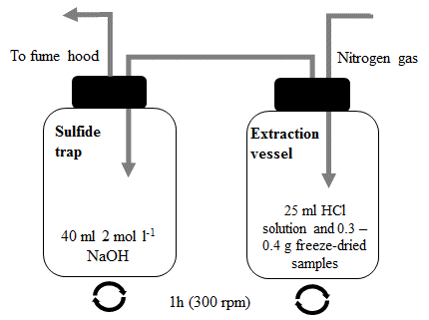
Fig. S1. Schematic picture of the sample pretreatment set up.

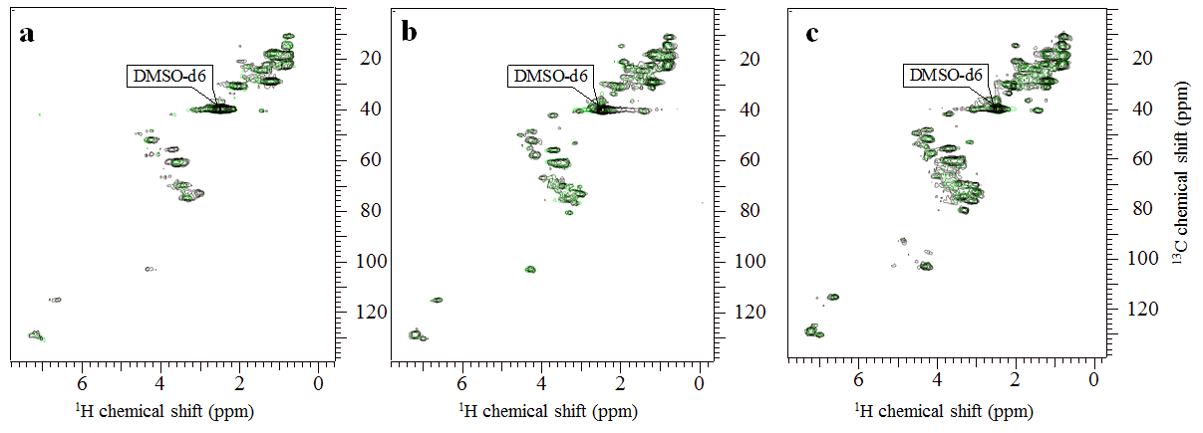
Fig. S2. ¹H,¹³C HSQC NMR spectra of SSD digestate samples pretreated with 1.0 (a), 2.0 (b), and 3.0 (e) mol l⁻¹ HCl. Green and black lines indicate the spectra from duplicate sample pretreatments.

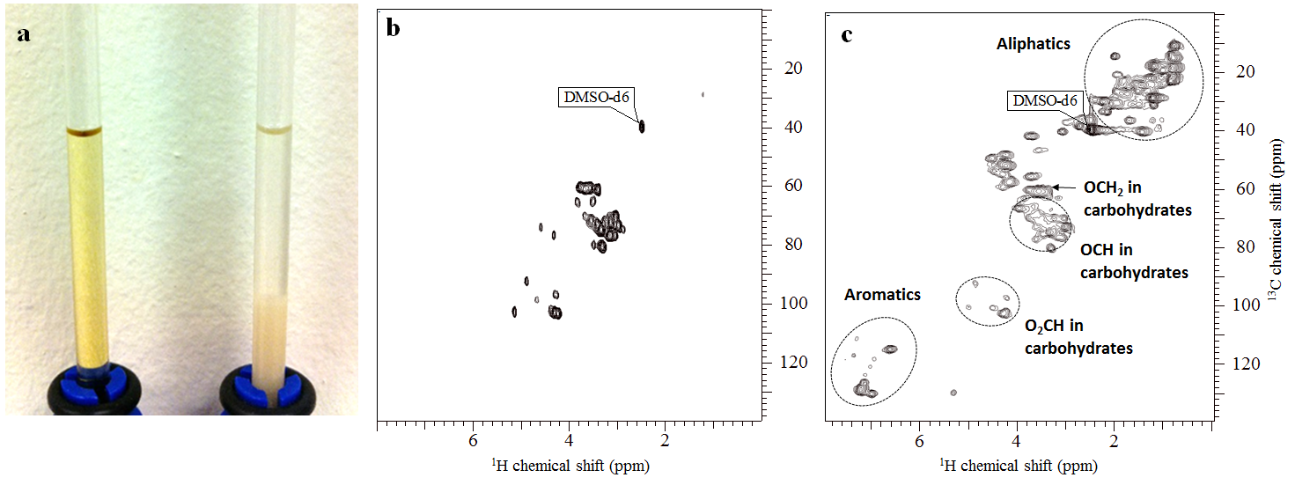
Fig. S3. a) 20 mg of pretreated microcrystalline cellulose powders were dissolved completely in 0.6 ml DMSO-d₆ (the tube on the left hand side of the picture), while untreated microcrystalline cellulose did not dissolve (the tube on the right hand side of the picture). It was not possible to acquire a meaningful NMR spectrum from untreated cellulose powder. ¹H,¹³C HSQC spectra acquired from microcrystalline cellulose powder (b) and CD digestate samples (c), pretreated with 2 mol l⁻¹ HCl.

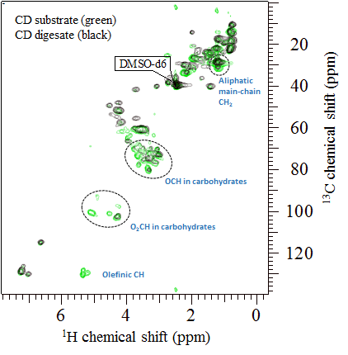
Fig. S4. ¹H,¹³C HSQC NMR spectra of CD substrate (green) and CD digestate (black) samples both pretreated with 2.0 mol l⁻¹ HCl. Differences between NMR spectral patterns of pretreated digestate and substrate samples were discerned within the regions related to resonances of OCH and O₂CH in carbohydrates, olefinic CH, and aliphatic CH₂ (in proteins and lipids). Resonances marked in the figure appeared with substantially lower intensities or were entirely absent in spectra of digestate samples as compared to spectra of substrate samples.

