Compatibility of medication with PRISCUS criteria and identification of drug interactions in a large cohort of patients with COPD
Jana Graf^{1,2}, Tanja Lucke^{1,2}, Ronald Herrera^{1,3}, Henrik Watz⁴, Rolf Holle⁵, Claus Vogelmeier⁶, Joachim H. Ficker^{7,8}, Rudolf A. Jörres^{1,2}

¹Institute and Outpatient Clinic for Occupational, Social and Environmental Medicine, University Hospital LMU Munich, München, Germany
²Comprehensive Pneumology Center Munich, DZL, German Center for Lung Research, München, Germany
³Center for International Health, Ludwig-Maximilian University Munich, München, Germany
⁴Pulmonary Research Institute at LungenClinic Grosshansdorf, Airway Research Center North, Member of the German Center for Lung Research, Woehrendamm 80, 22927 Grosshansdorf, Germany
⁵German Research Center for Environmental Health, Institute of Health Economics and Health Care Management, Member of the German Center for Lung Research, Comprehensive Pneumology Center Munich (CPC-M), Neuherberg, Germany
⁶Pulmonary and Critical Care Medicine, Department of Medicine, University Medical Centre Giessen and Marburg, Philipps-University, Marburg, Germany
⁷Department of Respiratory Medicine, Allergology and Sleep Medicine, Klinikum Nuremberg, Nürnberg, Germany
⁸Paracelsus Medical University Nuremberg, Nürnberg, Germany

Corresponding Author:
PD Dr. Rudolf A. Jörres
Institut und Poliklinik für Arbeits-, Sozial- und Umweltmedizin
Ziemssenstr. 1, D-80336 München, Germany
Tel.: +49 (0)89 4400-52466, rudolf.joerres@med.uni-muenchen.de

This work was supported by BMBF Competence Network Asthma and COPD (ASCONET) and performed in collaboration with the German Center for Lung Research (DZL). The project is funded by the German Federal Ministry of Education and Research (BMBF) with grant number 01 GI 0881; and is funded by unrestricted grants from AstraZeneca GmbH, Bayer Schering Pharma AG, Boehringer Ingelheim Pharma GmbH & Co. KG, Chiesi GmbH, GlaxoSmithKline, Grifols Deutschland GmbH, MSD Sharp & Dohme GmbH, Mundipharma GmbH, Novartis Deutschland GmbH, Pfizer Pharma GmbH, Takeda Pharma Vertrieb GmbH & Co. KG for patient investigations and laboratory measurements.
ABSTRACT
Patients with COPD are often of advanced age and have a high number of medications due to their lung disease and comorbidities. Thus they are at risk for unwanted effects from drugs, either due to age or due to interactions between drugs. These issues are not clarified. We therefore assessed the number of medications and potential adverse effects in a large cohort of patients with COPD.
The analysis was performed in 2741 patients of the German COPD cohort COSYCONET, using baseline data (visit 1) and follow-up data after about 1.5 years (visit 3). Spirometric GOLD grades 1-4 were found in 8/35/32/9 % of patients and GOLD groups ABCD in 7/25/4/48 % of patients, while the remaining patients (n= 450, 16.4 %) could not be classified according to GOLD criteria. The compatibility of medication with age was evaluated via the PRISCUS list, drug interactions via the AiD clinic system, whereby only drug combinations occurring in at least 10 patients were considered (nine unwanted interactions, one wanted interaction).
The median numbers of medications were 5 or more in all patient categories, among them 3 or more non-respiratory medications. In the total population there were 153 patients (10.2 %) aged ≥65 years who had any medication of the PRISCUS list with intermediate or low risk. Serious adverse combinations of drugs according to AiD occurred in 114 patients (4.2 %), while the number of unwanted but only potentially clinically relevant combinations was 175 (6.4 %). The number of wanted combinations was 219 (8.0 %). These numbers did not markedly change when restricting the analysis to patients of GOLD grades 1-4. Moreover, the results were similar for visit 1 and visit 3.
We conclude that in a large cohort of COPD patients about 10 % of those patients older than 65 years had medications that could interfere with their age and that the proportions of patients with either unwanted or wanted drug interactions were both in the range of 8-10%. These results suggest that problems arising from the high number of medications were not very frequent in the COPD cohort analysed.
Word count: 344

Key words: COPD; medication; polypharmacy; severity; age; PRISCUS; interactions; AiD

- INTRODUCTION
Problems arising from medication are of increasing concern in an aging society comprising many elderly with multiple morbidities. There are two aspects regarding this problem. The first is the potential of certain drugs to elicit pharmacologically adverse effects at advanced age [1], [2]. The second is the problem that with an increasing number of medications the likelihood of drug interactions increases. The interactions may comprise both adverse (unwanted) effects and beneficial (wanted) effects [3]. Polypharmacy could be an issue especially in COPD which is (a) a prevalent disease, (b) predominantly found in the elderly, and (c) associated with a high number of comorbidities [4].
Dolce at al. reported in their study of a COPD cohort in the South-eastern United States that patients had on average 6 oral and inhaled drugs solely for their respiratory disease [5]. Similarly, in a large cohort study in the US that was not limited to COPD it was found that subjects aged 65 years and older had on average at least 5 medications prescribed [6]. Such numbers qualify for the common criterion of polypharmacy in terms of at least 5 drugs taken [7]. They are also in accordance with the common experience from clinical practice. It is thus reasonable to expect that patients with COPD might be at high risk for unwanted effects of polymedication, but up to now little information is available regarding this concern.
We therefore studied a large cohort of well characterized COPD patients and determined the number of medications for both the lung disease and comorbidities, the age-related risk associated with single medications, and the potential of interactions between drugs based on their pharmacology. For this purpose we evaluated data of the baseline visit and one follow-up visit of the German COPD cohort COSYCONET (German COPD and Systemic Consequences-Comorbidities Network) [8].

- MATERIAL AND METHODS
  - Study population
The baseline sample (recruitment visit) of COSYCONET comprised 2741 patients [8]. In addition to a comprehensive set of measurements and questionnaires, information on comorbidities and medication was obtained. Comorbidities in terms of doctors’ diagnoses were assessed via a structured list and free-text [8]. Moreover, patients were asked to bring all of their medication at each visit, which was recorded and coded into ATC and ICD-10 codes [9]. Data from spirometry and information on symptoms and exacerbation history were used to categorize the patients into the spirometric grades GOLD 1-4 [10],[8] and the severity groups GOLD A-D [11]. The details of the assessments and categorization have been described previously, as well as the distribution of comorbidities [8].
In addition to patients met the spirometric criterion of COPD [11] (ratio of forced expiratory volume in one second, FEV₁, and forced vital capacity, FVC, <0.7) the study population also included patients who did not meet this criterion but still reporting a diagnosis of COPD. These patients showed comorbidity profiles similar to those of patients fulfilling the spirometric criterion and were therefore included in the analysis.
In the assessment of the PRISCUS list all patients of age 65 years or older were included. For the assessment of drug interactions we analysed data from all patients and studied data from a subgroup with spirometric GOLD grades 1-4 separately. We also stratified patients of GOLD grades 1-4 for the exacerbation risk in terms of GOLD 2017 groups A-D [11]; for this purpose GOLD groups A+B (low exacerbations) and C+D (high exacerbations) were compared.
The analyses described above were performed for baseline data (visit 1, recruitment) and also for visit 3 data to determine the robustness of our findings over time. The median (quartiles) interval between the two visits was 561 (545; 590) days.
2.2. Risk assessment of medication in relation to age
To evaluate potential problems of drugs in relation to advanced age we used the criteria defined by PRISCUS for patients of age ≥65 years [12]. The German PRISCUS list was created in 2010 based on the American Beers criteria [13], the Canadian McLeod criteria [14] and the French Laroche list [15], all of which were designed to detect potentially inappropriate medication in the elderly. The intention of the PRISCUS list was to generate a similar list adapted to the German market. All 83 drugs included in the list had been rated by expert consensus on a five-point scale ranging from 1 (drugs definitely being regarded as inappropriate for elderly patients) to 5 (drugs whose risk is similar for younger and older patients) [1]. To simplify the description of the results we summarized the drugs listed by PRISCUS into the four categories of analgetics, cardiovascular medication, psychiatric medication and anticholinergics. For these categories the prevalence and associated weighted risk according to PRISCUS were determined, in addition to information on single drugs.
  - Risk assessment of medication with regard to interactions
Interactions between drugs were identified via the AiD clinic system which has been developed by the Heidelberg University Medical Centre [16] and is in widespread use. The AiD system is based on the scientifically available information on drug interactions and regularly updated. As the number of potential interactions was large but mostly encountered in very few patients of our cohort, we restricted the analysis to combinations of a certain frequency. In a first step all medications prescribed within the cohort were grouped into different substance classes to facilitate the search for interactions. In a second step we selected all drugs with at least 50 prescriptions. For the selected drugs scientific literature was reviewed to identify drugs known for their potential of drug-drug interactions. This approach had to be chosen as the AiD system is designed to evaluate potential interactions between specific drugs, not merely categories of drugs. In the next step, those combinations were identified which were indicated by the literature and occurred in at least 10 patients at visit 1. Finally, we decided to focus on the interactions defined as potentially clinically relevant (marked orange) or clinically serious (marked red) in AiD. Those indicated as not clinically relevant were omitted.
This approach led to nine unwanted interactions and one wanted interaction. It should be noted that we did not include inhaled respiratory medications since their systemic effects and potential for interactions are low compared to oral medications, provided the application (e.g. inhalation of glucocorticosteroids) is performed in the proper way. The set of interactions identified in the present study is shown in Table 1.

Drug | Interacting drug | Type of interaction | Unwanted Effect
Diuretics (Torasemide, Furosemide) | Cardiac glycosides (Digoxin, Digitoxin) | Increased risk for glycoside intoxication due to pharmacodynamically induced potassium loss by diuretics and narrow therapeutic range of cardiac glycosides | Dizziness, sickness and cardiac arrhythmias even to the point of life-threatening ventricular fibrillation [17]
Diuretics (Torasemide, Furosemide) | Glucocorticoids (Prednisolone) | Risk of hypokalaemia due to additive pharmacodynamically effect of increased potassium excretion | Drowsiness, weakness or nausea [18]
Statins (esp. Simvastatin due to CYP3A4/5 regulation) | Calcium channel blockers (Diltiazem, Verapamil) | Pharmacokinetic inhibition of simvastatin CYP3A4/5 metabolism | Higher risk of myopathy and rhabdomyolysis [19], [20] due to increased simvastatin plasma levels
Theophylline | Allopurinol | High dosage of allopurinol may result in theophylline over dosage due to a reduced theophylline metabolism having a narrow therapeutic range | Dizziness, sickness, tachycardia or convulsions [21]
Theophylline | Calcium channel blockers (Verapamil) | Pharmacokinetically reduced Theophylline metabolism (CYP3A4) | Possible Theophylline over dosage [22]
ACE inhibitors (Ramipril, Enalapril, Lisinopril and its combinations) | Potassium-sparing-diuretics (Spironolactone) | Pharmacodynamically additive effect of hyperkalaemia | Paraesthesia, drop of blood pressure or even cardiac arrest [23]
Beta-blockers (Bisopolol, Nebivolol and Metoprolol) | Cardiac glycosides (Digoxin, Digitoxin) | Pharmacodynamic synergism | Increased bradycardia and hypotension [24]
Proton pump inhibitors (Pantoprazole) | Platelet aggregation inhibitors (Clopidogrel) | Pharmacokinetic interaction (CYP2C19) interfering with activation of platelet aggregation inhibitors | Anticoagulation possibly less effective (less distinctive than for Omeprazole) [25]
Calcium channel blockers (Verapamil) | Cardiac glycosides (Digoxin) | Increased risk for Digoxin intoxication via inhibition of glycoside metabolism (CYP3A4) | Dizziness, sickness, cardiac arrhythmias [26]
Drug | Interacting drug | Type of interaction | Wanted effect
Diuretics (Torasemide, Furosemide, HCT and their combinations) | ACE-Inhibitors | Pharmacodynamic synergism | Used for antihypertensive therapy; over dosage poses risk of hypotension
Table 1: Drug interactions analysed in the COPD cohort

  - Data analysis
The results are given as counts and percentages for the different categories of medications and interactions. The presentation is mostly descriptive, and we performed statistical comparisons, e.g. between GOLD grades and groups, only in few instances as the case numbers were often very low.

- RESULTS
3.1. Study population
Details on the study cohort have been previously published [8]. At visit 1 there were 1122 (41 %) women and 1619 (59 %) men, the mean (± SD) age being 65.1 (± 8.6) years, and mean (± SD) FEV₁ 56.9 ± 21.2 % predicted [10]. In accordance with the mean age, 55% of patients (n= 1508) were at least 65 years old, thus the evaluation according to PRISCUS was reasonably feasible; these patients showed a mean (± SD) age of 71 ± 4.6 years (611 women, 897 men). The distribution across spirometric GOLD grades 1 to 4 was n= 206/962/874/249 patients, corresponding to 8/35/32/9 % of the total study cohort. Accordingly, 450 patients (16.4 %) had the diagnosis/symptoms of COPD without showing the grades 1 to 4 (uncategorized COPD). Patients of grades 1 to 4 were categorized into the GOLD (2017) groups ABCD based on symptoms (COPD Assessment Test, CAT) and exacerbations [11]. The distribution of ABCD groups was n= 184/672/104/1322 corresponding to 7/25/4/48 %.
At visit 3 n= 2053 patients (839 % women) were still in the study, and their distribution of GOLD grades 1-4 was 151/730/643/197 corresponding to 17/36/31/10 %, with the remaining 332 patients (16.2 %) uncategorized.

3.2. Number of medications

Table 2 shows the number of medications in terms of median values and quartiles. In the different groups the median number of drugs was at least 5, therefore the potential of drug interactions was given, especially as respiratory medication mostly accounted for less than one half of the medication. The results for visit 3 were similar (data not shown). Please note that rescue medication, such as short-acting beta-2-agonists, was not counted as it was not intended to be taken regularly.

Visit 1 |  | GOLD 1-4 (n=2291) and GOLD uncategorized (n=450)
Visit 1 |  | n.c. (n= 450) | 1 (n=206) | 2 (n=962) | 3 (n=874) | 4 (n=249)
Median  (25% quartile; 75% quartile) | All medication groups | 5 (3;8) | 5 (3;8) | 6 (4;8) | 7 (5;9) | 7 (5;10)
Median  (25% quartile; 75% quartile) | Respiratory medication including oral glucocorticosteroids | 2 (1;3) | 2 (1;3) | 2 (2;3) | 3 (3;4) | 4 (3;4)
Median  (25% quartile; 75% quartile) | Respiratory medication excluding oral glucocorticosteroids | 2 (1;3) | 2 (1;3) | 2 (2;3) | 3 (2;4) | 3 (3;4)
Median  (25% quartile; 75% quartile) | Non-respiratory medication | 4 (2;6) | 3 (1;5) | 3 (1;5) | 3 (1;6) | 4 (1;5)

Table 2: Number of medications taken per patient in different groups at visit 1. “n.c.” (uncategorized) denotes patients who did not fulfil the spirometric criterion for GOLD 1-4 but reported a diagnosis and/or symptoms of COPD. The table shows the total number of medications, that of respiratory medications except oral corticosteroids, that of respiratory medications including oral corticosteroids, and that of non-respiratory medications except oral corticosteroids. Oral corticosteroids were listed in two separate categories since they may be administered for respiratory and non-respiratory diseases.

  - Risk assessment of single drugs according to PRISCUS
All patients were included irrespective of their COPD classification but the analysis was restricted to patients older than 65 years. There were 1508 of these patients in visit 1 and 1266 in visit 3. The pattern of drugs identified as potentially problematic by PRISCUS only slightly differed between the two visits. The number of patients with any relevant medication of the PRISCUS list in visit 1 was 153 (10.2%), in visit 3 it was 138 (10.9%). For the sake of clarity Figure 1 shows only medications taken by more than five patients at visit 1. Results for visit 3 were similar.
Seventeen medications were identified at visit 1 in this manner. Figure 1 also shows the risk score attributed to each medication by PRISCUS, whereby 1 indicates a high age-specific risk and higher scores indicate decreasing age-specific risk. Scores did not exceed 2.44. It can be seen that most drugs were estimated to be only potentially inadequate for elderly patients and no patient of risk score 1 was identified (minimum 1.35). Among the 17 potentially problematic medications of the PRISCUS list that were taken by more than 5 patients, the four groups of analgetics, cardiovascular medication, psychiatric medication and anticholinergics comprised 2, 4, 10, and 1 medications, respectively. The corresponding percentages of potentially problematic medications according to the PRISCUS list at visit 1 are illustrated in Figure 2. The analysis was performed separately for patients 65 to 70 years and for patients of 70 years in order to reveal whether the number of potentially problematic drugs depended on age. These cut-off values were chosen, as PRISCUS applies to patients of age ≥65 years and 70 years was the average age within the sub-population relevant for PRISCUS.
The average risk scores were in the range of 2.2 to 2.3 for the groups of analgetics, cardiovascular complex and anticholinergics, and about 2.1 for the psychiatric complex.

Figure 1: Selection of potentially problematic medications according to PRISCUS list (with ATC-code) taken by > 5 patients at visit 1

Figure 2: Distribution of potentially problematic medications according to PRISCUS categories for visit 1 in terms of percentages of patients aged ≥ 65-70 years and patients aged >70 years in whom the categories applied

  - Drug interactions according to AiD criteria
Among the potential interactions resulting from the drugs taken, only nine potentially adverse and one potentially beneficial interaction with patient numbers of at least 10 at visit 1 were identified (refer to 2.3; Table 1). When considering all patients irrespective of their COPD classification, the numbers and percentages given in Table 3 were observed. It can be seen that the total number (sum) of unwanted interactions was higher than the number of wanted interactions. Moreover, the contributions from serious unwanted effects (marked red) were lower than those of potentially adverse effects (marked orange). The results for visit 1 and 3 were very similar, and visit 1 data of the patients who dropped out at visit 3 were also similar to the total visit 1 data. Therefore the findings were stable over time.
Analogous data limited to patients of GOLD grades 1 to 4 are displayed in Table 4. Again the results for visits 1 and 3 were comparable and similar to the data shown in Table 3. To elucidate a potential relationship to COPD severity, especially exacerbations, we stratified the GOLD 1 to 4 patients according to the combined GOLD groups A+B (low exacerbations) and C+D (high exacerbations). These results are shown in Table 5. There was a tendency towards higher percentages of unwanted interactions in GOLD C+D compared to A+B, as underlined by the significant difference regarding diuretics+glucocorticoids (p<0.001). This probably reflected a more severe disease in these patients which was associated with more medication. On the other hand, patients of the GOLD C+D group also showed significantly (p<0.001) more wanted interactions than those of the A+B group.
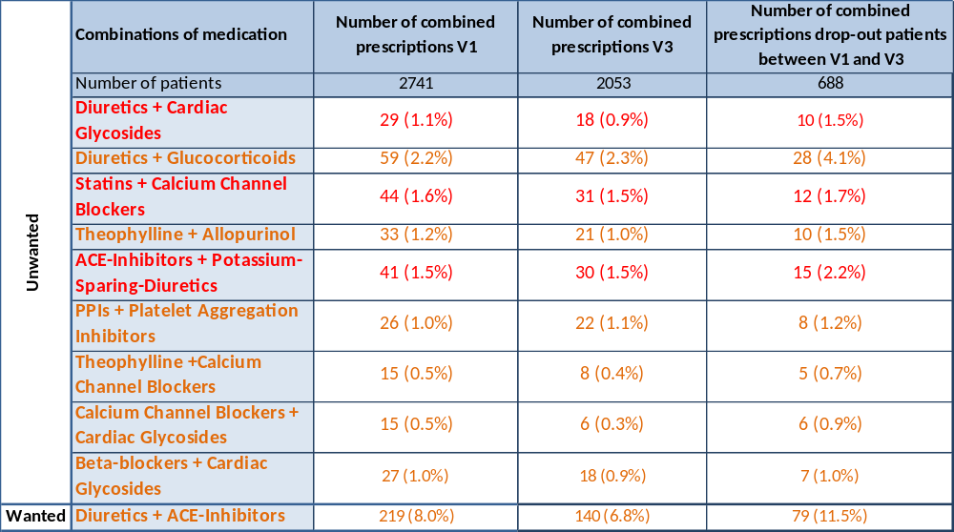
In order to estimate the potential bias from the fact that we had decided to only those combinations analyse in detail which had occurred at least 10 times at visit 1, the combinations omitted from this analysis were evaluated in a summary form. When considering all additional combinations that could be identified from the medication actually taken by the patients, it was found that these combinations occurred in much lower numbers than those shown in Tables 3 to 5. The additional combinations referred to diverse interactions with anticonvulsants (total number 9) and antidiabetics (total number 8) and were therefore of low frequency compared to the other analysed interactions.

Table 3: Numbers and percentages of patients in different interaction categories as defined by the AiD system for visits 1 and 3, as well as for the patients attending visit 1 but not 3 (drop-outs). The analysis included all patients regardless of the GOLD grade. The colours indicate the scoring according to AiD. Orange: potentially clinically relevant, red: clinically serious.

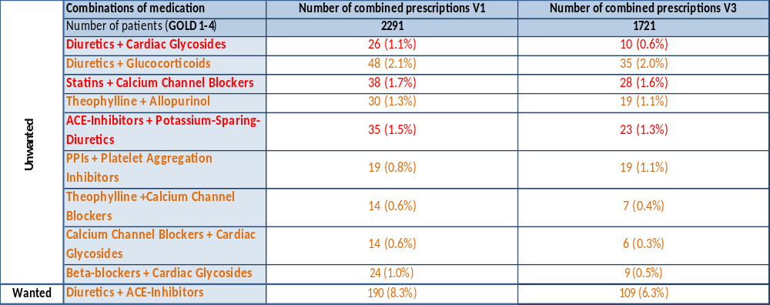
Table 4: Numbers and percentages of patients in different interaction categories as defined by the AiD system for visits 1 and 3. The table refers only to patients categorized into GOLD grades 1-4 (compare with Table 3). The colours indicate the scoring according to AiD. Orange: potentially clinically relevant, red: clinically serious.

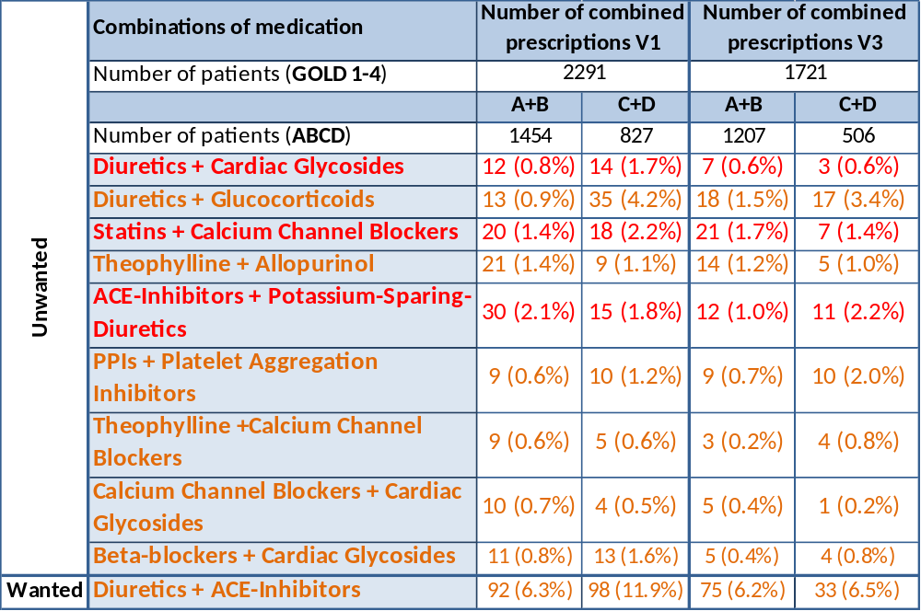
Table 5: Numbers and percentages of patients in different interaction categories as defined by the AiD system for visits 1 and 3. The table refers only to patients categorized into GOLD grades 1-4 (compare with Table 4). Additionally, the patients have been stratified for their exacerbation risk according to GOLD ABCD (A+B low risk, C+D high risk). The colours indicate the scoring according to AiD. Orange: potentially clinically relevant, red: clinically serious.

- DISCUSSION
Our data indicate that in a large cohort of COPD patients about 10 % of the patients were treated with drugs which could be problematic due to the advanced age of these patients. Similarly, about 8-10% of the patients were treated with drugs which might have unwanted and wanted drug interactions. The median numbers of medications across different degrees of COPD severity were at least 5. The respiratory medication contributed about one half or less to these numbers, while the median numbers of non-respiratory medication showed median values of at least 3. Rescue medication, such as short-acting beta-2-agonists, was not included in the medication count as it was not intended to be taken on a regular basis. The high number of medications suggested a significant potential for drug interactions. Those of interest comprised nine categories of adverse, unwanted responses and one category of positive, wanted interactions. We did not include inhaled respiratory drugs in the analysis of interactions since their systemic effects and interaction potential are low compared to oral medications, at least if the application is done properly (e.g. inhalation of steroids). For PRISCUS as well as most interactions the results were very similar when comparing two study visits separated by about 1.5 years.

Patients with COPD are often of advanced age which is known to be a risk factor per se with regard to certain drugs. To estimate the risk we used the PRISCUS list of potentially inappropriate medications (PIM) in the elderly which is long established and in widespread use for this purpose. Among all COPD patients older than 65 years, about 10% had medications that could be problematic but for all of these the risk attributed by PRISCUS was only intermediate or low. We grouped the potentially problematic drugs identified in our study into four major categories. Among these, “psychiatric” medications were most frequent but it should be noted that we defined this category very broad and included also sleep-inducing drugs of all kind.
The percentage of potentially inappropriate medications was stable between visits 1 and 3. Their prescription level seemed to be low compared to other cohorts not specifically addressing COPD patients. In the primary care setting previous studies reported PIM prescription rates for the elderly ranging between 22.5 and 28.4 % [27], [28]. Voigt et al. found in their study on a cohort of general practitioners’ patients in the region of Dresden, Germany, that 23.9% of patients (mean age 76 years) had at least one prescription of medication of the PRISCUS list [29]. Moreover, Tommelein et al. estimated an overall PIM prevalence of 22.6 % in their systematic review of community-dwelling older people across Europe [30]. The reasons for the differences compared to our COPD cohort are not known. As we evaluated all drugs listed by PRISCUS it is unlikely that we have inadvertently restricted the scope of relevant medication compared to other studies. Possibly the chronic, often significantly symptomatic disease COPD is associated with a closer monitoring of patients by their physicians which might increase the removal of potentially adverse medication.
To evaluate the risk of interactions between drugs, we employed the AiD clinic system. This system has the advantage that it is in widespread clinical use and not only a scientific tool known to experts. Using this system we found total percentages of about 8-10% of patients showing either one of nine potentially adverse interactions, or one beneficial interaction. In view of the high number of medications taken, both respiratory and non-respiratory, one might have expected a higher number of problematic combinations. It could be objected that our analysis was based on a restricted set of interactions among all possible combinations, since we only evaluated only combinations occurring in at least 10 patients. On the other hand, for most of the remaining combinations the numbers were extremely low, and their total sum was low compared to those explicitly shown in the tables. One of the potential interactions below a frequency of 10 was that between platelet activation inhibitors and PPIs (n=6). Such low numbers however did not markedly change the overall count of interactions. In order to follow strict selection criteria we considered it justified to present only interactions with numbers of at least 10.
The total number of interactions was similar to data obtained in general, non-respiratory cohorts [31], indicating low percentages for single interactions and total numbers of wanted and unwanted interactions that were comparable to those observed in our study. The low frequency of unwanted interactions may be favoured by the physicians’ awareness of potential problems. On the other hand, the frequency of beneficial (wanted) interactions was about as high as the total frequency of (potentially) adverse interactions, and it might well be that the physicians are also aware of these benefits. The findings regarding potential interactions were essentially reproduced at a follow-up study visit about 1.5 years later. The only difference appeared to occur in the wanted interactions in patients with high exacerbation rates and possibly reflected a differential loss of patients in this category.
The COSYCONET cohort has been set up as a follow-up study of patients with COPD, with special emphasis on comorbidities and their interplay with the lung disease. The characteristics of patients in COSYCONET are similar to those reported for other large COPD cohorts. Despite this, it is unclear to which extent the present observations can be generalized to clinical practice. On the one hand patients participating in COSYCONET may be under more close supervision by their physicians which could reduce the frequency of medication-related problems. On the other hand COSYCONET comprises not only patients with mild disease but also a significant proportion of patients of GOLD grades 3 and 4. These patients showed particularly high numbers of drugs and therefore an increased likelihood for potential drug-related problems.
Noteworthy enough, our findings were not markedly altered when including patients who did not show a ratio of forced expiratory volume in one second (FEV₁) to forced vital capacity (FVC) of less than 0.7 as required for the definition of COPD by the GOLD consortium [11]. Despite this, all of these patients had a diagnosis of COPD and most of them showed symptoms of chronic bronchitis, in accordance with the former COPD category GOLD 0 [32]. Their medication was not largely different from that observed in COPD of grades 1 and 2.
As our data was obtained within a study cohort, a natural limitation of our analysis is that we do not have information to which extent our findings apply to the total population of COPD patients, either in Germany or in other countries. This remains true in spite of the very broad inclusion criteria of COSYCONET. The strength of our study is that patients were well characterized by standardized procedures and that medication was assessed in detail, which ensured a high quality compared to other sources often used in studies like insurance file data. Moreover, the findings were reproduced in the main in a follow-up visit about 1.5 years later.

- CONCLUSION
The present findings indicate that in a large cohort of COPD patients with multiple comorbidities the proportion of patients with potentially problematic medication due to either advanced age or of unwanted drug interactions was about 10 % each. Wanted drug interactions were found in about 8% of patients. Across all stages of disease, at least 50% of patients took 5 or more drugs. Against this background we consider the proportion of potentially severe interactions as relatively low. Most of the interactions involved cardiovascular medication, in line with the high prevalence of corresponding comorbidities in the COSYCONET cohort [8]. These novel data provided by our study could be valuable for comparison with other COPD cohorts, other disease cohorts and the general population.

REFERENCES

1. Holt, S., S. Schmiedl, and P.A. Thürmann, Potentially Inappropriate Medications in the Elderly: The PRISCUS List. Deutsches Ärzteblatt International, 2010. 107(31-32): p. 543-551.
2. Thiem, U., Potenziell inadäquate Medikation. Der Internist, 2012. 53(9): p. 1125-1130.
3. Cascorbi, I., Drug Interactions—Principles, Examples and Clinical Consequences. Deutsches Ärzteblatt International, 2012. 109(33-34): p. 546-556.
4. Rabe, K.F., et al., Global Strategy for the Diagnosis, Management, and Prevention of Chronic Obstructive Pulmonary Disease. American Journal of Respiratory and Critical Care Medicine, 2007. 176(6): p. 532-555.
5. Dolce, J.J., et al., Medication Adherence Patterns in Chronic Obstructive Pulmonary Disease. CHEST. 99(4): p. 837-841.
6. Sutherland, J.J., et al., Co-Prescription Trends in a Large Cohort of Subjects Predict Substantial Drug-Drug Interactions. PLoS ONE, 2015. 10(3): p. e0118991.
7. Siegmund-Schultze, N., Polypharmakotherapie im Alter: Weniger Medikamente sind oft mehr. Dtsch Arztebl International, March 2, 2012. V 109.
8. Karch, A., et al., The German COPD cohort COSYCONET: Aims, methods and descriptive analysis of the study population at baseline. Respiratory Medicine, 2016. 114: p. 27-37.
9. Lucke, T., et al., Systematic Analysis of Self-Reported Comorbidities in Large Cohort Studies – A Novel Stepwise Approach by Evaluation of Medication. PLoS ONE, 2016. 11(10): p. e0163408.
10. Quanjer, P.H., et al., Multi-ethnic reference values for spirometry for the 3–95-yr age range: the global lung function 2012 equations. European Respiratory Journal, 2012. 40(6): p. 1324-1343.
11. Vogelmeier, C.F., et al., Global Strategy for the Diagnosis, Management and Prevention of Chronic Obstructive Lung Disease 2017 Report. Respirology, 2017. 22(3): p. 575-601.
12. Holt, S., S. Schmiedl, and P. Thürmann, PRISCUS-Liste potenziell inadäquater Medikation für ältere Menschen. BMBF-Fördernummer 01ET0721 http://priscus. net/download/PRISCUS-Liste_PRISCUS-TP3_2011 pdf (2001 2014), 2011.
13. Beers, M.H., Explicit criteria for determining potentially inappropriate medication use by the elderly: an update. Archives of Internal Medicine, 1997. 157(14): p. 1531-1536.
14. McLeod, P.J., et al., Defining inappropriate practices in prescribing for elderly people: a national consensus panel. Canadian Medical Association Journal, 1997. 156(3): p. 385-391.
15. Laroche, M.-L., J.-P. Charmes, and L. Merle, Potentially inappropriate medications in the elderly: a French consensus panel list. European Journal of Clinical Pharmacology, 2007. 63(8): p. 725-731.
16. Kaltschmidt, J. and W. Haefeli. Essentielle Charakteristika eines Arzneimittel-Informationssystems am Beispiel der Eigenentwicklung AiDKlinik des Universitätsklinikums Heidelberg. in Telemedizinführer Deutschland. Medizin Forum AG, Bad Nauheim. 2008.
17. Wang, M.-T., et al., Risk of digoxin intoxication in heart failure patients exposed to digoxin–diuretic interactions: a population-based study. British Journal of Clinical Pharmacology, 2010. 70(2): p. 258-267.
18. Widmer, P., et al., Diuretic-related hypokalaemia: the role of diuretics, potassium supplements, glucocorticoids and β2-adrenoceptor agonists. European Journal of Clinical Pharmacology, 1995. 49(1): p. 31-36.
19. Wang, Y.-C., et al., Risks of Adverse Events Following Coprescription of Statins and Calcium Channel Blockers: A Nationwide Population-Based Study. Medicine, 2016. 95(2): p. e2487.
20. Mousa, O., et al., The interaction of diltiazem with simvastatin. Clinical Pharmacology & Therapeutics, 2000. 67(3): p. 267-274.
21. Jonkman, J.H.G., Therapeutic consequences of drug interactions with theophylline pharmacokinetics. Journal of Allergy and Clinical Immunology, 1986. 78(4): p. 736-742.
22. Nielsen‐Kudsk, J.E., J.S. Buhl, and A.C. Johanuessen, Verapamil‐Induced Inhibition of Theophylline Elimination in Healthy Humans. Basic & Clinical Pharmacology & Toxicology, 1990. 66(2): p. 101-103.
23. Abbas, S., et al., Risk of hyperkalemia and combined use of spironolactone and long-term ACE inhibitor/angiotensin receptor blocker therapy in heart failure using real-life data: a population- and insurance-based cohort. Pharmacoepidemiol Drug Saf, 2015. 24(4): p. 406-13.
24. Khand, A.U., et al., Carvedilol alone or in combination with digoxin for the management of atrial fibrillation in patients with heart failure? Journal of the American College of Cardiology, 2003. 42(11): p. 1944-1951.
25. Cuisset, T., et al., Comparison of omeprazole and pantoprazole influence on a high 150-mg clopidogrel maintenance dose. Journal of the American College of Cardiology, 2009. 54(13): p. 1149-1153.
26. Elliott, W.J. and C.V.S. Ram, Calcium channel blockers. The Journal of Clinical Hypertension, 2011. 13(9): p. 687-689.
27. Fiss, T., et al., Cognitive impairment in primary ambulatory health care: pharmacotherapy and the use of potentially inappropriate medicine. International Journal of Geriatric Psychiatry, 2013. 28(2): p. 173-181.
28. Zimmermann, T., et al., Potentially inappropriate medication in elderly primary care patients: a retrospective, longitudinal analysis. Bundesgesundheitsblatt, Gesundheitsforschung, Gesundheitsschutz, 2013. 56(7): p. 941-949.
29. Voigt, K., et al., Why do family doctors prescribe potentially inappropriate medication to elderly patients? BMC Family Practice, 2016. 17(1): p. 93.
30. Tommelein, E., et al., Potentially inappropriate prescribing in community-dwelling older people across Europe: a systematic literature review. European Journal of Clinical Pharmacology, 2015. 71(12): p. 1415-1427.
31. Tulner, L.R., et al., Drug-Drug Interactions in a Geriatric Outpatient Cohort: Prevalence and Relevance. Drugs & Aging, 2008. 25(4): p. 343.
32. Pauwels, R.A., et al., Global strategy for the diagnosis, management, and prevention of chronic obstructive pulmonary disease: National Heart, Lung, and Blood Institute and World Health Organization Global Initiative for Chronic Obstructive Lung Disease (GOLD): executive summary. Respiratory care, 2001. 46(8): p. 798.

