p52 expression enhances lung cancer progression

Jamie A. Saxon, Hui Yu, Vasiliy V. Polosukhin, Georgios T. Stathopoulos, Linda A. Gleaves, Allyson G. McLoed, Pierre P. Massion, Fiona E. Yull, Zhongming Zhao, and Timothy S. Blackwell

Supplementary Figure S1:
a.
b.
Supplementary Figure S1: p52 expression does not affect urethane-induced inflammatory cell recruitment or formation of atypical adenomatous hyperplasia (AAH). A) Total inflammatory cells in BALs from WT and CCSP-p52 mice 10 days, 21 days (3 weeks), and 42 days (6 weeks) after urethane injection (10 and 21 day n=7-8 mice/group; 42 day n=22-24 mice/group). B) Average number of AAH lesions counted on lung sections from WT and CCSP-p52 mice 6 weeks after urethane (n=13-16 mice/group).

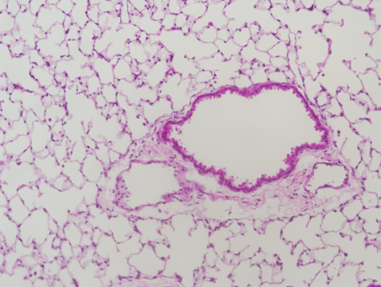
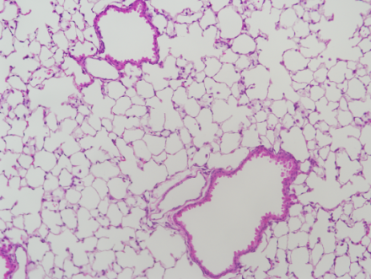
p52
TBP
CCSP-p52
WT
Supplementary Figure S2:
a.
b.
c.
WT
CCSP-p52
Supplementary Figure S2: Long-term p52 expression does not affect inflammatory cell recruitment or lung histology. A) Western blot demonstrating p52 transgene expression in lung nuclear protein from WT and CCSP-p52 mice on dox for 6 months. TBP was probed as a nuclear loading control. B) Total BAL inflammatory cell numbers and C) representative lung photomicrographs (20x magnification) from WT and CCSP-p52 mice (n=8 mice/group).

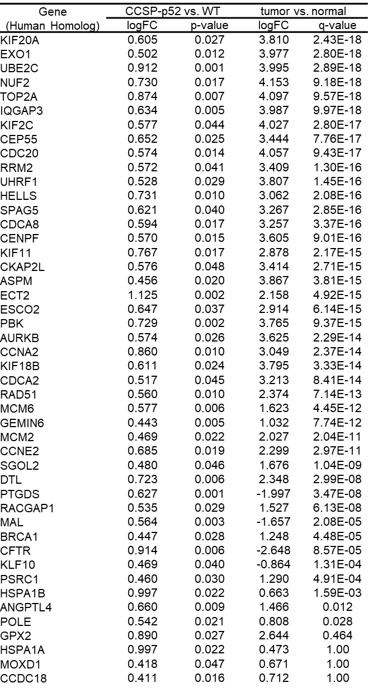
Supplementary Table S1:

CRYGN | 0.421 | 0.037 | 282.976 | 1.00
MAGEB1 | 0.425 | 0.023 | 193.612 | 1.00
LCN2 | 0.585 | 0.036 | 1.387 | 1.00
HSPH1 | 0.689 | 0.033 | 0.379 | 1.00
PAPPA2 | 0.608 | 0.007 | -176.187 | 1.00
CTNND2 | 0.547 | 0.035 | -126.328 | 1.00
CDKN1A | 0.432 | 0.025 | -0.415 | 1.00
CYP2C8 | 0.417 | 0.022 | -106.253 | 1.00
MAT1A | 0.409 | 0.031 | 0.815 | 1.00
NFKB2 | 0.720 | 0.022 | 0.279 | 1.00
GRIN2A | 0.416 | 0.012 | -70.563 | 1.00
HIST1H2AA | 0.545 | 0.016 | 52.794 | 1.00
TNIP3 | 2.112 | 0.003 | -0.598 | 1.00
AREG | 0.565 | 0.012 | -0.599 | 1.00
DIAPH3 | 0.441 | 0.025 | 0.303 | 1.00
ADAMTS9 | 0.564 | 0.040 | -0.261 | 1.00
YBX2 | 0.556 | 0.001 | 91.762 | 1.00
ATF7IP2 | 0.443 | 0.025 | 0.167 | 1.00
SLC26A4 | 1.295 | 0.020 | 0.262 | 1.00
GIF | 0.485 | 0.003 | 35.537 | 1.00
EPHA7 | 0.573 | 0.035 | -17.780 | 1.00
TNFSF9 | 0.796 | 0.047 | 0.093 | 1.00
ELOVL7 | 0.455 | 0.017 | -0.075 | 1.00
RNASE2 | 0.742 | 0.031 | 1.143 | 1.00
OR4K1 | 0.471 | 0.009 | 0.070 | 1.00

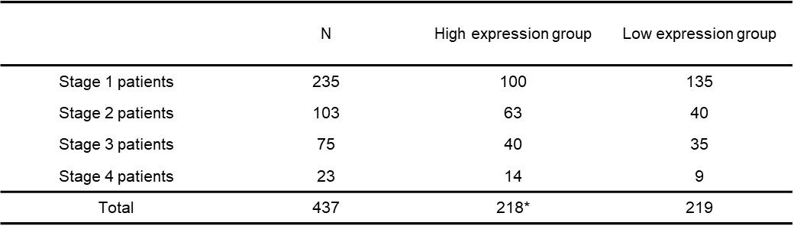
Supplementary Table S2:
*One sample in the high expression group had data for survival and expression but no stage information. This sample was included in overall analysis but not in stage-specific analysis.

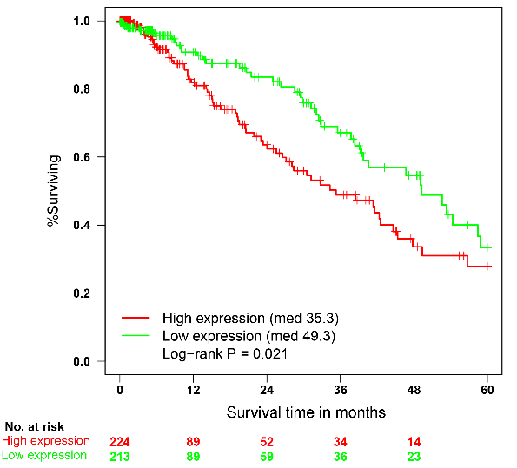
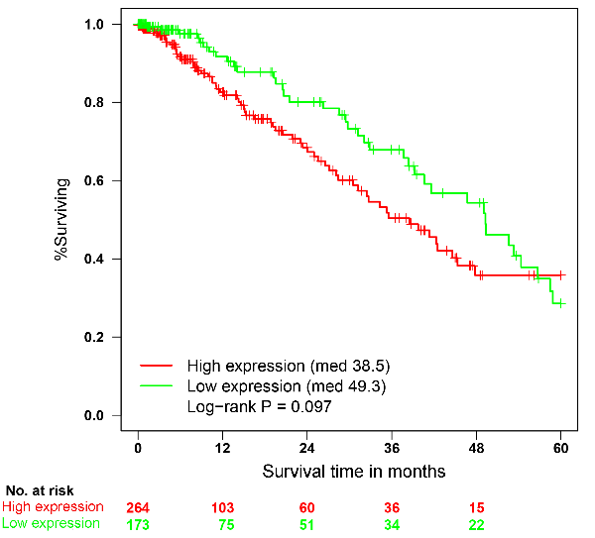
Supplementary Figure S3:
B.
A.
Supplementary Figure S3: Expression of p52-associated genes based on “voting” method correlates with poor patient outcomes. A) Kaplan-Meier survival curve of overall patient survival data divided based on expression “votes” of p52-associated genes (log-rank test, p=0.021). B) Kaplan-Meier survival curve of overall patient survival based on expression “votes” of imputed mediator genes (log-rank test, p=0.097).

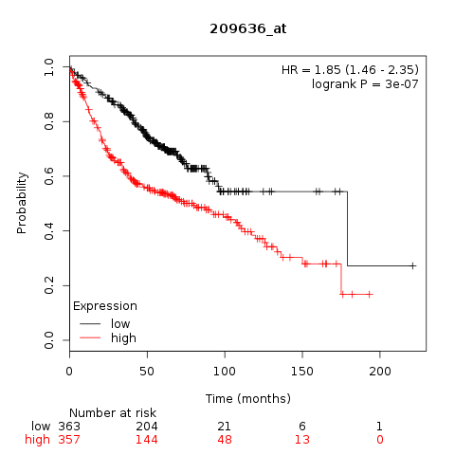
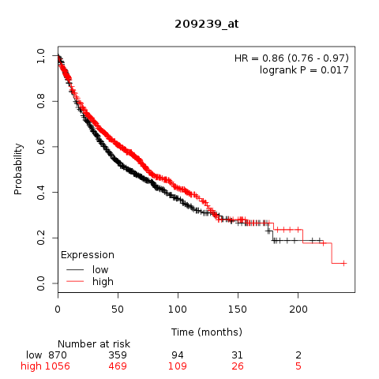
Supplementary Figure S4: p52 expression negatively impacts survival in human lung adenocarcinoma. Kaplan-Meier survival analysis of patients with lung adenocarcinoma (n = 720) stratified by (a) Nfkb1 (encoding p50; optimal cut-off = 852 relative mRNA abundance units) and (b) Nfkb2 (encoding p52; optimal cut-off = 65 relative mRNA abundance units) expression levels. Data were obtained from http://kmplot.com/ (Gyorffy B, Surowiak P, Budczies J, Lanczky A. Online survival analysis software to assess the prognostic value of biomarkers using transcriptomic data in non-small-cell lung cancer, PLoS One, 2013 Dec 18;8(12):e82241. doi: 10.1371/journal.pone.0082241).
A
B
Supplementary Figure S4:
v
v

