Supplementary Information
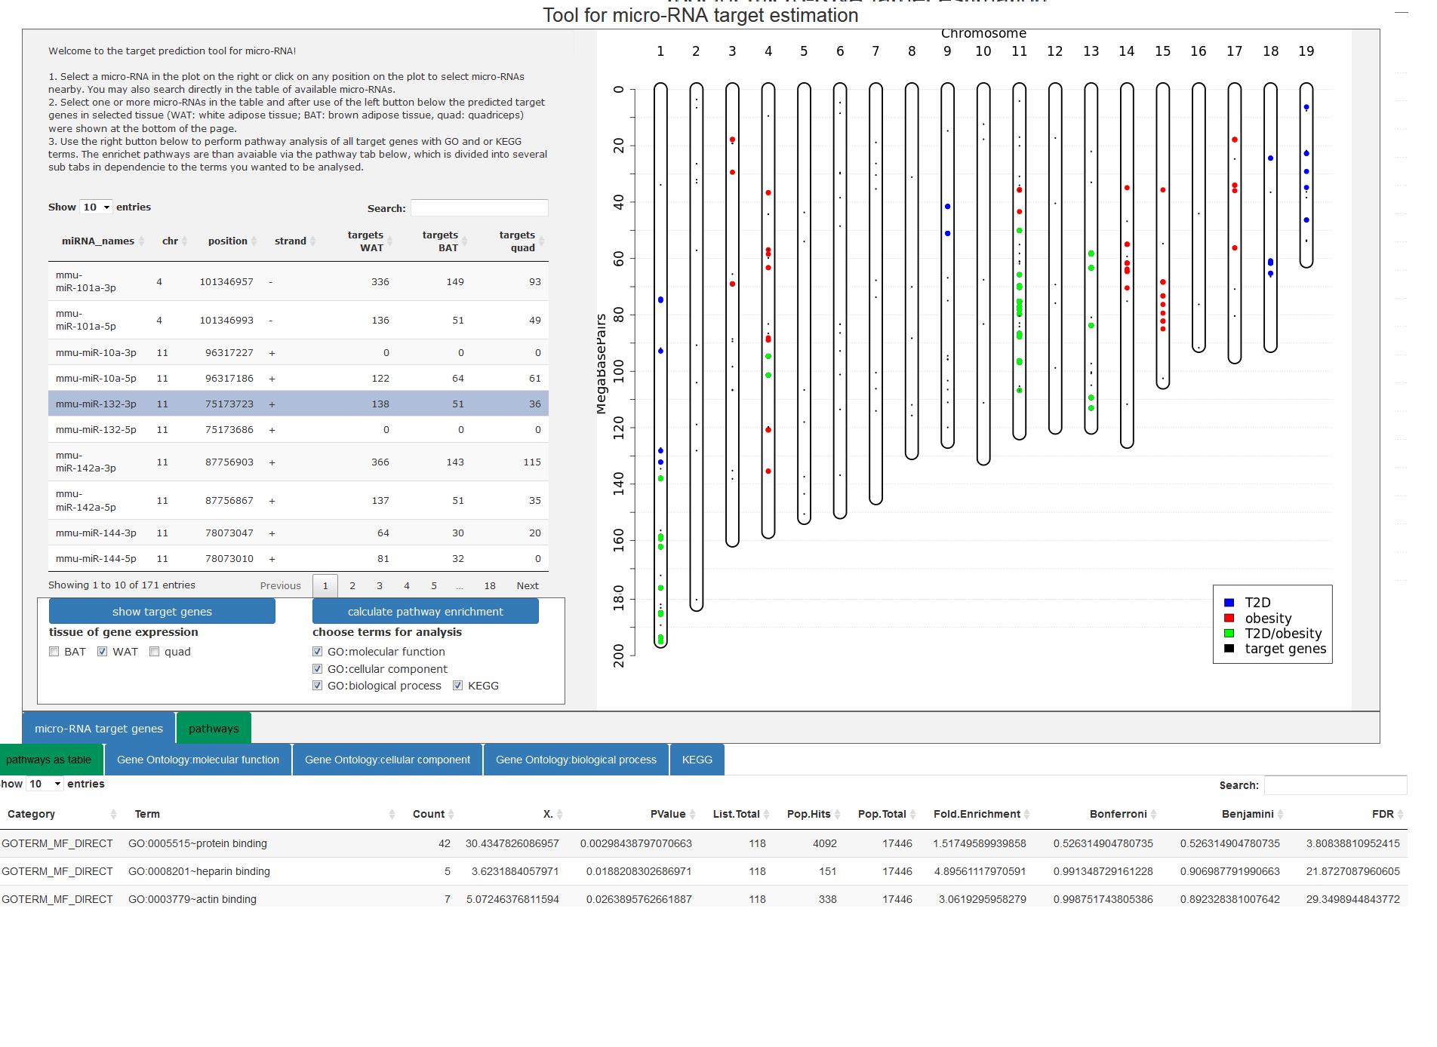

1
Supplementary Figure S1: Screenshot of the online tool. (1) shows the interactive plot of the location of miRNAs and target genes on the chromosomes. (2) shows a list of miRNAs, their location in QTLs; the tissue specific targets based on target prediction (3) and pathway enrichment analysis of miRNA-specific targets (4) can be selected. (5) includes the tabs for the results of the target prediction (inactive; blue) and for the pathway enrichment (active; green). (6) contains the tabs for the pathway enrichment analysis as table or bar plot for GO or KEGG terms.

2
3
4
6

5

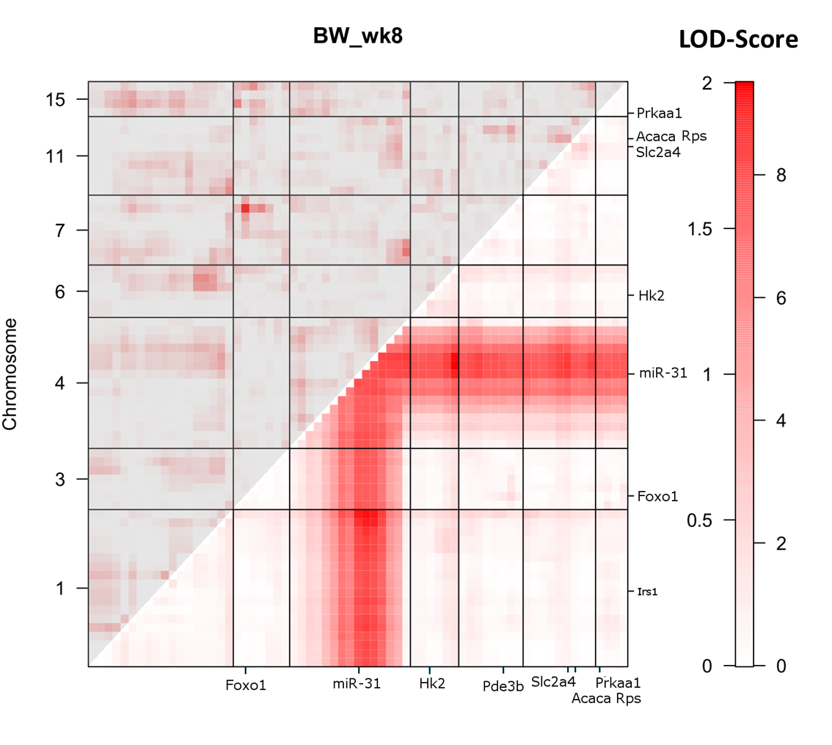
Supplementary Figure S2: 2-QTL analysis for body weight in week 8 in the NZOxB6 backcross population. Heat map for a two-dimensional genome scan with a two-QTL model for the NZOxB6 cross. The maximum LOD score for the interaction model (locus to locus interaction) in the upper left triangle. The maximum LOD score for the full model (two QTLs plus additive effect) is indicated in the lower right triangle. LOD-score >6 (dark red).

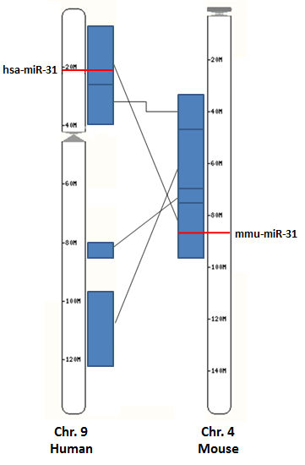

Supplementary Figure S3: Comparison of the genomic localization of miR-31 in the mouse and human genome. Genomic region of miR-31 on chromosome 4 was mapped to the human genome on chromosome 9.

Supplementary Table S1. Pathway enrichment analysis with 416 target genes of miR-31. FDR: False Discovery Rate
Pathway | Count | % | P-value | Fold Enrichment | FDR
Insulin signaling pathway | 10 | 2.35 | 2.76E-03 | 3.36 | 3.46
Valine, leucine, and isoleucine degradation | 6 | 1.41 | 5.86E-03 | 5.14 | 7.21
Tyrosine metabolism | 5 | 1.17 | 8.87E-03 | 6.04 | 10.71
Lysosome | 8 | 1.88 | 1.45E-02 | 3.09 | 16.96
Renin secretion | 6 | 1.41 | 1.68E-02 | 3.98 | 19.36
Insulin resistance | 7 | 1.64 | 2.86E-02 | 3.00 | 30.87
Calcium signaling pathway | 9 | 2.11 | 3.65E-02 | 2.35 | 37.72
Metabolic pathways | 37 | 8.69 | 3.84E-02 | 1.36 | 39.23
Pyruvate metabolism | 4 | 0.94 | 4.85E-02 | 4.83 | 46.89
Steroid biosynthesis | 3 | 0.70 | 5.99E-02 | 7.43 | 54.43
Pancreatic secretion | 6 | 1.41 | 6.00E-02 | 2.82 | 54.49
Glucagon signaling pathway | 6 | 1.41 | 6.00E-02 | 2.82 | 54.49
Salivary secretion | 5 | 1.17 | 7.94E-02 | 3.06 | 65.06
Regulation of actin cytoskeleton | 9 | 2.11 | 8.30E-02 | 1.98 | 66.79
Type 2 diabetes mellitus | 4 | 0.94 | 8.82E-02 | 3.77 | 69.12
Thyroid hormone signaling pathway | 6 | 1.41 | 9.05E-02 | 2.50 | 70.07

