Computational Phantoms, ICRP/ICRU and further developments

M. Zanklª, Janine Beckerª, Choonsik Lee^{b}, Wesley E. Bolch^{c}, Yeon Soo Yeom^{d}, and Chan Hyeong Kim^{d}

ª Institute of Radiation Protection, Department of Radiation Sciences, Helmholtz Zentrum München – German Research Center for Environmental Health (GmbH), Neuherberg, Germany; e-mail: zankl@helmholtz-muenchen.de
^{b} Radiation Epidemiology Branch, National Cancer Institute, National Institutes of Health (NIH), Rockville, MD, U.S.A.
^{c} J. Crayton Pruitt Family Department of Biomedical Engineering, University of Florida, Gainesville, FL, U.S.A.
^{d} Department of Nuclear Engineering, Hanyang University, Seoul, Korea

Abstract-Phantoms simulating the human body play a central role in radiation dosimetry. The first computational body phantoms have been based upon mathematical expressions describing idealised body organs. With the advent of more powerful computers in the 1980s, voxel phantoms have been developed. Being based on three-dimensional images of individuals, they offer a more realistic anatomy. Hence, the International Commission on Radiological Protection (ICRP) decided to construct voxel phantoms being representative of the adult Reference Male and Reference Female for the update of organ dose coefficients. Further work on phantom development has focused on phantoms that combine the realism of patient-based voxel phantoms with the flexibility of mathematical phantoms, so-called boundary representation (BREP) phantoms. This phantom type has been chosen for the ICRP family of paediatric reference phantoms. Finally, due to the limited voxel resolution of the adult reference computational phantoms, smaller tissues, such as the eye lens, skin and micron-thick target tissues in respiratory and alimentary tract regions could not be properly segmented. In this context, ICRP Committee 2 initiated a research project with the goal of producing replica of the ICRP Publication 110 phantoms in polygon mesh format, including all source and target regions, even those with micron resolution. Boundary representation based phantoms of the fetus and the pregnant female at various stages of gestation are completing the phantoms available for radiation protection computations.

Keywords: Reference computational phantoms; Adult; Paediatric; Voxel; Boundary representation
- Introduction
Phantoms simulating the human body or parts thereof play a central role in radiation dosimetry. The first computational body phantoms have been based upon mathematical expressions representing planes, cylindrical, conical, elliptical, and spherical surfaces describing the shape and position of idealised body organs (Fisher and Snyder, 1967, 1968; Snyder et al., 1969; Snyder et al., 1978; Cristy, 1980; Cristy and Eckerman, 1987). For this first generation of computational body phantoms, the organ masses and volumes were in accordance with the ICRP data of former Reference Man (ICRP, 1975).
With the advent of more powerful computers in the 1980s, various groups have developed voxel phantoms as an extension and improvement to these earlier models (Zankl et al., 1988; Dimbylow, 1996; Caon et al., 1999; Xu et al., 2000; Zankl and Wittmann, 2001; Petoussi-Henss et al., 2002; Kramer et al., 2003; Caon, 2004; Fill et al., 2004; Kramer et al., 2004b; Dimbylow, 2005; Kramer et al., 2006; Zaidi and Xu, 2007; Becker et al., 2008). Being based on three-dimensional images of single individuals, they offer a more realistic replication of human anatomy. Various authors have shown that the organ shapes of the earlier mathematical phantoms present an over-simplification that has an influence on the energy distribution which may deviate for some cases systematically from that calculated for voxel phantoms (Jones, 1997; Smith et al., 2000; Chao et al., 2001; Zankl et al., 2002; Kinase et al., 2003; Zankl et al., 2003; Kramer et al., 2004a; Kramer et al., 2005).
However, despite their obvious advantages compared to the previously used stylised phantom type, most of these phantoms do not represent the average Caucasian man or woman, due to being derived from a specific individual. Hence, the International Commission on Radiological Protection (ICRP) decided to construct voxel phantoms being representative of the adult Reference Male and Reference Female (ICRP, 2002) with respect to their external dimensions, their organ topology, and their organ masses (ICRP, 2009), for the update of organ dose conversion coefficients following the recent ICRP Recommendations (ICRP, 2007).
A further disadvantage of all voxel phantoms is their limited flexibility concerning changes in size, shape, and posture. Therefore, further work on phantom development has focused on the development of phantoms that seek to combine the realism of patient-based voxel phantoms with the flexibility of mathematical phantoms. So-called “hybrid” phantoms may be based on voxel geometry, but their stepped surfaces are replaced by polygon meshes (PM) and/or non-uniform rational B-splines (NURBS), thus resulting in so-called boundary representation (BREP) based phantoms. Hence this phantom type has been chosen for the family of paediatric reference phantoms being developed for the ICRP.
Finally, as the voxel resolution of the adult reference computational phantoms is of the order of a few mm, smaller tissues, such as, for example, the eye lens, skin and micron-thick target tissues in respiratory and alimentary tract regions could not be properly segmented. The calculated doses for these tissues have, therefore, some limitations, particularly for weakly-penetrating radiation. As a consequence, a series of stylised phantoms representing the skin, the eye lenses, and high-resolution source and target regions in the human respiratory and alimentary tracts have been used recently for dose calculations of the ICRP in addition to the reference voxel phantoms. In this context, ICRP Committee 2 recently initiated a research project with the goal of producing replica of the ICRP Publication 110 phantoms in polygon mesh format, including all source and target regions, even those with micron resolution, so that only one set of phantoms can be used for all reference dose calculations.
- Adult reference computational phantoms
  - Method of construction
Voxel phantoms were selected with external dimensions close to the reference data. The male phantom Golem (Zankl and Wittmann, 2001) is 176 cm high, corresponding exactly to the reference height of the adult male, whereas his body mass of 69 kg is slightly below the adult male reference mass of 73 kg. The female phantom Laura (Zankl et al., 2005) of height 167 cm is slightly taller than the ICRP female adult reference height of 163 cm, whereas her body mass of 59 kg is slightly lower than the corresponding ICRP reference mass of 60 kg. These two phantoms were then adjusted to the reference values of ICRP Publication 89 (ICRP, 2002) in several steps: (1) adjustment of the body height and the skeleton mass by voxel scaling; (2) adjustment of the individual organ and tissue masses to the reference values by adding or subtracting the required number of voxels; (3) additional organ and body region modifications, such as additional segmentation of the larger blood vessels and including a number of lymphatic nodes; and (4) adjustment of the whole-body mass to the reference values by adding or subtracting an appropriate number of adipose tissue voxels. The bones were subdivided into a cortical shell and a spongiosa region accommodating the bone trabeculae together with the marrow cavities – structures that are both much smaller than the voxel resolution of the phantoms; in the long bones, also medullary cavities were segmented separately. The method of constructing the adult male and female reference computational phantoms is described in detail in ICRP Publication 110 (ICRP, 2009).
  - Applications and conceptual limitations
The adult reference computational phantoms of ICRP Publication 110 are the official computational models representing the Reference Male and Reference Female (ICRP, 2002, 2007). Each of these reference computational phantoms has 140 different organs and tissues. The male phantom consists of approximately 1.9 million voxels with a resolution of 2.137 x 2.137 x 8.0 mm³, and the female phantom consists of approximately 3.9 million voxels at a slightly finer resolution of 1.775 x 1.775 x 4.84 mm³. Being based on computed tomographic data of real persons, these phantoms represent digital three-dimensional representations of human anatomy. They are defined to enable calculations of the protection quantities – organ and tissue equivalent dose and effective dose – from exposure to ionising radiation. The ICRP has recently published recommended values for dose coefficients for both external and internal exposures using these two phantoms: Publication 116 (ICRP, 2010) and Publication 133 (ICRP, 2016). Further dose coefficients issued by the ICRP will follow, e.g., for environmental exposures and a series of publications dealing with occupational intakes of radionuclides.
Although these phantoms have reference organ masses, they still have individual organ topology reflecting the tomographic data used for their construction. Obviously, both models cannot represent real individuals, and thus they should not be used to assess doses for specific individuals. While the reference computational phantoms were created for the purpose of deriving radiological protection quantities, they may have broader applications. However, the specific limitations related to their intended application have to be kept in mind.
  - Limitations due to voxel resolution
The reference computational phantoms’ voxel resolutions of the order of millimetres and, specifically, the slice thickness of several millimetres result in stepped organ surfaces, which is especially problematic for (1) the skin and (2) hollow organs, since there the contours are not closed. Also the eye lenses, a target that has recently come into focus of radiological protection, are too coarsely represented in the reference voxel phantoms. Furthermore, very fine structures, such as some specific source and target regions in the alimentary and respiratory tracts having micrometre dimensions cannot be represented at all by the relatively coarse voxels. This resulted in the necessity of using several stylised phantoms in addition to the voxel phantoms for the calculation of reference dose coefficients for high-resolution source and target regions and radiations of low penetration.
- Adult reference phantom conversion project
This issue of limitations due to voxel resolution was discussed by ICRP Committee 2, and it was decided to propose a research project for creating BREP versions of the reference computational phantoms with the aim to produce exact replica of the Publication 110 reference phantoms in a high-quality polygon-mesh format. These phantoms should include
- Continuous and fully-enclosed walls for skin, stomach, gall bladder, and urinary bladder;
- Thin target layers (10- 300 μm) for the alimentary and respiratory tract organs;
- Detailed and correct models for the skeletal system, eyes, lymphatic nodes, blood vessels, etc..
The research project is being carried out mainly at the Hanyang University in Seoul, South Korea, and is supported by a specific Task Group of ICRP Committee 2.
  - Method of construction
To construct PM models of simple organs, the voxel models of the Publication 110 reference phantoms were converted directly to the PM format. For this, varous conversion procedures were developed: one for very simple organs and the other for more complex organs. For very simple organs, the voxel model is ﬁrst used to generate a PM model using a three-dimensional surface rendering method. Next, the number of polygons in the PM model is increased to facilitate the smoothing and reﬁnement processes. After smoothing and reﬁnement, the number of facets is reduced to a proper number; for high efficiency in computer simulations, the minimum necessary number of facets to keep the shape of the organ is used. Finally, the shape of the constructed organ model is ﬁnely adjusted to the voxel model according to certain acceptance criteria (Yeom et al., 2013). The second procedure is applied to organs with a more complicated shape, such as the large intestine: again, the voxel model is ﬁrst used to generate a PM model using a three-dimensional surface rendering method. Then a contour line of the organ is created and subsequently converted to a NURBS surface model, which is then converted back into a polygon-surface model and finally adjusted to the organ shape in the voxel model according to the same acceptance criteria.
More specific procedures have been applied for individual organs and sub-organ structures, such as the small intestine (Yeom et al., 2016a), the skeleton (Yeom et al., 2016b), the eye lenses (Nguyen et al., 2015), and the thin target and source regions in the alimentary and respiratory tract (Kim et al., 2017).
  - Results
The resulting polygon-mesh phantoms are shown in Figure 1, together with the ICRP Publication 110 reference voxel phantoms. It can be seen that (1) the polygon-mesh phantoms closely resemble the Publication 110 phantoms in their main anatomical features and thus meet the requirement of being “exact replica”, but (2) clearly demonstrate on the other hand the high-quality smooth surfaces that are obviously lacking in the Publication 110 phantoms.
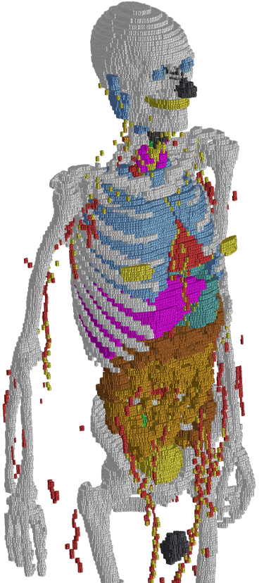
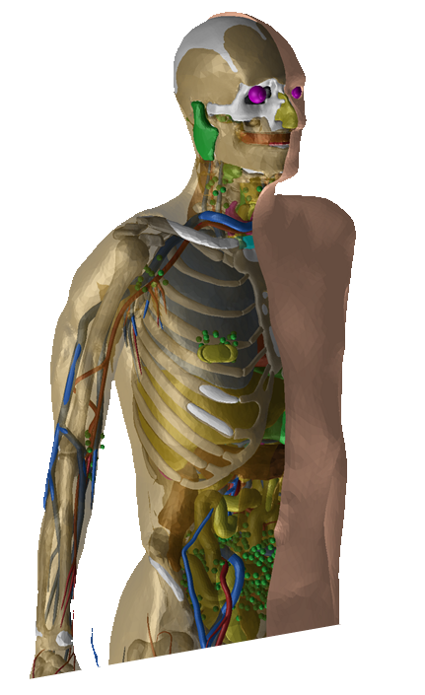
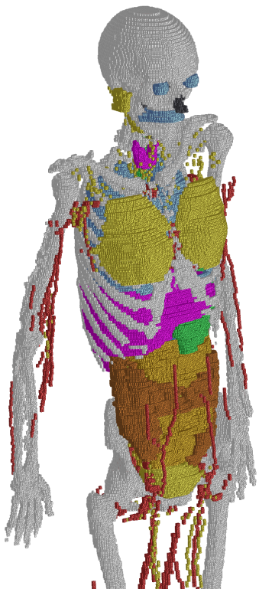
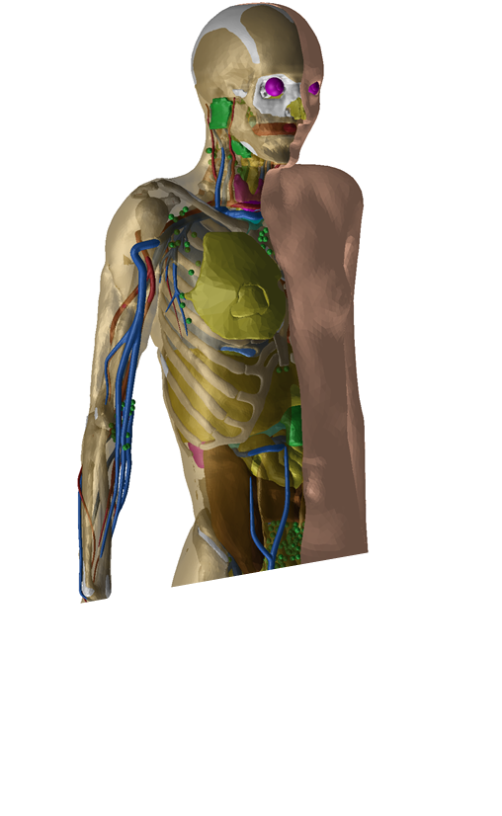

Fig. 1. Details from the Publication 110 voxel phantoms (left side) and from the high-quality polygon-mesh phantom versions (right side).

  - Computational results
It is expected that the converted phantoms would lead to the same, or very similar, dose coefficients as the ICRP Publication 110 reference phantoms for penetrating radiation and, at the same time, provide more accurate dose coefficients for weakly penetrating radiation and small tissues. In addition, the reference phantoms in polygon mesh format would be easily deformable and could serve as a starting point to create phantoms of various postures to be used, for example, in accidental dose calculations.
- Further developments
  - Paediatric reference computational phantoms
Researchers at the University of Florida (UF) have introduced a series of hybrid phantoms representing the ICRP Publication 89 reference newborn, 1 year, 5, 10, and 15 years paediatric phantoms (Lee et al., 2010). Major organs and tissues were segmented from CT data of patients at ages close to newborn, 1 year, 5, 10, and 15 years. NURBS and polygon mesh surfaces were then used to model individual organs and tissues and subsequently match anthropometric data and reference organ masses (ICRP, 2002). The UF hybrid phantom series is provided in two formats. The first is via NURBS and polygon mesh surface renderings; the second are voxelised versions of these same reference phantoms. They are in very close agreement with the reference data of ICRP Publication 89 (ICRP, 2002). In order to introduce these phantoms as ICRP reference paediatric phantoms, further modifications and refinements have been performed: a breast model with glandular and adipose tissue has been introduced; blood vessels in the lungs have been incorporated; the anatomical realism of the muscles have been improved; and a sophisticated distribution of lymphatic nodes has been incorporated (Lee et al., 2013). At present, polygon mesh versions of the paediatric phantoms are being developed, including also all the fine structures in the alimentary and respiratory tract regions as discussed above for the adult phantoms.
  - Phantoms of the developing human fetus
As concern grows over possible radiation-induced cancers from medical and non-medical exposures of the pregnant female, the need also increases to better quantify fetal radiation doses, particularly at the organ-level. To address this need, two fetal hybrid computational phantoms were constructed at the University of Florida using high-quality magnetic resonance imaging and computed tomography image sets obtained for two well-preserved fetal specimens aged 11.5 and 21 weeks post-conception. Individual soft tissue organs, bone sites and outer body contours were segmented from these images and then converted to deformable non-uniform rational B-spline surfaces. The two specimen-speciﬁc phantoms, along with a modiﬁed version of the 38 week UF hybrid newborn phantom, comprised a set of base phantoms from which a series of hybrid computational phantoms was derived for fetal ages 8, 10, 15, 20, 25, 30, 35 and 38 weeks post-conception. The methodology used to construct the series of phantoms accounted for the following age-dependent parameters: (1) variations in skeletal size and proportion, (2) bone-dependent variations in relative levels of bone growth, (3) variations in individual organ masses and total fetal masses and (4) statistical percentile variations in skeletal size, individual organ masses and total fetal masses. The resulting series of fetal hybrid computational phantoms is applicable to organ-level and bone-level internal and external radiation dosimetry for human fetuses of various ages and weight percentiles (Maynard et al., 2011).
  - Phantoms of the pregnant female
Efforts to assess in utero radiation doses and related quantities to the developing fetus should account for the presence of the surrounding maternal tissues. Maternal tissues can provide varying levels of protection to the fetus by shielding externally-emitted radiation or, alternatively, can become sources of internally-emitted radiation following the biokinetic uptake of medically-administered radiopharmaceuticals or radionuclides located in the surrounding environment. Using CT image sets of pregnant patients the eight UF fetal phantoms from the study of Maynard (Maynard et al., 2011) were systematically combined with the UF adult non-pregnant female (Lee et al., 2010) to yield a series of reference pregnant female phantoms at fetal ages 8, 10, 15, 20, 25, 30, 35 and 38 weeks post-conception. Deformable, non-uniform rational B-spline surfaces were utilised to alter contoured maternal anatomy in order to (1) accurately position and orient each fetus and surrounding maternal tissues and (2) match target masses of maternal soft tissue organs to reference data reported in the literature (Maynard et al., 2014).
- Summary
The ICRP Publication 110 adult male and female voxel phantoms are the official computational phantoms representing the ICRP Reference Male and Reference Female. They are defined to enable calculations of the protection quantities – organ and tissue equivalent dose and effective dose – from exposure to ionising radiation. Although these phantoms have reference organ masses, they still have individual organ topology reflecting the tomographic data used for their construction. Obviously, both models cannot represent real individuals, and thus they should not be used to assess doses for specific individuals. While the reference computational phantoms were created for the purpose of deriving radiological protection quantities, they may have broader applications. However, the specific limitations related to their intended application have to be kept in mind.
The reference voxel phantoms have limitations concerning the representation of small objects due to the voxel resolution of the underlying medical image data. These limitations are being addressed by the current phantom conversion project. The resulting mesh-type reference computational phantoms closely resemble the Publication 110 phantoms in their main anatomical features and thus meet the requirement of being “exact replica”, but on the other hand they include micrometre-fine source and target regions that could not be represented in the Publication 110 phantoms. It is expected that the converted phantoms would lead to the same, or very similar, dose coefficients as the ICRP Publication 110 reference phantoms for penetrating radiation and, at the same time, provide more accurate dose coefficients for weakly penetrating radiation and small tissues. In addition, the reference phantoms in polygon mesh format would be easily deformable and could serve as a starting point to create phantoms of various postures to be used, for example, in accidental dose calculations.
A series of hybrid phantoms representing the ICRP Publication 89 reference newborn, 1 year, 5, 10, and 15 years paediatric phantoms has been introduced, represented by NURBS and polygon mesh surfaces. At present, polygon mesh versions of the paediatric phantoms are being developed, including also all the fine structures in the alimentary and respiratory tract regions as discussed above for the adult phantoms.
Boundary representation based phantoms of the fetus and the pregnant female at various stages of gestation are completing the phantoms available for radiation protection computations.
- REFERENCES
Becker, J., Zankl, M., Fill, U., et al., 2008. Katja — the 24th week of virtual pregnancy for dosimetric calculations. Pol J Med Phys Eng. 14(1), 13-19.
Caon, M., 2004. Voxel-based computational models of real human anatomy: a review. Radiat. Environ. Biophys. 42, 229-235.
Caon, M., Bibbo, G., Pattison, J., 1999. An EGS4-ready tomographic computational model of a forteen year-old female torso for calculating organ doses from CT examinations. Phys. Med. Biol. 44(9), 2213-2225.
Chao, T.C., Bozkurt, A., Xu, X.G., 2001. Conversion coefficients based on the VIP-Man anatomical model and EGS4-VLSI code for external monoenergetic photons from 10 keV to 10 MeV. Health Phys. 81(2), 163-183.
Cristy, M., 1980. Mathematical phantoms representing children of various ages for use in estimates of internal dose. ORNL Report TM-367, Oak Ridge National Laboratory, Oak Ridge, TN.
Cristy, M., Eckerman, K.F., 1987. Specific absorbed fractions of energy at various ages from internal photon sources, Part I: Methods. ORNL Report TM-8381/V1, Oak Ridge National Laboratory, Oak Ridge, TN.
Dimbylow, P., 2005. Development of the female voxel phantom, NAOMI, and its application to calculations of induced current densities and electric fields from applied low frequency magnetic and electric fields. Phys. Med. Biol. 50(6), 1047-1070.
Dimbylow, P.J., 1996. The development of realistic voxel phantoms for electromagnetic field dosimetry. In: Dimbylow, P.J. (Ed.), Workshop on Voxel Phantom Development, Chilton, UK, pp. 1-7.
Fill, U., Zankl, M., Petoussi-Henss, N., et al., 2004. Adult female voxel models of different stature and photon conversion coefficients for radiation protection. Health Phys. 86(3), 253-272.
Fisher, H.L., Snyder, W.S., 1967. Distribution of dose in the body from a source of gamma rays distributed uniformly in an organ. ORNL-4168, Oak Ridge National Laboratory, Oak Ridge, TN.
Fisher, H.L., Snyder, W.S., 1968. Distribution of dose in the body from a source of gamma rays distributed uniformly in an organ. In: First International Congress on Radiation Protection, Oxford, UK, pp. 1473-1486.
ICRP, 1975. Reference man: Anatomical, physiological and metabolic characteristics. ICRP Publication 23, Pergamon Press, Oxford, UK.
ICRP, 2002. Basic anatomical and physiological data for use in radiological protection: reference values. ICRP Publication 89, Pergamon Press, Oxford, UK. Ann. ICRP 32(3-4)
ICRP, 2007. The 2007 Recommendations of the International Commission on Radiological Protection. ICRP Publication ICRP Publication 103, Elsevier, Oxford, UK. Ann. ICRP 37(2-4)
ICRP, 2009. Adult reference computational phantoms. ICRP Publication ICRP Publication 110, International Commission on Radiological Protection, Oxford, UK. Ann. ICRP 39(2)
ICRP, 2010. Conversion Coefficients for Radiological Protection Quantities for External Radiation Exposures. ICRP Publication 116, International Commission of Radiological Protection, Oxford, UK. Ann. ICRP 40(2-5)
ICRP, 2016. The ICRP computational framework for internal dose assessment for reference adults: specific absorbed fractions. ICRP Publication 133, International Commission of Radiological Protection, Oxford, UK. Ann. ICRP 45 (2)
Jones, D.G., 1997. A realistic anthropomorphic phantom for calculating organ doses arising from external photon irradiation. Radiat. Prot. Dosim. 72(1), 21-29.
Kim, H.S., Yeom, Y.S., Nguyen, T.T., et al., 2017. Inclusion of thin target and source regions in alimentary and respiratory tract systems of mesh-type ICRP adult reference phantoms. Phys. Med. Biol. 62(6), 2132-2152.
Kinase, S., Zankl, M., Kuwabara, J., et al., 2003. Evaluation of specific absorbed fractions in voxel phantoms using Monte Carlo simulation. Radiat. Prot. Dosim. 105(1-4), 557-563.
Kramer, R., Khoury, H.J., Vieira, J.W., 2005. Comparison between effective doses for voxel-based and stylized exposure models from photon and electron irradiation. Phys. Med. Biol. 50, 5105-5126.
Kramer, R., Vieira, J.W., Khoury, H.J., et al., 2004a. MAX meets ADAM: a dosimetric comparison between a voxel-based and a mathematical model for external exposure to photons. Phys. Med. Biol. 49, 887-910.
Kramer, R., Khoury, H.J., Vieira, J.W., et al., 2006. MAX06 and FAX06: update of two adult human phantoms for radiation protection dosimetry. Phys. Med. Biol. 51, 3331-3346.
Kramer, R., Vieira, J.W., Khoury, H.J., et al., 2003. All about MAX: a male adult voxel phantom for Monte Carlo calculations in radiation protection dosimetry. Phys. Med. Biol. 48, 1239-1262.
Kramer, R., Khoury, H.J., Vieira, J.W., et al., 2004b. All about FAX: a female adult voxel phantom for Monte Carlo calculations in radiation protection dosimetry. Phys. Med. Biol. 49, 5203-5216.
Lee, C., Lamart, S., Moroz, B.E., 2013. Computational lymphatic node models in pediatric and adult hybrid phantoms for radiation dosimetry. Phys. Med. Biol. 58(5), N59-N82.
Lee, C., Lodwick, D., Hurtado, J., et al., 2010. The UF family of reference hybrid phantoms for computational radiation dosimetry. Phys. Med. Biol. 55(2), 339-363.
Maynard, M.R., Geyer, J.W., Aris, J.P., et al., 2011. The UF family of hybrid phantoms of the developing human fetus for computational radiation dosimetry. Phys. Med. Biol. 56(15), 4839–4879.
Maynard, M.R., Long, N.S., Moawad, N.S., et al., 2014. The UF Family of hybrid phantoms of the pregnant female for computational radiation dosimetry. Phys. Med. Biol. 59(15), 4325–4343.
Nguyen, T.T., Yeom, Y.S., Kim, H.S., et al., 2015. Incorporation of detailed eye model into polygon-mesh versions of ICRP-110 reference phantoms. Phys. Med. Biol. 60(22), 8695–8707.
Petoussi-Henss, N., Zankl, M., Fill, U., et al., 2002. The GSF family of voxel phantoms. Phys. Med. Biol. 47, 89-106.
Smith, T., Petoussi-Henss, N., Zankl, M., 2000. Comparison of internal radiation doses estimated by MIRD and voxel techniques for a 'family' of phantoms. Eur. J. Nucl. Med. 27(9), 1387-1398.
Snyder, W.S., Ford, M.R., Warner, G.G., 1978. Estimates of specific absorbed fractions for monoenergetic photon sources uniformly distributed in various organs of a heterogeneous phantom. MIRD Pamphlet 5, Revised, Society of Nuclear Medicine, New York, NY.
Snyder, W.S., Ford, M.R., Warner, G.G., et al., 1969. Estimates of absorbed fractions for monoenergetic photon sources uniformly distributed in various organs of a heterogeneous phantom. Medical Internal Radiation Dose Committee (MIRD). Pamphlet No. 5. Society of Nuclear Medicine, New York, NY.
Xu, X.G., Chao, T.C., Bozkurt, A., 2000. VIP-MAN: An image-based whole-body adult male model constructed from color photographs of the Visible Human Project for multi-particle Monte Carlo calculations. Health Phys. 78(5), 476-486.
Yeom, Y.S., Han, M.C., Kim, C.H., et al., 2013. Conversion of ICRP male reference phantom to polygon-surface phantom. Phys. Med. Biol. 58(19), 6985-7007.
Yeom, Y.S., Kim, H.S., Nguyen, T.T., et al., 2016a. New small-intestine modeling method for surface-based computational human phantoms. J. Radiol. Prot. 36(2), 230–245.
Yeom, Y.S., Wang, Z.J., Nguyen, T.T., et al., 2016b. Development of skeletal system for mesh-type ICRP reference adult phantoms. Phys. Med. Biol. 61(19), 7054–7073.
Zaidi, H., Xu, X.G., 2007. Computational anthropomorphic models of the human anatomy: The path to realistic Monte Carlo modeling in radiological sciences. Annual Review of Biomedical Egineering 9, 471-500.
Zankl, M., Wittmann, A., 2001. The adult male voxel model "Golem" segmented from whole body CT patient data. Radiat. Environ. Biophys. 40, 153-162.
Zankl, M., Fill, U., Petoussi-Henss, N., et al., 2002. Organ dose conversion coefficients for external photon irradiation of male and female voxel models. Phys. Med. Biol. 47(14), 2367-2385.
Zankl, M., Petoussi-Henss, N., Fill, U., et al., 2003. The application of voxel phantoms to the internal dosimetry of radionuclides. Radiat. Prot. Dosim. 105(1-4), 539-548.
Zankl, M., Becker, J., Fill, U., et al., 2005. GSF male and female adult voxel models representing ICRP Reference Man - the present status. In: The Monte Carlo Method: Versatility Unbounded in a Dynamic Computing World, Chattanooga, TN,
Zankl, M., Veit, R., Williams, G., et al., 1988. The construction of computer tomographic phantoms and their application in radiology and radiation protection. Radiat. Environ. Biophys. 27, 153-164.

