Supplementary data to

MiR-744-5p inducing cell death by directly targeting HNRNPC and NFIX in ovarian cancer cells

Michael Kleemann^{1,2,}*, Helga Schneider¹, Kristian Unger³, Philip Sander⁴, E. Marion Schneider⁴, Pamela Fischer-Posovszky⁵, René Handrick¹, Kerstin Otte¹

¹ Institute of Applied Biotechnology, University of Applied Sciences Biberach, Hubertus-Liebrecht-Str. 35, 88400 Biberach, Germany
² University of Ulm, Faculty of Medicine, Albert-Einstein-Allee 11, 89079 Ulm, Germany
³ Research Unit Radiation Cytogenetics, Helmholtz Center Munich, German Research Center for Environmental Health, Ingolstädter Landstr. 1, 85764 Neuherberg, Germany
⁴ University Medical Center Ulm, Division of Experimental Anesthesiology, Albert-Einstein-Allee 23, 89081 Ulm, Germany
⁵ University Medical Center Ulm, Division of Pediatric Endocrinology and Diabetes, Department of Pediatrics and Adolescent Medicine, Eythstr. 24, 89075 Ulm, Germany

Supplementary Figure S1
Unprocessed Western Blot supporting Figure 3: Time course and hallmarks of miR-744 induced apoptosis
Parp GAPDH
kDa

135

100
75
kDa
63

48

35

Caspase 3 / cleaved Caspase 3
kDa

63

48

35

25
20

17

Densitometrical analysis of Western Blots for Figure 3

Supplementary Figure S2
Unprocessed Western Blot supporting Figure 6: HNRNPC and NFIX as direct targets for miR-744
NFIX HNRNPC
kDa
63

48

35
kDa
63

48

35
kDa

75
63
48

35
kDa

75
63
48

35

GAPDH
kDa

75
63
48

35
kDa

75
63
48

35

Densitometrical analysis of Western Blots for Figure 6

Supplementary Figure S3
Unprocessed Western Blot supporting Figure 7: Signalling pathways leading to apoptosis
NFIX AR
kDa

63

48

35
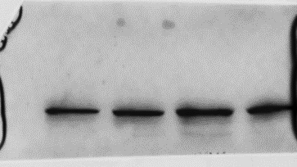
kDa

135
100
75

FOXA1 BCL2
kDa

25

20

17
kDa

48

35

25
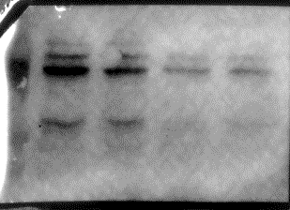
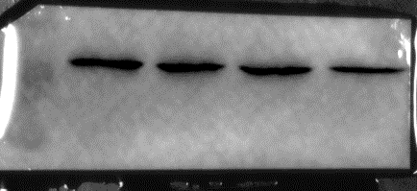

GAPDH
kDa

63

48

35

HNRNPC GAPDH
kDa

48

35
kDa

48

35

pAKT AKT
kDa

75

63
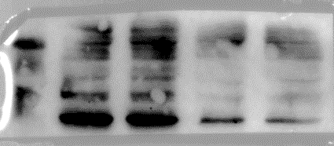
kDa

75

63

Densitometrical analysis of Western Blots for Figure 7

