Supplemental Material

Pathways linking residential noise and air pollution to mental ill-health in young adults

Angel M. Dzhambov¹, Iana Markevych^{2,3}, Boris Tilov^{4,5}, Zlatoslav Arabadzhiev⁶, Drozdstoj Stoyanov⁶, Penka Gatseva¹, Donka D. Dimitrova⁷

¹ Department of Hygiene and Ecomedicine, Faculty of Public Health, Medical University of Plovdiv, Plovdiv, Bulgaria
² Institute and Clinic for Occupational, Social and Environmental Medicine, University Hospital, LMU Munich, Munich, Germany
³ Institute of Epidemiology, Helmholtz Zentrum München – German Research Center for
Environmental Health, Neuherberg, Germany
⁴ Medical College, Medical University of Plovdiv, Plovdiv, Bulgaria
⁵ Department of Management, Faculty of Economics and Management, University of Agribusiness and Rural Development, Plovdiv, Bulgaria
⁶ Department of Psychiatry and Medical Psychology, Faculty of Medicine, Medical University of Plovdiv, Plovdiv, Bulgaria
⁷ Department of Health Management and Healthcare Economics, Faculty of Public Health, Medical University of Plovdiv, Plovdiv, Bulgaria

TABLE OF CONTENTS

Figure S1. Location of the study area

Figure S2. Structural equation model showing the estimated paths linking residential noise and air pollution to mediators and mental ill-health (GHQ) (N = 720)

Figure S3. Stratified association between residential noise (per 5 dBA) and air pollution (per 10 µg/m³) and mental ill-health (GHQ) (N = 720)

Table S1. Pearson correlations of the variables in the measurement model for the final structural equation model linking L_{Aeq} and NO₂ to mediators and mental ill-health (N = 720)

Figure S1. Location of the study area

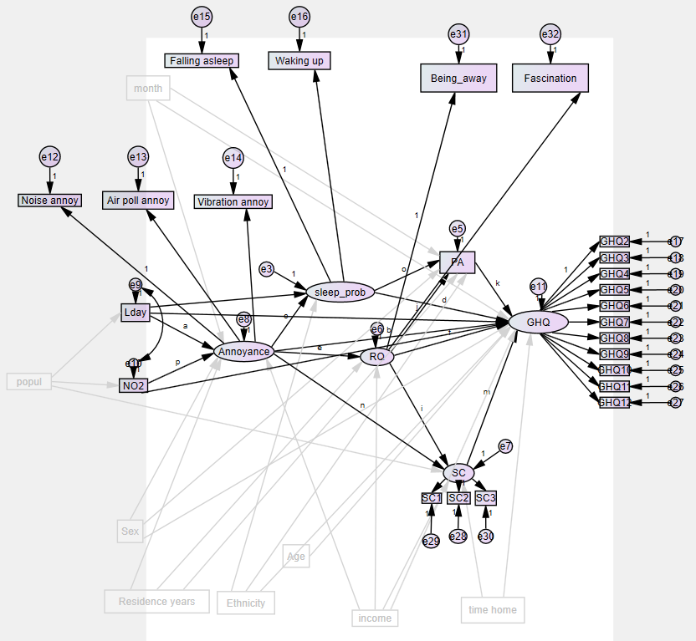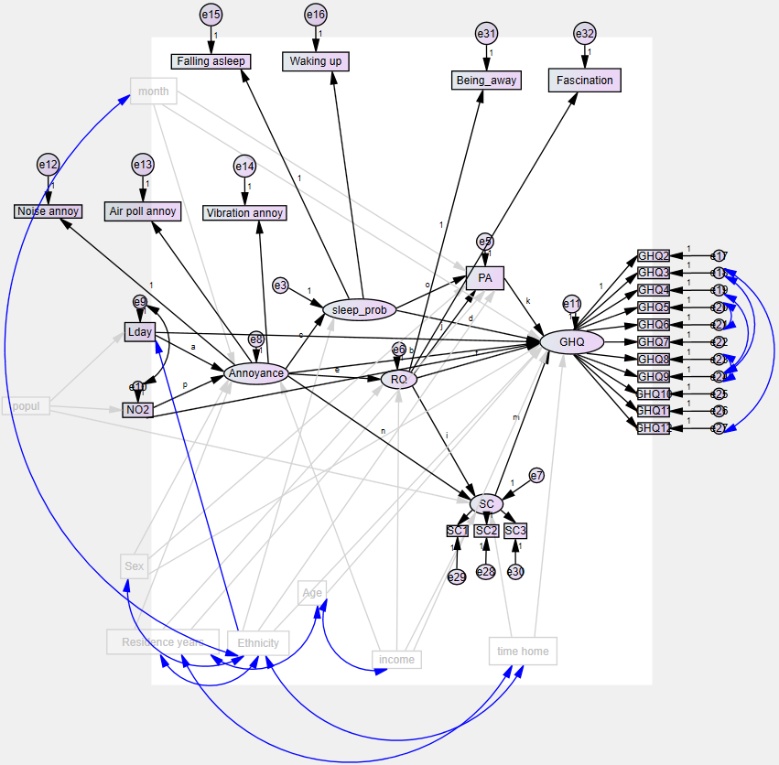
Figure S2. Structural equation model showing the estimated paths linking residential noise and air pollution to mediators and mental ill-health (GHQ) (N = 720)
Initial Model 0 on the left, final Model 1 on the right. Abbreviations: e – error term, GHQ – General Health Questionnaire, Lday – day equivalent noise level, NO2 – nitrogen dioxide, PA – physical activity, popul – population density in 500-m buffer, RQ – restorative quality, SC – social cohesion, sleep_prob – sleep disturbance. Covariance links in blue were added in Model 1 after model re-specification.

L_{Aeq} NO₂
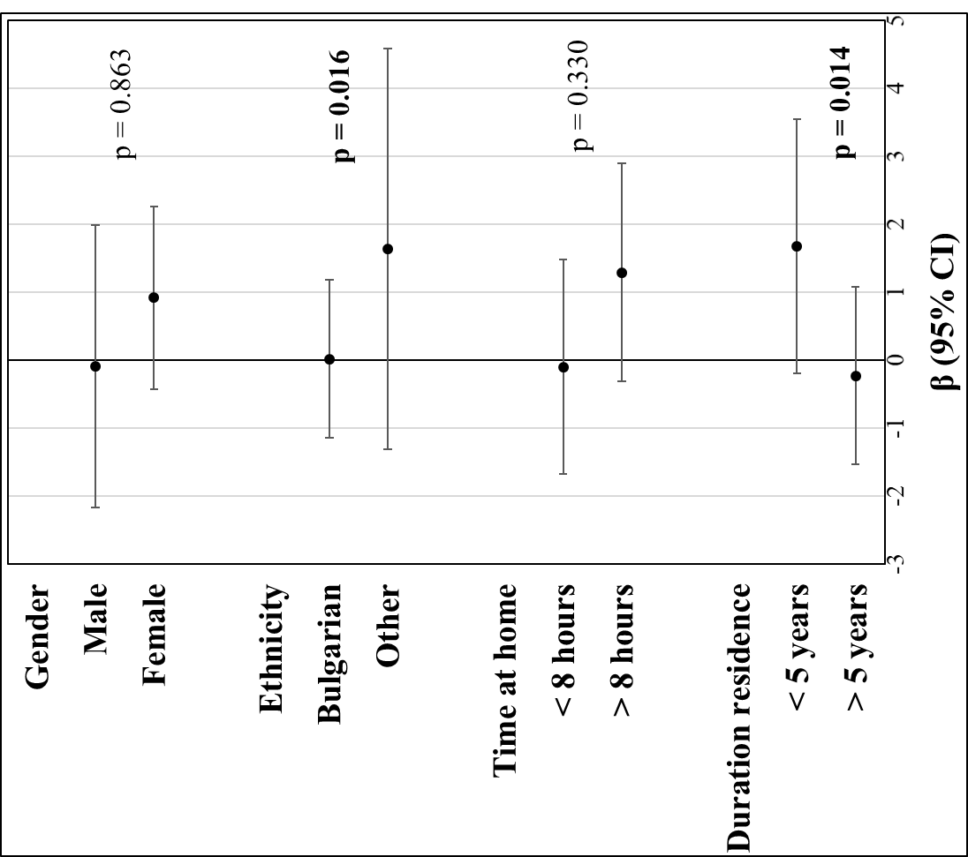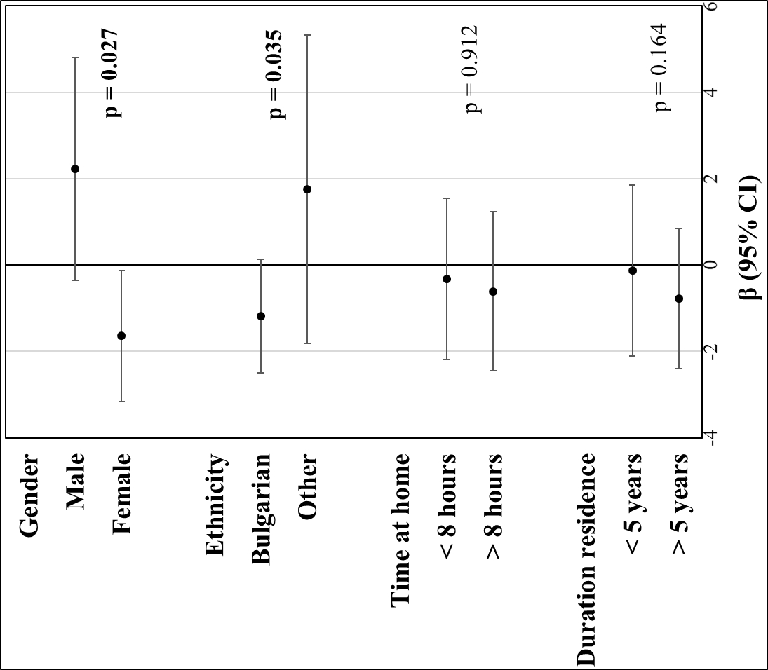
Figure S3. Stratified association between residential noise (per 5 dBA) and air pollution (per 10 µg/m³) and mental ill-health (GHQ) (N = 720)
Abbreviations: GHQ – General Health Questionnaire, L_{Aeq} – day equivalent noise level, NO₂ – nitrogen dioxide. Regression coefficients are unstandardized. Higher GHQ score is indicative of poorer mental health. Adjustments: L_{Aeq} and NO₂ are mutually adjusted; models are also adjusted for age, sex, ethnicity, individual-level economic status, duration of residence, time spent at home/day, population, and month of data collection. p-values are for Wald’s test of interaction.

Table S1. Pearson correlations of the variables in the measurement model for the final structural equation model linking L_{Aeq} and NO₂ to mediators and mental ill-health (N = 720)
 | 1 | 2 | 3 | 4 | 5 | 6 | 7 | 8 | 9 | 10 | 11 | 12 | 13 | 14 | 15 | 16 | 17 | 18 | 19 | 20 | 21 | 22 | 23 | 24 | 25 | 26 | 27 | 28 | 29 | 30 | 31 | 32 | Mean | SD
1. L_{Aeq} | 1 | .329 | .161 | .079 | .116 | -.007 | .040 | .055 | .015 | .089 | .057 | .059 | .019 | .104 | .027 | .020 | .033 | .057 | .136 | .039 | .031 | .127 | .103 | .141 | .051 | .205 | -.115 | .066 | .020 | -.031 | -.010 | .232 | 67.052 | 1.731
2. NO₂ |  | 1 | .119 | .079 | .081 | .003 | -.004 | .028 | .052 | .050 | .029 | .030 | -.003 | .043 | .023 | .039 | -.026 | -.019 | .013 | -.015 | .046 | .043 | .005 | .052 | .071 | .310 | -.063 | .003 | .019 | -.040 | -.080 | .137 | 15.175 | 3.028
3. Noise annoyance |  |  | 1 | .520 | .687 | -.082 | -.111 | -.111 | -.066 | -.021 | .285 | .211 | -.055 | .278 | .146 | .120 | .098 | .073 | .201 | .131 | .165 | .239 | .217 | .142 | .005 | .070 | -.117 | .065 | -.107 | .033 | -.046 | .118 | 1.554 | .953
4. Air pollution annoyance |  |  |  | 1 | .493 | -.110 | -.148 | -.151 | -.090 | -.135 | .226 | .256 | .021 | .258 | .122 | .117 | .107 | .066 | .202 | .109 | .153 | .214 | .192 | .096 | .094 | .005 | -.059 | .025 | -.174 | .047 | .026 | .077 | 1.615 | 1.060
5. Vibration annoyance |  |  |  |  | 1 | -.158 | -.183 | -.190 | -.115 | -.082 | .267 | .218 | -.029 | .286 | .171 | .078 | .137 | .060 | .202 | .126 | .116 | .245 | .182 | .087 | .052 | .041 | -.120 | .074 | -.112 | .121 | -.056 | .067 | 1.665 | 1.157
6. SC1 |  |  |  |  |  | 1 | .705 | .664 | .256 | .230 | -.047 | -.053 | .021 | -.019 | -.046 | -.071 | -.041 | -.013 | .010 | -.051 | -.104 | -.022 | -.013 | .001 | .030 | -.076 | .041 | .051 | .103 | .004 | .084 | .052 | 2.809 | 1.585
7. SC2 |  |  |  |  |  |  | 1 | .787 | .295 | .282 | -.022 | -.080 | .053 | -.076 | -.062 | -.112 | -.053 | -.073 | .011 | -.066 | -.136 | -.040 | -.019 | -.020 | .056 | -.075 | -.053 | .083 | .119 | -.023 | .008 | .033 | 2.910 | 1.509
8. SC3 |  |  |  |  |  |  |  | 1 | .269 | .264 | -.052 | -.091 | .017 | -.095 | -.087 | -.151 | -.078 | -.040 | -.037 | -.121 | -.134 | -.079 | -.045 | -.044 | .060 | -.102 | -.081 | .071 | .095 | .030 | -.007 | .070 | 2.949 | 1.546
9. Being away |  |  |  |  |  |  |  |  | 1 | .714 | -.024 | -.080 | .170 | -.074 | -.096 | -.143 | -.106 | -.085 | -.110 | -.136 | -.123 | -.057 | -.049 | -.017 | .020 | .020 | -.064 | .028 | .085 | -.061 | .030 | -.001 | 4.260 | 2.607
10. Fascination |  |  |  |  |  |  |  |  |  | 1 | .024 | -.042 | .115 | -.009 | -.066 | -.124 | -.089 | -.035 | -.013 | -.075 | -.058 | .038 | .017 | .037 | .065 | -.005 | -.083 | .023 | .090 | -.062 | -.005 | .077 | 3.196 | 2.533
11. Trouble falling asleep |  |  |  |  |  |  |  |  |  |  | 1 | .473 | -.046 | .352 | .245 | .191 | .151 | .131 | .345 | .249 | .199 | .383 | .305 | .285 | .099 | .014 | -.139 | .101 | -.099 | -.006 | -.117 | .205 | 3.089 | 2.674
12. Wake up at night |  |  |  |  |  |  |  |  |  |  |  | 1 | -.064 | .328 | .238 | .223 | .191 | .203 | .343 | .245 | .272 | .334 | .294 | .287 | .037 | -.006 | -.106 | .083 | -.117 | .010 | .031 | .219 | 2.399 | 2.580
13. Physical activity |  |  |  |  |  |  |  |  |  |  |  |  | 1 | -.109 | -.064 | -.108 | -.053 | -.070 | -.123 | -.110 | -.146 | -.112 | -.086 | -.158 | .069 | .048 | .096 | -.051 | .063 | -.199 | .017 | -.097 | 5.775 | 3.028
14. GHQ1 |  |  |  |  |  |  |  |  |  |  |  |  |  | 1 | .331 | .261 | .202 | .126 | .528 | .363 | .344 | .613 | .529 | .453 | .165 | -.026 | -.191 | .146 | -.164 | -.028 | -.066 | .399 | 1.341 | .945
15. GHQ2 |  |  |  |  |  |  |  |  |  |  |  |  |  |  | 1 | .222 | .208 | .180 | .295 | .293 | .384 | .272 | .286 | .159 | .117 | -.012 | -.055 | .103 | -.129 | -.026 | -.080 | .098 | 1.169 | .658
16. GHQ3 |  |  |  |  |  |  |  |  |  |  |  |  |  |  |  | 1 | .281 | .240 | .309 | .316 | .374 | .346 | .395 | .363 | .009 | .002 | -.139 | .145 | -.101 | -.121 | -.080 | .180 | .724 | .755
17. GHQ4 |  |  |  |  |  |  |  |  |  |  |  |  |  |  |  |  | 1 | .409 | .289 | .271 | .297 | .290 | .320 | .253 | .060 | -.022 | -.067 | .136 | .007 | -.021 | -.042 | .135 | .726 | .614
18. GHQ5 |  |  |  |  |  |  |  |  |  |  |  |  |  |  |  |  |  | 1 | .224 | .269 | .310 | .178 | .216 | .245 | .037 | -.075 | -.032 | .015 | -.050 | -.059 | -.030 | .082 | .737 | .565
19. GHQ6 |  |  |  |  |  |  |  |  |  |  |  |  |  |  |  |  |  |  | 1 | .339 | .300 | .549 | .516 | .471 | .125 | -.028 | -.205 | .201 | -.074 | -.015 | -.105 | .378 | 1.032 | .789
20. GHQ7 |  |  |  |  |  |  |  |  |  |  |  |  |  |  |  |  |  |  |  | 1 | .569 | .479 | .384 | .341 | .059 | .003 | -.097 | .085 | -.123 | -.064 | -.073 | .147 | .944 | .764
21. GHQ8 |  |  |  |  |  |  |  |  |  |  |  |  |  |  |  |  |  |  |  |  | 1 | .408 | .387 | .317 | .057 | -.004 | -.137 | .046 | -.164 | -.040 | -.089 | .158 | .933 | .713
22. GHQ9 |  |  |  |  |  |  |  |  |  |  |  |  |  |  |  |  |  |  |  |  |  | 1 | .627 | .524 | .154 | .045 | -.271 | .218 | -.138 | -.067 | -.103 | .433 | .967 | .923
23. GHQ10 |  |  |  |  |  |  |  |  |  |  |  |  |  |  |  |  |  |  |  |  |  |  | 1 | .584 | .069 | .033 | -.235 | .192 | -.116 | -.021 | -.112 | .387 | .913 | .846
24. GHQ11 |  |  |  |  |  |  |  |  |  |  |  |  |  |  |  |  |  |  |  |  |  |  |  | 1 | .085 | .010 | -.231 | .240 | -.072 | -.132 | -.071 | .452 | .526 | .782
25. Month |  |  |  |  |  |  |  |  |  |  |  |  |  |  |  |  |  |  |  |  |  |  |  |  | 1 | .052 | -.053 | .081 | .040 | -.093 | -.136 | .186 | .544 | .498
26. Population |  |  |  |  |  |  |  |  |  |  |  |  |  |  |  |  |  |  |  |  |  |  |  |  |  | 1 | -.089 | -.003 | .075 | -.016 | -.025 | .073 | 8723.833 | 3605.173
27. Duration residence |  |  |  |  |  |  |  |  |  |  |  |  |  |  |  |  |  |  |  |  |  |  |  |  |  |  | 1 | -.178 | .050 | .049 | .188 | -.376 | .383 | .487
28. Time at home |  |  |  |  |  |  |  |  |  |  |  |  |  |  |  |  |  |  |  |  |  |  |  |  |  |  |  | 1 | .016 | -.077 | -.084 | .354 | .547 | .498
29. Income |  |  |  |  |  |  |  |  |  |  |  |  |  |  |  |  |  |  |  |  |  |  |  |  |  |  |  |  | 1 | -.008 | -.154 | .026 | 2.635 | 1.200
30. Sex |  |  |  |  |  |  |  |  |  |  |  |  |  |  |  |  |  |  |  |  |  |  |  |  |  |  |  |  |  | 1 | -.007 | -.207 | .663 | .473
31. Age |  |  |  |  |  |  |  |  |  |  |  |  |  |  |  |  |  |  |  |  |  |  |  |  |  |  |  |  |  |  | 1 | -.041 | 22.485 | 4.228
32. Ethnicity |  |  |  |  |  |  |  |  |  |  |  |  |  |  |  |  |  |  |  |  |  |  |  |  |  |  |  |  |  |  |  | 1 | .260 | .439
Abbreviations: GHQ 1-11 – General Health Questionnaire items, L_{Aeq} – day equivalent noise level, NO₂ – nitrogen dioxide, SC 1-3 – social cohesion items, SD – standard deviation.

