Supplemental material

Outdoor air pollution, greenspace, and incidence of ADHD:
A semi-individual study

Iana Markevych, Falko Tesch, Thomas Datzmann,
Marcel Romanos, Jochen Schmitt, Joachim Heinrich

Table S1. Pearson correlation coefficients of interrelations between air pollution, greenspace, healthcare access, and ADHD.
 | Population density | ADHD | PM₁₀ | NO₂ | NDVI | Pediatricians in 15-km radius | Child psychologists in 30-km radius | Child psychiatrists in 40-km radius
Population density | 1 | 0.31 | 0.61 | 0.83 | -0.67 | 0.55 | 0.19 | 0.25
ADHD |  | 1 | 0.43 | 0.37 | -0.31 | 0.41 | 0.23 | 0.48
PM₁₀ |  |  | 1 | 0.84 | -0.80 | 0.51 | 0.18 | 0.38
N0₂ |  |  |  | 1 | -0.88 | 0.64 | 0.28 | 0.31
NDVI |  |  |  |  | 1 | -0.50 | -0.27 | -0.26
Pediatricians in 15-km radius |  |  |  |  |  | 1 | 0.45 | 0.49
Child psychologists in 30-km radius |  |  |  |  |  |  | 1 | 0.41
Child psychiatrists in 40-km radius |  |  |  |  |  |  |  | 1
ADHD – attention deficit hyperactivity disorder; NO₂ – nitrogen dioxide; NDVI – Normalized Difference Vegetation Index; PM₁₀ – particulate matter with diameter less than 10 µm.

Table S2. Adjusted RRs with 95% CIs of air pollution and greenspace and ADHD estimated by two-level Poisson regression models with observation time as an offset. Fixed part refers to an individual level (level 1) and random part refers to a PLZ-4 level (level 2). Children who changed who moved to another PLZ-4 area at least once within 2005 and 2014 were excluded.
Models / variables | ADHD incidence
Model 1
Fixed part, RR (95% CI)
PM₁₀ (per 10 µg/m³) | 1.95 (1.30 – 2.95)
Child psychiatrists in 40 km-radius | 1.82 (1.51 – 2.19)
Sex (ref: female)
Male | 3.43 (3.04 - 3.86)
Year of birth (ref: 2000)
2001 | 1.04 (0.90 - 1.20)
2002 | 0.83 (0.71 - 0.97)
2003 | 0.88 (0.76 - 1.03)
2004 | 0.77 (0.66 - 0.90)
Fixed part, variance | 0.16
Random part, variance
Level 2: PLZ-4 area | 0.22
Model 2
Fixed part, RR (95% CI)
NO₂ (per 10 µg/m³) | 1.26 (1.13 – 1.53)
Child psychiatrists in 40-km radius | 1.93 (1.03 – 1.53)
Sex (ref: female)
Male | 3.43 (3.04 - 3.86)
Year of birth (ref: 2000)
2001 | 1.04 (0.90 - 1.20)
2002 | 0.83 (0.71 - 0.97)
2003 | 0.88 (0.76 - 1.03)
2004 | 0.77 (0.66 - 0.90)
Fixed part, variance | 0.16
Random part, variance
Level 2: PLZ-4 area | 0.23
Model 3
Fixed part, RR (95% CI)
NDVI (per 0.1 units) | 0.84 (0.69 – 1.02)
Child psychiatrists in 40-km radius | 1.98 (1.65 – 2.37)
Sex (ref: female)
Male | 3.43 (3.04 - 3.86)
Year of birth (ref: 2000)
2001 | 1.04 (0.90 - 1.20)
2002 | 0.83 (0.71 - 0.97)
2003 | 0.88 (0.76 - 1.03)
2004 | 0.77 (0.66 - 0.90)
Fixed part, variance | 0.16
Random part, variance
Level 2: PLZ-4 area | 0.23
ADHD – attention deficit hyperactivity disorder; CI – confidence interval; NO₂ – nitrogen dioxide; NDVI – Normalized Difference Vegetation Index; PM₁₀ – particulate matter with diameter less than 10 µm; RR – relative risk.

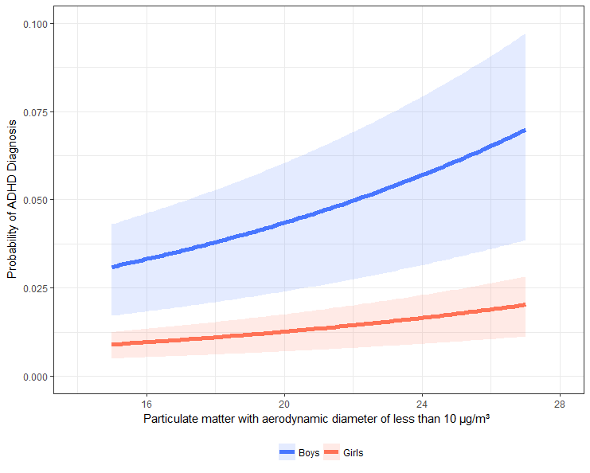
Figure S1. Prediction for the risk of ADHD for 100 different values of PM₁₀ holding all other variables from the model constant.

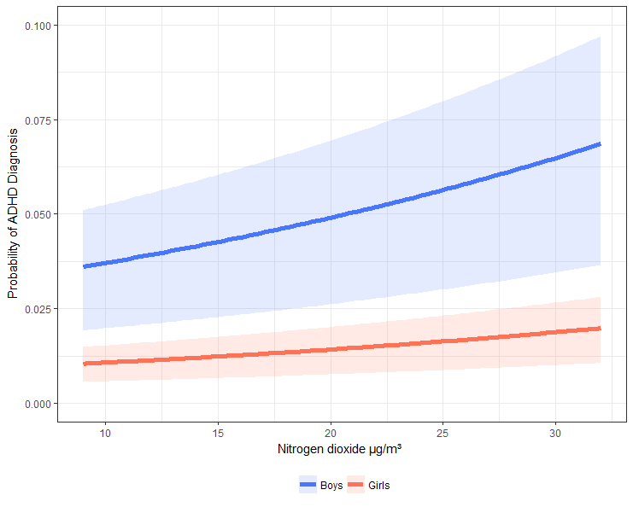
Figure S2. Prediction for the risk of ADHD for 100 different values of NO₂ holding all other variables from the model constant.

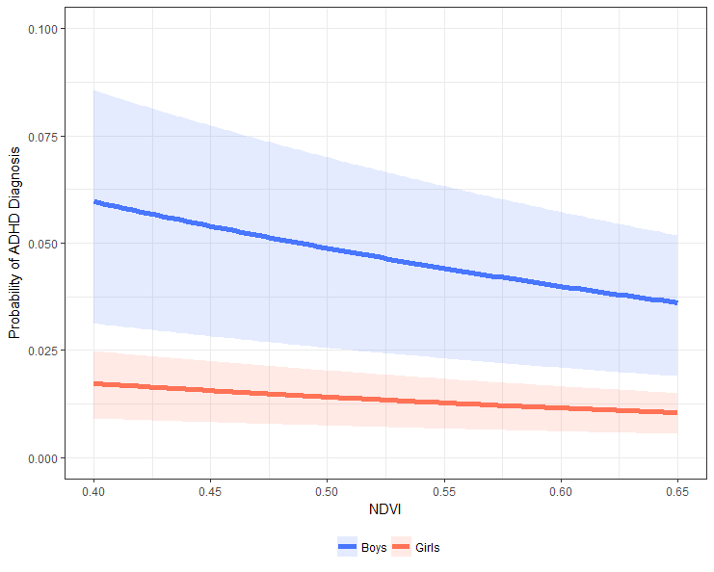
Figure S3. Prediction for the risk of ADHD for 100 different values of NDVI holding all other variables from the model constant.

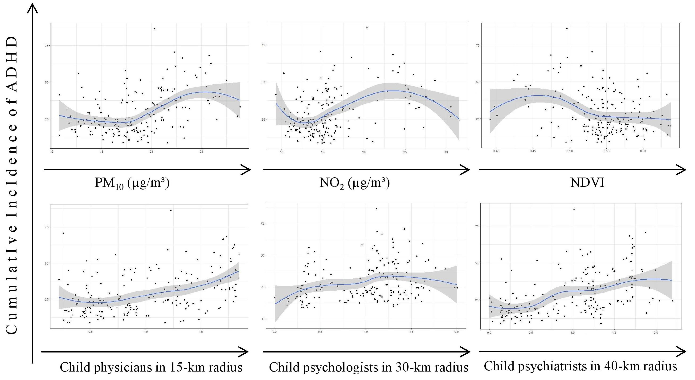

Figure S4. LOESS curves with 95% CIs of the associations between air pollution, greenspace, health care access, and ADHD in 186 PLZ-4 areas.

