Environmental grass pollen levels in utero and at birth and Cord Blood IgE: Analysis of three birth cohorts

Nugroho Harry Susanto^{a,k,l}, Ann-Marie Malby Schoos^{b}, Marie Standl^{c}, Adrian J. Lowe^{d}, Shyamali C. Dharmage^{d}, Cecilie Svanes^{e,m}, Agus Salim^{f}, Andrea von Berg^{g}, Irina Lehmann^{h}, Morten Arendt Rasmussen^{b}, Matthias Werchan^{i}, Karl-Christian Bergmann^{i}, Caroline Lodge^{d}, Michael J Abramson^{j}, Joachim Heinrich^{c,n}, Hans Bisgaard^{b}, Bircan Erbasª

ª School of Pyschology and Public Health, La Trobe University, Melbourne, Australia
^{b} Copenhagen Prospective Studies on Asthma in Childhood, Faculty of Health and Medical Sciences, University of Copenhagen & Danish Pediatric Asthma Center, Gentofte Hospital, University of Copenhagen; Denmark
c Institute of Epidemiology I, Helmholtz Zentrum München - German Research Center for Environmental Health, Neuherberg, Germany
^{d} Allergy and Lung Health Unit, School of Population and Global Health, The University of Melbourne, Melbourne, Australia
^{e} Centre for International Health, University of Bergen, Norway
^{f} Department of Mathematics and Statistics, La Trobe University, Melbourne, Australia
^{g} Research Institute, Department of Pediatrics, Marien-Hospital Wesel, Wesel, Germany
^{h} Department of Environmental Immunology/Core Facility Studies, Helmholtz Centre for Environmental Research – UFZ, Leipzig, Germany
^{i} Foundation German Pollen Information Service, Berlin, Germany
^{j} School of Public Health & Preventive Medicine, Monash University, Melbourne, Australia
^{k} Indonesia Research Partnership on Infectious Diseases (INA-RESPOND), Jakarta, Indonesia
^{l} Epidemiology and Biostatistics Division, Public Health Department, Faculty of Medicine, Padjadjaran University, Bandung, Indonesia
^{m} Department of Occupational Medicine, Haukeland University Hospital, Norway
^{n} Institute and Outpatient Clinic for Occupational, Social and Environmental Medicine, Inner City Clinic, University Hospital of Ludwig Maximilians University, Munich, Comprehensive Pneumology Centre (LMU), Munich, German Centre for Lung Research, Germany

Corresponding Author: Bircan Erbas,
School of Public Health, La Trobe University,
Rm 520, Health Sciences 2,
Bundoora, Victoria, Australia 3086
Tel: +61 3 9479 5657
Email: b.erbas@latrobe.edu.au

Word Count: 3643

ABSTRACT
Background: Early life factors are associated with allergic respiratory diseases, but the role of high grass pollen concentrations during pregnancy and shortly after birth is not known.

Objective: To assess outdoor levels of grass pollen during the intrauterine period and at birth during peak pollen season on cord blood IgE in birth cohorts.

Methods: Three birth cohorts were included: MACS, Australia; COPSAC₂₀₀₀, Denmark; and LISA, Germany. Cord blood IgE was categorized (<0.5 kU/L, 0.5-1 kU/L, >1 kU/L) and dichotomized (high IgE ≥ 0.5 kU/L). Birth during the grass pollen season months and cumulative exposure to outdoor grass pollen counts during pregnancy with cord blood IgE were analysed using multinomial regression and analysed in meta-analysis using binomial regression adjusted for potential confounders.

Results: Birth during the grass pollen season had higher pooled odds of cord blood IgE >0.5 kU/L 1.37 (95% CI 1.06, 1.77) in a meta-analysis with little heterogeneity between the three cohorts. Cumulative exposure to outdoor grass pollen counts during the entire pregnancy were associated with slightly lower pooled odds but significant (OR = 0.98, 95% CI: 0.96 to 0.99).

Conclusions: Birth during grass pollen seasons were associated with increased risk of high cord blood IgE in cities from both hemispheres, but high pollen loads in the environment during the entire pregnancy appeared protective. As IgE responses develop during the first months of life, our study findings provide new insights into the mechanisms of grass pollen exposure at birth and shortly after on possible allergic respiratory diseases.

Key words: cord blood IgE, grass pollen, in utero, allergic respiratory disease
INTRODUCTION
Globally, especially in developed countries¹ allergic respiratory diseases in children are an important public health problem, and understanding the role of allergen exposure on IgE could help in managing this problem. Cord blood IgE may be important in identifying children at risk of developing allergic diseases. Although studies analysing cord blood IgE have been mixed, the majority of these studies found higher levels of IgE in cord blood in infants who go on to develop allergies in later childhood.^{2, 3} Understanding factors that may be associated with cord blood IgE, may help to understand the risk profile in the early life of children who are at risk of allergic diseases.

Season of birth as a possible marker of environmental allergen exposure has been consistently associated with cord blood IgE.⁴ However season of birth may act as a proxy for other prenatal exposures such as ultraviolet-B⁵, seasonal variations in maternal nutrient intake⁶ or viral infections during pregnancy.⁷ Little is known about cord blood IgE when exposed to high levels of pollen during pregnancy. To our knowledge, only two studies have reported the effect of exposures to pollen during pregnancy and risk of allergic disease in childhood. One study reported that exposure to high levels pollen in the last 12 weeks of pregnancy was associated with increased risk of asthma hospitalisation during the first year of life.⁸ Another reported a trend that high exposures to birch pollen during pregnancy increased the risk of sensitization to birch pollen at 5 years of age.⁹

Studies including our own, have shown that outdoor pollen exposure during the first couple of months after birth is important in subsequent allergic respiratory diseases.^{10, 11} We hypothesized that it may also be important during the pregnancy, especially during the 2nd and 3rd trimesters where the immune system develops¹² and among women with a history of allergic disease . In this analysis, using three cohorts from different countries with varying pollen seasons and distributions, we sought to investigate what role pollen concentrations in the outdoor environment have during pregnancy, at birth during months where outdoor levels of pollen peak (pollen seasons) on cord blood IgE. We specifically focussed on grass pollen as this is the predominant species with longer seasons and highest allergenic load and common to all regions included in this study.

METHODS
Study design and population
This study was a cross-sectional analysis of data from the Melbourne Atopic Cohort Study (MACS) in Australia, Copenhagen Prospective Study of Asthma in Childhood (COPSAC₂₀₀₀) cohort in Denmark, and Life-style Related Factors on the Immune System and the Development of Allergies in Childhood (LISA) cohort in Germany. Details of these studies, recruitment and data collection have been described previously.¹³⁻¹⁷ All studies required written informed consent from participating parents. In general, detailed demographic, environmental and familial allergy data were obtained at birth for all birth cohorts.

Briefly, 620 babies were enrolled into MACS by recruiting pregnant women living in Melbourne, Australia between March 1990 and November 1994. Infants were eligible to be enrolled if they had at least one-first-degree family member with a history of eczema and/or asthma and/or allergic rhinitis and/or severe food allergy. Ethical approval for MACS was given by the Mercy Maternity Hospital Ethics Committee.

COPSAC₂₀₀₀ recruited 411 children between 1998 and 2001 from Copenhagen, Denmark, born to mothers with a verified history of asthma. The study was approved by Copenhagen Ethics Committee and the Danish Data Protection Agency.

LISA recruited a population based sample of 3097 healthy, term-born neonates between 1997 and 1999 from obstetric clinics in Munich, Leipzig, Wesel and Bad Honnef, Germany. Neonates displaying any of the following excluded from the study: preterm birth (maturity <37 gestational weeks), low birth weight (<2,500 g), congenital malformation, symptomatic neonatal infection, antibiotic medication, hospitalization or intensive medical care during neonatal period. In addition, newborns from mothers with immune-related diseases (autoimmune disorders, diabetes, hepatitis B), on long-term medication or who abuse drugs and/or alcohol, and newborns from parents with a nationality other than German or who were not born in Germany, were excluded. Approval was given by the Ethics Committees of the Bavarian Board of Physicians, University of Leipzig and the Board of Physicians of North-Rhine-Westphalia. Written consent from the participant’s families was obtained. A requirement for each cohort was that all children were born full-term.

Pollen collection and measurement
Pollen data of all three study areas (Australia, Denmark, Germany) were collected using a 7-day volumetric spore trap (Burkard).¹⁸ Burkard trap for MACS was located on the roof top of the Earth Sciences building, The University of Melbourne in Melbourne. For COPSAC, the pollen trap was placed at the Danish Meteorological Institute in Copenhagen. For LISA, volumetric spore traps were located within the city limits of Bochum, Dresden and Munich on the roofs of hospital buildings or university buildings. For each city, all traps were located more than 15 metres above the ground as per standard in pollen monitoring. Airborne grass pollen grains were trapped on an adhesive surface and identified under a light microscope. The daily average grass pollen counts are expressed as pollen grains/m³ of air. High grass pollen concentrations in Melbourne appear usually between October to December. Daily pollen concentrations for grass were only available between October 1991 and January 1994 from one pollen trap located at the University of Melbourne. Grass pollen season in all study centers of LISA were detected usually between end of April to end of August with maximum concentrations between May to June. Daily average pollen concentrations of the three pollen monitoring stations in Bochum, Dresden and Munich were used for Germany, available for the whole period of birch and grass pollen season between 1997 and 1999. The grass pollen season in Copenhagen, Denmark, was from May to August with the peak between May to June. Daily pollen data in Copenhagen were available during the pollen season for all the year of births of COPSAC₂₀₀₀.

Cord blood collection and measurement
In MACS, cord blood was collected from the umbilical vein at birth. Total IgE was measured using solid-phase radio-immunoassay based on a sandwich technique, RIA Ultra kit (Pharmacia, Uppsala, Sweden), with a detection limit of 0.5 kU/L. Cord blood also measured for IgA using low-level IgA radial diffusion plates (Behring AG, Germany), samples with IgA levels more than 32 μg/L were considered as contaminated by maternal IgE and removed from analysis.¹⁹

In COPSAC₂₀₀₀, cord blood was collected by needle puncture of the umbilical cord vein. Total IgE level was measured via ImmunoCAP assay (Phadia AB, Uppsala, Sweden) with a very low detection limit 0.1 kU/L. Total IgA was analysed using ELISA assay with a very low level detection limit 0.1 μg/L (analysed by Phadia AB). Samples with IgA levels > 50 μg/L were considered as contaminated by maternal IgE and removed from the analysis.²⁰

In LISA, cord blood samples were collected during recruitment in maternity wards as described previously.¹⁶ Total-serum IgE was determined with the Pharmacia system (neonate IgE kit; Pharmacia, Freiburg, Germany). The limit of detection was 0.35 kU/L. IgA was also determined to exclude cord blood contaminated by the mothers’ blood.^{16, 19} No single IgA level exceeded the cut-off point of 32 μg/L.

Definition of outcomes/exposures for statistical analysis
Outcome definitions
We defined IgE levels based on three cutoffs: low (<0.5 kU/L), moderate (0.5 to 1 kU/L), and high (>1 kU/L). We used 0.5 kU/L as the limit for lowest group because this was a frequent cut-off level in previous studies to detect IgE in newborns²¹⁻²⁴ and it was also the highest detection limit among all cohorts in this study. We used 1.0 kU/L as the limit for highest group as it was the highest IgE level used in previous studies to detect IgE in newborns.^{25,26}
We also dichotomized IgE levels into low (<0.5 kU/L) and high (≥0.5 kU/L) to be used for the meta-analysis.

Exposure definitions
We defined grass pollen exposure in multiple ways: First, we defined pollen exposures as being born inside or outside pollen season where pollen season was defined as months where the grass pollination occurs in each region. For example, in Melbourne the main flowering period for the grasses is from October to December. Born inside refers to the child being born during this pollen season period. We also then analysed those born in months of the pollen season. Second, we defined the variable, cumulative grass pollen measurements during entire pregnancy, as a continuous measurement where we summed the daily grass pollen measurements corresponding to the pregnancy months of the child’s mother. We then divided the amount by 100 to get the effect of an increase of 100 grains/m³ grass pollen exposure during the whole pregnancy.

Potential confounders/effect modifiers
We used mother’s age, history of hayfever and smoking during pregnancy, parent’s socioeconomic status and infant’s birth weight as adjustments in the regression analysis. For MACS, history of hayfever was defined as mother reporting currently or ever having hayfever, and smoking history was defined as currently smoking, or smoking in the last 3 months or in the last 6 months during pregnancy. Parent’s socioeconomic status was comprised of mother’s education, father’s education, and father’s occupation. Infant’s birth weight data in MACS was not available instead we used infant’s weight at 4 weeks age. In LISA, mother’s history of allergy was defined as ever having asthma, eczema or hay fever. Smoking history was defined as ever smoking during the third trimester of pregnancy. Parent’s socioeconomic status was represented by mother’s education in LISA cohort. As LISA was a multi-centre study, the study centres were considered as covariates in the models. Mothers history of hayfever in COPSAC₂₀₀₀ was defined as history of doctor diagnosed hayfever. Symptoms were typically defined as significant problems with sneezing, blocked or runny nose in periods outside the common cold or flu and upon relevant exposure to a known allergen. Smoking history for COPSAC₂₀₀₀ was defined as smoking ≥1 cigarette/week during the third trimester of pregnancy. Mother’s education and father’s education represented socioeconomic status in COPSAC₂₀₀₀.

Statistical analysis
We used multinomial logistic regression for the three level cord blood IgE outcome. Results were presented as crude and adjusted relative-risk ratios (RRR) with corresponding 95% confidence intervals (CI). We used logistic regression for dichotomized cord blood IgE ( > 0.5 kU/L) as estimates from these models were required for the pooled meta-analysis. These results were presented as crude and adjusted odds ratios (OR) with corresponding 95% CI.

All statistical analyses were performed locally in each study centre. Cohort-specific effect sizes from a binary regression analysis were later meta-analysed for pollen season of birth and cumulative pollen exposures during pregnancy using inverse variance weighted random-effect models. I² statistics were calculated for statistical heterogeneity among studies. All analysis was performed in Stata™ version 14.2 (StataCorp, Texas, TX, USA). In LISA, analysis was performed in R version 3.3.2 (R Core Team (2016))²⁷ using the function multinom from the package nnet for the multinomial regression models.²⁸

RESULTS
In MACS, cord blood samples were available for 69% of participants. Although mothers with cord blood samples were slightly older than those without, there were no differences in the distribution of hayfever history, smoking history, or season of delivery between mothers with and without cord blood samples. Cord blood samples were available for 64% of all LISA participants. Those mothers without cord blood samples available were significantly older and more likely to ever have allergy (asthma, eczema or hay fever/rhinitis), but there was no difference in the prevalence of smoking during pregnancy. Cord blood samples were available for 49% of all COPSAC₂₀₀₀ participants. There was no difference between the mothers with and without cord blood samples with regards to age, allergy (all mothers had asthma), smoking during pregnancy or season of delivery.

The characteristics of each study cohort with available cord blood data are detailed in Table 1. Maternal age was similar across the three cohorts. As high risk cohorts, MACS and COPSAC₂₀₀₀ had a high prevalence of maternal hayfever (60 and 74% respectively), while being population based LISA had the lowest prevalence (34%).

Revised Table 1. Characteristics of study participants from each cohort with available cord blood data
 | No (%) or Mean (SD)
 | MACS  (n=429) | LISA  (n=1968) | COPSAC₂₀₀₀  (n=200)
Mother’s age (mean (SD)) | 31 (4) | 31 (5) | - (4)
Mother’s history of hayfever (No (%)) | 256 (60) | 653 (34) | 148 (74)
Mother’s history of smoking during pregnancy (No (%)) | 39 (7) | 205 (11) | 25 (13)
Mother’s education in year (mean (SD))  Mother’s education (No (%))  - Low  - Medium  - High | 13 (2) | 196 (10)  805 (42)  938 (48)
Mother’s education  - Elementary or college  - Medium  - University |  |  | 220 (58)  104 (27)  58 (15)
High IgE  - Low IgE (<0.5 kU/L)  - High IgE (≥0.5 kU/L) | 326 (76.0)  103 (24.0) | 1528 (78)  440 (22) | 160 (80)  40 (20)
IgE as three levels (No (%))  - Low (<0.5 kU/L)  - Intermediate (0.5-1 kU/L)  - High (>1 kU/L) | 326 (76.0)  49 (11)  54 (13) | 1528 (78)  196 (10)  244 (12) | 160 (80)  17 (9)  23 (11)

Revised Table 2. The number of births during the pollen season and cumulative exposure to grass pollen exposure during the mother’s entire pregnancy for each cohort
 | MACS  (n=429)  No (%) | LISA  (n=1968)  No (%) | COPSAC₂₀₀₀  (n=200)  No (%)
Born in the pollen season  Months corresponding to birth during the pollen season  - Month 1  - Month 2  - Month 3  - Month 4  - Month 5  - Month 6 | 307 (71)  51 (12)  39 (9)  32 (8) | 666 (34)  136 (7)  149 (8)  156 (8)  225 (11) | 101 (51)  9 (4)  11 (5)  21 (11)  21 (11)  8 (4)  29 (14)
Grass pollen during pregnancy, Mean (SD) | 47.2 (26.1) | 9.6 (5.9) | 19.7 (10.4)
Notes:
For MACS: month 1 was October, month 2 was November, and month 3 was December. For LISA: month 1 was April, month 2 was May, month 3 was June, month 4 was July. For COPSAC₂₀₀₀: month 1 was March, month 2 was April, month 3 was May, month 4 was June, month 5 was July, month 6 was August.
Grass pollen measurement was in 100 grains/m³

The prevalence of children born in the pollen season was highest in MACS, followed by LISA and COPSAC₂₀₀₀ (Table 2). The mothers of children in MACS had the highest exposure of grass pollen during the entire pregnancy, almost five times that of children in LISA and more than double that of COPSAC₂₀₀₀ (Table 2).

In MACS, birth during the grass pollen season was associated with high cord blood IgE > 1 kU/L in a multinomial analysis (RRR=2.48, 95%CI: 1.38, 4.48) (Supplementary table 1). In particular, birth during October was associated with high cord blood IgE > 1 kU/L (3.03, 95%CI: 1.41, 6.52) and birth in December was associated with cord blood IgE > 1 kU/L (2.78, 95%CI: 1.09, 7.11). In LISA, birth in the first month of the pollen season was associated with increased risk of high cord blood IgE > 1 kU/L (2.05, 95%CI: 1.26, 3.33).

Adjusted analysis in MACS showed a stronger effect than in the crude analysis (Table 3), as birth in the grass pollen season was associated with IgE > 1 kU/L (RRR=3.01, 95%CI: 1.58, 5.73). Birth in October and December was also associated with increased -risk of IgE > 1 kU/L (3.61, 95%CI: 1.59, 8.17 , 4.10, 95%CI: 1.50, 11.24 respectively). In adjusted analysis, an April birth in LISA was associated with cord blood IgE > 1 kU/L (2.03 , 95%CI: 1.24, 3.31). There were no significant associations in the adjusted analysis of the COPSAC₂₀₀₀ cohort. Cumulative exposure to grass pollen in mothers during the entire pregnancy was associated with a slightly reduced risk for high cord blood IgE in MACS (0.97, 95%CI: 0.95, 0.99) and in LISA (0.96 [95%CI: 0.93, 0.99]) but not in the COPSAC₂₀₀₀ cohort (Table 3).
Revised Table 3. Adjusted effects of birth in pollen seasons and grass pollen exposure on cord blood total IgE
Cohort | n | Exposure | High IgE  (<0.5 kU/L as ref)  OR (95% CI) | p | Multinomial IgE (<0.5 kU/L as ref)
 |  |  |  |  | 0.5-1 kU/L  RRR (95% CI) | p | >1 kU/L  RRR (95% CI) | p
MACS | 403 | Born in grass pollen season | 1.91 (1.16, 3.15) | 0.01 | 1.19 (0.59, 2.42) | 0.62 | 3.01 (1.58, 5.73) | <0.01
 | 403 | Born in grass pollen months  - Oct  - Nov  - Dec | 2.24 (1.16, 4.35)  1.19 (0.51, 2.80)  2.42 (1.06, 5.48) | 0.01  0.68  0.03 | 1.35 (0.52, 3.52)  0.82 (0.23, 2.89)  1.48 (0.46, 4.74) | 0.54  0.75  0.51 | 3.61 (1.59, 8.17)  1.70 (0.58, 5.4.97)  4.10 (1.50, 11.24) | <0.01  0.33  <0.01
 | 169 | Total grass pollen during pregnancy | 0.98 (0.97, 0.99) | 0.02 | 1.00 (0.98, 1.01) | 0.64 | 0.97 (0.95, 0.99) | <0.01
LISA | 1797 | Born in grass pollen seasons | 1.25 (0.99, 1.58) | 0.06 | 1.34 (0.97, 1.85) | 0.07 | 1.18 (0.87,1.59) | 0.29
 | 1797 | Grass pollen month birth  - April  - May  - June  - July | 1.59 (1.05, 2.43)  1.35 (0.89, 2.03)  1.16 (0.76, 1.76)  1.08 (0.75, 1.54) | 0.03  0.15  0.49  0.68 | 1.07 (0.55, 2.09)  1.55 (0.90, 2.66)  1.19 (0.66, 2.12)  1.45 (0.93, 2.28) | 0.83  0.12  0.56  0.10 | 2.03 (1.24, 3.31)  1.19 (0.7, 2.04)  1.14 (0.67, 1.94)  0.77 (0.46, 1.29) | <0.01  0.52  0.64  0.32
 | 1797 | Total grass pollen during pregnancy | 0.96 (0.94,0.99) | <0.01 | 0.96 (0.93, 0.99) | 0.03 | 0.96(0.93,0.99) | 0.02
COPSAC₂₀₀₀ |  | Born in grass pollen seasons | 1.21 (0.49, 2.80) | 0.67 | 1.23 (0.31, 4.00) | 0.76 | 1.11 (0.33, 3.28) | 0.86
 |  | Grass pollen month birth  - March  - April  - May  - June  - July  - August | 0.67 (0.03, 4.35)  2.49 (0.58, 9.63)  0.92 (0.23, 3.00)  1.26 (0.36, 3.89)  0.70 (0.09, 3.81)  0.47 (0.12, 1.44) | 0.72  0.19  0.90  0.70  0.70  0.22 | N/A  2.44 (0.30, 14.0)  1.41 (0.19, 6.88)  0.78 (0.10, 3.92)  N/A  0.54 (0.07, 2.52) | 0.34  0.69  0.78  0.47 | 1.74 (0.08, 13.4)  3.43 (0.44, 18.9)  0.64 (0.09, 3.07)  1.54 (0.30, 6.33)  0.71 (0.07, 4.71)  0.35 (0.05, 1.59) | 0.64  0.18  0.62  0.57  0.74  0.22
 |  | Total grass pollen during pregnancy | 0.97 (0.94; 1.00) | 0.08 | 0.97 (0.92; 1.02) | 0.23 | 0.97 (0.93; 1.01) | 0.15
Model adjustments:
- Mother’s age, mother’s education, father’s education, father’s occupation, mother’s history of hayfever, mother’s history of smoking during pregnancy and infant’s weight at 4 weeks age for MACS.
- Mother’s age, mother’s history of allergic disease, mother’s history of smoking in pregnancy, mother’s education, and study centers in LISA. In LISA models, study center was adjusted as a covariate as mixed effects models showed no difference in estimated effect sizes or p values.
- Mother’s age, mother’s education, father’s education, mother’s history of hayfever, mother’s history of smoking during pregnancy, and infant’s birth weight in COPSAC₂₀₀₀.
A meta-analysis of all three cohorts and pollen season of birth indicated significantly higher odds of having high cord blood IgE compared to birth outside the grass pollen season (OR = 1.37, 95%CI: 1.06 to 1.77). There was no significant heterogeneity (I² = 14%, p=0.31), suggesting little variation between the three studies (Figure 1). The pooled odds of cumulative exposure to grass pollen in mothers during their entire pregnancy and cord blood IgE (≥ 0.5 kU/L) was slightly lower odds but significant (OR = 0.98, 95% CI: 0.96 to 0.99). The meta-analysis for this also found no significant heterogeneity (I² = 13.5%, p=0.31) (Figure 2).

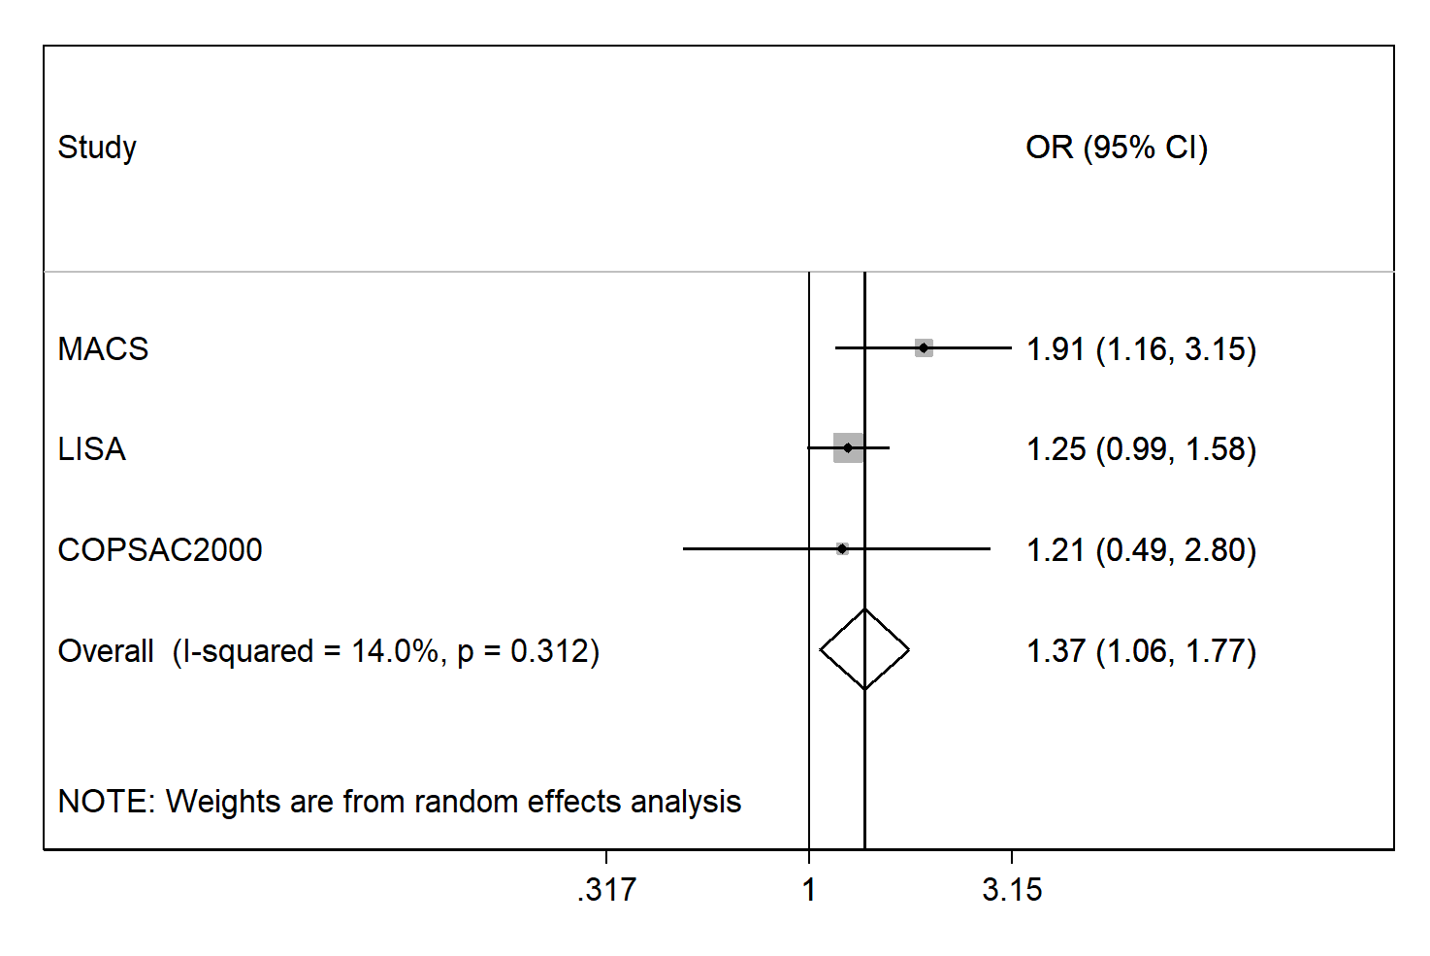
Figure 1. Forest plot of associations between being born during grass pollen seasons and cord blood IgE (≥ 0.5 kU/L). Estimates are expressed as adjusted odds ratios (ORs) and 95% confidence intervals (CIs; pooled using a random-effects meta-analysis).

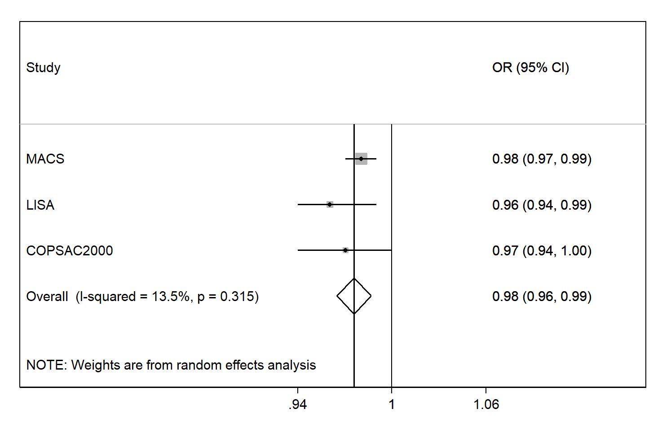
Figure 2. Forest plot of associations between cumulative exposure to outdoor grass pollen in mothers during their entire pregnancy and cord blood IgE (≥ 0.5 kU/L). Estimates are expressed as adjusted odds ratios (ORs) and 95% confidence intervals (CIs; pooled using a random-effects meta-analysis).

As a sensitivity analysis, we redid the meta-analysis using only the MACS and COPSAC₂₀₀₀ cohorts as both were high risk. We also redid the analysis only including mothers with a history of allergic disease in LISA. Results remained the same but became slightly stronger (Supplementary Figure 1, 2, 3 and 4).

DISCUSSION
This is the first study of three birth cohorts from three different countries (Australia and two in Europe) to show evidence of a pooled association between birth in grass pollen seasons and high cord blood IgE, with no evidence of heterogeneity between studies. Birth during the first month of the high grass pollen season seemed important for MACS and LISA. In Australia, cord blood IgE was higher in infants born in October (Southern spring). In Denmark and Germany cord blood IgE appeared to be higher in those born around April respectively. The estimated effect sizes were stronger in MACS, but the trends and significance level were consistent with LISA. COPSAC₂₀₀₀ estimates also tended towards the same direction but not significant. Although birth in the entire pollen season was not significant, levels for individual months seemed to be significant. However, this needs to be interpreted with caution as power is much lower to detect associations and less reliable than the data sets as a whole.

There was some evidence that cumulative outdoor grass pollen exposure in mothers during their entire pregnancy maybe protective, but this was borderline significant in a pooled meta-analysis. It is possible that the third trimester could be the development of a sensitisation barrier to other environmental factors (sensitisation hypothesis). However, this is not the case when they are born during the high grass pollen seasons. This possible inverse effect indicates that season is independent of grass pollen suggesting exposure to other environmental factors may be important. It is also possible that infants born at the start of spring would have been carried through winter, and low maternal vitamin D was influencing the estimated effects. We do not have maternal vitamin D measurements to test this directly.

It is also possible that we are observing an effect of pollen exposure on sensitised mothers resulting in increased IgE at the start of the pollen season. As the season progresses, the immune response may lessen. Any possibility that there is a higher effect in MACS could be attributed to more pollen sensitised mothers, due to the location and sampling frame. Maternal pollen sensitization was not available in MACS. In the MACS analysis, birth in December (usually the last month of the pollen season) also had increased odds of >1 kU/L which could partly be explained by the high pollen load in December during the study period (3 to 4 times the total pollen load occurred in December compared to November in 1992 and 1993).

No studies to date have investigated the association between birth during any pollen season and cord blood IgE level. Therefore, we compared our results with two previous studies that examined the distribution of high cord blood IgE level only in each month of birth with no data on pollen concentrations. A study of 1,652 children in Sweden reported that children born in grass pollen season, around June to August, had a slightly higher cord blood IgE levels, but this association was not significant (OR 1.03, 95%CI: 0.74, 1.45).²⁹ Another study of 5,353 children in Belgium showed that children born in grass pollen season, mid-May to mid-July, had higher odds of high cord blood IgE levels compared to children born in the rest of the year, although not significant (OR 1.21, 95%CI: 0.88, 1.66).²⁴ These results are consistent with another study finding from LISA cohort on impact of prenatal exposure to indoor allergens derived from mites and cats.¹⁶ Increased maternal exposure to these indoor allergens during pregnancy showed increased odds for elevated total IgE in cord blood of offsprings. However, high pollen loads in the outdoor environment during pregnancy in this multicenter study were associated with lower cord blood IgE in both the Australian and the German cohorts but these were not significant in a pooled meta-analysis of cohorts.

There are several strengths in our analysis. First, we included cord blood IgE data from three birth cohorts in both hemispheres to investigate the consistency of the role of birth during a pollen season and high pollen loads in the outdoor environment in utero. Second, all three cohorts used the same assay manufactured by Pharmacia which increased the reliability of the cord blood IgE measurement although COPSAC used a more sensitive assay with a different cutoff for IgA. We used the same levels for IgE categorization. Third, we removed suspected contaminated samples from our analysis, so our results were specific for fetal IgE and minimized the possibility of maternal IgE contaminated cord blood.

Some limitations also need to be considered in interpreting our results. MACS and COPSAC₂₀₀₀ recruited high-risk children (defined as having at least one family member with asthma and/or allergies), while LISA was a general population sample, it may not be representative and hence, generalisability may be limited. We did however conduct additional analysis by adjusting for maternal education and found that this adjustment did not substantially change the observed associations. Although there were different dominant pollens in each birth cohort, grass was still considered an important species in each country. However, we still cannot exclude overlapping of other aeroallergens in the atmosphere (such as other pollens) which may be different across the study settings and therefore may play a role. Only MACS and LISA had pollen measurements for the entire year of birth, so children from COPSAC₂₀₀₀ born outside of the pollen seasons did not contribute to the findings. In addition, we acknowledge the complexity in defining the pollen exposure, especially during the mother’s entire pregnancy and interpreting these effects and birth during months where pollen peaked was somewhat challenging.

Although the cut points used for IgE levels are somewhat arbitrary the aim was to be consistent with other published studies assessing risk and cord blood IgE. We did not have other data on maternal environment, such as level of vitamin D during pregnancy, that might have affected cord blood IgE levels.³⁰ While we have adjusted for a range of factors associated with cord IgE level, we cannot exclude the possibility of residual confounding, particularly by environmental exposures that vary across seasons, such as pollution. In MACS and COPSAC₂₀₀₀ we did not have data on the time women spent indoors or outdoors during their pregnancy. Although some of the centers participating in the LISA cohort did collect some of this data it is incomplete and therefore adjustments for time spent outdoor could not be performed. The low sampling proportions from each cohort with available data on cord blood IgE makes our study vulnerable to sampling bias. However, there was little difference in characteristics between participants with/without cord blood data from each cohort.

In summary, this is the first analysis of three birth cohorts from both hemispheres to show that a pooled effect of birth during high grass pollen seasons were associated with increased risk of high cord blood IgE. On the other hand, exposure to high pollen loads in women during their entire pregnancy seemed protective Although the link between cord blood IgE and subsequent allergic respiratory diseases is still unproven, IgE responses develop during the first months of life. Therefore, our study findings provide new insights into the mechanisms of exposure during the first year of life and possible subsequent allergic respiratory diseases.

Funding
The first 6 years of the MACS was funded (study formula and staff) by Nestec Ltd, a subsidiary of Nestlé Australia. The 12-year follow-up was funded by a project grant from the Asthma Foundation of Victoria. The National Health and Medical Research Council of Australia funded the 18-year (APP454856), and current 25-year (APP1079668) follow-up study. All bodies that have funded aspects of the MACS have had no role in interpretation or publication of study findings.

The COPSAC birth cohort is sponsored by the following funds: the Pharmacy Foundation of 1991; the Lundbeck Foundation; Ronald McDonald House Charities; the Danish Medical Research Council; Direktør, K. Gad Andersen og Hustrus Familiefond; Aage Bangs Fond; Danish Lung Association; Kai Lange og Gunhild Kai Langes Fond; Direktør, Ib Henriksens Fond; Gerda og Aage Hensch’s Fond; Rosalie Petersens Fond; Hans og Nora Buchards Fond; Dagmar Marshalls Fond; Foundation of Queen Louise’s Children Hospital; the Danish Hospital Foundation for Medical Research, Region of Copenhagen, the Faroe Island, and Greenland; Gangsted Fond; Højmosegård-Legatet; Fonden til Lægevidenskabens Fremme. A. P. Møller og Hustru Chastine Mc-Kinney Møllers Fond til almene Formaal; and the Danish Ministry of the Interior and Health’s Research Centre for Environmental Health. The nested intervention study is sponsored by AstraZeneca. The analyses of specific IgE are sponsored by Pharmacia-Pfizer. The funding agencies did not have any role in design and conduct of the study; collection, management, and interpretation of the data; or preparation, review, or approval of the manuscript.

The LISA study was mainly supported by grants from the Federal Ministry for Education, Science, Research and Technology and in addition from Helmholtz Zentrum Munich (former GSF), Helmholtz Centre for Environmental Research - UFZ, Leipzig, Research Institute at Marien-Hospital Wesel, Pediatric Practice, Bad Honnef for the first 2 years. The 4 year, 6 year, 10 year and 15 year follow-up examinations of the LISA study were covered from the respective budgets of the involved partners (Helmholtz Zentrum Munich (former GSF), Helmholtz Centre for Environmental Research - UFZ, Leipzig, Research Institute at Marien-Hospital Wesel, Pediatric Practice, Bad Honnef, IUF – Leibniz-Research Institute for Environmental Medicine at the University of Düsseldorf) and in addition by a grant from the Federal Ministry for Environment (IUF Düsseldorf, FKZ 20462296). Further, the 15 year follow-up examination of the LISA study was supported by the Commission of the European Communities, the 7th Framework Program: MeDALL project.

N.H.S. is supported by La Trobe University Postgraduate Research Scholarship (LTUPRS) and La Trobe University Full Fee Research Scholarship (LTUFFRS) from La Trobe University.

Acknowledgements
For MACS study, the authors thank Dr John Thorburn, FRACP, for assistance in patient recruitment and administrative assistance and the Mercy Maternity Hospital Department of Obstetrics for participant recruitment, and Dr Cliff Hosking for study leadership up to the 12-year follow-up. We thank Anne Balloch for assistance with data management. Most importantly, we thank all of the MACS children and parents for their participation and ongoing support for this study.

For COPSAC_{2000,} the authors thank the children and families of the COPSAC₂₀₀₀ cohort study for all their support and commitment. We acknowledge and appreciate the unique efforts of the COPSAC research.

For LISA study, the authors thank all the families for their participation in the LISA study. Furthermore, we thank all members of the LISA Study Group for their excellent work. The LISA Study group consists of the following: Helmholtz Zentrum München, German Research Center for Environmental Health, Institute of Epidemiology I, Munich (Heinrich J, Schnappinger M, Brüske I, Ferland M, Schulz H, Zeller C, Standl M, Thiering E, Tiesler C, Flexeder C); Department of Pediatrics, Municipal Hospital “St. Georg”, Leipzig (Borte M, Diez U, Dorn C, Braun E); Marien Hospital Wesel, Department of Pediatrics, Wesel (von Berg A, Berdel D, Stiers G, Maas B); Pediatric Practice, Bad Honnef (Schaaf B); Helmholtz Centre of Environmental Research – UFZ, Department of Environmental Immunology/Core Facility Studies, Leipzig (Lehmann I, Bauer M, Röder S, Schilde M, Nowak M, Herberth G , Müller J); Technical University Munich, Department of Pediatrics, Munich (Hoffmann U, Paschke M, Marra S); Clinical Research Group Molecular Dermatology, Department of Dermatology and Allergy, Technische Universität München (TUM), Munich (Ollert M, J. Grosch).

NHS is funded by La Trobe University and supported by Indonesia Research Partnership on Infectious Diseases (INA-RESPOND).

REFERENCES
1. Asher MI, Montefort S, Bjorksten B, Lai CK, Strachan DP, Weiland SK, et al. Worldwide time trends in the prevalence of symptoms of asthma, allergic rhinoconjunctivitis, and eczema in childhood: ISAAC Phases One and Three repeat multicountry cross-sectional surveys. Lancet 2006; 368:733-43.
2. Tariq, Arshad, Matthews, Hakim. Elevated cord serum IgE increases the risk of aeroallergen sensitization without increasing respiratory allergic symptoms in early childhood. Clinical and Experimental Allergy 1999; 29:1042-8.
3. Ferguson A, Dimich-Ward H, Becker A, Watson W, Dybuncio A, Carlsten C, et al. Elevated cord blood IgE is associated with recurrent wheeze and atopy at 7 yrs in a high risk cohort. Pediatric Allergy and Immunology 2009; 20:710-3.
4. Susanto NH, Vicendese D, Salim A, Lowe AJ, Dharmage SC, Tham R, et al. Effect of season of birth on cord blood IgE and IgE at birth: A systematic review and meta-analysis. Environ Res 2017; 157:198-205.
5. Camargo CA, Jr., Ingham T, Wickens K, Thadhani R, Silvers KM, Epton MJ, et al. Cord-blood 25-hydroxyvitamin D levels and risk of respiratory infection, wheezing, and asthma. Pediatrics 2011; 127:e180-7.
6. Watson PE, McDonald BW. Seasonal variation of nutrient intake in pregnancy: effects on infant measures and possible influence on diseases related to season of birth. Eur J Clin Nutr 2007; 61:1271-80.
7. Sullivan Dillie KT, Tisler CJ, Dasilva DF, Pappas TE, Roberg KA, Carlson-Dakes KT, et al. The influence of processing factors and non-atopy-related maternal and neonate characteristics on yield and cytokine responses of cord blood mononuclear cells. Clinical and Experimental Allergy 2008; 38:298-304.
8. Lowe AJ, Olsson D, Braback L, Forsberg B. Pollen exposure in pregnancy and infancy and risk of asthma hospitalisation - a register based cohort study. Allergy, Asthma and Clinical Immunology 2012; 8.
9. Kihlström A, Lilja G, Pershagen G, Hedlin G. Exposure to high doses of birch pollen during pregnancy, and risk of sensitization and atopic disease in the child. Allergy 2003; 58:871-7.
10. Erbas B, Lowe AJ, Lodge CJ, Matheson MC, Hosking CS, Hill DJ, et al. Persistent pollen exposure during infancy is associated with increased risk of subsequent childhood asthma and hayfever. Clin Exp Allergy 2013; 43:337-43.
11. Kemp A, Ponsonby AL, Dwyer T, Cochrane J, Pezic A, Carmichael A, et al. The interaction between early life upper respiratory tract infection and birth during the pollen season on rye-sensitized hay fever and ryegrass sensitization--a birth cohort study. Pediatr Allergy Immunol 2009; 20:536-44.
12. Holt PG, Jones CA. The development of the immune system during pregnancy and early life. Allergy 2000; 55:688-97.
13. Bisgaard H. The Copenhagen Prospective Study on Asthma in Childhood (COPSAC): design, rationale, and baseline data from a longitudinal birth cohort study. Ann Allergy Asthma Immunol 2004; 93:381-9.
14. Bisgaard H, Hermansen MN, Loland L, Halkjaer LB, Buchvald F. Intermittent inhaled corticosteroids in infants with episodic wheezing. N Engl J Med 2006; 354:1998-2005.
15. Bisgaard H, Hermansen MN, Buchvald F, Loland L, Halkjaer LB, Bonnelykke K, et al. Childhood asthma after bacterial colonization of the airway in neonates. N Engl J Med 2007; 357:1487-95.
16. Heinrich J, Bolte G, Holscher B, Douwes J, Lehmann I, Fahlbusch B, et al. Allergens and endotoxin on mothers' mattresses and total immunoglobulin E in cord blood of neonates. Eur Respir J 2002; 20:617-23.
17. Lowe AJ, Carlin JB, Bennett CM, Abramson MJ, Hosking CS, Hill DJ, et al. Atopic disease and breast-feeding--cause or consequence? J Allergy Clin Immunol 2006; 117:682-7.
18. Hirst JM. An automatic volumetric spore trap. Ann Appl Biol. 1952; 39:257–65.
19. Ownby DR, McCullough J, Johnson CC, Peterson EL. Evaluation of IgA measurements as a method for detecting maternal blood contamination of cord blood samples. Pediatr Allergy Immunol 1996; 7:125-9.
20. Bonnelykke K, Pipper CB, Bisgaard H. Transfer of maternal IgE can be a common cause of increased IgE levels in cord blood. Journal of Allergy and Clinical Immunology 2010; 126:657-63.

21. Kaan A, Dimich-Ward H, Manfreda J, Becker A, Watson W, Ferguson A, et al. Cord blood IgE: its determinants and prediction of development of asthma and other allergic disorders at 12 months. Ann Allergy Asthma Immunol 2000; 84:37-42.
22. Kerkhof M, Wijga A, Smit HA, De Jongste JC, Aalberse RC, Brunekreef B, et al. The effect of prenatal exposure on total IgE at birth and sensitization at twelve months and four years of age: The PIAMA study. Pediatric Allergy and Immunology 2005; 16:10-8.
23. Kuiper S, Muris JWM, Dompeling E, Van Schayck CP, Schonberger HJAM, Wesseling G, et al. Association between first-degree familial predisposition of asthma and atopy (total IgE) in newborns. Clinical and Experimental Allergy 2006; 36:594-601.
24. Sadeghnejad A, Karmaus W, Hasan Arshad S, Ewart S. IL13 gene polymorphism association with cord serum immunoglobulin E. Pediatric Allergy and Immunology 2007; 18:288-92.
25. Kimpen J, Callaert H, Embrechts P, Bosmans E. Cord blood IgE and month of birth. Arch Dis Child 1987; 62:478-82.
26. Sternthal MJ, Enlow MB, Cohen S, Canner MJ, Staudenmayer J, Tsang K, et al. Maternal interpersonal trauma and cord blood IgE levels in an inner-city cohort: A life-course perspective. Journal of Allergy and Clinical Immunology 2009; 124:954-60.
27. R: A language and environment for statistical computing. R Foundation for Statistical Computing, Vienna, Austria. Available from https://www.R-project.org/. (Accessed 10 January 2017).
28. Venables WN, Ripley BD. Modern Applied Statistics with S: Springer; 2002.
29. Croner S, Kjellman NI. Predictors of atopic disease: cord blood IgE and month of birth. Allergy 1986; 41:68-70.
30. Zittermann A, Dembinski J, Stehle P. Low vitamin D status is associated with low cord blood levels of the immunosuppressive cytokine interleukin-10. Pediatr Allergy Immunol 2004; 15:242-6.
Revised Supplementary Table 1. Crude effect of birth in grass pollen seasons and grass pollen exposure on cord blood total IgE
Cohort | Exposure | High IgE  (<0.5 kU/L as ref)  OR (95% CI) | p | Multinomial IgE (<0.5 kU/L as ref)
 |  |  |  | 0.5-1 kU/L  RRR (95% CI) | p | >1 kU/L  RRR (95% CI) | p
MACS | Born in grass pollen seasons | 1.68 (1.05, 2.70) | 0.03 | 1.04 (0.53, 2.06) | 0.91 | 2.48 (1.38, 4.48) | <0.01
 | Grass pollen month of birth  - Oct  - Nov  - Dec | 2.03 (1.07, 3.84)  1.12 (0.51, 2.47)  1.95 (0.89, 4.25) | 0.03  0.79  0.09 | 1.22 (0.48, 3.12)  0.67 (0.20, 2.32)  1.28 (0.42, 3.94) | 0.68  0.53  0.67 | 3.03 (1.41, 6.52)  1.67 (0.64, 4.35)  2.78 (1.09, 7.11) | <0.01  0.29  0.03
 | Total grass pollen during pregnancy | 0.99 (0.98, 1.00) | 0.06 | 1.00 (0.98, 1.02) | 0.94 | 0.98 (0.96, 0.99) | 0.01
LISA (n=1968) | Born in grass pollen seasons | 1.24 (0.99, 1.55) | 0.06 | 1.37 (1.01, 1.86) | 0.04 | 1.15 (0.86, 1.52) | 0.35
 | Grass pollen month birth  - April  - May  - June  - July | 1.52 (1.02, 2.26)  1.32 (0.89, 1.95)  1.16 (0.78, 1.72)  1.10 (0.79, 1.55) | 0.04  0.17  0.47  0.57 | 1.09 (0.58, 2.05)  1.69 (1.02, 2.81)  1.19 (0.68, 2.08)  1.44 (0.93, 2.23) | 0.80  0.04  0.54  0.10 | 1.84 (1.16, 2.93)  1.04 (0.61, 1.77)  1.13 (0.69, 1.86)  0.85 (0.53, 1.36) | 0.01  0.88  0.63  0.49
 | Total grass pollen during pregnancy | 0.96 (0.94,0.99) | <0.01 | 0.96 (0.93, 0.99) | 0.01 | 0.97 (0.94, 1.00) | 0.03
COPSAC₂₀₀₀ | Born in grass pollen seasons | 1.12 (0.46, 2.50) | 0.80 | 1.18 (0.32, 3.30) | 0.78 | 1.07 (0.33, 2.91) | 0.90
 | Grass pollen month birth  - March  - April  - May  - June  - July  - August | 0.51 (0.03, 3.00)  2.31 (0.56, 8.47)  0.95 (0.25, 2.92)  1.27 (0.38, 3.68)  1.35 (0.19, 6.38)  0.65 (0.18, 1.91) | 0.53  0.21  0.94  0.68  0.73  0.47 | N/A  2.57 (0.35, 12.8)  1.06 (0.15, 4.59)  1.13 (0.16, 4.90)  N/A  0.72 (0.11, 3.03) | 0.28  0.95  0.89  0.69 | 0.92 (0.05, 5.76)  2.10 (0.29, 10.1)  0.87 (0.13, 3.62)  1.38 (0.29, 5.04)  2.45 (0.33, 12.3)  0.59 (0.09, 2.39) | 0.94  0.39  0.86  0.65  0.31  0.51
 | Total grass pollen during pregnancy | 0.97 (0.94, 1.01) | 0.411 | 0.97 (0.93, 1.02) | 0.25 | 0.97 (0.94, 1.02) | 0.21
LISA is adjusted for study center as it is a multi-center study (Munich, Wesel, Leipzig, and Bad Honnef).

Supplementary Table 2. Crude and adjusted effects of birth in the pollen seasons and grass pollen exposure during pregnancy on cord blood total IgE in LISA infants whose mother had a history of allergic disease
 | Exposure | High IgE  (<0.5 kU/L as ref)  OR (95% CI) | p | Multinomial IgE (<0.5 kU/L as ref)
 |  |  |  | 0.5-1 kU/L  RRR (95% CI) | p | >1 kU/L  RRR (95% CI) | p
Crude (n=653) | Born in pollen seasons | 1.12 (0.78, 1.61) | 0.55 | 0.86 (0.51, 1.45) | 0.57 | 1.36 (0.87, 2.13) | 0.18
 | Grass pollen month birth  - April  - May  - June  - July | 1.49 (0.81, 2.74)  0.84 (0.43, 1.66)  1.11 (0.57, 2.13)  1.10 (0.63, 1.91) | 0.20  0.62  0.76  0.74 | 0.34 (0.08, 1.48)  0.73 (0.28, 1.96)  0.83 (0.31, 2.22)  1.27 (0.63, 2.56) | 0.15  0.54  0.71  0.50 | 2.53 (1.31, 4.31)  0.93 (0.40, 2.20)  1.36 (0.62, 2.98)  0.93 (0.43, 2.00) | 0.01  0.88  0.45  0.85
 | Total grass pollen during pregnancy | 0.96 (0.93, 1.00) | 0.06 | 0.99 (0.94, 1.05) | 0.72 | 0.95 (0.90, 0.99) | 0.02
Adjusted (n=615) | Born in pollen seasons | 1.21 (0.83, 1.75) | 0.33 | 0.86 (0.50, 1.48) | 0.59 | 1.56 (0.87, 1.59) | 0.29
 | Grass pollen month birth  - April  - May  - June  - July | 1.94 (1.03, 3.68)  0.84 (0.41, 1.72)  1.16 (0.6, 2.25)  1.12 (0.64, 1.98) | 0.04  0.64  0.66  0.70 | 0.42 (0.10, 1.82)  0.59 (0.20, 1.75)  0.82 (0.31, 2.22)  1.31 (0.64, 2.66) | 0.24  0.34  0.70  0.46 | 3.62 (1.79, 7.31)  1.09 (0.46, 2.61)  1.54 (0.69, 2.43)  0.91 (0.40, 2.05) | <0.01  0.84  0.29  0.81
 | Total grass pollen during pregnancy | 0.95 (0.92, 0.99) | 0.01 | 0.99 (0.93, 1.05) | 0.68 | 0.92 (0.88, 0.97) | <0.01
LISA is adjusted for study center as it is a multi-center study (Munich, Wesel, Leipzig, and Bad Honnef) for crude effect. Adjusted for mother’s age, mother’s history of smoking in pregnancy, mother’s education, and study centers in LISA. In LISA models, study center was adjusted as a covariate as mixed effects models showed no difference in estimated effect sizes or p values for adjusted effect.

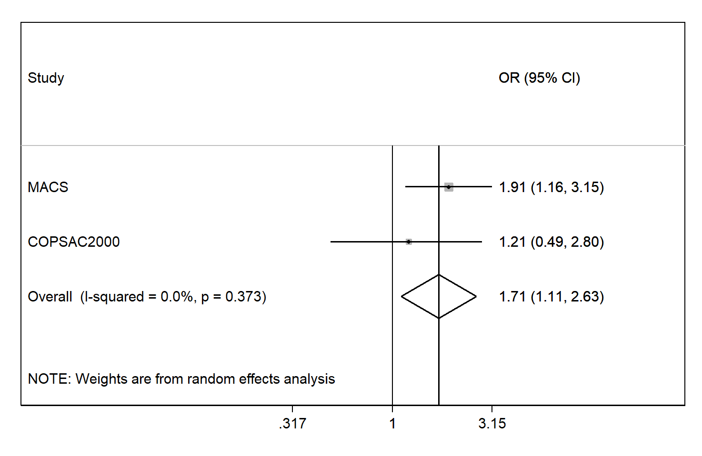
Supplementary Figure 1. Forest plot of born in pollen season effect on cord blood IgE (MACS and COPSAC₂₀₀₀ only)

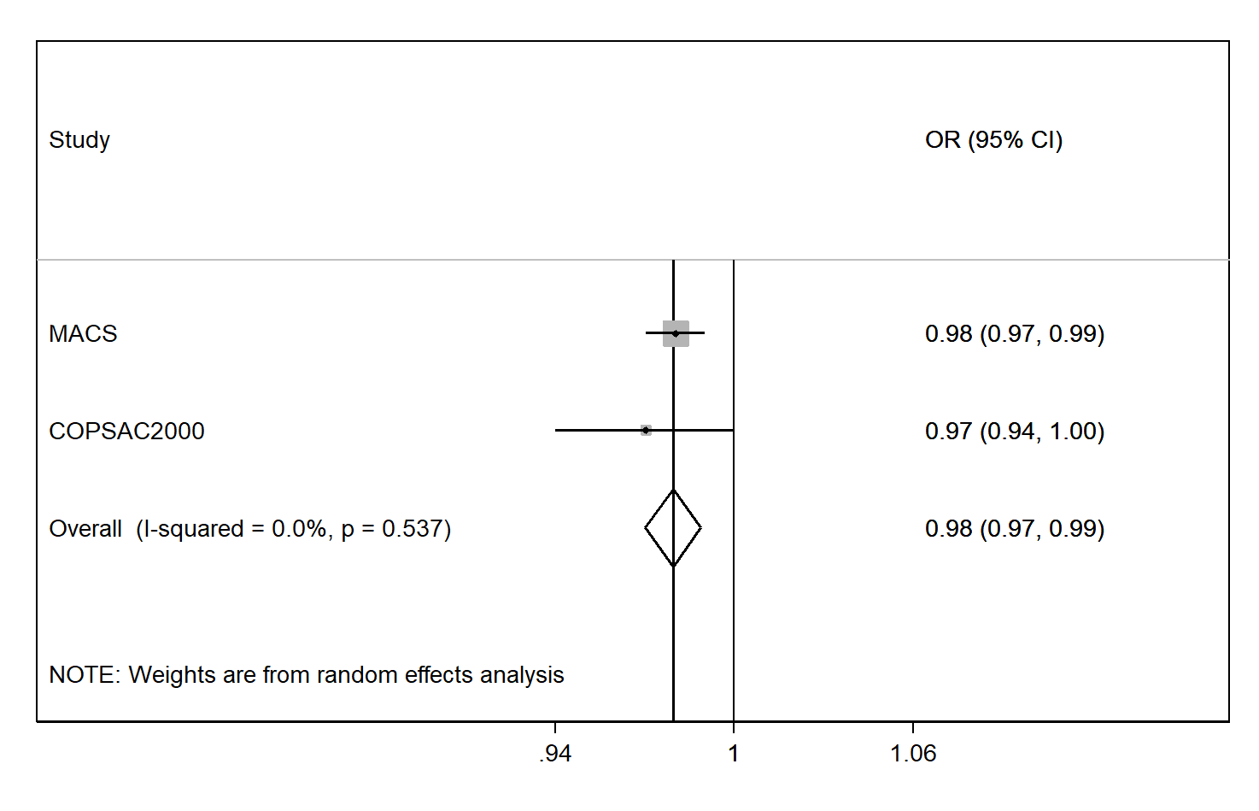
Supplementary Figure 2. Forest plot of pollen exposure during pregnancy effect on cord blood IgE (MACS and COPSAC₂₀₀₀ only)

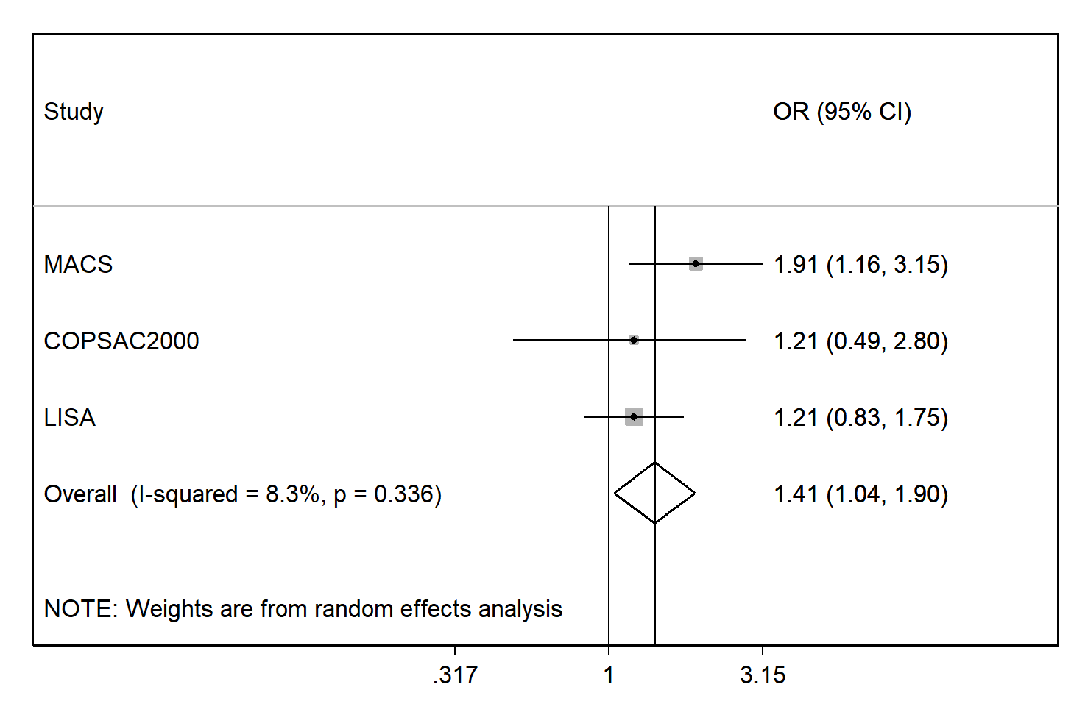
Supplementary Figure 3. Forest plot of born in pollen season effect on cord blood IgE (LISA only included mother with allergy history)

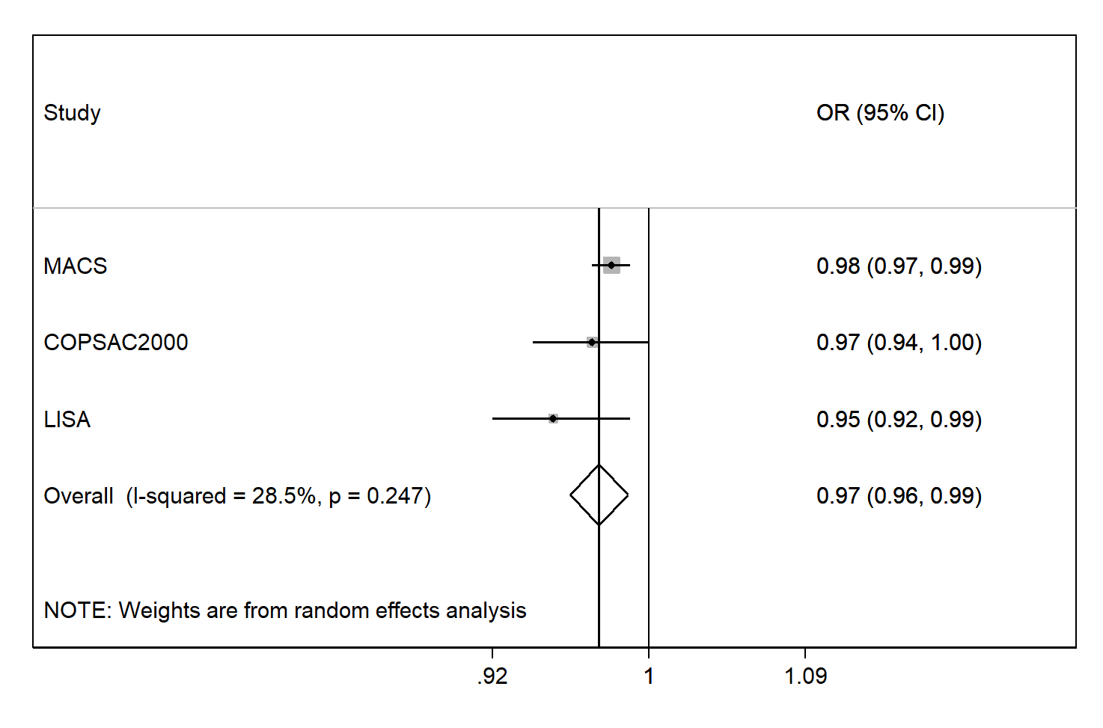
Supplementary Figure 4. Forest plot of pollen exposure during pregnancy effect on cord blood IgE (LISA only included mother with history allergy)

