Short-term Effects of Fine Particulate Air Pollution on Cardiovascular Hospital Emergency Room Visits: A Time-series Study in Beijing, China

Chang Su,2*, Susanne Breitner1, Alexandra Schneider1, Liqun Liu2, Ulrich Franck3,
Annette Peters1 and Xiaochuan Pan
- Helmholtz Zentrum München - German Research Center for Environmental Health, Institute of Epidemiology II, Neuherberg, Germany
- Peking University Health Science Center, School of Public Health, Beijing, China
- Helmholtz Centre for Environmental Research – UFZ, Core Facility Studies, Leipzig, Germany

Correspondence
Chang Su
Helmholtz Zentrum München - German Research Center for Environmental Health,
Institute of Epidemiology II
Ingolstädter Landstraße 1, 85764 Neuherberg, Germany.
Tel.: +49 89 3187 4563
Fax: +49 89 3187 3380
E-mail: chang.su@helmholtz-muenchen.de
Abstract:
Background: The link between particulate matter (PM) and cardiovascular morbidity has been investigated in numerous studies. Less evidence exists, however, about how age, gender and season may modify this relationship. The aim of this study was to evaluate the association between ambient PM_{2.5} (PM ≤ 2.5 µm) and daily hospital emergency room visits (ERV) for cardiovascular diseases in Beijing, China. Moreover, potential effect modification by age, gender, season, air mass origin and the specific period with 2008 Beijing Olympic were investigated. Finally, the temporal lag structure of PM_{2.5} has also been explored.
Methods: Daily counts of cardiovascular ERV were obtained from the Peking University Third Hospital from January 2007 to December 2008. Concurrently, data on PM_{2.5}, PM₁₀ (PM ≤ 10 µm), nitrogen dioxide and sulfur dioxide concentrations were obtained from monitoring networks and a fixed monitoring station. Poisson regression models adjusting for confounders were used to estimate immediate, delayed and cumulative air pollution effects. The temporal lag structure was also estimated using polynomial distributed lag (PDL) models. We calculated the relative risk (RR) for overall cardiovascular disease ERV as well as for specific causes of disease; and also investigated the potential modifying effect of age, gender, season, air mass origin and the period with 2008 Beijing Olympics.
Results: We observed adverse effects of PM_{2.5} on cardiovascular ERV - an IQR increase (68 μg/m³) in PM_{2.5} was associated with an overall RR of 1.022 (95% CI: 0.990-1.057) obtained from PDL model. Strongest effects of PM_{2.5} on cardiovascular ERV were found for a lag of seven days; the respective estimate was 1.012 (95%CI: 1.002-1.022). The effects were more pronounced in females and in spring. Arrhythmia and cerebrovascular diseases showed a stronger association with PM_{2.5}. We also found stronger PM-effects for stagnant and southern air masses and the period of Olympics modified the air pollution effects.
Conclusions: We observed a rather delayed effect of PM_{2.5} on cardiovascular ERV, which was modified by gender and season. Our findings provide new evidence about effect modifications and may have implications to improve policy making for particulate air pollution standards in Beijing, China.

Key words: emergency room visits; fine particulate matter; cardiovascular diseases; time-series study; polynomial distributed model; 2008 Olympics
- Introduction
In recent years, numerous epidemiologic studies have provided evidence for a link between ambient air pollution and cardiovascular morbidity and mortality . There have also been a number of studies focusing on short-term effects of particulate matter (PM) on emergency room visit (ERV) . These studies indicated that elevated concentrations of PM increase the risk of ERV due to cardiovascular diseases (CVD).
In 2014, Atkinson et al. published a large review of more than 100 peer-reviewed studies investigating adverse effects of PM_{2.5} on mortality and hospital admissions, including CVD . However, there were not many Asian studies, which could be included. On the other hand, the air quality in Beijing is quite concerning. According to a WHO database (http://www.who.int/phe/healthtopics/outdoorair/databases/cities/en/), recent annual mean levels of PM₁₀ (PM with an aerodynamic diameter ≤ 10µm) and PM_{2.5} (PM with an aerodynamic diameter ≤ 2.5µm) were much higher in Beijing compared to other Chinese cities, including even some industrialized cities such as Shenyang, Harbin, Guangzhou, etc. Compared to Western countries, PM concentrations in Beijing are about three times higher than in Europe . Therefore, the demand to investigate the health effects of PM seems more urgent.
One of the important gaps in our current knowledge is a better understanding of who is most susceptible to PM and what would modify the PM-effect - this will be helpful in public health regulations and environmental public policy . Some previous studies have found effect modification of PM-related health effects by, for example, age , gender , pre-existing disease and socioeconomic class . However, evidence remains inconclusive, as there are also studies which have not found a modifying effect of these factors , or, for example, only weak evidence of a modification by race . Beijing has four clear seasons with hot, humid summers and generally cold, windy, dry winters. Moreover, the spring season is short and dry accompanied by rapid warming; autumn is also short with a rapid cooling. A prior study showed that the highest frequency of sandstorms occurrence and their duration mainly occurred in spring . This makes season another interesting potential modifier for our PM-effects to explore. It is well known that air pollution variations in Beijing are partially influenced by wind directions. Especially with prevailing wind from the north to south, air quality is getting much better. To ascertain the effect modification by air mass origin would do great help in public health.
In the urban area of Beijing, Guo et al. conducted a study using a case-crossover approach to examine the relationship between PM_{2.5} and cardiovascular ERV from June, 2004 to December, 2006. In Beijing, as the host of 2008 summer Olympic Games (8th-24th of August 2008) and Paralympic Games (6th -17th of September 2008), air quality was a serious concern for the Chinese government. To ensure a good enough ambient air quality, some main air pollution control policies were taken from 1st July to 20th September 2008, e.g. a total of 400,000 yellow-labeled vehicles were not allowed on road, and the odd-even alternative day off rule was applied . Such unprecedented measures to reduce the sources of air pollution offered a unique research opportunity to investigate whether the specific Olympic period modified the PM-effect. Moreover, some air quality measures were already started from 2007 on. Compared to 2004-2006, for example, stricter emission standards were adopted. Therefore, many factories, especially those using much coal, were closed down or relocated to other provinces . Moreover, new and stringent vehicle emission standards were adopted, and access to public transportation was improved. Thus, annual mean concentrations of major air pollutants decreased during 2007 to 2008 (See Appendix, Figure A1), which makes a follow-up analysis scientifically interesting and useful for Chinese policies. We applied a time-series analysis to investigate the effects of short-term exposure to PM_{2.5} as well as PM₁₀ , nitrogen dioxide (NO₂) and sulfur dioxide (SO₂) on cause-specific cardiovascular ERV events from January 2007 to December 2008, using different approaches (single lag models, models using multi-day averages and polynomial distributed lags (PDL)). Furthermore, susceptible population identification and other interesting potential effect modifiers were investigated with a main focus on PM_{2.5}. Finally, the temporal lag structure of PM_{2.5} has also been explored in this study.

- Material and methods
2.1 Study area and period
We conducted the study in the Haidian district of Beijing, China, from 1 Jan 2007 to 31 Dec 2008 (731days). The Haidian district is located in the northwestern part of Beijing, with an area of 431 km² and 2.039.000 registered residents in 2007 (Figure 1).
2.2 Emergency room visits data
The medical records were collected between January 1, 2007, and December 31, 2008, from the Peking University Third Hospital, located in the northwestern part of Beijing in the Haidian district (Figure 1). A standardized form was completed by medically trained study personnel at Peking University, School of Public Health, abstracting the data from the medical records. A database was built based on these files, and the clinical endpoints were coded using the ICD-10 codes (International Classification of Disease and Related Health Problem 10th version) of the diseases.
To assure good data quality, about 20% of the ERV information was double entered; the identity of the numeric content between the two entries was higher than 90%. Assignments of the diagnoses to ICD-10 disease categories were quality assured by a nosological expert from the third Hospital. This was already done in the previous study from 2004 to 2006 and proved good assignment quality (the percentage of misclassification was about 4%).
The total cases of daily ERV were classified into: cardiovascular diseases (ICD10: I00～I99), hypertension (ICD10: I10～I15), ischemic heart disease (ICD10: I20～I25), cardiac arrhythmia (ICD10: I47～I49), congestive heart failure (ICD10: I50), and cerebrovascular disease (ICD10: I60～I69). We also divided the overall cardiovascular ERV cases into different gender (male and female) and age groups (Age<45yrs.; 45yrs.≤Age<75yrs.; Age≥75yrs.). Based on the location of permanent residences, only patients from the Haidian district were considered for our analysis to better match exposure measurements and intended health outcomes.
2.3 Meteorological and air pollution data
Meteorological data including daily mean temperature, relative humidity and barometric pressure were obtained from two sources. One was the regular monitoring data from the Institute of Atmospheric Physics (IAP), Chinese Academy of Science (Figure 1). The station is located approximately 2 km away from the Peking University Third Hospital. Other data was collected from the China Meteorological Data Sharing Service System (World Meteorological Organization [WMO]) station 54511, located at N39°48´ E116°28´ in the southeastern part of Beijing; see Figure 1). Data from the two sources were highly correlated; the Pearson correlation coefficients were 0.998 and 0.971 for daily temperature and relative humidity, respectively. As the data obtained from IAP were incomplete, we used data from the WMO station for the analyses.
Data on the gaseous air pollutants SO₂ and NO₂ as well as data on PM₁₀ for the period January 2007 to December 2008 were collected from the Beijing Municipal Environmental Monitoring Center’s network. It includes eight fixed monitoring sites, which are distributed in the urban area of Beijing (see Figure 1). The locations of these monitoring stations are considered not to be in the direct vicinity of traffic or industrial sources, not to be influenced by local pollution sources, and to avoid buildings, housing, and large emitters such as coal-, waste-, or oil-burning boilers, furnaces, and incinerators . We used daily average concentrations from these eight monitoring sites. If air pollutant concentrations were missing from one station on a given day, the average concentration was calculated using the values from the remaining monitors. Since data on PM_{2.5} was not available from the network, the concentration of PM_{2.5} was measured by a TEOM(R) RP1400A air sampler (TEOM, model 1400A, Rupprecht and Patashnick; Thermo Electron, East Greenbush, NY). The sampler was also located in the Haidian district (see Figure 1), 7 km away from Peking University’s Third Hospital. For PM_{2.5}, hourly values were recorded, and we calculated daily average concentrations of PM_{2.5} for analyses when at least 75% of the hourly data was available. There were no missing values for the daily averages of PM_{2.5.}
Data on the air mass history was obtained using the Hybrid Single-Particle Lagrangian Integrated Trajectory model (version 4.8, http://ready.arl.noaa.gov/HYSPLIT.php). Back-trajectories with a length of 72 hours were used to determine the origin of air masses. A total of 730 daily trajectories were obtained between January 1, 2007, and December 31, 2008. Cluster analysis was applied to the trajectories, which resulted in four clusters (see Appendix, Figure A3). Cluster 1 consists of trajectories mostly coming from the northwest of Beijing, but originating from China and Mongolia. Cluster 2 represents air mass coming from the areas surrounding Beijing with low wind speed. Cluster 3 consists of air masses mainly coming from the northwest, but with much higher wind speed than in cluster 1. Cluster 4 represents air mass coming from the north to northwest, stretching to the north of Mongolia and Central Siberia.
2.4 Statistical analysis
We applied a time-series analysis approach using generalized additive Poisson regression models to estimate the associations between air pollutants and cardiovascular ERV.
First of all, a confounder model was built without including any air pollutants. To control for systematic variation over time, we introduced a time trend as well as dummy variables for day of the week (DOW) and public holidays. For long-term trend, we used a penalized spline of date order. The minimization of the absolute value of the sum of the partial autocorrelation function (PACF) of the model’s residuals up to 30 lags was used to guide the selection of degrees of freedom (DF) . Besides, we used penalized splines for the meteorological parameters: air temperature, barometric pressure, and relative humidity. The DFs of meteorological parameters were chosen based on the minimization of Generalized Cross Validation (GCV) criterion. Furthermore, at the beginning of November, the heating system in Beijing was turned on, so the heating period was another factor we considered as a potential confounder. To ensure sufficient adjustment for long-term trend and meteorological effects, we forced time trend and same-day air temperature as well as relative humidity into all models; however, the other potential confounders were only introduced into the model if they improved the model fit by minimizing the GCV criterion . In the final confounder model, we re-adjusted the number of DF for the smooth function of time trend also by the minimization of PACF, since many of the meteorological variables exhibit seasonal patterns themselves and hence capture part of the observed seasonal trends in the outcome .
In the next step of the analysis, we added air pollutants separately to single lag models and estimated acute and delayed associations linearly. We analyzed single-day lags of the same day (lag0) and previous fourteen days (lag1-lag14). We also estimated cumulative effects models by including 8-day moving averages (lag0-lag7) of air pollutants into the model. PDL models were used to investigate the temporal lag structure of PM_{2.5} on daily cardiovascular ERV counts. We constrained the lag coefficients in PDL models to follow a third-degree polynomial. Since null associations between PM_{2.5} and cardiovascular ERV were detected in the single lag models ten days after exposure, we used a maximum lag time of ten days in the PDL models.
Multi-pollutants models were applied to examine the independent effects of PM_{2.5}; these analysis were only conducted when the pollutants’ inter-correlation was < 0.6 to avoid collinearity .
Moreover, we investigated the association between air pollutants and cardiovascular ERV in different gender (male and female) and age groups (Age<45yrs.; 45yrs.≤Age<75yrs.; Age≥75yrs.) as well as for specific causes of disease. Further, we used an interaction term approach to investigate whether there was modification of the PM effects by different seasons (Spring: April 3rd-May 25th; Summer: May 26th-September 3rd; Fall: September 4th-October 24th; Winter: October 25th-April 2nd). Additionally, the modification by air mass origin was also investigated. In our analysis, we defined a category variable for the four described air mass clusters. An interaction term was added to the models in order to estimate PM-effects of the corresponding clusters. We used a likelihood ratio test to determine whether there were indeed differences between the four clusters. Finally, air pollution effects were estimated for two periods - Olympic period (August 8 to September 17, 2008, including Olympic Games and Paralympic Games) and non-Olympics period (January 1, 2007 to December 31, 2008, excluding Olympics period) - by use of two dummy variables and corresponding interaction terms in the models.
Data were analyzed using the package “mgcv” version 1.6-2 in the statistical software R version 2.12.0 (R Development Core Team, 2010).
2.5 Sensitivity analysis
In our analyses, we performed several sensitivity analyses to explore the robustness of the models. Sensitivity analyses used different degrees of smoothness for the time trend function or used apparent temperature instead of air temperature and relative humidity. We added 2-day average air temperature (representing the effect of higher temperatures) and 15-day average air temperature (representing the effect of colder temperatures) to the model at the same time. Further analyses were done replacing the linear term of PM concentrations with a fixed 3-df regression spline to check the exposure-response functions for deviations from linearity. Also, a different number of lags in the PDL models were used to explore the shapes of polynomial distributed lag curves.
- Results
3.1 Descriptive results
Descriptive statistics of cardiovascular ERV, air pollutants, and meteorological data are provided in Table 1. In total, there were 10,948 cases of cardiovascular ERV during the study period from January 1, 2007, to December 31, 2008; the daily average count was 15. Females corresponded to 54.8% of the cases and arrhythmia (40.9%) and hypertension (26.0%) were the two major causes of cardiovascular ERV; the middle age group (45yrs.≤Age<75 yrs.) accounted for around 57% of cases. The time-series of cardiovascular ERV showed a seasonal and weekly pattern with more cases during the cold season and on weekends ( see Appendix, Figure A2).
Daily average concentrations of SO₂, NO₂ and PM₁₀ were 42.2 μg/m³, 58.5 μg/m³ and 136.0 μg/m³ respectively. SO₂, NO₂ and PM₁₀ concentrations were lower than the 24-hour secondary National Ambient Air Quality Standards (NAAQS, GB 3095-2010) for urban areas in China corresponding to 150 μg/m³, 80 μg/m³ and 150 μg/m³ respectively. Daily average PM_{2.5} concentration amounted to 78.0μg/m³, which was slightly higher than the secondary standard in China (75 μg/m³), but much higher than the 24-hour ambient air quality standard in the United States (35 μg/m³, http://www.epa.gov/air/criteria.html). The meteorological parameters and air pollutants also followed seasonal patterns; the air pollutants showed a trend towards higher values during winter (data not shown).
PM_{2.5} was not or only slightly correlated with meteorological parameters and SO₂, and moderately correlated with NO₂, whereas PM_{2.5} and PM₁₀ were highly correlated with each other, the Spearman correlation coefficient was 0.77 (see Appendix, Table A1).
3.2 Regression results
Table 2 presents relative risks (RR) for overall cardiovascular ERV per an interquartile range (IQR) increase in air pollutants. Using a single lag model, the strongest association was found for a delay of seven days. In the PDL model, the overall effect on ERV associated with an IQR increase in PM_{2.5} was 1.022 (95% CI: 0.990-1.057); the respective estimate for lag 7 was 1.012 (95% CI: 1.002-1.022). For SO₂ and PM₁₀, we also found the strongest associations with a delay of seven days in both single lag and PDL models.
The analyses between PM_{2.5} and subgroups of cardiovascular ERV showed stronger associations with PM_{2.5} for females; effect estimates for women were all significant in the three presented models (Table 3). Further, the elderly (Age≥75years) showed a higher estimate; however, the middle age group (45yrs.≤Age<75 yrs.) also indicated a stronger association with PM_{2.5}. In the cause-specific analysis, cardiac arrhythmia and cerebrovascular diseases showed stronger associations with PM_{2.5} than the other disease groups. Similarly, PM₁₀ showed a stronger association with females and cardiac arrhythmia cases; estimates varied moderately with the three age groups (Table 4).
Table 5 shows the RR for cardiovascular ERV per IQR increment of air pollutants in different seasons. Stronger effects of PM_{2.5} were observed in spring and winter; especially in spring, the effect on ERV associated with an IQR increase in PM_{2.5} on lag 7 was 1.186 (95% CI: 1.130-1.244). All other air pollutants also showed strongest effects in spring.
The results of effect modification by air mass origin indicated that effects of air pollutants were stronger for stagnant and southern air masses (cluster 2), although the difference between the four clusters was not statistically significant. There was no effect modification by air mass origin in SO₂ and NO₂ (Figure 2).
Figure 3 shows the effects of air pollution in the Olympics period (August 8 to September 17, 2008) vs. the non-Olympics period. We observed increases in cardiovascular ERV in association with air pollution increases in the non-Olympics period while no effects were observed during the Olympics period. The differences were more pronounced for PM; the difference for PM_{2.5} was statistically significant.
Figure 4 shows the PDL curves of daily PM_{2.5} exposures and overall cardiovascular ERV as well as for different gender and age subgroups. Most of the curves showed a similar pattern. For overall ERV, women and all age groups, effect estimates increased at lags 5 to 8. Moreover, for females we observed an immediate (same-day) effect of PM_{2.5} on cardiovascular ERV. No statistically significant effects were observed for males. Regarding age, the youngest age group (Age<45yrs.) showed the strongest effects.
There were slight changes observed in the overall effect estimates for PM_{2.5}, while controlling for SO₂, NO₂ or both of them (Figure 5). The effect estimates of PM_{2.5} at lag 7 remained consistent in the multi-pollutant models. All exposure-response functions between air pollutants and cardiovascular ERV could be considered as linear (see Appendix, Figure A4).
3.3 Sensitivity analysis results
There were only slight changes in the risk for cardiovascular ERV when we performed our before mentioned sensitivity analyses, which indicated that the estimated effects were quite robust (Table 6).
- Discussion
In this study, we observed adverse effects of PM_{2.5} on cardiovascular ERV- an IQR increase (68 μg/m³) in PM_{2.5} was associated with an overall RR of 1.022 (95% CI: 0.990-1.057) in Beijing during a two-year period (2007-2008). Effect modification analyses showed that the association with PM_{2.5} was stronger for females than for males. Effect estimates varied only moderately by the three age groups (Age<45yrs.; 45yrs.≤Age<75yrs.; Age≥75yrs.). Regarding different causes of disease, stronger effects of PM_{2.5} were observed for arrhythmia and cerebrovascular diseases. Season, however, was a modifier of the association between PM_{2.5} and cardiovascular events: in spring, the association was much stronger. The results of effect modification by air mass origin indicated that effects of air pollutants were stronger for stagnant and southern air masses. Besides, we found that a reduction of the air pollution concentrations during the Olympics led to a reduction in the cardiovascular ERV. Furthermore, the strongest lagged effects of PM_{2.5} on daily cardiovascular ERV were observed with a delay of seven days.
Our findings of adverse effects of PM_{2.5} on cardiovascular ERV - an IQR increase (68 μg/m³) in PM_{2.5} was associated with an overall RR of 1.022 (95% CI: 0.990-1.057) - is in agreement with a previous study conducted in Beijing, where the association for a 10 μg/m³ increase in PM_{2.5} level was statistically significant with an odds ratio (OR) of 1.005 (95% CI: 1.001-1.009) . The results are also consistent with other previous studies reporting that PM_{2.5} was associated with short-term increases in cardiovascular morbidity . A recent meta-analysis of Atkinson et al. reported a summary excess for CVD hospital admissions of 0.90% (1.04% in WHO South East Asian Region) for an increment in PM_{2.5} of 10 μg/m³ . In summary, our effect estimate was slightly larger than the estimate in the previous study conducted in Beijing; however, smaller than those of studies in the U.S. or Europe.
Our study showed stronger associations of PM_{2.5} and ERV for females compared to males. This finding is in agreement with the observed effects of PM_{2.5} in a number of studies . Yorifuji et al. (2014), for example, also observed that women were at greater risk for both cardiovascular and cerebrovascular hospital emergency visits. The increased risk in females may be attributable to biological or exposure differences between men and women . For example, Kim and Hu (1998) examined the variability in the particle deposition between men and women under controlled breathing conditions and found that deposition in women was greater than in men. Besides, Sorensen et al. (2003) reported significant positive associations between personal PM_{2.5} exposure and oxidation products in females but not in males, which suggested that females might be more sensitive to airborne pollution. However, evidence is not consistent. In contrast, some other previous studies found that males were at higher risk for cardiovascular disease; for example, slightly stronger associations between PM and cardiovascular hospital admissions were observed among males than among females .
In our study, we observed that effects differed in the three age groups. Consistent with numerous previous studies , the oldest age group (age≥75) showed higher although not significant effect estimates. Elderly people are generally considered to be a susceptible population for PM-exposure not only because of the gradual decline in physiological processes over time but also due to possible preexisting cardiovascular diseases . Besides, in this study, we also observed effects for the middle age group (45yrs.≤Age<75yrs.). A previous study by Serinelli and colleagues on PM and coronary deaths found a strong effect in cases with age 65-74 years but no effect at age 75-84 years. In our study, one of the possible explanations for the significant effect estimates in the middle age group may be the biggest sample size, which would result in more statistical power; however, the magnitudes of the estimates in the oldest age group seemed to be higher.
Previous findings of the modifying effect of season have remained inconsistent. Some studies found evidence of stronger effects of PM in the cold season ; however, other studies observed stronger PM effects in the warm season . In our study, we found a stronger effect of PM_{2.5} in spring and winter. There may be some possible explanations: Beijing is impacted by regional and/or local soil dust, since northern China includes many deserts and arid loess-land . A prior study showed that the highest frequency of sandstorms occurrence and their duration mainly occurred in March, April and May, especially in April . Besides, much higher coal consumption coupled with meteorological conditions likely cause high PM_{2.5} concentrations during the cold season . In addition, as gaseous air pollutions also showed higher concentration levels in the cold season, it is possible that there might be some interactions between PM and gaseous air pollutants, which may be more harmful .
In the cause-specific analysis, we found that arrhythmias were strongly associated with PM_{2.5.} Arrhythmia, as a significant cause of mortality, has been associated with short-term as well as long-term exposure to air pollution . Consistent with our results, Santos et al. (2008) found that an IQR increase in PM was associated with an increase of 6.7% (95%CI: 1.2%-12.4%) in arrhythmia ERV . In an experimental study on rats, Kim and colleagues have observed a pro-arrhythmic effect of particles and hypothesized this could be mediated by oxidative stress and calcium calmodulin kinase II activation . Furthermore, our findings that PM_{2.5} had an association with cerebrovascular disease are in agreement with other previous studies. Dominici et al. (2006) conducted a U.S. study about the association between PM_{2.5} and hospital admissions and found evidence of positive associations between day-to-day variation in PM_{2.5} and hospital admissions for cerebrovascular disease .
In Beijing, air pollution variations were partially influenced by wind directions. Especially with prevailing wind from the north to south, air quality improved. In our analysis, the risks of PM on cardiovascular ERV were slightly higher for stagnant and surrounding air masses. However, the interaction term was not statistically significant. This is similar to a previous study also conducted in Beijing which found that the effects of accumulation mode particles (0.1-0.8μm) were elevated for stagnant and southern air masses .
The study period incorporated the time of the Olympic Games and Paralympic Games, during which air pollution was significantly lower due to regulation . Several studies have been evaluating the air quality improvement measures taken for the Beijing Olympics . For example, Rich et al. (2012) indicated that changes in air pollution levels during the Beijing Olympics were associated with acute changes in biomarkers of inflammation and thrombosis. Similar results were reported regarding biomarkers of pulmonary and systemic inflammation . However, few studies were related to cardiovascular ERV. In our study, we estimated air pollution effects for two periods: Olympics period (August 8 to September 17, 2008, including Olympic Games and Paralympic Games) vs. non-Olympics period. We found that a reduction of the air pollution concentrations during the Olympics (when strongest reduction measures had bee applied) led to a reduction in the cardiovascular ERV. We can only speculate that even short air pollution reduction measures can quickly lead to health benefits.
According to Zanobetti , different patterns of lagged effects for different disease outcomes may provide insight into different biological mechanisms of acute responses to particulate matter air pollution. In this study, PM_{2.5} exhibited similarly lagged pattern on overall cardiovascular ERV as well as in different sub-groups. In most of the polynomial distributed lag curves, strongest associations of PM_{2.5} with cardiovascular ERV were found for a 5-day to 8-day delay, although there was an acute effect for one day or two days delay. Previous studies have reported different lag structures for the effects of air pollutants on cardiovascular mortality or morbidity . In contrast to our finding, most of them reported that cardiovascular effects due to PM were found to be more acute with adverse responses on the same day or within a few days . In our case, we can only speculate on a possible explanation for this: under the background of generally high concentrations of ambient particulate matter in Beijing, it may occur that the human body would get less sensitive to high levels of particulate matter. So after exposure, at first people may only have a few weak symptoms that aggravate over the following days to become serious enough to seek for emergency treatment with a delay of several days . Another possible explanation for the delayed patterns we observed would be a different composition of specific cardiovascular diseases. For example, ischemic heart diseases (IHD) tended to show immediate response and the proportion of IHD in this study seems to be lower than in previous studies.
Strengths and Limitations
We conducted this study in the urban area of Beijing. The daily ERV count reached 15, ensuring enough statistical power for our analysis. Besides, the data input and double entry were carried out by senior medical students who had good clinical experience, assuring a good quality of the ERV data. In addition, in the U.S. and in Germany, for example, people tend to go to a general physician firstly or call an emergency physician before they go to the ER; in China you would always go to the ER right away, not to your physician, which reflect the true acute effect of air pollution better. Moreover, patients seek medical care in their designated local hospitals which provides reliable information on the geographic location of the investigated population . Furthermore, we used different models in our statistical analyses and applied several sensitivity analyses and the effects remained quite robust.
Nevertheless, this study also has some limitations. First, PM_{2.5} was measured from only one monitoring station; therefore, measurement error due to a greater spatial variability of PM_{2.5} in Beijing could be present in this study. However, our measurement site is considered to be an urban background station, and for Beijing, PM_{2.5} and PM₁₀ concentrations were reported to be evenly distributed across the urban area, including the Haidian district . Besides, the PM_{2.5} measurement site and the Third Hospital were quite close to each other (see Figure 1). We can, therefore, assume that our measurement site collected the average population exposure of the study area. Moreover, assigning individuals to central site levels is primarily a Berkson-type error , as discussed by , which in linear models, such as ours, does not lead to any bias in estimation, although it reduces the precision. Secondly, the health data was gathered from only one hospital, and only patients of a certain area of Beijing (patients within 10 km of the measurement site) were likely to be treated there. Due to the Chinese medical system, 95% of the hospital’s patients are permanent residents of the Haidian district, and in our analysis only cases of permanent residents were considered in the analysis. The Haidian area is an urban area, without heavy industry and has no substantial difference from other areas of the urban part of Beijing; except that many universities are located there. Therefore, it can be speculated that the education level and socioeconomic status of the population in this area might be higher than the average level of the whole Beijing urban area. Additionally, in this time-series study, a sort of ecological study, measurements at an individual level (for example, personal information on smoke habits or previous CVD etc.) are not available, which might be another limitation of our study.

- Conclusions
The current levels of air pollution in Beijing, China may have harmful effects on daily cardiovascular ERV. The effects of PM_{2.5} were more pronounced in females and in cause-specific subgroups of cardiac arrhythmia and cerebrovascular disease. The effects were particularly strong in winter and spring. Results also indicated that there was rather a delayed than an acute effect of PM_{2.5} on cardiovascular ERV.

Acknowledgements
We would like to thank the Medical Record Department of Peking University Third Hospital, and Yi Li in Beijing Meteorological Bureau for providing the data of emergency room visits and PM_{2.5}.
This work was supported by the National Natural Science Foundation of China [20637026] and the German Research Foundation (DFG) [WI 621/16-1]. Parts of this work were funded by a scholarship being awarded to Chang Su (File no.2011601062) under the State Scholarship Fund by the China Scholarship Council (CSC).

Conflict of Interest
There exists no conflict of any competing financial interest regarding the submitted article.
References
Anderson HR, Atkinson RW, Bremner SA, Marston L. 2003. Particulate air pollution and hospital admissions for cardiorespiratory diseases: Are the elderly at greater risk? The European respiratory journal Supplement 40:39s-46s.
Atkinson RW, Kang S, Anderson HR, Mills IC, Walton HA. 2014. Epidemiological time series studies of pm2.5 and daily mortality and hospital admissions: A systematic review and meta-analysis. Thorax 69:660-665.
Barnett AG, Williams GM, Schwartz J, Best TL, Neller AH, Petroeschevsky AL, et al. 2006. The effects of air pollution on hospitalizations for cardiovascular disease in elderly people in australian and new zealand cities. Environmental health perspectives 114:1018-1023.
Bateson TF, Schwartz J. 2004. Who is sensitive to the effects of particulate air pollution on mortality? A case-crossover analysis of effect modifiers. Epidemiology 15:143-149.
Braga AL, Zanobetti A, Schwartz J. 2001. The lag structure between particulate air pollution and respiratory and cardiovascular deaths in 10 us cities. J Occup Environ Med 43:927-933.
Breitner S, Liu L, Cyrys J, Bruske I, Franck U, Schlink U, et al. 2011. Sub-micrometer particulate air pollution and cardiovascular mortality in beijing, china. The Science of the total environment 409:5196-5204.
Brook RD, Rajagopalan S, Pope CA, 3rd, Brook JR, Bhatnagar A, Diez-Roux AV, et al. 2010. Particulate matter air pollution and cardiovascular disease: An update to the scientific statement from the american heart association. Circulation 121:2331-2378.
Cakmak S, Dales RE, Judek S. 2006. Do gender, education, and income modify the effect of air pollution gases on cardiac disease? J Occup Environ Med 48:89-94.
Cao J, Li W, Tan J, Song W, Xu X, Jiang C, et al. 2009. Association of ambient air pollution with hospital outpatient and emergency room visits in shanghai, china. Sci Total Environ 407:5531-5536.
Chen LH, Knutsen SF, Shavlik D, Beeson WL, Petersen F, Ghamsary M, et al. 2005. The association between fatal coronary heart disease and ambient particulate air pollution: Are females at greater risk? Environ Health Perspect 113:1723-1729.
Chen R, Kan H, Chen B, Huang W, Bai Z, Song G, et al. 2012. Association of particulate air pollution with daily mortality: The china air pollution and health effects study. Am J Epidemiol 175:1173-1181.
Cheng SY, Chen DS, Li JB, Wang HY, Guo XR. 2007. The assessment of emission-source contributions to air quality by using a coupled mm5-arps-cmaq modeling system: A case study in the beijing metropolitan region, china. Environ Modell Softw 22:1601-1616.
Dominici F, Peng RD, Bell ML, Pham L, McDermott A, Zeger SL, et al. 2006. Fine particulate air pollution and hospital admission for cardiovascular and respiratory diseases. JAMA 295:1127-1134.
Duan FK, He KB, Ma YL, Yang FM, Yu XC, Cadle SH, et al. 2006. Concentration and chemical characteristics of pm2.5 in beijing, china: 2001-2002. Sci Total Environ 355:264-275.
Fischer P, Hoek G, Brunekreef B, Verhoeff A, van Wijnen J. 2003. Air pollution and mortality in the netherlands: Are the elderly more at risk? The European respiratory journal Supplement 40:34s-38s.
Franck U, Odeh S, Wiedensohler A, Wehner B, Herbarth O. 2011. The effect of particle size on cardiovascular disorders--the smaller the worse. Sci Total Environ 409:4217-4221.
Gasparrini A, Armstrong B. 2010. Time series analysis on the health effects of temperature: Advancements and limitations. Environ Res 110:633-638.
Gong J, Zhu T, Kipen H, Wang G, Hu M, Guo Q, et al. 2014. Comparisons of ultrafine and fine particles in their associations with biomarkers reflecting physiological pathways. Environ Sci Technol 48:5264-5273.
Guo Y, Jia Y, Pan X, Liu L, Wichmann HE. 2009. The association between fine particulate air pollution and hospital emergency room visits for cardiovascular diseases in beijing, china. The Science of the total environment 407:4826-4830.
Hoek G, Brunekreef B, Fischer P, van Wijnen J. 2001. The association between air pollution and heart failure, arrhythmia, embolism, thrombosis, and other cardiovascular causes of death in a time series study. Epidemiology 12:355-357.
Huang W, Wang G, Lu SE, Kipen H, Wang Y, Hu M, et al. 2012. Inflammatory and oxidative stress responses of healthy young adults to changes in air quality during the beijing olympics. American journal of respiratory and critical care medicine 186:1150-1159.
Ito K, Mathes R, Ross Z, Nadas A, Thurston G, Matte T. 2011. Fine particulate matter constituents associated with cardiovascular hospitalizations and mortality in new york city. Environ Health Perspect 119:467-473.
Jakab GJ, Clarke RW, Hemenway DR, Longphre MV, Kleeberger SR, Frank R. 1996. Inhalation of acid coated carbon black particles impairs alveolar macrophage phagocytosis. Toxicol Lett 88:243-248.
Kan H, London SJ, Chen G, Zhang Y, Song G, Zhao N, et al. 2008. Season, sex, age, and education as modifiers of the effects of outdoor air pollution on daily mortality in shanghai, china: The public health and air pollution in asia (papa) study. Environmental health perspectives 116:1183-1188.
Kim CS, Hu SC. 1998. Regional deposition of inhaled particles in human lungs: Comparison between men and women. J Appl Physiol 84:1834-1844.
Kim JB, Kim C, Choi E, Park S, Park H, Pak HN, et al. 2012. Particulate air pollution induces arrhythmia via oxidative stress and calcium calmodulin kinase ii activation. Toxicology and applied pharmacology 259:66-73.
Kim SY, Peel JL, Hannigan MP, Dutton SJ, Sheppard L, Clark ML, et al. 2012a. The temporal lag structure of short-term associations of fine particulate matter chemical constituents and cardiovascular and respiratory hospitalizations. Environ Health Perspect.
Kim SY, Peel JL, Hannigan MP, Dutton SJ, Sheppard L, Clark ML, et al. 2012b. The temporal lag structure of short-term associations of fine particulate matter chemical constituents and cardiovascular and respiratory hospitalizations. Environmental health perspectives 120:1094-1099.
Kleinman MT, Bufalino C, Rasmussen R, Hyde D, Bhalla DK, Mautz WJ. 2000. Toxicity of chemical components of ambient fine particulate matter (pm 2.5) inhaled by aged rats. Journal of applied toxicology : JAT 20:357-364.
Kloog I, Nordio F, Zanobetti A, Coull BA, Koutrakis P, Schwartz JD. 2014. Short term effects of particle exposure on hospital admissions in the mid-atlantic states: A population estimate. PloS one 9:e88578.
Lin CM, Kuo HW. 2013. Sex-age differences in association with particulate matter and emergency admissions for cardiovascular diseases: A hospital-based study in taiwan. Public health 127:828-833.
Lin CP, Lin FY, Huang PH, Chen YL, Chen WC, Chen HY, et al. 2013. Endothelial progenitor cell dysfunction in cardiovascular diseases: Role of reactive oxygen species and inflammation. BioMed research international 2013:845037.
Lin W, Huang W, Zhu T, Hu M, Brunekreef B, Zhang Y, et al. 2011. Acute respiratory inflammation in children and black carbon in ambient air before and during the 2008 beijing olympics. Environmental health perspectives 119:1507-1512.
Linares C, Diaz J. 2010. Short-term effect of concentrations of fine particulate matter on hospital admissions due to cardiovascular and respiratory causes among the over-75 age group in madrid, spain. Public health 124:28-36.
Martins LC, Pereira LA, Lin CA, Santos UP, Prioli G, Luiz Odo C, et al. 2006. The effects of air pollution on cardiovascular diseases: Lag structures. Rev Saude Publica 40:677-683.
Middleton N, Yiallouros P, Kleanthous S, Kolokotroni O, Schwartz J, Dockery DW, et al. 2008. A 10-year time-series analysis of respiratory and cardiovascular morbidity in nicosia, cyprus: The effect of short-term changes in air pollution and dust storms. Environmental health : a global access science source 7:39.
Nuvolone D, Balzi D, Chini M, Scala D, Giovannini F, Barchielli A. 2011. Short-term association between ambient air pollution and risk of hospitalization for acute myocardial infarction: Results of the cardiovascular risk and air pollution in tuscany (riscat) study. American journal of epidemiology 174:63-71.
Peng RD, Dominici F, Pastor-Barriuso R, Zeger SL, Samet JM. 2005. Seasonal analyses of air pollution and mortality in 100 us cities. Am J Epidemiol 161:585-594.
Pope CA, 3rd, Burnett RT, Thurston GD, Thun MJ, Calle EE, Krewski D, et al. 2004. Cardiovascular mortality and long-term exposure to particulate air pollution: Epidemiological evidence of general pathophysiological pathways of disease. Circulation 109:71-77.
Pope CA, 3rd, Dockery DW. 2006. Health effects of fine particulate air pollution: Lines that connect. Journal of the Air & Waste Management Association 56:709-742.
Pope CA, 3rd, Muhlestein JB, May HT, Renlund DG, Anderson JL, Horne BD. 2006. Ischemic heart disease events triggered by short-term exposure to fine particulate air pollution. Circulation 114:2443-2448.
Pope CA, 3rd, Turner MC, Burnett RT, Jerrett M, Gapstur SM, Diver WR, et al. 2015. Relationships between fine particulate air pollution, cardiometabolic disorders, and cardiovascular mortality. Circulation research 116:108-115.
Rich DQ, Kipen HM, Huang W, et al. 2012. Association between changes in air pollution levels during the beijing olympics and biomarkers of inflammation and thrombosis in healthy young adults. JAMA 307:2068-2078.
Romieu I, Ramirez-Aguilar M, Moreno-Macias H, Barraza-Villarreal A, Miller P, Hernandez-Cadena L, et al. 2004. Infant mortality and air pollution: Modifying effect by social class. J Occup Environ Med 46:1210-1216.
Ruckerl R, Schneider A, Breitner S, Cyrys J, Peters A. 2011. Health effects of particulate air pollution: A review of epidemiological evidence. Inhalation toxicology 23:555-592.
Sacks JD, Stanek LW, Luben TJ, Johns DO, Buckley BJ, Brown JS, et al. 2011. Particulate matter-induced health effects: Who is susceptible? Environmental health perspectives 119:446-454.
Santos UP, Terra-Filho M, Lin CA, Pereira LA, Vieira TC, Saldiva PH, et al. 2008. Cardiac arrhythmia emergency room visits and environmental air pollution in sao paulo, brazil. Journal of epidemiology and community health 62:267-272.
Schleicher N, Norra S, Dietze V, Yu Y, Fricker M, Kaminski U, et al. 2011. The effect of mitigation measures on size distributed mass concentrations of atmospheric particles and black carbon concentrations during the olympic summer games 2008 in beijing. The Science of the total environment 412-413:185-193.
Schleicher N, Norra S, Chen Y, Chai F, Wang S. 2012. Efficiency of mitigation measures to reduce particulate air pollution--a case study during the olympic summer games 2008 in beijing, china. The Science of the total environment 427-428:146-158.
Schwartz J. 2000. The distributed lag between air pollution and daily deaths. Epidemiology 11:320-326.
Serinelli M, Vigotti MA, Stafoggia M, Berti G, Bisanti L, Mallone S, et al. 2010. Particulate matter and out-of-hospital coronary deaths in eight italian cities. Occupational and environmental medicine 67:301-306.
Sorensen M, Daneshvar B, Hansen M, Dragsted LO, Hertel O, Knudsen L, et al. 2003. Personal pm2.5 exposure and markers of oxidative stress in blood. Environ Health Perspect 111:161-166.
Stafoggia M, Samoli E, Alessandrini E, Cadum E, Ostro B, Berti G, et al. 2013. Short-term associations between fine and coarse particulate matter and hospitalizations in southern europe: Results from the med-particles project. Environ Health Perspect 121:1026-1033.
Stieb DM, Szyszkowicz M, Rowe BH, Leech JA. 2009. Air pollution and emergency department visits for cardiac and respiratory conditions: A multi-city time-series analysis. Environmental health : a global access science source 8:25.
Su C, Guo YM, Franck U, Pan XC. 2010. [association between ambient air pollution and hospital emergency room visits for respiratory diseases: A case-crossover study.]. Zhonghua liu xing bing xue za zhi = Zhonghua liuxingbingxue zazhi 31:845-849.
Touloumi G, Samoli E, Pipikou M, Le Tertre A, Atkinson R, Katsouyanni K. 2006. Seasonal confounding in air pollution and health time-series studies: Effect on air pollution effect estimates. Statistics in medicine 25:4164-4178.
Wang M, Zhu T, Zheng J, Zhang RY, Zhang SQ, Xie XX, et al. 2009. Use of a mobile laboratory to evaluate changes in on-road air pollutants during the beijing 2008 summer olympics. Atmos Chem Phys 9:8247-8263.
Wang T, Xie SD. 2009. Assessment of traffic-related air pollution in the urban streets before and during the 2008 beijing olympic games traffic control period. Atmos Environ 43:5682-5690.
Wang X, Chen R, Meng X, Geng F, Wang C, Kan H. 2013. Associations between fine particle, coarse particle, black carbon and hospital visits in a chinese city. The Science of the total environment 458-460:1-6.
Wang ZF, Chen LF, Tao JH, Zhang Y, Su L. 2010. Satellite-based estimation of regional particulate matter (pm) in beijing using vertical-and-rh correcting method. Remote Sens Environ 114:50-63.
Wehner B, Birmili W, Ditas F, Wu Z, Hu M, Liu X, et al. 2008. Relationships between submicrometer particulate air pollution and air mass history in beijing, china, 2004–2006. Atmos Chem Phys 8:6155-6168.
Wood SN. 2006. Low-rank scale-invariant tensor product smooths for generalized additive mixed models. Biometrics 62:1025-1036.
Yang F, Ye B, He K, Ma Y, Cadle SH, Chan T, et al. 2005. Characterization of atmospheric mineral components of pm2.5 in beijing and shanghai, china. Sci Total Environ 343:221-230.
Yorifuji T, Suzuki E, Kashima S. 2014. Cardiovascular emergency hospital visits and hourly changes in air pollution. Stroke; a journal of cerebral circulation 45:1264-1268.
Yunginger JW, Reed CE, O'Connell EJ, Melton LJ, 3rd, O'Fallon WM, Silverstein MD. 1992. A community-based study of the epidemiology of asthma. Incidence rates, 1964-1983. The American review of respiratory disease 146:888-894.
Zanobetti A, Schwartz J. 2000. Race, gender, and social status as modifiers of the effects of pm10 on mortality. J Occup Environ Med 42:469-474.
Zanobetti A, Schwartz J, Samoli E, Gryparis A, Touloumi G, Peacock J, et al. 2003. The temporal pattern of respiratory and heart disease mortality in response to air pollution. Environ Health Perspect 111:1188-1193.
Zanobetti A, Schwartz J. 2005. The effect of particulate air pollution on emergency admissions for myocardial infarction: A multicity case-crossover analysis. Environmental health perspectives 113:978-982.
Zanobetti A, Schwartz J. 2006. Air pollution and emergency admissions in boston, ma. J Epidemiol Community Health 60:890-895.
Zeger SL, Thomas D, Dominici F, Samet JM, Schwartz J, Dockery D, et al. 2000. Exposure measurement error in time-series studies of air pollution: Concepts and consequences. Environ Health Persp 108:419-426.
Zeka A, Zanobetti A, Schwartz J. 2006. Individual-level modifiers of the effects of particulate matter on daily mortality. Am J Epidemiol 163:849-859.
Zhang J, Zhu T, Kipen H, Wang G, Huang W, Rich D, et al. 2013. Cardiorespiratory biomarker responses in healthy young adults to drastic air quality changes surrounding the 2008 beijing olympics. Research report:5-174.
Zhang KC, Qu JJ, Zu RP, Fang HY. 2005. Environmental characteristics of sandstorm of minqin oasis in china for recent 50 years. Journal of environmental sciences 17:857-860.

Table 1. Descriptive statistics for daily counts of cardiovascular ERV as well as daily mean values of meteorological and air pollution variables.

 | Nª | Mean±SD | Minimum | 25% | 50% | 75% | Maximum
Total CV ERV | 10948 | 15±5 | 1 | 11 | 15 | 18 | 42
Hypertension | 2844 | 4±3 | 0 | 2 | 4 | 5 | 19
Ischemic heart disease | 1132 | 2±2 | 0 | 0 | 1 | 3 | 12
Cardiac arrhythmia | 4473 | 6±3 | 0 | 4 | 6 | 8 | 19
Heart failure | 314 | 0±1 | 0 | 0 | 0 | 1 | 5
Cerebrovascular disease | 2059 | 3±2 | 0 | 1 | 3 | 4 | 11
Female | 5754 | 8±4 | 0 | 6 | 8 | 10 | 24
Male | 4750 | 6±3 | 0 | 4 | 6 | 8 | 22
Age<45yrs. | 2238 | 3±2 | 0 | 2 | 3 | 4 | 12
45yrs.≤Age<75 yrs. | 6251 | 9±4 | 0 | 6 | 8 | 11 | 28
Age≥75yrs. | 2291 | 3±2 | 0 | 2 | 3 | 4 | 11
 | N^{b}
SO₂ (μg/m³) | 731 | 42.2±43.2 | 6.0 | 13.0 | 24.0 | 55.0 | 248.0
NO₂ (μg/m³) | 731 | 58.5±24.4 | 14.0 | 42.0 | 56.0 | 72.0 | 150.0
PM_{2.5} (μg/m³) | 731 | 78.0±54.3 | 3.3 | 38.8 | 62.9 | 106.9 | 360.9
PM₁₀ (μg/m³) | 731 | 136.0±85.5 | 12.0 | 74.0 | 122.0 | 172.0 | 600.0
Air temperature (°C) | 731 | 13.7±10.7 | -8.3 | 3.8 | 14.6 | 24.1 | 30.7
Relative humidity (%) | 731 | 53.3±20.7 | 11.0 | 36.0 | 54.0 | 71.0 | 97.0
Air pressure (hPa) | 731 | 1013±10 | 991.0 | 1004.3 | 1012.6 | 1020.9 | 1039.0

CV: cardiovascular; ERV: emergency room visits; SD: standard deviation; SO₂: sulfur dioxide; NO₂: nitrogen dioxide; PM: particulate matter; PM_{2.5}: PM<2.5µm in aerodynamic diameter; PM₁₀: PM<10µm in aerodynamic diameter.
ª Number of cases for each sub-category of disease.
^{b} Number of valid days.
Percentage of missing cases in cause-specific sub-groups: 0.01%;
Percentage of missing cases in gender sub-groups: 0.04%;
Percentage of missing cases in age sub-groups: 0.02%.

Table 2. Relative risks (RR; with 95% confidence intervals [95% CI]) for cardiovascular ERV per interquartile range (IQR ) increase of air pollutants. ª
 |  |  | RR (95% CI) per IQR increase
 | IQR  (μg/m³) | Lag | Single lag model | Cumulative effects model (average of lags 0-7) | PDL model
PM_{2.5} | 68 | Lag 0 | 0.998 (0.967-1.030) |  | 1.008 (0.983-1.033)
 | 68 | Lag 7 | 1.035 (1.010-1.061)* |  | 1.012 (1.002-1.022)*
 | 68 | Overall |  | 1.039 (0.990-1.091) | 1.022 (0.990-1.057)
PM₁₀ | 97 | Lag 0 | 0.983 (0.957-1.011) |  | 0.995 (0.974-1.016)
 | 97 | Lag 7 | 1.025 (1.001-1.048)* |  | 1.012 (1.002-1.021)*
 | 97 | Overall |  | 0.997 (0.953-1.043) | 0.991 (0.959-1.024)
SO₂ | 41 | Lag 0 | 0.980 (0.950-1.012) |  | 0.994 (0.968-1.022)
 | 41 | Lag 7 | 1.035 (1.007-1.064)* |  | 1.015 (1.003-1.027)*
 | 41 | Overall |  | 0.991 (0.936-1.050) | 0.979 (0.902-1.062)
NO₂ | 30 | Lag 0 | 1.000 (0.966-1.035) |  | 1.010 (0.983-1.038)
 | 30 | Lag 7 | 1.009 (0.982-1.038) |  | 1.008 (0.997-1.020)
 | 30 | Overall |  | 1.003 (0.946-1.062) | 1.000 (0.949-1.054)
ERV: emergency room visits; PM: particulate matter; PM_{2.5}: PM<2.5µm in aerodynamic diameter; PM₁₀: PM<10µm in aerodynamic diameter; SO₂: sulfur dioxide; NO₂: nitrogen dioxide.
ª Models were adjusted for time trend, air temperature, relative humidity, day of week, public holiday and heating period.
Table 3. Relative risks (RR; with 95% confidence intervals [95% CI]) for cardiovascular ERV per interquartile range (IQR ª) increase of PM_{2.5} , by gender, age groups and cause of disease. ^{b}
 | Single lag model  (lag 7) | Cumulative effects model | PDL model
 | (lag 7) | (average of lags 0-7) | (10 days overall)
Gender
Female | 1.060 (1.025-1.096) * | 1.087 (1.018-1.160) * | 1.075 (1.029-1.123) *
Male | 1.032 (0.995-1.071) | 1.065 (0.990-1.146) | 1.031 (0.981-1.084)
Age
Age<45yrs. | 1.009 (0.941-1.081) | 1.035 (1.002-1.068) * | 1.008 (0.937-1.085)
45 yrs.≤Age<75yrs. | 1.018 (1.001-1.061) * | 1.069 (1.014-1.128) * | 1.045 (1.000-1.091) *
Age≥75yrs. | 1.065 (1.012-1.122) * | 1.096 (0.993-1.210) | 1.037 (0.971-1.109)
Cause-specific
Hypertension | 0.984 (0.938-1.032) | 0.954 (0.870-1.046) | 0.984 (0.927-1.044)
Ischemic heart disease | 0.978 (0.905-1.057) | 1.087 (0.930-1.271) | 1.006 (0.912-1.109)
Cardiac arrhythmia | 1.073 (1.033-1.114) * | 1.060 (0.984-1.143) | 1.093 (1.042-1.146) *
Heart failure | 1.035 (0.905-1.184) | 0.965 (0.728-1.281) | 0.940 (0.786-1.125)
Cerebrovascular disease | 1.062 (1.004-1.123) * | 1.076 (0.966-1.200) | 1.053 (0.987-1.126)
ERV: emergency room visits; PM: particulate matter; PM_{2.5}: PM<2.5µm in aerodynamic diameter.
ª Interquartile range (IQR) for PM_{2.5}: 68 μg/m³.
^{b} Models were adjusted for time trend, air temperature, relative humidity, day of week, public holiday and heating period.
Table 4. Relative risks (RR; with 95% confidence intervals [95% CI]) for cardiovascular ERV per interquartile range (IQR ª) increase of PM₁₀ , by gender, age groups and cause of disease.
 | Single lag model  (lag 7) | Cumulative effects model | PDL model
 | (lag 7) | (average of lags 0-7) | (10 days overall)
Gender
Female | 1.050 (1.019-1.083) * | 1.056 (0.999-1.116) | 1.060 (0.996-1.128)
Male | 1.026 (0.992-1.062) | 1.050 (0.998-1.117) | 1.007 (0.939-1.080)
Age
Age<45yrs. | 1.059 (1.009-1.112) * | 1.129 (1.035-1.231) * | 1.047 (0.947-1.157)
45 yrs.≤Age<75yrs. | 1.031 (1.000-1.062) * | 1.015 (0.961-1.072) | 1.024 (0.964-1.088)
Age≥75yrs. | 1.039 (0.990-1.092) | 1.067 (0.980-1.162) | 1.025 (0.930-1.129)
Cause-specific
Hypertension | 1.010 (0.966-1.055) | 0.962 (0.887-1.044) | 0.986 (0.902-1.078)
Ischemic heart disease | 0.947 (0.878-1.022) | 1.052 (0.909-1.217) | 0.963 (0.830-1.117)
Cardiac arrhythmia | 1.064 (1.029-1.101) * | 1.045 (0.985-1.108) | 1.083 (1.010-1.161) *
Heart failure | 1.043 (0.919-1.185) | 1.097 (0.866-1.391) | 0.951 (0.734-1.231)
Cerebrovascular disease | 1.006 (0.955-1.061) | 1.052 (0.909-1.217) | 0.958 (0.862-1.066)
ERV: emergency room visits; PM: particulate matter; PM₁₀: PM<10µm in aerodynamic diameter.
ª Interquartile range (IQR) for PM₁₀: 97 μg/m³.
Models were adjusted for time trend, air temperature, relative humidity, day of week, public holiday and heating period.
Table 5. Relative risks (RR; with 95% confidence intervals [95% CI]) for cardiovascular ERV per interquartile range (IQR ª) increase of air pollutants - single lag models (lag 7) in different seasons.
Season^{b} | RR (95% CI) per IQR increase
Season^{b} | PM_{2.5} | PM₁₀ | SO₂ | NO₂
Spring | 1.186 (1.130-1.244) * | 1.077 (1.027-1.130) * | 1.251 (1.136-1.377) * | 1.072 (1.016-1.132) *
Summer | 1.002 (0.995-1.055) | 0.984 (0.943-1.026) | 0.978 (0.865-1.107) | 0.992 (0.928-1.060)
Fall | 0.961 (0.902-1.024) | 0.962 (0.904-1.023) | 0.877 (0.731-1.052) | 0.961 (0.918-1.007)
Winter | 1.031 (1.002-1.060) * | 1.028 (1.000-1.058) * | 1.019 (0.991-1.049) | 1.004 (0.975-1.034)
ERV: emergency room visits; PM: particulate matter; PM_{2.5}: PM<2.5µm in diameter; PM₁₀: PM<10µm in diameter; SO₂: sulfur dioxide; NO₂: nitrogen dioxide.
ª Interquartile range (IQR) for air pollutants: PM_{2.5}: 68 μg/m³;PM₁₀: 97 μg/m³;SO₂:41μg/m³;NO₂:30 μg/m³
^{b} Season: Spring: April 3rd-May 25th; Summer: May 26th-September 3rd; Fall: September 4th-October 24th; Winter: October 25th-April 2nd
Table 6. Relative risk (RR, with 95% confidence intervals (CI)) for cardiovascular ERV per IQR increment of PM_{2.5} by using different sensitivity analyses approaches in the PDL model.

Pollutant | Sensitivity analyses approach | RR | 95% CI
PM_{2.5} | Original result (k ^{b}=10) | 1.012 | 1.002 | 1.022
 | k=9 | 1.015 | 1.005 | 1.025
 | k=11 | 1.010 | 1.000 | 1.020
 | adding 2-day and 15-day average temperature | 1.014 | 1.006 | 1.023
 | using apparent temperature ^{c} | 1.012 | 1.002 | 1.023
 | adding SO₂ into the model | 1.012 | 1.002 | 1.023
Abbreviations: ERV: emergency room visits; IQR: interquartile range; PDL: polynomial distributed lag; PM_{2.5}: fine particulate matter with an aerodynamic diameter of ＜2.5 μm; SO_{2:} sulfur dioxide;
ª All results were from PM_{2.5} at lag 7 in PDL model
^{b} k is the degree of smoothness of the time trend function
^{c} Using apparent temperature instead of air temperature and relative humidity
Figure 1. Beijing Municipal Map (include Haidian district)
Peking University Third Hospital, eight fixed monitoring sites for PM10, SO2 and NO2, PM2.5 monitoring site, Institute of Atmospheric Physics and WMO station 54511 for meteorological variables are showed.
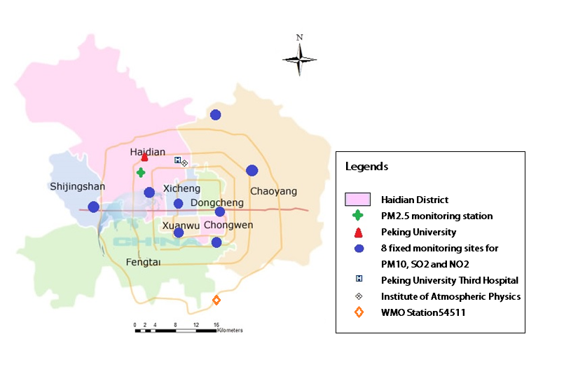
Figure2. Percent change (95%-confidence interval) in cardiovascular ERV per an interquartile range increase (IQR ª) in air pollutants (lag7). Effect modification by clusters of air mass origin on overall cardiovascular ERV.^{b}
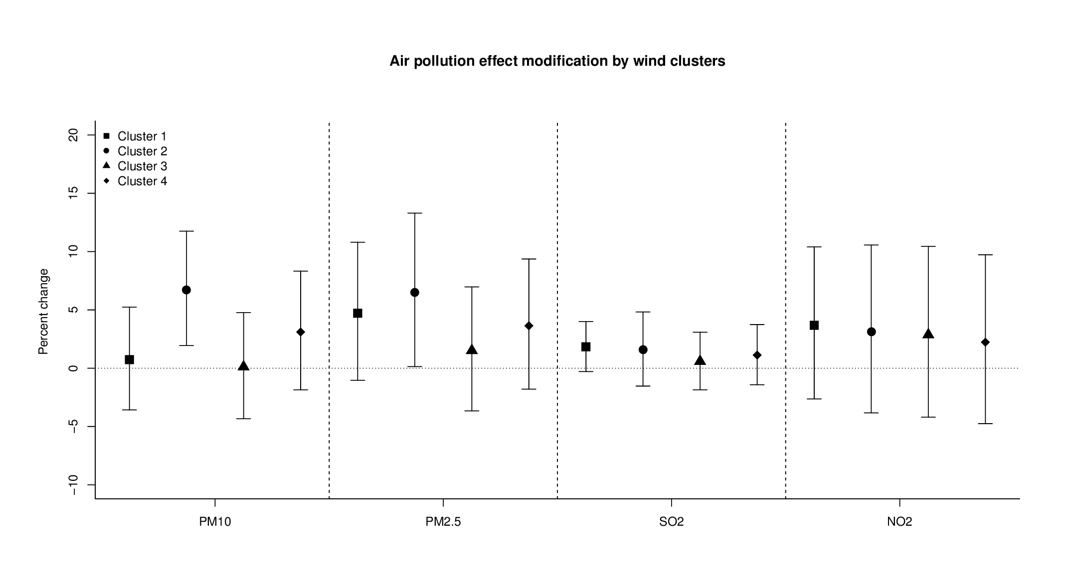
ERV: emergency room visits; PM: particulate matter; PM₁₀: PM<10µm in aerodynamic diameter; PM_{2.5}: PM<2.5µm in aerodynamic diameter; NO₂: nitrogen oxide.
ª Interquartile range (IQR) for air pollutants: PM_{2.5}: 68 μg/m³;PM₁₀: 97 μg/m³;SO₂:41μg/m³;NO₂:30 μg/m³
^{b} Models were adjusted for time trend, air temperature, relative humidity, day of week, public holiday and heating period.
Cluster 1 represents air masses coming from the areas surrounding Beijing with low wind speed;
Cluster 2 consists air masses arriving from northwestern direction with average to high wind speed.

Figure3. Percent change (95%-confidence interval) in cardiovascular ERV per an interquartile range increase (IQR ª) in air pollutants (lag7). Effect modification by Olympic period on overall cardiovascular ERV.^{b}
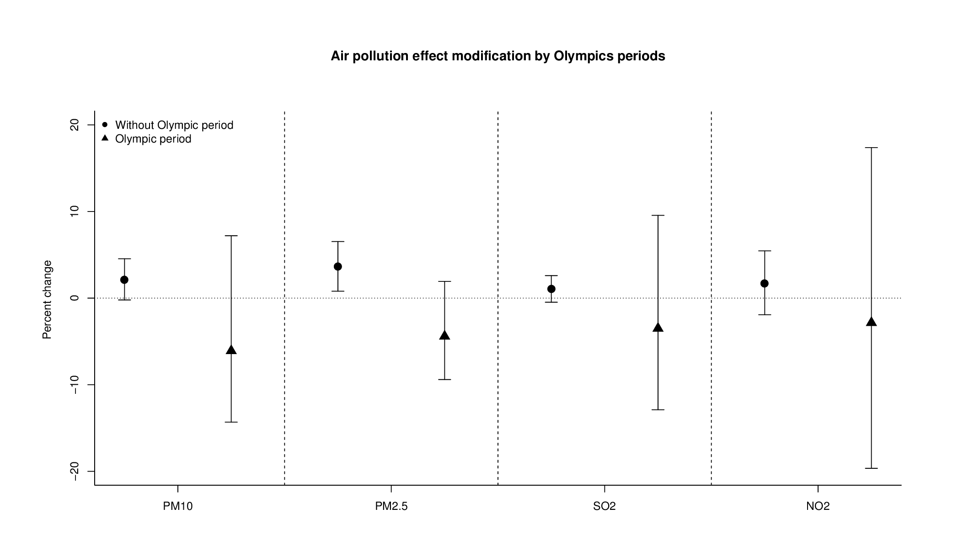

ERV: emergency room visits; PM: particulate matter; PM₁₀: PM<10µm in aerodynamic diameter; PM_{2.5}: PM<2.5µm in aerodynamic diameter; NO₂: nitrogen oxide.
ª Interquartile range (IQR) for air pollutants: PM_{2.5}: 68 μg/m³;PM₁₀: 97 μg/m³;SO₂:41μg/m³;NO₂:30 μg/m³
^{b} Models were adjusted for time trend, air temperature, relative humidity, day of week, public holiday and heating period.
Figure 4. Relative risks (RR; with 95% confidence intervals [95% CI]) for cardiovascular ERV as well as for different gender and age groups per interquartile range (IQR ª) increment of PM_{2.5} obtained with polynomial distributed lag models ^{b}.
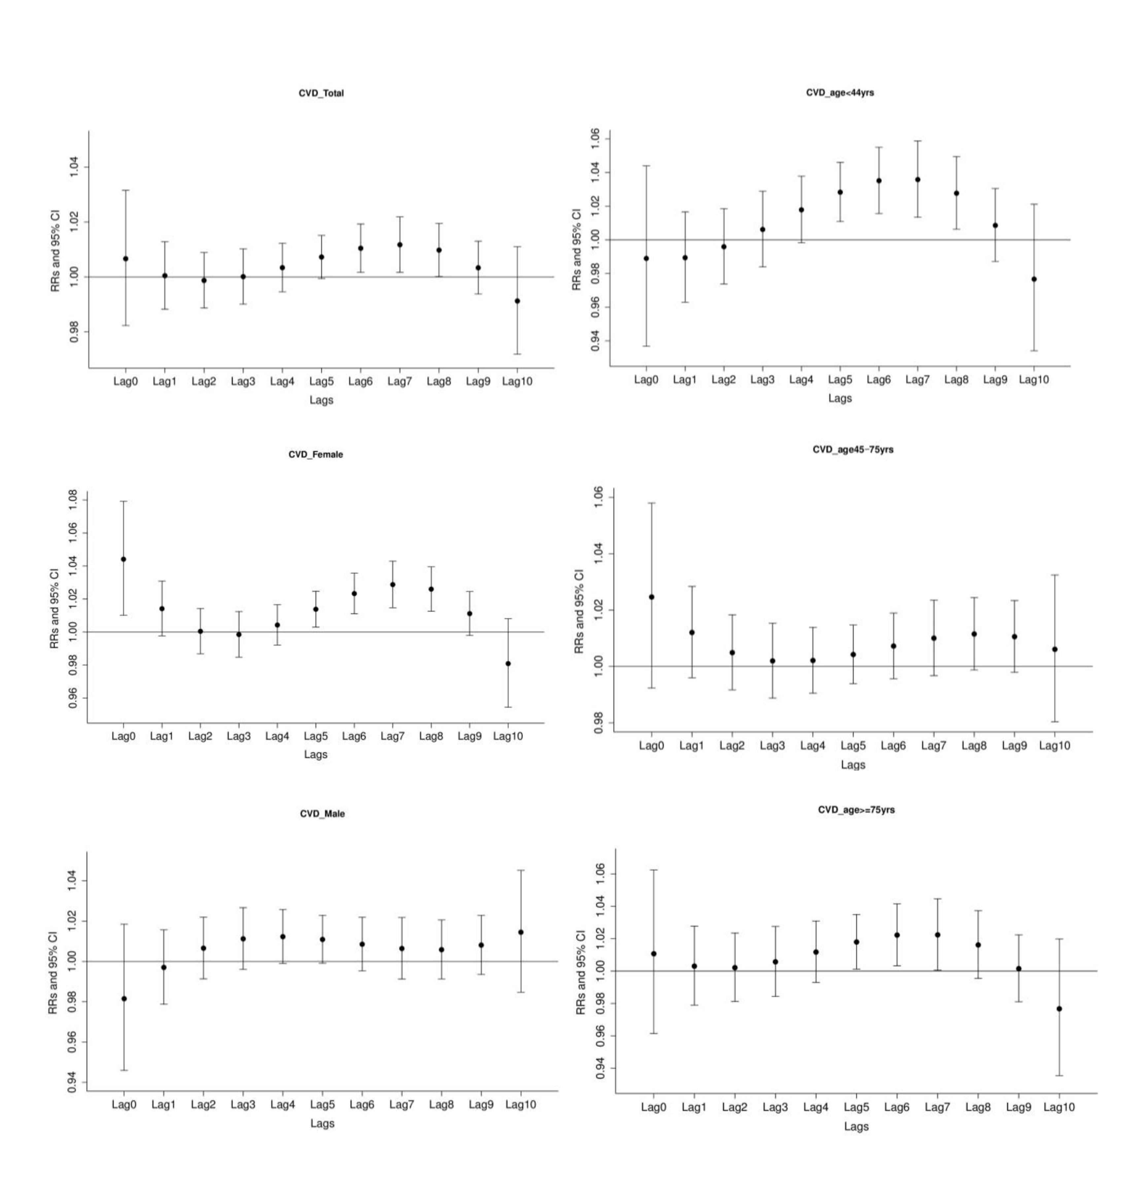
ERV: emergency room visits; PM: particulate matter; PM_{2.5}: PM<2.5µm in aerodynamic diameter.
ª Interquartile range (IQR) for PM_{2.5}: 68 μg/m³.
^{b} Models were adjusted for time trend, air temperature, relative humidity, day of week, public holiday and heating period.
Models were estimated with lags up to ten days constrained with a third degree polynomial.
Figure 5. Relative risks (RR; with 95% confidence intervals [95% CI]) for cardiovascular ERV per interquartile range increase (IQR ª) of PM_{2.5} in single-pollutant models as well as in multi-pollutant models ^{b}.
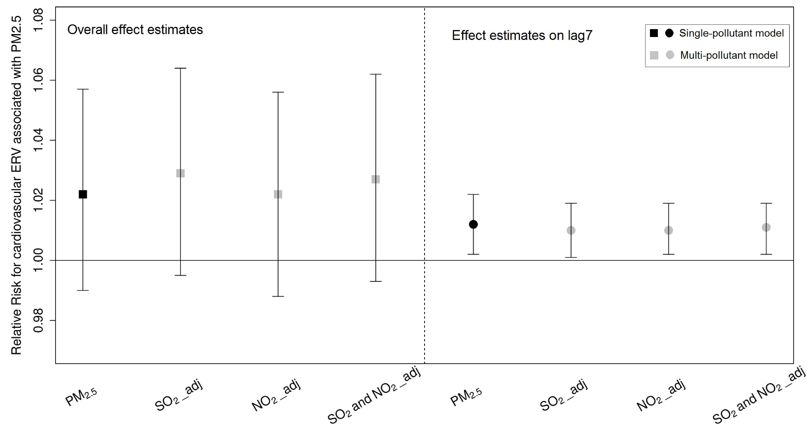
ERV: emergency room visits; PM: particulate matter; PM_{2.5}: PM<2.5µm in aerodynamic diameter; SO₂: sulfur dioxide; NO₂: nitrogen dioxide.
SO₂_adj: effect of PM_{2.5} adjusted for SO_{2.}
ª Interquartile range (IQR) for air pollutants: PM_{2.5}: 68 μg/m³
^{b} Models were adjusted for time trend, air temperature, relative humidity, day of week, public holiday and heating period.

2
1
1
1

