Table A1.
Correlation coefficients for daily mean values of meteorological variables and air pollution variables.
 | Air temperature | Relative humidity | Air pressure | SO₂ | NO₂ | PM_{2.5} | PM₁₀
Air temperature | 1.000 | 0.372 | -0.881 | -0.662 | -0.267 | 0.140 | 0.053
Relative humidity |  | 1.000 | -0.362 | -0.242 | 0.128 | 0.460 | 0.212
Air pressure |  |  | 1.000 | 0.554 | 0.225 | -0.218 | -0.156
SO₂ |  |  |  | 1.000 | 0.659 | 0.348 | 0.483
NO₂ |  |  |  |  | 1.000 | 0.559 | 0.650
PM_{2.5} |  |  |  |  |  | 1.000 | 0.771
PM₁₀ |  |  |  |  |  |  | 1.000
Abbreviations: PM_{2.5}: fine particulate matter with an aerodynamic diameter of ＜2.5 μm; PM₁₀: particulate matter with an aerodynamic diameter of ＜10 μm; SO2: sulfur dioxide; NO₂: nitrogen dioxide

Figure A1:
Yearly mean concentrations of major air pollutants between 2001 and 2008

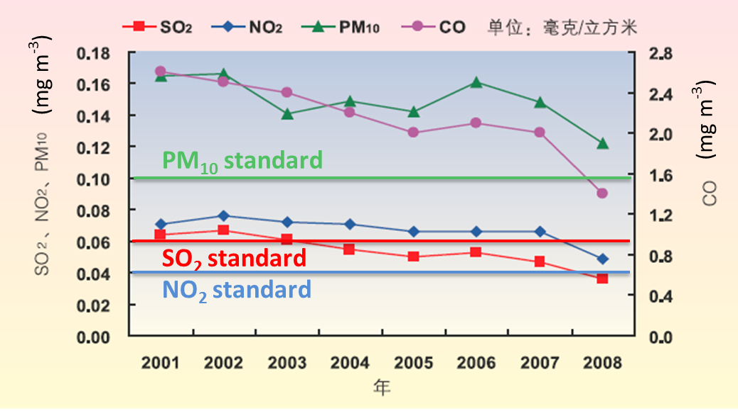
Figure A2:
Time-series of PM₁₀, PM_{2.5,} SO₂, NO₂ as well as daily case of cardiovascular emergency room visits from Jan 1st 2007 to Dec 31st 2008.

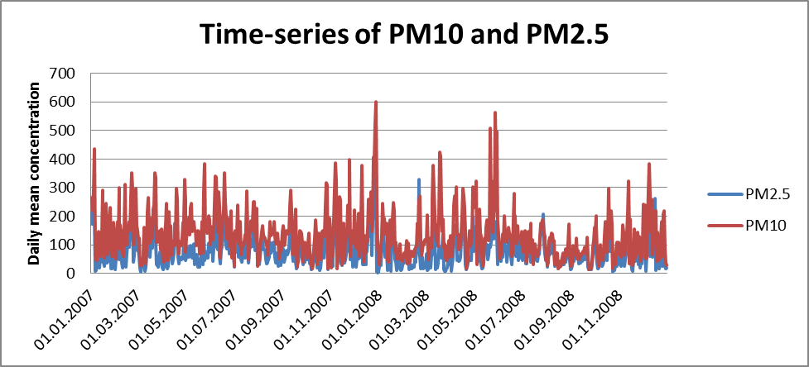
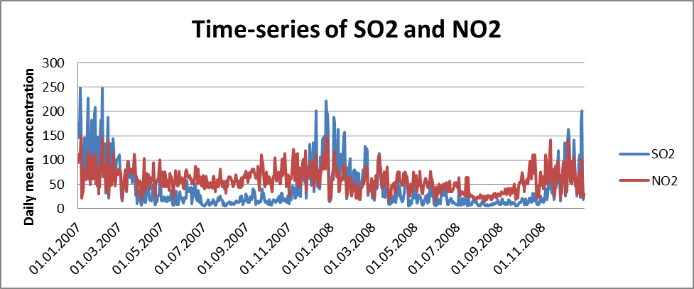
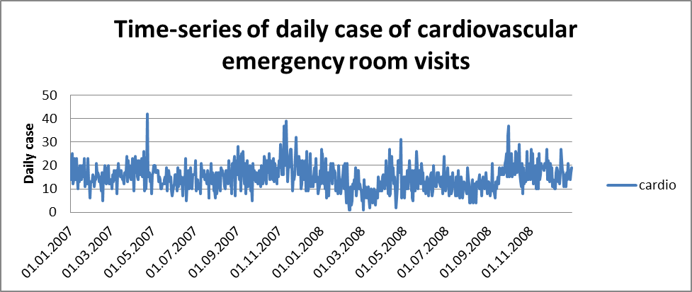

Figure A3:
Four clusters of air mass origin obtained from back-trajectories.
Cluster 1 consists of trajectories mostly coming from northwest of Beijing, but within China and Mongolia.
Cluster 2 represents air mass coming from the areas surrounding Beijing with low wind speed.
Cluster 3 consists of air masses mainly coming from northwest, but with much higher wind speed than in cluster 1.
Cluster 4 represents air mass coming from north to northwest, stretching to north of Mongolia and Central Siberia.

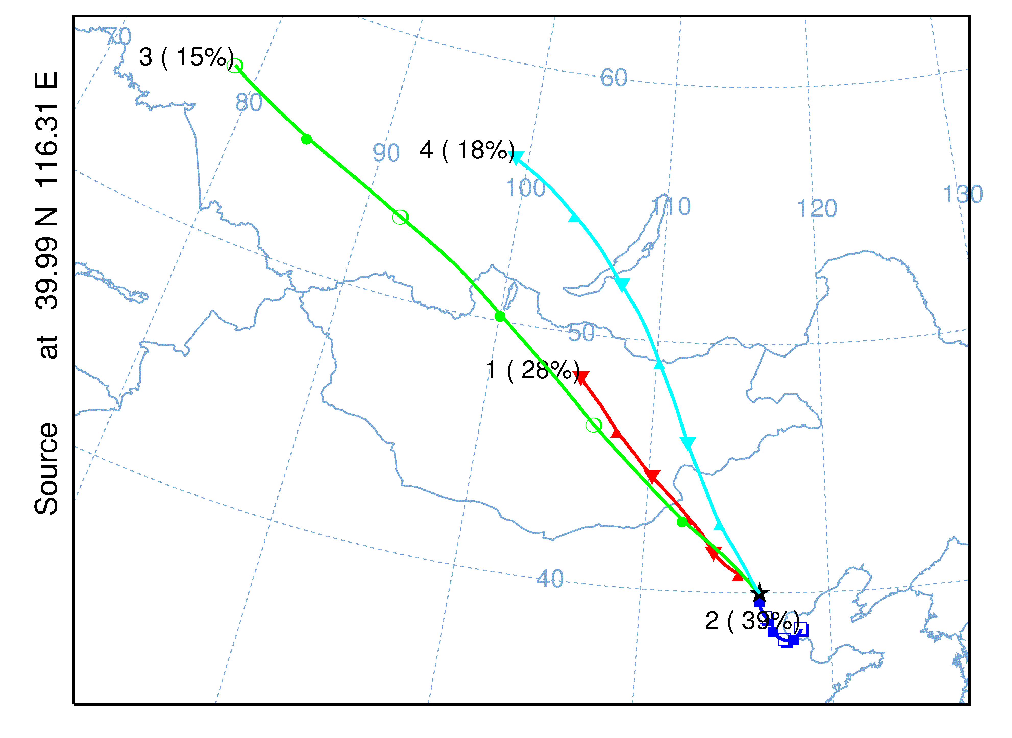
Figure A4:
Exposure-response function for daily total cardiovascular disease emergency room visits associated with PM_{2.5.}
