Management versus site effects on the abundance of nitrifiers and denitrifiers in European mountain grasslands

Szukics, U.¹, Grigulis, K.², Legay, N. ^{3,4}, Kastl, E.M. ⁵, Baxendale, C. ⁶, Bardgett, R.D.⁷, Clément, J. C. ⁸, Lavorel, S.², Schloter, M. ⁵, Bahn, M.¹
¹ Universität Innsbruck, Institut für Ökologie, Innsbruck, Austria
² Laboratoire d'Ecologie Alpine, UMR 5553 CNRS, Université Joseph Fourier, Grenoble, France
³ École de la Nature et du Paysage, INSA Centre Val de Loire, 9 Rue Chocolaterie, 41000 Blois, France.
⁴ CNRS, CITERES, UMR 7324, 37200 Tours, France.
⁵ Helmholtz Zentrum München GmbH, Research Unit for Comparative Microbiome Analysis, 85758 Oberschleissheim, Germany
⁶ Lancaster Environment Centre, Lancaster University, Lancaster, LA1 4YQ, UK
⁷ School of Earth and Environmental Sciences, Michael Smith Building, The University of Manchester, Oxford Road, Manchester M13 9PT, UK.
⁸CARRTEL, Université Savoie Mont Blanc, INRA, 74200 Thonon-Les-Bains, France

Abstract
It is well established that the abundances of nitrogen (N) transforming microbes are strongly influenced by land-use intensity in lowland grasslands. However, their responses to management change in less productive and less fertilized mountain grasslands are largely unknown. We studied eight mountain grasslands, positioned along gradients of management intensity in Austria, the UK and France, which differed in their historical management trajectories. We measured the abundance of ammonia oxidizing bacteria (AOB) and archaea (AOA) as well as nitrite reducing bacteria using specific marker genes. We found that management affected the abundance of these microbial groups along each transect, though the specific responses differed between sites, due to different management histories and resulting environmental parameters. In Austria, abandonment of management caused an increase in nirK and nirS gene abundances. In the UK, intensification of grassland management led to 10-fold increases in the abundance of AOA and AOB and doubling of nirK gene abundance. In France, ploughing of previously mown grassland caused a 20-fold increase in AOA abundance. Across sites the abundance of AOB was most strongly related to soil NO₃⁻-N availability, and AOA were favoured by higher soil pH. Among the nitrite reducers, nirS abundance correlated most strongly with N parameters, such as soil NO₃⁻-N, microbial N, leachate NH₄⁺-N, while the abundance of nirK-denitrifiers was affected by soil total N, organic matter (SOM) and water content. We conclude that site-specific soil conditions and management, rather than management intensity per se determine the abundance of nitrifiers and denitrifiers.

Keywords:
nitrifiers, denitrifiers, land use intensity, mountain grasslands, soil nitrogen cycle

Introduction
Mountain grasslands cover a substantial proportion of the European land surface (Tasser et al., 2005, Quétier et al., 2007). Over the past few decades, and still to this day, mountain grasslands have undergone significant shifts in land management practices, involving increases and decreases in intensity of management practices, as well as abandonment. This variety of land-use trajectories contrasts lowland grasslands, whose management has typically been intensified. Changes in land management can have lasting effects on the composition of plants and the soil microbiome, with cascading effects on ecosystem processes (Bardgett and Leemans 1995; Robson et al., 2007; Schmitt et al. 2010; Legay et al. 2014) and services (Lavorel et al., 2011; Grigulis et al., 2013). The nitrogen (N) cycle plays a key role for the provisioning of ecosystem services, both directly and indirectly (Galloway et al., 2004). However, the mechanisms by which changes in the soil microbiome are linked to shifts in soil quality and N cycling under changing management in mountain grasslands are poorly understood.
In order to fill this gap, a network of European mountain grasslands was established across three sites in Austria, France and the United Kingdom (UK), each site comprising a gradient of agricultural management intensity representative of farming practices in the respective region. These included agricultural improvement in the UK, land abandonment in Austria, and extensification either by conversion from mowing to grazing or by cessation of fertilization on hay meadows in France (Lavorel et al., 2017). Previous research using this network of sites indicates that different levels of management intensity affect soil N availability, and that both abiotic soil properties and plant traits influence the underlying microbial processes (Grigulis et al. 2013; Legay et al. 2014). Here, we advance on these studies by exploring effects of management changes on the abundances of N transforming microbes that drive nitrification and denitrification, and thus play a key role in the grassland N cycle. Together, these microbial processes determine, to a large extent, the availability of ammonia and nitrate in soil, which are essential for plant growth, but also can have detrimental effects on environmental quality due to the leaching of nitrate and the emission of N₂O to the atmosphere, a potent greenhouse gas.
The aim of our study was to assess effects of management intensity on the abundance of nitrifiers and denitrifiers for a range of land-use trajectories typical for European mountain grasslands. Further, our setting with differing geographic, edaphic and climatic conditions, enabled us to test whether effects of management on nitrifiers and denitrifiers vary with environmental context. We measured the abundance of ammonia oxidizing bacteria (AOB) and archaea (AOA) as a proxy for nitrifiers using the amoA gene as marker. In lowland grasslands, the abundance of AOB is thought to be regulated primarily by inorganic N availability (Meyer et al., 2013, Di et al., 2009, 2010), and thus by fertilization (Schauss et al., 2009, Hallin et al., 2009), while AOA abundance often shows no such response (Di et al., 2009, Shen et al., 2008, 2011). Other soil properties can also influence the abundance of AOA, including soil pH, organic matter and moisture content (Tourna et al., 2011; Stahl and de la Torre, 2012; Zhalnina et al., 2012; Stieglmeier et al., 2014). Similarly, denitrifiers have been shown to respond strongly to environmental factors, such as the soil pH (Nicol et al., 2008; Enwall et al., 2010, Pereira et al., 2012), N concentrations (Prosser and Embley, 2002), plant species identity (Bremer et al., 2007), as well as management practices such as tillage (Attard et al., 2010) and grazing (Patra et al., 2005). In our study, we quantified denitrifiers using the two functional redundant nitrite reductase genes nirK and nirS as markers. Much of the current knowledge on effects of management practices and land-use changes on nitrifiers and denitrifiers stems from lowland grasslands (Stempfhuber et al., 2014; Meyer et al., 2014), where intensification is the key trajectory of land-use change, and where background fertilizer inputs are typically higher than in the less productive mountain grasslands studied here.

Methods
Sites and sampling
We studied a total of eight grasslands representing different levels of management intensity (low – medium – high) in terms of the level of fertilizer application, mowing frequency, and grazing intensity (Table 1). The selected individual management forms represent typical types of grassland management in the investigated regions. Whereas for the site in France (F) and United Kingdom (UK) all three management intensities were studied, for the Austrian side (A) only sites with low and medium intensities were present. Soils were sampled within three plots (30x30 m) at each of the studied grasslands. In each plot, 3 replicate quadrats of 50x50 cm were established. Four soil cores of the main rooting horizon (0-5 cm depth in A and 0-10 cm depth in F, UK) were sampled at peak vegetation growth phase in July/August 2010. Replicate soil cores sampled within a quadrat were pooled, sieved to 5.6 mm and kept at 4°C for soil chemical analyses, or at -20°C until DNA extraction, respectively.

Soil chemical and physical properties
Soil abiotic properties including water content, bulk density, porosity and pH were determined according to Schinner et al. (1996). Soil organic matter content was measured using 5 g dried soil samples (at 70°C for one week) after combustion at 550°C for 4 h; the soil organic fraction was determined as the mass loss during combustion (Schinner et al., 1996). Total C and N contents were determined in sieved soil aliquots, ground to a powder using a ball mill and analysed with a FlashEA 1112 elemental analyser (Fisher Scientific Inc., Waltham, MA, USA). For determining soluble inorganic (NH₄⁺, NO₃⁻), dissolved organic N (DON), and total organic carbon (TOC), 10 g of fresh soil were extracted with 50 ml of 0.5 M K₂SO₄ and shaken at 150 rpm for 1 h (Jones & Willett, 2006) . Soil TOC, NH₄⁺-N and NO₃⁻-N concentrations were determined colorimetrically (FS-IV colorimetric chain, OI-Analytical Corp., TX, USA). For measuring total dissolved nitrogen (TDN), extracts were digested with persulfate and subsequently subjected to analyses of NO₃⁻-N (Ross, 1992; Ameel et al., 1993). N-DON was calculated as the difference between N-TDN and inorganic N (N-NO₃⁻ + N-NH₄⁺). Inorganic N in leachates was used as a measure of bioavailable N. In each quadrat one extra soil core was taken and placed on a mesh inside a plastic funnel. A defined amount (between 100 and 150 ml) of distilled water was gently poured onto the soil core, trickling through until the dripping stopped. Leachates were collected (de Vries et al., 2011), filtered (Whatmann 42, 2.5 µm) and frozen at -20 °C until analysis of NH₄⁺-N and NO₃⁻ -N.

Microbial parameters
Microbial biomass N was analyzed using the chloroform-fumigation method according to Brookes et al. (1985). Microbial community structure was measured using phospholipid fatty acid (PLFA) analysis, as described by Bligh and Dyer (1959), adapted by White et al. (1979) and Bardgett et al. (1996). The fatty acids i150:0, a150:0, 15:0, i16:0, 17:0, i17:0, cy17:0, cis18:1ω7 and cy19:0 were chosen to represent bacterial fatty acids and 18:2ω6 to represent fungal fatty acids, allowing us to calculate the fungal to bacterial PLFA ratio (F:B) which is commonly used as a measure of the composition of microbial communities (Bardgett and McAlister, 1999).
Nitrifiers and denitrifiers were quantified using DNA directly extracted from soil samples, followed by a quantitative real time PCR (qPCR) approach for marker genes of the respective group. Therefore DNA was extracted from 0.5 g of fresh soil using the FastDNA® SPIN Kit for Soil (MP Biomedicals, Irvine, CA) and a Precellys24 (Bertin Technologies, France). After extraction, DNA was tested in quantity and quality with a spectrophotometer (Nanodrop, PeqLab, Germany). QPCR was carried out on a 7300 Real-Time PCR System (Applied Biosystems, Germany) using SYBR green as fluorescent dye. The Power SybrGreen Master Mix was obtained from Applied Biosystems, primers were synthesized by Metabion (Germany), and bovine serum albumin (BSA) and dimethyl sulfoxide (DMSO) were purchased from Sigma (Germany). Compositions of reaction mixes as well as PCR conditions are given in Table 2. Dilution series of the DNA extracts were tested in a pre-experiment to avoid inhibition of PCR, resulting in an optimal dilution of 1:64 for all samples. Serial plasmid dilutions of the respective genes ranging from 10¹ to 10⁶ gene copies µl⁻¹ were used as standards. All PCR runs started with an initial step for enzyme activation at 95 °C for 10 mins. To confirm the specificity of the amplicons after each PCR run, a melting curve and a 2 % agarose gel stained with ethidium bromide were conducted. The efficiencies (Eff) of the amplification were calculated from the standard curve with the formula Eff = [10 ^{(−1/slope)} − 1] * 100 % and resulted in the following values: AOB 93-95%, AOA 91–98%, nirS 99–100%, nirK 94–99%.

Data analyses
In order to test for the effects of grassland management intensity on the abundance of nitrifying and denitrifying microbes, one-way ANOVA was performed using the multiple range test (STATGRAPHICS PLUS 5.0) for the response variables of soil characteristics, N pools, and gene abundances. Sites were treated separately to take management gradients within sites into account. An LSD test was used for comparison of samples with equal size numbers; the Scheffé test was used for samples with varying numbers of replicates. Relationships between the measured variables and ammonia oxidizers (AOA, AOB) and nitrite reducers (nirK, nirS) were explored using a principal components analysis carried out by using the ade4 package (Dray et al., 2007), with biologically informative axes of variation being retained. Missing values in the dataset were replaced by the mean value of that variable across all sites. Correlations between parameters (Table 4) were calculated by means of multiple-variable analysis at the p<0.001 and p<0.05 level.

Results
Abiotic soil properties
At the UK site, total N and C concentrations increased in soil from unimproved to improved and semi-improved grassland (UI<I<SI); in France soil C and N concentrations did not differ between differently managed grasslands; in Austria soil C and N concentrations were twice higher in the abandoned grassland compared to the managed grassland (Tab. 3). Soil C/N ratios of the unimproved site in the UK (UI) and the abandoned site in Austria (A) were significantly higher than those of the more intensively managed soils, whereas the opposite trend was observed in France. For Austria and France, soil organic matter content (SOM) was highest at the abandoned and unmown sites (A; UM), which contained up to 15% more SOM than alternative management types (M; UT and FMT). Total soil organic carbon (TOC) concentrations were 2 times higher at the improved (I, SI) compared to the unimproved site in the UK, whereas in Austria the abandoned site contained more TOC than the managed meadow soil.
Soil inorganic N concentrations (NO₃⁻-N + NH₄⁺-N) increased with management intensity at the UK site (UI<SI<I), respectively (Tab. 3). Soil NO₃⁻-N concentrations were highest at the most intensively managed grassland site (I), while the semi-improved grassland contained most NH₄⁺-N (Fig. 1A, 1C). At the Austrian sites, the abandoned site contained more inorganic N than the fertilized meadow; concentrations of NH₄⁺-N were twice as high in soil of the abandoned site compared to the fertilized meadow site, but NO₃⁻-N concentrations were distinctly lower (Fig. 1A, 1C). At the French sites, the soil of intermediately managed grasslands (UT) contained the most NO₃⁻-N and NH₄⁺-N as compared to the least (UM) and most intensively managed (FMT) grasslands.
The amount of leached NO₃⁻-N was higher at the more intensively managed sites in France and the UK (Fig. 1D), and amounted to 7% and 13% of the total NO₃⁻-N measured in the improved grassland (I) of UK and at the more intensively managed sites (UT, FMT) in France, respectively (Tab. 3). In Austria, a higher fraction of NO₃⁻-N was leached at the abandoned site (25%) as compared to the managed site (4%). The leached NH₄⁺-N fraction was highest at the UK sites (Tab. 3), where almost two times more NH₄⁺-N was leached from the improved and semi-improved sites (SI and I) compared to the unimproved (UI) site (Fig. 1B). Soil DON concentrations were related to management differences only in Austria, where more DON was found in the abandoned as compared to the managed meadow soil.
Soil pH generally varied from 5.7 to 8.0 across all sites, and decreased from abandoned to managed grassland in Austria, whereas it was greater in previously ploughed grasslands (UT, FMT) that in never ploughed, unmown grassland (UM) in France and showed no overall management-trend in the UK (Tab. 3). At the Austrian and French site, soil water contents were 1.4- and 2 times higher in the abandoned or unmown soils (A, UM) compared to the more intensively managed soils, however, water holding capacity (WHC) within sites were similar (Tab. 1). At the Austrian site, soil porosity was 9 % lower in the managed compared to the abandoned soil, whereas in the UK and France variation in soil porosity was not related to management intensity.

Microbial biomass and bacteria:fungi ratio
Total fungal and bacterial PLFA were lowest at highest management intensity across all studied transects (Tab. 3). At the semi-improved site in the UK (SI) and the least managed site in France (UM) microbial biomass was 2 and 1.2 times higher compared to the more intensively managed soils, respectively. At the Austrian site, microbial biomass was even 3 times higher in the abandoned soil compared to the meadow soil.
Microbial biomass N increased with management intensity at the UK and Austrian sites; in the UK, microbial biomass N was more than twice as high in soil of the improved sites (I and SI), while in Austria the meadow site contained 4 times more microbial biomass N than the abandoned site. The opposite trend was observed in France, where microbial biomass N in formerly ploughed FMT and UT soils was 2 to 4 times lower than in the unploughed soil (UM), which had a distinctly lower pH.
Fungi to bacteria ratios (F:B) decreased by a factor of two along the intensity gradient of management at the UK site (Tab. 3), whereas in France the F:B ratio was lowest in unmown grassland (UM) soil. The F:B PLFA ratio did not vary with management in Austria.

Abundance of nitrifiers and denitrifiers
Copy numbers of archaeal amoA genes were higher in soils of the more intensively managed sites in the UK and France, whereas AOA abundance remained unaffected by management intensity in Austria (Fig. 2). In the UK, AOA abundance increased with increasing management intensity by a factor of approximately 8, whereas in France AOA abundance was more than 20 times higher in soil of the previously ploughed sites (UT, FMT) relative to the unmown meadow (UM) soil. At the UT and FMT sites in France, AOA abundance was exceptionally high, being an order of magnitude greater compared to the other sites studied (Fig. 2A). The abundance of AOB was lower and less variable than AOA in the grassland soils investigated. Bacterial amoA gene copy numbers increased with management intensity in the UK, were higher at the managed relative to the abandoned site in Austria, but showed no variation according to management in France. AOB abundance was greatest in soil of the managed than the abandoned (A) site in Austria (M), and in the most intensively managed site in the UK (Fig. 2B). The AOA/AOB ratio increased with management intensity at the French site, where the AOA/AOB ratio was 10-times higher in the most intensively managed (FMT), compared to the unmown meadow (UM) (Tab. 3). At the intermediately managed (SI) site in the UK, the AOA/AOB ratio was twice as high compared to the unmanaged (UI) and intensively (I) managed sites.
In the UK, no differences in nirS gene copy numbers were observed across the management gradient, whereas at the Austrian site nirS gene copy numbers were 2.7 times more abundant in the abandoned compared to the managed soil (Fig. 3). At the French site, nirS gene abundance increased with management intensity in the order UM<UT<FMT. Across all sites, nirK gene abundance was greater than nirS gene abundance (Fig. 3). While along the UK transect, nirK gene copy numbers were highest in the intensively managed soil (I), in Austria and France nirK was more abundant at the least intensively managed sites (UM and A). The abandoned soil in Austria and the unmown meadow soil in France harbored 2 and 3 times more nirK genes, respectively, than managed soils (M, UT and FMT). The nirK/nirS ratio was generally highest in the Austrian grasslands, but did not vary with management (Tab. 3). Within the French transect at the unmown meadow (UM), the nirK/nirS ratio was 20- and 46-times higher as in the more intensively managed grasslands (UT, FMT).

Relationships between soil characteristics, N concentrations and marker genes for nitrifiers and denitrifiers
Amongst all environmental drivers, and across all sites, the abundance of the archaeal amoA gene correlated best with soil pH (R² = 0.65) (Tab. 4, Fig. 4A), and was negatively correlated to soil water content, leachate NH₄⁺-N concentration, SOM and microbial biomass N (Tab. 4). The abundance of the bacterial amoA gene was related to soil NO₃⁻-N concentration and inorganic N (Tab. 4). The abundance of the nirK gene correlated best with soil water content, SOM and soil N and C, while it was negatively related to soil C/N, pH and inorganic N (NO₃⁻-N + NH₄⁺-N). The nirS gene abundance correlated best with soil NO₃⁻-N, leachate NH₄⁺-N and microbial biomass N, and correlated negatively with the F:B ratio (Tab. 4, Fig. 4B).

Discussion
In the mountain grasslands studied, agricultural management affected a range of soil abiotic properties, including N availability, pH, organic matter content and water availability. Responses of nitrogen transforming microbes were specific and differed between management transects in each country. This suggests that individual agricultural histories and practices, rather than management intensity per se, influence the abundance of ammonia oxidizers and nitrite reducers by altering soil environmental conditions.

Drivers for AOA and AOB in managed mountain grasslands
AOA and AOB have been suggested to differ with respect to their preferences for abiotic factors, including pH, nitrogen content and soil organic C. AOB is typically more responsive to fertilizer application compared to AOA (Erguder et al., 2009, Wessen et al., 2011). In our study, AOB abundances increased with management intensity at two of the three studied sites (i.e., UK and in Austria). However, we also found that AOA abundance was greater in the more intensively managed grasslands in the UK and France, suggesting that both groups were responding similarly to management. While Keil et al. (2011) found a higher abundance of AOA in fertilized compared to unfertilized grasslands, which was associated with increased NO₃⁻ availability, in our study soil inorganic N concentrations were not always related to management intensity; as such, other soil parameters likely drive the abundance of AOA in the mountain grassland soils investigated. For instance, while soil NO₃⁻-N concentrations were higher in the managed than abandoned meadow at the Austrian site, concentrations of NH₄⁺-N and DON were greater in the abandoned grassland site compared to the fertilized meadow. This latter response is possibly due to the accumulation of plant residue as particulate organic matter over the 29 years since abandonment (Meyer et al. 2012, Zeller et al., 2000), which has increased the amount and C/N ratio of soil organic matter (Table 3), potentially providing negatively charged binding sites for NH₄⁺ cation adsorption (Tipping, 2002).
Soil N availability at the French site was also not strictly related to fertilizer application, as soil of the intermediately managed (UT) site contained more NH₄⁺-N and NO₃⁻-N than soil of the most intensively managed site (FMT). Along the French transect, the abundance of AOB remained constant, whereas AOA abundance was much higher at the terraced sites (UT and FMT). Their soils were alkaline (pH 8) due to former ploughing and mixing of the soil with alkaline bedrock (Robson et al., 2007 and 2010). In these rather alkaline soils, AOA were between 20- and 529-times more abundant than in all other grassland soils investigated in our study. Thus, AOA abundance appeared to be driven by pH rather than by soil inorganic N availability or organic carbon content.
Previous studies have identified drivers for bacterial amoA abundance in lowland systems, including soil pH, microbial biomass, nitrate and total nitrogen content (Hayden et al., 2010). Among these factors, N availability related most strongly to the AOB abundance in our study, since the number of bacterial amoA genes correlated significantly with NO₃⁻-N and total inorganic N across all the grasslands investigated.
Until recently, the prevalent paradigm has been that AOA have a preference for low pH environments (Erguder et al., 2009; Lu and Jia, 2012; He et al., 2012; Shen et al., 2014; Monteiro et al., 2014; Nicol et al., 2008; Hu et al., 2013). This general notion is not supported by our findings: AOA abundance clearly increased with soil pH, indicating a potential importance of AOA in alkaline soils. In accordance to our findings, Gubry-Rangin et al. (2011) studied niche specialization of terrestrial AOA and reported archaeal amoA diversity and abundance to increase with soil pH. While the extremely high substrate affinity of the archaeal ammonia oxidase enzyme (Könnecke et al. 2014) may explain the advantage of AOA in acidic/oligotrophic environments, the mechanism by which AOA cope with alkaline conditions remains open. These findings imply a niche partitioning for pH within the group of ammonia oxidizing Archaea (Tripathi et al., 2013). The clear dominance of AOA under alkaline conditions was underlined by AOA/AOB ratios as high as 57 and 97, which clearly exceed the ratios (between 2 and 16) found previously in managed grasslands (Meyer et al., 2014). Even if the biochemical pathways are mostly unknown, AOA have generally been suggested to be better adapted to conditions such as salinity (Venter et al., 2004), high temperatures (Reigstad et al., 2008), freezing temperature (Nakagawa et al., 2007), sulfidity (Beman and Francis, 2006), acidity (Nicol et al., 2008), as well as to alkalinity, as indicated in the present study. Still, higher abundance of AOA does not necessarily signify their functional dominance over AOB (Prosser and Nicol, 2008); however, increased archaeal amoA copy numbers certainly indicate a higher potential for archaeal ammonia oxidation.

Drivers for nitrite reducers in managed mountain grasslands
As with AOA and AOB abundance, the response pattern of nirK- versus nirS-type nitrite reducers to management was strongly site-specific and driven by management effects on environmental parameters. At the UK site, nirK gene abundance increased with management intensity, whereas nirS gene abundance was unaffected. In contrast, nirK gene abundance at the French site was highest in the unmanaged soil, while nirS increased with management intensity, which was also reflected in different nirK/nirS ratios. Similar specific responses of nirK- versus nirS- type nitrite reducers were reported by Enwall et al. (2010), who hypothesized that they were due to differential habitat selection of the two groups of nitrite reducers. A further study by Keil et al. (2011) on low and high land-use intensity grasslands reported niche partitioning between nirK – and nirS-type nitirite reducers with pH as a selecting factor. Other driving factors such as copper, or the presence or absence of plants, which were not considered in this study, have been suggested (Hallin et al., 2009; Enwall et al., 2010). However, in our study, soil inorganic N concentration appeared to be a key factor determining the abundance of nirS genes, which was related to NO₃⁻-N and leachate NH₄⁺-N concentrations. The nirK abundance correlated with soil total N content, but also responded to other soil parameters. For example, in Austria and France, nirK was most abundant in soils from abandoned or least managed grasslands, which were characterized by highest within-site SOM contents of 34% (A) and of 18.4% (UM) respectively, and at the sampling time both soils had highest within-site water contents at comparable water holding capacities. The enhanced water contents in these highly organic soils may have favored growth of nirK-nitrite reducers, which is consistent with the key role of soil water availability and lack of oxygen for denitrification (Firestone 1982; Tiedje 1988; Szukics et al., 2010). Soil water availability may be modulated by grassland management, which secondarily affects the water balance, e.g. by increasing the thickness of the litter layer (a 12-fold increase between FMT and UM at the French site – Quétier et al. 2007), which keeps water and protects the soil from drying out (Meyer et al. 2012). The importance of these factors determining the availability of soil water was previously highlighted by Fuchslueger et al. (2014), who reported effects of drought and rewetting in Austrian mountain grassland soils. Moreover, we observed a relationship between the nirK gene abundance and the SOM content, indicating that this group of denitrifiers responds to the availability of organic substrates more than nirS nitrite reducers. According to Attard et al. (2011), 81% to 92% of the variance observed for potential denitrification in differently managed sites was explained by soil organic carbon, together with water-filled pore space and nitrate. Since denitrification represents a facultative process performed by bacteria alternatively to O₂ respiration, population sizes need to be interpreted cautiously since a vast majority of bacteria is believed to be able to denitrify. Still, in our study the quantification of the respective population sizes indicated that, besides soil N, soil organic carbon and water-filled pore space affected nirK abundance, while variation in the nirS abundance correlated with N concentrations in mountain grasslands, indicating niche specialization of the two groups of nitrite reducers.

Conclusion
Our study of mountain grassland soils in three European countries has shown that, while both nitrifier and denitrifier abundance is broadly affected by agricultural management intensity, their responses to management are group- and site-specific, and primarily influenced by soil abiotic properties. We found that among ammonia oxidizers, the abundance of AOA was favored by more alkaline conditions, while AOB abundance was preferentially related to soil NO₃⁻-N concentrations. Across sites, nitrite reducers of the nirS type dominated under N rich conditions, while their counterpart (nitrite reducers of the nirK–type) was most abundant in moist soils of high organic matter content. We thus conclude that specific management practices affect soil properties and nutrient availability, which then determine niche specialization of N converting microbes in mountain grasslands. How these observations affect nutrient fluxes and in situ transformation rates needs to be studied in further experiments, which measure also activity parameters of the respective functional microbial groups, for example by using specific mRNA as a proxy.

Acknowledgements
This study was conducted as part of ERA-Net BiodivERsA project VITAL, ANR-08-BDVA-008, with the national funders ANR, FWF, NERC (grant number NE/G002258/2), BMBF and Austrian Science Fund (FWF project number I 242-B17). The writing of this manuscript was supported by the ClimLUC project funded through the ESS-programme of the Austrian Academy of Sciences. We thank Cindy Arnoldi, Marie-Pascale Colace and Helen Quirk for their assistance. The Lautaret site in France is part of the long-term ecological research site Zone Atelier Alpes, a member of the ILTER-Europe. We acknowledge the National Research Agency support (“Investissements d’avenir” - ANR11 INBS-0001AnaEE-Services) and from the SAJF research station (UMR 3370, UGA/CNRS) infrastructures and competences.
References

Attard, E., et al. 2010. Shifts between Nitrospira- and Nitrobacter-like nitrite oxidizers underlie the response of soil potential nitrite oxidation to changes in tillage practices. Environ. Microbiol. 12, 315–326.

Attard, E., et al. 2011. Soil environmental conditions rather than denitrifier abundance and diversity drive potential denitrification after changes in land uses. Glob. Chang. Biol. 17, 1975–1989.

Ameel, J.J., Axler, R.P., Owen, C.J., 1993. Persulfate digestion for determination of total nitrogen and phosphorus in low nutrient waters. Am. Environ. Lab. 10, 1-11.

Bahn, M., et al., 2006. Root respiration in temperate mountain grasslands differing in land use. Glob. Chang. Biol. 12, 995-1006.

Bardgett, R.D., Leemans, D.K., 1995. The short-term effects of cessation of fertilizer applications, liming, and grazing on microbial biomass and activity in a reseeded upland grassland soil. Biol. Fert. Soils. 19, 148-154.

Bardgett, R.D., Hobbs, P.J., Frostegard, A., 1996. Changes in soil fungal:bacterial biomass ratios following reductions in the intensity of management of an upland grassland. Biol. Fert. Soils. 22, 261-264.

Bardgett, R.D., McAlister, E., 1999. The measurement of soil fungal:bacterial biomass ratios as an indicator of ecosystem self-regulation in temperate meadow grasslands. Biol. Fertil. Soils. 29, 282–290.

Beman, J.M., Francis, C.A., 2006. Diversity of ammonia-oxidizing archaea and bacteria in the sediments of a hypernutrified subtropical estuary: Bahia del Tobari, Mexico. Appl. Environ. Microbiol. 72, 7767-7777.

Bligh, E.G., Dyer, W.J., 1959. A rapid method of total lipid extraction and purification. Canad. Journ. Biochem. Physiol. 37, 911–917.

Bremer, C., et al., 2007. Impact of plant functional group, plant species, and sampling time on the composition of nirK-type denitrifier communities in soil. Appl. Environ. Microbiol. 73, 6876–6884.

Brookes, P.C., et al., 1985. Chloroform fumigation and the release of soil nitrogen: The effects of fumigation time and temperature. Soil Biol. Biochem. 17, 831-835.

Di, H.J., et al., 2009. Nitrification driven by bacteria and not archaea in nitrogen-rich grassland soils. Nat. Geosci. 2, 621-624.

Di, H.J., et al., 2010. Ammonia-oxidizing bacteria and archaea grow under contrasting soil nitrogen conditions. FEMS Microbiol. Ecol. 72, 386-394.

Dray, S., et al., 2007. The ade4 package-II: twotable and K-table methods. R News 7:47–52.

Enwall K., et al., 2010. Soil resources influence spatial patterns of denitrifying communities at scales compatible with land management. Appl. Environ. Microbiol. 76, 2243-2250.

Erguder T.H., et al. 2009. Environmental factors shaping the ecological niches of ammonia oxidizing archaea. FEMS Microbiol. Rev. 33, 855–869.

Firestone, M.K., 1982. Biological denitrification, in: Stevenson, F.J. (Ed.), Nitrogen in Agricultural Soils. American Society of Agronomy, Madison, pp. 289-326.

Fuchslueger, L., et al., 2014. Effects of drought on nitrogen turnover and abundances of ammonia-oxidizers in mountain grassland. Biogeosci. 11, 6003-6015.

Galloway, J.N., et al., 2004. Nitrogen cycles: past, present, and future. Biogeochem. 70, 153-226.

Grigulis, K., et al., 2013. Relative contributions of plant traits and soil microbial properties to mountain grassland ecosystem services. Journ. Ecol. 101, 47–57.

Gubry-Rangin, C., et al., 2011. Niche specialization of terrestrial archaeal ammonia oxidizers. PNAS 108, 52.

Hallin, S., et al., 2009. Relationship between N-cycling communities and ecosystem functioning in a 50-year-old fertilization experiment. ISME 3, 597–605.

Hayden H.L., et al., 2010. The abundance of nitrogen cycle genes amoA and nifH depends on land-uses and soil types in South-Eastern Australia. Soil Biol. Biochem. 42, 1774-1783.

He, J.Z, Hu, H.W., Zhang, L.M., 2012. Current insights into the autotrophic thaumarchaeal ammonia oxidation in acidic soils. Soil Biol. Biochem. 55, 146-154.

Hu, H.W. et al., 2013. pH-dependent distribution of soil ammonia oxidizers across a large geographical scale as revealed by high-throughput pyrosequencing. J. Soil. Sed. 13, 1439-1449.

Jones, D.L., Willett, V.B., 2006. Experimental evaluation of methods to quantify dissolved organic nitrogen (DON) and dissolved organic carbon (DOC) in soil. Soil Biol. Biochem. 38, 991-999.

Keil, D., et al., 2011. Influence of land-use intensity on the spatial distribution of N-cycling microorganisms in grassland soils. FEMS Microbiol. Ecol. 77, 95–106.

Könnecke, M., et al., 2014. Ammonia-oxidizing archaea use the most energy-efficient aerobic pathway for CO₂ fixation. PNAS 111, 8239-8244.

Lavorel, S., et al., 2011. Using plant functional traits to understand the landscape distribution of multiple ecosystem services. J. Ecol. 99, 135-147.

Lavorel, S., et al., 2017. Historical trajectories in land use pattern and grassland ecosystem services in two contrasted alpine landscapes. Regional Envrion. Change, 17, 2251-2264.

Legay, N., et al., 2014. Contribution of above- and below-ground plant traits to the structure and function of grassland soil microbial communities. Annals Bot. 114, 1011-1021.

Lu, L. and Jia, Z., 2012. Urease gene-containing Archaea dominate autotrophic ammonia oxidation in low acid soils. Environ. Microbiol. 15, 1795-1809.

Meyer, A., et al., 2013. Different land use intensities in grassland ecosystems drive ecology of microbial communities involved in nitrogen turnover in soil. PLOS 8, 1-11.

Meyer, A., et al., 2014. Influence of land use intensity on the diversity of ammonia oxidizing bacteria and archaea in soils from grassland ecosystems. Microb. Ecol. 67, 161-166.

Meyer, S., et al., 2012. Free and protected soil organic carbon dynamics respond differently to abandonment of mountain grassland. Biogeosci. 9, 853-865.

Monteiro M., Séneca, J., Magalhaes, C., 2014. The history of aerobic ammonia oxidizers: from the first discoveries to today. Microbiol. 52, 537-547.

Nakagawa, T., et al., 2007. Distribution of cold-adapted ammonia oxidizing microorganisms in the deep-ocean of the northeastern Japan Sea. Microb. Environ. 22, 365-372.

Nicol, G.W., et al., 2008. The influence of soil pH on the diversity, abundance and transcriptional activity of ammonia oxidizing archaea and bacteria. Environ. Microbiol. 10, 2966–2978.

Patra, A.K., et al., 2005. Effects of grazing on microbial functional groups involved in soil N dynamics. Ecol. Monogr. 75, 65-80.

Pereira e Silva, M.C., et al., 2012. Fluctuations in ammonia oxidizing communities across agricultural soils are driven by soil structure and pH. Front. Microbiol. 3, 1-22.

Prosser, J.I., Embley, T.M., 2002. Cultivation-based and molecular approaches to characterisation of terrestrial and aquatic nitrifiers. Antonie van Leeuwenhoek 81, 165–179.

Prosser, J.I., Nicol, W.G., 2008. Relative contributions of archaea and bacteria to aerobic ammonia oxidation in the environment. Environ. Microbiol. 10, 2931–2941.

Quétier, F., Thébault, A., Lavorel, S., 2007. Plant traits in a state and transition framework as markers of ecosystem response to land-use change. Ecol. Monogr. 77, 33–52.

Reigstad, L.J., et al., 2008. Nitrification in terrestrial hot springs of Iceland and Kamchatka. FEMS Microbiol. Ecol. 64, 167-174.

Robson, T.M., et al., 2007. Neglect of mowing and manuring leads to slower nitrogen cycling in subalpine grasslands. Soil Biol. Biochem. 39, 930–941.

Robson, T.M., et al., 2010. Land use in subalpine grasslands affects nitrogen cycling via changes in plant community and soil microbial uptake dynamics. J. Ecol. 98, 62-73.

Ross, D.J., 1992. Influence of sieve mesh size on estimates of microbial carbon and nitrogen by fumigation-extraction procedures in soils under pasture. Soil Biol. Biochem. 24, 343-350.

Schauss, K., et al., 2009. Dynamics and functional relevance of ammonia-oxidizing archaea in two agricultural soils. Environ. Microbiol. 11, 446–456.

Schinner, F., et al., 1996. Methods in Soil Biology, Springer Verlag, Berlin.

Schmitt, M., et al., 2010. Land use affects the net ecosystem CO₂ exchange and its components in mountain grasslands. Biogeosci. 7, 2297–2309.

Shen, J.P., et al., 2008. Abundance and composition of ammonia-oxidizing bacteria and ammonia-oxidizing archaea communities of an alkaline sandy loam. Environ. Microbiol. 10, 1601–1611.

Shen, J.P., et al., 2011. Nitrogen loading levels affect abundance and composition of soil ammonia oxidizing prokaryotes in semiarid temperate grassland. J. Soils Sed. 11, 1243-1252.

Shen, J.P., Xu, Z., He, J.Z., 2014. Frontiers in the microbial processes of ammonia oxidation in soils and sediments. J. Soil Sed. 14, 1023-1029.

Stahl, D.A., de la Torre, J.R., 2012. Physiology and diversity of ammonia oxidizing Archaea. Annu. Rev. Microbiol. 66, 83–101.

Stempfhuber, B., et al., 2014. Drivers for ammonia-oxidation along a land-use gradient in grassland soils. Soil Biol. Biochem. 69, 179-186.

Stieglmaier, M., et al., 2014. Nitrososheaera viennensis gen. nov., sp. Nov., an aerobic and mesophilic, ammonia-oxidizing archaeon from soil and a member of the archaeal phylum Thaumarchaeota. Internat. J. System Evol. Microbiol. 64, 2738-2752.

Szukics, U., et al., 2010. Nitrifiers and denitrifiers respond rapidly to changed moisture and increasing temperature in a pristine forest soil. FEMS Microbiol. Ecol. 72, 395-406.

Tasser, E., Tappeiner, U., Cernusca, A., 2005. Ecological effects of land-use changes in the European Alps, in: Huber, U.M., Bugmann, H.K.M., Reasoner, M.A. (Eds.), Global Change and Mountain Regions, Springer, Netherlands, pp. 409–420.

Tiedje, J.M., 1988. Ecology of denitrification and dissimilatory nitrate reduction to ammonium, in: Zehnder, A.J.B. (Ed.), Biology of anaerobic microorganisms. John Wiley & Sons Inc., New York, pp. 179-244.

Tipping, E., 2002. Cation binding by humic substances, Cambridge University Press, Cambridge.

Tourna, M., et al., 2011. Nitrososphaera viennensis, an ammonia oxidizing archaeon from soil. PNAS 108, 8420-8425.

Tripathi, B.M., et al., 2013. pH dominates variation in tropical soil archaeal diversity and community structure. FEMS Microbiol. Ecol. 86, 303-311.

Venter, J.C., et al., 2004. Environmental genome shotgun sequencing of the Saragasso Sea. Science 304, 66-74.

Wessén, E., Hallin, S., 2011. Abundance of archaeal and bacterial ammonia oxidizers – possible bioindicator for soil monitoring. Ecol. Ind. 11, 1696–1698.

White, D.C., et al., 1979. Determination of the sedimentary microbial biomass by extractible lipid phosphate. Oecol. 40, 51-62.

Zeller, V., et al., 2000. Impact of land-use change on nitrogen mineralization in subalpine grasslands in the Southern Alps. Biol. Fert. Soils 31, 441-448.

Zhalnina, K., et al., 2012. Drivers of archaeal ammonia-oxidizing communities in soil. Front. Microbiol. 3, 210.
Legends to Figures

Figure 1. A) Soil NH₄⁺-N concentration and B) leachate NH₄⁺-N fraction C) soil NO₃⁻-N and D) leachate NO₃⁻-N fraction of the meadow (M), abandoned (A), unmown meadow (UM), unmown terrace (UT), fertilized mown terrace (FMT), unimproved (UI), semi-improved (SI) and improved (I) sites in Austria, France and the UK. Different lower case characters represent significant differences between treatments within a country (site), * denotes significant differences across all sites, P<0.05.

Figure 2. Functional gene abundances of A) archaeal ammonia oxidizers and B) bacterial ammonia oxidizers on the meadow (M), abandoned (A), unmown meadow (UM), unmown terrace (UT), fertilized mown terrace (FMT), unimproved (UI), semi-improved (SI) and improved (I) sites in Austria, France and the UK. Different lower case characters represent significant differences between treatments within a country (site), * denotes significant differences across all sites, P<0.05.

Figure 3. Functional gene abundances of A) type nirS-and B) type nirK-nitrite reducers on the meadow (M), abandoned (A), unmown meadow (UM), unmown terrace (UT), fertilized mown terrace (FMT), unimproved (UI), semi-improved (SI) and improved (I) sites in Austria, France and the UK. Different lower case characters represent significant differences between treatments within a country (site), * represent significant differences across all sites, P<0.05.

Figure 4. Principal component analyses (PCA) of soil porosity, pH, SOM, soil C, soil N, soil C/N, soil water content, NH₄⁺-N, NO₃⁻-N, inorganic N, leachate NH₄⁺-N, leachate NO₃⁻-N, microbial biomass N, F:B, AOB, AOA, nirK, nirS including data from all study sites in Austria, France and the UK. Vectors represent parameters associated with the abundance of A) ammonia oxidisers (bacterial, archaeal amoA) and B) nitrite reducers (nirK, nirS).

Figures and Tables

Table 1. Site characteristics and soil properties of the abandoned (A) and the meadow (M) site, unmown meadow (UM), unmown terrace (UT), fertilized mown terrace (FMT), unimproved (UI), semi-improved (SI) and improved (I) sites in Austria, France and the UK.
Above sea level (a.s.l.), mean annual temperature (MAT), mean annual precipitation (MAP), water holding capacity of soil samples (WHC).

country | AUT |  | F |  |  | UK
site | A | M | UM | UT | FMT | UI |  | SI |  | I
grassland type | abandoned | meadow | unmown meadow | unmown terrace | fertilised mown terrace | unimproved |  | semi-improved |  | improved
location | Stubay Valley, Kaserstattalm |  | Villar d'Arène, Central French Alps |  |  | Wensleydale Valley, Yorkshire Dales
elevation (m a.s.l) | 1970 | 1850 | 2047 | 1840 | 1835 | 220
MAT (°C) | 3 |  | 3 |  |  | 7.3
MAP (mm) | 1097 |  | 902 |  |  | 1620
soil type | dystric Cambisol |  |  | Brown soils |  |  |  | Brown-earth
bedrock | Siliceous |  | Mixture of colluviums dominated by calshists with eolian material |  |  | Carboniferous limestone
vegetation type | Seslerio Caricetum | Trisetum flavescentis | Centaureo uniflorae-Festucetum spadiceae | Mesobromion erecti / Seslerio caeruleae-Mesobromenion erecti | Triseto-Polygion bistortae | Anthoxanthum – Geranium sylvaticum (MG3) | Lolium perenne – Cynosurus cristatus (MG6) |  | Lolium perenne – Alopecurus pratensis (MG7)
legumes (%) | 1.8 | 2.4 | 0.1 | 14.1 | 14.6 | 0.8 |  | 1.6 |  | 0.6
WHC (%) | 24.5 | 24.6 | 48.4 | 56.3 | 51.4 | 94.4 |  | 131.1 |  | 130.8
clay (%) | 33.5 | 13.5 | 30.0 | 28.3 | 36.8 | 11.0 |  | 13.5 |  | 12.9
silt (%) | 30.3 | 44.1 | 46.6 | 44.7 | 45.8 | 47.6 |  | 38.0 |  | 32.1
sand (%) | 36.1 | 42.8 | 23.4 | 27.0 | 17.4 | 41.4 |  | 48.5 |  | 55.0

Table 2. PCR cycling conditions. PCR reaction mixture consisted of Power SybrGreen Master Mix (12.5 μl), BSA (0.5 μl), template (2 μl) as well as primer and DMSO as referred, a= touchdown PCR, Vol given in µl.
Target gene | Thermal profile | No. of cycles | Primer | Primer (10 μM) | DMSO | Source of standard
amoA AOA | 94°C–45 s/55°C–45 | 40 | amo19F, CrenamoA16r48x | 0.5 | - | Fosmid clone 54d9
 | s/72°C–45 s
amoA AOB | 94°C–60 s/58°C–60 | 40 | amoA1F, amoA2R | 0.5 | - | Nitrosomonas sp.
 | s/72°C–60 s
nirS | 94°C–45 s/57°C–45 | 40 | cd3aF, R3cd | 0.5 | 0.625 | Pseudomonas stutzeri
 | s/72°C–45 s
nirK | 95°C–15 s/63°C–30 | 5a | nirK876, nirK5R | 0.5 | 0.625 | Azospirillum irakense
 | s/72°C–30 s
 | 95°C–15 s/58°C–30 | 40
 | s/72°C–30 s

Table 3. Soil characteristics and microbial parameters of the meadow (M) and the abandoned (A) site, unmown meadow (UM), unmown terrace (UT), fertilized mown terrace (FMT), unimproved (UI), semi-improved (SI) and improved (I) sites in AUT, F and the UK. Different lower case characters represent significant intra-site differences at P<0.05 level.
ns no significant difference, na data not available.

 |  | AUT |  |  |  |  |  |  | F |  |  |  |  |  |  |  |  |  | UK
 | A |  |  | M |  |  | UM |  |  |  | UT |  | FMT |  |  | UI |  |  |  | SI |  | I
Soil characteristics
Inorganic N (µg g-¹) | 11.7 |  | b | 7.1 | a |  | 14.5 |  |  | a | 21.1 | b | 15.1 | a |  | 8.4 |  | a |  | 16.6 | b | 21.7 | c
Proportion of leachate NH₄⁺-N of total NH₄⁺-N (%) | 3 |  | a | 2 | a |  | 3 |  |  | a | 3 | a | 2 | a |  | 8 |  | a |  | 13 | ab | 14 | b
Proportion of leachate NO₃⁻-N of total NO₃⁻-N (%) | 25 |  | b | 4 | a |  | 8 |  |  | a | 13 | a | 13 | a |  | 2 |  | a |  | 2 | a | 7 | a
Total soil C (mg g⁻¹) | 135.2 |  | b | 69.0 | a |  | 82.5 |  |  | ns | 90.0 | ns | 90.1 | ns |  | 40.7 |  | a |  | 90.0 | c | 68.8 | b
Total soil N (mg g⁻¹) | 11.7 |  | b | 6.5 | a |  | 6.8 |  |  | ns | 6.6 | ns | 6.1 | ns |  | 2.8 |  | a |  | 7.0 | c | 5.5 | b
Soil C/N ratio | 11.6 |  | b | 10.6 | a |  | 12.1 |  |  | a | 14.0 | b | 14.9 | b |  | 14.6 |  | b |  | 13.0 | a | 12.6 | a
SOM (%) | 34.0 |  | b | 18.4 | a |  | 18.4 |  |  | b | 14.4 | a | 13.2 | a |  | 11.1 |  | a |  | 26.3 | c | 18.7 | b
Soil TOC (µg g⁻¹) | 152.7 |  | b | 122.2 | a |  | na |  |  |  | na |  | na |  |  | 81.5 |  | a |  | 175.1 | b | 163.0 | b
Soil DON (µg g⁻¹) | 28.4 |  | b | 21.3 | a |  | 64.6 |  |  | ns | 67.2 | ns | 53.6 | ns |  | 323.5 |  | ns |  | 90.1 | ns | 17.1 | ns
Soil pH | 6.4 |  | b | 5.7 | a |  | 6.3 |  |  | a | 8.0 | b | 8.0 | b |  | 6.2 |  | a |  | 6.9 | b | 6.1 | a
Soil water content at sampling time (g g⁻¹ soil) | 0.73 |  | b | 0.54 | a |  | 0.35 |  |  | c | 0.18 | a | 0.22 | b |  | 0.29 |  | a |  | 0.49 | b | 0.33 | a
Soil porosity (%) | 86 |  | b | 77 | a |  | 78 |  |  | a | 83 | b | 79 | ab |  | 70 |  | a |  | 80 | b | 68 | a
Microbial parameters
Total PLFA (nmol g⁻¹) | 101.6 |  | b | 32.9 | a |  | 86.5 |  |  | b | 73.2 | a | 60.5 | a |  | 47.8 |  | a |  | 82.7 | b | 38.7 | a
Microbial biomass N (µg g⁻¹) | 8.2 |  | a | 115.1 | b |  | 338.7 |  |  | c | 176.2 | b | 96.4 | a |  | 290.1 |  | a |  | 780.5 | b | 666.5 | b
F:B ratio | 0.09 |  | ns | 0.09 | ns |  | 0.07 |  |  | a | 0.1 | b | 0.09 | ab |  | 0.03 |  | b |  | 0.02 | b | 0.01 | a
AOA/AOB ratio | 2.8 |  | a | 3.1 | a |  | 10.6 |  |  | a | 56.6 | b | 96.8 | c |  | 2.4 |  | a |  | 4.9 | b | 2.3 | a
nirK/nirS ratio | 2211 |  | a | 2199 | a |  | 2970 |  |  | b | 155 | a | 136 | a |  | 136 |  | a |  | 222 | a | 179 | a

Table 4. Correlations between functional gene abundances and environmental parameters. Numbers given represent R² values. Highlighted values are significant at the p<0.001 level, others at the p<0.05 level.
 | AOA | AOB | nirK | nirS
Soil porosity |  |  |  | -0.37
pH | 0.65 |  | -0.36
Water content | -0.37 |  | 0.58
Inorganic N |  | 0.25 | -0.25 | 0.28
NO₃⁻-N |  | 0.27 |  | 0.44
SOM | -0.25 |  | 0.52
Soil N |  |  | 0.43
Soil C |  |  | 0.25
Soil C/N |  |  | -0.50
Leachate NH₄⁺-N | -0.27 |  |  | 0.60
Microbial biomass N | -0.31 |  |  | 0.51
F:B |  |  |  | -0.56

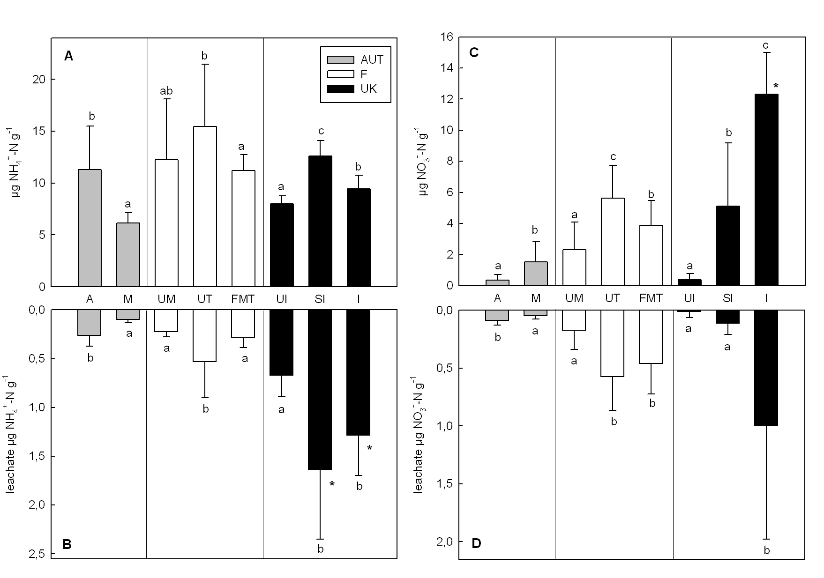
Figure 1

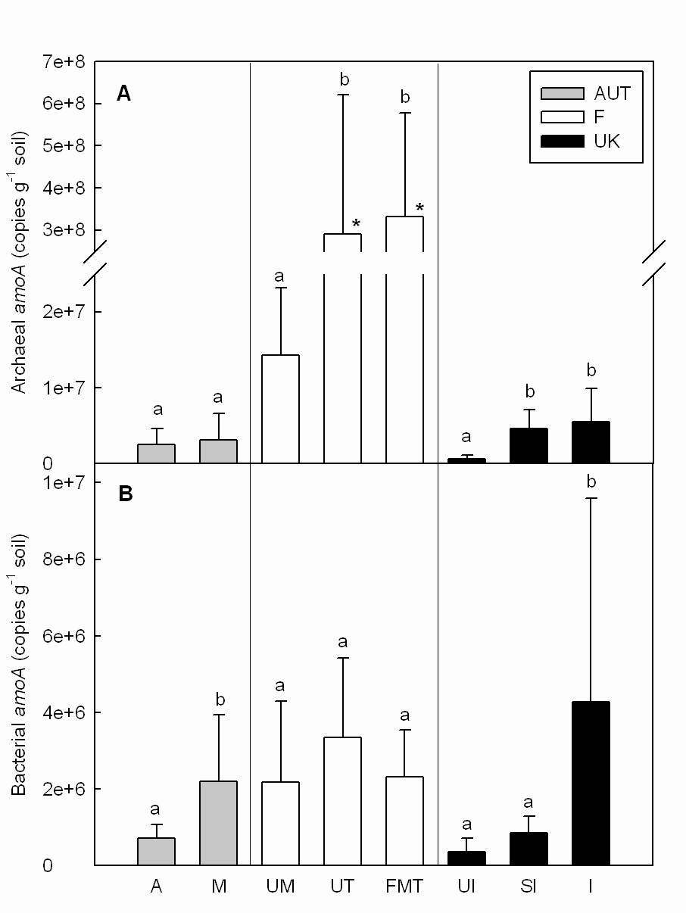
Figure 2

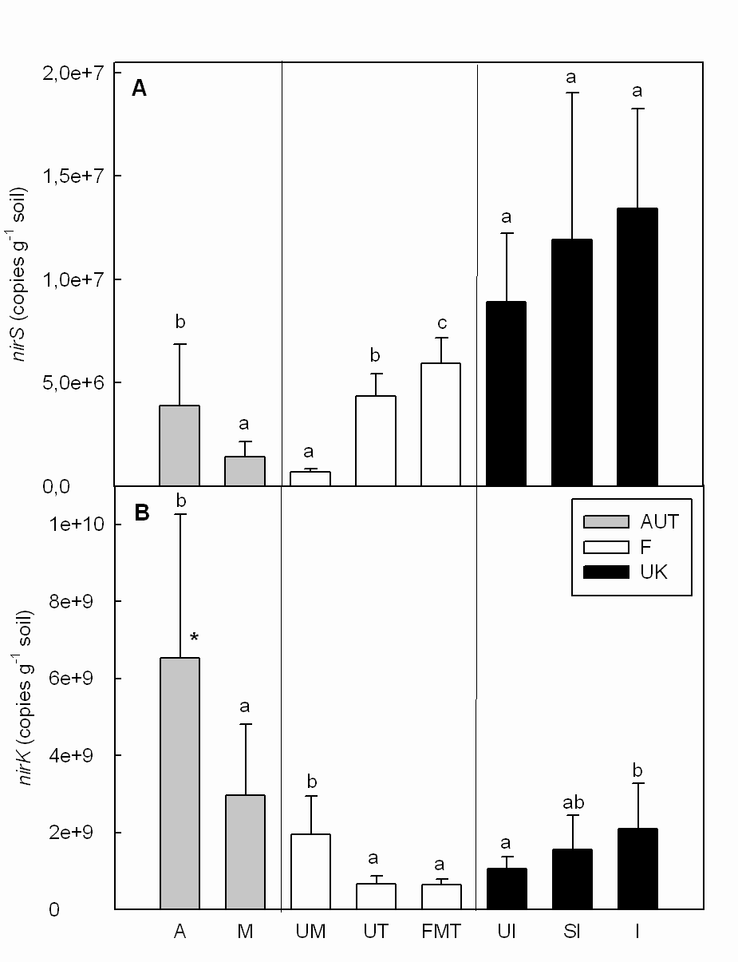
Figure 3

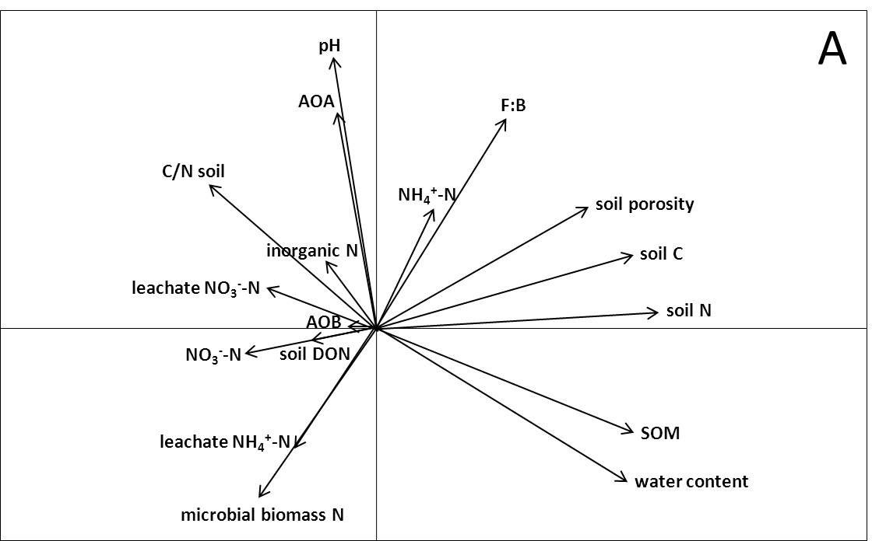

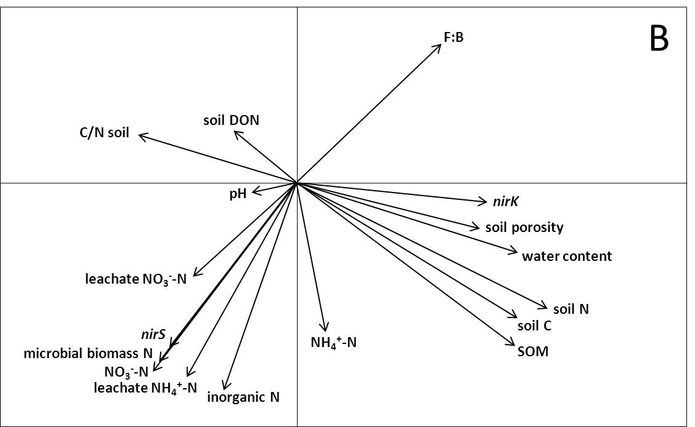

Figure 4

