Fasting hypoglycemia is associated with disease progression in presymptomatic early stage type 1 diabetes
Melanie Heinrich^{1*}, MD; Nicole Maison^{1*}, MD; Peter Achenbach¹, MD; Robin Assfalg¹, PhD; Sonja Braig², MD; Dominik Böcker³, MD; Desiree Dunstheimer⁴, MD; Uwe Ermer⁵, MD; Antonia Gavazzeni⁶, MD; Eva-Maria Gerstl⁷, MD; Sandra Hummel¹, PhD; Kerstin Kick¹, MD; Herbert Müller⁸, MD; Nicole Nellen-Hellmuth⁹, MD; Christian Ockert¹⁰, MD; Marina Sindichakis¹¹, MD; Stefanie Tretter¹², MD; Katharina Warncke^{1,13}, MD; Anette-Gabriele Ziegler^{1**}, MD; Andreas Beyerlein^{1**}, PhD; and the Fr1da-Study group
¹ Institute of Diabetes Research, Helmholtz Zentrum München, Munich, Germany, and Forschergruppe Diabetes der Technischen Universität München, Munich, Germany
² Department of Pediatrics, Klinikum Bayreuth, Bayreuth, Germany
³ Department of Pediatrics, Klinikum Nürnberg Nord, Nuremberg, Germany
⁴ Department of Pediatrics, Klinikum Augsburg, Augsburg, Germany
⁵ Department of Pediatrics, Kliniken St Elisabeth, Neuburg an der Donau, Germany
⁶ Pediatric Practice Bogenhausen, Munich, Germany
⁷ Pediatric Hospital Dritter Orden Passau, Passau, Germany
⁸ Department of Pediatrics, Klinikum Kempten, Kempten, Germany
⁹ Family Practice Dr med Hans-Jörg Hellmuth, Würzburg, Germany
¹⁰ Department of Pediatrics, RoMed Kliniken, Rosenheim, Germany
¹¹Department of Pediatrics, Kliniken Südostbayern, Traunstein, Germany
¹²Department of Pediatrics, Kliniken Nordoberpfalz, Weiden, Germany
¹³Department of Pediatrics, Klinikum rechts der Isar, Technische Universität München, Munich, Germany
* shared first authorship
** shared senior authorship and correspondence
Prof. Dr. Anette-G. Ziegler, MD
PD Dr. Andreas Beyerlein, PhD
Institute of Diabetes Research
Helmholtz Zentrum München
Ingolstädter Landstraße 1
85764 Neuherberg, Germany
Phone +49(0)89 3187-2836
Fax +49(0)89 3081-733
E-mail: anette-g.ziegler@helmholtz-muenchen.de

Word count abstract: 247
Word count main text: 1500
Abstract
Aims: In children with presymptomatic type 1 diabetes, intermittent hyperglycemia and rising HbA1c levels are a known signal of progression towards insulin-dependency. Episodes of hypoglycemia, however, have also been reported in one published case. We investigated the prevalence of hypoglycemia and its association with disease progression in children with presymptomatic type 1 diabetes.
Methods: We compared the frequency of hypoglycemic fasting blood glucose levels (<60 mg/dl) in 48 autoantibody negative and 167 multiple beta-cell autoantibody positive children aged 2-5 years. We classified the autoantibody positive children into three categories based on their glucose levels in fasting state (hypoglycemic (<60 mg/dl, normoglycemic (60-99 mg/dl) or hyperglycemic (≥100 mg/dl)). We then compared the glucose levels under challenge during oral glucose tolerance tests (OGTT) between the three categories.
Results: In the autoantibody positive children, 5.1% of the fasting samples were hypoglycemic, while in the autoantibody negative children no hypoglycemia was observed. Hypoglycemia occurred more often in autoantibody positive children who had already entered stage 2 or stage 3 of type 1 diabetes than in stage 1 patients (p=0.02). Children who had hypoglycemic compared to normoglycemic fasting blood glucose values had higher 120 minute blood glucose values under OGTT challenge, and a higher rate of pathological OGTTs (p=0.04).
Conclusions: Fasting hypoglycemia seems to be an indicator of disease progression in presymptomatic type 1 diabetes and may therefore represent a novel marker for the identification of children who should be monitored more closely for progression towards insulin dependent type 1 diabetes.
Research in context
- Hypoglycemia has previously been suggested as a precursor of insulin-dependent type 1 diabetes, but never been investigated in detail.
- The aim of this study was to determine if hypoglycemic fasting blood glucose values were associated with disease progression in children with multiple beta cell autoantibodies who did not receive insulin treatment.
- Hypoglycemic fasting blood glucose values were observed in multiple beta cell autoantibody positive, but not in beta cell autoantibody negative children participating in the German Fr1da and POGO studies, respectively. Hypoglycemia also occurred more often in autoantibody positive children with an advanced stage of type 1 diabetes.
- Children who had hypoglycemic compared to normoglycemic fasting blood glucose values had higher 120 minute blood glucose values under OGTT challenge, and a higher rate of pathological OGTTs.
- We suggest that hypoglycemia is a symptom of presymptomatic type 1 diabetes and indicates disease progression.
Introduction
In the context of type 1 diabetes (T1D), hypoglycemia under insulin therapy is a common issue [1-3]. Hypoglycemia before insulin treatment in people with presymptomatic T1D, however, has only been reported in one case study [4]. In general, knowledge about blood glucose levels in presymptomatic T1D is sparse because up to now T1D was only diagnosed when patients presented with typical symptoms resulting from metabolic decompensation. Early stages of T1D are defined by the absence of such symptoms, the presence of at least two beta cell autoantibodies and either normoglycemia (stage 1) or dysglycemia (stage 2) during an oral glucose tolerance test (OGTT) performed before the onset of symptomatic, insulin-dependent diabetes (stage 3) [5]. The Fr1da study aims to establish a population-based screening of 2-5 year old children for the presence of an early stage of T1D and thus provides a unique opportunity to explore blood glucose levels in presymptomatic T1D [6]. We investigated whether fasting hypoglycemia more often occurs in presymptomatic multiple beta cell autoantibody positive (multAB) than autoantibody negative (ABneg) children, and whether hypoglycemia is associated with disease progression.

Research Design and Methods
Study population
The Fr1da study screens children aged 2-5 years living in Bavaria, Germany, for an early stage of T1D, which is defined by the presence of multiple beta cell autoantibodies (IAA, GADA, IA2A or ZnT8) [6]. Between January 2015 and October 2017, 167 multAB children had their first Fr1da study visit (median age 4.2 years, 93 (55.7%) males), where an HbA1c test and a weight-adapted 75-g OGTT were performed. Further OGTTs were performed as part of the Fr1da follow-up as described elsewhere [6], summing up to a total of 277 OGTT and HbA1c measurements in 1-5 visits per child. OGTTs of 150 ABneg children aged 1-17 years were available from the POGO study, where healthy offspring of mothers with gestational diabetes were enrolled [7]. In order to match the age distribution in Fr1da, we restricted the POGO data to children who were 2-5 years old and did not have a pathological OGTT (i. e. fasting blood glucose (FBG) ≥100 mg/dl and, if available, blood glucose ≥200 mg/dl at 30, 60 and 90 minutes and ≥140 mg/dl at 120 minutes during OGTT) at the time of the single study visit, yielding a sample size of 48 children (median age 4.5 years, 27 (56.3%) males) and 15 OGTT measurements. In both studies, children’s weight and height were measured under standardized conditions by trained study personnel. The studies were approved by the Ethical Committee of the Technical University, Munich, Germany (No. 70/14 and 2937, respectively). Written consent was obtained from the children's legal guardians. All samples from both studies were analyzed in the laboratory of the Institute of Diabetes Research at the Helmholtz Zentrum München, Neuherberg, Germany, for glucose levels and HbA1c, as well as for the presence of islet autoantibodies as previously described [8, 9].

Statistical Analysis
The FBG samples were classified as hypoglycemic, normoglycemic or hyperglycemic (<60, 60-99, and ≥100 mg/dl, respectively). The first occurrence of a pathological OGTT (as defined above) was considered onset of stage 2 or (in case of a blood glucose value ≥200 mg/dl at 120 minutes) of stage 3 of T1D. Height and weight were used to calculate body mass index (BMI) and lipids were transformed into age- and sex-specific standard deviation scores (SDS), according to German reference values [10]. We compared the frequency of hypoglycemia (at first visit) and FBG values (at any visit) in ABneg and multAB children using the Fisher and Mann-Whitney-U test, respectively. In the multAB children, we investigated associations between blood glucose values during fasting state and under OGTT challenge, using scatterplots and locally estimated scatter plot smoothing (LOESS) curves. As a sensitivity analysis, we assessed these associations only for the initial samples of each child to avoid potential bias by differing numbers of repeated measurements within each individual. We further assessed associations of FBG categories with basic characteristics as well as with disease progression, HbA1c values and mean OGTT patterns using Fisher and Mann-Whitney U tests (as appropriate). Finally, we used logistic regression to assess the association of hypoglycemia (outcome variable) with disease stage in multiple autoantibody positive children, performing stepwise adjustment for sex, age, season of blood glucose measurement (Mar-May: spring; Jun-Aug: summer; Sep-Nov: autumn; Dec-Feb: winter) and BMI SDS. All data were analyzed using SAS 9.4 (SAS Institute Inc, Cary, North Carolina) and R 3.4.2 (R Foundation for Statistical Computing, Vienna, Austria).

Results
FBG levels were on average lower in samples from multAB than ABneg children (median 81 (interquartile range (IQR): 73, 88) mg/dl versus 84 (80, 87) mg/dl; p=0.02).
Ten multAB children (6.0%) had hypoglycemic FBG levels at their first visit compared to none of the ABneg children (p=0.12). One of these ten multAB children had another hypoglycemic FBG at its follow-up visit. Two multAB children who did not have a hypoglycemic FBG at their first visit had a hypoglycemic FBG at a follow-up visit, one of them another hypoglycemic FBG at the next consecutive visit. Overall, hypoglycemia therefore occurred in 14 of the 277 FBG measurements (5.1%) performed in the multAB children (total range of FBG measurements: 32-116 mg/dl).
Of the 167 children with multAB, 129 (77.3%) remained throughout follow-up in stage 1, while 29 (17.4%) progressed to stage 2, and nine (5.4%) to stage 3. There were no significant differences between autoantibody negative children and children who progressed to different stages during follow-up with respect to basic characteristics with the exception of a lower age at enrolment in those children who progressed to stage 2 (table 1). Fasting hypoglycemia was significantly more often observed in multAB children who had already entered stage 2 (4/60 samples (6.7%)) or stage 3 (3/14 samples (21.4%)) than in those who remained in stage 1 (7/203 samples (3.5%); p=0.02; figure 1). Accordingly, occurrence of hypoglycemia was significantly associated with having disease stage 3, but not with other potential predictors, and independently of those (table 2).
Scatterplots indicated that fasting hypoglycemia in multAB mainly correlated with blood glucose values after 120 minutes during OGTT, as these values were higher in samples with hypoglycemic than normoglycemic FBG values (figure 2, supplementary figure 1). The associations between fasting hypoglycemia and blood glucose values at 30, 60 or 90 minutes were less clear or non-existent. Accordingly, a pathological OGTT was observed on four of the 14 occasions (28.6%) where fasting hypoglycemia occurred compared to 23 of the 249 occasions (9.2%) where fasting normoglycemia was seen (p=0.04).
Mean curves of OGTTs associated with normo- and hyperglycemic fasting glucose values in multAB children peaked at 30 minutes, similar to the OGTTs of ABneg children. The respective mean blood glucose peak of multAB children with a hypoglycemic fasting blood glucose occurred only after 60 minutes (figure 3). The decrease in blood glucose from peak to 120 minutes was relatively weak in multAB samples associated with a hypoglycemic FBG value (15.4 mg/dl) compared to multAB samples with a normoglycemic FBG or ABneg samples (38.0 and 32.4 mg/dl, respectively), but similar to that in multAB children with a hyperglycemic FBG sample (20.1 mg/dl). Results were similar when multAB children who did not progress from stage 1 during follow-up were not included in the analysis (supplementary figure 2).
MultAb children with fasting hypoglycemia had similar median (IQR) HbA1c levels (5.3 (5.1-5.6) %) compared to those with normoglycemic fasting glucose levels (5.3 (5.1-5.5) %, p=0.62).

Discussion
Our analyses showed that hypoglycemic FBG levels occasionally appear in multAB children aged 2-5 years, while we observed no fasting hypoglycemia in ABneg children of the same age. Fasting hypoglycemia was more frequently observed in multAB children with an advanced disease stage, and multAb children with fasting hypoglycemia more often had pathological OGTTs compared to those with normoglycemic FBG. HbA1c, however, was comparable in both FBG groups. We think this is most likely due to the fact that the hypoglycemic FBG values balanced the elevated post-prandial blood glucose values. Hypoglycemic FBG values were also associated with a diminished decrease in blood glucose after peaking indicating a decreased insulin secretion response, similar to hyperglycemic FBG values.
Further studies with continued glucose monitoring of patients with hypoglycemic FBG values are needed in order to determine how often these patients have fasting hypoglycemia and whether their awareness of hypoglycemic events is diminished. A theoretical explanation for the results may be a dysregulation between alpha and beta cells. Another explanation may be a surge of insulin release due to beta cell destruction. A similar phenomenon has already been documented in thyroid autoimmunity. In Hashitoxicosis an excess of thyroid hormone is released prior to Hashimoto thyroiditis [11]. Studies to assess glucagon and insulin levels will have to be performed in order to determine the underlying pathomechanism. In summary, we suggest that hypoglycemic FBG values in multAB children are an important prodrome of advanced stages of presymptomatic T1D. Monitoring of diabetes progression via HbA1c may not be sufficient and additionally require post-prandial blood glucose measurements.

Funding
The POGO study was supported by grants from the German Federal Ministry of Education and Research (BMBF) to the German Center for Diabetes Research (DZD e.V.) and the German Diabetes Association. The Fr1da study is supported by grants from the LifeScience-
Stiftung, JDRF (1-SRA-2014-310-M-R), the Bavarian State Ministry of Health and Care (Gesund.Leben.Bayern, LP00228), Deutsche Diabetes-Stiftung, Landesverband Bayern der Betriebskrankenkassen, B. Braun-Stiftung (BBST-D-15-00016) and Deutsche Diabetes-Hilfe.

Duality of interest
The authors have no conflicts of interest to disclose.

Authors’ contributions
M.H. and N.M. contributed to acquisition, analysis and interpretation of data and drafted the article. A.B. performed data analysis, reviewed the manuscript and contributed to the final draft of the manuscript. R.A. and K.K. helped acquire the data in their functions as study coordinators. S.B., D.B., D.D., U.E., A.G., E.-M.G., H.M., N.N.-H., C.O., M.S., S.T. and K.W. contributed to the acquisition of the Fr1da OGTT data. S.H. contributed to the acquisition of the POGO data. P.A. contributed to data analysis and writing of the final draft. A.-G.Z. designed the study, is the Principal Investigator of the Fr1da and POGO studies, contributed to data analysis and writing of the final draft. M.H. and N.M. are the guarantors of this work, and as such had full access to all the data in the study and take responsibility for the integrity of the data and the accuracy of the data analysis.
All authors critically revised the article for important intellectual content and gave final approval of the version to be published.

References

1. Pramming, S., et al., Symptomatic hypoglycaemia in 411 type 1 diabetic patients. Diabet Med, 1991. 8(3): p. 217-22.
2. Hypoglycemia in the Diabetes Control and Complications Trial. The Diabetes Control and Complications Trial Research Group. Diabetes, 1997. 46(2): p. 271-86.
3. Beregszaszi, M., et al., Nocturnal hypoglycemia in children and adolescents with insulin-dependent diabetes mellitus: prevalence and risk factors. J Pediatr, 1997. 131(1 Pt 1): p. 27-33.
4. Rafeullah, N., N. Cackett, and K. Hussain, Fasting hypoglycaemia and postprandial hyperglycaemia as a prodrome of type 1 diabetes mellitus. Horm Res Paediatr, 2012. 78(5-6): p. 332-5.
5. Insel, R.A., et al., Staging presymptomatic type 1 diabetes: a scientific statement of JDRF, the Endocrine Society, and the American Diabetes Association. Diabetes Care, 2015. 38(10): p. 1964-74.
6. Raab, J., et al., Capillary blood islet autoantibody screening for identifying pre-type 1 diabetes in the general population: design and initial results of the Fr1da study. BMJ Open, 2016. 6(5): p. e011144.
7. Hummel, S., et al., Postpartum outcomes in women with gestational diabetes and their offspring: POGO study design and first-year results. Rev Diabet Stud, 2013. 10(1): p. 49-57.
8. Ziegler, A.G., et al., Autoantibody appearance and risk for development of childhood diabetes in offspring of parents with type 1 diabetes: the 2-year analysis of the German BABYDIAB Study. Diabetes, 1999. 48(3): p. 460-8.
9. Achenbach, P., et al., Autoantibodies to zinc transporter 8 and SLC30A8 genotype stratify type 1 diabetes risk. Diabetologia, 2009. 52(9): p. 1881-8.
10. Kromeyer-Hauschild, K., et al., Perzentile für den Body-mass-Index für das Kindes- und Jugendalter unter Heranziehung verschiedener deutscher Stichproben. Monatsschrift Kinderheilkunde, 2001. 149(8): p. 807-818.

Table 1. Characteristics of the children analyzed, stratified by autoantibody status / maximum disease stage during follow-up. Data are presented as n (%) or median (interquartile range), and differences between the groups were assessed using the Fisher or Mann-Whitney-U test (as appropriate). Body mass index (BMI), height and weight were transformed into age- and sex-specific standard deviation scores (SDS), according to German reference values [10].
 | Autoantibody negative (n=48) | Stage 1 (n=129) | Stage 2 (n=29) | Stage 3 (n=9) | p-value
Female children | n=21 (44%) | n=56 (43%) | n=15 (52%) | n=3 (33%) | 0.78
Age at enrolment (years) | 4.5 (3.7, 4.9) | 4.2 (3.3, 5.4) | 2.9 (2.3, 4.2) | 4.2 (3.1, 4.6) | <0.01
BMI SDS at enrolment | 0.0 (-0.8, 0.5) | 0.1 (-0.4, 0.7) | 0.2 (-0.9, 0.4) | -0.4 (-1.1, 0.9) | 0.47
Height SDS at enrolment | -0.1 (-0.5, 1.0) | 0.4 (-0.5, 1.1) | 0.1 (-0.4, 0.9) | 1.4 (0.0, 1.6) | 0.17
Weight SDS at enrolment | -0.1 (-0.7, 0.5) | 0.3 (-0.2, 0.9) | -0.1 (-0.6, 0.7) | 0.2 (-0.2, 1.6) | 0.10
Season of measurement
Spring (Mar-May) | n=21 (44%) | n=35 (27%) | n=6 (21%) | n=3 (33%) | 0.35
Summer (Jun-Aug) | n=12 (25%) | n=42 (33%) | n=8 (28%) | n=1 (11%) | 0.35
Autumn (Sep-Nov) | n=10 (21%) | n=27 (21%) | n=9 (31%) | n=2 (22%) | 0.35
Winter (Dec-Feb) | n=5 (10%) | n=25 (19%) | n=6 (21%) | n=3 (33%) | 0.35
Missing values on BMI, height and weight SDS at enrolment: n=1 (autoantibody negative); n=12 (stage 1); n=8 (stage 2); n=2 (stage 3)
Figure 1. Dot plots of fasting blood glucose by stage of type 1 diabetes in 277 samples of 167 children with multiple beta-cell autoantibodies, as well as in 48 autoantibody negative children (ABneg; one sample per child). The dashed and dotted lines indicate thresholds of fasting hypo- and hyperglycemia, respectively.

Table 2. Odds ratios (95% confidence intervals) of hypoglycemia by disease stage (reference: stage 1), sex, age, season of blood glucose measurement (reference: spring) and body mass index standard deviation score (BMI SDS) as derived from logistic regression models with stepwise adjustment (multiple samples per individual).
 | Model 1 | Model 2 | Model 3 | Model 4
Disease stage
Stage 2 | 2.00 (0.57, 7.08) | 1.64 (0.44, 6.03) | 1.79 (0.48, 6.65) | 0.42 (0.05, 3.92)
Stage 3 | 7.64 (1.73, 33.63) | 6.46 (1.43, 29.25) | 6.99 (1.40, 34.79) | 5.42 (0.79, 37.20)
Female child |  | 0.55 (0.16, 1.86) | 0.54 (0.16, 1.88) | 0.53 (0.12, 2.30)
Age (per year) |  | 0.72 (0.42, 1.21) | 0.69 (0.41, 1.17) | 0.60 (0.32, 1.11)
Season of measurement
Summer |  |  | 0.33 (0.08, 1.37) | 0.24 (0.04, 1.39)
Autumn |  |  | 0.13 (0.01, 1.10) | 0.16 (0.02, 1.45)
Winter |  |  | 0.35 (0.08, 1.55) | 0.15 (0.02, 1.53)
BMI SDS (per unit)* |  |  |  | 1.05 (0.57, 1.94)
*n=105 missing values
Figure 2. Scatterplots and LOESS estimates with corresponding 95% confidence intervals (red lines) of fasting blood glucose and blood glucose measurements at 30, 60, 90 and 120 minutes, respectively, during an oral glucose tolerance test (OGTT) in multiple autoantibody positive children (multiple samples per individual). Dashed lines indicate thresholds of pathological OGTTs.
Figure 3. Mean blood glucose values measurements at 0, 30, 60, 90 and 120 minutes during an oral glucose tolerance test (OGTT) in multiple beta cell autoantibody positive (multAB) and autoantibody negative (ABneg) children by their fasting blood glucose (FBG) values.
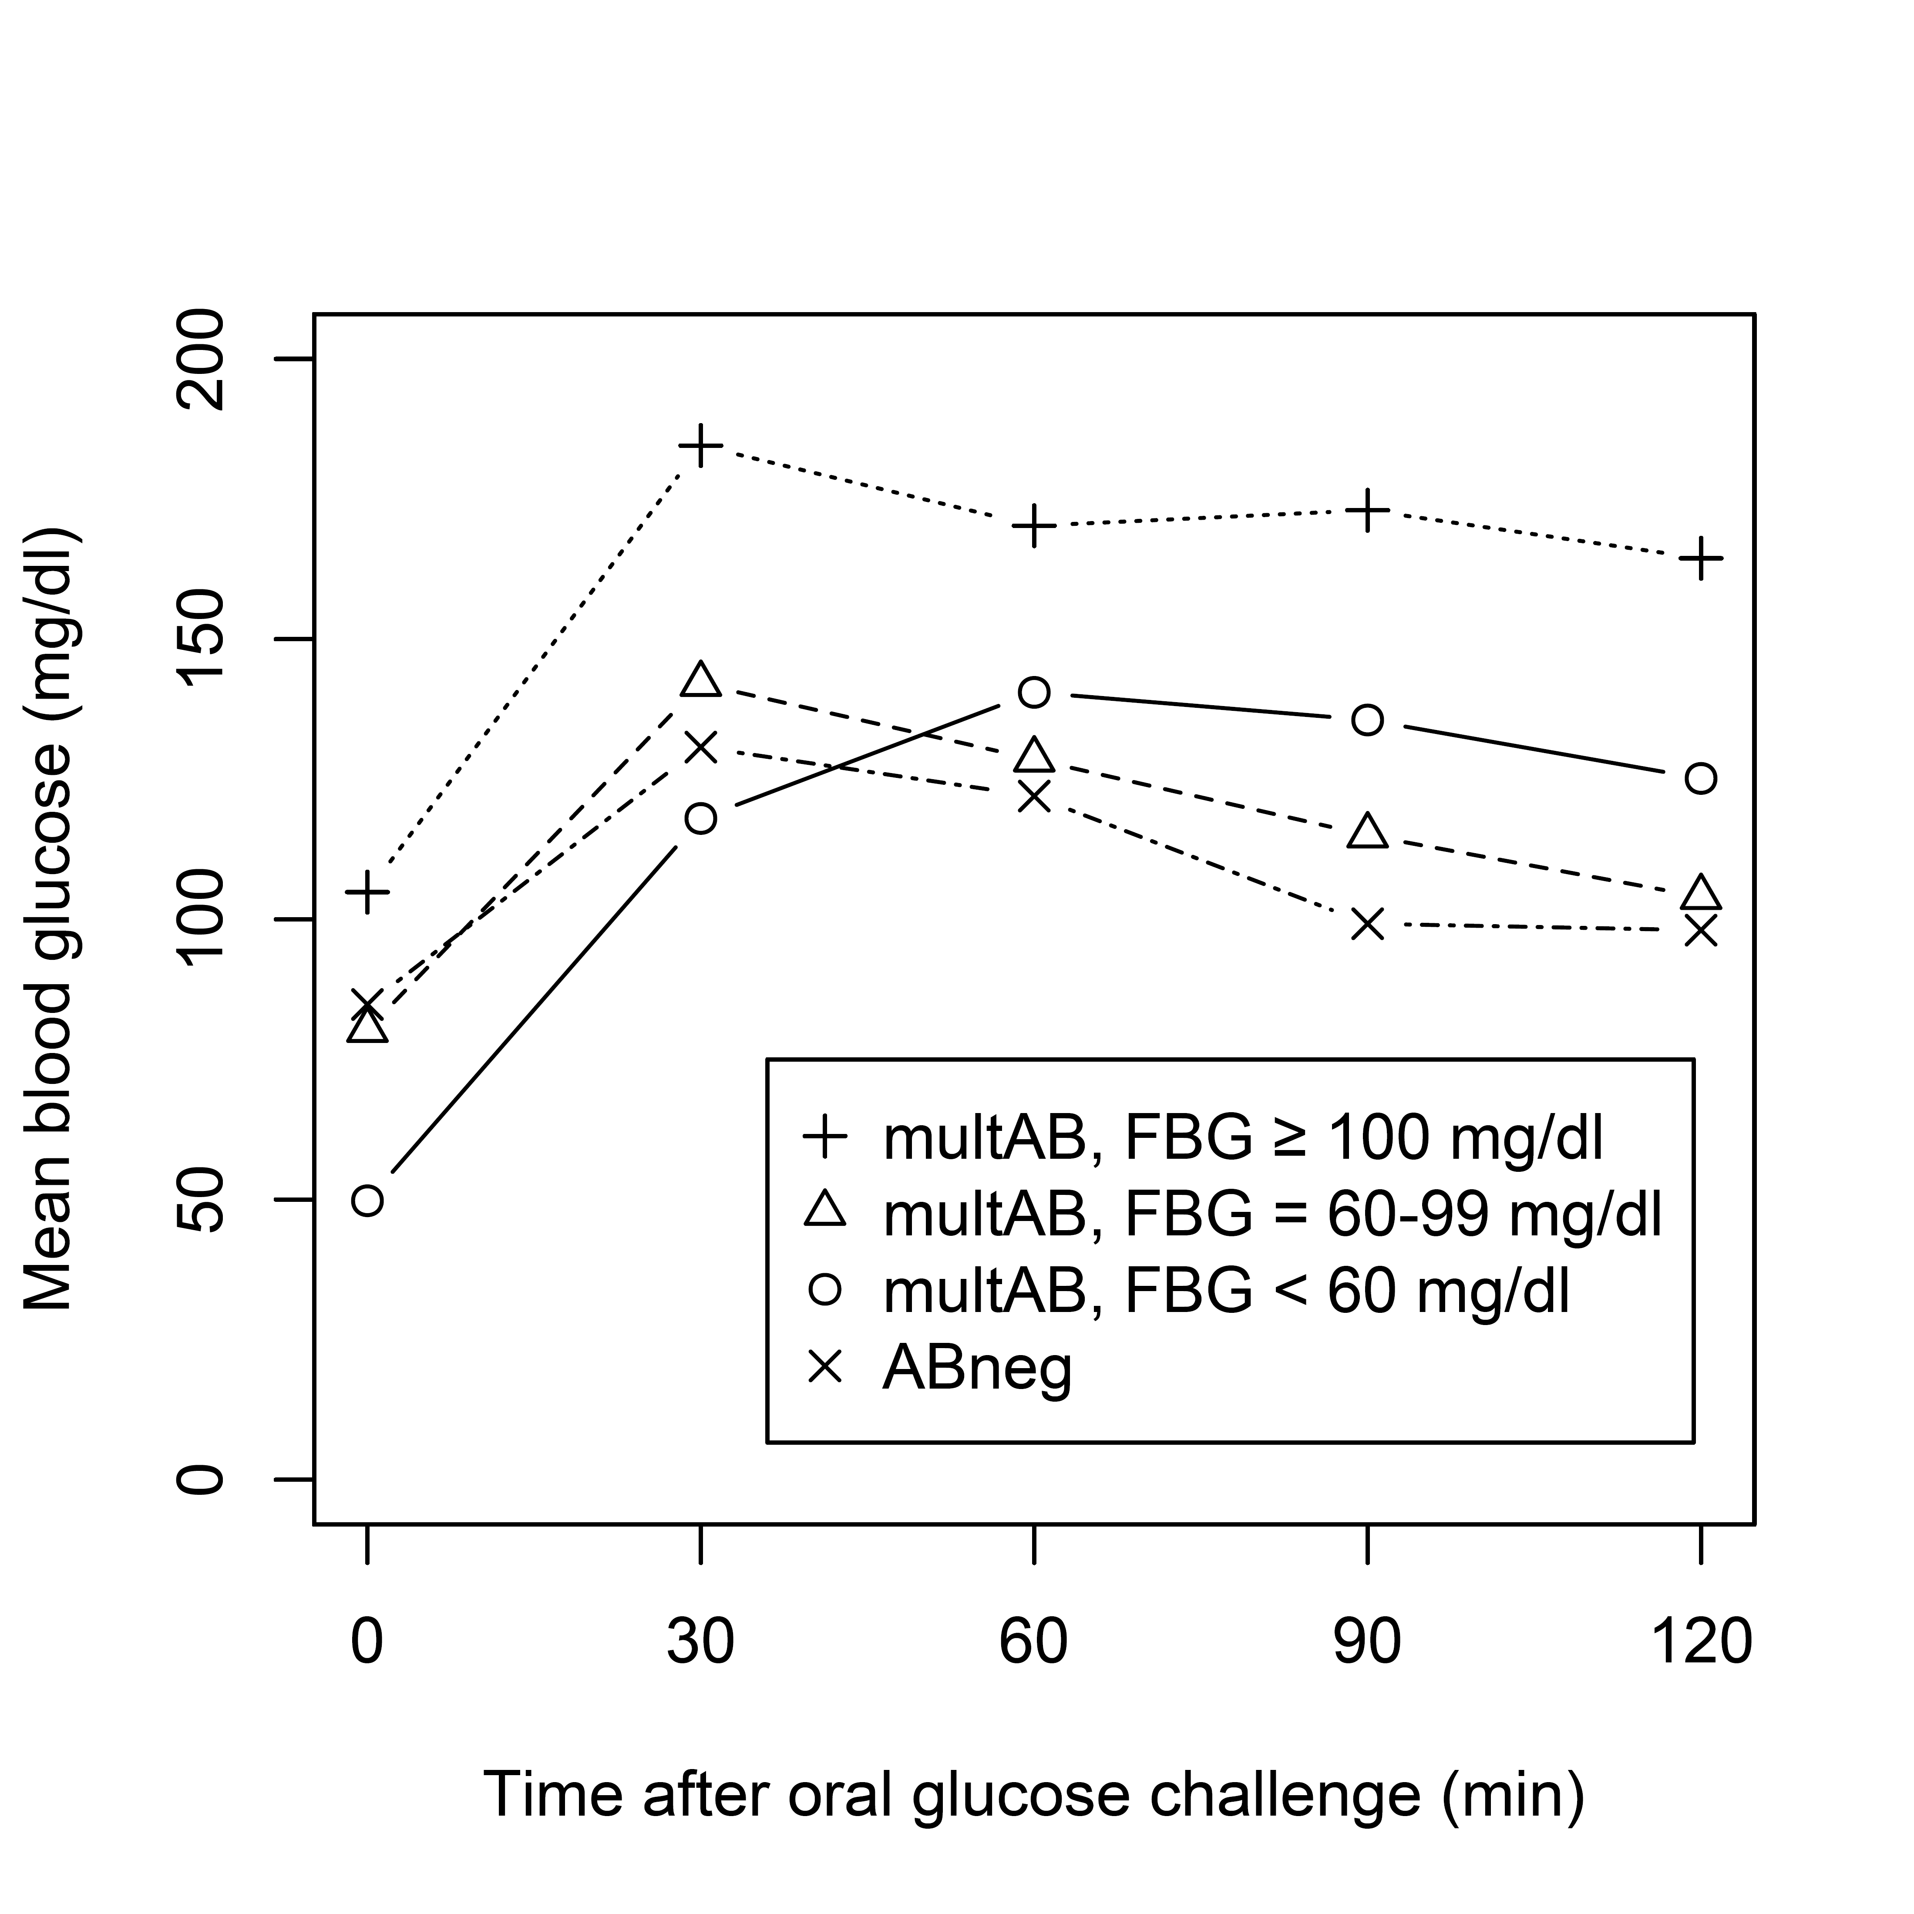
Supplementary Figure 1. Scatterplots and LOESS estimates with corresponding 95% confidence intervals (red lines) of fasting blood glucose and blood glucose measurements at 30, 60, 90 and 120 minutes, respectively, during an oral glucose tolerance test (OGTT) in multiple autoantibody positive children (only initial samples, i.e. one sample per individual). Dashed lines indicate thresholds of pathological OGTTs.
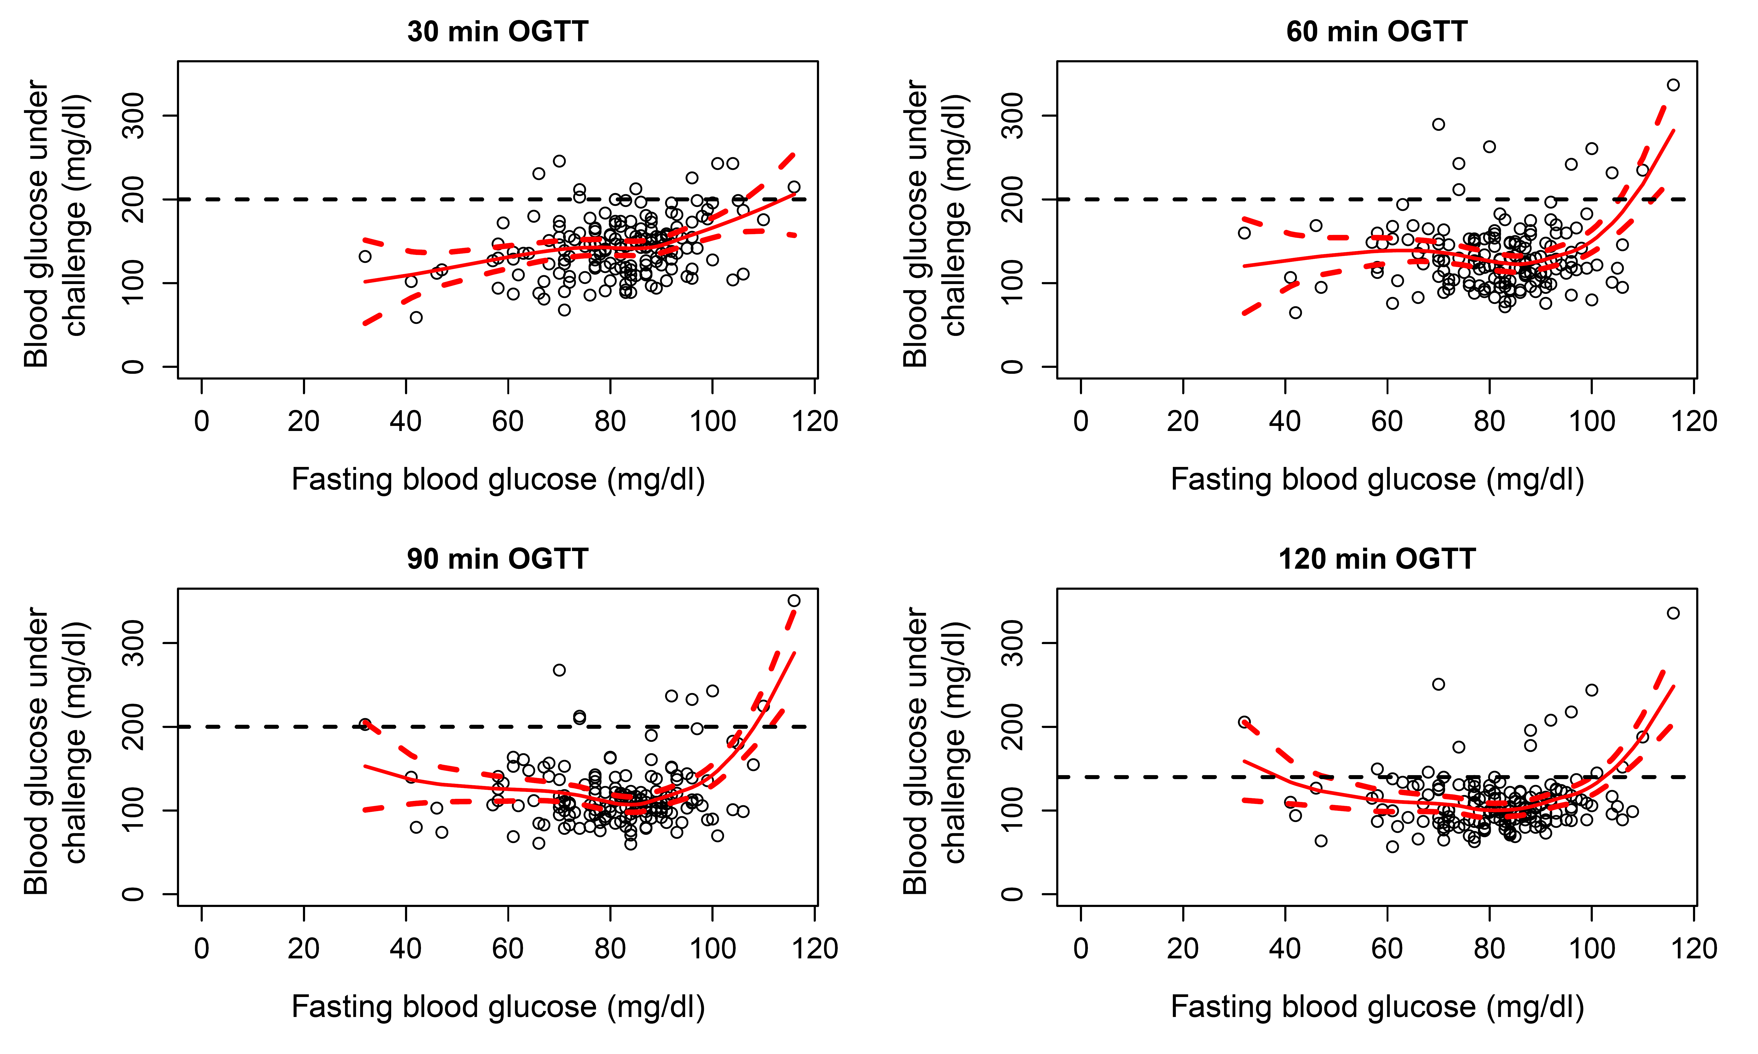
Supplementary Figure 2. Mean blood glucose values measurements at 0, 30, 60, 90 and 120 minutes during an oral glucose tolerance test (OGTT) in multiple beta cell autoantibody positive (multAB) who progressed to stage 2 or 3 during follow-up and autoantibody negative (ABneg) children by their fasting blood glucose (FBG) values.
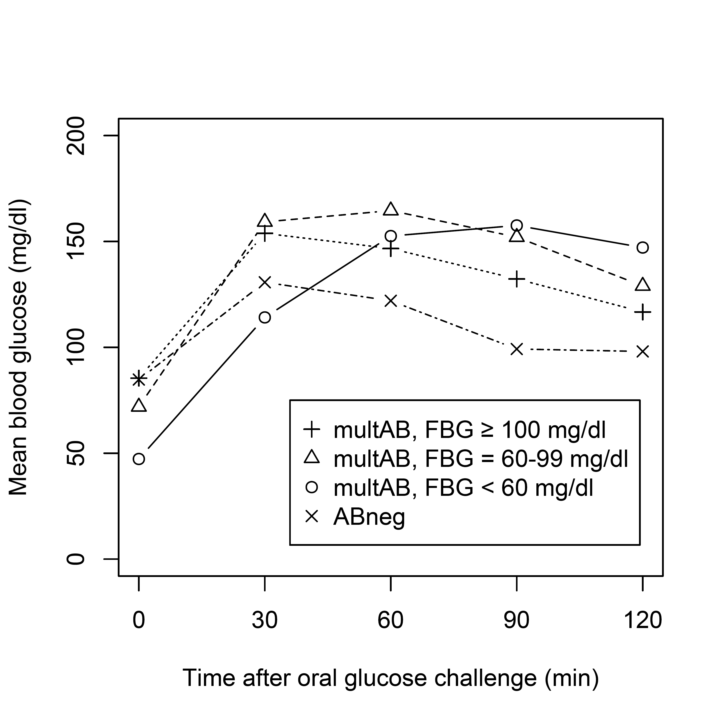
Supplement
Fr1da-Study Group: Screening centre Munich—Alevtina Durmashkina, MD, Stephanie Zillmer, MD, Anna Hofelich, MD, Susanne Aydin MD, Melanie Bunk, Susanne Hivner, Melanie Herbst, Yvonne Kriesen, Annette Knopff, Claudia Ramminger, Charlotte Koch, Joanna Stock, Laura Schulzik, Anja Heublein, Manja Jolink, Florian Haupt, PhD, Christiane Winkler, PhD, Marlon Scholz, Claudia Matzke, Lorena Wendel, Susanne Wittich, Katharina Gestrich, Anita Gavrisan, Cigdem Gezginci.
Primary care paediatricians— Renate Abt, MD, Wendelstein; Aderbauer/Leonhardt/Riedl, MD, Weiden; Ina Albrich, Dorfen; Stephan Arenz, MD, Pfaffenhofen; Bernd Aulinger, MD, Burglengenfeld; Glenn Averbeck, MD, Pfaffenhofen; Annette Bachmann-Hoschka, MD, Teisendorf; Andrea Bachmeyr, MD, München; Baier/Baier, MD, Schwabach; Elmar Barthel, MD, Gemünden; Marina Bascone-Fricke, MD, Aidenbach; Batz/Hubmann, MD, Zirndorf; Rolf Bauer, MD, Roth; Yvonna Bauer, MD, Augsburg; Gunhild Bauer-Niedermaier, MD, Zirndorf; Larissa Baumgärtner, Heilsbronn; Michael Bäzner, MD, Sonthofen; Beck/Baier/Mussar, MD, Donauwörth; Axel Becker, MD, Haar; Ulrich Müller, MD, München; Herbert; Beer/Schirmer, MD, Marktredwitz; Lutz Bellingrath, MD, Bamberg; Reiner Benckendorff, MD, Augsburg; Gertraud Bergen, MD, Haßfurt; Monika Berger, MD, Haimhausen; Annerose Bergner, MD, München; Beste/Hosemann, MD, Dachau; Reinhard Beuthan, MD, Dingolfing; Katrin Biebach, MD, München; Dominique Bienert, MD, München; Matthias Bierler, MD, Amberg;Biermann-Franke/Trinczek, MD, Erlangen; Klaus Binder, MD, Nürnberg; Brigitte Birk, MD, Peißenberg; Maria-Magdalena Blauditschek, MD, Würzburg; Jörg Blume, Schweinfurt; Blümel-Eiber/Rösch, MD, Nürnberg; Andreas Blüml, Trostberg; Sabine Böhm-Vogt, MD, Ottobrunn; Karola Börzsönyi, MD, Freising; Stephan Böse-O’Reilly, MD, München; Malte Bräutigam, MD, Eichstätt; Walter Breiner, Marktoberdorf; Ulrike Brendel, MD, Parsberg; Michael Brijnen von Oldershausen, MD, München; Christian Brückmann, MD, Brannenburg; Halina Eva Buchalik, Lauf an der Pegnitz; Franz Bundscherer, MD, Geretsried; Anna Bürcky, MD, Ochsenfurt; Barbara Capelle, MD, Unterhaching; Mona Castrop, MD, Regensburg; Alina Cocos, MD, Markt Schwaben; Cordes/Gebhard, MD, Nürnberg; Christoph Daffner, MD, Nürnberg; Arcan Demircioglu, MD, München; Jost Dieckerhoff, MD, Rosenheim; Karolin Diergarten, MD, Germering; Elmar Dietmair, MD, Bobingen; Lutz Dietrich, MD, Hof; Maximilian Dietrich, MD, Aichach; Brigitte Dietz, MD, Taufkirchen; Christian Döbig, MD, Erlangen; Sylvia Döpfer, MD, München; Jürgen Dörrer,
Freyung; Ragnar Dörrfuss, MD, Nürnberg; Monika Drexel, MD, Rehau; Elke Düll-Schiller, MD, Neumarkt; Stefan Eber, MD, München; Christoph Ebert, MD, Ebersberg; Thomas Ebert, Veitsbronn/Siegelsdorf; Christina Eder, MD, Bayreuth; Claudia Eichwald, MD, Ingolstadt; Annette Eiden, MD, Gauting; Claus Engelhardt, MD, Nürnberg; Anja Engelmann, MD, Dinkelscherben; Georg Engl, MD, München; Uta Enzensberger, MD, Mering; Patricia Erlinger, MD, Postbauer-Heng; Uwe Ermer, MD, Neuburg/Donau; Kirsten Exl, München; Florian Fackler, MD, Erlangen; Edgar Fath, MD, München; Peter Feiereisen, MD, München; Daniela Felsl, MD, Wolnzach; Fendel/Wieland, MD, München; Maria Fischer, MD, Lappersdorf; Cordula Fischer-Trüstedt, MD, München; Katrin Franke-Augustin, MD, Bayreuth; Harald Frantzmann, MD, Memmingen; Rudolf Franz, MD, München; Claudia Frey, MD, Augsburg; Müller, MD, Kempten; Müller/ Wilken/Schürmann, MD, Naila; Müller/Wilken/ Susanne Gandenberger, MD, München; Antonia Gavazzeni, MD, München; Christian Geißendörfer, MD, Selb; Edeltraud Gerber, MD, Kolbermoor; Martin Gerlich, MD, Dinkelsbühl; Elke Gerlitz, MD, Herzogenaurach; Julia Gerstl, MD, Hauzenberg; Jürgen Geuder, MD, Freilassing; Johannes Gilles, Gunzenhausen; Rainer Gillessen, MD, Ottobrunn; Cornelia Gläßel, MD, Fürth; Judith Glöckner-Pagel, MD, Regensburg; Hermann Gloning, MD, München; Birgit Goldschmitt-Wuttge, MD, München; Martin Götz, MD, Elisabethzell; Wolfgang Graser, MD, Nürnberg; Marion Grau-vom-Scheidt, MD, Nürnberg; Martin Griebel, MD, Poing; Angelika Gruber-Müller, MD, Ingolstadt; Dietrich Grunert, MD, Kempten; Christian Haas, MD, München; Richard Haaser, MD, Feucht; Caroline Haberl, MD, Starnberg; Ulrich Hagen, MD, Friedberg; Verner Hallmen, MD, München; Emma Halwas, MD, Geisenfeld; Ingrid Hartmann, MD, Lichtenfels; Conny Hartmann, MD, Bad Wörishofen; Christian Hartnik, Bad Staffelstein; Ulrike Haun, MD, Vilshofen; Gabi Haus, MD, München; Rudolf Havla, MD, Hof; Wolfgang Heck, MD, Vöhringen; Heck-Buchhorn/ Willnow, MD, Kösching; Ralph Heidingsfelder, Ansbach; Anette Hein, MD, Gerbrunn; Markus Helmreich, MD, Schweinfurt; Tanja Hemmers, MD, Augsburg; Anna Hencz, MD, Germering; Holger Hertzberg, MD, Schwabach; Sigrid Hesse, MD, Straubing; Daniela Heuschmann, MD, Regensburg; Cornelia Hoegen, MD, Herrsching; Reinhard Hoffmann, MD, Landshut; Steffen Hoffmann-Baldus, MD, Haar; Gerhard Hofmann, MD, Würzburg; Meike Hofmann, Mitterteich; Sabina Hohn, Nürnberg; Gabriele Hopf, MD, Ingolstadt; Jörg Horcher, MD, Straubing; Birgit Hortig-Nevelö, MD, Regenstauf; Annette Hovestadt, MD, München; Irene Hummel, Bamberg; Peter Hußlein, MD, Grassau; Wolfgang Hüttner, MD, Coburg; Anna Iarrapino-Demmel, MD, München; Birgit Indlekofer, MD, Tutzing; Annelie Intemann, MD, München; Margarete Jäger, MD, München; Peter Jakob, MD, Erlangen; Christine Janello, MD, Neubiberg; Jarosch/Schleupner, MD, Würzburg; Stefan Jobst, MD, Bayreuth; Janina Joiko, MD, München; Guido Judex, Regensburg; Ronny Jung, MD, Roth; Andreas Kalmutzki, Schwabach; Lampros Kampouridis, MD, Baldham; Michael Kandler, MD, Nürnberg; Susanne Kastl, MD, Bayreuth; Walther Kaufmann, Nürnberg; Bernhard Keck, MD, Augsburg; Peter Kellner, MD, Vilsbiburg; Lars Kellner, MD, Gräfelfing; Ghassan Khazim, MD, Hammelburg; Conelia Kiani, MD, Bayreuth; Gunhild Kilian-Kornell, MD, Starnberg; Annegret Klein, MD, Oberaudorf; Wolfgang Klein, MD, Augsburg; Kristina Klemp, MD, Burgkunstadt; Margreth Knebel, MD, München; Norbert Knieß, MD, Ingolstadt; Kober/Spannagel, MD, Gmund; Cornelia Komm, MD, Waldkraiburg; Nikos Konstantopoulos, MD, München; Cosima Köring, MD, Altötting; Renate Kramer, MD, München; Guido Krandick, MD, Deisenhofen; Barbara Krappatsch, MD, Viechtach; Krebs/Güler, MD, Neuendettelsau; Berndt Kreisberger, MD, Ismaning; Gerlinde Kreß-Rohrbach, MD, Stegaurach; Josef Kriesmair, MD, München; Andreas Kronwitter, MD, München; Matthias Krueger, MD, Klingenberg; Kubryk/Döring, MD, Aschheim; Thomas Kuchenbauer, MD, München; Ursula Kuhnle-Krahl, MD, Gauting; Stephan Küntzer, MD, Kitzingen; Wolfgang Künzer, MD, Regensburg; Beate Kusser, MD, München; Werner Küstermann, MD, Veitshöchheim; Wolfgang Küver, MD, München; Franz Lachner, MD, Ruhpolding; Wolfgang Landendörfer, MD, Nürnberg; Christina Lang, MD, Nürnberg; Martin Lang, MD, Schwabmünchen; Martin Lang, MD, Augsburg; Lang/Zötl, MD, Bad Tölz; Otto Laub, Rosenheim; Peter Lautenbach, Herzogenaurach; Gerhard Legat, MD, Amberg; Karl-Heinz Leppik, MD, Erlangen; Katrin Leuchtenberger, MD, Kelheim; Karin Leykauf, Bayreuth; Hans Lichtenstern, MD, Pocking; Werner Lick, MD, Würzburg; Gabriele Lieb, MD, Würzburg; Bärbel Liebezeit, MD, Mühldorf am Inn; Armin Liebscher, MD, Eckental; Susanne Linder, MD, Grafrath; Ruth Lindner-Gajek, MD, München; Lipinski/ Mende/Kirtscher, MD, Lindenberg; Harald Lodes, MD, Neumarkt; Markus Loeff, MD, Landsberg am Lech; Andreas Lorenz, Krumbach; Martin Löw, Memmingen; Anna Elisabeth Lüdtke, MD, Neu-Ulm; Renata Lysy, MD, Möhrendorf; Eva Maas-Doyle, MD, Erlangen-Tennenlohe; Michaela Maier, MD, Pfaffenhofen; Soyoun Maisch, MD, München; Stefanie Marr, Ingolstadt; Martin/Schilder, MD, Schrobenhausen; Stephan Martini, MD, München; Monika Maurus, MD, Memmingen; Barbara Meiler, Grafrath; Bettina Meinel, MD, Regensburg; Udo Meißner, MD, Bamberg; Steffi Menzel, München; Jürgen Messner, MD, Lohr; Roland Metzner, MD, Würzburg; Petra
Sibyl Meyer, MD, Augsburg; Oliver Michael, Murnau; Rupert Moser, Schwandorf; Kathrin Mothes, MD, Schwandorf; Miriam Mrach, München; Sabine Mühlbauer, MD, München; Schürmann, MD, Hof; Patrick Muzzolini, MD, Kulmbach; Sabine Nagel, MD, Neustadt/Do.; Dieter Nagel, MD, Freyung; Karsten Naumann, Erlangen; Nicole Nellen-Hellmuth, MD, Würzburg; Klaus Neumann, MD, Höhenkirchen-Siegertsbrunn; Christiane Neumeir, MD, Königsbrunn; Hans-Peter Niedermeier, MD, Erding; Jochen Noss, MD, München; Andreas Nowack, MD, Siegsdorf; Thomas Nowotny, MD, Stephanskirchen; Stefan Oberle, MD, Höchstadt; Osang/Pudenz, MD, München; Nicola Pape-Feußner, MD, Berg; Parhofer/Wiß, MD, Dachau; Michael Pätzold, Marktoberdorf; Christian Pauli, MD, Olching; Michaela Pausenberger, MD, Lauf a.d. Pegnitz; Angela Pfeffer, MD, Regen; Bergit Pfleger, Neuendettelsau; Stefan Platzer, MD, Osterhofen; Hermann Pöhlmann, Bayreuth; Polster/Kainzinger, MD; Dingolfing; Pontz/Wimmer, MD, Passau; Manfred Praun, MD, Gilching; Preis/ Preis, MD, Bischberg; Preissler/Tomas/Theil, MD, Gersthofen; Verena Printz, MD, Fürstenfeldbruck; Prinz/Sedlacek, MD, Burgau; Barbara Przyklenk, MD, München; Georg Puchner, MD, Regensburg; Marco Ramella Pezza, MD, Meitingen; Rampf/Lautner, MD, Freising; Jürgen Ratay, MD, Freising; Thomas Rath, MD, Landsberg am Lech; Karla Rauschning-Sikora, MD, Mainaschaff; Christiane Razeghi, MD, Miesbach; Anja Regenfus, MD, Nürnberg; Brigitte Reichstein, MD, Ingolstadt; Reitz/Pawlak, MD, Rosenheim; Christian Renner, MD, Deggendorf; Renz/Lauterbach, MD, Weiden; Tobias Reploh, MD, Bad Tölz; Reschke/Exner, MD, Kaufbeuren; Michael Richter, MD, München; Mustafa Rihawi, MD, Kronach; Ringert-Esmaeili/Müller-Bühl, MD, Alzenau; Carsten Rinker, MD, München; Ingrid Rohland, MD, Erding; Herbert Rohr, MD, Fürstenfeldbruck; Alexander Roithmaier, MD, München; Rosenthal/ Lütkemeyer, MD, Unterschleißheim; Anne Katrin Rothe, MD, München; Irene Rühlemann, MD, München; Ramon Rümler, MD, Dachau; Monika Sachse, Neumarkt/Opf.; Uwe Sack, MD, Würzburg; Sirin Salik, Nürnberg; Schaaff/ Höpner, MD, Eckental-Eschenau; Hans-G. Schatz, MD, Bayreuth; Hans-Ulrich Schatz, MD, München; Carolus Schenke, MD, Neustadt a.d. Aisch; Barbara Scherer, MD, München; Scheuerer/Eidenschink, MD, München; Ute Schindler, MD, Kelheim; Lydia Schlak, Sulzbach-Rosenberg; Andreas Schlossbauer, Bad Kissingen; Schmid-Seibold/Leipold, MD, Regensburg; Volker Schmidt, MD, Kempten; Stefan Schmidt, Rosenheim; Dorothea Schmidt-Colberg, MD, Erlangen; Stephan Schneider, Schweinfurt; Klaus Schnell, MD, Coburg; Scholz/Scholz-Kühn, MD, Deggendorf; Monika Schömig-Spingler, MD, Würzburg; Volker Schönecker, Kaufering; Martin Schöniger, MD, Weilheim; Philipp Schoof, München; Franziskus Schuhböck, MD, Kirchheim; Christine Schweikl, MD, Eggenfelden; Rosemarie Schwertner, MD, Germering; Christian Seidel, MD, Ingolstadt; Josef Seidl, MD, Füssen; Monika Seidt, MD, München; Seiler/Pletl-Maar, MD, Erlangen; Horst Seithe, MD, Nürnberg; Marko Senjor, MD, Wasserburg am Inn; Manfred Singer, MD, Forchheim; Wilfried Späth, Weißenhorn; Michael Sperlich, MD, Ampfing; Spieß/Robert, MD, Neuburg; Spooren/Usadel, MD, Senden; Sprich/Sannig, MD, Biessenhofen; Johannes Stadler, Gerolzhofen; Wilhelm Stechl, MD, Raubling; Wolfgang Steck, MD, Immenstadt; Constanze Steinborn, MD, Sauerlach; Bernd Steinkirchner, MD, Neufahrn; Stefan Stellwag, MD, München; Frank Steppberger, Oberasbach; Anke Steuerer, MD, Augsburg; Stöckhert/Meyer, MD, Fürth; Christoph Stöhr-Sökefeld, MD, Neubiberg; Annette Stratmann, MD, Holzkirchen; Dominik Stricker, MD, Lappersdorf; Annette Strobel, MD, Erlangen; Michael Strobelt, MD, Bruckmühl; Gesine Strohbach, Nürnberg; Thomas Sturm, MD, Fürstenfeldbruck; Raphael Sturm, MD, Affing; Sturm/Mayr, MD, Memmingen; Vita Teichler, MD, München; Günter Theurer, MD, Traunstein; Uta Tielker, MD, Eichenau; Achim Timnik, MD, Neusäß; Michael Torbahn, MD, Nürnberg; Regina Trammer, MD, Planegg; German Tretter, MD, Altenstdt/WN; Burkhard Trusen, MD, Bamberg; Roland Ulmer, MD, Lauf; Stephan Unkelbach, MD, Volkach; Reiner Valentin, MD, Grafing; Michael Veh-Hölzlein, Fürth; Veh-Hölzlein/Richter, MD, Fürth; Oliver Viethen, MD, Traunstein; Michael Vogel, MD, München; Victor von Arnim, MD, Roding; Eleonore von der Schulenburg, MD, München; Patrik von Schoenaich, MD, Neusäss; Olaf Vorbeck, Moosburg; Christoph Wachenfeld-Wahl, MD, Augsburg; Roland Wagner, MD, Nittendorf; Edgar Waldmann, MD, Bamberg; Karin Waldmann, Memmelsdorf; Annette Weber-Pöhlmann, MD, Selb; Claudia Wegener, MD, München; Josef Weidinger, MD, Nabburg; Johannes Weigel, MD, Augsburg; Weigel/Chittka/Kordowich, MD, Karlstadt; Christine Weigmann-Popp, MD, Bamberg; Benedikt Weiß, MD, Bad Kötzting; Mathias Wendeborn, MD, München; Wiesheu/Buckl/Paul/Popp, MD, Landshut; Wiessner-Straßer/ Eisenhut, MD, München; Hermann Wittrock, Mering; Daniela Wohlmann, MD, Garmisch-Partenkirchen; Alexander Zeiss, MD, München; Roland Zeller, Aschaffenburg; Stefan Zeller, MD, Kempten; Ziemer/Ziemer, MD, Nürnberg; Ulrich Zimmer, MD, Rothenburg ob der Tauber; Mathias Zimmer, Coburg; Lothar Zimmermann, MD, Aichach; Thomas Zimmermann, MD, Burgebrach; Thomas Zimmermann, MD, Hirschaid; Andreas Zurmühl, MD, Penzberg; Kristin Zwenzner, MD, Neudrossenfeld;

