Crystal structure of a biliverdin-bound phycobiliprotein: interdependence of oligomerization and chromophorylation
Juan Pablo Fuenzalida-Werner+, Robert Janowski+, Kanuj Mishra, Ina Weidenfeld, Dierk Niessing, Vasilis Ntziachristos, and Andre C. Stiel*
Abstract: Small, ultra-red fluorescence protein (smURFP) introduces the non-native biliverdin (BV) chromophore to phycobiliproteins (PBPs), allowing them to be used as transgenic labels for in vivo mammalian imaging. Presently, no structural information exists for PBPs bound to the non-native BV chromophore, which limits the further development of smURFP and related proteins as imaging labels or indicators. Here we describe the first crystal structure of a PBP bound to BV. The structures of smURFP-Y56R with BV and smURFP-Y56F without BV reveal unique oligomerization interfaces different from those in wild-type PBPs bound to native chromophores. Our structures suggest that the oligomerization interface affects the BV binding site, creating a link between oligomerization and chromophorylation that we confirmed through site-directed mutagenesis and that may help guide efforts to improve the notorious chromophorylation of smURFP and other PBPs engineered to bind BV
Supplemental Table S1: Overview of smURFP variants discussed in this study
Supplementary Figure S1: Structural differences in the region upstream of CLRD for smURFP-Y56R and Y56F
Supplementary Table S2: Data collection and refinement statistics
Supplementary Table S3: Pocket characteristics of smURFP-Y56R and selected Bacteriophytochromes
Experimental details and references.

Supplementary Table S1. Overview of smURFP variants discussed in this study. Second column provides the molar ratio of protein to BV. Quantum yield in column 5 is given in percent.
 | [Protein]/ | λ_{max} | ε_{peak}·10³ | Φ,%
 | [BV]⁺ | λ_{max} | M⁻¹cm⁻¹ | Φ,%
Wild-type smURFP dimer | 18 | 644 | 165 | 18
Wild-type smURFP tetramer | 7 | 644 | 165 | n.d.
Y56R dimer | 4 | 672 | 110 | 1.2
Y56F dimer | 15 | 677 | 73 | 2.7
F45A S46A dimer | 13 | 643 | 172 | 20
G57S dimer | 7 | 643 | 161 | 18
F65A I81R I83A dimer | 88 | 644 | 61 | 9
F65A I81R I83A monomer | non | n.d. | n.d. | n.d.
F56K I81R I83A monomer | non | n.d. | n.d. | n.d.

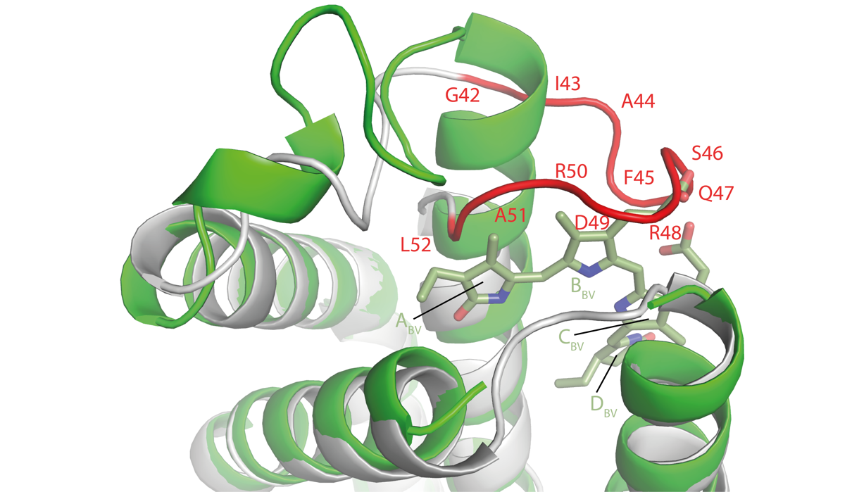
Supplementary Figure S1. Comparison of smURFP-Y56R (green) with the bound chromophore (dark green) and smURFP-Y56F (grey). The stretch upstream of the conserved CLRD motif (red) is distorted and largely unstructured in the structure without the chromophore. The rings of the chromophore are labelled.

Supplementary Table S2: Data collection and refinement statistics (*Values in parentheses are for highest-resolution shell).
Data collection | Apo Y56F | Holo Y56R
PDB ID | 6FZN | 6FZO
Beamline | ESRF ID23-2 | SLS PX X06SA
Wavelength | 0.87313 | 1.000009
Space group | P2₁ | P2₁
Cell dimensions a, b, c (Å)  and α, β, γ (°) | 41.31, 77.32, 79.49, 90.00, 92.83, 90.00 | 42.55, 57.96, 52.11, 90.00, 105.04, 90.00
No. of molecules per asymmetric unit | 4 | 2
Resolution (Å) | 50–2.3  (2.36–2.30) | 50–2.5  (2.57–2.50)
R_{merge} | 16.6 (94.0) | 8.8 (93.6)
I / σI | 10.94 (1.99) | 10.83 (1.99)
CC (1/2) | 99.6 (86.1) | 99.9 (81.1)
Completeness (%) | 99.4 (99.2) | 98.6 (98.0)
Redundancy | 6.2 (6.6) | 6.9 (7.0)
Refinement
Resolution (Å) | 2.30 | 2.50
No. reflections | 22,168 | 8,452
R_{work} / R_{free} | 25.99 / 30.86 | 21.48 / 26.26
No. atoms
Protein | 4,259 | 2,103
Ligand | - | 43
Water | 101 | 10
Other | 68 | -
B-factor overall | 47.12 | 79.8
R.m.s. deviations
Bond lengths (Å) | 0.012 | 0.008
Bond angles (°) | 1.68 | 1.56
Ramachandran plot
Most favored (%) | 96.9 | 97
Additional allowed (%) | 3.1 | 2
Supplementary Table S3: Chromophore planarity and Results of PISA analysis of smURFP-Y56R, Bacteriophytochromes miRFP703 and miRFP709. Planarity has been obtained according to the analysis described by Sjöqvist (citation 12 in the manuscript). PISA data was obtained from ('Protein interfaces, surfaces and assemblies' service PISA at the European Bioinformatics Institute. (http://www.ebi.ac.uk/pdbe/prot_int/pistart.html))

Protein | Planarity Index | Buried surface area (%) | Aromatic amino acids in  the interface | Energy gain on chromophore binding (K_{cal}/mol)
miRFP703 | 0.58 | 91 | 5 | -14.7
miRFP709 | 0.61 | 91 | 5 | -14.8
smURFP Y56R | 0.82 | 73 | 3 | -9.8

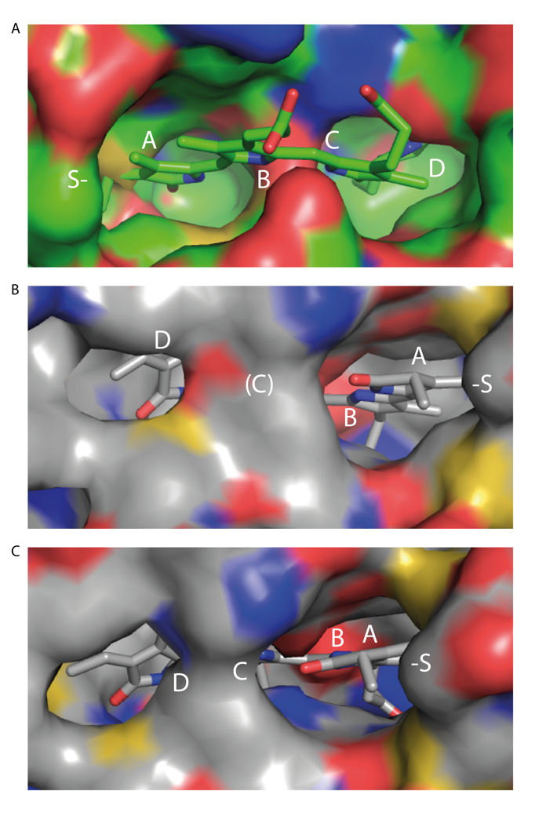

Supplementary Figure S2. Comparison of the binding pockets of (A) our chromophorylated structure smURFP-Y56R and two engineered BphPs: (B) IFP1.4, 5AJG (Feliks et al., 2016) and WiPHY, (C) 3S7Q (Auldridge et al., 2012). The positions of the rings of the BV chromophore as well as the attachment cysteine are indicated.
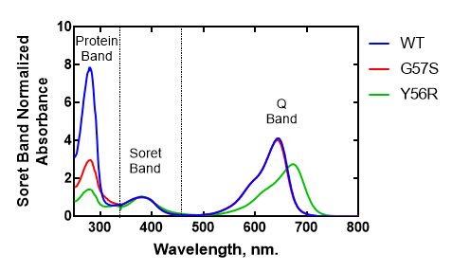
Supplementary Figure S3. Three exemplary smURFP protein samples normalized to the Soret band to show the ration A₂₈₀ to Soret we use to characterize chromophorylation.

Experimental Procedures
Chemicals: BV was purchased from Frontier Scientific (Logan, USA). All other chemicals used for buffer preparation were purchased from Sigma-Aldrich (St Louis, MO, USA). Phosphate-buffered saline was used for all purifications and measurements.

Cloning and mutagenesis: The coding sequence of smURFP was subcloned into pET21(+) (Novagene) using Nde I/Xho I and the second multiple cloning site of pET-Duet1 (Novagene). Additionally, the heme oxygenase of Nostoc sp. (a kind gift of Prof. Kai-Hong Zhao) was subcloned into the first multiple cloning site of pET-Duet1 using Nco I/Hind III. Mutagenesis was performed using the QuikChange Lightning Mutagenesis Kit (Agilent Technologies, Palo Alto, USA) according to the manufacturer’s instructions.

Protein Expression: Proteins were expressed in Escherichia coli BL21 and purified by Ni-NTA affinity chromatography, followed by a gel-filtration on a HiLoad 26/600 Superdex 75pg column (Amersham Biosciences, Uppsala, Sweden). Immediately after protein purification proteins were frozen in liquid nitrogen and stored at -80 °C. Thawed proteins were centrifuged at 14,000 rpm for 45 minutes, before performing measurements.

Absorption and Fluorescence Spectroscopy: UV−VIS measurements were performed using a Shimadzu UV-1800 spectrophotometer (Shimadzu Inc., Kyoto, Japan) in 100 µl quartz cell with a path length of 1 cm. The extinction coefficients were calculated assuming that the extinction coefficient of the holo-protein at 388 nm was equal to that of free BV, which was measured to be 39,900 l/mol cm⁻¹ in PBS. We measured relative chromophorylation by comparing the Soret band (388 nm) of BV with protein absorption at 280 nm, providing an indication of the amount of bound chromophore. Supplementary Figure 3 shows exemplary spectra normalized to the Soret band to visualize this normalization strategy. Fluorescence measurements were performed with a Cary Eclipse Fluorescence spectrophotometer (Varian, Australia). The excitation wavelength was fixed at 646 nm, and emission and excitation slits were set to 5 nm. The absorbance at the excitation wavelength was always 0.1 to avoid inner filter effects.

Crystallization, diffraction data collection and processing: The crystallization experiments for BV-bound smURFP-Y56R and BV-free smURFP-Y56F were performed at the X-ray Crystallography Platform at Helmholtz Zentrum München. Crystallization screening for smURFP-Y56R was done at 292 K using 10 mg/ml of protein in sitting-drop 96-well plates and commercial screes. Blue crystals appeared after 1-2 days and were large enough for X-ray diffraction experiments. The best data set was collected for a crystal grown in 2% (v/v) 1,4-dioxane, 0.1 M Tris (pH 8.0), 15% (w/v) polyethylene glycol 3,350 (Hampton Research PEG screen). Crystals were cryoprotected with 25% (v/v) ethylene glycol and flash-cooled to 100 K in liquid nitrogen. Diffraction data were collected at 100 K on the PX X06SA beamline at the Swiss Light Source (Villigen).

The initial crystallization screening for unbound smURFP-Y56F mutant was done at 292 K using 9.6 mg/ml of protein in sitting-drop 96-well plates and commercial screens. After selecting the best hits from the screening, manual optimization was performed. The best X-ray diffraction data set was collected for a crystal grown in 1.8 M ammonium sulphate, 0.1 M Bis-Tris (pH 5.25). Crystals were cryoprotected for 2 seconds in reservoir solution containing 25% (v/v) ethylene glycol. Diffraction data were collected at 100 K on the ID23-2 beamline at ESRF (Grenoble).

Diffraction data were indexed and integrated using XDS1 and scaled using SCALA2,3. Intensities were converted to structure-factor amplitudes using TRUNCATE4. The structure of smURFP-Y56R was solved using the Auto-Rickshaw pipeline5,6, which involved a molecular replacement step followed by several cycles of automated model building and refinement supported by the following software: MORDA (Vagin and Lebedev; http://www.biomexsolutions.co.uk/morda/), CCP410, SHELXE11, BUCCANEER12,13, RESOLVE14, REFMAC515 and PHENIX16. The search model for molecular replacement was generated by combining structural information from allophycocyanins from Synechocystis PCC 6803 (PDB ID: 4po5)7, Porphyra yezoensis (PDB ID: 1kn1)8, and Mastigocladus laminosus (PDB ID: 1b33)9. Model rebuilding was performed in COOT17, and further refinement was done in REFMAC515 using the maximum likelihood target function. The stereochemical analysis of the final model was done in PROCHECK18 and MolProbity19. The structure of smURFP-Y56F was solved in a similar fashion, using the BV-bound smURFP-Y56R structure as a search model. The final models show R and Rfree of 21.48% and 26.26 % for smURFP-Y56F and 25.99% and 30.8% for smURFP-Y56R (Supplementary Table S2). Atomic coordinates and structure factors have been deposited in the Protein Data Bank under accession codes 6fzo and 6fzn.

References

- Kabsch, W. Xds. Acta crystallographica Section D, Biological crystallography 66, 125-132 (2010).
- Evans, P. Scaling and assessment of data quality. Acta crystallographica Section D, Biological crystallography 62, 72-82 (2006).
- Winn, M.D., et al. Overview of the CCP4 suite and current developments. Acta crystallographica Section D, Biological crystallography 67, 235-242 (2011).
- French, S., Wilson, K. On the Treatment of Negative Intensity Observations. Acta crystallogr A 34, 517-525 (1978).
- Panjikar, S., Parthasarathy, V., Lamzin, V. S., Weiss, M. S. & Tucker, P. A. (2005). Auto-Rickshaw - An automated crystal structure determination platform as an efficient tool for the validation of an X-ray diffraction experiment. Acta Cryst. D61, 449-457.
- Panjikar, S., Parthasarathy, V., Lamzin, V.S., Weiss, M.S., Tucker, P.A. (2009) On the combination of molecular replacement and single-wavelength anomalous diffraction phasing for automated structure determination Acta Cryst. D65,1089-1097.
- Peng, P.P., Dong, L.L., Sun, Y.F., Zeng, X.L., Ding, W.L., Scheer, H., Yang, X., Zhao, K.H. The structure of allophycocyanin B from Synechocystis PCC 6803 reveals the structural basis for the extreme redshift of the terminal emitter in phycobilisomes. Acta Crystallogr.,Sect.D 70: 2558-2569 (2014).
- Liu, J.Y., Jiang, T., Zhang, J.P., Liang, D.C. Crystal structure of Allophycocyanin from red algae Porphyra yezoensis at 2.2 A resolution. J. Biol. Chem. 274, 16945-16952 (1999).
- Reuter, W., Wiegand, G., Huber, R., Than, M.E. Structural analysis at 2.2 A of orthorhombic crystals presents the asymmetry of the allophycocyanin-linker complex, AP.LC7.8, from phycobilisomes of Mastigocladus laminosus. Proc. Natl. Acad. Sci. USA 96, 1363-1368 (1999).
- Collaborative Computational Project, Number 4. Acta Cryst. D50, 760-763 (1994).
- Sheldrick, G. M. Macromolecular phasing in SHELXE. Z. Kristallogr. 217, 644-650 (2002).
- Cowtan, K. The Buccaneer software for automated model building. Acta Cryst. D62, 1002-1011 (2006).
- Cowtan, K. Fitting molecular fragments into electron density. Acta Cryst. D64, 83-89 (2008).
- Terwilliger, T. C. Maximum likelihood density modification. Acta Cryst. D56, 965-972 (2000).
- Murshudov, G.N., Vagin, A.A., Dodson, E.J. Refinement of macromolecular structures by the maximum-likelihood method. Acta crystallographica Section D, Biological crystallography 53, 240-255 (1997).
- P.D. Adams, P.V. Afonine, G. Bunkoczi, V.B. Chen, I.W. Davis, N. Echols, J.J. Headd, L.W. Hung, G.J. Kapral, R.W. Grosse-Kunstleve, A.J. McCoy, N.W. Moriarty, R. Oeffner, R.J. Read, D.C. Richardson, J.S. Richardson, T.C. Terwilliger, and P.H. Zwart. PHENIX: a comprehensive Python-based system for macromolecular structure solution. . Acta Cryst. D66, 213-221 (2010).
- Emsley, P., Lohkamp, B., Scott, W.G., Cowtan, K. Features and development of Coot. Acta crystallographica Section D, Biological crystallography 66, 486-501 (2010).
- Laskowski, R., MacArthur, M.W., Moss, D.S., Thornton, J.M. PROCHECK: a program to check the stereochemical quality of protein structures. J Appl Cryst 26, 283-291 (1993).
- Chen, V.B., et al. MolProbity: all-atom structure validation for macromolecular crystallography. Acta crystallographica Section D, Biological crystallography 66, 12-21 (2010).

Author Contributions
J.P. F.-W. and R.J. contributed equally

J.P.F-W. and A.C.S. conceived experiments, analyzed all data and wrote the manuscript. J.P.F W. and K.M. conducted mo-lecular biology and protein purification and spectroscopy. R.J. conducted x-ray crystallography work and elucidated the structures. I.M.W. helped testing smURFP variants. D.N. and V.N. contributed to the manuscript

