NMR fragment-based screening for development of the CD44-binding small molecules

Marcin Pustuła^{a‡}, Mirosława Czub^{a‡}, Beata Łabuzekª, Ewa Surmiakª, Marcin Tomalaª, Aleksandra Twarda-Clapa^{c}, Katarzyna Guzikª, Grzegorz M. Popowicz^{b} and Tad A. Holak*ª

ªFaculty of Chemistry, Jagiellonian University, Gronostajowa 2, 30-387, Krakow, Poland
^{b}Institute of Structural Biology, Helmholtz Zentrum München, Ingolstädter Landstrasse 1, 85764, Neuherberg, Germany
^{c}Faculty of Biochemistry, Biophysics, and Biotechnology, Jagiellonian University, Gronostajowa 7, 30-387 Krakow, Poland
* holak@chemia.uj.edu.pl

‡These authors contributed equally.

Abstract
The cell-surface protein CD44, a primary receptor for hyaluronic acid (HA), is one of the most promising targets for cancer therapies. It is prominently involved in the process of tumor growth and metastasis. The possibility of modulating the CD44-HA interaction with a pharmacological inhibitor is therefore of great importance, yet until now there are only few small molecules reported to bind to CD44. Here, we describe the results of the NMR fragment-based screening conducted against CD44 by which we found eight new hit compounds that bind to the receptor with the affinity in milimolar range. The NMR-based characterization revealed that there are two possible binding modes for these compounds, and for some of them the binding is no longer possible in the presence of hyaluronic acid. This could provide an interesting starting point for the development of new high-affinity ligands targeting the CD44-HA axis.

Keywords: CD44, hyaluronic acid, small-molecular inhibitors, fragment-based screening

Introduction
The CD44 protein belongs to a large family of type I transmembrane glycoproteins. CD44, first described in 1983 (Gallatin et al., 1983), is expressed on the surface of most vertebrate cells and is an important receptor for the components of extracellular matrix (ECM) such as: fibronectin (Jalkanen and Jalkanen, 1992), osteopontin (Weber et al., 1996), collagen (Wayner and Carter, 1987) and, most notably, hyaluronic acid (HA) (Aruffo et al., 1990). CD44 and its interaction with hyaluronan have been found to be involved in a wide variety of physiological processes, among which are cell adhesion and migration (DeGrendele et al., 1996), cell signaling, lymphocyte activation (Shimizu et al., 1989) or tumor metastasis (Günthert et al., 1991).
Structural diversity of the CD44 variants originates in an alternative splicing of the CD44 gene and is further enhanced by post-translational modifications, mainly N- and O-glycosylation (Brown et al., 1991; Screaton et al., 1992). The first and last 5 exons of the CD44 gene are constant and encode the simplest, and ubiquitously expressed in most tissues, standard isoform (CD44s). The middle exons are included in larger variant isoforms of CD44, which are expressed only under specific conditions, e. g. in some epithelial cells, activated T-cells or in cancer tissues. The first five exons encode the extracellular N-terminal domain of the protein, which is responsible for binding hyaluronan. This domain is connected to the transmembrane domain through the stem structure, which differs in length among different CD44 variants (Stamenkovic et al., 1991).
The importance of CD44 in the process of tumor growth and metastasis has been studied extensively since the discovery that its splice variant CD44v4-7 is involved in the metastatic spread of tumor cells (Günthert et al., 1991). It has been also found that variants containing exon v6 are specific for advanced stages of tumor development and progression (Wielenga et al., 1993). Overexpression of CD44v6 was associated with poor prognosis for several types of cancer (Kaufmann et al., 1995; Mulder et al., 1994), while antibodies against this variant inhibited metastasis (Seiter et al., 1993). Also other variants of CD44 can have impact on tumor growth, metastasis and chemoresistance among many types of cancer (reviewed in Chen et al., 2018).
The role of CD44 in metastasis makes it a potential target in cancer treatment. During last several years several monoclonal antibodies (mAb) against CD44 were tested in animal studies (Li et al., 2014) and even in preclinical and clinical trials (Tijink et al., 2006; van Oordt et al., 2016; Zhang et al., 2013), however severe toxicity-related events seriously hampered some of these studies (Riechelmann et al., 2008). Other studies showed that the conjugates of the anti-CD44v antibodies with radioisotopes exhibit significantly higher uptake in tumor tissues (Sandström et al., 2008). Apart from antibodies, other strategies for targeting CD44 include: using peptide mimetics (Khurana et al., 2013; Ugarte-Berzal et al., 2014), aptamers (Alshaer et al., 2015; Iida et al., 2014; Zheng et al., 2017) or pharmacological inhibitors (Handorean et al., 2009; Kim et al., 2014). Targeting CD44 with direct small-molecular inhibitors is considered to be difficult due to the lack of the well-defined, deep binding pocket. The structure of the murine CD44-HA complex reveals that the binding site for hyaluronan forms a shallow groove dominated by hydrogen bonds, which is not attractive for binding of small molecules (Banerji et al., 2007). Recently, however, formation of a small binding site, adjacent to the HA groove, was found to be induced by the binding of some 1,2,3,4-tetrahydroisoquinoline derivatives (Liu and Finzel, 2014). The reported compounds exhibit milimolar affinity, as determined by the SPR assay; however, some of these results were questioned in more recent studies by NMR (Baggio et al., 2016). Until now, only few small molecules were found to bind to CD44, all with affinity in milimolar range, thus making the development of novel binders still an important issue in the field of modern targeted therapies.

Results

2.1 Expression and purification of CD44
Screening experiments were conducted on a ¹⁵N labeled, recombinant construct of the human CD44 hyaluronic acid binding domain (HABD) (residues 22-178) expressed in Eschericha coli and purified as reported previously (Banerji et al,. 1998).

2.2 Fragment-based screening of ligands
We have applied a high-throughput screening approach in order to find possible novel binding agents for CD44. The Maybridge Ro3 diversity fragment library was screened for the binding to CD44 using the ¹H−¹⁵N HMQC NMR experiments. The initial hits were further validated for their binding to CD44. This was accomplished with the NMR-binary-titration experiment, during which CD44 was treated with increasing concentration of each compound (dissolved in dimethylsulfoxide-d₆), and ¹H and ¹H–¹⁵N-sofast-HMQC NMR spectra were collected after each addition. The significant changes in chemical shift of protein signals upon addition of the tested compound indicate their mutual interaction. For the compounds found to interact with CD44 (Figure 1, compounds 1, 2, 3, and 4), we observed substantial changes in both the ¹H and ¹H−¹⁵N HMQC spectra (Figure 2 with spectra for 1 and 4 as an example; Figures S1, S2 and S3 for other compounds).
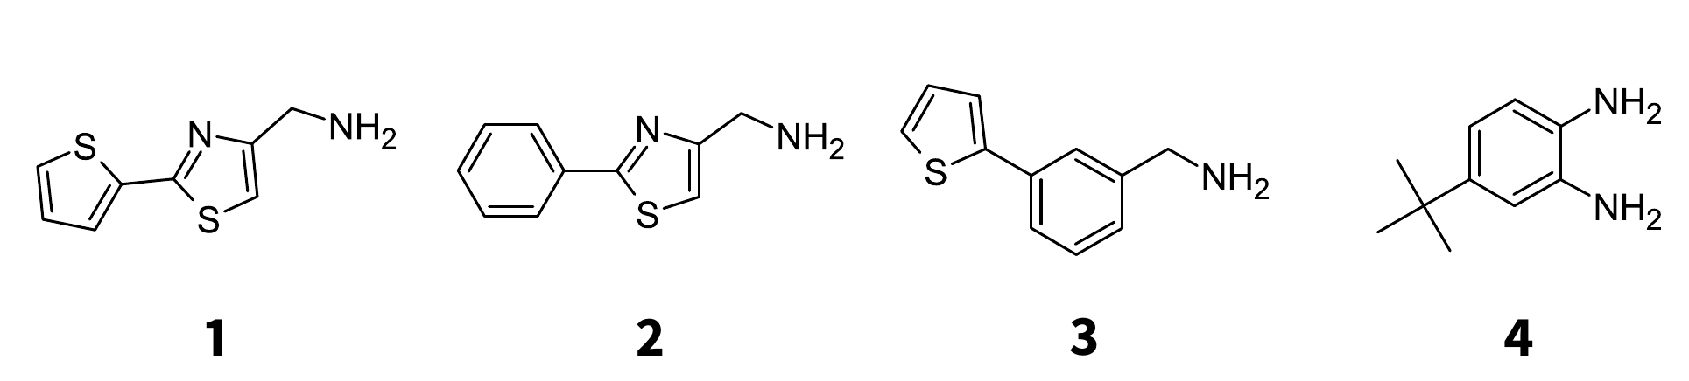
Figure 1: Active compounds found by NMR screening of CD44
Quantitative analysis of the perturbations of the protein NMR signals allowed us to determine binding constants (K_{D}) for the compounds according to the standard procedure used for the fast-exchange binding (Williamson, 2013). The titration curves are provided in Figures 3 (for compounds 1 and 4) and S5 (for the remaining compounds). The values of K_{D} are between 0.66 and 2.56 mM (Table 1).

Table 1: The values of binding constant for compounds found in HTS and validated by the binary titration experiment.
Compound | Structure | K_{D} [mM]
1 |  | 0.895 ± 0.042
2 |  | 2.56 ± 0.13
3 |  | 0.662 ± 0.082
4 |  | 2.16 ± 0.19
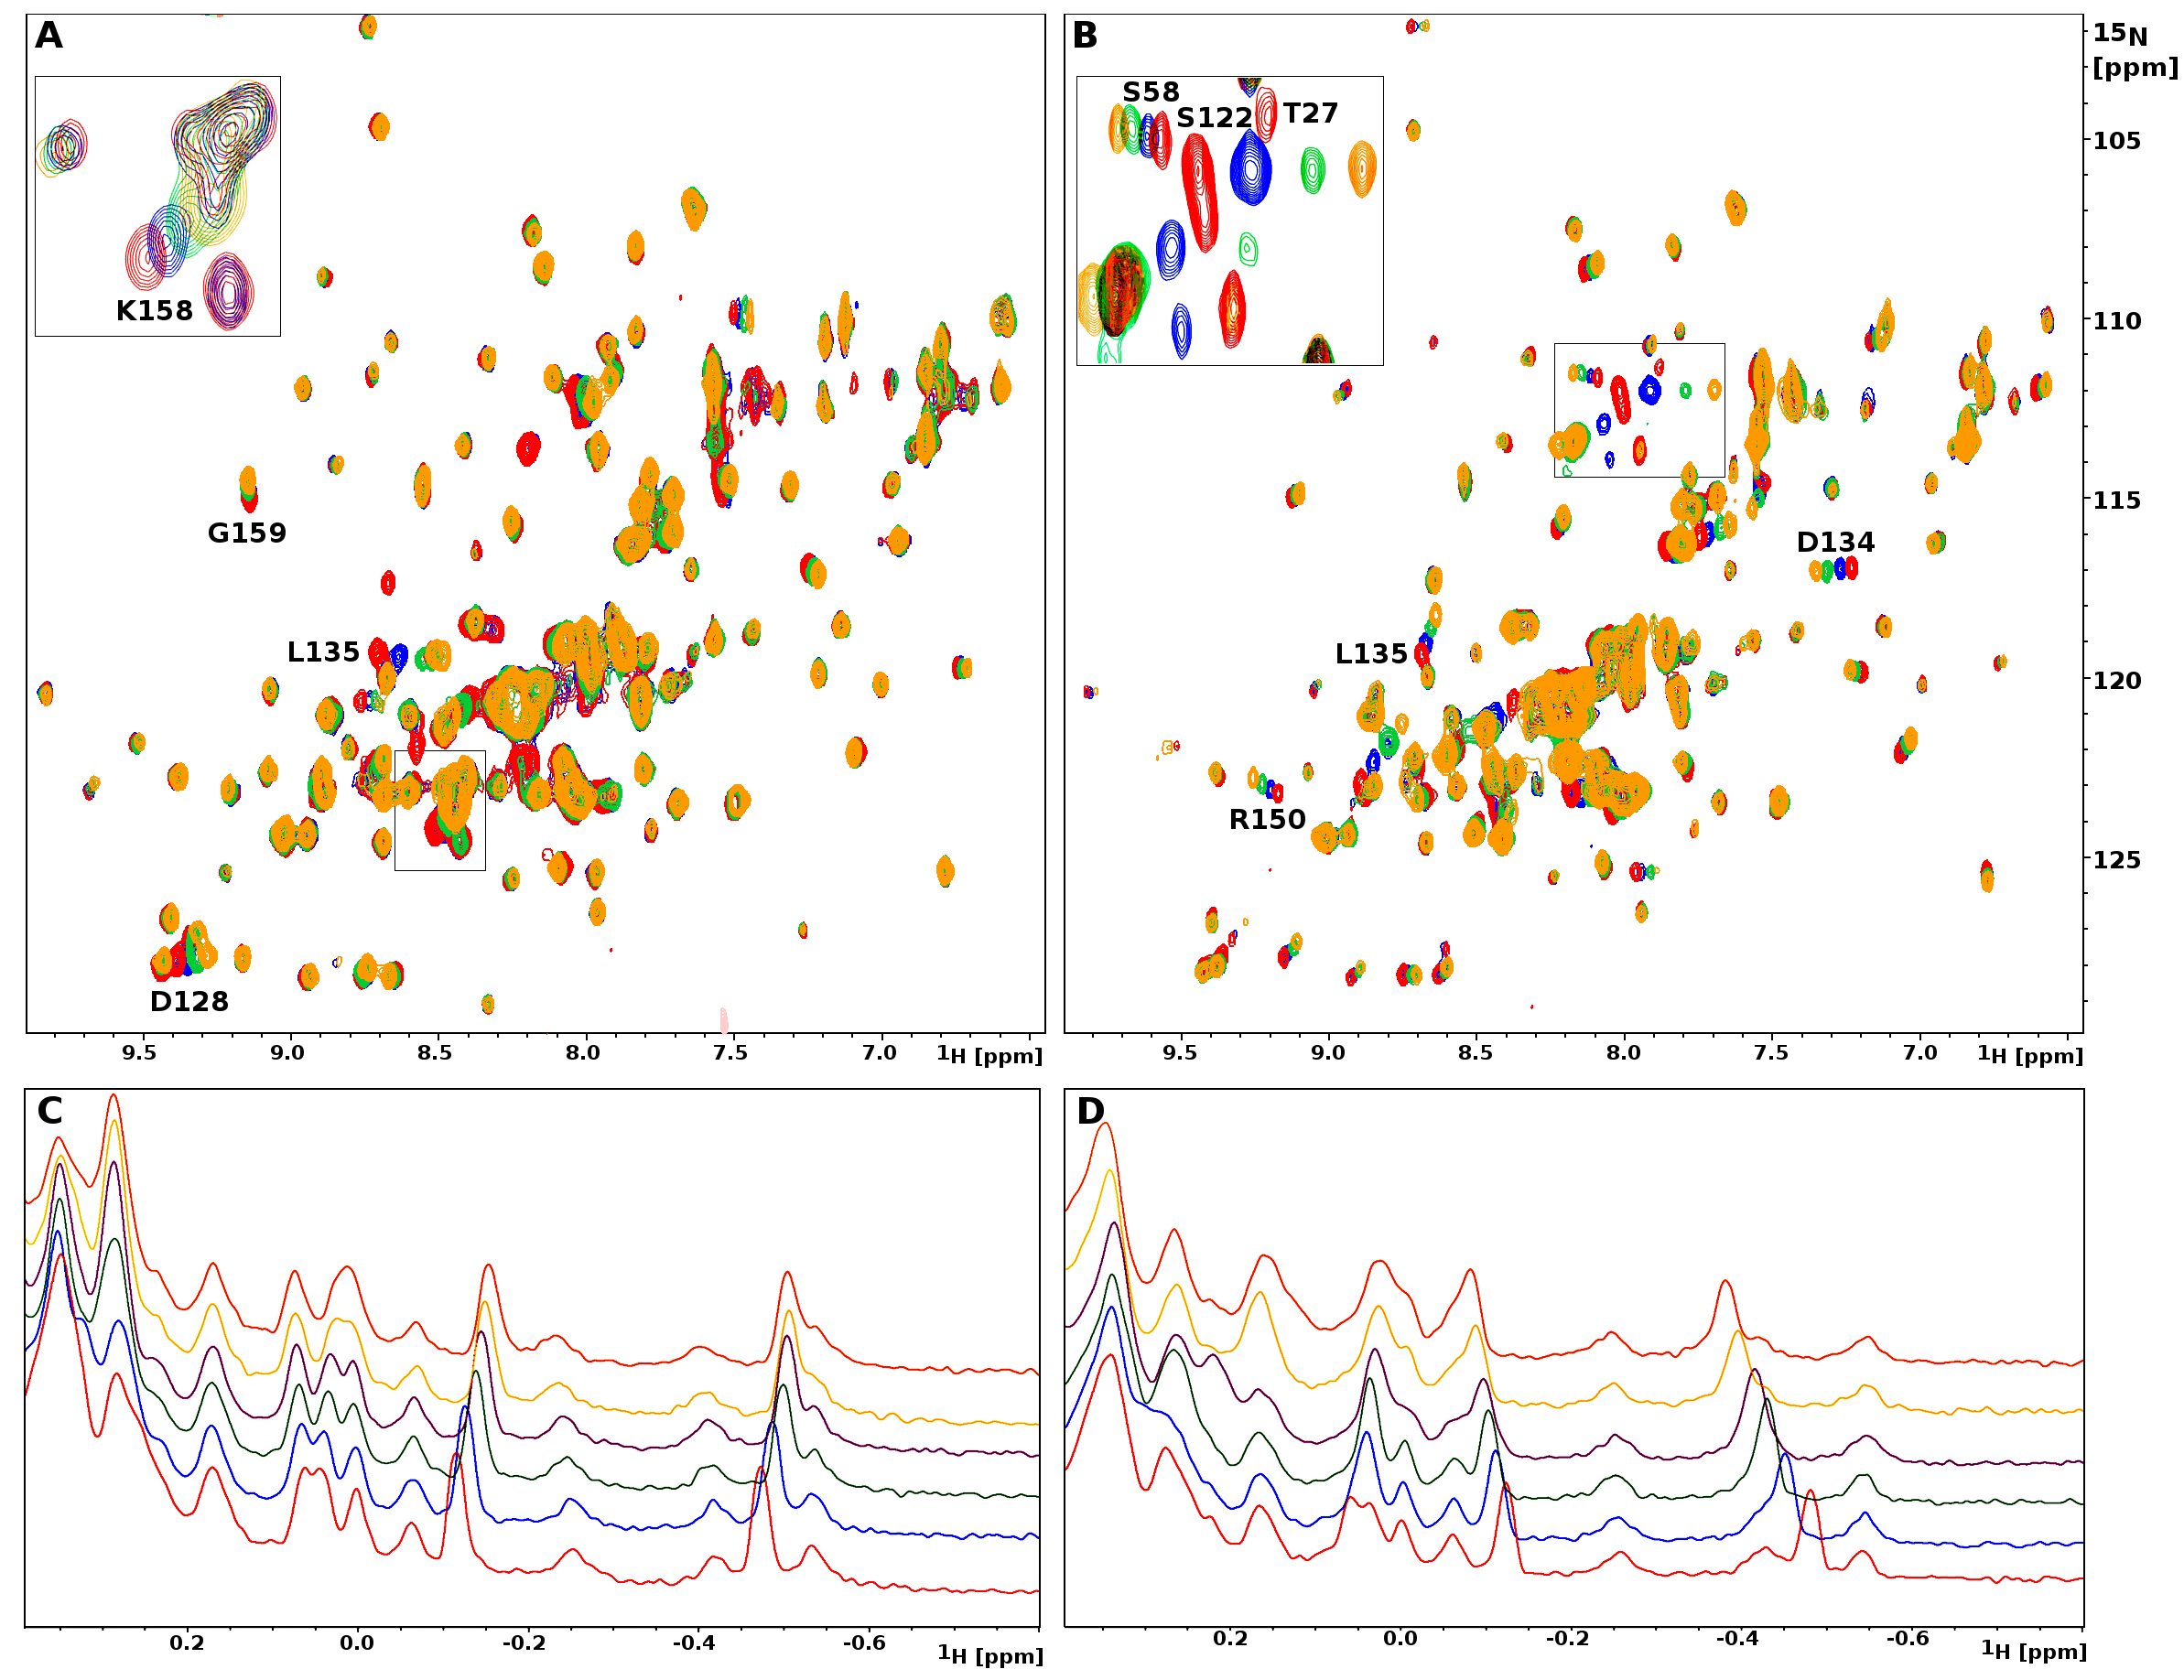
Figure 2: ¹H–¹⁵N-sofast-HMQC and ¹H NMR spectra of CD44 with compound 1 (A and C) and 4 (B and D). A: HMQC NMR spectrum of apo CD44 at 0.4 mM (red) and the spectra after subsequent additions of 1 (blue, green, yellow; at compound concentrations 0.4 mM, 1.2 mM and 2.8 mM, respectively). The most significant changes in chemical shifts can be observed for signals of Gly159, Asp128, Leu135 and Lys158. B: HMQC NMR spectrum of apo CD44 at 0.3 mM (red) and CD44 with the addition of compound 4 (blue, green, yellow; at compound concentrations 0.3 mM, 0.9 mM and 1.5 mM, respectively). More residues are affected by binding of this compound than by binding of compound 3, the most shifted being Ser122, Thr27, Asp134, Leu135, Arg150 and Ser58. C and D: ¹H NMR spectra of apo CD44 (red) and CD44 with increasing concentrations of compounds 1 (C) and 4 (D).
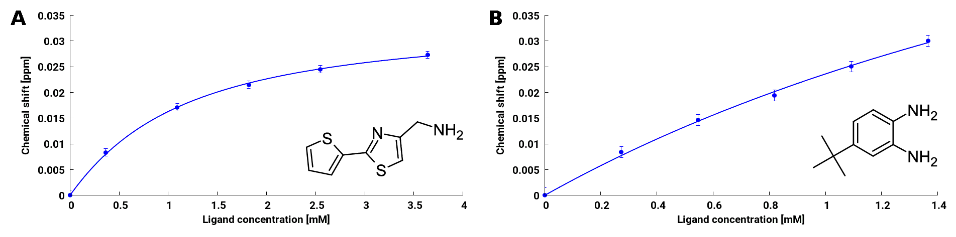

Figure 3: Titration curves for compounds 1 (A) and 4 (B), plotted for perturbations in chemical shifts of the aliphatic signals in the ¹H NMR spectra.

Compounds 1-3 showed chemical structures somewhat similar to those found in the screening for binders to the unrelated protein studied by us: the deubiquitinase USP2a (Tomala et al., 2018). We therefore checked several of these small-molecule inhibitors of USP2a for binding to CD44. No cross-binding between CD44 and USP2 was detected (Table S3).

Analysis of the binding mode of HTS hits

Analysis of perturbations of chemical shifts of protein signals in the HMQC spectra allowed us to select residues that are most strongly affected by binding of the compounds. In the case of compounds 1, 2 and 3, the most significant chemical shift perturbations can be observed for Gly159, Asp128, Leu135, and Asp134 (mainly for compound 3) (Figure 2A). The changes look different, however, for compound 4. In this case the signals from Gly159 and Lys158 are not affected, while strong changes can be observed for Ser122, Thr27, Ser58 and Arg150 (Figure 2B). The differences in the binding of these compounds are also reflected in the ¹H NMR spectra (Figure 2C, D). For compounds 1, 2 and 3 the signals from Leu135 methyl groups (δ = −0.11 and δ = −0.47) are moved towards lower values of chemical shift upon binding, which is the same direction as for the binding of hyaluronic acid. Contrary, binding of compound 4 moves them in opposite direction.
In order to further investigate these differences, we have repeated the NMR titration experiment for compounds 1 and 4 in the presence of the octamer of hyaluronic acid (which was obtained by enzymatic digestion of commercially available high-molecular mass HA) (Mahoney et al., 2001). The solution of the ¹⁵N-labeled CD44 was first treated with increasing amount of HA₈, until the formation of the complex was visible in the ¹H NMR spectra. The complex obtained in this way was then treated with increasing amount of the compound and the ¹H and ¹H–¹⁵N-sofast-HMQC NMR spectra were collected after each step (Figure 4). The ¹H spectra show that the aliphatic signals of CD44 complexed to hyaluronan are further perturbed upon addition of compound 1 (Figure 4A), indicating that its binding is independent of the binding of HA. A different behavior is observed for compound 4 (Figure 4A)—the protein signals once perturbed by hyaluronan are not moved any further after addition of the compound, even though strong changes were observed without HA. This suggests that the interaction with HA somehow prevents CD44 from binding this compound, and not compound 1.

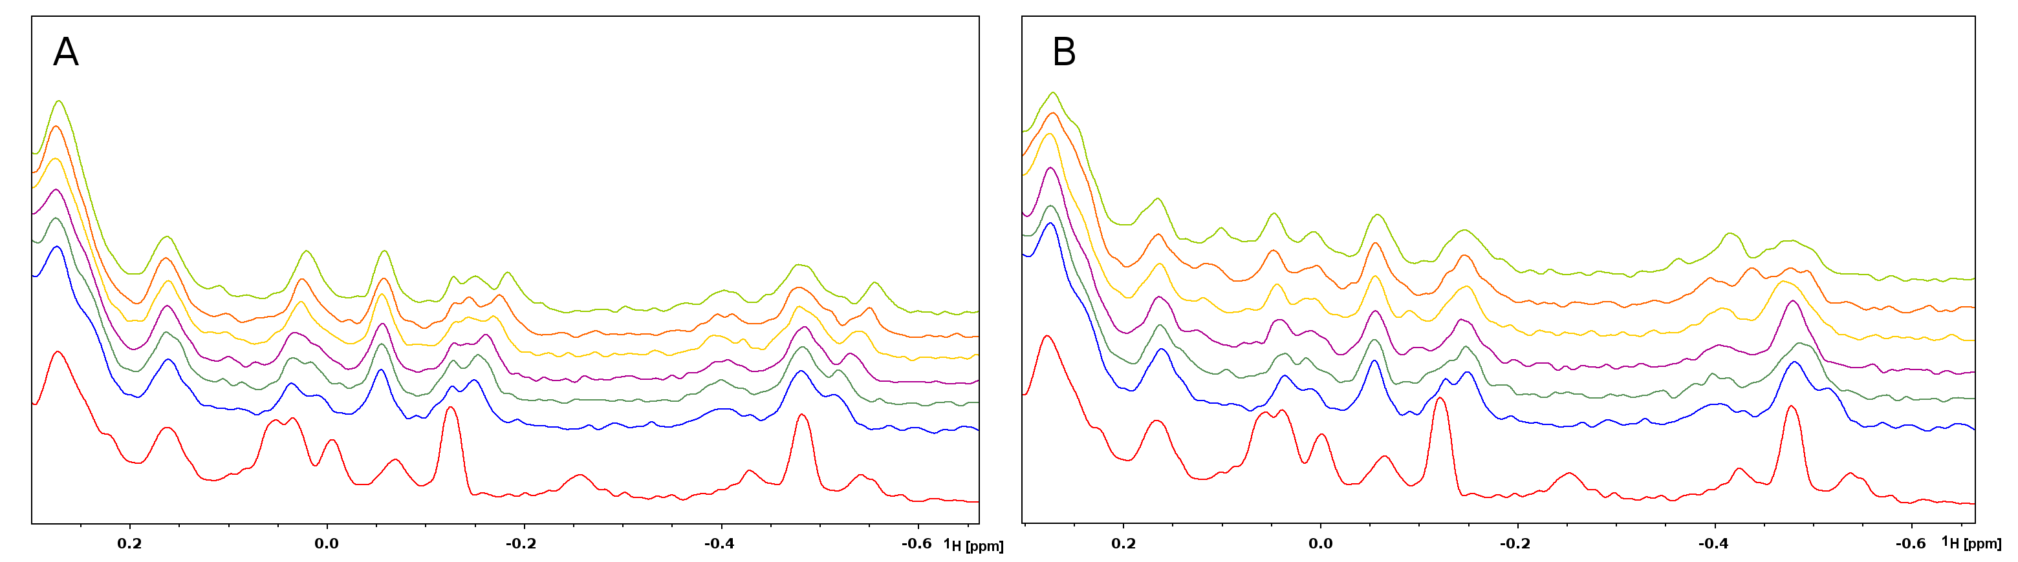
Figure 4: ¹H NMR spectra of apo CD44 at 0.2 mM (red), CD44 in the presence of 7-fold excess of hyaluronic acid octamer (blue) and in the presence of both HA₈ and increasing concentrations of compound 1 (A) or compound 4 (B). The aliphatic signals of the protein already bound to HA are still shifted upon addition of compound 1. In case of compound 4, the signals are not moved any further, suggesting that presence of HA₈ prevents binding of the compound.

Optimization of fragment hits
In spite of lack of a detailed explanation of the binding mode of compound 4, we were trying to find some other compounds binding to CD44 in a similar way. Thus, we have tested several commercially available aniline and benzylamine derivatives, similar to those found in the HTS, in NMR binary titration experiment (Table S1) and found next 4 compounds exhibiting affinity for CD44 (Table 2). For one of those compounds (5), we observed similar behavior as for compounds 1, 2 and 3, while for the remaining three the binding was similar to that for compound 4.

Table 2: Active compounds found by screening of aniline and benzylamine derivatives
Compound | Structure | K_{D} [mM] | Most affected residues
5 |  | 2.44 ± 0.22 | G159, D128, D134, A138, K158
6 |  | 2.65 ± 0.23 | S122, D134, V132, T111/N137
7 |  | 1.687 ± 0.071 | S122, D134, L135
8 |  | 0.980 ± 0.038 | S122, L24, T27, D134, L135

Discussion
We have found four initial active structures by high-throughput screening of commercially available library of small molecules and next four by testing various modifications of the initial hits. The structures are to some extent similar to 1,3-thiazole derivatives previously described by Baggio (Baggio et al., 2016), yet the binding constant reported there for the optimized structure is about 7.5 mM, which over one order of magnitude higher than for the compounds described here (between 0.66 mM and 2.65 mM). Other small molecules with affinity for CD44 in similar range were described by Liu in 2014 (Liu and Finzel, 2014) and were based on 1,2,3,4-tetrahydroisoquinoline moiety, with best K_{D} values of 0.5 mM and 0.9 mM. However, these values were obtained from less sensitive SPR assay and subsequent validation of one of these compounds (with K_{D}=0.9 mM) by NMR and ITC did not confirm its binding to the human CD44 (Baggio et al., 2016).
The analysis of changes induced on CD44 upon binding of our compounds allowed us to divide them into two subsets. Compounds 1, 2, 3 and 5 caused the aliphatic NMR signals of CD44 to move towards lower values of the chemical shift, whereas binding of compounds 4, 6, 7 and 8 induced the opposite changes. Also the perturbations of signals in the HMQC spectra are distinct for each group, with the most visible examples being the changes of Gly159 for first group and Ser122 for the second.
This different behaviour was also observed in the titration experiment repeated in the presence of the hylauronic acid octamer. For compound 1, the experiment indicates that its binding is independent of the binding of HA, while binding of compound 4 seems to be blocked by hyaluronan. The differences in location of amino acids residues affected by the binding of these two compounds may shed some light on this effect. Residues Arg150 and Trh27, which are affected by binding of 4 and not by 1, are located in close proximity to the area occupied by hyaluronic acid (Figure 5). In fact, these residues form the inducible binding site described by Liu and Finzel (2014), and a similar compound described there, (3-methylbenzene-1,2-diamine), was found to bind in this site (the complex with murine CD44 was crystallized: PDB code 4mre). This resemblance does not prove the binding site for compound 4, since the effect induced on Ser122, Asp134 and Leu135 might as well suggest binding on the opposite site of the protein, with perturbations in Arg150 and Thr27 caused by some conformational changes, or even simultaneous binding at multiple sites. The exact nature of this interaction cannot be determined without results of other experiments, such as a crystal structure of the complex of CD44 with this compound; nevertheless, the fact that binding of compound 4 is blocked by the presence of HA seems to be compatible with its influence on Arg150 and Thr27 residues of CD44.
All of these observations suggest that the two groups of compounds feature different binding modes, yet its detailed description and explanation would require additional experiments. Nevertheless, the finding that the interaction of CD44 with some compounds is blocked by hyaluronic acid is especially interesting, since by developing more potent ligands in future we might be able to influence or modulate the binding of hyaluronan itself.
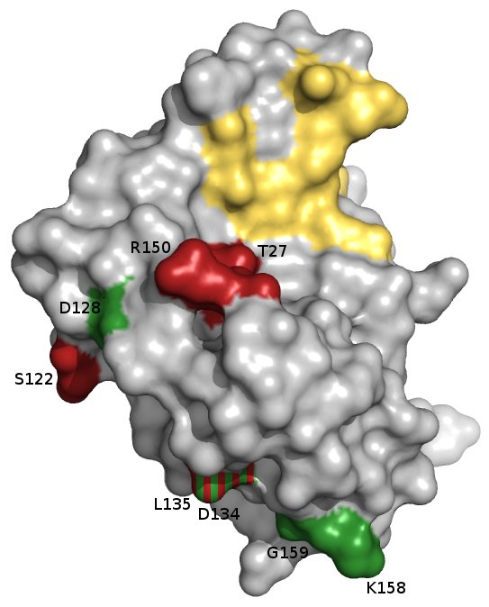
Figure 5: Representation of the crystal structure of human HABD (PDB: 1UUH). Residues located in hyaluronan binding groove are colored in yellow. Residues affected by binding of compound 4 are coloured in red and those affected by compound 1, in green. Residues L135 and D134 are affected in both cases.
Conclusion
CD44 and its interaction with hyaluronic acid are important in many physiological processes, especially in the formation and spread of cancer. The druggability of the interaction of CD44 with hyaluronic acid is challenging. In this paper we describe the fragment-based screening conducted with NMR methods. The screening, and subsequent modifications of initial hits, resulted in eight active compounds with the binding constants in the range 0.66–2.65 mM. The modes of binding can be divided into two groups, according to the differences in the changes induced by the compounds on CD44, observed in both ¹H and ¹H−¹⁵N HMQC spectra. These differences can be attributed to the distinct binding sites of the compounds from each group, and, moreover, one of these modes seems to be blocked by the binding of hyaluronan to CD44. Such dependence can be potentially very interesting in the design of future small-molecular binders to CD44.

Materials and methods

CD44 expression and purification
The CD44 HABD construct in pET 19b vector (Novagen) (residues 22-178) was transformed into the E. coli strain BL21 (DE3) Rosetta (Invitrogen). Cells was selected on Luria–Bertani (LB) agar plates supplemented with appropriate antibiotics. Starting bacteria culture in ¹⁵N labeled M9 Minimal Medium was inoculated by single colony and grown at 37ºC on a rotary shaker at 180 rpm, afterwards used for 4 L culture inoculation. Culture was grown to mid-log phase (OD600 = 0.6-0.9), then recombinant protein expression was induced by addition of isopropyl β-D-1-thiogalactopyrano-side (IPTG) to a final concentration of 1mM and kept overnight at 25ºC. After expression bacteria were harvested by standard centrifugation (4000g, 20 min), resuspended in phosphate-buffered saline (PBS) and sonicated until the lysate was homogeneous. Subsequently inclusion bodies were completely resuspended in ice cold 0.5% Triton X-100, 50 mM Tris-HCl (pH 8.0), 100 mM NaCl buffer and centrifuged (20 000g, 10 min) 2-3 times until the pellet was free from bacterial debris contaminations. Afterwards washing process was repeated for another 2-3 times in buffer free of Triton X-100. The inclusion body pellet was solubilized in 20 ml of 8 M urea, 50 mM MES (pH 6.5), 0.1 mM EDTA, 0.1 mM DTT solution and gently rotated overnight at 4ºC. Than the insoluble material was removed by centrifugation (20 000g, 20 min) and the protein was refolded by 200-fold dilution into 400 mM L-arginine, 100 mM Tris-HCl (pH 8.0), 2 mM EDTA, 5 mM reduced glutathione, 0.5 mM oxidized glutathione, 1 mM phenylmethylsulfonyl fluoride (PMSF), 0.5 µg/ml leupeptin buffer. The mixture was stirred for 48 h at 4ºC and concentrated to a volume of 30 ml by crossflow cassette Vivaflow 200 followed by ultrafiltration on Amicon Ultra-15 to 10 ml. Protein was purified by gel filtration on a HiLoad 16/600 Superdex 75 pg column (GE Healthcare) in PBS buffer. For further experiments buffer was changed on Amicon Ultra-15 to 50 mM KH₂PO₄, 50 mM Na₂HPO₄, 150 mM NaCl (pH=7.4) for NMR experiments.

Preparation of LMW hyaluronic acid oligomers
Low-molecular-weight hyaluronic acid oligomers were obtained by the digestion of hyaluronic acid from Streptococcus equi (~1.5-1.8 MDa, Sigma Aldrich) with ovine testicular hyaluronidase (500 U/mg, Carl Roth). Hyaluronic acid was dissolved in digest buffer consisted of 0.1 M NaCl, 0.15 M NaOAc (pH=5.5 adjusted with acetic acid) to final concentration 2 mg/ml and preincubated for 10 min at 37°C. Ovine testicular hyaluronidase was added to final concentration 100 U of enzyme per 1 mg HA. Reaction of enzymatic digestion was carried out for 1h at 37ºC with gentle shaking and quenched by boiling for 10 min. The sample was centrifuged at 5000xg for 20 min and the supernatant was dialyzed overnight against H₂O at 4ºC. Oligomers were separated using the preparative anion-exchange chromatography using the HiPrep Q Sepharose High Performance column (GE Healthcare) and washed with solution A consisted of 0.01 M NaCl, 0.015 M NaOAc (pH=5.5). Oligomers were eluted with the continuous gradient (37% in 270 ml) of solution B consisted of 1.01 M NaCl, 0.015 M NaOAc (pH=5.5). Fractions from each peak were pooled and desalted using the HiTrap Desalting column with Sephadex G-25 resin (GE Healthcare) followed by lyophilization and freezing.

NMR Measurements
NMR spectra were acquired on Bruker Avance III (600 MHz) spectrometer at 300 K. Protein samples were measured in water solution with the addition of 10% (v/v) D₂O to provide a lock signal, and the water suppression was carried out with WATERGATE sequence (Piotto et al., 1992). The ¹H−¹⁵N correlations were obtained using the SOFAST HMQC pulse sequence (Schanda and Brutscher, 2005). Assignment of CD44 resonances was based on Takeda et al. (2003). Fragment compounds used in the binary NMR titration experiments were purchased from Maybridge (compounds 1-4) or Sigma-Aldrich (compounds 5-8). For each experiment the protein sample (0.2-0.4 mM) was treated with increasing amount of the 100 mM stock solution of a tested compound in DMSO-d₆ and ¹H and ¹H−¹⁵N HMQC spectra were collected. The weight-averaged chemical shift perturbations of protein signals were used to fit the corresponding saturation curves according to Williamson (2013). The resonances used in this procedure for each compound are specified in Table S2.

Competing financial interest statement
Authors declare no competing financial interest

Acknowledgements
This research has been supported by Grant UMO-2012/06/A/ST5/00224 from the National Science Centre, Poland (to T.A.H.).

References
Alshaer, W., Hillaireau, H., Vergnaud, J., Ismail, S., and Fattal, E. (2015). Functionalizing Liposomes with anti-CD44 Aptamer for Selective Targeting of Cancer Cells. Bioconjug. Chem., 26(7):1307–13.
Aruffo, A., Stamenkovic, I., Melnick, M., Underhill, C. B., and Seed, B. (1990).CD44 is the principal cell surface receptor for hyaluronate. Cell, 61(7):1303–1313.
Baggio, C., Barile, E., Di Sorbo, G., Kipps, T. J., and Pellecchia, M. (2016). The Cell Surface Receptor CD44: NMR-Based Characterization of Putative Ligands. ChemMedChem, 11(10):1097–1106.
Banerji, S., Day, A. J., Kahmann, J. D., and Jackson, D. G. (1998). Characterization of a functional hyaluronan-binding domain from the human CD44 molecule expressed in Escherichia coli. Protein Expr. Purif., 14(3):371–81.
Banerji, S., Wright, A. J., Noble, M., Mahoney, D. J., Campbell, I. D., Day, A. J., and Jackson, D. G. (2007). Structures of the Cd44-hyaluronan complex provide insight into a fundamental carbohydrate-protein interaction. Nat. Struct. Mol. Biol., 14(3):234–9.
Brown, T. A., Bouchard, T., St John, T., Wayner, E., and Carter, W. G. (1991). Human keratinocytes express a new CD44 core protein (CD44E) as a heparansulfate intrinsic membrane proteoglycan with additional exons. J. Cell Biol., 113(1):207–21.
Chen, C., Zhao, S., Karnad, A., and Freeman, J. W. (2018). The biology and role of CD44 in cancer progression: therapeutic implications. J. Hematol. Oncol., 11(1):64.
DeGrendele, H. C., Estess, P., Picker, L. J., and Siegelman, M. H. (1996). CD44 and its ligand hyaluronate mediate rolling under physiologic flow: a novel lymphocyte-endothelial cell primary adhesion pathway. J. Exp. Med., 183(3):1119–1130.
Gallatin, W. M., Weissman, I. L., and Butcher, E. C. (1983). A cell-surface molecule involved in organ-specific homing of lymphocytes. Nature, 304(5921):30–34.
Günthert, U., Hofmann, M., Rudy, W., Reber, S., Zöller, M., Haussmann, I., Matzku, S., Wenzel, A., Ponta, H., and Herrlich, P. (1991). A new variant of glycoprotein CD44 confers metastatic potential to rat carcinoma cells. Cell, 65(1):13–24.
Handorean, A. M., Yang, K., Robbins, E. W., Flaig, T. W., and Iczkowski, K. A. (2009). Silibinin suppresses CD44 expression in prostate cancer cells. Am. J. Transl. Res., 1(1):80–6.
Iida, J., Clancy, R., Dorchak, J., Somiari, R. I., Somiari, S., Cutler, M. L., Mural, R. J., and Shriver, C. D. (2014). DNA aptamers against exon v10 of CD44 inhibit breast cancer cell migration. PLoS One, 9(2):e88712.
Jalkanen, S. and Jalkanen, M. (1992). Lymphocyte CD44 binds the COOH-terminal heparin-binding domain of fibronectin. J. Cell Biol., 116(3):817–825.
Kaufmann, M., von Minckwitz, G., Heider, K. H., Ponta, H., Herrlich, P., and Sinn, H. P. (1995). CD44 variant exon epitopes in primary breast cancer and length of survival. Lancet, 345(8950):615–619.
Khurana, S. S., Riehl, T. E., Moore, B. D., Fassan, M., Rugge, M., Romero-Gallo, J., Noto, J., Peek, R. M., Stenson, W. F., and Mills, J. C. (2013). The hyaluronic acid receptor CD44 coordinates normal and metaplastic gastric epithelial progenitor cell proliferation. J. Biol. Chem., 288(22):16085–97.
Kim, S., Kil, W. H., Lee, J., Oh, S.-J., Han, J., Jeon, M., Jung, T., Lee, S. K., Bae, S. Y., Lee, H. C., Lee, J. H., Yi, H. W., Kim, S. W., Nam, S. J., and Lee, J. E. (2014). Zerumbone suppresses EGF-induced CD44 expression through the inhibition of STAT3 in breast cancer cells. Oncol. Rep., 32(6):2666–72.
Li, L., Hao, X., Qin, J., Tang, W., He, F., Smith, A., Zhang, M., Simeone, D. M., Qiao, X. T., Chen, Z.-N., Lawrence, T. S., and Xu, L. (2014). Antibody against CD44s inhibits pancreatic tumor initiation and postradiation recurrence in mice. Gastroenterology, 146(4):1108–18.
Liu, L.-K. and Finzel, B. C. (2014). Fragment-Based Identification of an Inducible Binding Site on Cell Surface Receptor CD44 for the Design of Protein–Carbohydrate Interaction Inhibitors. J. Med. Chem., 57(6):2714–2725.
Mahoney, D. J., Aplin, R. T., Calabro, a., Hascall, V. C., and Day, a. J. (2001). Novel methods for the preparation and characterization of hyaluronan oligosaccharides of defined length. Glycobiology, 11(12):1025–33.
Mulder, J. W., Kruyt, P. M., Sewnath, M., Oosting, J., Seldenrijk, C. A., Weidema, W. F., Offerhaus, G. J., and Pals, S. T. (1994). Colorectal cancer prognosis and expression of exon-v6-containing CD44 proteins. Lancet, 344(8935):1470–2.
Piotto, M., Saudek, V., and Sklenář, V. (1992). Gradient-tailored excitation for single-quantum NMR spectroscopy of aqueous solutions. J. Biomol. NMR, 2(6):661–665.
Riechelmann, H., Sauter, A., Golze, W., Hanft, G., Schroen, C., Hoermann, K., Erhardt, T., and Gronau, S. (2008). Phase I trial with the CD44v6-targeting immunoconjugate bivatuzumab mertansine in head and neck squamous cell carcinoma. Oral Oncol., 44(9):823–9.
Sandström, K., Nestor, M., Ekberg, T., Engström, M., Anniko, M., and Lundqvist, H. (2008). Targeting CD44v6 expressed in head and neck squamous cell carcinoma: preclinical characterization of an 111In-labeled monoclonal antibody. Tumour Biol., 29(3):137–44.
Schanda, P. and Brutscher, B. (2005). Very Fast Two-Dimensional NMR Spectroscopy for Real-Time Investigation of Dynamic Events in Proteins on the Time Scale of Seconds. J. Am. Chem. Soc., 127(22):8014–8015.
Screaton, G. R., Bell, M. V., Jackson, D. G., Cornelis, F. B., Gerth, U., and Bell, J. I. (1992). Genomic structure of DNA encoding the lymphocyte homing receptor CD44 reveals at least 12 alternatively spliced exons. Proc. Natl. Acad. Sci. U. S. A., 89(24):12160–4.
Seiter, S., Arch, R., Reber, S., Komitowski, D., Hofmann, M., Ponta, H., Herrlich, P., Matzku, S., and Zöller, M. (1993). Prevention of tumor metastasis formation by anti-variant CD44. J. Exp. Med., 177(2):443–55.
Shimizu, Y., Van Seventer, G. A., Siraganian, R., Wahl, L., and Shaw, S. (1989). Dual role of the CD44 molecule in T cell adhesion and activation. J. Immunol., 143(8):2457–63.
Stamenkovic, I., Aruffo, A., Amiot, M., and Seed, B. (1991). The hematopoietic and epithelial forms of CD44 are distinct polypeptides with different adhesion potentials for hyaluronate-bearing cells. EMBO J., 10(2):343–8.
Takeda, M., Terasawa, H., Sakakura, M., Yamaguchi, Y., Kajiwara, M., Kawashima, H., Miyasaka, M., and Shimada, I. (2003). Hyaluronan Recognition Mode of CD44 Revealed by Cross-saturation and Chemical Shift Perturbation Experiments. J. Biol. Chem., 278(44):43550–43555.
Tijink, B. M., Buter, J., de Bree, R., Giaccone, G., Lang, M. S., Staab, A., Leemans, C. R., and van Dongen, G. A. M. S. (2006). A phase I dose escalation study with anti-CD44v6 bivatuzumab mertansine in patients with incurable squamous cell carcinoma of the head and neck or esophagus. Clin. Cancer Res., 12(20 Pt 1):6064–72.
Tomala, M. D., Magiera-Mularz, K., Kubica, K., Krzanik, S., Zieba, B., Musielak, B., Pustula, M., Popowicz, G. M., Sattler, M., Dubin, G., Skalniak, L., and Holak, T. A. (2018). Identification of small-molecule inhibitors of USP2a. Eur. J. Med. Chem., 150:261–267.
Ugarte-Berzal, E., Bailón, E., Amigo-Jiménez, I., Albar, J. P., García-Marco, J. A., and García-Pardo, A. (2014). A novel CD44-binding peptide from the pro-matrix metalloproteinase-9 hemopexin domain impairs adhesion and migration of chronic lymphocytic leukemia (CLL) cells. J. Biol. Chem., 289(22):15340–9.
van Oordt, C. W. M.-v. d. H., Gomez-Roca, C., van Herpen, C., Coveler, A. L., Mahalingam, D., Verheul, H. M. W., van der Graaf, W. T. A., Christen, R., Rüttinger, D., Weigand, S., Cannarile, M. A., Heil, F., Brewster, M., Walz, A.-C., Nayak, T. K., Guarin, E., Meresse, V., and Le Tourneau, C. (2016). First-in-human phase I clinical trial of RG7356, an anti-CD44 humanized antibody, in patients with advanced, CD44-expressing solid tumors. Oncotarget 7(48):80046–80058.
Wayner, E. A. and Carter, W. G. (1987). Identification of multiple cell adhesion receptors for collagen and fibronectin in human fibrosarcoma cells possessing unique alpha and common beta subunits. J. Cell Biol., 105(4):1873–1884.
Weber, G. F., Ashkar, S., Glimcher, M. J., and Cantor, H. (1996). Receptor-Ligand Interaction Between CD44 and Osteopontin (Eta-1). Science, 271(5248):509–512.
Wielenga, V. J., Heider, K. H., Offerhaus, G. J., Adolf, G. R., van den Berg, F. M., Ponta, H., Herrlich, P., and Pals, S. T. (1993). Expression of CD44 variant proteins in human colorectal cancer is related to tumor progression. Cancer Res., 53(20):4754–6.
Williamson, M. P. (2013). Using chemical shift perturbation to characterise ligand binding. Prog. Nucl. Magn. Reson. Spectrosc., 73:1–16.
Zhang, S., Wu, C. C. N., Fecteau, J.-F., Cui, B., Chen, L., Zhang, L., Wu, R., Rassenti, L., Lao, F., Weigand, S., and Kipps, T. J. (2013). Targeting chronic lymphocytic leukemia cells with a humanized monoclonal antibody specific for CD44. Proc. Natl. Acad. Sci. U. S. A., 110(15):6127–32.
Zheng, J., Zhao, S., Yu, X., Huang, S., and Liu, H. Y. (2017). Simultaneous targeting of CD44 and EpCAM with a bispecific aptamer effectively inhibits intraperitoneal ovarian cancer growth. Theranostics, 7(5):1373–1388.

Supporting Information

NMR fragment-based screening for the development of the CD44-binding small molecules

Marcin Pustułaª, Mirosława Czubª, Beata Łabuzekª, Ewa Surmiakª, Marcin Tomalaª, Aleksandra Twarda-Clapa^{c}, Katarzyna Guzikª, Grzegorz M. Popowicz^{b} and Tad A. Holakª

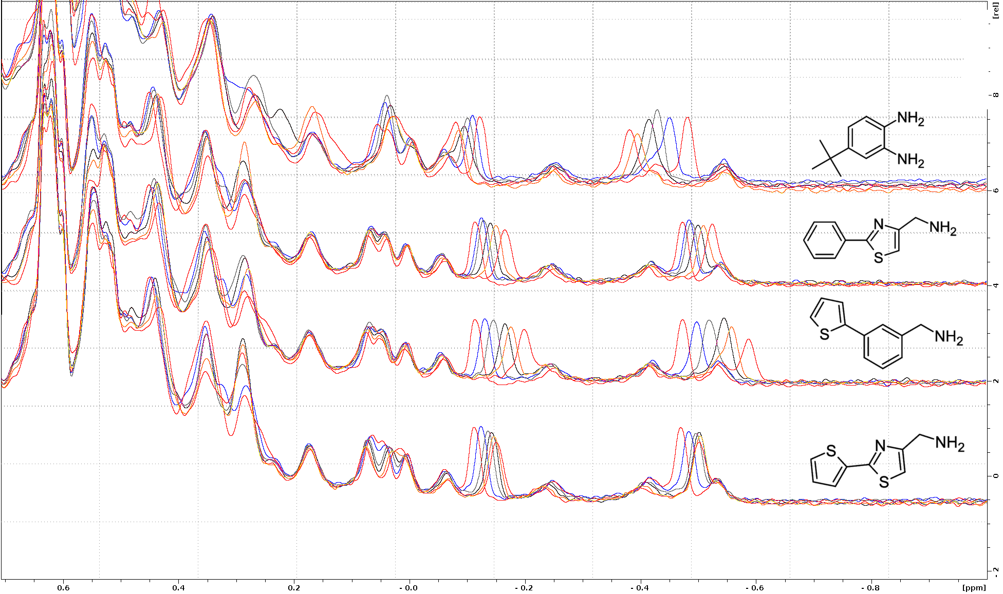

Figure S1: ¹H NMR spectra of apo CD44 with increasing concentrations of tested compounds.

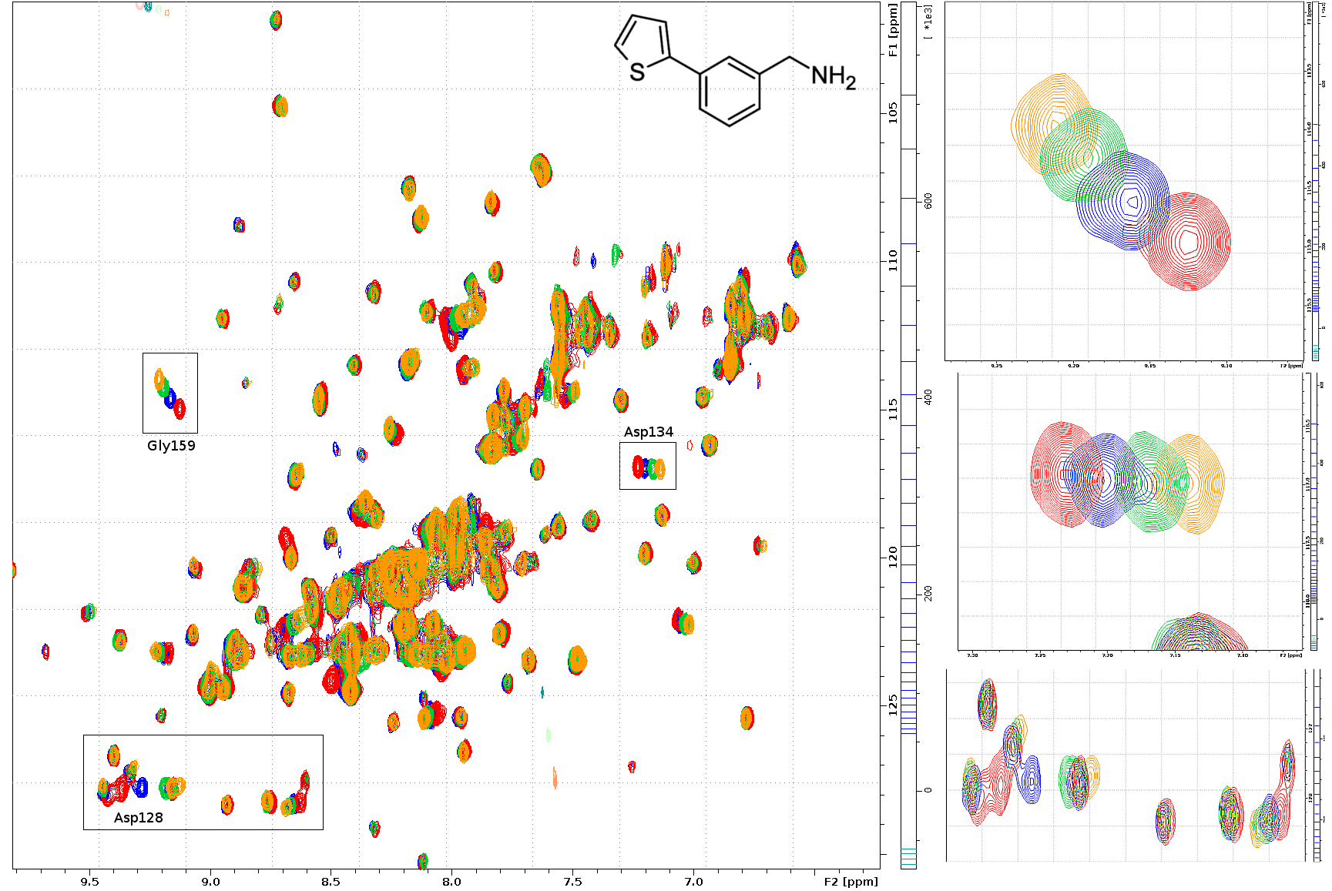
Figure S2: ¹H-¹⁵N-sofast-HMQC NMR spectra of apo CD44 (red) and the spectra after subsequent additions of compound 3 (blue, green, yellow)
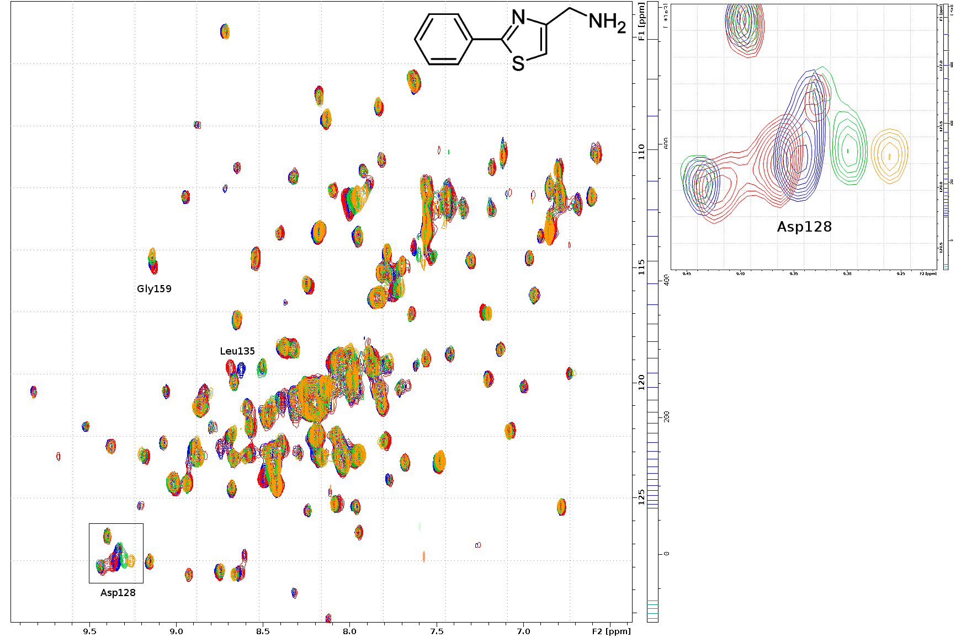
Figure S3: ¹H-¹⁵N-sofast-HMQC NMR spectra of apo CD44 (red) and the spectra after subsequent additions of compound 2 (blue, green, yellow)

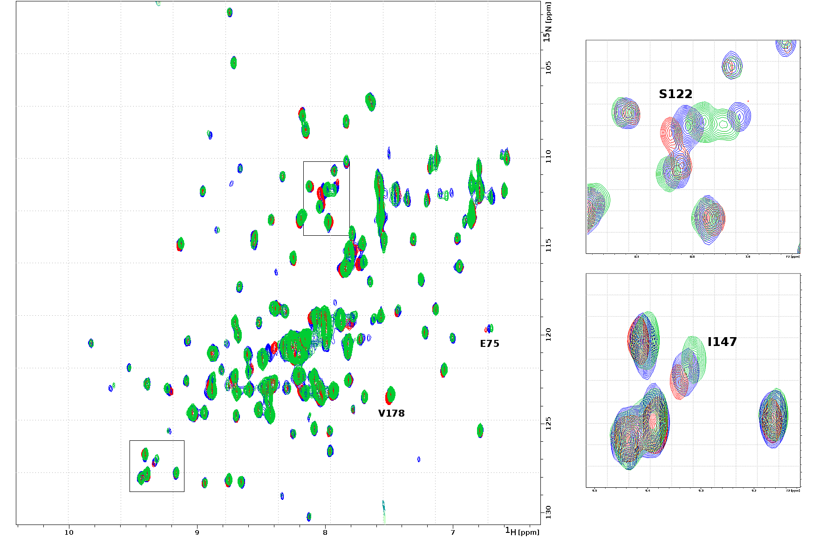

Figure S4: ¹H–¹⁵N-sofast-HMQC NMR spectra of apo CD44 (red) with increasing amount of DMSO-d₆ (5 μL (blue) and 10 μL (green) of DMSO-d₆ per 200 μL of 0.4 mM CD44). The boxes show enlargements of S122 (upper box) and D128 (lower box) of the spectrum. This allows comparison with the perturbations caused by the tested compounds since similar areas were also enlarged in Figures 2, S2 and S3.

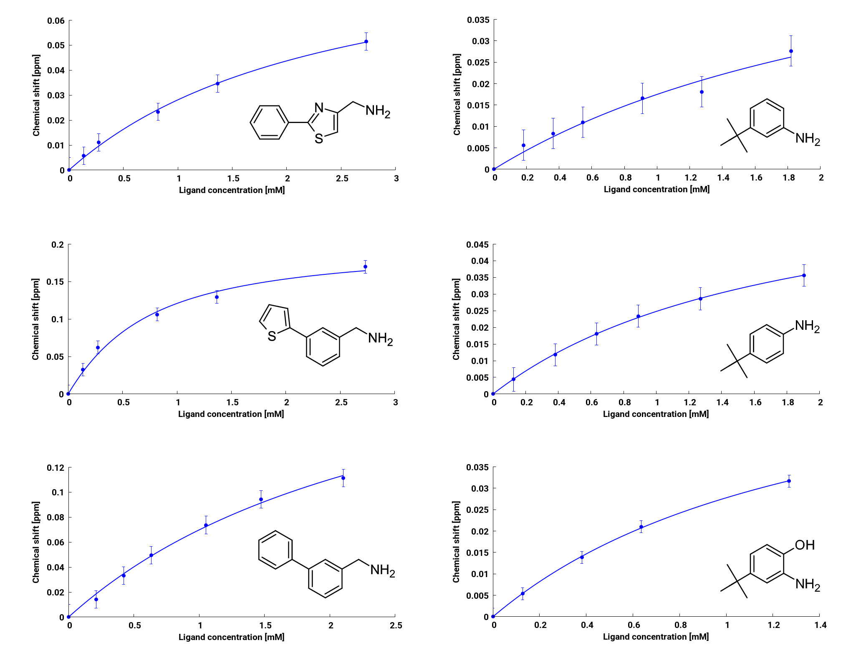
Figure S5: Titration curves for compounds 3–8.

Table S1: Aniline and benzylamine derivatives tested for the affinity for CD44
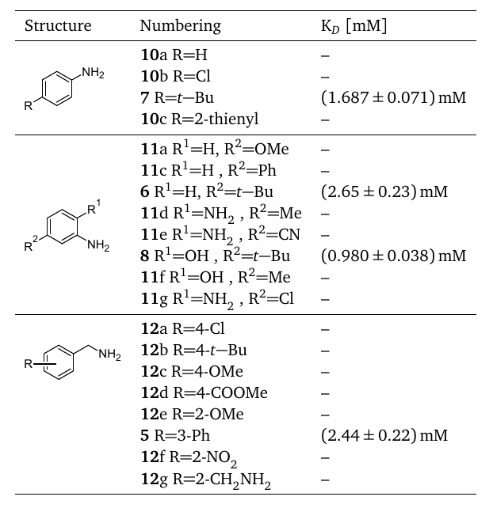

Table S2: CD44 residues which perturbations were included in the dose-response analysis and calculation of K_{D} for tested compounds.
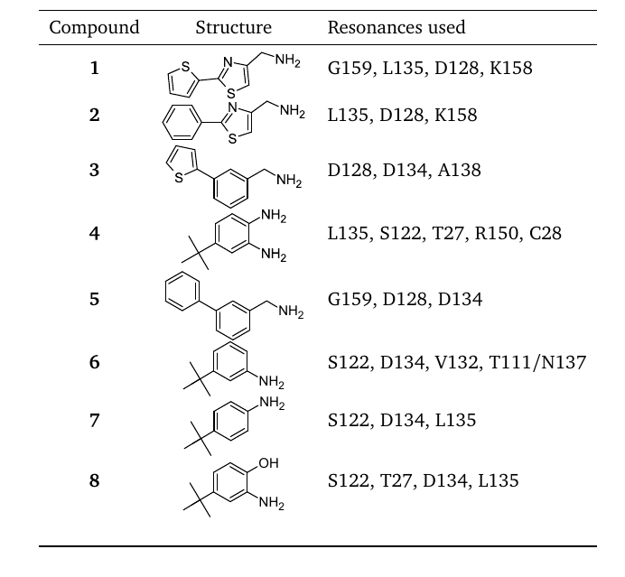

Table S3: Compounds described in Tomala et. al. (2018) for the USP2a protein and tested for affinity to CD44.
^{a)}Values of IC50 as published in Tomala et. al. (2018). ^{b)}Activity measured by the NMR binary titration experiment as described in the main text of the paper; No - no activity.
References
Tomala, M. D., Magiera-Mularz, K., Kubica, K., Krzanik, S., Zieba, B., Musielak, B., Pustula, M., Popowicz, G. M., Sattler, M., Dubin, G., Skalniak, L., and Holak, T. A. (2018). Identification of small-molecule inhibitors of USP2a. Eur. J. Med. Chem., 150:261–267.

