Ambient PM₁ air pollution, blood pressure, and hypertension: Insights from the 33 Communities Chinese Health Study
Bo-Yi Yang, Yuming Guo, Michael S. Bloom, Xiang Xiao, Zhengmin (Min) Qian, Echu Liu, Steven W. Howard, Tianyu Zhao, Si-Quan Wang, Shanshan Li, Duo-Hong Chen, Huimin Ma, Steve Hung-Lam Yim, Kang-Kang Liu, Xiao-Wen Zeng, Li-Wen Hu, Ru-Qing Liu, Dan Feng, Mo Yang, Shu-Li Xu, Guang-Hui Dong
Table of Contents
Supplemental methods: Explanation for ground-monitored data on PM₁ and PM_{2.5}
Fig. S1. Directed acyclic graph for the association between ambient air pollution and blood pressure, created with the help of dagitty.net
Table S1. Pairwise correlations of air pollutants
Table S2. Association of 10-μg/m³ increase in air pollutants with blood pressure after excluding participants having antihypertensive medication (n=22,201)
Table S3. Association of 10-μg/m³ increase in air pollutants with blood pressure after excluding participants with cardiovascular diseases (n=23,839).
Table S4 Associations between 10-μg/m³ increase in air pollutants and blood pressure and hypertension (n = 24,845) in the additionally adjusted model

Supplemental methods: Explanation for ground-monitored data on PM₁ and PM_{2.5}
Ground-monitored PM₁ and PM_{2.5} were obtained from the China Atmosphere Watch Network (CAWNET) of the China Meteorological Administration (CMA). The network consisted of 96 stations across mainland China. Concentrations of PM₁ and PM_{2.5} at all stations were measured with GRIMM 180 Environmental dust monitors (Model 1.108, Grimm Aerosol Technik GmbH, Ainring, Germany). Two quality-control procedures were applied to all PM measurements: a "limit check" and "climatological check". For the limit check, we evaluated each valid PM measurement to determine whether it fell within its possible limits, otherwise, they were removed. In the climatological check, the median and standard deviation (SD) of hourly PM measurements were calculated at each PM observational site. Any PM values lying outside of more than three SDs from the median PM have been removed.

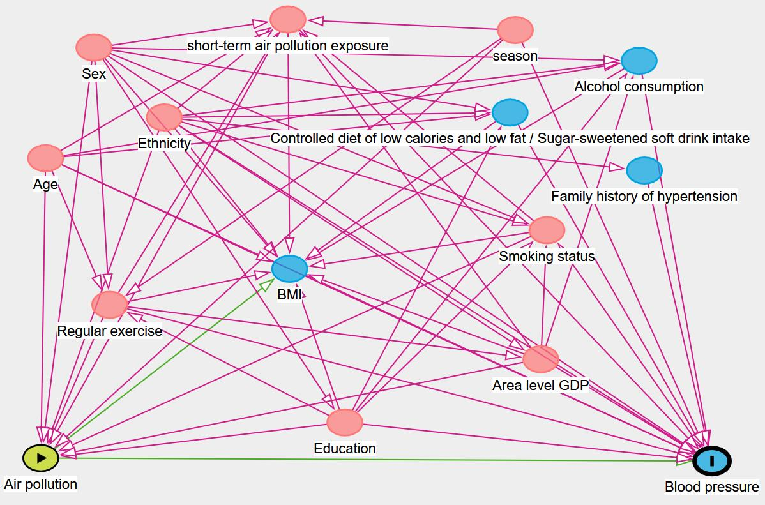
Fig. S1. Directed acyclic graph for the association between ambient air pollution and blood pressure, created with the help of dagitty.net

Table S1 Pairwise correlations of air pollutants
 | Spearman correlation coefficients
 | PM₁ | PM_{2.5} | PM_{1-2.5}
PM₁ (μg/m³) | 1.00 | 0.99 (<0.0001) | 0.63(<0.0001)
PM_{2.5} (μg/m³) |  | 1.00 | 0.67 (<0.0001)
PM_{1-2.5} (μg/m³) |  |  | 1.00
Abbreviations: PM₁, particle with aerodynamic diameter ≤1.0 µm; PM_{1-2.5}, particle with aerodynamic diameter ranging between 1 and 2.5 µm; PM_{2.5}, particle with aerodynamic diameter ≤2.5 µm.

Table S2 Association of 10-μg/m³ increase in air pollutants with blood pressures after excluding participants having antihypertensive medicine (n=22,201)
 | SBP |  | DBP
Air pollutant | β (95% CI)ª |  | β (95% CI)ª
PM₁ | 0.53 (0.28, 0.78) |  | 0.18 (0.03, 0.34)
PM_{2.5} | 0.19 (0.02, 0.37) |  | 0.07 (-0.04, 0.18)
PM_{1-2.5} | -0.25 (-0.74, 0.23) |  | -0.18 (-0.49, 0.14)
Abbreviations: β, regression coefficient; CI, confidence interval; DBP, diastolic blood pressure; PM₁, particle with aerodynamic diameter ≤1.0 µm; PM_{1-2.5}, particle with aerodynamic diameter ranges from 1 to 2.5 µm; PM_{2.5}, particle with aerodynamic diameter ≤2.5 µm; SBP, systolic blood pressure.
ªAdjusted for age, sex, ethnicity, education, smoking status, and regular exercise, 7-day average air pollutants levels before blood pressure measurement, season when blood pressure measurements were taken, and area-level gross domestic product..

Table S3 Association of 10-μg/m³ increase in air pollutants with blood pressures after excluding participants with cardiovascular diseases (n=23,839)
 | SBP |  | DBP
Air pollutants | β (95% CI)ª |  | β (95% CI)ª
PM₁ | 0.56 (0.29, 0.82) |  | 0.20 (0.02, 0.34)
PM_{2.5} | 0.24 (0.06, 0.43) |  | 0.09 (-0.03, 0.20)
PM_{1-2.5} | -0.23 (-0.78, 0.31) |  | -0.01 (-0.34, 0.32)
Abbreviations: β, regression coefficient; CI, confidence interval; DBP, diastolic blood pressure; PM₁, particle with aerodynamic diameter ≤1.0 µm; PM_{1-2.5}, particle with aerodynamic diameter ranges from 1 to 2.5 µm; PM_{2.5}, particle with aerodynamic diameter ≤2.5 µm; SBP, systolic blood pressure.
ªAdjusted for age, sex, ethnicity, education, smoking status, and regular exercise, 7-day average air pollutants levels before blood pressure measurement, season when blood pressure measurements were taken, and area-level gross domestic produc
Table S4 Associations between 10-μg/m³ increase in air pollutants and blood pressure and hypertension in the additionally adjusted model (n = 24,845)
 | SBP |  |  | DBP |  |  | Hypertension
Air pollutants | β (95% CI)ª | P value |  | β (95% CI)ª | P value |  | OR (95% CI)ª | P value
PM₁ | 0.53 (0.27, 0.79) | <0.0001 |  | 0.15 (-0.00, 0.31) | 0.0552 |  | 1.05 (1.00, 1.29) | 0.0346
PM_{2.5} | 0.22 (0.04, 0.39) | 0.0180 |  | 0.08 (-0.03, 0.19) | 0.1482 |  | 1.03 (0.99, 1.07) | 0.1062
PM_{1-2.5} | -0.03 (-0.51, 0.51) | 0.9917 |  | -0.08 (-0.40, 0.24) | 0.6349 |  | 1.01 (0.88, 1.16) | 0.8552
Abbreviations: β, regression coefficient; CI, confidence interval; DBP, diastolic blood pressure; OR, odds ratio; PM₁, particles with aerodynamic diameter ≤1.0 µm; PM_{1-2.5}, particles with aerodynamic diameter range from 1 to 2.5 µm; PM_{2.5}, particles with aerodynamic diameter ≤2.5 µm; SBP, systolic blood pressure.
ªAdjusted for age, sex, ethnicity, education, smoking status, and regular exercise, 7-day average air pollutants levels before blood pressure measurement, season when blood pressure measurements were taken, alcohol intake, low fat and low calorie diet intake, sugar-sweetened beverages intake, family history of hypertension, and area-level gross domestic product.

