DOI: 10.1002/((please add manuscript number))
Article type: Full paper

Biocompatibility of Amine-Functionalized Silica Nanoparticles: The Role of Surface Coverage

I-Lun Hsiao, Susanne Fritsch-Decker, Arnold Leidner, Marco Al-Rawi, Vanessa Hug, Silvia Diabaté, Stephan L Grage, Matthias Meffert, Tobias Stoeger, Dagmar Gerthsen, Anne S. Ulrich, Christof M. Niemeyer, and Carsten Weiss*

((Optional Dedication))

Dr. I.L. Hsiao, Dr. S. Fritsch-Decker, Dr. M. Al-Rawi, V. Hug, Dr. S. Diabaté, PD Dr. C. Weiss
Institute of Toxicology and Genetics, Karlsruhe Institute of Technology, Campus North, Hermann-von-Helmholtz-Platz 1, D-76344 Eggenstein-Leopoldshafen, Germany
E-mail: carsten.weiss@kit.edu
Dr. A. Leidner, Prof. Dr. C.M. Niemeyer
Institute of Biological Interfaces (IBG-1), Karlsruhe Institute of Technology, Campus North, Hermann-von-Helmholtz-Platz 1, D-76344 Eggenstein-Leopoldshafen, Germany
Dr. S.L. Grage, Prof. Dr. A.S. Ulrich
Institute of Biological Interfaces (IBG-2), Karlsruhe Institute of Technology, Campus North, Hermann-von-Helmholtz-Platz 1, D-76344 Eggenstein-Leopoldshafen, Germany
Dr. T. Stoeger
German Research Center for Environmental Health (GmbH), Ingolstädter Landstraße 1, D-85764 Neuherberg, Germany
Prof. Dr. D. Gerthsen, Dr. M. Meffert
Laboratory for Electron Microscopy, Karlsruhe Institute of Technology, Campus South, Engesserstr. 7, D-76131 Karlsruhe, Germany
Dr. I.L. Hsiao
School of Food Safety, College of Nutrition, Taipei Medical University, Taipei, Taiwan
Keywords: silica nanoparticles, surface-functionalization, surface-characterization, macrophages, cytotoxicity

Abstract
Here, we used amorphous silica nanoparticles (NPs), one of the most abundant nanomaterials, as an example to illustrate the utmost importance of surface coverage by functional groups which critically determines biocompatibility. Silica NPs were functionalized with increasing amounts of amino groups, and the number of surface exposed groups was quantified and characterized by detailed NMR and fluorescamine binding studies. Subsequent biocompatibility studies in the absence of serum demonstrate that, irrespective of surface modification, both plain and amine-modified silica NPs trigger cell death in RAW 264.7 macrophages. The in vitro results could be confirmed in vivo and were predictive for the inflammatory potential in murine lungs. In the presence of serum proteins, on the other hand, a replacement of only 10% of surface-active silanol groups by amines was sufficient to suppress cytotoxicity, emphasizing the relevance of exposure conditions. Mechanistic investigations identified a key role of lysosomal injury for cytotoxicity only in the presence, but not in the absence, of serum proteins. In conclusion, this work shows the critical need to rigorously characterize the surface coverage of NPs by their constituent functional groups, as well as the impact of serum, to reliably establish quantitative nanostructure activity relationships and develop safe nanomaterials.

Introduction
Amorphous silica nanoparticles (SiO₂ NPs) represent the most abundant manufactured nanomaterial and are frequently used in consumer products or as food additives.^{[1]} In recent years, they also gained interest in the field of nanomedicine for gene or drug delivery, in cancer therapy, and for imaging purposes.^{[2]} This is because SiO₂ NPs can be synthesized in various well-defined sizes and can be easily surface modified and coupled with biomolecules. For example, PEGylated (i.e. surface coated by polyethylene glycol) ultra-small SiO₂ NPs labeled by an NIR-dye as well as radioactive tracers, known as C-dots, can be used as multimodal imaging devices to detect melanoma, highlighting their safety in the first human clinical trial.^{[3]}
Amine-functionalization is very popular to modify the surface of SiO₂ NPs. The amino group can be easily coupled further to other frequently used crosslinkers, such as n-hydroxysuccinimide (NHS) and maleimide-functionalized linkers which are able to bind thiol-containing proteins.^{[4]} Due to their positive charge, amine-modified SiO₂ NPs bind strongly to DNA and are thus suitable as gene transfer vectors with potential applications in gene therapy.^{[5]} Given the variety of potential applications of silica-based nanomaterials and specifically of amine-modified SiO₂ NPs, it is important to assess putative hazards for humans.^{[6–8]}
Although SiO₂ NPs are generally considered to be non-toxic, some adverse effects have been described in cell culture as well as in animal models, such as cytotoxicity, hemolysis and inflammation.^{[9–13]} Toxicity most likely results from strong interactions between silanol groups on the unmodified silica surface and biological membranes composed of lipids and proteins.^{[9]} Amine-modified amorphous SiO₂ NPs were shown to be less toxic than pristine SiO2 NPs in vitro and in vivo.^{[14,15]} However, contradictory reports also exist.^{[16,17]}
One possible reason for the discrepancy in the findings regarding the role of amine-modifications of the silica surface for toxicity might stem from differences in the quantitative coverage by the functional groups. It is assumed that replacement of reactive silanol groups by amino groups prevents their detrimental interaction with cells.^{[17,18]} However, it has not been determined yet, how much of the silica surface needs to be covered by amino groups to suppress toxicity. Interestingly, amino groups are protonated at lower pH, as found in the endolysosomal compartment of cells, which leads to lysosomal rupture due to influx of water - an adverse outcome pathway also known as the so-called “proton sponge effect”.^{[19,20]} This mode of action has been established for amine-modified polystyrene (PS-NH₂) nanoparticles in e.g. human and murine macrophages, but has not yet been analyzed for amine-modified silica beads.^{[20,21]} To further elucidate these mechanisms, it is important to find out whether there is any threshold above which the amino groups will further enhance toxicity of SiO₂ NPs instead of suppressing it.
Another hypothesis for the lowered toxicity of amine-modified SiO₂ NPs is based on steric hindrance imposed by the carbon linker that tethers the functional amino group to the silicon atom. The linker might decrease the interaction between the silica surface and the cell membrane. Currently, only the effects of polyethylene glycol (PEG) chain length on reduced protein adsorption and macrophage recognition have been investigated, while such knowledge is scarce for other functional groups.^{[22]}
Here we have employed two common linkers, 3-aminopropyltriethoxysilane (APTES) and N1-(3-trimethoxysilylpropyl)diethylenetriamine (DETAS), for amine-functionalization, in order to obtain different levels of amine-coverage on 50 nm SiO₂ NPs (Figure S1, B).The amount of available amino groups on the particle surface was analyzed by an adapted fluorescamine assay as well as by NMR studies and respective coverage levels were calculated. Furthermore, detailed investigations of the physico-chemical properties of NPs specifically with respect to size, structure and morphology were performed by transmission electron microscopy (TEM), and colloidal stability was assessed in different media by dynamic light scattering measurements. The biocompatibility of plain and amine-modified NPs was evaluated in vitro in a murine macrophage cell line (RAW 264.7) in the presence or absence of serum proteins, as well as in vivo in the murine lung. Mechanistic studies addressed the mode of cytotoxicity initiated by the different NPs exploring different injury pathways. Two widely studied commercial SiO₂ NPs (plain and amine-modified) as well as amine-modified polystyrene NPs were also included in our study for comparison.

Results and discussion

Physico-chemical characterization of SiO₂ NPs
- Amine-modified SiO₂ NPs were prepared by reversed microemulsion synthesis following previously reported protocols (Figure S1, A).^{[23]} The primary as well as hydrodynamic size in water and culture medium, surface charge and amine coverage level were determined by transmission electron microscopy, dynamic light scattering, zeta potential measurements and by an adapted fluorescamine assay, respectively, and the results are summarized in Table 1.
TEM images of plain, APTES- and DETAS-modified SiO₂ NPs showed that all nanoparticles are highly uniform in size and possess a spherical shape (Figure S2). Average diameters of the silica particles including the commercial products ranged from 49 to 56 nm (Table 1). The concentration of amino groups at the silica surface was obtained with the fluorescamine assay ^{[23,24]} that is based on calibration curves, obtained from variable amounts of APTES or DETAS which were incubated with fluorescamine and subsequently analyzed by fluorescence measurements (Table S1). The amount of amino groups on the surface of the commercial SiO₂ NPs and PS NPs was then estimated by the use of these APTES calibration curves. In the case of the home-made SiO₂ NPs, it was found that a linear increase in the number of amino groups on the silica surface occurred with increasing amounts of APTES of DETAS added to the synthesis reaction (Table 1). Next, the percentage of coverage for all amine-modified silica NPs was calculated assuming binding of 3 silanol groups per amino group and 5 silanol groups per nm² at the silica surface.^{[25]} Accordingly, 100% coverage would be achieved at 1.67 amino groups/nm² (Table 1).
To corroborate the surface coverage with amino groups, a more sophisticated method was established. Magic angle spinning (MAS) ²⁹Si-NMR can identify different silicon coordinations and distinguish, e.g. silanols or silicon bonded to carbon (Figure S3). Quantitative NMR analysis thus allows for the direct estimation of the surface coverage by deconvoluting the different contributions to the ²⁹Si-NMRspectra. A comparison of spectra obtained using either direct polarization (DP) or cross polarization (CP) from ¹H indicated that most of the silanol groups appear as isolated silanols (Q3 peak) (Figure 1). As CP from H₂O allows to enhance the signals of the surface, the relative surface coverage by amino groups was determined from the CP-spectra. Surface coverage levels of 0, 10 and 15% for plain and two APTES-modified (APTES-11 and APTES-51) silica NPs, respectively, were determined this way (Table S2). For APTES-11, both methods - NMR and the fluorescamine assay - yielded a similar coverage level of 10 and 11%, respectively. Furthermore, the chemical shift of the most downfield signal at -67 ppm and the absence of further downfield signals indicated that the alkylated species is dominated by T3 coordinated silicon, with only little T1 and T2 species. This finding supports our initial assumption that three silanol groups are indeed replaced by one amino group, as otherwise T1 and T2 should also be present. However, in the case of APTES-51, the relative surface coverage deduced by NMR was roughly three times lower as compared to the result obtained from the fluorescamine assay (15% vs. 51%, respectively). We hypothesize that, at higher APTES concentrations, one APTES molecule might bind to less than three isolated silanols. This interpretation is supported by the chemical shift range of the downfield signal that extends to > -67 ppm and possibly covers also a T2 signal besides a T3 signal, which could explain the different percentages. Hence, the fluorescamine assay most likely overestimates the coverage level at high APTES concentrations.
Plain SiO₂ NPs are highly negatively charged in water (-45 mV), but they gradually shift towards positive zeta potentials upon addition of increasing levels of APTES or DETAS (Table 1). This can be explained by an exchange of negatively charged silanol groups by positively charged amine moieties. Surprisingly, for commercial amine-modified silica, the zeta potential was also found to be negative (-28 mV, Table 1) despite the very high number of amino groups on the surface (2.8 #NH₂/nm², Table 1). Similar findings of a negative surface charge for commercial amine-modified silica NPs were published previously by others.^{[26]} As no distinctive information on the exact chemical composition could be obtained from the manufacturer, we could only speculate on the presence of anionic surfactants or linkers bearing additional negative charges. However, a proper surface characterization of immobilized surfactants or covalently attached surface groups of unknown nature is extremely difficult, and as this was not in the focus of our study we did not pursue this aspect further. Yet, the present example illustrates that, although many publications use commercial particles, a detailed physico-chemical characterization with respect to coverage level, linker structure and also the presence of surfactant often remains elusive. Nonetheless, to draw firm conclusions on structure activity relationships it is absolutely essential in the field of nanotoxicology/-medicine to have full knowledge and control of the synthesis conditions for the respective NPs under study.
As presented in Table 1, particle stability was monitored by DLS in water, and in cell culture medium (CCM) with (+) or without (-) serum. The hydrodynamic diameter in water gradually increased with the coverage by APTES or DETAS molecules, yet remained below 200 nm. In CCM (-), plain and APTES-modified SiO₂ NPs up to a coverage of 23% were still stable after 6 h of incubation, while at higher surface coverage levels of 41 and 51% APTES-modified particles agglomerated. Coupling to DETAS rendered SiO₂ NPs unstable, irrespective of surface coverage. Increasing numbers of amino groups might contribute to amine-silanol hydrogen bonding,^{[27]} thereby enhancing inter-particle attractive forces and agglomeration. DETAS in comparison to APTES contains two additional secondary amines (Figure S1), which further facilitate amine-silanol hydrogen bonding in accordance with the decreased colloidal stability of DETAS-covered SiO₂ NPs. In the presence of serum, the sizes of APTES- and DETAS-modified NPs tended to be larger, correlating again with the amount of functional groups (Table 1). Binding of proteins to the NP surface is usually assumed to destabilize the suspensions. To test this hypothesis SiO₂ NPs were incubated in CCM with serum proteins and purified by centrifugation. Indeed, SiO₂ NPs with a pre-adsorbed protein corona showed a similar increase in size related to the number of positively charged amino groups, indicating a critical role of protein binding for NP agglomeration (Table S3). Interestingly, the size of all SiO₂ NPs decreased after 24 h of incubation in CCM (Table 1 and S3). TEM analysis indicated an increased porosity and dissolution of SiO₂ NPs in accordance with previous findings on Stöber-type silica (Figure S4).^{[28,29]} As a consequence of partial dissolution, loss of amino groups from the silica surface might also decrease the inter-particle attractive forces and, hence, particles suspensions should become more stable again, as suggested by decreased hydrodynamic radii (Table 1).
Similar sized amine-modified polystyrene (PS-NH₂) NPs that were used as reference particles in our study were found to be positively charged (Table 1). Compared to all other amine-modified NPs, an extremely high number of amino groups at the surface of PS-NH₂ NPs was detected (22 #NH₂/nm², Table 1). In CCM, the PS-NH₂NPs were stable and revealed only a slight increase in size due to agglomeration in the presence of serum (Table 1).

Biocompatibility of SiO₂ NPs
It was recently reported that the in vitro response of macrophages exposed to NPs in the absence of serum could predict short-term inhalation toxicity of the same NPs in vivo.^{[30]} Therefore, toxicity was assessed in murine RAW 264.7 macrophages by automated fluorescence microscopy.^{[31]} Because SiO₂ NPs with higher surface densities of APTES molecules as well as all DETAS-modified NPs agglomerated in CCM without serum, only plain NPs and particles with a surface coverage of 11% and 23% (APTES-11 and APTES-23, respectively, in Table 1) were investigated. Similar to the commercial plain SiO₂ NPs (SiO₂ plain (C)) produced by Stöber synthesis, plain SiO₂ NPs manufactured by the microemulsion procedure (SiO₂ plain) decreased the cell viability dependent on dose, using either mass or specific surface area as a metric (Figure 2A and S5). Notably, amine-modification of the silica surface did not prevent adverse effects. As the negative zeta potential was decreased for APTES-11 and even turned positive for APTES-23, the surface charge did not correlate with biocompatibility. A more detailed analysis concerning the mode of cell death showed that SiO₂ NPs trigger condensation of DNA and membrane rupture reminiscent of late apoptotic events (Figure 2B and S6). Moreover, in the bright-field images vacuoles are visible that are indicative of autophagy, an adaptive process initiated to improve survival.^{[32]} In contrast to our freshly synthesized material (APTES-11 and APTES-23), commercial amine-modified SiO₂ NPs (SiO₂-NH₂ (C)) were non-toxic but still provoked formation of vacuoles (Figure 2 and Figure S6). For comparison, positively charged PS-NH₂ NPs (Table 1) already drastically induced cell death at lower concentrations, categorized as late apoptosis in line with previous reports.^{[33,34]} In summary, positively charged amine-functionalized polystyrene and silica NPs are toxic in the absence of serum, whereas commercial negatively charged amine-modified SiO₂ NPs with ill-defined surface chemistry appear to be biocompatible.
As outlined above, in vitro assays with macrophages are predictive for the inflammatory response in vivo in the rodent lung.^{[30]} Therefore, we administered plain and amine modified (APTES-11) NPs via intratracheal instillation into the murine lung and assessed inflammation 24 h later by analysis of the bronchoalveolar lavage fluid (BALF) (Figure 3). Whereas the total amount of cells in the BALF was not altered (Figure 3A), exposure to plain silica NPs provoked a clear inflammatory response as evidenced by increased amounts of neutrophils in the BALF (Figure 3B, C). Interestingly, and in line with our in vitro studies, amine modified silica NPs also induced inflammation to a similar extent, which was statistically not different from the response after instillation of plain silica NPs. Hence, in agreement with previous experiments in vivo, ^{[28]} ranking the toxicity of differently modified silica NPs in vitro in macrophages in the absence of serum is indeed suitable to estimate the inflammatory potential in vivo in the lung.
For biomedical applications NPs are intended to be delivered via the bloodstream,^{[35]} hence biocompatibility should also be evaluated in the presence of serum and at longer exposure times. Whereas at 6h post exposure only a modest increase in cell death could be observed when serum was added to the cell culture medium (Figure S7), plain SiO₂ NPs (SiO₂ plain) caused a delayed and strong cytotoxicity after 24 h accompanied by a higher proportion of necrotic cells presumably due to the longer exposure time (Figure 4A, B and S8). Real time imaging of single cells exposed to SiO₂ NPs reveals the classical hallmarks of apoptosis i.e. shrinkage and blebbing of cells accompanied by nuclear condensation and fragmentation which is subsequently followed by membrane rupture typical of secondary necrosis (Figure S9). Induction of apoptosis by SiO₂ NPs was also confirmed with Annexin V/ PI staining by flow cytometry (Figure S10). However, all APTES-modified SiO₂ NPs were less toxic or almost non-toxic. In addition, some DETAS-modified NPs with reasonable stability in CCM in the presence of serum (SiO₂ DETAS-5, -14, -19 in Table 1) were also investigated. Again, increasing amounts of amino groups at the silica surface suppressed toxicity. This finding suggests that increasing the linker length more than twice still allows to enhance the biocompatibility of amine modified silica NPs (Figure 4C, D and S11). Commercial amine-modified SiO₂ NPs in the presence of serum behaved similarly to our self-produced NPs, whereas PS-NH₂ NPs were found to be still highly toxic.
As discussed above, upon inhalation of silica NPs there is also no protein corona present on the pristine NPs, and the cytotoxic effects of plain and amine-coupled silica NPs observed in vitro correlate well with the inflammatory effects observed in vivo in the lung of exposed mice (Figure 2 and 3). However, in the presence of a protein corona, the toxicity of amine-modified but not of plain silica NPs is suppressed in vitro, which correlates again well with the reduced toxicity of injected amine-modified silica NPs observed in mice by others previously.^{[36]} Hence, our in vitro data on the dependence of the biocompatibility of silica NPs on surface modification and the protein corona reflects the outcome also found in vivo.

Mechanistic studies on the toxicity of SiO₂ NPs
Finally, we addressed in more detail the mechanism of toxicity upon exposure to silica NPs and first investigated the role of reactive oxygen species (ROS), which often mediate adverse effects of nanoparticles.^{[35]} However, in contrast to the positive control hydrogen peroxide, plain silica NPs did not promote ROS formation in cells (Figure S12A). Furthermore, addition of the anti-oxidant N-acetylcysteine did also not prevent cell death induced by silica NPs (Figure S12B). These findings are in agreement with our recently published study,^{[37]} where we also could not demonstrate a decisive role of ROS in the toxicity of silica NPs produced by flame synthesis. In order to identify the underlying mechanisms of toxicity, we screened a selection of compounds which target specific pathways of cell death and survival (as summarized in Table S4). Whereas inhibition of necroptosis and general apoptosis as well as interference with multiple kinases involved in cell death, did not suppress the cytotoxicity of plain silica NPs, multiple inhibitors of lysosomal injury indeed clearly reduced cell death in the presence of serum (Table S4 and Figure 5B). Real-time imaging of exposed cells demonstrated, that the onset of apoptosis coincides with the loss of lysosomal integrity (Figure 5A and Movie S1). Next, we extended our mechanistic studies to also consider the impact of the protein corona on the lysosomal injury pathway triggered by plain silica NPs. Interestingly, only in the presence of serum, inhibition of endolysosomal damage prevented cytotoxicity (Figure 5C and Movie S2). In the absence of a protein corona, cells are still damaged presumably due to a direct effect on the plasma membrane.^{[26]} Indeed, imaging of exposed cells by transmission electron microscopy (TEM) illustrates that plain silica NPs are mainly localized at the cell membrane when no serum is present (Figure S13). However, addition of serum promotes cellular uptake and confinement to the endolysosomal compartment (Figure S13 and Movies S1 and S2). To summarize and discuss our results, we propose a mechanistic model to describe how the protein corona and different surface modifications differentially affect biocompatibility and the pathway of toxicity (Figure S14). In the presence of a protein corona, silica NPs enter the endolysosomal compartment, whereas in the absence they primarily localize at the cell membrane, as shown above and previously by fluorescence and electron microscopy.^{[11,12]} Interaction of silica NPs with the cell membrane in the absence of serum leads to direct cellular damage irrespective of surface modification. In contrast, in the presence of a protein corona, initially the cell membrane is not affected and silica NPs enter the cell via endocytosis to localize in the endolysosomal compartment. However, over time the adsorbed protein layer is presumably digested by lysosomal proteases, and subsequently the vesicular membrane is damaged leading to lysosomal rupture and cell death. Amine-modification of the silica surface might prevent or reduce the digestion of the protein corona and thereby alleviate the deleterious action on the membrane. Such a model is not without precedence as at least the initial steps i.e. the degradation of the protein corona in the lysosome has been demonstrated, which coincides with the onset of lysosomal rupture induced by plain polystyrene NPs.^{[38]} Therefore, the detailed molecular mechanisms of how different nanoparticles generally interact with lysosomal membranes, and the impact of surface modification as well as the protein corona on lysosomal injury, are highly relevant to further improve the biocompatibility of nanomaterials and warrant further investigations.

Conclusions
Substitution of up to 23% of silanol groups on the surface by amino groups is not sufficient to avoid toxicity in cultured RAW 264.7 macrophages exposed to SiO₂ NPs in the absence of serum, indicating that the remaining levels of silanols are still sufficient to promote detrimental interactions with cellular membranes. Similar results were obtained upon instillation of silica NPs into murine lungs, corroborating the utility of this specific in vitro assay to predict acute pulmonary inflammation in vivo. However, in the presence of serum, which is relevant in the case of NP injection, already the exchange of 10 % of silanol groups by APTES clearly improves the biocompatibility of silica nanoparticles. Possibly, an altered composition or reduced degradation of the protein corona in the lysosome may prevent lethal membrane injury. Indeed, interference with the lysosomal injury pathway prevents cytotoxicity of plain silica NPs and enhances biocompatibility. The simple notion that positively charged amine-modified NPs, as established for PS-NH₂ NPs,^{[34]} will always be toxic, obviously needs to be revisited. The chemical composition of the core material, i.e., silica or polystyrene, but also the number of surface exposed amino groups, seem to be critical to determine the ultimate toxicity of NPs. In the case of SiO₂ NPs, surface functionalization by amino groups in fact reduces toxicity in the presence of serum and renders the particles biocompatible.
In essence, our study emphasizes the necessity of working with fully characterized nanoparticles for the assessment of biocompatibility. Detailed information on the synthesis of commercial nanoparticles, as illustrated here for amine-modified SiO₂ NPs, which are frequently used for toxicity and biological studies, are often not disclosed due to intellectual property rights. The addition of stabilizers (e.g. surfactant), other ligands on the surface, but also the lack of information on the linker chemistry, might lead to erratic conclusions on how surface properties relate to biocompatibility. Finally, a careful quantification of surface coverage by functional groups as shown here for amine-modified silica NPs, and the consequences for biocompatibility should be examined in all future work to establish reliable quantitative nanostructure activity relationships, and hence to support the safe application of nanomaterials in industry and medicine by rational design.
Experimental Section
Materials
Absolute ethanol, 1-hexanol and cyclohexane were purchased from Alfa Aesar (Lancashire, UK). 3-Aminopropyltriethoxysilane (APTES), N1-3-trimethoxysilylpropyl-diethylenetriamine (DETAS), tetraethylorthosilicate (TEOS) and acetone were purchased from Sigma-Aldrich (Steinheim, Germany), Triton X-100 was purchased from AppliChem GmbH (Darmstadt, Germany). 70 nm plain, fluorescein-5-isothiocyanate-labelled (FITC) and amine-modified silica NPs were purchased from Postnova Analytics GmbH (Lansberg am Lech, Germany) and micromod Partikeltechnologie GmbH (Rostock, Germany), respectively. Crystalline quartz microparticles (MIN-U-SIL® 5) were obtained from U.S. Silica (Berkeley Springs, WV, USA). Pure amine-modified polystyrene nanoparticles were purchased from Bangs Laboratories Inc. (Indiana, USA). Dulbecco´s modified eagle´s medium (DMEM) and supplements, phosphate-buffered saline without calcium and magnesium (PBS), Accutase®, Lysotracker® Red DND-99 and 2´,7´-dichlorodihydrofluorescein-diacetate (H₂DCF-DA) were obtained from Life Technologies (Frankfurt, Germany). N-Acetyl-L-cysteine (NAC), Hoechst33342 (Hoechst), and propidium iodide (PI) were supplied by Sigma-Aldrich (Taufkirchen, Germany). The inhibitor of Cathepsin B, [L-3-trans-(propylcarbamoyl)oxirane-2-carbonyl]-L-isoleucyl-L-proline methyl ester, was obtained from Merck (Darmstadt, Germany). Chloroquine (N⁴-(7-Chloro-4-quinolinyl)-N¹,N¹-dimethyl-1,4-pentanediamine diphosphate salt) and Bafilomycin A1 from streptomyces griseus were purchased from Sigma-Aldrich (Taufkirchen, Germany).
Particle synthesis
50 nm silica nanoparticles (SiO₂ NPs) were fabricated by a reverse microemulsion method as one-pot reaction.^{[23]} In brief, cyclohexane (38 mL), 1-hexanol (9 mL) and Triton X-100 (9 mL) was mixed rigorously in a 100 mL PTFE round-bottom flask. Then, double distilled water (2.6 mL) was added to form reverse micelles. After 10 min of stabilization, TEOS (0.5 mL) and ammonia solution (28-30 %, 0.5 mL) were added to the mixture, which was kept stirring at room temperature for 24 h. Thereafter, additional TEOS (250 μL) was added and the mixture was stirred for 30 min, then the various amounts of APTES or DETAS listed in Table S1 were added to modify the particle surface with positively charged amino groups. The mixture was reacted for another 24 h. Then, acetone was added to the mixture to break up micelles. Nanoparticle suspensions were centrifuged at 17,000g for 15 min and washed 3 times with absolute ethanol and 3 times with heat-inactivated double distilled water. Finally, the nanoparticles were re-dispersed in heat-inactivated distilled water at a concentration of 10 mg mL⁻¹. A schematic illustration of the synthesis procedure is also shown in Figure S1.
Determination of particle size and zeta potential
Primary sizes and morphology of NPs were assessed by transmission electron microscopy (LEO 910, Zeiss, Oberkochen, Germany). NPs were suspended in double distilled water at a concentration of 200 µg mL⁻¹, spotted (4 µl) on 75-mesh Formvar® coated copper grids (Sigma Aldrich, Taufkirchen, Germany), and dried at room temperature. To monitor dissolution of NPs in cell culture medium, NPs (100 µg mL⁻¹) were centrifuged at 20,000xg for 20 min after particle incubation for 0 and 24h, respectively. Supernatants were discarded and NP pellets re-suspended in water at the initial concentration followed by spotting of 4 µl on grids and drying at room temperature.
The hydrodynamic size and surface charge of the SiO₂ NPs in water were monitored using a Zetasizer Nano ZS apparatus (Malvern Instruments, UK). Particle size was also determined in cell culture medium at 0 and 6 h (DMEM) or 24 h (DMEM/10%FCS). Prior to measurement, all samples (100 µg mL⁻¹) were briefly vortexed for 5 seconds to also detect possible agglomerates, which might have settled.
Quantification of amino groups
Fluorescamine, which can react with primary amines and forms highly fluorescent products, was used to quantify the amino groups on the surface of SiO₂- and PS- NPs. Calibration curves were calculated by regression analysis (R² ≥ 0.99) plotting the fluorescence intensities derived from mixing increasing amounts of APTES or DETAS (0-0.4 mM in 900 μL PBS) with fluorescamine (1 mg mL⁻¹ in acetone, 100 μL). For sample preparation, the APTES- or DETAS-modified SiO₂ (10 mg mL⁻¹, 100 μL) were first added to 800 μL PBS. Then, 100 μL fluorescamine was added to each NP suspension, followed by 10 min incubation at room temperature. The fluorescence intensity was measured at 485 nm with an excitation at 392 nm. The concentration (μmol g⁻¹) of amino groups could be determined from the calibration curves. The number of amino groups per nm² of particle surface was calculated by the following Equation 1:
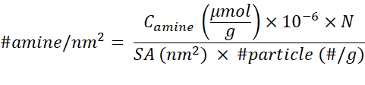 (1)
Where C_{amine} is amine concentration deduced from fluorescamine analysis; N is Avogadro's number; SA is surface area of spherical NPs which was calculated from the radius derived from TEM-analysis; #particle is number of particles per gram. The density of silica and polystyrene nanoparticles was assumed as 2 and 1.05 g cm⁻³, respectively.
Amine coverage rate (%) was calculated by the following Equation 2:
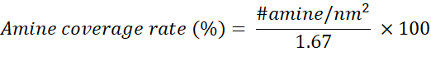 (2)
Assuming 5 Si-OH groups per nm² of silica surface,^{[25]} 1, 2 or 3 of them can be replaced by 1 amino group coupled via 1, 2 or 3 of the silanes in the trialkoxysilane linker, respectively. With the maximal binding of 3 silanol groups per amino group a factor of 1.67 is calculated. However, note that this stringent approach might overestimate the coverage rate as also a factor of 2.5 and 5 could be applied.
Solid state MAS ²⁹Si-NMR
Solid state ²⁹Si-NMR spectra of wet silica nanoparticle slurries were acquired under 11 kHz magic angle sample spinning at a resonance frequency of 99.4 MHz (500.1 MHz for ¹H) using a Bruker Avance III HD spectrometer (Bruker Biospin, Karlsruhe) equipped with a HX 4 mm MAS probe. Coherent ²⁹Si-NMR signals generated in two different ways, using direct polarization (DP) by a 90°-pulse of 4 µs, or ramped cross-polarization (CP) from ¹H with a contact time of 2 ms and B₁ field strength of 40 kHz. The signal was acquired for 40 ms under ¹H decoupling of 60 kHz. Around 1000 scans with a recycle delay of 100 s, or ~25000 scans with a recycle delay of 4 s were averaged in the DP and CP experiments, respectively. The ²⁹Si-NMR spectra were referenced by transferring the water ¹H-NMR signal (set to 4.7 ppm) of the same sample to the ²⁹Si spectrum, using a ratio of the ²⁹Si and ¹H Larmor frequencies of Ξ = 0.19867187. The peak integrals were determined by fitting up to five lines (for Q4, Q3, Q2, T3, T2 resonances) with a 50% Lorentzian/50% Gaussian line shape using the Bruker Topspin 3.5 software.
Cell culture and assessment of biocompatibility
Murine macrophages (RAW 264.7 from American Type Culture Collection, ATCC, Rockville, MD, USA) were cultured in DMEM medium supplemented with 10% FCS, 1% L-glutamine and 1% penicillin/ streptomycin. Cells were cultivated at 37°C, 5% CO₂ and with 95% relative humidity.
Prior to preparing NP suspensions in cell culture media, all SiO₂ NPs stock solutions (10 mg mL⁻¹) were incubated in an ultrasonication bath (480 W, RK102-H, Bandelin GmbH , Germany) for 10 min and then diluted to 2 mg mL⁻¹ in heat-inactivated double distilled water. Thereafter, SiO₂ NPs were diluted to 100, 200 or 400 µg mL⁻¹ in DMEM or DMEM/10%FCS medium.
RAW 264.7 cells (2.5 × 10⁴ and 1.25 × 10⁴ cells well⁻¹ for 6 and 24 h NP incubation, respectively) were first seeded in 96-well plates and incubated overnight. Then, the medium was discarded and 50 µL of fresh medium (DMEM or DMEM/10%FCS) was added. For inhibitor studies, cells were pre-incubated for 30 min in 50 µl medium containing the respective inhibitor. 50 µL of diluted NP suspensions were then added to achieve the final concentrations (50, 100, 200 µg mL⁻¹). Although nanosilica is a promising tool for nanomedicine, it is not yet applied in the clinics. Therefore, we used concentrations which are considered clinically relevant as reported for superparamagnetic iron oxide nanoparticles which are used as contrast agents for imaging.^{[39]} Note, however, that for acute exposure at the workplace concentrations are indeed much lower ^{[40]} although in toxicological studies 50 µg mL⁻¹ are nevertheless often used to simulate cumulative exposure over many years or to take into account the strong accumulation of NPs at the branching points of the airways in the lung.^{[41]}
For endpoint analysis, cells were incubated with 0.3 μg mL⁻¹ Hoechst 33342 and 0.5 μg mL⁻¹ propidium iodide (PI) for 30 min at 37 °C and 5% CO₂ directly after 6 or 24 h NP exposure. Subsequently, four images per well and channel (bright-field, Hoechst and PI) were acquired using the automated fluorescence microscope IX81 (Olympus, Germany) with a 10-fold objective. Automated image analysis was carried out using the Olympus ScanR analysis software. The total number of cells was determined by counting the Hoechst-stained nuclei. The individual Hoechst signal intensities in combination with the PI signal were used to discriminate between the different stages of cell death. Cells with intensive Hoechst staining and PI staining were recognized as late apoptotic cells. Cells with intensive Hoechst staining but without PI staining were recognized as early apoptotic cells. Necrotic cells were detected via the PI fluorescence signal while without intensive Hoechst staining. Data is depicted as means ± SEM, which are derived from quadruplicate exposures and two independent experiments (n=8). For more details see also Marquardt et al. 2017 and Donauer et al. 2012.^{[32,42]}
Real-time imaging
In order to analyze RAW264.7 macrophages by real-time imaging at single cell level, cells were first seeded in 96-well plates and incubated overnight as described above. Next day, macrophages were directly incubated with 0.1 μg mL⁻¹ Hoechst 33342, 0.083 μg mL⁻¹ propidium iodide (PI) and 500nM Lysotracker®, respectively, for 1 h at 37 °C and 5% CO₂. Then, cells were incubated with FITC-labelled or unlabeled 50 µg mL⁻¹ SiO₂ NPs over 24h in a microscope incubator box (EMBLEM, Germany) for control of CO₂, humidity and temperature (37°C, 5% CO₂). Every 15 min two images per well and channel (bright-field, Hoechst, FITC, PI and Lysotracker®, respectively) were acquired using the automated fluorescence microscope IX81 (Olympus, Germany) with a 20-fold objective. Images were converted to movies using the NIH ImageJ Software.

Transmission electron microscopy
The amorphous structure of NPs was analyzed by high-resolution transmission electron microscopy or selected area electron diffraction patterns (SAED) of NP ensembles. Specimens for TEM were prepared by suspending the particles in deionized water at a concentration of 1µg mL⁻¹ and evaporating a drop of the suspension on ultrathin carbon film on type-A 400-mesh copper grids (Ted Pella Inc., Redding, CA, USA). SAED patterns of NP ensembles and high-resolution or bright-field TEM images were acquired using a FEI Osiris TEM (Hillsboro, OR, USA), operated at 200 kV. Resulting SAED patterns were converted into radial intensity profiles by azimuthal averaging. Areas affected by the beam stop were excluded. See Figure S15 for the final results on plain and APTES-11 modified silica NPs.
For TEM analysis of particle-treated macrophages, cells were seeded on Transwell inserts (Corning No. 3412, 24 mm polycarbonate membranes with 0.4 µm pores) as described previously.^{[43]} After particle treatment, the cells were fixed with 1.25% glutaraldehyd, 2% paraformaldehyde, 0.1% NaN₃ in 0.1 M PIPES buffer (pH 7.0), post-fixed with 0.5% osmium tetroxide and stained with 2% uranyl acetate. After dehydration in a graded ethanol series, the cells were embedded in EPON (Polysciences, Eppelheim, Germany), cut into ultrathin sections and visualized with a Zeiss TEM (EM 109T, Oberkochen, Germany).
Instillation and BAL
9-12-week-old male C57BL/6J wild type mice were used for intratracheal NP instillation. Prior to the NP exposure, the mice were maintained in specific pathogen-free (SPF) area with a 14h-light/10h-dark cycle. Food and water were available ad libitum. Animals were treated according to the animal protection law and the experiments are approved through the Regierungspräsidium Karlsruhe. The mice were anaesthetized by intraperitoneal injection of a mixture of ketamine (100 mg kg⁻¹ body weight) and xylazine (16 mg kg⁻¹ body weight).^{[44]} Then, 50µl of a suspension containing 50 µg silica NPs in sterilized water were carefully instilled.^{[45]} Sham animals received the equal volume of sterilized water. 100 µl of air on top of the suspension were used to administrate the compounds as a spray into the trachea. 24 h after instillation, the mice were anesthetized and killed by an overdose of ketamine (200 mg kg⁻¹ body weight) and xylazine (32 mg kg⁻¹ body weight). BAL (bronchoalveolar lavage) was performed by infusing the lungs 4 times with 1 mL of PBS (without calcium and magnesium) via a cannula in the trachea. Bronchoalveolar fluid (BALF) was collected and centrifuged at 450 g at 4°C for 10 min. The cell pellet was re-suspended in 1 mL RPMI 1640 medium, cell number was counted by the trypan blue exclusion method. BAL cell composition was determined by cytospin preparations following May-Grünwald-Giemsa staining. At least 200 cells were counted for each cytospin slide by using the microscope. Each of the three experimental groups had two or three mice, and the experiments were independently conducted four times. Statistical differences between each two groups were performed by one-tailed unpaired t test.
DCF assay
The DCF assay was performed as previously described.^{[12]} RAW 264.7 macrophages (1 x 10⁴ cells/well) were seeded in 96-well plates and incubated overnight. After washing with phenol-red free medium, the cells were loaded with 50 µM H₂DCF-DA in medium without phenol-red for 40 min. Subsequently, the cells were washed again with phenol-red free medium and exposed to 50 µg mL⁻¹ particles. The relative fluorescence was measured at 530 nm using an automated fluorescence reader (MWG-Biotech AG, Ebersberg, Germany).
Flow cytometric analysis of FITC-Annexin V/Propidium iodide staining
RAW 264.7 macrophages were seeded in 6-well plates and particle treatment of cells was performed as described above. After NP incubation the cells were stained using FITC- Annexin V and propidium iodide (PI) detection kit according to the manufacturer´s instructions (BD Biosciences, Heidelberg, Germany). Briefly, after NP exposure the cell culture medium was discarded and the adherent macrophages were detached from the surface using accutase. The cell suspension was collected and centrifuged for 5 min at 300 × g. The supernatant was removed and the pellet was re-suspended in 100 µl binding buffer (Hepes 10 mM, NaCl 140 mM, CaCl₂ 2.5 mM, pH 7.4). Staining was performed by adding 5 µl PI and 5 µl FITC-conjugated Annexin V for 15 min at RT in the dark. Then, 400 µl of binding buffer was added and the samples were analyzed using the LSR II FACS system (BD Biosciences, Heidelberg, Germany).

Statistical analysis: The significance of difference between two mean values was assessed by the Student’s t-test. A p-value < 0.05 was considered to be statistically significant.
Supporting Information
Supporting Information is available from the Wiley Online Library

Acknowledgements
I-Lun Hsiao thanks the Ministry of Science and Technology Taiwan (MOST) for financial support. We acknowledge financial support of this work by the Helmholtz programme BioInterfaces in Technology and Medicine, and the DFG instrument grant INST 121384/58-1. AL, ASU, CMN acknowledge financial support through GRK 2039.

Received: ((will be filled in by the editorial staff))
Revised: ((will be filled in by the editorial staff))
Published online: ((will be filled in by the editorial staff))

References
[1] S. F.Hansen, E. S.Michelson, A.Kamper, P.Borling, F.Stuer-Lauridsen, A.Baun, Ecotoxicology 2008, 17, 438.
[2] L.Tang, J.Cheng, Nano Today 2013, 8, 290.
[3] E.Phillips, O.Penate-Medina, P. B.Zanzonico, R. D.Carvajal, P.Mohan, Y.Ye, J.Humm, M.Gönen, H.Kalaigian, H.Schöder, H. W.Strauss, S. M.Larson, U.Wiesner, M. S.Bradbury, Sci. Transl. Med. 2014, 6, 260ra149.
[4] R. A.Sperling, W. J.Parak, Philos. Trans. A. Math. Phys. Eng. Sci. 2010, 368, 1333.
[5] Z.Csogör, M.Nacken, M.Sameti, Mater. Sci. Eng. C 2003, 23, 93.
[6] C.Weiss, S.Diabaté, Arch. Toxicol. 2011, 85, 705.
[7] T.Gebel, H.Foth, G.Damm, A.Freyberger, P. J.Kramer, W.Lilienblum, C.Roehl, T.Schupp, C.Weiss, K. M.Wollin, J. G.Hengstler, Arch. Toxicol. 2014, 88, 2191.
[8] I.Lynch, C.Weiss, E.Valsami-Jones, Nano Today 2014, 9, 266.
[9] I. I.Slowing, C.-W.Wu, J. L.Vivero-Escoto, V. S. Y.Lin, Small 2009, 5, 57.
[10] E.-J.Park, K.Park, Toxicol. Lett. 2009, 184, 18.
[11] M.Al-Rawi, S.Diabaté, C.Weiss, Arch. Toxicol. 2011, 85, 813.
[12] A.Panas, C.Marquardt, O.Nalcaci, H.Bockhorn, W.Baumann, H.-R.Paur, S.Mülhopt, S.Diabaté, C.Weiss, Nanotoxicology 2013, 7, 259.
[13] A.Panas, A.Comouth, H.Saathoff, T.Leisner, M.Al-Rawi, M.Simon, G.Seemann, O.Dössel, S.Mülhopt, H. R.Paur, S.Fritsch-Decker, C.Weiss, S.Diabaté, Beilstein J. Nanotechnol. 2014, 5, 1590.
[14] T.Yoshida, Y.Yoshioka, K.Matsuyama, Y.Nakazato, S.Tochigi, T.Hirai, S.Kondoh, K.Nagano, Y.Abe, H.Kamada, S. ichiTsunoda, H.Nabeshi, T.Yoshikawa, Y.Tsutsumi, Biochem. Biophys. Res. Commun. 2012, 427, 748.
[15] V.Marzaioli, J. A.Aguilar-Pimentel, I.Weichenmeier, G.Luxenhofer, M.Wiemann, R.Landsiedel, W.Wohlleben, S.Eiden, M.Mempel, H.Behrendt, C.Schmidt-Weber, J.Gutermuth, F.Alessandrini, Int. J. Nanomedicine 2014, 9, 2815.
[16] A.Kurtz-Chalot, J. P.Klein, J.Pourchez, D.Boudard, V.Bin, G. B.Alcantara, M.Martini, M.Cottier, V.Forest, J. Nanoparticle Res. 2014, 16, 2738.
[17] T.Yu, A.Malugin, H.Ghandehari, ACS Nano 2011, 5, 5717.
[18] A. S.Morris, A.Adamcakova-Dodd, S. E.Lehman, A.Wongrakpanich, P. S.Thorne, S. C.Larsen, A. K.Salem, Toxicol. Lett. 2016, 241, 207.
[19] O.Boussif, F.Lezoualc’h, M. A.Zanta, M. D.Mergny, D.Scherman, B.Demeneix, J. P.Behr, Proc. Natl. Acad. Sci. U. S. A. 1995, 92, 7297.
[20] T.Xia, M.Kovochich, M.Liong, J. I.Zink, A. E.Nel, ACS Nano 2008, 2, 85.
[21] O.Lunov, T.Syrovets, C.Loos, G. U.Nienhaus, V.Mailänder, K.Landfester, M.Rouis, T.Simmet, ACS Nano 2011, 5, 9648.
[22] Y.Li, M.Kröger, W. K.Liu, Biomaterials 2014, 35, 8467.
[23] X. D.Wang, K. S.Rabe, I.Ahmed, C. M.Niemeyer, Adv. Mater. 2015, 27, 7945.
[24] A.Leidner, S.Weigel, J.Bauer, J.Reiber, A.Angelin, M.Grösche, T.Scharnweber, C. M.Niemeyer, Adv. Funct. Mater. 2018, 28, 1707572.
[25] L. T.Zhuravlev, Colloids Surfaces A Physicochem. Eng. Asp. 2000, 173, 1.
[26] S.Tenzer, D.Docter, J.Kuharev, A.Musyanovych, V.Fetz, R.Hecht, F.Schlenk, D.Fischer, K.Kiouptsi, C.Reinhardt, K.Landfester, H.Schild, M.Maskos, S. K.Knauer, R. H.Stauber, Nat. Nanotechnol. 2013, 8, 772.
[27] V. Y.Davydov, Adsorption on Silica Surfaces., 2000.
[28] E.Mahon, D. R.Hristov, K. A.Dawson, Chem. Commun. 2012, 48, 7970.
[29] I.Ojea-Jiménez, P.Urbán, F.Barahona, M.Pedroni, R.Capomaccio, G.Ceccone, A.Kinsner-Ovaskainen, F.Rossi, D.Gilliland, ACS Appl. Mater. Interfaces 2016, 8, 4838.
[30] M.Wiemann, A.Vennemann, U. G.Sauer, K.Wiench, L.Ma-Hock, R.Landsiedel, J. Nanobiotechnology 2016, 14, 16.
[31] S. R.Mane, I. L.Hsiao, M.Takamiya, D.Le, U.Straehle, C.Barner-Kowollik, C.Weiss, G.Delaittre, Small 2018, 14, 1801571.
[32] C.Marquardt, S.Fritsch-Decker, M.Al-Rawi, S.Diabaté, C.Weiss, Toxicology 2017, 379, 40.
[33] F.Wang, M. G.Bexiga, S.Anguissola, P.Boya, J. C.Simpson, A.Salvati, K. A.Dawson, Nanoscale 2013, 5, 10868.
[34] S.Anguissola, D.Garry, A.Salvati, P. J.O’Brien, K. A.Dawson, PLoS One 2014, 9, e108025.
[35] A. E.Nel, L.Mädler, D.Velegol, T.Xia, E. M.V.Hoek, P.Somasundaran, F.Klaessig, V.Castranova, M.Thompson, Nat. Mater. 2009, 8, 543.
[36] K.Yamashita, Y.Yoshioka, K.Higashisaka, K.Mimura, Y.Morishita, M.Nozaki, T.Yoshida, T.Ogura, H.Nabeshi, K.Nagano, Y.Abe, H.Kamada, Y.Monobe, T.Imazawa, H.Aoshima, K.Shishido, Y.Kawai, T.Mayumi, S. I.Tsunoda, N.Itoh, T.Yoshikawa, I.Yanagihara, S.Saito, Y.Tsutsumi, Nat. Nanotechnol. 2011, 6, 321.
[37] S.Fritsch-Decker, C.Marquardt, T.Stoeger, S.Diabaté, C.Weiss, Arch. Toxicol. 2018, 92, 2163.
[38] F.Bertoli, D.Garry, M. P.Monopoli, A.Salvati, K. A.Dawson, ACS Nano 2016, 10, 10471.
[39] S. Y.Shaw, E. C.Westly, M. J.Pittet, A.Subramanian, S. L.Schreiber, R.Weissleder, Proc. Natl. Acad. Sci. 2008, 105, 7387.
[40] H. R.Paur, F. R.Cassee, J.Teeguarden, H.Fissan, S.Diabate, M.Aufderheide, W. G.Kreyling, O.Hänninen, G.Kasper, M.Riediker, B.Rothen-Rutishauser, O.Schmid, J. Aerosol Sci. 2011, 42, 668.
[41] R. F.Phalen, M. J.Oldham, A. E.Nel, Toxicol. Sci. 2006, 92, 126.
[42] J.Donauer, I.Schreck, U.Liebel, C.Weiss, Arch. Toxicol. 2012, 86, 329.
[43] S.Fritsch-Decker, T.Both, S.Mülhopt, H. R.Paur, C.Weiss, S.Diabaté, Part. Fibre Toxicol. 2011, 8, 23.
[44] T.Stoeger, C.Reinhard, S.Takenaka, A.Schroeppel, E.Karg, B.Ritter, J.Heyder, H.Schulz, Environ. Health Perspect. 2006, 114, 328.
[45] T. Stöger, C. Reinhard, B. Ritter, E. Karg, A. Schröppel, J. Heyder, et al., Inflammatory effects of five different particles in BALB/cJ mice. In Effects of Air Contaminants on the Respiratory Tract-Interpretations from Molecules to Meta Analysis. Vol.75 (Eds: U. Heinrich), Fraunhofer IRB Verlag, Stuttgart, Germany, 2004.

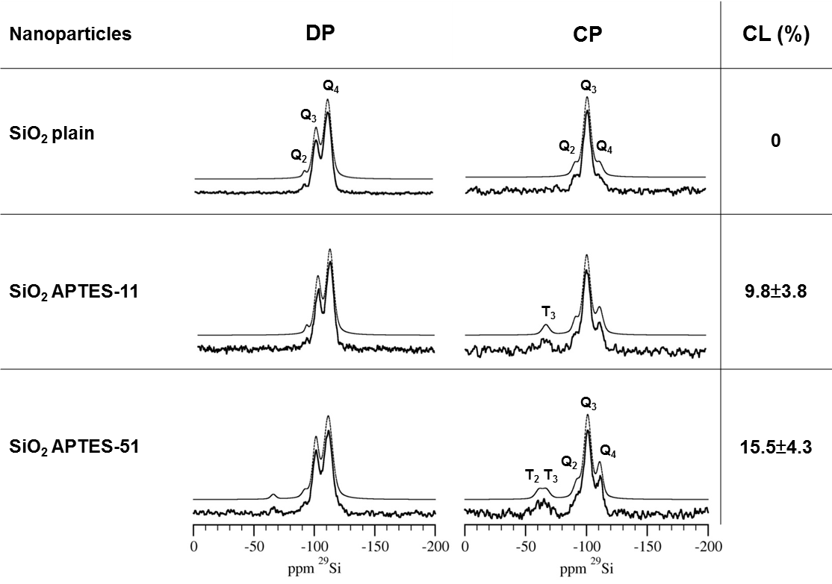

Figure 1: Magic angle spinning ²⁹Si-NMR characterization of NPs. Direct polarization (DP) and cross polarization (CP) was used to distinguish bulk material from the surface-exposed silanol groups, respectively. Spectra of plain silica NPs and two APTES-modified NPs (APTES-11 and APTES-51). The different peaks Q2, Q3, Q4, T2, and T3 specify silicon nuclei in different coordination sites (Q) and states of amine-modified environments (T) (for more details see Figure S3). The black and grey lines represent the experimental spectra and the sum of the respective deconvoluted peaks, respectively. CL: Coverage Level (as quantified from Table S2, for further details see Experimental Section).
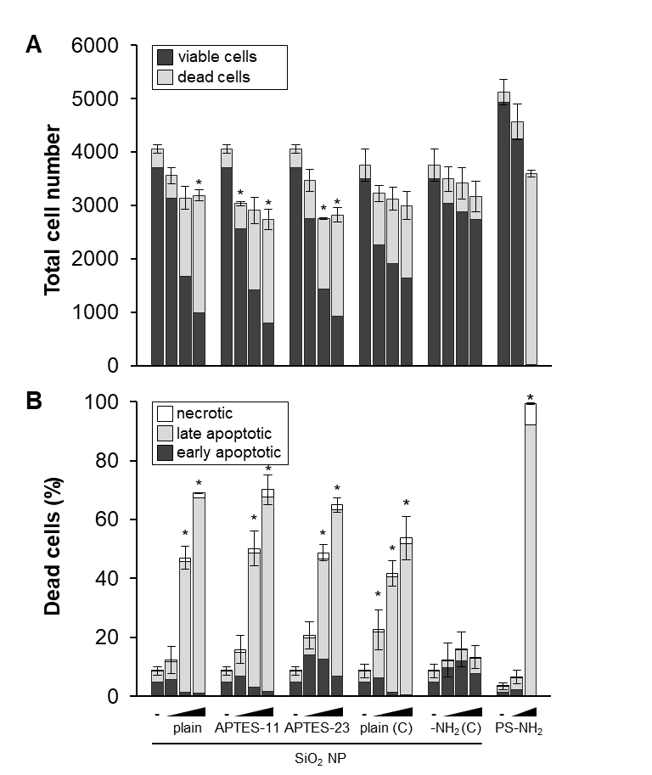
Figure 2: In the absence of serum, silica NPs induce cell death reminiscent of late apoptosis irrespective of APTES-modifications. RAW 264.7 macrophages were treated with NPs (50, 100 and 200 µg mL⁻¹) as indicated for 6 h. (A) shows the total cell number divided into living and dead cells. (B) shows the percentage of dead cells relative to the total cell number divided into early and late apoptotic and necrotic cells. Data are representative for 2 independent experiments each carried out with four replicates and show means ± SEM. (*) Significantly different from the control group (p< 0.05). For comparison, commercial silica and polystyrene (PS) NPs were studied. Due to the high toxicity of PS-NPs lower concentrations were applied (5 and 50 µg mL⁻¹).

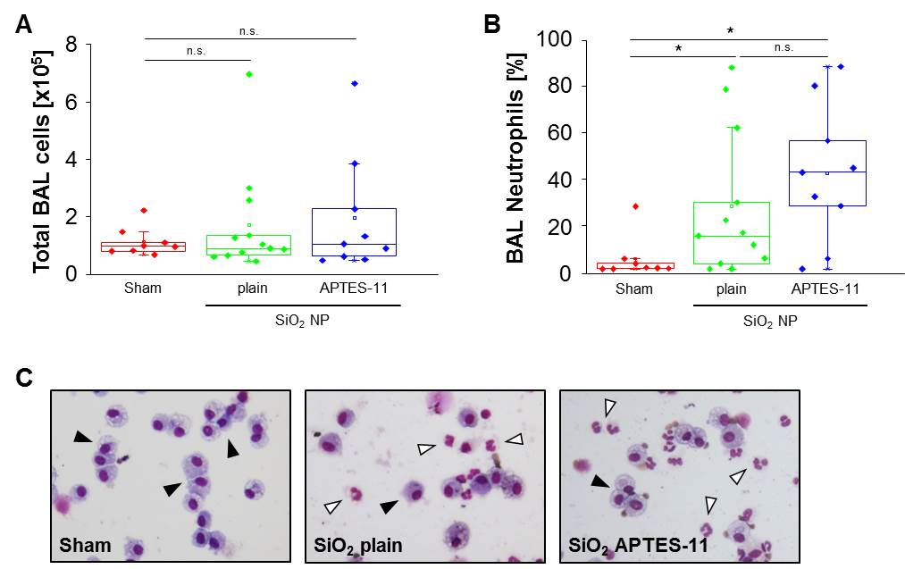

Figure 3: Plain and APTES modified silica NPs trigger inflammation in the murine lung.
BAL (bronchoalveolar lavage) cell counts after intratracheal instillation of silica NPs. The total BAL cell number (A) and ratio of neutrophils (B) are shown as box plot with data overlay (n = 8–12 per group, asterisks represent significance as compared to different groups with * p < 0.05, **p < 0.01). (C) shows representative images of BAL cells after cytospin preparation. White arrows indicate neutrophils and black arrows macrophages.

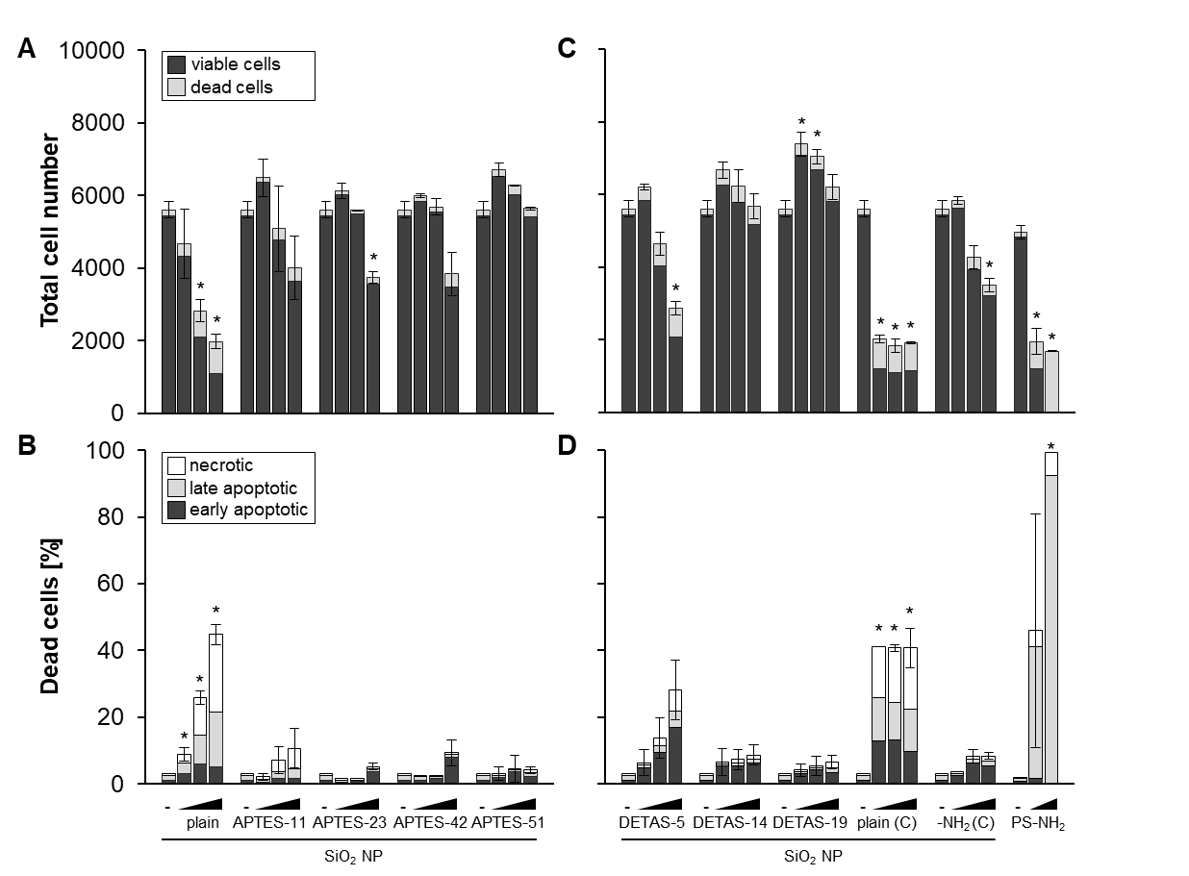

Figure 4: In the presence of serum, surface modification of silica NPs by either APTES or DETAS suppresses toxicity. RAW 264.7 macrophages were exposed to increasing concentrations of APTES- (A, B) or DETAS- (C, D) modified NPs for 24 h. For further details see Figure 2.

Figure 5: In the presence of serum, SiO₂ NPs-induced cell death is dependent on the lysosomal injury pathway. (A) Lysosomal rupture coincides with the onset of cell death. RAW 264.7 macrophages were treated with 50 µg mL⁻¹ commercial SiO₂ NPs in medium supplemented with FCS and images were taken every 15 min. The image sequence, converted to a movie, is shown in Movie S1. In the bright-field, the morphological changes of one selected cell due to apoptosis are indicated by an arrow. Of note, the same cell undergoes lysosomal rupture evidenced by the loss of lysosomal staining (Lysotracker®, LT). Another cell is depicted in the lowest panel, which shows the same features 15 min later. Hoechst 33342 labels nuclear DNA and in the FITC channel fluorescently labelled SiO₂ NPs inside cells are detected. (B) Inhibitors of lysosomal rupture inhibit cell death provoked by SiO₂ NPs. RAW 264.7 macrophages were pre-treated with Bafilomycin A1 (Baf A1, 5nM), Chloroquine (CHQ, 5µg/mL) or Cathepsin B inhibitor (Ca-074, 10µM) prior to SiO₂ NPs treatment (50 µg mL⁻¹). Macrophages were either exposed to commercial SiO₂ NPs for 24h in the presence of serum (B) or to SiO₂ plain NPs for 6h in the absence and for 24h in the presence of serum (C). The microscopy assay was performed and analysed as described under methods. Shown are the percentages of dead cells relative to the total cell number. Data are representative for two independent experiments each carried out with 3-4 replicates and show mean values ±SD. (**,***) Significantly different from the respective control cells (p<0.01, p<0.001).

Table 1. Physico-chemical characterization of nanoparticles. C: Commercial, CCM(+) or (-): Cell Culture Medium with or without serum, CL: Coverage Level, DLS: Dynamic Light Scattering, FA: Fluorescamine Assay, N.D.: not determined, TEM: Transmission Electron Microscopy, Zet. Pot.: Zeta Potential

Nanoparticles | TEM  (nm) | FA  (#NH₂/nm²) | CL  (%) | Zet.Pot.  (mV) | DLS  (nm)
 |  |  |  |  | H₂O  0h | CCM(-)  0h | CCM(-)  6h | CCM(+)  0h | CCM(+)  24h
SiO₂ plain | 50±3 | - | - | -45±0 | 94±1 | 84±1 | 59±0 | 186±3 | 131±5
SiO₂ APTES-11 | 54±3 | 0.19 | 11 | -24±3 | 93±1 | 89±1 | 98±1 | 349±26 | 208±22
SiO₂ APTES-23 | 56±3 | 0.39 | 23 | +20±0 | 116±1 | 116±1 | 147±2 | 560±10 | 277±9
SiO₂ APTES-42 | 54±3 | 0.69 | 42 | +28±0 | 174±1 | 1297±161 | 2826±28 | 626±27 | 237±5
SiO₂ APTES-51 | 53±3 | 0.84 | 51 | +33±1 | 188±1 | 1628±210 | 3404±220 | 895±200 | 197±3
SiO₂ DETAS-5 | 52±2 | 0.09 | 5 | -30±0 | 75±0 | 77±0.2 | 4185±227 | 349±41 | 147±1
SiO₂ DETAS-14 | 51±3 | 0.24 | 14 | -14±0 | 74±1 | 79±1 | 6589±660 | 566±61 | 181±1
SiO₂ DETAS-19 | 52±3 | 0.31 | 19 | -3±0 | 125±32 | 93±3 | 7808±447 | 518±84 | 250±9
SiO₂ DETAS-38 | 51±4 | 0.63 | 38 | +29±2 | 134±1 | 2445±135 | 3591±270 | 1722±130 | 795±77
SiO₂ DETAS-210 | 49±6 | 3.5 | 210 | +47±0 | 119±0 | 873±126 | 2932±14 | 1377±91 | 945±200
SiO₂ plain (C) | 55±7 | - | - | -31±1 | 62±1 | 63±1 | 64±1 | 112±43 | 105±45
SiO₂-NH₂ (C) | 55±7 | 2.8 | 168 | -28±3 | 66±1 | 68±1 | 66±1 | 113±47 | 105±43
Polystyrene-NH₂ (C) | 58 | 22.1 | N.D. | +28±2 | 61±0 | 64±1 | 94±0 | 296±1 | 218±16

C. Author 2, D. E. F. Author 3, A. B. Corresponding Author*

Biocompatibility of Amine-Functionalized Silica Nanoparticles: The Role of Surface Coverage

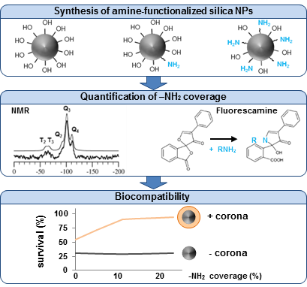

Copyright WILEY-VCH Verlag GmbH & Co. KGaA, 69469 Weinheim, Germany, 2016.

Supporting Information

Biocompatibility of Amine-Functionalized Silica Nanoparticles: The Role of Surface Coverage

I-Lun Hsiao, Susanne Fritsch-Decker, Arnold Leidner, Marco Al-Rawi, Vanessa Hug, Silvia Diabaté, Stephan L Grage, Matthias Meffert, Tobias Stoeger, Dagmar Gerthsen, Anne S. Ulrich, Christof M. Niemeyer, and Carsten Weiss*

Nanoparticles | APTES  (µL) | DETAS  (µL) | [NH₂]  (µmol/g)
SiO₂ plain | 0 | - | N.A.
SiO₂ APTES-11 | 10 | - | 17
SiO₂ APTES-23 | 15 | - | 35
SiO₂ APTES-42 | 25 | - | 65
SiO₂ APTES-51 | 35 | - | 79
SiO₂ DETAS-5 | - | 5 | 9
SiO₂ DETAS-14 | - | 10 | 23
SiO₂ DETAS-19 | - | 15 | 30
SiO₂ DETAS-38 | - | 20 | 61
SiO₂ DETAS-210 | - | 120 | 356
SiO₂-NH₂ (C) | - | - | 253
Polystyrene-NH₂ (C) | - | - | 3614
N.A.: not applicable
C: commercial

Table S1: Amount of amino groups at the surface of SiO₂ nanoparticles derived from fluorescamine analysis and corresponding volume of APTES or DETAS in reactions.

Nanoparticles | Polarization | Unit | Chemical shift (ppm) | Integral fraction
SiO₂ plain | DP | Q₄ | -112 | 0.654±0.050
 |  | Q₃ | -102 | 0.330±0.025
 |  | Q₂ | -92 | 0.016±0.005
 |  | T₃ |  | 0
 |  | T₂ |  | 0
SiO₂ plain | CP | Q₄ | -112 | 0.094±0.020
 |  | Q₃ | -101 | 0.828±0.060
 |  | Q₂ | -91 | 0.078±0.015
 |  | T₃ |  | 0
 |  | T₂ |  | 0
SiO₂ APTES-11 | DP | Q₄ | -112 | 0.636±0.050
 |  | Q₃ | -102 | 0.345±0.025
 |  | Q₂ | -92 | 0.019±0.010
 |  | T₃ |  | 0
SiO₂ APTES-11 | CP | Q₄ | -112 | 0.181±0.035
 |  | Q₃ | -101 | 0.668±0.050
 |  | Q₂ | -92 | 0.071±0.015
 |  | T₃ | -67 | 0.080±0.030
 |  | T₂ |  | 0
SiO₂ APTES-51 | DP | Q₄ | -112 | 0.639±0.050
 |  | Q₃ | -102 | 0.311±0.025
 |  | Q₂ | -92 | 0.027±0.010
 |  | T₃ | -66 | 0.022±0.010
 |  | T2 |  | 0
SiO₂ APTES-51 | CP | Q₄ | -111 | 0.184±0.034
 |  | Q₃ | -101 | 0.604±0.050
 |  | Q₂ | -92 | 0.085±0.015
 |  | T₃ | -67 | 0.063±0.020
 |  | T₂ | -61 | 0.063±0.020

Table S2: Quantification of the different coordination sites of plain silica NPs, and of APTES-11- and APTES-51- modified NPs, obtained as integral fractions from MAS ²⁹Si-NMR spectra. DP: direct polarization, CP: cross polarization, Q2-4 and T2-3: silicon units (for further details see Figure S3)

Nanoparticles | DLS (nm)
 | 0h | 24h
SiO₂ plain | 146±3 | 108±8
SiO₂ APTES-11 | 151±3 | 124±2
SiO₂ APTES-23 | 174±2 | 142±1
SiO₂ APTES-42 | 385±17 | 130±1
SiO₂ APTES-51 | 586±40 | 133±2

Table S3: Size of SiO₂ NPs pre-coated with serum proteins in DMEM as determined by DLS. All samples (100 µg mL⁻¹) were first suspended in cell culture medium with FCS for 0 or 24 h and then centrifuged at 20,000 g for 20 min. All supernatants were discarded and the NP pellets were re-suspended in cell culture medium.

chemical inhibitors (target) | inhibition of cell death
cell death

DPQ (PARP inhibitor) | -
Glycine (pyroptosis inhibitor) | -
Necrostatin (necroptosis inhibitor) | -
z-VAD-fmk (pan-caspase inhibitor) | -
kinases

Triciribine (Akt inhibitor V) | -
BAY 61-3606 (SYK inhibitor) | -
PD98059 (ERK inhibitor) | -
PP1 (tyrosine kinase inhibitor) | -
SB203580 (p38 inhibitor) | -
SP600125 (JNK inhibitor) | -
Wortmannin (PI3K inhibitor) | -
metal ions / ROS chelator

BAPTA/AM (Ca²⁺-chelator) | -
DFO (Fe^{III}-chelator) | -
NAC (ROS scavenger) | -
endosomal/lysosomal function

Ca-074 (Cathepsin-B inhibitor) | +
Chloroquine (inhibitor of endosomal acidification) | +
Bafilomycin A1 (V-ATPase inhibitor) | +
Calpain inhibitor 1 | +

Table S4: Influence of different targeted inhibitors on silica NP-induced cell death.

Figure S1: Schematic illustration of the synthesis procedure of plain, APTES- or DETAS-modified silica nanoparticles. (A) In brief, aliquots of TEOS and ammonia solution (28-30 %) were added to the mixture of reverse micelles including cyclohexane, 1-hexanol, Triton X-100 and water, and then kept stirring at room temperature for 24 h (Day I). Thereafter, additional TEOS was added and the mixture was stirred for 30 min, then the various amounts of APTES or DETAS were added to modify the particle surface with positively charged amino groups. The mixture was incubated for another 24 h (Day II). Then, acetone was added to the mixture to break up the micelles. Nanoparticle suspensions were washed 3 times with absolute ethanol and 3 times with heat-inactivated double distilled water (Day III) and stored in water at a concentration of 10 mg mL⁻¹. (B) Chemical structure of APTES and DETAS.

Figure S2: TEM images of plain, APTES-, and DETAS-modified silica nanoparticles. The indicated NPs were suspended in H₂O, spotted on formvar covered copper grids, dried at RT and analyzed by transmission electron microscopy (TEM), scale bar = 100 nm. Particle size distributions were calculated from TEM images by using NIH ImageJ software.

Figure S3: Types of silicon units on APTES-modified silica NPs surface.

Figure S4: TEM images of plain, APTES-11, APTES-23 and DETAS-14 silica nanoparticles incubated in cell culture medium supplemented with FCS for 0 and 24 h. Scale bar = 100 nm. Insets depict NPs at two-fold higher magnification to illustrate partial dissolution at 24 h.

Figure S5. Dose-response curves according to surface area of the various applied NPs. Cells were exposed in the absence (A) or presence (B, C) of serum. For more details see also Fig 2.

Figure S6: In the absence of serum, silica NPs induce cell death reminiscent of late apoptosis irrespective of APTES modifications. In the absence of serum, silica NPs induce cell death reminiscent of late apoptosis irrespective of APTES modifications. Representative images of RAW 264.7 cells after treatment for 6 h with either plain or amine-modified SiO₂ NPs (100 µg mL⁻¹) or PS-NH₂ NPs (50 µg mL⁻¹). In bright-field images the appearance of vacuoles can be visualized whereas cellular disintegration is indicated by loss of contrast. DNA staining by Hoechst 33342 or propidium iodide (PI) identifies cells with condensed DNA and perturbed cell membrane integrity, respectively. C= commercial

Figure S7: In the presence of serum, silica NPs only modestly provoke cell death at 6h post exposure. In the presence of serum RAW 264.7 macrophages were treated with NPs (50, 100 and 200 µg mL⁻¹) for 6 h. Shown is the percentage of dead cells relative to the total cell number divided into early and late apoptotic and necrotic cells. Data are representative for 2 independent experiments each carried out with four replicates and show means ± SD. (*) Significantly different from the control group (p< 0.05). For comparison, commercial silica and polystyrene (PS) NPs were studied (50 µg mL⁻¹).

Figure S8: In the presence of serum, surface modifications of silica NPs by APTES suppress cell death. Representative images of RAW 264.7 cells after treatment for 24 h with plain and APTES-modified SiO₂ NPs (100 µg mL⁻¹). For further details see Figure S6.

Figure S9: Classical features of apoptosis precede the onset of secondary necrosis.
Representative images of RAW 264.7 macrophages after treatment with commercial FITC-labelled SiO₂ NPs (50 µg mL⁻¹) over a period of 24 h. Fluorescently labelled SiO₂ NP inside cells are detected in the FITC-channel, Hoechst 33342 and PI staining were used to discriminate between cells with condensed DNA and damaged cell membrane, respectively. Arrowhead indicates a selected cell where first morphological changes i.e. detachment, shrinkage and blebbing appear (in the bright-field channel) accompanied by signs of DNA condensation and fragmentation (in the Hoechst channel). Subsequent to these classical features of apoptosis, a few hours later the membrane integrity is compromised as evidenced by increased PI staining.

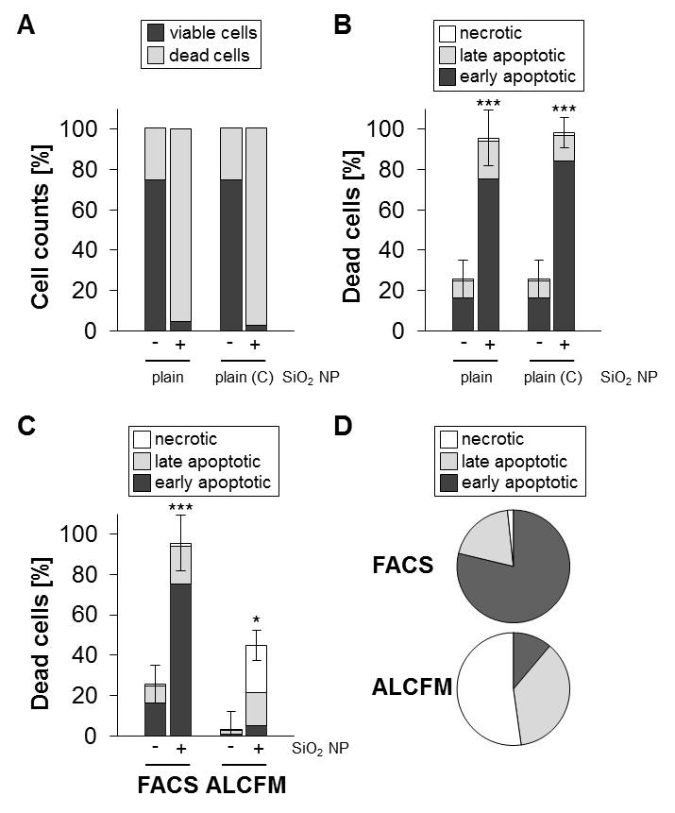

Figure S10: Cell death analysis by flow cytometry confirms the induction of apoptosis in response to SiO₂ NPs.
In the presence of serum, RAW 264.7 macrophages were treated with 200 µg mL⁻¹ SiO₂ NPs for 24h. The cells were stained with FITC-Annexin V and PI and analyzed by flow cytometry as described in the Methods Section. (A) shows the total cell counts divided into living and dead cells. (B) shows the percentage of dead cells relative to the total cell counts divided into early (Annexin V-positive) and late apoptotic (Annexin V- and PI-positive) and necrotic cells (PI-positive). Data are representative for two independent experiments each carried out with duplicates and show mean values ±SD. For comparison, percentage of dead cells relative to the total cell counts (C) and percentage of necrotic, early and late apoptotic cells relative to the total cell death (D) analyzed by FACS (fluorescence activated cell sorting) and automated live cell fluorescence microscopy (ALCFM) are shown. (*, ***) Significantly different from the control cells (p<0.05, p<0.001). Note that the two different methods both confirm the apoptotic nature of cell death, yet as expected detect diverging percentages of the various modes of cell death as different endpoints are measured.^{[1]} Whereas flow cytometry scores more early apoptotic cells evidenced by enhanced Annexin V binding, ALCFM is more advantageous to monitor necrotic cells which have been probably lost during the preparation of cells for flow cytometry.

Figure S11: In the presence of serum, surface modifications of silica NPs by DETAS suppress cell death. Representative images of RAW 264.7 cells after treatment for 24 h with either plain or DETAS-modified and commercial SiO₂ NPs (100 µg mL⁻¹) or PS-NH₂ NPs (50 µg mL⁻¹). For further details see Figure S6.

Figure S12: SiO₂ NPs do neither promote intracellular formation of ROS nor induce cell death dependent on ROS. (A) RAW 264.7 macrophages were exposed in the presence of serum to 50 µg mL⁻¹ of SiO₂ plain (C) NPs for 15, 30, 45, 60, 150, and 300 min or positive controls were exposed to 500 µM H₂O₂. Negative control cells received medium alone. The DCF-test was performed as described under methods. Depicted are mean values ± SD of one representative experiment (n=2) carried out with four replicates. (B) The anti-oxidant N-acetyl cysteine (NAC) does not prevent cell death provoked by silica NPs. Cells were pre-treated or not with 5mM NAC for 30 min, exposed to silica NPs (50µg mL⁻¹) in the presence of serum and analyzed after 24h.

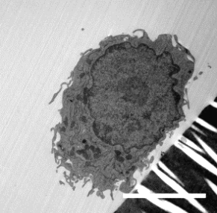
control
SiO₂ plain (C)
+ serum
- serum

Figure S13: Presence of serum facilitates the uptake of SiO₂ NPs in macrophages. However, in the absence of serum SiO₂ NPs are localized at or close to the cell membrane. Representative TEM images of RAW264.7 macrophages after treatment for 5 h with commercial SiO₂ NPs (50 µg mL⁻¹) either in the presence or absence of serum. White scale bars = 5 µm, black scale bars = 1 µm. Arrowheads indicate localization of NPs and black squares depict the selected region enlarged on the right.

Figure S14: Mechanistic model to explain the impact of the protein corona and surface modification on the cytotoxicity of silica NPs. In the presence of serum, plain but not amine-modified silica NPs lead to lysosomal damage. Inhibition of lysosomal acidification by chloroquine (CHQ) or bafilomycin (Baf A1) and of the lysosomal protease cathepsin B prevents cytotoxicity and enhances biocompatibility. However, in the absence of serum both, plain and amine-modified, silica NPs damage cells independent of the lysosomal injury pathway, presumably by direct detrimental interaction with the cellular membrane. For further details see text.

Figure S15: Structure analysis of silica NPs. TEM images and SAED (selected area electron diffraction) patterns of amorphous plain (A) and amorphous APTES-11 (B) silica NPs and, for comparison, TEM image and SAED pattern of crystalline silica MIN-U-SIL® particles (C). SAED patterns of NP ensembles and radial intensity profiles obtained by azimuthal integration of SAED patterns show diffuse rings for plain (A) and APTES-11 (B) NPs, which are characteristic for amorphous material. In contrast, the SAED pattern of crystalline silica MIN-U-SIL® particles shows discrete Bragg reflections and sharp intensity maxima in the radial intensity profile. The black pointed object in the center of the SAED patterns is the beam stop, which prevents overexposure of the charge-coupled-device (CCD) camera used for acquisition of the SAED patterns.

Reference:
[1] L.Galluzzi, S. A.Aaronson, J.Abrams, E. S.Alnemri, D. W.Andrews, E. H.Baehrecke, N. G.Bazan, M.V.Blagosklonny, K.Blomgren, C.Borner, D. E.Bredesen, C.Brenner, M.Castedo, J. A.Cidlowski, A.Ciechanover, G. M.Cohen, V.DeLaurenzi, R.DeMaria, M.Deshmukh, B. D.Dynlacht, W. S.El-Deiry, R. A.Flavell, S.Fulda, C.Garrido, P.Golstein, M. L.Gougeon, D. R.Green, H.Gronemeyer, G.Hajnóczky, J. M.Hardwick, M. O.Hengartner, H.Ichijo, M.Jäättelä, O.Kepp, A.Kimchi, D. J.Klionsky, R. A.Knight, S.Kornbluth, S.Kumar, B.Levine, S. A.Lipton, E.Lugli, F.Madeo, W.Malorni, J. C. W.Marine, S. J.Martin, J. P.Medema, P.Mehlen, G.Melino, U. M.Moll, E.Morselli, S.Nagata, D. W.Nicholson, P.Nicotera, G.Nuñez, M.Oren, J.Penninger, S.Pervaiz, M. E.Peter, M.Piacentini, J. H. M.Prehn, H.Puthalakath, G. A.Rabinovich, R.Rizzuto, C. M. P.Rodrigues, D. C.Rubinsztein, T.Rudel, L.Scorrano, H. U.Simon, H.Steller, J.Tschopp, Y.Tsujimoto, P.Vandenabeele, I.Vitale, K. H.Vousden, R. J.Youle, J.Yuan, B.Zhivotovsky, G.Kroemer, Cell Death Differ. 2009, 16, 1093.

