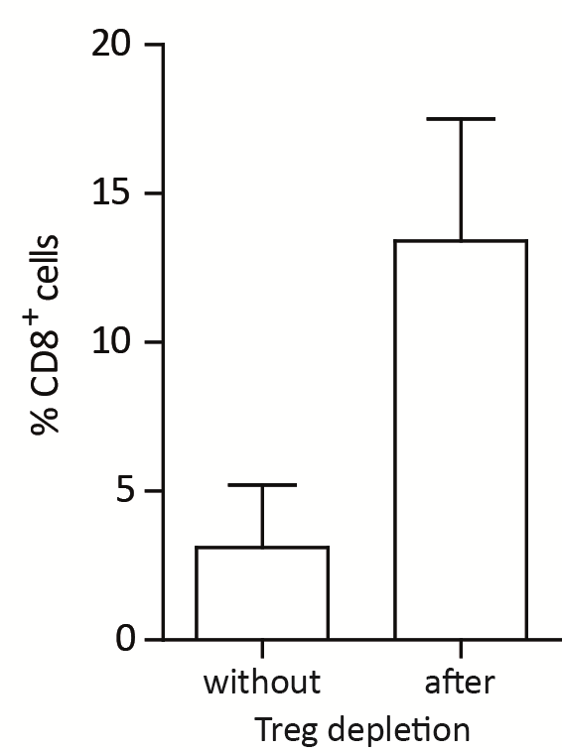

Supplementary Figure 1. Fractions of CD8⁺ T cells in spleens of λ-MYC/DEREG mice that were (n=4) or were not (n=12) depleted of Foxp3⁺ Treg cells by injection of DT. Mice were sacrificed two days after the second DT treatment cycle. Proliferation as indicated by Ki-67 expression as well as IFN-γ production by CD8⁺ T cells were also increased after Treg ablation.

Supplementary Table 1. Candidate peptides predominantly expressed on lymphoma cells. The core epitopes of the peptides detected by MS are marked by grey shading. Gene names and UniProt entries are listed. The numbers in the left column indicate those sequences that were associated with cell cycle functions and therefore chosen for further analyses.

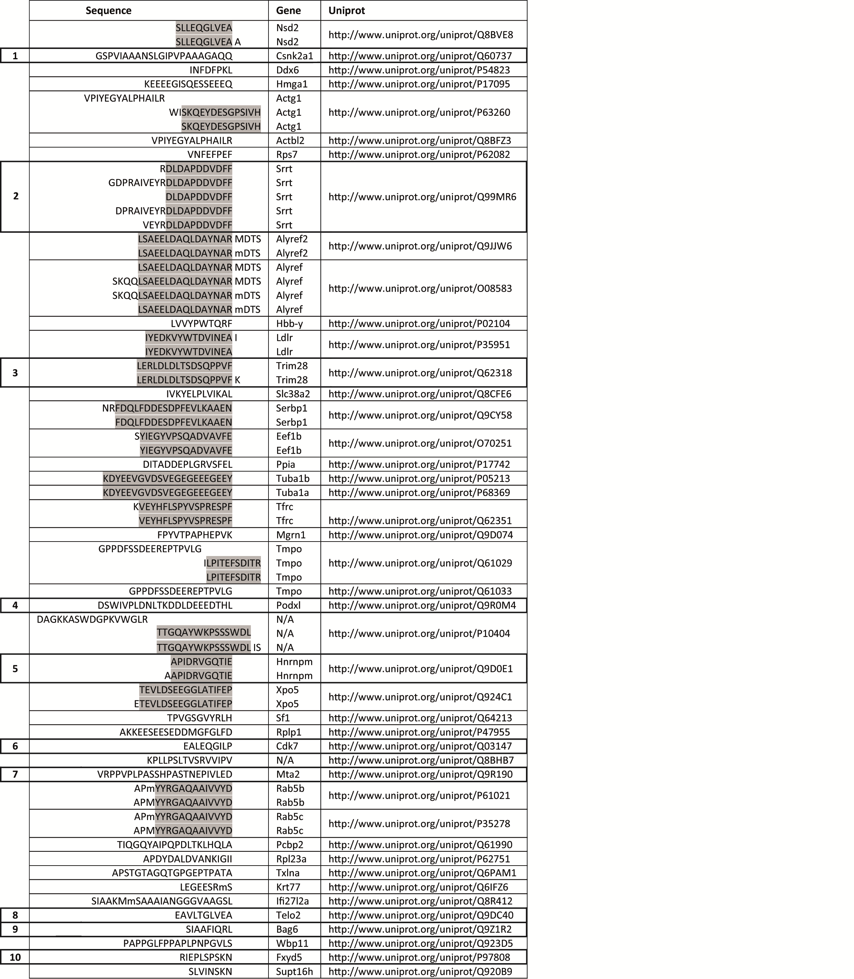

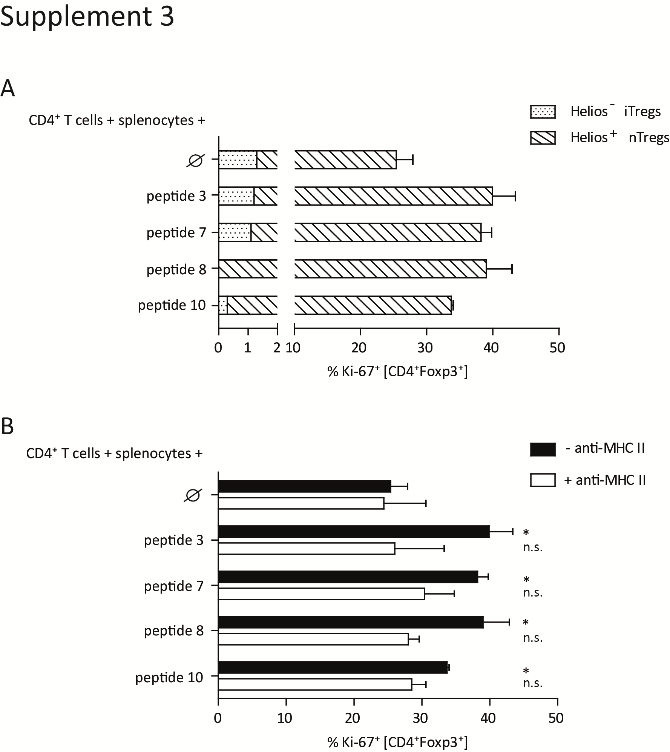

Supplementary Figure 2. Characterization of responses elicited by Treg-stimulating peptides. Stimulation assays were exactly done as described in Fig. 5. A, Peptides are mainly recognized by Helios⁺ Foxp3⁺ Treg cells. B, Responses are reduced by antibody-mediated blocking of MHC II. Where indicated, anti-MHC-II mAb was added as outlined in Materials and Methods. Significant T-cell proliferation in comparison to the control without any peptide is denoted by asterisks.

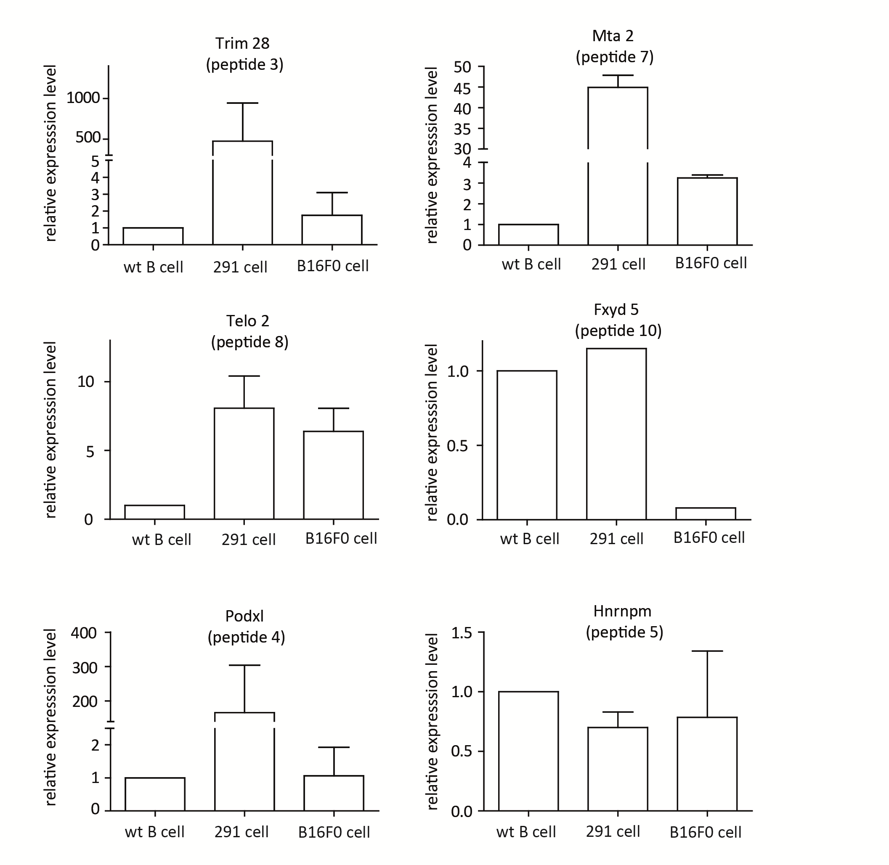
Supplementary Figure 3. Expression of genes encoding peptides that did or did not significantly stimulate Treg cells. Transcript levels in 291 cells or control tumor cells were quantitated by RT-PCR and normalized to normal B cells and to 18s expression. All genes that encode T cell-stimulating peptides (peptides 3, 7, 8 and 10) showed elevated expression in 291 cells as compared to B16F0 cells. The expression profiles of peptides that were not recognized by T cells were less consistent (shown for peptides 4 and 5). For discussion see main text.

