Supporting information

Direct Inlet Probe – high-resolution time-of-flight mass spectrometry as fast technique for the chemical description of complex high-boiling samples
Uwe Käfer†, Thomas Gröger*†, Christopher P. Rüger‡, Hendryk Czech‡, Mohammad Saraji-Bozorgzad§, Thomas Wilharm∥, and Ralf Zimmermann†,‡
† Joint Mass Spectrometry Centre, Comprehensive Molecular Analytics, Helmholtz Zentrum München, Ingolstädter Landstr. 1, 85764 Neuherberg †‡§
‡ Joint Mass Spectrometry Centre, Chair of Analytical Chemistry, University of Rostock, Dr. Lorenz Weg 2, 18059 Rostock, Germany; Germany;
§ Photonion GmbH, Hagenower Str. 73, 19061 Schwerin, Germany
∥ ASG Analytik-Service Gesellschaft mbH, Trentiner Ring 30, 86356 Neusäss, Germany
*E-mail: thomas.groeger@helmholtz-muenchen.de

Table S1: MS-Parameters
 | DIP-EI | TGA-EI
Source temperature [°C] | 250 | 250
Electron energy [eV] | 70 | 70
Emission current [mA] | 1 | 1
Transferline temp. (GC) [°C] | - | 300
Transferline temp. (TGA) [°C] | - | 250
Acquisition rate [Hz] | 0.5 | 1
Mass resolution (m/z 413.9775) | 64 reflections*: 52k  32 reflections:  34k | 32 reflections:  29k
*average value for 18 measurements from the comparative investigation of six bitumen samples

Table S2: Needle penetration values according to DIN EN 1426
Sample | Penetration [mm] | Provenience
VR_CPC | >20.0 (max. Value) | refinery 3
SRB_5070 | 6.55 ± 0.14 | refinery 1
SRB_70100 | 6.51 ± 0.18 | refinery 1
VR_MP | <0.10 (min. Value) | refinery 4
MB_OXID | 4.44 ± 0.08 | refinery 2
MB_PMB | 4.90 ± 0.03 | refinery 2

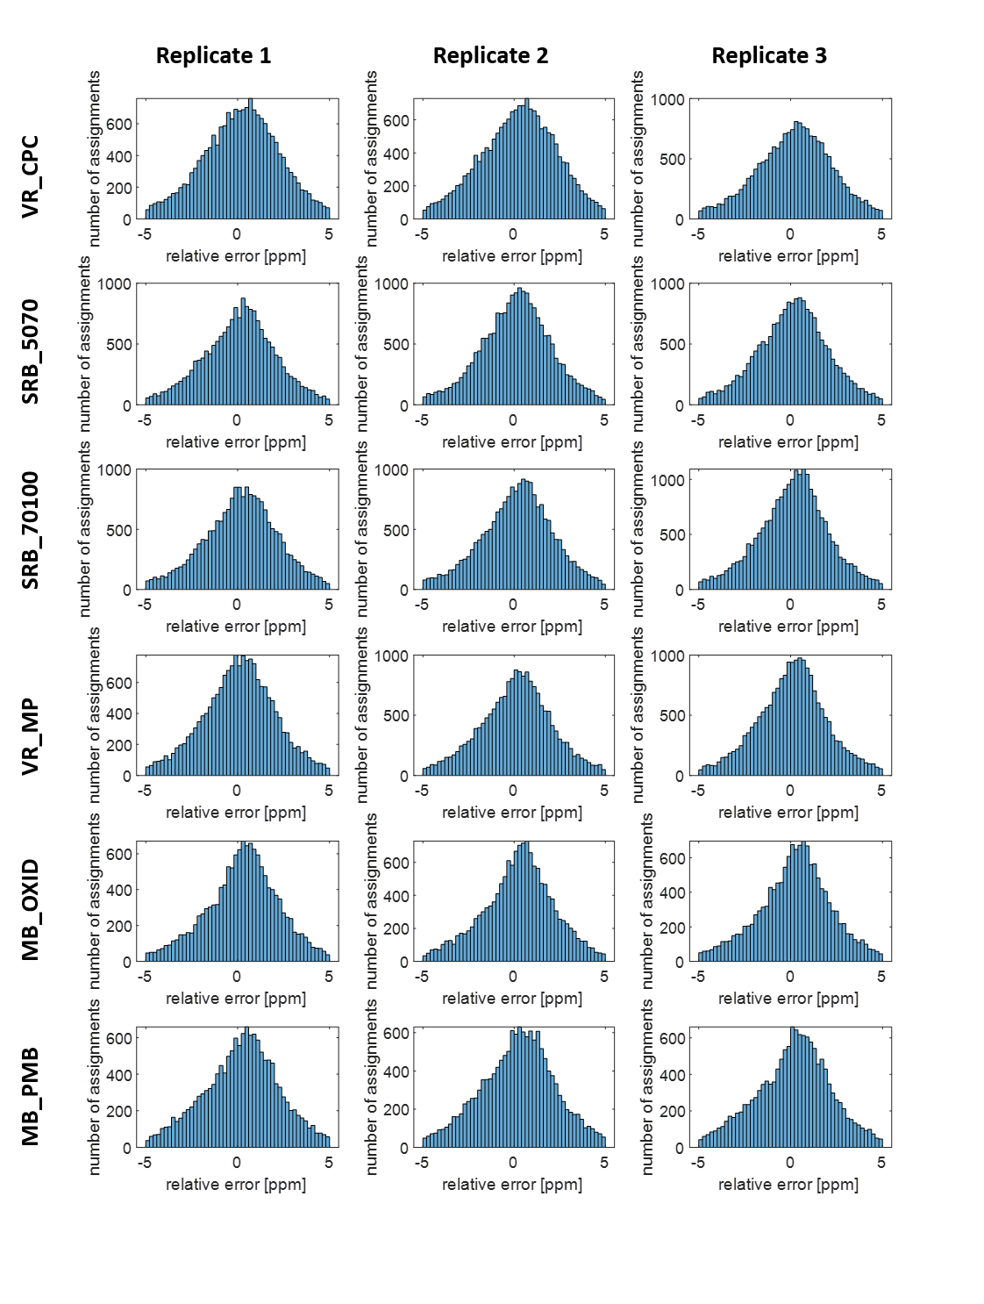
Figure S1: Histograms of relative mass errors for all measurement

Figure S2: Distribution of relative mass errors for one exemplary run (SRB_5070)

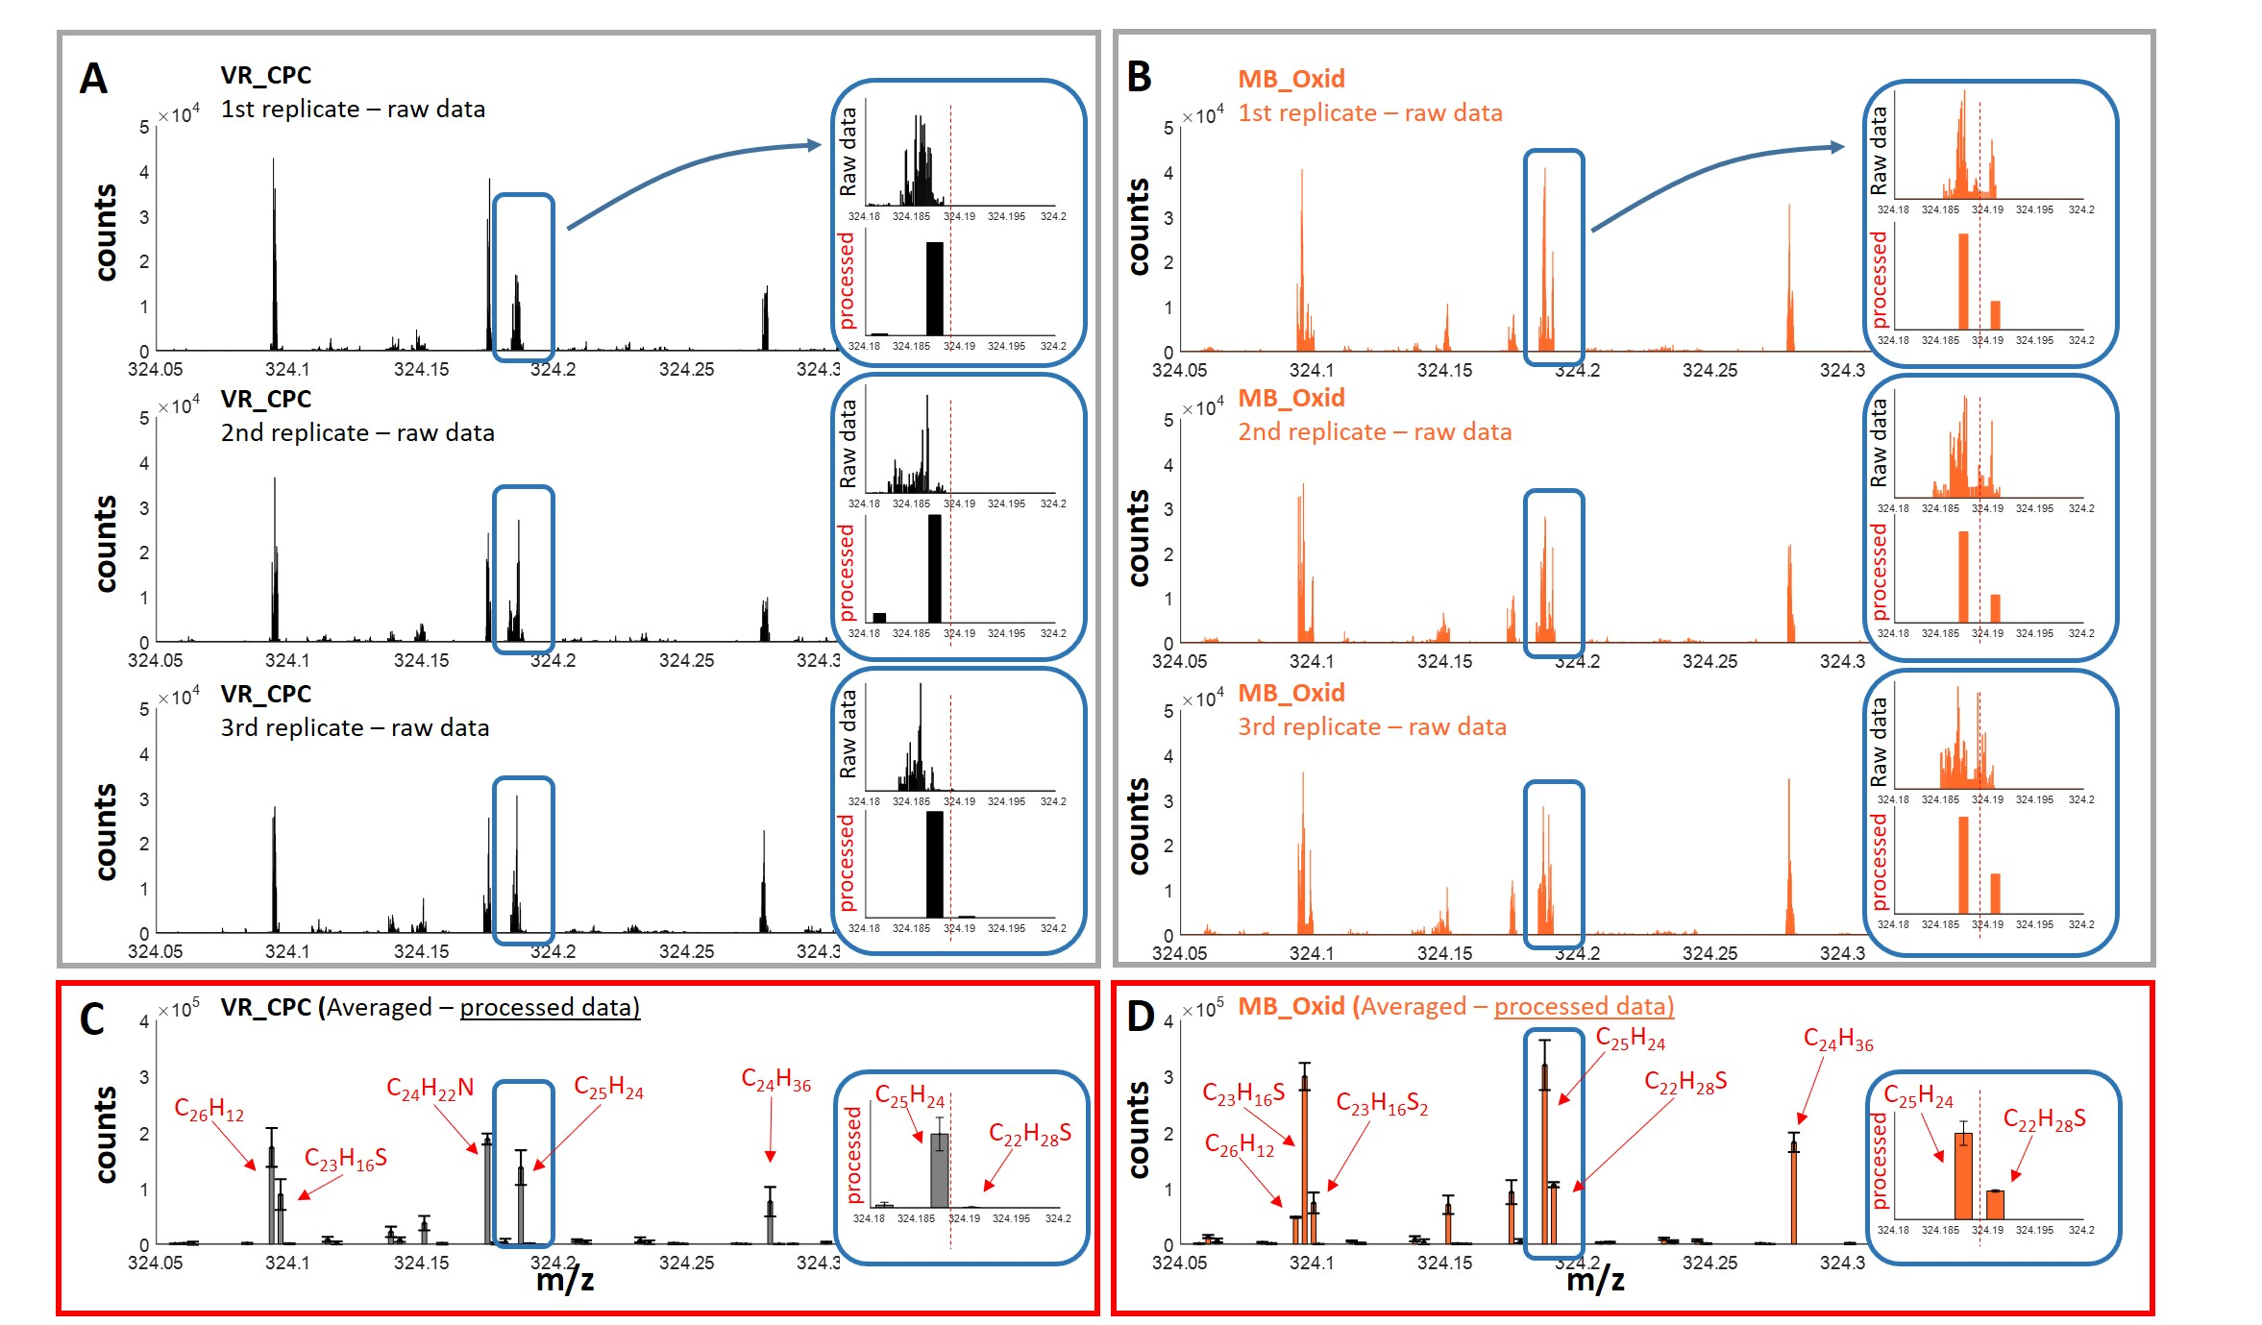
Figure S3: Binned (0.1 mDa bins) m/z signals of three independent runs of VR_CPC (A) and MB_OXID (B). For these summed spectra the detected peak maxima positions of the 520 indivdual spectra within one run were used. The blue box highlights the critical mass split C₃/SH₄ (3.4 mDa) and shows raw spectrum (top) and assigned mass spectrum (bottom). Averaged processed mass spectrum for the three replicates VR_CPC (C) and MB_OXID (D) shows the variance of assignment by errorbars.

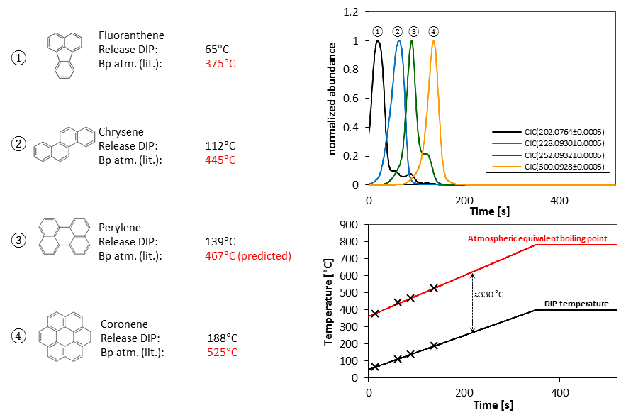
Figure S4: DIP-HRMS measurement of a PAH standard mixture and a comparison of their literature boiling points under atmospheric conditions and their DIP-release-temperature.

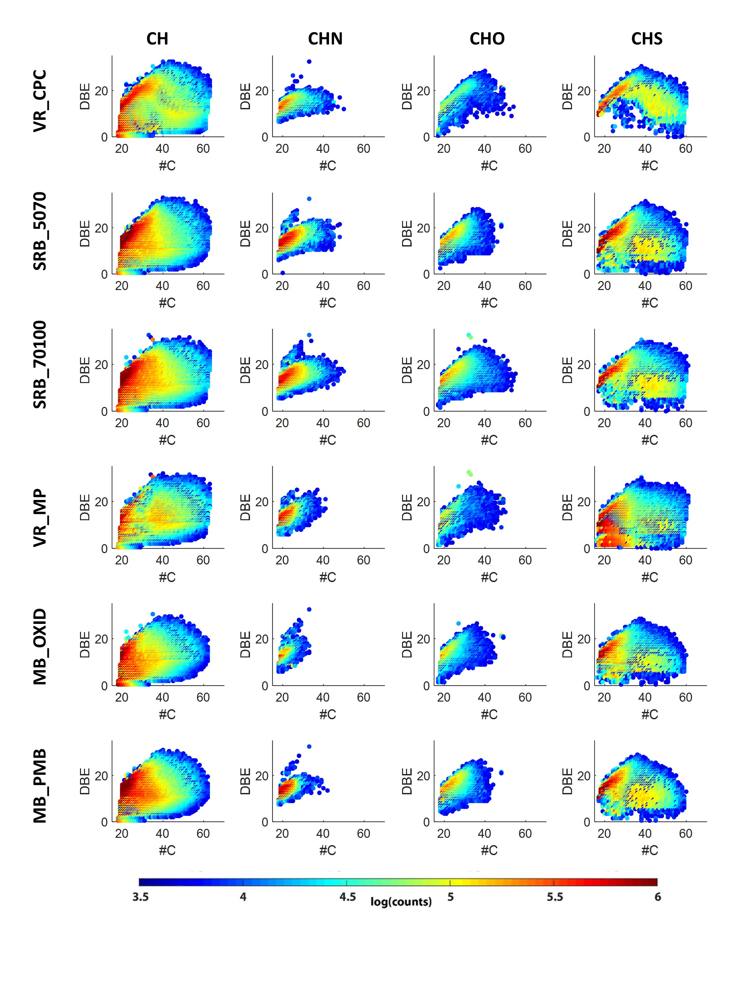

Figure S5. #C vs DBE plots of CH, CHN, CHO and CHS-class of all found features for six different bitumen samples. Colorcode represents counts of each feature on a log10 scale.
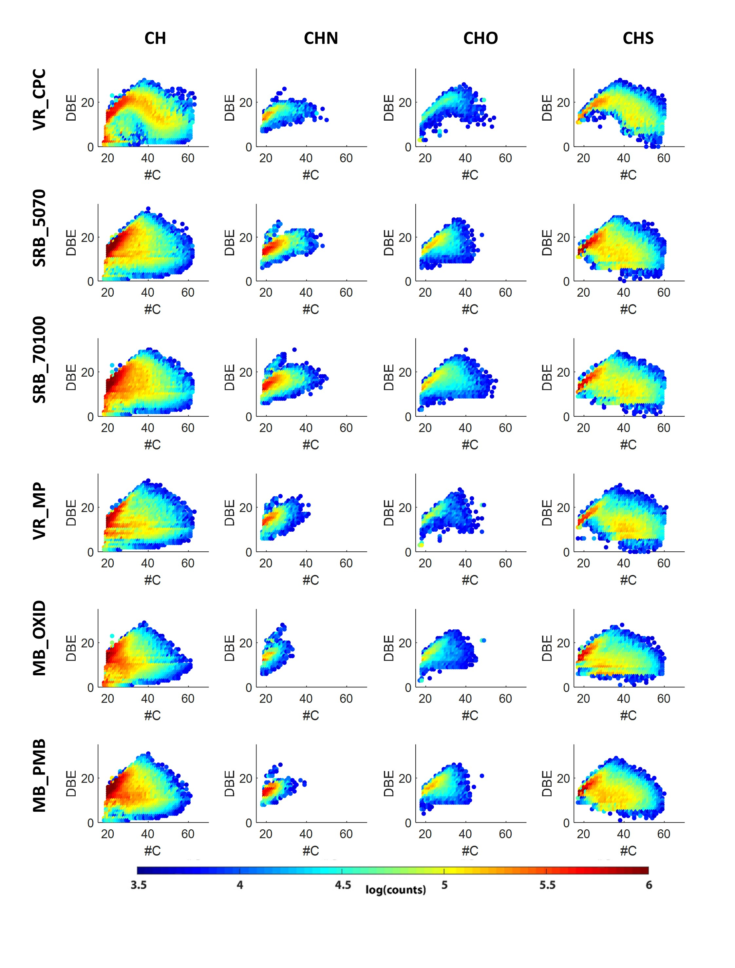

Figure S6. #C vs DBE plots of CH, CHN, CHO and CHS-class of features with integer DBE values for six different bitumen samples. Colorcode represents counts of each feature on a log10 scale.

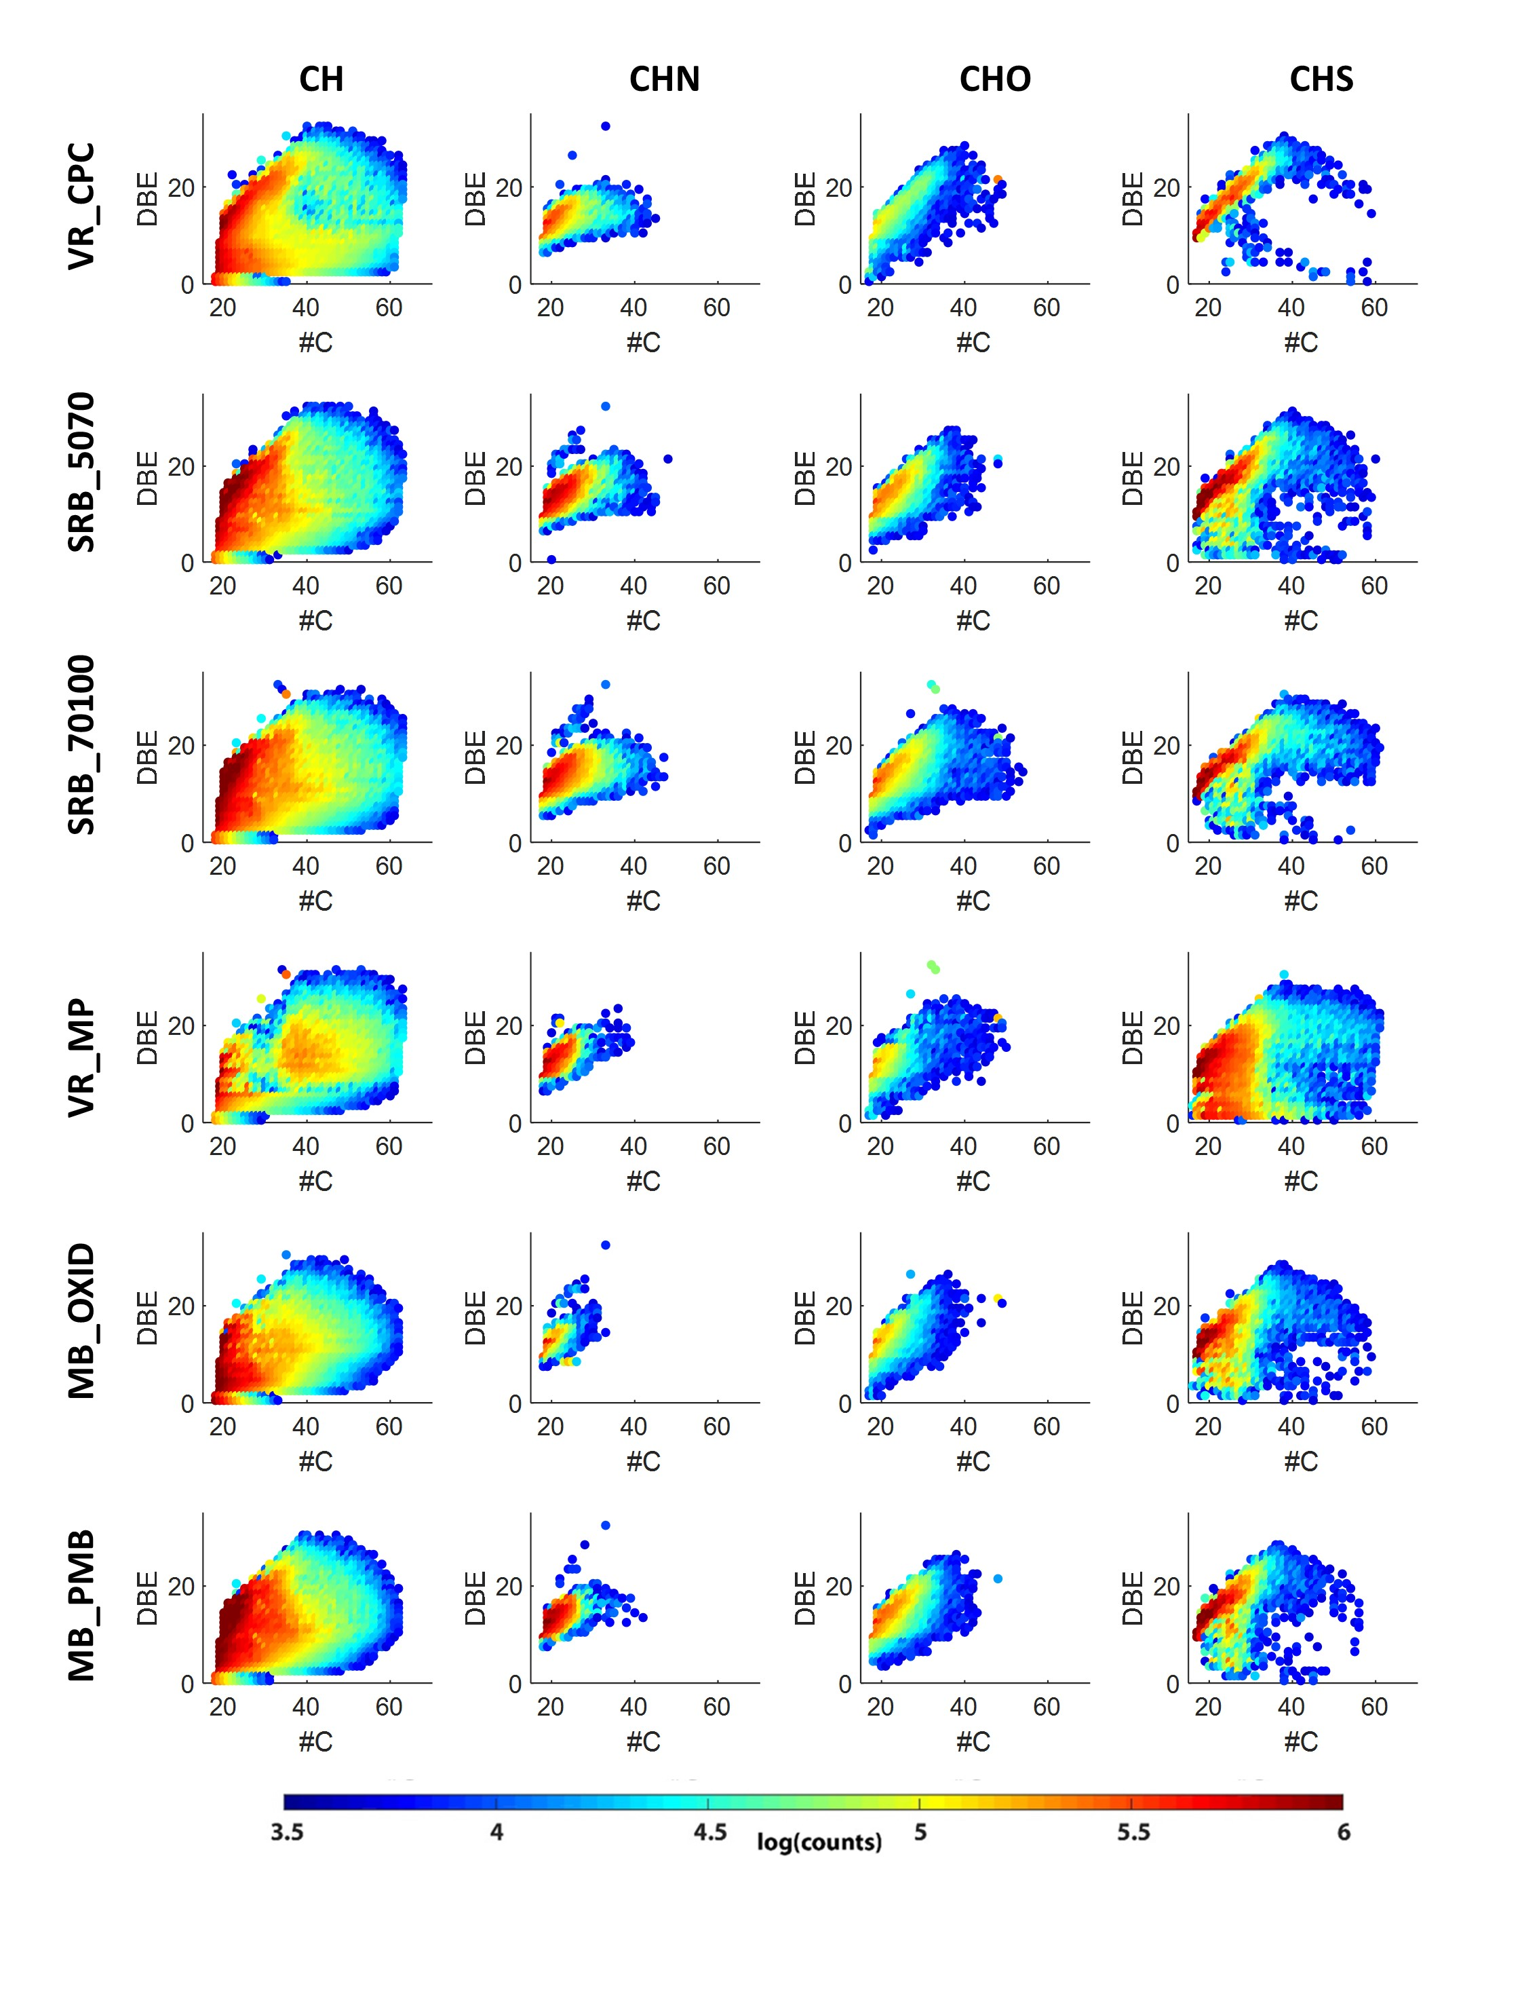
Figure S7. #C vs DBE plots of CH, CHN, CHO and CHS-class of features with non-integer DBE values for six different bitumen samples. Colorcode represents counts of each feature on a log10 scale.

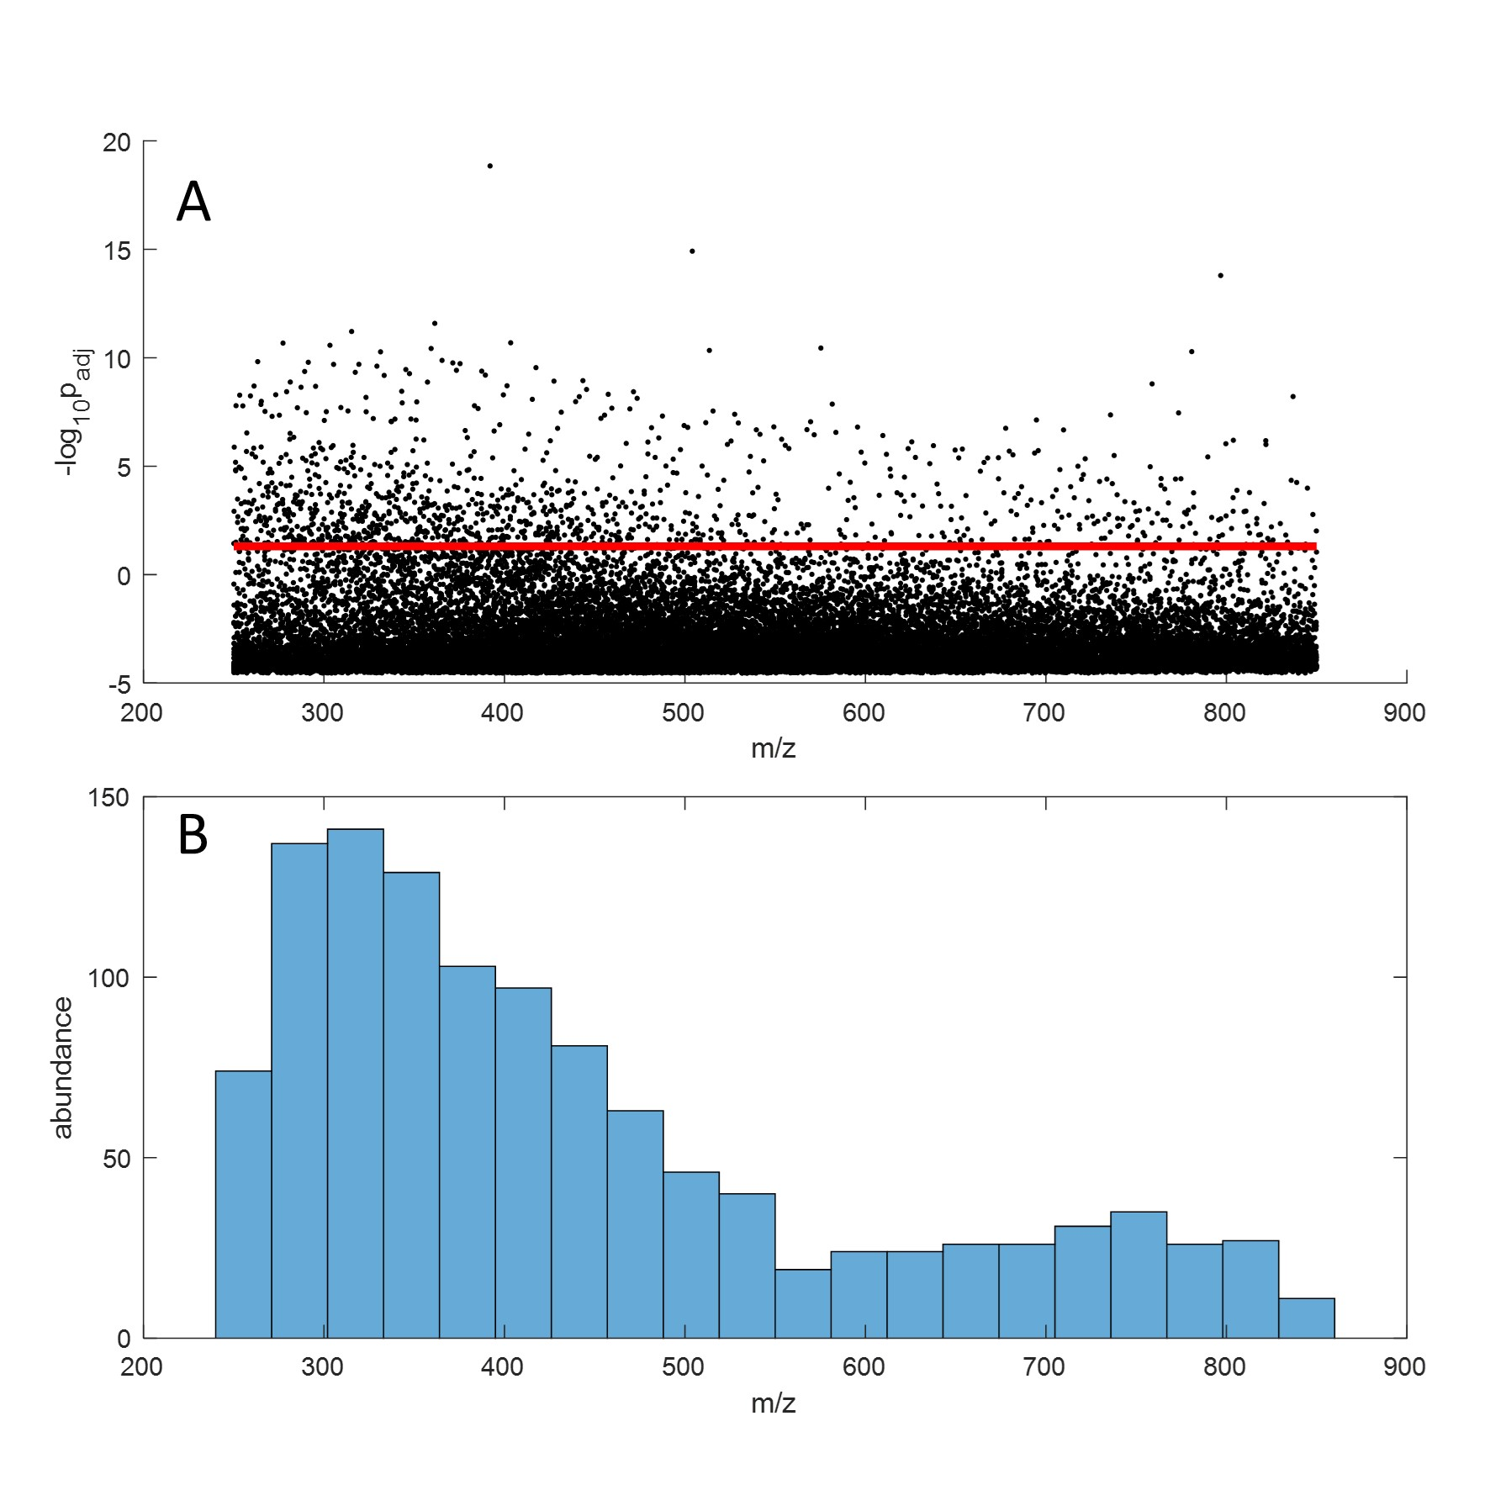
Figure S8: Bonferroni-corrected p-values from ANOVA vs m/z with significance level of 5 % (red solid line). Impossible p-values above 1 (i.e. –log₁₀ p below 0) are caused by the conservative character of the Bonferroni method, leading to of overcorrection of type I error. Thus, those m/z with p-values >1 should be regarded like other p-values > 0.05 as insignificant (A). Histograms with 20 bins each illustrate the origin of significant m/z on an absolute scale (B).

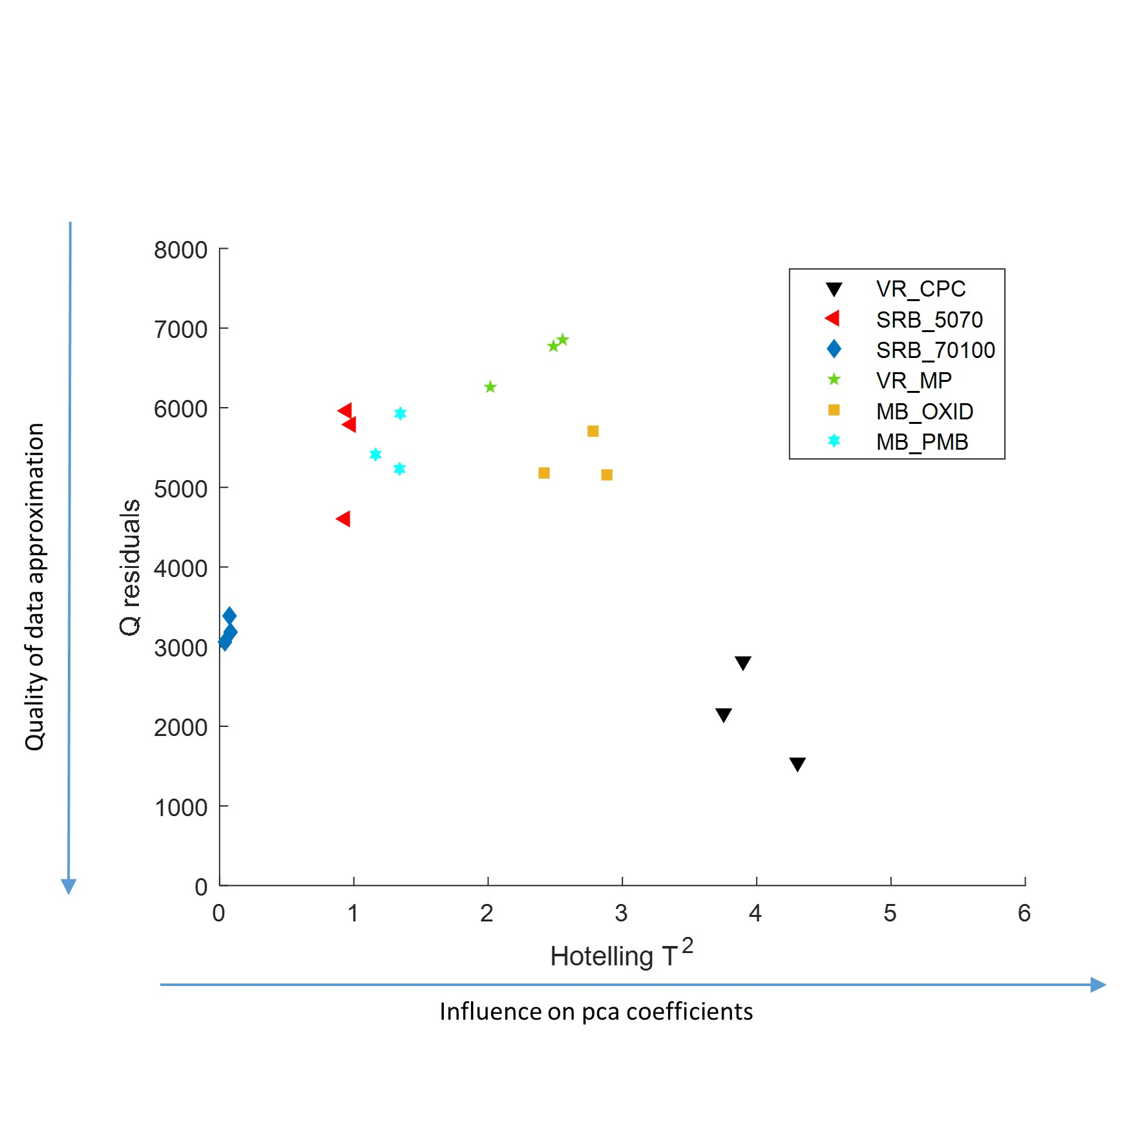
Figure S9: Influence diagram depicting Hotelling’s T² , representing the influence of a sample on the PCA result, vs the residue Q from the data reconstruction by the first two PCs, showing the goodness-of-fit of between original data and PCA result. A sample is regarded as outlier if it has a high influence on the PCA result, but is concurrently poorly described. Therefore, the data is appropriately modelled by PCA despite larger number of variables than samples.

