Supplemental table S1: primers list

gene | Forward primer | Reverse primer
MYF5 | GTGGAGATCCTCAGGAATGC | AGGTTGCTCTGAGGAGGTGA
MYF6 | GGATCAGCAGGAGAAGATGC | CTCGAGGCTGACGAATCAAT
MYOD1 | AGCACTACAGCGGCGACT | AGGCAGTCTAGGCTCGACAC
MYOG | AAGAGAAGCACCCTGCTCAA | AGGTTGTGGGCATCTGTAGG
PAX3 a | GGAGACTGGCTCCATACGTC | CCGCGTCCTTGAGTAATTTG
PAX3 b | AAAGAGGAAACAGCGCAGAA | TGGTTGAAAGCCATCAGTTG
PAX7 a | CCAAGATTCTTTGCCGCTAC | CACAGTGCTTCGGTCACAGT
PAX7 b | GATGAAGCGGACAAGAAGGA | CCTCGCGGGTGTATATGTCT
PAX7 E1 | ACGGGATTCCCTTTGGAAG | GCTGTCGGGAGATGACACA
PAX7 E2 | GTCTTGGGGCTCAAACAAAC | GATTCCCTTTGGAAGTGTCC
MYH3 | GGAAGACCTGGAAAGCTCCC | CATAGTCGCTGCGCTGTTTC
DES | GGGCACTAACGATTCCCTGA | ATGGACCTCAGAACCCCTTT
GAPDH | CGGAGTCAACGGATTTGGTC | GATGGCATGGACTGTGGTCA
18S | CCCTGTAATTGGAATGAGTCCACTT | ACGCTATTGGAGCTGGAATTAC

Supplemental figure S1: PAX3 and PAX7 protein sequence. Sequence identity of PAX7 and PAX3 (73,8%). The paired box domain (amino acids 34-163) is highly analogous.

Supplemental figure S2: Phylogenetic conservation analysis of PAX7 by sequence alignment. Multiple sequence alignment (Clustal Omega, v1.2.4) for PAX7 showing high conservation across species. Arg56 (variant in patients 4 and 5) is highlighted in yellow.

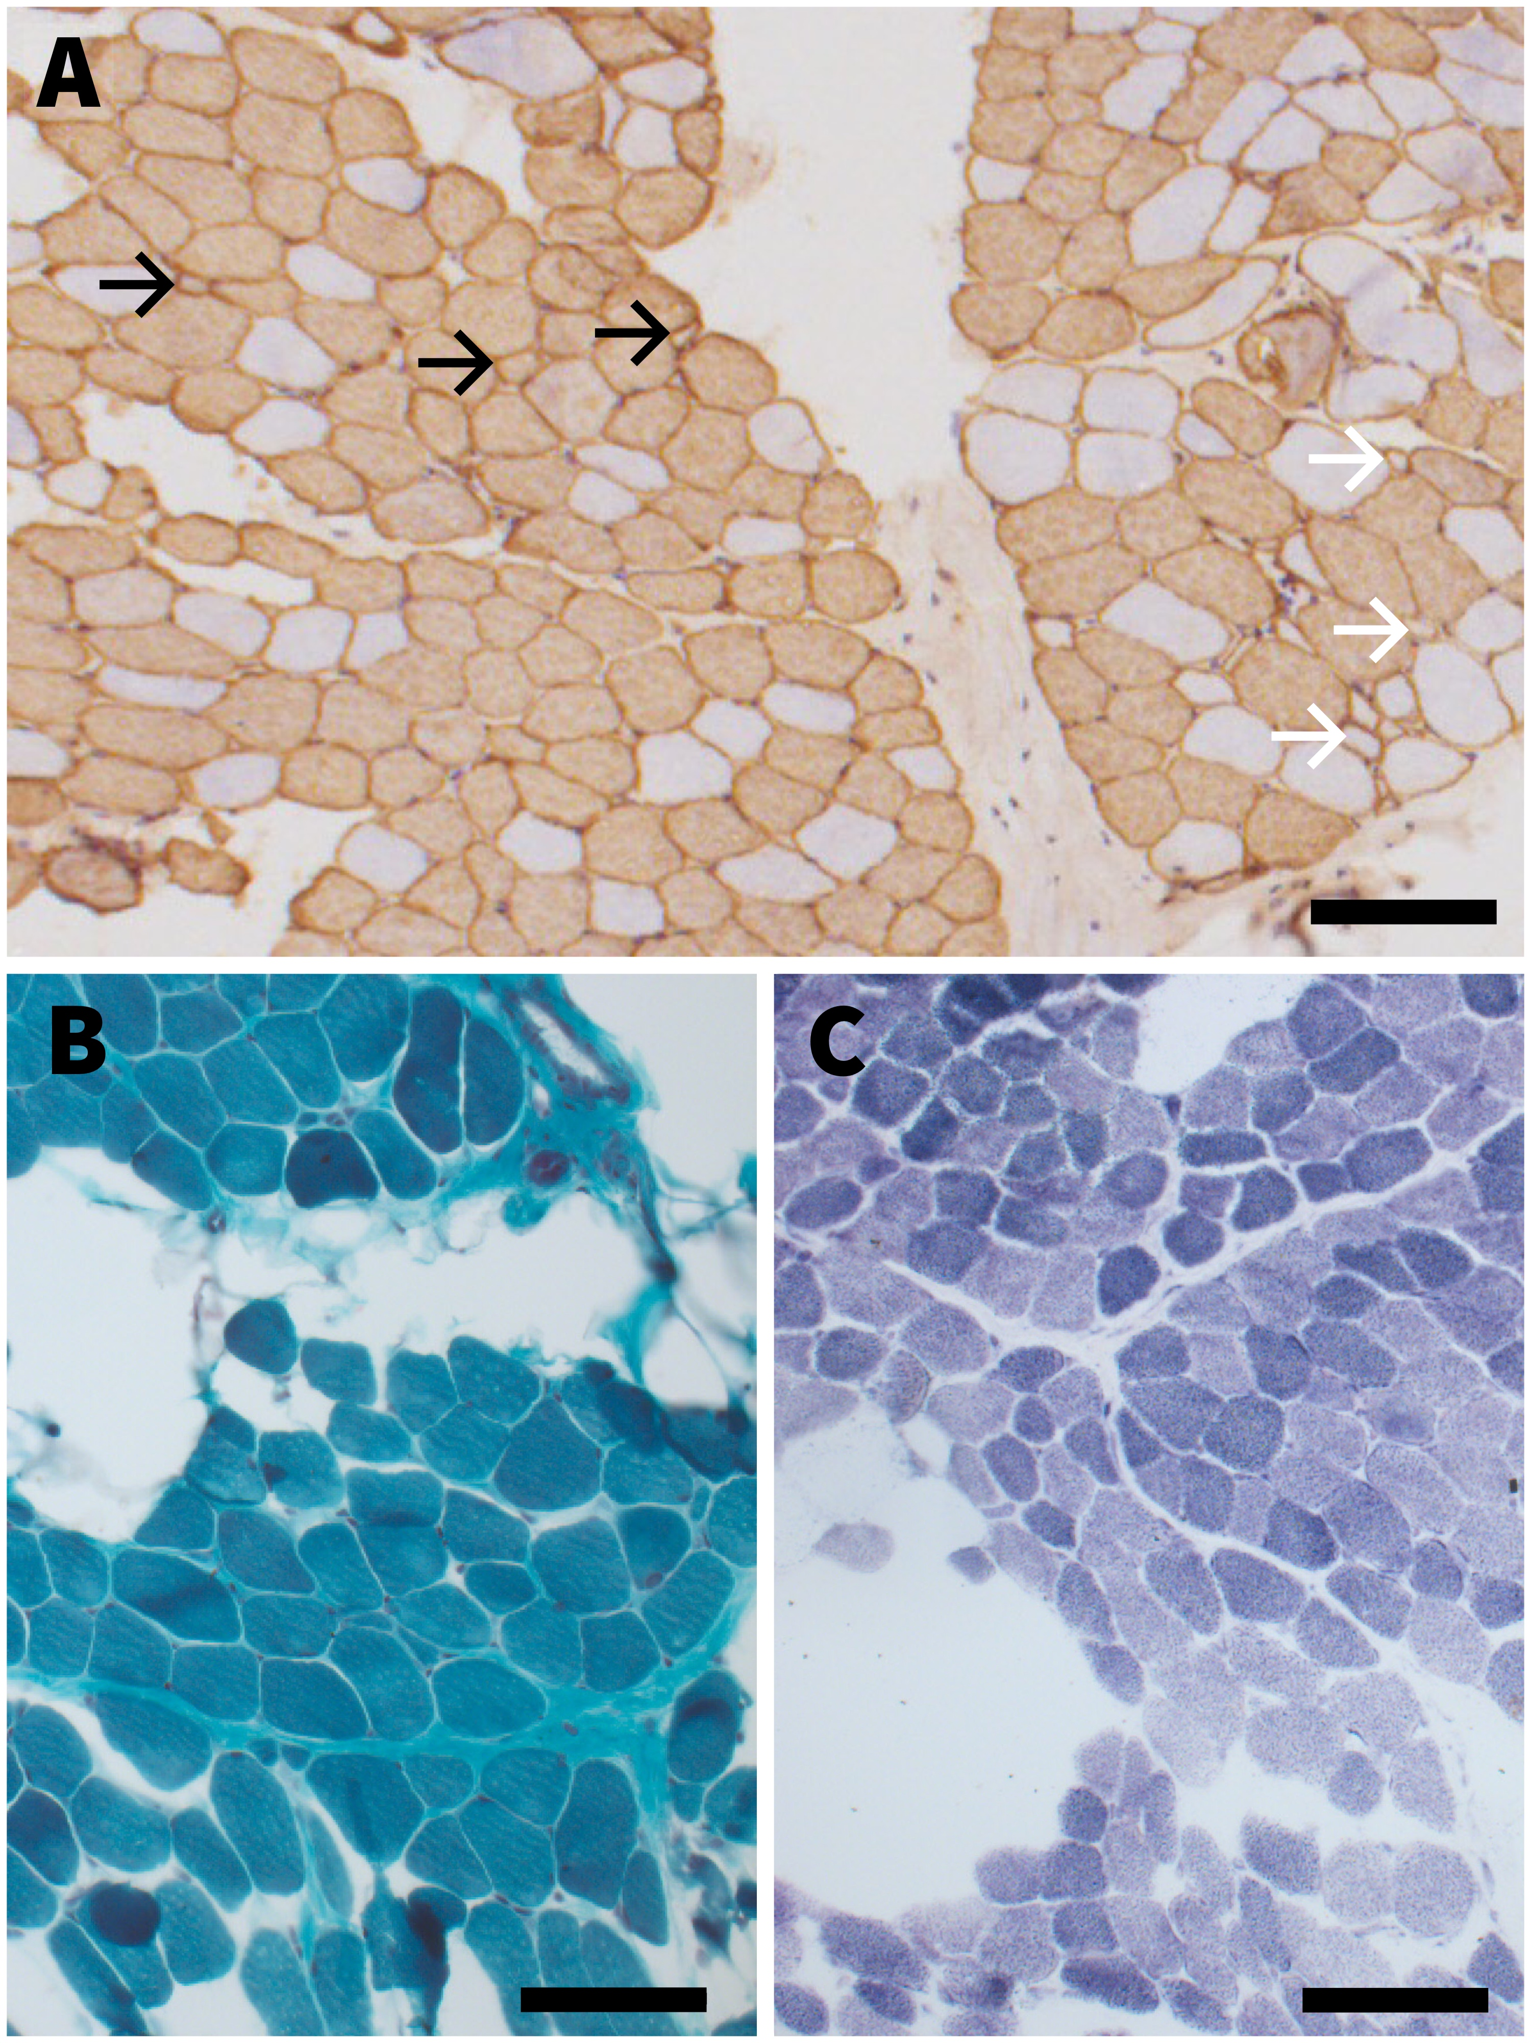
Supplemental figure S3: Additional histological data on individual 1 biopsy at 3.7 years of age. (A) Photomicrograph of an immunohistochemical preparation for myosin heavy-chain fast showing scattered atrophic angulated fibres of both type I (white arrows) and type II (black arrows). Note the absence of fibre type grouping. (B) Gomori trichrome and (C) NADH-TR stains both showing fatty change and scattered atrophic fibers without revealing further pathological features. Bars=100 μm.

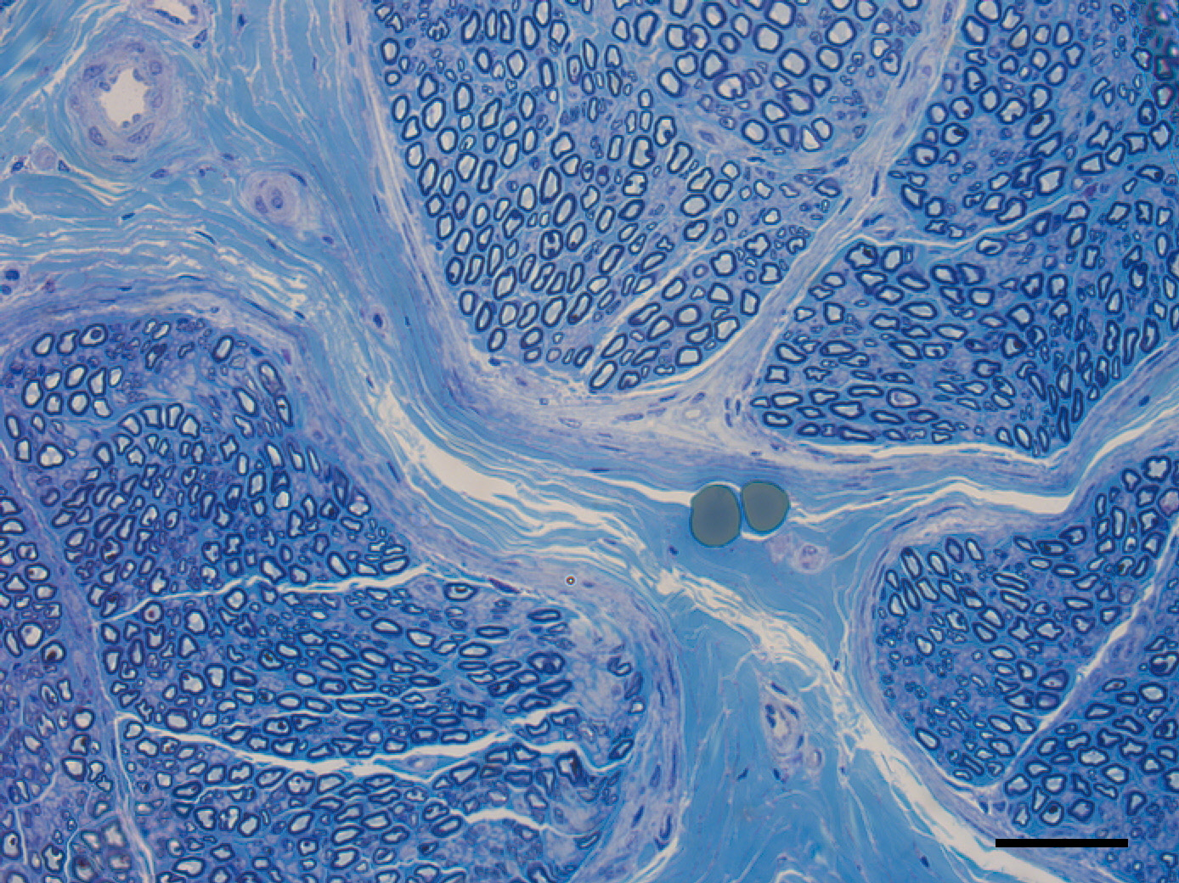

Supplemental figure S4. Peripheral nerve histology in individual 1. Photomicrograph of sural nerve biopsy performed at 3.7 years of age on individual 1, showing normal histology. Scale bar, 50 µm.

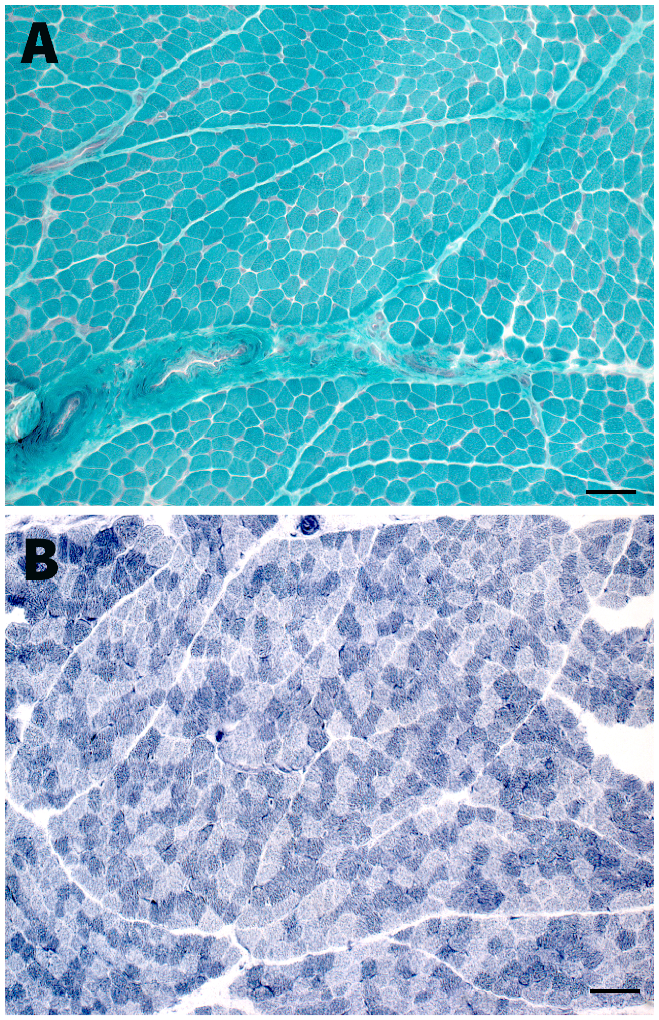

Supplemental figure S5: Additional histological data on individual 2 biopsy at 2.3 years of age. (A) Gomori trichrome and (B) NADH-TR stains revealing no pathologic features. Bars=100 μm.
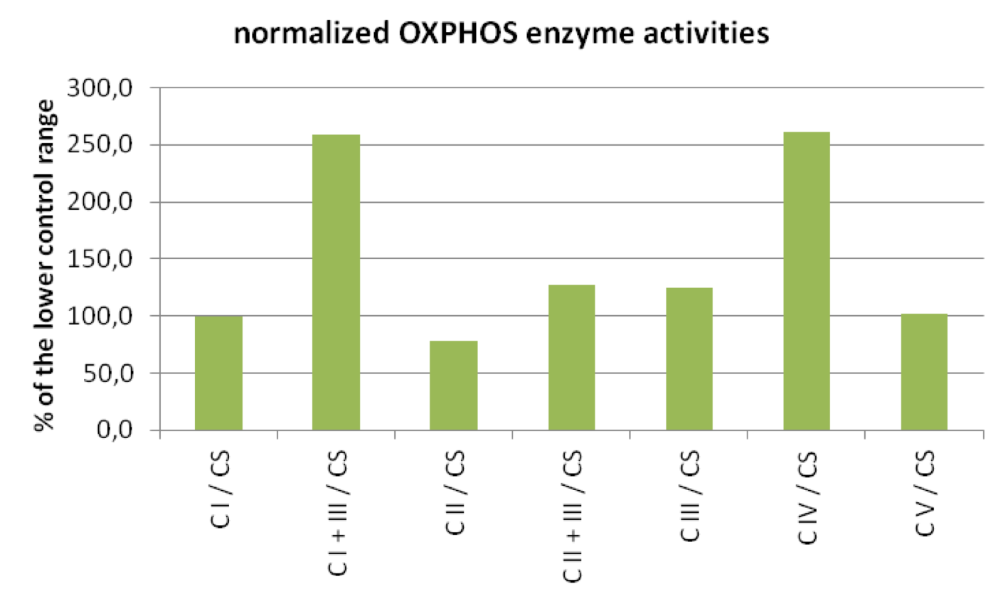

Supplemental figure S6. Normalized OXPHOS enzyme activities of individual 2.
Respiratory chain enzyme activity. Muscle tissues were homogenized in extraction buffer (20mM Tris-HCl pH 7.6, 250mM sucrose, 40mM KCl, 2mM EGTA). The post-nuclear supernatant isolated by centrifugation at 600x g containing the mitochondrial fraction was used for measurement of enzyme activities. Spectrophotometric measurement of OXPHOS enzyme and citrate synthase activity was performed as previously described (Feichtinger RG et al; BMC Cancer 2010). The activities of the OXPHOS enzymes (CI, complex I; CII, complex II; CIII, complex III; CIV, complex IV; CV, complex V; CI+III, combined activity of complexes I and III; CII+III, combined activity of complexes II+III) were normalized to the citrate synthase (CS) activity. The lowest value of the normal range was taken as 100%. A minor reduction of complex II (SDH) was observed in individual 2, likely due to the relatively poor quality of the muscle biopsy. All other OXPHOS enzyme activities were within the normal limits.
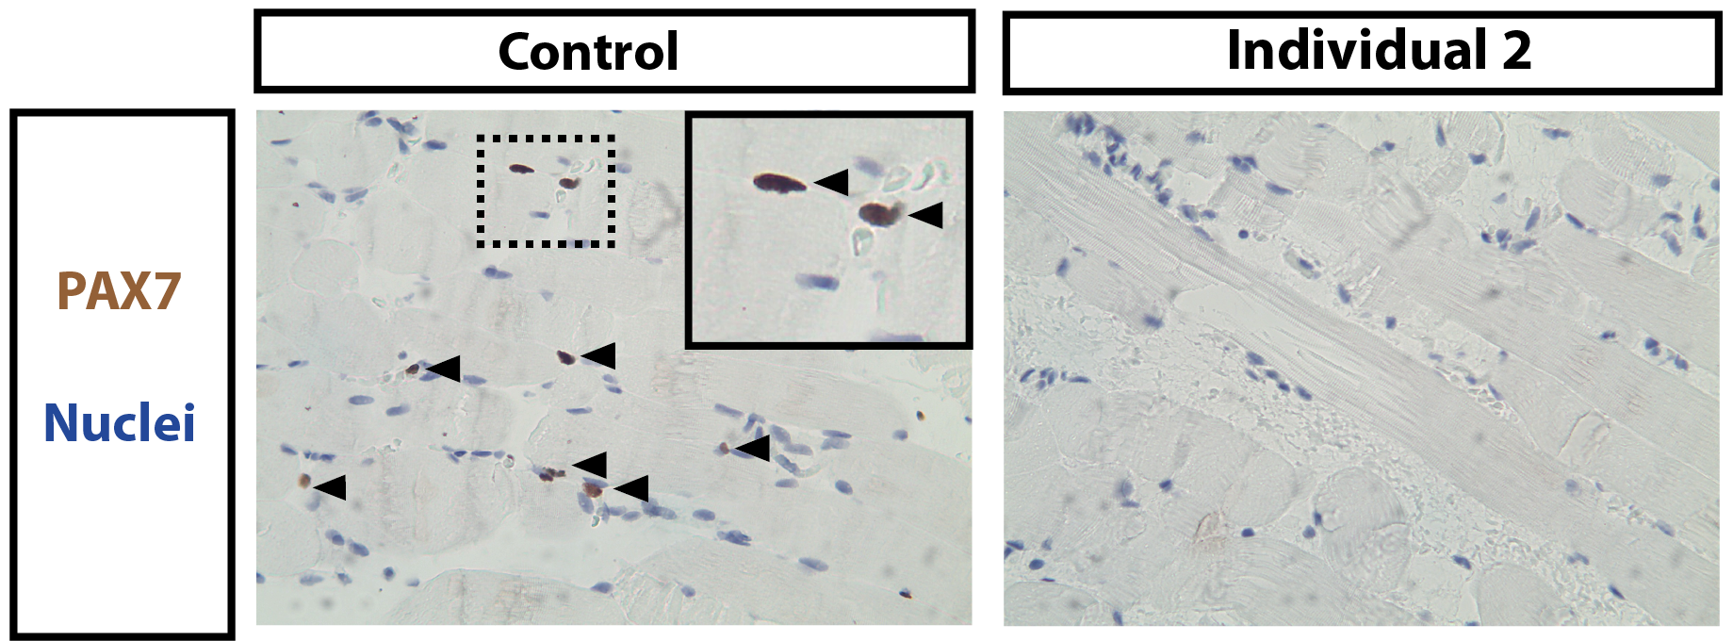

Supplemental figure S7. PAX7 expression in individual 2. Immunohistochemical staining for PAX7 (orange-brown cells) on skeletal muscle from healthy controls (left picture) and individual 2 (right picture). Sections are counterstain with hematoxylin (label nuclei in blue). PAX7-expressing cells are identified by black arrowheads. The dashed box is zoomed in and displayed in the right corner of the picture

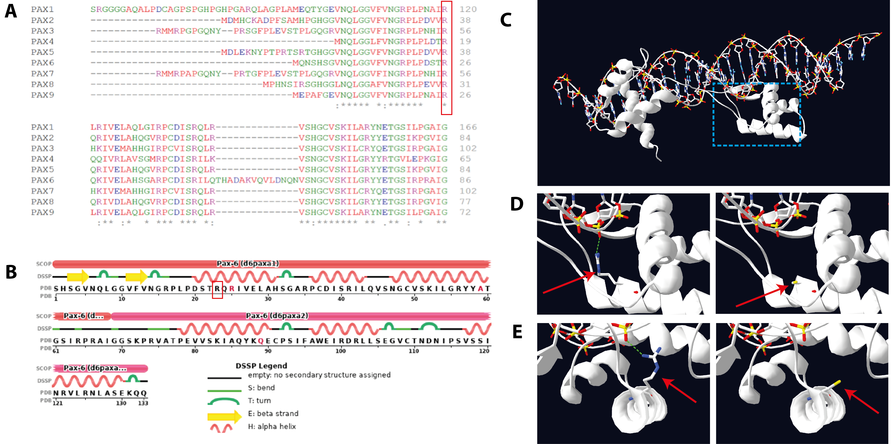
Supplemental figure S8. Structural context of the conserved arginine in the missense variant of PAX7. A) Multiple alignment sequence showing conservation of the Arg56 residue (in PAX7) across all PAX proteins (displayed in the red box). B) Secondary structure of the PAX6 protein showing that the corresponding arginine residue (displayed in the red box) is part of the Helix-Turn-Helix domain superfamily. C) PAX6 crystalline structure (Swiss-Pdbviewer). Blue dash box on the upper picture is zoomed and showed in D (side view) and E (front view). D-E) Left pictures show that the corresponding arginine residue (identified by red arrow) interacts with DNA. Right pictures show the absence of DNA interaction when the arginine is mutated into a cysteine (identified by red arrow).

