Supporting Information

CONTENTS
Supplementary table 2
Table S1 Overview of the methodology of the ESA surveys 1995 - 2015 2
Supplementary figures 3
Figure S1 Main effects of age, period and cohort on 30-day drinking prevalence. 3
Figure S2 Main effects of age, period and cohort on 30-day alcohol volume (drinkers only). 4
Figure S3 Main effects of age, period and cohort on 30-day prevalence of EHD (drinkers only) 5
References 6

Supplementary table

Table S1 Overview of the methodology of the ESA surveys 1995 - 2015.
Survey Year | Sample Size | Age  Range | RRª | Design | Method | Ref.
1995 | 7,833 | 18-59 | 65% | Electoral districts; random route sampling | Paper and pencil | [1]
1997 | 8,020 | 18-59 | 65% | Electoral districts; random route sampling | Paper and pencil | [2]
2000 | 8,139 | 18-59 | 51% | Population registers; probability sample | Paper and pencil | [3]
2003 | 8,061 | 18-59 | 55% | Population registers; probability sample | Paper and pencil | [4]
2006 | 7,912 | 18-64 | 45% | Population registers; probability sample | Paper and pencil; telephone | [5]
2009 | 8,030 | 18-64 | 50% | Population registers; probability sample | Paper and pencil; telephone; online | [6]
2012 | 9,084 | 18-64 | 54% | Population registers; probability sample | Paper and pencil; telephone; online | [7]
2015 | 9,204 | 18-64 | 52% | Population registers; probability sample | Paper and pencil; telephone; online | [8]
ª RR: Response Rate

Supplementary figures

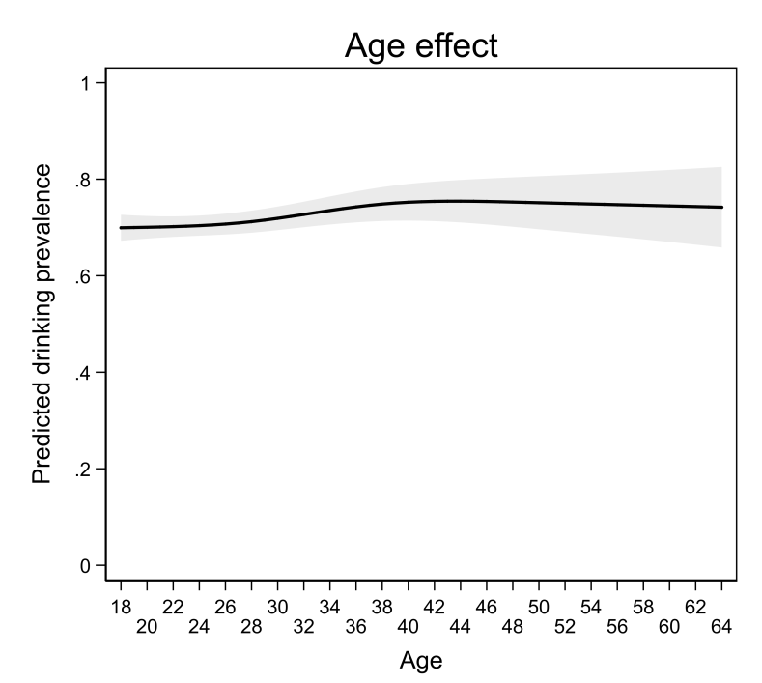
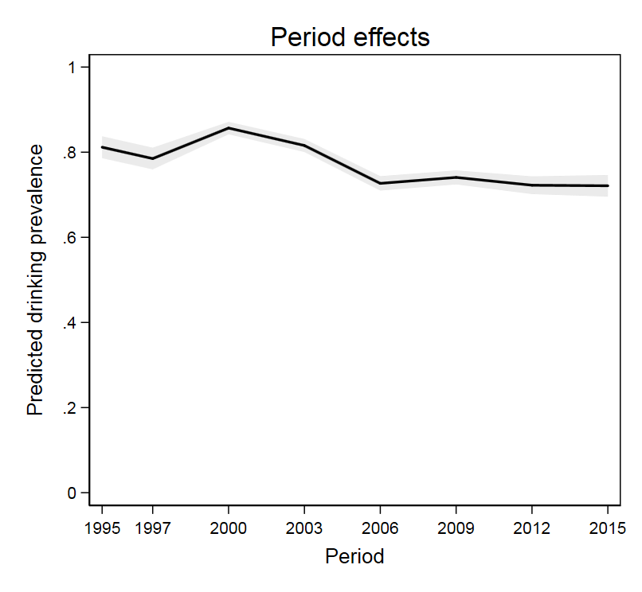
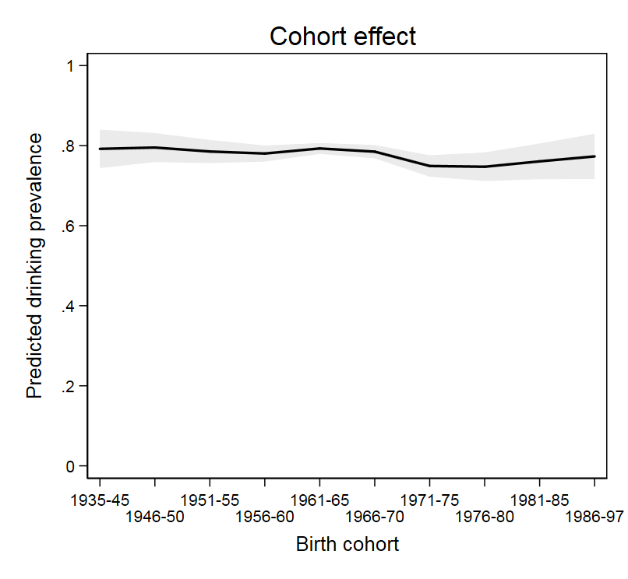

Figure S1 Main effects of age, period and cohort on 30-day drinking prevalence. The black area shading represents 95% confidence intervals.
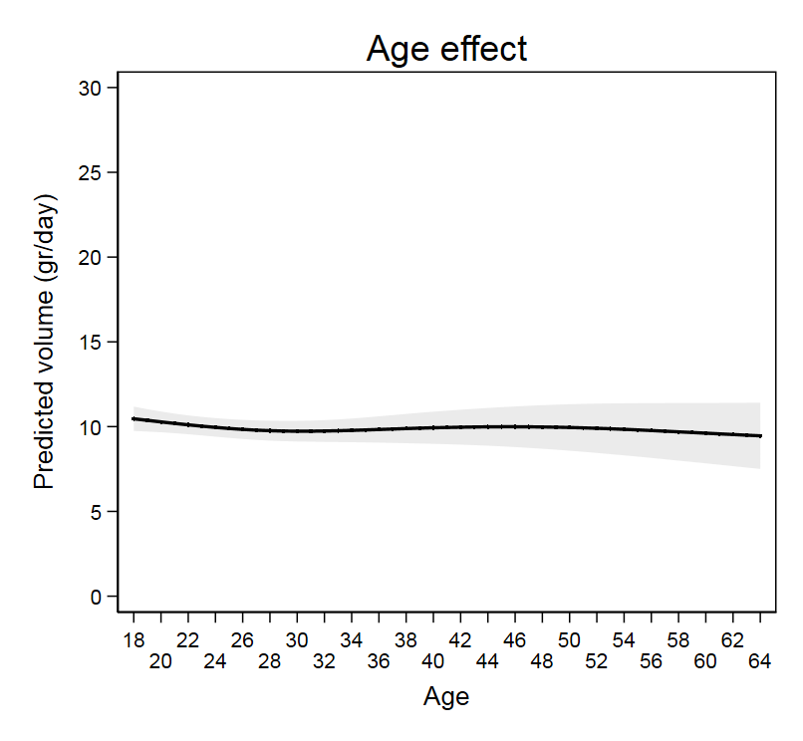
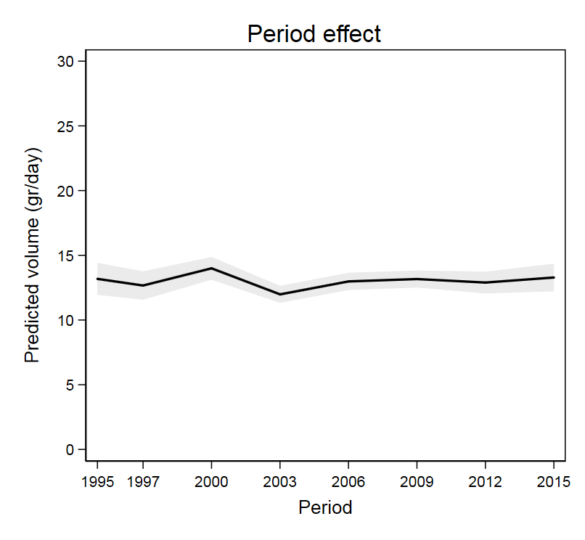
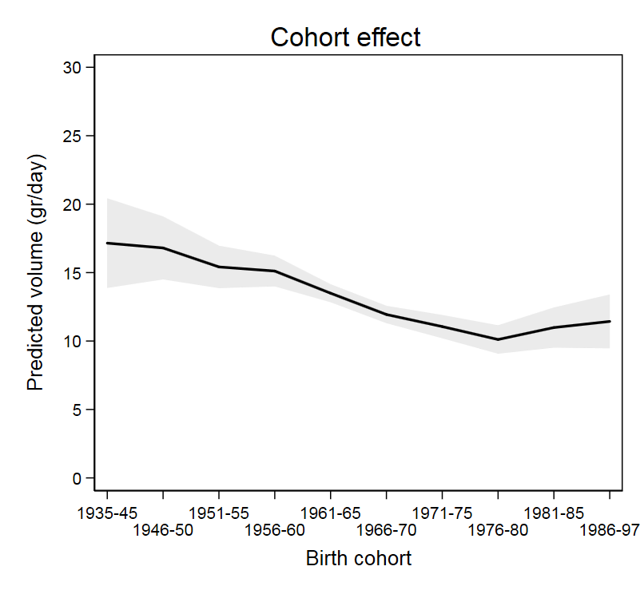

Figure S2 Main effects of age, period and cohort on 30-day alcohol volume (drinkers only). The black area shading represents 95% confidence intervals.
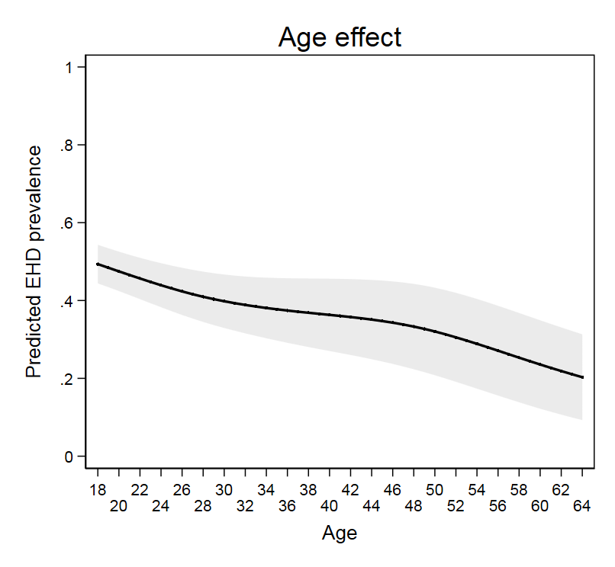
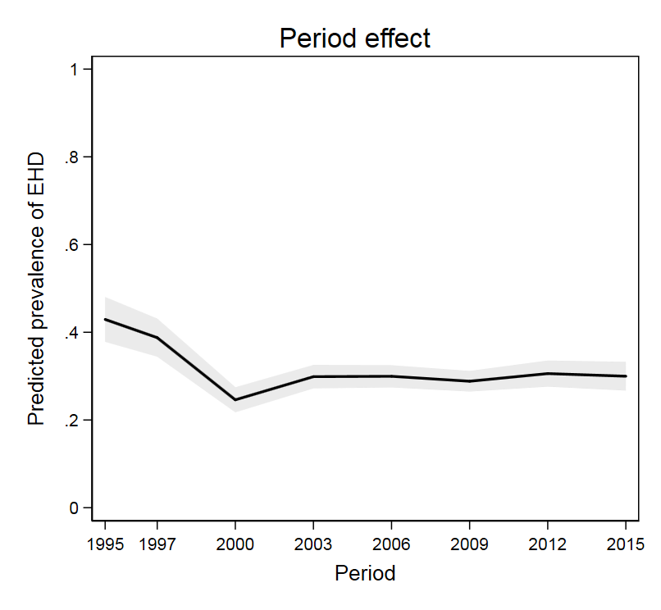
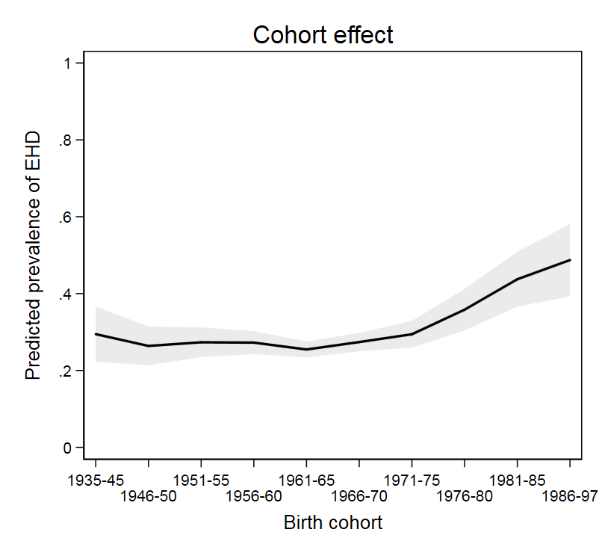

Figure S3 Main effects of age, period and cohort on 30-day prevalence of EHD (drinkers only). The black area shading represents 95% confidence intervals.

References

1. Herbst K, Kraus L, Scherer K. Repräsentativerhebung zum Gebrauch psychoaktiver Substanzen bei Erwachsenen in Deutschland. Schriftliche Erhebung 1995. Bonn: Bundesministerium für Gesundheit; 1996.
2. Kraus L., Bauernfeind R. Repräsentativerhebung zum Konsum psychoaktiver Substanzen bei Erwachsenen in Deutschland 1997 [1997 Epidemiological Survey of Substance Abuse in Germany]. Sucht 1998; 44: S3-S82.
3. Kraus L., Augustin R. Repräsentativerhebung zum Gebrauch psychoaktiver Substanzen bei Erwachsenen in Deutschland 2000 [2000 Epidemiological Survey of Substance Abuse in Germany]. Sucht 2001; 47: S3-S86.
4. Kraus L., Augustin R. Konzeption und Methodik des Epidemiologischen Suchtsurvey 2003 [Design and methodology of the 2003 Epidemiological Survey of Substance Abuse]. Sucht 2005; 51: S6-S18.
5. Kraus L., Baumeister S.E. Studiendesign und Methodik des Epidemiologischen Suchtsurveys 2006 [Study design and methodology of the 2006 Epidemiological Survey of Substance Abuse]. Sucht 2008; 54: S6-S15.
6. Kraus L., Pabst A. Studiendesign und Methodik des Epidemiologischen Suchtsurveys 2009 [Study design and methodology of the 2009 Epidemiological Survey of Substance Abuse]. Sucht 2010; 56: 315-26.
7. Kraus L., Piontek D., Pabst A., Gomes de Matos E. Studiendesign und Methodik des Epidemiologischen Suchtsurveys 2012 [Study design and methodology of the 2012 Epidemiological Survey of Substance Abuse]. Sucht 2013; 59: 309-20. Verfügbar unter http://econtent.hogrefe.com/doi/pdf/10.1024/0939-5911.a000274.
8. Piontek D., Kraus L., Gomes de Matos E., Atzendorf J. Der Epidemiologische Suchtsurvey 2015: Studiendesign und Methodik [The 2015 Epidemiological Survey of Substance Abuse: study design and methodology]. Sucht 2016; 62: 259-69.

