Table S1. Summary statistics of air pollution measurements
 | Air pollutant | type | N | Mean (µg/m³) | Median (µg/m³) | SD (µg/m³) | Percentiles (µg/m³) |  |  |  | min | max
 |  |  |  |  |  |  | 5 | 25 | 75 | 95 | (µg/m³) | (µg/m³)
AIRBASE  (Training dataset) | PM_{2.5} | Traffic | 149 | 16.3 | 16.6 | 4.9 | 8.6 | 13.0 | 19.7 | 23.7 | 6.3 | 28.1
AIRBASE  (Training dataset) | PM_{2.5} | BGª | 341 | 15.8 | 15.8 | 5.2 | 7.3 | 12.7 | 18.7 | 23.7 | 2.1 | 33.4
AIRBASE  (Training dataset) | PM_{2.5} | Industrial | 53 | 15.1 | 15.3 | 5.5 | 7.8 | 10.4 | 18.8 | 25.4 | 6.7 | 26.0
AIRBASE  (Training dataset) | PM_{2.5} | All | 543 | 15.8 | 15.9 | 5.1 | 7.7 | 12.4 | 19.2 | 23.9 | 2.1 | 33.4
AIRBASE  (Training dataset) | NO₂ | Traffic | 740 | 40.2 | 38.7 | 14.6 | 20.6 | 30.4 | 47.7 | 65.6 | 3.0 | 101.8
AIRBASE  (Training dataset) | NO₂ | BG | 1287 | 21.5 | 21.0 | 9.8 | 5.7 | 14.8 | 27.9 | 37.1 | 0.4 | 58.7
AIRBASE  (Training dataset) | NO₂ | Industrial | 372 | 19.4 | 18.2 | 10.1 | 4.5 | 11.5 | 26.6 | 37.4 | 1.6 | 60.5
AIRBASE  (Training dataset) | NO₂ | All | 2399 | 26.9 | 25.1 | 14.6 | 6.8 | 16.4 | 34.7 | 53.6 | 0.4 | 101.8
AIRBASE  (Training dataset) | NO₂ sample | Traffic | 168 | 40.1 | 37.0 | 16.0 | 16.2 | 30.1 | 49.1 | 67.1 | 7.9 | 99.9
AIRBASE  (Training dataset) | NO₂ sample | BG | 291 | 21.7 | 21.0 | 10.0 | 5.3 | 14.8 | 29.4 | 38.6 | 0.4 | 57.5
AIRBASE  (Training dataset) | NO₂ sample | Industrial | 84 | 18.8 | 18.1 | 10.1 | 4.5 | 11.4 | 25.3 | 38.3 | 1.6 | 43.1
AIRBASE  (Training dataset) | NO₂ sample | All | 543 | 27.0 | 24.7 | 15.1 | 6.2 | 16.2 | 34.9 | 54.3 | 0.4 | 99.9
ESCAPE (External validation dataset) | PM_{2.5} | Street | 196 | 17.1 | 17.1 | 6.0 | 8.8 | 12.3 | 20.5 | 29.8 | 7.9 | 36.3
ESCAPE (External validation dataset) | PM_{2.5} | Rural BG | 53 | 13.8 | 14.0 | 4.6 | 6.0 | 11.1 | 16.8 | 21.3 | 4.4 | 23.2
ESCAPE (External validation dataset) | PM_{2.5} | Urban BG | 167 | 15.1 | 14.8 | 5.4 | 7.5 | 10.9 | 18.5 | 24.2 | 5.6 | 32.6
ESCAPE (External validation dataset) | PM_{2.5} | All | 416 | 15.9 | 15.8 | 5.7 | 7.9 | 11.5 | 19.1 | 26.0 | 4.4 | 36.3
ESCAPE (External validation dataset) | NO₂ | Street | 713 | 37.0 | 32.8 | 17.1 | 16.1 | 24.7 | 47.0 | 71.2 | 9.8 | 109.0
ESCAPE (External validation dataset) | NO₂ | Rural BG | 118 | 14.4 | 15.1 | 6.3 | 5.1 | 9.5 | 17.9 | 25.3 | 1.5 | 32.9
ESCAPE (External validation dataset) | NO₂ | Urban BG | 565 | 22.7 | 22.0 | 10.0 | 7.8 | 14.6 | 29.5 | 41.1 | 3.0 | 57.6
ESCAPE (External validation dataset) | NO₂ | All | 1396 | 29.3 | 26.3 | 16.1 | 9.4 | 17.6 | 36.7 | 62.1 | 1.5 | 109.0

ªBG = Background

Table S2. Potential predictor variables and statistics for grid estimate or selected buffers (100m, 1000m and 10000m)
Predictor variable | Name variable | Year | Buffer size (radius in m) or grid estimate | PM_{2.5} model predictors |  |  |  |  | NO₂ model predictors
 |  |  |  | 1st percentile | Median | 99th percentile | Mean |  | 1st percentile | Median | 99th percentile | Mean
Dispersion model estimates (µg/m³) | MACC_PM₂₅ | 2010 | grid | 5 | 12 | 19 | 11 |  | - | - | - | -
Dispersion model estimates (µg/m³) | MACC_NO₂ | 2010 | grid | - | - | - | - |  | 3 | 13 | 31 | 14
Satellite derived estimates (µg/m³) | SAT_PM₂₅ | 2010 | grid | 4 | 13 | 31 | 14 |  | - | - | - | -
Satellite derived estimates (µg/m³) | SAT_NO₂ | 2010 | grid | - | - | - | - |  | 0 | 2 | 7 | 2
Length of Major roads (m) | MJRD | 2010 | 50, 100, 200, 300, 400, 500, 700, 1000, 2000, 5000, 10000 | 0 | 0 | 808 | 82 |  | 0 | 0 | 804 | 74
 |  |  |  | 0 | 2639 | 16070 | 3381 |  | 0 | 2091 | 14728 | 2945
 |  |  |  | 0 | 135837 | 526443 | 155813 |  | 0 | 109657 | 627774 | 142825
Length of All roads (m) | ALRD | 2010 | 50, 100, 200, 300, 400, 500, 700, 1000, 2000, 5000, 10000 | 0 | 190 | 1112 | 241 |  | 0 | 200 | 1208 | 244
 |  |  |  | 0 | 11461 | 32668 | 11619 |  | 0 | 9897 | 28910 | 10723
 |  |  |  | 77525 | 453868 | 1472325 | 511710 |  | 63050 | 391724 | 1675754 | 468810
Surface area of total build upª (m²) | TBU | 2006 | 50, 100, 200, 300, 400, 500, 600, 700, 800, 1000, 1200, 1500, 1800, 2000, 2500, 3000, 3500, 4000, 5000, 6000, 7000, 8000, 10000 | 0 | 5 | 5 | 4 |  | 0 | 5 | 5 | 4
 |  |  |  | 0 | 253 | 317 | 208 |  | 0 | 226 | 317 | 194
 |  |  |  | 41 | 6593 | 26013 | 7996 |  | 67 | 4662 | 26248 | 6704
Surface area of natural areas (m²) | NAT | 2006 |  | 0 | 0 | 5 | 0 |  | 0 | 0 | 5 | 0
 |  |  |  | 0 | 0 | 297 | 28 |  | 0 | 0 | 317 | 39
 |  |  |  | 254 | 7020 | 26634 | 9045 |  | 89 | 8692 | 29360 | 10241
Surface area of industrial/ commercial areas (m²) | IND | 2006 |  | 0 | 0 | 5 | 0 |  | 0 | 0 | 5 | 0
 |  |  |  | 0 | 2 | 178 | 27 |  | 0 | 2 | 181 | 27
 |  |  |  | 0 | 1087 | 4385 | 1303 |  | 0 | 853 | 4470 | 1146
Surface area of ports (m²) | POR | 2006 |  | 0 | 0 | 1 | 0 |  | 0 | 0 | 0 | 0
 |  |  |  | 0 | 0 | 88 | 3 |  | 0 | 0 | 78 | 2
 |  |  |  | 0 | 0 | 2468 | 171 |  | 0 | 0 | 2007 | 122
Surface area of urban green (m²)^{b} | UGR | 2006 |  | 0 | 0 | 5 | 0 |  | 0 | 0 | 4 | 0
 |  |  |  | 0 | 0 | 94 | 13 |  | 0 | 0 | 89 | 8
Surface area of residential land^{c} (m²) | RES | 2006 |  | 0 | 5 | 5 | 3 |  | 0 | 5 | 5 | 3
 |  |  |  | 0 | 198 | 317 | 172 |  | 0 | 175 | 317 | 159
 |  |  |  | 24 | 4846 | 21049 | 6017 |  | 27 | 3283 | 21319 | 4958
Altitude – transformed^{d} | ALT |  | point | -2 | 80 | 957 | 160 |  | -1 | 106 | 1121 | 204

ªResidential + Ind/comm + Port + transport infrastructure, airports, mines, dumps and construction sites
^{b}Surface area of urban green only has estimates for buffer size of 50m, 100m, 200m, 300m, 400m, 500m, 600m, 700m, 800m, 1000m
^{c}Continuous urban fabric (high density housing) + discontinuous urban fabric (low density housing)
^{d}Transformed altitude is calculated as √(nalt/max(nalt)), where nalt = altitude − min(altitude)

Table S3. Hyperparametersª selected in main models
Algorithm^{b} | R package | PM_{2.5} models |  | NO₂ models
FLR | SignifReg | - |  | -
BLR | SignifReg | - |  | -
WLR | SignifReg | - |  | -
SLR | stats | - |  | -
Ridge | glmnet | α = 0, λ = 0.66 |  | α = 0, λ = 0.87
EN25 | glmnet | α = 0.25, λ = 0.38 |  | α = 0.25, λ = 0.16
EN50 | glmnet | α = 0.50, λ = 0.22 |  | α = 0.50, λ = 0.07
EN75 | glmnet | α = 0.75, λ = 0.16 |  | α = 0.75, λ = 0.05
LASSO | glmnet | α = 1, λ = 0.12 |  | α = 1, λ = 0.04
GAM | mgcv | gamma = 3 |  | gamma = 1
Bagging | randomForest | nbag = 3000, nodesize = 5 |  | nbag = 500, nodesize = 5
RF | randomForest | mtry = 100, ntree = 750, nodesize = 5 |  | mtry = 130, ntree = 2500, nodesize = 5
GBM | gbm | ntree = 4000, max.inter = 10, shrinkage = 0.001 |  | ntree = 6000, max.inter = 10, shrinkage = 0.001
SVR | e1071 | eps-regression, ε= 0.01, cost = 2, kernel = "radial" |  | eps-regression, ε= 0.28, cost = 1, kernel = "radial"
KRLS | KRLS | lambda = 0.3, sigma=500 |  | lambda = 0.7, sigma=310
ANN^{c} | nnet | size = 1, maxit = 10000 |  | size = 1, maxit = 10000

ªα = hyperparameter to balance LASSO penalty and ridge penalty; λ = hyperparameter to control the shrinkage penalty; gamma = the lever of penalty added to smoothing parameter; nbag = number of bootstrapped subsets; nodesize = minimum number of observations in the terminal nodes; mtry = number of predictors at each split; ntree = number of trees; max.inter = maximum depth of interactions; shrinkage = the learning speed of a boosted model; ε = epsilon in the insensitive-loss function; cost = hyperparameter to control regularization; lambda = hyperparameter determines the trade-off between model fit and complexity; sigma = kernel bandwidth that governs the maximum distance between two observations that enters into the kernel calculation; size = number of neurons in the hidden layer; maxit = maximum number of iterations
^{b}FLR = Forward stepwise Linear Regression; BLR = Backward stepwise Linear Regression; WLM = Stepwise Linear Regression; SLR = Supervised Linear Regression; EN25 = Elastic Net with α=0.25; EN50 = Elastic Net with α=0.50; EN75 = Elastic Net with α=0.75; LASSO = Least Absolute Shrinkage and Selection Operator; GAM = Generalized Additive Model; RF = Random Forest; GBM = Generalized Boosted Machine; SVR = Support Vector Regression; KRLS = Kernel-based Regularized Least Squares; ANN = Artificial Neural Network
^{c}One hidden layer was used in ANN because, as suggested by Schalkoff (1997), this is sufficient for avoiding overfitting in most applications; data were normalized and rescaled before training to ensure equal initial contribution of each potential predictor (determined by its variability) (Iglewicz 1983)
Table S4. Performance of PM_{2.5} models at ESCAPE sites with annual average PM_{2.5} concentration below certain values

Algorithmª | < 10 µg/m³ |  |  |  | < 12 µg/m³ |  |  |  | < 15 µg/m³ |  |  |  | < 20 µg/m³ |  |  |  | < 25 µg/m³
Algorithmª | (N = 74) |  |  |  | (N = 118) |  |  |  | (N = 191) |  |  |  | (N = 327) |  |  |  | (N = 390)
Algorithmª | R² | RMSE^{b} | Bias |  | R² | RMSE | Bias |  | R² | RMSE | Bias |  | R² | RMSE | Bias |  | R² | RMSE | Bias
Algorithmª | R² | (µg/m³) | (µg/m³) |  | R² | (µg/m³) | (µg/m³) |  | R² | (µg/m³) | (µg/m³) |  | R² | (µg/m³) | (µg/m³) |  | R² | (µg/m³) | (µg/m³)
FLR | 0.273 | 4.3 | 3.9 |  | 0.360 | 4.1 | 3.7 |  | 0.493 | 3.9 | 3.3 |  | 0.547 | 3.4 | 2.2 |  | 0.522 | 3.5 | 1.4
BLR | 0.335 | 4.4 | 3.8 |  | 0.325 | 4.1 | 3.5 |  | 0.400 | 4.1 | 3.3 |  | 0.468 | 3.7 | 2.2 |  | 0.437 | 3.8 | 1.4
WLR | 0.273 | 4.3 | 3.9 |  | 0.360 | 4.1 | 3.7 |  | 0.493 | 3.9 | 3.3 |  | 0.547 | 3.4 | 2.2 |  | 0.522 | 3.5 | 1.4
SLR | 0.376 | 4.4 | 4.2 |  | 0.421 | 4.3 | 4.0 |  | 0.516 | 4.0 | 3.6 |  | 0.541 | 3.5 | 2.4 |  | 0.517 | 3.6 | 1.5
Ridge | 0.319 | 4.5 | 4.2 |  | 0.378 | 4.3 | 3.9 |  | 0.477 | 4.0 | 3.4 |  | 0.536 | 3.4 | 2.2 |  | 0.522 | 3.5 | 1.4
EN25 | 0.372 | 4.5 | 4.3 |  | 0.427 | 4.3 | 4.0 |  | 0.520 | 4.0 | 3.5 |  | 0.553 | 3.4 | 2.3 |  | 0.534 | 3.5 | 1.4
EN50 | 0.372 | 4.5 | 4.2 |  | 0.427 | 4.3 | 4.0 |  | 0.526 | 4.0 | 3.5 |  | 0.555 | 3.4 | 2.3 |  | 0.535 | 3.5 | 1.4
EN75 | 0.373 | 4.5 | 4.2 |  | 0.429 | 4.3 | 4.0 |  | 0.528 | 4.0 | 3.5 |  | 0.554 | 3.4 | 2.3 |  | 0.535 | 3.5 | 1.4
LASSO | 0.374 | 4.5 | 4.2 |  | 0.429 | 4.3 | 4.0 |  | 0.529 | 4.0 | 3.5 |  | 0.554 | 3.4 | 2.3 |  | 0.535 | 3.5 | 1.4
GAM | 0.339 | 4.4 | 4.1 |  | 0.398 | 4.2 | 3.9 |  | 0.522 | 4.0 | 3.5 |  | 0.563 | 3.4 | 2.4 |  | 0.542 | 3.5 | 1.5
Bagging | 0.241 | 4.2 | 3.7 |  | 0.340 | 4.1 | 3.5 |  | 0.478 | 3.8 | 3.2 |  | 0.531 | 3.2 | 1.9 |  | 0.523 | 3.4 | 0.9
RF | 0.252 | 4.2 | 3.7 |  | 0.356 | 4.1 | 3.6 |  | 0.495 | 3.8 | 3.2 |  | 0.542 | 3.2 | 1.9 |  | 0.534 | 3.4 | 1.0
GBM | 0.216 | 4.2 | 3.7 |  | 0.354 | 4.1 | 3.6 |  | 0.486 | 3.7 | 3.1 |  | 0.571 | 3.1 | 1.9 |  | 0.556 | 3.3 | 1.0
SVR | 0.213 | 4.4 | 3.9 |  | 0.300 | 4.2 | 3.7 |  | 0.453 | 3.9 | 3.3 |  | 0.460 | 3.4 | 1.9 |  | 0.444 | 3.6 | 1.0
KRLS | 0.329 | 4.5 | 4.3 |  | 0.384 | 4.3 | 4.0 |  | 0.502 | 4.0 | 3.5 |  | 0.522 | 3.4 | 2.2 |  | 0.500 | 3.6 | 1.2
ANN | 0.257 | 4.4 | 3.5 |  | 0.272 | 4.3 | 3.3 |  | 0.302 | 4.5 | 3.1 |  | 0.363 | 4.6 | 2.5 |  | 0.370 | 4.6 | 1.8
Ensemble1 | 0.348 | 4.4 | 4.1 |  | 0.410 | 4.2 | 3.9 |  | 0.523 | 3.9 | 3.5 |  | 0.562 | 3.4 | 2.2 |  | 0.542 | 3.5 | 1.4
Ensemble2 | 0.348 | 4.3 | 4.0 |  | 0.416 | 4.1 | 3.8 |  | 0.533 | 3.8 | 3.4 |  | 0.574 | 3.3 | 2.2 |  | 0.552 | 3.4 | 1.3

ªFLR = Forward stepwise Linear Regression; BLR = Backward stepwise Linear Regression; WLM = Stepwise Linear Regression; SLR = Supervised Linear Regression; EN25 = Elastic Net with α=0.25; EN50 = Elastic Net with α=0.50; EN75 = Elastic Net with α=0.75; LASSO = Least Absolute Shrinkage and Selection Operator; GAM = Generalized Additive Model; RF = Random Forest; GBM = Generalized Boosted Machine; SVR = Support Vector Regression; KRLS = Kernel-based Regularized Least Squares; ANN = Artificial Neural Network; Ensemble1 = Ensemble model based on median prediction; Ensemble2 = Ensemble model based on weighted average
^{b}RMSE = Root-mean-square error
Table S5. Performance of PM_{2.5} models at different type of sites
Algorithmª | Street |  |  |  | Rural Background |  |  |  | Urban Background
Algorithmª | (N = 196) |  |  |  | (N = 53) |  |  |  | (N = 167)
Algorithmª | R² | RMSE^{b} | Bias |  | R² | RMSE | Bias |  | R² | RMSE | Bias
Algorithmª | R² | (µg/m³) | (µg/m³) |  | R² | (µg/m³) | (µg/m³) |  | R² | (µg/m³) | (µg/m³)
FLR | 0.482 | 4.4 | 0.0 |  | 0.675 | 3.2 | 1.7 |  | 0.504 | 4.1 | 1.3
BLR | 0.469 | 4.4 | -0.1 |  | 0.508 | 4.0 | 2.4 |  | 0.449 | 4.2 | 1.2
WLR | 0.482 | 4.4 | 0.0 |  | 0.675 | 3.2 | 1.7 |  | 0.504 | 4.1 | 1.3
SLR | 0.495 | 4.4 | 0.1 |  | 0.669 | 3.2 | 1.7 |  | 0.520 | 4.1 | 1.6
Ridge | 0.504 | 4.4 | -0.1 |  | 0.662 | 3.3 | 1.9 |  | 0.532 | 4.0 | 1.3
EN25 | 0.519 | 4.3 | -0.1 |  | 0.665 | 3.3 | 1.8 |  | 0.538 | 4.1 | 1.4
EN50 | 0.519 | 4.3 | -0.1 |  | 0.669 | 3.3 | 1.8 |  | 0.541 | 4.1 | 1.5
EN75 | 0.520 | 4.3 | -0.1 |  | 0.670 | 3.3 | 1.8 |  | 0.543 | 4.1 | 1.5
LASSO | 0.520 | 4.3 | -0.1 |  | 0.671 | 3.2 | 1.8 |  | 0.544 | 4.1 | 1.5
GAM | 0.536 | 4.2 | 0.0 |  | 0.679 | 3.3 | 2.0 |  | 0.553 | 4.0 | 1.6
Bagging | 0.537 | 4.3 | -0.5 |  | 0.677 | 3.1 | 1.4 |  | 0.597 | 3.8 | 1.1
RF | 0.552 | 4.2 | -0.5 |  | 0.670 | 3.1 | 1.5 |  | 0.601 | 3.8 | 1.1
GBM | 0.586 | 4.1 | -0.5 |  | 0.711 | 3.0 | 1.5 |  | 0.616 | 3.7 | 1.1
SVR | 0.423 | 4.7 | -0.8 |  | 0.677 | 3.5 | 2.3 |  | 0.493 | 4.1 | 1.0
KRLS | 0.487 | 4.5 | -0.4 |  | 0.663 | 3.4 | 2.1 |  | 0.551 | 4.0 | 1.2
ANN | 0.411 | 4.7 | 0.3 |  | 0.542 | 4.8 | 3.2 |  | 0.363 | 5.0 | 1.7
Ensemble1 | 0.522 | 4.3 | -0.1 |  | 0.680 | 3.2 | 1.8 |  | 0.554 | 4.0 | 1.4
Ensemble2 | 0.544 | 4.3 | -0.2 |  | 0.688 | 3.2 | 1.9 |  | 0.579 | 3.9 | 1.3

ªFLR = Forward stepwise Linear Regression; BLR = Backward stepwise Linear Regression; WLM = Stepwise Linear Regression; SLR = Supervised Linear Regression; EN25 = Elastic Net with α=0.25; EN50 = Elastic Net with α=0.50; EN75 = Elastic Net with α=0.75; LASSO = Least Absolute Shrinkage and Selection Operator; GAM = Generalized Additive Model; RF = Random Forest; GBM = Generalized Boosted Machine; SVR = Support Vector Regression; KRLS = Kernel-based Regularized Least Squares; ANN = Artificial Neural Network; Ensemble1 = Ensemble model based on median prediction; Ensemble2 = Ensemble model based on weighted average
^{b}RMSE = Root-mean-square error
Table S6. Performance of PM_{2.5} models at different regions
Algorithmª | North |  |  |  | West |  |  |  | Central |  |  |  | South
Algorithmª | (N = 99) |  |  |  | (N = 119) |  |  |  | (N = 78) |  |  |  | (N = 120)
Algorithmª | R² | RMSE^{b} | Bias |  | R² | RMSE | Bias |  | R² | RMSE | Bias |  | R² | RMSE | Bias
Algorithmª | R² | (µg/m³) | (µg/m³) |  | R² | (µg/m³) | (µg/m³) |  | R² | (µg/m³) | (µg/m³) |  | R² | (µg/m³) | (µg/m³)
FLR | 0.705 | 3.8 | 2.0 |  | 0.610 | 3.7 | 2.7 |  | 0.400 | 3.2 | 0.0 |  | 0.387 | 5.2 | -1.8
BLR | 0.611 | 3.9 | 1.8 |  | 0.519 | 4.1 | 2.8 |  | 0.301 | 3.5 | -0.2 |  | 0.323 | 5.1 | -1.5
WLR | 0.705 | 3.8 | 2.0 |  | 0.610 | 3.7 | 2.7 |  | 0.400 | 3.2 | 0.0 |  | 0.387 | 5.2 | -1.8
SLR | 0.650 | 4.0 | 2.1 |  | 0.656 | 3.9 | 3.0 |  | 0.320 | 3.4 | -0.1 |  | 0.546 | 4.8 | -1.5
Ridge | 0.739 | 3.8 | 2.2 |  | 0.575 | 3.7 | 2.6 |  | 0.391 | 3.2 | -0.2 |  | 0.439 | 5.1 | -1.7
EN25 | 0.716 | 4.0 | 2.1 |  | 0.634 | 3.7 | 2.7 |  | 0.359 | 3.3 | -0.1 |  | 0.530 | 5.0 | -1.7
EN50 | 0.715 | 3.9 | 2.0 |  | 0.636 | 3.7 | 2.7 |  | 0.358 | 3.3 | -0.1 |  | 0.529 | 5.0 | -1.7
EN75 | 0.715 | 4.0 | 2.0 |  | 0.637 | 3.7 | 2.8 |  | 0.350 | 3.3 | -0.1 |  | 0.540 | 5.0 | -1.7
LASSO | 0.715 | 3.9 | 2.0 |  | 0.638 | 3.7 | 2.8 |  | 0.350 | 3.3 | 0.0 |  | 0.541 | 5.0 | -1.7
GAM | 0.741 | 3.8 | 1.9 |  | 0.613 | 3.8 | 2.8 |  | 0.397 | 3.2 | 0.2 |  | 0.505 | 4.9 | -1.5
Bagging | 0.650 | 3.7 | 1.5 |  | 0.568 | 3.6 | 2.2 |  | 0.095 | 3.9 | 0.4 |  | 0.700 | 4.4 | -2.3
RF | 0.675 | 3.6 | 1.5 |  | 0.555 | 3.6 | 2.2 |  | 0.125 | 3.8 | 0.3 |  | 0.699 | 4.5 | -2.3
GBM | 0.684 | 3.6 | 1.6 |  | 0.603 | 3.5 | 2.2 |  | 0.248 | 3.5 | -0.1 |  | 0.697 | 4.5 | -2.1
SVR | 0.646 | 3.8 | 1.8 |  | 0.426 | 3.7 | 2.0 |  | 0.230 | 3.7 | 0.1 |  | 0.437 | 5.5 | -2.5
KRLS | 0.743 | 3.8 | 2.1 |  | 0.488 | 3.7 | 2.3 |  | 0.273 | 3.5 | 0.1 |  | 0.518 | 5.2 | -2.0
ANN | 0.665 | 3.7 | 2.0 |  | 0.332 | 5.9 | 4.0 |  | 0.472 | 3.6 | -0.9 |  | 0.238 | 5.2 | -0.8
Ensemble1 | 0.721 | 3.8 | 2.0 |  | 0.628 | 3.7 | 2.7 |  | 0.356 | 3.3 | 0.0 |  | 0.537 | 5.0 | -1.7
Ensemble2 | 0.737 | 3.7 | 1.9 |  | 0.621 | 3.7 | 2.6 |  | 0.356 | 3.3 | 0.0 |  | 0.593 | 4.9 | -1.8

ªFLR = Forward stepwise Linear Regression; BLR = Backward stepwise Linear Regression; WLM = Stepwise Linear Regression; SLR = Supervised Linear Regression; EN25 = Elastic Net with α=0.25; EN50 = Elastic Net with α=0.50; EN75 = Elastic Net with α=0.75; LASSO = Least Absolute Shrinkage and Selection Operator; GAM = Generalized Additive Model; RF = Random Forest; GBM = Generalized Boosted Machine; SVR = Support Vector Regression; KRLS = Kernel-based Regularized Least Squares; ANN = Artificial Neural Network; Ensemble1 = Ensemble model based on median prediction; Ensemble2 = Ensemble model based on weighted average
^{b}RMSE = Root-mean-square error
Table S7. Predictorsª included and corresponding coefficients^{b} of parametric PM_{2.5} models
Algorithm^{c} | main model
FLR | 2.82+11.74*SAT_PM₂₅+4.12*TBU₄₀₀+8.97*MACC_PM₂₅-4.29*ALT+2.32*ALRD₁₀₀-2.72*ALRD₁₀₀₀₀-2.57*POR₅₀₀₀ +6.43*POR₈₀₀-2.1*NAT₅₀-3.04*IND₁₀₀-3.46*POR₁₈₀₀+0*POR₅₀-4.77*RES₈₀₀+2.99*RES₁₅₀₀
BLR | 3.63-4.73*ALT+27.61*TBU₁₂₀₀-28.19*TBU₁₅₀₀-21.63*TBU₁₀₀+30.93*TBU₂₀₀+25*TBU₄₀₀₀-24.02*TBU₅₀₀₀-8.7*TBU₇₀₀ +71.36*NAT₁₀₀₀-37.91*NAT₁₂₀₀+23*NAT₂₀₀₀-38.42*NAT₂₅₀₀-7.52*NAT₂₀₀+41.51*NAT₃₀₀₀-20.49*NAT₃₅₀₀ -22.89*NAT₄₀₀ +107.1*NAT₅₀₀-136.23*NAT₆₀₀+100.22*NAT₇₀₀-82.57*NAT₈₀₀-10.12*IND₁₂₀₀ +12.68*IND₁₅₀₀ +18.14*IND₁₀₀-38.81*IND₂₀₀ +26.93*IND₃₀₀-5.56*IND₄₀₀₀-12.36*IND₄₀₀+8.08*IND₆₀₀₀-12.67*IND₇₀₀₀+9.1*IND₈₀₀₀+2.62*POR₁₀₀-35.7*POR₃₀₀ +32.35*POR₄₀₀-3.21*POR₅₀₀₀+2.71*UGR₁₀₀₀+9.18*UGR₄₀₀-10.42*UGR₆₀₀+2.09*ALRD₁₀₀+8.48*MACC_PM₂₅ +10.95*SAT_PM₂₅ +18.52*RES₁₀₀-28.83*RES₂₀₀+8.8*RES₃₀₀-33.07*RES₁₂₀₀+36.61*RES₁₅₀₀-19.22*RES₄₀₀₀+28.69*RES₆₀₀₀-14.33*RES₈₀₀₀
WLR | 2.82+11.74*SAT_PM₂₅+4.12*TBU₄₀₀+8.97*MACC_PM₂₅-4.29*ALT+2.32*ALRD₁₀₀-2.72*ALRD₁₀₀₀₀-2.57*POR₅₀₀₀ +6.43*POR₈₀₀ -2.1*NAT₅₀-3.04*IND₁₀₀-3.46*POR₁₈₀₀+0*POR₅₀-4.77*RES₈₀₀+2.99*RES₁₅₀₀
SLR | 3.19 +13.24*SAT_PM₂₅ +7.08*MACC_PM₂₅ - 3.82*ALT + 2.17*ALRD₁₀₀ -2.07*NAT₅₀ +2.39*POR₈₀₀ +1.41*RES₂₀₀
Ridge | 4.48-3.69*ALT-0.77*TBU₁₀₀₀₀-0.09*TBU₁₀₀₀+0.21*TBU₁₂₀₀ +0.34*TBU₁₅₀₀+0.26*TBU₁₈₀₀+0.19*TBU₁₀₀ +0.18*TBU₂₀₀₀ -0.19*TBU₂₅₀₀+0.62*TBU₂₀₀-0.14*TBU₃₀₀₀-0.09*TBU₃₅₀₀+0.71*TBU₃₀₀-0.07*TBU₄₀₀₀+0.55*TBU₄₀₀-0.13*TBU₅₀₀₀ +0.31*TBU₅₀₀+0.14*TBU₆₀₀₀+0.19*TBU₆₀₀-0.08*TBU₇₀₀₀ +0.03*TBU₇₀₀-0.42*TBU₈₀₀₀-0.06*TBU₈₀₀-0.62*TBU₅₀-0.62*NAT₁₀₀₀₀+0.46*NAT₁₀₀₀+0.29*NAT₁₂₀₀+0.18*NAT₁₅₀₀+0.3*NAT₁₈₀₀-1.09*NAT₁₀₀ +0.33*NAT₂₀₀₀-0.1*NAT₂₅₀₀-0.82*NAT₂₀₀-0.09*NAT₃₀₀₀-0.21*NAT₃₅₀₀-0.36*NAT₃₀₀-0.21*NAT₄₀₀₀-0.09*NAT₄₀₀-0.21*NAT₅₀₀₀ +0.38*NAT₅₀₀-0.08*NAT₆₀₀₀ -0.05*NAT₆₀₀+0.1*NAT₇₀₀₀-0.02*NAT₇₀₀+0.03*NAT₈₀₀₀-0.17*NAT₈₀₀-0.92*NAT₅₀ +0.93*IND₁₀₀₀₀ +0.12*IND₁₀₀₀ +0.07*IND₁₂₀₀ +0.03*IND₁₅₀₀+0*IND₁₈₀₀-0.41*IND₁₀₀+0.04*IND₂₀₀₀-0.06*IND₂₅₀₀-0.32*IND₂₀₀-0.1*IND₃₀₀₀-0.22*IND₃₅₀₀ +0.12*IND₃₀₀-0.4*IND₄₀₀₀-0.13*IND₄₀₀-0.37*IND₅₀₀₀ -0.31*IND₅₀₀-0.1*IND₆₀₀₀-0.12*IND₆₀₀ +0.21*IND₇₀₀₀ +0.02*IND₇₀₀ +0.94*IND₈₀₀₀+0.31*IND₈₀₀-0.5*IND₅₀ +0*POR₁₀₀₀₀ +0.54*POR₁₀₀₀ +0.09*POR₁₂₀₀ -0.67*POR₁₅₀₀-0.72*POR₁₈₀₀ +0.11*POR₁₀₀-0.74*POR₂₀₀₀-0.1*POR₂₅₀₀-0.16*POR₂₀₀-0.2*POR₃₀₀₀-0.35*POR₃₅₀₀ -0.37*POR₃₀₀-0.31*POR₄₀₀₀ +0.06*POR₄₀₀-0.75*POR₅₀₀₀+0.5*POR₅₀₀-0.44*POR₆₀₀₀ +1.14*POR₆₀₀-0.34*POR₇₀₀₀+1.38*POR₇₀₀-0.17*POR₈₀₀₀ +1.44*POR₈₀₀ +0*POR₅₀ +0.37*UGR₁₀₀₀-0.13*UGR₁₀₀ +0.86*UGR₂₀₀+0.58*UGR₃₀₀+0.29*UGR₄₀₀-0.56*UGR₅₀₀-0.67*UGR₆₀₀-0.46*UGR₇₀₀-0.26*UGR₈₀₀ -0.27*UGR₅₀-0.61*MJRD₁₀₀₀₀ -0.01*MJRD₁₀₀₀+0.82*MJRD₁₀₀-0.19*MJRD₂₀₀₀+0.13*MJRD₂₀₀-0.37*MJRD₃₀₀-0.17*MJRD₄₀₀-0.05*MJRD₅₀₀₀ -0.63*MJRD₅₀₀ +0.41*MJRD₇₀₀+0.89*MJRD₅₀-0.99*ALRD₁₀₀₀₀+0.34*ALRD₁₀₀₀+1.6*ALRD₁₀₀-0.37*ALRD₂₀₀₀ +0.17*ALRD₂₀₀ +0.25*ALRD₃₀₀ +0.22*ALRD₄₀₀ -0.81*ALRD₅₀₀₀ -0.59*ALRD₅₀₀+0.22*ALRD₇₀₀-0.54*ALRD₅₀ +8.09*MACC_PM₂₅+10.2*SAT_PM₂₅-0.07*RES₅₀ +0.22*RES₁₀₀ +0.39*RES₂₀₀ +0.37*RES₃₀₀ +0.21*RES₄₀₀-0.03*RES₅₀₀-0.28*RES₆₀₀-0.56*RES₇₀₀-0.8*RES₈₀₀-0.81*RES₁₀₀₀-0.28*RES₁₂₀₀ +0.32*RES₁₅₀₀ +0.43*RES₁₈₀₀+0.42*RES₂₀₀₀-0.03*RES₂₅₀₀ +0.03*RES₃₀₀₀+0.23*RES₃₅₀₀+0.3*RES₄₀₀₀ +0.43*RES₅₀₀₀ +0.71*RES₆₀₀₀ +0.31*RES₇₀₀₀-0.28*RES₈₀₀₀-0.68*RES₁₀₀₀₀
EN25 | 4.04 -3.56*ALT+0.17*TBU₂₀₀+0.54*TBU₃₀₀+0.25*TBU400-0.2*NAT₁₀₀₀₀-1.08*NAT₁₀₀-0.25*NAT₂₀₀-0.01*NAT₄₀₀₀ -0.79*NAT₅₀-0.33*IND₅₀ -0.31*POR3000-0.85*POR3500-0.35*POR₄₀₀₀-0.82*POR₅₀₀₀-0.13*POR₆₀₀₀ +0.1*POR₆₀₀ +0.98*POR₇₀₀+1.23*POR₈₀₀-0.1*UGR600 -0.2*UGR₇₀₀-0.16*MJRD₁₀₀₀₀ +0.39*MJRD₁₀₀ +0.56*MJRD₅₀-0.8*ALRD₁₀₀₀₀ +1.25*ALRD₁₀₀ +7.58*MACC_PM₂₅ +11.17*SAT_PM₂₅ +0.1*RES₁₀₀ +0.43*RES₂₀₀ +0.11*RES₃₀₀ +0.02*RES₂₀₀₀
EN50 | 3.74 -3.66*ALT+0.81*TBU₃₀₀+0.07*TBU₄₀₀-1.29*NAT₁₀₀-0.77*NATp-0.23*IND₅₀-0.14*POR₃₀₀₀ -1.22*POR₃₅₀₀-1.08*POR₅₀₀₀ +0.83*POR₇₀₀ +1.43*POR₈₀₀-0*UGR₆₀₀-0.21*UGR₇₀₀-0.04*MJRD₁₀₀₀₀ +0.28*MJRD₁₀₀ +0.58*MJRD₅₀ -0.78*ALRD₁₀₀₀₀ +1.31*ALRD₁₀₀ +7.56*MACC_PM₂₅ +11.62*SAT_PM₂₅+0*RES₁₀₀+0.7*RES₂₀₀
EN75 | 3.73 -3.63*ALT+0.73*TBU₃₀₀-1.31*NAT₁₀₀-0.7*NAT₅₀-0.09*IND₅₀-1.26*POR₃₅₀₀-1.04*POR₅₀₀₀ +0.69*POR₇₀₀ +1.51*POR₈₀₀ -0.17*UGR₇₀₀ +0.21*MJRD₁₀₀ +0.59*MJRD₅₀-0.7*ALRD₁₀₀₀₀ +1.3*ALRD₁₀₀ +7.44*MACC_PM₂₅ +11.78*SAT_PM₂₅ +0.81*RES₂₀₀
LASSO | 3.67 -3.65*ALT+0.74*TBU₃₀₀-1.29*NAT₁₀₀-0.69*NAT₅₀-0.08*IND₅₀-1.33*POR₃₅₀₀-1*POR₅₀₀₀ +0.04*POR₇₀₀ +2.2*POR₈₀₀ -0.15*UGR₇₀₀ +0.18*MJRD₁₀₀ +0.59*MJRD₅₀-0.72*ALRD₁₀₀₀₀ +1.33*ALRD₁₀₀ +7.45*MACC_PM₂₅ +11.9*SAT_PM₂₅ +0.8*RES₂₀₀

ªMACC = MACC dispersion model, SAT = satellite, MJRD = major roads, ALRD = all roads, TBU = total build up, NAT = natural land, IND = industry, POR = ports, UGR = urban green, RES = residential, ALT = altitude
^{b}Regression slope were multiplied by the difference between the 1st and 99th percentile of each predictor to allow comparison across predictors
^{c}FLR = Forward stepwise Linear Regression; BLR = Backward stepwise Linear Regression; WLM = Stepwise Linear Regression; SLR = Supervised Linear Regression; EN25 = Elastic Net with α=0.25; EN50 = Elastic Net with α=0.50; EN75 = Elastic Net with α=0.75; LASSO = Least Absolute Shrinkage and Selection Operator

Table S8. Performance of NO₂ models at ESCAPE sites with annual average NO₂ concentration below certain values

Algorithmª | < 20 µg/m³ |  |  |  | < 30 µg/m³ |  |  |  | < 40 µg/m³
Algorithmª | (N = 433) |  |  |  | (N = 844) |  |  |  | (N = 1116)
Algorithmª | R² | RMSE^{b} | Bias |  | R² | RMSE | Bias |  | R² | RMSE | Bias
Algorithmª | R² | (µg/m³) | (µg/m³) |  | R² | (µg/m³) | (µg/m³) |  | R² | (µg/m³) | (µg/m³)
FLR | 0.339 | 9.6 | 7.9 |  | 0.463 | 8.8 | 6.6 |  | 0.488 | 8.4 | 5.1
BLR | 0.313 | 9.8 | 8.0 |  | 0.451 | 9.2 | 6.9 |  | 0.473 | 8.9 | 5.5
WLR | 0.339 | 9.6 | 7.9 |  | 0.463 | 8.8 | 6.6 |  | 0.488 | 8.4 | 5.1
SLR | 0.385 | 10.2 | 8.7 |  | 0.492 | 9.5 | 7.6 |  | 0.508 | 9.2 | 6.3
Ridge | 0.341 | 10.3 | 8.8 |  | 0.471 | 9.6 | 7.6 |  | 0.492 | 9.3 | 6.3
EN25 | 0.337 | 10.0 | 8.4 |  | 0.467 | 9.2 | 7.2 |  | 0.492 | 8.9 | 5.8
EN50 | 0.333 | 9.9 | 8.3 |  | 0.464 | 9.2 | 7.0 |  | 0.490 | 8.8 | 5.7
EN75 | 0.334 | 9.9 | 8.3 |  | 0.465 | 9.1 | 7.0 |  | 0.491 | 8.8 | 5.7
LASSO | 0.334 | 9.9 | 8.2 |  | 0.465 | 9.1 | 7.0 |  | 0.490 | 8.8 | 5.7
GAM | 0.367 | 9.3 | 7.4 |  | 0.491 | 9.3 | 6.8 |  | 0.507 | 9.2 | 5.8
Bagging | 0.320 | 10.9 | 9.3 |  | 0.448 | 10.2 | 8.1 |  | 0.481 | 9.8 | 6.9
RF | 0.323 | 11.0 | 9.5 |  | 0.447 | 10.3 | 8.3 |  | 0.480 | 9.9 | 7.0
GBM | 0.344 | 10.0 | 8.4 |  | 0.476 | 9.6 | 7.5 |  | 0.498 | 9.4 | 6.3
SVR | 0.311 | 9.3 | 7.6 |  | 0.455 | 8.7 | 6.4 |  | 0.483 | 8.5 | 5.0
KRLS | 0.326 | 9.9 | 8.4 |  | 0.470 | 9.5 | 7.3 |  | 0.495 | 9.2 | 6.1
ANN | 0.332 | 14.6 | 12.6 |  | 0.470 | 14.9 | 12.8 |  | 0.489 | 14.6 | 12.1
Ensemble1 | 0.352 | 9.9 | 8.4 |  | 0.478 | 9.2 | 7.2 |  | 0.500 | 8.9 | 5.9
Ensemble2 | 0.356 | 10.1 | 8.6 |  | 0.487 | 9.5 | 7.5 |  | 0.511 | 9.1 | 6.3

ªFLR = Forward stepwise Linear Regression; BLR = Backward stepwise Linear Regression; WLM = Stepwise Linear Regression; SLR = Supervised Linear Regression; EN25 = Elastic Net with α=0.25; EN50 = Elastic Net with α=0.50; EN75 = Elastic Net with α=0.75; LASSO = Least Absolute Shrinkage and Selection Operator; GAM = Generalized Additive Model; RF = Random Forest; GBM = Generalized Boosted Machine; SVR = Support Vector Regression; KRLS = Kernel-based Regularized Least Squares; ANN = Artificial Neural Network; Ensemble1 = Ensemble model based on median prediction; Ensemble2 = Ensemble model based on weighted average
^{b}RMSE = Root-mean-square error
Table S9. Performance of NO₂ models at different type of sites
Algorithmª | Street |  |  |  | Rural Background |  |  |  | Urban Background
Algorithmª | (N = 713) |  |  |  | (N = 118) |  |  |  | (N = 565)
Algorithmª | R² | RMSE^{b} | Bias |  | R² | RMSE | Bias |  | R² | RMSE | Bias
Algorithmª | R² | (µg/m³) | (µg/m³) |  | R² | (µg/m³) | (µg/m³) |  | R² | (µg/m³) | (µg/m³)
FLR | 0.392 | 13.7 | -3.2 |  | 0.486 | 7.6 | 5.3 |  | 0.584 | 9.0 | 6.1
BLR | 0.400 | 13.5 | -2.7 |  | 0.466 | 8.1 | 5.7 |  | 0.573 | 9.4 | 6.6
WLR | 0.392 | 13.7 | -3.2 |  | 0.486 | 7.6 | 5.3 |  | 0.584 | 9.0 | 6.1
SLR | 0.384 | 13.6 | -2.0 |  | 0.594 | 8.9 | 7.2 |  | 0.612 | 9.7 | 7.2
Ridge | 0.398 | 13.4 | -2.0 |  | 0.534 | 8.7 | 6.8 |  | 0.596 | 9.8 | 7.4
EN25 | 0.403 | 13.5 | -2.5 |  | 0.514 | 8.3 | 6.2 |  | 0.595 | 9.4 | 6.8
EN50 | 0.405 | 13.5 | -2.6 |  | 0.505 | 8.2 | 6.1 |  | 0.593 | 9.4 | 6.7
EN75 | 0.404 | 13.5 | -2.6 |  | 0.506 | 8.2 | 6.1 |  | 0.594 | 9.4 | 6.7
LASSO | 0.404 | 13.5 | -2.7 |  | 0.505 | 8.2 | 6.1 |  | 0.594 | 9.3 | 6.7
GAM | 0.400 | 13.4 | -1.8 |  | 0.541 | 8.4 | 5.9 |  | 0.604 | 9.5 | 6.7
Bagging | 0.353 | 13.8 | -0.6 |  | 0.535 | 8.9 | 7.0 |  | 0.570 | 9.9 | 7.3
RF | 0.346 | 13.8 | -0.5 |  | 0.537 | 9.0 | 7.2 |  | 0.570 | 9.9 | 7.4
GBM | 0.363 | 13.7 | -1.0 |  | 0.563 | 8.4 | 6.6 |  | 0.583 | 9.4 | 6.7
SVR | 0.365 | 13.9 | -3.0 |  | 0.536 | 8.6 | 6.9 |  | 0.581 | 8.5 | 5.4
KRLS | 0.381 | 13.5 | -1.7 |  | 0.568 | 8.4 | 6.7 |  | 0.576 | 9.4 | 6.6
ANN | 0.388 | 14.3 | 5.1 |  | 0.527 | 13.3 | 11.3 |  | 0.579 | 15.1 | 13.0
Ensemble1 | 0.401 | 13.4 | -2.3 |  | 0.530 | 8.3 | 6.4 |  | 0.603 | 9.3 | 6.8
Ensemble2 | 0.404 | 13.3 | -1.7 |  | 0.544 | 8.5 | 6.6 |  | 0.611 | 9.5 | 7.1

ªFLR = Forward stepwise Linear Regression; BLR = Backward stepwise Linear Regression; WLM = Stepwise Linear Regression; SLR = Supervised Linear Regression; EN25 = Elastic Net with α=0.25; EN50 = Elastic Net with α=0.50; EN75 = Elastic Net with α=0.75; LASSO = Least Absolute Shrinkage and Selection Operator; GAM = Generalized Additive Model; RF = Random Forest; GBM = Generalized Boosted Machine; SVR = Support Vector Regression; KRLS = Kernel-based Regularized Least Squares; ANN = Artificial Neural Network; Ensemble1 = Ensemble model based on median prediction; Ensemble2 = Ensemble model based on weighted average
^{b}RMSE = Root-mean-square error
Table S10. Performance of NO₂ models at different regions
Algorithmª | North |  |  |  | West |  |  |  | Central |  |  |  | South
Algorithmª | (N = 240) |  |  |  | (N = 319) |  |  |  | (N = 403) |  |  |  | (N = 434)
Algorithmª | R² | RMSE^{b} | Bias |  | R² | RMSE | Bias |  | R² | RMSE | Bias |  | R² | RMSE | Bias
Algorithmª | R² | (µg/m³) | (µg/m³) |  | R² | (µg/m³) | (µg/m³) |  | R² | (µg/m³) | (µg/m³) |  | R² | (µg/m³) | (µg/m³)
FLR | 0.446 | 10.6 | 7.4 |  | 0.596 | 9.7 | 3.5 |  | 0.484 | 9.5 | 1.7 |  | 0.464 | 14.7 | -4.2
BLR | 0.449 | 11.0 | 7.9 |  | 0.597 | 9.8 | 4.0 |  | 0.456 | 9.7 | 2.0 |  | 0.465 | 14.4 | -3.5
WLR | 0.446 | 10.6 | 7.4 |  | 0.596 | 9.7 | 3.5 |  | 0.484 | 9.5 | 1.7 |  | 0.464 | 14.7 | -4.2
SLR | 0.405 | 10.6 | 7.1 |  | 0.628 | 10.8 | 6.5 |  | 0.487 | 9.7 | 2.9 |  | 0.468 | 14.5 | -3.4
Ridge | 0.441 | 11.3 | 8.5 |  | 0.616 | 10.4 | 5.6 |  | 0.487 | 9.7 | 2.7 |  | 0.478 | 14.3 | -3.3
EN25 | 0.445 | 11.0 | 8.1 |  | 0.614 | 9.9 | 4.6 |  | 0.480 | 9.6 | 2.3 |  | 0.474 | 14.4 | -3.5
EN50 | 0.445 | 11.0 | 8.0 |  | 0.614 | 9.8 | 4.3 |  | 0.477 | 9.6 | 2.1 |  | 0.473 | 14.4 | -3.5
EN75 | 0.445 | 11.0 | 8.0 |  | 0.614 | 9.8 | 4.3 |  | 0.478 | 9.6 | 2.1 |  | 0.473 | 14.4 | -3.5
LASSO | 0.445 | 11.0 | 8.0 |  | 0.614 | 9.8 | 4.3 |  | 0.477 | 9.6 | 2.1 |  | 0.472 | 14.4 | -3.5
GAM | 0.447 | 9.8 | 6.1 |  | 0.638 | 10.9 | 6.8 |  | 0.513 | 9.5 | 3.0 |  | 0.478 | 14.4 | -3.8
Bagging | 0.419 | 11.7 | 8.7 |  | 0.719 | 9.9 | 6.5 |  | 0.469 | 10.1 | 3.9 |  | 0.433 | 14.7 | -2.9
RF | 0.418 | 11.8 | 8.8 |  | 0.721 | 10.0 | 6.6 |  | 0.464 | 10.2 | 4.0 |  | 0.430 | 14.8 | -2.8
GBM | 0.430 | 10.7 | 7.5 |  | 0.707 | 10.0 | 6.5 |  | 0.477 | 10.0 | 3.7 |  | 0.457 | 14.6 | -3.6
SVR | 0.416 | 10.1 | 6.6 |  | 0.642 | 9.4 | 3.9 |  | 0.464 | 9.6 | 2.1 |  | 0.448 | 15.0 | -4.6
KRLS | 0.414 | 10.7 | 7.5 |  | 0.689 | 9.5 | 5.2 |  | 0.483 | 9.8 | 3.3 |  | 0.449 | 14.6 | -3.4
ANN | 0.431 | 15.7 | 12.6 |  | 0.605 | 15.0 | 12.1 |  | 0.449 | 13.7 | 9.8 |  | 0.467 | 14.4 | 3.4
Ensemble1 | 0.447 | 10.9 | 7.9 |  | 0.638 | 9.9 | 4.9 |  | 0.495 | 9.5 | 2.4 |  | 0.473 | 14.4 | -3.5
Ensemble2 | 0.451 | 11.0 | 8.0 |  | 0.674 | 9.8 | 5.5 |  | 0.500 | 9.7 | 3.1 |  | 0.476 | 14.3 | -3.1

ªFLR = Forward stepwise Linear Regression; BLR = Backward stepwise Linear Regression; WLM = Stepwise Linear Regression; SLR = Supervised Linear Regression; EN25 = Elastic Net with α=0.25; EN50 = Elastic Net with α=0.50; EN75 = Elastic Net with α=0.75; LASSO = Least Absolute Shrinkage and Selection Operator; GAM = Generalized Additive Model; RF = Random Forest; GBM = Generalized Boosted Machine; SVR = Support Vector Regression; KRLS = Kernel-based Regularized Least Squares; ANN = Artificial Neural Network; Ensemble1 = Ensemble model based on median prediction; Ensemble2 = Ensemble model based on weighted average
^{b}RMSE = Root-mean-square error
Table S11. Predictorsª included and corresponding coefficients^{b} of parametric NO₂ models
Algorithm^{c} | main model
FLR | 3.00+8.82*ALRD₂₀₀₀+25.98*MACC_NO₂+6.83*ALRD₁₀₀+3.91*RES₁₅₀₀+10.74*MJRD₁₀₀+3.92*TBU₄₀₀+3.31*POR₇₀₀-4.47*SAT_NO₂+4.12*ALRD₅₀-2.71*NAT₄₀₀+5.26*RES₂₅₀₀
BLR | 2.46-50.66*TBU₁₀₀₀₀+10.74*TBU₁₀₀-78.03*TBU₂₅₀₀-16.9*TBU₂₀₀+189.36*TBU₃₀₀₀-190.53*TBU₃₅₀₀ +79.97*TBU₄₀₀₀ +17.7*TBU₇₀₀-4.22*TBU₅₀+17.3*NAT₁₀₀₀₀-23.17*NAT₂₅₀₀+44.66*NAT₃₀₀₀-29.89*NAT₃₅₀₀ +28.23*NAT₆₀₀₀-38.78*NAT₇₀₀₀+14.73*IND₁₀₀₀₀+24.52*IND₂₅₀₀-58.15*IND₃₀₀₀+63.53*IND₃₅₀₀+14.83*IND₃₀₀-33.63*IND₄₀₀₀ -13.52*IND₇₀₀+2.05*POR₂₀₀+2.81*POR₃₅₀₀-13.7*UGR₂₀₀ +11.6*UGR₃₀₀ +10.31*MJRD₁₀₀ +7.33*MJRD₂₀₀ -7.44*MJRD₃₀₀ +8.24*ALRD₂₀₀₀+5.29*ALRD₃₀₀+6.85*ALRD₅₀+26.4*MACC_NO₂-4.32* SAT_NO₂ -6.82*RES₁₀₀+17.73*RES₂₀₀-38.35*RES₁₀₀₀+27.64*RES₁₂₀₀+65.82*RES₂₅₀₀-148.65*RES₃₀₀₀+169.51*RES₃₅₀₀-83.31*RES₄₀₀₀+44.98*RES₁₀₀₀₀
WLR | 3.00+8.82*ALRD₂₀₀₀+25.98*MACC_NO₂+6.83*ALRD₁₀₀+3.91*RES₁₅₀₀+10.74*MJRD₁₀₀+3.92*TBU₄₀₀+3.31*POR₇₀₀-4.47*SAT_NO₂+4.12*ALRD₅₀-2.71*NAT₄₀₀+5.26*RES₂₅₀₀
SLR | 3.30 +22.73*MACC_NO₂ +7.04* ALRD₅₀ +3.92* ALRD₃₀₀ +12.32* MJRD₁₀₀ +15.73*ALRD₂₀₀₀ -3.38*NAT₄₀₀ +4.1*POR₇₀₀ +5.8*RES₃₀₀
Ridge | 3.65-0.06*ALT-1.34*TBU₁₀₀₀₀-0.82*TBU₁₀₀₀-0.07*TBU₁₂₀₀+0.19*TBU₁₅₀₀+0.33*TBU₁₈₀₀-0.1*TBU₁₀₀+0.39*TBU₂₀₀₀ +0.19*TBU₂₅₀₀-0.23*TBU₂₀₀+0.21*TBU₃₀₀₀-0.75*TBU₃₅₀₀+0.61*TBU₃₀₀-1.51*TBU₄₀₀₀+0.8*TBU₄₀₀-2.07*TBU₅₀₀₀ +1.3*TBU₅₀₀ -1.76*TBU₆₀₀₀+1.07*TBU₆₀₀-1.3*TBU7000+0.67*TBU₇₀₀-0.22*TBU₈₀₀₀+0.11*TBU₈₀₀-1.65*TBU₅₀ +3.31*NAT₁₀₀₀₀ +0.66*NAT₁₀₀₀-0.1*NAT₁₂₀₀-0.52*NAT₁₅₀₀-0.65*NAT1800+0.1*NAT₁₀₀-0.81*NAT₂₀₀₀-0.92*NAT₂₅₀₀ +0.16*NAT₂₀₀ -0.61*NAT₃₀₀₀-0.85*NAT₃₅₀₀-1.61*NAT₃₀₀-0.55*NAT₄₀₀₀-1.56*NAT400-0.1*NAT₅₀₀₀-0.6*NAT₅₀₀ -0.21*NAT₆₀₀₀ +0.01*NAT₆₀₀-0.2*NAT₇₀₀₀ +0.32*NAT₇₀₀+0.62*NAT₈₀₀₀ +0.82*NAT₈₀₀+1.15*NAT₅₀ +4.4*IND₁₀₀₀₀ +0.14*IND₁₀₀₀ -0.42*IND₁₂₀₀-0.74*IND₁₅₀₀+0.53*IND₁₈₀₀+1.32*IND₁₀₀+0.86*IND₂₀₀₀-0.9*IND2500-0.38*IND₂₀₀-0.43*IND₃₀₀₀ +0.1*IND₃₅₀₀+1.77*IND₃₀₀-0.52*IND₄₀₀₀+1.31*IND₄₀₀-1.2*IND₅₀₀₀+0.24*IND₅₀₀-0.72*IND₆₀₀₀-0.58*IND₆₀₀ +0.37*IND₇₀₀₀-1.17*IND₇₀₀+1.31*IND₈₀₀₀-0.63*IND₈₀₀-0.68*IND₅₀-1.92*POR₁₀₀₀₀ +0.47*POR₁₀₀₀ +0.04*POR₁₂₀₀ -0.45*POR₁₅₀₀ -0.02*POR₁₈₀₀+0*POR₁₀₀-0.15*POR₂₀₀₀-0.18*POR₂₅₀₀+0.63*POR₂₀₀-0.1*POR₃₀₀₀ +0.3*POR₃₅₀₀-0.46*POR₃₀₀ +1.61*POR₄₀₀₀+0.16*POR₄₀₀+1.2*POR₅₀₀₀ +0.47*POR₅₀₀+0.61*POR₆₀₀₀ +0.34*POR₆₀₀ +0.46*POR₇₀₀₀ +0.9*POR₇₀₀-1.21*POR₈₀₀₀+0.52*POR₈₀₀+0*POR₅₀+0.26*UGR₁₀₀₀-3.51*UGR₁₀₀-2.55*UGR₂₀₀+2.04*UGR₃₀₀ +2.78*UGR₄₀₀+0.25*UGR₅₀₀-0.81*UGR₆₀₀-0.7*UGR₇₀₀-0.27*UGR₈₀₀+0.39*UGR₅₀-3.55*MJRD₁₀₀₀₀ +2.42*MJRD₁₀₀₀ +6.28*MJRD₁₀₀-0.38*MJRD₂₀₀₀+3.86*MJRD₂₀₀-0.55*MJRD₃₀₀-1.33*MJRD₄₀₀ +0.71*MJRD₅₀₀₀-1.45*MJRD₅₀₀-0.23*MJRD₇₀₀+2.57*MJRD₅₀ +0.72*ALRD₁₀₀₀₀+1.91*ALRD₁₀₀₀+4.71*ALRD₁₀₀ +4.54*ALRD₂₀₀₀ +0.66*ALRD₂₀₀ +2.51*ALRD₃₀₀ +0.21*ALRD₄₀₀+3.49*ALRD₅₀₀₀-0.71*ALRD₅₀₀+0.43*ALRD₇₀₀ +3.74*ALRD₅₀ +21.46*MACC_NO₂ -1.28*SAT_NO₂-0.58*RES₅₀+0.92*RES₁₀₀ +1.38*RES₂₀₀+1.18*RES₃₀₀ +0.46*RES₄₀₀ +0.57*RES₅₀₀ +0.18*RES₆₀₀-0.13*RES₇₀₀-0.55*RES₈₀₀-0.94*RES₁₀₀₀+0.33*RES₁₂₀₀ +1.06*RES₁₅₀₀ +1.15*RES₁₈₀₀ +1.29*RES₂₀₀₀ +2.04*RES₂₅₀₀ +1.59*RES₃₀₀₀+0.87*RES₃₅₀₀+0*RES₄₀₀₀+0.27*RES₅₀₀₀+1.01*RES₆₀₀₀+1.44*RES₇₀₀₀+2.34*RES₈₀₀₀+2.03*RES₁₀₀₀₀
EN25 | 3.19+0.17*TBU₃₀₀+0.36*TBU₄₀₀-1.32*TBU₅₀₀₀+2.11*TBU₅₀₀-0.01*TBU₆₀₀₀+0.11*TBU₆₀₀ -1.75*TBU50 +2.82*NAT₁₀₀₀₀ -0.54*NAT₂₀₀₀ -2.21*NAT₂₅₀₀-0.72*NAT₃₅₀₀-0.04*NAT₃₀₀ -1.96*NAT₄₀₀+0.42*NAT₅₀+3.9*IND₁₀₀₀₀-0.78*IND₁₂₀₀ +0.32*IND₁₀₀ -0.36*IND₂₅₀₀-0.24*IND₃₀₀₀+1.97*IND₃₀₀-0.37*IND4000-1.69*IND₅₀₀₀-0.04*IND₇₀₀-0.01*IND₈₀₀ -1.69*POR₁₀₀₀₀ +0*POR₁₀₀+0.67*POR200+1.54*POR₄₀₀₀+2.15*POR₇₀₀-3.04*UGR₁₀₀+0.81*UGR₄₀₀-3.11*MJRD₁₀₀₀₀ +1.81*MJRD₁₀₀₀+7.65*MJRD₁₀₀+2.51*MJRD₂₀₀-1.05*MJRD₄₀₀-1.33*MJRD₅₀₀ +1.99*MJRD₅₀ +1.73*ALRD₁₀₀₀ +5.18*ALRD₁₀₀ +5.3*ALRD₂₀₀₀+2.52*ALRD₃₀₀+2.14*ALRD₅₀₀₀+3.77*ALRD₅₀+24.34*MACC_NO₂ -2.93*SAT_NO₂ +1.51*RES₂₀₀ +2*RES₃₀₀+0.64*RES₅₀₀+0.62*RES₁₅₀₀ +0.55*RES₁₈₀₀ +0.88*RES₂₀₀₀ +4.47*RES₂₅₀₀ +0.42*RES₃₀₀₀ +2.53*RES₈₀₀₀
EN50 | 3.04-3.71*TBU₅₀₀₀+3.47*TBU₅₀₀-0.01*TBU₆₀₀₀-2.15*TBU₅₀+3.19*NAT₁₀₀₀₀-0.01*NAT₁₈₀₀-0.07*NAT₂₀₀₀ -2*NAT₂₅₀₀ -1.65*NAT₃₅₀₀-2.06*NAT₄₀₀+0.49*NAT₅₀+4.39*IND₁₀₀₀₀-0.62*IND₁₂₀₀+0.38*IND₁₀₀-0.02*IND₂₅₀₀ -0.44*IND₃₀₀₀ +2.73*IND₃₀₀-1.86*IND₅₀₀₀ -1.12*IND₇₀₀-1.91*POR₁₀₀₀₀ +0*POR₁₀₀+0.78*POR₂₀₀+2.03*POR₄₀₀₀ +1.95*POR₇₀₀-3.56*UGR₁₀₀+1.27*UGR₄₀₀ -3.81*MJRD₁₀₀₀₀+2.3*MJRD₁₀₀₀+8.04*MJRD₁₀₀+2.51*MJRD₂₀₀ -1.35*MJRD₄₀₀+0*MJRD₅₀₀₀ -1.58*MJRD₅₀₀ +1.87*MJRD₅₀+1.22*ALRD₁₀₀₀ +5.01*ALRD₁₀₀+5.51*ALRD₂₀₀₀ +2.77*ALRD₃₀₀+2.51*ALRD₅₀₀₀ +3.89*ALRD₅₀ +24.97*MACC_NO₂-3.38*SAT_NO₂ +2.24*RES₂₀₀+1.77*RES₃₀₀ +0.3*RES₁₅₀₀ +0.58*RES₁₈₀₀ +6.72*RES₂₅₀₀ +3.79*RES₈₀₀₀
EN75 | 3.05-2.93*TBU₅₀₀₀+3.18*TBU₅₀₀-1.97*TBUp+3.01*NAT₁₀₀₀₀+0*NAT₁₈₀₀-0.03*NAT₂₀₀₀-2.36*NAT₂₅₀₀ -1.18*NAT₃₅₀₀ -2.01*NAT₄₀₀+0.42*NAT₅₀+4.17*IND₁₀₀₀₀-0.5*IND₁₂₀₀+0.21*IND₁₀₀-0.1*IND₂₅₀₀ -0.43*IND₃₀₀₀ +2.59*IND₃₀₀ -1.86*IND₅₀₀₀+0*IND₇₀₀-0.88*IND₈₀₀ -1.77*POR₁₀₀₀₀ +0*POR₁₀₀+0.81*POR₂₀₀ +1.82*POR₄₀₀₀ +2.03*POR₇₀₀-3.35*UGR₁₀₀+1.06*UGR₄₀₀ -3.55*MJRD₁₀₀₀₀+2.09*MJRD₁₀₀₀+8.28*MJRD₁₀₀+2.14*MJRD₂₀₀ -1.11*MJRD₄₀₀-1.47*MJRD₅₀₀+1.82*MJRD₅₀+1.3*ALRD1000+5.06*ALRD₁₀₀+5.62*ALRD₂₀₀₀+2.7*ALRD₃₀₀ +2.17*ALRD₅₀₀₀ +3.85*ALRD₅₀+25.02*MACC_NO₂-3.38*SAT_NO₂ +1.56*RES₂₀₀+2.5*RES₃₀₀ +0.65*RES₁₅₀₀ +6.82*RES₂₅₀₀+3.33*RES₈₀₀₀
LASSO | 3.04-3.41*TBU₅₀₀₀+3.36*TBU₅₀₀-2*TBU₅₀+2.99*NAT₁₀₀₀₀+0*NAT₁₈₀₀-0.05*NAT₂₀₀₀-2.36*NAT₂₅₀₀-1.16*NAT₃₅₀₀ -1.98*NAT₄₀₀ +0.4*NAT₅₀+4.18*IND₁₀₀₀₀-0.52*IND₁₂₀₀+0.24*IND₁₀₀-0.15*IND₂₅₀₀-0.32*IND₃₀₀₀+2.52*IND₃₀₀ -1.79*IND₅₀₀₀ -0.01*IND₇₀₀-0.93*IND₈₀₀-1.77*POR₁₀₀₀₀+0*POR₁₀₀+0.81*POR₂₀₀+1.89*POR₄₀₀₀+1.98*POR₇₀₀ -3.36*UGR₁₀₀ +1.08*UGR₄₀₀-3.57*MJRD₁₀₀₀₀+2.09*MJRD₁₀₀₀+8.37*MJRD₁₀₀+2.04*MJRD₂₀₀-1.07*MJRD₄₀₀ -1.5*MJRD₅₀₀ +1.79*MJRD₅₀+1.32*ALRD₁₀₀₀+5.05*ALRD₁₀₀+5.59*ALRD₂₀₀₀+2.7*ALRD₃₀₀+2.19*ALRD₅₀₀₀ +3.85*ALRD₅₀ +25.08*MACC_NO₂ -3.44*SAT_NO₂ +1.7*RES₂₀₀ +2.27*RES₃₀₀ +0.37*RES₁₅₀₀ +7.24*RES₂₅₀₀ +3.55*RES₈₀₀₀

ªMACC = MACC dispersion model, SAT = satellite, MJRD = major roads, ALRD = all roads, TBU = total build up, NAT = natural land, IND = industry, POR = ports, UGR = urban green, RES = residential, ALT = altitude
^{b}Regression slope were multiplied by the difference between the 1st and 99th percentile of each predictor to allow comparison across predictors
^{c}FLR = Forward stepwise Linear Regression; BLR = Backward stepwise Linear Regression; WLM = Stepwise Linear Regression; SLR = Supervised Linear Regression; EN25 = Elastic Net with α=0.25; EN50 = Elastic Net with α=0.50; EN75 = Elastic Net with α=0.75; LASSO = Least Absolute Shrinkage and Selection Operator

Table S12. Performances of NO₂ sample models
Algorithmª | Model Performance |  |  | Cross Validation |  |  |  | External Validation (ESCAPE)
Algorithmª | (N = 543) |  |  | (N = 543) |  |  |  | (N = 1396)
Algorithmª | R² | RMSE^{b}  (µg/m³) |  | R² | MSE-R² | RMSE  (µg/m³) |  | R² | MSE-R² | RMSE  (µg/m³) | Bias  (µg/m³)
FLR | 0.648 | 8.9 |  | 0.607 | 0.606 | 9.5 |  | 0.451 | 0.451 | 11.9 | 0.2
BLR | 0.722 | 7.9 |  | 0.521 | 0.478 | 10.9 |  | 0.419 | 0.404 | 12.4 | 0.7
WLR | 0.648 | 8.9 |  | 0.607 | 0.606 | 9.5 |  | 0.451 | 0.451 | 11.9 | 0.2
SLR | 0.638 | 9.1 |  | 0.608 | 0.606 | 9.4 |  | 0.460 | 0.420 | 12.3 | 3.2
Ridge | 0.690 | 8.4 |  | 0.618 | 0.617 | 9.3 |  | 0.473 | 0.458 | 11.9 | 2.0
EN25 | 0.658 | 8.8 |  | 0.615 | 0.615 | 9.3 |  | 0.481 | 0.462 | 11.8 | 2.1
EN50 | 0.650 | 8.9 |  | 0.616 | 0.616 | 9.3 |  | 0.478 | 0.449 | 12.0 | 2.7
EN75 | 0.653 | 8.9 |  | 0.617 | 0.617 | 9.3 |  | 0.483 | 0.463 | 11.8 | 2.2
LASSO | 0.654 | 8.9 |  | 0.617 | 0.617 | 9.3 |  | 0.484 | 0.466 | 11.8 | 2.0
GAM | 0.703 | 8.2 |  | 0.595 | 0.589 | 9.7 |  | 0.474 | 0.466 | 11.8 | 1.4
Bagging | 0.951 | 3.8 |  | 0.595 | 0.594 | 9.6 |  | 0.431 | 0.384 | 12.6 | 3.5
RF | 0.950 | 3.8 |  | 0.596 | 0.595 | 9.6 |  | 0.432 | 0.383 | 12.7 | 3.5
GBM | 0.886 | 5.6 |  | 0.605 | 0.603 | 9.5 |  | 0.445 | 0.412 | 12.4 | 2.9
SVR | 0.820 | 6.6 |  | 0.619 | 0.615 | 9.3 |  | 0.436 | 0.412 | 12.4 | 2.4
KRLS | 0.781 | 7.2 |  | 0.617 | 0.617 | 9.3 |  | 0.452 | 0.405 | 12.4 | 3.5
ANN | 0.773 | 7.2 |  | 0.034* | -21.443* | 71.3* |  | 0.309 | -0.905 | 22.2 | 12.2
Ensemble1 | 0.718 | 8.1 |  | 0.624 | 0.624 | 9.2 |  | 0.484 | 0.462 | 11.8 | 2.3
Ensemble2 | 0.773 | 7.3 |  | 0.613 | 0.613 | 9.4 |  | 0.484 | 0.460 | 11.8 | 2.5

ªFLR = Forward stepwise Linear Regression; BLR = Backward stepwise Linear Regression; WLM = Stepwise Linear Regression; SLR = Supervised Linear Regression; EN25 = Elastic Net with α=0.25; EN50 = Elastic Net with α=0.50; EN75 = Elastic Net with α=0.75; LASSO = Least Absolute Shrinkage and Selection Operator; GAM = Generalized Additive Model; RF = Random Forest; GBM = Generalized Boosted Machine; SVR = Support Vector Regression; KRLS = Kernel-based Regularized Least Squares; ANN = Artificial Neural Network; Ensemble1 = Ensemble model based on median prediction; Ensemble2 = Ensemble model based on weighted average
^{b}RMSE = Root-mean-square error
*An extremely high value was predicted by hold-out validation model 1. After removing the outlier, the CV R² increased to 0.331, MSE-R² increased to -0.124, RMSE decreased to 16.0 µg/m³
Table S13. Performances of selected PM_{2.5} models with kriging surface added
Algorithmª | Training |  |  | Cross Validation |  |  |  | External Validation
Algorithmª | (N = 543) |  |  | (N = 543) |  |  |  | (N = 416)
Algorithmª | R² | RMSE^{b}  (µg/m³) |  | R² | MSE-R² | RMSE  (µg/m³) |  | R² | MSE-R² | RMSE  (µg/m³) | Bias  (µg/m³)
BLR | 0.704 | 2.8 |  | 0.506 | 0.472 | 3.7 |  | 0.463 | 0.445 | 4.3 | 0.8
BLR + kriging | 0.873 | 1.8 |  | 0.547 | 0.509 | 3.6 |  | 0.574 | 0.557 | 3.8 | 0.6
SLR | 0.622 | 3.2 |  | 0.595 | 0.594 | 3.3 |  | 0.529 | 0.478 | 4.1 | 0.9
SLR + kriging | 0.762 | 2.5 |  | 0.635 | 0.630 | 3.1 |  | 0.667 | 0.638 | 3.4 | 0.3
LASSO | 0.641 | 3.1 |  | 0.610 | 0.609 | 3.2 |  | 0.547 | 0.487 | 4.1 | 0.8
LASSO + kriging | 0.768 | 2.5 |  | 0.648 | 0.642 | 3.1 |  | 0.669 | 0.632 | 3.5 | 0.3
GBM | 0.895 | 1.8 |  | 0.631 | 0.630 | 3.1 |  | 0.610 | 0.548 | 3.9 | 0.4
GBM + kriging | 0.936 | 1.3 |  | 0.639 | 0.639 | 3.1 |  | 0.648 | 0.630 | 3.5 | 0.2
ANN | 0.723 | 2.7 |  | 0.477 | 0.428 | 3.9 |  | 0.391 | 0.286 | 4.8 | 1.2
ANN + kriging | 0.766 | 2.5 |  | 0.500 | 0.421 | 3.9 |  | 0.452 | 0.369 | 4.5 | 1.1

ªSLR = Supervised Linear Regression; GBM = Generalized Boosted Machine
^{b}RMSE = Root-mean-square error

Figure S1. location of AirBase and ESCAPE monitoring sites (de Hoogh et al. 2016)
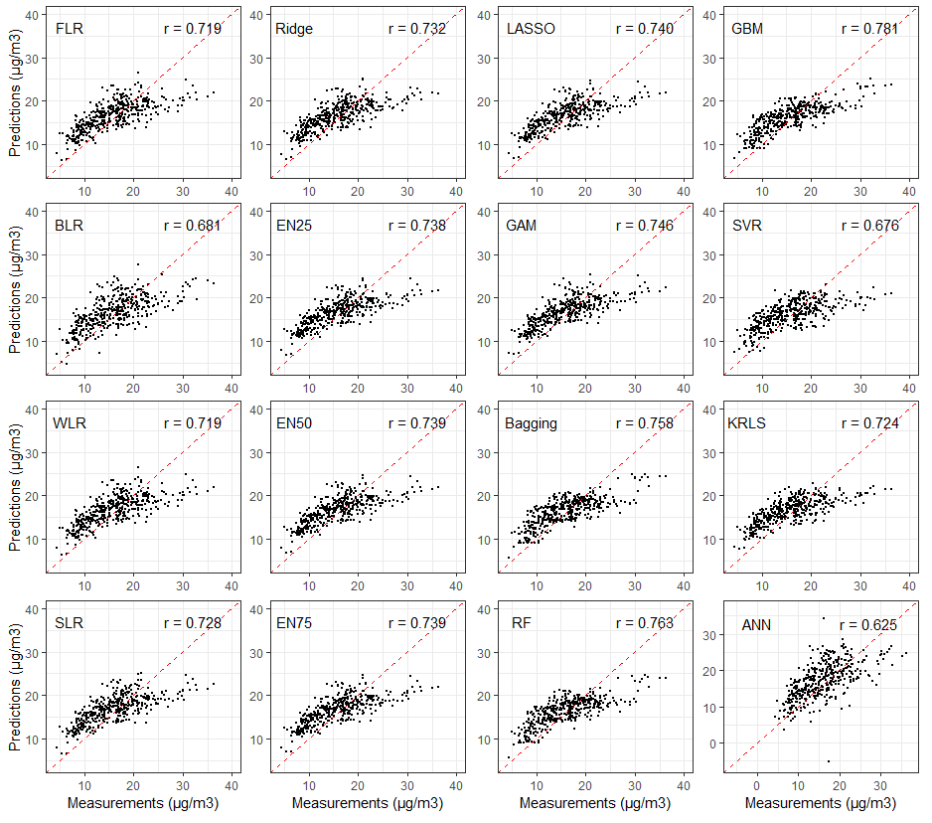
Figure S2. Correlations between PM_{2.5} predictions and measurements at ESCAPE sites (r = Pearson correlation coefficient)
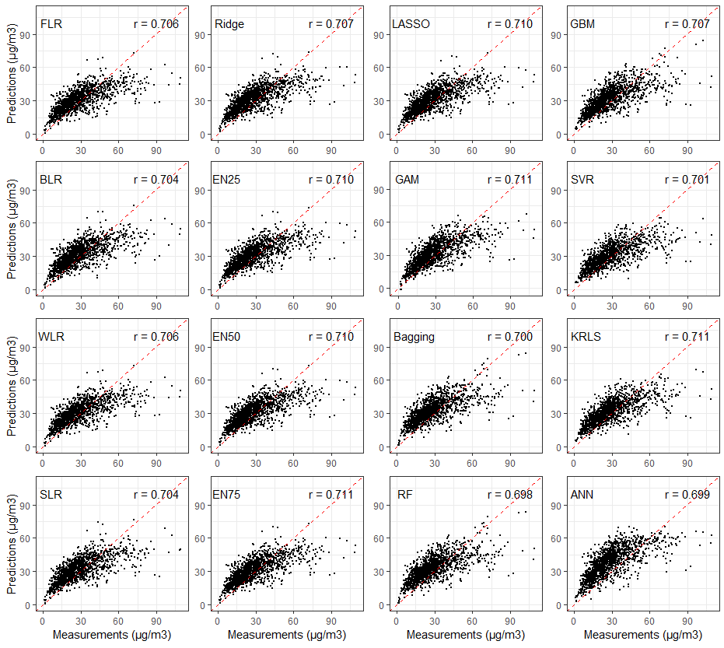
Figure S3. Correlations between NO₂ predictions and measurements at ESCAPE sites (r = Pearson correlation coefficient)

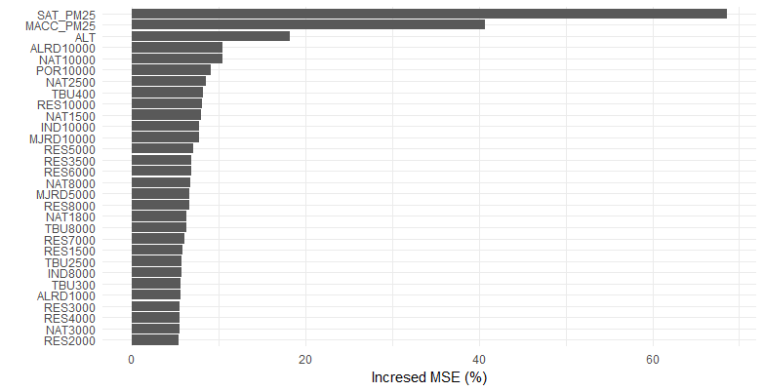
(A) Percentage increase in MSE (Mean Squared Errors) after a random permutation of the values of a variable (Random Forest)
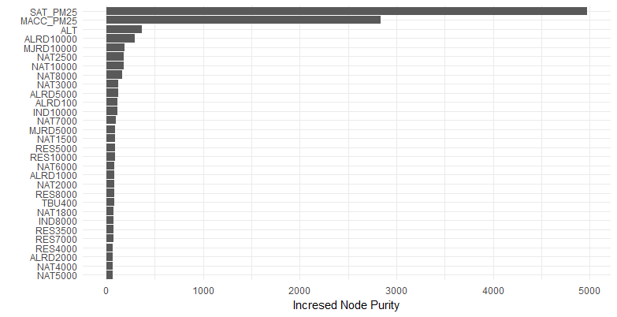
(B) Increase in MSE after a split on a variable (Random Forest)
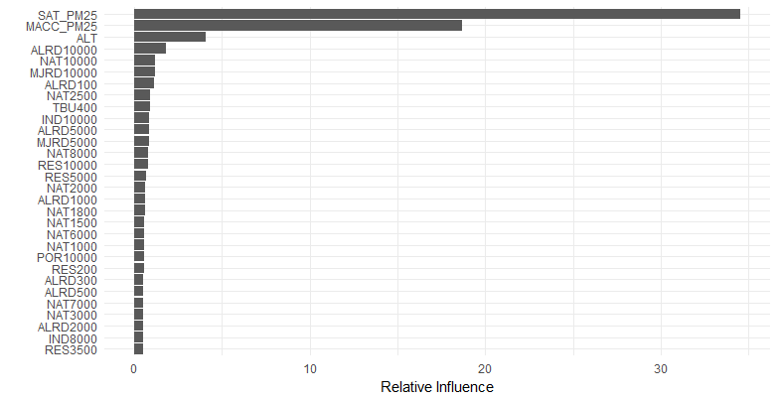
(C) Relative influence of predictors (Generalized Boosted Machine)
Figure S4. Variable importance plots of PM_{2.5} random forest and Generalized Boosted Machine models
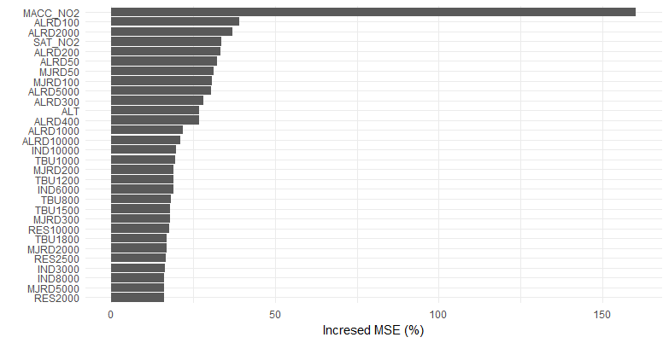
(A) Percentage increase in MSE after a random permutation of the values of a variable (random Forest)
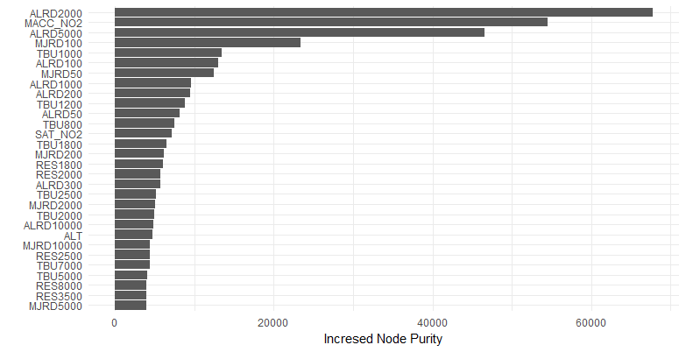
(B) Increase in MSE after a split on a variable (Random Forest)
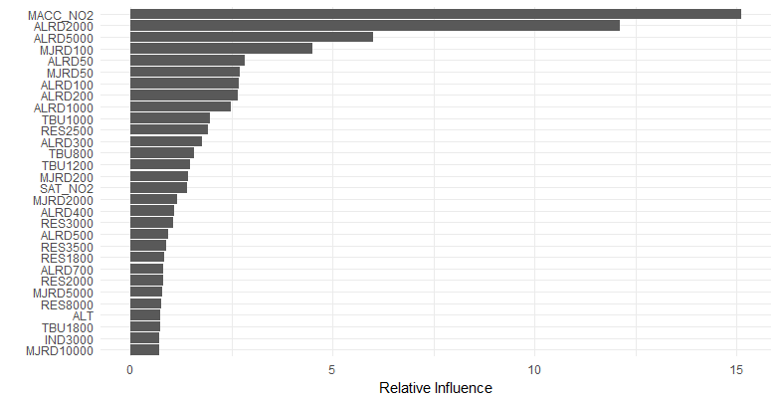
(C) Relative influence of predictors (Generalized Boosted Machine)
Figure S5. Variable importance plots of NO₂ Random Forest and Generalized Boosted Machine models

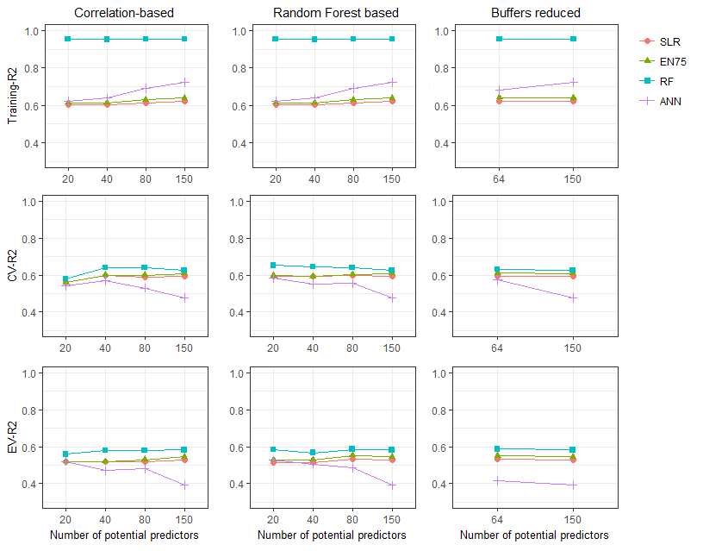
Figure S6. Model Training-R², CV R² and EV R² of PM_{2.5} models with reduced number of potential predictors offered (the number of all potential predictors is 150)
SLR = Supervised Linear Regression; EN75 = Elastic Net with α=0.75; RF = Random Forest; ANN = Artificial Neural Network; CV = Cross Validation; EV = External Validation
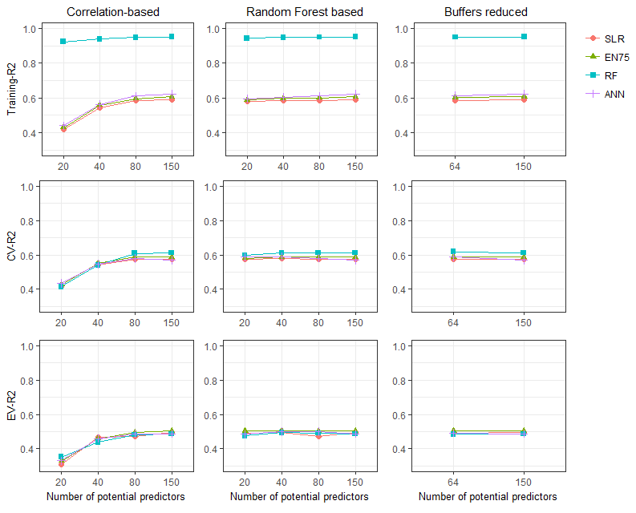
Figure S7. Model Training-R², CV R² and EV R² of NO₂ models with reduced number of potential predictors offered (the number of all potential predictors is 150)
SLR = Supervised Linear Regression; EN75 = Elastic Net with α=0.75; RF = Random Forest; ANN = Artificial Neural Network; CV = Cross Validation; EV = External Validation
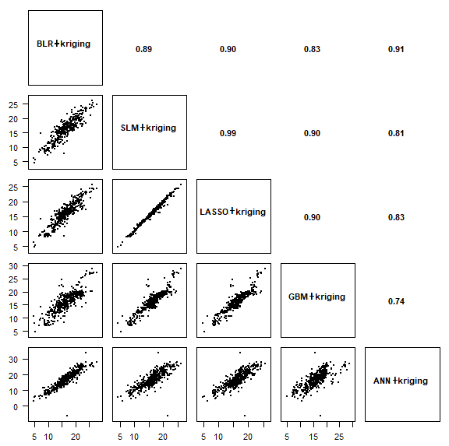
Figure S8. Correlation of PM_{2.5} estimations at ESCAPE sites predicted by selected models plus kriging
BLR = Backward stepwise Linear Regression; SLR = Supervised Linear Regression; LASSO = Least Absolute Shrinkage and Selection Operator; GBM = Generalized Boosted Machine; ANN = Artificial Neural Network

References

de Hoogh K, Gulliver J, van Donkelaar A, et al. 2016. Development of west-european pm 2.5 and no 2 land use regression models incorporating satellite-derived and chemical transport modelling data. Environmental research 151:1-10.
Iglewicz B. 1983. Robust scale estimators and confidence intervals for location:New York: Wiley.
Schalkoff RJ. 1997. Artificial neural networks:McGraw-Hill New York.

