S1 APPENDIX

The role of C-reactive protein levels on the association of physical activity with lung function in adults

Elaine Fuertes^{1,2,3,4}, Anne-Elie Carsin^{1,2,3}, Vanessa Garcia-Larsen⁵, Stefano Guerra^{1,2,3,6}, Isabelle Pin^{7,8,9}, Bénédicte Leynaert^{10,11}, Simone Accordini¹², Jesús Martinez-Moratalla^{13,14}, Josep M Antó^{1,2,3}, Isabel Urrutia¹⁵, Audrey Le Gouellec¹⁶, Joachim Heinrich^{17,18}, Thorarinn Gislason¹⁹, Rain Jõgi²⁰, Christer Janson²¹, Debbie Jarvis^{4,22}, Judith Garcia-Aymerich^{1,2,3}
- ISGlobal, Barcelona, Spain
- Universitat Pompeu Fabra (UPF), Barcelona, Spain
- CIBER Epidemiologia y Salud Publica (CIBERESP), Barcelona, Spain
- National Heart and Lung Institute, Imperial College London, London, United Kingdom
- Program in Human Nutrition, Department of International Health, Johns Hopkins Bloomberg School of Public Health - Baltimore, USA
- Asthma and Airway Disease Research Center, University of Arizona - Tucson, Arizona, USA
- Department of Pediatrics, CHU Grenoble Alpes, Grenoble, France
- INSERM, Institut for Advanced Biosciences, Grenoble, France
- University Grenoble Alpes, Grenoble, France
- UMR 1152, Pathophysiology and Epidemiology of Respiratory Diseases, INSERM, Paris, France
- UMR 1152, University Paris Diderot Paris, Paris, France
- Unit of Epidemiology and Medical Statistics, Department of Diagnostics and Public Health, University of Verona, Verona, Italy
- Servicio de Neumologia del Complejo, Servicio de Salud de Castilla – La Mancha (SESCAM), Hospitalario Universitario de Albacete, Albacete, Spain
- Facultad de Medicina de Albacete, Universidad de Castilla - La Mancha, Albacete, Spain
- Department of Respiratory, Galdakao Hospital, Galdakao, Spain
- University Grenoble Alpes, CNRS, Grenoble INP, CHU Grenoble Alpes, TIMC-IMAG, Grenoble, France
- Institute of Epidemiology, Helmholtz Zentrum Munchen - German Research Center for Environmental Health, , Munich, Germany
- Institute and Outpatient Clinic for Occupational, Social and Environmental Medicine, University Hospital Munich, Ludwig Maximilians University Munich, Munich, Germany
- Department of Respiratory Medicine and Sleep, Landspitali University Hospital Reykjavik, Reykjavik, Iceland
- Lung Clinic, Tartu University Hospital, Tartu, Estonia
- Department of Medical Sciences: Respiratory, Allergy and Sleep Research, Uppsala University, Uppsala, Sweden
- MRC-PHE Centre for Environment and Health, Imperial College London, London, United Kingdom
Measurement of CRP
CRP levels at the first follow-up (ECRHS II) in the three Spanish centers (Albacete, Barcelona and Galdakao) were measured using a Millipore HNDG2MAG-36K | MILLIPLEX MAP Human Neurodegenerative Disease Magnetic Bead Panel 2 - Neuroscience Multiplex Assay. No measured samples were below the lowest standard limit. 19 samples were higher than the highest standard value and were re-coded to twice the highest standard value. The interplate coefficient of variability was 29% and the intraplate coefficient of variability was 15%.

CRP levels at the first follow-up (ECRHS II) in Reykjavik, Uppsala and Tartu were all measured at the Department of Clinical Biochemistry, Landspitali University Hospital, Iceland on a Hitachi 911 analyser using a commercially available latex enhanced immunoturbidimetric assay from Roche. The lower detection limit of the assay is 0.1 mg/l. The between-day coefficient of variation was 1.1% at a concentration of 3.7 mg/l and 1.9% at a concentration of 0.7 mg. For Uppsala, which also had CRP data available at the second follow-up (ECRHS III), a Kone 30 analyser using a commercially available latex-enhanced immunoturbidimetric assay from Roche Diagnostic Systems (Mannheim, Germany) was used. The lower detection limit of this assay is 0.1 mg/L.

CRP levels at the first follow-up (ECRHS II) in the two French centers (Grenoble and Paris) were measured at the Biochemistry Department of Bichat Hospital, Paris, by means of an ultra-sensitive competitive immunoassay on a BN II analyzer (Dade Behring, Marburg, Germany). The intra- and interassay coefficients of variation were both <10%. CRP levels was also measured at ECRHS III for these two French centers by turbidimetric assay on a SPAPlus® system (BindingSite, France), with a full range C-reactive protein kit, according to the manufacturer’s instructions. The lower detection limit of this assay is 0.05 mg/L and the method is linear up to 40mg/L.
Table A. Characteristics of the participants excluded from the analyses
 |  | Excluded from  main population  (ECRHS II, N=1,293) |  |  | Excluded from  subsample population  (ECRHS III, N=426)
 |  | n/N or mean | % or (SD) | p-valueª | n/N or mean | % or (SD) | p-value^{b}
Male sex |  | 568/1293 | 43.9 | 0.002 | 202/426 | 47.4 | 0.515
Symptomatic study arm of ECRHS cohort |  | 226/1293 | 17.5 | 0.739 | 49/426 | 11.5 | 0.793
Age completed full time education | < 17 years | 274/1284 | 21.3 | 0.938 | 39/423 | 9.2 | 0.199
Age completed full time education | 17-20 years | 398/1284 | 31.0 |  | 124/423 | 29.3
Age completed full time education | > 20 years | 612/1284 | 47.4 |  | 260/423 | 61.5
Age in years^{c} |  | 41.5 | 7.4 | <0.001 | 55.4 | 7.3 | 0.960
Height in cm^{c} |  | 169.8 | 9.9 | 0.461 | 170.9 | 8.9 | 0.265
Weight in kg^{c} |  | 73.4 | 16.2 | 0.400 | 77.2 | 14.7 | 0.398
BMI | < 25 kg/m² | 307/572 | 53.7 | 0.365 | 97/236 | 41.1 | 0.143
BMI | 25 - 30 kg/m² | 198/572 | 34.6 |  | 103/236 | 43.6
BMI | > 30 kg/m² | 67/572 | 11.7 |  | 36/236 | 15.3
Smoking habit | Never | 453/1031 | 43.9 | 0.121 | 143/303 | 47.2 | 0.863
Smoking habit | Ex-smoker, < 15 pack-years | 152/1031 | 14.7 |  | 57/303 | 18.8
Smoking habit | Ex-smoker, >= 15 pack-years | 87/1031 | 8.4 |  | 53/303 | 17.5
Smoking habit | Current smoker, < 15 pack-years | 145/1031 | 14.1 |  | 13/303 | 4.3
Smoking habit | Current smoker, >= 15 pack-years | 194/1031 | 18.8 |  | 37/303 | 12.2
Secondhand smoke exposure at home or work |  | 539/1286 | 41.9 | 0.612 | 72/424 | 17.0 | 0.714
Occupation | Management/professional/non-manual | 409/1293 | 31.6 | <0.001 | 198/426 | 46.5 | 0.004
Occupation | Technical/professional/non-manual | 206/1293 | 15.9 |  | 73/426 | 17.1
Occupation | Other non-manual | 306/1293 | 23.7 |  | 68/426 | 16.0
Occupation | Skilled manual | 107/1293 | 8.3 |  | 23/426 | 5.4
Occupation | Semi-skilled/unskilled manual | 122/1293 | 9.4 |  | 24/426 | 5.6
Occupation | Other/unknown | 143/1293 | 11.1 |  | 40/426 | 9.4
Asthma |  | 182/1289 | 14.1 | 0.008 | 79/426 | 18.5 | 0.245
Pre-bronchodilator FEV₁ in ml^{c} |  | 3447.5 | 815 | 0.859 | 2990.3 | 706.7 | 0.956
Pre-bronchodilator FVC in ml^{c} |  | 4268.9 | 1010.6 | 0.337 | 4036.3 | 958.7 | 0.704

BMI = body mass index; ECHRS = European Community Respiratory Health Survey; FEV₁ = forced expiratory volume in one second; FVC = forced vital capacity; n = number of participants with characteristic; N= total number of participants available; SD = standard deviation
ª Comparing those included (N=2,347, Table 1) and excluded (N=1,293, Table A) from the analysis at ECHRS II (Student’s t-test for normally distributed continuous variables and chi-square test for categorical variables)
^{b} Comparing those included (N=671, Table 1) and excluded (N=426, Table A) from the analysis at ECHRS III (Student’s t-test for normally distributed continuous variables and chi-square test for categorical variables)
^{c} The arithmetic mean and standard deviation are presented for these data which were normally distributed
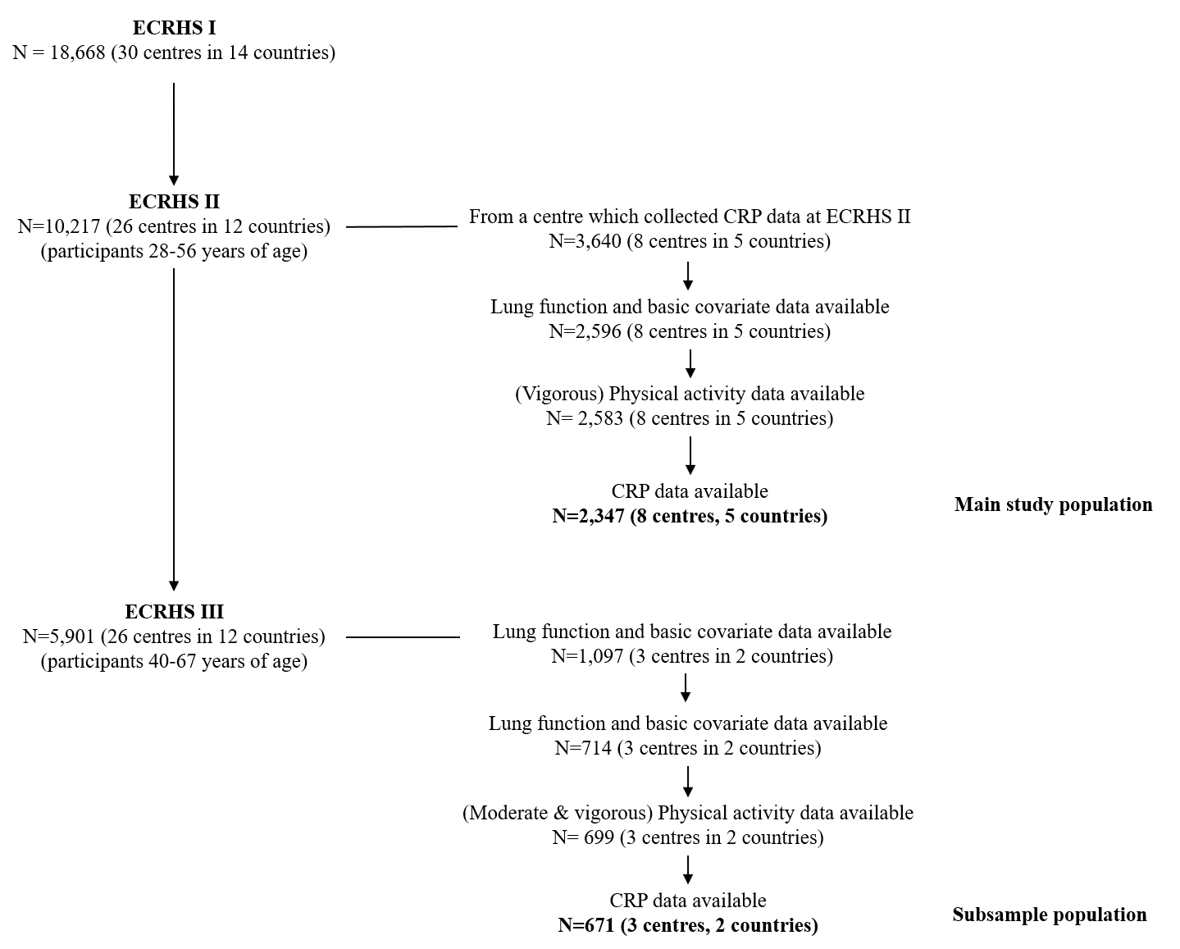

Fig A. Flow chart of the main study population and the subsample with available IPAQ data
Table B. Cross-sectional associations between physical activity and CRP levels in the main study population and the subsample with IPAQ data. Means ratios and their corresponding 95% confidence intervals are presented per increase in physical activity parameterª.

 |  |  | Main models^{b} | Current smokers^{c} | Weight removed^{d}
Main study population (ECRHS II,  N = 2347) | Active | no | reference | reference | reference
Main study population (ECRHS II,  N = 2347) |  | yes | 1.01 [0.94, 1.10] | 0.95 [0.82, 1.11] | 1.01 [0.93, 1.10]
Main study population (ECRHS II,  N = 2347) | Frequency | low | reference | reference | reference
Main study population (ECRHS II,  N = 2347) | Frequency | medium | 1.01 [0.93, 1.10] | 0.98 [0.84, 1.14] | 0.98 [0.90, 1.07]
Main study population (ECRHS II,  N = 2347) | Frequency | high | 1.04 [0.93, 1.16] | 1.01 [0.82 1.25] | 1.07 [0.95, 1.21]
Main study population (ECRHS II,  N = 2347) | Duration | low | reference | reference | reference
Main study population (ECRHS II,  N = 2347) | Duration | medium | 1.03 [0.94, 1.12] | 0.96 [0.83, 1.12] | 1.01 [0.92, 1.10]
Main study population (ECRHS II,  N = 2347) | Duration | high | 1.04 [0.94, 1.16] | 1.01 [0.82, 1.25] | 1.04 [0.93, 1.17]
Subsample with IPAQ data  (ECRHS III, N=671) | Total | first tertile | reference | reference | reference
Subsample with IPAQ data  (ECRHS III, N=671) | Total | second tertile | 0.94 [0.80, 1.11] | 1.60 [1.13, 2.26] | 0.90 [0.75, 1.09]
Subsample with IPAQ data  (ECRHS III, N=671) | Total | third tertile | 0.96 [0.80, 1.14] | 1.23 [0.85, 1.79] | 0.90 [0.74, 1.09]
Subsample with IPAQ data  (ECRHS III, N=671) | Vigorous | first tertile | reference | reference | reference
Subsample with IPAQ data  (ECRHS III, N=671) | Vigorous | second tertile | 0.90 [0.75, 1.09] | 0.98 [0.63, 1.52] | 0.83 [0.67, 1.01]
Subsample with IPAQ data  (ECRHS III, N=671) | Vigorous | third tertile | 0.89 [0.77, 1.03] | 0.75 [0.55, 1.03] | 0.83 [0.71, 0.97]
Subsample with IPAQ data  (ECRHS III, N=671) | Moderate | first tertile | reference | reference | reference
Subsample with IPAQ data  (ECRHS III, N=671) | Moderate | second tertile | 0.84 [0.71, 0.99] | 0.97 [0.69, 1.37] | 0.78 [0.65, 0.94]
Subsample with IPAQ data  (ECRHS III, N=671) | Moderate | third tertile | 0.94 [0.80, 1.10] | 1.39 [0.98, 1.96] | 0.89 [0.75, 1.05]
Subsample with IPAQ data  (ECRHS III, N=671) | Walking | first tertile | reference | reference | reference
Subsample with IPAQ data  (ECRHS III, N=671) | Walking | second tertile | 1.00 [0.84, 1.18] | 1.12 [0.80, 1.58] | 1.04 [0.86, 1.25]
Subsample with IPAQ data  (ECRHS III, N=671) | Walking | third tertile | 1.02 [0.86, 1.21] | 1.46 [1.02, 2.10] | 1.02 [0.85, 1.23]

ECHRS = European Community Respiratory Health Survey; IPAQ = International Physical Activity Questionnaire
ª A means ratios can be interpreted as the percentage change in the mean of the outcome variable in one group compared to the reference group.
^{b} Models are adjusted for sex, age, height, weight, education, occupation, secondhand smoke exposure, smoking habit and include a random intercept for center.
^{c} Models are adjusted for sex, age, height, weight, education, occupation, secondhand smoke exposure and include a random intercept for center.
^{d} Models are adjusted for sex, age, height, education, occupation, secondhand smoke exposure, smoking habit and include a random intercept for center.
Table C: E-values for the point estimate and the limit of the 95% confidence interval closest to the nullª

Physical activity |  | Effect | FEV₁ |  | FVC
 |  |  | Point estimate | 95% CI  closest to null | Point estimate | 95% CI  closest to null
Main study population
(ECRHS II, N = 2347)
Active
 | Yes vs. no | Indirect (via CRP) | 1.04 | 1.00 | 1.04 | 1.00
 |  | Direct (not via CRP) | 1.31 | 1.11 | 1.30 | 1.12
 |  | Total | 1.30 | 1.08 | 1.30 | 1.09
Frequency
 | Medium vs. low | Indirect (via CRP) | 1.03 | 1.00 | 1.05 | 1.00
 |  | Direct (not via CRP) | 1.17 | 1.00 | 1.22 | 1.00
 |  | Total | 1.16 | 1.00 | 1.21 | 1.00
 | High vs. low | Indirect (via CRP) | 1.07 | 1.00 | 1.07 | 1.00
 |  | Direct (not via CRP) | 1.36 | 1.05 | 1.34 | 1.04
 |  | Total | 1.34 | 1.00 | 1.32 | 1.00
Duration
 | Medium vs. low | Indirect (via CRP) | 1.05 | 1.00 | 1.05 | 1.00
 |  | Direct (not via CRP) | 1.27 | 1.00 | 1.27 | 1.00
 |  | Total | 1.26 | 1.00 | 1.27 | 1.00
 | High vs. low | Indirect (via CRP) | 1.08 | 1.00 | 1.06 | 1.00
 |  | Direct (not via CRP) | 1.35 | 1.07 | 1.33 | 1.07
 |  | Total | 1.33 | 1.00 | 1.32 | 1.04
Subsample with IPAQ data
(ECRHS III, N=671)
Total
 | T2 vs T1 | Indirect (via CRP) | 1.12 | 1.00 | 1.09 | 1.00
 |  | Direct (not via CRP) | 1.16 | 1.00 | 1.40 | 1.00
 |  | Total | 1.21 | 1.00 | 1.42 | 1.00
 | T3 vs T1 | Indirect (via CRP) | 1.10 | 1.00 | 1.09 | 1.00
 |  | Direct (not via CRP) | 1.46 | 1.00 | 1.64 | 1.31
 |  | Total | 1.49 | 1.00 | 1.66 | 1.33
Vigorous
 | T2 vs T1 | Indirect (via CRP) | 1.10 | 1.00 | 1.08 | 1.00
 |  | Direct (not via CRP) | 1.21 | 1.00 | 1.33 | 1.00
 |  | Total | 1.24 | 1.00 | 1.35 | 1.00
 | T3 vs T1 | Indirect (via CRP) | 1.13 | 1.00 | 1.10 | 1.00
 |  | Direct (not via CRP) | 1.52 | 1.17 | 1.54 | 1.25
 |  | Total | 1.55 | 1.23 | 1.56 | 1.28
Moderate
 | T2 vs T1 | Indirect (via CRP) | 1.19 | 1.06 | 1.14 | 1.00
 |  | Direct (not via CRP) | 1.37 | 1.00 | 1.37 | 1.00
 |  | Total | 1.45 | 1.00 | 1.42 | 1.00
 | T3 vs T1 | Indirect (via CRP) | 1.11 | 1.00 | 1.08 | 1.00
 |  | Direct (not via CRP) | 1.40 | 1.00 | 1.58 | 1.27
 |  | Total | 1.43 | 1.00 | 1.60 | 1.29
Walking
 | T2 vs T1 | Indirect (via CRP) | 1.06 | 1.00 | 1.05 | 1.00
 |  | Direct (not via CRP) | 1.09 | 1.00 | 1.08 | 1.00
 |  | Total | 1.06 | 1.00 | 1.09 | 1.00
 | T3 vs T1 | Indirect (via CRP) | 1.04 | 1.00 | 1.05 | 1.00
 |  | Direct (not via CRP) | 1.04 | 1.00 | 1.05 | 1.00
 |  | Total | 1.06 | 1.00 | 1.07 | 1.00

CRP = C-reactive protein; ECHRS = European Community Respiratory Health Survey; FEV₁ = forced expiratory volume in one second; FVC = forced vital capacity IPAQ = International Physical Activity Questionnaire; T1 = first tertile; T2 = second tertile; T3 = third tertile

ª Calculated according to [1].
Local Principal Investigators, senior scientific teams and funding agencies for the participating European Community Respiratory Health Survey centers

ECRHS II Principal Investigators and senior scientific teams
France: Paris (F. Neukirch, B. Leynaert, R. Liard, M. Zureik), Grenoble (I. Pin, J. Ferran-Quentin); Spain: Albacete (J. Martinez-Moratalla Rovira, E. Almar, M. Arévalo, C. Boix, G González, J.M. Ignacio García, J. Solera, J Damián), Galdakao (N. Muñozguren, J. Ramos, I. Urrutia, U. Aguirre), Barcelona (J. M. Antó, J. Sunyer, M. Kogevinas, J. P. Zock, X. Basagaña, A. Jaen, F. Burgos, C. Acosta); Sweden: Uppsala (C. Janson, G. Boman, D. Norback, G. Wieslander, M. Gunnbjornsdottir); Iceland: Reykjavik (T. Gislason, E. Bjornsson, D. Gislason, K.B Jörundsdóttir); Estonia: Tartu (R. Jõgi, A. Soon);

Financial Support for ECRHS II
France: (All) Programme Hospitalier de Recherche Clinique—Direction de la Recherche Clinique (DRC) de Grenoble 2000 number 2610, Ministry of Health, Ministère de l’Emploi et de la Solidarité, Direction Génerale de la Santé, Centre Hospitalier Universitaire (CHU) de Grenoble, Grenoble: Comite des Maladies Respiratoires de l’Isere, Paris: Union Chimique Belge- Pharma (France), Aventis (France), Glaxo France; Spain: Albacete: Fondo de Investigacion Santarias (grant codes, 97/0035-01,99/0034-01 and 99/0034 02), HospitalUniversitario de Albacete, Consejeria de Sanidad, Barcelona: Sociedad Espanola de Neumologı´a y Cirugı´a Toracica, Public Health Service(grant code, R01 HL62633-01), Fondo de Investigaciones Santarias (grant codes, 97/0035-01, 99/0034-01, and 99/0034-02), Consell Interdepartamentalde Recerca i Innovacio´ Tecnolo`gica (grant code, 1999SGR 00241) Instituto de Salud Carlos III; Red deCentros de Epidemiologı´a y Salud Pu´blica, C03/09,Redde Basesmoleculares y fisiolo´gicas de lasEnfermedadesRespiratorias,C03/011and Red de Grupos Infancia y Medio Ambiente G03/176, Galdakao: Basque Health Department; Sweden: Uppsala: Swedish Heart Lung Foundation, Swedish Foundation for Health Care Sciences and Allergy Research, Swedish Asthma and Allergy Foundation, Swedish Cancer and Allergy Foundation, Swedish Council for Working Life and Social Research (FAS); Iceland: Reykjavik: Icelandic Research Council, Icelandic University Hospital Fund; Estonia: Tartu Estonian Science Foundation grant no 4350;

ECRHS III Principal Investigators and senior scientific teams
France: Grenoble (I. Pin, V. Siroux, J.Ferran, J.L Cracowski), Paris (B. Leynaert, D. Soussan, D. Courbon, C. Neukirch, L. Alavoine, X. Duval, I. Poirier); Sweden: Uppsala:(B Andersson, D Norback, U Spetz Nystrom, G Wieslander, G.M Bodinaa Lund, K Nisser).

Financial Support for ECRHS III
France: (All) Ministère de la Santé. Programme Hospitalier de Recherche Clinique (PHRC) national 2010, Grenoble: Comite Scientifique AGIRadom 2011, Paris: Agence Nationale de la Santé, Région Ile de France, domaine d’intérêt majeur (DIM); Sweden: Uppsala: The Swedish Heart and Lung Foundation, The Swedish Asthma and Allergy Association, The Swedish Association against Lung and Heart Disease, Swedish Research Council for health, working life and welfare (FORTE).
References
- VanderWeele TJ, Ding P. Sensitivity analysis in observational research: introducing the E-Value. Ann Intern Med. 2017;167(4):268-274. doi:10.7326/M16-2607

