Supplemental Materials

Samples and Analytical procedures -

Optical and electron microscopy
Several thin and thick sections of Renchen (PL18087, PL18088, PL18089, PL18090; Institut für Planetologie, Münster) were studied by optical and electron microscopy. For optical microscopy in transmitted and reflected light a ZEISS polarizing microscope (Axiophot) was used. A JEOL 6610-LV electron microscope (SEM) at the Interdisciplinary Center for Electron Microscopy and Microanalysis (ICEM) at the Westfälische Wilhelms-Universität Münster was used to study the fine-grained textures of and to identify the different mineral phases. The surface morphology of the uncoated sample was investigated using a Phenom ProX scanning electron microscope (SEM) in backscattered electron mode. This instrument is equipped with an energy dispersive X-ray spectrometer (EDS) for analyzing the surface elements with a constant 15 kV accelerating voltage.

Mineral analyses
Most quantitative mineral analyses were obtained using a JEOL JXA 8530F electron microprobe (EPMA) at the Institut für Mineralogie, which was operated at 15 kV and a probe current of 15 nA. Natural and synthetic standards were used for wavelength dispersive spectrometry. Jadeite (Na), kyanite (Al), sanidine (K), chromium oxide (Cr), San Carlos olivine (Mg), hypersthene (Si), diopside (Ca), rhodonite (Mn), rutile (Ti), fayalite (Fe), apatite (P), celestine (S), and nickel oxide (Ni) were used as standards for mineral analyses. Using the Münster-SEM for quantitative analysis, samples and appropriate mineral standards were measured at an excitation voltage of 20 kV, and the beam current constancy was controlled by a Faraday cup. The attached EDS system was used for chemical characterization and analyses of the different mineral constituents. Standard (Astimex) olivine (Mg, Fe, Si), jadeite (Na), plagioclase (Al), sanidine (K), diopside (Ca), rutile (Ti), chromium-oxide (Cr), rhodonite (Mn), and pentlandite (Ni) were used as natural and synthetic standards. For these EDS analyses the INCA analytical program provided by Oxford Instruments was used.

Raman Spectroscopy
Raman spectroscopic investigations were conducted using an Ocean Optics IDR-Micro Raman system at the IR/IS laboratory of the Institut für Planetologie in Münster operating with the OneFocus optical system. A 40X objective was used with a given spot size on the sample in focus of about 2 µm. The laser excitation was 532 nm, and the spectral resolution (=distance between two detector pixels) is about 7 cm⁻¹. Evaluable spectra were obtained starting at frequencies around 200 cm⁻¹.

Computed tomography (CT)
The CT was performed at Central European Institute of Technology, Brno University of Technology (CEITEC BUT). Due to a very different size of two scanned samples, different machines from GE equipped with different X-ray tubes were used (Table below). The tomographic reconstruction was realized using GE phoenix datos|x software. The CT data of R1 were segmented by global thresholding to obtain volumes of metals and sulfides in VG Studio MAX 3.2 software (Volume Graphics, Germany). To express the estimation of repeatability in a calculation of porosity, regions with each material were eroded and dilated by 0.5 px to express porosity values variation.

Parameters of CT measurement of meteorites.
 | CT device | Acceleration voltage | Tube current | Exposure time | Projections | Voxel size
M1 | GE phoenix L240 | 150 kV | 190 µA | 400 ms | 2200 | 16 µm
M2 | GE phoenix M300 | 260 kV | 300 µA | 1 s | 2000 | 80 µm

Chemical analysis of phosphates by ICP-MS
The abundances of 37 trace elements for the Ca-phosphate grains were analyzed at the Institut für Mineralogie (WWU Münster) by a ThermoFisher Element 2 single collector ICP-MS coupled with Excimer laser ablation system (Analyte G2, Photon Machines). The latter provided an output wavelength of 193 nm and was operated with a fluence of 3 J/cm2 and a repetition rate of 10 Hz. Counting times were 40 s on peak signals and 20 s on background, respectively. The spot size varied from 25–65 μm. External reference material was NIST-SRM 612 glass. For quantification 43Ca was used as internal standard. To keep track of precision and accuracy basaltic BIR-1G (Jochum et al., 2005) and phosphatic STDP5 (Klemme et al., 2008) reference glasses were measured as unknowns over the course of this study.

Bulk chemical analysis
The sample of 0.283 g from Renchen fragment R3 was crushed and homogenized. Additionally, a 0.206 g sample of the Cloppenburg chondrite (H4-5) was analysed for comparison. The chemical composition of the bulk samples were obtained by using ICP-AES (for Al, Fe, Mn, Mg, Na, Cr, Co, and Ni) and ICP-SFMS. The bulk compositions using ICP were performed at the Institut Universitaire Européen de la Mer, Université de Bretagne Occidentale in Plouzané, France.

Ti isotope analyses
Titanium isotope compositions were measured at the Institut für Planetologie in Münster and the Institute of Geochemistry and Petrology at ETH Zurich.
For Münster: About 50 mg of the sample powder was dissolved in a 15 ml Savillex teflon beakers on a hotplate at 170°C using HF:HNO₃ (ratio 3:1) and aqua regia. Titanium was separated from the matrix broadly following previously established procedures (Zhang et al., 2011). Titanium isotope measurements were made in two lines using a ThermoScientific NeptunePlus MC-ICPMS in high resolving power mode (Zhang et al., 2011). Solutions containing about 400 ppb Ti in 0.3 M HNO3 – 0.0014 M HF were introduced through a Cetac Aridus II desolvating system, resulting in a ~3×10⁻¹⁰ A ion beam on ⁴⁸Ti. Measurements consisted of a 30 s baseline measurement (deflected beam) followed by 40 isotope ratio measurements of 4.2 s each. Mass bias was corrected using the exponential law and ⁴⁹Ti/⁴⁷Ti = 0.749766. Titanium isotope anomalies are reported as parts per ten thousand deviation (ε-notation) from the terrestrial OL-Ti (Millet and Dauphas, 2014) bracketing standard. The sample uncertainty is reported as the Student-t 95% confidence interval based on repeated analyzes (N=7) of the sample solution on three different days.
For Zurich: The sample digestion procedure was divided in three steps. First, 1ml of concentrated HNO₃ and 1 ml of concentrated HF were added to the Savillex® vial containing the powdered sample (~30 mg) and heated in an oven at 160°C for 3 days. Then, the sample was taken to dryness, dissolved in 2 ml of concentrated HCl and heated again for 2 days in the oven at 160°C. Finally, the sample dried down and re-dissolved in 6 M HCl twice. For Ti separation ~20 mg of the dissolved sample was processed in a three-stage anion exchange procedure using Bio-Rad AG1-X8 resin (Williams, 2015). For the first column, 4 M HF was used for sample loading and matrix elution followed by Ti collection in 6 M HCl – 1 M HF. In the second column, sample loading and Ti collection was done with 0.25 M H₂SO₄ + 1% H₂O₂, followed by the third column where 4 M HF was used to load the sample, followed by matrix elution in 0.5 M HCl - 0.5 M HF and the collection of Ti in 6 M HCl – 1 M HF (Schönbächler et al., 2004, Williams, 2015). The Ti isotope analysis was performed on a Thermo Scientific Neptune Plus multi-collector inductively coupled plasma mass spectrometer (MC-ICPMS) at ETH Zurich. The sample was diluted in 0.5 M HNO₃ - 0.015 M HF and introduced into the mass spectrometer via a Cetac Aridus II desolvator. Titanium isotopes were measured in two integration cycles. All five Ti isotopes and ⁴⁴Ca comprised a first cycle (8.39s integration time), while followed by a second, where ⁵⁰Ti, ⁵³Cr and ⁵¹V were collected to correct for the isobaric interferences of V and Cr isotopes on ⁵⁰Ti (4.19s). This was repeated 40 times for each sample measurement in high and medium mass resolution. The isotope data were corrected for instrumental mass-bias by internally normalization to a ⁴⁹Ti/⁴⁷Ti ratio of 0.749766 (Niederer et al., 1981) and reported in ε-notation relative to an in-house Ti wire standard solution (Williams, 2015) applying the standard bracketing method. The sample uncertainty is reported as standard error based on repeated analyses of the sample solution on four different days.

Cr isotope analyses
Chromium isotope compositions were analysed by MC-ICPMS at the Institute of Geochemistry and Petrology at ETH Zurich. The powdered sample was dissolved in a 1:1 mixture of concentrated HNO3 and HF in a sealed 7ml Teflon vial in an oven at 160°C for 3 days. The solution was then evaporated on a hot plate. The residue was dissolved in 2 ml 9.6 M HCl and placed in an oven at 160°C for 2 days. Finally, the dissolved sample was dried down and dissolved in 2 ml 6 M HCl. This latest step was repeated until a clear solution was obtained. Chromium was separated from the matrix and elements that form major isobaric interferences (Fe, Ti and V) following a two column ion exchange procedure using AG50-X8 resin, adapted from Trinquier et al. (2008a,b).
Chromium isotopes were measured on a Thermo Scientific Neptune plus MC-ICPMS using a Cetac Aridus II desolvating nebuliser as introduction system. Analyses were performed at medium-resolution (6000<M/∆M <9000) to resolve molecular isobaric interferences (ArC, ArN, and ArO). An aliquot of the sample solution was used to estimate the approximate Cr concentration, after which the solution was diluted to a concentration of 3 ppm in 0.25 HNO₃, typically yielding a ⁵²Cr signal of 7 x 10⁻¹⁰ A.
The instrumental blank was determined with 50 8-second integrations prior to each sample or standard analysis, following a 12-minute wash period. Each sample measurement was bracketed by a Cr NIST SRM 979 standard measurement. Each analysis was corrected using the on-peak baseline. A sample or standard measurement consisted of 100 integrations of 16s.
Samples and standards were corrected for instrumental mass bias using the exponential law and ⁵⁰Cr/⁵²Cr = 0.051859 (Shields et al., 1966). The isobaric interferences coming from of Fe, Ti, and V were monitored by collection ⁵⁶Fe, ⁴⁹Ti and ⁵¹V. The Renchen sample was measured 7 times and the isotope composition and uncertainty are the average and standard error of these repeat measurements.

Radionuclides
Cosmogenic radionuclide concentrations have been analyzed by means of non-destructive high purity germanium (HPGe) gamma spectroscopy. The counting efficiencies have been calculated using thoroughly tested Monte Carlo codes. The pieces R2 (955 g) and R6 (228.2 g) were measured at the low level laboratory of the Max-Planck Institut für Kernphysik (Heusser et al., 2015).

IR Spectroscopy
In the IRIS lab at the Institut für Planetologie of the Westfälische Wilhelms-Universität in Münster, a Bruker Vertex 70v spectrometer for mid-infrared measurements was used. A polished thin section of the meteorite was analyzed. We used different observation geometries for the measurements with identical incident and emergent angle between 20° and 70°, using a Bruker A513 bidirectional reflectance stage. The used detector was a liquid nitrogen cooled MCT-detector. The mean of 512 single spectra per geometry were calculated in the measured wavelength range from 2 µm to 18 µm. All measurements took place at pressures of around 2 hPa and at room temperature of around 23°C. For the background calibration, we use a polished gold mirror. The spectral data will be available in the upcoming IRIS database for space science missions with the sample ID 121 (Weber et al., 2018).

Organics
A destructive methanolic solvent extraction of organic matter was performed in a pillar using 20 mg freshly broken fragment of the Renchen meteorite (from sample R2). All precautions were taken to avoid external organic contamination and the broken parts were washed intensively with the solvent prior crushing. Negative electrospray ionization mode (ESI) Fourier transform ion cyclotron resonance mass spectrometry (FT-ICR-MS) was undertaken using standard operation procedure as described previously by Schmitt-Kopplin et al. (2010, 2012) and 3,000 scans were averaged. The polar, protic solvent extraction (methanol) and mild ESI-ionization preferentially extracted and ionized polar, oxygenated molecules. Data processing was carried out using the Compass Data Analysis 4.0 (Bruker, Bremen, Germany) and formulae were assigned by a custom made software (NetCalc network), as described by Tziotis et al. (2011). Assigned molecular formulas were classified into CHO, CHNO, CHOS, CHNOS, and CHOMg molecular series, which were visualized in the class-selective van Krevelen diagrams (Schmitt-Kopplin et al., 2010, 2012; Hertkorn et al., 2015; Ruf et al., 2017).

References-Supplement:
Hertkorn, N., Harir, M., Schmitt-Kopplin, Ph., 2015. Nontarget analysis of Murchison soluble organic matter by high-field NMR spectroscopy and FTICR mass spectrometry. Magnetic Resonance Chemistry 53, 754-768.
Heusser, G., Weber, M., Hakenmüller, J., Laubenstein, M., Lindner, M., Maneschg, W., Simgen, H., Stolzenburg, D., Strecker, H., 2015. GIOVE: a new detector setup for high sensitivity germanium spectroscopy at shallow depth. The European Physical Journal C 75, 531.
Jochum, K. P., Willbold, M., Raczek I., Stoll, B., Herwig, K., 2005. Chemical Characterisation of the USGS ,Reference Glasses GSA‐1G, GSC‐1G, GSD‐1G, GSE‐1G, BCR‐2G, BHVO‐2G and BIR‐1G Using EPMA, ID‐TIMS, ID‐ICP‐MS and LA‐ICP‐MS. Geostandards and Geoanalytical Research 29, 285-302.
Klemme, S., Prowatke, S., Münker, C., Magee, C., Lahaye, Y., Zack, T., Kasemann, S.A., Cabato, E. J. A., Kaeser, B., 2008. Synthesis and preliminary characterisation of new silicate, phosphate and titanite reference glasses. Geostandards and Geoanalytical Research 32, 39–54.
Millet, M.-A, Dauphas, N., 2014. Ultra-precise titanium stable isotope measurements by double-spike high resolution MC-ICP-MS. J. Anal. At. Spectrom. 29, 1444-1458
Niederer, F.R., Papanastassiou, D.A., Wasserburg, G.J., 1981. The isotopic composition of titanium in the Allende and Leoville meteorites. Geochimica et Cosmochimica Acta 45, 1017-1031.
Ruf, A., Kanawati, B., Hertkorn, N., Yin, Q. Z., Moritz, F., Harir, M., Lucio, M., Michalke, B., Wimpenny, J., Shilobreeva, S., Bronsky, B., Saraykin, V., Gabelica, Z., Gougeon, R., Quirico, E., Ralew, S., Jakubowski, T., Haack, H., Jenniskens, P., Hinman, N. W., Schmitt-Kopplin, Ph., 2017. Previously unknown class of metalorganic compounds revealed in meteorites, Proceedings of the National Academy of Sciences 114, 2819–2824.
Schmitt-Kopplin, Ph., Gabelica, Z., Gougeon, R.D., Fekete, A., Kanawati, B., Harir, M., Gebefuegi, I., Eckel, G., Hertkorn, N., 2010. High molecular diversity of extraterrestrial organic matter in Murchison meteorite revealed 40 years after its fall. PNAS, 107(7), 2763-2768.
Schmitt-Kopplin, Ph., Harir, M., Kanawati, B., Tziotis, D., Hertkorn, N., Gabelica, Z., 2012. Chemical footprint of the solvent soluble extraterrestrial organic matter occluded in Sołtmany ordinary chondrite, Meteorite Journal, Special issue Soltmany, 1–2, 79–92.
Schönbächler, M., Rehkämper, M., Lee, D.-C., Halliday, A. N., 2004. Ion exchange chromatography and high precision isotopic measurements of zirconium by MC-ICP-MS. Analyst 129, 32-37.
Shields, W. R., Murphy, T. J., Catanzaro, E. J., Garner, E. L., 1966. Absolute isotopic abundance ratios and the atomic weight of a reference sample of chromium. Journal of Research of the National Bureau of Standards A 70, 193–197.
Trinquier, A., Birck, J. L., Allègre, C. J., Göpel, C., Ulfbeck, D., 2008a. ⁵³Mn–⁵³Cr systematics of the early Solar System revisited. Geochimica et Cosmochimica Acta 72:5146–5163.
Trinquier, A., Birck, J.-L., Allègre, C. J., 2008b. High-precision analysis of chromium isotopes in terrestrial and meteorite samples by thermal ionization mass spectrometry. Journal of Analytical Atomic Spectrometry 23:1565–1574.
Tziotis, D., Hertkorn, N., Schmitt-Kopplin, Ph., 2011. Kendrick-analogous Network Visualisation of Ion Cyclotron Resonance Fourier Transform (FTICR) Mass Spectra: Improved Options to Assign Elemental Compositions and to Classify Organic Molecular Complexity, European Journal of Mass Spectrometry 17:415-421.
Weber, I., Morlok, A., Grund, T., Bauch, K. E., Hiesinger, H., Stojic, A., Grumpe, A., Wöhler, C., Klemme, S., Sohn, M., Martin, D. J. P., Joy, K. H., 2018. A Mid-Infrared Reflectance Database in Preparation for Space Missions. Lunar Planet. Sci. Conf. 48:#1430.
Williams, N. H., 2015. The origin of titanium isotopic anomalies within solar system material. PHD thesis, The University of Manchester.
Zhang, J., Dauphas, N., Davis, A. M., Pourmand, A., 2011. A new method for MC-ICPMS measurement of Ti isotopic composition: identification of correlated isotope anomalies in meteorites. J. Anal. At. Spectrom. 26:2197-2205.

Figures of the supplement:

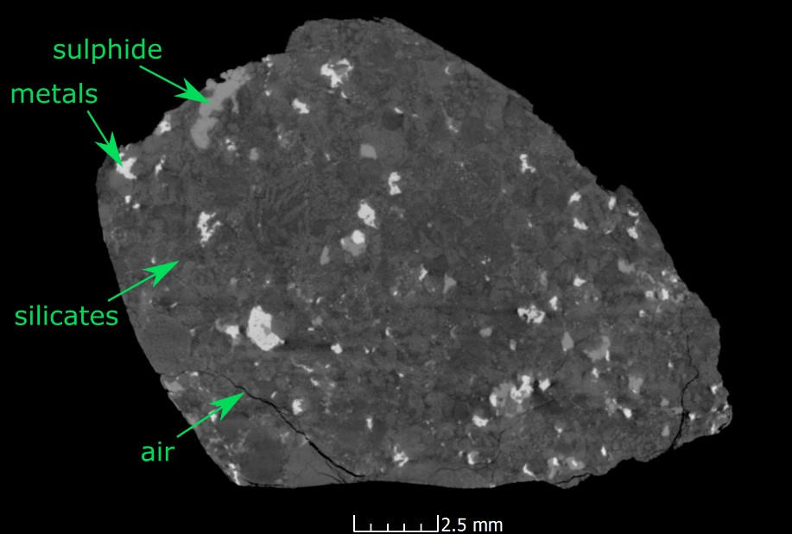

Fig. S1: Rock slice obtained by computed tomography (CT) of Renchen fragment R1. Four phases are distinguishable: sulphide (light grey), metals (white), silicates (grey), and air (cracks, pores; black).

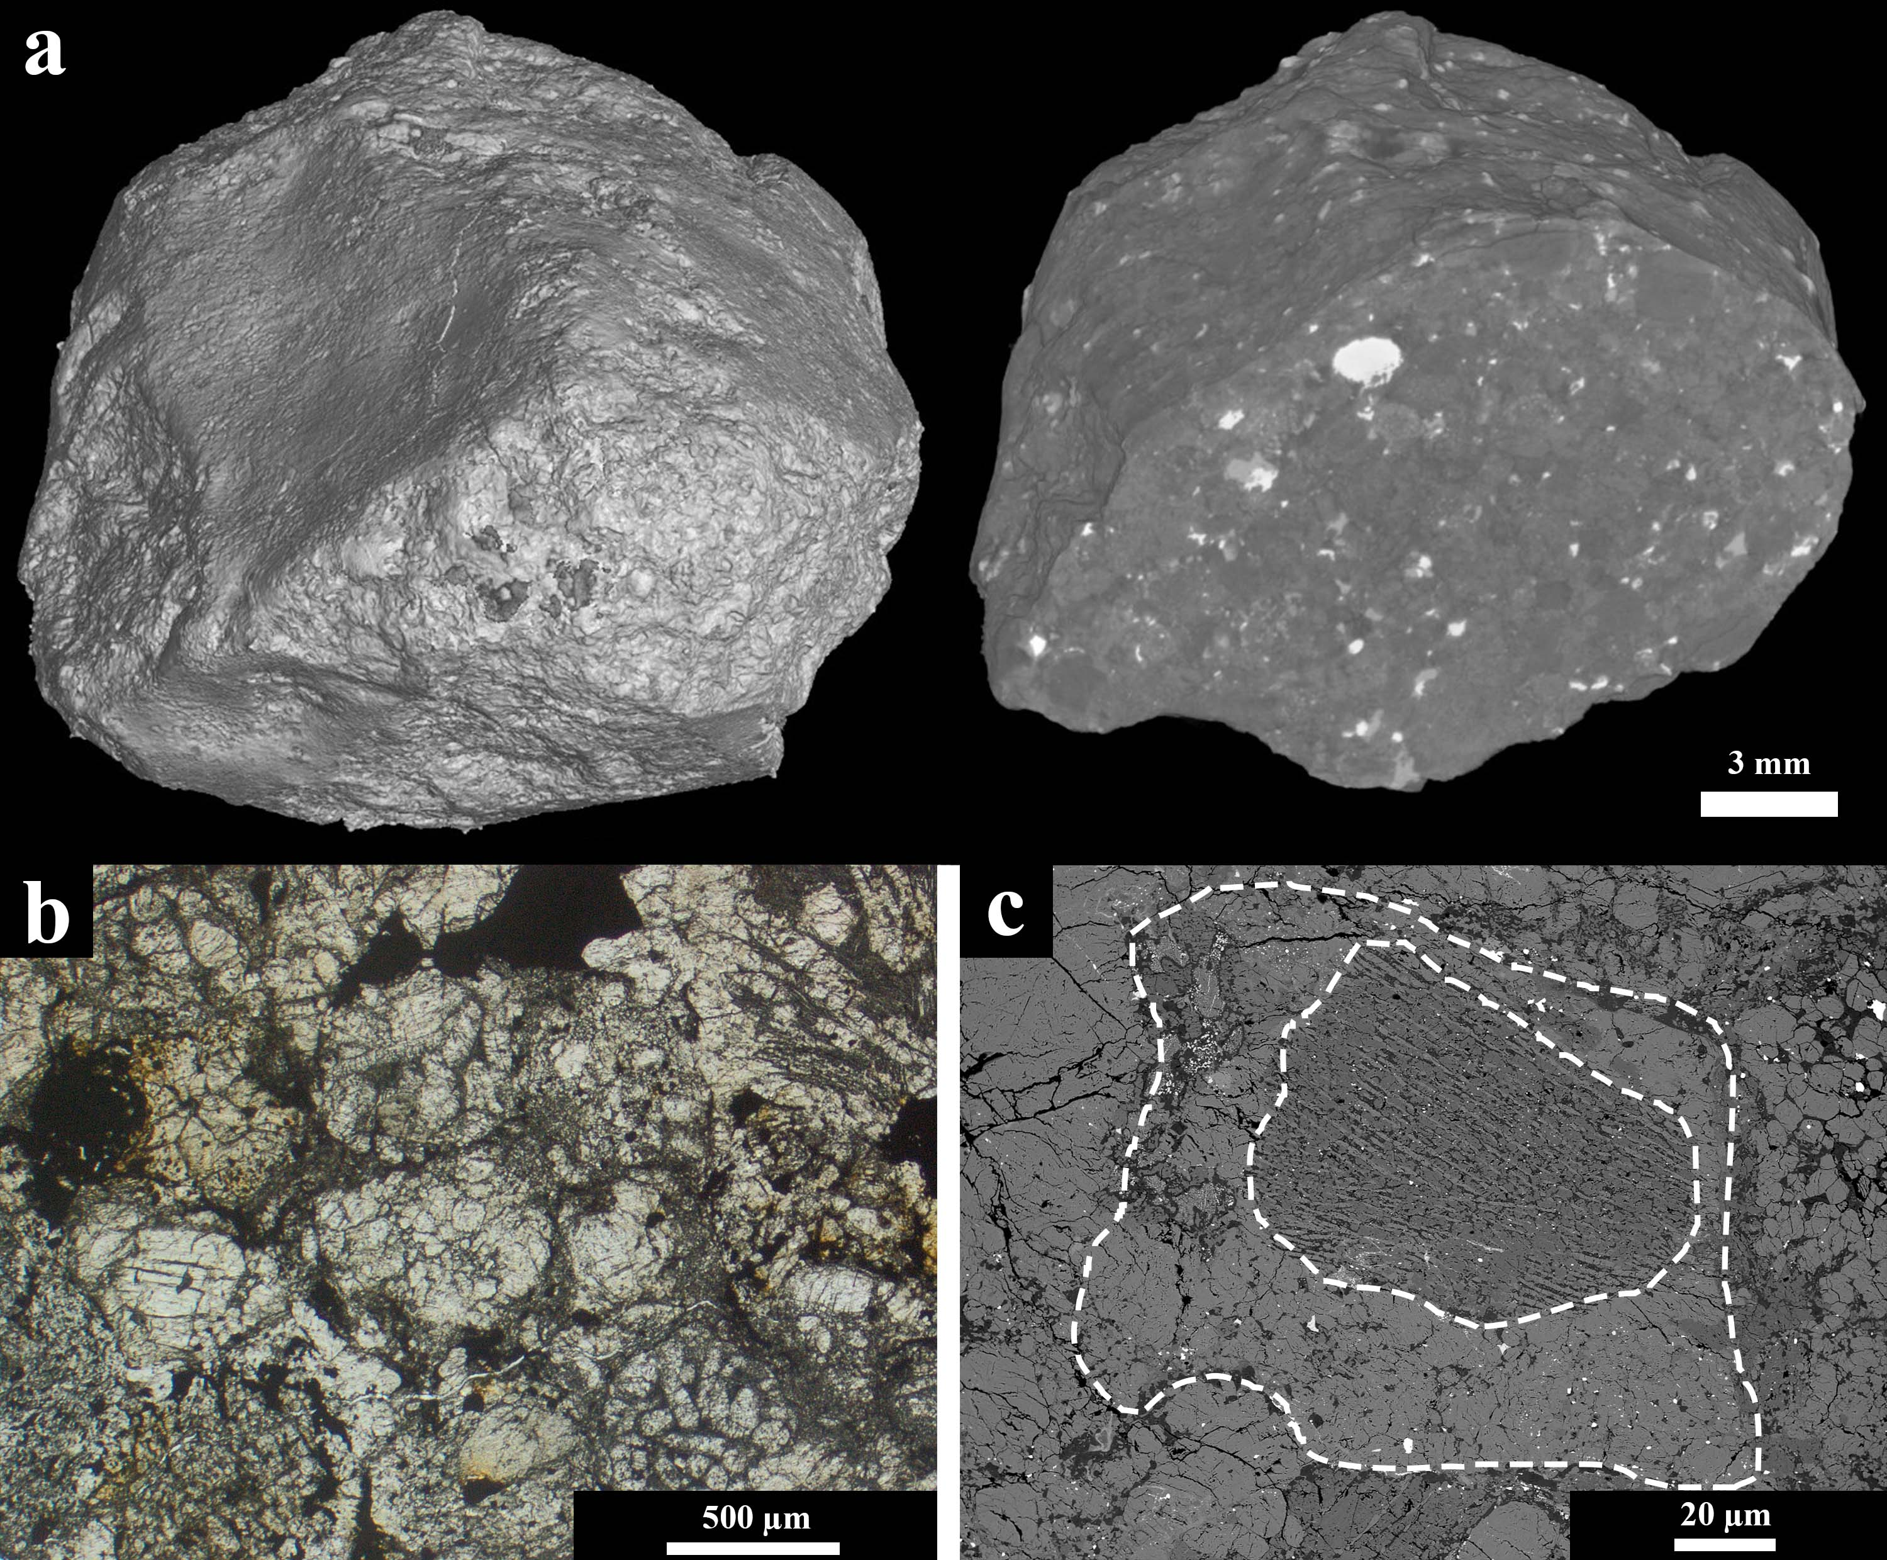

Fig. S2: (a) 3D image obtained from CT studies of fragment R1. Surface morphology on the left and a CT image of a slice through the R1 fragment on the right-hand side. The white objects are metals embedded within a greyish silicate-rich matrix. (b) Area of the Renchen breccia with clearly-detectable relict chondrules (type 5). (c) Fragment having a relict object with a barred/radial texture included.

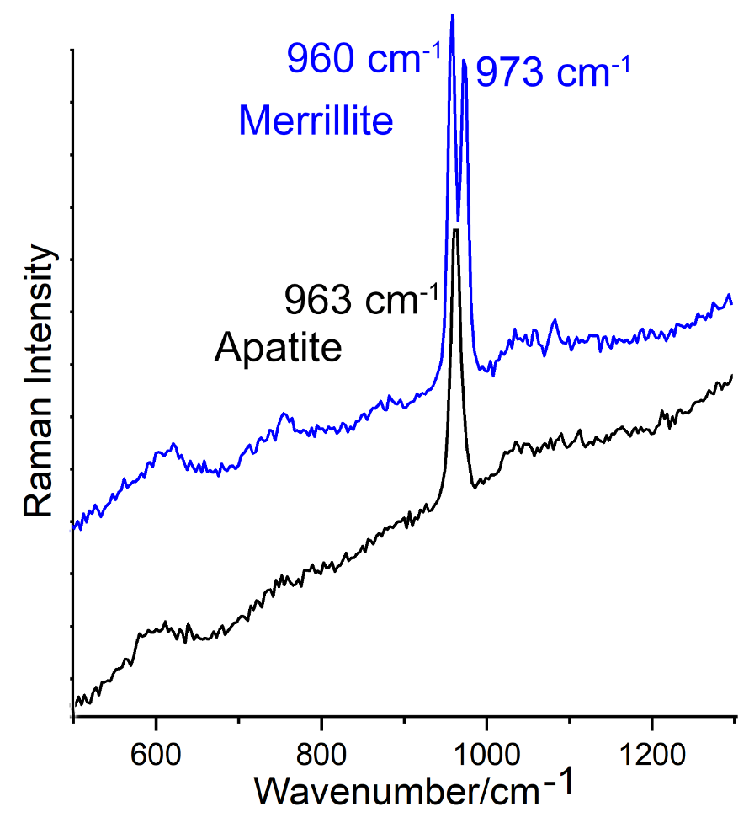

Fig. S3: Raman spectra of the apatite and merrillite in the range from 700 cm⁻¹ to 1300 cm⁻¹. The spectra are not background-corrected. The intensity increases due to an increase of fluorescence.

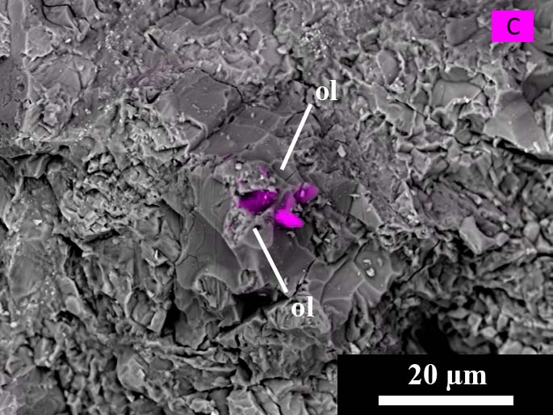

Fig. S4: Backscattered electron image including C-mapping of the broken surface of the Renchen meteorite. Carbon is present in specific grains close to olivine (ol). The origin and phase mineralogy remains unclear.

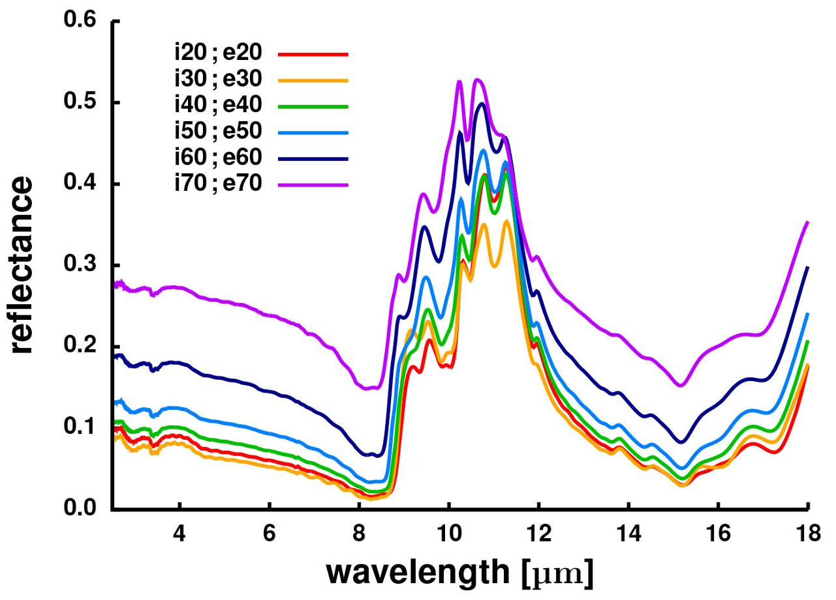

Fig. S5: Spectra of Renchen thin section PL 18089 at different observation geometries and phase angles (incident and emergent angles).

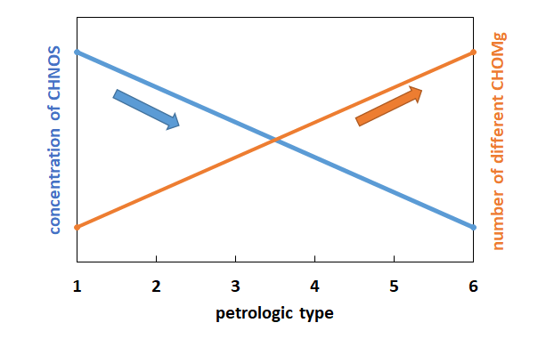

Fig. S6: Simple trends concerning the petrologic type of a chondrite and the concentrations of CHNOS (blue) and the number of different CHOMg-species (orange).

