Supplementary Table 1: Interobserver concordance between two pathologists for the Cellular Dissociation Grade.

Supplementary Table 2: Correlation of clinicopathological factors with cell nest size, budding activity and Cellular Dissociation Grade.

Supplementary Table 3: Association of Cellular Dissociation Grade with disease specific survival in multiparametric regression analysis.

Supplementary Table 4: Association of Cellular Dissociation Grade with overall survival in multiparametric regression analysis.

Supplementary Figure 1: Association of cell nest size (A-C) and budding activity (D-F) with overall, disease specific and disease-free survival.

Supplementary Figure 2: Association of the raw sum scores derived from tumour budding and cell nest size with overall (A), disease specific (B) and disease free (C) survival.

Supplementary Figure 3: Association of Cellular Dissociation Grade with overall (A), disease specific (B) and disease free (C) survival in the subgroup of patients with subtotal regression.

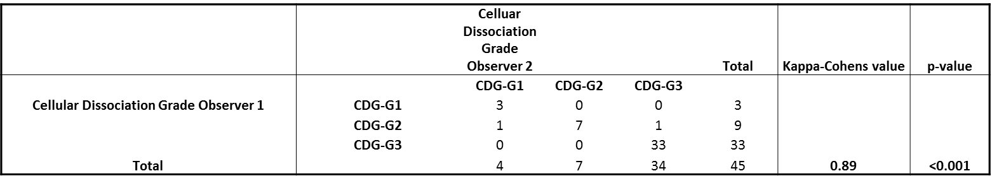

Supplementary Table 1

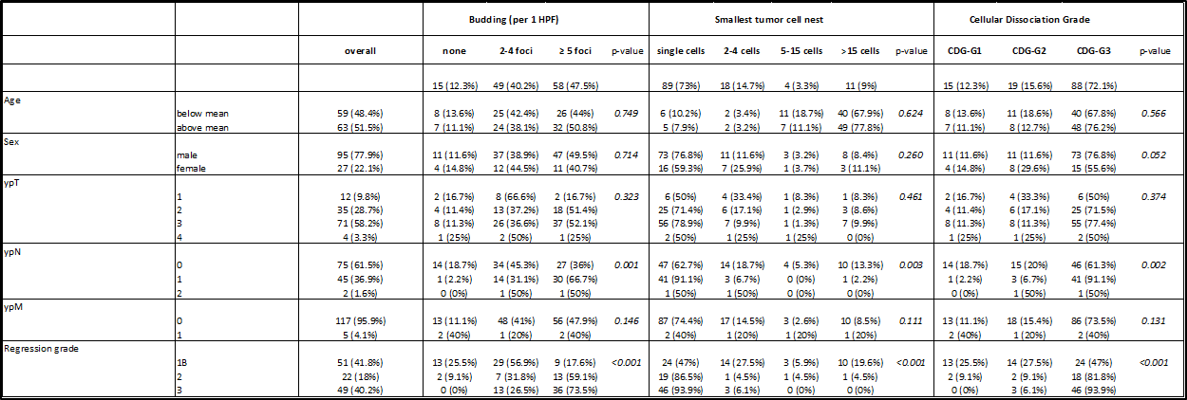

Supplementary Table 2

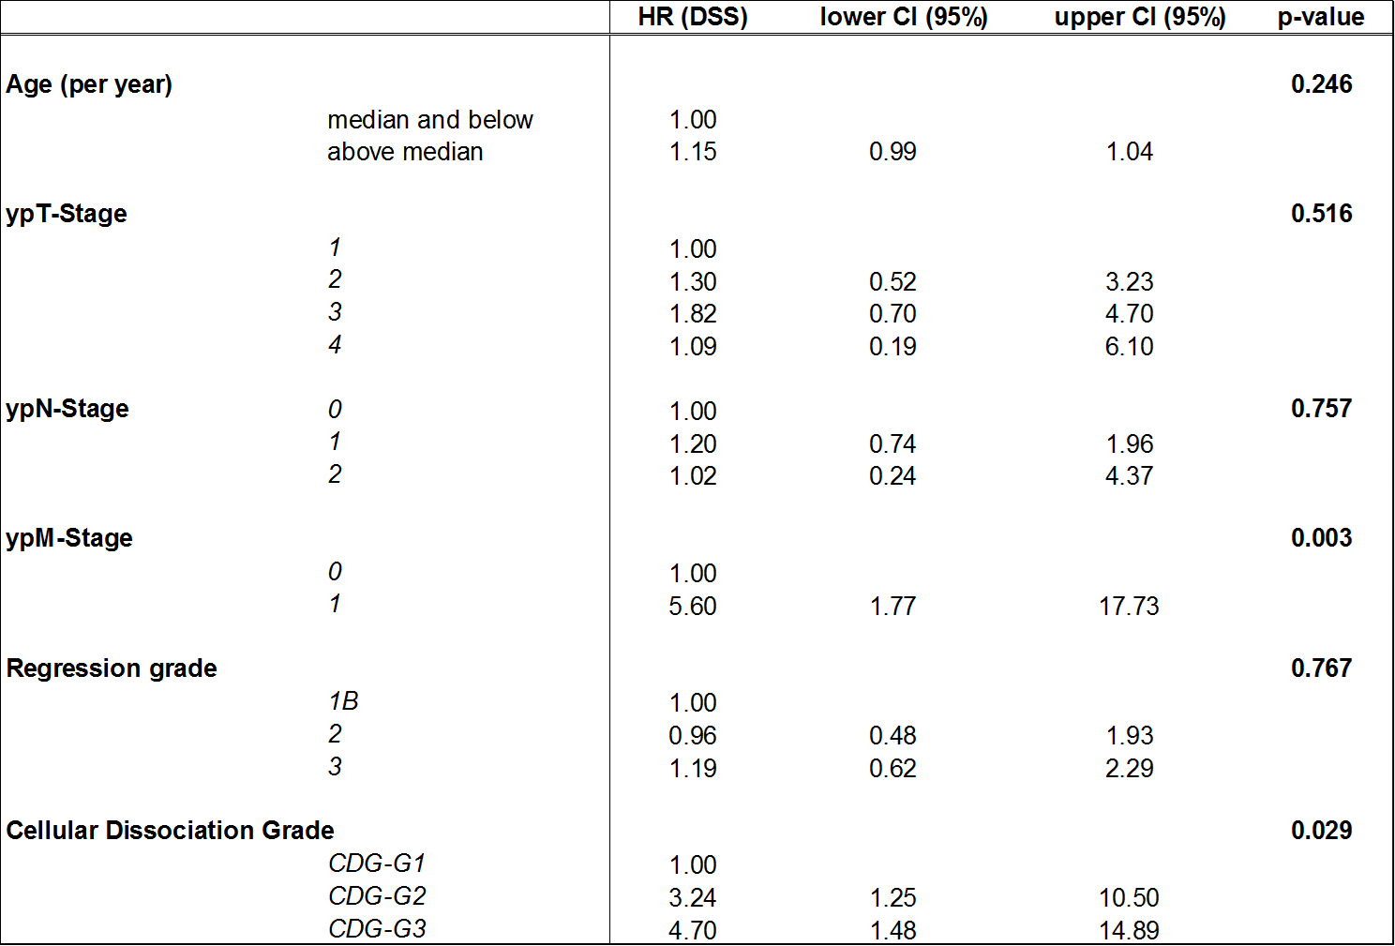

Supplementary Table 3
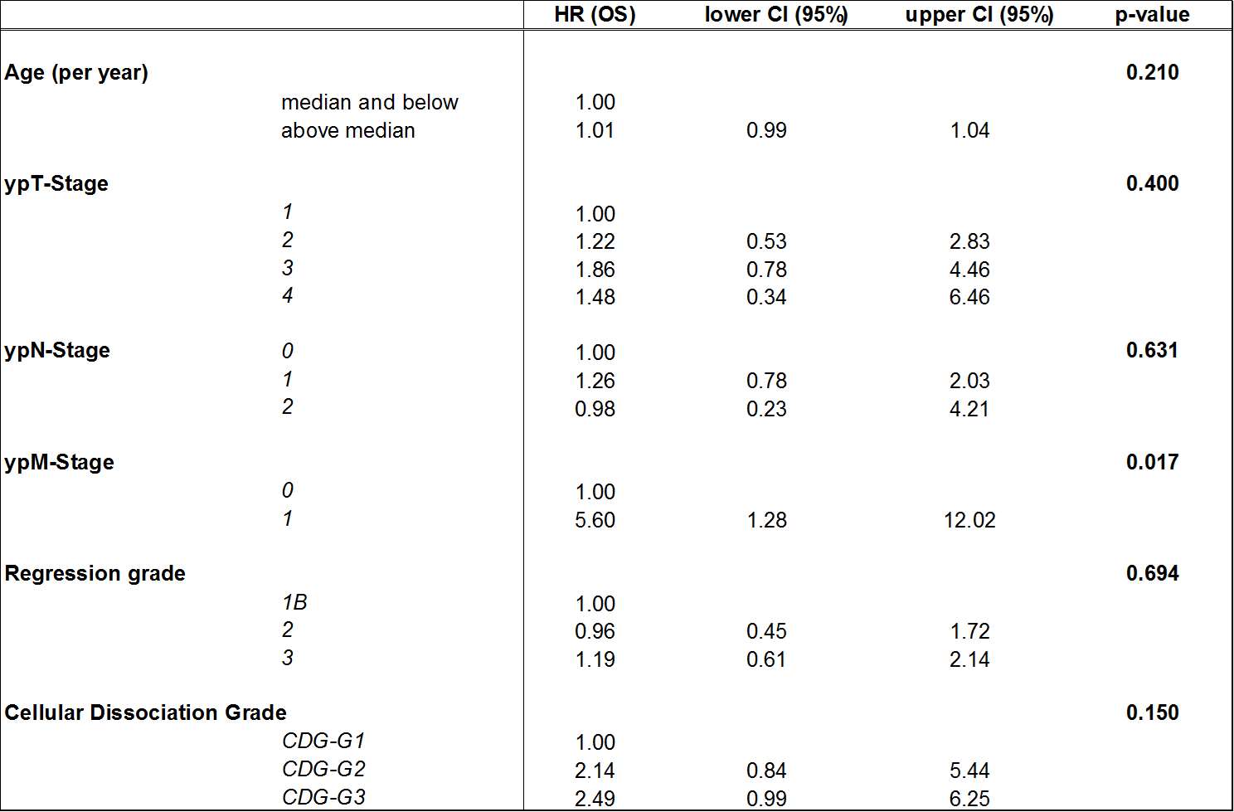

Supplementary Table 4

Supplementary Figure 1
Supplementary Figure 2

Supplementary Figure 3

