Supplementary Materials

Mutation in Bmpr1b Leads to Optic Disc Coloboma and Ventral Retinal Gliosis in Mice

Xiaohe Yan,^{1,2} Jenny Atorf,³ David Ramos,⁴ Frank Thiele,⁵ Susanne Weber,⁶ Claudia Dalke,^{6,7} Minxuan Sun,^{6,7} Oliver Puk,^{6,7} Dian Michel,⁵ Helmut Fuchs,^{5,7} Matthias Klaften,⁵ Gerhard K.H. Przemeck,⁵ Sibylle Sabrautzki,⁵ Jack Favor,^{7,8} Jesus Ruberte,⁴ Jan Kremers,³ Martin Hrabˇe de Angelis,^{5,7,9,10} and Jochen Graw^{6,7}; German Mouse Clinic-Consortium#

¹Shenzhen Key Laboratory of Ophthalmology, Shenzhen Eye Hospital, Jinan University, Shenzhen, China
²School of Optometry, Shenzhen University, Shenzhen, China
³Department of Ophthalmology, University Hospital Erlangen, Erlangen, Germany
⁴Department of Animal Health and Anatomy, Center of Animal Biotechnology and Gene Therapy, Universitat Autonoma de Barcelona, Barcelona, Spain
⁵Institute of Experimental Genetics, Helmholtz Zentrum München, Neuherberg, Germany
⁶Institute of Developmental Genetics, Helmholtz Zentrum München, Neuherberg, Germany
⁷The German Mouse Clinic, Helmholtz Zentrum Munchen, Neuherberg, Germany
⁸Institute of Human Genetics, Helmholtz Zentrum München, Neuherberg, Germany
⁹Chair of Experimental Genetics, Faculty of Life and Food Sciences Weihenstephan, Technische Universität München, Freising-Weihenstephan, Germany
¹⁰German Center for Diabetes Research (DZD), Neuherberg, Germany

Current affiliations:
JA (Jenny Atorf): Municipal Eye Hospital, Karlsruhe, Germany.
DR (David Ramos): CIISA–Centre for Interdisciplinary Research in Animal Health, Faculty of Veterinary Medicine, Universidade de Lisboa, Lisbon, Portugal.
FT (Frank Thiele): Institute of Virology, Helmholtz Zentrum München, München, and Institute of Virology, Technical University Munich, München, Germany.
CD (Claudia Dalke): Institute of Metabolism and Cell Death, Helmholtz Zentrum München, Neuherberg, Germany.
MS (Minxuan Sun): Jiangsu Key Lab of Medical Optics, Suzhou Institute of Biomedical Engineering and Technology, Chinese Academy of Sciences, Suzhou, China.
OP (Oliver Puk): Practice of Human Genetics, Tubingen, Germany.
DM (Dian Michel): Deutsches Zentrum für Luft- und Raumfahrt e. V. (DLR), DLR Project Management Agency, Bonn, Germany.
MK (Matthias Klaften): Amcure GmbH, Eggenstein-Leopoldshafen, Germany.
SS (Sibylle Sabrautzki): Research Unit Comparative Medicine, Helmholtz Zentrum Munchen, Neuherberg, Germany.
JF (Jack Favor), JG (Jochen Graw): Retired.
#A full list of consortium members appears in the appendix.
Comprehensive phenotyping screening at the German Mouse Clinic (GMC)

Comprehensive phenotyping was performed at the German Mouse Clinic (GMC). In the morphological investigation via visual inspection and X-ray analysis, we observed shortened and distorted limbs in the homozygous mutants. In the dual-energy X-ray absorptiometry (DXA), all bone parameters and almost all body parameters were changed in mutants. ALI030 mutants showed several differences in energy metabolism parameters with decreased body mass and complex effects on energy assimilation. Moreover, ALI030 mutants showed a sex-dependent change in locomotor activity and anxiety behavior in the Open Field, and a prepulse inhibition deficit, occurring mainly in male mice.
The results of all screens are summarized in Table S1; the detailed results of the eye phenotypic analysis of the mice are described in the main text.
Skeletal changes: In the morphological investigation via visual inspection and X-ray analysis, we confirmed shortened and distorted limbs in the mutants. In the dual-energy X-ray absorptiometry (DXA), all bone parameters and almost all body parameters were changed in the mutants. Heterozygous mutants did not show any obvious anomalies, whereas homozygous mutant mice were smaller (Fig. S2a) and presented with shortened, distorted limbs and syndactyly in the fore- and hind-limbs (Fig. S2b). Therefore, this mouse line was referred to as abnormal limb #030 (ALI030) according to the internal lab code.
Eye abnormalities: Significant genotype-specific differences between wild-type control and mutant ALI030 mice were detected by Ophthalmoscopy, Laser Interference Biometry and histological analysis, namely larger axial eye length and en-larged optic disc.
Metabolic changes: Interestingly, alkaline phosphatase activity was not changed in the mutants compared to the wild-type mice. Therefore, bone turnover does not seem to be affected although bone morphology and density were changed. We detected reduced blood lipid and protein values in the mutant animals, suggesting a state of negative energy balance or impaired liver function. ALI030 mutants showed several differences in energy metabolism parameters with decreased body mass and complex effects on energy assimilation.
Alterations in Behavior: ALI030 mutants show a sex-dependent increase in locomotor activity and a decreased anxiety behavior in the Open Field together with deficit in the prepulse inhibition, both occurring mainly in male mice. These changes suggest central effects of the mutation, the neurobiology of which remains to be determined.
Immunology: The analysis of ALI030 mutant mice in the primary Immunology Screen revealed no statistically significant differences in the frequencies of main leukocyte populations between mutant mice compared to controls. In male mutant mice, a lower frequency of CD62L-coexpressing cells within the T-cell cluster has been found. Furthermore, a very minor reduction in the expression of CD44 on CD4 T-cells in female mice has been found. The analysis of the blood plasma did not show statistically different levels of antibodies in ALI030 mutant mice, but extraordinary high antibody levels in females.
Pathology: The ALI030 mutant mice showed a congenital anomaly with shortened, distorted front and hind limbs (100% penetrance). There were no obvious morphological changes affecting the endocrine organs. In the screens concerning neurology, allergy, steroid metabolism, cardiovascular system or lung function, no genotype-specific differences were observed.

Table S1: Phenotyping overview of the homozygous ALI030 mutant mice
Screen | Test | Description of the phenotype | Number of animals tested  (Male mutants/M controls//Female mutants/F controls)
Dysmorphology | Anatomical observation  (Visual inspection and DXA)  BMD  BMC  Bone content  Body weight  Fat mass  Click box (hearing) | Shortened and distorted limbs and digits  decreased  decreased  decreased  decreased  decreased  No | 10/10//10/10
Cardiovascular | Blood pressure  Heart weight  ANP  ECG or Echo | No  No  No  No | 10/10//9/10
Energy Metabolism | Calorimetry | Complex effects on energy assimilation | 7/7//7/7
Clinical Chemistry | Simplified IpGTT  Clinical chemical  analysis  Hematology | No  Reduced blood lipid and protein  No | 10/10//10/10
Eye | Eye size  Ophthalmoscopy  Slit lamp | Increased  Enlarged optic disc  No | 7/7//7/7  9/11//11/9  9/11//11/9
Lung function | Plethysmography | No | 6/6//6/6
Behavior | Open field  PPI | In males: increased locomotion, decreased anxiety  PPI deficit in males | 11/8//9/10
Neurology | Modified SHIRPA  (Grip strengthRotarod) | No  (Not tested due to limb malformation) | 11/9//9/10
Immunology & Allergy | FCM analysis of PBCs  IgG/IgM/IgAconc  IgE conc | No  No | 5/6//9/10  10/10//10/10
Steroid Metabolism | DHEA  Testosterone | No  No | 11/9//9/10
Pathology | Macro- and microscopic analysis | Limb anomalies  No obvious anomalies in theendocrine systems | 3/3//3/3
Abbreviations:
ANP, atrial natriuretic peptide;
BMC, bone mineral content
BMD, bone mineral density
DXA, dual-energy X-ray absorptiometry
FCM, flow cytometry
ECG, electrocardiography;
DHEA, dehydroepiandrosterone;
PBCs, peripheral blood cells;
PPI, prepulse inhibition

Table S2
- Primary antibodies
Target protein | Species | Dilution | Catalog number | Company
BrdU | Rat | 1:500 | OBT0030CX | AbD Serotec, Germany
BRN3 | Goat | 1:100 | Sc-6026 | Santa Cruz, Germany
Calretinin | Rabbit | 1:1000 | 7699/3H | Swant, Switzerland
Collagen IV | Rabbit | 1:200 | AB756P | Millipore, Germany
Glutamine Synthetase | Mouse | 1:200 | BD 610517 | BD Biosciences, Germany
Neurofilament 2H3 | Mouse | 1:100 | None | Developmental Studies Hybridoma Bank, U.S
Neurofilament 200 | Rabbit | 1:500 | N4142 | Santa Cruz, Germany
OTX2 | Rabbit | 1:200 | a gift from Dr. Antonio Simeone, Institute of Genetics and Biophysics, CNR, Napoli, Italy
PAX2 | Rabbit | 1:200 | 2549-1 | Epitomics, Germany
PAX6 | Rabbit | 1:400 | PRB-278P | Chemicon, Germany
PDE6b | Rabbit | 1:500 | PA1-722 | Thermo Scientific, Germany
PKC-α | Mouse | 1:500 | Ab1723 | Abcam, Germany
PROX1 | Rabbit | 1:1000 | AB 5475 | Millipore, Germany
SOX2 | Goat | 1:500 | sc-17320 | Santa Cruz, Germany

- Secondary antibodies
Name | Species | Dilution | Catalog No. | Company
Alexa Fluor ® 488 | Anti-Rabbit | 1:250 | A21206 | Invitrogen, Germany
Alexa Fluor ® 488 | Anti-Rat | 1:250 | A21208 | Invitrogen, Germany
Cy3 | Anti-Goat | 1:250 | 705-165-147 | Dianova, Germany
Cy3 | Anti-Rat | 1:250 | 712-165-153 | Dianova, Germany
Cy5 | Anti-Mouse | 1:250 | 715-175-150 | Jackson immuno, Germany

Figure S1

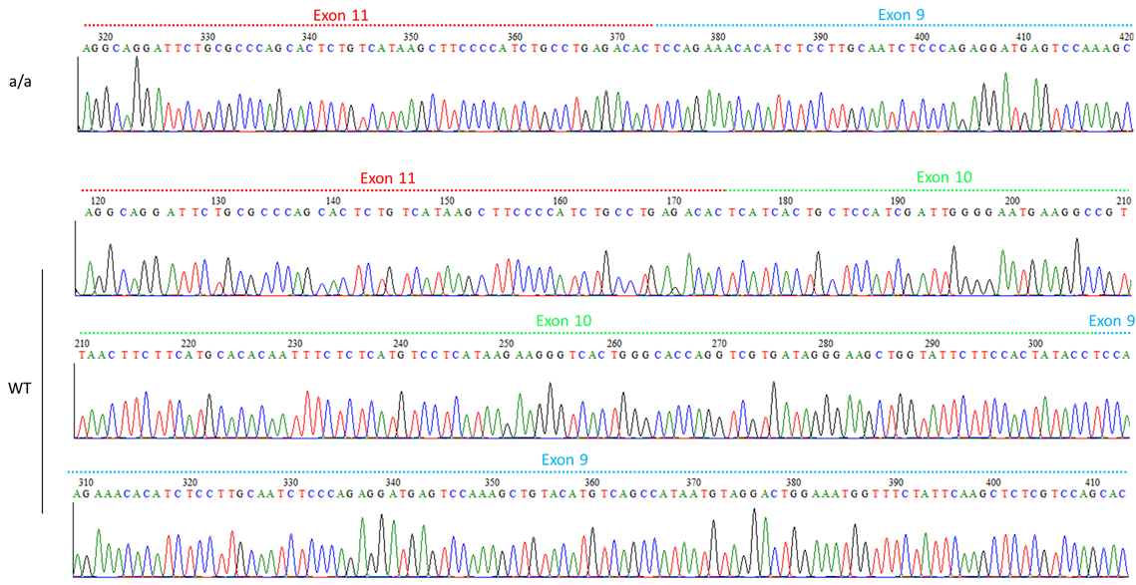

Figure S2.
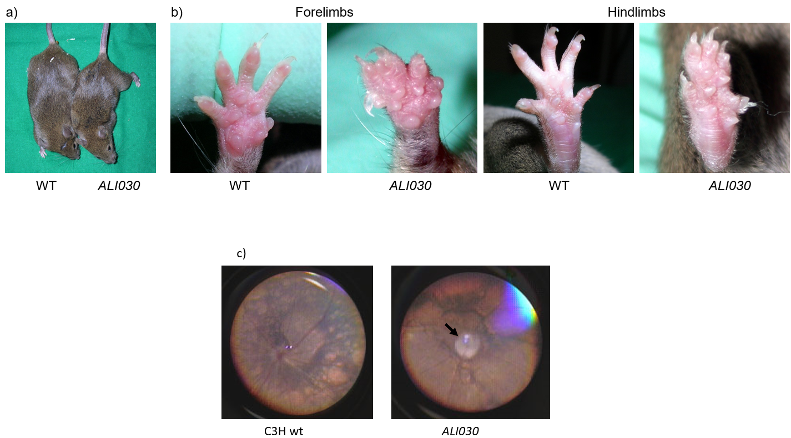

Figure S3.

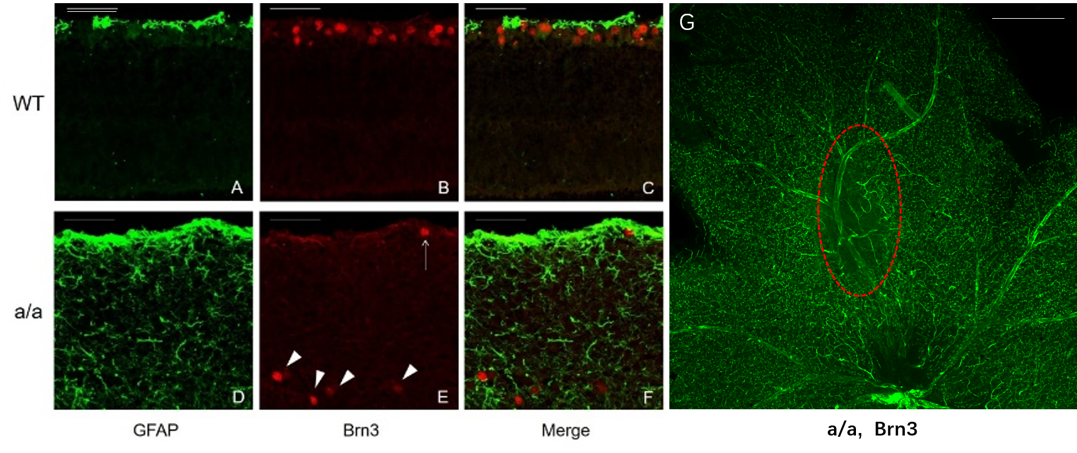

Supplemental Figure Legends

Fig. S1: Sequence analysis of the ALI030 mutant mouse.
Sequence analysis of Bmpr1b cDNA demonstrates mis-splicing of exon 10 in ALI030 mutants. Exon 10 is skipped in homozygous mutants compared to wild types.

Fig. S2: Phenotype of the ALI030 mutant mouse.
a) At the age of 12 weeks, homozygous mutant mice (ALI030) are smaller than wild-type mice (WT).
b) Syndactylism of the forelimbs and hindlimbs.
c) Retinal fundus photo of a wild-type C3HeB/FeJ (C3H) mouse and an ALI030 mutant showing an enlarged optic disc (arrow).

Fig. S3: Retinal ganglion cells of the ALI030 mutant mouse.
At the age of 8 weeks, retinal ganglion cells are almost absent in the ventral gliosis retina of the homozygous mutant mice (a/a) (A-C) compared to the wild-type mice (WT) (D-F). Flat-mount retina immunofluorescence against Brn3a also showed absent retinal ganglion cells in the ventral gliosis area (G, red circle) of the mutants. Scale bar: 100 µm.

APPENDIX X:
⁺German Mouse Clinic, Helmholtz Zentrum München, German Research Center for Environmental Health GmbH, Neuherberg, Germany
Antonio Aguilar-Pimentel¹
Markus Ollert³
Holger Schulz^{1,4}
Lore Becker^{1,5}
Thomas Klopstock ^{5,14,15,18,19}
Thure Adler¹
Dirk H. Busch ²
Anja Schrewe¹
Hugo A. Katus⁶
Lillian Garrett^{1,8}
Sabine M. Hölter ^{1,8}
Wolfgang Wurst ^{8,13,14,15}
Wolfgang Hans¹
Jan Rozman ^{1,17}
Martin Klingenspor^{9,10}
Julia Calzada-Wack^{1,7}
Birgit Rathkolb ^{1,11,17}
Eckhard Wolf ¹¹
Cornelia Prehn¹²
Jerzy Adamkski^{12,13,17}
Manuela Östereicher¹
Gregor Miller¹
Christoph Lengger¹
Holger Maier¹
Claudia Stoeger¹
Stefanie Leuchtenberger¹
Valérie Gailus-Durner ¹
Helmut Fuchs ¹
Martin Hrabě de Angelis ^{1,16,17}
1 German Mouse Clinic, Institute of Experimental Genetics, Helmholtz Zentrum München, German Research Center for Environmental Health GmbH, Ingolstädter Landstrasse 1, 85764 Neuherberg, Germany
2 Institute for Medical Microbiology, Immunology and Hygiene, Technical University of Munich, Trogerstrasse 30, 81675 Munich, Germany
3 Department of Infection and Immunity, Luxembourg Institute of Health, Esch-sur- Alzette, Luxembourg, and Department of Dermatology and Allergy Center, Odense Research Center for Anaphylaxis, University of Southern Denmark, Odense, Denmark
4 Institute of Epidemiology, Helmholtz Zentrum München, German Research Center for Environmental Health GmbH, Ingolstädter Landstraße 1, 85764 Neuherberg, Germany and Member of the German Center for Lung Research
5 Department of Neurology, Friedrich-Baur-Institut, Ludwig-Maximilians-Universität München, Ziemssenstrasse 1a, 80336 Munich, Germany
6 Department of Cardiology, University of Heidelberg, Im Neuenheimer Feld 410, 69120 Heidelberg, Germany
7 Institute of Pathology, Helmholtz Zentrum München, German Research Center for Environmental Health GmbH, Ingolstädter Landstrasse 1, 85764 Neuherberg, Germany
8 Institute of Developmental Genetics, Helmholtz Zentrum München, German Research Center for Environmental Health GmbH, Ingolstädter Landstrasse 1, 85764 Neuherberg, Germany
9 Chair of Molecular Nutritional Medicine, Technical University Munich, EKFZ – Else Kröner Fresenius Center for Nutritional Medicine, Gregor-Mendel-Str. 2, 85350 Freising-Weihenstephan, Germany
10 ZIEL – Institute for Food and Health, Technical University Munich, Gregor- Mendel-Str. 2, 85350 Freising-Weihenstephan, Germany
11 Ludwig-Maximilians-Universität München, Gene Center, Institute of Molecular Animal Breeding and Biotechnology, Feodor-Lynen Strasse 25, 81377 Munich, Germany
12 Molekulare Endokrinologie und Metabolismus, Helmholtz Zentrum München, German Research Center for Environmental Health GmbH, Ingolstädter Landstrasse 1, 85764 Neuherberg, Germany
13 Chair of Developmental Genetics, Center of Life and Food Sciences Weihenstephan, Technische Universität München, Ingolstädter Landstrasse 1, 85764 Neuherberg, Germany
14 Deutsches Institut für Neurodegenerative Erkrankungen (DZNE) Site Munich, Schillerstrasse 44, 80336 Munich, Germany
15 Munich Cluster for Systems Neurology (SyNergy), Adolf-Butenandt-Institut, Ludwig-Maximilians-Universität München, Schillerstrasse 44, 80336 Munich, Germany
16 Chair of Experimental Genetics, Center of Life and Food Sciences Weihenstephan, Technische Universität München, 85354 Freising-Weihenstephan, Germany
17 Member of German Center for Diabetes Research (DZD), Ingolstädter Landstraße 1, 85764 Neuherberg, Germany
18 German Network for Mitochondrial Disorders (mitoNET)
19 German Center for Vertigo and Balance Disorders, Munich, Germany

