Supplementary Material
In silico and in vitro studies of a number PILs as new antibacterials against MDR clinical isolate Acinetobacter baumannii

Maria M. Trush^{a,*}, Vasyl Kovalishynª, Diana Hodynaª, Olexandr V. Golovchenkoª, Svitlana Chumachenkoª, Igor V. Tetko^{b,c}, Volodymyr S. Brovaretsª, Larysa Metelytsiaª

ªV.P. Kukhar Institute of Bioorganistry and Petrochemistry, National Academy of Science of Ukraine, 1 Murmanska Street, 02660, Kyiv, Ukraine
^{b}Helmholtz Zentrum München - German Research Center for Environmental Health (GmbH), Ingolstädter Landstraße 1, DE-85764, Neuherberg
^{c}BIGCHEM GmbH, Valerystr. 49, DE-85716 Unterschleißheim, Germany
*Corresponding author:

Maria M. Trush
ªV.P. Kukhar Institute of Bioorganic Chemistry and Petrochemistry, National Academy of Science of Ukraine, 1 Murmanska Street, 02660, Kyiv, Ukraine
Email: maria.m.trush@gmail.com

- Experimental Section

  - Chemistry

1.1.1. General
The reactions were followed by TLC (Silica gel, aluminum sheets 60 F₂₅₄, Merck). Melting points were recorded on a Fisher-Johns apparatus. ¹H, ¹³C and ³¹P NMR spectra were recorded on a Varian Mercury spectrometer (400, 125 and 200 MHz, respectively) in DMSO-d₆, with TMS as internal standard. Multiplicities were described using the following abbreviations: s = singlet, d = doublet, t = triplet and m = multiplet, q = quartet. Mass spectra were recorded on an Agilent 1100 Series LC-MS system, equipped with diode array and mass selective detector Agilent LC/MSD SL (atmospheric pressure chemical ionization). Elemental analysis was performed in the Analytical Laboratory of the V. P. Kukhar Institute of Bioorganic Chemistry and Petrochemistry of the National Academy of Sciences of Ukraine. Reagents and solvents from commercial sources were used.

1.1.2. Synthesis
1.1.2.1. (2-R-5-Alkylthio-1,3-oxazole-4-yl)triphenylphosphonium iodides 1-17
(General procedure)
To a solution of 1-acylamino-2,2-dichloroethenyltriphenylphosphonium chlorides (0.01 mol) (were synthesythed as described previously (Brovarets et al., 2017)) in 10 ml of methanol, a solution of NaSH (0.035 mol) in 50 ml of methanol was added. The mixture was kept at 20-25°C for 24 h. A precipitate formed was filtered, washed with water, dried and dissolved in 20 ml of methanol. To this solution appropriate alkyl iodide (0.01 mol) was added, the mixture was kept at 20-25°C for 24 h, methanol was removed in vacuum and precipitate was recrystallized from ethanol.

1.1.2.2. [2-(4-Chlorophenyl)-5-propylsulfanyl-1,3-oxazol-4-yl]triphenylphosphonium iodide (1).
Light yellow solid, mp 183-185 °С; ¹Н NMR (400 MHz, DMSO-d₆): δ 0.85 (3Н, t, J = 7.4 Hz, CH₃), 1.59-1.64 (2Н, m, CH₂), 3.11 (2Н, t, J = 7.0 Hz, CH₂), 7.68 (2H, d, J = 8.8 Hz, ArH), 7.78-7.94 (12H, m, ArH), 7.96-8.08 (3H, m, ArH), 8.06 (2H, d, J = 8.8 Hz, ArH). ¹³C NMR (125 MHz, DMSO-d₆): δ 13.3 (CH₃), 23.3 (CH₂), 36.2 (CH₂), 117.4 (d, J = 93.2 Hz), 119.2 (d, J = 138.1 Hz), 124.5, 128.9, 130.1, 131.0 (d, J = 13.5 Hz), 135.1 (d, J = 11.0 Hz), 136.2 (d, J = 3.0 Hz), 137.3, 161.3 (d, J = 28.9 Hz), 163.4 (d, J = 19.9 Hz). ³¹P NMR (200 MHz, DMSO-d₆): δ 10.20. LC-MS: m/z 514 [M-I]⁺ Anal. Calcd for С₃₀Н₂₆ClINOPS: С, 56.13; Н, 4.08; Cl, 5.52; N, 2.18; P, 4.83; S, 4.99. Found: С, 56.27; Н, 4.12; Cl, 5.43; N, 2.24; P, 4.75; S, 5.08.

1.1.2.3. [5-Ethylsulfanyl-2-(furan-2-yl)-1,3-oxazol-4-yl]triphenylphosphonium iodide (2).
Yellow solid, mp 189-191 °С; ¹Н NMR (400 MHz, DMSO-d₆): δ 1.18 (3Н, t, J = 7.4 Hz, CH₃), 3.33 (2Н, q, J = 7.4 Hz, CH₂), 6.82 (1H, dd, J = 1.9, 3.2 Hz, ArH), 7.43 (1H, d, J = 3.2 Hz, ArH), 7.78-7.94 (12H, m, ArH), 7.98-8.20 (3H, m, ArH), 8.06 (1H, d, J = 1.9 Hz, ArH). ¹³C NMR (125 MHz, DMSO-d₆): δ 15.7 (CH₃), 29.2 (CH₂), 113.3, 115.4, 117.3 (d, J = 93.2 Hz), 119.7 (d, J = 138.1 Hz), 131.0 (d, J = 13.5 Hz), 135.1 (d, J = 11.0 Hz), 136.2 (d, J = 3.0 Hz), 140.9, 147.6, 156.9 (d, J = 20.9 Hz), 160.1 (d, J = 28.9 Hz). ³¹P NMR (200 MHz, DMSO-d₆): δ 10.82. LC-MS: m/z 456 [M-I]⁺ Anal. Calcd for С₂₇Н₂₃INO₂PS: С, 55.59; Н, 3.97; N, 2.40; P, 5.31; S, 5.50. Found: С, 55.67; Н, 3.82; N, 2.36; P, 5.45; S, 5.57.

1.1.2.4. [2-(4-Chlorophenyl)-5-methylsulfanyl-1,3-oxazol-4-yl]triphenylphosphonium iodide (3).
Light yellow solid, mp 200-202 °С; ¹Н NMR (400 MHz, DMSO-d₆): δ 2.66 (3Н, s, CH₃), 7.61 (2H, d, J = 8.4 Hz, ArH), 7.74-7.95 (14H, m, ArH), 7.97-8.17 (3H, m, ArH). ¹³C NMR (125 MHz, DMSO-d₆): δ 21.8 (CH₃), 117.8 (d, J = 91.3 Hz), 128.5 (d, J = 127.7 Hz), 129.1, 130.2, 130.6, 131.0 (d, J = 13.0 Hz), 135.1 (d, J = 11.0 Hz), 136.0 (d, J = 3.0 Hz), 136.6, 156.4 (d, J = 24.4 Hz), 167.2 (d, J = 24.9 Hz). ³¹P NMR (200 MHz, DMSO-d₆): δ 13.21. LC-MS: m/z 487 [M-I]⁺ Anal. Calcd for С₂₈Н₂₂ClINOPS: С, 54.78; Н, 3.61; Cl, 5.78; N, 2.28; P, 5.05; S, 5.22. Found: С, 54.89; Н, 3.62; Cl, 5.88; N, 2.25; P, 5.14; S, 5.01.

1.1.2.5. (5-Butylsulfanyl-2-phenyl-1,3-oxazol-4-yl)triphenylphosphonium iodide (4).
Yellow solid, mp 181-183 °С; ¹Н NMR (400 MHz, DMSO-d₆): δ 0.84 (3Н, t, J = 7.4 Hz, CH₃), 1.19-1.34 (2H, m, CH₂), 1.48-1.58 (2H, m, CH₂), 3.12 (2Н, t, J = 7.0 Hz, CH₂), 7.58-7.69 (3H, m, ArH), 7.77-7.94 (12H, m, ArH), 7.95-8.02 (3H, m, ArH), 8.05 (2H, d, J = 7.9 Hz, ArH). ¹³C NMR (125 MHz, DMSO-d₆): δ 13.8 (CH₃), 21.4 (CH₂), 31.8 (CH₂), 34.0 (CH₂), 117.4 (d, J = 92.9 Hz), 125.6, 127.0, 128.5 (d, J = 122.5 Hz), 129.9, 130.9 (d, J = 13.1 Hz), 132.5, 135.0 (d, J = 11.0 Hz), 136.1 (d, J = 3.0 Hz), 160.9 (d, J = 29.1 Hz), 164.4 (d, J = 20.1 Hz). ³¹P NMR (200 MHz, DMSO-d₆): δ 10.14. LC-MS: m/z 494 [M-I]⁺ Anal. Calcd for С₃₁Н₂₉INOPS: С, 59.91; Н, 4.70; N, 2.25; P, 4.98; S, 5.16. Found: С, 60.03; Н, 4.90; N, 2.14; P, 4.99; S, 5.28.

1.1.2.6. (2-Methyl-5-propylsulfanyl-1,3-oxazol-4-yl)triphenylphosphonium iodide (5).
Light yellow solid, mp 182-184 °С; ¹Н NMR (400 MHz, DMSO-d₆): δ 0.69 (3Н, t, J = 7.4 Hz, CH₃), 1.39-1.45 (2H, m, CH₂), 2.86 (3H, s, CH₃), 2.85 (2Н, t, J = 7.0 Hz, CH₂), 7.77-7.93 (12H, m, ArH), 7.94-8.03 (3H, m, ArH). ¹³C NMR (125 MHz, DMSO-d₆): δ 13.2 (CH₃), 14.6 (CH₂), 23.1 (CH₃), 36.2 (CH₂), 117.5 (d, J = 93.4 Hz), 118.2 (d, J = 138.5 Hz), 130.9 (d, J = 13.6 Hz), 134.9 (d, J = 11.0 Hz), 136.1 (d, J = 3.0 Hz), 160.0 (d, J = 26.6 Hz), 165.9 (d, J = 20.1 Hz). ³¹P NMR (200 MHz, DMSO-d₆): δ 10.07. LC-MS: m/z 418 [M-I]⁺ Anal. Calcd for С₂₅Н₂₅INOPS: С, 55.05; Н, 4.62; N, 2.57; P, 5.68; S, 5.88. Found: С, 55.17; Н, 4.76; N, 2.40; P, 5.74; S, 5.76.

1.1.2.7. [2-(2-Chlorophenyl)-5-ethylsulfanyl-1,3-oxazol-4-yl]triphenylphosphonium iodide (6).
Light yellow solid, mp 192-194 °С; ¹Н NMR (400 MHz, DMSO-d₆): δ 1.24 (3Н, t, J = 7.0 Hz, CH₃), 3.14 (2Н, q, J = 7.0 Hz, CH₂), 7.56-7.68 (2Н, m, ArH), 7.72 (1H, d, J = 7.9 Hz, ArH), 7.746-7.94 (12H, m, ArH), 7.96-8.04 (3H, m, ArH), 8.14 (1H, d, J = 8.4 Hz, ArH). ¹³C NMR (125 MHz, DMSO-d₆): δ 15.8 (CH₃), 29.0 (CH₂), 117.4 (d, J = 93.2 Hz), 118.5 (d, J = 139.1 Hz), 124.1, 128.5, 131.0 (d, J = 13.5 Hz), 131.8, 131.9, 132.1, 133.7, 135.1 (d, J = 11.5 Hz), 136.2 (d, J = 3.0 Hz), 161.5 (d, J = 28.4 Hz), 161.9 (d, J = 20.4 Hz). ³¹P NMR (200 MHz, DMSO-d₆): δ 9.89. LC-MS: m/z 500 [M-I]⁺ Anal. Calcd for С₂₉Н₂₄ClINOPS: С, 55.47; Н, 3.85; Cl, 5.65; N, 2.23; P, 4.93; S, 5.11. Found: С, 55.33; Н, 3.97; Cl, 5.82; N, 2.26; P, 4.98; S, 5.25.

1.1.2.8. (5-Methylsulfanyl-2-phenyl-1,3-oxazol-4-yl)triphenylphosphonium iodide (7).
Light yellow solid, mp 209-211 °С; ¹Н NMR (400 MHz, DMSO-d₆): δ 2.64 (3Н, s, CH₃), 7.54-7.63 (3H, m, ArH), 7.68-7.95 (12H, m, ArH), 7.96-8.04 (3H, m, ArH), 8.07 (2H, d, J = 7.0 Hz, ArH). ¹³C NMR (125 MHz, DMSO-d₆): δ 16.3 (CH₃), 117.1 (d, J = 139.1 Hz), 117.5 (d, J = 93.2 Hz), 125.6, 127.1, 129.9, 131.0 (d, J = 13.5 Hz), 132.6, 135.0 (d, J = 11.5 Hz), 136.2 (d, J = 3.0 Hz), 162.1 (d, J = 29.4 Hz), 164.0 (d, J = 20.4 Hz). ³¹P NMR (200 MHz, DMSO-d₆): δ 9.90. LC-MS: m/z 452 [M-I]⁺ Anal. Calcd for С₂₈Н₂₃INOPS: С, 58.04; Н, 4.00; N, 2.42; P, 5.35; S, 5.53. Found: С, 58.12; Н, 4.11; N, 2.09; P, 5.47; S, 5.67.

1.1.2.9. (5-Ethylsulfanyl-2-methyl-1,3-oxazol-4-yl)triphenylphosphonium iodide (8).
Yellow solid, mp 172-174 °С; ¹Н NMR (400 MHz, DMSO-d₆): δ 1.13 (3Н, t, J = 7.4 Hz, CH₃), 2.59 (3Н, s, CH₃), 2.94 (2Н, q, J = 7.4 Hz, CH₂), 7.74-7.94 (12H, m, ArH), 7.96-8.03 (3H, m, ArH). ¹³C NMR (125 MHz, DMSO-d₆): δ 14.6 (CH₃), 15.7 (CH₃), 28.9 (CH₂), 117.6 (d, J = 93.2 Hz), 118.2 (d, J = 139.0 Hz), 131.0 (d, J = 13.5 Hz), 135.0 (d, J = 11.5 Hz), 136.1 (d, J = 3.0 Hz), 159.9 (d, J = 29.4 Hz), 166.1 (d, J = 20.4 Hz). ³¹P NMR (200 MHz, DMSO-d₆): δ 10.10. LC-MS: m/z 404 [M-I]⁺ Anal. Calcd for С₂₄Н₂₃INOPS: С, 54.25; Н, 4.36; N, 2.64; P, 5.83; S, 6.03. Found: С, 54.38; Н, 4.25; N, 2.53; P, 5.74; S, 6.00.

1.1.2.10. (5-Ethylsulfanyl-2-fluoromethyl-1,3-oxazol-4-yl)triphenylphosphonium iodide (9).
Yellow solid, mp 149-151 °С; ¹Н NMR (400 MHz, DMSO-d₆): δ 1.18 (3Н, t, J = 7.0 Hz, CH₃), 3.02 (2Н, q, J = 7.0 Hz, CH₂), 5.64 (2Н, d, J = 46.4 Hz, CH₂), 7.75-7.95 (12H, m, ArH), 7.97-8.02 (3H, m, ArH). ¹³C NMR (125 MHz, DMSO-d₆): δ 15.7 (CH₃), 28.8 (CH₂), 75.7 (d, J = 166.6 Hz, CH₂F), 117.2 (d, J = 93.2 Hz), 118.4 (d, J = 146.1 Hz), 131.0 (d, J = 13.5 Hz), 135.0 (d, J = 11.0 Hz), 136.2 (d, J = 2.5 Hz), 160.9 (d, J = 27.4 Hz), 162.3 (d, J = 27.4 Hz). ³¹P NMR (200 MHz, DMSO-d₆): δ 10.45. LC-MS: m/z 500 [M-I]⁺ Anal. Calcd for С₂₄Н₂₂FINOPS: С, 52.47; Н, 4.04; F, 3.46; N, 2.55; P, 5.64; S, 5.84. Found: С, 52.61; Н, 4.09; F, 3.42; N, 2.67; P, 5.49; S, 5.95.

1.1.2.11. [5-Allylsulfanyl-2-(furan-2-yl)-1,3-oxazol-4-yl]triphenylphosphonium iodide (10).
Yellow solid, mp 166-168 °С; ): δ 3.72 (2H, d, J = 7.0 Hz, CH₂), 5.12 (1H, d, J = 9.7 Hz, CH=CH₂), 5.19 (1H, d, J = 17.2 Hz, CH=CH₂), 5.64-5.81 (1H, m, CH), 6.80-6.85 (1H, m, ArH), 7.46 (1H, d, J = 2.8 Hz, ArH), 7.77-7.92 (12H, m, ArH), 7.94-8.03 (3H, m, ArH), 8.03-8.07 (1H, m, ArH). ¹³C NMR (125 MHz, DMSO-d₆): δ 37.3 (CH₂), 113.4, 115.7, 117.1 (d, J = 93.2 Hz), 120.1, 121.0 (d, J = 138.6 Hz), 131.0 (d, J = 13.5 Hz), 133.3, 135.1 (d, J = 12.5 Hz), 136.3 (d, J = 2.0 Hz), 140.7, 147.7, 157.1 (d, J = 20.4 Hz), 159.3 (d, J = 28.9 Hz). ³¹P NMR (200 MHz, DMSO-d₆): δ 10.53. LC-MS: m/z 468 [M-I]⁺ Anal. Calcd for С₂₈Н₂₃INO₂PS: С, 56.48; Н, 3.89; N, 2.35; P, 5.20; S, 5.38. Found: С, 56.47; Н, 3.94; N, 2.24; P, 5.08; S, 5.28.

1.1.2.12. (5-Allylsulfanyl-2-methyl-1,3-oxazol-4-yl)triphenylphosphonium iodide (11).
Light yellow solid, mp 167-169 °С; ¹Н NMR (400 MHz, DMSO-d₆): δ 2.59 (3Н, s, CH₃), 3.62 (2H, d, J = 7.4 Hz, CH₂), 5.06 (1H, d, J = 9.5 Hz, CH=CH₂), 5.20 (1H, d, J = 17.4 Hz, CH=CH₂), 5.61-5.75 (1H, m, CH), 7.75-7.93 (12H, m, ArH), 7.94-8.19 (3H, m, ArH). ¹³C NMR (125 MHz, DMSO-d₆): δ 14.5 (CH₃), 37.1 (CH₂), 117.4 (d, J = 94.2 Hz), 119.9 (d, J = 138.1 Hz), 120.0, 131.0 (d, J = 13.5 Hz), 133.2, 135.0 (d, J = 11.5 Hz), 136.1 (d, J = 3.0 Hz), 159.1 (d, J = 28.4 Hz), 166.4 (d, J = 19.9 Hz). ³¹P NMR (200 MHz, DMSO-d₆): δ 10.51. LC-MS: m/z 416 [M-I]⁺ Anal. Calcd for С₂₅Н₂₃INOPS: С, 55.26; Н, 4.27; N, 2.58; P, 5.70; S, 5.90. Found: С, 55.25; Н, 4.38; N, 2.73; P, 5.85; S, 5.92.

1.1.2.13. [5-Allylsulfanyl-2-(2,4-dichlorophenyl)-1,3-oxazol-4-yl]triphenylphosphonium iodide (12).
Yellow solid, mp 138-140 °С; ¹Н NMR (400 MHz, DMSO-d₆): 3.79 (2H, d, J = 7.0 Hz, CH₂), 5.13 (1H, d, J = 10.2 Hz, CH=CH₂), 5.21 (1H, d, J = 17.2 Hz, CH=CH₂), 5.69-5.88 (1H, m, CH), 7.70 (1H, dd, J = 1.9, 8.4 Hz, ArH), 7.78-7.94 (12H, m, ArH), 7.95 (1H, d, J = 1.9, Hz, ArH), 7.97-8.05 (3H, m, ArH), 8.17 (1H, d, J = 8.4 Hz, ArH). ¹³C NMR (125 MHz, DMSO-d₆): δ 37.0 (CH₂), 117.2 (d, J = 92.9 Hz), 120.0 (d, J = 138.6 Hz), 120.1, 122.9, 128.8, 131.0 (d, J = 13.6 Hz), 131.6, 132.8, 133.0, 133.2, 135.0 (d, J = 11.0 Hz), 136.2 (d, J = 3.0 Hz), 137.6, 160.7 (d, J = 28.6 Hz), 161.3 (d, J = 20.6 Hz). ³¹P NMR (200 MHz, DMSO-d₆): δ 10.06. LC-MS: m/z 546 [M-I]⁺ Anal. Calcd for С₃₀Н₂₃Cl₂INOPS: С, 53.43; Н, 3.44; Cl, 10.51; N, 2.08; P, 4.59; S, 4.75. Found: С, 53.37; Н, 3.52; Cl, 10.67; N, 2.00; P, 4.64; S, 4.78.

1.1.2.14. (5-Ethylsulfanyl-2-phenyl-1,3-oxazol-4-yl)triphenylphosphonium iodide (13).
Yellow solid, mp 202-204 °С; ¹Н NMR (400 MHz, DMSO-d₆): δ 1.23 (3Н, t, J = 7.0 Hz, CH₃), 3.12 (2Н, q, J = 7.0 Hz, CH₂), 7.58-7.67 (3H, m, ArH), 7.78-7.94 (12H, m, ArH), 7.95-8.03 (3H, m, ArH), 8.06 (2H, d, J = 7.0 Hz, ArH). ¹³C NMR (125 MHz, DMSO-d₆): δ 15.7 (CH₃), 28.9 (CH₂), 117.4 (d, J = 92.9 Hz), 119.3 (d, J = 135.0 Hz), 125.6, 127.1, 129.9, 130.9 (d, J = 13.6 Hz), 132.6, 135.0 (d, J = 11.0 Hz), 136.1 (d, J = 3.0 Hz), 160.8 (d, J = 28.6 Hz), 164.3 (d, J = 20.1 Hz). ³¹P NMR (200 MHz, DMSO-d₆): δ 10.16. LC-MS: m/z 466 [M-I]⁺ Anal. Calcd for С₂₉Н₂₅INOPS: С, 58.69; Н, 4.25; N, 2.36; P, 5.22; S, 5.40. Found: С, 58.78; Н, 4.33; N, 2.54; P, 5.21; S, 5.34.

1.1.2.15. (2-tert-Butyl-5-methylsulfanyl-1,3-oxazol-4-yl)triphenylphosphonium iodide (14).
Orange solid, mp 195-197 °С; ¹Н NMR (400 MHz, DMSO-d₆): δ 1.39 (9Н, s, 3CH₃), 3.32 (3Н, s, CH₃), 7.75-7.95 (12H, m, ArH), 7.97-8.15 (3H, m, ArH). ¹³C NMR (125 MHz, DMSO-d₆): δ 16.1 (C(CH₃)₃), 28.4 (CH₃), 34.6 (CH₃), 115.3 (d, J = 139.6 Hz), 117.7 (d, J = 93.2 Hz), 131.0 (d, J = 13.5 Hz), 134.9 (d, J = 11.0 Hz), 136.1 (d, J = 3.0 Hz), 161.3 (d, J = 29.4 Hz), 174.2 (d, J = 18.9 Hz). ³¹P NMR (200 MHz, DMSO-d₆): δ 9.80. LC-MS: m/z 432 [M-I]⁺ Anal. Calcd for С₂₆Н₂₇INOPS: С, 55.82; Н, 4.86; N, 2.50; P, 5.54; S, 5.73. Found: С, 55.87; Н, 4.88; N, 2.41; P, 5.38; S, 5.90.

1.1.2.16. [5-Ethylsulfanyl-2-(4-methylphenyl)-1,3-oxazol-4-yl]triphenylphosphonium iodide (15).
Light yellow solid, mp 230-232 °С; ¹Н NMR (400 MHz, DMSO-d₆): δ 1.22 (3Н, t, J = 7.4 Hz, CH₃), 2.40 (3H, s, CH₃), 3.11 (2Н, q, J = 7.4 Hz, CH₂), 7.42 (2Н, d, J = 8.4 Hz, ArH), 7.76-8.04 (17H, m, ArH). ¹³C NMR (125 MHz, DMSO-d₆): δ 15.7 (CH₃), 21.7 (CH₃), 29.0 (CH₂), 117.4 (d, J = 93.2 Hz), 119.4 (d, J = 138.1 Hz), 123.0, 127.1, 130.5, 131.0 (d, J = 13.5 Hz), 135.1 (d, J = 11.5 Hz), 136.2 (d, J = 3.0 Hz), 142.7, 160.4 (d, J = 28.9 Hz), 164.6 (d, J = 19.9 Hz). ³¹P NMR (200 MHz, DMSO-d₆): δ 10.17. LC-MS: m/z 480 [M-I]⁺ Anal. Calcd for С₃₀Н₂₇INOPS: С, 59.31; Н, 4.48; N, 2.31; P, 5.10; S, 5.28. Found: С, 59.45; Н, 4.50; N, 2.25; P, 5.18; S, 5.21.

1.1.2.17. [2-(4-Chlorophenyl)-5-ethylsulfanyl-1,3-oxazol-4-yl]triphenylphosphonium iodide (16).
Yellow solid, mp 204-206 °С; ¹Н NMR (400 MHz, DMSO-d₆): δ 1.23 (3Н, t, J = 7.0 Hz, CH₃), 3.13 (2Н, q, J = 7.0 Hz, CH₂), 7.68 (2Н, d, J = 8.8 Hz, ArH), 7.78-7.95 (12H, m, ArH), 7.96-8.04 (3H, m, ArH), 8.07 (2Н, d, J = 8.8 Hz, ArH). ¹³C NMR (125 MHz, DMSO-d₆): δ 15.7 (CH₃), 29.0 (CH₂), 117.4 (d, J = 93.2 Hz), 119.5 (d, J = 138.1 Hz), 124.6, 128.9, 130.1, 131.0 (d, J = 13.5 Hz), 135.1 (d, J = 11.5 Hz), 136.2 (d, J = 2.5 Hz), 137.3, 161.1 (d, J = 28.4 Hz), 163.5 (d, J = 19.9 Hz). ³¹P NMR (200 MHz, DMSO-d₆): δ 10.23. LC-MS: m/z 500 [M-I]⁺ Anal. Calcd for С₂₉Н₂₄ClINOPS: С, 55.47; Н, 3.85; Cl, 5.65; N, 2.23; P, 4.93; S, 5.11. Found: С, 55.34; Н, 3.89; Cl, 5.68; N, 2.12; P, 4.98; S, 5.22.

1.1.2.18. (5-Allylsulfanyl-2-phenyl-1,3-oxazol-4-yl)triphenylphosphonium iodide (17).
Light yellow solid, mp 198-200 °С; ¹Н NMR (400 MHz, DMSO-d₆): δ 3.81 (2H, d, J = 7.0 Hz, CH₂), 5.14 (1H, d, J = 10.2 Hz, CH=CH₂), 5.23 (1H, d, J = 16.2 Hz, CH=CH₂), 5.72-5.88 (1H, m, CH), 7.58-7.69 (3H, m, ArH), 7.79-7.94 (12H, m, ArH), 7.94-8.04 (3H, m, ArH), 8.08 (2H, d, J = 7.4 Hz, ArH). ¹³C NMR (125 MHz, DMSO-d₆): δ 37.1 (CH₂), 117.3 (d, J = 94.2 Hz), 119.9, 120.6 (d, J = 137.6 Hz), 125.5, 127.2, 130.0, 131.0 (d, J = 13.5 Hz), 132.8, 133.6, 135.1 (d, J = 11.0 Hz), 136.2 (d, J = 3.0 Hz), 160.0 (d, J = 28.9 Hz), 164.6 (d, J = 19.9 Hz). ³¹P NMR (200 MHz, DMSO-d₆): δ 10.22. LC-MS: m/z 480 [M-I]⁺ Anal. Calcd for С₃₀Н₂₅INOPS: С, 59.51; Н, 4.16; N, 2.31; P, 5.12; S, 5.30. Found: С, 59.46; Н, 4.03; N, 2.35; P, 5.17; S, 5.40.

1.1.2.19. [5-(4-Chlorophenyl)-2-(4-methylphenyl)-1,3-oxazol-4-yl]triphenylphosphonium perchlorate (18) was synthesized previously (Golovchenko et al., 2004).
Table 1S. Chemical structures of synthesized compounds.
Compound No | Chemical Structure | Weight | Chemical Name
1 |  | 641.94 | [2-(4-Chlorophenyl)-5-propyl-sulfanyl-1,3-oxazol-4-yl]triphenyl-phosphonium iodid
2 |  | 583.43 | [5-Ethylsulfanyl-2-(furan-2-yl)-1,3-oxazol-4-yl]triphenylphosphonium iodide
3 |  | 613.44 | [2-(4-Chlorophenyl)-5-methyl-sulfanyl-1,3-oxazol-4-yl]triphenyl-phosphonium iodide
4 |  | 621.53 | (5-Butylsulfanyl-2-phenyl-1,3-oxazol-4-yl)triphenylphosphonium iodide
5 |  | 545.53 | (2-Methyl-5-propylsulfanyl-1,3-oxazol-4-yl)triphenylphosphonium iodide
6 |  | 627.92 | [2-(2-Chlorophenyl)-5-ethylsulfanyl-1,3-oxazol-4-yl]triphenyl-phosphonium iodide
7 |  | 579.44 | (5-Methylsulfanyl-2-phenyl-1,3-oxazol-4-yl)triphenylphosphonium iodide
8 |  | 531.40 | (5-Ethylsulfanyl-2-methyl-1,3-oxazol-4-yl)triphenylphosphonium iodide
9 |  | 549.39 | (5-Ethylsulfanyl-2-fluoromethyl-1,3-oxazol-4-yl)triphenylphosphonium iodide
10 |  | 595.44 | [5-Allylsulfanyl-2-(furan-2-yl)-1,3-oxazol-4-yl]triphenylphosphonium iodide
11 |  | 543.41 | (5-Allylsulfanyl-2-methyl-1,3-oxazol-4-yl)triphenylphosphonium iodide
12 |  | 674.37 | [5-Allylsulfanyl-2-(2,4-dichlorophenyl)-1,3-oxazol-4-yl]triphenylphosphonium iodide
13 |  | 593.47 | (5-Ethylsulfanyl-2-phenyl-1,3-oxazol-4-yl)triphenylphosphonium iodide
14 |  | 559.45 | (2-tert-Butyl-5-methylsulfanyl-1,3-oxazol-4-yl)triphenylphosphonium iodide
15 |  | 607.50 | [5-Ethylsulfanyl-2-(4-methylphenyl)-1,3-oxazol-4-yl]triphenyl-phosphonium iodide
16 |  | 627.92 | [2-(4-Chlorophenyl)-5-ethylsulfanyl-1,3-oxazol-4-yl]triphenyl-phosphonium iodide
17 |  | 605.48 | (5-Allylsulfanyl-2-phenyl-1,3-oxazol-4-yl)triphenylphosphonium iodide
18 |  | 663.54 | [5-(4-Chlorophenyl)-2-(4-methylphenyl)-1,3-oxazol-4-yl]triphenylphosphonium perchlorate

- On-line Chemical Database and Modeling Environment (OCHEM)

The model creation was done using On-line Chemical Database and Modeling Environment (Sushko et al., 2011), which propose different descriptors and machine learning techniques.

  - Machine learning techniques

k-Nearest Neighbors (kNNs). kNNs is a non-parametric method for automatic classification of objects. The main principle of kNNs is that an object is classified by a majority vote of its neighbors, with the object being assigned to the class most common among its k nearest neighbors (Dasarathy, 1991). Here k is a positive integer and detects the number of neighboring objects in the descriptor space that is compared to the object being classified. If k = 1, then the object is assigned to the class of that nearest neighbor. The optimal value of k (in the range of 1 and 100) is automatically determined by OCHEM for each model (Sushko et al., 2011).

Associative Neural Networks (ASNNs). An Associative Neural Network (ASNN) unites an ensemble of Feed-Forward Backpropagation Neural Networks (FFNNs) with the method of k-Nearest Neighbours (k-NN). A FFNN is a machine learning technique capable of modeling any continuous function to an arbitrary degree of accuracy given suitable training data. FFNNs are model-free (not based on an internal model of a process), nonlinear, and very good at pattern recognition. These are important characteristics for modeling complex systems, like living organisms, as they do not require an understanding of the internal processes in order to build good predictive models. However, the traditional FFNN represents a memory-less approach, i.e. after training, the initial data are no longer needed and all the information necessary for predictions is stored within the neural network weights. To the contrary, the k-NN method keeps in memory the whole database of examples and their predictions are based on local approximation of the stored examples. ASNNs use the correlation between ensemble outputs (each molecule is represented in the neural network models space as a vector of model predictions) as a measure of distance between the analyzed cases by the kNNs (Tetko, 2008). This combination corrects the bias of the neural network ensemble and delivers models of higher accuracy.
The SuperSAB algorithm was used in ASNN training (Tollenaere, 1990). The neural networks had a number of inputs equal to the number of descriptors. One hidden layer with five neurons was used in the calculations. Weights were initialized with random numbers. A bias neuron was also included in both the input and hidden layers. The BPNNs used one output neuron for regression tasks, and the output values were linearly scaled between 0.1 and 0.9. All the networks had the same architecture. Cross-validation techniques were used to strictly control the possibility of over-fitting the data (Tetko et al., 2006). Each ASNN ensemble included M=100 networks. The initial training set was divided into two equal learning/validation subsets. The first data set was used for training the neural network, while the second one was used to control the training procedure. Leave-one-out cross-validation (LOO) was used to access the quality of each final model. Further details of this algorithm can be found in earlier publications.

WEKA-RF (Random Forest). WEKA (Waikato Environment for Knowledge Analysis) is a collection of machine learning algorithms for data mining tasks. The Random Forest (RF) approach entails a recursive partition ensemble classifier composed of a number of decision trees (Frank et al., 2004). The underlying algorithm presents a number of attractive features, such as an internal procedure for descriptor selection. RF is not affected by correlated descriptors since it uses random samples to build each tree in the forest. Random Forests calculate predictions by majority vote of the individual trees. The performance of the model is internally assessed by the prediction error for the objects left out in the bootstrap procedure (out-of-bag estimation, OOB). All descriptors in the OOB data are randomly moved one at a time and modified data sets are used for prediction by the tree. This is a high-dimensional non-parametric method that operates quickly on large datasets.

2.2 Molecular descriptors
OCHEM supports many commonly used software packages for calculation of vast collections of molecular descriptors. In OCHEM, the descriptors are grouped by the name of the software name that calculates them:
E-State indices. Calculation of electro-topological state indices is based on the chemical graph theory. The E-state indices are 2D-descriptors that combine together both electronic and topological characteristics of the analyzed compounds (Hall et al., 1995).
ALogPS. The program calculates two 2D descriptors, namely the 1-octanol-water partition coefficient and the aqueous solubility (Tetko et al., 2002; Tetko et al., 2001).

2.3. Validation of binary classifiers
To overcome the problem of overfitting given by descriptor selection we performed 5-fold cross-validation with variable selection in each step of the analysis (Tetko et al., 2006). In the 5-fold cross-validation the original data set was divided into 5-subsets of approximately equal size. Out of 5-subsets, a single subset was retained as a validation set to test the model, and the remaining four subsets were used to build the model. For each subset, we first selected the best descriptors set using the corresponding training set, built the best model and then applied it to predict the compounds, which were excluded from the training set. After repeating the procedure 5 times, the statistical coefficients for all 5-test sets were averaged. In addition, we used test sets to verify the prediction power of the final models within the applicability domain.
Statistical parameters, such as sensitivity (SN), specificity (SP), and balanced accuracy (BA) were calculated to assess the predictive power of the binary classifier. Sensitivity is also known as the true positive rate or recall, while specificity is also known as the true negative rate or recall of the negative class. A perfect model would achieve 100% sensitivity (i.e., would predict all active molecules from the active group as active) and 100% specificity (i.e., would not predict any molecule from the inactive group as active). These parameters are defined as follows:

SN = TP / (TP + FN) (1)
SP = TN / (TN + FP) (2)

Here TP, FP, TN and FN denote the number of true positives, false positives, true negatives and false negatives, respectively.
The balanced accuracy (also sometimes referred to as the correct classification rate, BA) denotes a measure of the classification quality of the models and is calculated as:
BA = 0.5 • (SN + SP) (3)
The balanced accuracy is complemented with a confusion matrix (see Fig1S) that shows the number of compounds classified correctly for each class as well as details of incorrectly classified compounds, e.g., the number of the false positive and the false negative predictions. Detailed information about additional statistical coefficients can be found on the OCHEM website.

- Computational Machine Learning results

Classification models from Table 1

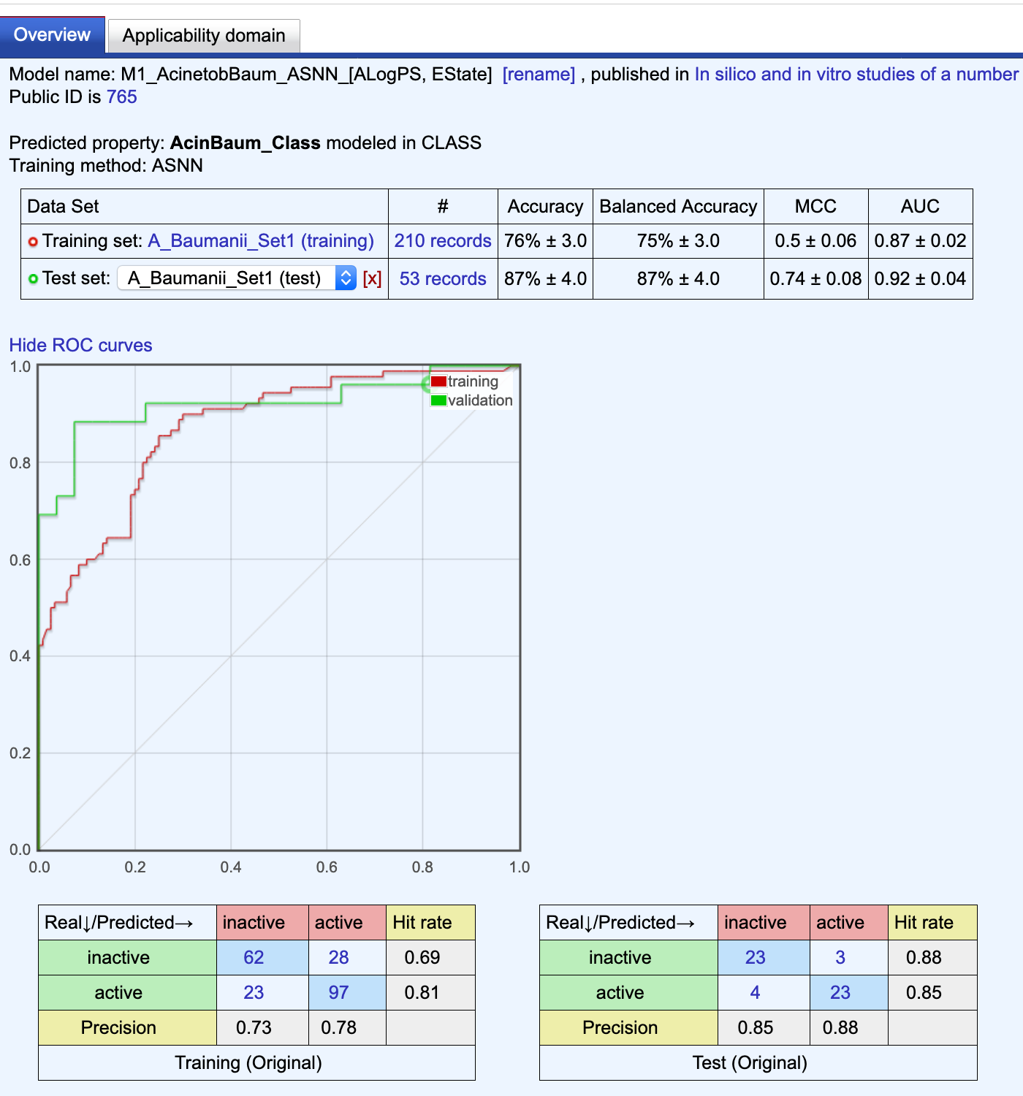

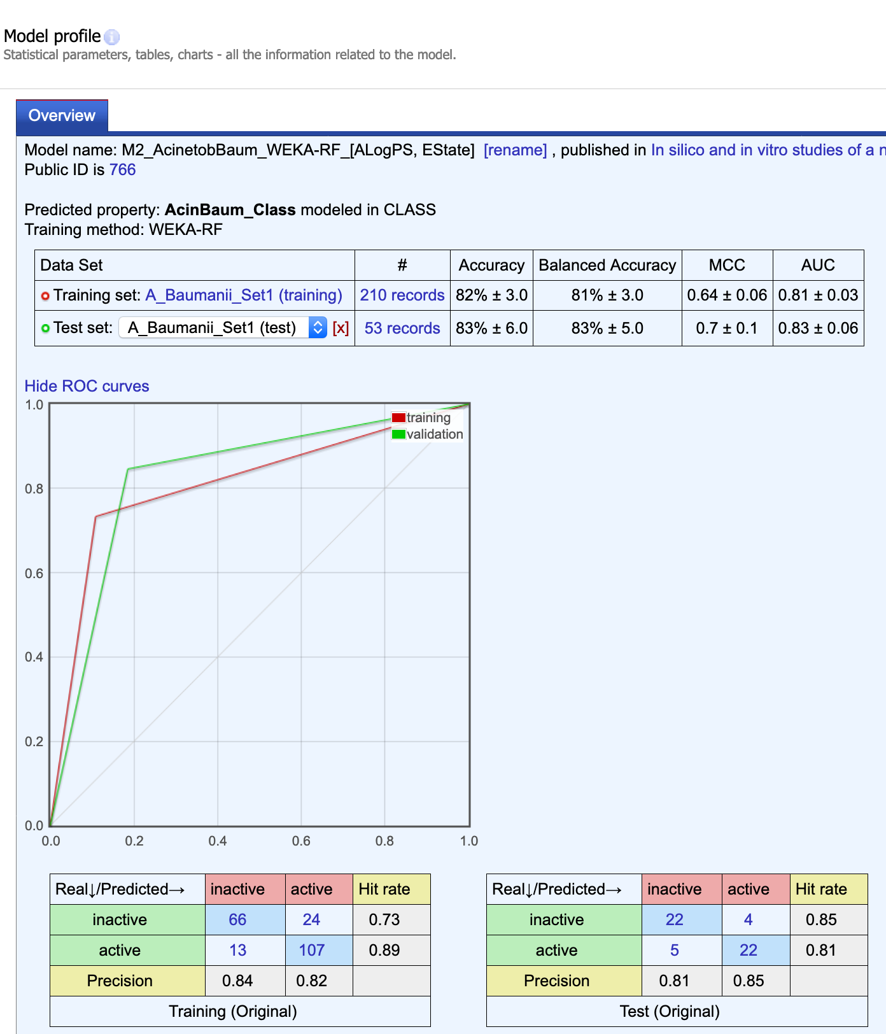

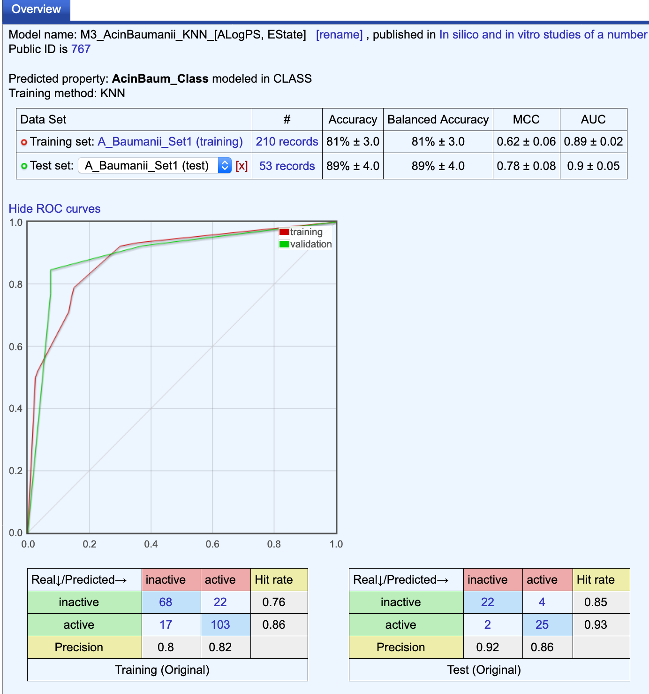
c)
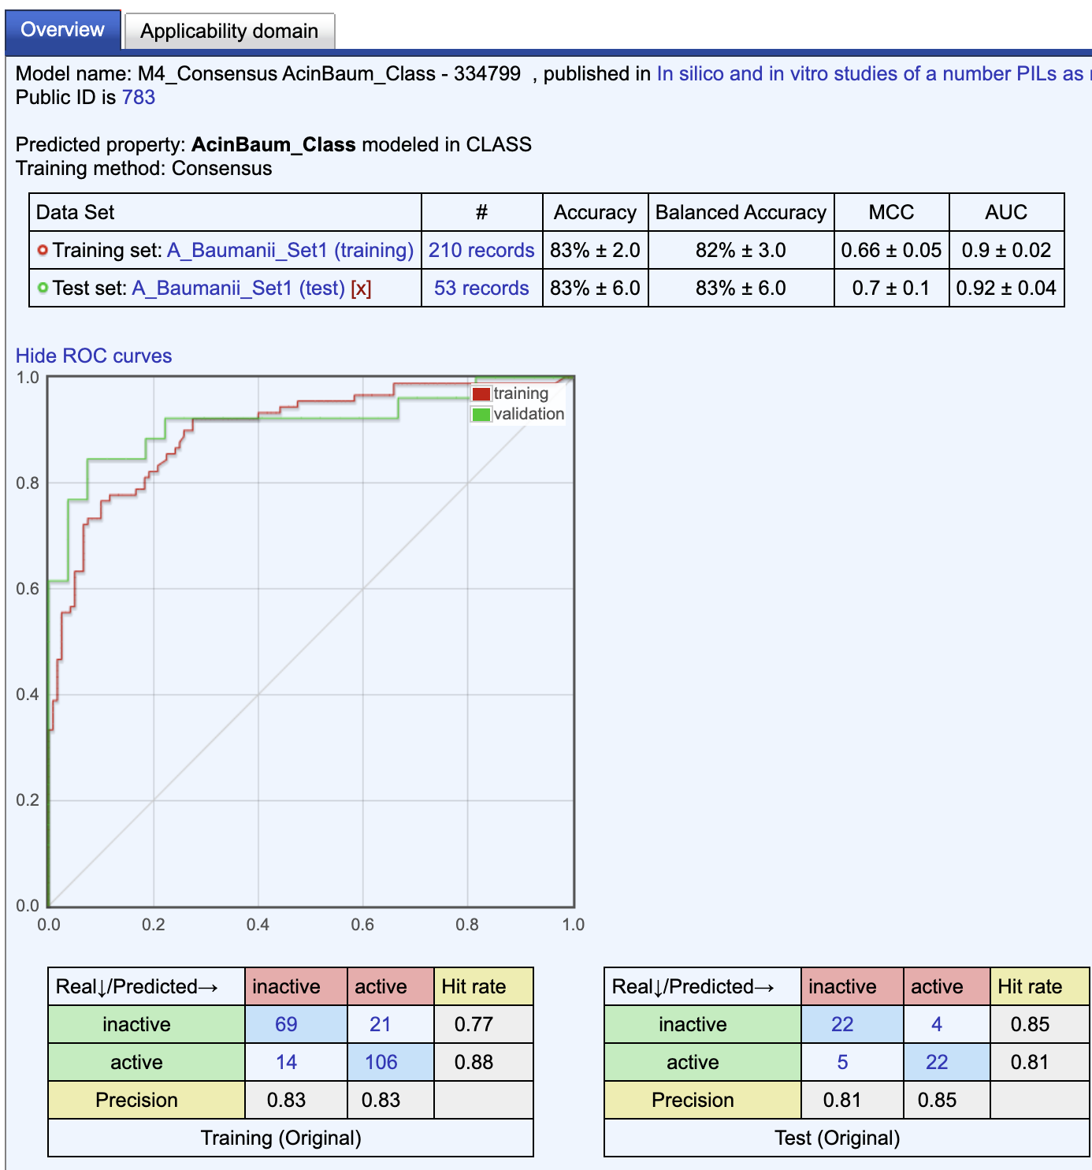
d)

Fig. 1S. Classification machine learning models built by the OCHEM server for data; a-c) Performance statistics of binary classifiers; d) Consensus model calculated on the basis of previous 3 models.

- Evaluation activity of new compounds

Table 2S. Anti-A. baumanii activity calculated by using the consensus classification models for 41 virtual compounds
Compound No | Chemical Structure | Pred. activity | Numeric prediction | CONSENSUS-STD | AD
1 |  | active | 0.83 | 0.17 | TRUE
2 |  | active | 0.85 | 0.17 | TRUE
3 |  | active | 0.86 | 0.17 | TRUE
4 |  | inactive | 0.47 | 0.48 | FALSE
5 |  | active | 0.83 | 0.17 | TRUE
6 |  | active | 0.84 | 0.17 | TRUE
7 |  | active | 0.83 | 0.17 | TRUE
8 |  | active | 0.50 | 0.44 | TRUE
9 |  | active | 0.84 | 0.17 | TRUE
10 |  | active | 0.83 | 0.17 | TRUE
11 |  | active | 0.51 | 0.46 | TRUE
12 |  | active | 0.67 | 0.34 | TRUE
13 |  | active | 0.90 | 0.17 | TRUE
14 |  | active | 0.60 | 0.36 | TRUE
15 |  | active | 0.83 | 0.17 | TRUE
16 |  | active | 0.78 | 0.19 | TRUE
17 |  | inactive | 0.01 | 0.01 | TRUE
18 |  | inactive | 0.01 | 0 | TRUE
19 |  | inactive | 0.01 | 0 | TRUE
20 |  | inactive | 0.01 | 0.01 | TRUE
21 |  | inactive | 0.12 | 0.18 | TRUE
22 |  | inactive | 0.13 | 0.18 | TRUE
23 |  | inactive | 0.17 | 0.17 | TRUE
24 |  | inactive | 0.06 | 0.1 | TRUE
25 |  | inactive | 0.12 | 0.18 | TRUE
26 |  | inactive | 0.17 | 0.17 | TRUE
27 |  | active | 0.73 | 0.25 | TRUE
28 |  | inactive | 0.13 | 0.22 | TRUE
29 |  | active | 0.56 | 0.51 | FALSE
30 |  | active | 0.6 | 0.53 | FALSE
31 |  | active | 0.59 | 0.52 | FALSE
32 |  | active | 0.81 | 0.17 | TRUE
33 |  | active | 0.83 | 0.17 | TRUE
34 |  | active | 0.56 | 0.38 | TRUE
35 |  | active | 0.62 | 0.34 | TRUE
36 |  | active | 0.64 | 0.38 | TRUE
37 |  | inactive | 0.29 | 0.35 | TRUE
38 |  | active | 0.63 | 0.39 | TRUE
39 |  | inactive | 0.12 | 0.19 | TRUE
40 |  | inactive | 0.12 | 0.18 | TRUE
41 |  | inactive | 0.45 | 0.5 | FALSE
Final set of compounds are represented in bold. CONSENSUS-STD – the standard deviation of the predictions, obtained from an ensemble of models.

References

Brovarets, V., Holovchenko, O., Naumenko, A., Vydzhak, R., Abdurakhmanova, E., Prostota, Y., & Kachkovsky, O. (2017). Electronic and spectral properties of phosphonium ylides-betaines, derivatives of 2-oxazoline-5-one with conjugated and non-conjugated substituents. European Chemical Bulletin, 6(9), 380-392. doi:10.17628/ecb.2017.6.380-392
Dasarathy, B. V. (1991). Nearest neighbor (NN) norms : nn pattern classification techniques. Washington: IEEE Computer Society Press.
Frank, E., Hall, M., Trigg, L., Holmes, G., & Witten, I. H. (2004). Data mining in bioinformatics using Weka. Bioinformatics, 20(15), 2479-2481. doi:10.1093/bioinformatics/bth261
Golovchenko, A. V., Brovarets, V. S., & Drach, B. S. (2004). A convenient procedure for introducting arylsulfanyl and heterosulfanyl groups into the 5 position of the oxazole ring. Russian Journal of General Chemistry, 74, 1414-1417.
Hall, L. H., & Kier, L. B. (1995). Electrotopological State Indexes for Atom Types - a Novel Combination of Electronic, Topological, and Valence State Information. Journal Of Chemical Information And Computer Sciences, 35(6), 1039-1045. doi:10.1021/Ci00028a014
Sushko, I., Novotarskyi, S., Korner, R., Pandey, A. K., Rupp, M., Teetz, W., . . . Tetko, I. V. (2011). Online chemical modeling environment (OCHEM): web platform for data storage, model development and publishing of chemical information. Journal of Computer-Aided Molecular Design, 25(6), 533-554. doi:10.1007/s10822-011-9440-2
Tetko, I. V. (2008). Associative neural network. Methods Mol Biol, 458, 185-202. doi:10.1007/978-1-60327-101-1_10
Tetko, I. V., Solov'ev, V. P., Antonov, A. V., Yao, X., Doucet, J. P., Fan, B., . . . Varnek, A. (2006). Benchmarking of linear and nonlinear approaches for quantitative structure-property relationship studies of metal complexation with ionophores. J Chem Inf Model, 46(2), 808-819. doi:10.1021/ci0504216
Tetko, I. V., & Tanchuk, V. Y. (2002). Application of associative neural networks for prediction of lipophilicity in ALOGPS 2.1 program. Journal of Chemical Information & Computer Sciences, 42(5), 1136-1145. doi:10.1021/ci025515j
Tetko, I. V., Tanchuk, V. Y., Kasheva, T. N., & Villa, A. E. P. (2001). Estimation of Aqueous Solubility of Chemical Compounds Using E-State Indices. Journal Of Chemical Information And Computer Sciences, 41(6), 1488-1493. doi:10.1021/ci000392t
Tollenaere, T. (1990). SuperSAB: Fast adaptive back propagation with good scaling properties. Neural Networks, 3(5), 561-573. doi:10.1016/0893-6080(90)90006-7

