Supplementary Material
Detection and Quantification of the Anti-Obesity Drug Celastrol in Murine Liver and Brain
Meri De Angelis^{1*}, Sonja C. Schriever^{2,3,4}, Eleni Kyriakou^{5,6}, Michael Sattler^{5,6}, Ana C. Messias^{5,6}, Karl-Werner Schramm^{1,7}, Paul T. Pﬂuger^{2,3,4,8**}

¹Helmholtz Zentrum München-German Research Center for Environmental Health (GmbH), Molecular EXposomics, Ingolstädter Landstr. 1, 85764 Neuherberg, Germany
²Helmholtz Zentrum München-German Research Center for Environmental Health (GmbH), Research Unit Neurobiology of Diabetes, 85764 Neuherberg, Germany
³Helmholtz Zentrum München-German Research Center for Environmental Health (GmbH), Institute for Diabetes and Obesity, 85764 Neuherberg, Germany
⁴German Center for Diabetes Research (DZD), 85764 Neuherberg, Germany
⁵Helmholtz Zentrum München-German Research Center for Environmental Health (GmbH), Institute of Structural Biology, 85764 Neuherberg, Germany
⁶Technical University of Munich, Biomolecular NMR and Center for Integrated Protein Science Munich at Department of Chemistry, 85747 Garching, Germany
⁷Technical University of Munich, Department für Biowissenschaftliche Grundlagen, 85350 Freising, Germany
⁸Technical University of Munich, Neurobiology of Diabetes, TUM School of Medicine, 81675 Munich, Germany

*Corresponding author
Dr. Meri De Angelis, Molecular EXposomics
Helmholtz Zentrum München-German Research Center for Environmental Health (GmbH), Ingolstädter Landstr. 1, 85764 Neuherberg, Germany
Tel. +49 (0)89 3187 2932
meri.deangelis@helmholtz-muenchen.de

**Corresponding author
Dr. Paul T. Pfluger, Research Unit NeuroBiology of Diabetes
Helmholtz Zentrum München-German Research Center for Environmental Health (GmbH),
Ingolstädter Landstr. 1, 85764 Neuherberg, Germany
Tel. +49 (0) 89 3187 2104
paul.pfluger@helmholtz-muenchen.de

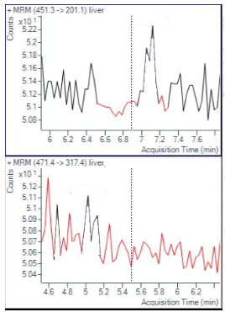
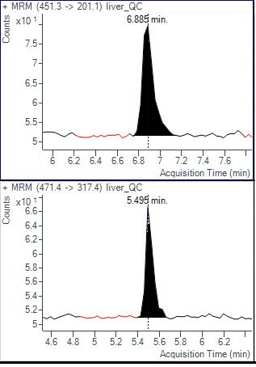
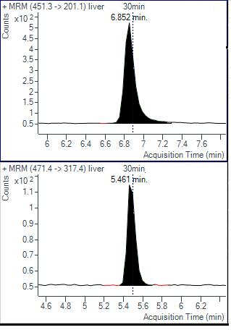
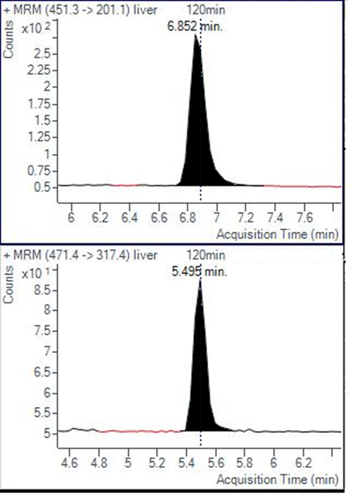
(I)
(II)
A
B
C
(I)
(II)
(I)
(II)
D

Fig. S1. Multiple reaction monitoring chromatograms of celastrol (I) and glycyrrhetinic acid (IS; II): (A) blank mouse liver; (B) blank mouse liver spiked with celastrol (5 pg/µL) and IS (20 pg/µL); (C) mouse liver sample 30 min after i.p. injection of celastrol (100 µg/kg BW); (D) mouse liver sample 120 min after i.p. injection of celastrol (100 µg/kg BW).

Table S1. Inter-day precision and accuracy of celastrol in mouse brain samples, using 200 mg of extract.

Inter-day (n=2)
Spiked conc.ª  (pg/µL) | Concentration measured (pg/µL) | Precision (% RSD) | Accuracy (%)
5 | 4.23±0.85 | 20 | 84.6
50 | 43.12±5.2 | 12.1 | 86.24

ª 100 µL of standard solution, at given concentration, is spiked into about 200 mg of tissue extract

Table S2. Intra-day and inter-day precision and accuracy of celastrol in mouse liver samples.
ª 100 µL of standard solution, at given concentration, is spiked into about 50 mg of tissue extract

Intra-day (n=3) |  |  |  | Inter-day (n=12)
Spiked conc.ª  (pg/µL) | Concentration measured (pg/µL) | Precision  (% RSD) | Accuracy (%) | Concentration measured (pg/µL) | Precision (% RSD) | Accuracy (%)
5 | 5.16±0.56 | 10.9 | 103.2 | 5.30±0.92 | 17.4 | 106.0
50 | 45.35±10.35 | 22.8 | 90.7 | 52.05±10.35 | 19.8 | 104.1

Table S3. Stability of celastrol spiked in mouse liver extracts (n=3).

Stability conditions | Spiked conc.ª  (pg/µL) | Concentration measured (pg/µL) | Precision  (% RSD) | Accuracy (%)
Short-term (10 °C, 6h autosampler) | 5  50 | 4.72±0.96  62.5±9.94 | 20.3  15.9 | 94.4  125.0
Mid-term (-20 °C for 3 days) | 5  50 | 4.17±0.39  60.6±11.5 | 9.4  18.9 | 83.4  121.2
Long-term (-80 °C for 2 weeks) | 5  50 | 4.40±0.28  52.68±10.41 | 6.4  19.7 | 88.0  105.4
ª 100 µL of standard solution, at given concentration, is spiked into about 50 mg of tissue extract

