Supplementary Material

Structure-activity relationship and cardiac safety of 2-aryl-2-(pyridin-2-yl)acetamides as a new class of broad-spectrum anticonvulsants derived from Disopyramide

Maciej Dawidowski^{1,*} Marek Król¹, Bartłomiej Szulczyk^{1,2}, Andrzej Chodkowski¹, Piotr Podsadni¹, Piotr Konopelski³, Marcin Ufnal³, Piotr Szuberski¹, Martyna Zofia Wróbel¹, Yihong Zhang⁴, Aziza El Harchi⁴, Jules C. Hancox⁴, Dagmar Jarkovska⁵, Eliska Mistrova⁵, Jitka Sviglerova⁵, Milan Štengl⁵, Grzegorz M. Popowicz⁶, Jadwiga Turło¹

¹ Department of Drug Technology and Pharmaceutical Biotechnology, Medical University of Warsaw, Banacha 1, 02-097 Warsaw, Poland
² Laboratory of Physiology and Pathophysiology, Centre for Preclinical Research, Medical University of Warsaw, Banacha 1B, 02-097 Warsaw, Poland
³ Department of Experimental Physiology and Pathophysiology, Centre for Preclinical Research, Medical University of Warsaw, Banacha 1B, 02-097 Warsaw, Poland
⁴ School of Physiology, Pharmacology and Neuroscience, Faculty of Medical Sciences, University of Bristol, Bristol BS8 1TD, United Kingdom
⁵ Department of Physiology, Biomedical Center, Faculty of Medicine in Pilsen, Charles University, Alej Svobody 1655/76, 323 00 Pilsen, Czech Republic
⁶ Institute of Structural Biology, Helmholtz Zentrum München, Ingolstädter Landstrasse 1, 85764 Neuherberg, Germany.

* Corresponding author. Tel.: +48 22 5720721; fax: +48 22 5720643. E-mail address: maciej.dawidowski@wum.edu.pl (M. Dawidowski).
Table of contents:

Table S1. Anticonvulsant activity of compounds in the scMET model following intraperitoneal (ip.) administration in mice. S3

Table S2. Anticonvulsant activity and neurotoxicity of selected compounds in the he MES model following intraperitoneal (i.p.) administration in rats. S4

Table S3. Anticonvulsant activity and neurotoxicity of selected compounds in the he
MES model following oral (po.) administration in rats. S5

Table S4. Anticonvulsant activity and neurotoxicity of compounds in the 6 Hz (32 mA)
model following intraperitoneal (ip.) administration in mice. S5

Table S5. Anticonvulsant activity and neurotoxicity of selected compounds in the
6 Hz (44 mA) model following intraperitoneal (ip.) administration in mice. S7

Evaluation of cardiac safety in guinea pigs S8

Cardiac safety in methoxamine-sensitized rabbit model of
torsades de pointes arrhythmia. S11

ADME/PK profile of 1 S15

Copies of ¹H and ¹³C NMR spectra S16

References S89

Table S1. Anticonvulsant activity of compounds in the scMET model following intraperitoneal (ip.) administration in mice.
Compound | Dose (mg/kg) |  | scMETª
Compound |  |  | 0.5 h | 2.0 h | 4.0 h
1 | 100 |  | 0/1 | -^{b} | 0/1
 | 300 |  | 0/1 | - | 0/1
2a | 100 |  | - | - | -
 | 300 |  | - | - | -
2d | 100 |  | 3/4 | 0/3 | 0/4
3a | 100 |  | 0/1 | - | 0/1
 | 300 |  | - | - | -
3b | 100 |  | 0/1^{c} | - | 0/1^{c}
 | 300 |  | 0/1^{c} | - | 0/1^{c}
3c | 100 |  | 0/1 | - | 0/1
 | 300 |  | 0/1 | - | 0/1
3d | 100 |  | 0/1 | - | 0/1
 | 300 |  | 0/1 | - | 0/1
3e | 100 |  | 1/4^{d} | 0/4 | 0/4
3f | 100 |  | 0/4 | 0/4 | 0/4
3g | 100 |  | 0/1e | - | 0/1
3h | 100 |  | - | - | -
3i | 100 |  | 1/4 | 0/4 | 0/4
3j | 100 |  | 0/1 | - | 0/1
 | 300 |  | - | - | -
3k | 100 |  | 0/1e | - | 0/1
 | 300 |  | 0/1 | - | -
3l | 100 |  | 0/1e | - | 0/1
 | 300 |  | 0/1 | - | 0/1
3m | 100 |  | 0/1 | - | 0/1
 | 300 |  | - | - | -
3n | 100 |  | 0/1e | - | 0/1
 | 300 |  | 0/1 | - | 0/1e
Ratios where at least one animal was protected or displayed neurotoxicity have been highlighted in bold for easier data interpretation.
ª Subcutaneous Metrazole test (number of animals protected/number of animals tested)
^{b} Not determined
^{c} Continuous seizure activity
^{d} Myoclonic jerks
^{e} Tonic extension

Table S2. Anticonvulsant activity and neurotoxicity of selected compounds in the he MES model following
intraperitoneal (i.p.) administration in rats.
Compound | Testª | 0.25 h | 0.5 h | 1.0 h | 2.0 h | 4.0 h
1 | MES^{b} | 2/4 | 0/4 | 1/4 | 0/4 | 0/4
 | TOX^{c} | 0/4 | 0/4 | 0/4 | 0/4 | 0/4
2a | MES | 2/4 | 4/4 | 4/4 | 4/4 | 1/4
 | TOX | 0/4 | 0/4 | 0/4 | 0/4 | 0/4
2d | MES | 2/4 | 4/4 | 4/4 | 4/4 | 0/4
 | TOX | 0/4 | 0/4 | 0/4 | 0/4 | 0/4
3a | MES | 1/4 | 2/4 | 1/4 | 0/4 | 0/4
 | TOX | 0/4 | 0/4 | 0/4 | 0/4 | 0/4
3b | MES | 4/4 | 2/4 | 2/4 | 0/4 | 1/4
 | TOX | 0/4 | 0/4 | 0/4 | 0/4 | 0/4
3d | MES | 2/4 | 4/4 | 1/4 | 1/4 | 1/4
 | TOX | 0/4 | 0/4 | 0/4 | 0/4 | 0/4
3e | MES | 4/4 | 3/4 | 3/4 | 0/4 | 0/4
 | TOX | 0/4 | 0/4 | 0/4 | 0/4 | 0/4
3i | MES | 4/4 | 3/4 | 3/4 | 2/4 | 0/4
 | TOX | 0/4 | 0/4 | 0/4 | 0/4 | 0/4
3n | MES | 2/4 | 2/4 | 2/4 | 3/4 | 1/4
 | TOX | 0/4 | 0/4 | 0/4 | 0/4 | 0/4
3q | MES | 1/4 | 0/4 | 0/4 | 0/4 | 0/4
 | TOX | 0/4 | 0/4 | 0/4 | 0/4 | 0/4
Ratios where at least one animal was protected or displayed neurotoxicity have been highlighted in bold for easier data interpretation.
ª At dose 30 mg/kg
^{b} Maximal Electroshock test (number of animals protected/number of animals tested)
^{c} Neurotoxicity test (number of animals exhibiting neurological toxicity/number of animals tested)
^{d} At dose 60 mg/kg
^{d} At dose 100 mg/kg

Table S3. Anticonvulsant activity and neurotoxicity of selected compounds in the he MES model following
oral (po.) administration in rats.
Compound | Testª | 0.25 h | 0.5 h | 1.0 h | 2.0 h | 4.0 h
1 | MES^{b} | 1/4 | 1/4 | 2/4 | 3/4 | 0/4
 | TOX^{c} | 0/4 | 0/4 | 0/4 | 0/4 | 0/4
2a | MES | 1/4 | 1/4 | 2/4 | 0/4 | 0/4
 | TOX | 0/4 | 0/4 | 0/4 | 0/4 | 0/4
2d | MES^{d} | 0/4 | 1/4 | 0/4 | 0/4 | 0/4
 | TOX^{d} | 0/4 | 0/4 | 0/4 | 0/4 | 0/4
3a | MES | 1/4 | 1/4 | 2/4 | 0/4 | 0/4
 | TOX | 0/4 | 0/4 | 0/4 | 0/4 | 0/4
3b | MES | 1/4 | 2/4 | 2/4 | 1/4 | 0/4
 | TOX | 0/4 | 0/4 | 0/4 | 0/4 | 0/4
3d | MES | 1/4 | 2/4 | 2/4 | 1/4 | 0/4
 | TOX | 0/4 | 0/4 | 0/4 | 0/4 | 0/4
3e | MES | 2/4 | 2/4 | 1/4 | 0/4 | 0/4
 | TOX | 0/4 | 0/4 | 0/4 | 0/4 | 0/4
3f | MES | 0/4 | 0/4 | 0/4 | 0/4 | 0/4
 | TOX | 0/4 | 0/4 | 0/4 | 0/4 | 0/4
3i | MES | 0/4 | 1/4 | 1/4 | 2/4 | 3/4
 | TOX | 0/4 | 0/4 | 0/4 | 0/4 | 0/4
3j | MES | 2/4 | 1/4 | 2/4 | 1/4 | 1/4
 | TOX | 0/4 | 0/4 | 0/4 | 0/4 | 0/4
3m | MES | 2/4 | 0/4 | 0/4 | 1/4 | 1/4
 | TOX | 0/4 | 0/4 | 0/4 | 0/4 | 0/4
3n | MES | 2/4 | 3/4 | 3/4 | 3/4 | 1/4
 | TOX | 0/4 | 0/4 | 0/4 | 0/4 | 0/4
3q | MES | 0/4 | 0/4 | 0/4 | 0/4 | 0/4
 | MES^{e} | 4/4 | 3/4 | 2/4 | 0/4 | 1/4
 | TOXe | 0/4 | 0/4 | 0/4 | 0/4 | 0/4
Ratios where at least one animal was protected or displayed neurotoxicity have been highlighted in bold for easier data interpretation.
ª At dose 30 mg/kg
^{b} Maximal Electroshock test (number of animals protected/number of animals tested)
^{c} Neurotoxicity test (number of animals exhibiting neurological toxicity/number of animals tested)
^{d} At dose 60 mg/kg
^{e} At dose 100 mg/kg

Table S4. Anticonvulsant activity and neurotoxicity of compounds in the 6 Hz (32 mA) model following intraperitoneal (ip.) administration in mice.
Compound | Testª | 0.25 h | 0.5 h | 1.0 h | 2.0 h | 4.0 h
1^{b} | 6 Hz^{c} | 3/4 | 4/4 | 4/4 | 0/4 | 0/4
 | TOX^{d} | 0/4 | 0/4 | 0/4 | 0/4 | 0/4
2a | 6 Hz | 3/4 | 4/4 | 2/4 | 1/4 | 0/4
 | TOX | 0/4 | 0/4 | 0/4 | 0/4 | 0/4
2d | 6 Hz | 4/4 | 3/4 | 2/4 | 1/4 | 0/4
 | TOX | 0/4 | 0/4 | 0/4 | 0/4 | 0/4
3a | 6 Hz | 4/4 | 4/4 | 4/4 | 2/4 | 2/4
 | TOX | 1/4 | 0/4 | 0/4 | 0/4 | 0/4
3b | 6 Hz | 4/4 | 4/4 | 4/4 | 2/4 | 0/4
 | TOX | 1/4 | 0/4 | 0/4 | 1/4 | 0/4
3c | 6 Hz | 2/4 | 4/4 | 1/4 | 0/4 | 0/4
 | TOX | 0/4 | 0/4 | 0/4 | 0/4 | 0/4
3d^{b} | 6 Hz | 4/4 | 4/4 | 1/4 | 0/4 | 0/4
 | TOX | 0/4 | 0/4 | 0/4 | 0/4 | 0/4
3e | 6 Hz | 3/4 | 4/4 | 0/4 | 0/4 | 0/4
 | TOX | 0/4 | 0/4 | 0/4 | 0/4 | 0/4
3f | 6 Hz | 2/4 | 0/4 | 0/4 | 0/4 | 0/4
 | TOX | 0/4 | 0/4 | 0/4 | 0/4 | 0/4
3g | 6 Hz | 1/4 | 1/4 | 0/4 | 0/4 | 0/4
 | TOX | 0/4 | 0/4 | 0/4 | 0/4 | 0/4
3h | 6 Hz | 4/4 | 2/4 | 1/4 | 0/4 | 0/4
 | TOX | 0/4 | 0/4 | 0/4 | 0/4 | 0/4
3i | 6 Hz | 3/4 | 4/4 | 4/4 | 2/4 | 0/4
 | TOX | 0/4 | 0/4 | 0/4 | 0/4 | 0/4
3m | 6 Hz | 4/4 | 3/4 | 2/4 | 1/4 | 0/4
 | TOX | 0/4 | 0/4 | 0/4 | 0/4 | 0/4
3n | 6 Hz | 1/4 | 1/4 | 1/4 | 0/4 | 0/4
 | TOX | 0/4 | 0/4 | 0/4 | 0/4 | 0/4
3o | 6 Hz | - | 0/4 | - | 0/4 | -
 | TOX | - | 0/8 | - | 0/8 | -
3p | 6 Hz | -^{e} | 2/4 | - | 0/4 | -
 | TOX | - | 0/8 | - | 0/8 | -
3q^{f} | 6 Hz | 1/4 | 2/4 | 1/4 | 1/4 | 0/4
 | TOX | 0/4 | 0/4 | 0/4 | 0/4 | 0/4
3r | 6 Hz | - | 4/4 | - | 4/4 | -
 | TOX | - | 0/8 | - | 0/8 | -
3s | 6 Hz | - | 4/4 | - | 4/4 | -
 | TOX | - | 2/8 | - | 1/8 | -
4 | 6 Hz | - | 0/4 | - | 0/4 | -
 | TOX | - | 0/8 | - | 0/8 | -
5a | 6 Hzª | - | 0/4 | - | 0/4 | -
 | 6Hz^{g} | - | 4/4 | - | 4/4 | -
 | TOX^{g} | - | 1/8 | - | 0/4 | -
5b | 6 Hzª | - | 2/4 | - | 0/4 | -
 | 6Hz^{g} | - | 3/4 | - | 4/4 | -
 | TOX^{g} | - | 1/8 | - | 0/8 | -
5c | 6 Hzª | - | 2/4 | - | 0/4 | -
 | 6Hz^{g} | - | 1/4 | - | 4/4 | -
 | TOX^{g} | - | 7/8 | - | 7/8 | -
5d | 6 Hzª | - | 2/4 | - | 2/4 | -
 | 6Hz^{g} | - | 2/4 | - | 4/4 | -
 | TOX^{g} | - | 7/8 | - | 1/8 | -
5e | 6 Hzª | - | 0/4 | - | 0/4 | -
 | 6Hz^{g} | - | 4/4 | - | 2/4 | -
 | TOX^{g} | - | 0/8 | - | 0/8 | -
Ratios where at least one animal was protected or displayed neurotoxicity have been highlighted in bold for easier data interpretation.
ª At dose 100 mg/kg
^{b} At dose 75 mg/kg
^{c} 6 Hz test, 32 mA (number of animals protected/number of animals tested)
^{d} Neurotoxicity test (number of animals exhibiting neurological toxicity/number of animals tested)
^{e} Not determined
^{f} At dose 200 mg/kg
^{g} At dose 300 mg/kg

Table S5. Anticonvulsant activity and neurotoxicity of selected compounds in the 6 Hz (44 mA) model following intraperitoneal (ip.) administration in mice.
Compound | Testª | 0.25 h | 0.5 h | 1.0 h | 2.0 h | 4.0 h
1 | 6 Hz^{b} | 2/4 | 4/4 | 3/4 | 3/4 | 0/4
 | TOX^{c} | 0/4 | 0/4 | 0/4 | 0/4 | 0/4
2a | 6 Hz | 3/4 | 4/4 | 2/4 | 1/4 | 0/4
 | TOX | 0/4 | 0/4 | 0/4 | 0/4 | 0/4
2d | 6Hz^{d} | 4/4 | 1/4 | 1/4 | 0/4 | 0/4
 | TOX^{d} | 0/4 | 0/4 | 0/4 | 0/4 | 0/4
3a | 6 Hz | 3/4 | 1/4 | 2/4 | 0/4 | 0/4
 | TOX | 0/4 | 0/4 | 0/4 | 0/4 | 0/4
3d | 6 Hz | 4/4 | 4/4 | 3/4 | 2/4 | 0/4
 | TOX | 0/4 | 0/4 | 0/4 | 0/4 | 0/4
3i | 6 Hz | 2/4 | 2/4 | 0/4 | 0/4 | 0/4
 | TOX | 0/4 | 0/4 | 0/4 | 0/4 | 0/4
3p | 6 Hz | 3/4 | 3/4 | 1/4 | 0/4 | 0/4
 | TOX | 0/4 | 0/4 | 0/4 | 0/4 | 0/4
3r | 6 Hz | 3/4 | 4/4 | 3/4 | 3/4 | -^{e}
 | TOX | 0/4 | 0/4 | 0/4 | 0/4 | 0/4
3s | 6 Hz | 7/8 | 8/8 | 8/8 | - | -
 | TOX | - | 2/8 | - | 1/8 | -
5a | 6 Hzª | 0/4 | 0/4 | 0/4 | 1/4 | 0/4
 | 6Hz^{f} | 3/4 | 3/4 | 3/4 | 3/4 | 3/4
 | TOX^{f} | 0/4 | 0/4 | 0/4 | 0/4 | 0/4
5b | 6 Hz | 0/4 | 1/8 | 1/8 | 0/4 | 0/4
 | TOX | - | 0/8 | - | 0/8 | -
5e | 6 Hz^{f} | 0/4 | 4/8 | 0/4 | 0/4 | 0/4
 | TOX^{g} | - | 0/8 | - | 0/8 | -
Ratios where at least one animal was protected or displayed neurotoxicity have been highlighted in bold for easier data interpretation.
ª At dose 100 mg/kg
^{b} 6 Hz test, 44 mA (number of animals protected/number of animals tested)
^{c} Neurotoxicity test (number of animals exhibiting neurological toxicity/number of animals tested)
^{d} At dose 75 mg/kg
^{e} Not determined
^{f} At dose 200 mg/kg
^{g} At dose 300 mg/kg

Evaluation of cardiac safety in guinea pigs

Previously, we found that in rats ADD424042 (1) does not produce any significant changes in QT and corrected QT, the electrocardiographic markers of cardiotoxicity¹. However, the rat heart does not rely on hERG for ventricular repolarization, hence current cardiac safety testing guidelines (ICH S7B) suggest testing cardiotoxicity of drugs in species including guinea pigs, which express this channel and more human-like ventricular repolarization². Accordingly, here we tested the effect of 1 (110 mg/kg), DISO (150 mg/kg, equimolar) and vehicle on electrical activity of the heart in guinea pigs. Treatment with vehicle and 1 did not affect morphology of ECG recordings (Figure S1). In contrast, DISO produced significant disturbances including widening of QRS complex, and prolongation of QT interval. At baseline, there was no significant differences between Control (118.57 ms), DISO group (129.94 ms) and 1 (122.37 ms) groups. Administration of the vehicle and 1 caused no significant changes in QT. In contrast, DISO produced a significant increase in QT (F_{2,12} = 10, p < 0.05). The between-groups analysis showed significant differences between groups in QT changes after the administration of investigated substances (F_{2,16} = 10, p < 0.05). Namely, animals treated with disopyramide showed significantly longer QT in comparison to control (p = 0.002) and 1 (p = 0.003) (Fig. S2A). Administration of the vehicle and 1 did not affect QTc. On the contrary, DISO produced a significant increase in QTc (F_{2,12} = 12, p < 0.05). The between-groups analysis showed significant differences between groups in QT changes after the administration of investigated substances (F_{2,16} = 16, p < 0.05). Namely, animals treated with DISO showed significantly longer QTc in comparison to controls (p = 0.0006) and 1 (p = 0.0005) (Fig S2B).
Figure. S1. Examples of ECG recordings (II lead) in guinea pigs at baseline, 30 and 60 minutes after the i.p. injection of one of the following: vehicle (vehicle), disopyramide phosphate (Disopyramide) or 1 (ADD424042).
Figure S2. (A) QT interval (QT) and (B) corrected QT interval (QTc) in guinea pigs at baseline and after i.p. injection of one of the following: vehicle (vehicle group), DISO and 1 (ADD424042). * — p < 0.05, the values after i.p. injection vs baseline, by one-way ANOVA for repeated measurements.
Experimental section:

1. Animals
The experiments were carried out according to EU directive 2010/63/EU and were approved by the Ethical Committee. A total of 19, male, tricolor guinea pigs, weighted 300–400 g supplied by Laboratory Animals Breeding (Ilkowice, Poland), were housed indoors under a 12 h light:12 h darkness cycle.

2. Experimental design
All measurements were performed under general anesthesia with a 1.5 g/kg dose of urethane (Sigma-Aldrich, Poznań, Poland). Standard ECG needle electrodes were inserted subcutaneously according to standard limb leads after Einthoven I-III. ECG was recorded with Biopac MP 150 unit (Biopac Systems, Goleta, USA).
The measurements started 20 min after the induction of anesthesia, and 10 min after connecting ECG needles. ECG was recorded 10 min at baseline and 60 min after i.p. injection of 1.5 mL of one of the following: vehicle (67% DMSO solution in 0.9% NaCl), 110 mg/kg of 1 dissolved in the vehicle or 150 mg/kg of DISO (Sigma) dissolved in the vehicle. Doses of administered drugs were chosen, based on pervious experiments performed on rats¹.

3. Data analysis and statistics
Lead II was used to evaluate ECG. QT length was manually measured from the onset of QRS complex to the end of T wave. In guinea pigs QT interval was proven to be affected by heart rate ³, therefore Bazett’s formula (QTc = QT/(square root) RR) was used for calculating corrected QT (QTc) ⁴.
To examine the effect of i.p. infusions of investigated compounds on QT and QTc within groups, the average of 10 consecutive QT/QTc intervals from the last baseline minute was compared with the averages of 10 consecutive beats from 30, 60 min after the i.p. injection. Differences between the groups were evaluated by multivariate ANOVA, followed by Tukey post hoc test. A value of two-sided p < 0.05 was considered significant. Analyses were conducted using STATISTICA 13.1 (Stat Soft, Kraków, Poland).

Cardiac safety in methoxamine-sensitized rabbit model of torsades de pointes arrhythmia.

Arylacetamide 1 does not produce cardiac side effects in rodents, most likely due to inability of the compound to affect hERG channel and M receptors. As the compound still affects voltage-gated sodium currents, we examined its possible antiarrhythmic activity in the methoxamine-sensitized rabbit model of torsades de pointes arrhythmia. In rabbit in vivo experiments, combination of an alpha-adrenergic agonist, methoxamine, and I_{Kr}-blocker dofetilide induced development of torsades de pointes arrhythmia (TdP) with 80% incidence (8 out of 10 rabbits, Figure S3A), as expected. Intraperitoneal administration of 1 (125 mg/kg) did not affect ECG intervals regardless whether at baseline or in the presence of proarrhythmic interventions (methoxamine alone, methoxamine + dofetilide, Table S6). In the presence of the compound, TdP incidence was 50% (5 out of 10 rabbits, Figure S3A), which was not significantly different from the control group. Similarly, there were no significant differences between control and 1 groups in the numbers of proarrhythmic events (single and multiple ectopic beats, not shown). The time to the first arrhythmic event (single ectopic beat, multiple ectopic beat, TdP) was not influenced by 1 (e.g. for TdP 385 ± 147 s in control vs 508 ± 145 s in 1 group from the administration of dofetilide, p > 0.05).
Analysis of heart rate variability, both in time and frequency domain, did not reveal any significant effects of 1. Lack of effect of the compound on the low-frequency/high-frequency band ratio (LF/HF, Figure S3B) indicates that it did not significantly influence the sympathovagal balance of cardiac autonomic innervation.
In vitro measurements of contraction force and action potentials in papillary muscles did not show any significant effect of 1 on either cardiac contractility (Figure S3C) or electrophysiology (Figure S3D).
Both in vivo and in vitro experiments indicate high level of cardiac safety for 1 with no significant detrimental effects on cardiac electrophysiology, contractility, autonomic innervation and arrhythmia inducibility in methoxamine-sensitized rabbit model of arrhythmia.
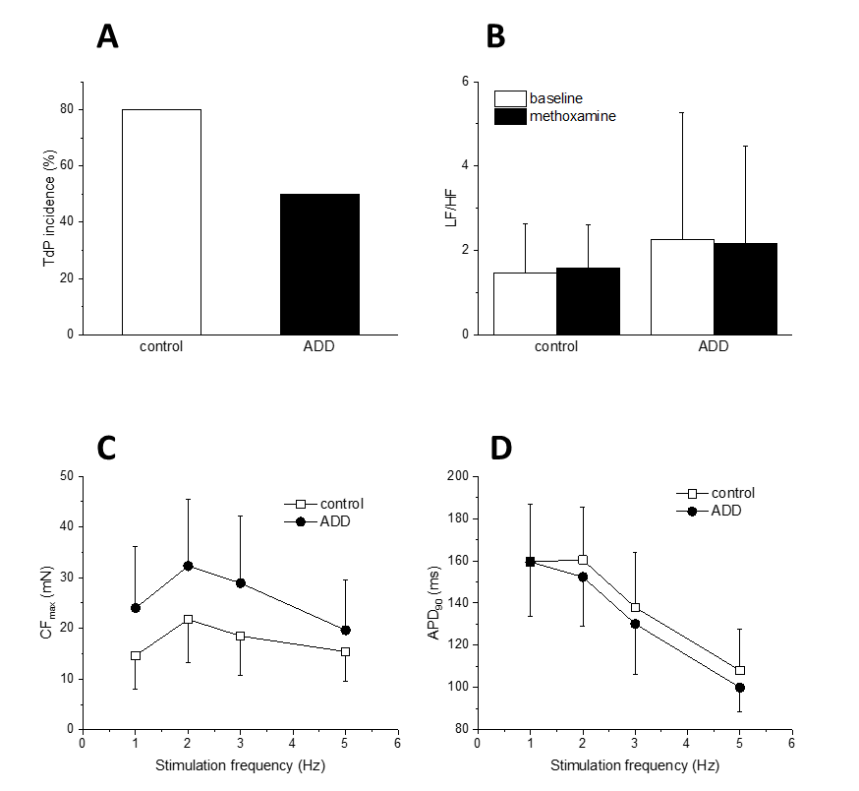
Figure S3. Cardiac effects of 1 (ADD, 125 mg/kg, i.p.) in methoxamine sensitized rabbit model of torsades de pointes arrhythmia. A) Incidence of torsades de pointes arrhythmia in methoxamine-sensitized rabbit model in the absence (control) and presence of 1 (ADD). B) LF/HF ratio at baseline (open columns) and in the presence of methoxamine (filled columns) in control and 1 groups. C) Peak contraction force (CF_{max}) of cardiac ventricular trabeculae from control rabbits and rabbits exposed to 1 at various stimulation frequencies (1-5 Hz). D) Action potential duration at 90% level of repolarization of cardiac ventricular trabeculae from control rabbits and rabbits exposed to 1 at various stimulation frequencies (1-5 Hz).

Table S6. ECG intervals in methoxamine sensitized rabbit model of torsades de pointes arrhythmia. Baseline1, before i.p. administration of 1 or vehicle alone. Baseline 2, after i.p. administration of 1 or vehicle alone.
Group | ECG interval | Baseline 1 (ms) | Baseline 2 (ms) | Methoxamine (ms) | Methoxamine + Dofetilide (ms)
Control | RR | 405±62 | 421±60 | 545±92ª | 654±126^{a,b}
Control | PQ | 86±8 | 83±9 | 90±8 | 91±7
Control | QRS | 59±5 | 62±5 | 62±5 | 63±3
Control | QT | 225±35 | 241±38 | 270±41 | 341±66^{a,b}
Control | QTc | 206±26 | 219±28 | 227±38 | 280±66^{a,b}
1 | RR | 422±94 | 447±117 | 536±74ª | 592±168ª
1 | PQ | 86±10 | 83±10 | 90±13 | 92±7
1 | QRS | 54±6 | 52±3 | 54±6 | 55±7
1 | QT | 239±52 | 250±56 | 283±50 | 342±101^{a,b}
1 | QTc | 217±38 | 224±39 | 241±39 | 291±74^{a,b}
ª n = 10, p < 0.05 vs baseline 1 and 2.
^{b} n = 10, p < 0.05 vs methoxamine.

Experimental section:

1. Animals
Animal handling was performed in accordance with the European Directive for the Protection of Vertebrate Animals Used for Experimental and Other Scientific Purposes (86/609/EU). The experiments were approved by the Committee for Experiments on Animals of the Charles University Faculty of Medicine in Pilsen and by the Ministry of Education, Youth and Sports of the Czech Republic (protocol number MSMT-7311/2018–7). Twenty female New Zealand White Rabbits (2.38 ± 0.34 kg) were divided into two groups randomly: control group (n = 10) and 1 group (n = 10).

2. Experimental design

Animals were anaesthetized by ketamine (35 mg/kg, Narkamon, Bioveta, Czech Republic) and xylazine (5 mg/kg, Rometar, Bioveta, Czech Republic). Needle electrodes were inserted subcutaneously to record ECG (standard limb lead II; Biopac Systems Inc., Santa Barbara, CA, USA). Either vehicle alone (67% DMSO solution in 0.9% NaCl) in control group or 1 (125 mg/kg) dissolved in the vehicle in ADD group were injected i.p. After 20 and 30 min, methoxamine (15 µg/kg/min) and dofetilide (20 µg/kg/min), respectively, were infused into the left jugular vein. ECG recording was initiated 10 min before vehicle or 1 application and finished 20 min after the start of dofetilide infusion or when torsades de pointes arrhythmia (duration at least 5 sec) occurred. Afterwards the heart was excised and the papillary muscles were dissected from the right ventricles, placed into an experimental chamber and attached to an isometric force transducer F30 (Hugo Sachs, March-Hugstetten, Germany). The preparation was perfused with 36 °C warm, oxygenated Tyrode solution (in mM: NaCl 137, KCl 4.5, MgCl₂ 1, CaCl₂ 2, glucose 10, HEPES 5; pH was adjusted to 7.4 with NaOH) at a constant flow rate (6–10 mL/min). After a stabilization period (~30 min), we recorded the steady-state contraction force and membrane potential at stimulation frequencies 1, 2, 3 and 5 Hz. The membrane potential was measured with glass microelectrodes (filled with 3 M KCl, resistance > 20 MΩ).

3. Data analysis and statistics

ECG (lead II) was evaluated manually in Biopac System. In five consecutive beats RR, PQ, QRS, and QT intervals were measured and averaged at baseline 1 (before i.p. administration of 1 in ADD group or vehicle alone in control group), baseline 2 (20 min after i.p. administration of 1 in ADD group or vehicle alone in control group), methoxamine (after 10 min of methoxamine i.v. application in both experimental groups), and methoxamine + dofetilide (after 5 min of methoxamine and dofetilide i.v. application). QTc intervals were computed using Carlsson formula⁵: QTc = QT – 0.175 (RR – 300) ms. Heart rate variability was assessed in MATLAB 2014b (MathWorks Inc., Natick, MA, USA). R peaks were detected automatically with derivative-threshold algorithm and powers in low (LF; 0.04–0.15 Hz) and high (HF; 0.15–0.40 Hz) frequency range were determined using Lomb-Scargle periodogram. Contraction force and membrane potentials were also analyzed in MATLAB 2014b, maximal amplitude of contraction force (CFmax) and action potential duration at 90% level of repolarization (APD90) were measured in at least ten beats and averaged.
Statistical differences between control and ADD group were tested in Origin 2017 (OriginLab, Corp., Northampton, MA, USA). After testing for normality of distribution (Shapiro-Wilk test), statistical comparisons were performed using two-way mixed-design ANOVA followed by Tukey post hoc test. Results are presented as means ± standard deviation, values of p < 0.05 were considered significant.

ADME/PK profile

ADME profiling and pharmacokinetic studies of 1 were performed commercially by Bienta (Kyiv, Ukraine), according to the established testing procedures. The compound exhibits excellent pharmacochemical characteristics and in vitro stability (Table S7), a generally favorable pharmacokinetic profile and high bioavailability (Table S8).

Table S7. Selected ADME properties of 1.
MW (g/mol) | 246
logD_{7.4} | 1.63
mouse microsomal stabilityª:
Cl_{int} (μL/min/mg) | 7.58
remaining after 40 min (%) | 88
t_{1/2} (min) | 220
mouse plasma stability t_{1/2} (min)^{b} | >120
mouse PPB (% free)^{b,c} | 66%
ª intrinsic clearance from hepatic microsomes isolated from perfused livers of Balb/c male, 2 μM of ADD424042, n = 2.
^{b} 1 μM of 1, n = 2.
^{c} % free calculated assuming a single-site binding model.

Table S8. Pharmacokinetics of 1 in male Balb/c mice.
route | dose (mg/kg) | T_{max}  (min) | C_{max}  (ng/mL) | AUC_{inf}  (ng*min/mL) | T_{1/2} (min) | V_{d} (mL/kg) | CL  (mL/min/kg) | F%
iv | 5 | 30 | 3940 | 597000 | 112 | 106 | 6.56 | -
ip | 5 | 15 | 3620 | 459000 | 88 | - | - | -
po | 10 | 120 | 8550 | 1510000 | 77 | - | - | 120

NMR pectra of 2-methyl-2-phenyl-2-(pyridin-2-yl)acetonitrile (2r)
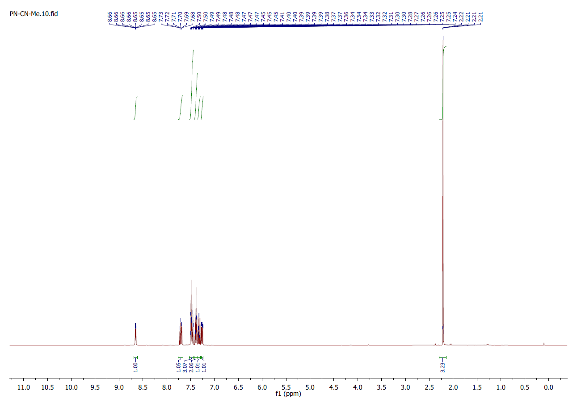
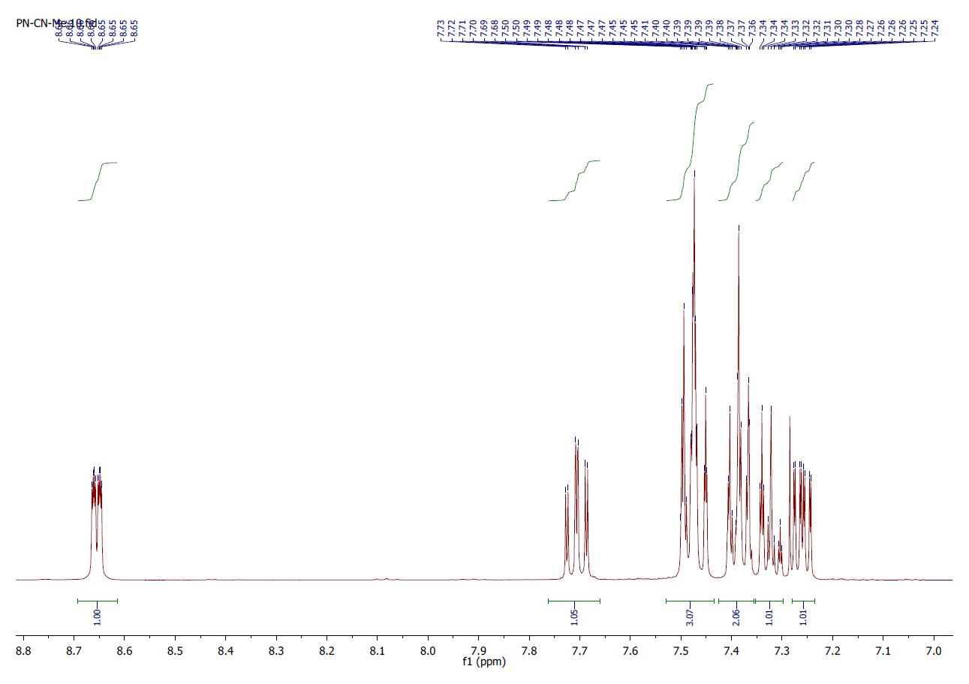
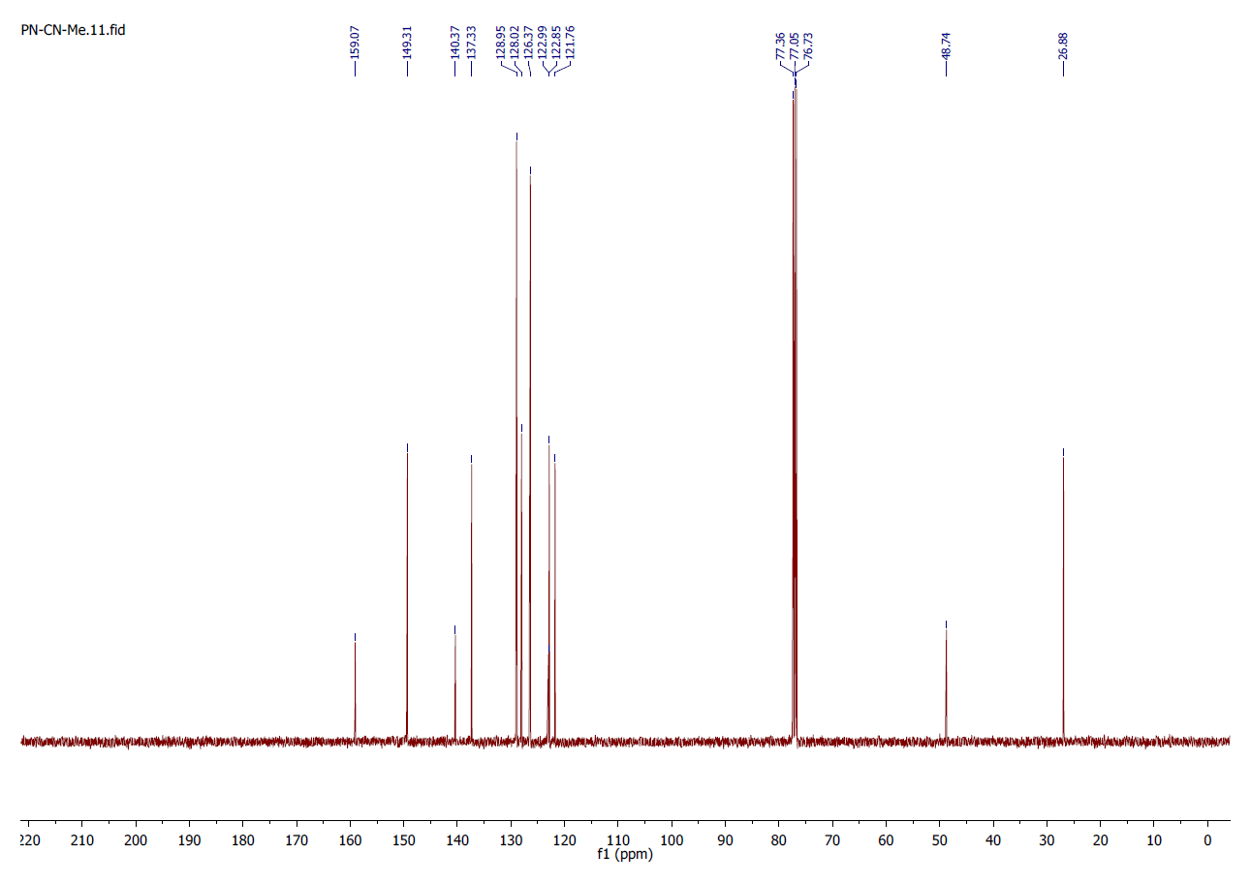
NMR pectra of 2-fluoro-2-phenyl-2-(pyridin-2-yl)acetonitrile (2s)
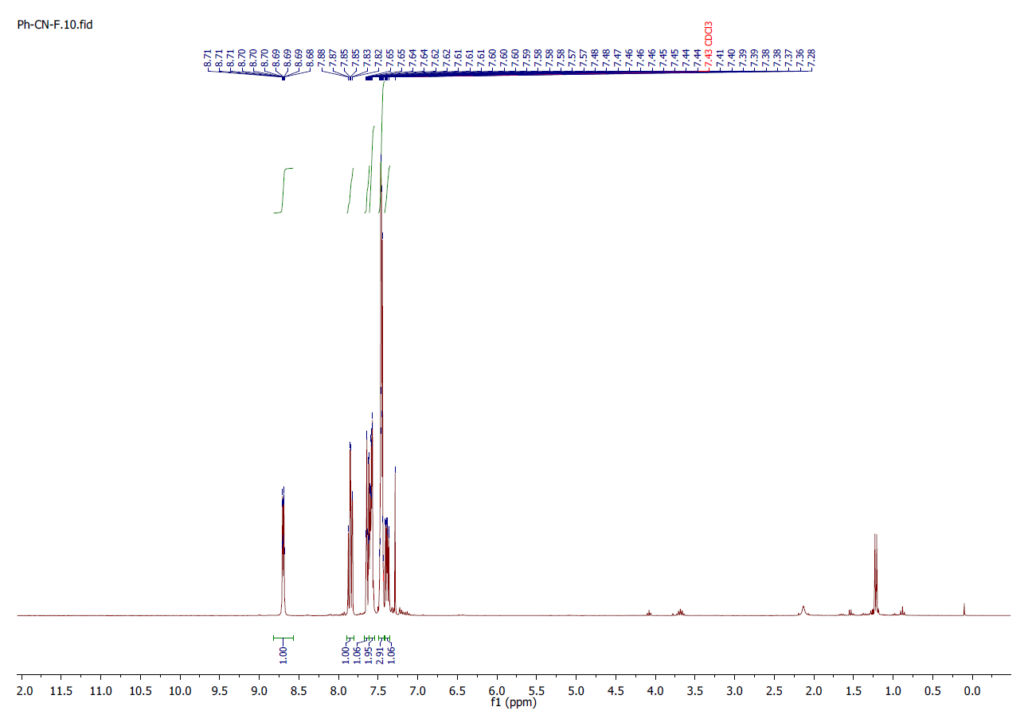
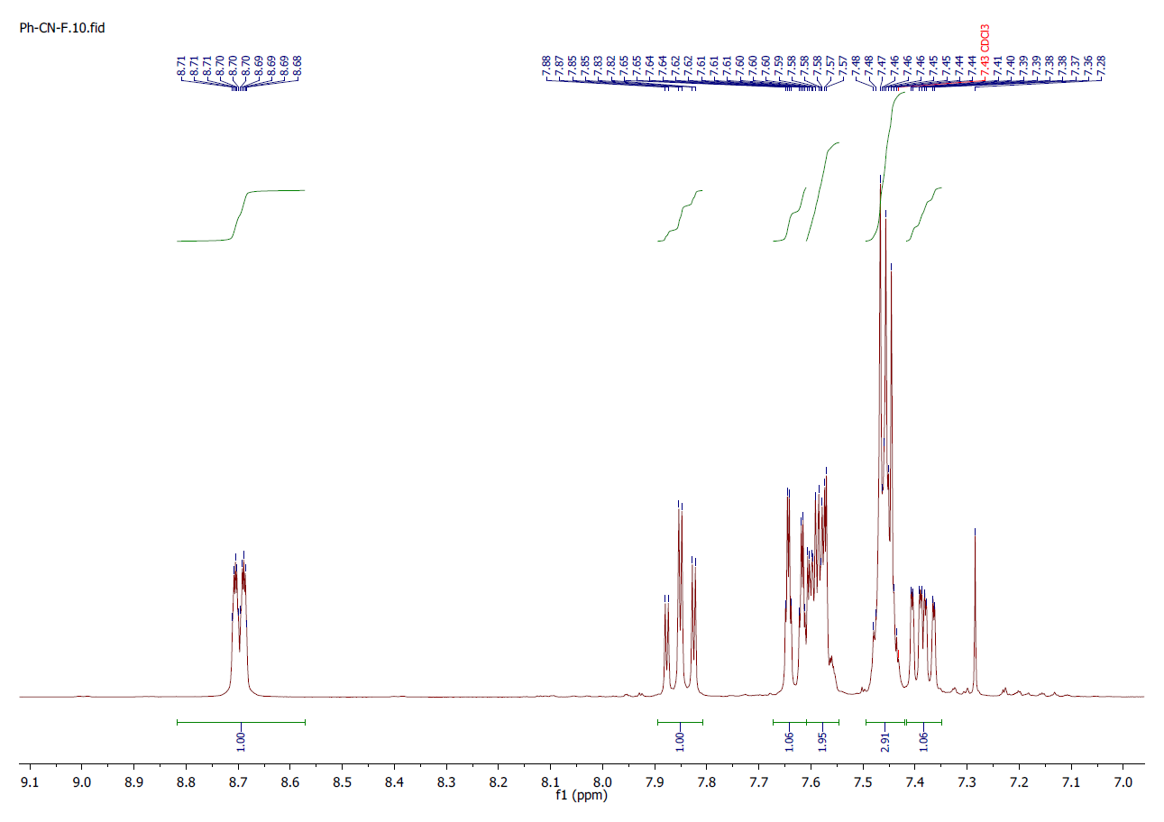
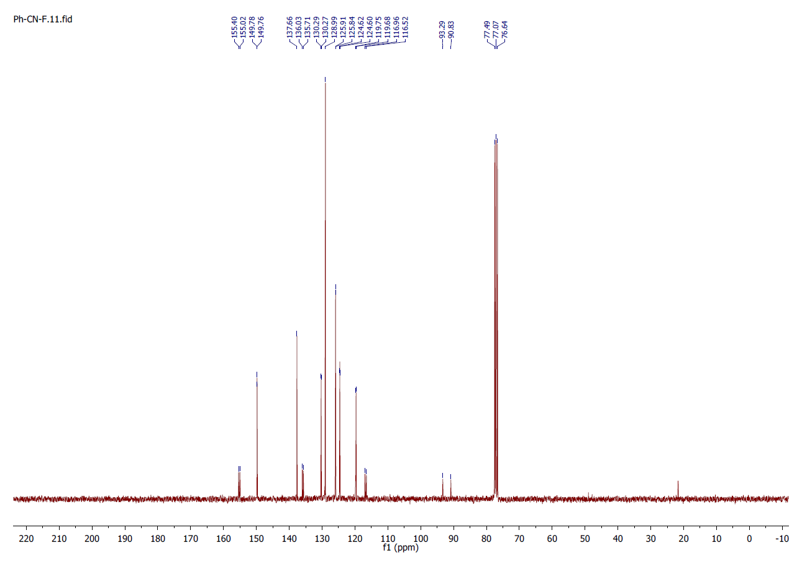
NMR spectra of 2-(3-chlorophenyl)-2-(pyridin-2-yl)acetamide (3e):

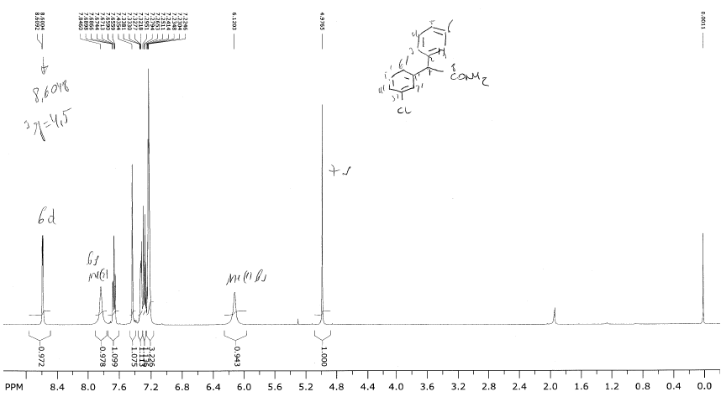

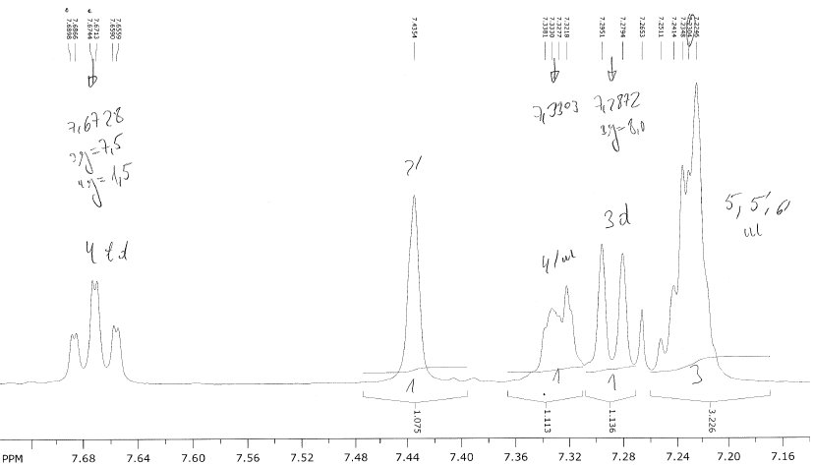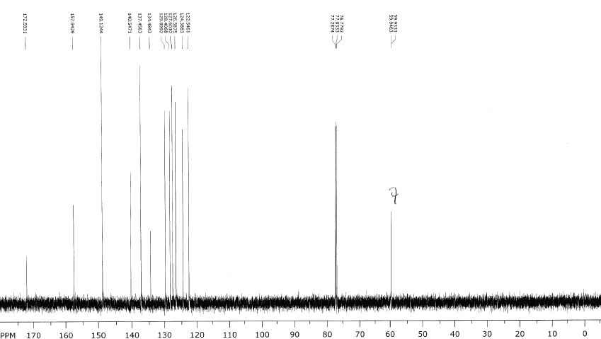

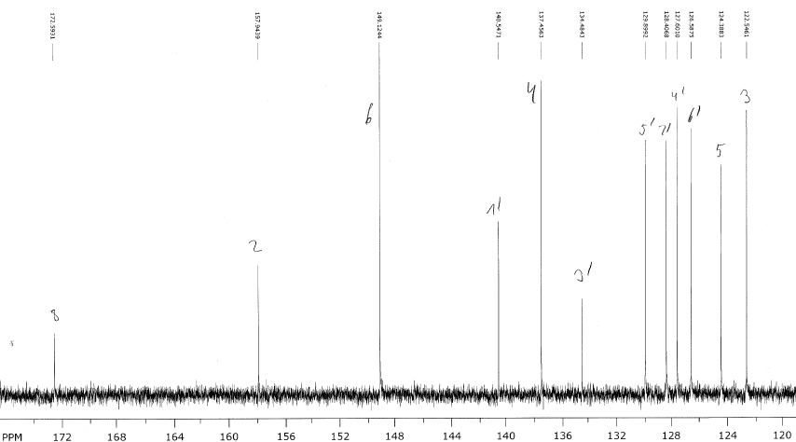

NMR spectra of 2-(3-methyl)-2-(pyridin-2-yl)acetamide (3f):
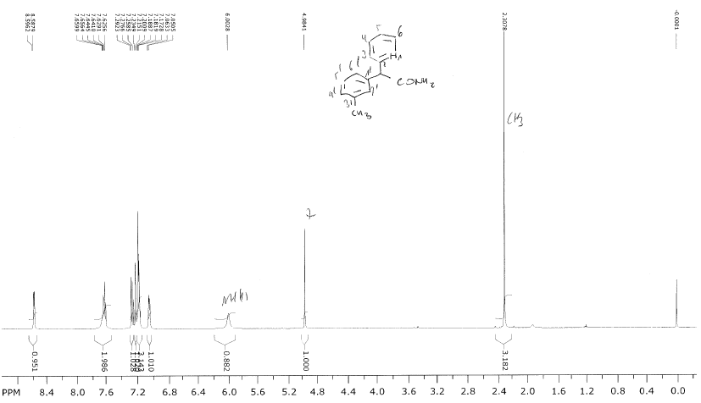

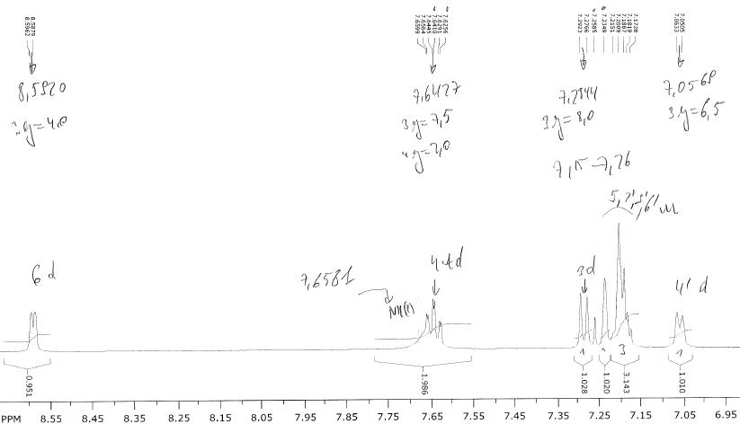

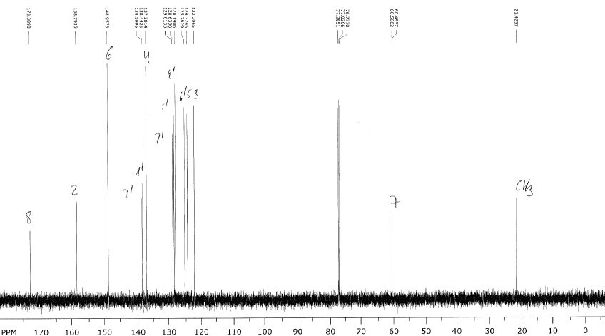

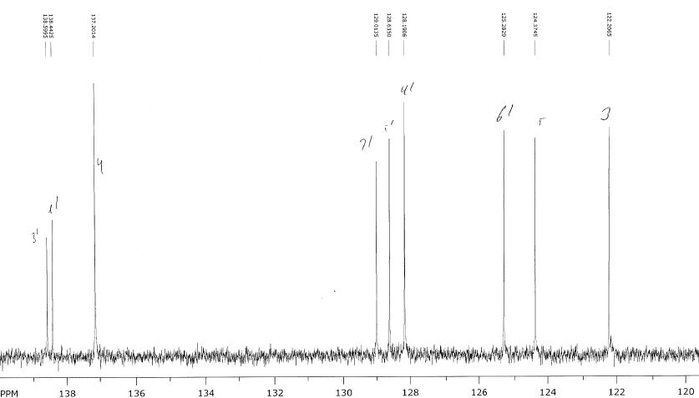
NMR spectra of 2-(3-methoxy)-2-(pyridin-2-yl)acetamide (3g):
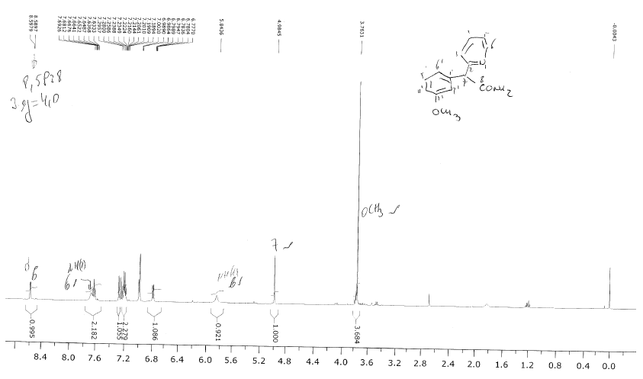

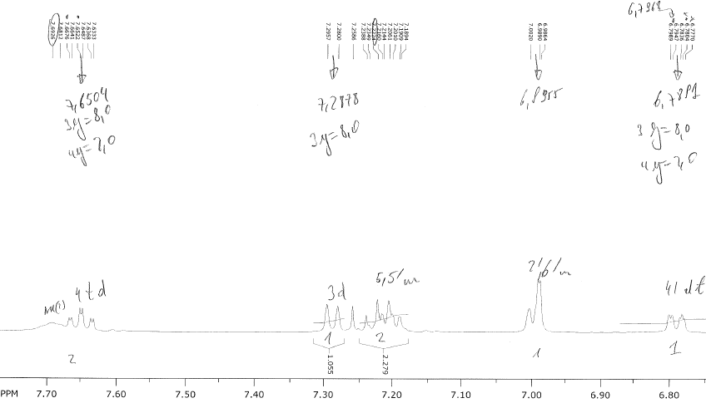

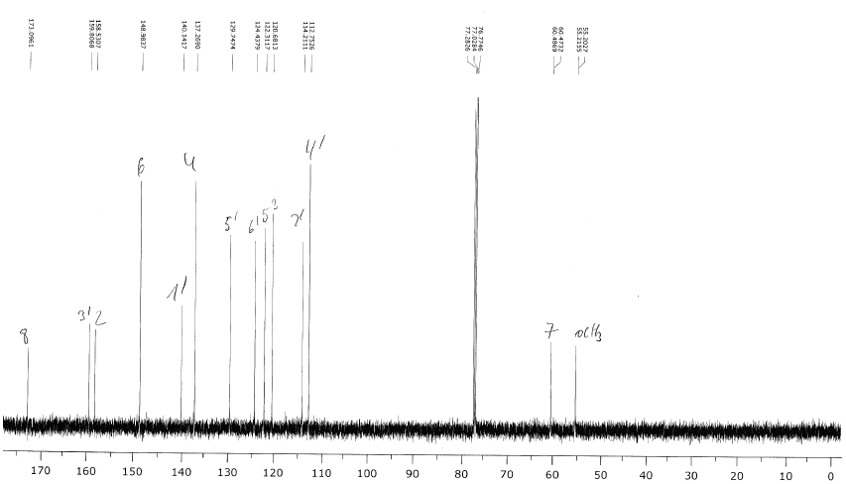
NMR spectra of 2-(3-fluorophenyl)-2-(pyridin-2-yl)acetamide (3h):

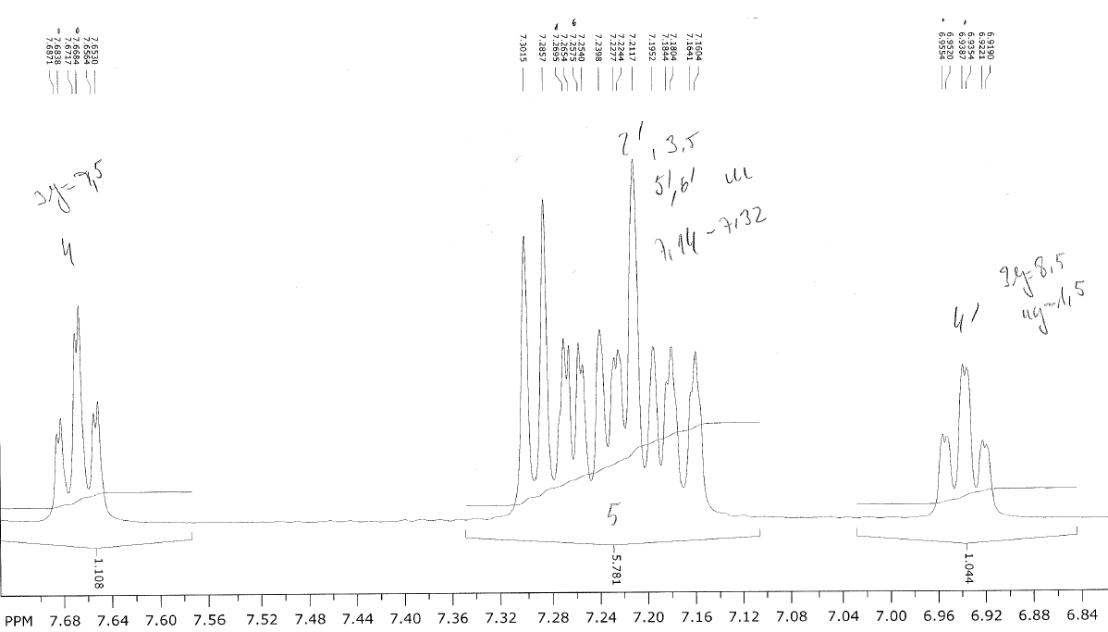

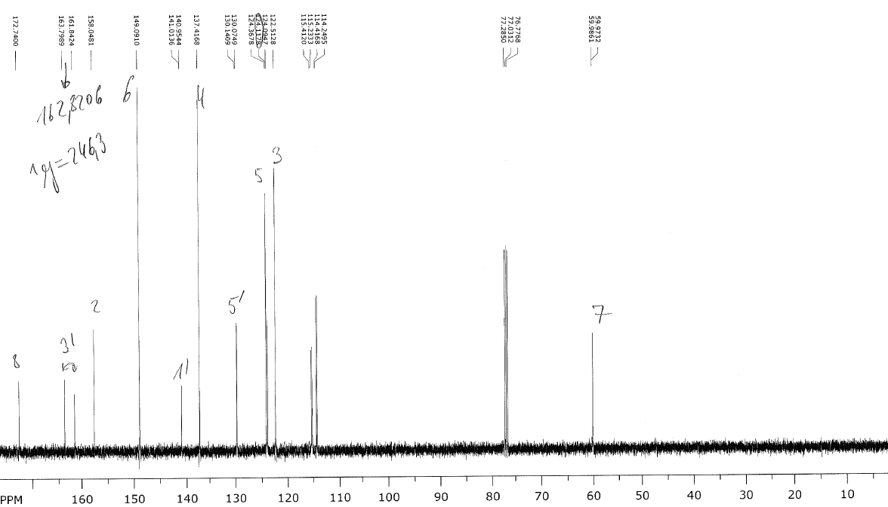

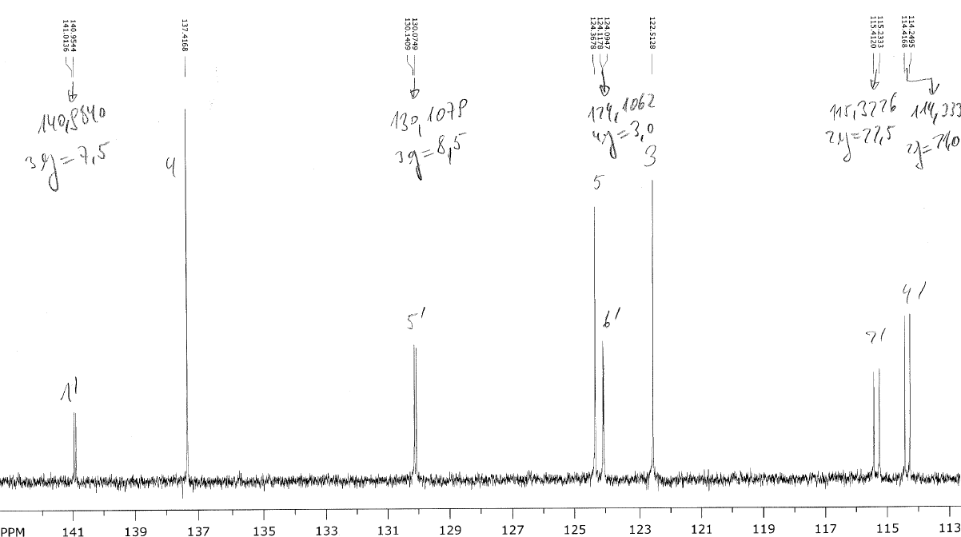

NMR spectra of 2-(3-trifluoromethylphenyl)-2-(pyridin-2-yl)acetamide (3i)
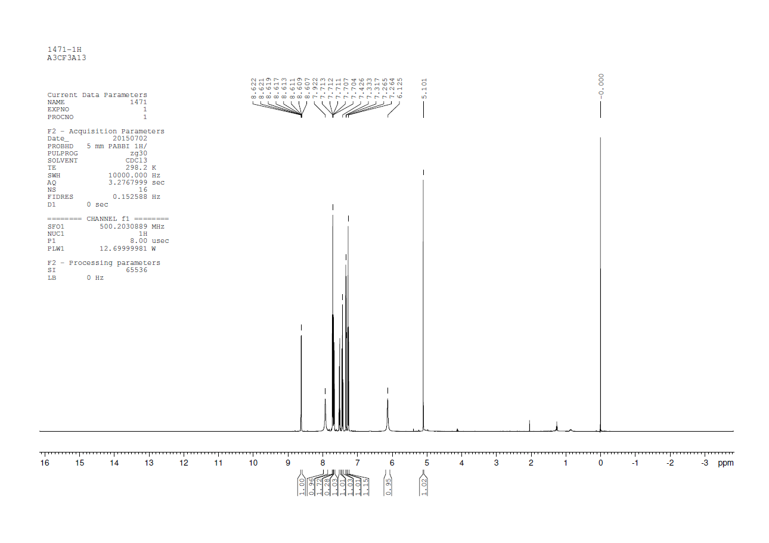
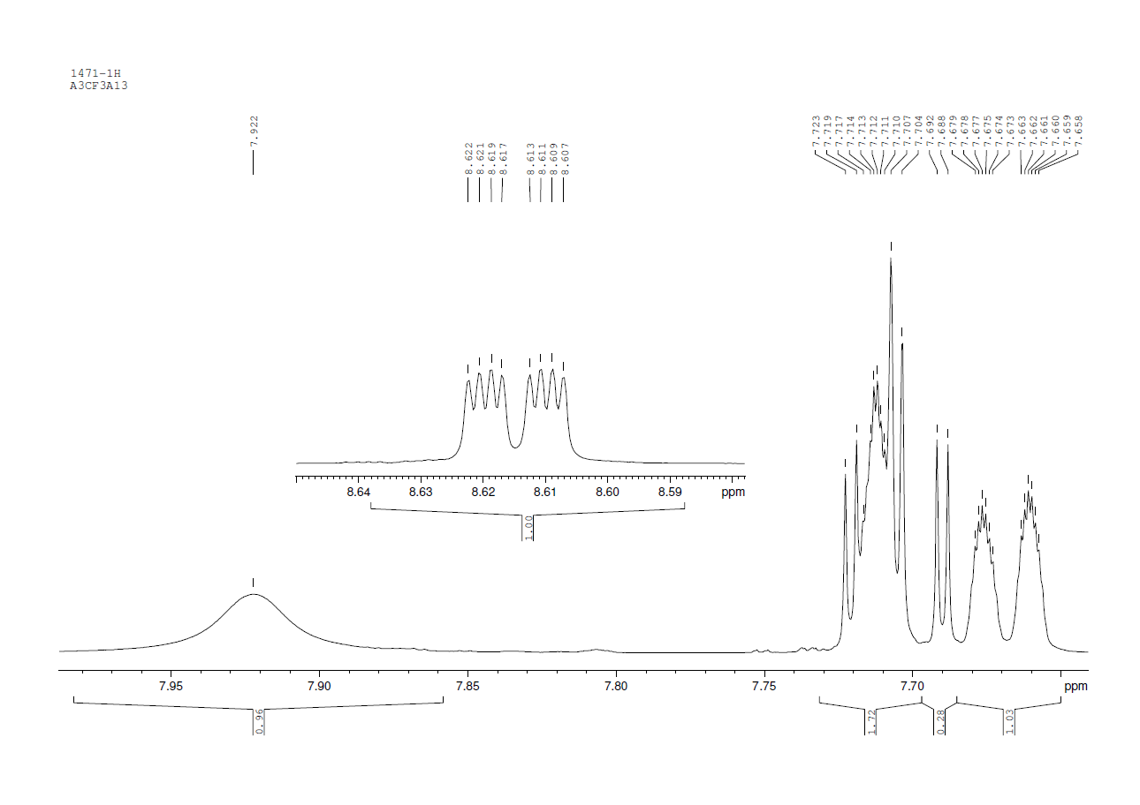
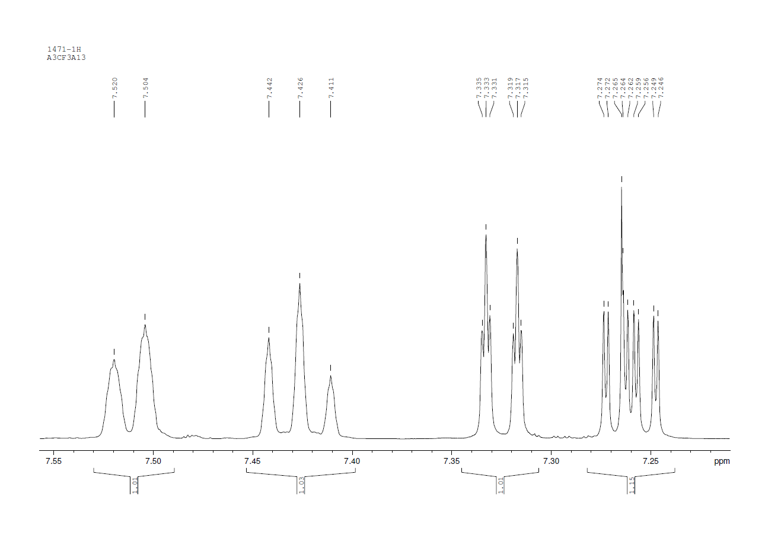
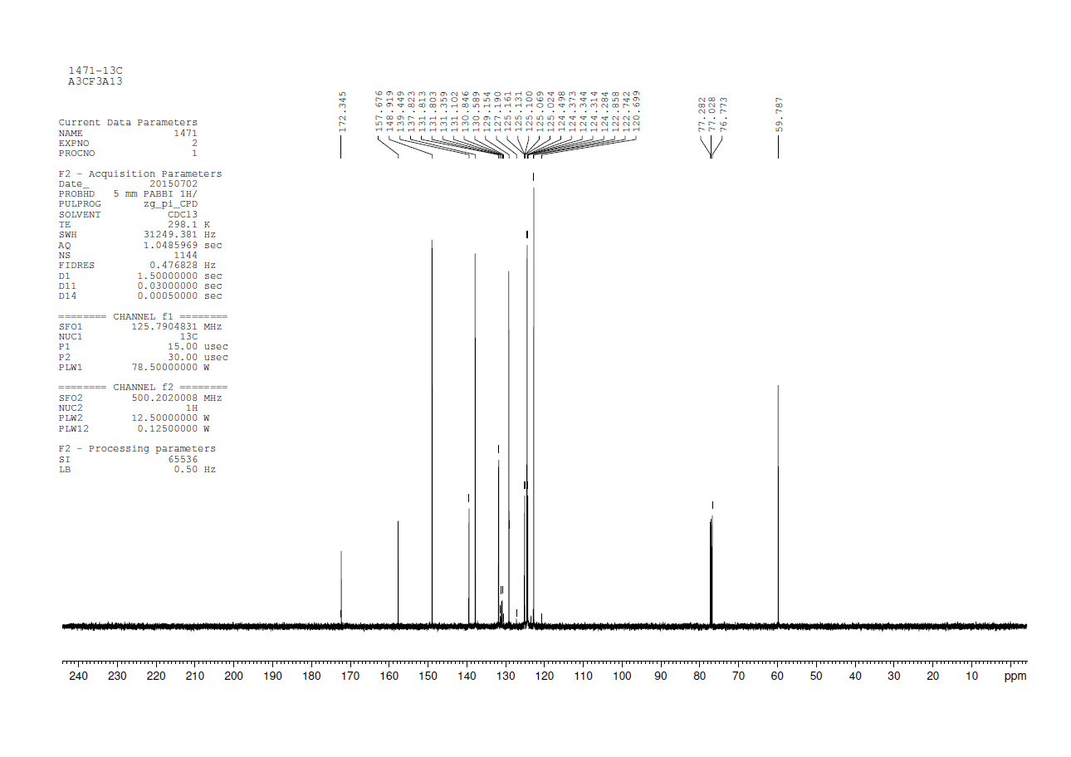
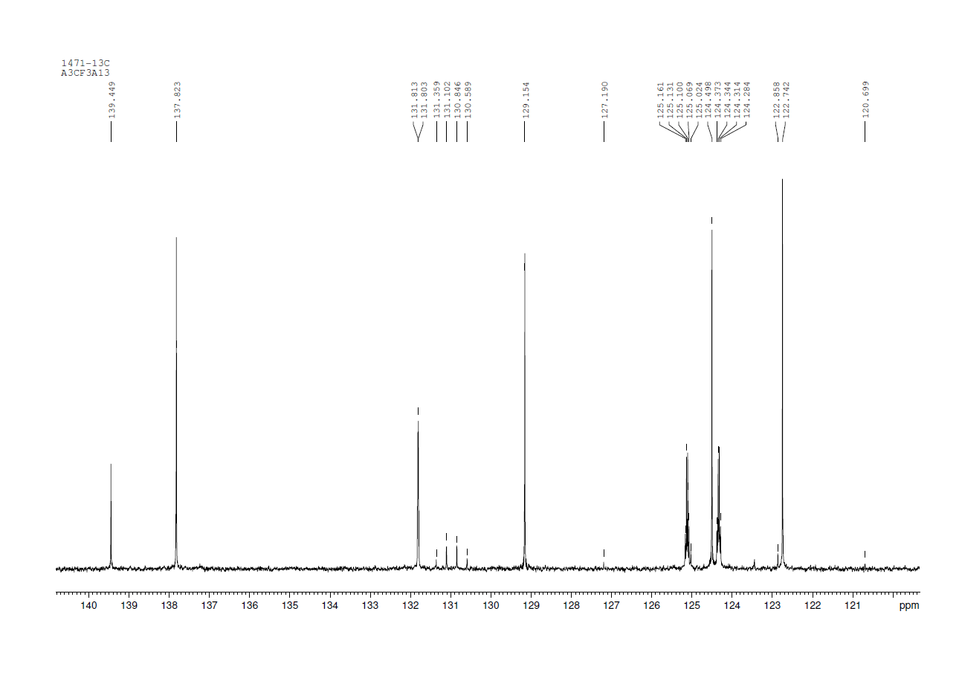
NMR spectra of 2-(3,4-dichlorophenyl)-2-(pyridin-2-yl)acetamide (3n)
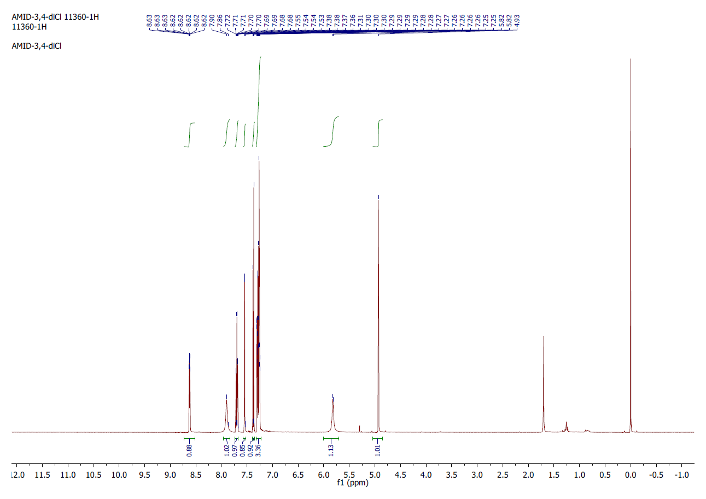
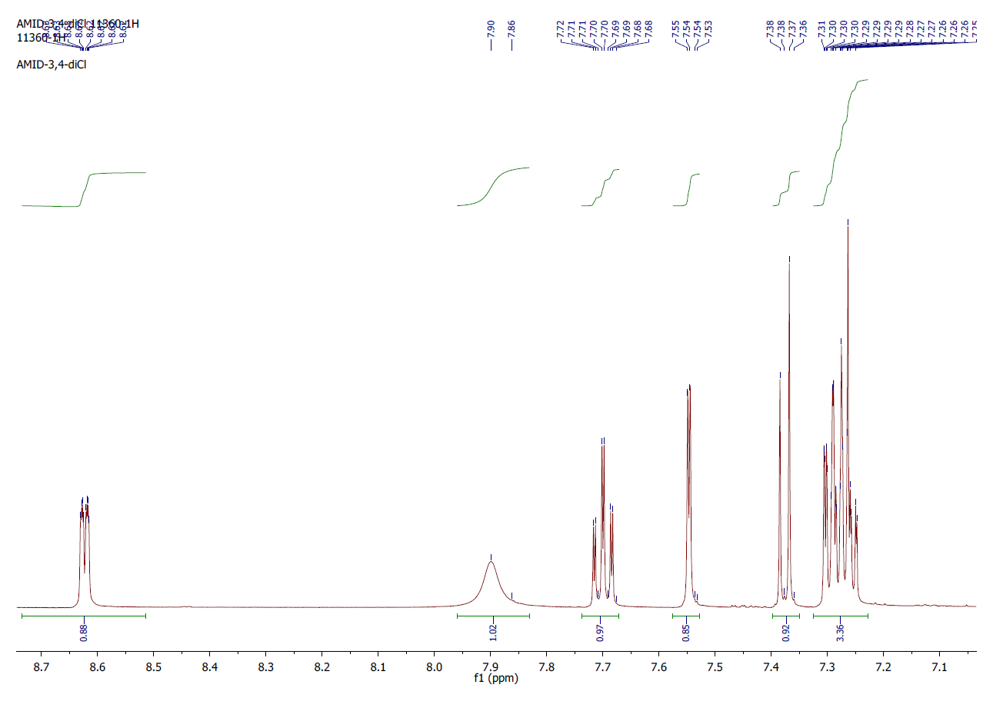
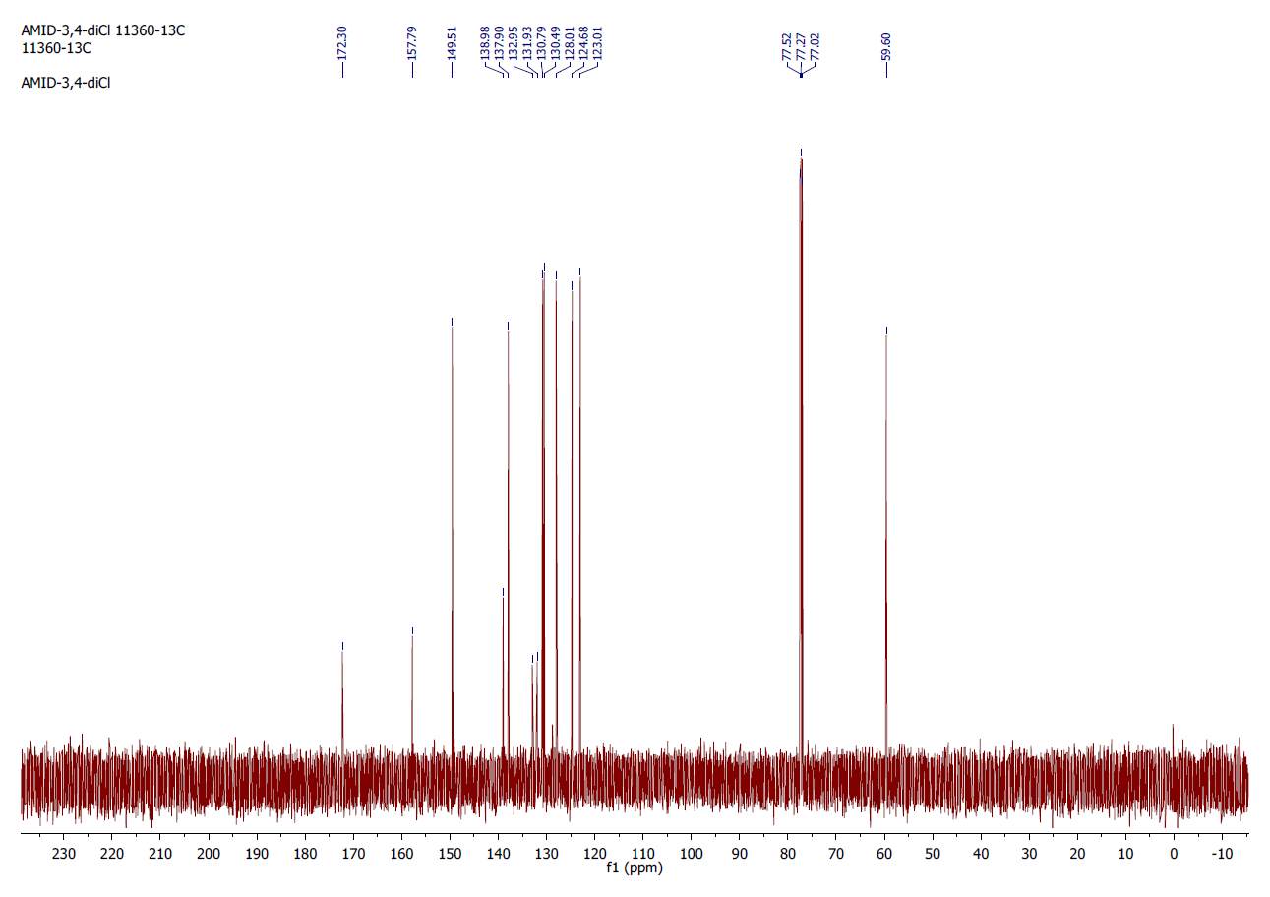
NMR spectra of 2,2-di(pyridin-2-yl)acetamide (2o)

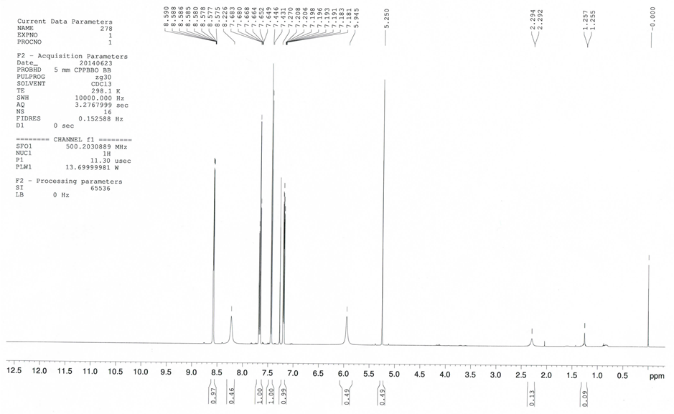

NMR spectra of 2-(1-naphthyl)-2-(pyridin-2-yl)acetamide (3p)
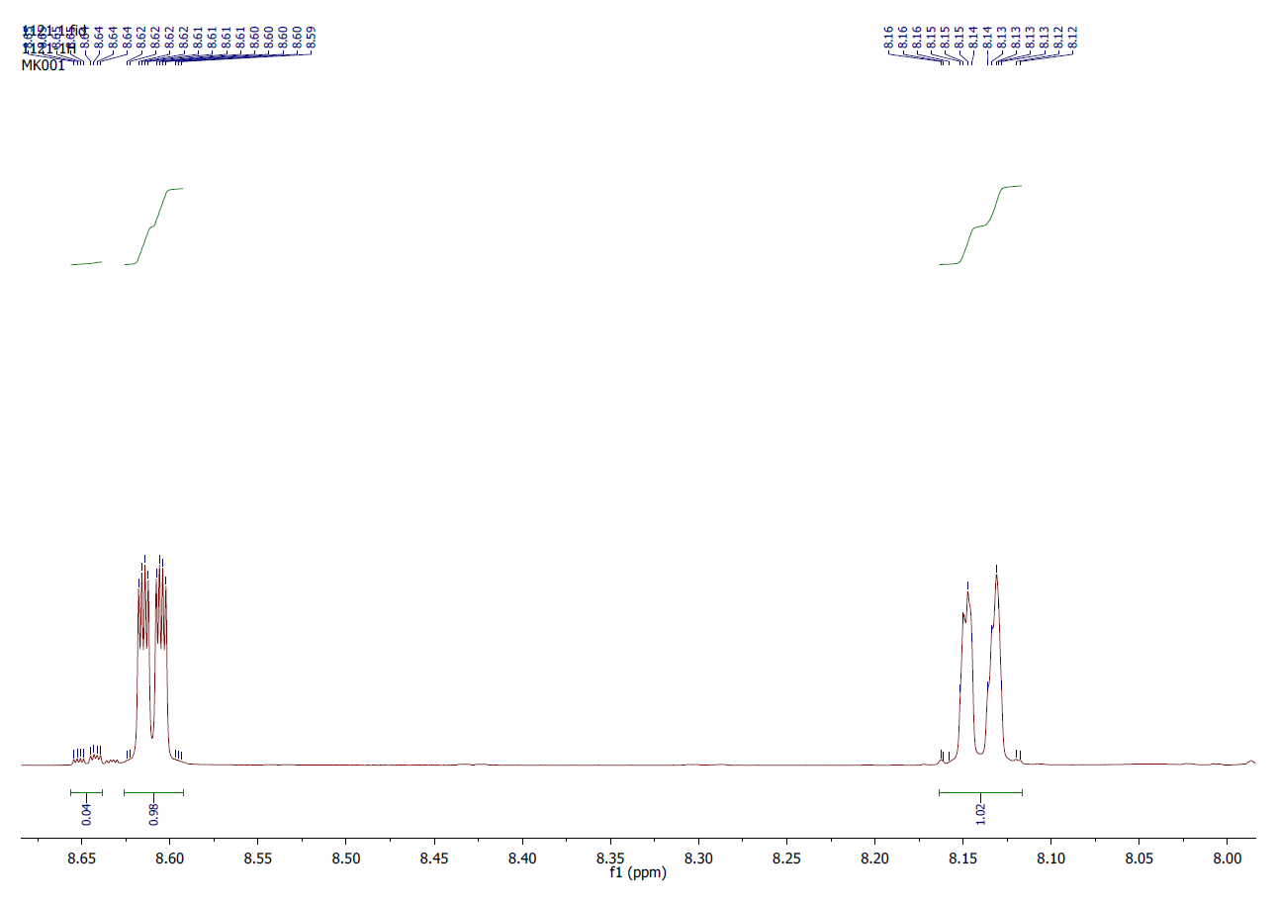
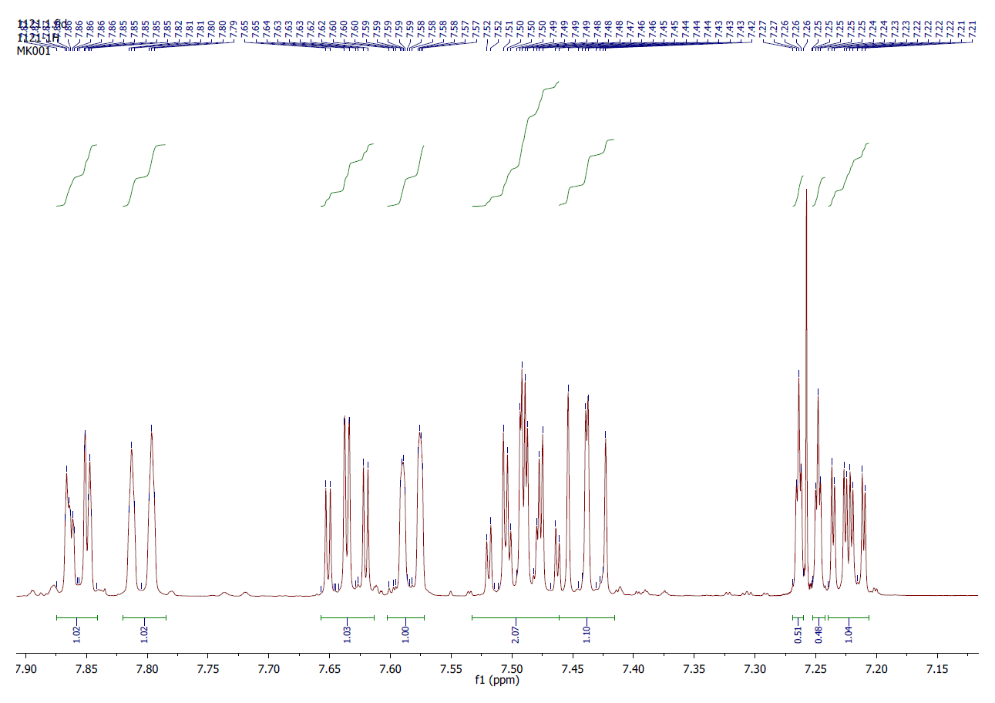
NMR spectra of 2-(2-naphthyl)-2-(pyridin-2-yl)acetamide (3q)
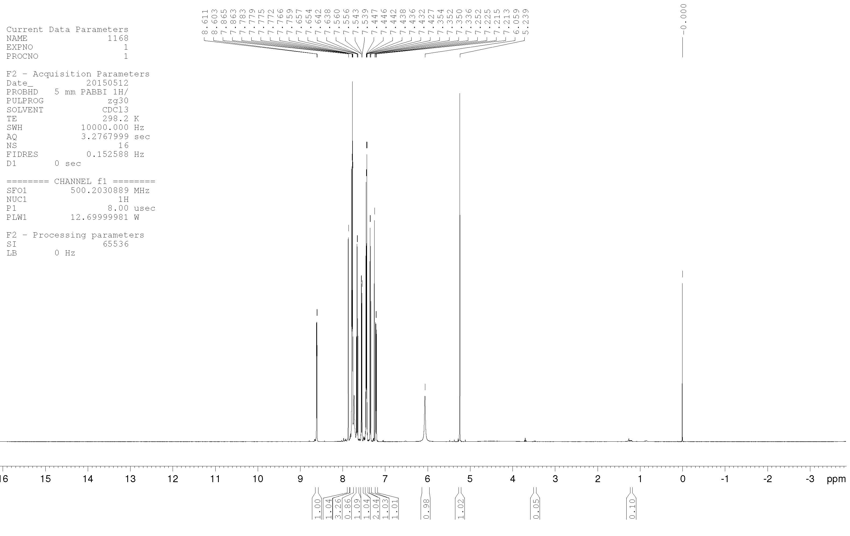

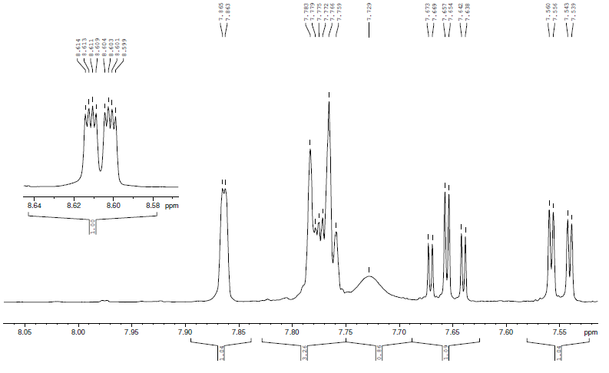
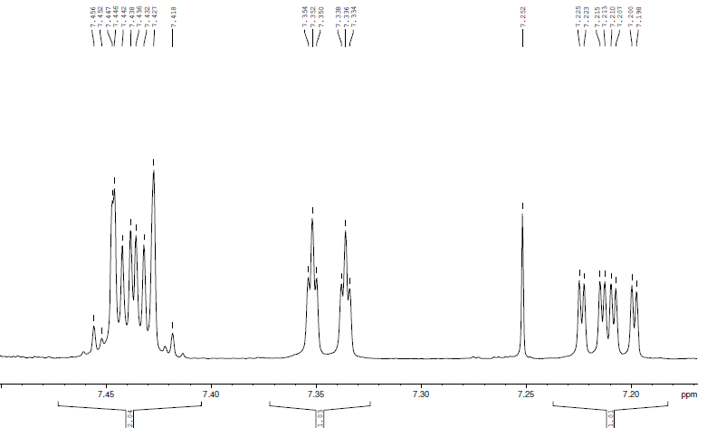

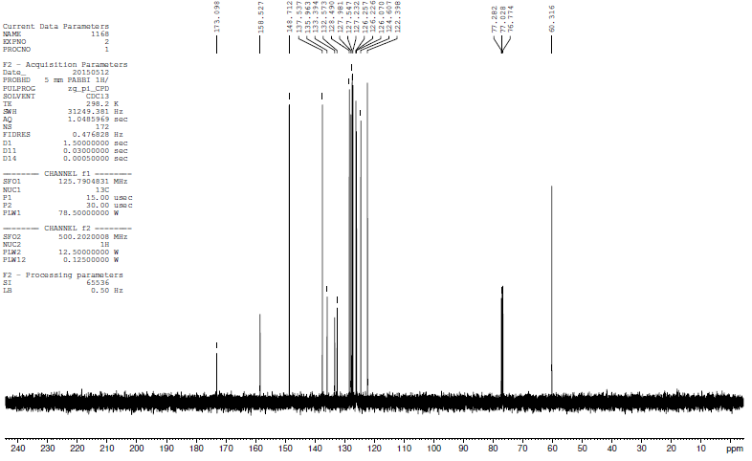

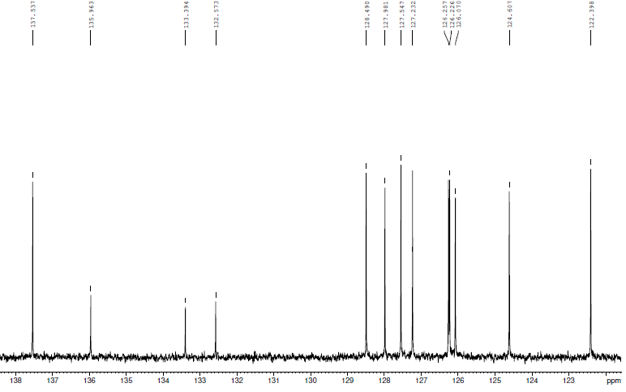
NMR spectra of 2-methyl-2-phenyl-2-(pyridin-2-yl)acetamide (3r)
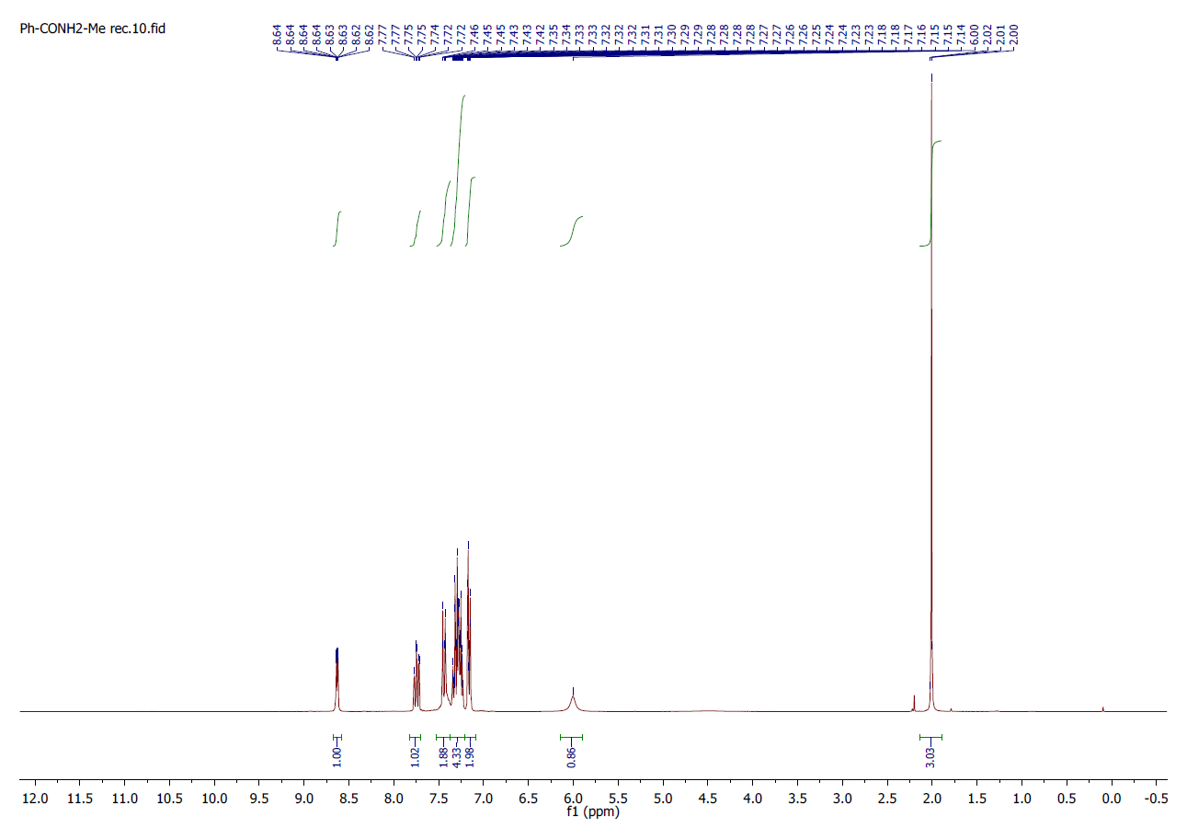
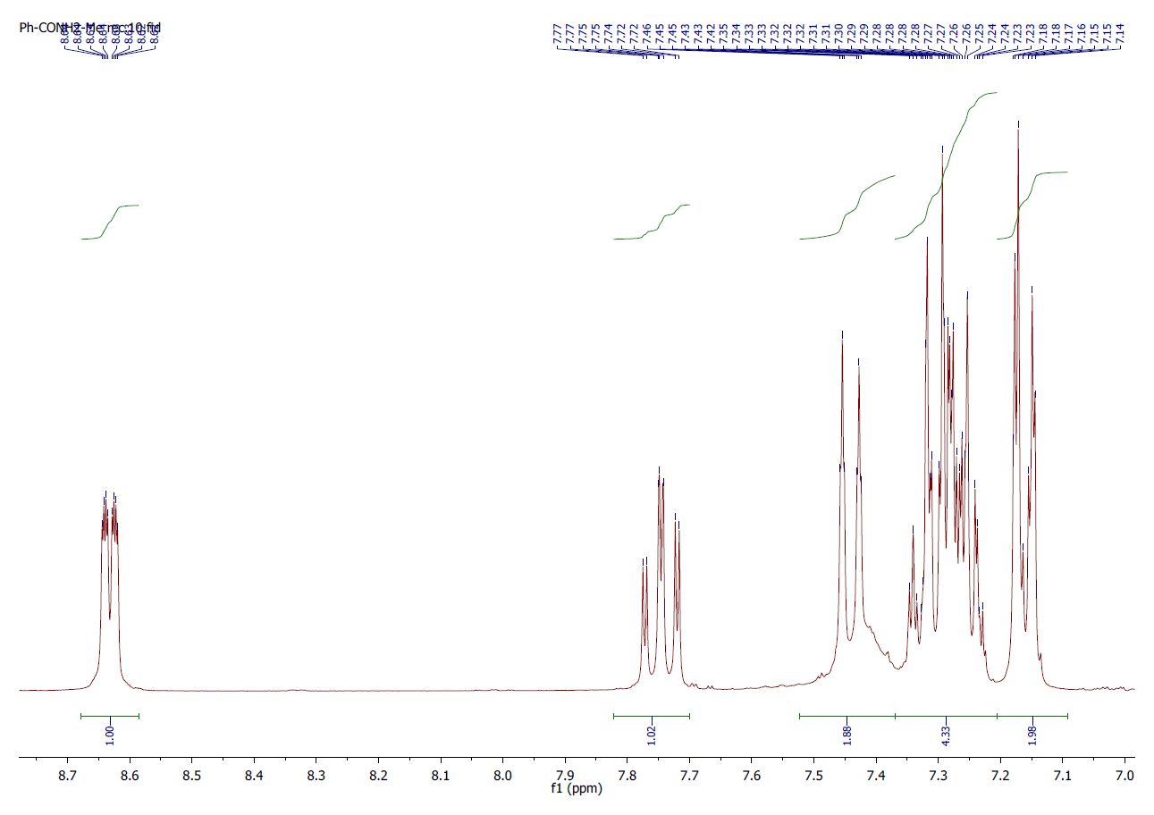
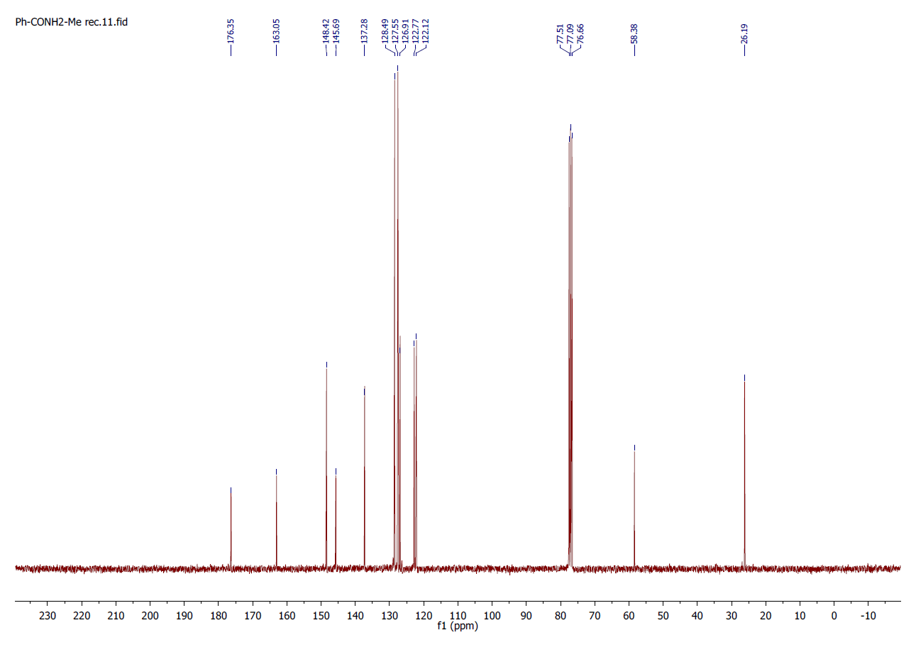
NMR spectra of 2-fluoro-2-phenyl-2-(pyridin-2-yl)acetamide (3s)
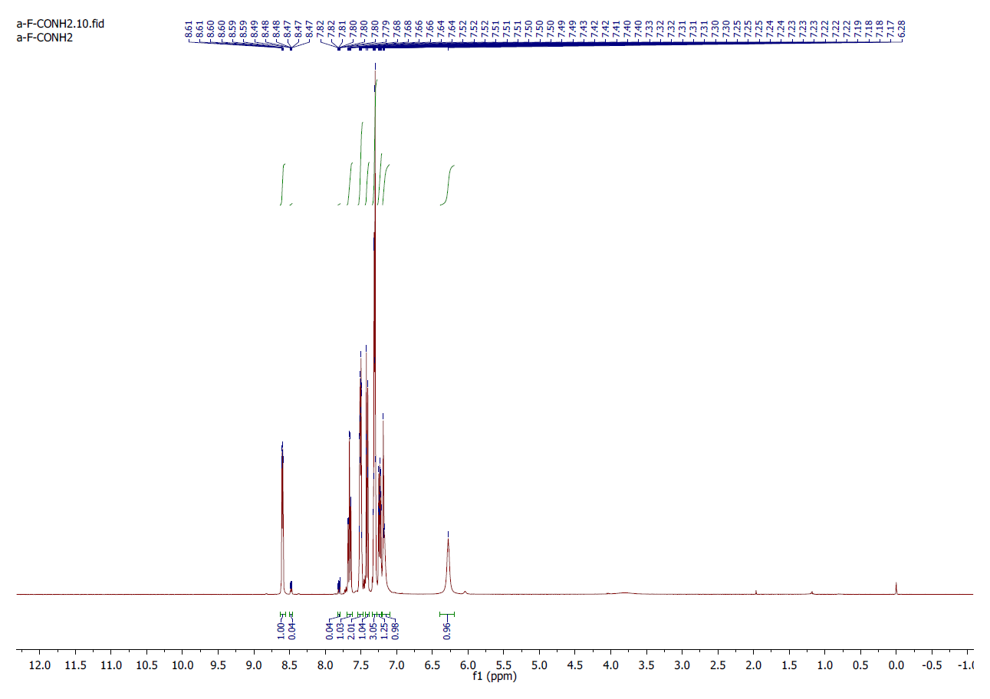
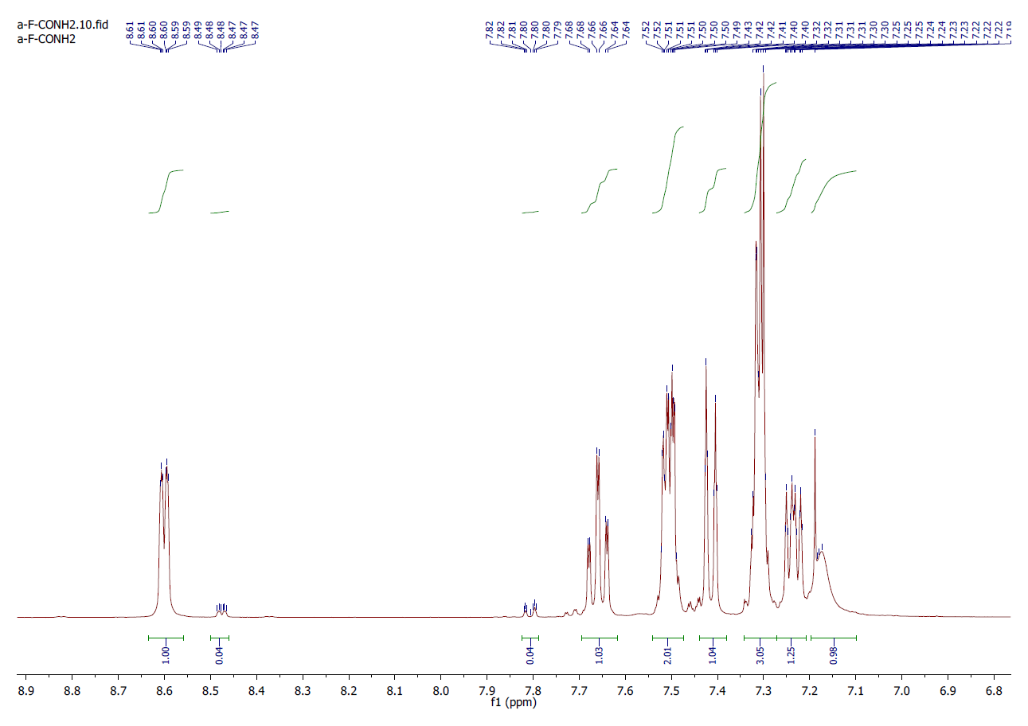
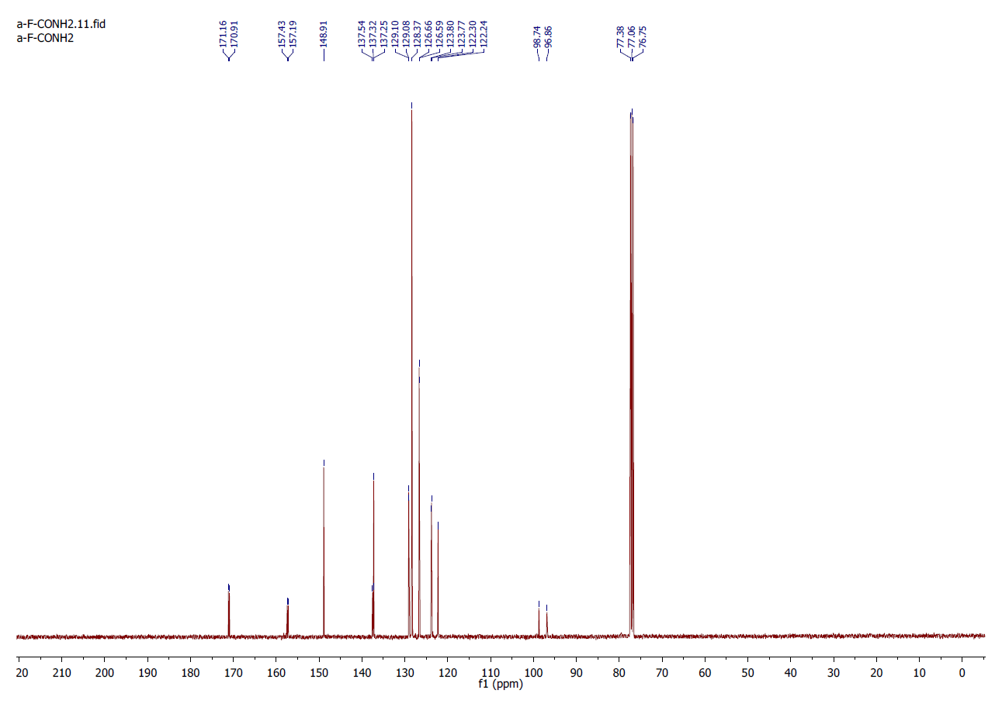
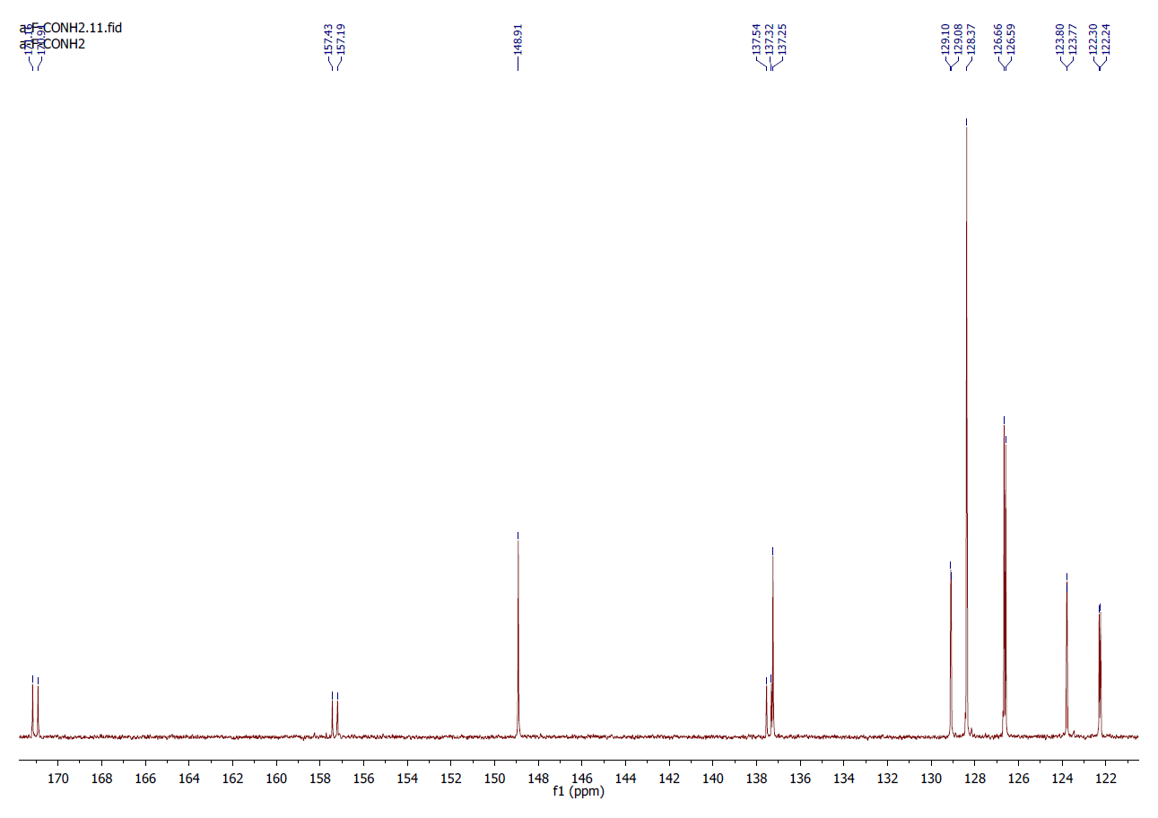
NMR spectra of Methyl 2-phenyl-2-(piridin-2yl)acetate (4):
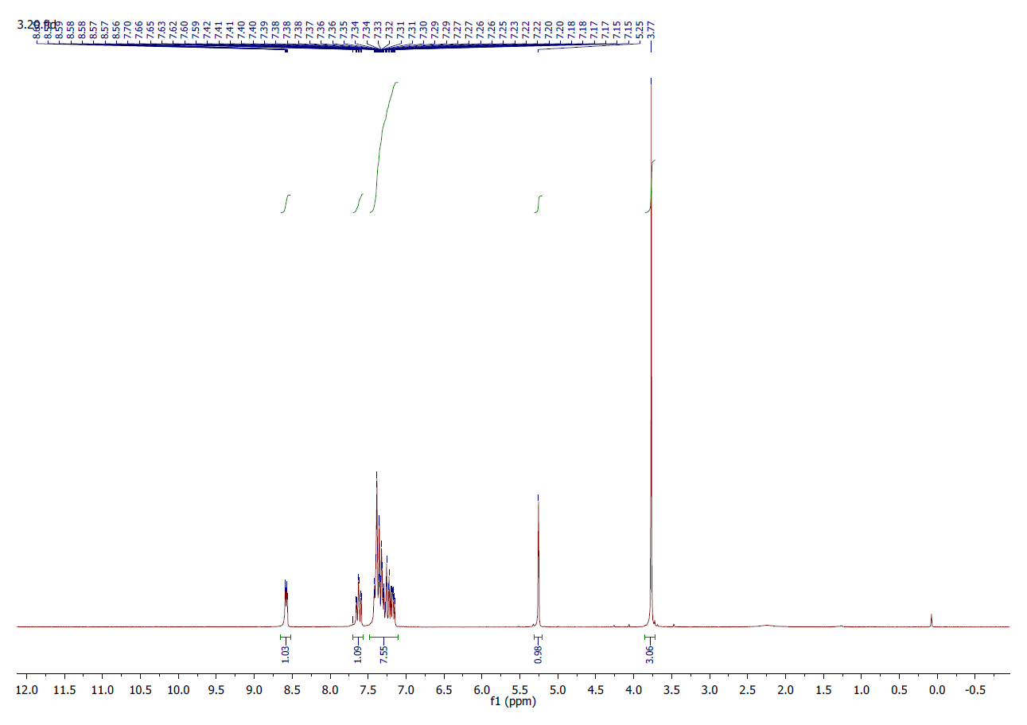
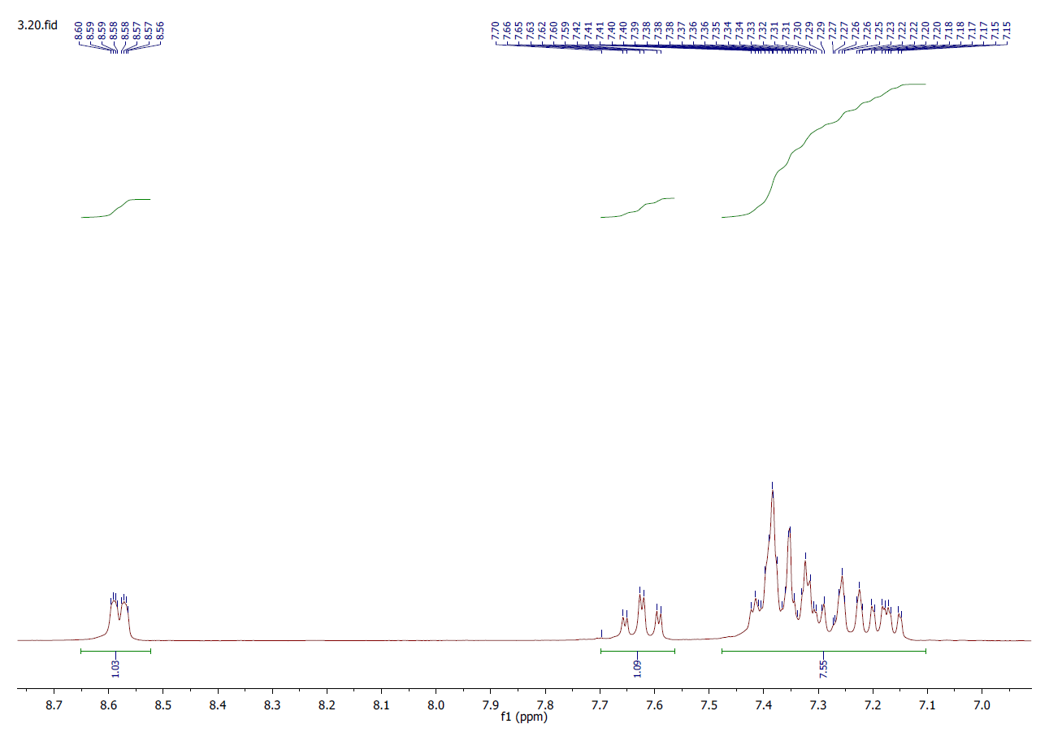
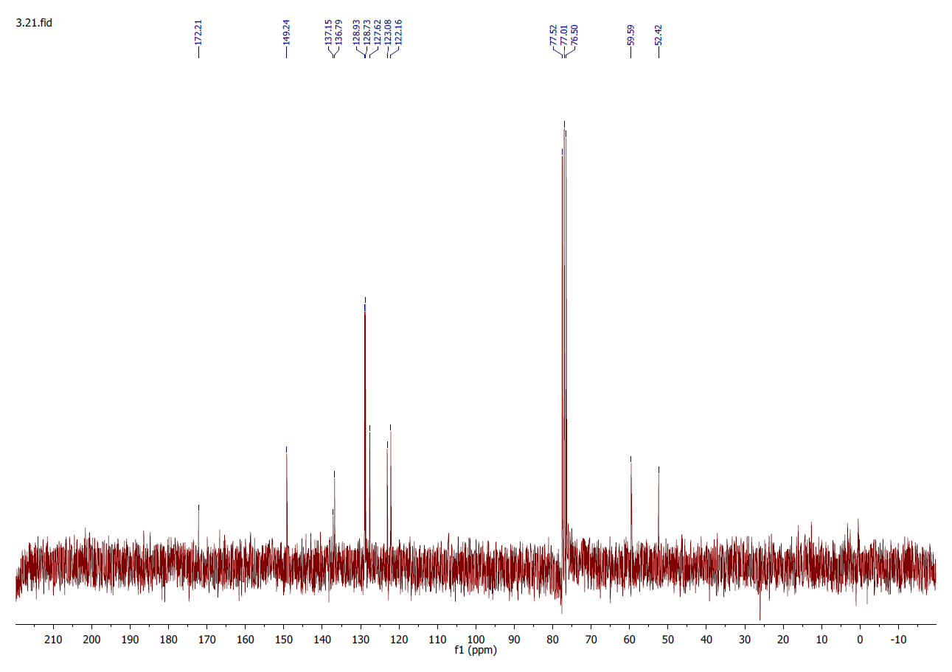
NMR spectra of N-methyl-2-phenyl-2-(piridin-2yl)acetamide (5a):
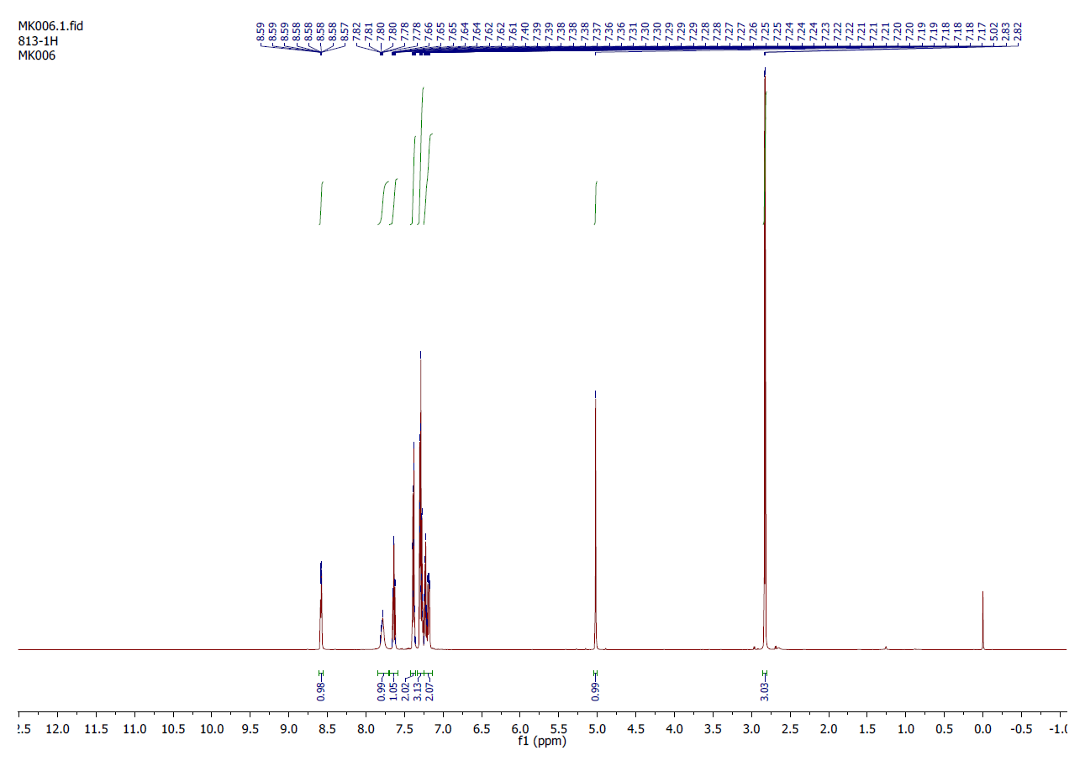
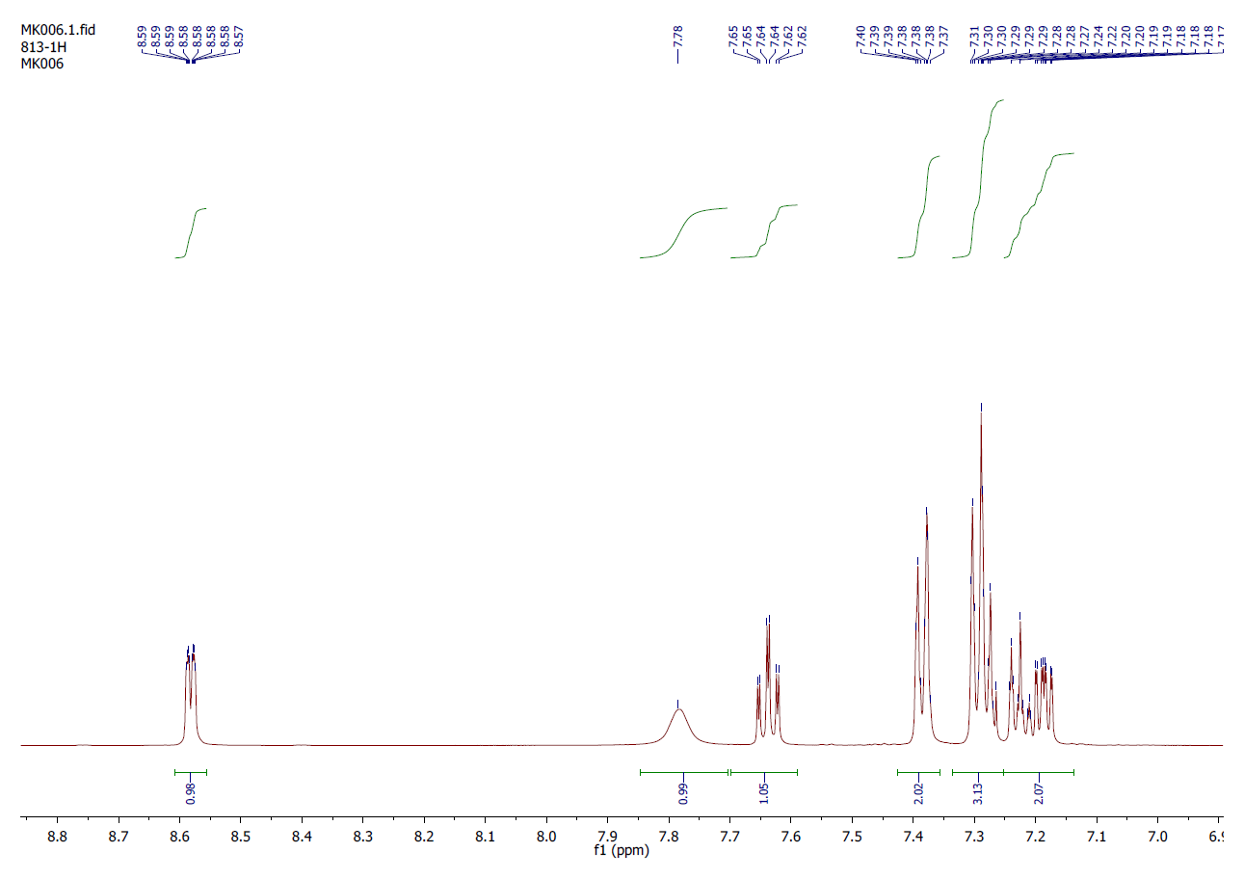
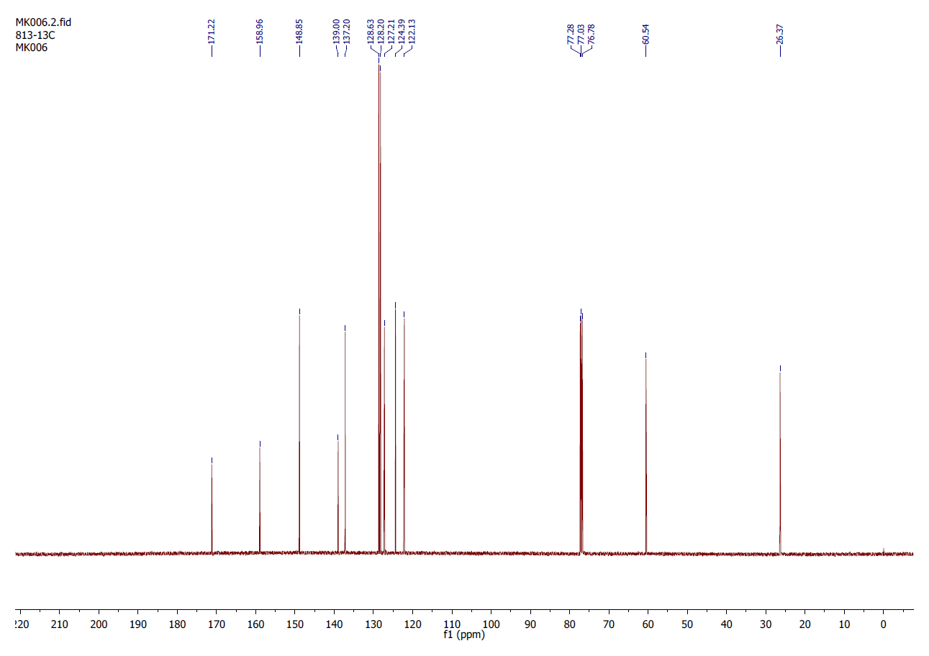
NMR spectrum of N-ethyl-2-phenyl-2-(piridin-2yl)acetamide (5b):
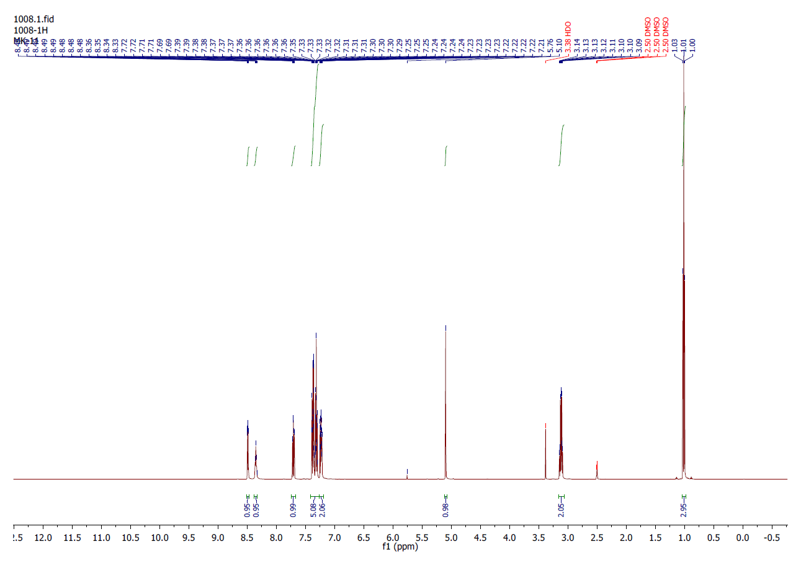
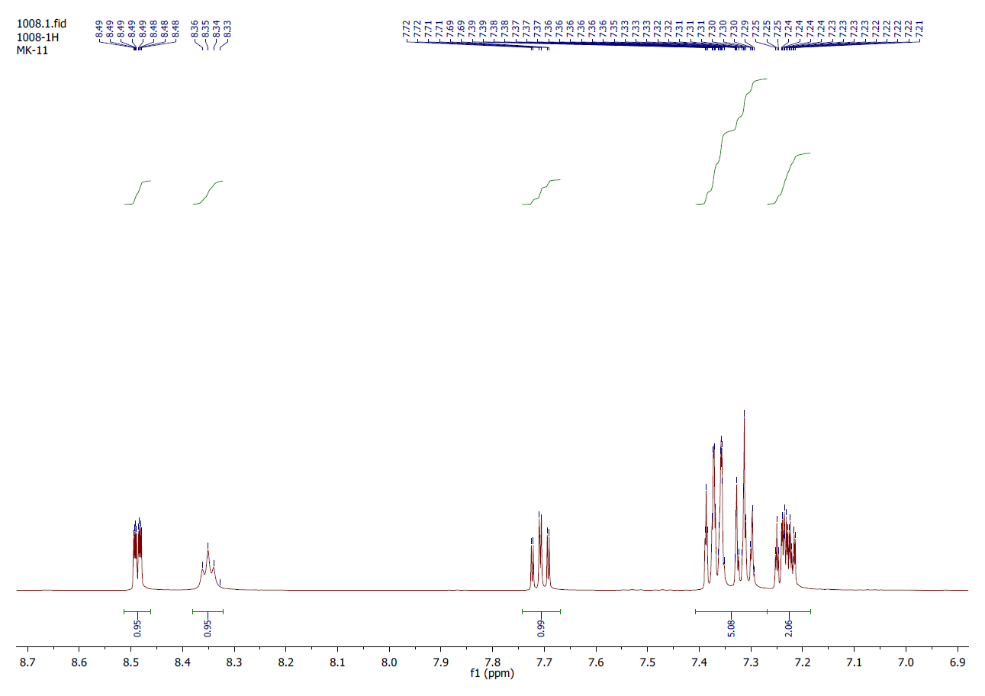
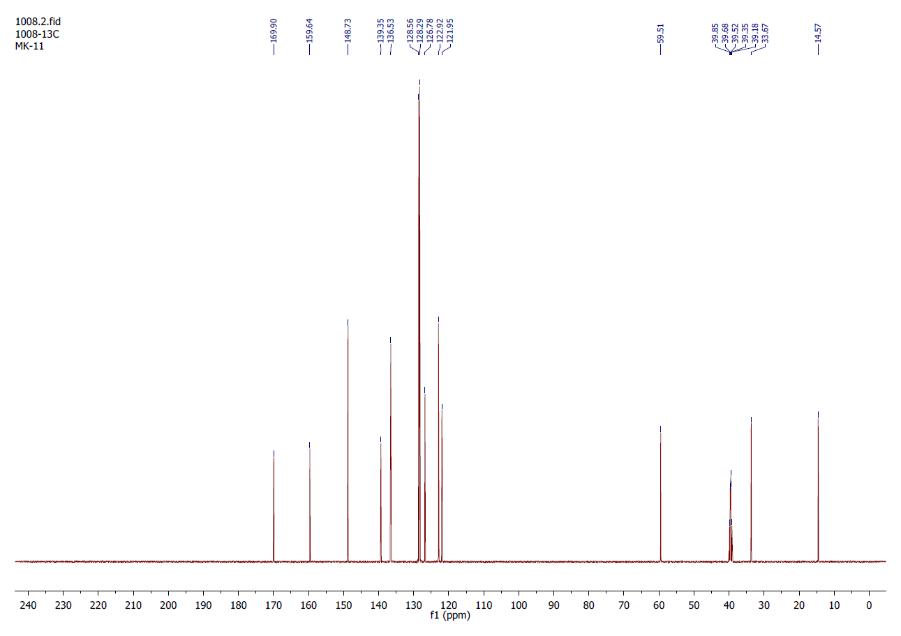
NMR spectrum of N-propyl-2-phenyl-2-(piridin-2yl)acetamide (5c):
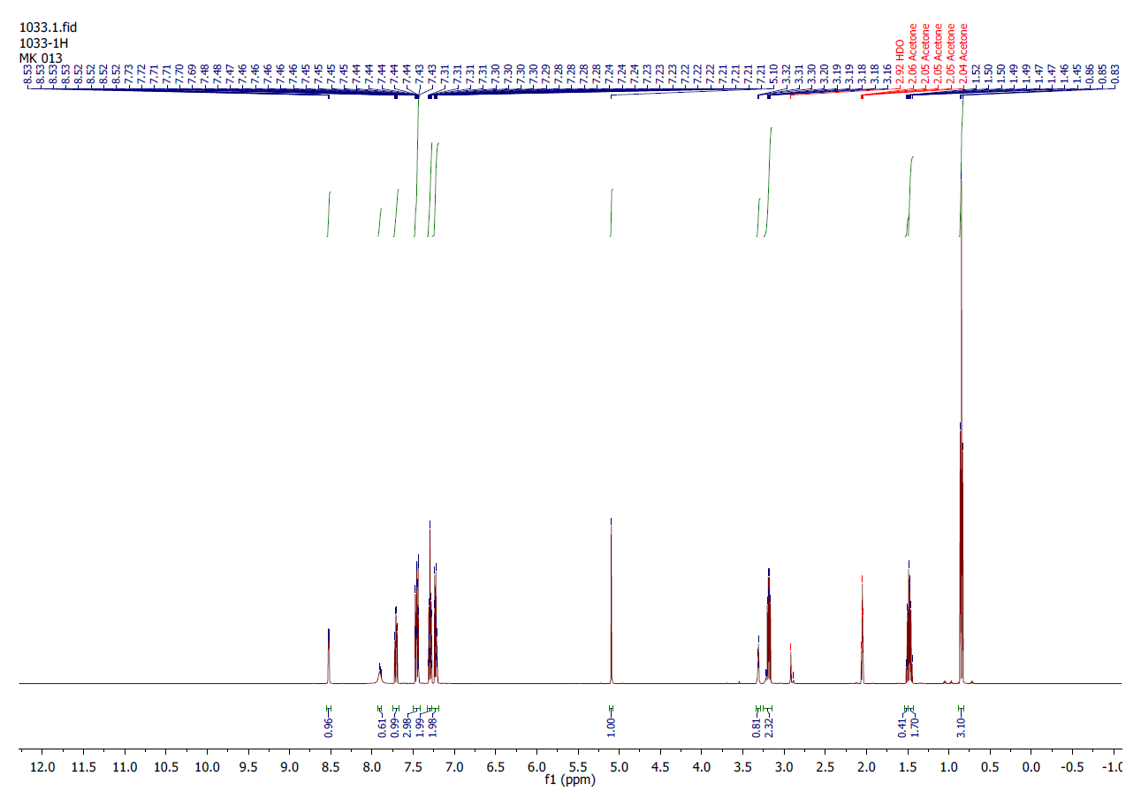
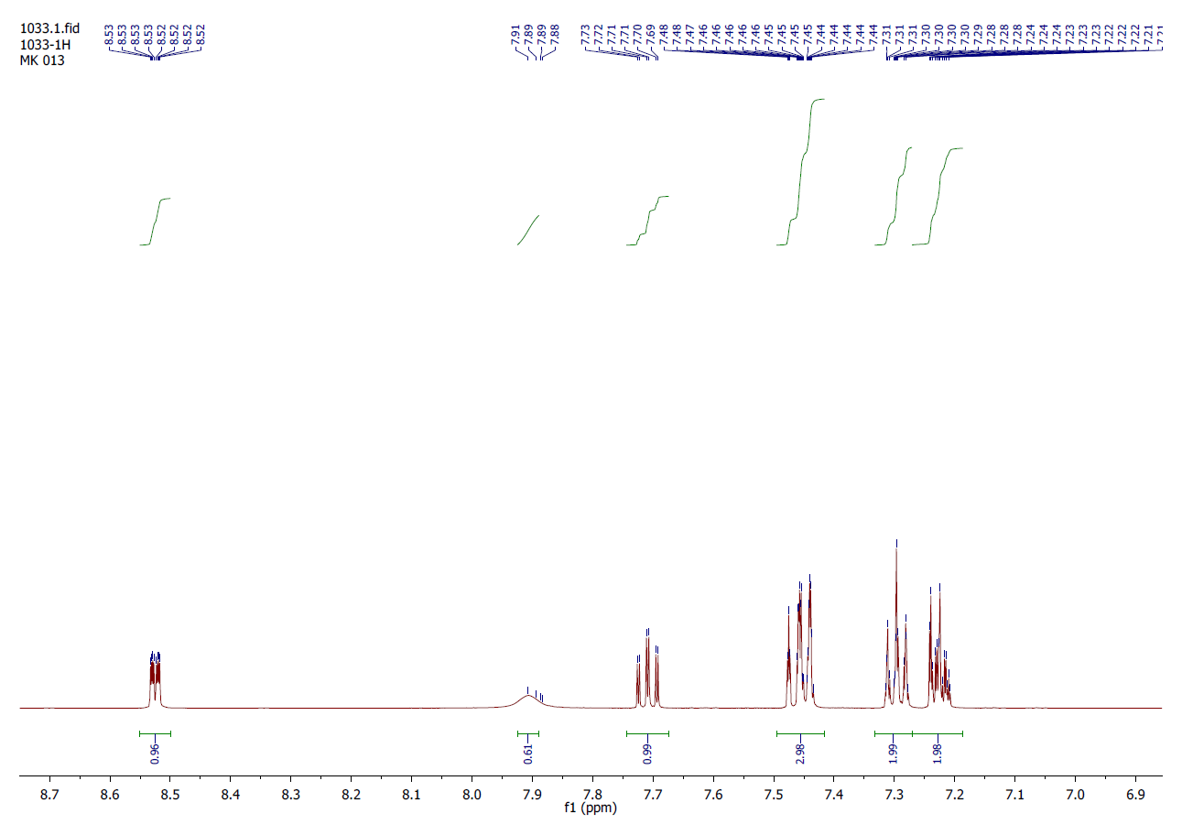
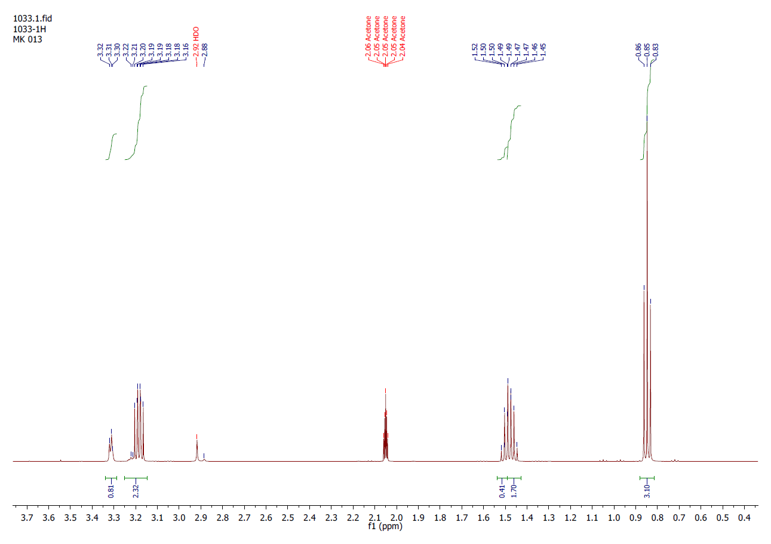
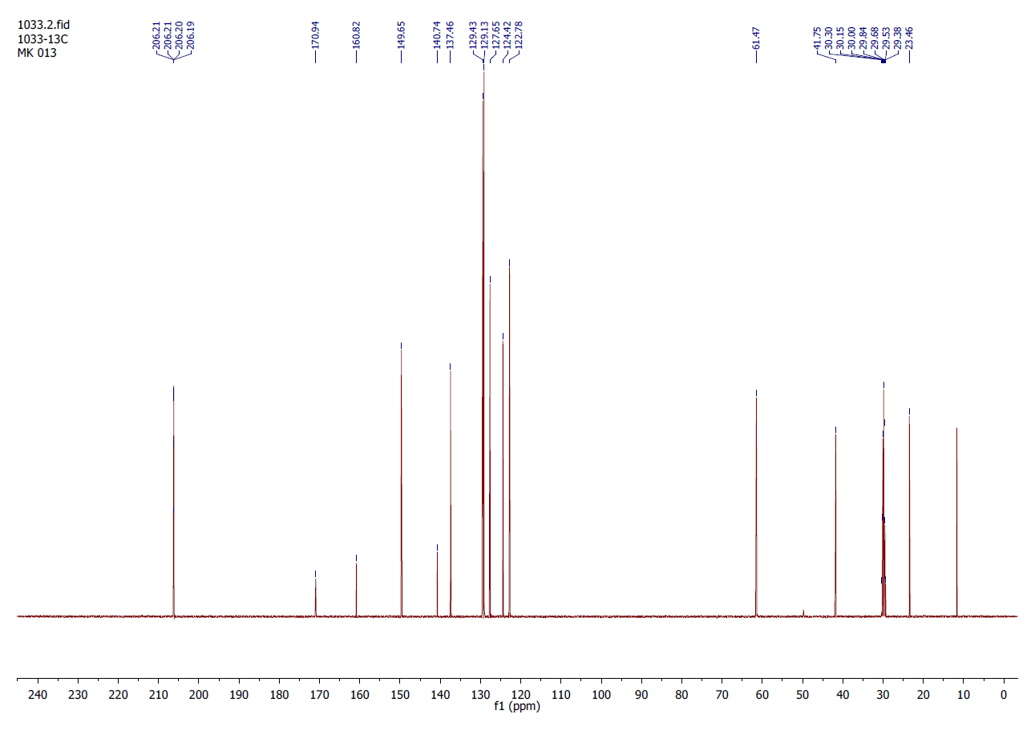
NMR spectrum of N-isopropyl-2-phenyl-2-(piridin-2yl)acetamide (5d)
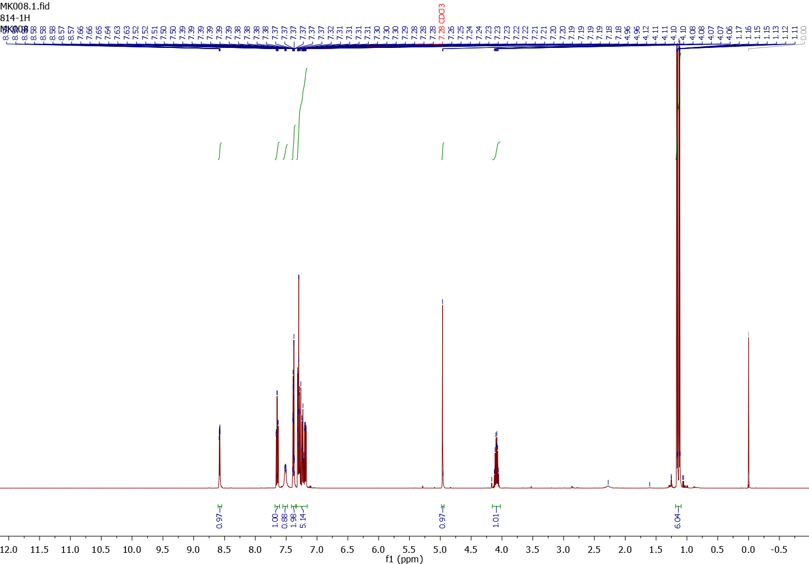
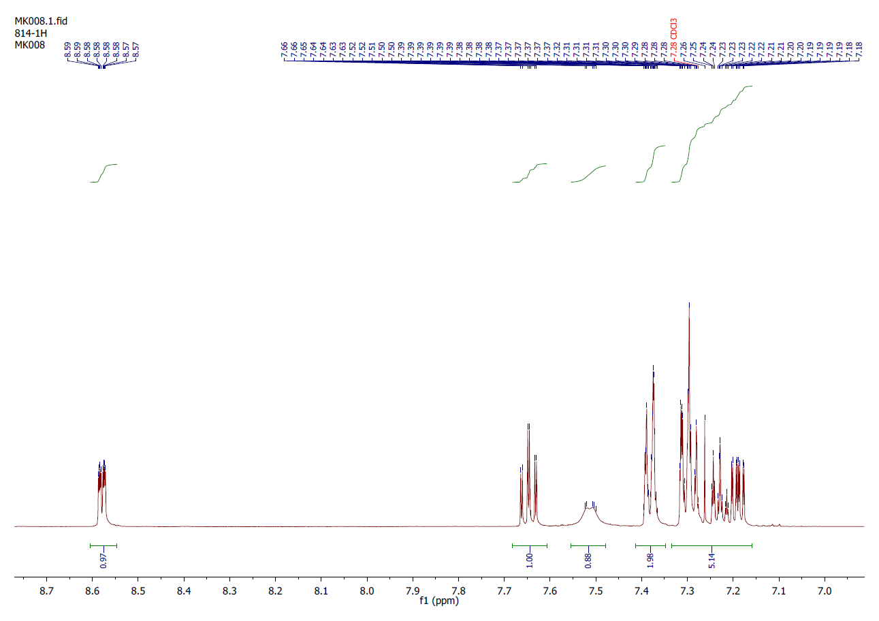
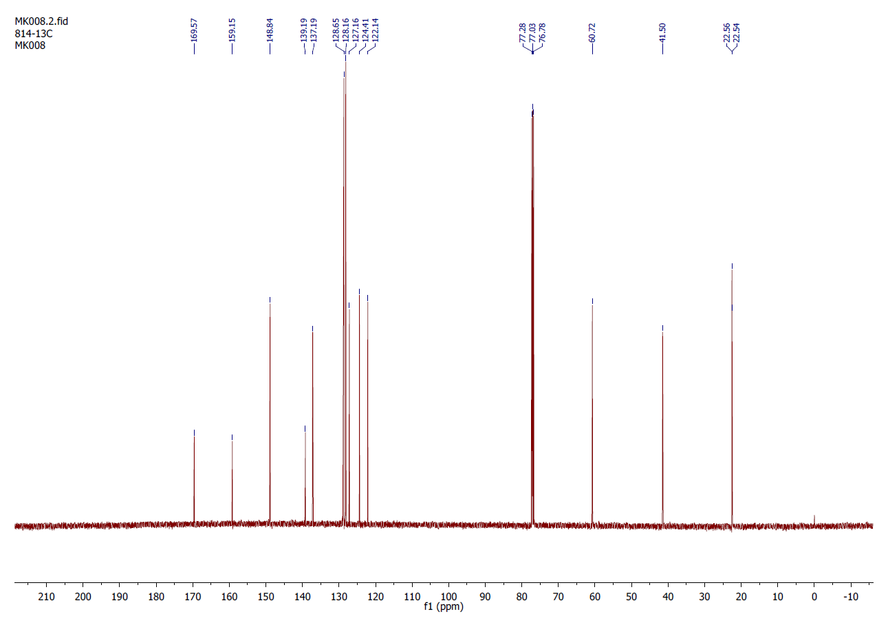
NMR spectrum of N-benzyl-2-phenyl-2-(piridin-2yl)acetamide (5e) 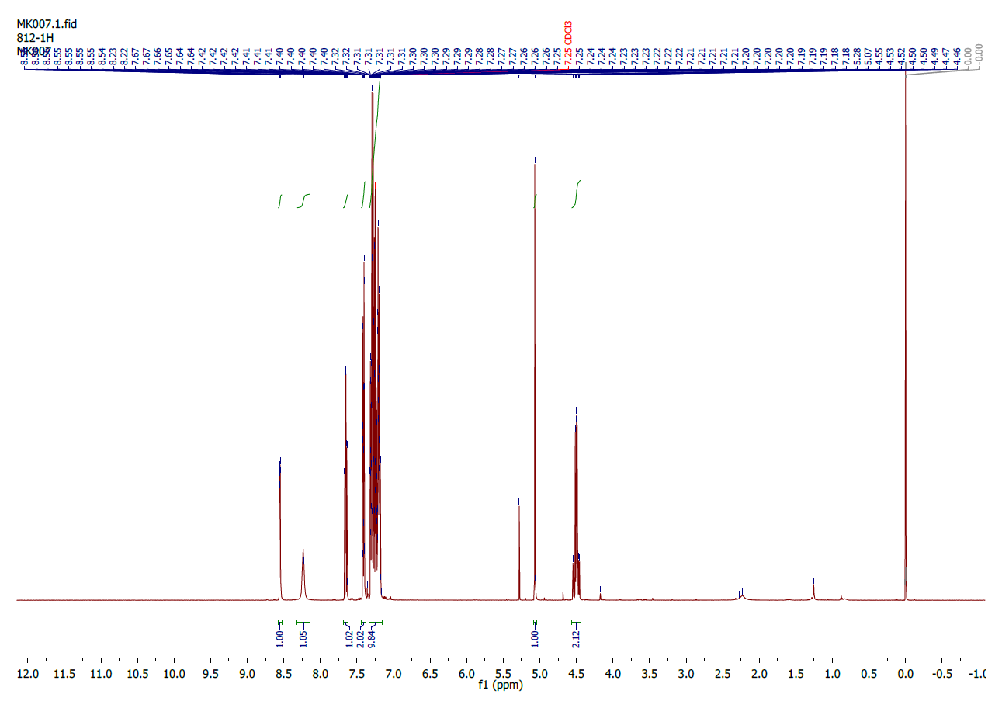
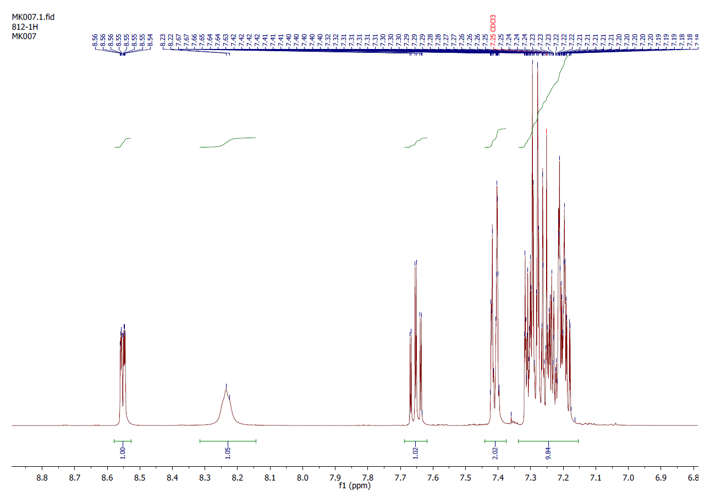
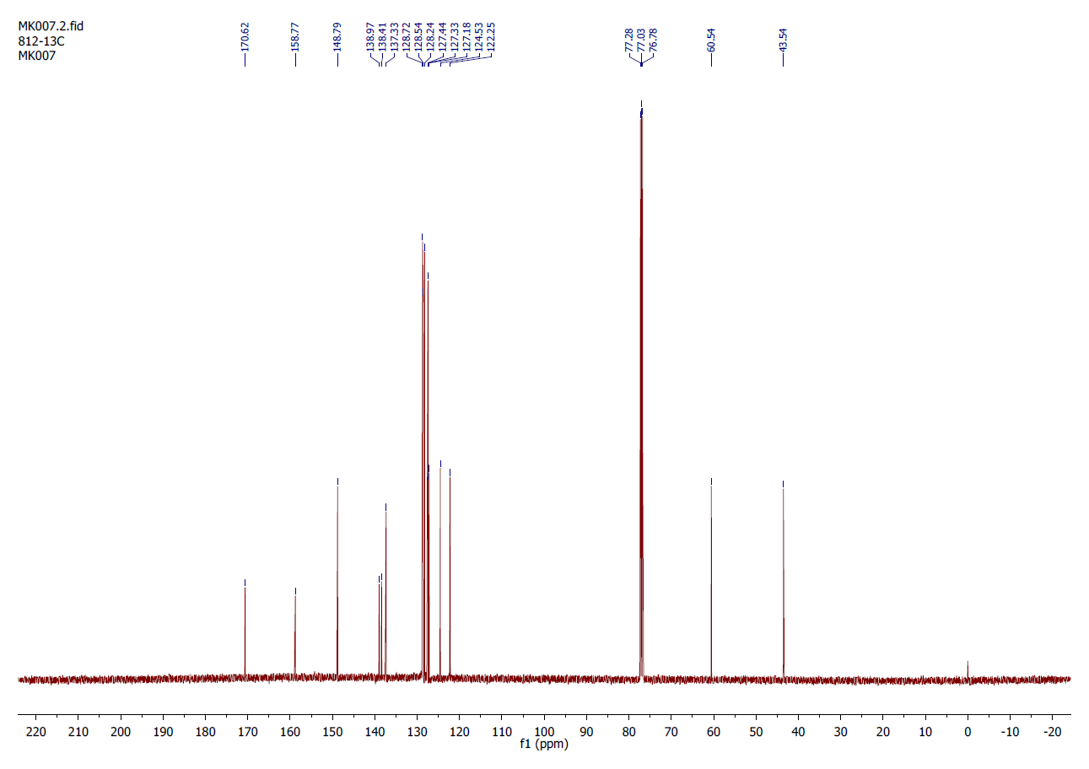
References

1. Krol, M.; Ufnal, M.; Szulczyk, B.; Podsadni, P.; Drapala, A.; Turlo, J.; Dawidowski, M., Characterization of Disopyramide derivative ADD424042 as a non-cardiotoxic neuronal sodium channel blocker with broad-spectrum anticonvulsant activity in rodent seizure models. European journal of pharmaceutical sciences : official journal of the European Federation for Pharmaceutical Sciences 2016, 81, 42-51.
2. ICH harmonised tripartite guideline. The non-clinical evaluation of the potential for delayed ventricular repolarization (QT interval prolongation) by human pharmaceuticals (S7B). FDA, Ed. 2005.
3. Minematsu, T.; Ohtani, H.; Sato, H.; Iga, T., Sustained QT prolongation induced by tacrolimus in guinea pigs. Life Sci 1999, 65 (14), PL197-202.
4. Hamlin, R. L.; Kijtawornrat, A.; Keene, B. W.; Hamlin, D. M., QT and RR intervals in conscious and anesthetized guinea pigs with highly varying RR intervals and given QTc-lengthening test articles. Toxicol Sci 2003, 76 (2), 437-42.
5. Carlsson, L.; Abrahamsson, C.; Andersson, B.; Duker, G.; Schiller-Linhardt, G., Proarrhythmic effects of the class III agent almokalant: importance of infusion rate, QT dispersion, and early afterdepolarisations. Cardiovascular Research 1993, 27 (12), 2186-2193.

