Supplementary Information for

Full-frequency correction of spatial impulse response in back-projection scheme using space-variant filtering for optoacoustic mesoscopy

Tong Lu, Yihan Wang, Jiao Li*, Jaya Prakash, Feng Gao, and Vasilis Ntziachristos

* Corresponding to: jiaoli@tju.edu.cn

The amount of optoacoustic mesoscopy (OPAM) datasets is too large to carry out the method in Ref. [1] and the model-based method considering spatial impulse response (SIR) in Ref. [2]. Therefore, we turn to perform the comparisons following the simulation settings in Ref. [1] for optoacoustic tomography (OPAT) with finite-sized unfocused transducer by K-Wave toolbox.

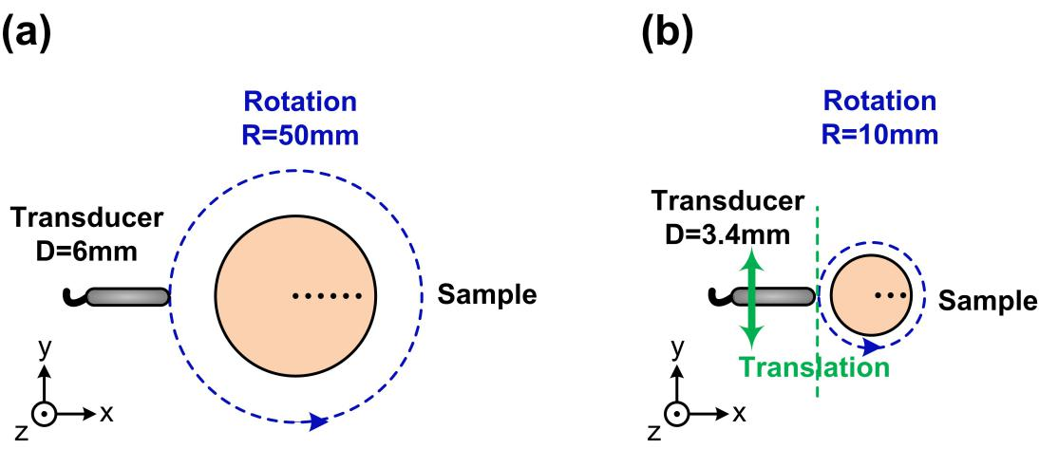
Figure S1. The simulation settings. (a) OPAT mode: rotation scanning mode, and (b) OPAM mode: translation-rotation scanning mode.

Fig. S1 displays the simulation settings of two different scanning modes. In the rotation scanning mode shown in Fig. S1(a), the diameter of simulated unfocused transducer is 6 mm, with the scanning radius of 50 mm. Six point absorbers are located at 0 mm, 5 mm, 10 mm, 15 mm, 20 mm, and 25 mm away from the scanning center. 360 detection positions covering 360° are set to reduce the number of datasets. The grid size is 0.2 mm, the signal sampling rate is 20 MHz, and the speed of sound is 1500 m/s. The translation-rotation scanning mode displayed in Fig. S1(b) is same as the scanning geometry in Fig. 2.
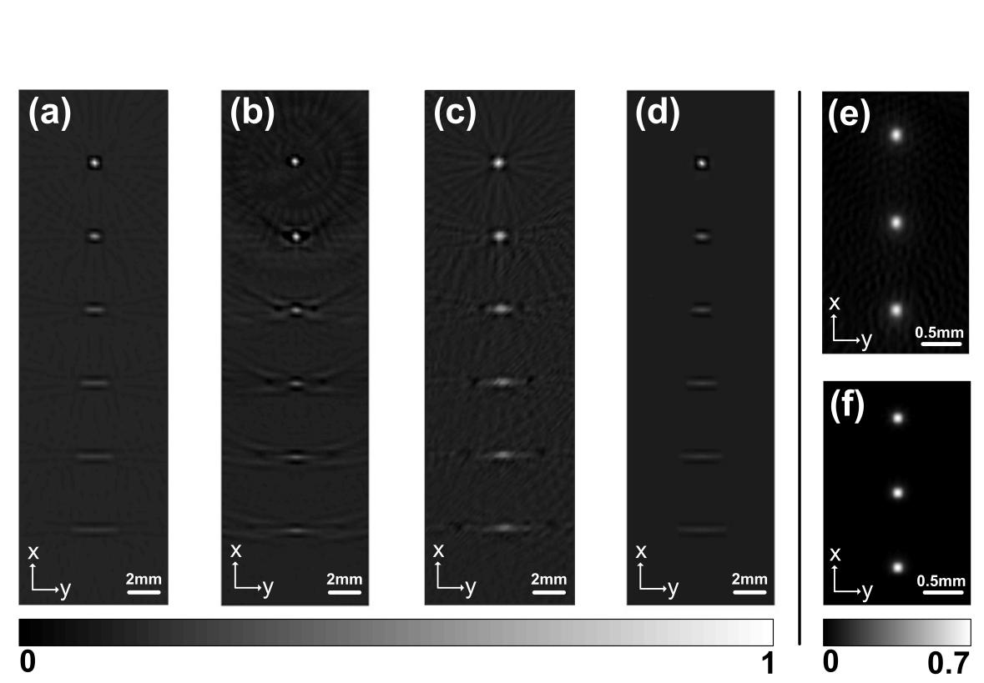
Figure S2. The reconstructed results by different methods: (a) the back-projection method, (b) the spatiotemporal optimal filter method (the mentioned OE paper), (c) the model-based method considering SIR, and (d) the SIRBP method. These four results of (a-d) are under the OPAT mode. (e) and (f) are the results by the back-projection method and the SIRBP method, respectively, under the OPAM mode. (e) and (f) are part of the results shown in Fig. 3.

Fig. S2(a-d) shows the imaging results by the back-projection method, the spatiotemporal optimal filter method [1], the model-based method considering SIR [2], and the proposed SIRBP method, respectively, under the OPAT mode. In Fig. S2(a), the finite aperture effect caused by SIR can be clearly observed in the image reconstructed by the back-projection method. In Fig. S2(b), the shape of the absobers can be well recovered by the spatiotemporal optimal filter method. The great image fidelity can be recognized in Fig. S2(c) reconstructed by the model-based method considering SIR. Although the performance of SIRBP method in recovering point absorbers is not as obvious as the spatiotemporal optimal filter method and the model-based method considering SIR, it still shows its ability of image denoising in Fig. S2(d). The spatiotemporal optimal filter method and the model-based method considering SIR show great performance in OPAT. However, these methods are not suitable for OPAM with the large datasets.
For the comparison in Fig. S2(a-d), the computation time of the back-projection method in the GPU framework, the spatiotemporal optimal filter method, the model-based method considering SIR and the proposed SIRBP method is 0.01 s, 8 s, 2.5 h and 0.11 s, respectively. The computation time of the the model-based method considering SIR in the central processing unit (CPU) framework is much longer than that of the back-projection method in graphics processing unit (GPU) framework. The calculation time can be reduced to several minutes by the GPU-based model-based method, which is still thousands of times longer than the back-projection method. It can be seen that the proposed SIRBP method accelerates the speed of image reconstruction and improves the image contrast in OPAT.
Fig. S2(e) and (f) illustrates the imaging results by the back-projection method and the SIRBP method, respectively, under the OPAM mode. These results are part of the imaging results of Fig. 3. In Fig. S2(f), the reconstruction result by the SIRBP method has the improved performance in in image fidelity, resolution, and contrast, compared with the result by the back-projection method in Fig. S2(e). Quantitative analysis has been illustrated in Fig. 4 and Table 1. The parameters such as peak signal-to-noise ratio (PSNR) and universal quality index (UQI) of the SIRBP result are increased by 16.4% and 164.8%, compared with the common back-projection result. In OPAM, the computation time of the common back-projection method and the SIRBP method is 0.12 s and 1.79 s. The computational time of the SIRBP method is about 15 times longer than the back-projection method, which is satisfying in high-resolution OPAM. The computations were done on a NVIDIA GTX 750 GPU with 64 GB memory.

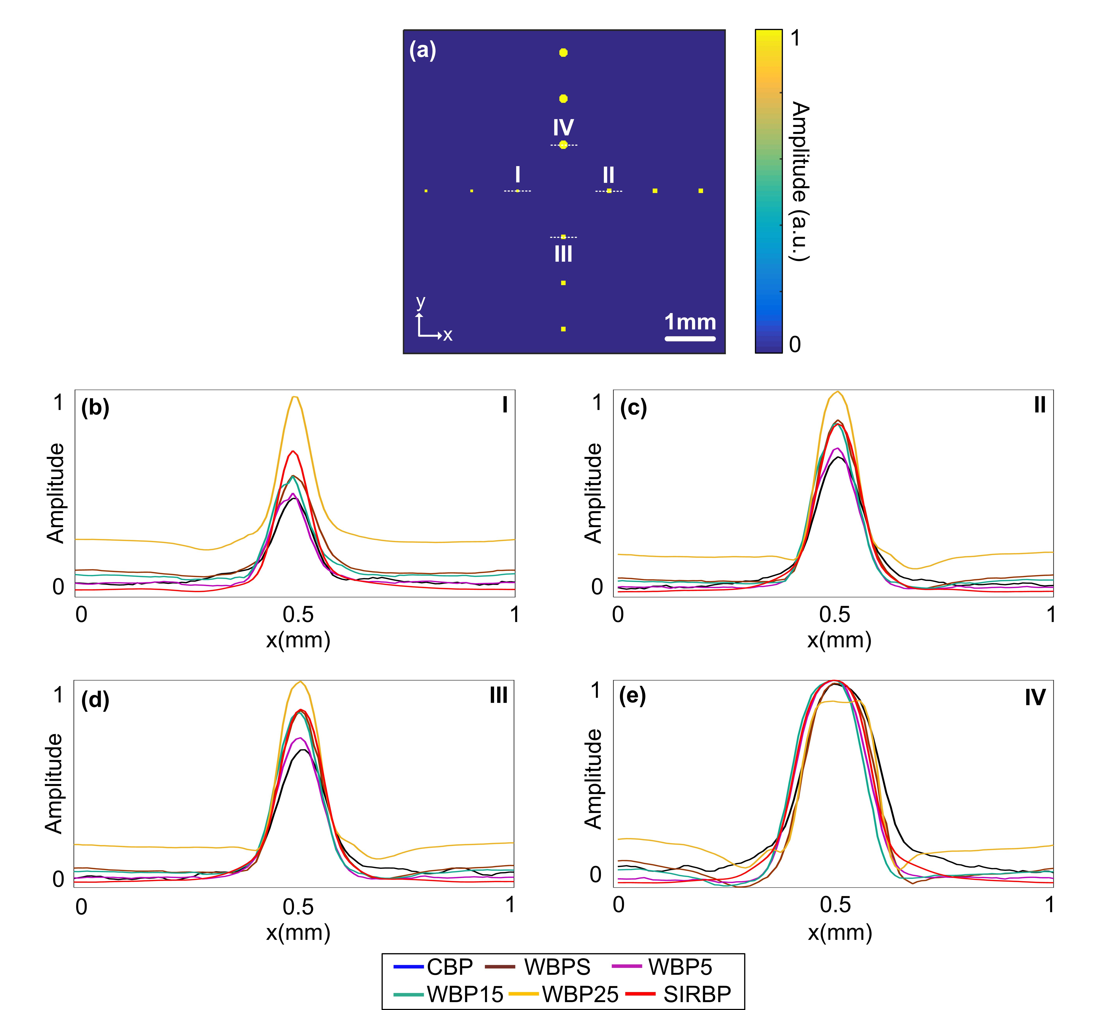
Figure S3. The cross-section profiles of the microspheres with four different sizes reconstructed by six different methods: (a) The numerical phantom shown in Fig. 3, (b) the profiles of the 60 μm-diameter microsphere along the dotted white line marked as “I” in (a), (c) the profiles of the 100 μm-diameter microsphere along the dotted white line marked as “II” in (a), (d) the profiles of the 120 μm-diameter microsphere along the dotted white line marked as “III” in (a), (e) the profiles of the 200 μm-diameter microsphere along the dotted white line marked as “IV” in (a).

Fig. S3(a) displays the image of numerical phantom containing the microspheres with four different sizes (60 μm-diameter, 100 μm-diameter, 120 μm-diameter and 200 μm-diameter) in Fig. 3. The cross-section profiles of the microspheres with four different sizes reconstructed by six different methods (CBP, WBPS, WBP5, WBP15, WBP25 and SIRBP methods) have been shown in Figs. S3(b-e). The numerical analysis of contrast-to-noise ratio (CNR) and full width at half maximum (FWHM) which can be reflected by the profiles has been shown in Fig. 4.

References
- M. L. Li, Y. C. Tseng, C. C. Cheng, Model-based correction of finite aperture effect in photoacoustic tomography, Opt. Express, 18 (25) (2010) 26285-26292, https://doi.org/10.1364/OE.18.026285.
- L. Ding, X. L. Dean Ben, D. Razansky, Efficient three-dimensional model-based reconstruction scheme for arbitrary optoacoustic acquisition geometries, IEEE T. Med. Imaging, 36 (9) (2017) 1858-1867, https://doi.org/10.1109/TMI.2017.2704019.

