Supporting Information

De novo variants in CELF2 that disrupt the nuclear localization signal cause developmental and epileptic encephalopathy

Contents
1. Statistical analysis of CELF2 mutation events in individuals with developmental and epileptic encephalopathy p. 1
2. Supplementary figures
Figure S1. Amino acid sequence similarity between human and chicken CELF2 p. 3
Figure S2. Additional electroencephalograms (EEGs) from Individuals 3 and 4 p. 4
Figure S3. Western blotting of GFP-fused wild-type and CELF2 variants. p. 5
Figure S4. Transfection of GFP-tagged wild-type and CELF2 variants into COS7 cells p. 6
Figure S5. Representative images of the distribution of GFP-fused wild-type and CELF2 variants p. 7
3. Supplementary tables
Table S1. Summary of anti-epileptic treatments for Individual 4 p. 8
Table S2. Summary of identified CELF2 variants p. 9
Table S3. Evaluation of mosaicism in various tissues from the mother of Individual 3 p. 10
4. Supplementary references p. 11

Statistical analysis of CELF2 mutation events in individuals with developmental and epileptic encephalopathy

We denoted the probability of detecting de novo missense variants in each allele per generation in ENST00000450189 (corresponding to CELF2: NM_006561.3) as Pr(dnCELF2). We calculated Pr(dnCELF2) following the methods of Samocha et al. (2014) and Short et al. (2018) using a table of de novo variant probability in each tri-nucleotide context (https://github.com/pjshort/dddMAPS), as follows:

#1: Pr(dnCELF2) = 1.71e-05.

We calculated the expected number of de novo CELF2 missense variants in the 950 individuals of our DEE cohort with no genetic diagnosis, denoted as (#2). Then, under Poisson distribution with a mean (lambda) of 0.03249, we calculated the probability of detecting two or fewer de novo CELF2 variants in the cohort of 950 individuals using the R “ppois” function (#3). Using #3, we then calculated the probability of detecting three or more de novo CELF2 variants in the cohort (#4).

#2: Pr(dnCELF2) × 950 × 2 = 0.003249
#3: ppois(2, lambda = 0.03249) = 0.9999944
#4: 1 – ppois(2, lambda = 0.03249) = 0.00000557858

Next, we calculated the statistical significance of the three detected variants’ proximity (c.1558C>T, chr10:11371008; c.1558C>T, chr10:11371008; and c.1516C>G, chr10:11370966) using the Denovonear code (#5) (Deciphering Developmental Disorders Study, 2017; Hamdan et al., 2017; Short et al., 2018). Briefly, the software randomly sampled three de novo variants in CELF2 (matching the number of variants identified in this study) weighted by the de novo variant probabilities at each tri-nucleotide context, as described in the previous paragraph. The clustering distances for the three de novo variants identified in the present study were compared with the distribution of clustering distances obtained from one million simulations of three de novo variants. The P-values were determined as the proportion of simulations with a clustering distance less than or equal to that of the three de novo variants identified in this study. The clustering distance was calculated as the geometric mean coding distance between all the possible pairs among three variants. The P-value was calculated in Python (https://github.com/hamanakakohei/denovonear_edited) as follows:
>>> symbol = 'ENST00000450189'
>>> de_novos = {'missense': [11370966,11371008,11371008], 'nonsense': []}
>>> p_values = cluster_de_novos(symbol, de_novos, iterations=1000000)
>>> p_values
{'miss_prob': 0.001081998918001082, 'nons_prob': nan, 'miss_dist': '11.3', 'nons_dist': 'nan'}
#5: 0.001081998918001082

Finally, we used Fisher’s method to combine the P-values of #4 and #5 as described previously (Deciphering Developmental Disorders Study, 2017). The combined P-value of enrichment and clustering of de novo CELF2 missense variants in individuals with DEE was 1.2027079630143315e-07, which was lower than the threshold of 2.5e-06 [P-value of 0.05, adjusted by hypothesizing 20,000 coding genes (Bonferroni correction)].

With these calculations, we demonstrated that the statistical analysis combining enrichment and clustering of de novo variants at CELF2 was significant exome-wide, although we might have overestimated the statistical significance because parental mosaicism was identified in Individual 3.
Figure S1. Amino acid sequence similarity between human and chicken CELF2

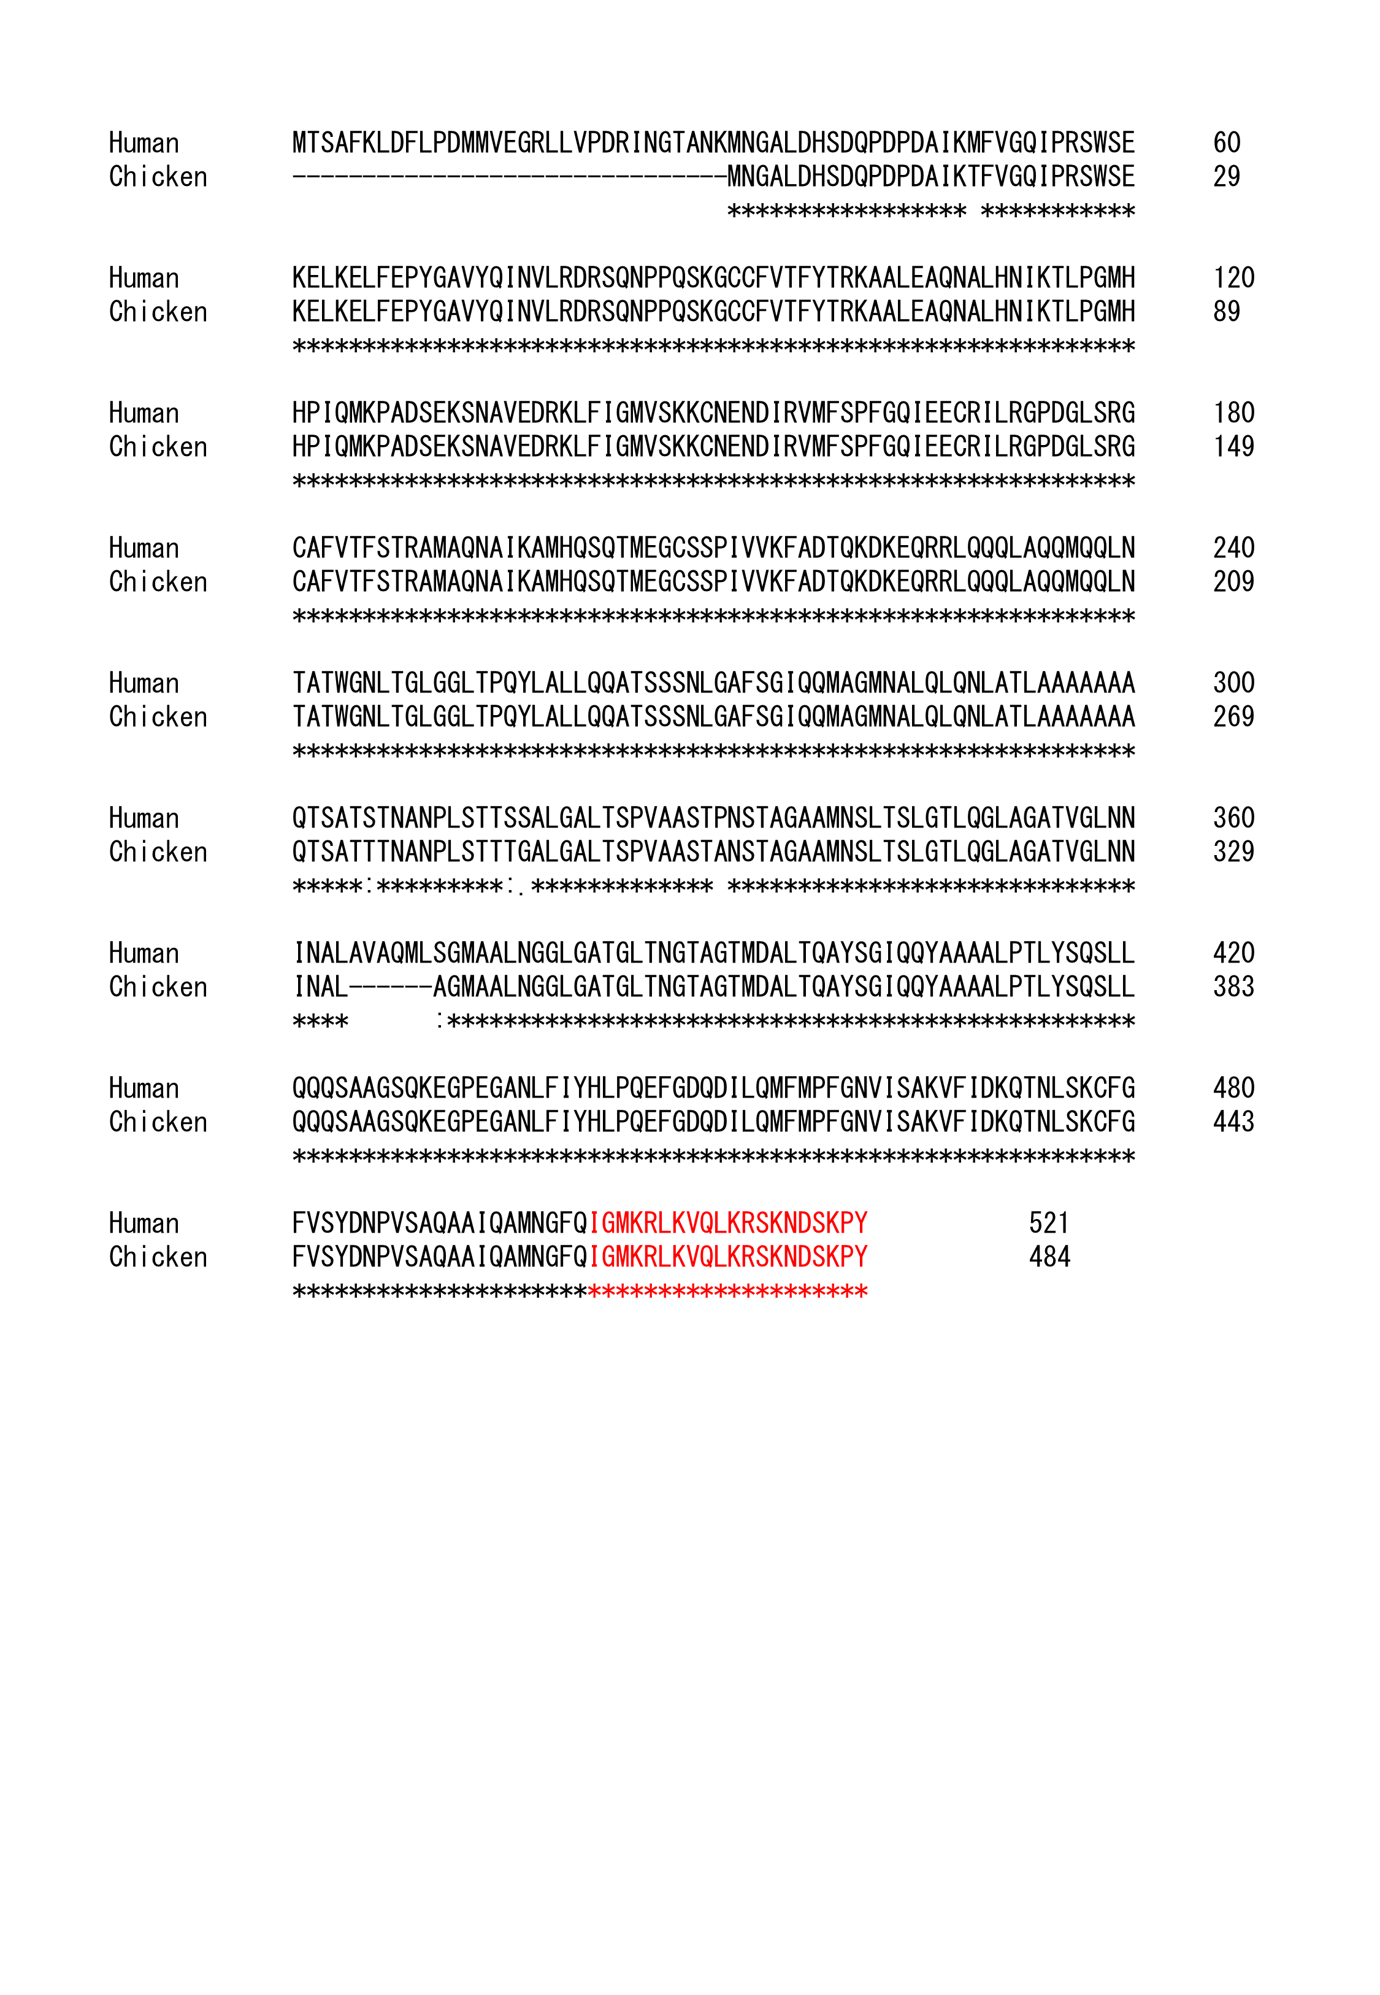
The amino acid sequence similarity between human CELF2 (NM_006561.3, NP_006552.3) and chicken CELF2 (NM_204260.2, NP_989591.2) is shown using Clustal Omega. Of the 484 amino acids in chicken CELF2, 478 are identical to those of human CELF2 (91.7% identity). The 20 C-terminal amino acids of the nuclear localization signal are in red (Ladd & Cooper, 2004).

Figure S2 Additional electroencephalograms (EEGs) from Individuals 3 and 4
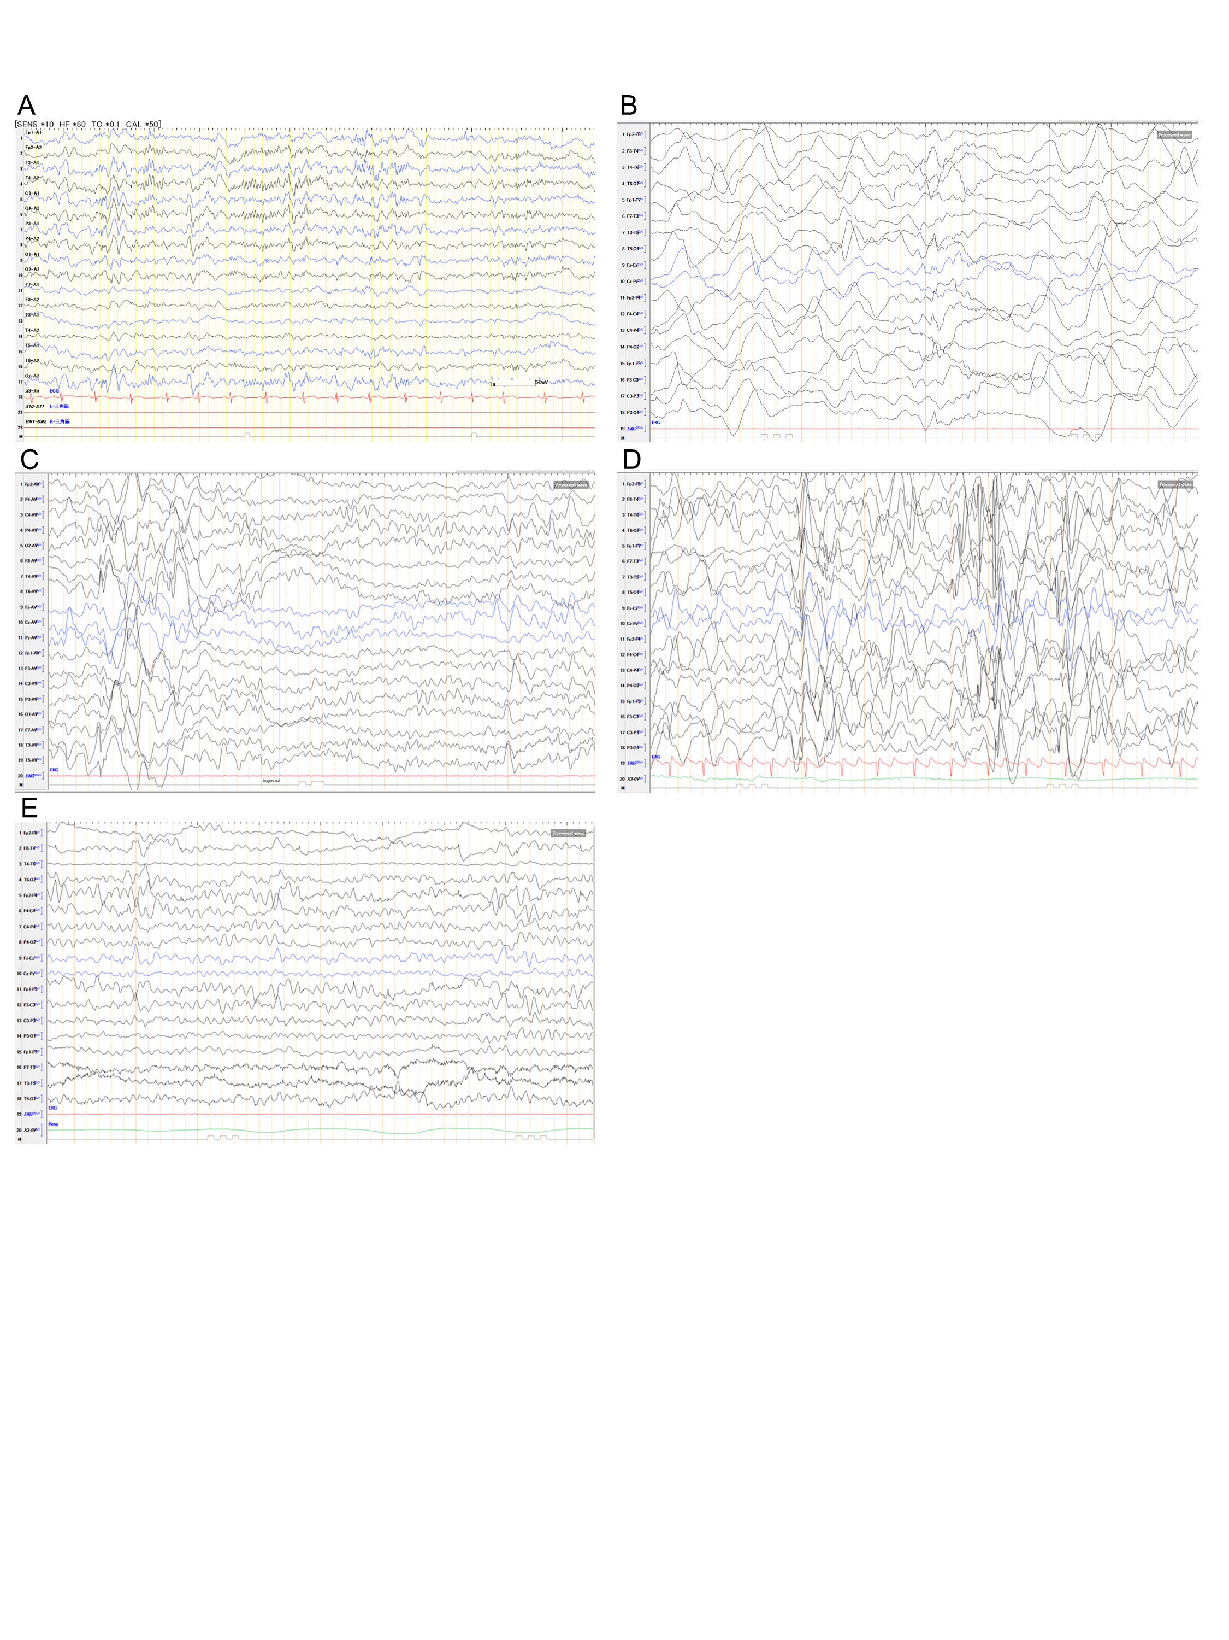
(A) Normal EEG findings at 9 years and 1 month of age in Individual 3. (B–E) EEG findings in Individual 4. (B) EEG showing general slowdown with pathological beta rhythms and suppression patterns at 14 months of age, recorded 1 week after the initiation of prednisolone according to the International Collaborative Infantile Spasms Study protocol (O'Callaghan et al., 2018). (C) EEG showing multifocal spike-slow waves and sharp-slow waves at 24 months of age. (D) EEG showing pathological incomplete and complete generalized spike-slow waves at 36 months of age. (E) EEG showing isolated spike-slow waves at 5 years and 6 months of age.

Figure S3. Western blotting of GFP-fused wild-type and CELF2 variants.
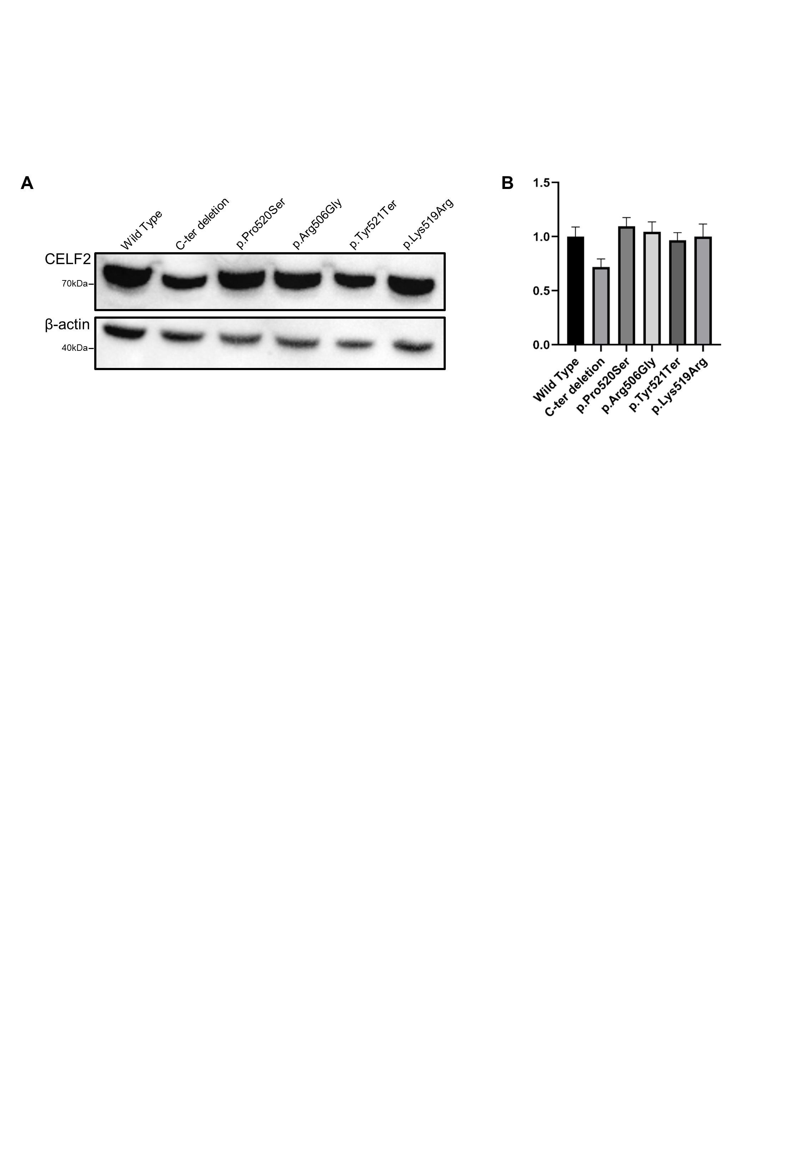

(A) Western blot analysis confirmed that all plasmids expressed proteins of the expected sizes (Ladd & Cooper, 2004). (B) Values are presented as the mean, and the bars show the standard errors of the means. All experiments were performed independently three times. One-way ANOVA analysis showed no significant difference in the amount of protein expressed in each transfection (P = 0.12).

Figure S4. Transfection of GFP-fused wild-type and CELF2 variants into COS7 cells
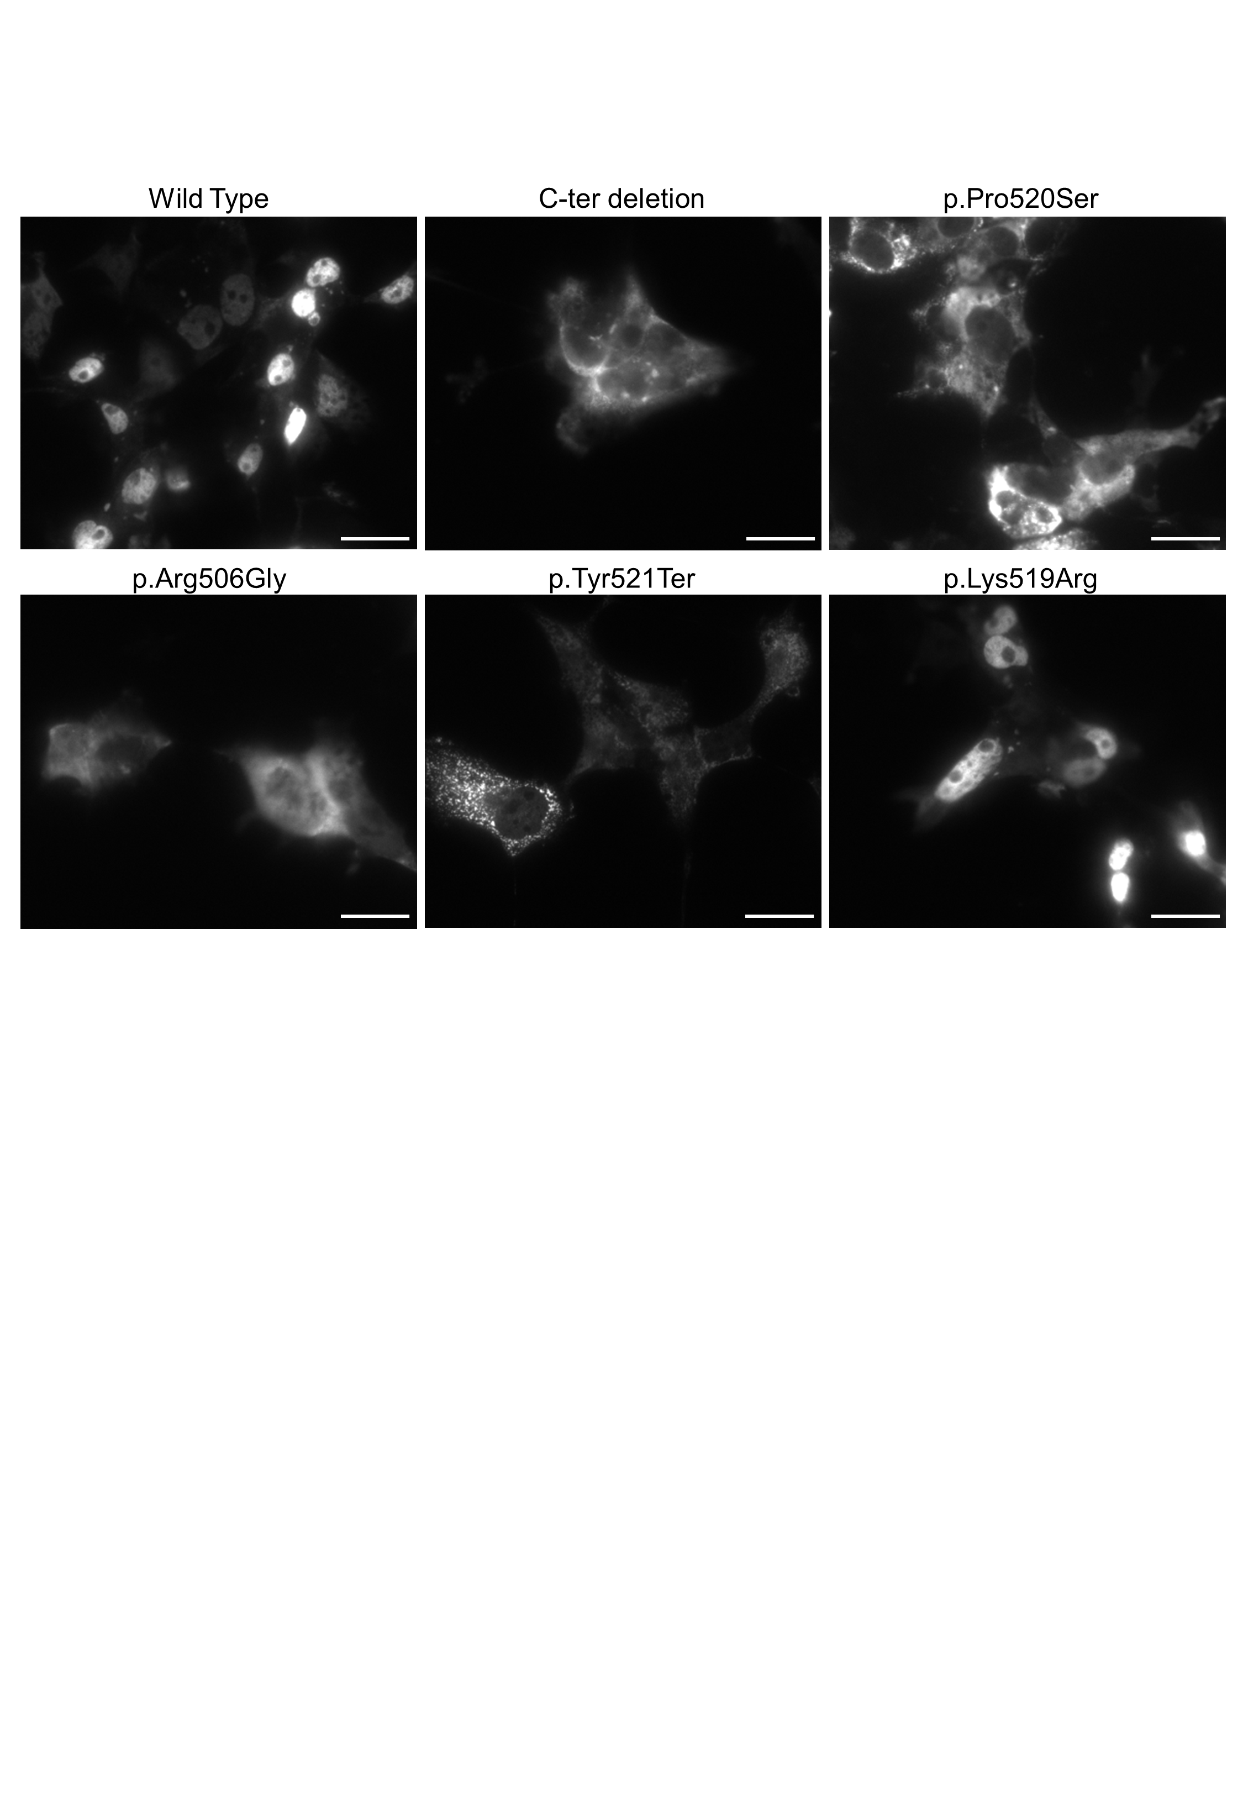

C-ter deletion denotes the deletion of 20 amino acid residues at the C-terminus. Similar to the experiments using HEK293T cells shown in Figure 3A, p.Pro520Ser and p.Tyr521Ter CELF2 showed specific cytoplasmic localization, as did the C-ter deletion CELF2. p.Arg506Gly CELF2 showed both nuclear and cytoplasmic localization, which reflects a mild variant effect, while p.Lys519Arg CELF2 showed predominantly intranuclear localization, similar to that of wild-type CELF2. Scale bars: 25 µm.
Figure S5. Representative images of the distribution of GFP-fused wild-type and CELF2 variants in HEK293T cells
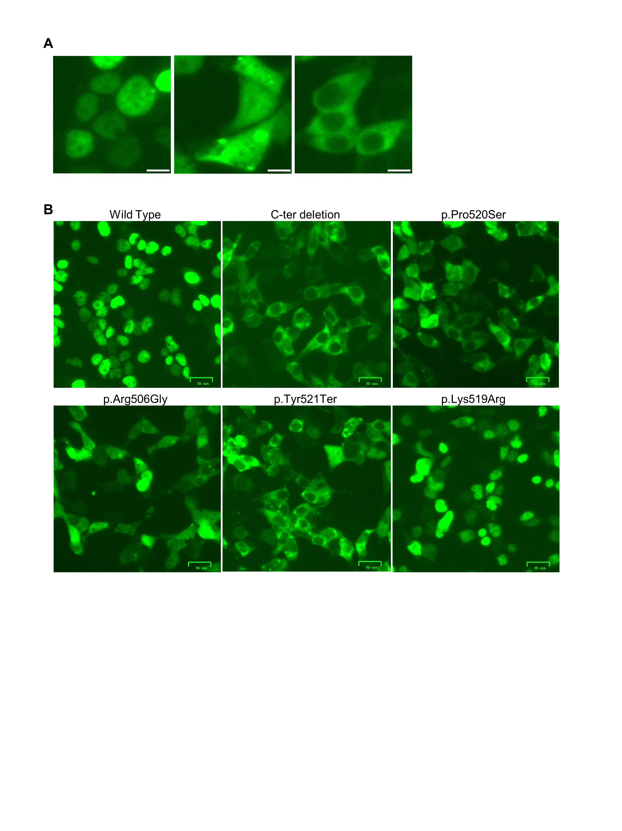

(A) Representative images of CELF2 localization: nuclear (left), nuclear + cytoplasmic (middle), and cytoplasmic (right). Scale bars: 10 µm. (B) Representative images of the distribution of CELF2 localization in each transfection. Consistent with the previous experiments, wild-type and p.Lys519Arg CELF2 showed a predominantly nuclear pattern, whereas the variants identified in Individuals 1–4 (p.Pro520Ser, p.Arg506Gly, and p.Tyr521Ter CELF2) showed aberrant localization patterns, resembling CELF2 C-ter deletion. p.Arg506Gly CELF2 predominantly showed both nuclear and cytoplasmic localization, indicating a milder variant effect.

Table S1. Summary of anti-epileptic treatments for Individual 4

Age  (months) | Medication | Response of  seizure frequency | Response of EEG findings | Side effects
4–13 | VPA + CZP | - | - | -
14–15 | PRED* | +++ | +++ | -
16–20 | VGB | + | - | -
20–21 | PRED* + VGB + LEV | ++ | ++ | -
21–33 | VGB + LEV | ++ | + | -
34–36 | LEV + VPA | - | + | -
37–38 | VPA + OXC | - | - | Exanthema
39–41 | VPA + TPM | - | - | Loss of appetite
42 onward | VGB + VPA | +++ | ++- | -
(-) No response; (+) mild response; (++) medium good response; (+++) very good response.
CZP, clonazepam; LEV, levetiracetam; OXC, oxcarbazepine; PRED, prednisolone; VGB, vigabatrin; VPA, valproic acid.
*PRED was administered according to the International Collaborative Infantile Spasms Study protocol (O'Callaghan et al., 2018).

Table S2. Summary of identified CELF2 variants

 | Individuals 1 and 2 | Individuals 3 | Individual 4 | Individual 5
Nucleotide change | c.1558C>T | c.1516C>G | c.1562dup | c.272-1G>C
Amino Acids change | p.(Pro520Ser) | p.(Arg506Gly) | p.(Tyr521Ter) | -
SIFT_score | 0.002 | 0.001 | - | -
Polyphen2_HDIV_score | 0.995 | 0.765 | - | -
Polyphen2_HVAR_score | 0.975 | 0.869 | - | -
MutationTaster_score | 1 | 1 | - | 1
MutationTaster_pred | D | D | - | D
CADD_phred | 29.8 | 25.2 | - | 24.5

D, disease-causing.

We applied following programs for pathogenicity interpretation: SIFT (https://sift.bii.a-star.edu.sg/), Polyphen-2 (http://genetics.bwh.harvard.edu/pph2/), MutationTaster (http://www.mutationtaster.org/), and CADD (https://cadd.gs.washington.edu/). We used ANNOVAR for variant annotation (https://doc-openbio.readthedocs.io/projects/annovar/).

We set thresholds in these predictions for filtering variants as follows: SIFT < 0.05, Polyphen-2 (both HDIV and HVAR) > 0.5; MutationTaster assigned as “disease-causing” regardless of the prediction score; and CADD ≥ 20.

Table S3. Evaluation of mosaicism in various tissues from the mother of Individual 3

Tissue | Wild-type alleles | Mutant alleles | Total alleles | % of the mutant allele
Blood leukocytes | 53 | 12 | 65 | 18.5
Hair roots | 54 | 12 | 66 | 18.2
Nails | 50 | 5 | 55 | 9.1
Saliva | 72 | 2 | 74 | 2.7

Supplementary References

Deciphering Developmental Disorders Study. (2017). Prevalence and architecture of de novo mutations in developmental disorders. Nature, 542(7642), 433-438. doi:10.1038/nature21062
Hamdan, F. F., Myers, C. T., Cossette, P., Lemay, P., Spiegelman, D., Laporte, A. D., . . . Michaud, J. L. (2017). High Rate of Recurrent De Novo Mutations in Developmental and Epileptic Encephalopathies. Am J Hum Genet, 101(5), 664-685. doi:10.1016/j.ajhg.2017.09.008
Ladd, A. N., & Cooper, T. A. (2004). Multiple domains control the subcellular localization and activity of ETR-3, a regulator of nuclear and cytoplasmic RNA processing events. J Cell Sci, 117(Pt 16), 3519-3529. doi:10.1242/jcs.01194
O'Callaghan, F. J. K., Edwards, S. W., Alber, F. D., Cortina Borja, M., Hancock, E., Johnson, A. L., . . . Tandy, A. (2018). Vigabatrin with hormonal treatment versus hormonal treatment alone (ICISS) for infantile spasms: 18-month outcomes of an open-label, randomised controlled trial. The Lancet Child & Adolescent Health, 2(10), 715-725. doi:10.1016/s2352-4642(18)30244-x
Samocha, K. E., Robinson, E. B., Sanders, S. J., Stevens, C., Sabo, A., McGrath, L. M., . . . Daly, M. J. (2014). A framework for the interpretation of de novo mutation in human disease. Nat Genet, 46(9), 944-950. doi:10.1038/ng.3050
Short, P. J., McRae, J. F., Gallone, G., Sifrim, A., Won, H., Geschwind, D. H., . . . Hurles, M. E. (2018). De novo mutations in regulatory elements in neurodevelopmental disorders. Nature, 555(7698), 611-616. doi:10.1038/nature25983

