Appendix A. Supplementary material

Table S1. Overview of the models used to calculate air pollution exposures.
Air pollutant | Study center | Model-year and source
 |  | 2007 | 2010
NO₂ | Umea, Uppsala, Gothenburg | - | de Hoogh et al 2016 (1)
 | Bergen | - | de Hoogh et al 2016 (1)
PM_{2.5} | Umea, Uppsala, Gothenburg | - | de Hoogh et al 2016 (1)
 | Bergen | - | de Hoogh et al 2016 (1)
PM₁₀ | Umea, Uppsala, Gothenburg | Vienneau et al 2013 (2) | -
 | Bergen | Vienneau et al 2013 (2) | -
BC | Umea, Uppsala, Gothenburg | - | de Hoogh et al 2018 (3)
 | Bergen | - | de Hoogh et al 2018 (3)
O₃ | Umea, Uppsala, Gothenburg | - | de Hoogh et al 2018 (3)
 | Bergen | - | de Hoogh et al 2018 (3)
Abbreviations: BC, black carbon; NDVI, normalized difference vegetation index; NO₂, nitrogen dioxide; O₃, ozone; PM_{2.5}, particulate matter with an aerodynamic diameter less than 2.5 µm; PM₁₀, particulate matter with an aerodynamic diameter less than 10 µm.

Table S2. Landsat images used for NDVI calculations.
 | Bergen, 201/18 | Gothenburg, 195/20 | Gothenburg, 196/19 | Umea, 193/15 | Umea, 193/16 | Uppsala, 193/18 | Uppsala, 193/19
2014 | 18/06/201, 8OLI | 27/08/2014, 8OLI | 21/08/2015, 8OLI | 12/07/2014, 8OLI | 25/07/2013, 8OLI | 10/06/2014, 8OLI | 10/06/2014, 8OLI
2009 | 03/07/2008, 5TM | 26/06/2009, 5TM | 01/06/2009, 5TM | 28/06/2009, 5TM | 28/06/2009, 5TM | 28/06/2009, 5TM | 28/06/2009, 5TM
2004 | 06/07/2003, 5TM | 07/06/2002, 5TM | 14/06/2002, 5TM | 17/06/2005, 5TM | 03/07/2005, 5TM | 14/07/2003, 5TM | 14/07/2003, 5TM
1999 | 03/06/1997, 5TM | 17/06/2000, 5TM | 08/06/2000, 5TM | 20/07/1997, 5TM (194/15) | 13/07/1997, 5TM | 17/06/1999, 5TM | 17/06/1999, 5TM
1994 | 29/07/1994, 5TM | 30/06/1993, 5TM | 24/06/1994, 5TM | 05/07/1994, 5TM | 05/07/1994, 5TM | 05/07/1994, 5TM | 05/07/1994, 5TM
1989 | 13/06/1989, 5TM | 05/07/1989, 5TM | 29/08/1989, 5TM | 21/06/1989, 5TM | 21/06/1989, 5TM | 07/07/1989, 5TM | 07/07/1989, 5TM
1984 | 18/06/1985, 5TM | 27/06/1986, 5TM | 02/06/1986, 5TM | 26/06/1985, 5TM | 26/06/1985, 5TM | 09/07/1984, 5TM | 09/07/1984, 5TM
Abbreviations: NDVI, normalized difference vegetation index; OLI, operational land imager; TM, thematic mapper.

Table S3. NDVI assignment to addresses.
NDVI map | Address year
1984 | 1975 to 1986
1989 | 1987 to 1991
1994 | 1992 to 1996
1999 | 1997 to 2001
2004 | 2002 to 2006
2009 | 2007 to 2011
2014 | 2012 to 2015
Abbreviations: NDVI, normalized difference vegetation index.

Table S4. Pearson correlation coefficients for the included air pollutants and NDVI and the different susceptibility windows.
S4a. 0-10 years
Exposure | PM_{2.5} | PM₁₀ | NO₂ | BC | O₃ | NDVI
PM_{2.5} | 1.0 | 0.913 | 0.848 | 0.638 | -0.376 | -0.225
PM₁₀ | 0.913 | 1.0 | 0.765 | 0.603 | -0.281 | -0.237
NO₂ | 0.848 | 0.765 | 1.0 | 0.791 | -0.654 | -0.409
BC | 0.638 | 0.603 | 0.791 | 1.0 | -0.787 | -0.240
O₃ | -0.376 | -0.281 | -0.654 | -0.787 | 1.0 | 0.310
NDVI¹ | -0.225 | -0.237 | -0.409 | -0.240 | 0.310 | 1.0
Abbreviations: BC, black carbon; NDVI, normalized difference vegetation index; NO₂, nitrogen dioxide; O₃, ozone; PM_{2.5}, particulate matter with an aerodynamic diameter less than 2.5 µm; PM₁₀, particulate matter with an aerodynamic diameter less than 10 µm. ¹300-m buffer.
S4b. 10-18 years
Exposure | PM_{2.5} | PM₁₀ | NO₂ | BC | O₃ | NDVI
PM_{2.5} | 1.0 | 0.908 | 0.812 | 0.697 | -0.329 | -0.170
PM₁₀ | 0.908 | 1.0 | 0.728 | 0.674 | -0.266 | -0.187
NO₂ | 0.812 | 0.728 | 1.0 | 0.821 | -0.663 | -0.360
BC | 0.697 | 0.674 | 0.821 | 1.0 | -0.677 | -0.216
O₃ | -0.329 | -0.266 | -0.663 | -0.677 | 1.0 | 0.333
NDVI¹ | -0.170 | -0.187 | -0.360 | -0.216 | 0.333 | 1.0
Abbreviations: BC, black carbon; NDVI, normalized difference vegetation index; NO₂, nitrogen dioxide; O₃, ozone; PM_{2.5}, particulate matter with an aerodynamic diameter less than 2.5 µm; PM₁₀, particulate matter with an aerodynamic diameter less than 10 µm. ¹300-m buffer.

S4c. Lifetime
Exposure | PM_{2.5} | PM₁₀ | NO₂ | BC | O₃ | NDVI
PM_{2.5} | 1.0 | 0.917 | 0.830 | 0.712 | -0.194 | -0.074
PM₁₀ | 0.917 | 1.0 | 0.753 | 0.670 | -0.101 | -0.101
NO₂ | 0.830 | 0.753 | 1.0 | 0.862 | -0.101 | -0.300
BC | 0.712 | 0.670 | 0.862 | 1.0 | -0.857 | -0.162
O₃ | -0.194 | -0.101 | -0.587 | -0.628 | 1.0 | 0.320
NDVI¹ | -0.074 | -0.101 | -0.300 | -0.162 | 0.320 | 1.0
Abbreviations: BC, black carbon; NDVI, normalized difference vegetation index; NO₂, nitrogen dioxide; O₃, ozone; PM_{2.5}, particulate matter with an aerodynamic diameter less than 2.5 µm; PM₁₀, particulate matter with an aerodynamic diameter less than 10 µm. ¹300-m buffer.

Table S5. Pearson correlation coefficients for different susceptibility windows for each exposure.
S5a. PM_{2.5}
Susceptibility window | 0-10 years | 10-18 years | Lifetime
0-10 years | 1.0 | 0.900 | 0.973
10-18 years | 0.900 | 1.0 | 0.900
Lifetime | 0.973 | 0.900 | 1.0
Abbreviations: PM_{2.5}, particulate matter with an aerodynamic diameter less than 2.5 µm.

S5b. PM₁₀
Susceptibility window | 0-10 years | 10-18 years | Lifetime
0-10 years | 1.0 | 0.876 | 0.970
10-18 years | 0.876 | 1.0 | 0.864
Lifetime | 0.970 | 0.864 | 1.0
Abbreviations: PM₁₀, particulate matter with an aerodynamic diameter less than 10 µm.

S5c. NO₂
Susceptibility window | 0-10 years | 10-18 years | Lifetime
0-10 years | 1.0 | 0.883 | 0.952
10-18 years | 0.883 | 1.0 | 0.925
Lifetime | 0.952 | 0.925 | 1.0
Abbreviations: NO₂, nitrogen dioxide.

S5d. BC
Susceptibility window | 0-10 years | 10-18 years | Lifetime
0-10 years | 1.0 | 0.879 | 0.945
10-18 years | 0.879 | 1.0 | 0.906
Lifetime | 0.945 | 0.906 | 1.0
Abbreviations: BC, black carbon.

S5e. O₃
Susceptibility window | 0-10 years | 10-18 years | Lifetime
0-10 years | 1.0 | 0.900 | 0.941
10-18 years | 0.900 | 1.0 | 0.942
Lifetime | 0.941 | 0.942 | 1.0
Abbreviations: O₃, ozone.

S5f. NDVI (300m)
Susceptibility window | 0-10 years | 10-18 years | Lifetime
0-10 years | 1.0 | 0.701 | 0.850
10-18 years | 0.701 | 1.0 | 0.845
Lifetime | 0.850 | 0.845 | 1.0
Abbreviations: NDVI, normalized difference vegetation index

Table S6. Mean annual average exposure (range) for air pollutants per center for the exposure time windows (0-10 years, 10-18 years and lifetime).
Mean annual average exposure (range)ª |  | NO₂ µg/m³ | PM_{2.5} µg/m³ | PM₁₀ µg/m³ | BC 10⁻⁵m⁻¹ | O₃ µg/m³
Umea | 0-10 years | 14.1 (0.2-38.6) | 10.5 (1.0-22.5) | 16.6 (10.7-26.8) | 0.10 (0.00-1.07) | 68.4 (62.8-74.8)
Umea | 10-18 years | 12.6 (0.1-37.3) | 8.9 (0.5-21.9) | 14.0 (8.0-26.2) | 0.11 (0.00-1.13) | 68.2 (60.0-75.7)
Umea | Lifetime | 13.6 (0.3-33.1) | 9.3 (0.7-20.4) | 14.4 (9.7-25.1) | 0.17 (0.00-1.17) | 67.8 (62.8-75.2)
Uppsala | 0-10 years | 22.7 (2.7-47.7) | 16.8 (7.0-29.5) | 23.0 (12.7-34.1) | 0.68 (0.03-1.76) | 67.4 (60.9-74.3)
Uppsala | 10-18 years | 18.3 (2.2-49.0) | 13.2 (5.7-24.8) | 18.3 (10.1-31.7) | 0.56 (0.00-1.60) | 68.1 (60.9-77.3)
Uppsala | Lifetime | 19.9 (2.5-39.8) | 13.8 (7.0-22.5) | 19.1 (11.7-26.4) | 0.63 (0.02-1.54) | 67.6 (61.0-74.7)
Gothenburg | 0-10 years | 36.5 (7.0-72.4) | 23.6 (11.5-30.7) | 27.7 (16.3-40.6) | 1.07 (0.42-2.06) | 64.5 (59.0-73.2)
Gothenburg | 10-18 years | 29.7 (5.5-69.0) | 18.1 (6.1-29.8) | 21.6 (9.8-35.7) | 0.92 (0.15-2.20) | 65.5 (54.3-77.2)
Gothenburg | Lifetime | 30.7 (9.1-60.0) | 18.6 (9.8-24.8) | 22.3 (13.8-31.0) | 0.95 (0.14-1.66) | 65.1 (58.8-73.6)
Bergen | 0-10 years | 24.0 (3.0-49.0) | 14.4 (2.9-24.4) | 19.4 (12.0-27.8) | 0.91 (0.00-2.58) | 62.7 (50.0-74.4)
Bergen | 10-18 years | 22.0 (2.9-47.9) | 12.1 (2.1-22.6) | 16.6 (9.4-26.5) | 0.72 (0.00-2.58) | 62.8 (49.9-74.4)
Bergen | Lifetime | 21.2 (4.5-43.5) | 11.5 (2.5-16.7) | 15.9 (8.6-21.5) | 0.68 (0.00-2.01) | 62.7 (50.1-74.5)
EU limit values |  | 40^{b} | 25^{b} | 40^{b} | - | -^{c}
WHO guideline values |  | 40^{b} | 10^{b} | 20^{b} | - | -^{c}
Abbreviations: BC, black carbon; EU, European Union; NDVI, normalized difference vegetation index; NO₂, nitrogen dioxide; O₃, ozone; PM_{2.5}, particulate matter with an aerodynamic diameter lower than 2.5 µm; PM₁₀, particulate matter with an aerodynamic diameter lower than 10 µm; WHO, World Health Organization. ª All air pollutants exposures were extrapolated in time with the ratio method. ^{b} Annual mean values. ^{c} Only maximum daily 8-hour mean values available

Table S7. Mean annual average exposure (range) for all NDVI buffer zones per centre for the exposure time windows (0-10 years, 10-18 years and lifetime).
Mean annual average exposure (range) |  | NDVI 100m | NDVI 300m | NDVI 500m | NDVI 1000m
Umea
Umea | 0-10 years | 0.550 (0.137-0.840) | 0.551 (0.204-0.797) | 0.555 (0.215-0.781) | 0.559 (0.230-0.770)
 | 10-18 years | 0.559 (0.147-0.831) | 0.558 (0.198-0.803) | 0.561 (0.273-0.794) | 0.568 (0.198-0.770)
 | Lifetime | 0.530 (0.127-0.840) | 0.531 (0.184-0.797) | 0.536 (0.192-0.811) | 0.544 (0.222-0.796)
Uppsala
Uppsala | 0-10 years | 0.565 (0.240-0.851) | 0.570 (0.281-0.789) | 0.577 (0.300-0.778) | 0.594 (0.286-0.782)
 | 10-18 years | 0.580 (0.210-0.848) | 0.583 (0.268-0.801) | 0.590 (0.325-0.807) | 0.602 (0.317-0.791)
 | Lifetime | 0.559 (0.251-0.816) | 0.562 (0.347-0.783) | 0.569 (0.192-0.811) | 0.582 (0.369-0.766)
Gothenburg
Gothenburg | 0-10 years | 0.546 (0.209-0.814) | 0.551 (0.222-0.767) | 0.560 (0.198-0.768) | 0.564 (0.208-0.751)
 | 10-18 years | 0.580 (0.168-0.833) | 0.585 (0.232-0.796) | 0.592 (0.206-0.782) | 0.594 (0.228-0.774)
 | Lifetime | 0.558 (0.225-0.815) | 0.563 (0.241-0.777) | 0.570 (0.224-0.770) | 0.574 (0.231-0.748)
Bergen
Bergen | 0-10 years | 0.534 (0.121-0.779) | 0.549 (0.155-0.802) | 0.545 (0.128-0.799) | 0.533 (0.146-0.782)
 | 10-18 years | 0.549 (0.108-0.786) | 0.553 (0.133-0.774) | 0.548 (0.136-0.770) | 0.537 (0.121-0.764)
 | Lifetime | 0.522 (0.121-0.776) | 0.532 (0.163-0.758) | 0.528 (0.147-0.772) | 0.519 (0.164-0.768)
Abbreviations: NDVI, normalized difference vegetation index.

Table S8. Logistic regression analyses of asthma attack last 12 months in relation with mean air pollution and greenness exposures the year before RHINESSA participation, in the full (imputed) study population.
 | Univariable |  | Multivariable²
Exposure^{1*} | OR (95% CI) | p³ | OR (95% CI) | p³
NO₂ | 1.10 (0.88-1.38) | 0.400 | 1.60 (1.20-2.13) | 0.001
PM_{2.5} | 1.67 (0.96-2.91) | 0.067 | 2.10 (1.22-3.62) | 0.008
PM₁₀ | 2.03 (1.13-3.65) | 0.017 | 2.46 (1.34-4.54) | 0.004
BC | 1.34 (0.82-2.20) | 0.238 | 2.14 (1.21-3.78) | 0.008
O₃ | 1.40 (0.93-2.09) | 0.104 | 2.44 (1.39-4.26) | 0.002
NDVI 300m | 0.99 (0.89-1.10) | 0.857 | 0.97 (0.85-1.10) | 0.598
NDVI 100m | 0.96 (0.87-1.06) | 0.408 | 0.93 (0.84-1.04) | 0.212
NDVI 500m | 0.99 (0.89-1.10) | 0.889 | 0.97 (0.85-1.10) | 0.593
NDVI 1000m | 0.99 (0.89-1.10) | 0.859 | 0.97 (0.85-1.10) | 0.619

Abbreviations: BC, black carbon; CI, confidence interval; FEV, forced expiratory volume in 1 second; NDVI, normalized difference vegetation index; NO₂, nitrogen dioxide; O₃, ozone; OR, odds ratio; PM_{2.5}, particulate matter with an aerodynamic diameter lower than 2.5 µm; PM₁₀, particulate matter with an aerodynamic diameter lower than 10 µm. ¹ All air pollutants exposures were extrapolated in time with the ratio method. ² All models were adjusted for O₃ and NDVI (300m), except for the O₃-model that was adjusted for NO₂ and NDVI (300m) and the NDVI-model that was adjusted for O₃ and NO₂. All models were also adjusted for age, sex and parental education and asthma. ³ All p-values < 0.05 = significant and marked bold. *BC per 1-μg/m³ increase, NDVI per 0.1-unit increase. NO₂, PM exposures and O₃ per 10-μg/m³ increase.

Table S9. Logistic regression analyses of current rhinitis in relation with mean air pollution and greenness exposures the year before RHINESSA participation, in the full (imputed) study population.
 | Univariable |  | Multivariable²
Exposure^{1*} | OR (95% CI) | p³ | OR (95% CI) | p³
NO₂ | 1.15 (1.03-1.28) | 0.012 | 1.25 (1.08-1.45) | 0.003
PM_{2.5} | 1.32 (1.01-1.73) | 0.040 | 1.35 (1.02-1.77) | 0.033
PM₁₀ | 1.45 (1.09-1.93) | 0.011 | 1.45 (1.08-1.94) | 0.014
BC | 1.40 (1.11-1.76) | 0.004 | 1.50 (1.15-1.96) | 0.003
O₃ | 0.96 (0.80-1.15) | 0.633 | 1.22 (0.95-1.57) | 0.119
NDVI 300m | 0.98 (0.93-1.03) | 0.446 | 1.00 (0.94-1.05) | 0.894
NDVI 100m | 0.99 (0.94-1.03) | 0.562 | 1.00 (0.95-1.05) | 0.978
NDVI 500m | 0.98 (0.93-1.03) | 0.346 | 0.99 (0.93-1.05) | 0.677
NDVI 1000m | 0.98 (0.93-1.03) | 0.364 | 0.99 (0.93-1.05) | 0.685

Abbreviations: BC, black carbon; CI, confidence interval; FEV, forced expiratory volume in 1 second; NDVI, normalized difference vegetation index; NO₂, nitrogen dioxide; O₃, ozone; OR, odds ratio; PM_{2.5}, particulate matter with an aerodynamic diameter lower than 2.5 µm; PM₁₀, particulate matter with an aerodynamic diameter lower than 10 µm. ¹ All air pollutants exposures were extrapolated in time with the ratio method. ² All models were adjusted for O₃ and NDVI (300m), except for the O₃-model that was adjusted for NO₂ and NDVI (300m) and the NDVI-model that was adjusted for O₃ and NO₂. All models were also adjusted for age, sex and parental education and asthma. ³ All p-values < 0.05 = significant and marked bold. *BC per 1-μg/m³ increase, NDVI per 0.1-unit increase. NO₂, PM exposures and O₃ per 10-μg/m³ increase.

 | 0-10 years |  |  |  | 10-18 years |  |  |  | Lifetime
 | Univariable |  | Multivariable² |  | Univariable |  | Multivariable² |  | Univariable |  | Multivariable²
Exposure^{1*} | OR (95% CI) | p³ | OR (95% CI) | p³ | OR (95% CI) | p³ | OR (95% CI) | p³ | OR (95% CI) | p³ | OR (95% CI) | p³
FEV₁/FVC
NO₂ | 1.34 (0.87-2.05) | 0.180 | 1.16 (0.64-2.07) | 0.628 | 1.39 (0.90-2.16) | 0.139 | 1.16 (0.57-2.38) | 0.676 | 1.36 (0.79-2.35) | 0.272 | 1.15 (0.52-2.56) | 0.734
PM_{2.5} | 1.44 (0.61-3.37) | 0.402 | 1.00 (0.34-2.91) | 0.998 | 1.89 (0.75-4.72) | 0.174 | 1.34 (0.31-5.77) | 0.698 | 1.54 (0.45-5.26) | 0.488 | 1.11 (0.25-4.94) | 0.887
PM₁₀ | 1.27 (0.49-3.31) | 0.618 | 0.82 (0.23-2.84) | 0.750 | 1.56 (0.60-4.07) | 0.363 | 0.79 (0.13-4.93) | 0.801 | 1.31 (0.34-5.10) | 0.695 | 0.85 (0.16-4.67) | 0.856
BC | 2.47 (0.94-6.49) | 0.067 | 2.88 (0.69-12.03) | 0.146 | 2.66 (1.02-6.90) | 0.045 | 2.27 (0.48-10.69) | 0.299 | 2.59 (0.72-9.31) | 0.146 | 2.22 (0.37-13.42) | 0.386
O₃ | 0.50 (0.18-1.42) | 0.192 | 0.49 (0.13-1.83) | 0.289 | 0.52 (0.20-1.36) | 0.183 | 0.49 (0.12-2.03) | 0.328 | 0.55 (0.17-1.75) | 0.313 | 0.49 (0.11-2.17) | 0.348
NDVI 300m dddd33d300m300(300m) | 0.98 (0.71-1.35) | 0.900 | 1.12 (0.77-1.64) | 0.541 | 1.10 (0.80-1.52) | 0.551 | 1.22 (0.85-1.75) | 0.286 | 1.01 (0.71-1.44) | 0.962 | 1.22 (0.82-1.81) | 0.333
NDVI 100m | 1.03 (0.78-1.37) | 0.826 | 1.16 (0.87-1.55) | 0.312 | 1.11 (0.83-1.48) | 0.473 | 1.25 (0.93-1.67) | 0.144 | 1.03 (0.74-1.43) | 0.867 | 1.22 (0.89-1.68) | 0.222
NDVI 500m | 0.98 (0.72-1.34) | 0.906 | 1.09 (0.77-1.55) | 0.637 | 1.11 (0.83-1.50) | 0.479 | 1.22 (0.86-1.71) | 0.260 | 1.03 (0.74-1.43) | 0.857 | 1.23 (0.84-1.79) | 0.285
NDVI 1000m | 1.07 (0.78-1.46) | 0.692 | 1.15 (0.82-1.63) | 0.420 | 1.18 (0.86-1.63) | 0.300 | 1.30 (0.90-1.87) | 0.165 | 1.09 (0.79-1.50) | 0.617 | 1.26 (0.86-1.86) | 0.238
Table S10. Logistic regression analyses of lower limit of normal (LLN) FEV₁/FVC in relation with mean air pollution and greenness exposures for all time windows in the full (imputed) study population.
Abbreviations: BC, black carbon; CI, confidence interval; FEV, forced expiratory volume in 1 second; NDVI, normalized difference vegetation index; NO₂, nitrogen dioxide; O₃, ozone; OR, odds ratio; PM_{2.5}, particulate matter with an aerodynamic diameter lower than 2.5 µm; PM₁₀, particulate matter with an aerodynamic diameter lower than 10 µm. ¹ All air pollutants exposures were extrapolated in time with the ratio method. ² All models were adjusted for O₃ and NDVI (300m), except for the O₃-model that was adjusted for NO₂ and NDVI (300m) and the NDVI-models that were adjusted for O₃ and NO₂. All models were also adjusted for age, sex and parental education and asthma. ³ All p-values < 0.05 = significant and marked bold. *BC per 1-μg/m³ increase, NDVI per 0.1-unit increase. NO₂, PM exposures and O₃ per 10-μg/m³ increase.

 | 0-10 years |  |  |  | 10-18 years |  |  |  | Lifetime
 | Univariable |  | Multivariable¹ |  | Univariable |  | Multivariable¹ |  | Univariable |  | Multivariable¹
Exposure* | OR (95% CI) | p² | OR (95% CI) | p³ | OR (95% CI) | p³ | OR (95% CI) | p³ | OR (95% CI) | p³ | OR (95% CI) | p³
FEV₁
NDVI 100m | 1.47 (1.13-1.91) | 0.004 | 1.44 (1.07-1.92) | 0.014 | 1.46 (1.11-1.92) | 0.008 | 1.39 (1.04-1.86) | 0.026 | 1.68 (1.21-2.34) | 0.002 | 1.55 (1.09-2.19) | 0.015
NDVI 500m | 1.45 (1.05-2.02) | 0.026 | 1.41 (0.94-2.12) | 0.1010 | 1.68 (1.22-2.31) | 0.002 | 1.62 (1.12-2.35) | 0.011 | 1.86 (1.24-2.79) | 0.003 | 1.72 (1.11-2.66) | 0.015
NDVI 1000m | 1.50 (1.05-2.14) | 0.027 | 1.42 (0.93-2.17) | 0.108 | 1.68 (1.15-2.45) | 0.008 | 1.55 (1.02-2.35) | 0.041 | 1.82 (1.19-2.79) | 0.006 | 1.61 (1.02-2.52) | 0.039
FVC
NDVI 100m | 1.26 (0.93-1.70) | 0.141 | 1.14 (0.80-1.62) | 0.461 | 1.19 (0.89-1.60) | 0.239 | 1.13 (0.81-1.57) | 0.466 | 1.30 (0.90-1.87) | 0.161 | 1.17 (0.77-1.79) | 0.458
NDVI 500m | 1.50 (1.00-2.27) | 0.052 | 1.36 (0.84-2.21) | 0.211 | 1.66 (1.16-2.39) | 0.006 | 1.61 (1.07-2.43) | 0.023 | 1.87 (1.15-3.04) | 0.011 | 1.74 (1.05-2.90) | 0.032
NDVI 1000m | 1.55 (0.96-2.50) | 0.071 | 1.39 (0.81-2.38) | 0.227 | 1.61 (1.05-2.47) | 0.030 | 1.48 (0.93-2.37) | 0.098 | 1.86 (1.08-3.21) | 0.025 | 1.64 (0.93-2.87) | 0.085
Table S11. Logistic regression analyses of lower limit of normal (LLN) FEV₁ and FVC in relation to mean greenness exposures (buffer zones 100 m, 500 m and 1000 m) for all time windows in the full (imputed) study population.
Abbreviations: CI, confidence interval; FEV, forced expiratory volume in 1 second; NDVI, normalized difference vegetation index; OR, odds ratio;¹All models were adjusted for O₃ and NDVI (300m), except for the O₃-model that was adjusted for NO₂ and NDVI (300m) and the NDVI-models that were adjusted for O₃ and NO₂. All models were also adjusted for age, sex and parental education and asthma. ² All p-values < 0.05 = significant and marked bold. * NDVI per 0.1-unit increase.

Figure S1. Directed Acyclic Graph for greenness.
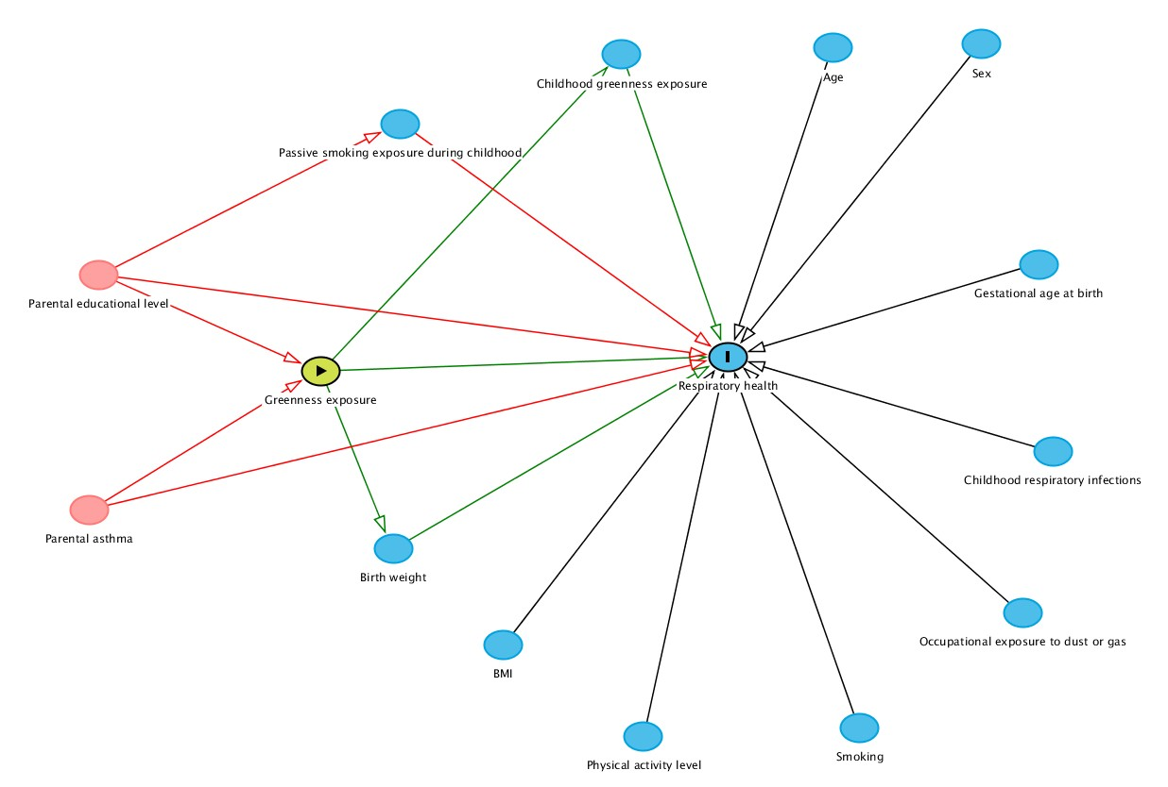

Figure S2. Directed Acyclic Graph for air pollution.

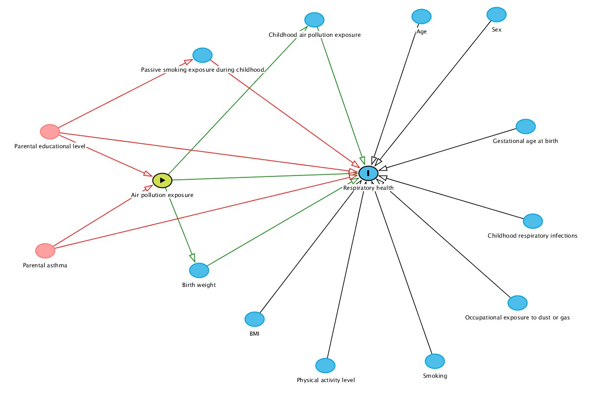

1. de Hoogh K, Gulliver J, Donkelaar AV, Martin RV, Marshall JD, Bechle MJ, et al. Development of West-European PM2.5 and NO2 land use regression models incorporating satellite-derived and chemical transport modelling data. Environmental research. 2016;151:1-10 DOI: 10.1016/j.envres.2016.07.005.
2. Vienneau D, de Hoogh K, Bechle MJ, Beelen R, van Donkelaar A, Martin RV, et al. Western European land use regression incorporating satellite- and ground-based measurements of NO2 and PM10. Environmental science & technology. 2013;47(23):13555-64 DOI: 10.1021/es403089q.
3. de Hoogh K, Chen J, Gulliver J, Hoffmann B, Hertel O, Ketzel M, et al. Spatial PM2.5, NO2, O3 and BC models for Western Europe - Evaluation of spatiotemporal stability. Environment international. 2018;120:81-92 DOI: 10.1016/j.envint.2018.07.036.

