SUPPLEMENTARY DATA
For: Engineered versus hybrid cellular vesicles as efficient drug delivery systems: A comparative study with brain targeted vesicles
M.Kannavou^{1,2,&}, A. Marazioti^{1,2.&}, G.T. Stathopoulos^{3,4}, S.G. Antimisiaris^{1,2},*
¹Laboratory of Pharmaceutical Technology, Department of Pharmacy, University of Patras, Rio 26510, Greece
²Foundation for Research and Technology Hellas, Institute of Chemical Engineering Sciences, FORTH/ICE-HT, Rio 26504, Greece
³ Laboratory for Molecular Respiratory Carcinogenesis, Department of Physiology, Faculty of Medicine, University of Patras, Rio 26510, Greece
⁴Comprehensive PneumologyCenter (CPC) and Institute for Lung Biology and Disease (iLBD); Helmholtz Center Munich–German Research Center for Environmental Health; Member of the German Center for Lung Research; Munich, Bavaria, 81377; Germany.

Table S1. PEG/lipid (theoretical) ratio, and measured rations of Chol/lipid, and Chol/protein, for the different types of vesicles used. Values for CVs derived from HEK cells, were measured for comparison.
Formulation code | PEG/Phospholipid (mol%) | Surface exposed PEG/Phospholipid (mol%) | Chol/phospholipid (w/w) | Chol/protein (w/w)
PEG-LIP (PC/Chol/PEG 2/1/0.25) | 12.5 | 6.25 | 0.25 | -
Hybrids | 6.245 | 3.12 | 0.340 ± 0.015 | 3.38 ± 0.14
CVs (hCMEC/D3) | - | - | 0.431 ± 0.026 | 2.06 ± 0.22
e-CVs (hCMEC/D3) | 10 | 10 | 0.502 ± 0.030 | 3.40 ± 0.11
CVs (B16) |  | - | 0.97 ± 0.16 | 3.32 ± 0.40
CVs (HEK) |  | - | 0.965 ± 0.063 | 3.38 ± 0.32

Figure S1:
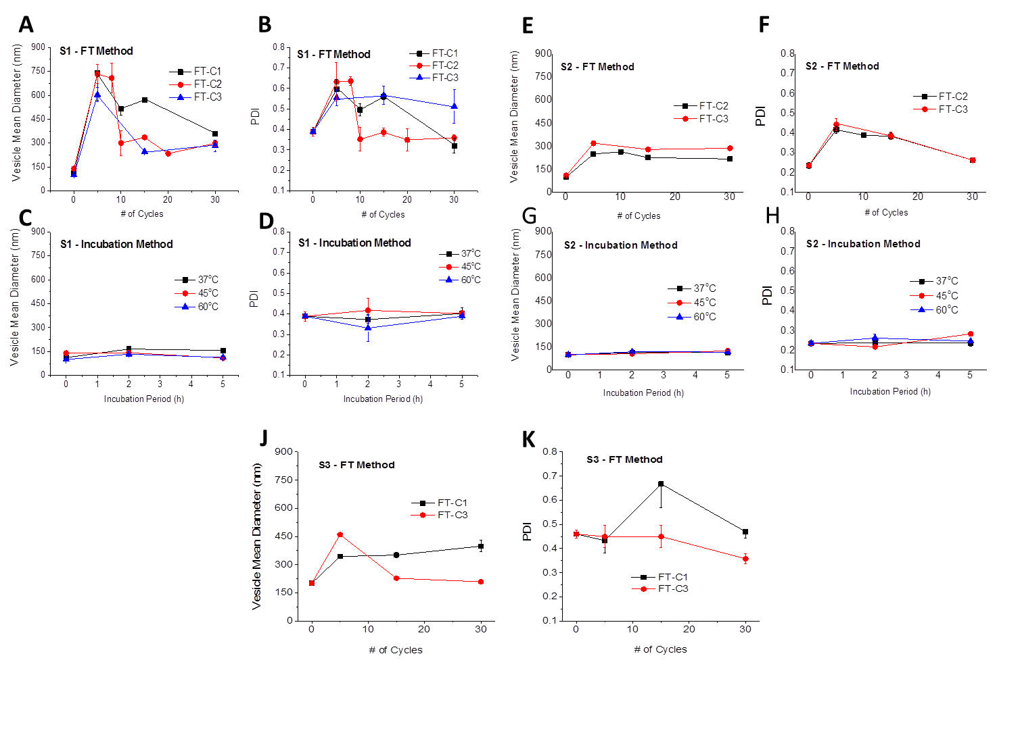Figure S1. Vesicle mean diameters (A, C, E, G, J) and PDI values (B, D, F, H, K) measured during and after application of different vesicle fusion protocols (details are presented in Table 1), between: (i) non-charged (PC/Chol) liposomes (A-D) [S1]; (ii) Pegylated liposomes and negatively charged liposomes (E-H) [S2] and (iii) CVs from hCMEC/D3 cells and Pegylated liposomes (J, K) [S3]. Each value is the mean from at least three different samples, and the SD’s of each mean value are presented as bars.

Figure S2
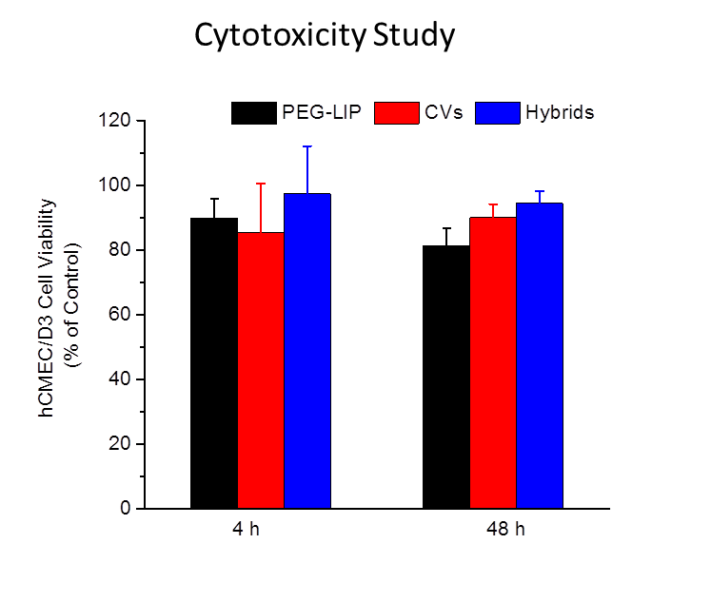
Figure S2. hCMEC/D3 cell viability (% of Control) following incubation with PEG-LIP, CVs from hCMEC/D3 cells, and Hybrids, for 4h and 48 h. Each value is the mean from at least three different samples, and the SD of each mean value is presented as bars.

